# Declarations of Interest Policy Statement

## Purpose

To ensure members of MRFF advisory panels, committees, groups and other bodies identify and declare relevant interests and that the Health and Medical Research Office (HMRO) manages these interests appropriately.

## Objective

This policy aims to:

* make members aware that they must declare any relevant interests
* apply a consistent, transparent approach to managing conflicts of interest, where needed, and
* promote public confidence in the management of the MRFF.

## Scope

This policy applies to any individual formally advising the Australian Government and/or the HMRO on MRFF related activities.

The policy excludes:

* members of grant opportunity assessment panels. Their declarations of interest and the subsequent management of these are covered by grant hubs’ policies.
* persons engaged as employees or contractors by the Department of Health. Their declarations of interest and the subsequent management of these are subject to the Department of Health’s internal policies and procedures as well as the Australian Public Service Values and Code of Conduct.

## Definition

A conflict of interest arises when there is a risk that an individual’s advice in relation to the MRFF is, or is perceived to be, or potentially could be:

* influenced by a private interest
* not based on the MRFF’s best interests.

Interests may be:

* Financial– if it is likely that the member could make an appreciable financial gain or loss.[1]
* Professional– involvement with organisations with a direct interest in or relevance to the MRFF, including:
  + membership
  + affiliation
  + being a representative.[2]
* Personal – any other interest that may conflict, or appear to conflict, with a member’s obligations in providing advisory services in relation to the MRFF[3]

Conflicts of interest may be:

* Real – an actual conflict exists between the member’s duties and personal interests, and the conflict improperly influences the employee’s performance of their duties or
* Apparent – it would be reasonable for others to conclude that personal interests could improperly influence a member’s performance of their official duties, but this is not actually the case.

## Procedures

### Declaring interests

Members are required to declare all relevant interests, so that the HMRO can assess and manage them appropriately in line with the Policy.

Current and historic (within the last 5 years) interests must be declared:

* when they accept an MRFF advisory role (by signing a ‘Deed of Undertaking in Relation to Confidential Information and Conflict of Interest’),
* ahead of each meeting, and
* as circumstances change.

The Chair (or relevant proxy[4]) and members are required to ensure interests are accurately recorded in the meeting minutes.

Full disclosure, including publication of real or apparent conflicts of interest, is an important safeguard to the MRFF’s transparency and integrity, and also protects the reputational interests of the member or members.

### Assessing interests

Upon the making of a declaration of an interest/s, the HMRO and/or Chair (or relevant proxy4) will determine whether the declaration is a conflict of interest (real or apparent), and then decide the appropriate approach for its management.[5]

### Managing conflicts of interests

The management of interests considers the nature of the interest and the likelihood of the interest interfering with a member’s ability to provide independent, objective and impartial advice on a particular matter in relation to the MRFF.

In some cases, conflicts of interest cannot be avoided. This is because the people invited to provide advice will have a stake in the subject they are considering. The nature of the advice provided typically relates to policy and implementation considerations and will not often have a direct influence on funding outcomes. As such it is expected that a less intrusive approach (register, restrict, recruit rather than remove, relinquish, resign) will usually be utilised.

The table below sets out possible approaches to managing conflicts of interest:

| **Approach** | **Action(s)** | **When is this most suitable** |
| --- | --- | --- |
| **Register** | Publicly record all the details of the conflict of interest. | For very low-risk conflicts of interest where recording the conflict of interest is enough to maintain transparency. |
| **Restrict** | Involve the member in discussion but restrict their involvement in decision-making on the matter (i.e. no vote). | For medium-risk conflict of interest that is not likely to arise frequently. |
| **Recruit** | Recruit an impartial, non-conflicted third party to oversee, audit and/or review:   * the decision-making * part or all of the process affected by the conflict of interest. | When the effects (or perceived effects) of the conflict are significant but it is not feasible or desirable to remove the member from the decision-making process. This applies when the member’s particular expertise is necessary and not easily replaced. |
| **Remove** | Remove the member completely from any discussion or recommendations regarding the matter creating the conflict (i.e. the member will have to leave the room or not take part in tele/videoconferences). | For ongoing and serious conflicts of interest, where other strategies are not feasible, practical or appropriate. |
| **Relinquish** | The member decides to relinquish the personal interest(s) that create(s) the conflict. | Where affected member’s commitment to public duty outweighs their attachment to their private interest(s). |
| **Resign** | The member steps down from their role with the committee/board on a temporary or permanent basis. | Where no other options are workable. Where relinquishing conflicting private interest is not possible. |

The HMRO or Chair may choose to seek advice in relation to decisions to be taken as part of this process. Such advice may be sought from other panel members, persons with relevant knowledge of a matter, or from independent probity advisors.

The HMRO will record all decisions and actions taken in relation to declared interests in meeting minutes, or separately where no minutes are taken.

The HMRO will publish a register of conflicts of interest on the MRFF website.  
Members will be consulted prior to publishing the register.

## Compliance with the policy

All members subject to this policy are responsible for ensuring that they comply with the requirements of the policy.

The HMRO will monitor compliance with the Chairs’ assistance.

Reported or suspected breaches will be investigated by HMRO.

If the HMRO identifies a breach, membership may be revoked.

**MRFF Declaration of Interest Policy**

**Decision Making Flowchart**

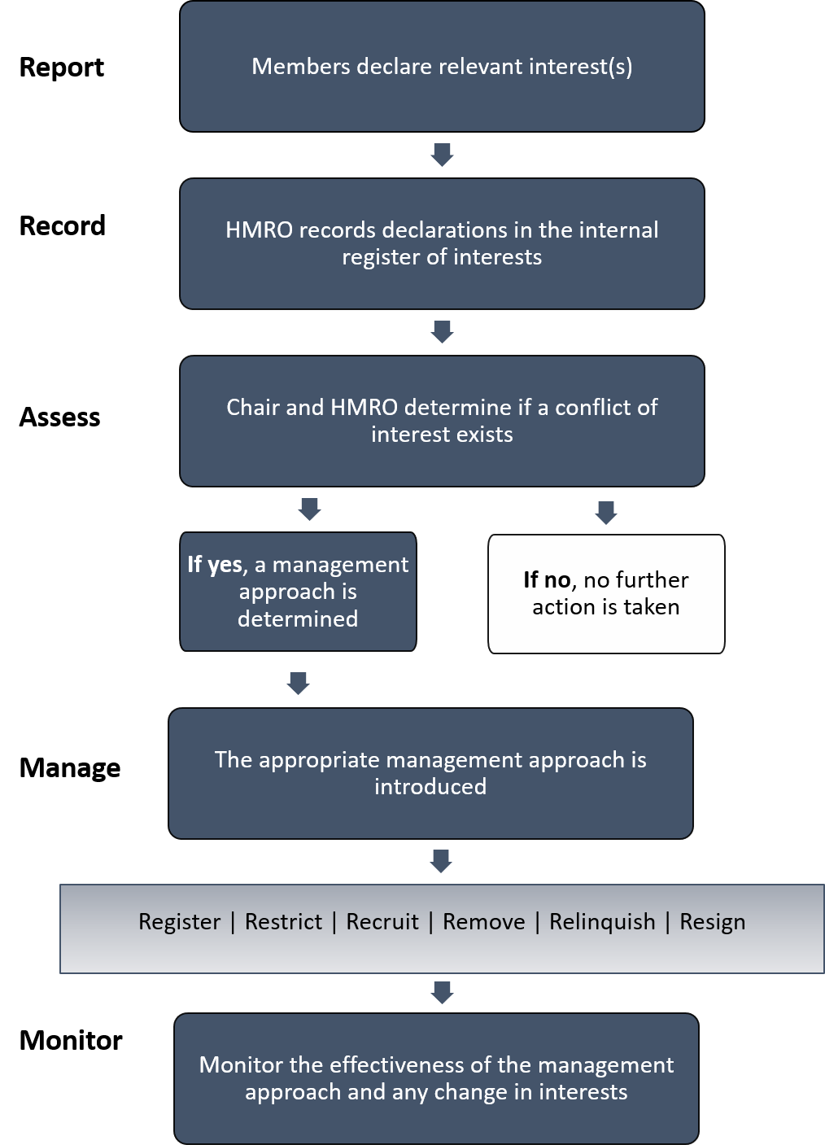Flowchart – decision making

1. Adapted from the Pecuniary Interest Tribunal website: <https://www.findlaw.com.au/articles/1694/the-pecuniary-interest-tribunal.aspx>
2. Adapted from NHMRC’s *Identifying and managing conflicts of interest*: <https://www.nhmrc.gov.au/guidelinesforguidelines/plan/identifying-and-managing-conflicts-interest>
3. Adapted from ATAGI declaration of member interests form
4. Where a Chair declares a conflict of interest, alternative chairing arrangements will be put in place utilising the Co-Chair, Deputy Chair or another member of the group as necessary
5. Section 32K of the Medical Research Future Fund Act 2015 prescribes certain additional requirements for members of the Australian Medical Research Advisory Board (AMRAB) regarding the disclosure of interests. AMRAB, in performing its functions, is accountable to the Minister for Health.