Procedure guidance for medicines funded through the Life Saving Drugs Program (LSDP)

Version 1.0

July 2018

Note: Subject to revision by the LSDP Expert Panel

Contents

2 Purpose 3

3 Procedures for consideration of new medicines 4

Pre-application 6

Assessment 6

New medicines applications 6

Consideration of applications by the LSDP Expert Panel 6

Publication of the agenda for upcoming LSDP Expert Panel meetings 7

Written stakeholder input 7

Presentations to the Expert Panel 7

Advice from the LSDP Expert Panel to the CMO 7

Recommendation 8

Recommendation from the CMO to the Minister for Health 8

4 Guidance for preparing applications 9

LSDP application 9

LSDP application: Funding Criteria 9

LSDP application: Pricing issues 13

Draft Guidelines for treatment through the LSDP 13

Identifying and addressing uncertainties in your application 13

5 Procedures for implementation 15

Price agreement 15

Deeds of agreement 16

Price reductions 16

Guidelines for treatment through the LSDP 16

Patient eligibility for initial and ongoing subsidy through the LSDP 16

6 Medicines reviews 18

24 month reviews 18

Reviews of existing LSDP products 20

Review recommendations 22

7 Confidentiality and transparency 24

LSDP Expert Panel 24

Expert Panel meetings 24

LSDP Medicine Reviews 24

Conflict of Interest 25

Transparency 26

8 Key contacts 26

Attachment A – Template for new medicine applications 27

# Purpose

The Life Saving Drugs Program (LSDP) provides access for eligible patients with rare and life-threatening diseases to essential and very expensive medicines. The LSDP provides eligible patients with access to these life-saving medicines at no expense to the patients or their families.

In 2014, the Minister for Health announced a Review of the LSDP. The main objectives were to review the access, equity, value for money and future administration of the program with a view to facilitating continued subsidy to important and necessary medicines for patients in need.

On 28 January 2018, the Minister for Health announced the outcomes of the Review of the LSDP and provided the Government response. The Australian Government committed to retaining and improving the LSDP, drawing upon recommendations of the Review. Improvements to the program ensure that eligible patients retain ongoing access to medicines through the LSDP and that the program remains sustainable into the future.

Changes to the program from 1 July 2018 include:

* the adoption of a rare diseases definition, that being a disease prevalence of 1:50,000 people or less in the Australian population (around 500 people). This is in line with the current LSDP prevalence rates;
* developing explanatory materials to support the criteria to specify that lifesaving medicines are those that extend lifespan, including through the measurement of substantial reduction to the level and duration of disability, which will lead to a significant increase in life extension;
* implementation of transparent and rigorous assessment of medicines, delivered through the establishment of an expert panel which will provide advice and assistance to the Commonwealth’s Chief Medical Officer (CMO);
* introduction of a mechanism where medicines listed on the LSDP will be subject to a review of usage and financial costs after 24 months, ensuring use and performance of the medicine is in line with the recommendations and expectations at listing. Similar reviews will be undertaken on all existing LSDP medicines over the first two years from the commencement of the new program;
* the negotiated application of pricing policies to new and existing medicines on the LSDP, as per those applying to Pharmaceutical Benefits Scheme (PBS) listed medicines; and
* streamlining administration of the LSDP, and implementing cost recovery arrangements from sponsors for listing considerations and management of their agreements. These improvements to the LSDP deliver certainty to patients and stakeholders.

In implementing these changes to the LSDP, the Government and Medicines Australia, on behalf of sponsors of medicines on the LSDP, entered into an agreement in May 2018. The agreement provides policy stability, transparency and certainty for the rare diseases medicines sector.

This guidance document delivers on the commitments made in the agreement to develop a clearly defined and transparent process and associated timelines for consideration of medicines seeking funding through the LSDP. This guidance further delivers on the commitment to assist sponsors in preparing an application to make a rare disease medicine available on the LSDP, ensuring access to treatment for people with rare diseases is not unnecessarily delayed.

This guidance is intended to provide:

* support for sponsors seeking to prepare applications to the LSDP
* an explanation of procedures for considering new medicines seeking listing on the LSDP
* information to consumers relating to the decision making process for LSDP medicines and how individuals can be involved in the process
* an explanation of procedures for reviews of LSDP medicines
* an overview of procedures for implementing a Government decision to make a medicine available through the LSDP.

This document is maintained by the Department of Health. The document is routinely revised in consultation with relevant stakeholders (including clinicians, patients and sponsors) in response to changes in the processes involved in consideration of LSDP medicines.

# Procedures for consideration of new medicines

Before being considered for inclusion on the LSDP, a drug must first be considered by the Pharmaceutical Benefits Advisory Committee (PBAC) and accepted as clinically effective but rejected for Pharmaceutical Benefits Scheme (PBS) listing because it fails to meet the required cost effectiveness criteria. The Commonwealth Chief Medical Officer (CMO) advises the Minister for Health on drugs proposed to be included on the LSDP. The process for new medicines seeking funding through the LSDP is represented in the timeline below.

**PROCEDURE FOR CONSIDERATION OF NEW MEDICINES FOR SUBSIDY THROUGH THE LSDP**

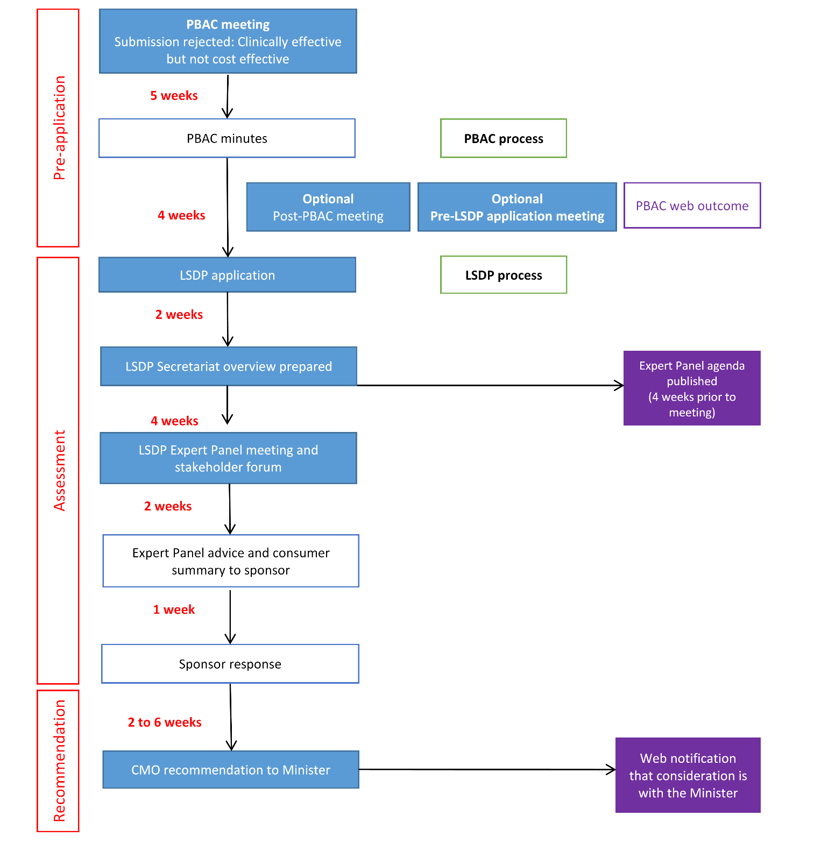

## Pre-application

Once a medicine has been accepted as clinically effective, but rejected for PBS listing because it fails to meet the required cost effectiveness criteria, the sponsor can seek advice from the Department on the preparation of an application for a new medicine to be funded through the LSDP.

Sponsors can email the [LSDP Secretariat](mailto:LSDPEP@health.gov.au) to request a pre-application meeting once advice has been given to the sponsor that their medicine was not recommended for PBS listing on the basis that PBAC considered the medicine to be clinically effective but not cost effective. The pre-application meeting will not occur until the sponsor has received the ratified PBAC minutes. Members of the LSDP Secretariat will attend meetings. The sponsor is able to request additional attendees but these cannot be guaranteed.

The purpose of this pre-application meeting is to ensure as far as possible that the information contained within a sponsor’s application will address concerns that may arise through the LSDP Expert Panel consideration of the medicine.

The sponsor should advise the department who will be attending the meeting and what their role at the meeting will be. The sponsor is able to bring employees of their organisation, which shall not be limited to employees from the Australian affiliate, and members of professions such as health professionals, other health service providers, and patient advocacy group representatives. Sponsors need to provide a brief document to assist discussion.

Meetings may require up to 2 hours to address the issues and to discuss the approach to the LSDP application.

All advice provided by the Department to the sponsor is non-binding for both parties.

## Assessment

### New medicines applications

Guidance for how sponsors should apply for a new medicine to be funded through the LSDP is in Section 3 and a template for the application is at Attachment A.

Applications to list a new medicine can be lodged by email to the [LSDP Secretariat](mailto:LSDPEP@health.gov.au) or if file size is greater than 30MB, this can be posted in via USB storage device. Sponsor should contact the secretariat if this is the case.

### Consideration of applications by the LSDP Expert Panel

All applications for new medicines seeking funding through the LSDP are considered by the LSDP Expert Panel. The role of the panel is to provide advice and assistance to the Commonwealth Chief Medical Officer (CMO) on a range of matters relating to new medicines seeking funding, including assessment of how the medicine addresses the LSDP criteria, guidelines for medicine use and testing requirements, suitable pricing arrangements, and data collection required for future reviews.

Materials considered by the Expert Panel will include the sponsor’s application, assessment (overview) of the submission prepared by the LSDP Secretariat, relevant materials from the PBAC consideration (including ratified minutes/advice from the PBAC and its sub-committees, Pre-Sub-Committee and pre-PBAC responses from sponsors, and consumer comments received by the PBAC), additional written stakeholder input to the Expert Panel, and presentations made to the Expert Panel at the meeting.

Consideration of medicines by the Expert Panel will be sufficiently flexible to consider the needs of, and benefits to, patients living with rare diseases and their carers.

When an application is received for a new medicine to be funded through the LSDP, the Secretariat will prepare an overview of the application to assist the Expert Panel in their considerations. The Sponsor of the medicine will receive this overview and will have an opportunity to respond to issues raised face-to-face at the Expert Panel meeting.

### Publication of the agenda for upcoming LSDP Expert Panel meetings

The agenda of the LSDP Expert Panel will be published on the LSDP website 4 weeks in advance of the meeting and will list the new medicines seeking funding through the LSDP that will be considered at the upcoming meeting.

### Written stakeholder input

Patients, their carers, and their treating physicians are central to the assessment of new medicines, particularly when considering medicines for rare diseases as clinical trial data is often sparse and understanding stakeholder perspectives is integral to the consideration. Once the agenda for the upcoming Expert Panel meeting is published, any interested parties are welcome to provide their input directly to the [LSDP Secretariat](mailto:LSDPEP@health.gov.au) via email. Information on how stakeholders can provide input will be published on the LSDP website. All stakeholder comments received throughout the PBAC process will be made available to the LSDP Expert Panel, therefore stakeholders do not need to duplicate responses. A summary of the stakeholder input will be provided to the sponsor along with the advice from the Expert Panel.

### Presentations to the Expert Panel

When considering new medicines for funding through the LSDP, oral presentations can be made to the Expert Panel during its meeting. Presenters are subject to agreement by the Expert Panel, and are likely to include disease experts to enable clinical opinion to supplement clinical trial evidence, the medicine’s sponsor, and patients or patient advocates. Requests to present to the Expert Panel can be made to the [LSDP Secretariat](mailto:LSDPEP@health.gov.au).

### Advice from the LSDP Expert Panel to the CMO

Following a meeting of the Expert Panel, sponsors receive the Expert Panel’s advice to the CMO within two weeks. Sponsors have one week to prepare a response to the Expert Panel advice and to provide this to the Department. This will be sent to the CMO along with the Expert Panel advice.

In the event that additional clinical information is provided by the sponsor that would significantly change the cost effectiveness of the medicine, such that it may subsequently meet the PBS cost effectiveness criteria, the LSDP Expert Panel may recommend to the Sponsor to reapply to the PBAC for consideration for listing on the PBS.

The sponsor’s response to the Expert Panel advice should include a clear statement of whether the sponsor wants the application to be provided to the CMO or if the sponsor instead chooses to postpone the application for reconsideration at a later date. If the application is withdrawn from the Expert Panel agenda, this will be reflected in the published meeting agenda.

## Recommendation

### Recommendation from the CMO to the Minister for Health

The CMO will make a recommendation within two to six weeks of receiving the Expert Panel advice and the sponsor’s response to this advice. Verbal advice of the recommendation of the CMO will be provided to sponsors, however sponsors must note that the final decision for medicines funded through the LSDP lies with the Minister for Health. Decisions by the CMO to recommend a medicine for funding through the LSDP will be published on the LSDP website following formal advice being sent from the CMO to the Minister for Health.

# Guidance for preparing applications

The following guidance has been developed as a commitment under the Agreement between the Government and Medicines Australia. It intends to assist sponsors in developing their applications for funding through LSDP, to ensure that all relevant information is provided in the most appropriate form to best support consideration of new medicines against the LSDP criteria by the LSDP Expert Panel, CMO, and Government. The provision of complete information against each criterion reduces the likelihood that more information will be requested, and facilitates timely consideration to ensure there are no unnecessary delays in making new medicines available for patients. This guidance may be updated periodically in consultation with other stakeholders to ensure the needs of all parties continue to be met.

All applications for new medicines seeking funding through the LSDP must include:

* LSDP application
* SAP Vendor form
* Draft patient access form, marked up as appropriate for requested therapy
* Covering letter
* Updated LSDP cost of goods form to include LSDP requirements costs

## LSDP application

An application template for new medicines seeking funding through the LSDP is available at Attachment A to this guidance document. From 1 July 2018, this application document replaces the previous LSDP new drug application form.

Much of the requested information will have been provided in submission/s to the PBAC. Sponsors should refer to relevant sections of the PBAC submission/s where appropriate, and update information to take into account any recommendations from the PBAC minutes and sub-committee advice.

In order to be included in the LSDP, a medicine **must** meet each of the LSDP criteria A1-A8. The LSDP Expert Panel will provide an assessment of how the medicine addresses the LSDP criteria. The following provides guidance on the information that should be provided against each of the LSDP criteria in an application for a new product to be funded through the LSDP. Where there are any uncertainties surrounding the claims against the LSDP criteria, these should be clearly outlined in the application.

Failure to provide the relevant information to address each of the criteria may cause delays in the assessment process, where missing information is requested from the sponsor.

## LSDP application: Funding Criteria

**Criterion A1**: There is a rare but clinically definable disease for which the drug is regarded as a proven therapeutic modality, i.e. approved for that indication by the Therapeutic Goods Administration.

A brief outline of the registered TGA indication should be included against this criterion.

For the purposes of the LSDP, a rare disease is one for which prevalence is ≤1 per 50,000 people. Evidence that the disease meets this criterion should be from a reputable source of Australian prevalence data where available. This is as per Section 1.1.2 of the PBAC submission. Any comments of PBAC or DUSC regarding the reliability of the prevalence estimate should be included. If no Australian data is available and the claim against this criterion relies on international data, discussion should be provided of whether there is any basis for prevalence to vary geographically.

The intent of the program is related to very rare diseases with a very high lifelong cost burden. As such, it is not intended that medicines on the LSDP are for targetable causative mutations or specific genetic subtypes of more common diseases. Similarly, the LSDP is not intended to cover specific stages of more common diseases (for example, last line therapy for a particular disease). The rare disease definition is intended to cover whole diseases when all stages and genetic subtypes are considered.

Medicines for rare diseases often differ along a clinical spectrum according to a range of factors such as enzyme functionality, severity, and age at onset. It is the role of the Expert Panel to consider whether the medicine suitably fits within the criteria of a population prevalence of no more than 1 in 50,000.

**Criterion A2**: The disease is identifiable with reasonable diagnostic precision.

Sufficient description should be provided of how the condition is diagnosed, the setting that diagnostic tests are typically conducted in, and a discussion of any issues associated with the precision or accuracy in a diagnostic test that might result in the misclassification of patients as having the disease of interest. This may relate to information in Section 1.2 of the PBAC submission, and Section 2 of a co-dependent submission, and include any advice previously provided by PBAC and/or MSAC about test accuracy if available.

**Criterion A3**: Epidemiological and other studies provide evidence that the disease causes a significant reduction in age-specific life expectancy for those suffering from the disease.

This criterion is intended to provide natural history data for the progression of the disease in the absence of treatment. This will be used as a comparison to the clinical outcomes described in Criterion A4. If claims of life extension are based upon disability reduction, any available information about the extent (level and duration) of any disability associated with the disease in the absence of treatment should be discussed.

Baseline data does not have to be limited to the Australian treatment context.

If relevant, the Sponsor may also include any available information about the extent (level and duration) of any disability associated with the disease in the absence of treatment, and its impact on life expectancy.

This is graphically represented below. All arrows represent a biologically plausible or evidence-based link.

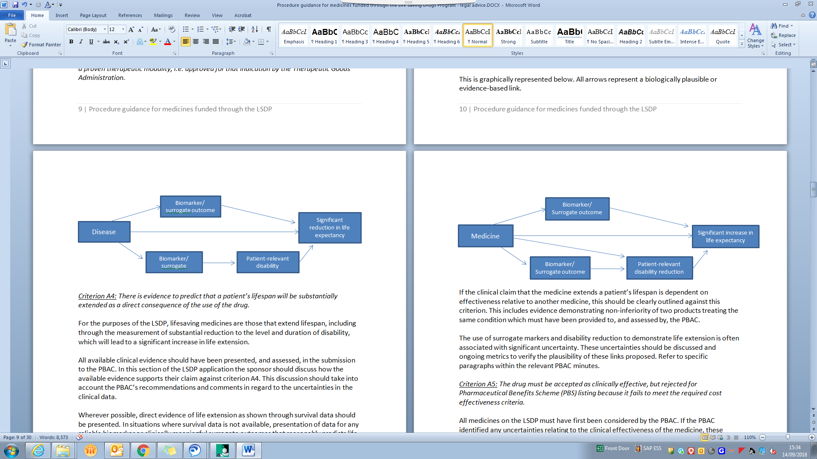

**Criterion A4**: There is evidence to predict that a patient’s lifespan will be substantially extended as a direct consequence of the use of the drug.

For the purposes of the LSDP, lifesaving medicines are those that extend lifespan, including through the measurement of substantial reduction to the level and duration of disability, which will lead to a significant increase in life extension.

All available clinical evidence should have been presented, and assessed, in the submission to the PBAC. In this section of the LSDP application the sponsor should discuss how the available evidence supports their claim against criterion A4. This discussion should take into account the PBAC’s recommendations and comments in regard to the uncertainties in the clinical data.

Wherever possible, direct evidence of life extension as shown through survival data should be presented. In situations where survival data is not available, presentation of data for any reliable biomarker or clinically meaningful surrogate outcomes that reasonably predicts life extension may be necessary. Appendix 5 of the PBAC Guidelines provides guidance on the presentation and justification of proposed surrogate markers (PSMs). While data might not be available to fully explore the suitability of a PSM in the LSDP context, at a minimum the biological plausibility of the outcome as an appropriate surrogate for survival should be addressed.

Where there is no reliable surrogate outcome that directly predicts life extension, the claim that the medicine extends lifespan can be supported through evidence of a reduction in disability that leads to life extension. Where claiming that treatment will result in a substantial reduction to the level and duration of disability, this should be based on patient-relevant outcomes. There should be clear and justifiable links to how the reduction in disability leads to an increase in lifespan.

This is graphically represented below. All arrows represent a biologically plausible or evidence-based link. Due to the limitations in data available, a combination of the below evidence pathways may be required to support the claim that the medicine leads to a significant life-extension.

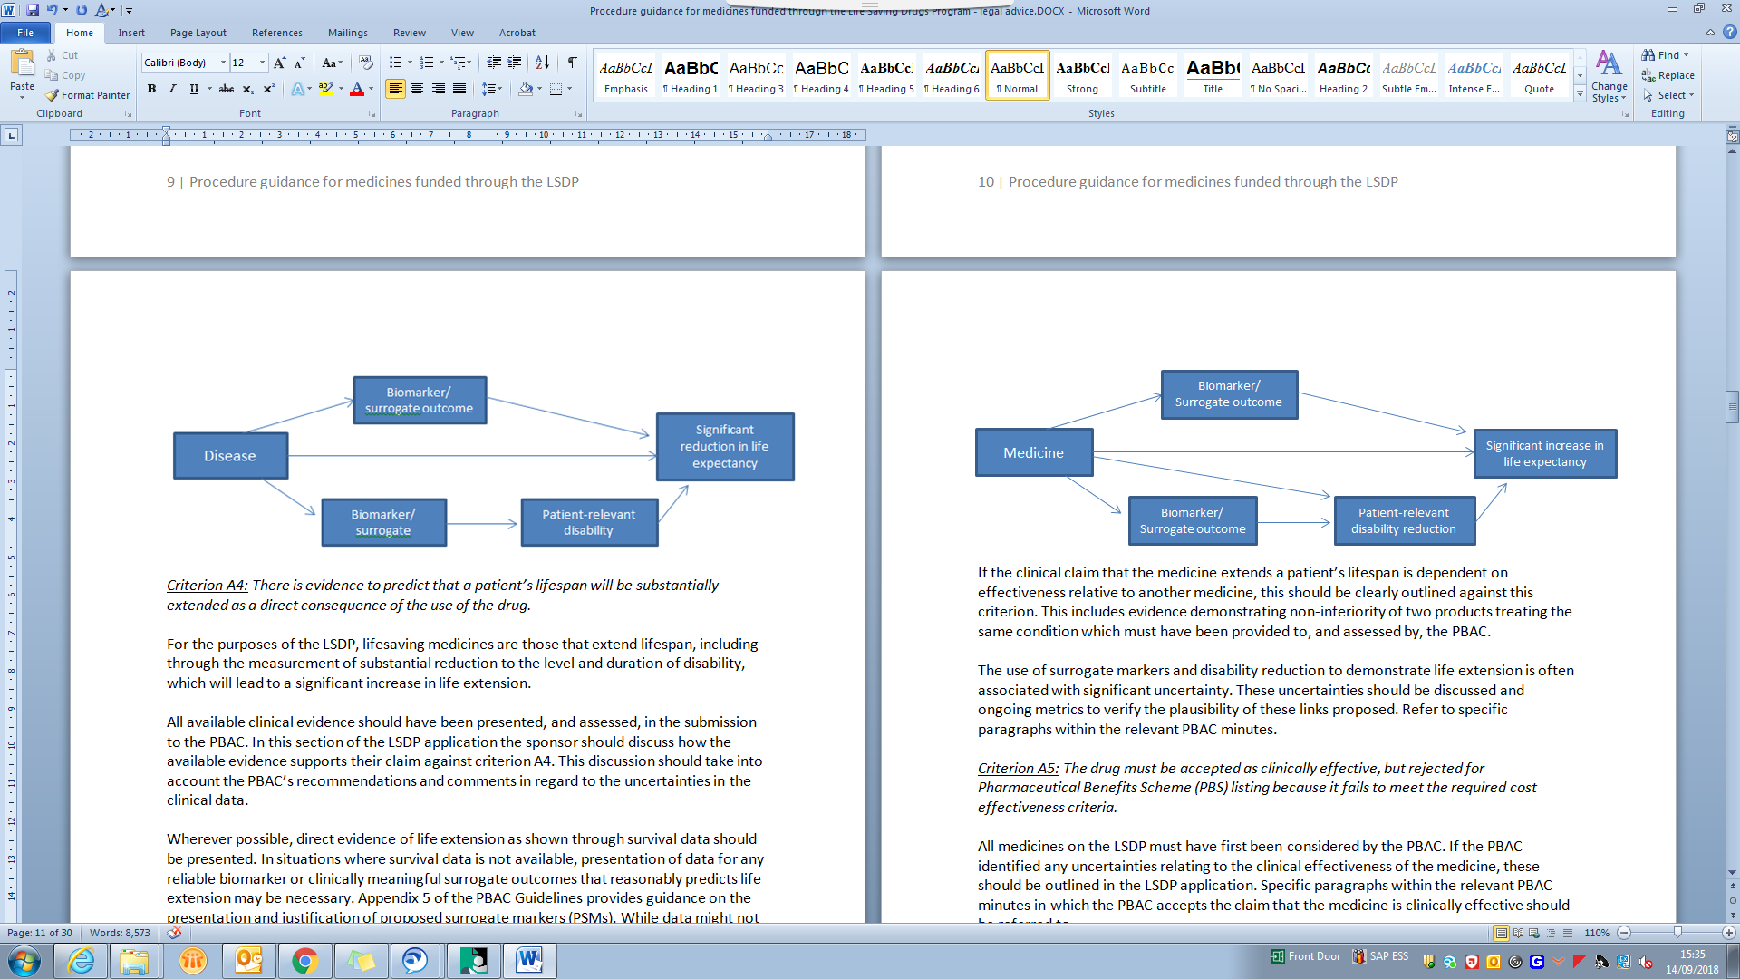

If the clinical claim that the medicine extends a patient’s lifespan is dependent on effectiveness relative to another medicine, this should be clearly outlined against this criterion. This includes evidence demonstrating non-inferiority of two products treating the same condition which must have been provided to, and assessed by, the PBAC.

The use of surrogate markers and disability reduction to demonstrate life extension is often associated with significant uncertainty. These uncertainties should be discussed and ongoing metrics to verify the plausibility of these links proposed. Refer to specific paragraphs within the relevant PBAC minutes.

**Criterion A5**: The drug must be accepted as clinically effective, but rejected for Pharmaceutical Benefits Scheme (PBS) listing because it fails to meet the required cost effectiveness criteria.

All medicines on the LSDP must have first been considered by the PBAC. If the PBAC identified any uncertainties relating to the clinical effectiveness of the medicine, these should be outlined in the LSDP application. Specific paragraphs within the relevant PBAC minutes in which the PBAC accepts the claim that the medicine is clinically effective should be referred to.

**Criterion A6**: There is no alternative drug listed on the PBS or available for public hospital in-patients which can be used as lifesaving treatment for the disease. However, the availability of an alternative drug under the LSDP does not disqualify the proposed drug from consideration for inclusion on the LSDP.

All available alternative drugs should be presented. This may be based on the clinical management algorithm presented in the submission to PBAC.

**Criterion A7**: There is no alternative non-drug therapeutic modality (eg. surgery, radiotherapy) which is recognised by medical authorities as a suitable and cost effective treatment for this condition.

Describe any suitable and cost effective alternative non-drug therapeutic modality which may be available. Therapeutic modalities that may be used to treat diseases could include, but are not limited to, surgery, radiotherapy or standard medical management. All available alternative treatment options should be presented. This may be based on the clinical management algorithm presented in the submission to PBAC.

**Criterion A8**: The cost of the drug, defined as the cost per dose multiplied by the expected number of doses in a one year period for the patient, would constitute an unreasonable financial burden on the patient or his/her guardian.

The cost per patient per year should be provided based on the TGA approved dose and dosing frequency. Where the medicine is dosed by weight, the following apply:

* If the indication is for infants, a price per patient per year based on the treatment of a 10 kg infant.
* If the indication is for children, a price per patient per year based on the treatment of a 35 kg child.
* If the indication is for adults, a price per patient per year based on the treatment of a 70 kg adult.

If the TGA recommended dosage is not considered appropriate, this should be justified.

Where it is known that a disease has a significant impact on average body weight irrespective of treatment, then the sponsor may provide supporting evidence to justify alternative average body weights being used for the purposes of determining the cost per patient per year.

## LSDP application: Pricing issues

Consideration and advice should also be provided, if applicable, on the following criteria relating to the proposed pricing of the new medicine. This information is intended to give some context to the pricing of the medicine, both internationally and in relation to products already subsidised through the LSDP, and to help address uncertainties identified by the sponsor in criteria A1-A8.

The sponsor should also comment here on any issues with medicines presentation, size, dosage and wastage.

**Criterion B1**: The proposed confidential price of the drug compared with the effective price of the drug in comparable overseas markets.

**Criterion B2**: The proposed cost of the drug compared with the cost of comparable drugs, if any, that are already funded through the LSDP.

## Draft Guidelines for treatment through the LSDP

In addition to providing an assessment against the LSDP criteria, the LSDP Expert Panel will provide advice to the CMO regarding the guidelines for use, which includes initiation criteria, continuation criteria, stopping rules and testing requirements. These should be outlined by the sponsor in the application. To expedite the process of making medicines available through the LSDP following Government approval, the sponsor is required to provide draft patient application and reapplication forms with their application.

## Identifying and addressing uncertainties in your application

In order to address any uncertainties identified by the PBAC or in the pre LSDP application meeting, sponsors can provide a proposal to the LSDP Expert Panel for data that could be collected to address these uncertainties at the 24-month review.

This could include (but should not be limited to) uncertainty around:

* Treatment guidelines (including eligibility criteria, dosage amount and frequency)
* Life extension/survival benefit
* Clinical effectiveness in terms of surrogate outcomes
* Medicine safety
* Reliability of diagnostic test
* Extent of use
* Patient relevant outcomes

A proposal for managing uncertainty should include:

* Proposed price of the medicine
* Areas of uncertainty
* Timeframe for evidence collection
* Pre-determined pricing consequences of updated evidence gathered (if required)

In its review of the application, the LSDP Expert Panel will provide advice about sources of uncertainty based on issues identified in the application and the proposals from the sponsor to address, and make recommendations about how these can be addressed through further data collection.

Implementation of these arrangements occurs via deeds of agreement between the Commonwealth and the sponsor.

Where appropriate, the Expert Panel will consider efficacy outcomes that can be collected within a reasonable timeframe and may be linked to the future price of the medicine, particularly where the outcome measure was uncertain on the basis of the clinical trial evidence presented in the application. Patient-level measures of disease stability, or improvement compared to the predicted natural history of the disease, may be measured at baseline and at a pre-determined point in the future, forming the basis of outcome-based risk sharing arrangements between sponsors and the Commonwealth. Performance of a medicine is tracked through data collected by the Department for the purposes of the program.

These data and parameters will be agreed during the course of initial funding negotiations. Section 5 of this Guidance provides further details on LSDP medicine reviews.

# Procedures for implementation

Once a medicine has been considered by the Expert Panel and the CMO, a range of processes are required to implement recommendations. The following process outlines some of the key steps in implementation.

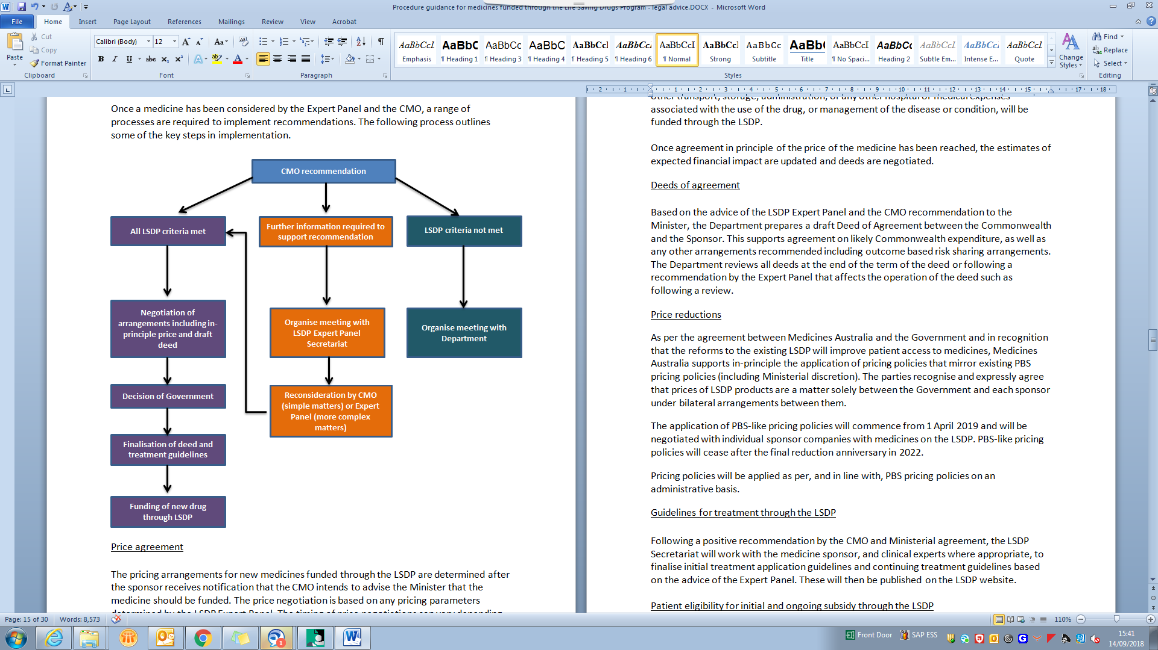

## Price agreement

The pricing arrangements for new medicines funded through the LSDP are determined after the sponsor receives notification that the CMO intends to advise the Minister that the medicine should be funded. The price negotiation is based on any pricing parameters determined by the LSDP Expert Panel. The timing of price negotiations can vary depending on individual circumstances and pricing discussions may take place in parallel to other processes.

Only the cost of the drug will be funded through the LSDP. This may include a factor for importation and transportation of the drug by the manufacturer direct to the place of administration to the patient but this cost must be made transparent in the application. No other transport, storage, administration, or any other hospital or medical expenses associated with the use of the drug, or management of the disease or condition, will be funded through the LSDP.

Once agreement in principle of the price of the medicine has been reached, the estimates of expected financial impact are updated and deeds are negotiated.

## Deeds of agreement

Based on the advice of the LSDP Expert Panel and the CMO recommendation to the Minister, the Department prepares a draft Deed of Agreement between the Commonwealth and the Sponsor. This supports agreement on likely Commonwealth expenditure, as well as any other arrangements recommended including outcome based risk sharing arrangements. The Department reviews all deeds at the end of the term of the deed or following a recommendation by the Expert Panel that affects the operation of the deed such as following a review.

## Price reductions

As per the agreement between Medicines Australia and the Government and in recognition that the reforms to the existing LSDP will improve patient access to medicines, Medicines Australia supports in-principle the application of pricing policies that mirror existing PBS pricing policies (including Ministerial discretion). The parties recognise and expressly agree that prices of LSDP products are a matter solely between the Government and each sponsor under bilateral arrangements between them.

The application of PBS-like pricing policies will commence from 1 April 2019 and will be negotiated with individual sponsor companies with medicines on the LSDP. PBS-like pricing policies will cease after the final reduction anniversary in 2022.

Pricing policies will be applied as per, and in line with, PBS pricing policies on an administrative basis.

## Guidelines for treatment through the LSDP

Following a positive recommendation by the CMO and Ministerial agreement, the LSDP Secretariat will work with the medicine sponsor, and clinical experts where appropriate, to finalise initial treatment application guidelines and continuing treatment guidelines based on the advice of the Expert Panel. These will then be published on the LSDP website.

## Patient eligibility for initial and ongoing subsidy through the LSDP

Following an Australian Government decision to fund a drug, a patient must meet the following conditions to receive subsidised drugs through the LSDP:

1. Satisfy the relevant criteria for treatment with the drug, as detailed in the relevant drug/condition LSDP Guidelines.
2. Participate in the evaluation of effectiveness of the drug by periodic assessment, as directed by the relevant LSDP drug/condition Guidelines, or have an acceptable reason not to participate. This consent does not extend to other uses, including personal research, and all patient data remains confidential.
3. Not be suffering from any other medical condition, including complications or sequelae of the primary condition that might compromise the effectiveness of the drug treatment.
4. Be a permanent Australian resident who qualifies for Medicare.

Patient eligibility will be reviewed in accordance with the frequency set out in the relevant drug/condition LSDP Guidelines, but generally 12 months after commencing therapy and every 12 months thereafter. If deemed appropriate by the Expert Panel, clinicians may be required to submit data more frequently on behalf of their patients.

Continued eligibility will be subject to the assessment of evidence, as outlined in the relevant drug/condition LSDP Guidelines, which demonstrates:

1. clinical improvement in the patient, or
2. stabilisation of the patient’s condition.

The assessment of eligibility will be made with regard to the natural course and stage of the disease, as described in the relevant drug/condition LSDP Guidelines, the context of natural ageing, and any exceptional circumstances that may apply, such as short-term illness or injury.

# Medicines reviews

The Government response to the LSDP Review outlined that from 1 July 2018, medicines listed on the LSDP will be subject to reviews of usage and financial costs after 24 months, and similar reviews will be undertaken on all existing LSDP medicines. These reviews aim to ensure use and performance of the medicine is in line with the recommendations and expectations at the time of listing, and are supported through the Agreement between the Government and Medicines Australia.

Reviews of medicines aim to develop a better understanding of the real-world use of a medicine, review and confirm the clinical benefits achieved through medicine use, ensure the ongoing viability of the program through improving preventable wastage, and ensure testing and access requirements and the price paid for the medicine remain appropriate.

LSDP Medicine Reviews are a systematic way to monitor medicines available through the LSDP. Patient-level data is collected annually for all patients on the LSDP, and similar international evidence may become available over time that contributes to the data on safety, effectiveness, and optimal use of the medicine.

The Medicine Review process provides a mechanism for medicines to be considered in the full and current treatment context, including effectiveness of the medicine, comparative effectiveness between medicines where there is more than one medicine to treat the same condition, safety, utilisation, dosage, program treatment guidelines, testing requirements, surrogate health outcomes, patient relevant health outcomes, and extent of life extension.

An active review of an existing LSDP medicine does not prevent other processes from being undertaken, such as considering new medicines for the same disease or patient access to the medicine whilst it is under review.

The below frameworks outline the usual approaches to LSDP Medicine Reviews and provide approximate time frames. The frameworks are not intended to be prescriptive, as reviews will differ in their complexity and focus. The status of reviews is published online as part of the LSDP Expert Panel agenda.

## 24 month reviews

All new medicines made available on the LSDP are routinely monitored after listing through the eligibility requirements for new and ongoing patients. This data is collected annually by patients’ treating physicians and submitted to the Department.

Where not otherwise specified by the Expert Panel, reviews of new medicines commence 24 months after initial subsidy through the LSDP. The draft scope for the review is established based on issues identified when the medicine was first recommended for inclusion on the LSDP, however the scope of the review may be altered by the Expert Panel if new issues have arisen since listing. The figure below outlines the general process for 24 month reviews. More complex reviews or those requiring expert input may take longer.

The expert panel will identify the uncertainties, outcomes to be reviewed and data collection requirements. The new medicine is then scheduled for a 24 month review.

At the first panel meeting, the scope of the review will be finalised. After 1 week, the sponsor will be notified that a review is going to be undertaken. The meeting agenda will be published to include this 24 month review. The sponsor has 2 weeks to provide any additional data to support the review. Submissions for written stakeholder input will also be accepted from this time.

The report is prepared and sent to sponsors and other relevant parties where appropriate. They have 2 weeks to provide a response. One week later is the second panel meeting where the report will be considered and recommendations made. The sponsor will receive the panel minutes. The deadline for stakeholder input is just prior to this meeting.

The CMO will consider the recommendation and a the review outcomes/summary of proposed changes will be published. The recommendations will then be implemented. 


The scope for 24 month reviews is finalised by the Expert Panel. At this time, the Expert Panel may determine that the review should be delayed in order to optimise timing of the review. Similarly, if the Expert Panel determines that additional expert input is required, the Expert Panel may recommend that the review be conducted over a longer duration to allow for this input to be sought.

Once the scope and timing of the review is agreed by the Expert Panel, the medicine sponsor is notified in writing that the review is being undertaken. At this time, the sponsor of the medicine submits any additional information available, such as published data and reports from international registries to assist in the completion of the review.

The review evaluates data collected from patients accessing medicines on the program as well as any additional data provided by the sponsor. A review report is completed by the Department. The sponsor of the medicine has an opportunity to consider the report and provide a response. The Expert Panel considers the report, the sponsor response, the key clinician representative response and the key patient representative response when making recommendations.

Announcement of 24 month reviews of existing medicines will be published on the LSDP website 8 weeks in advance of the review commencing. Sponsors and stakeholders will have 4 weeks to provide input for consideration by the LSDP Expert Panel as they develop the draft terms of reference.

## Reviews of existing LSDP products

A review may involve a single medicine or a group of medicines that are used to treat a particular disease. Under the revised LSDP arrangements that commenced on 1 July 2018, all medicines available through the LSDP at this time are reviewed according to this framework. In addition, the Expert Panel, CMO or Minister can direct a review to be undertaken under this framework when appropriate. A review takes approximately twelve months from first panel consideration of draft terms of reference to final panel recommendations being made, however more complex reviews may vary from this structure and could take longer.

The terms of reference for each review inform the review protocol that will be followed for the given review, outlining the key issues and guiding the focus and scope of each review. Draft terms of reference are developed by the Department based on the main issues determined by the LSDP Expert Panel, are shared with the sponsor for response and are published to allow for consultation by interested parties. Sponsors and interested parties will be given 4 weeks to respond to the draft terms of reference. Following consultation, the terms of reference are endorsed by the CMO and finalised terms of reference will be reflected on the LSDP website.

Sponsors are invited to provide a submission to the review to support the report and the Expert Panel’s consideration. It is not necessary that the evidence provided for consideration as part of the review is in the same form that was provided when the medicine was first considered for subsidy. In particular, as patient-level data collected routinely for annual eligibility requirements is analysed as part of a review, sponsors are asked to provide information from international registries and publications where available. The Expert Panel provides guidance on data collection, interpretation of results and stakeholder input.

This flow chart outlines that at the first panel meeting for a review, the expert panel will consider the main issues to inform the draft terms of reference. The draft terms of reference will be published at this time for stakeholder comment. Sponsors will be notified of the draft terms of reference and they can provide the panel with any additional data from international databases. The final terms of reference will be endorsed by the CMO and published. 

At the second meeting, the research protocol and final terms of reference will be finalised. A stakeholder meeting will also be held at this meeting, if requested. The evidence evaluation report will be prepared and this will be sent to the sponsor for comment. Prior to the third panel meeting will be the deadline for written stakeholder input to the review.

A third meeting, an update can be provided on the progress of the report. At the fourth panel meeting, the draft review report will be considered. The sponsor will receive the draft report as will select stakeholders for comment. They will prepare their responses to be considered at the fifth panel meeting. 

At the fifth panel meeting, the panel will consider the final report and make its recommendations. The sponsor will receive the panel minutes. The CMO will consider the recommendations and seek Ministerial approval. The review outcomes and public summary document will be published and the recommendations will be implemented.


Stakeholders are able to provide written submissions to inform the reviews. Due to the small number of patients receiving treatment through the LSDP, stakeholder input is kept confidential, if requested. A stakeholder forum will be held to inform the review. This is usually held on the day of the scheduled Expert Panel meeting, after the terms of reference have been endorsed by the CMO. Forums are based on discussion questions that have been developed in consultation with the Expert Panel.

Where the Expert Panel considers that specific advice on clinical and other issues is beneficial to the review, advice on these issues is sought from appropriate local and/or international experts in the field who have experience and expertise in the management of the specific rare disease including use of the medicine(s) under review. This may include advice on place in therapy, implications of data gathered and other issues raised by the sponsor or stakeholders. This specific advice is usually presented at a meeting of the Expert Panel, or provided to the Expert Panel separately if attendance at panel meetings is not possible. All experts will declare any conflicts of interest prior to presenting to the Expert Panel. Deeds of confidentiality may be required in some instances, dependent upon the nature of information shared with the expert/s. Sponsors may provide recommendations of suitable local and international experts.

Reviews consider the most recent, relevant evidence available regarding the safety, efficacy, effectiveness and utilisation of the medicine being considered, as guided by the terms of reference. Wherever possible, patient relevant outcomes are analysed. This information could be sought from a range of sources including literature reviews and patient/clinician surveys to support registry data. The format of such surveys will be guided by evidence based principles. Utilisation analyses may include persistence on treatment, interval between doses, treatment breaks, administration-related side effects, and dosage. An evidence evaluation report will be completed based on the evidence available. The draft evidence evaluation report will be sent to sponsors to enable any misinterpretation or omission of data or other errors of fact to be corrected ahead of the Expert Panel consideration of this report.

The evidence evaluation report informs the Expert Panel’s review report, and can include a summary of stakeholder input, methods of data collection and analysis, results and discussion. The Expert Panel may consider and provide advice on the report at different points in the review process. Sponsors have the opportunity to consider the Expert Panel’s draft report and provide a response. The Expert Panel considers the sponsor’s response, the key clinician representative response and the key patient representative response to the draft report when making recommendations.

## Review recommendations[1]

Recommendations may include, but are not limited to:

* take no action
* change eligibility criteria or LSDP treatment guidelines
* measures to improve cost-effectiveness, including pay-for-performance or other risk sharing arrangements
* changes to ongoing data collection requirements
* education for health professionals or consumers
* future review
* referral to PBAC for consideration for PBS listing

Sponsors of the medicine/s involved in the review are provided with the Expert Panel advice and recommendations.

Advice from the Expert Panel, along with the final report and sponsor comments, is provided to the CMO. Recommendations and options for implementation are provided by the CMO to the Minister for consideration.

The LSDP Secretariat in the Department of Health is responsible for the management of reviews. This includes providing secretariat support for the Expert Panel, sourcing and managing contracts for health technology assessments completed by external parties, organising stakeholder forums, and drafting and editing review reports and maintaining data and patient confidentiality.

# Confidentiality and transparency

The Australian Government is conscious of the need to be as open as possible and provide as much information as possible in relation to making medicines available through the LSDP. The constraints on providing all information associated with applications to list a new medicine on the LSDP and reviews of LSDP medicines arise generally from considerations of privacy and commercial sensitivity.

Specific provisions dealing with the confidentiality of information are provided for in contracts between contractors providing services and the government, and deeds of agreement between pharmaceutical companies and the government.

## LSDP Expert Panel

All members of the LSDP Expert Panel are required to sign a Deed of Confidentiality when appointed. The deed includes text about not disclosing information provided in agenda papers to a third party. Panel members are advised of the requirements to securely handle and dispose of confidential material appropriately, whether electronic or printed.

## Expert Panel meetings

Where other parties attend meetings of the LSDP Expert Panel and are not currently Australian Government employees, they will have access to submission material (LSDP application documents, PBAC submission documents, submissions from public) only after they sign a Deed of Confidentiality that includes text about not disclosing any information provided in the agenda papers to a third party. All attendees at meetings are required to dispose of any electronic and paper material appropriately.

## LSDP Medicine Reviews

For the purposes of medicines review, external evaluators will receive electronic copies of documents that are being evaluated. The conditions of storage, management and disposal of submission material (PBAC submission documents, LSDP applications, submissions from the public) are explicitly stated in the Department’s contracts with those evaluators. Signed deeds of confidentiality are required by all people undertaking evaluations or other work for the LSDP. Contracted evaluators must agree not to disclose information provided in the submission to a third party and to maintain confidentiality in regard to the content of submissions. Contracted evaluators must also agree to return and/or destroy any information provided for the purposes of the reviews. The information provided is for the purposes of medicines reviews only, and may not be published in any format or used for other research purposes by the evaluators.

Due to the small number of patients accessing medicines on the LSDP, reporting outcomes of medicine reviews will ensure that individual patients remain de-identified.

## Conflict of Interest

In relation to the Expert Panel:

A conflict of interest occurs when there is an actual conflict between the Expert Panel duties and personal interests of a member that improperly influences the member in the performance of his or her duties.

An apparent conflict of interest occurs when it appears that a member’s personal interests could improperly influence the performance of his or her duties, regardless of whether or not there is an actual conflict.

Appropriate management of conflicts of interest protects the member and the Expert Panel from unfair or improper allegations of conflict of interest. All members must declare both pecuniary interests and non-pecuniary interests.

* Pecuniary interests may be direct or indirect involving the member or their immediate family and may include, but is not limited to:
  + Current shareholdings which the member controls, irrespective of whether their name is on the share register;
  + Current shareholdings through an unlisted managed fund or trust, if the fund or trust has investments in only a few companies and/or the member could significantly influence investment decisions;
  + Board memberships or other offices;
  + Paid employment or contracting work, including personal involvement in the design and analysis of a major trial of a drug;
  + Grants for overseas travel or conference expenses; or
  + Significant hospitality.
* Professional interests include situations where the member or their immediate family have a professional interest in companies or organisations involved or associated with the development, manufacture or marketing of products.
* Non-pecuniary interests include any personal interests which may conflict or give the appearance of being in conflict with the member’s obligations as an Expert Panel member. This may include, but is not limited to:
  + Where a member or his/her immediate family is aware that a person close to them suffers from a condition for which a product under consideration may be prescribed; or
  + Where a member or his/her immediate family has strong personal or religious beliefs about a product or treatment under consideration by the Expert Panel.

All non-member attendees at the meetings of the Expert Panel, including clinicians and patient groups who give presentations to the Expert Panel, must also sign a conflict of interest declaration, a confidentiality agreement and must disclose any relevant interests to the Chair prior to the meeting.

## Transparency

A list of agenda items that will be considered at a given meeting of the LSDP Expert Panel is published on the [LSDP website](http://www.health.gov.au/LSDP). This includes new medicines, 24 month reviews, and reviews of existing medicines. Deadlines for sponsor and stakeholder input will be published in advance on the LSDP website.

Once the LSDP Expert Panel has considered a new medicine for inclusion in the LSDP and the CMO has made a recommendation, this information is published on the [LSDP website](http://www.health.gov.au/LSDP). Sufficient information will be available to enable consumers and health professionals to understand the basis for the decision and will not include confidential information.

Outcomes of reviews and a summary of proposed changes are published on the [LSDP website](http://www.health.gov.au/LSDP) following CMO consideration of 24 month reviews.

In reviewing LSDP products, draft and final terms of reference are published on the [LSDP website](http://www.health.gov.au/LSDP) to allow for submissions to be received from consumers, health professionals and professional organisations. Review outcomes and a summary of proposed changes are published following CMO consideration. No confidential information will be published.

# Key contacts

Email the LSDP Expert Panel Secretariat at LSDPEP@health.gov.au for matter relating to:

* Organising a pre-application meeting with the Secretariat
* New medicines seeking listing on the LSDP
* Reviews of medicines
* To provide input into items on the Expert Panel agenda
* To discuss recommendations of the Expert Panel

Email the LSDP team at [LSDP@health.gov.au](mailto:LSDP@health.gov.au) for matters relating to:

* Medicine ordering
* Invoice payment
* Patient applications and reapplications
* Pharmacy dispensing records
* Day to day patient management

# Attachment A – Template for new medicine applications

This template should be used in conjunction with Section 3 of the Procedure guidance for medicines funded through the Life Saving Drugs Program.

[All information in italics to be completed by applicant]

## MEDICINE NAME TRADE NAME SPONSOR

1. Medicine & applicant details

|  |  |
| --- | --- |
| Name of drug |  |
| Form and strength |  |
| Manner of admin |  |
| ARTG Product name and ID for each form and strength |  |
|  |
|  |
|  |
| Company name |  |
| Responsible person |  |

1. Current clinical situation

### Condition

Outline the condition that will be treated by the new medicine. This is in line with Section 1.1.2 of the PBAC submission.

### Current clinical situation

Briefly outline how patients with the condition are currently managed and the expected impact of the proposed medicine, including the clinical need for the therapy. This is in line with Sections 1.1.1 and 1.2.1 of the PBAC submission.

### Proposed population and treatment guidelines

Provide a brief description of the proposed population that will be treated with the medicine on the LSDP. This should include the intended specific patient population as outlined in Section 1.4 of the PBAC submission and updated to incorporate PBAC advice on the most appropriate population to be treated, where appropriate. This includes an outline of eligibility criteria for commencing, continuing, and stopping treatment as reflected in the draft patient application forms attached to this application.

## Background of drug

### PBAC consideration

List dates of PBAC considerations of this medicine for all indications and briefly outline the PBAC recommendations and reasons at each consideration. This is outlined in Section 1.1.4 of the PBAC submission, with any references to PBAC recommendations directly referencing the relevant paragraph of PBAC minutes.

### Consumer input

As per PBAC minutes (usually paragraph 6.2), briefly describe the number and type of consumer comments that the medicine received.

### Other information

Any relevant background including relevant regulatory history and reimbursement arrangements of the medicine in other comparable jurisdictions should be provided.

While medicines seeking funding through the LSDP have been considered by the PBAC as not cost effective for PBS listing, the value for money of funding the medicine remains an important consideration for Government. The value proposition of the medicine for Government funding can be included in this section.

1. Funding criteria

#### Criterion A1.

There is a rare but clinically definable disease for which the drug is regarded as a proven therapeutic modality, i.e. approved for that indication by the Therapeutic Goods Administration.

#### Criterion A2.

The disease is identifiable with reasonable diagnostic precision.

#### Criterion A3.

Epidemiological and other studies provide evidence that the disease causes a significant reduction in age-specific life expectancy for those suffering from the disease.

#### Criterion A4.

There is evidence to predict that a patient’s lifespan will be substantially extended as a direct consequence of the use of the drug.

Criterion A5. The drug must be accepted as clinically effective, but rejected for Pharmaceutical Benefits Scheme (PBS) listing because it fails to meet the required cost effectiveness criteria.

#### Criterion A6.

There is no alternative drug listed on the PBS or available for public hospital in-patients, which can be used as lifesaving treatment for the disease. However, the availability of an alternative drug under the LSDP does not disqualify the proposed drug from consideration for the LSDP.

#### Criterion A7.

There is no alternative non-drug therapeutic modality (eg. surgery, radiotherapy) which is recognised by medical authorities as a suitable and cost effective treatment for this condition.

#### Criterion A8.

The cost of the drug, defined as the cost per dose multiplied by the expected number of doses in a one year period for the patient, would constitute an unreasonable financial burden on the patient or his/her guardian.

|  |  |  |  |  |  |
| --- | --- | --- | --- | --- | --- |
| Drug name | Patient type (Adult/ Child) | TGA approved dose and frequency | Number of vials / tablets per dose | Cost per dose ($AUD) | Price per patient per year ($AUD) |
|  |  |  |  |  |  |
|  |  |  |  |  |  |
|  |  |  |  |  |  |

**Criterion B1**. The proposed confidential price of the drug compared with the effective price of the drug in comparable overseas markets.

|  |  |  |  |  |  |  |  |
| --- | --- | --- | --- | --- | --- | --- | --- |
| Country | Form and Strength | MoA | Currency | Exchange Rate used | Price per vial / tablet (ex GST) in $AUD | Number of  vial / tablets per pack | Price per pack (ex GST) in $AUD |
| Australia |  |  |  |  |  |  |  |
|  |  |  |  |  |  |  |  |
|  |  |  |  |  |  |  |  |
|  |  |  |  |  |  |  |  |
|  |  |  |  |  |  |  |  |
|  |  |  |  |  |  |  |  |
|  |  |  |  |  |  |  |  |
|  |  |  |  |  |  |  |  |
|  |  |  |  |  |  |  |  |
|  |  |  |  |  |  |  |  |

**Criterion B2**. The proposed cost of the drug compared with the cost of comparable drugs, if any, that are already funded through the LSDP.

|  |  |  |  |  |  |
| --- | --- | --- | --- | --- | --- |
| Name of current LSDP drug/s | MoA | Form and Strength | Price per vial / tablet (ex GST) | Number of vials / tablets per pack | Price per pack (ex GST) in $AUD |
|  |  |  |  |  |  |
|  |  |  |  |  |  |
|  |  |  |  |  |  |

1. Estimated extent of use and financial implications

Provide an update of the estimates spreadsheet submitted with the PBAC submission. This should be updated following any advice from the PBAC about the population treated. An estimate of the cost for importation and transportation of the drug by the manufacturer direct to the place of administration to the patient should be given as the proportion of the drug cost and made transparent in the financial impact of funding.

1. Managing uncertainties

For any areas of uncertainty identified in Section 4 that limit the reliability of the claims against the LSDP criteria, provide a proposal for data that could be collected to address these uncertainties at the 24 month review (and beyond).

This could include (but should not be limited to) uncertainty around:

* Treatment guidelines (including eligibility criteria, dosage amount and frequency)
* Life extension/survival benefit
* Clinical effectiveness in terms of surrogate outcomes
* Medicine safety
* Reliability of diagnostic test
* Extent of use

A proposal for managing uncertainty should include:

* Appropriate initial price
* Areas of uncertainty
* Timeframe for evidence collection
* Pre-determined pricing consequences of updated evidence gathered

1. Additional information

Provide any additional information for Expert Panel consideration that has not been captured in the PBAC submission or above.

1. Attachments to application
2. Vendor form
3. Draft patient initial application form
4. Draft patient reapplication form
5. Covering letter with declaration that all information is correct
6. LSDP cost of goods form

Forward this application by email to [LSDPEP@health.gov.au](Mailto:LSDPEP@health.gov.au). If file size is greater than 30MB, the application can be posted to the Department via USB storage device.

1. Process for implementation of review recommendations continues to be developed in consultation with the Expert Panel and stakeholders