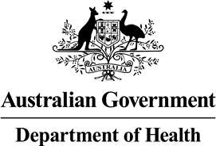

Nurse Practitioner 10 Year Plan Steering Committee Meeting Communique 31 August 2021

The first meeting of the Nurse Practitioner Steering Committee (NPSC) was held on 31 August 2021. The NPSC has been established to facilitate collaboration between

government and non-government stakeholders on development of the Nurse Practitioner 10 Year Plan (NP 10 Year Plan), and consists of members representing nursing, medical, consumer and Aboriginal and Torres Strait Islander health organisations.

The NP 10 Year Plan will describe a set of actions that can be taken to address nurse practitioner workforce issues of national significance to enhance the delivery of nursing care to the Australian community. The NP 10 Year Plan will have 1- 3, 5 and 10 year goals.

Development of the NP 10 Year Plan will occur concurrently with development of the National Nursing Strategy, due to the critical role nurse practitioners play in broader nursing career pathways and health care outcomes for patients.

The NPSC meeting focussed on gaining members' feedback on some of the baseline documentation that will inform the process to develop the NP 10 Year Plan, including the Project Management Plan and Stakeholder Engagement and Communication Plan. The Committee also noted other current projects which will have an impact on the NP 10 Year Plan, including the review of Collaborative Arrangements.

Extensive consultation will inform the development of the NP 10 Year Plan. Public consultation will be conducted via the Department’s consultation hub.