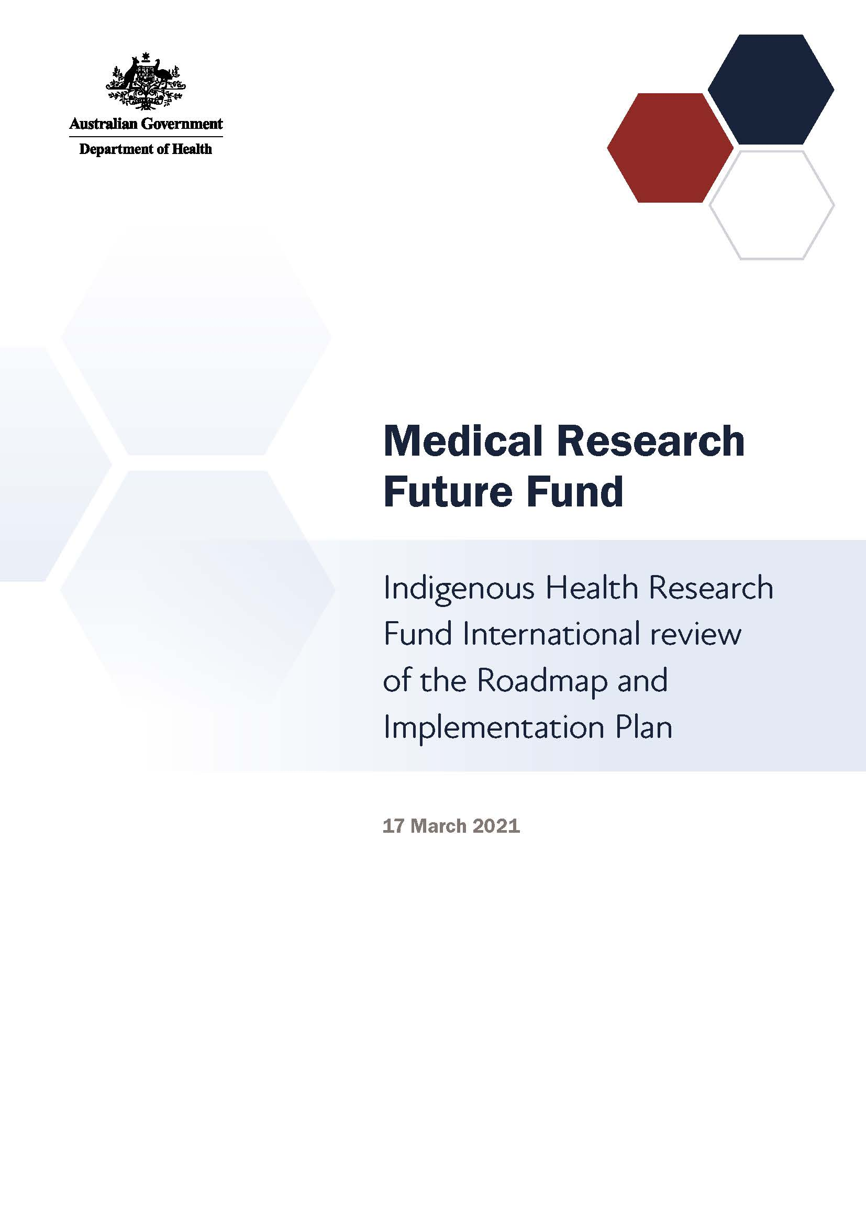

# Introduction

The Medical Research Future Fund (MRFF) is a $20 billion long-term investment supporting Australian health and medical research. The MRFF aims to transform health and medical research and innovation to improve lives, build the economy and contribute to health system sustainability.

The Indigenous Health Research Fund will provide $160 million over 10 years under the MRFF to improve the health of Aboriginal and/or Torres Strait Islander people. The Indigenous Health Research Fund will mobilise health and medical research for the prevention of disease and promotion of health and social equity. Through cohesive research led by Aboriginal and/or Torres Strait Islander people that is designed to deliver community benefit, the Indigenous Health Research Fund seeks to inform and transform the way the health system responds to the needs of Aboriginal and/or Torres Strait Islander people across the life course.

## Indigenous Health Research Fund Expert Advisory Panel

An Indigenous Health Research Fund Expert Advisory Panel, comprising prominent Aboriginal and/or Torres Strait Islander research experts and community leaders, was established to advise the Australian Minister for Health and Aged Care on the strategic priorities for research investment through the Indigenous Health Research Fund. It is the first national research fund led by Aboriginal and/or Torres Strait Islander people, and conducted through close engagement with Aboriginal and/or Torres Strait Islander people and communities.

The Indigenous Health Research Fund Expert Advisory Panel’s role is to define evidence and knowledge gaps that should be addressed through research funding, to help transform health care and health outcomes for individuals and communities. This role includes defining key research questions that — if answered — will deliver meaningful change to patients through the translation of research.

The Indigenous Health Research Fund Expert Advisory Panel developed a Roadmap and Implementation Plan to advise about priorities for research investment through the Indigenous Health Research Fund.

**Our goal**

To improve the health of Aboriginal and/or Torres Strait Islander people through:

* Indigenous-led research practice and governance
* knowledge translation
* evidence-based change in Aboriginal and/or Torres Strait Islander health practice

The Roadmap includes:

* the Indigenous Health Research Fund goals
* possible themes and priorities for investment

The Implementation Plan includes:

* 4 aims that outline how the Indigenous Health Research Fund will benefit Aboriginal and/or Torres Strait Islander health
* priorities for investment in the short, medium and long term
* opportunities for leveraging additional investment
* activities needed to support the Indigenous Health Research Fund outcomes and facilitate their implementation.

Indigenous Health Research Fund Expert Advisory Panel members will consult and engage with community, other researchers, industry, and consumer and patient groups, and participate in media and public activities to build awareness of, and facilitate interaction with, the Indigenous Health Research Fund and with other MRFF-funded research.

# Indigenous Health Research Fund International Review Panel

The Indigenous Health Research Fund International Review Panel’s (the Panel’s) role was to provide expert feedback and experiential advice in the context of relevant activities occurring internationally, which can inform the strategic direction of the Indigenous Health Research Fund Roadmap and Implementation Plan.

The Panel members were asked to:

1. Advise on the applicability of the Indigenous Health Research Fund goals to the international context, specifically whether the goals duplicate or contribute to international research activities
2. Advise on the likely efficacy of the research priorities (including their sequencing) to achieve the goals
3. Provide learnings from relevant international research activities in the field
4. Identify opportunities for leveraging and complementing relevant international research activities to achieve the goals
5. Advise on the appropriateness of the proposed measures for evaluating progress towards meeting the goals.

The Panel comprised 6 members representing expertise in a variety of clinical and scientific research areas:

* Dr Amohia Boulton, Research Director at Whakauae Research for Māori Health & Development, Whanganui, a partner organisation of Ngā Pae o te Māramatanga/New Zealand’s Māori Centre of Research Excellence (CoRE), University of Auckland, New Zealand
* Professor Malcolm King, Professor Community Health and Epidemiology; Scientific Director of the Saskatchewan Centre for Patient-Oriented Research, University of Saskatchewan, Canada
* Distinguished Professor Spero Manson, Distinguished Professor and Director, Centers for American Indian and Alaska Native Health, Colorado School of Public Health, University of Colorado, USA
* Professor Linda Waimarie Nikora, Co-director of Ngā Pae o te Māramatanga; Professor of Indigenous Studies at Te Wānanga o Waipapa, University of Auckland, New Zealand
* Professor Papaarangi Mary-Jane Reid, Head of Department of Māori Health at the Faculty of Medical and Health Sciences, University of Auckland, New Zealand
* Professor Donald Warne, Associate Dean, Director, Indians into Medicine; Professor, Family & Community Medicine; Director, Public Health Program, Population Health, University of North Dakota, USA

# Consultation discussion

The Panel met on Wednesday 17 March 2021 to discuss the Indigenous Health Research Fund Roadmap and Implementation Plan.

All participants at the meeting were required to declare any conflicts of interest and relevant collaborations. None of the declared interests were considered material to the meeting.

**Key points**

* The Panel was enthusiastic about the Indigenous Health Research Fund, and supported the Roadmap and Implementation Plan
* A whole-of-system approach is needed to improve Aboriginal and/or Torres Strait Islander health; the burden cannot be shouldered by the Aboriginal and/or Torres Strait Islander research community alone
* The funding provided under the MRFF Indigenous Health Research Fund is low considering the high burden of ill health in Aboriginal and/or Torres Strait Islander people
* The Aboriginal and/or Torres Strait Islander culture is centred on Country, land and spirituality; these should be considered in the Roadmap and Implementation Plan
* A capacity development plan should be included as part of the Indigenous Health Research Fund to recruit, engage, upskill and support Aboriginal and/or Torres Strait Islander researchers at all stages of their careers
* Aboriginal and/or Torres Strait Islander researchers require autonomy to govern their own research
* The Panel noted that success metrics should be developed alongside community needs
* A revamped peer review process that is more supportive than the traditional approach could help support and build Aboriginal and/or Torres Strait Islander researcher capacity

The Panel was very supportive of the Indigenous Health Research Fund and its accompanying Roadmap and Implementation Plan. The Panel members particularly appreciated the lifelong health initiative approach, and that the Implementation Plan addressed root causes and social causes of health inequities. The Panel believed the framework was overall the right approach to improving Aboriginal and/or Torres Strait Islander health. However, some caveats were noted, as discussed below.

The Panel noted that the challenges facing Aboriginal and/or Torres Strait Islander health and research in Australia resonate with Indigenous people all over the world, including the United States, Canada and New Zealand.

## Ensure a whole-of-system approach to Aboriginal and/ or Torres Strait Islander health

The Panel noted that, for Aboriginal and/or Torres Strait Islander health to improve, a whole-of-system approach is needed. Approaches to best address the health issues of, and to foster leadership in, Aboriginal and/or Torres Strait Islander communities must be embedded in other MRFF initiative grant opportunities, not just isolated to the Indigenous Health Research Fund. Panel members noted that, in other countries, health research proposals must consider how the research will benefit minority groups and Indigenous peoples.

The Panel noted that improving Aboriginal and/or Torres Strait Islander health is not a burden that can be borne by Aboriginal and/or Torres Strait Islander researchers alone.

## Consider Country, land and spirituality

The Panel noted the somewhat ‘generic’ feel of the Roadmap and Implementation Plan, and felt there was room to make these documents bolder, to better reflect the Aboriginal and/or Torres Strait Islander culture and world view. Country, land and spirituality are major contributors to health for many Indigenous people around the world, including Aboriginal and/or Torres Strait Islander people. Land, and having a place to stand and belong, are fundamental to a healthy start to life and for ongoing life. The panel noted that these considerations were reflected in Priority area 4.4 ‘Strengthening culture as a determinant of health’, but that they must be incorporated more specifically throughout the Roadmap and Implementation Plan.

## Build capacity at all levels

Building capacity was a major area of concern for the Panel. The Panel members strongly felt that a capacity development plan should be included as part of the Indigenous Health Research Fund to recruit, engage, train and support Aboriginal and/or Torres Strait Islander researchers at every career stage.

The Panel also noted that any capacity building must plan for the long term, to avoid burnout in a few individuals. It was noted that while the MRFF does not provide ‘direct’ capacity building support, there are ‘indirect’ ways this can be achieved through clearly articulated objectives and outcomes for grant opportunities and assessment criteria. These can be reflected in the Implementation Plan.

Also see Reconsider the peer review process.

## Provide autonomy for Aboriginal and/or Torres Strait Islander people

The Panel strongly felt that Aboriginal and/or Torres Strait Islander researchers require autonomy to govern their own research. The Panel noted that there is currently a lot of pressure on Aboriginal and/or Torres Strait Islander researchers to achieve research goals that are often broad and undefined. They also noted that a funding mechanism cannot simply identify research goals without providing researchers the power to achieve these goals.

Also see Identify measures of success.

The Panel suggested that autonomy for Aboriginal and/or Torres Strait Islander researchers be embedded in all layers of research.

## Identify measures of success

The Panel noted that the pathway to success requires a link between researchers and community. Often, funding bodies and research institutions define what successful research is, which does not necessarily align with what the community considers to be successful. Success needs to be timely and make a difference to people.

Long-term success metrics are important to identify, and must be formulated in such a way to show the impact of the research on the Aboriginal and/or Torres Strait Islander community. The Panel suggested forming positive and strength-based metrics — for example, rather than ‘decreased rates of suicide’, use ‘increased rates of people who are thriving and healthy’ as a metric.

## Reconsider the peer review process

The Panel noted that, historically, Aboriginal and/or Torres Strait Islander–led research can be overlooked and queried by the mainstream peer review process.

The Panel noted that a more supportive peer review process that was centred on conversations, rather than a ‘yes/no’ approach, would benefit Aboriginal and/or Torres Strait Islander research. In other countries, such as in Canada, and in New Zealand with the Healthier Lives National Science Challenge, Indigenous research-focused panels have a more iterative peer review process, where research groups have an opportunity to address queries about projects raised by the review panel and re-submit an application for consideration.

## Consider data ownership and acquisition

The Panel noted that data acquisition and data ownership, particularly around genomics data, should be considered early in the Indigenous Health Research Fund’s rollout. Commercialisation opportunities are often progressed without any added value or benefit to the people who contributed those data, and this is especially true for data from Aboriginal and/or Torres Strait Islander people.

# Recommendations

* Incorporate Country, land and spirituality into the Indigenous Health Research Fund Roadmap and Implementation Plan
* Support autonomy for Aboriginal and/or Torres Strait Islander researchers at all levels of research
* Develop a strong, well-funded, capacity-building plan for Aboriginal and/or Torres Strait Islander researchers that considers the short and long term. This capacity should also be incorporated into the other MRFF initiatives
* Be ‘bold and brave’ — the burden of improving Aboriginal and/or Torres Strait Islander health cannot be borne by Aboriginal and/or Torres Strait Islander researchers alone. Improving Aboriginal and/or Torres Strait Islander health requires a whole-of-system approach. Aboriginal and/or Torres Strait Islander researchers need the opportunity to enter and influence ‘mainstream’ research