Evaluation of the Early Psychosis Youth Services Program

Final Report

26 August 2020

# Acknowledgement

The Evaluation Team would like to acknowledge and thank everyone who contributed their time, information and data for the purposes of the Evaluation of the Early Psychosis Youth Services (EPYS) Program (‘the Evaluation’). In particular, the headspace Early Psychosis services, headspace National, lead agencies, Orygen and the Primary Health Networks (PHNs).

The Evaluation Team would like to acknowledge the oversight and expert advice provided by the Evaluation Reference Group throughout the Evaluation.

The Evaluation Team also acknowledges the:

* Western Australia (WA) Health data custodians and the WA Health Data Linkage Branch for the provision and linkage of hospital, emergency department and death data used in the ecological analysis.
* New South Wales (NSW) Ministry of Health and the Centre for Health Record Linkage for the provision and linkage of hospital, emergency department, ambulatory mental health and death data used in the ecological analysis.

The time and effort outlaid by all was highly valued and contributed greatly to the quality of the Evaluation.

# The structure of this report

This report consists of three overarching components – an executive summary, the report body and appendices:

1. The executive summary provides a summary overview of the Evaluation. This includes a succinct description of the findings by primary evaluation question, a discussion of the key findings across the Evaluation and a summary of the opportunities for the EPYS Program.
2. The report body provides the detail of the Evaluation. Including relevant policy and background information on the EPYS Program, the evaluation methodology, summary and detailed findings by evaluation question, a discussion of the key findings and opportunities for the program.
3. The appendices (provided in the document titled *Final Report Appendices*) contain further detail to support the content in this report. This includes further detail on the methodologies and findings for the Evaluation.

# Table of contents

Acknowledgement 2

The structure of this report 2

Table of contents 3

List of acronyms 5

1. Executive summary 7

1.1 Overview and background to the Evaluation 7

1.2 Evaluation findings 8

1.3 Discussion of the findings of the Evaluation 13

1.4 Opportunities 15

1.5 Conclusion 16

2. Introduction 17

2.1 Australia’s mental health system 17

2.2 An overview of Early Psychosis and Ultra High Risk 20

2.3 The Early Psychosis Prevention and Intervention Centre (EPPIC) model 21

2.4 The Early Psychosis Youth Services Program 22

2.5 Previous evaluations of the EPYS Program 29

2.6 Policy context and background 30

3. Evaluation process 34

3.1 Purpose and objectives of the Evaluation 34

3.2 Scope of the Evaluation 34

3.3 Evaluation questions 35

3.4 Overview of the design of the Evaluation 36

3.5 Overview of the of evaluation methods 36

3.6 Timeline of evaluation activities 45

3.7 The Evaluation Reference Group 47

4. Summary of evaluation findings 48

4.1 Summary key findings for Evaluation Question 1: Effectiveness of the implementation of the EPYS Program 48

4.2 Summary key findings for Evaluation Question 2: Appropriateness of the EPYS Program design to deliver outcomes 55

4.3 Summary key findings for Evaluation Question 3: Effectiveness of the EPYS Program in achieving outcomes 57

4.4 Summary key findings for Evaluation Question 4: The efficiency and cost effectiveness of the EPYS Program 63

4.5 Summary key findings for Evaluation Question 5: Implications of a wider implementation of the EPYS model 67

5. Evaluation Question 1: Effectiveness of the implementation of the EPYS Program 70

5.1 How has policy shaped the implementation of the EPYS Program? 70

5.2 To what extent has the EPYS Program been implemented as intended? 81

5.3 To what extent did the EPYS Program reach the target population? 116

5.4 How successfully was the EPYS Program integrated with the local health and other service systems? 130

6. Evaluation Question 2: Appropriateness of the EPYS Program design to deliver outcomes 142

6.1 To what extent is program design acceptable and relevant to clients and their families 142

6.2 To what extent does the program design align with the policy and practice of the broader system of care for young people experiencing Early Psychosis or other severe mental illness 146

7. Evaluation Question 3: Effectiveness of the EPYS Program in achieving outcomes 150

7.1 How effective is the EPYS Program in reducing the duration of untreated psychosis? 150

7.2 How effective is the EPYS Program in reducing the severity of symptoms for young people with or at risk of Early Psychosis? 156

7.3 How effective is the EPYS Program for young people with or at risk of Early Psychosis in reducing risk behaviours? 159

7.4 How effective is the EPYS Program in reducing the impact of young people with or at risk of Early Psychosis, on health service utilisation? 166

7.5 How effective is the EPYS Program in reducing or delaying the transition to full threshold psychosis? 183

7.6 How effective is the EPYS Program in restoring the functional trajectory of young people with or at risk of Early Psychosis? 184

7.7 How effective is the EPYS Program in improving the capacity of families to support and maintain relationships with young people with Early Psychosis? 190

7.8 How satisfied are clients and their families with the EPYS Program (explored through elements of perception, experience, expectation, baseline need)? 193

8. Evaluation Question 4: How efficient and cost-effective is the EPYS Program? 196

8.1 Introduction 196

8.2 How efficiently have EPYS Program resources been used? 198

8.3 How cost-effective is the EPYS Program compared with usual care? 230

8.4 Is there a minimum target population size required for cost-effective delivery of the EPYS Program? 242

9. Evaluation Question 5: What are the implications for the program inputs arising from a wider implementation of the EPYS model? 244

9.1 What would be the cost and service implications of a wider rollout of the EPYS model across Australia 244

9.2 What economies of scale could be achieved through a wider rollout of the EPYS model? 253

10. Discussion of the evaluation findings 257

11. Opportunities for EPYS Program improvement and conclusion 267

11.1 Priority opportunities for the EPYS Program 267

11.2 Secondary opportunities for the EPYS Program 278

11.3 Conclusion 282

# List of acronyms

| Acronym | Explanation |
| --- | --- |
| ACT | Australian Capital Territory |
| AMHS | Adolescent Mental Health Services |
| APS | Attenuated Psychotic Symptoms |
| BLIPS | Brief limited intermittent psychotic symptoms |
| BPRS | Brief Psychiatric Rating Scale |
| CAARMS | The Comprehensive Assessment of At-Risk Mental States |
| CALD | Culturally and Linguistically Diverse |
| CAMHS | Child and Adolescent Mental Health Services |
| CCT | Continuing Care Team |
| CI | Confidence interval |
| CTO | Community Treatment Order |
| DSP | Disability Support Pension |
| DUP | Duration of untreated psychosis |
| eMR | Electronic Medical Record |
| EPPIC | Early Psychosis Prevention and Intervention Centre |
| EPYS | Early Psychosis Youth Services |
| FEP | First Episode Psychosis |
| FPS | First threshold psychotic symptoms |
| FRP | Functional Recovery Program |
| FTE | Full Time Equivalent |
| FY | Financial Year |
| GP | General Practitioner |
| hAPI | headspace Application Platform Interface |
| HoNOS | Health of the Nation Outcome Scale |
| ICER | Incremental cost effectiveness ratio |
| IPS | Individual Placement Support |
| IT | Information Technology |
| K10 | Kessler Psychological Distress Scale-10 |
| LGBQ | Lesbian, gay, bisexual, questioning |
| LHN | Local Hospital Network |
| MATT | Mobile Assessment and Treatment Team |
| MDS | Minimum Data Set |
| MDT | Multidisciplinary team |
| NEET | Not in education, employment or training |
| NESB | Non-English Speaking Background |
| NGO | Non-government organisation |
| NSW | New South Wales |
| NT | Northern Territory |
| OOS | Occasions of service |
| PHN | Primary Health Network |
| QALY | Quality adjusted life year |
| QLD | Queensland |
| SA | South Australia |
| SD | Standard deviation |
| SE | South East |
| SEIFA | Socio-Economic Indexes for Areas |
| SOFAS | Social and Occupational Functioning Assessment Scale |
| TAFE | Technical and Further Education |
| TPA | Time to program assessment |
| UHR | Ultra High Risk |
| VIC | Victoria |
| WA | Western Australia |
| YSAS | Youth Support and Advocacy Service |

1. Executive summary
   1. Overview and background to the Evaluation

The purpose of the Evaluation of the Early Psychosis Youth Services (EPYS) Program (‘the Evaluation’) was to examine the appropriateness, effectiveness, efficiency and equity of the EPYS Program to determine its impact and inform future policy direction. The Evaluation covered the period from July 2017 to June 2020.

The Evaluation utilised a mixed method design which enabled a multi-pronged, methodological approach to help answer these objectives. The sources of data included: consultation with local stakeholders with direct experience of the EPYS Program; client and family interviews; a family and carer survey; program specific data including the headspace Application Platform Interface (hAPI) Minimum Data Set (MDS) and workforce and financial data; case studies of usual care; comparative data including: (1) a like-service control comparison using the comparative service cohort; and (2) an ecological counterfactual using NSW Health and WA Health data;[1] and relevant literature and program documents.

In this document:

* The overarching support, design, funding and implementation of the national program is referred to as the **EPYS Program** (or ‘the program’).
* While local delivery of the EPYS Program is referred to as **headspace Early Psychosis** (‘the service’) which reflects terminology used within headspace Centres for local program delivery.
  + 1. The Early Psychosis Youth Services Program

The Australian Clinical Guidelines for Early Psychosis define psychosis as:

“Symptoms in which there is misinterpretation and misapprehension of the nature of reality, for example, disturbances in perception, disturbances of belief and interpretation of the environment, and disorganised speech patterns.” [2]

The prevalence rates of psychosis ranges from 0.1 percent to 0.5 percent[3] of young people (aged 12 to 25). When applied to the Australian population,[4] the estimated number of young people with psychosis is expected to be approximately 8,800.

Early intervention in psychosis has been increasingly adopted as a way of reducing the long-term impact of the condition, reducing the time to recovery or supporting recovery and reintegration (through employment and education).[5] Early Psychosis intervention models of care are generally aimed at two groups of clients, those with who are at Ultra High Risk (UHR) of developing psychosis, and those who have had their First Episode of Psychosis (FEP).

The EPYS Program commenced in 2014 to provide integrated early intervention treatment and intensive for young people aged 12 to 25 years who were at UHR of, or were experiencing, a FEP. The EPYS Program was based on the internationally recognised Early Psychosis Prevention and Intervention Centre (EPPIC) Model which requires adherence to the 16 core components of the model[6] to achieve full fidelity. The program was originally commissioned by headspace National in each of the six clusters or services based in NSW, Northern Territory (NT), Queensland (QLD), South Australia (SA), Victoria (VIC) and WA and delivered by eight lead agencies utilising the existing headspace Centre network in those areas.

* 1. Evaluation findings
     1. Evaluation Question 1: How effective has the implementation of the EPYS Program been to date and what can we learn from it?

The Evaluation found that the implementation of the EPYS Program to date has been effective to an extent. On the one hand, delivery of the model to individual clients and their families was very successful, but there were significant challenges in the initial establishment of the program due to policy decisions, as well as being able to achieve the necessary scale. The reach of the EPYS Program to the target population was hindered by services being unable to consistently achieve their target caseloads. The program was also inherently limited in its ability to reach populations in rural and remote regions given its design. Nevertheless, EPYS Program clients were reflective of the target population with good representation from the Indigenous Australian and lesbian, gay, bisexual and questioning (LGBQ) communities.

The positive experience reported by clients and families is consistent with the degree of fidelity achieved across most of the 16 core components of the model, which improved over time. In November 2019, all services scored ‘high’ to ‘superior’ fidelity when observing overall fidelity performance. However, performance against each individual component of fidelity varied.[7] In achieving ‘high’ to ‘superior’ fidelity, some services reported using a co-design process to establish a program which was tailored to local need – involving community, young people, families, clinicians and other service providers. Functional recovery and group programs also formed a critical part of the model and were reported to be a key factor in achieving sustainable outcomes for clients. It was also noted that Orygen played a substantial and supportive role in the set-up and early implementation of the program – consistent with their funded role. The services welcomed Orygen’s continued involvement, investment and advocacy for the EPYS Program.

The effective implementation of the program was hampered initially by the disruption to funding which occurred from July to November 2016. In addition, the recruitment and retention of suitability skilled staff was reported to be one of the biggest challenges in implementing the model as planned. By late-2019, services reported that although staff numbers were increasing to meet their target staffing profile, some ongoing challenges remained. Such as: the impact of program funding uncertainty on staff turnover; the competitiveness of remuneration and benefits with state-funded health services; and the high level of specialisation required of clinical staff. The short-term nature of funding cycles, as well as the late notice for funding decisions, also made it difficult for services to plan long-term and maintain a stable service for clients. Funding uncertainty also impacted the reputation and awareness of services, the ability to improve service integration and caseloads – which was a key concern raised by Primary Health Networks (PHNs) in ascertaining the value of the EPYS Program.

An underlying feature of program implementation to date was the EPYS Program’s complex governance arrangements. These were perceived as being duplicative and involving “too many masters” – being the PHNs, lead agencies, headspace National, Orygen and the Australian Government Department of Health. Furthermore, the nature of how services were established meant that some of the clusters operated across two PHNs, Local Hospital Networks (LHNs),[8] and/or had two lead agencies – which added to the complexity of local arrangements and impacted service integration. It also impacted visibility of the performance and outcomes of the EPYS Program, as performance reporting and management mechanisms were not clear.

The level of integration of services with their local health system varied and generally improved during the evaluation period. Some services reported having implemented Service Level Agreements, Memoranda of Understanding and psychosis network meetings/forums – which highlighted the maturing of this aspect of service delivery.

A key lesson learned during implementation was the increasing recognition of the importance of data in helping to understand how effectively the EPYS Program was operating, the impact the program was having and to inform ongoing improvement. To that end, a hAPI system upgrade in mid-2019 was undertaken by headspace National which allowed for: consolidation of systems at a national level; more configurability and less reliance on vendors; and regular updates/releases in response to service feedback. Data improvements were also supported by the introduction of data and system managers across each service or cluster, who were funded through program underspend. Stakeholders reported that headspace National had established one of the most comprehensive mental health datasets in Australia and a strong brand for headspace services. However, the opportunity remained for headspace National to continue to build upon the current work on the hAPI MDS, undertake system and reporting improvements to better meet the specific requirements of the EPYS Program and improve data integration with the electronic medical records (eMRs) of lead agencies.

* + 1. Evaluation Question 2: How appropriate is the EPYS Program design to deliver the program outcomes?

Overall, the Evaluation found that the EPYS Program and its implementation in the primary care environment was appropriate in delivering program outcomes to this high-risk group and families in crisis. The headspace Early Psychosis services were generally viewed as acceptable and relevant for most young people and families, with approximately three quarters of feedback highlighting positive aspects of the program and that it suited the young person and family’s needs. Compared to other services that young people and families had accessed for mental health support, most held a preference for headspace Early Psychosis because of its inclusive, empowering and welcoming environment. Although some young people were hesitant about having their family or carers involved in their support at headspace Early Psychosis, they appreciated having agency in decisions around the level of family involvement. They also valued the holistic range of tailored and flexible supports provided under one service. Opportunities which may improve acceptability and relevancy included: reducing staff turnover to promote greater continuity of care; improvements in communication at both an individual and organisational level; and intensified support at transition points in a young person’s life (such as hospitalisation, medication changes, starting or ceasing employment, and discharge from headspace Early Psychosis).

The positive experience of the service was also reflected in staff and external stakeholder perceptions of the program. External stakeholders reported that headspace Early Psychosis was able to improve the life trajectory of vulnerable young people and they placed significant value on the strong evidence base which underpinned the model. The functional recovery aspect and peer involvement was highly valued, the outcomes of which were reported could not be underestimated.

The EPYS Program was in most part aligned with the broader system of care and mental health policy direction. Examples of how this was achieved included: the community/primary based setting in which care was provided; the use of an evidence-based model; an early intervention approach; the involvement of young people in their care and use of a peer workforce; and the transition of the commissioning role to PHNs to enable local adaption to best meet local needs. However, the EPYS Program was limited in the extent to which it enabled equitable access to care to all young people with UHR and FEP, this was due to: (1) the program being limited in reaching the target client cohort within the regions it operated (i.e. caseloads were not me and those from the CALD community were under represented); and (2) the program operated in a small number of locations. Nevertheless, it was acknowledged by a range of stakeholders that the absence of the headspace Early Psychosis service would likely lead to increased pressure on state-funded health services. Overall, external stakeholders generally reported that the headspace Early Psychosis program helped to “bridge the gap” in the public health system and improved capacity to provide early intervention.

Stakeholders also observed that psychosis was low prevalence and, as such, a very small proportion of the population was receiving a select and resource intensive service. While this was good for that cohort (and they should continue to receive it), it meant that many young people, including those with more prevalent conditions such as depression and anxiety, were not receiving similar levels of support.

The issue of equity of access is therefore multi-layered – both in terms of access within the program as well as how it relates to other mental health conditions – which will require a review of the program’s design and delivery model. For example, it could be possible to expand the diagnostic criteria for the program which would create greater economies of scale for this resource intensive program, as well as reach more young people in need of support. However, given the evidence base for the EPYS Program is psychosis specific, there is also an argument for maintaining the existing diagnostic criteria.

* + 1. Evaluation Question 3: How effective is the EPYS Program in achieving outcomes for young people and their families?

Overall, the Evaluation found the EPYS Program was effective in achieving improved outcomes for some young people. The outcome measures captured in the EPYS Program and examined in the Evaluation included: duration of untreated psychosis (DUP); symptom severity; at-risk behaviours; health service utilisation; transition to full threshold psychosis; and functional trajectory. There were significant improvements seen regarding some risk-taking behaviours, as well as functional recovery – especially in the FEP treatment arm. Both FEP and UHR clients showed a significant reduction in psychiatric symptoms from program commencement. This was also shown in the Kessler Psychological Distress Scale-10 (K10) scores which saw a reduction in 5.2 points more than a comparative cohort, suggesting that the program is effective in reducing the severity of symptoms compared to a like-service comparator. Young people and families reported headspace Early Psychosis provided good support to address self-harm, suicidal thoughts, behaviours and acts, and substance misuse. This finding was borne out in the quantitative analyses, particularly in relation to suicidality and substance use.

Clients and their family members also reported improvements in young people’s lives for education, employment, relationships and socialising. This observation was reflected in increases in the clinician rated Social and Occupational Functioning (SOFAS) measure over time in both the UHR and FEP treatment arms. FEP clients, but not UHR clients, also experienced a greater change in functional improvement than the like-service comparator. Although there was an improvement in the societal participation of young people in the program in the first six months, there was little change, if any after that. Those in the FEP treatment arm still had higher rates of ‘Not in Education, Employment or Training’ (NEET) status than the general young adult population in Australia. However, the UHR rates of NEET status after 180 days (c10 percent) were similar to the Australian norm.

Whilst improvements were made, it was difficult to conclude the program’s effect on some outcomes. This was due to several reasons: (1) the nature in which DUP was captured within hAPI; (2) the relatively low rate of some at-risk behaviours at program commencement; and (3) the limited lens through which transitioning clients can be observed (i.e. clients who drop out are not included in transition rates).

The treatment for young people with psychosis is complex, as they are likely to deal with many aspects of the health system. It was noted that whilst young people in the EPYS Program did not experience different rates of hospital utilisation compared to other young people with psychosis, it was not possible to capture other types of health service utilisation (e.g. community-based mental health services) for either group. Nevertheless, approximately half of all young people and their families interviewed did attribute their involvement with headspace Early Psychosis to facilitating early discharge from hospital, avoiding rehospitalisation, or any admission to hospital – as the young person could be effectively supported in the community through the program.

* + 1. Evaluation Question 4: How efficient and cost-effective is the EPYS Program?

The Evaluation found that the EPYS Program was not consistently delivered cost efficiently or cost effectively across clusters. From a cost efficiency perspective, there was wide variation in the average cost per client across services indicating there is substantial scope to increase the efficiency with which the EPYS Program is delivered in some geographies. For example, the average cost per client ranged from $10,405 (South East Queensland) to $23,927 (North Perth), with a mean across all clusters of $15,304.

The average cost per client was correlated with the number of direct occasions of service (OOS) delivered to clients. However, the variation in the number of direct OOS could only be explained in part by: differences in the ratio of FEP to non-FEP clients; variations in the type and length of services delivered to clients; intake rates; workforce composition and productivity; and service characteristics. It could not be determined if those sites delivering higher numbers of direct OOS were achieving better client outcomes, as the client sample size at an individual service level were too small to be analysed in isolation.

The estimated incremental cost-effectiveness ratio (ICER) was calculated by measuring the: $incremental change in quality adjusted life year(QALY) ÷ incremental change in costs$. Improvement in K10 scores was the outcome measure used to determine QALY improvement; there was no alternate and relevant outcome measure captured by the program which could be used instead. The ICER for the EPYS Program was $318,954 per QALY gained (with sensitivity analysis indicating a range from $232,850 to $435,404 per QALY gained). This ICER value included the cost offset from the reduction in hospitalisations arising from fewer EPYS UHR clients transitioning to FEP relative to the counterfactual. This scenario represents the base case for the analysis. Sensitivities and an alternative scenario were tested against this base case.

The ICER value indicated that the EPYS program did not meet any of a range of potential thresholds for which health interventions[9],[10],[11],[12] are likely to be considered cost-effective to receive public health system funding. It is important to note, however, that the ICER only considered health costs and benefits. It is recognised within the literature that the impact of psychosis (on costs and outcomes) is largely experienced outside of the health system,[13] for example in employment, education and justice. With improved systems-wide data linkage and longer-term monitoring of EPYS Program clients, these broader impacts could potentially be evaluated in the future.[14]

An alternative scenario was considered in which FEP clients were assumed to receive services from state-funded community services in the counterfactual scenario. The ICER under this alternative scenario was $223,848 per QALY. This was lower than the ICER presented in the base case but remained above the level at which health interventions are typically funded in Australia or internationally.

The minimum viable population required to deliver the EPYS Program cost-effectively in a single location was estimated to be approximately 400,000 people. This estimate was based on the minimum viable staffing profile delivering their maximum caseload (a caseload of 20 clients per Continuing Care Team (CCT) full-time equivalent staff (FTE). It also utilised estimates of the prevalence of psychosis, population data, and ratios of FEP to UHR individuals in existing services. The estimate should not be interpreted as suggesting that the EPYS Program cannot, or should not, be delivered in smaller population centres – as there may be important equity considerations to be considered – only that it would be at a reduced level of cost efficiency or would require a change in design to the existing model.

* + 1. Evaluation Question 5: What are the implications for the program inputs arising from a wider implementation of the EPYS model?

The focus of this evaluation question was on the wider rollout of the program via increasing geographic reach, rather than a broader range of diagnostic criteria since considering the latter would require additional research and consultation which is outside the scope of this Evaluation.

Given the absence of headspace Early Psychosis services in Tasmania, the ACT and rural and regional locations, this is where the greatest opportunity for a wider rollout of the EPYS Program may exist depending on the other services present. Several mechanisms exist for wider roll-out, including: utilising technology in conjunction with face-to-face contact; service integration with state-funded health services and non-government organisations; and an expansion of the EPYS Program to new locations and leveraging the infrastructure of existing headspace Centres. Any broader rollout scenario would need to ensure service feasibility and sustainability, whilst being evidence-based and having fidelity to the EPPIC model. Governance of the program would need to be simplified and workforce availability could still be a major constraint.

As per the cost efficiency findings described in response to Evaluation Question 4, there are limited opportunities for achieving economies of scale under the current delivery model approach. This is because services which delivered a greater number of OOS did not do so at a lower cost per client. Furthermore, clusters with more spokes or less complex governance arrangements were not necessarily more cost effective. It is possible that the EPYS Program has not reached the level of maturity required to clearly identify where economies are being delivered, due to variable data quality and inconsistency across clusters. This makes it difficult to determine the likely economies of scale through a broader rollout. Given client numbers are capped relative to staff (the main cost driver) and OOSs, the program is inherently limited in its ability to achieve economies of scale/greater efficiencies, with the exception of: (1) absorbing overarching program costs across a larger number of services; and (2) reducing the time and costs associated with program set up and implementation through greater knowledge sharing and leveraging of partnerships.

* 1. Discussion of the findings of the Evaluation

Whilst the EPYS Program delivered very positive outcomes for young people and their families, there was opportunity to improve its cost effectiveness. Given the significant burden on young people, it is important that the governance, design and implementation of the service is carefully considered to optimise cost efficiencies to create a scalable and sustainable model in the future. A consideration of the key findings of the Evaluation across the evaluation questions is provided below.

**1. Policy alignment in EPYS Program delivery:** Clarity regarding the respective roles and responsibilities of the Australian Government and state and territory governments in the prevention and treatment of Early Psychosis is imperative for the future delivery of the program. The program would be more efficient if there was alignment and consensus at a state and federal policy level on how to integrate headspace Early Psychosis and state-funded health services to optimise opportunities for economies of scale, address unmet need and reduce duplication. This is essential because whilst the program appeared to improve outcomes for some young people, it was difficult to compare this improvement to usual care due to data limitations and conclusively determine the benefit of the program to the Australian health system.

**2. EPYS Program governance**: The governance arrangements for the EPYS Program were complex at both the national and local levels and directly involved the Australian Government Department of Health, PHNs, Orygen, headspace National and lead agencies. headspace Early Psychosis services were also required to navigate the local health policy environment, including state and territory governments, LHNs and co-located headspace Primary and other services. Governance arrangements were difficult to navigate, duplicative and increased the burden of effort, impacting the effective implementation and performance management of the program. Whilst it was noted that the size and complexity of local governance arrangements were not significant predictors of the cost efficiency of a cluster (see Section 5.1 for more details), these factors would hinder effective scalability.

**3. EPYS Program design**: There was a lost opportunity to review the design and implementation of the EPYS Program following the 2016 evaluation and the reinstatement of program funding in 2017. The long-term, strategic opportunities to improve policy relating to the EPYS Program remained largely unchanged. Consequently, there is now the prospect of enhancing the design of the program going forward (particularly local implementation and integration) to better reflect the lessons learned to date and the current primary care landscape. For example, PHNs could have a greater role in facilitating integration at a service level through co-commissioning and co-design with state-funded health services, drug and alcohol service providers and local non-government organisations (NGOs). The increase in digital technologies could also allow headspace Early Psychosis services to be better integrated with the local health system, whilst also having a broader reach.

**4. Service design and setting**: Generally, there was strong support for the EPYS service design being based on the EPPIC model. It provided easy access and entry points in the regions it serviced, the model of treatment was evidence-based with fidelity to the model regularly monitored, and the youth friendly service design was both relevant and acceptable to clients and families who used it – all of which is in line with the broader system of care. With that being said, it was important to recognise that due to the complexity and acuity of the psychotic condition and the need to meet diagnostic criteria to be accepted into the program, the EPYS Program functioned much like a tertiary service. As such, integration and referral pathways with state-funded health services is essential going forward.

**5. Service implementation**:Effective implementation of the EPYS Program was impacted by program uncertainty resulting from policy and funding decisions in the early implementation phase. Over the evaluation period the program stabilised, and services were demonstrating improved fidelity and maturity. However, some challenges remained (for example, low caseloads) which ought to be addressed as part of future program improvement activities.

**6. EPYS Program performance monitoring**: The complex governance arrangements together with limited available data (such as longer-term outcomes data, routinely collected health service utilisation datasets etc.) and inconsistent national reporting requirements (with clear key performance indicators), meant there was insufficient visibility on the progress of the program both at a local and national level. The investment into the hAPI database provides an excellent opportunity to build a significant data asset to support ongoing monitoring and evaluation if the appropriate governance and performance monitoring approach is also implemented.

**7. EPYS Program equity**: Equity of access to the EPYS Program was inherently limited due: (1) the small number of locations that the headspace Early Psychosis services operated in; (2) the geographical overlap of some services with state-funded Early Psychosis services, which meant some regions had access to more than one service whilst others had no access; and (3) the limited extent to which caseloads were met. Despite this, the hAPI data for the Evaluation showed a good range of client characteristics, referral sources, and representation from the LGBQ and Indigenous Australian communities. Ease of access to care was also reflected in family and client feedback. There was however underrepresentation of the CALD community within the UHR treatment arm, which may signal access issues for this cohort.

**8. EPYS Program outcomes**: The program appeared to improve outcomes for young people; however, limited data availability made it difficult to compare this improvement to usual care and conclusively determine the benefit of the program to the Australian health system. Furthermore, at least five to ten percent of young people receiving headspace Early Psychosis services were also receiving other state-funded hospital services in any three-month period. Isolating the impact of the EPYS Program was therefore very difficult. Addressing the data issues to enable greater comparability and tracking of participants’ whole care journey is an important, although challenging, opportunity for the program moving forward.

**9. Comparison to ‘usual care’:** The usual care services consulted during the Evaluation shared several similarities with headspace Early Psychosis services, including their adoption of the EPPIC model (although this varied by site). This required a similar assertive outreach approach and low client caseload per FTE like headspace Early Psychosis. However, the usual care services tended to broker more with internal and external state-funded mental health services and teams, enabling them to distribute intake and functional recovery activities and administrative and staff costs across a broader client cohort, i.e. non-psychosis specific mental health clients. Another differentiator was the absence of UHR treatment within the state-funded health services. Furthermore, it is noted that usual care consultations were limited to metropolitan services and thus service equity and access issues would also likely exist in rural and regional state-funded health service. Given the constrained workforce capacity which exists across the mental health sector, identifying ways it can be more effectively leveraged across a range of settings – which are either Commonwealth or state-funded – ought to be considered as part of the future planning for the EPYS program.

**10. EPYS Program value for money**: With an ICER of $318,954 per QALY gained, the EPYS Program was well above the standard threshold for funding health interventions domestically or internationally. When an alternative scenario was tested in which EPYS was considered a substitute service for existing state-funded community services for FEP clients, the ICER was $223,848 per QALY which is still relatively high. Whilst acknowledging this analysis does not reflect the potential benefits to society resulting from improved functional outcomes, it will be important consider (as described above) how the governance, design and implementation of the service can be optimised to create a scalable and sustainable model in the future. Particularly as significant economies of scale are not expected to be achieved from a broader rollout of the model (in its current form), as noted below.

**11. Broader rollout of the EPYS Program:** The broader rollout of the program in its current form would be limited to populations of 400,000 or more (or with a youth population of 50,000). This approach would reach 73 percent of the population (over 10,000 clients) at an estimated cost of between $169 to $209 million per annum. However, this would mean that most of regional and all rural and remote locations would still not be covered. To address the value for money and service equity issues, a change in the design of the program would be required prior to a further rollout. This may involve, for example, a greater uptake of telemedicine and online platforms, as well as redesigned models of care that leverage state-funded health service resources and infrastructure.

* 1. Opportunities

The following priority opportunities were identified through the Evaluation to enhance and support the sustainability of the EPYS Program into the future. These opportunities were grouped into short, medium and longer-term opportunities, based on the ease and potential timeframe for implementation.

Table 1: Overview of priority opportunities for the EPYS Program

| *Legend:* | *Short-term* | | *Medium-term* | *Longer-term* |
| --- | --- | --- | --- | --- |
| Opportunity area | Timing | Opportunity | | | |
| EPYS Program governance and design |  | Review, clarify and streamline the roles and responsibilities of each stakeholder with a role in the governance of the EPYS Program nationally | | | |
|  | Improve PHN capability and capacity in commissioning specialist mental health services and ensure a holistic approach is adopted | | | |
|  | Commission headspace Early Psychosis services (both recommissioning and commissioning new services) in a consistent and cohesive way that better engages the range of key stakeholders in the process | | | |
|  | Work towards the simplification of existing local service arrangements (and for any future services) through a codesigned approach to commissioning | | | |
| Policy impacting service delivery and implementation |  | Work collaboratively between Commonwealth, state and territory governments to develop an appropriate funding model for the program | | | |
|  | Provide greater stability and certainty on the longer-term future of the program through improved funding arrangements which span three to five years | | | |
|  | Review the funding model to ensure it is appropriate and equitable for the EPYS Program into the future and fosters ongoing service improvement and innovation | | | |
| EPYS Program performance monitoring andprogram outcomes |  | Establish consistent and clear process and outcome based key performance indicators to monitor performance for the EPYS Program | | | |
|  | Collaboratively determine between respective program stakeholders, the reporting requirements of the program at each level of governance | | | |
|  | Improve governance and consistency over existing program data to support program reporting | | | |
|  | Triangulate existing program datasets to improve reporting insights | | | |
|  | Change consent protocols and enable EPYS client data to be linked with other datasets, including state funded health data MBS and PBS | | | |
|  | Extend the period in which clients are followed up, following discharge from the program to better understand the long-term impacts of the program | | | |
|  | Improve financial systems so that reconciliation and reporting on service expenditure can easily take place | | | |
|  | Integrate data between hAPI and service eMRs to improve data completeness and reliability | | | |
|  | Undertake ongoing education and auditing to ensure data consistency | | | |
|  | Review the breadth and nature of data being collected to improve data utility and comparability | | | |
| Service design and setting |  | Improve service integration of headspace Early Psychosis with local state and Commonwealth funded providers to help deliver an equitable and efficient service | | | |
|  | Increase support and emphasis on how to best integrate headspace Early Psychosis and state-funded health services to better address client needs | | | |
|  | Improve sharing of data between service providers to facilitate a more seamless client experience | | | |
|  | Better leverage digital health technologies to improve the reach and efficiency of the program | | | |
|  | Integrate or coordinate better with substance abuse services to maximise access and engagement with this poorer prognosis group | | | |
|  | Broaden existing national education and communication efforts to have a greater impact on appropriate referrals into the program | | | |
|  | Undertake and invest in local engagement to encourage appropriate referrals into the service | | | |
|  | Improve awareness and engagement of the culturally and linguistically diverse (CALD) population to better reach into this special interest group | | | |

* 1. Conclusion

The Evaluation sought to examine the appropriateness, effectiveness, efficiency and equity of the EPYS Program to determine its impact and inform future policy direction. The program was effective to an extent in delivering good outcomes for young people and this was also reflected in the positive feedback provided by clients, families and external stakeholders. The current design of the EPYS program was not shown to be as efficient or cost effective as it could be, nor was it sustainable for a broader expansion in its current format. With that said, there were unique challenges associated with delivering a specialist service in a primary care setting, and these challenges were exacerbated by funding disruptions which led to services being less mature than expected. The program design offered limited equity of access – with reach into only approximately 23 percent of the population.

A lot has changed in the healthcare landscape since the EPYS Program was established in 2014. For example, PHNs are now established as regional commissioners for a range of services, including mental health, and there are several reviews and reforms underway in the mental health sector which may influence the EPYS Program into the future. Now is the time to harness the strengths of the EPPIC model and improve the EPYS Program for the benefit of young people, including greater integration with state-funded health services, non-government organisations and other health care providers to provide mental health services for young people in the community which are person-centred and less fragmented.

1. Introduction
   1. Australia’s mental health system

The prevalence of mental illness in Australia is not uncommon, with almost four million Australians experiencing a mental illness in any given year.[15] The ABS National Health Survey estimated there were 4.8 million Australians (20.1 percent) with a mental health or behavioural condition in 2017-18.[16] Of the 20 percent of Australians impacted by mental illness, 11.5 per cent had a single mental health disorder while another 8.5 per cent had two or more mental health disorders.[17] Moreover, the severity levels of mental illness differ across the Australian population, as depicted in Figure 1.

Figure 1: Twelve-month prevalence estimates of mental illness by severity in Australia[18]

Figure 1 is a flowchart showing twelve- month prevalence estimates of mental illness by severity in Australia

* + 1. Roles and responsibilities

The Australian Government, along with states and territories, are responsible for the development of national frameworks and governance structures to effectively implement and monitor key reforms in the Australian mental health system. This work is predominantly led by the COAG Health Council, with input from the Australian Health Ministers’ Advisory Council and associated Principal Committees and the National Mental Health Commission.

Mental health‑related services are provided in Australia in a variety of ways, including:

* Admitted patient care in hospital and other residential care
* Hospital‑based outpatient services
* Community mental health care services
* Consultations with both specialist medical practitioners and general practitioners (GPs).

There is a division of roles and responsibilities in service delivery in Australia’s mental health system. Services are delivered and/or funded by the Australian Government, state and territory governments, private mental health services and non-government organisations. Figure 2 highlights the key relevant bodies and their services that can be accessed by the community.

Figure 2: Mental health services accessed by young Australians

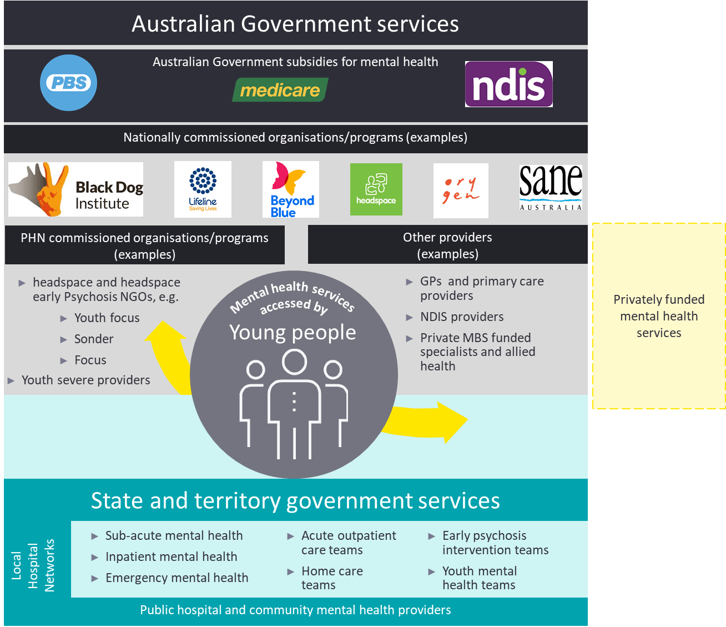

The Australian Government

The Australian Government is responsible for national leadership of mental health reform. It subsidises mental health-related services through PHNs, headspace, the National Disability Insurance Scheme, the Medicare Benefits Schedule and prescribed medications through the Pharmaceutical Benefits Scheme and Repatriation Schedule of Pharmaceutical Benefits.

In addition, it has a central role in the infrastructure of the mental health system and provides a range of mainstream programs that provide support for those with mental illness. These services include income support, disability services through the National Disability Insurance Agency and housing assistance, among others.

Primary Health Networks

PHNs are funded to commission services to meet the needs and priorities for their regions. Mental health is one of six key priorities for targeted work by PHNs. They manage approximately 10 percent of the Australian government’s expenditure in mental health.[19] Approximately 60 percent of PHN mental health funding is attributed to the flexible funding pool, while the remaining 40 percent of funding is linked to nationally prescribed commitments, including: funding for headspace services; Early Psychosis youth services; Aboriginal and Torres Strait Islander mental health; suicide prevention services trial sites; and ‘Partners in Recovery’ transition funding.

State and territory governments

State and territory governments set the legislative, regulatory and policy frameworks for mental health service delivery within their jurisdiction. They fund and deliver public sector mental health services that provide specialist care for people with severe mental illness. These services can include specialised mental health care delivered in public acute and psychiatric hospital settings, specialised community mental health care services and residential mental health care services.[20] Additionally, states and territories provide other mental health-specific services in community settings, such as social housing programs. In general, there is a focus on shifting away from traditional inpatient services to more community and primary care services. Key services that are funded by state and territories include:

* LHNs[21] manage the delivery of public hospital services and community-based health services, consisting of single of groups of public hospitals – they have a role in working with PHNs to plan and co-commission health care services for the local region
* Community mental health services which include acute care teams, home care teams, Early Psychosis intervention teams and youth mental health teams
* Some states also have their own mental health initiatives, including state specific strategies and programs, and/or have established their own mental health commissions (such as in NSW, WA and SA).

Non-government organisations

NGOs are key providers of mental health care and provide services such as psychosocial support services, advocacy, respite, and telephone and internet-based interventions.[22] These services focus on providing well-being support and assistance for those living with mental illness, rather than the assessment and treatment work that is undertaken by clinical services.

Examples of some of the key mental health NGOs[23] include:

* headspace: provides youth mental health services for Australians aged 12-25 years
* Black Dog Institute: is a research institute that aims to reduce the incidence of mental illness and the stigma around it
* Beyond Blue: works to address issues around depression, suicide, anxiety disorders and other related mental disorders
* Lifeline: provides free, 24-hour telephone crisis support services in Australia.

Private mental health care providers

Private sector services include admitted patient care in a private psychiatric hospital and private services provided by psychiatrists, psychologists and other allied health professionals. Private health insurance funds treatment costs in private hospitals, public hospitals and out of hospital services provided by health professionals. [24]

* 1. An overview of Early Psychosis and Ultra High Risk

Psychosis is a term used to describe a range of psychiatric symptoms in which reality-testing, perceptions, thoughts and emotions are impaired. *The Australian Clinical Guidelines for Early Psychosis* define psychosis as:

Symptoms in which there is misinterpretation and misapprehension of the nature of reality, for example, disturbances in perception, disturbances of belief and interpretation of the environment, and disorganised speech patterns.[25]

This can be extremely frightening for a person, not well understood by others, and can seriously disrupt a person’s life and the lives of those around them. In psychiatric classification systems there are several disorders, which can have psychotic symptoms – including schizophrenia, bipolar Type 1 disorder, severe depressive episodes.[26] Psychotic symptoms can also be caused by a range of medical conditions, such as delirium, epilepsy and metabolic disorders[27] and intoxication with several substances (for example, amphetamines).

The prevalence rates of psychosis ranges from 0.1 percent to 0.5 percent[28] of young people (aged 12 to 25). When applied to the Australian population,[29] the estimated number of young people with psychosis is expected to be approximately 8,800 (see Table 89 for further detail).

Early Psychosis refers to the early course of a psychotic disorder from the appearance of threshold psychotic symptoms and includes the first episode of psychosis.[30] Most psychotic illnesses first present in young people during adolescence or in early adulthood but may not be identified until the young person has experienced an extended period of illness or until a later episode,[31] often with a long prodromal phase. The latency between the emergence of psychotic experiences and treatment, the Duration of Untreated Psychosis (DUP), is a key indicator of treatment outcome. From early observations and randomised controlled trials, such services have also focussed upon detecting and intervening in this prodromal phase with young people defined as being “Ultra High Risk” (UHR). The UHR criteria combine the risk factor of age (adolescence and young adulthood) with clinical risk factors, such as functional decline and prodromal symptoms – particularly those that occur close to the onset of frank psychosis, such as Attenuated Psychotic Symptoms (APS) and isolated (Brief Limited Intermittent) psychotic symptoms.

Early intervention in psychosis has been increasingly adopted with the aim of: (1) reducing DUP and the long-term impact of the condition; and (2) reducing the time to recovery or supporting recovery and reintegration (through employment and education).[32] The *Australian Clinical Guidelines for Early Psychosis* and associated models of care, cover the period from the emergence of the prodrome (indicative of UHR) and the period up to five years from first entry into treatment for a psychotic episode.

* 1. The Early Psychosis Prevention and Intervention Centre (EPPIC) model

The EPPIC model is a specialised model of early intervention in psychosis, developed by Orygen in 1992. The EPPIC model supports easier access to specialist psychosis treatment in a comprehensive and integrated manner and has been widely adopted as a word-class model for psychosis early intervention[33],[34] (see Appendix A for more detail on the model and its evidence base).

The aims of the EPPIC model are to:[35]

* Detect early those young people who are at risk of developing a first episode of psychosis or have experienced a first episode of psychosis.
* Reduce the risk of transition to full threshold psychosis, or to delay or attenuate the impact of such transition in those young people who are manifesting early clinical features indicating incipient risk of a first episode of psychosis, and who seek and have a need for care.
* Restore the normal developmental and functional trajectory of those young people who are at risk of, or have experienced, a first episode of psychosis as early as possible.
* Minimise the impact of a first episode of psychosis on the family system through the provision of education, support and care.

To achieve the aims of the model, 16 core components were developed as a framework for service delivery, as outlined in Figure 3.

Figure 3: The 16 core components of the EPPIC Model[36]

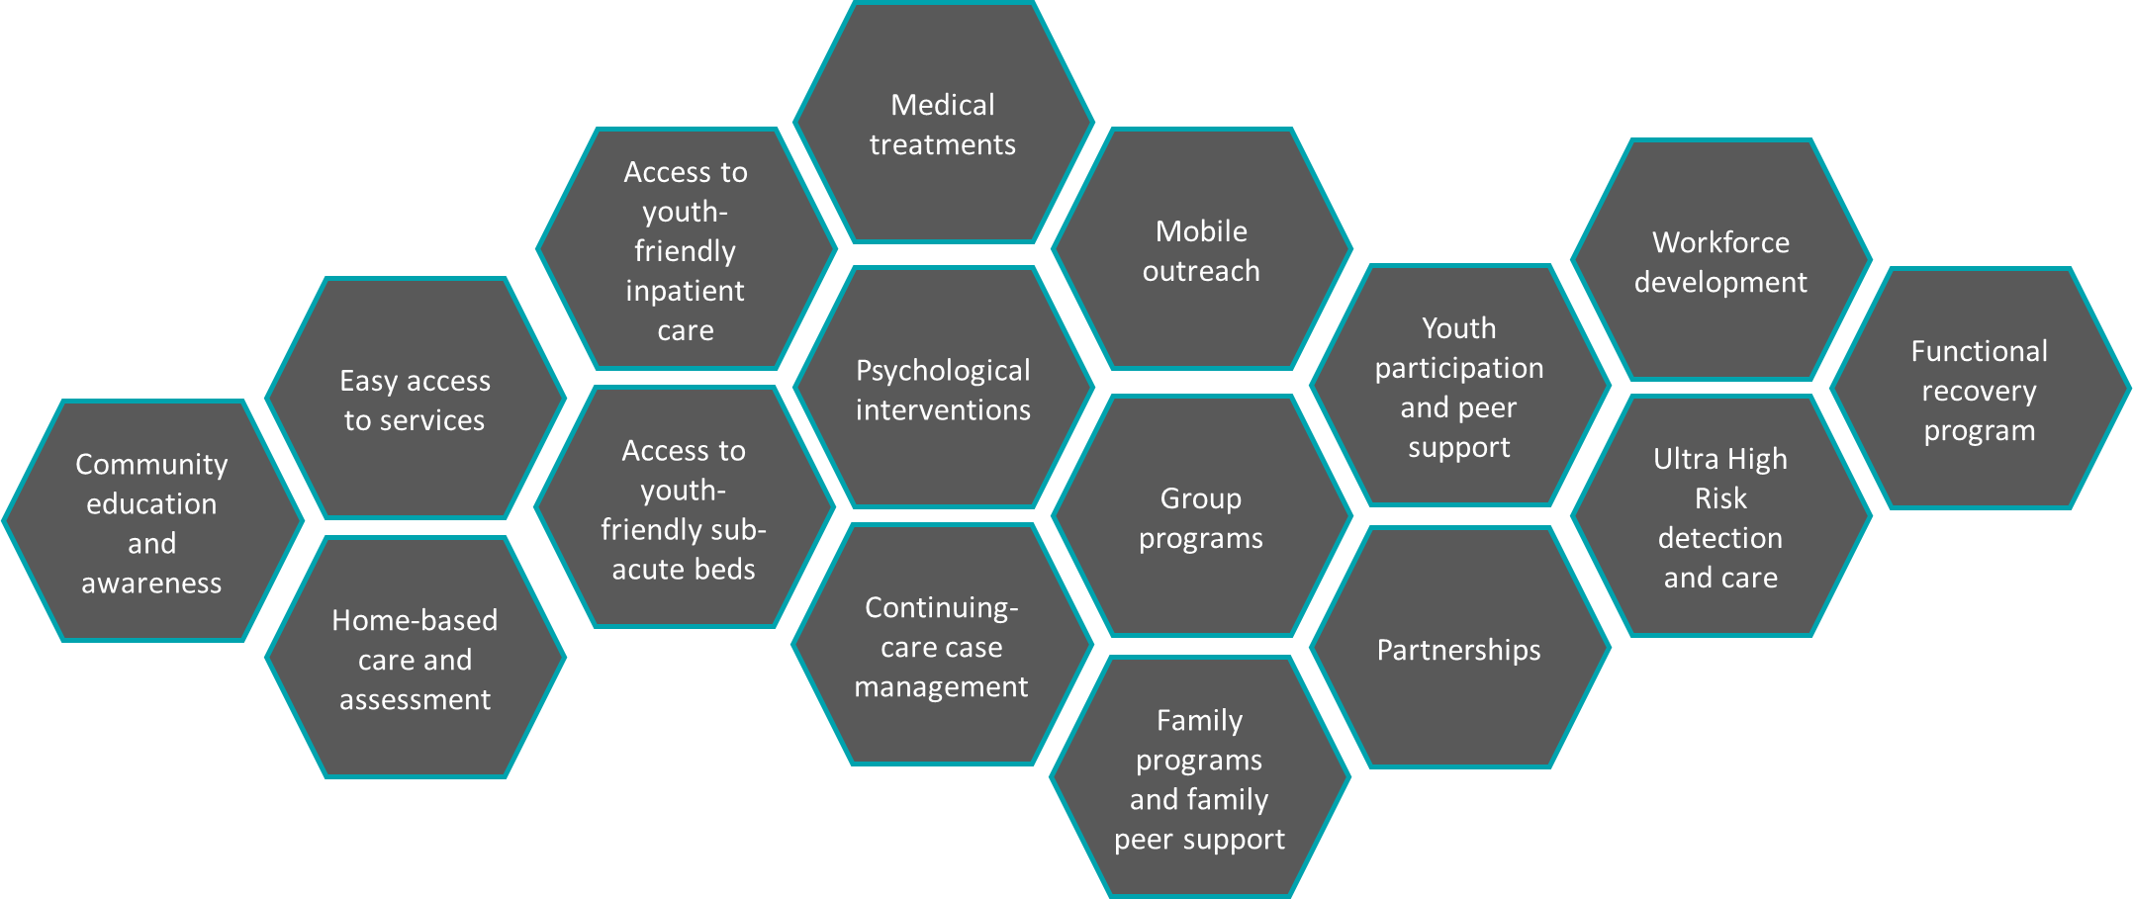

* 1. The Early Psychosis Youth Services Program

headspace Primary services commenced in 2006 to provide tailored and holistic mental health support to those aged 12 to 25. It focused on early intervention, working with young people to provide support at a crucial time in their lives – to help get them back on track and strengthen their ability to manage their mental health in the future. The 100+ headspace Centres act as a one-stop-shop for young people who require help with mental health, physical health (including sexual health), alcohol and other drugs or work and study support. The centres were designed not just for young people, but with them, to ensure they are relevant, accessible and highly effective. In addition, headspace offers a national telehealth service and online platform – eheadspace – to provide broader access, including to youth in regional and remote areas.

The EPYS Program is the delivery of the EPPIC model through the existing headspace Centre network, to provide integrated early intervention treatment and intensive support to young people aged 12 to 25 years who were at UHR, or were experiencing or had recently experienced a FEP. Within headspace, the EPYS Program was known as *headspace Early Psychosis* – in this report local delivery of the EPYS Program will be referred to as headspace Early Psychosis.

The recommended duration of treatment for UHR clients in headspace Early Psychosis was up to six months. For FEP clients two years of treatment was provided, with the option to provide up to five years of treatment if it was deemed necessary. Delivery of the EPYS Program required full fidelity to the EPPIC Model (i.e. the 16 core components of the EPPIC Model as outlined in Figure 3), aligned with the *headspace Model Integrity Framework*.

* + 1. Aims and objectives of the EPYS Program

The EPYS Program aimed to reduce the incidence and severity of psychosis within the community through prevention, early detection and coordinated care delivery. It does this by providing a single point of entry for comprehensive evidence-based treatment and support, as well as ease of access to varying levels of intensity of care for young people and their families, replacing often fragmented treatment and support pathways.

The specific objectives of the EPYS Program are:

* Early detection of those young people aged 12-25 who are at risk of developing a first episode of psychosis, or have experienced a first episode of psychosis, and to provide specialist treatment and care
* Reduce the severity and impact of symptoms on these young people
* Reduce the risk of transition to full threshold psychosis, or delay or attenuate the impact of such transition in those young people who are manifesting early clinical features indicating risk of a first episode of psychosis, and who seek and have a need for care
* Restore the normal developmental and functional trajectory of those young people who are at risk of, or have experienced, a first episode of psychosis as early as possible
* Minimise the impact of a first episode of psychosis on the family system through the provision of education, support and care.
  + 1. EPYS Program locations

The EPYS Program was delivered in six locations across Australia: in Adelaide, Darwin, North Perth, South East Melbourne, South East Queensland and Western Sydney.

The model of implementation involved the establishment of a ‘hub’ service in each of the delivery areas which was located at the main headspace Centre in the region. Some hubs had connecting ‘spoke’ services in other headspace Centres in the region, forming a local cluster. The hub and spoke services of each cluster work together to deliver headspace Early Psychosis. The central hub was designed as the base for staff providing the service and for onsite programs such as client groups and staff education sessions. The hub included all core components (excluding those relating to inpatient and sub-acute care) and the spokes included a continuing care team.

Services were commissioned by PHNs and delivered by a lead agency (which were non-government organisations in most instances). Table 2 provides the location and an overview of local arrangements for each cluster or service.

Table 2: EPYS Program locations and local arrangements

| Location | Commenced limited services | Lead agency(s) | Lead agency for co-located headspace Primary | Hub/spoke | PHN(s) | Local Hospital Network(s) |
| --- | --- | --- | --- | --- | --- | --- |
| **Darwin** | April 2015 | Anglicare NT | Anglicare NT | Hub only | Northern Territory PHN | Top End Health Service |
| **Adelaide** | January 2016[37] | Sonder[38] | Sonder | Hub only | Adelaide PHN | Central Adelaide Local Health Network  Northern Adelaide Local Health Network  Southern Adelaide Local Health Network  Women’s and Children’s Health Network |
| **Perth North cluster** | January 2015 (all locations) | Black Swan (covers Joondalup, Osborne Park)  Youth Focus (covers Midland) | Black Swan (covers Joondalup, Osborne Park)  Youth Focus (covers Midland) | Hub: Joondalup  Spokes: Osborne Park, Midland | Perth North PHN | North Metropolitan Health Service |
| **South East Queensland cluster** | Southport: November 2014[39]  Meadowbrook: January 2015 | Lives Lived Well (Southport)  After Care (Meadowbrook) | Lives Lived Well (Southport)  After Care (Meadowbrook) | Hub: Southport  Spoke: Meadowbrook | Gold Coast PHN (covers Southport)  Brisbane South PHN (covers Meadowbrook) | Gold Coast Hospital and Health Service (covers Southport)  Metro South Hospital and Health Service (covers Meadowbrook) |
| **South East Melbourne cluster** | Bentleigh/Frankston – September 2014  Dandenong/Narre Warren – May 2015 | Alfred Health[40] | The Alfred (Bentleigh, Elsternwick)  Youth Support and Advocacy Service (Frankston)  EACH (Dandenong, Narre Warren) | Hub: Bentleigh  Spokes: Frankston, Dandenong, Narre Warren | South East Melbourne PHN | Alfred Health (covers Bentleigh)  Monash Health (covers Dandenong/Narre Warren)  Peninsular Health (covers Frankston) |
| **Western Sydney cluster** | September 2014 (all locations) | Uniting Care | Uniting Care  Flourish (Parramatta only)[41] | Hub: Mt Druitt  Spokes: Parramatta, Penrith | Western Sydney PHN (covers Parramatta, Mt Druitt)  Nepean Blue Mountains PHN (covers Penrith) | Western Sydney Local Health District (covers Parramatta, Mt Druitt)  Nepean Blue Mountains Local Health District (covers Penrith) |

* + 1. EPYS Program services

All services provided through the EPYS Program were required to comply with the *National Standards for Mental Health Services*. Clinical practice was guided by the *Australian Clinical Guidelines for Early Psychosis*, developed by Orygen. While the *EPPIC model and Service Implementation Guide* and the *headspace Youth Early Psychosis Program: Operations Guide*, were developed to guide the implementation and operation of the EPYS Program. They outlined the aims, objectives, minimum standards and essential elements of the EPYS Program.

There were several services delivered as part of the EPYS Program, as described in Table 3.

Table 3: EPYS Program services

| Service | Description |
| --- | --- |
| Mobile Assessment and Treatment Team (MATT) | MATT clinicians provide triage, assessment and intensive extended-hours home treatment service to young people referred to the EPYS Program and current EPYS clients. MATT clinicians work closely with CCT clinicians for current EPYS clients. While the program is open to all young people in Australia, the MATT service is restricted to the geographic area within one-hour travel time from EPYS services (as per the *headspace Youth Early Psychosis Program: Operations Guide*). |
| Continuing Care Team (CCT) | The CCT clinicians provide ongoing case management during regular business hours and are the young person’s primary point of contact with the service. CCT clinicians undertake comprehensive assessments of the young person’s mental health to determine their eligibility for the program. The CCT clinician has a therapeutic and coordination role for the client, working collaboratively with the young person and their family. Some of their primary tasks include engagement, developing the treatment plan, education of the young person and their family, risk management, developing a relapse prevention plan and discharge planning. CCT clinicians are also responsible for providing mobile outreach services and home-based care.  Each client is allocated a consultant psychiatrist who maintains clinical responsibility for the client, overseeing and approving all clinical decisions. Further to this, consultant psychiatrists facilitate biological interventions identified in the young person’s management plan. Consultant psychiatrists also assist in the intake and assessment process, especially if a young person displays significant distress associated with psychotic symptoms. |
| Functional Recovery Program (FRP) | The FRP incorporates vocational and educational support on an individual or group program basis to provide recovery‑based treatment. This is only delivered at hub services but is available to all clients within the program. Working with the young person’s case manager, the functional recovery worker provides support and direction regarding employment and education opportunities. |
| Group and family programs | Group programs are a part of a young person’s management plan to build social confidence and foster peer support. The four different streams of group programs are social and recreational, vocational and educational, psycho-educational and personal development, and creative and expressive.  Family programs empower the family to cope and adjust to a young person’s illness. The aim is to minimise disruption and maximise the adaptive functioning of a young person’s family. The tasks of family work vary depending on the stage of treatment and illness of the client, and may include psycho-education, collaborative treatment planning, carer support options, referral to external family support services and structured family intervention. |
| Peer support program | The peer support program, ideally provided by previous headspace Early Psychosis clients, aims to address stigma tied to psychosis, enhance engagement with clients and instil hope and optimism in current clients. Peer support workers share their personal experiences, validate a young person’s experience and provide practical information and advice. Support plans for the peer support workers themselves are also developed, to identify coping strategies and reduce the likelihood of relapse. |

* + 1. EPYS Program data

EPYS Program data is collected through the headspace Application Platform Interface (hAPI), based on a Minimum Data Set (MDS). An initial MDS was developed by headspace National in September 2014 to monitor program performance and support future evaluation. The data are collected at critical points along a young person’s care journey through hAPI.

In August 2015, headspace National released an update to hAPI to standardise the data collected across all headspace services and to gather important information to assist clients and improve the future delivery of services. Information was collected from a range of sources – including the young person, someone on their behalf, intake workers, headspace Early Psychosis clinicians and the young person’s family. The information collected included personal details, demographics, referral, current work and school situation, services provided, diagnosis, management plan, client and family satisfaction, and future care needs. Data were collected throughout the client’s care journey – including registration, intake and assessment, each occasion of service, and discharge.

A further update to hAPI was made in July 2019 which enabled headspace National to consolidate disaggregate systems, with the aim of being less reliant on vendors and ultimately an improved ability to make changes and address functionality (see further detail on hAPI in Section 5.1.2). During the evaluation period, headspace National reported a review will commence into the hAPI MDS to further improve the value of the dataset. The objectives of this review will be to: (1) ensure the continued relevance of the MDS while reducing the data burden; (2) identify and streamline competing data priorities; and (3) improve system functionality to support and align as closely as practicable with the service practice and pathways.

Supplementary to hAPI, each lead agency uses their own medical record and patient/client administration systems for the collection of information on the client and service delivery.

* + 1. Governance arrangements for the EPYS Program

Governance over the EPYS Program was complex and involved multiple organisations and agencies; including the Australian Government Department of Health, PHNs, lead agencies, Orygen and headspace National. In some instances, the headspace Early Psychosis clusters have more than one PHN or lead agency. The roles and responsibilities of the organisations with a role in the delivery of the EPYS Program are outlined below.

Australian Government Department of Health

The Australian Government Department of Health provided EPYS Program funding to PHNs for the commissioning of headspace Early Psychosis services, through:

* The Mental Health and Suicide Prevention Operational and Flexible Fund schedule
* The unspent 2015-16 EPYS Program funds (redistributed by headspace National).

The Australian Government Department of Health provided PHNs with the full funding amount for the EPYS Program, plus the volume of unspent 2015-16 EPYS Program funds in March 2017.

All funds, irrespective of whether they were provided via the Mental Health and Suicide Prevention Operational and Flexible Fund schedule or headspace National, were Australian Government funds appropriated for the EPYS Program. As such, they are required to be recognised and utilised for the sole purpose of commissioning headspace Early Psychosis services. Separate funding was provided to PHNs to develop regional models of care for young people with severe and complex mental illness.

Primary Health Networks

The roles and functions associated with the contract management of headspace Early Psychosis services were the responsibility of PHNs. As such, the key functions of PHNs were to:

* Commission existing lead agencies at 2015-16 funding levels (full funding) to deliver headspace Early Psychosis services from 2016-17 through until 30 June 2021
* Ensure that headspace Early Psychosis services maintain fidelity to the Early Psychosis Prevention and Intervention Centre (EPPIC) model as outlined in the EPPIC Model and Implementation Guide
* Ensure that appropriate clinical governance and quality frameworks are in place for the headspace Early Psychosis services in their region
* Recognise in PHN work plans and reporting to the Australian Government Department of Health, all EPYS Program funds and associated activity
* Ensure that lead agencies comply with the headspace Trademark Licence Deed including collecting headspace Early Psychosis service activity data via the headspace Early Psychosis module of hAPI.

However, these responsibilities differed for each PHN depending on the hub and spoke arrangement for the headspace Early Psychosis service. In some circumstances, more than one PHN had responsibility for commissioning an EPYS cluster. Where this was the case, it was expected that the PHNs work collaboratively to ensure that headspace Early Psychosis services are delivered across the cluster in an integrated and coordinated manner. The relevant PHNs are required to support the lead agency service partnerships to function as a cluster, to maximise service integration, impact and the degree of the incidence of Early Psychosis that can be serviced. In addition, they are to ensure continuity of care and seamless access to all components of treatment and care.

PHNs had the flexibility to make individual arrangements with lead agencies to manage reporting requirements but are also required to report on the EPYS Program to the Australian Government Department of Health.

Lead agencies

Lead agencies are commissioned by PHNs to deliver headspace Early Psychosis, including the contracting of staff and clinical governance of the service. Lead agencies have important roles in consultation, collaboration, and support for implementing and running the EPYS Program through PHNs. They are required to have sound business viability and have demonstrated leadership and clinical capacity and governance to provide the services at headspace Centres. They also have roles in supporting PHNs in business planning and delivery.

Orygen

Orygen is funded by the Australian Government Department of Health to provide technical and clinical advice, guidance and specialised consultation to PHNs and lead agencies in relation to the EPYS Program. This may be in relation to the EPPIC model and its core components, scaling up services, Key Performance Indicators and key data collection, or challenges faced by different centres.

Orygen regularly assessed each headspace Early Psychosis service for fidelity to the EPPIC model and provided feedback on the extent to which the services were delivering all 16 components of the model. It also advised on how a service could improve its fidelity. Orygen also had a role to facilitate opportunities for services to collaborate and share knowledge on a national level.

During the establishment phase of the EPYS Program, Orygen was funded to provided face-to-face training to headspace Early Psychosis Services. At the time of the Evaluation, this funding had ceased, however, Orygen continued to play a role in training headspace Early Psychosis Services, via clinical manuals, resources and a comprehensive array of clinical training modules.

headspace National

headspace National is funded by the Australian Government Department of Health to manage hAPI, which includes support to PHNs in ensuring data collection and quality is maintained, as well as support and training for headspace Early Psychosis staff. headspace National undertook a major redevelopment of the headspace Early Psychosis module of hAPI in February 2017, incorporating changes to the system identified through a consultation process with all headspace Early Psychosis services undertaken. The system aimed to better align headspace Centre practice and client pathways and provide a more flexible and simple system to ensure a comprehensive and consistent data collection to support evaluation. Following this upgrade, headspace National established reporting for headspace Early Psychosis using Tableau enabling headspace Early Psychosis staff to have access to real time reporting dashboards. In mid-2019 headspace National undertook another major system upgrade to hAPI which resulted in several benefits and challenges (as detailed in Sections 5.1.2 and 5.2.3). As the data and systems administrator for the EPYS Program, headspace National is also responsible for providing reports to the PHNs, Orygen and the Australian Government Department of Health.

As the custodian of the headspace brand, headspace National is responsible for headspace branding and marketing and subsequently ensuring that headspace Centres and the headspace Early Psychosis services adhere to these branding requirements. To achieve this, headspace National requires headspace Centres to be compliant with the headspace Model Integrity Framework.

During 2019, with additional funding provided by the Australian Government Department of Health, headspace National appointed a new position to lead headspace National’s headspace Early Psychosis data collection and reporting activities and to improve the delivery and integration of headspace Early Psychosis services with the primary headspace platform.

* 1. Previous evaluations of the EPYS Program

The 2015 internal evaluation

An internal evaluation of the EPYS Program was conducted by headspace National in 2015. The evaluation aimed to explore the implementation of the EPPIC model within the headspace context and develop evidence of its impact on young people with, or at risk of, developing psychosis. The evaluation identified challenges and suggested future strategies relating to the selection of lead agencies, service development, the process of establishment, ongoing performance monitoring, and the cluster configurations.

The 2016 external evaluation

EY were commissioned to undertake a mixed methods evaluation of the EPYS Program to assess the implementation of the EPYS Program within the headspace setting and identify lessons from the implementation to date that would support PHNs as youth mental health commissioning bodies moving forward. The evaluation did not consider clinical outcomes, as it was too early to reliably measure clinical outcomes. The evaluation considered the following domains:

* Appropriateness of the EPYS Program design
* Effectiveness of EPYS Program implementation
* Utilisation of services
* Costs associated with the service delivery model
* Lessons learnt for PHNs in the commissioning of future services for young people, with or at risk of, severe mental illness.

The evaluation was undertaken in a period of change, when program funding for youth mental health service was being transitioned to PHNs to support regional planning and commissioning of locally appropriate mental health services. It resulted in 17 recommendations aimed at developing a nationally consistent and flexible model, building on the significant progress made by the existing services.

Given the timing of the 2016 evaluation relative to EPYS Program maturity (and implication for EPYS Program data), the Evaluation of the Early Psychosis Youth Services Program was commissioned by the Australian Government Department of Health in July 2017 (this Evaluation). This evaluation was initially scheduled to be completed in 2018-2019, however, was extended to 2020-2021 to cover the funding extension to the program and enable additional data to be collected.

* 1. Policy context and background

The EPYS Program has been impacted by several significant policy and funding decisions. There are also several reforms underway which may influence the program going forward.

* + 1. History of the policy reform which has influenced the set up and early implementation of the EPYS Program

The National Mental Health Commission’s report *Contributing lives, thriving communities: Report of the National Review of Mental Health Programmes and Services* (2014),[42] outlined the need for major reform of the Australian mental health system. The report recommended a suite of reforms which put an increased emphasis on community-based mental health services and the importance of early intervention programs to support self-care and personal resilience. It also sought to reduce the fragmentation of services, create local ownership and development of services and embed a stepped care approach – enabling access to the right care at the right time.

The policy history for the EPYS Program is detailed below:

* In the 2010-11 Federal Budget, the Australian Government committed $25.5 million in funding over four years to deliver the EPPIC Model at select locations, in partnership state and territory mental health services. States and territories were anticipated to provide a co-contribution to scale up services. These services were expected to reach 3,500 young people with, or at risk of developing psychosis.
* On 23 May 2013, it was announced that due to delays in funding negotiations with states and territories, the Australian Government-funded headspace Centre network would be the delivery platform for the EPPIC model in nine areas. This was to ensure a single national model and consistency of service across Australia.
* On 23 June 2013, a funding agreement between the Australian Government and headspace was executed until 30 June 2016 for the delivery of services. Orygen also received funding to support headspace by providing workforce training and support. Nine services were to be established over three years, with at least one service in each state and territory, including: Western Sydney and Nepean Blue Mountains in NSW; South Eastern Melbourne in VIC; Brisbane South and Gold Coast in QLD; Adelaide in SA; Perth North in WA; Northern Territory in NT; and the Australian Capital Territory in ACT.
* On 26 November 2015, the Australian Government announced its response to the National Mental Health Commission’s review into the efficiency and effectiveness of mental health programs and services, which included the following commitments:
* Ensure that headspace and other youth mental health services are integrated at a regional level with primary care services through PHNs.
* Explore opportunities to use available youth mental health funding to provide early intervention for a broader group of young people who present to primary care services with severe mental illness or at risk of such.
* In July 2016, the PHN Primary Health Care Flexible Funding Pool was created to provide a consolidated funding source of approximately $1.03 billion over three years from which PHNs could direct primary mental health care services to best meet regional needs. As part of this measure, PHNs assumed responsibility for commissioning the EPYS Program in their region. In line with the policy at the time, PHNs were required to transition out of commissioning headspace Early Psychosis services by 30 June 2018.
* On 15 November 2016, the Australian Government reinstated funding to the EPYS Program, via their PHNs, for three years until 30 June 2019. The Australian Government also committed to an independent evaluation of the EPYS Program.
* In the 2019-20 Federal Budget, the Australian Government committed a further $736.6 million for mental health and suicide prevention over the seven years across 25 action measures.[43] Of this funding, $109.7 million was provided to extend the EPYS Program for an additional two years from 2019-20. Whilst this provided some certainty for the EPYS Program into the future, there was considerable uncertainty in the lead up to this funding announcement which impacted service delivery.
  + 1. Other mental health policy and reform which may influence the EPYS Program in the future

There are a several reviews and reforms underway within the Australian mental health system which may influence the EPYS Program in the future – this includes the work of the National Mental Health Commission, the Productivity Commission inquiry into mental health and the Royal Commission into Victoria’s mental health system. At the time of submitting this report, the final reports for both the Productivity Commission inquiry into mental health and the Royal Commission into Victoria’s mental health system were yet to be finalised and therefore have not been referenced.

The National Mental Health Commission

In the 2019-20 Federal Budget, the National Mental Health Commission (‘the Commission’) received $12.4 million over four years to increase the Commission’s capacity to provide advice and leadership on mental health reform under its expanded role under the *Fifth National Mental Health and Suicide Prevention Plan*. The Commission provides independent reports and advice to the community and government on what is working and what is not working in mental health and suicide prevention in Australia.

The Commission launched the *Connections* project on 1 July 2019, as a national conversation about the future of mental health and suicide prevention in Australia. Feedback from this process will be utilised to develop:

* Vision 2030 for Mental Health and Suicide Prevention: A blueprint for mental health in Australia which outlines the goals and objectives for mental health and the systems or services which may meet these.
* A Roadmap (planned for 2020) to identify the long-term strategies in investment, coordination, development and performance measurement required to achieve the Vision for 2030 and meet goals and objectives for mental health.

The work of the Commission will likely provide a system-wide view of the future of the Australian mental health system and where programs and services, like the EPYS Program, have a role to play.

The Productivity Commission inquiry into mental health

The Productivity Commission released their draft report on their inquiry into mental health in October 2019. They assessed how people at risk of mental illness can be enabled to reach their potential in life, while enhancing the wellbeing of the wider community through more rewarding relationships.[44]

The initial recommendations included: prevention and early intervention for mental illness and suicide attempts; decreasing the critical gaps in healthcare services; investment in services beyond health; an increased focus on enabling early treatment of work-related mental illness; and fundamental reform to care coordination, funding arrangements and governance arrangements to inject accountability and clarify responsibilities.

One significant recommendation specific to the EPYS Program was for the Australian Government Department of Health to cease directing PHNs to fund headspace Centres, including headspace Early Psychosis (Recommendation 24.2). Furthermore, it was recommended that in the medium term there should be no requirement for PHNs to have to fund particular services or providers. Should this recommendation be considered, this could have considerable implications for the future of the EPYS Program, as PHNs would be able to continue to fund headspace and headspace Early Psychosis or redirect EPYS Program funding to better meet the needs of their local areas as they see fit. The Productivity Commission’s inquiry final report was handed to the Australian Government on 30 June 2020.

Royal Commission into Victoria’s mental health system

The Royal Commission into Victoria’s mental health system was established following an acknowledgement that the state’s mental health services had reached crisis point. In calling for the Royal Commission, the current Victorian Government signalled that psychological distress and mental illness should be given due recognition as fundamental health and social concerns. The Victorian Government has made a commitment to implementing all the Commission’s recommendations. An interim report was published in November 2019.

The report has several foci of reform which align which encourages aspects of service delivery that are present within headspace Early Psychosis services, i.e. involvement of those with lived experience.

The interim report put forward nine recommendations that focused on preparing the way for a new approach to mental health treatment, care and support in Victoria. The report also outlined some of the building blocks that will promote and support the large-scale change that is to come, which may have implications for the delivery of services like the EPYS Program. The findings and recommendations will need to be considered once a final report is provided.

National Medical Workforce Strategy

The Australian Government Department of Health, in collaboration with state and territory governments and key stakeholders, has commenced the development of the National Medical Workforce Strategy.[45]

The National Medical Workforce Strategy will be a collaborative vision for how the investment of individuals, doctors and organisations are best coordinated for Australia’s health system. It is being developed in response to the recognised lack of national planning and coordination, which creates risks, waste and suboptimal outcomes. The strategy recognises the need to keep up with increasing consumer demand for particular medical specialities, such as psychiatry. The strategy emphasises the need for better integration of medical workforce planning, including with the National Mental Health Workforce Strategy.

Whilst it is not yet obvious what the impact of this strategy will be for the EPYS Program, it will likely support coordinated delivery of mental health services to a broader population, improving the equity of access to care.

Australian Youth Development Index 2020

The Australian Government will commission the delivery of the 2020 Australian Youth Development Index — a one-stop shop for information related to the most significant issues which young Australians face.

In July 2019, the Australian Government established the Youth Taskforce to develop a joint whole-of-government approach towards ensuring young Australians are heard.[46] The Youth Taskforce was set up to improve the coordination of programs impacting young people, to identify gaps and challenges faced by young people through existing policies and programs and to improve engagement and consultation. The Australian Youth Development Index 2020 will consolidate information relevant to young Australians in health, education and employment.

The Youth Development Index provides researchers, policymakers, young people and civil society with a resource to compare jurisdictions on their relative levels of youth development, to see where youth are doing well and where improvement is needed.[47]

1. Evaluation process
   1. Purpose and objectives of the Evaluation

The purpose of the Evaluation was to examine the appropriateness, effectiveness, efficiency and equity of the EPYS Program to determine its impact and inform future policy direction.

The objectives of the Evaluation were to:

* Assess the implementation of the EPYS Program
* Assess the appropriateness, effectiveness, efficiency and equity of the EPYS Program in meeting the needs of youth with, or at risk of, Early Psychosis
* Identify any barriers and enablers to EPYS Program implementation and outcomes
* Identify lessons to improve Early Psychosis services for young people and services for youth with severe mental illness
* Model the cost and service implications of a wider EPYS Program rollout beyond 2020-2021 (the period in which the program is currently funded).

In this document:

* ‘Overarching’ support, design, funding and implementation of the national program is referred to as the **EPYS Program** (or ‘the program’).
* ‘Local’ delivery of the EPYS Program is referred to as **headspace Early Psychosis** (‘the service’) which reflects terminology used within headspace Centres for local program delivery.
  1. Scope of the Evaluation

The Evaluation encompassed the six headspace Early Psychosis services or clusters who delivered the EPYS Program – South East Melbourne, Western Sydney, North Perth, South East Queensland, Darwin and Adelaide.

Evaluation stakeholders included the Australian Department of Health, headspace Early Psychosis lead agencies, headspace National, Orygen, the eight PHNs covering the six headspace Early Psychosis clusters or services, headspace Early Psychosis clients and their families and carers, and local stakeholders of headspace Early Psychosis.

In addressing the evaluation objectives, the scope of the Evaluation included:

* All aspects of the EPYS Program design, implementation and operation
* headspace Early Psychosis implementation through PHNs and headspace Centres
* Australian Government Department of Health processes and guidelines
* EPYS Program support provided by Orygen and headspace National
* EPYS Program governance arrangements.

The following were outside the scope of the Evaluation:

* Analysis of non-EPYS Program service delivery through the headspace Centres or eheadspace
* Analysis of the non-EPYS activities of Orygen or headspace National.
  1. Evaluation questions

Table 4 outlines the primary and secondary evaluation questions asked by the Australian Government Department of Health of the Evaluation.

Table 4: Primary and secondary evaluation questions

| Primary evaluation questions | Secondary evaluation questions |
| --- | --- |
| 1. How effective has the implementation of the EPYS Program been to date and what can we learn from it? | 1. How has policy shaped the implementation of the program? 2. To what extent has the EPYS Program been implemented as intended? 3. To what extent has the EPYS Program reached the target population? 4. How successfully has the EPYS Program integrated within the local health and other service systems? |
| 1. How appropriate is the EPYS Program design to deliver the program outcomes? | 1. To what extent is program design acceptable and relevant to clients and their families? 2. To what extent does the program design align with the policy and practice of the broader system of care for young people experiencing Early Psychosis or other severe mental illness? |
| 1. How effective is the EPYS Program in achieving outcomes for young people and their families? | 1. How effective is the EPYS Program in reducing the duration of untreated psychosis? 2. How effective is the EPYS Program in reducing the severity of symptoms for young people with or at risk of Early Psychosis? 3. How effective is the EPYS Program for young people with or at risk of Early Psychosis in reducing risk behaviours? 4. How effective is the EPYS Program in reducing the impact of young people with or at risk of Early Psychosis, on health service utilisation? 5. How effective is the EPYS Program in reducing or delaying the transition to full threshold psychosis? 6. How effective is the EPYS Program in restoring the functional trajectory of young people with or at risk of Early Psychosis? 7. How effective is the EPYS Program in improving the capacity of families to support and maintain relationships with young people with Early Psychosis? 8. How satisfied are clients and their families with the EPYS Program? |
| 1. How efficient and cost-effective is the EPYS Program? | 1. How efficiently have EPYS Program resources been used? 2. How cost-effective is the EPYS Program compared with usual care?[48] 3. Is there a minimum target population size required for cost-effective delivery of the EPYS Program? |
| 1. What are the implications for the program inputs arising from a wider implementation of the EPYS model? | 1. What would be the cost and service implications of a wider rollout of the EPYS model across Australia? 2. What economies of scale could be achieved through a wider rollout of the EPYS model? |

* 1. Overview of the design of the Evaluation

The Evaluation used a mixed methods design. This enabled a multi-pronged, methodological approach to answer the evaluation questions to the extent possible at this stage of the EPYS Program and with the available data. A mixed methodology was utilised for the measurement of program implementation, appropriateness, effectiveness, efficiency and equity, and provided insights from clients, families and staff about why or why not they found the program accessible, appropriate, effective and equitable (for example, most and least helpful aspects).[49] It also supported data triangulation and cross-question analysis.

A program logic (see Appendix B) was developed collaboratively with the Australian Government Department of Health, Orygen and headspace National. It is a schematic representation of the EPYS Program and reflects its intended delivery and design. The program logic lists the program’s inputs, activities and outputs and how they relate to program outcomes in the short, medium and long-term. The program logic also includes key contextual elements that influenced the design and implementation of the EPYS Program.

The program logic was used to map the EPYS Program theory of change and inform the development of the Evaluation Plan by identifying key areas for examination. It shows how the activities and outputs of national program development, local program set-up and implementation and local program delivery (headspace Early Psychosis) work together to achieve the intended program outcomes.

The Evaluation Plan[50] described the evaluation methodology and approach in detail, and was developed with input from the Department, members of the Evaluation Reference Group (see Section 3.7 for further detail), headspace National and Orygen.

* 1. Overview of the of evaluation methods
     1. Summary of the evaluation methods

A summary of the methods used in the Evaluation are outlined in Table 5. The limitations associated with the evaluation methods and data are outlined in Section 3.5.3. Relevant ethics approvals for the below mentioned methods were sought and met from a Human Research Ethics Committee, applicable Site Specific Assessments, and applicable state-based ethics requirements. Further detail on this is provided in the appendices (see Appendix C and Appendix D).

Table 5: Summary of methods utilised in the Evaluation

| Method | Evaluation question answered | Description of method | Data type | Sample | Analysis | Timing |
| --- | --- | --- | --- | --- | --- | --- |
| 1. **Consultation with overarching EPYS Program stakeholders** | 1,2,4,5 | New data from overarching stakeholders to gain insight on the context and policy environment, implementation, efficiency and effectiveness of the EPYS Program. | Qualitative | * The Australian Government Department of Health * Orygen * headspace National * National Mental Health Commission | Thematic analysis of consultation notes and supporting documents | January to May 2020 |
| 1. **Consultation with local stakeholders with direct experience of headspace Early Psychosis services** | 1,2,4,5 | New data from local stakeholders with direct experience of headspace Early Psychosis services through service visits to all six headspace Early Psychosis services/clusters to understand how the program is being implemented within different contexts. | Qualitative | * All six headspace Early Psychosis clusters and services * headspace Early Psychosis staff * PHNs * Lead agencies * headspace Primary staff * Local service providers and clinicians * Schools and community organisations * Health departments and LHNs | A thematic analysis of consultation notes and supporting documents (e.g. Orygen fidelity data) | Initial consultations May – July 2018 (referred to as early-2018 consultations in this report)  Follow-up consultations October – December 2019 (referred to as late-2019 consultations in this report) |
| 1. **Case studies of usual care models (state-funded Early Psychosis services)** | 1,4,5 | New data from examples of state-funded Early Psychosis services to better understand the model of ‘usual care’. References to ‘usual care’ in this report refer to the six usual care services consulted as part of the Evaluation. Finds from case studies of usual care are scattered throughout this report where comparison to usual care was possible and appropriate. Detailed findings from the case studies of usual care in Appendix E. | Qualitative | Six services across WA (three) and NSW (three) were selected and demonstrated one of the following characteristics:   * Co-location with a headspace Early Psychosis service * Located in a region that also had a headspace Early Psychosis service * Located in a region with no headspace Early Psychosis | A thematic analysis of consultation notes and supporting documents | February – March, 2020 |
| 1. **Client and family/carer interviews and focus groups** | 2,3 | Data from individual semi-structured client and family interviews (timepoints 1 and 2) and focus groups (timepoint 1 only) conducted with young people and their families and/or carers in two states with headspace Early Psychosis services in Western Sydney and Darwin. At time point 2, interviews were also conducted with young people and their families and/or carers accessing state-funded Early Psychosis services from two NSW Local Districts (Sydney and Western Sydney).  Refer to Appendix C for further detail. | Qualitative | Timepoint 1:   * Cohort 1: clients and family members or carers were who had recently assessed by MATT < 6 months with   headspace Early Psychosis.   * Cohort 2: clients and family members or carers engaged with headspace Early Psychosis > 6 months.   Timepoint 2:   * Cohort 1: headspace Early Psychosis clients / family and carer with hospitalisation experiences (prior or during service engagement) * Cohort 2: state-funded Early Psychosis clients / family and carer with hospitalisation experiences (prior or during service engagement) | Thematic coding and analysis of interview transcriptions using inductive and deductive approaches. | Time point 1a: Initial consultations April to July 2018, 2018  Time point 1b: Follow up consultations  November 2018  Time point 2: Additional consultations  Dec 2019 – April 2020 |
| 1. **Family and carer survey** | 3 | New data gathering perceptions of the families and carers of clients of the EPYS Program and state UHR/FEP services and their experience of caregiving responsibilities.  Refer to Appendix F for further detail. | Quantitative | All six headspace Early Psychosis services/clusters (consenting clients)  State-funded early intervention services in NSW, VIC, WA | Comparison between services | March 2018 |
| 1. **headspace Early Psychosis specific data** | 1,3,4 | Existing data from headspace Early Psychosis services, which includes: Client data from hAPI and locally provided workforce and financial data. This was used to explore service usage and the impact of different workforce implementation models. | Quantitative | All six headspace Early Psychosis services/clusters (consenting clients) | Effect of time in service | First data extraction October 2018  Second data extraction October 2019 |
| 1. **Comparative service analysis (using Transitions study data)** | 3,4 | Comparison of routine data from hAPI MDS (clients with UHR and FEP) with a comparable client cohort as identified in Purcell et al’s 2015 Transitions study (see Appendix G). This was done to compare the health outcomes of the EPYS Program with a like-service control comparison comprising of clients from a similar, EPPIC based service within Australia. | Quantitative | All six headspace Early Psychosis services/clusters (consenting clients)  Cohort with one-year follow-up data | Comparison between cohorts | First data extraction October 2018  Second data extraction October 2019 |
| 1. **Ecological counterfactual** | 3,4 | Comparison of health service utilisation for young people with psychosis between “regions” with or without access to the EPYS Program using Admitted Patient Data collection and emergency department presentation (see further detail in Appendix D). | Quantitative | People born between 1990 and 2006 who were hospitalised with a diagnosis of psychosis at any time between 2010 and 2019 in NSW and WA | Comparison of health service utilisation outcomes between EPYS and non-EPYS “regions” | First data extraction in Q4 2018  Second data extraction Q1 2020 |
| 1. **Document analysis** | 1,3,4 | Document scan for related mental health policy and health system documents including information on psychosis and prevalence. Literature review (Appendix A) to support and contextualise economic analysis. | Quantitative | Publicly available data and literature | N/A | Undertaken throughout the evaluation period |
| 1. **Economic analysis** | 4,5 | The economic analysis explores the cost-efficiency of program delivery, the cost-effectiveness of the program in delivering improvements in clinical outcomes, and potential cost-savings to the public health sector. | Quantitative | Entire EPYS cohort, but limited to those who have information in the headspace Early Psychosis hAPI MDS and have provided consent | Cost-efficiency, cost-effectiveness, cost-consequence and modelling the program inputs arising from wider implementation | Late 2019-early 2020 |

* + 1. The EPYS Program data (hAPI) utilised in the Evaluation

The EPYS Program data utilised in the Evaluation consisted of routinely collected data (via hAPI) between 17 June 2017 and 30 September 2019 from each service. hAPI was intended to be used to track every episode of care provided by headspace Early Psychosis, from assessment to discharge. A headcount of all young people who were assessed during the above-mentioned period was provided by headspace National and is referred to in the following sections as the ‘hAPI summary data’.

The sample for the Evaluation is from the hAPI data evaluation extract (‘hAPI evaluation extract’) and contained individual level data from all clients who had consented to share their records with the Evaluation, as at 30 September 2019.

The number of total episodes in hAPI (*N*), as well as a comparison to the consenting subset (*n*) for the Evaluation, is presented in Table 6. The limitations of the hAPI data for the Evaluation are outlined in Section 3.5.3.

Table 6 shows that the evaluation sample reflected more than 85 percent of episodes within the UHR and FEP treatment arms, except for Victoria, whose proportion was relatively lower for both. As such, the sample appears to be reasonable representative of the episodes of care that took place within the EPYS Program.

However, this table also shows that the sample was less representative of “Not eligible” episodes, especially in Victoria. Therefore, inferences about who has been excluded from the EPYS Program (and any comparisons with those excluded) requires caution.

Table 6: hAPI population (N) to sample size (n) from each service/cluster

|  | UHRa | | | FEPa | | | Non-eligibleb | | | Unknownc | | | Total | | |
| --- | --- | --- | --- | --- | --- | --- | --- | --- | --- | --- | --- | --- | --- | --- | --- |
| **N** | **n** | **%** | **N** | **n** | **%** | **N** | **n** | **%** | **N** | **n** | **%** | **N** | **n** | **%** |
| NSW | 93 | 87 | 93.5 | 136 | 124 | 91.2 | 136 | 114 | 83.8 | 213 | 73 | 34.3 | 578 | 398 | 68.9 |
| NT | 124 | 118 | 95.2 | 44 | 41 | 93.2 | 219 | 138 | 63.0 | 19 | 7 | 36.8 | 406 | 304 | 74.9 |
| QLD | 300 | 264 | 88.0 | 224 | 197 | 87.9 | 655 | 210 | 32.1 | 53 | 9 | 17.0 | 1232 | 680 | 55.2 |
| SA | 87 | 86 | 98.9 | 205 | 191 | 93.2 | 278 | 107 | 38.5 | 14 | 7 | 50.0 | 584 | 391 | 67.0 |
| VIC | 252 | 207 | 82.1 | 319 | 239 | 74.9 | 277 | 13 | 4.7 | 139 | 58 | 41.7 | 987 | 517 | 52.4 |
| WA | 76 | 71 | 93.4 | 210 | 185 | 88.1 | 327 | 284 | 86.9 | 10 | 9 | 90.0 | 623 | 549 | 88.1 |
| **AUS** | **932** | **833** | **89.4** | **1138** | **977** | **85.9** | **1892** | **866** | **45.8** | **448** | **163** | **36.4** | **4410** | **2839** | **64.4** |

*a UHR and FEP are episodes which were accepted into each treatment arm*

*b “Non-eligible” are episodes which were assessed and not accepted into treatment*

*c “Unknown” represent episodes with an unconfirmed assessment or assessment outcome.*

* + 1. Limitations of the Evaluation

There were several limitations associated with the evaluation methodologies. For the qualitative components, these limitations primarily related to potential selection bias relating to individuals who were recruited or chose to participate in the consultation/interview process (see Appendix C). For the quantitative components, the limitations were primarily regarding the integrity, completeness and availability of the data and are explained in further detail below.

Due to the duration of the EPYS Program and the impact of funding uncertainty on service delivery, long-term analysis of service data was not possible – this is an inherent limitation, particularly for the economic analysis.

The hAPI data limitations

There were two fundamental and important limitations to the hAPI data provided for the Evaluation, consent and the completeness of data recording – these are described in detail below. However, the Evaluation Team would like to acknowledge the great lengths that both headspace National and the headspace Early Psychosis services went to in trying to address these for the Evaluation. Some of the challenges relating to the hAPI were a legacy of funding and service disruption for the EPYS Program.

Consent by young people

The main limitation of the hAPI evaluation extract pertains to how well it represented the wider population of young people engaged with the EPYS Program (as shown in Section 3.5.2). In particular:

* *The evaluation extract was not like routine health system data and only contained the data from young people who consented to having their data shared and used:* As such, it is likely the sample over-represents young people who were: well-engaged with the program; sufficiently motivated to consent to take part in the Evaluation and with more positive attitudes toward the program; and had attributes associated with better prognoses. This “individual” limitation was difficult to detect or quantify, so this note must serve as a general caution when making inferences from this data.
* *Despite the above, the proportion of clients in the hAPI evaluation extract who were in the total hAPI data was quantified and compared to aggregated client data:* This shows (Section 3.5.2) that the hAPI evaluation extract represented more than 85 percent of young people who enter the FEP and UHR treatment arms. As such, this offers confidence that inferences from the evaluation extract are likely to be relatively generalisable to all those treated (i.e. including those who did not provide consent). Conversely, less than half of the young people assessed by the services that were deemed ineligible, were included in the hAPI evaluation extract. Inferences regarding this group can be made with little confidence. This limited insight into triage aspects of headspace Early Psychosis, whether headspace Early Psychosis reached its intended target population, and why people were deemed eligible or ineligible for the service.

Completeness of data recording

As with any routinely derived health data, 100 percent completeness is not expected. In this case however, there was some variation between the services and clusters as to the completeness of data within hAPI. For instance, South Eastern Melbourne showed marked variation compared to other clusters in having more complete data about those in the FEP and UHR treatment arms, but far less data about those deemed ineligible for the service. This was likely attributed to the manner in which client data was recorded in hAPI by the cluster after being entered into the eMR. This, and other smaller variations between services, limited attempts to make comparisons between the services over and above logistical issues. For example, how mature the service was when funding was reinstated. In addition, and perhaps more notably, during the evaluation period, it was identified that over 10,000 OOS for South East Melbourne were ‘missing’ over a nine-month period. It is understood that this was attributed by the retrospective way in which data were entered in hAPI. This missing data did not affect the analysis in Evaluation Question 3 as this analysis was limited to episode and client level data, rather than OOS. However, due to the magnitude of missing OOS, South East Melbourne was excluded from any analysis that was reliant on OOS data within Evaluation Question 4.

The “discharge” data should provide vital service outcome information on the clinical state, function and future care destination of the young person. However, it was completed for only approximately 50 percent of clients at the end of their episode of care, in either the FEP or UHR treatment arms, and <10 percent in South East Melbourne. This subsequently made it difficult to accurately determine program success or drop-out rates.

Comparative service analysis limitations

The comparative service analysis used Transitions study data to perform a historical comparison for the EPYS Program. The Transitions study followed a cohort of young people recruited between January 2011 to August 2012 who sought help from one of four headspace Centres in Melbourne and Sydney. This service provided a broader range of care than standard headspace Primary services, including psychiatrists, vocational interventions and clinical psychologists. They also accepted much more severe clients than the headspace Primary service, including young people that met *The Comprehensive Assessment of At-Risk Mental States* (CAARMS) criteria for UHR and FEP. As such these services represent an integrated service focused on UHR and FEP clients, much like the EPYS Program before it was in place.

The major limitation with this “like-service” comparator was the interpretation of any observed differences between it and the EPYS Program. It does not represent a minimum standard, or a *counterfactual* control group against which the EPYS Program can be judged. In many cases, both services may be expected to be comparable as they share similar characteristics and clients.

Ecological counterfactual limitations

The main limitation of the ecological approach is that the Evaluation cannot tell for certain whether an eligible young person residing in a certain (catchment) area was actually exposed to the early-psychosis service available in that area (exposure assumption). It is possible that an eligible young person never received services from their catchment area. The Evaluation also cannot completely exclude the possibility that an eligible young person received services outside of their catchment area. To obtain this degree of detail would have required individual linkage between headspace Early Psychosis clients and routinely collected hospitalisation records. To assess the exposure assumption, sensitivity analyses were performed by analysing outcomes of young people who have been exposed to state-funded Early Psychosis services.

Another limitation of the ecological approach is its reliance on hospitalisation data. First, this means that to be included in the ecological evaluation, a young person must have been hospitalised with a diagnosis of psychosis. Thus, likely limiting the ecological analysis to a more severe population. Second, using hospitalisations as an outcome is an imperfect measure of success given that, depending on the young person, an increase in hospitalisations may be a good outcome as young people are actively engaging with health services.

Finally, in NSW, hospitalisation data from private hospitals was only available until 30 June 2018 instead of 30 September 2019 for public hospital admissions and emergency department presentations. Given the Evaluation was unable to distinguish public versus private hospitals from the data, the main analysis of hospitalisation outcomes was truncated at 30 June 2018.

Economic analysis limitations

Table 7 details the limitations associated with economic analysis and the approach undertaken to address the limitation.

Table 7: Economic analysis limitations

| Limitation | Approach to managing limitation |
| --- | --- |
| **Availability of control group/counterfactual** | |
| This analysis relies on a historical counterfactual in lieu of a current control group. An historical counterfactual has been identified within the current literature which has similar characteristics to the EPYS cohort. The transition rate from this cohort was used as a counterfactual to the EPYS cohort. | A range of potential transition rates has been included, based on the findings from studies from similar cohorts. This range reflects the uncertainty around the ‘true’ counterfactual rate. |
| **Hospital service utilisation** | |
| Consent was not obtained from EPYS clients upon entry to the EPYS Program to have their records linked at an individual level to hospital service datasets. | The inability to link EPYS client data directly with hospital service necessitated the use of the ecological analysis approach to estimate potential differences in hospital service utilisation between EPYS clients and non‑EPYS clients. |
| **Interpretation of change in hospital service utilisation** | |
| Changes (if any) observed in hospital service utilisation may not be correlated with improved client outcomes. | The cost-effectiveness analysis does not provide a viewpoint on the value of any changes in hospital service utilisation other than of its cost. As such any changes are incorporated into the analysis in the form of health service cost offsets (either positive or negative) in calculating the net cost of the EPYS Program.  Changes in client outcomes are considered independently in the analysis through changes in K10 scores and the secondary analysis.  The lack of ability to link individual EPYS clients with hospital service utilisation (see limitation below) means this cannot be included as an explanatory variable when looking at changes in client outcomes. |
| **Non-hospital service use** | |
| Changes in hospital service utilisation (either increased or decreased) may potentially have additional health sector flow on impacts – such as transportation costs and costs associated with hospital outreach programs. | Due to the lack of available appropriate data these have been not been considered in this analysis. |
| **EPYS client mental health outcomes used** | |
| K10 is an imperfect measure of the severity of psychosis symptoms. | Conducted a sensitivity analysis on cost-effectiveness results.  Conducted secondary analysis on the cost-effectiveness of the EPYS Program when measured in terms of other client outcomes.  The approach undertaken is not unique to this evaluation and is supported by relevant literature.[51] [52] |
| **Duration of clients in program** | |
| Only clients who were in the program for at least 12 months have been included in the cost-effectiveness analysis. | Selection of comparative service study with the same length and no dropout. |
| Benefits do not extend beyond the 18-month evaluation period. | Acknowledged as a limitation. |
| Wider societal perspectives beyond employment outcomes were not considered in the cost-consequence analysis.  Other societal impacts from the program such as lower interaction with the justice system, lifetime benefits and positive externalities from employment and education, and other social benefit are not included here. | Potential impacts noted qualitatively. |
| **headspace Early Psychosis service data completeness and accuracy** | |
| The service costs for the economic analysis were provided by each lead agency based on budgeted expenditure. It is possible that due to human error and accounting approaches that variation in the provision of this data exists. Furthermore, it is acknowledged that due to staff turnover, budgets verse actuals may vary, whilst efforts were made to collect actual expenditure, some services were unable to provide this, and hence budgeted figures were used. Furthermore, given the difficulty in calculating actual FTE (when staff resign and commence) mid-year, budgeted amounts were considered a more reliable and consistent approach.  Some services did not provide or were not able to provide financial and workforce data for the 17/18 financial year, this has been noted accordingly. | Potential impacts noted qualitatively  Services provided clarification on how to complete financial and workforce data collection tool  Multiple follow up of services was undertaken to retrieve missing data. |
| OOS and client data provided within the hAPI evaluation extract was used for the economic analysis. Limitations noted previously regarding the hAPI data also apply to the economic evaluation. Specifically, the under reporting of OOS within hAPI for South East Melbourne, excluded the cluster for some of the analysis. | Client numbers provided by headspace National ere used for the Evaluation (per the total figures noted in Section 3.5.2). Client numbers, rather than OOS were used as the primary driver of the cost effectiveness analysis. |
| It is noted that there is some variability between Australian Government Department of Health, PHN and service reported costs for the program. This variation is as a large as 13 percent between what a service and PHN have reported. It is unclear why this variation exists, and this warrants further investigation between respective stakeholders. | Due to the granularity of data required for the evaluation, service reported figures have been used for all analysis unless otherwise stated. This has ensured consistent comparisons between services. |
| **Exclusion of non-health outcomes** | |
| Non-health benefits may arise from an effective youth psychosis program, including employment, productivity, and education improvements. | These benefits have not been captured due to a lack of individual-level data on the outcomes before, during and after admission to the program. This is an acknowledged limitation. |

* 1. Timeline of evaluation activities

The Evaluation commenced in July 2017 and data collection covered the period up to May 2020. An interim report of findings was provided to the Australian Government Department of Health in May 2019. Figure 4 provides an overview of the timing of key evaluation activities.

Figure 4: Timeline of key evaluation activities 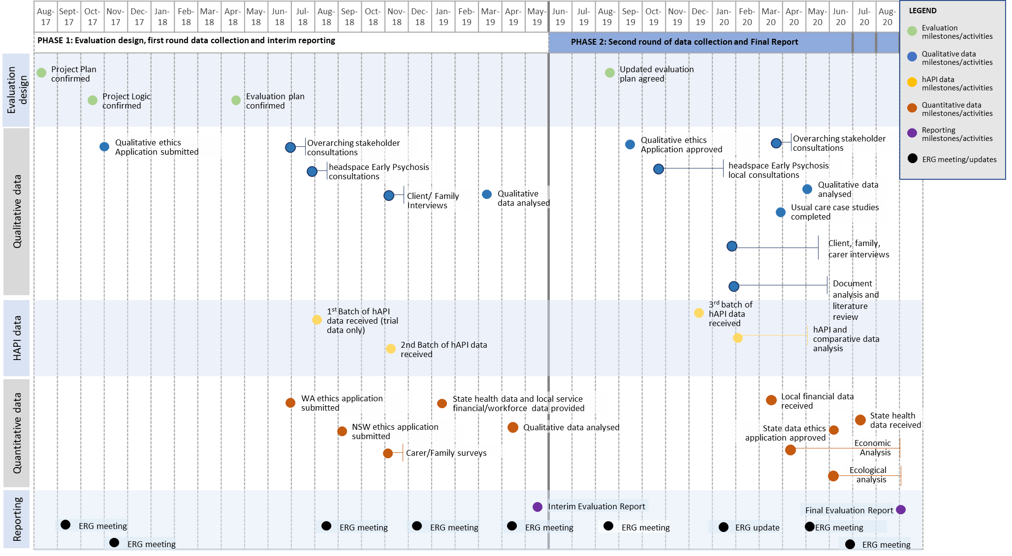

* 1. The Evaluation Reference Group

The role of the Evaluation Reference Group was to support the Evaluation by providing strategic advice to the Australian Government Department of Health and the Evaluation Team, assist in resolving issues that arose during the Evaluation, and to advise on aspects of evaluation design, methodology and interpretation of findings.

The Evaluation Reference Group members and terms of reference (See Appendix H) brought a wide range of expertise and experience to support the Evaluation, including mental health service planning, mental health service commissioning, mental health needs of young people, mental health data, evaluation design, research methodology, clinical expertise, and a lived experience with, or caring for someone with mental health.

1. Summary of evaluation findings
   1. Summary key findings for Evaluation Question 1: Effectiveness of the implementation of the EPYS Program

This section details the *summary key findings* for the following evaluation questions – the detailed findings can be found in Section 5:

| Evaluation question | Secondary evaluation questions |
| --- | --- |
| 1. How effective has the implementation of the EPYS Program been to date and what can we learn from it? | 1. How has policy shaped the implementation of the program? 2. To what extent has the EPYS Program been implemented as intended? 3. To what extent has the EPYS Program reached the target population? 4. How successfully has the EPYS Program integrated within the local health and other service systems? |

* + 1. How has policy shaped the implementation of the program?

There is strong evidence to indicate the EPYS implementation was hindered by program policy and governance, particularly the funding wind down of the program in 2016 and the complex governance arrangements of the program at both the national and local levels.

The key findings regarding how policy has shaped the implementation of the EPYS Program included:

* The first EPYS service commenced in 2014, with six services or clusters being established across NSW, QLD, VIC, WA, the NT and SA. From 1 July 2016, the Australian Government began to transition mental health program funding to PHNs to create a mental health flexible funding pool. PHNs were to increasingly commission early intervention support to young people with, or at risk of, a broader range of severe mental illness managed in the primary care setting, including those presenting with Early Psychosis.
* As a result, transition funding arrangements were put into place for each of the headspace Early Psychosis services or clusters. From 1 July 2016 the funding was wound down as per these arrangements. These policy and funding decisions impacted the early implementation of the EPYS Program, particularly the period of reduced funding from 1 July 2016. While funding was reinstated in November 2016 (with funds flowing through to services in April 2017), the ability of the services to retain workforce, build and maintaining local relationships and prioritise program data were impacted.
* The short-term funding cycles for the EPYS Program limited the extent to which longer-term planning and investment was made by services. They reported it was challenging to implement and embed a new service when there was a risk of defunding or uncertainty of longer-term funding. All services reported that it had been difficult to maintain a service for clients when funding decisions came at late notice (that is, just before funding contracts were due to expire).
* Governance arrangements for the program were complex. They were perceived as being duplicative and involving “too many masters” – being the PHNs, lead agencies, headspace National, Orygen and the Australian Government Department of Health. Furthermore, the nature of how services were established meant that some of the clusters operated across two PHNs, LHNs, and/or had two lead agencies – adding to the complexity of local arrangements.
* The roles and functions associated with contract management of the EPYS Program transitioned from headspace National to the PHNs in July 2016. There was mixed feedback from stakeholders as to whether this change benefited or hindered the implementation of the EPYS Program. The main criticism being that some PHNs did not fully understand psychosis and the specialist nature of the program in order to effectively commission and monitor the implementation and outcomes of the service. While some PHNs had mixed opinions regarding the value of the EPYS Program in meeting local need, primarily due to the proportion of funding versus the target population being reached and reporting gaps.
* It was reported that the relationship between PHNs and services was strengthening over time but could be improved in several ways. For example, improved reporting by headspace Early Psychosis services to PHNs regarding drivers of caseload performance, improved transparency regarding funding and decision making by PHNs, improved collaboration and consistency where there were two PHNs in each cluster.
* The primary role of headspace National was the collection and reporting of program data through hAPI. They also had a role in program branding and marketing and the model integrity framework. Stakeholders reported that headspace National has established one of the most comprehensive mental health datasets in Australia and a strong brand for headspace services. However, there was opportunity for headspace National to continue to build upon the current work on the hAPI MDS, system and reporting improvements.
* Generally, staff reported that Orygen played a substantial and supportive role in the set-up, early implementation of the program and through the funding disruptions. Staff welcomed their continued involvement, investment and advocacy for the EPYS Program.
  + 1. To what extent has the EPYS Program been implemented as intended?

Implementation of the EPYS Program requires local delivery of the EPPIC model. headspace Early Psychosis services became increasingly mature in implementing the EPPIC model within their local context and were achieving ‘high’ to ‘superior’ in fidelity assessments. Achievement of caseload targets continued to be an area for improvement.

The key findings regarding the extent to which the EPYS Program has been implemented as intended included:

Implementation of the EPYS Program at the local level is called headspace Early Psychosis – it is based on the EPPIC model components and was the first time the specialist service was implemented in the Australian primary care setting (through headspace Primary centres). Fidelity across most components was actively assessed, against 14 of the 16 components. The remaining two components were not assessed due to feasibility of meeting these components within the local context the model was implemented. Fidelity assessments highlighted that all services are still working towards full implementation of the EPPIC model and continue to operate in various stages of maturity.

* Services and local external stakeholders reported strong support for the EPPIC model and its evidence base for the delivery of headspace Early Psychosis.
* The delivery of the EPPIC model in the EPYS Program was influenced by:
* How services were set-up and implemented – such as the hub and spoke model, the commencement date of services, program funding, lead agency arrangements, clinical governance, co-design and local adaptation of the model.
* The context of the local region in which the service was delivered - such as the availability of skilled workforce, the local health system and availability of services, the state and territory mental health policy, PHN regions etc.
* It was reported that funding uncertainty and the quantum of funding for services impacted implementation and was not sustainable to meet the future needs of the service. Current funding arrangements did not enable longer-term investment in the service, but also hindered the desire for longer term quality improvement initiatives – where investment in time and resources may not have the opportunity to show returns. The funding was not indexed to reflect increasing costs (such as staff, training, rent, travel, transport).
* Adelaide headspace Early Psychosis transitioned to a new lead agency during the evaluation period which impacted service operations. The transition to a new lead agency required considerable effort by staff, the new lead agency and the PHN to work through the change management process and was consistently reported as a stressful time by staff. Some of the key service impacts included: a hold on new client referrals for a 14-week period; changes to employment arrangements which resulted in turnover of staff; and an increase in clinical governance risks during the transition which needed to be effectively managed. The new lead agency recognised that the complexity and clinical risk of the services was not fully understood at the time of tendering, due to the level of information provided as part of the tender process. Despite these challenges, the service was able to reach business as usual again relatively quickly, which was credited to the determination and resilience of staff and having the EPPIC model as the basis of the service.
* A change in lead agency for one of the headspace Primary services in Western Sydney also took place during the evaluation period - resulting in a different lead agency between the co-located headspace Primary and headspace Early Psychosis services. This resulted in service fragmentation which did not previously exist, for example the use of different eMRs and split in reception staff.
* Both examples highlight that commissioning decisions need to carefully consider the benefits versus the risks of lead agency changes (particularly to headspace Early Psychosis). While ensuring that sufficiently detailed documentation is available on the scope of the service, as well as establishing the appropriate planning, support and change management processes to minimise risks and service impacts where a change of lead agency is required and is in the best interests of the community.
* Services reported that the co-location of headspace Early Psychosis with headspace Primary was appropriate and encouraged access for young people – given it provided a youth friendly, safe and accessible environment for clients and their families. However, challenges for access included providing outreach in vast geographical regions, plus the availability of public transport in some regions impacted a young person’s access.
* The presence of headspace Early Psychosis added complexity to the headspace Centres given the complex needs of the target group compared to headspace Primary. This required the continual learning and updating of processes and clinical governance across the two services. But it also enabled a more seamless pathway and experience for young people and fostered a culture of collaboration and sharing of expertise between the two services.
* The recruitment and retention of suitability skilled staff was reported to be one of the biggest challenges in implementing the model as planned. By late-2019, services reported that staff numbers were increasing to meet their target staffing profile and they were developing their workforce to be fit-for-purpose to deliver services according to the EPPIC model. Some ongoing challenges remained, such as the impact of program funding uncertainty on staff turnover, remuneration and benefits which were not competitive with state-funded health services, and the high level of specialisation required of medical staff.
* All services acknowledged that the collection of data was essential in understanding how effectively the EPYS Program was operating, the impact is was having and to inform ongoing improvement. While staff reported challenges with hAPI (for example, having to keep duplicate records with the lead agency EMR, the extent of data collection required for hAPI, the usability and usefulness of hAPI data in working collaboratively with the young person), a number of quality improvement efforts were enabled through a hAPI upgrade in mid-2019. This upgrade allowed: consolidation of systems at a national level; more configurability and less reliance on vendors; and regular updates/releases in response to service feedback. Data improvements were also supported by the introduction of data and system managers across each service or cluster, who were funded through program underspend.
* Services reported that they had evolved and refined their service intake processes over time to suit local requirements and needs (for example, by integrating headspace Primary into the intake process or having both CCT and MATT clinicians involved) and resulted in a range of approaches. For example, some services used the headspace Primary access team to undertake the initial assessment process, some used a joint team including the MATT and headspace Primary staff, while others also integrated with the CCT. These different approaches evolved to increase efficiency and improve client familiarity with the broader headspace Early Psychosis team from the outset.
* Fidelity scores against the assessed components, fluctuated over the five assessments conducted between July 2017 to November 2019 – but fidelity was higher in November 2019 compared to July 2017. All services scored ‘high’ to ‘superior’ fidelity in the November 2019 assessment, but no service or cluster reached 100 percent fidelity overall. Recruitment and retention of staff (including peer workforce) was a key factor that impacted fidelity assessment scores. Service strengths and improvements as highlighted in assessments included: inclusion of physical/metabolic health services, recovery star being embedded into clinical care, service consistency and well-developed procedures and processes. Service improvement opportunities as highlighted within assessments included: caseloads, referral numbers, successful and strategic community engagement, staff training to ensure best practice.
* All services or clusters experienced a decline in fidelity between July 2018 and November 2019 for continuing case management. The key challenge faced in relation to continuing case management was the ability to meet caseloads. Whilst some services were able to achieve their caseload target of 15-20 clients per CCT FTE, a separate cluster/service caseload target existed (established at commencement of the program by Orygen) which services did not achieve – the latter target was based on cluster/service budgets rather than actual CCT FTE. Caseloads were challenging for several reasons; including the impact of funding uncertainty, alternative state-funded Early Psychosis services being available and awareness of the service by referrers and the community. Some services had applied caseload weightings to assist with distributing caseloads based on client complexity. Western Sydney undertook an internal restructure which increase clinical FTE and improved the ability to meet caseload targets. Low caseload numbers were a key concern raised by PHNs in determining the value of the EPYS Program.
* Functional recovery and group programs formed a critical part of the model and were reported to be a key factor in achieving sustainable outcomes for clients. Across the Evaluation period, services generally reported further developing and growing the FRPs and group programs, which was consistent with the fidelity data. One example of this was at South East Queensland where the FRP had become better integrated into the MATT and CCT team which enabled functional recovery to be more embedded into service delivery. These improvements were further validated in client outcomes data as explained in Section 3.
* The involvement of a peer support workforce varied across services, primarily due to how well resourced they were to deliver this component and how mature the services were to identify appropriate candidates and build that workforce. There was a strong desire to continue to grow and invest in the peer workforce across the services, given the value some clients and their families placed in it. Despite this, some services had also worked towards better embedding young people into the delivery of the model. For example, the establishment of youth reference groups (multiple services), peer review of outgoing communications North Perth) the development and delivery of education programs (South East Melbourne), committee participation (Western Sydney) and peer support workers participating in staff interviews (South East Melbourne).
* Services were able to implement some of the 16 components of the EPPIC model more effectively than others – for example, mobile outreach, group programs, partnerships, functional recovery and workforce development were consistently implemented to ‘maximum fidelity’[53].
* The components of ‘streamed youth friendly inpatient care’ and ‘access to youth friendly sub-acute beds’ were not measured given the limited availability of youth friendly inpatient and sub-acute beds in some regions. Some services (Darwin, South East Melbourne, North Perth, South East Queensland) were able facilitate access to these services through Service Level Agreements or Memoranda of Understanding with their Local Hospital Network where they were available.
* All services reported that while they increased their after-hours coverage, the provision of 24-hour care was an enormous challenge – particularly in terms of financial viability, clinical risk and staff safety.
  + 1. To what extent has the EPYS Program reached the target population?

Clients in the EPYS Program were reflective of the target population with good representation from Indigenous and LGBQ communities. Reach of the target population was somewhat hindered by the limitations in meeting target caseloads. The program was also inherently limited in its ability to reach populations in rural and remote regions given it was delivered in a metropolitan setting.

The key findings regarding the extent to which the EPYS Program reached the target population included:

* headspace Early Psychosis provided services to young people aged between 12 and 25 years of age (at the point of referral to the program) who experienced their first episode of psychosis or who were at risk of developing psychosis.
* While the EPYS Program was a national program, it did not have national reach as no services existed in Canberra or Tasmania and there were no services located outside of metropolitan areas.
* The caseload targets set for each service by the Department of Health/Orygen at the establishment of the program were not achieved by any service.
* In keeping with the model for headspace Centres, there were no defined catchment areas for the headspace Early Psychosis services. However, all services reported that they travelled up to one hour from the headspace Centre to provide services to young people.
* Compared to the general population, the EPYS Program clients were more likely to be:
* Male and LGBQ
* Many of the participants were either still in school or did not finish school
* Already in receipt of government benefits
* Had less vocational and educational participation
* Had a higher rate of substance use, particularly cannabis and smoking.
* The most common referral sources into the FEP and UHR treatment arms were from:
* Public psychiatric specialist service providers (e.g. psychiatrist, paediatrician, or in-patient service) – ranging from 10.1 percent in Darwin to 38.3 percent in North Perth
* Community-based mental health services, for example, Child and Adolescent Mental Health Services (CAMHS) or Adolescent Mental Health Services (AMHS) – ranging from 4.7 percent in Western Sydney to 30 percent in Adelaide
* Self-referral – ranging from 3.3 percent in Adelaide to 30.3 percent in Western Sydney.
* Referral sources varied substantially by service, this was due to headspace Early Psychosis service configuration, local health service context, service availability and possibly recording practices.
* The representation of young people in the EPYS Program across special interest groups was mixed, for example:
* Indigenous youth were well represented. Data from hAPI showed that youth who identified as Indigenous in headspace Early Psychosis represented 7 percent (excluding Darwin) and 25 percent (Darwin only) of the total number of clients treated.
* LGBQ clients were well represented. Data from hAPI showed that 12 percent of clients identified with a sexuality of Lesbian, Bisexual, Gay or Queer/Questioning. This is significantly higher than the LGBQ population of Australia which is 3.2 percent.[54]
* Approximately 25 percent of the Australian youth population are from a CALD background.[55] Within the EPYS Program, representation of clients born overseas was 10 percent and non-English speaking was 14 percent. This representation, particularly within the UHR cohort is an opportunity for improvement. Stakeholders reported that CALD communities were less likely to identify that they had a mental health concern or seek treatment and that mental health was highly stigmatised in their communities, thus making it difficult to engage.
* The level of awareness of headspace Early Psychosis prior to entering the program varied and this influenced the reach of the program. Word of mouth, internet searches, and other health services played an important role in awareness, as did headspace branding and reputation. Access to mental health support from other community-based services (e.g. private psychologists) prior to engagement with headspace Early Psychosis was common, which indicates that opportunity to improve engagement with these services exists.
  + 1. How successfully is the EPYS Program integrated within the local health and other service systems?

The extent of integration with the local health system varied across services, with relationships and partnerships developing over the evaluation period. These required significant investment in establishing the service, but also after the period of reduced funding to rebuild trust in the service. Some services had developed formal partnerships as demonstrated through service-level agreements or Memoranda of Understanding, as well as meaningful partnerships with other service providers.

The key findings regarding the extent to which EPYS Program is integrated with local health and other service systems included:

* headspace Early Psychosis operated in a complex environment which required interaction and integration with many stakeholders. Internally, integration was required between different lead agencies within a cluster, with headspace Primary, between hubs and spokes, and amongst internal teams (MATT, CCT and the FRP) which sometimes operated quite separately. Externally, partnerships and integration with a broad range of stakeholders was required to successfully deliver services.
* Clusters with two lead agencies reported improvements in working relationships between the two agencies over time, but it required considerable effort by both lead agencies and involved the establishment of protocols for clinical governance, administrative matters and information sharing.
* The extent of local integration was influenced by how challenging these arrangements were. For example, some clusters had more than one PHN and/or lead agency and so these relationships required more time and effort to foster between the different organisations across the cluster.
* Funding instability impacted the reputation, relationships and integration of headspace Early Psychosis with external stakeholders. Services had to invest significant time and effort to re-establish and re-build trust and stakeholder relationships in a proactive way, while education and awareness of the program was ongoing. Despite these challenges, the program established a positive reputation within the community and amongst most external stakeholders.
* External stakeholders did not perceive that multiple or separate organisations were responsible for delivering the service and this united front was reported to be predominantly attributed to the headspace branding of the service.
* There was a perception by some LHNs that headspace services were not able to see complex clients, resulting in confusion around who could be referred to headspace Early Psychosis.
* The extent of integration between the headspace Early Psychosis program and LHNs improved over the Evaluation period and was dependant on local context and the culture of the local health system. This varied both across clusters and within a cluster. Some services were impacted by the legacy of funding decisions for the EPYS Program – where some LHNs appeared less willing to work collaboratively due to the funding decision which saw the EPYS funding directed to primary care rather than states and territories.
* There was increasing use of Service Level Agreements or Memoranda of Understanding by services with their Local Hospital Network across the Evaluation period (for example, in Darwin, North Perth and South East Queensland), which indicated these services had become more integrated into the local health system.
* All LHNs reported that the demand for mental health services in their region was so great that they could not address the issue within their existing resources. They reported that headspace Early Psychosis service benefited the health system through their ability to see UHR clients and deliver functional recovery – given they were not as well-resourced to do these.
* Most LHNs reported that headspace Early Psychosis was a valuable service and if it were to cease, this would likely result in longer wait times in the tertiary setting and more young people in adult mental health services.
* External local stakeholders reported that the absence of the headspace Early Psychosis service and reduced funding for early intervention would likely lead to increased pressure on state-funded health services. As it would mean less capacity in the system to make a meaningful difference to the lives of vulnerable young people and their independence going forward. Overall, they generally reported that the headspace Early Psychosis program helped to “bridge the gap” in the public health system and capacity to provide early intervention.
* The experience of young people and their families of the integration between the hospital and headspace Early Psychosis was highly dependent on multiple contextual factors including geographical (e.g. location of the hospital), temporal (e.g. when the hospitalisation occurred, the length of hospitalisation), organisational (e.g. the culture of the hospital, the strength of the established link between hospital and the headspace Early Psychosis) and individual (e.g. case-manager approach, client preference). Opportunities to improve integration particularly around key transition points, for example, as patients were discharged from hospital were identified.
  1. Summary key findings for Evaluation Question 2: Appropriateness of the EPYS Program design to deliver outcomes

This section details the *summary key findings* for the following evaluation questions – the detailed findings can be found in Section 6:

| Evaluation question | Secondary evaluation questions |
| --- | --- |
| 1. How appropriate is the EPYS Program design to deliver the program outcomes? | 1. To what extent is program design acceptable and relevant to clients and their families? 2. To what extent does the program design align with the policy and practice of the broader system of care for young people experiencing Early Psychosis or other severe mental illness? |

* + 1. To what extent is program design acceptable and relevant to clients and their families?

There is strong evidence to support that the EPYS Program is both relevant and acceptable to clients and families. Support for the program’s design was also reported consistently by internal and external stakeholders. Reported concerns of families and clients with the program did not indicate underlying issues with the program design.

The key findings regarding the extent to which the EPYS Program design is acceptable and relevant to clients and their families included:

* headspace Early Psychosis was generally viewed as acceptable and relevant for most young people and families, with approximately three quarters of comments highlighting positive aspects of the program that suited the young person and family’s needs.
* Compared to other services young people and families had accessed for mental health support, most held a preference for headspace Early Psychosis. This was attributed to factors such as: (1) program accessibility, being an inclusive and welcoming environment and the targeted youth focus; (2) having a range of supports provided under one service, along with choice and flexibility in engaging with the service which was tapered based on acuity of mental health needs at the time; (3) the mental health support and planning provided; (4) holistic support that promoted a biopsychosocial approach; and (5) the involvement of young people in decision making about their care. These findings were in line with reports from the young people interviewed who were accessing state-funded Early Psychosis services.
* Opportunities which may improve acceptability and relevancy included: reducing staff turnover to promote greater continuity of care, improvements in communication (at an individual and organisational level), and intensified support at transition points in a young person’s life (such as hospitalisation, medication changes, starting or ceasing employment, discharge from headspace Early Psychosis).
* Client satisfaction of the service was also recorded within hAPI at each 90-day review. Generally, all clients who completed the survey rated the five aspects of the headspace Early Psychosis Program very highly. Overall, 90.91 percent of responses were ‘Satisfied’ or ‘Very satisfied’.
* Satisfaction with headspace Early Psychosis was also reflected in the level of drop out from service. The dropout rate amongst all discharged episodes was 22.12 percent for UHR and 21.46 percent for FEP (noting that this may not represent the true dropout rate, since a large portion of discharges have no information about future care decisions).
* headspace Early Psychosis staff reported that while clients do drop out of the service, it has not been as high as they expected and drop out occurs for a variety of reasons. For example, when a client is doing well, they might need less intensive treatment at that time and, as such, they do not require as many occasions of care or interactions with the service. Staff reported that the program can be quite intensive and time consuming for clients and their families. As such, having flexibility in the program is beneficial to focus on the priority for the young person at the time for example, finding employment, as this assists with engagement.
  + 1. To what extent does the program design align with the policy and practice of the broader system of care for young people experiencing Early Psychosis or other severe mental illness?

In most part, the EPYS Program design, as enabled through the EPPIC model, aligned with the broader system of care and future policy direction of the Australian mental health system.

* There are numerous policies, reforms and inquiries underway that will influence the broader system of care, collectively, these efforts encourage: early intervention for mental health; consumer/client centricity; culturally appropriate care; equitable access to care; alignment with local needs; holistic and community-based care; policy and service integration; and value-based care.
* The EPPIC model which forms the basis of the EPYS Program, was and is very much aligned to the broader system of care (as outlined above). The EPPIC model was pioneered in Australia is a world class evidence-based model that is considered an exemplar approach to early intervention. This is also supported through the wide adoption of the EPPIC model, both internationally and by state-funded health services in Australia.
* An important aspect of the EPPIC model, considering the broader system of care, is the provision of treatment for young people who are at UHR of psychosis. The provision of care to this cohort is a fundamental gap in the Australian mental health system given state-funded health services have limited capacity to deliver services to this cohort given their focus is on those in crisis. As such, the EPYS Program has offered a truly preventive mental health service for the cohort by targeting clients before they become acutely unwell.
* A differentiating yet valuable aspect of the model which was consistently highlighted by external stakeholders, clients and families was the provision of functional recovery and the presence of peer support staff. These were aspects of care that external stakeholders considered to be a gap within the state-funded health system.
* As services were working towards maximum EPPIC model fidelity and varied in fidelity across the assessment periods (see Section 5.2.3), the opportunity to improve alignment with the broader system of care, relative to the EPPIC model, remains.
* The implementation of the EPYS Program and other program design features indicate areas of alignment, as well as opportunities to better align with the broader system of care. These have been detailed in Evaluation Question 1 (see Section 5). The most notable areas of alignment were in relation to: adaption to local needs and culturally appropriate care; the development of formal and informal partnerships at a local level; a client centric focus enabled through the one-stop shop headspace Centres; and service equity enabled through provision of universal health care.
* The opportunities to improve alignment with the broader system of care relate to: (1) the limited reach (and therefore equity of access) possible through the current design and implementation; and (2) improved policy direction from all levels of government on specialist mental health services particularly around integration/pathways of care, which PHNs can use to inform future commissioning decisions for the program which best meet local need and in collaboration with relevant stakeholders.
  1. Summary key findings for Evaluation Question 3: Effectiveness of the EPYS Program in achieving outcomes

This section details the *summary key findings* for the following evaluation questions – the detailed findings can be found in Section 7:

| Evaluation question | Secondary evaluation questions |
| --- | --- |
| 1. How effective is the EPYS Program in achieving outcomes for young people and their families? | * 1. How effective is the EPYS Program in reducing the duration of untreated psychosis?   2. How effective is the EPYS Program in reducing the severity of symptoms for young people with or at risk of Early Psychosis?   3. How effective is the EPYS Program for young people with or at risk of Early Psychosis in reducing risk behaviours?   4. How effective is the EPYS Program in reducing the impact of young people with or at risk of Early Psychosis, on health service utilisation?   5. How effective is the EPYS Program in reducing or delaying the transition to full threshold psychosis?   6. How effective is the EPYS Program in restoring the functional trajectory of young people with or at risk of Early Psychosis?   7. How effective is the EPYS Program in improving the capacity of families to support and maintain relationships with young people with Early Psychosis?   8. How satisfied are clients and their families with the EPYS Program? |

Evaluation Question 3 aimed to determine how effective the EPYS Program is in achieving outcomes for young people. The key outcomes for evaluation were *reducing* the duration of untreated psychosis (DUP), the severity of symptoms, risk behaviours, health service utilisation, transition to psychosis, as well as *restoring* the functional trajectory of young people to education or employment and *improving* capacity of families to support young people. The major source of data to answer these questions was routinely collected data (hAPI). However, a major limitation in attributing improvements in outcomes for young people to EPYS was the lack of a suitable comparator against which to quantify the benefits of the program.

* + 1. How effective is the EPYS Program in reducing the duration of untreated psychosis?

It was not possible to accurately determine whether the EPYS Program was successful in reducing DUP due to how data is collected and how this outcome is measured.

The key findings regarding how effective the EPYS Program has been in reducing DUP included:

* A central assumption of the EPPIC model is that better outcomes are achieved by reducing the DUP, usually defined as duration from the first onset of psychotic symptoms to the first treatment with antipsychotic medication.
* One of the primary modalities of treatment for psychosis is antipsychotic medication, with first prescription required for the definition of DUP. Non-compliance with antipsychotic medication is a major risk factor for relapse. At any one time point only 75-80 percent of FEP treatment arm clients were recorded as being prescribed antipsychotic medication, with the pattern of antipsychotic prescription varying between services. The antipsychotic treatment rate in UHR clients varied markedly by service, with rate of antipsychotic prescription generally increasing over time, potentially reflecting use for other conditions (i.e. atypical antipsychotics are indicated for bipolar disorder).
* Of 977 FEP episodes, only 398 (41 percent) had valid information recorded to determine a DUP. 30 percent of FEP episodes with valid data were already prescribed antipsychotic medication at assessment and their DUP reflects treatment by other services. The median DUP was very short (3 weeks) and was the same for both FEP clients who had been prescribed antipsychotics prior to the EPYS Program and those prescribed antipsychotics for the first time at entry into the EPYS Program.
* Young people reported a wide variety in the duration of time they had been experiencing either mental health issues or psychosis symptoms, from recent sudden onset to “Since I was a young kid”. The intensification of symptoms, or a particular crisis incident, generally was the impetus to seek help from headspace Early Psychosis.
  + 1. How effective is the EPYS Program in reducing the severity of symptoms for young people with or at risk of Early Psychosis?

Symptom severity substantially reduced for young people after entry into the EPYS Program, but it was difficult to attribute this change to the program itself.

The key findings regarding how effective the EPYS Program has been in reducing the severity of symptoms for young people with or at risk of Early Psychosis included:

* At assessment FEP clients had more severe general psychiatric symptoms but lower levels of distress than UHR clients. Overall, the young people showed significant reduction in psychiatric symptoms with treatment.
* FEP clients made almost all symptom gains in the first three months but appeared to continue to make small symptomatic gains with ongoing care. While UHR clients showed ongoing symptom improvement with longer care and UHR clients with longer engagement had slightly more severe general psychiatric symptoms at assessment compared to those with shorter time in the program.
  + 1. How effective is the EPYS Program for young people with or at risk of Early Psychosis in reducing risk behaviours?

Some risk behaviours of young people reduced after entry into the EPYS Program. However, the reduction in some risk behaviours was difficult to measure due to the low rate of these behaviours at entry in the program.

The key findings regarding how effective the EPYS Program has been for young people with or at risk of Early Psychosis in reducing risk behaviours included:

* The proportion of clients reporting incidents of self-harm, aggression and suicide attempts were low, with self-harm being twice as common in UHR clients than FEP clients. The prevalence of these incidents did not change over time in the treatment program.
* One third (32.5 percent) of EPYS episodes were rated as at least moderate suicidality at assessment. There was a rapid and sustained decrease in clinician rated suicidality after initial assessment for both UHR and FEP. However, a quarter of clients with at least moderate suicidality continued to present this higher risk at subsequent reviews. Those reporting a low suicide risk at assessment generally sustained this, but services need to be aware of a small percentage whose risk increases, at least temporarily, over time.
* All forms of substance use were more frequent in EPYS clients than young people within the general population, with tobacco and amphetamines being used far more frequently. The greatest reduction in the proportion of young people reporting frequent substance users occurs in the first 90-days after assessment.
* About half of daily tobacco smokers and weekly alcohol drinkers continue to use these substances at the same frequency. Two thirds of daily cannabis users reduce the frequency of use by 90 days. At least a quarter of frequent amphetamine users continue to use amphetamines at least monthly. The observed decrease in the numbers of frequent substance users in the program is in part due to such clients being more likely to leave treatment.
* In terms of risk-related behaviours, young people and families reported headspace Early Psychosis provided support to address self-harm, suicidal thoughts, behaviours and acts, and substance misuse. For self-harm and suicide related risk behaviours, headspace Early Psychosis provided assessment, practical and mental health support as well as relief for families.
  + 1. How effective is the EPYS Program in reducing the impact of young people with or at risk of Early Psychosis, on health service utilisation?

The young people in the EPYS Program did not experience different rates of health services utilisation compared to other young people with psychosis. The program was reported to have assisted with reduced length of stay and reduced readmissions; however, this was not evidenced in the ecological analysis.

The key findings regarding how effective the EPYS Program has been in reducing the impact on health service utilisation included:

* The number of days spent in inpatient units or sub-acute units was recorded[56] at every review and discharge by headspace Early Psychosis staff. Only one in 20 UHR and one in 10 FEP clients report any admission in the previous three months at each review. There was no reduction in the proportion of clients hospitalised, or the days in hospital, with increasing time in the program.
* An ecological analysis explored baseline client characteristics within NSW and WA for EPYS and non-EPYS individuals. To be ‘eligible’ for the ecological analysis, individuals had to be born between 1 July 1990 and 1 July 2006 and have at least one hospitalisation with an ICD-10 coded psychosis diagnosis (primary or other) from 1 July 2010 onwards.
* In NSW, a total of 8,629 individuals met the eligibility criteria. The overall mean age was 19.6 years with 44 percent female. Baseline rates of health service utilisation were very similar between the EPYS and non-EPYS metropolitan regions; however, they were lower in the regional non-EPYS region.
* In WA, a total of 2,490 individuals met the eligibility criteria. The overall mean age was 19.7 years with 43 percent female. Baseline rates of health service utilisation were similar across all three regions (EPYS, non-EPYS metropolitan and country WA) but with less bed days and more emergency department admissions in country WA.
* The ecological analyses conducted in NSW and WA showed no evidence of a difference in the time trends of hospitalisation rates of young people with psychosis over the period the EPYS Program was implemented between regions where an EPYS Service was situated and regions not including EPYS.
* In NSW, the data did not include data from private hospitals from July 2018 onwards, therefore, the data was truncated on 1 July 2018. In NSW, between July 2017 and July 2018, the adjusted hospitalisation rate ratio for young people with psychosis was 1.05 (95 percent CI 0.89 to 1.23, p=0.56) for EPYS versus non-EPYS metropolitan catchments. There was a significant increase in the rate of emergency department admissions in EPYS regions with a rate ratio of 1.21 for the July 2017 – July 2019 period (95 percent CI 1.04 to 1.41, p-value 0.012).
* In WA, between July 2017 and July 2019, the adjusted hospitalisation rate ratio was 1.07 (95 percent CI 0.88 to 1.30, p=0.47) for EPYS versus non-EPYS metropolitan catchments. No significant differences were observed for any secondary measures of health service utilisation (for example, emergency department presentations, psychosis-related admissions or days on psychiatric care).
* In NSW, about 82 percent of young people hospitalised for psychosis also had at least one episode of care by a state-funded Early Psychosis service from 2015 onwards. This proportion was similar in area with and without EPYS.
* The findings from the ecological analysis highlight that treatment of psychosis is complex and importantly, that the EPYS Program is not a substitute but rather a complement to the state-funded health system – integration is therefore necessary.
* Every young person and family member interviewed in the second round of interview had some level of hospital contact before and/or during their time with headspace Early Psychosis. The number of contacts with hospital varied — with over half of young people (or the young people the family member supported) having multiple admissions, a fifth having one admission only, and a small proportion presenting at the hospital emergency department without having an overnight admission. Hospital admission length ranged from overnight to six months. Approximately half of young people had a hospital admission which led to a headspace referral.
* When considering impact of headspace Early Psychosis, approximately half of all young people and their families did attribute their involvement with headspace Early Psychosis to facilitating early discharge from hospital, avoiding rehospitalisation, or any admission to hospital as the young person could be effectively supported in the community.
* Conversely, a small proportion young people or family members did not feel that involvement from headspace Early Psychosis impacted their admission or the length of hospitalisation. This was chiefly attributed to headspace not being part of the decision-making process.
* Further, approximately a quarter of young people and families reported that headspace Early Psychosis missed opportunities that could have resulted in the young person avoiding hospitalisation — particularly because of issues with medication changes or compliance, communication issues with staff, or the young person or family member being unable to contact MATT after hours.
* The experience of hospitalisation was highly dependent on the case manager supporting the young person — as their support style, coordination of care, knowledge of the client, communication and assertive engagement could vary. Further, how well headspace Early Psychosis was integrated with the hospital system impacted the young person and their family’s experience.
  + 1. How effective is the EPYS Program in reducing or delaying the transition to full threshold psychosis?

The one-year transition rate of clients from the UHR to FEP treatment arm was 6.1 percent, which was slightly better than the one-year transition rate within a comparative service cohort (Transitions Study) in 2012 of 8.09 percent (See Appendix G). However, this rate is not conclusive as it does not include those that dropped out of the program, and it was not possible to attribute changes in rate to the EPYS Program itself.

The key findings regarding how effective the EPYS Program has been in reducing or delaying the transition to full threshold psychosis included:

* Within the literature (Appendix A) there was evidence of a decline in transition rates in recent UHR cohorts, with rates as low as 8 to 28 percent in one year[57]. Although not published, the Transitions study (conducted in 2012) recorded a transition rate of approximately 8.09 percent (see Appendix G for a detailed comparison).
* To evaluate the one-year UHR to FEP transition rate only UHR clients assessed at least one year prior to the Evaluation date when the hAPI data extraction occurred (n = 523). The prospective one-year transition rate from UHR to FEP was 6.1 percent for all people starting the UHR treatment arm one-year before the evaluation date. The broader inclusion criteria for the EPYS UHR treatment arm compared to the usual definition of “at risk mental state” in research trials limits the comparative transition rate with the literature i.e. UHR clients in the EPYS Program may have an inherently lower risk of transitioning. There was no evidence that the transition rate in the 70 percent of UHR clients with a formally defined “at risk mental state” was different to the other 30 percent of UHR clients.
* The total number of young people who started the UHR group and who were still engaged in the EPYS Program at each review who had transitioned to the FEP treatment was explored. Only half of all UHR clients still engaged with EPYS after a year had not transitioned to FEP. This suggests that the UHR treatment arm engages high risk clients for a longer time than low risk clients.
  + 1. How effective is the EPYS Program in restoring the functional trajectory of young people with or at risk of Early Psychosis?

The EPYS Program was effective in improving the functional trajectory of young people (especially in the FEP treatment arm), with this improvement plateauing after six months.

The key findings regarding how effective the EPYS Program has been in restoring the functional trajectory of young people with or at risk of Early Psychosis included:

* The clinician rated Social and Occupational Functioning (SOFAS) increased over time in both UHR and FEP treatment arms. Gains appeared to plateau after the 180-day review, with the mean SOFAS score still below 70 – the level at which the young person has “some difficulty in social, occupational, or school functioning, but generally functioning well, has some meaningful interpersonal relationships.” The UHR treatment arm clients made less improvement in functional outcomes over treatment, quite possibly because their functional trajectory was less impaired at entry to the service. FEP clients, but not UHR clients, experienced a greater change in functional improvement than the like-service comparator.
* Lack of societal participation of young people - those ‘Not in Education, Employment or Training’ (NEET) is important to clinicians, policymakers and researchers as this signifies a disengagement from both the labor market and education, major avenues of human development.
* Improvement in the societal participation of young people in the program was seen in the first six months, with little change, if any, after that time. Those in the FEP treatment arm had higher rates of NEET status at assessment and around 1 in 5 remained NEET, higher than the rates in seen in the general young adult population in Australia. The UHR rates of NEET status after 180 days (c10 percent) were similar to those seen in the general young adult population in Australia.
* Every young person and family member interviewed identified several areas of functioning in the young person’s life which had improved since commencing with headspace Early Psychosis. Approximately three quarters of overall comments about functional trajectory related to improvements in areas of young people’s lives. The most commonly reported shifts in functional trajectory related to education, employment and relationships and socialising.
  + 1. How effective is the EPYS Program in improving the capacity of families to support and maintain relationships with young people with Early Psychosis?

The EPYS Program was generally effective in improving the capacity of families to support and maintain relationship with young people engaged in the program.

The key findings regarding how effective the EPYS Program has been in improving the capacity of families to support and maintain relationships included:

* Although some young people were hesitant about having their family or carers involved in their support at headspace Early Psychosis, they reported feeling supported to have agency in decisions around the level of involvement.
* Families who were not fully involved in the young person’s support, still reported sufficient levels of support from headspace Early Psychosis, despite the situation being challenging. The support offered by headspace often centred on the provision of psycho-education and support through family therapy, counselling, communication with case managers or psychiatrist and through information or family peer support sessions (EPPIC model Fidelity: Family Programs & Family Peer Support).
* Many young people and families suggested that the support had improved the family dynamics, the support and understanding the family can provide the young person, and a feeling of connection with other families facing similar situations.
* Although support was generally offered, some family members themselves did not always want support, and there were a small proportion of families who reported the support was also not the right fit for them. Further, although interested, some of the family education or peer support group sessions had access barriers so not all families could easily engage (e.g., waitlist, location and travel time).
  + 1. How satisfied are clients and their families with the EPYS Program?

Clients and families are very satisfied with their experience of the EPYS Program.

The key findings regarding how satisfied clients and their families were with the EPYS Program included:

* Young people and families were predominantly very satisfied with headspace Early Psychosis in the interviews and focus groups (at all time-points from 2018 to 2020). Participants from the state-funded Early Psychosis comparison sites, also were highly satisfied with the service they received.
* In terms of young people and families baseline needs when coming into the program, all participants spoke of a period of being acutely unwell whether this was experiencing psychosis or other mental health symptoms for which they were requiring support. This frequently was the cause of great distress for young people and families often was not being satisfactorily addressed by other services and thus led to headspace Early Psychosis or hospital engagement.
* Once receiving support from headspace Early Psychosis, young people and family’s expectations for the program were quite varied, ranging from wanting support for their mental health, access to psychiatry, strategies and treatment. Others reported wanting a quick “fix” to the issue, and others reported not knowing how headspace Early Psychosis could help. After a period of support from headspace Early Psychosis, program expectations were generally met or exceeded.
* When considering their experience through the lens of satisfaction, young people and families reported that the multi-faceted youth-focused service, with its highly supportive and flexible staff provided holistic and individualised support and outreach, chiefly met their needs.
  1. Summary key findings for Evaluation Question 4: The efficiency and cost effectiveness of the EPYS Program

This section details the *summary key findings* for the following evaluation questions – the detailed findings can be found in Section 8:

| Evaluation question | Secondary evaluation questions |
| --- | --- |
| 1. How efficient and cost-effective is the EPYS Program? | 1. How efficiently have EPYS Program resources been used? 2. How cost-effective is the EPYS Program compared with usual care?[58] 3. Is there a minimum target population size required for cost-effective delivery of the EPYS Program? |

* + 1. How efficiently have EPYS Program resources been used?

The cost per client was the primary outcome metric used to measure the efficiency with which EPYS program resources were used. Cost per client varied substantially across clusters and over time from $10,405 (South East Queensland) to $23,927 (North Perth). On average, the cost per client was $15,823 across all clusters or services, which was high for a program of this type. Variations in cost were not correlated with the size or governance arrangement of services.

The key findings regarding how efficiently EPYS Program resources have been used included:

* The average cost per client ranged from $10,405 (South East Queensland) to $23,927 (North Perth), with a mean of $15,823 across all clusters or services.
* The average cost per client was correlated with the number of direct OOS delivered to clients. However, variation in the number of direct OOS could only be explained in part by the following explanatory variables:
* Differences in the ratio of FEP to non-FEP clients
* Variations in the type and length of services delivered to clients – with a focus on face-to-face services
* Workforce composition
* Workforce productivity
* Cluster characteristics (i.e. single service versus hub and spoke service).
* It could not be determined if services delivering higher numbers of direct OOS were achieving better client outcomes, as the client sample size at an individual service level were too small to be analysed in isolation.
* Services with more complex governance arrangements did not experience higher costs per clients.

Number of clients

* The number of clients varied between clusters and was not perfectly related to the number of spokes in a cluster. South East Queensland recorded significantly more clients serviced than North Perth, despite having fewer spokes (one compared to two spokes for North Perth).
* Western Sydney recorded a large change in the number of clients between evaluation years – an increase of 47 percent. In addition:
* This was accompanied by a five percent decrease in the total number of direct OOS, suggesting that the cluster was at direct OOS capacity in the previous financial year. Workforce data was not available from Western Sydney for both years which prevented further interrogation of this hypothesis.
* The impact of the additional clients was a reduction in the direct OOS per client. There may also have been fewer direct OOS in 2019 due to an increased administrative burden which reduced the time clinicians had to deliver direct OOS.

Client type

* As the proportion of FEP to UHR clients increased, the direct OOS per client and consequently cost per client also increased. However, there was significant variation in the cost per client amongst services which had similar proportions of FEP clients. For example:
* North Perth was, on average, $23,297 per client with 73 percent of its clients FEP
* South East Melbourne was, on average, $16,592 per client with 56 percent of its clients FEP
* Adelaide was, on average, $13,990 per client with 70 percent of its clients FEP in 2019.

Type and length of services delivered to clients

* There was a positive relationship between the cost per client and the average hours of face-to-face service delivery per client:
* North Perth’s relatively high cost per client can be explained by its relatively high service delivery levels
* Likewise, South East Queensland’s low cost per client can be explained by its relatively low service delivery per client, compared to other clusters
* The cost per service delivery day analysis indicates that if the number of days of service per client was uniform across services, then the cost per client would be more uniform.
* The positive relationship persisted, even after controlling for the service delivery mode. North Perth recorded more SMS direct OOS than other clusters, potentially owing to a difference in the measurement/recording approach (i.e. how many individual SMS messages are counted in a single direct OOS). After controlling for average length of service, North Perth delivered more hours of SMS service delivery than other clusters suggesting that measurement error did not impact the interpretation of the result.

Workforce composition

* There were some differences in workforce composition between sites in terms of clinical/nursing to non-clinical staff, but these are largely explained by cluster size. Single services had a higher proportion of management and administrative staff to clinical/nursing staff. Adelaide and Darwin had 17 percent and 23 percent respectively, compared to 8 percent to 14 percent for the other clusters. This indicated that clusters can achieve economies of scale by centralising management and administrative work at the hub.
* Despite this, there was not a clear relationship between workforce composition (in terms of non-clinical staff) and cost per client – with Adelaide and Darwin both delivering services at or below the average cost per client.
* There was significant variation in clinical/nursing staff between sites. The source of variation in staff type may be due to differences in how staff roles are recorded – for example, the extent to which leadership/management staff also engage in direct clinical work.

Workforce productivity

* The average number of clients per FTE employee was consistent with the results for the average cost per client. North Perth had the fewest clients per FTE employee (six) and South East Queensland had the most clients per FTE employee (15).
* There was a negative relationship between the cost per client and the cost per service delivery day. The negative relationship suggests that clusters with a high cost per client (North Perth, Western Sydney) do not have lower labour productivity than other clusters, but are providing more services.
* There was no clear relationship between days of service delivery per FTE and cost per client. The Western Sydney cluster delivered the most hours of face-to-face service delivery (77) per FTE and Adelaide delivered the least (42) in 2019.

Cluster characteristics

* The size of the cluster (in terms of its number of spokes) was not a reliable predictor of cost per client, suggesting that economies of scale in cost per client were not present in all large clusters:
* This result can be explained by the variance in the number of direct OOS per client delivered by clusters.
* Hubs recorded higher costs than spokes (approximately three times higher on average). The housing of the clinical staff in these services which cater to the clinical needs of the cluster (e.g. MATT and FRP) explain this cost difference.
* There was no relationship between the presence of multiple lead agencies in a cluster (North Perth, South East Queensland) and cost per client.

Other findings

* The ratio of direct to indirect OOS fell 40 percent on average per service between both evaluation years, indicating that staff spent more time with administrative work for each client in 2019 than in preceding years – or that data entry better reflected the quantum of indirect OOS.
* Differences in costs largely reflect differences in block funding provided and not relative efficiencies as services and clusters improved data capture in preparation for the Evaluation.
  + 1. How cost-effective is the EPYS Program compared with usual care?[59]

The ICER of the EPYS Program was $318,954 per QALY gained (with sensitivity analysis indicating a range from $232,850 to $435,404 per QALY gained).

* The EPYS Program did not meet the threshold for which health interventions are likely to be considered cost-effective and receive public health system funding. For example:
* The Australian Pharmaceutical Benefit Advisory Committee does not have an explicit ratio, but drugs delivering under $50,000 per QALY are rarely funded[60]
* The UK uses a higher ICER threshold for health interventions (£50,000 or AUD$93,000)[61]
* The US uses USD$100,000-USD$150,000 (AUD$150,000- AUD$225,000) as a threshold[62]
* World Health Organisation (WHO) guidelines suggest that an appropriate threshold is three times annual GDP per capita, or AUD$171,000[63]
* This suggests that the program is not value for money compared to other health interventions, even after benchmark values in other relevant jurisdictions.
* This ICER value included the cost offset from the reduction in hospitalisations arising from fewer EPYS UHR clients transitioning to FEP, relative to the counterfactual:
* An estimated 144 UHR clients did not transition to FEP in the EPYS cohort compared to what would have been expected in the absence of the program.
* Preventing an individual from transitioning from UHR to FEP was assumed to yield a saving of $8,621 (equal to the average annual cost of hospitalisation per FEP individual). Distributing this saving across all clients (FEP, UHR, and other) yielded an average cost reduction per client of $413 per annum. This cost offset was included in the ICER calculation.
* The EPYS Program reduced K10 scores by 5.2 points more than the comparative cohort, suggesting that the program is effective in reducing the severity of symptoms compared to the baseline in the comparative cohort.
* An ICER threshold scenario analysis found that the program would need to achieve a cost per client of $2,747, an incremental utility increase of 0.3, or a total number of clients equal to 20,225 (while holding total costs constant), to achieve an ICER of $50,000 per QALY gained. Achieving an ICER of $50,000 would make the program more likely to be considered cost-effective in the Australian context.
* A sensitivity analysis which tested the relative effects on K10 for each cohort (UHR and FEP individuals) produced a range of ICER values between $232,850 to $435,404 per QALY gained.
  + 1. Is there a minimum target population size required for cost-effective delivery of the EPYS Program?

The minimum viable population required to deliver the EPYS Program cost-effectively in a single location is estimated to be approximately 400,000 people.

This has been determined in the following manner:

* This estimate is based on the minimum viable staffing profile delivering their maximum caseload.
* It also utilises estimates of the prevalence of psychosis, population data, and ratios of FEP to UHR individuals in existing services.
* The estimate should not be interpreted as suggesting that the EPYS Program cannot or should not be delivered in smaller population centres, only that it would be at a reduced level of cost efficiency.
  1. Summary key findings for Evaluation Question 5: Implications of a wider implementation of the EPYS model

This section details the *summary key findings* for the following evaluation questions – the detailed findings can be found in Section 9.

| Evaluation question | Secondary evaluation questions |
| --- | --- |
| 1. What are the implications for the program inputs arising from a wider implementation of the EPYS model? | 1. What would be the cost and service implications of a wider rollout of the EPYS model across Australia? 2. What economies of scale could be achieved through a wider rollout of the EPYS model? |

* + 1. What would be the cost and service implications of a wider rollout of the EPYS model across Australia?

Based on the minimum viable population of 400,000, the EPYS Program could reach 73 percent of the population at an additional cost of $169 to $235 million per annum.

The key findings regarding the cost and service implications of a wider rollout included:

* The expansion of the EPYS Program to other *diagnoses* is a fundamental shift in the model and would require considerable consultation, research and development of the supporting evidence base (outside the scope of this Evaluation). As such, the focus of this evaluation question was on a wider rollout of the program via a broader geographic reach, rather than a broader diagnostic criteria.
* The most notable unmet need regarding the EPYS Program reach is the absence of services in Tasmania, the ACT and rural and regional locations. This is where the greatest opportunity for a wider rollout might exist, depending on the other services present.
* A wider geographic rollout could be achieved in the following ways:
* Expansion of existing single site services or clusters, i.e. through additional spokes. This may result in a limited increase in reach and the impact on hub services would need to be considered.
* Technology adoption, i.e. telehealth and online platforms. This would still require the support of clinical and face-to-face services.
* Increased service integration with state-funded health services and non-government organisations. This would have to be done in a seamless, fully integrated manner to ensure joint accountability and client centricity.
* Expansion of the EPYS Program to new locations, leveraging existing headspace Centres as the infrastructure base. This option is explored from a cost perspective below.
* The fundamental challenge for any expansion of the existing program is ensuring feasibility and sustainability, whilst being evidence-based and having fidelity to the EPPIC model.
* In expanding the model, there are several constraints and considerations, including:
* Modifications to the existing design may be needed to enable the rollout, for example, simplification of governance and change to policy (as explained in Evaluation Question 1).
* Workforce availability will be a major constraint, given the challenge for existing services in finding appropriately skilled staff. These resources will be even more limited in regional and rural locations.
* Existing headspace Centres, community health centres and digital platforms may be required as the infrastructure to support a wider reach.
* Two scenarios were developed to provide a structure for a wider rollout. This does not reflect advice on the staging of a rollout, or the options for a proposed rollout. The modelled scenarios include: (1) expanded metropolitan rollout; and (2) expanded coverage into regional areas.
* The expanded metropolitan rollout scenario estimates the cost of covering all major metropolitan centres (Adelaide, Brisbane, Canberra, Darwin, Hobart, Melbourne, Perth, Sydney) – approximately 68 percent of the total population. This scenario yielded an estimated cost range of $159 million to $187 million per annum, compared to the existing $47 million annually budgeted for by the Australian Government Department of Health to reach 23 percent of the population.
* Regional locations were included in Scenario 2 on the basis that they were large enough to support a service delivering services cost efficiently (as per the minimum viable population analysis in Section 8.4.1):
* This approach to regional rollout assumes that there is no change in the delivery model of the service.
* Expanding to regional locations with a population smaller than 400,000 may require either: (1) a change in service delivery model; or (2) a relaxing of the assumption of cost-efficient service delivery assumption – as service delivery to populations under this threshold would require some staff to be underutilised compared to caseload targets.
* This scenario yielded an estimated cost range of $169 to $235 million per annum and would allow reach into 73 percent of the population.
* Both estimates assume that all EPYS services are operating at full maturity, with staff fully utilised in terms of their caseload targets. They do not capture additional set-up and establishment costs.
  + 1. What economies of scale could be achieved through a wider rollout of the EPYS model?

The EPYS Program could be rolled out in its current form (i.e. per the EPPIC model and cost to caseload ratios), at a cost of $169 – 209 million, to service 73 percent of the population. If the model were to be expanded beyond this, and economies of scale realised, changes to the service model and design would be required.

The key findings regarding the economies of scale which could be achieved of a wider rollout included:

* Economies of scale refer to the reduction in the cost per unit of a good or service as the result of an increase in quantity.
* Analysis of the activity delivered by the EPYS Program suggests there are very limited economies of scale under the current delivery model approach:
* Sites which delivered a greater number of services, did not do so at a lower cost per client.
* However, there did appear to be economies of scale in the cost per direct OOS which declined as the total number of direct OOS increased. This did not appear in the cost per client due to variance in the number of services delivered per client.
* It is quite possible that the EPYS Program has not reached a level of maturity required to clearly identify where economies are being delivered, due to variable data quality and consistency across services.
* The primary cost driver for the program was salaries and wages, these costs theoretically should be proportionate to client numbers. Given client numbers are capped relative to staffing levels and OOS should be based on need, the program is inherently limited in its ability to achieve economies of scale – this would be consistent with other health services.
* It is possible that the following economies of scale (or efficiencies) *could* be achieved:
* Overarching program costs: Costs for hAPI system administration, reporting and evaluation, and marketing, i.e. costs carried by the Australian Government Department of Health, Orygen and headspace National. These costs would be distributed across a larger number of services and would unlikely increase proportionately to service expansion costs.
* Knowledge sharing: The time and cost associated with the set-up of the program and implementation through to business as usual can be streamlined through knowledge sharing and access to existing resources, thus improving the efficiency of new services.
* Relationships: If existing relationships and networks can be leveraged as part of service expansion then it is possible that efficiencies can be achieved in this manner. However, this will likely only be an outcome limited to new services that are in proximity to existing headspace Early Psychosis services.

1. Evaluation Question 1: Effectiveness of the implementation of the EPYS Program

This section details the findings for the following evaluation questions:

| Evaluation question | Secondary evaluation questions |
| --- | --- |
| 1. How effective has the implementation of the EPYS Program been to date and what can we learn from it? | 1. How has policy shaped the implementation of the program? 2. To what extent has the EPYS Program been implemented as intended? 3. To what extent has the EPYS Program reached the target population? 4. How successfully has the EPYS Program integrated within the local health and other service systems? |

* 1. How has policy shaped the implementation of the EPYS Program?

This section covers:

* Overview of the policy developments and the key impacts for the EPYS Program
* How policy impacted governance of the EPYS Program, and the role of organisations involved
* Policy developments which complemented the EPYS Program
* Opportunities for improving policy and governance of the EPYS Program.
  + 1. Overview of the policy developments and the key impacts for the EPYS Program

Since the inception of the EPYS Program, there were several policy changes resulting in changes to program funding which impacted the implementation of the EPYS Program.

As described in Section 2.5, from 1 July 2016, existing Australian Government mental health program funding was transitioned to PHNs to form a newly created mental health flexible funding pool. Over a two-year transition period, PHNs were to increasingly commission early intervention support to young people with, or at risk of, a broader range of severe mental illness managed in the primary care setting, including those presenting with Early Psychosis. As such, transition funding arrangements were put into place for headspace Early Psychosis services (Table 8). From 1 July 2016, funding to the services was wound down as per these arrangements.

Table 8: Funding transition arrangements for the EPYS Program which were effective from 1 July 2016

| Cluster / service | Funding transition arrangement from 1 July 2016 |
| --- | --- |
| Adelaide | * Funding was to cease on 30 June 2016. |
| Darwin | * Funding was to be wound down over 12 months. 75 percent of funding was to go the PHN for 12 months to continue to fund EPYS. The remaining 25 percent was to be distributed across remaining PHNs to commission services for moderate and severe mental health clients. |
| South East Melbourne  Western Sydney  Perth North  Gold Coast | * Funding was to be wound down over a two-year period. 75 percent of funding was to go the PHN for the EPYS Program in the first year, decreasing to 30 percent in the second year. The remaining funding was to be distributed across the remaining PHNs to commission services for moderate and severe mental health clients. |

While funding was reinstated for the EPYS Program in November 2016 and then extended to June 2021, the impacts of a period of reduced funding impacted the effectiveness of implementation – with the establishment period of the program being particularly challenging and disrupted. In 2018, most stakeholders reported that the program had not yet had the time, or the stability, to fully embed and build the model in the primary care setting and demonstrate the possible outcomes. In late-2019, the headspace Early Psychosis services reported that the challenges associated with the funding wind down had mostly stabilised.

Key policy milestones impacting the implementation of the EPYS Program are provided below Figure 5.

Figure 5: Timeline of the policy milestones impacting the EPYS Program

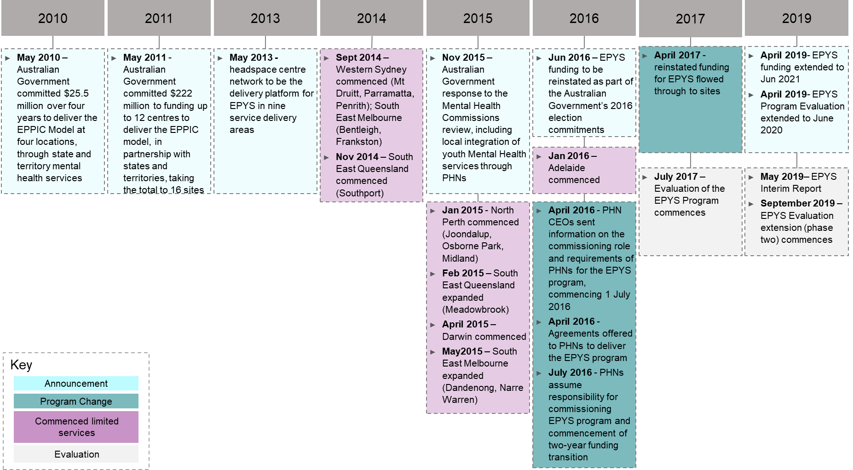

The overall impact of policy changes on the delivery of the EPYS Program

Whilst the EPYS Program commenced in September 2014 with the commencement of the Western Sydney and South East Melbourne clusters, the rollout of services and clusters within the program was done in a phased manner with Adelaide commencing in January 2016 (see Table 2 in Section 2.4.2). As such, services were at different levels of readiness and maturity at the point of the funding wind down in mid-2016. Staff reported that the commencement date of the services continued to influence their progress in implementing headspace Early Psychosis in their region. For example, those services who commenced limited services later had a shorter period of establishment before the funding was wound down in 2016. This meant that they had fewer resources to rely on during the wind down period and had to virtually start again when funding was re-instated.

The disruptive impact to services of the policy and funding changes was most significant during the establishment and early implementation phase of the EPYS Program (2016 and 2017). In early-2018, during local consultations it was observed that the EPYS Program was still in its establishment phase, since it had not been fully embedded across all the services. However, by late-2019 the program had moved to more of a “business as usual” phase in its implementation, with funding confirmed to June 2021 providing increased stability for the services.

The key challenges for the EPYS Program resulting from the policy changes were reported as:

**headspace Early Psychosis staff**

“The main challenge is the consistent threat about funding being taken away, it feels that regardless of our job the funding could be taken away. There is a possibility that the program could go to tender and this is worrying- as such we are working really hard to build the relationship with the new staff at the PHN.”

* *The challenge of* implementing *and embedding a new service under the constant threat or risk of defunding:* All stakeholders reported that the beginning of the EPYS Program was extremely challenging, recognising both the effort that it took to get the EPPIC model established in the primary care setting and the impact of the “stop, start” nature of its establishment. In follow-up consultations (late-2019), staff and local stakeholders reported that the services had stabilised which allowed them to build-up the service in line with the EPPIC model but the perception that the program was under threat as a result of the short-term funding cycles remained. As a result of funding instability, the EPYS Program generally remained less mature than it should have been – with one service reporting that they were two years behind in maturity, compared to where they would have liked to have been.
* *Despite the first headspace Early Psychosis service commencing in 2014, stakeholders were only able to get a sense of what the full implementation of the EPYS Program could look like and achieve from 2018 onwards:* The impact of funding disruption was significant; with some services having to think about closing and transition arrangements. Staff reported (in early-2018) getting close to full scale implementation. As such, 2017-18 was a year of consolidation and “getting back up and running”, with the development and change of the service over that period being significant to “bed down” the program again. In late-2019, staff and local stakeholders reported that the stability in and extension of funding for the EPYS Program had enabled services to be operating more on a “business as usual” basis, allowing a more strategic and targeted approach to implementation based on the lessons learned to date.
* *The fidelity of the EPYS Program was jeopardised when the funding was wound down, having an impact on program outcomes during that period:* Due to the implications of reduced funding (such as limited resources), all services reported in 2018 that they were not able to replicate the EPPIC model effectively during this period, with some reporting they were still feeling the repercussions in late-2019. However, as noted above, the reinstatement of funding and having greater stability within the program meant that services were achieving better fidelity to the model and achieving high-superior fidelity by late-2019.

**headspace Early Psychosis staff**

“The 12 month funding makes it really difficult… telling people to come into a program that isn’t funded! The way the funding is announced means we [the lead agencies] have to have spare cash flow and offer staff contracts without any funding guarantee”

* *The short-term funding cycles for the EPYS Program limited the extent to which longer-term planning and investment was made*. In the absence of longer-term funding certainty, services reported (late-2019) that they were limited in their ability or willingness to invest in strategic planning for the long-term delivery of the service. This included:
  + Investing in infrastructure and Information Technology (IT) to better support service delivery
  + Undertaking research to further support the evidence base for the program
  + Planning for long-term workforce development
  + Developing a strategic approach to performance reporting and data analysis
  + Having sufficient quantitative data to demonstrate outcomes and value for money
  + Building long-term relationships
  + Implement local quality improvement initiatives to better meet the EPPIC model
  + Progressing integration with the local health system.

Given this, all stakeholders suggested having longer term funding cycles, with staff reporting a desire for five to ten-year funding cycles. An increase in the duration of the funding cycle would align with the EPPIC model, which permits treatment for young people for up to five years.

The impact of policy changes for young people

*All* services reported that it had been difficult to maintain a service for clients when funding decisions came late. The impact for young people and their families varied by service when funding was wound down. For example, some services were so under resourced that they had to effectively “close the books” on referrals; others reported that they maintained continuity of services to an extent and did not have to turn away any clients. While some services could protect clients to some extent, they reported that it was challenging, and the clients got anxious about the possibility of the service being removed. Staff reported that the uncertainty around funding made it difficult to manage clients and effectively manage their care. In late-2019, staff reported that this issue had stabilised, particularly with extension of funding to 2021.

The impact of policy changes for headspace Early Psychosis staff

One of the most significant repercussions of the funding wind down and uncertainty of future funding was the impact on staff. This included:

* *A significant loss of staff across all headspace Early Psychosis services:* While all *services* lost staff, the extent of this was somewhat variable by centre. It was generally reported that there was a “mass exodus” off staff following the 2015 announcement, which was challenging for a program that was new and, in an environment, where recruitment of skilled and experienced staff was challenging in any case. Most services reported that the timing of the funding changes did not allow enough time to plan or prepare for the staffing changes. While some lead agencies could put strategies into place to minimise the impact more so than others, the loss of staff lead to delays in the program across all services. Following the reinstatement of funding, staff recruitment was needed to meet the required staffing profiles. In late-2019, staffing numbers were reported to be much closer to target profiles, however staff reported that the two-year funding cycles were an ongoing challenge for attracting appropriately experienced staff, particularly when compared to the pay and benefits offered in tertiary services. The “stop-start” nature of funding meant that some lead agencies have chosen at times to carry a financial risk by utilising spare cash flow to offer staff contracts without EPYS Program funding guarantee. In addition, some services reported that having positions funded temporarily through underspend has added to the level of uncertainty surrounding the program.
* *The program only worked during the funding wind down due to the passionate staff that stayed*: All headspace Early Psychosis services credited the hard work of the dedicated staff who stayed with the program during the challenging circumstances, where they knew that their jobs were potentially on the line. It was reported that these staff wanted to see the model succeed and believed in the difference that the program can make. This commitment, perseverance and resilience has been integral to the program’s implementation to date.
* *Staff that stayed with the program during the funding wind down were often stretched and had to take on extended roles, there was also a significant impact on morale:* The loss of staff was anxiety provoking for those who remained due to the limited capacity of resourcing. For example, staff that worked part time were having to work full-time, clinical staff were carrying high caseloads and a lot of clinical risk, clinicians were having to do everything to try and deliver all components of the model across the entire region. It was reported that staff that did stay often became exhausted, which sometimes led to further turnover. Despite the challenges, several services reported that they developed a strong staff culture during that time which they were able to build upon.

Impact of policy changes on the reputation and integration of headspace Early Psychosis services

All headspace Early Psychosis services reported that the disruption to funding caused significant reputational issues, limited the ability to promote the service and develop referral pathways, and resulted in ongoing legacy issues. The key impacts on reputation and perceptions of the program included:

* A loss of trust and confidence in the service
* Misconceptions and confusion about what the service was and what it delivered
* The impression that the program cannot manage complex clients
* Damage to partnerships and referral pathways, particularly with tertiary services
* A significant drop in referrals to the service
* A perception by some service providers that the program has closed, subsequently requiring significant re-education
* Uncertainty around the longevity of the program.

Overall, all local stakeholders reported that a lot of damage was done to the momentum of the EPYS Program early in the process, particularly the reputation of the service with the uncertainty of its future. As such, there has been a significant investment of time and resources made by all services in stakeholder engagement, education, and developing partnerships and care pathways. This has been building gradually since the reinstatement of funding and the subsequent extension of the program funding to 2021.

* + 1. How policy impacted governance of the program and the role of organisations involved

Across the Evaluation period, all stakeholders consistently reported that the governance of the program was too complex, as it had “too many masters” (see Section 2.4.5) for a description of the roles of lead agencies, PHNs, headspace National and Orygen). As a result, services reported that it was not always clear what the purpose, value and scope of each of the organisations involved was. This was particularly evident for services that had more than one PHN or lead agency, or a different lead agency to the co-located headspace Primary service.

All stakeholders reported that the governance arrangements and involvement of multiple organisations meant that: the program was difficult to navigate at times for staff (i.e. who to go to when experiencing issues and how to escalate); there was potential duplication in the roles of some organisations; and that clarification of the scope and role of PHNs, headspace National and Orygen was needed.

**headspace Early Psychosis staff**

*“Having two lead agencies doesn’t really confuse the community (public) because we are just perceived as headspace anyways. It does however create a number of challenges as we are unable to share fleet [due to insurance], and have to negotiate closures and workforce rostering between* ourselves”

Lead agencies

headspace Early Psychosis lead agencies were responsible for the contracting of staff and clinical governance of the service at each cluster and/or service. Local stakeholders perceived the program as being delivered through the headspace brand and infrastructure, rather than that of the lead agency. As such, the lead agency had an important role in upholding the brand of headspace.

Within the program, some clusters had more complex lead agency arrangements – including two lead agencies delivering the headspace Early Psychosis service within a cluster, or between the headspace Early Psychosis and headspace Primary services. These governance arrangements subsequently made developing relationships, integrating with the local health system and implementing change more complex.

Across the Evaluation period, two services were impacted by lead agency changes. Adelaide had a change of lead agency for both the headspace Early Psychosis service and headspace Primary. While Western Sydney had a change of lead agency for headspace Primary at one headspace Early Psychosis service in the cluster (Parramatta). These commissioning decisions, initiated by the PHNs required significant change management, trust and cooperation between stakeholders. Given this, the benefits and impacts of changing lead agency need to be considered prior to initiation of a tendering process, this includes the timing of such changes. Detail on the impact change of lead agencies has had on the implementation of the EPPIC model and service integration is explained further in Sections 5.2 and 5.4.

**Good practice example**

During the Evaluation period, North Perth reported a more mature approach to managing its complex governance arrangements. This included: establishing robust joint governance between the two lead agencies and establishing arrangements for shared systems and reporting. Joint meetings between the two lead agencies and the PHN were also underway.

Primary Health Networks

The roles and functions associated with the contract management of headspace Early Psychosis services were the responsibility of PHNs during the Evaluation period; these responsibilities could differ for each PHN depending on the hub and spoke arrangement in their region. PHNs had mixed opinions regarding the value of the EPYS Program in meeting local need. This was primarily attributed to the proportion of funding versus the target population being reached. Some PHNs reported that there were gaps in the reporting process, particularly having a “complete picture of the program”. However, the services and PHNs were working together to improve the reporting process. The addition of tertiary-type, complex mental health services to the portfolio of PHNs was a learning curve; however, this stabilised over the Evaluation period. PHNs consistently reported that their role as commissioners for the EPYS Program was appropriate and was in line with the regional commissioning approach the Australian Government Department of Health transitioned to.

Some staff reported mixed opinions about the value and contribution of the PHNs, particularly regarding Early Psychosis intervention and clinical knowledge needed to understand, commission and monitor the implementation and outcomes of the service.

headspace Early Psychosis staff, the Australian Government Department of Health, Orygen, headspace National and the PHNs reported that the addition of PHNs in 2016 added an extra layer of bureaucracy and complexity to the governance of the EPYS Program. Furthermore, there were some concerns reported regarding how PHNs were managing the contracts for the service. This included:

* The transparency of decisions made regarding program underspend by some PHNs, particularly where it impacted recruitment decisions.
* Transparency around how the EPYS Program funding was being utilised by some PHNs. For example: the administrative percentage that PHNs were taking and whether this amount was proportionate to the time and effort spent on commissioning the service; or whether program funding was being utilised for commissioning other mental health services.
* The level of understanding by some PHN staff responsible for the contract management of the service. For example, the EPPIC model, the societal impacts of psychosis and thus the need for early intervention. This concern was largely attributed to the rate of turnover of key PHN staff and the subsequent loss of intellectual property, which was evidenced by the relatively short tenure of many of the PHN staff consulted during the Evaluation. Staff and other stakeholders reported that this can flow onto contract decisions that are challenging for the program, for example, a change in lead agency and the impact this can have on a service.

In addition, several stakeholders reported that the oversight of, and how PHNs were held accountable to, commissioning decisions was not clear, especially when it appeared that they did not align to the best interest of the service.

In light of the draft recommendations from the Productivity Commission’s interim Mental Health report, Orygen expressed concern that if EPYS Program funding was to be moved to a flexible funding pool for PHNs to commission (i.e. no longer ring-fenced) it would compromise the intensity of the service and the ability to achieve desired outcomes.

Overall, most services reported in late-2019 that there had been a maturing of and improvement in the relationship between PHNs and the headspace Early Psychosis services. An example of this was the commencement of network meetings in Perth North in 2019, which included the two PHNs and two lead agencies, these meetings were established to discuss service issues in a more collaborative and strategic manner. Greater unity and consistency between PHNs in clusters where two PHNs were commissioning the service was also reported. A regional approach to understanding need, planning and commissioning through PHNs was reported to be positive and important in ensuring that services were tailored to local need. Whilst the relationships with PHNs are developing and maturing, they have required considerable time to foster and require attention and ongoing education of PHN staff, particularly with staff turnover.

The Australian Government Department of Health

The Australian Government Department of Health funds the EPYS Program through the PHNs. Inherently, they are responsible for ensuring the EPYS Program provides value to Australian taxpayers.

Reporting functions for the EPYS Program were split between Orygen (fidelity assessments) and headspace National (hAPI reporting) and PHNs (cluster level reporting to government) and there was no program-wide reporting that triangulated these inputs with financial and workforce data. This impacted the ability of the Australian Government Department of Health to appropriately oversee how the EPYS Program funds were being used and with what impact. Whilst, the information developed through the Evaluation addressed a reporting gap, it was acknowledged that a longer-term solution was needed.

From a policy perspective, the Australian Government Department of Health had a role in ensuring the EPYS Program aligned with the broader mental health system and policy direction. As a result of operating within a federated health system, this role was complex as interface with state health systems and policies was required. Furthermore, there was a need to ensure there was a balance between a national and localised approach for the EPYS Program.

headspace National

Up to 30 June 2016, headspace National had responsibility for commissioning the EPYS Program. Following this, the primary role for headspace National in the EPYS Program was focussed on the headspace branding, the model integrity framework, hAPI and the MDS.

headspace National was responsible for the headspace brand, under which the program sat. This brand was highly regarded and respected – as reported by all stakeholders. It was associated with a youth friendly environment, that was enabled through a single point of entry and a no wrong door approach.

One governance challenge for headspace National was in relation to the transition of commissioning responsibility to the PHNs. This resulted in headspace National having limited authority or influence over the delivery of the program, while holding the responsibility for the brand and reputation of the services. headspace National reported that they managed this by working with the services to ensure the brand was upheld consistently. This requirement to maintain brand consistency also influenced why separate branding for the service was not developed – noting that there was a preference by some headspace Early Psychosis staff to have separate branding. headspace National reported that their ability to promote the service more broadly, through targeted engagement strategies and service specific collateral, was limited due to funding.

headspace National was also responsible for the headspace Model Integrity Framework and monitoring of compliance at each headspace Centre. Staff did not provide feedback on the framework itself; rather they indicated that undergoing fidelity against the headspace model (as well as the EPPIC model) was onerous and time consuming and reflected the complex governance arrangements for the EPYS Program.

The most significant role of headspace National was the management of the program data through hAPI. Stakeholders reported that headspace National has established one of, if not the most, comprehensive mental health data sets in Australia. They also reported that they MDS included good outcome measures, but there were opportunities to review and refine the data items (in consultation with the services) as they felt it was too unwieldy.

One of the challenges that impacted the integrity of hAPI data were the lead agency eMR’ s being the main system for documenting service activity, resulting in duplicated recorded keeping and some data governance issues. headspace National undertook auditing processes to manage data discrepancies and worked with services when data gaps were identified; however, this was a challenging task, given they did not have oversight over the eMR data.

Over the Evaluation period, headspace National continued to invest in the hAPI system which resulted in a major system upgrade to the system in mid-2019. The system upgrade allowed headspace National to: consolidate disaggregate systems; rely less on vendors for system enhancements and configuration; and undertake regular system updates (releases). These changes had an impact on functionality and was a source of frustration for staff, however headspace National was working with services to resolve these. Further detail on the hAPI system including feedback on hAPI and the updates to hAPI is provided in Section 5.2. In addition to systems investment, headspace National employed a headspace Early Psychosis Manager to help facilitate collaboration integration and change with headspace Early Psychosis services.

Some stakeholders reported that the value of headspace National could be increased by improving the data and reporting back to services; for example, by making the data more granular and providing a comparative analysis across clusters (rather than comparing to a national average).

Orygen

Orygen was responsible for the development of the EPPIC model and its implementation in Australia. Given this, Orygen played a crucial role in the establishment of clinical standards, the adoption of the EPPIC model into the EPYS Program and the provision of technical and clinical advice, guidance, specialised consultation and assessment of fidelity to the model. Generally, headspace Early Psychosis staff reported that Orygen played a substantial and supportive role in the set-up, early implementation of the program and through the funding disruptions. They welcomed their continued involvement, investment and advocacy for the EPYS Program. Orygen expressed interest in having greater involvement in the EPYS Program going forward; for example, during the commissioning process to provide support to PHNs regarding the complexity of the model and implementation issues.

The key role for Orygen was monitoring fidelity of the EPPIC model and involved regular assessment (six monthly) at each of the headspace services to ensure appropriate standards were met (findings associated with these assessments are detailed in Section 5.2.4). Orygen provided services with feedback which included recommendations for improvement in relation to each of the components assessed. However, Orygen did not have authority to enforce or enact performance improvement recommendations. Summary reports based on fidelity assessment findings and hAPI data were also provided regularly to the Australian Government Department of Health. The fidelity assessment process was particularly valuable during the establishment phase of the program, as it helped ensure services were being commissioned and implemented in an evidence-based manner. With the program moving towards improved maturity, Orygen commenced exploring ways to evolve and adapt the fidelity process to better reflect program maturing, i.e. by changing the focus and frequency of testing.

headspace Early Psychosis staff reported that the fidelity process was very comprehensive but could be reviewed going forward given the services were becoming more mature. Some staff reported that fidelity could be improved if the assessments had a greater focus on quality improvement and innovation rather than having a focus just on compliance with the model. Orygen reported that the approach to fidelity was being reviewed and some changes being considered included: a reduction in the frequency of assessments; the inclusion of quality indicators; and greater consideration of physical health and culture. The updates to the fidelity would be guided by the updates to the *Australian Clinical Guidelines for Early Psychosis (3rd edition)* which was also in progress.

Orygen’s research, clinical and innovation focus provided a direct benefit to the ongoing delivery of the EPYS Program – a view consistently held by headspace Early Psychosis staff. This aspect of their role included: hosting clinical and operational conferences for Early Psychosis; research projects that sought to continuously improve the delivery of Early Psychosis in Australia (for example, Orygen was exploring establishing an Early Psychosis registry); and the provision of advice to Government which included guiding the locations for the existing headspace Early Psychosis services. In addition, Orygen played a role in advocating youth mental health services and policy reform which allowed them to gain the trust of headspace Early Psychosis services.

* + 1. Policy developments which complemented the EPYS Program

In addition to the broader policy and mental health system changes impacting on the program (Section 2.6.1), consultations with stakeholders identified that the Youth Enhanced services and the Individual Placement Support trial were two programs which complemented, or had the opportunity to complement, the EPYS Program.

Youth Enhanced services

In 2016-17, the Australian Government Department of Health transitioned commissioning of severe mental health early intervention services to the PHNs – this included funding for Youth Enhanced services, also known as Youth Severe. Youth Enhanced services seeks to address the “missing middle”, a cohort of youth with moderate to severe mental health concerns.

Consultations with staff and PHNs reflected that Youth Enhanced services:

* Had a significantly smaller funding pool than EPYS
* Consisted of localised models (i.e. the service model and operationalisation of Youth Enhanced services across PHNs varied)
* Was not a medical model
* Had a clinical focus of moderate to severe mental health.

Whilst these were points of differentiation from the EPYS Program, some PHNs and staff reported that there was some potential for diagnostic overlap, which may need to be considered more carefully if funding for Youth Enhanced services was to be enhanced. Some stakeholders reported that Youth Enhanced services was more complementary to the EPYS Program when there was a shared lead agency.

There were some concerns reported by staff that funding may be shifted from the EPYS Program to Youth Enhanced services in the future, or that existing EPYS Program funding may be diluted by broadening the diagnostic scope to address the “missing middle”. Some stakeholders also had concerns that there was not always a strong evidence base behind the Youth Enhanced services model (in contrast to the EPPIC model) and, as such, if EPYS funding was to be moved to a flexible funding pool alongside Youth Enhanced services, the evidence base would be lost.

Given this feedback, it is important to consider how Youth Enhanced services can be best commissioned, structured and funded so that local needs are met and synergies with the EPYS Program and headspace Primary are realised.

Individual Placement and Support trial

The Individual Placement and Support (IPS) trial forms part of the Australian Government’s broader Youth Employment Strategy aimed at tackling the problem of high youth unemployment. The program trial, which commenced in late 2016, is being delivered via 24 selected headspace services[64] nationally. Several services reported being part of the IPS trial, which allowed these services to provide vocational and education support via Department of Social Services funding. Vocational education services provided via IPS were reported as comprehensive and well-integrated. Given that most indirect costs relating to mental health sit outside of the health system, the introduction of the IPS trial is a good example of how mental health related interventions can be supported by government agencies outside of the health system.

* 1. To what extent has the EPYS Program been implemented as intended?

This section covers:

* An overview of the intended delivery of the EPPIC model at the local level
* Local factors that impacted the implementation of the EPPIC model through the EPYS Program
* The EPPIC model and EPYS Program data and governance
* The extent to which headspace Early Psychosis services implemented EPPIC model components
* Opportunities for improving the implementation and maturity of the EPYS Program.
  + 1. An overview of the intended delivery of the EPPIC model at the local level

Implementation of the EPYS Program at the local level was in the primary care setting and utilised the EPPIC model (as descried further in Section 5.2.3). Its effective implementation required the organisation of the program inputs, activities and outputs to achieve the short, medium and long-term program outcomes, as illustrated in the Program Logic in Appendix B. The Program Logic for the EPYS Program provides an overview of the intended delivery and design of the program. As evident from the program logic, the delivery of the headspace Early Psychosis service is based on the 16 components of the EPPIC model. However, it is also influenced by: (1) EPYS Program set-up and implementation; and (2) the context of the local region in which the service is delivered. Figure 6 provides a summary of the program logic, highlighting (in blue) the key aspects of the design and implementation of the program which will be discussed in this section.

Figure 6: Summary program logic for the EPYS Program

Figure 6 is an image showing the  summary program logic for the EPYS Program

* + 1. Local factors that impacted the implementation of the EPPIC model through the EPYS Program

The following sections outline how local factors impacted the implementation of services as a whole, further detail on how local factors impacted specific model components is provided in Section 5.2.4.

The impact of establishment and the administration of the services on implementation

A range of factors influenced the implementation of services at a local level. This included the hub and spoke model, commencement date of services, the location and local context of the services, program funding and changes to lead agencies.

The hub and spoke model

The design of the EPYS Program utilised a hub and spoke model of service delivery. This involved a ‘hub’ service in each of the delivery areas and, in areas with identified need, hubs were connected to ‘spoke’ services in surrounding centres. Together this forms a local ‘cluster’. The hub is designed to carry the full range of services of the EPPIC model, and the spokes have a CCT and share other resources – such as the MATT and FRP, which are based at the hub.

Clusters reported that the benefit of the hub and spoke model was that it provided wider reach and resources across the region. Clusters also reported that:

* The hub and spoke model were simpler when there was one lead agency for both the hub and spoke(s). Where there were multiple lead agencies and PHNs responsible for a cluster, it was reported that this created challenges for managing corporate and clinical governance across the hub and spokes.
* When there were multiple PHNs and LHNs within the region, it was more challenging to bring all parties together to establish common objectives and enable effective relationships and partnerships.
* Having multiple lead agencies in the hub and spoke model also created challenges for information management. Specifically, clusters reported difficulty in establishing shared client records between the hub and spoke and sharing information, potentially risking clinical safety.
* If the hub and spoke model was rolled out more broadly and/or the number of spokes increased, careful consideration of the governance implications would be required – the addition of extra lead agencies to a cluster would add further complexity to governance arrangements.
* In services with a hub only, it was reported that it would be useful to add spokes as the service continues to grow. They reported that this may assist them to better service the region and provide greater access to young people. The preference would be to have the same lead agency to assist with governance of the service.

The impact of the location of services on implementation

Physical location

Most services reported that the physical location of their services was generally appropriate and encouraged access for young people through public transport, proximity to other health and community services, and co-location with headspace. Services reported that the greatest challenge in the delivery of services was the geographic reach across the region, plus public transport availability in some regions.

Due to the intensive outreach nature of the program and the imperative to meet clients at a location where they feel most comfortable, services had to continually develop the capacity to adequately reach the target client group across their regions. Many clusters identified that additional spokes may be necessary to meet the needs of young people around their region.

Co-location with headspace Primary

Services reported that the co-location of headspace Early Psychosis services with the headspace Primary was a great benefit in the establishment and implementation of the program. It provided a youth friendly, safe and accessible environment for clients and their families.

Other benefits of co-location were described as:

* The strength of the headspace brand as the “front door” and in establishing the headspace Early Psychosis service
* headspace Primary provided a rich source of referrals to the program
* Providing a seamless pathway and experience for clients
* Fostering a culture of collaboration, working together and sharing expertise between headspace Primary and the headspace Early Psychosis service, for example, headspace Primary utilising the headspace Early Psychosis service clinicians for secondary consultations
* There was existing infrastructure to utilise, plus the sharing of office space, furniture, equipment and resources where appropriate.

Challenges of co-location were described as:

* The headspace Early Psychosis service added complexity to the headspace Primary centre given the target group, which required continual learning and updating of processes and clinical governance
* The need to establishing clear pathways and ensured integration between the two services, while also recognising they were two separate teams
* There was no separate brand for the headspace Early Psychosis service to distinguish it from the headspace Primary service, impacting awareness and recognition of the program
* Perceived de-skilling of some headspace Primary staff with headspace Early Psychosis staff working with the more complex clients
* Having IT systems which did not facilitate integration and collaboration between the two services.
* Several services reported that they were outgrowing their spaces as both headspace and headspace Early Psychosis services had grown.

Services reported that the location of headspace Centres was of benefit, as they were generally located in central areas that made it easy for young people to access the service via public transport. Co-location also enabled a step-up and step-down approach between the headspace Early Psychosis service and headspace Primary platform where appropriate. Whilst some staff reported co-location resulted in de-skilling, staff also reported that headspace Primary were able to be upskilled through joint referral intake processes and meetings with headspace Early Psychosis. For the most part, the two services were well integrated across the clusters and many clusters had developed structures for managing care through care pathways, clinical care groups and sharing of expertise, this is detailed further in Section 5.4.3.

Some services reported that the headspace platform created some confusion in the community about the level of care provided in the centres. It was reported that additional community education and awareness was required to improve understanding of the headspace Early Psychosis service provided and to improve referrals for more complex clients.

Other location factors

Other location-based factors that influenced the implementation of services included:

* *Jurisdiction within which the service is located:* Each service was influenced by the state and territory mental health policy in which they reside. Services reported that in states or territories where there was mental health policy that aligned to the objectives of the EPYS Program, as well as policy that aimed to improve integration of health services, it was easier to establish relationships with state-funded health services. This then enabled the establishment of appropriate referral pathways, sharing of resources and more integrated services to effectively implement key aspects of headspace Early Psychosis.
* *Alignment with PHNs:* The Darwin, Adelaide, South East Melbourne and Perth North clusters are commissioned by one PHN, the South East Queensland and Western Sydney clusters are both commissioned by two PHNs. headspace Early Psychosis staff from clusters with multiple PHNs reported that this made reporting and governance structures more complex, but also there could be differences in the view/focus of the two PHNs who may not necessarily be aligned. Most services reported that it has taken time for the PHNs to “get up to speed” with the needs of headspace Early Psychosis and there has been loss of corporate knowledge with PHN staff turnover.
* *Local Hospital Network boundaries:* The Adelaide, South East Queensland, South East Melbourne and Western Sydney services all reported that having multiple LHNs in their region which made the operating environment more complex to establish relationships for referrals and shared care. These services reported having to dedicate more resources to stakeholder engagement and community awareness activities.

The impact of program funding on implementation

As discussed in Section 5.1, funding was provided to the PHNs by the Australian Government Department of Health to commission the EPYS Program. The PHNs provided funding to the lead agencies to deliver the headspace Early Psychosis services according to the EPPIC model and headspace Early Psychosis *Operations Guide*. The breakdown of funding for each service is described in Table 9. Staff and local external stakeholders acknowledged that the headspace Early Psychosis services were well funded compared to other primary care mental health services, primarily due to the intensity and duration of services provided. However, all services reported that there were challenges with the funding model:

* *The quantum of funding was not sustainable to meet the future needs of the EPYS Program:* Services reported that the quantum of program funding has not been indexed to reflect increasing costs, such as staff, training, rent, travel, transport etc. Consequently, this was reported to have resulted in a drop in clinical and support staff over the duration of the program with an increasing reliance on underspend positions. Competitive salaries for medical staff was a challenge for most services. In addition, it was reported that the variation in medical officer pay between states was not factored into budgets. For example, the Adelaide service reported that medical officers are paid 30 percent more than in other states; however, this was not reflected in the budget. Being able to match the staff security and benefits (such as paid maternity leave) offered in the public health system was an ongoing concern expressed consistently across services. Capital investment was also identified by several services as a gap in current funding – this was a growing concern, with some services reporting they had outgrown their current space and did not have funding for a larger service.
* *There was high turnover of staff which was largely attributed to funding and program uncertainty:* There were financial implications associated with turnover of staff through direct and indirect loss in productivity. The high turnover also compounded this financial impact for some services, as it led to the use of agency and locum staff which were acquired at a premium cost. Furthermore, staff turnover played a significant factor in the extent of model maturity.
* *Obtaining timely agreement from PHNs on the use of underspent funds:* When funding for the EPYS Program was re-committed, the Australian Government provided the full program funding amount for 2016-2017, plus the volume of unspent 2015-16 program funds. Several services reported that they were note being provided with timely access to underspend funds by PHNs to recruit staff.

Table 9: Breakdown of funding for each headspace Early Psychosis service between 2013/14 and 2019/20 Finance Year (FY)

| EPYS cluster/service | | PHN | Base funding ($000) | | | | | | | |
| --- | --- | --- | --- | --- | --- | --- | --- | --- | --- | --- |
| 2013/14 | 2014/15 | 2015/16 | 2016/17 | 2017/18 | 2018/19 | 2019/20 | Total |
| NSW | Western Sydney | Western Sydney | $762,704 | $8,421,599 | $7,546,779 | $5,816,962 | $4,392,240 | $7,546,779 | $7,546,779 | **$42,033,842** |
| Nepean Blue Mountains | $37,296 | $2,056,229 | $1,686,494 | $1,107,993 | $981,543 | $1,686,494 | $1,686,494 | **$9,242,543** |
| QLD | South East Queensland | Gold Coast | $200,000 | $6,335,410 | $5,431,792 | $3,763,946 | $3,087,292 | $5,431,792 | $5,431,792 | **$29,682,024** |
| Brisbane South | - | - | $1,737,629 | $1,737,629 | $1,011,303 | $1,737,629 | $1,737,629 | **$7,961,819** |
| WA | North Perth | Perth North | $986,728 | $10,807,298 | $9,545,592 | $7,159,195 | $5,555,553 | $9,545,592 | $9,545,592 | **$53,145,550** |
| VIC | South East Melbourne | South East Melbourne | $2,200,000 | $12,493,920 | $11,187,801 | $8,390,852 | $6,511,322 | $11,187,801 | $11,187,801 | **$63,159,497** |
| NT | Darwin | Northern Territory | $260,300 | $3,071,542 | $2,757,385 | $2,068,039 | $1,110,840 | $2,757,385 | $2,757,385 | **$14,782,876** |
| SA | Adelaide | Adelaide | $220,000 | $7,969,435 | $7,021,623 | $4,022,233 | $6,953,933 | $7,087,454 | $7,087,454 | **$40,362,132** |
| **Total funding for the EPYS Program** | | | **$4,667,028** | **$51,155,433** | **$46,915,095** | **$34,066,848** | **$29,604,027** | **$46,980,926** | **$46,980,926** | **$260,370,283** |

*NOTE: In addition to the abovementioned program costs, administrative/support costs were paid by the Australian Government Department of Health to headspace National and Orygen. These include:*

* *Orygen: $4.5 million over two years to provide advice and support to PHNs (2019-20 to 2020-21). This funding contained a specific EPYS component for PHNs delivering the EPYS Program, as well as support to all PHNs in commissioning Youth Severe services.*
* *headspace National:*
  + - *$3 million over two years to support PHNs to improve EPYS data collection and quality (2019-20 to 2020-21).*
    - *$2,410,577 (2018-19 to 2019-20) to redevelop and improve the existing EPYS data collection system and train the PHN and lead agencies in the use of the redeveloped system.*

The impact of lead agency changes on implementation

As discussed in 5.1, lead agencies were responsible for the contracting of staff and clinical governance of the service at each cluster and/or service. Changes in lead agency at Adelaide (for headspace Early Psychosis and headspace Primary) and Western Sydney (headspace Primary at Parramatta only) during the Evaluation period highlighted the significant and/or potential impact a change in lead agency can have on service implementation and delivery.

Adelaide change of lead agency

**Good practice example**

Whilst the only example of a lead agency change, the Adelaide service managed this transition well, were able to mitigate risks effectively and return to business as usual in a relatively short time. Importantly, the down time in patient activity during this period was used productively to review the team’s internal processes, including how the CCT, MATT and FRT staff interact with one another.

In July 2019, Adelaide headspace Early Psychosis transitioned to a new lead agency – the first and only time a lead agency has changed since the commencement of the EPYS Program. As such, it serves as a learning opportunity for the PHNs, headspace National, Orygen, lead agencies and headspace Early Psychosis services. The change in lead agency had the potential to significantly disrupt operations and the extent to which the model could be delivered.

The transition to a new lead agency required considerable effort by staff, the new lead agency and the PHN to work through the change management process and was consistently reported as a stressful time by staff. During the transition period service operations were impacted, as evidenced by the 14-week period in which the service stopped taking new referrals to focus on the care of existing clients. The change in lead agency also resulted in high turnover of staff, which was compounded by changes in employment conditions, such as the loss of paid maternity leave and staff having to go on probation. Ensuring appropriate clinical governance over the clients and the program was one of the greatest concerns reported by staff and the new lead agency, with the new lead agency recognising that the program’s complexity and clinical risk was not fully understood at the time of tendering for the service due to the level of information provided as part of the tender process. Despite these challenges, the service was able to reach business as usual again relatively quickly, which was credited to the determination and resilience of staff and having the EPPIC model as the basis of the service.

Lessons learned through this process included:

* Considerable involvement by leadership within the new lead agency was critical to success, particularly in relation to instilling confidence amongst existing staff and establishing new governance processes.
* A need for transparency and honesty amongst all organisations involved (the new and former lead agency, headspace National and the PHN). This includes ensuring that respective parties are forthcoming with information, rather than being purely legalistic in approach.
* The need to understand the new lead agency’s experience in delivering complex clinical programs and being aware of the potential need to enhance existing quality and risk frameworks.

Western Sydney change of lead agency (Parramatta service)

During the Evaluation period, there was a change in lead agency at one headspace Primary centre in the Western Sydney cluster, thus resulting in a different lead agency between the co-located headspace Primary and headspace Early Psychosis service. Whilst some headspace Early Psychosis services already had a similar arrangement in place, this was the only occasion in which devolution of leads took place since the commencement of the program. As such, staff were having to manage the effects of change whilst continuing service delivery. The change in lead for headspace Primary at added further complexity and layers of administration in the management of the program for the Western Sydney cluster. Furthermore, it exacerbated the concerns around funding and contract instability as staff felt that the decision to change leads further cemented the view that the PHNs had limited understanding of the program. Further detail on the implications and lessons learned regarding this change are provided in Section 5.4.3.

* + 1. Implementation of the EPPIC model and EPYS Program data and governance

Overview of the implementation of the EPPIC model

As described in Section 2.4 the EPYS Program is the delivery of the EPPIC model through the headspace Centre network (headspace Early Psychosis program). The model consists of 16 components, 14 of which are included in fidelity assessment reviews.

Examples of how services adapted the EPPIC model to meet local needs are detailed below:

* *Services reported using a co-design process to establish a program which was tailored to local need, involving community, young people, families, clinicians and other service providers:* This assisted services in early engagement with stakeholders, creating understanding, buy-in and accountability to the community which it serves. The extent to which each service used the co-design process differed. For example, South Eastern Melbourne undertook a two-year co-design process to design the best service possible to meet the needs of the community. Other services used the co-design process following the commencement of headspace Early Psychosis to refine core functions and how services would be delivered. Nevertheless, all services reported continually engaging with the local community and Orygen to inform improvements to the service. As a result, many services not only improved their fidelity over time – but also improved the extent to which the service was meeting local need.
* *Services reported having to make adaptions to the model to create a culturally safe service:* For example, a service with a large Indigenous Australian population reported making several adaptions to the service to ensure it was culturally appropriate. Specific ways in which services adapted the model to make it more culturally appropriate included:
* Employment of Indigenous Australian staff
* Education sessions to upskill non-Indigenous staff on cultural awareness
* A focus on providing outreach into the community and home-based care where possible to overcome cultural barriers and transport challenges
* increased engagements times to factor in the additional time that may be needed to comport clients
* Adaptation of paper-based forms and data collection tools to make them more user friendly and accessible for Indigenous Australian clients (for example, one service adapted their survey form into an online tool that was more culturally engaging)
* Creation of an Aboriginal and Torres Strait Islander community group to advise on Aboriginal and Torres Strait Islander issues and improve the cultural competency of the service.

Staff reported that these adaptions helped to ensure that the service delivery was more fit-for-purpose and to better meet the needs of the young people.

Data and information management within the headspace Early Psychosis service

All services acknowledged that the collection of data was essential to understanding how effectively the EPYS Program was operating and to inform ongoing improvement. As such, services reported that the collection and use of hAPI data were beneficial.

However, staff reported several challenges with the system. Some of which were further exacerbated by the upgrade to hAPI in mid-2019, with staff reporting they were unclear of the benefit and reasoning behind the upgrade. headspace National reported that the hAPI upgrade aimed to enable:

* *Consolidation of systems at a national level:* Prior to the upgrade, headspace National was managing several disparate systems. The upgrade to hAPI enabled old back-end systems to be rescinded and subsequently managed via a single platform.
* *More configurability and less reliance on vendors:* As a by-product of system consolidation, headspace National were able to have more control and flexibility over hAPI which allowed them to undertake updates without having to go through third party vendors.
* *Regular updates/releases to take place in response to staff feedback:* Because of having greater control over hAPI, headspace National were able to undertake regular system updates (releases) to address system issues as identified by the services – previously they had been reliant on vendors which resulted in less frequent updates.

**Good practice example**

Considerable efforts were made by the North Perth data systems and project manager to improve data quality and insights of the service. This included: providing notifications to all staff as assessments were due; implementing small data strategies; cross-checking data to ensure assessments were appropriate based on client treatment (FEP or UHR); internal analysis of trends; undertaking a ‘mock fidelity’ to assess how the service would perform ahead of fidelity; and regular data reconciliation to ensure the eMR and hAPI matched.

Another system enhancement by headspace National during the Evaluation period was the introduction of Tableau dashboards and reporting. This enhancement enabled services to access dashboards and reports with minimal delay, whist also reducing the time and effort needed to run reports.

Several challenges were reported by headspace Early Psychosis staff relating to system features, reporting and data capture processes. It is acknowledged however, that much frustration came from hAPI being a secondary data capture system to the eMR and did not contain all client information.

Specific challenges associated with data capture and reporting included:

**headspace** **Early Psychosis staff**

“hAPI2 is like an old wine in a new bottle, nothing has changed really, perhaps things have changed in the back end… We have had to develop local options in the eMR instead of relying on hAPI. The numbers in hAPI are not reflective of what we are doing- the data is in hAPI but not coming across properly in tableau.”

”

* *The hAPI system did not integrate with other systems, such as the eMR used by lead agencies and was reported to result in duplication of data entry and inconsistencies in information recorded:* Staff reported it would be more efficient to collect data from the eMR given separate record keeping increased the likelihood of data omissions and errors. Integration between the eMR and hAPI was strongly advocated for by staff and it was reported in late-2019 that possible integration between hAPI and the Mastercare eMR (which was used by several services) was going to be explored by headspace National and some of the services.
* *The entry of data could be time consuming due to the quantum of data required:* Therefore, during busy periods clinicians would often prioritise client care over the entry of information.
* *Ongoing training was needed for headspace Early Psychosis staff to assist with developing a common understanding of data fields and to improve the consistency and quality of the data being entered:* As it was reported that it was subjective and open to interpretation, particularly with the turnover of staff in the service.
* *There were gaps and inconsistencies in the data prior to and over the Evaluation period impacting the quality of the data:* This was due to some of the changes which were made to the hAPI system in the upgrade, in addition to limited entry of data during the funding wind down, impacting the quality of the data.
* *There were reported anomalies between hAPI and Tableau with data “dropping off”:* That is, clients would appear as having an assessment as incomplete in Tableau but would appear as complete in hAPI. Subsequently, these anomalies resulted in manual reconciliation and a separate record which increased the administrative burden associated with data capture.
* *There were sometimes challenges in collecting the information from Indigenous and CALD clients:* As the data collection tools/surveys were not necessarily considered to be culturally friendly or appropriate. This was reported to have impacted fidelity scores as clients were more likely to have the entry of an assessment delayed or a survey left incomplete
* *The extent of the data required to be collected from clients as part of the MDS was raised by several services as being “burdensome” not only for staff but for clients:* This was primarily due to the number and frequency of assessments and outcome measures that required completion.
* *Not being able to include all headspace Early Psychosis service practitioners in the system:* Capturing the work that they do and the time they spend with the client. This particularly related to the functional recovery and peer work undertaken.
* *There was a preference to have greater input from clinicians in determining the outcome measures to be collected in the hAPI MDS:* It was also reported that input from clients and families would also be beneficial given that it was felt that the MDS did not necessarily capture what is happening in the young person’s life or what is important to them.
* *Most staff reported that the usefulness of hAPI for clinicians was to an extent limited as clinical information relating to a client remained within the eMR:* Services reported that the collection of data does not necessarily need to be collected in the hAPI system and there may be other systems which could be utilised.
* *Greater sharing and dissemination of useful information to services and PHNs from hAPI was reported to be necessary:* In particular, it was reported to be needed for performance monitoring, evaluation and performance improvement purposes.
* *Data managers across the services reported that “not owning” the data presented challenges:* Including the ability to undertake dynamic and customised reporting to monitor impact of quality improvement initiatives and to undertake research. It was reported that these were not possible without seeking the permission of headspace National.

Over the Evaluation period, some data integrity and data governance issues were highlighted. Of greatest significance, was a data issue in one cluster where approximately 10,000 OOS were ‘missing’ over a nine-month period. It is understood that this was a result from the retrospective way in which data were entered in hAPI. However, this also highlighted that gaps in data governance processes existed, particularly as the drop-off in activity went unnoticed by cluster staff, headspace National and the PHN for so long.

Whilst challenges exist with hAPI, Orygen, PHNs and local stakeholders reported that the hAPI MDS was one of the most comprehensive mental health datasets in Australia and that the efforts in developing such a comprehensive system should be recognised. Furthermore, whilst the 2019 upgrade to hAPI has had its challenges, the timing of the upgrade in relation to local stakeholder consultations (for the Evaluation) meant that the upgrade was going through teething issues when local consultations were being undertaken. It was evident that toward the end of the consultation process, staff were responding more favourably toward hAPI and Tableau reporting and that some of the issues listed above had been addressed.

The approach to governance, risk and quality

All services provided under the headspace Early Psychosis program needed to comply with the *National Standards for Mental Health Services*. In addition, the *Australian Clinical Guidelines for Early Psychosis* were to be used to guide clinical practice within the service. All headspace Centres and headspace Early Psychosis services were also required to comply with the headspace Model Integrity Framework. For South Eastern Melbourne, services were also required to adhere to the *National Safety and Quality Health Service Standards* and were required to undertake periodic accreditation, given the lead agency was a Local Hospital Network.

To effectively manage the implementation and delivery of the service locally, local governance, risk and quality frameworks were implemented in each service. These frameworks considered how the lead agency would manage risk and the interaction with headspace Primary. Services reported that the implementation of these structures in their services were clunky at times due to the changes in funding and policy, particularly when there was more than one lead agency involved. One cluster with two lead agencies, reported that considerable effort had gone into the development of a co-governance framework which was recognised externally by the Australian Institute of Directors as an exemplar approach to co-governance. Services reported that the EPPIC model provided them with a solid foundation on which services could rely on during the disruptions to reduce clinical governance risks.

Nevertheless, services reported having further developed their governance structures by late-2019 and had in place the leadership teams and corporate and clinical policies, procedures and systems to effectively manage their service. This was an aspect of operations that they continued to work on; particularly services that had more than one lead agency or had experienced a change in lead agency.

In addition, services also reported undertaking continual quality improvement processes, utilising reference groups (such as a youth reference group, clinical reference group, community reference group etc.) and fidelity testing to inform these processes. Staff reported that as the service continues to grow, it will be important to continually review and update governance structures to ensure they remain fit-for-purpose and to maintain quality and safety standards.

* + 1. The extent to which headspace Early Psychosis services implemented EPPIC model components

An overview of services fidelity to the EPPIC model

All headspace Early Psychosis staff and local external stakeholders reported strong support for the EPPIC model and its evidence base for the delivery of the program, reporting it as being “gold standard” and “world class”.

Data from the assessment of fidelity to the EPPIC model, as undertaken by Orygen, is used to indicate the extent to which key inputs of the EPYS Program are in place to enable local program delivery. Five fidelity assessments were undertaken during the Evaluation period:

* July 2017 (Visit 1)
* October 2017 (Visit 2)
* July 2018 (Visit 3)
* April 2019 (Visit 4)
* November 2019 (Visit 5).

Figure 7 below, shows the overall fidelity scores for each cluster or service over the five assessments undertaken between July 2017 and November 2019. During this time, fidelity improved by 19 percentiles, with fidelity peaking in July 2018. All clusters or services scored ‘high’ to ‘superior’ fidelity in the November 2019 assessment; however, across the five fidelity assessments no service was scored as reaching 100 percent fidelity. As such, each service is still working towards full implementation of the EPPIC model and continues to operate in various stages of maturity in the model. Staff reported in 2019 that they were confident with their understanding of the model and the 16 core components as they relate to their region and were also satisfied with the overall levels of fidelity they were seeing at their respective service.

Figure 7: Overall fidelity scores by cluster/service for assessments conducted in July 2017 to November 2019 (Orygen fidelity assessments)

Figure 7 is a grouped bar graph showing the overall fidelity scores by cluster/service for assessments conducted in July 2017 to November 2019 (Orygen fidelity assessments)

As outlined in Section 2.3 there are 16 components of the EPPIC model. Table 10 provides a summary of the extent to which 14 EPPIC model components assessed were being delivered across each cluster or service in November 2019 (Visit 5). ‘Streamed youth friendly inpatient care’ and ‘Access to youth friendly sub-acute beds’ were not measured at any assessment visit given the challenges services had with implementing them due to the limited availability of youth friendly inpatient and sub-acute beds in some regions. However, some services did make progress through Service Level Agreements or Memoranda of Understanding with their Local Hospital Network in facilitating access.

Table 10: Fidelity percentage for each cluster/service and component, November 2019 (Orygen fidelity assessments)

| Component | Adelaide | Darwin | North Perth | SE Melbourne | SE Queensland | Western Sydney |
| --- | --- | --- | --- | --- | --- | --- |
| Community Education and Awareness | 95% | 95% | 100% | 65% | 100% | 95% |
| Easy Access to Service | 96% | 96% | 96% | 92% | 96% | 96% |
| Home-based Care and Assessment | 84% | 82% | 76% | 82% | 82% | 80% |
| Continuing Care Case Management | 88% | 85% | 88% | 87% | 83% | 88% |
| Medical Treatments | 78% | 80% | 86% | 58% | 83% | 78% |
| Psychological Interventions | 100% | 73% | 100% | 100% | 100% | 100% |
| FRP | 100% | 100% | 100% | 100% | 100% | 100% |
| Mobile Outreach | 100% | 100% | 100% | 100% | 100% | 100% |
| Group Programs | 100% | 100% | 100% | 100% | 100% | 100% |
| Family Programs and Family Peer Support | 83% | 70% | 83% | 83% | 53% | 83% |
| Youth Participation and Peer Support | 100% | 95% | 100% | 90% | 100% | 95% |
| Partnerships | 100% | 100% | 100% | 100% | 100% | 100% |
| Workforce Development | 100% | 100% | 100% | 100% | 100% | 100% |
| UHR Detection and Care | 100% | 90% | 90% | 90% | 100% | 90% |

As evident from Table 10, services were able to implement some of the 16 components of the EPPIC model more effectively than others. For example, the components: ‘FRP’, ‘mobile outreach’, ‘group program’, ‘partnerships’ and 'workforce development’ were consistently implemented to maximum fidelity across the services.

For all other components, there was a degree of variability – with headspace Early Psychosis staff reporting that it was challenging to meet full implementation of the model without full staffing. ‘Family programs and ‘family peer support’, ‘home- base care and assessment’ ‘continuing case management’ and ‘medical interventions’ were the lowest scoring components. It was reported that the low score for family peer support was likely attributed to the difficulty recruiting and retaining family peers. All services reported that while they increased their after-hours coverage, the provision of 24-hour care was an enormous challenge – in terms of financial viability, clinical risk and staff safety, most services reported that there would not considerable value in delivering a 24-hour service and why only one cluster reported providing this feature of the model.

Consultations with local stakeholders in late-2019, highlighted that services were not only seeing ‘high’ and ‘superior’ fidelity, but were able to build on the EPPIC model to better meet local needs. Over the Evaluation period, and with the announcement of the EPYS Program funding extension to June 2021, all headspace Early Psychosis services reported during local consultations an increased level of maturity and stability in late-2019. However, this increase in maturity was not necessarily reflected in the fidelity data, as the program experienced a small decline in overall fidelity scores between July 2018 and November 2019. Staff reported several initiatives that had been implemented which supported the notion that services were maturing and becoming better integrated with their local health system – these initiatives are explained in detail further in this section. The anomaly between reported improvements in model maturity and fidelity scores could be attributed to: (1) improvements not being captured within the assessment criteria, or (2) improvements in one aspect of a component being met with declines in other aspects of the component.

The conscious effort made by some services to remain very consistent with the model, was reported to: reduce flexibility in how staff were deployed across the cluster; influence caseload numbers (for example, as a result of not accepting clients that may need more than six-month UHR treatment); and impact on target ratios for FEP versus UHR (some services were more open to seeing a broader diagnostic group for UHR). Some staff at one cluster reported that the provision of 24/7 support is not cost effective or particularly valuable. Several PHNs also reported that as caseload targets were not being reached, greater flexibility regarding aspects of the model may assist with increasing caseload numbers, for example, by broadening the diagnostic scope and acceptance criteria.

**headspace Early Psychosis staff**

“Once we accept a client it is very difficult to refer on, as a result of other services being so stretched, as such, we have to ensure those who are accepted clearly meet our criteria”

Detail on how services performed against each of the model components, including the reported challenges and improvements, are explained in further detail in the sections below.

The extent to which headspace Early Psychosis services were able to undertake psychosis case detection

headspace Early Psychosis was designed so that potential clients could be referred into the service through any channel. Including:

* Self-referral, family and carer referral, which may include walk-ins (presenting to the intake team) or a call to headspace
* Health care provider/service referral (for example, GP, inpatient units, sub-acute units, other health professionals etc.) which usually includes a referral form or a call directly to the service
* Community service referral (for example, teachers, community organisations etc.), which usually includes completion of a referral form.

The model was designed so that headspace Primary was generally the main entry point into headspace Early Psychosis and with referrals to be responded to within 24 hours to meet fidelity requirements. Some MATTs also take direct referrals from health care providers.

Referrals to the service were largely reliant on the local referral pathways established by each service. These were initially developed and promoted though community awareness and education activities to establish the program as a trusted Early Psychosis service for youth. These activities also aimed to educate referrers on how to recognise psychosis and how to refer to the program. Services built relationships in the community which is evidenced by the broad range of referrals sources into the program. The distribution of referral sources across the headspace Early Psychosis services is provided in Section 5.3.1.

All services reported that referrals increased over the Evaluation period due to:

* Activities such as community awareness sessions, presentations, education and in-services
* An increase in the regular presence of headspace Early Psychosis staff in inpatient units
* Establishment of more formal partnership arrangements, such as Memoranda of understanding and SLAs, with state-funded health services
* Maturation of the program and having more stability in the service (including key staffing appointments such as a psychiatrist) following the reinstatement of funding
* The ease of the referral process into the program
* Referrers knowing that young people referred to the program will be seen in a timely manner and assisted, including being referred to a more appropriate service if the program is not suitable.

However, one Local Hospital Network reported in late-2019 that there was still some reluctance to refer to the service given the impact of funding changes and the concern that the EPYS Program would not be available in the long-term. For example, one cluster reported that they had lost the trust of their Local Hospital Network due to the temporary “closure of their books” in early 2018 when they were not able to keep up with demand. This resulted in some confusion in the community regarding the status of headspace Early Psychosis and resulted in changes to referral patterns.

Some staff reported over the Evaluation period that they had not yet had the capacity to undertake case detection to the extent they would like. As shown in Figure 8, whilst there have been improvements in the UHR component since the reinstatement of funding, only two clusters achieved maximum fidelity since then for UHR case detection. Staff reported that in order to improve their case detection capabilities, they needed to increase the maturity of their relationship with the Local Hospital Network and build in-reach and case detection.

Figure 8: The extent to which each cluster/service met fidelity for UHR case detection, between July 2017 and November 2019 (Orygen fidelity assessments)

Figure 8 is a grouped bar graph showing the extent to which each cluster/service met fidelity for UHR case detection, between July 2017 and November 2019 (Orygen fidelity assessments)


headspace Early Psychosis staff reported that they referred young people who were not eligible for the service to the most appropriate health service for their needs. All services reported that they “held on to” young people until they were appropriately referred as their duty of care – in keeping with the headspace ‘no wrong door’ policy – even though this does not match with their funding. Nevertheless, all services reported that they are working towards improving inappropriate referrals through providing more community education and awareness sessions, as well as providing feedback to referrers regarding the acceptance of referred youth.

The extent to which headspace Early Psychosis services were able to undertake, intake, assessment and the provision of MATT services

Intake and initial screening for headspace Early Psychosis

The entry point for all referrals was intake (or triage), with subsequent referral of UHR and FEP young people to the MATT. The initial assessment of referrals not only determined the initial eligibility of a referral for the service, but also prioritised the urgency of the referral. From intake and triage, an initial screening assessment determined if the person met the eligibility criteria of the service and the need to undertake a full assessment, or if they should be referred to another service that better meets their needs. Staff reported having the flexibility to undertake initial consultation and assessment with clients in a location that they would prefer. This has enabled a more client centred approach and improved ease of access for clients to the service.

Services reported that they had evolved and refined their intake processes over time to suit their local requirements and needs. Some services reported that the headspace Primary access team undertook the initial assessment process, some used a joint team including the MATT and headspace Primary staff, while others used the MATT only. One service reported joint intake with more CCT and MATT allowed the teams to work better together and be more flexible in how resources were used. This cluster also reported the establishment of a casual pool with headspace Primary clinicians to assist with intake. Some services reported that they also included additional staff in the process, such as Indigenous liaison personnel, based on the needs of the young person. This meant that services had to provide additional training for staff to ensure that the intake process was undertaken consistently and met the needs of the service. It also required that they were clear on the clinical governance of the process. Services that utilised headspace Primary staff for intake reported investing in education and training to improve understanding of the client group, as well as adapting clinical governance of the headspace Primary to effectively manage clinical quality and safety.

Assessment and the MATT service

The MATT was a multidisciplinary team (including, medical staff, psychiatrists, nursing and allied health) which assessed for Early Psychosis and was the first stage of a young person’s treatment in the service. MATT clinicians provided triage, assessment and intensive extended-hours home treatment service (i.e. weekends and up to 10 pm) to young people referred to the program and current clients. The assessment process was designed to be flexible and conducive to the engagement of the young person into the service. This required a high level of mobility, along with the use of responsive crisis intervention and home treatment to minimise the trauma associated with psychosis.

During the assessment phase, the MATT assessed if the client is UHR or FEP to determine what type of treatment they should receive. Most services reported they would contact and see a client within the first 24-72 hours of referral and then maintain contact with clients regularly, ranging between daily to weekly. In addition to assessment, MATT undertook a range of activities for the service including, for example, crisis management work, shared care cases with the CCT and the provision of back-up for the service in the after-hours period.

All stakeholders generally reported that the service provided by the MATT were agile and respondent to the needs of the client or family. Feedback data were also used to understand whether clients and families were on track. Several services reported they reviewed how their MATT operated and integrated with the rest of the service. For example, at one service the access team (intake) was integrated into the rest of the service (MATT and CCT) rather than being a separate team with its own resources. The intake staff were sufficiently experienced, allowing them to make decisions with autonomy and accuracy, directing referrals to the most appropriate agency or team. It was reported that these changes helped expedite the time from referral to first appointment.

One limitation, however, was that the MATT service was generally restricted to a geographic area that was within one-hour travel time from the hub. This was a challenge for services that did not have their hub centrally located within their cluster.

As illustrated in Figure 9, fidelity to the EPPIC model of home-based care and assessment generally peaked across services in July 2018, with all services experiencing lower fidelity scores in November 2019.

Figure 9: The extent to which each cluster/service met fidelity for home based care and assessment by MATT, between July 2017 and November 2019 (Orygen fidelity assessments)

Figure 9 is a grouped bar graph showing the extent to which each cluster/service met fidelity for home based care and assessment by MATT, between July 2017 and November 2019 (Orygen fidelity assessments)

Orygen fidelity reports and consultations with local stakeholders highlighted several common factors that contributed to lower fidelity scores, these were:

* Despite appointments being offered to young people there were challenges with their engagement and availability which affected the timing of initial assessments.
* In most headspace Early Psychosis services there were challenges around the availability of clients which affected the timing of initial assessments, as well as young people being referred when they were not able to be located by the Local Health District services.
* Time to initial assessment from referral was influenced by the nature of referrals, for example, some services received referrals from clients that were still an inpatient, as such an initial assessment at the time was not always appropriate.
* Feedback from Orygen in the fidelity reports indicated that the above issues were not inherent or systemic, but operational issues that could to a large extent be managed through improved controls and processes.

Other factors which created challenges for the MATT but were not directly attributed to lower fidelity scores within the fidelity reports included:

* Having one MATT to service the entire region meant that it was not always possible to effectively leverage the team across the entire region, particularly due to the travel required and without supporting infrastructure, such as integrated electronic medical records between the hub and spokes.
* Rostering of MATT staff was particularly challenging due to the intensity of contact with clients and the travel and time required. Services reported that this had become more challenging as referrals and caseloads increased but improved as workforce increased.
* While the extended hours aspect of MATT was unique and critical, some services had to build this over time, or at times reduced the availability of MATT after hours, due to workforce constraints.

Mobile outreach was a core component of headspace Early Psychosis for both MATT and CCT. It was associated with intensive case management and home-based care for young people and their families who, for example, had difficulties accessing the centre or felt more comfortable at home or another setting, were in crisis, required assistance during the after-hours period, or were in hospital.

Staff reported that their ability to provide mobile outreach improved as staffing number improved. This is reflected in Figure 10, with all services achieving maximum fidelity in November 2019.

Figure 10: The extent to which each cluster/service met fidelity for mobile outreach, between July 2017 and November 2019 (Orygen fidelity assessments)

Figure 10 is a grouped bar graph showing the extent to which each cluster/service met fidelity for mobile outreach, between July 2017 and November 2019 (Orygen fidelity assessments)

The extent to which headspace Early Psychosis services were able to undertake continuing case management by the CCT

Continuing case management services were provided to both UHR and FEP clients by the CCT, who are responsible for treatment planning and interventions. The CCT clinicians provided ongoing case management during regular business hours and are the clients primary point of contact with the service. The CCT clinician had a therapeutic and coordination role for the client, working collaboratively with the young person and their family. Some of their primary tasks included engagement, developing the treatment plan, education of the young person and their family, risk management, developing a relapse prevention plan and discharge planning. CCT clinicians were also responsible for providing mobile outreach services and home-based care.

**Good practice example**

Western Sydney’s lead agency undertook an internal restructure of non-clinical roles. As a result, the service was able to experience FTE enhancements in clinical roles, improving the ability to meet caseloads. It also meant that underspend positions that were core to fidelity were able to be incorporated into the business as usual.

Each client was allocated a consultant psychiatrist who maintained clinical responsibility for the client, overseeing and approving all clinical decisions. Further to this, the consultant psychiatrist facilitated biological interventions identified in the young person’s management plan. Consultant psychiatrists also assisted in the intake and assessment process, especially if a young person displayed significant distress associated with psychotic symptoms.

**Good practice example**

During the Evaluation period, South East Melbourne commenced a more mature approach to outcome data collection – the Collaborative Adaptive Network Approach (CANA). This approach is based on the Open dialogue model. It provides clear measures of outcomes for each young person, engages the young person and allows clinicians to be adaptive to their feedback. The tool used to enter this data is also capable of modelling a young persons’ progress into the future.

In the headspace Early Psychosis service, continuing case management was provided for six months from the date of registration for UHR clients and for two, and up to five, years for FEP clients. Decisions regarding an extension of service was made by the treating team, including the consultant psychiatrist, and was discussed with the young person and their family.

As evident from Figure 11, the extent to which each service was delivering fidelity to the EPPIC model for continuing case management was variable, with all services experiencing a decline in fidelity since July 2018.

Figure 11: The extent to which each cluster/service met fidelity for continuing case management, between July 2017 and November 2019 (Orygen fidelity assessments)

Figure 11 is a grouped bar graph showing the extent to which each cluster/service met fidelity for continuing case management, between July 2017 and November 2019 (Orygen fidelity assessments)

As shown in Figure 12, one assessment measure for continuing case management was the number of caseloads per full-time CCT case manager. Performance against this was measured against the following ratings:

* 5 indicates a caseload of 16-20
* 4 indicates a caseload of 15
* 3 indicates a caseload of 12-14
* 2 indicates a caseload of 10-12.

Figure 12: Caseload per full-time CCT case manager fidelity rating, November 2019 (Orygen fidelity assessment reports)

Figure 12 is a horizontal bar graph showing the caseload per full-time CCT case manager fidelity rating, November 2019 (Orygen fidelity assessment reports)

As outlined in Figure 12, the Western Sydney cluster, Darwin and Adelaide were meeting the target for 'caseload per full-time case manager’ in November 2019. Whilst some services reported an increase in caseloads in late-2019, most services reported challenges in meeting the caseload numbers. Funding uncertainty, alternate available Local Hospital Network services, engagement with referrers and the community, the permitted duration of care (i.e. a six-month limit for UHR clients) and the rigidity of the acceptance criteria (particularly for UHR) were highlighted by staff as key reasons for lower caseloads. One service reported they had built in caseload targets into employment contracts as an attempt to encourage and enforce higher caseload numbers.

Staff often reported that there were benefits to a lower caseload, such as a greater level of intensity of service provision – including with the family, which set it apart from the state-funded health services. Services also reported that this was a function of the time required to establish a workforce that was fit-for- purpose for the service and met the needs of clients. Some stakeholders reported that there may be cultural challenges associated with increasing target caseloads to the recommended target of 15-20, with staff perceiving that this may compromise quality of care. The fidelity assessment reports provided several recommended strategies for services to effectively manage higher caseload numbers, including the use of the “Acuity Tool” and appropriate discharge planning from the headspace Early Psychosis service.

In addition to fidelity reporting, annual caseload targets were established by Orygen for each of the services. Performance reports were provided by Orygen to the Australian Government Department of Health which indicated how services were performing against the target at a given point in time. Whilst the reports provided some value, there were challenges in truly understanding cluster caseload performance, specifically:

* The point in time reporting of caseloads to targets provided to the Australian Government Department of Health were compared to annual targets set at the outset of the EPYS Program. The targets had not been adjusted to align with the actual funds received by the services and, as such, targets were higher than what could be achieved given services had underspend and/or staff vacancies.
* There was no aggregated or averaged view of the actual caseloads over time. In accordance with the advice from headspace National, it is understood that caseloads vary day-to-day due to new referrals and discharges. In the absence of aggregated or month-on-month reporting, it is difficult to gauge if the point-in-time reporting reflected the average day. It is important to note that an aggregated point-in-time report was developed for the purpose of the Evaluation, which was compared to the financial year targets for each cluster or service (Table 11).
* Fidelity reporting (as outlined in Figure 12) demonstrated that caseload targets (per CCT FTE) were being met for three clusters. This was contrasted to Table 11, which showed that just one cluster was achieving the total caseload targets as established during the design of the EPYS Program and as reported to the Australian Government Department of Health – this created some ambiguity around the appropriate metric for caseload performance.
* In discussion with headspace National, it was highlighted that annual (non-point-in-time reporting) was not appropriate for determining caseloads of FEP verse UHR, this was because UHR clients can transition between the two treatment arms within a reporting period.

As shown in Table 11 below, no cluster or service achieved their target caseload throughout the 2018-2019 Financial Year – although Darwin was quite close (94 percent). For the EPYS Program as a whole, 59 percent of the target caseload was achieved (this includes clients within assessment), and there was no significant increase in caseloads over time across the clusters/services. When considering only clients in the FEP and UHR treatment arms, only 49 percent of the caseload target was achieved. The average distribution of UHR, FEP and assessment clients varied significantly across clusters/services. For example, UHR ranged from eight to 35 percent of active clients at any given point in time. Darwin had the highest proportion of clients within the ‘assessment’ category. Surprisingly, a lower FEP proportion of caseloads did not necessarily correlate with having a state funded FEP service within the region. Note that the interpretation of this table should be done with caution, as the table attempts to compare the caseloads at a point in time to the FY2018-19 caseload targets. Further information on caseloads relative to budgets is provided in the cost efficiency section of this report (Section 8.2.4).

Table 11: Monthly snapshot of headspace Early Psychosis caseloads (UHR and FEP) and active clients by cluster/service (source: headspace National caseload point in time report and Orygen report to Australian Government Department of Health)

| Cluster | Client status | 15/07/18 | 12/09/18 | 16/10/18 | 20/11/18 | 19/12/18 | 15/01/19 | 20/02/19 | 20/03/19 | 15/04/19 | 15/05/19 | Average | % of Active clients |
| --- | --- | --- | --- | --- | --- | --- | --- | --- | --- | --- | --- | --- | --- |
| NSW | Assessment | 16 | 20 | 12 | 32 | 58 | 55 | 61 | 42 | 54 | 48 | 40 | 17% |
| UHR | 24 | 30 | 28 | 27 | 31 | 34 | 40 | 40 | 40 | 47 | 34 | 14% |
| FEP | 165 | 167 | 169 | 166 | 166 | 169 | 167 | 169 | 162 | 162 | 166 | 69% |
| Caseload | 205 | 217 | 209 | 225 | 255 | 258 | 268 | 251 | 256 | 257 | 240 | 100% |
| Target | 444 | 444 | 444 | 444 | 444 | 444 | 444 | 444 | 444 | 444 | 444 |  |
| **% of target met** | **46%** | **49%** | **47%** | **51%** | **57%** | **58%** | **60%** | **57%** | **58%** | **58%** | **54%** |  |
| NT | Assessment | 34 | 43 | 20 | 21 | 16 | 22 | 19 | 24 | 30 | 20 | 25 | 29% |
| UHR | 28 | 34 | 39 | 29 | 25 | 23 | 28 | 29 | 29 | 32 | 30 | 35% |
| FEP | 27 | 30 | 31 | 34 | 31 | 31 | 30 | 30 | 32 | 33 | 31 | 36% |
| Caseload | 89 | 107 | 90 | 84 | 72 | 76 | 77 | 83 | 91 | 85 | 85 | 100% |
| Target | 91 | 91 | 91 | 91 | 91 | 91 | 91 | 91 | 91 | 91 | 91 |  |
| **% of target met** | **98%** | **118%** | **99%** | **92%** | **79%** | **84%** | **85%** | **91%** | **100%** | **93%** | **94%** |  |
| QLD | Assessment | 44 | 40 | 22 | 29 | 23 | 20 | 22 | 15 | 26 | 22 | 26 | 15% |
| UHR | 54 | 67 | 61 | 56 | 58 | 55 | 54 | 53 | 51 | 49 | 56 | 32% |
| FEP | 84 | 85 | 90 | 99 | 100 | 95 | 98 | 93 | 88 | 94 | 93 | 53% |
| Caseload | 182 | 192 | 173 | 184 | 181 | 170 | 174 | 161 | 165 | 165 | 175 | 100% |
| Target | 312 | 312 | 312 | 312 | 312 | 312 | 312 | 312 | 312 | 312 | 312 |  |
| **% of target met** | **58%** | **62%** | **55%** | **59%** | **58%** | **54%** | **56%** | **52%** | **53%** | **53%** | **56%** |  |
| SA | Assessment | 38 | 51 | 22 | 34 | 23 | 28 | 17 | 20 | 26 | 15 | 27 | 13% |
| UHR | 23 | 24 | 32 | 32 | 36 | 36 | 31 | 34 | 25 | 30 | 30 | 15% |
| FEP | 119 | 127 | 143 | 146 | 152 | 153 | 157 | 152 | 157 | 162 | 147 | 72% |
| Caseload | 180 | 202 | 197 | 212 | 211 | 217 | 205 | 206 | 208 | 207 | 205 | 100% |
| Target | 320 | 320 | 320 | 320 | 320 | 320 | 320 | 320 | 320 | 320 | 320 |  |
| **% of target met** | **56%** | **63%** | **62%** | **66%** | **66%** | **68%** | **64%** | **64%** | **65%** | **65%** | **64%** |  |
| VIC | Assessment | 7 | 17 | 28 | 12 | 12 | 12 | 17 | 18 | 12 | 8 | 14 | 8% |
| UHR | 15 | 17 | 16 | 20 | 17 | 14 | 11 | 9 | 8 | 6 | 13 | 8% |
| FEP | 140 | 141 | 142 | 147 | 149 | 145 | 149 | 143 | 148 | 152 | 146 | 84% |
| Caseload | 162 | 175 | 186 | 179 | 178 | 171 | 177 | 170 | 168 | 166 | 173 | 100% |
| Target | 416 | 416 | 416 | 416 | 416 | 416 | 416 | 416 | 416 | 416 | 416 |  |
| **% of target met** | **39%** | **42%** | **45%** | **43%** | **43%** | **41%** | **43%** | **41%** | **40%** | **40%** | **42%** |  |
| WA | Assessment | 77 | 72 | 60 | 73 | 59 | 72 | 91 | 99 | 87 | 91 | 78 | 20% |
| UHR | 103 | 108 | 121 | 136 | 141 | 144 | 153 | 144 | 135 | 129 | 131 | 34% |
| FEP | 159 | 148 | 168 | 175 | 172 | 176 | 180 | 179 | 183 | 179 | 172 | 45% |
| Caseload | 339 | 328 | 349 | 384 | 372 | 392 | 424 | 422 | 405 | 399 | 381 | 100% |
| Target | 555 | 555 | 555 | 555 | 555 | 555 | 555 | 555 | 555 | 555 | 555 |  |
| **% of target met** | **61%** | **59%** | **63%** | **69%** | **67%** | **71%** | **76%** | **76%** | **73%** | **72%** | **69%** |  |
| **Total** | **Assessment** | **216** | **243** | **164** | **201** | **191** | **209** | **227** | **218** | **235** | **204** | **211** | **17%** |
| **UHR** | **247** | **280** | **297** | **300** | **308** | **306** | **317** | **309** | **288** | **293** | **295** | **23%** |
| **FEP** | **694** | **698** | **743** | **767** | **770** | **769** | **781** | **766** | **770** | **782** | **754** | **60%** |
| **Caseload** | **1157** | **1221** | **1204** | **1268** | **1269** | **1284** | **1325** | **1293** | **1293** | **1279** | **1259** | **100%** |
| **Target** | **2138** | **2138** | **2138** | **2138** | **2138** | **2138** | **2138** | **2138** | **2138** | **2138** | **2138** |  |
| **% of target met** | **54%** | **57%** | **56%** | **59%** | **59%** | **60%** | **62%** | **60%** | **60%** | **60%** | **59%** |  |

*Notes to above table: No caseload data were reported for August 2018 and June 2019. Caseloads include clients that are categorised under ‘Assessment’.*

A key role of the CCT was the provision of medical and psychological treatments. As outlined in Figure 13 fidelity against medical treatments across clusters or services was quite variable. While most services were close to achieving full fidelity in July 2018, there was a decline seen in the subsequent assessments. As shown in Figure 14, all clusters/services except for Darwin were at maximum fidelity for this component. Darwin was scored lower for this component due to the absence of neuropsychological testing.

Figure 13: The extent to which each cluster/service met fidelity for medical treatments, between July 2017 and November 2019 (Orygen fidelity assessments)

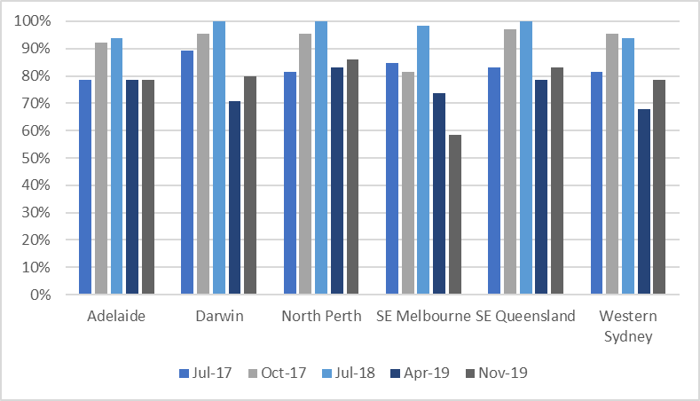

Figure 14: The extent to which each cluster/service met fidelity for psychological interventions, between July 2017 and November 2019 (Orygen fidelity assessments)

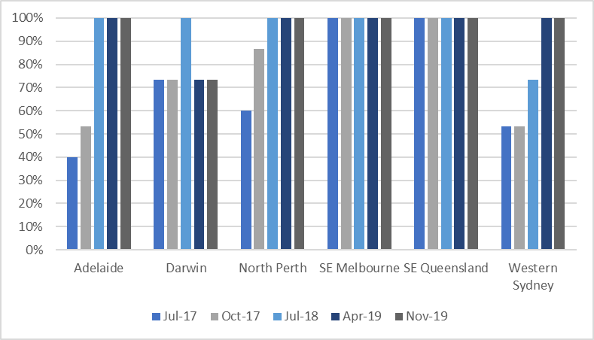

Services reported that they generally aimed to introduce clients to their CCT clinician early in the treatment process to assist with continuity of care. As clients stabilised, they were handed over from the MATT to the CCT and linked up with peer and family support as well. Clients were often transferred back to the MATT if their condition worsened, as the MATT cares for clients in crisis. However, some services reported that in practice the handover of clients from the MATT to the CCT was not always as integrated and coordinated as it could be. While some services developed a ‘step-up/step-down’ type model which aimed to integrate the two pathways to more seamlessly manage the client.

The extent to which headspace Early Psychosis services were able to form partnerships and raise community awareness

Relationships and partnerships with local service providers

**headspace Early Psychosis staff**

“Increased engagement with service providers has generally resulted in an increase in the proportion of appropriate referrals but not necessarily an increase in the volume of referrals”

headspace Early Psychosis staff, PHNs, Orygen, headspace National and the Australian Government Department of Health reported that development of local partnerships was critical to the effective implementation and delivery of the headspace Early Psychosis service. As evident in Figure 15, all six clusters or services developed relationships and partnerships, both informally and formally (for example, via Memoranda of Understanding or Service Level Agreements) and were consistently rated maximum fidelity in this component since July 2018. Awareness of the service was reported to have improved considerably over the Evaluation period, with the reputational challenges following the wind-down of funding which previously impacted relationships having mostly subsided in late-2019. This was largely attributed to improved relationships with LHNs resulting from ongoing communication with and presence in Local Hospital Network services. For example, one service reported having a triage nurse that did in-reach into hospitals to promote the service, while another service reported having youth ambassadors who did in-reach into schools. headspace Early Psychosis service staff and other local stakeholders consistently reported that while the community and service providers were aware of headspace, there was not always the same level of awareness with the headspace Early Psychosis service – which were not necessarily seen as distinct from headspace Primary. Furthermore, this also meant that some external providers were not always aware that the headspace Early Psychosis service was medically-led model, capable of seeing youth with complex mental health needs.

**Good practice example**

North Perth initiated a number of strategies which successfully drove an increase in the volume and appropriateness of referrals – an increase of 11 percent. This entailed: a review of the intake and exclusion criteria; changes to staffing; and a targeted GP engagement/networking event.

Figure 15: The extent to which headspace Early Psychosis clusters/services met fidelity for partnerships, between July 2017 and November 2019 (Orygen fidelity assessments)

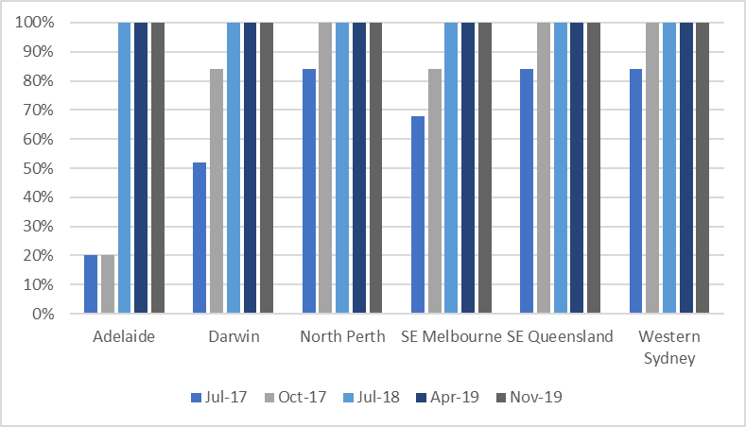

headspace Early Psychosis staff reported that as their relationships and partnerships expanded and developed, so did the number of referrals they received. They also reported that they were working on improving the number of appropriate referrals. Section 5.3.2 showed that referrals came from a wide range of sources, further highlighting the extent of partnerships made.

All services reported that the development of relationships and partnerships took more time and resources than expected to:

* Establish workforce capability and capacity in relationship building
* Identify relevant services to establish relationships and partnerships based on alliance with the headspace Early Psychosis services strategic/work plan
* Engage with services to establish relationships and shared objectives to establish informal and formal partnerships
* Develop and maintain an up-to-date list of all partner organisations
* Develop and maintain Service Level Agreements and/or Memoranda of Understanding with all partner organisations that set out the responsibilities of the headspace Early Psychosis service and the partner organisation.[65]

Services reported that changes to policy and disruptions to the EPYS Program, the state and territory policy landscapes and service systems in which services operate, PHN involvement in stakeholder relationship building and the local health and other service systems affected their ability to establish trust and relationships to build effective partnerships.

Relationships and partnerships with local community

As evident from Figure 16 engagement, education and awareness programs with local communities varied both across and within clusters at each fidelity assessment point– with only four of the six clusters/services having achieved maximum fidelity at any one of the given assessment points. Given that no services were consistently achieving maximum fidelity against this component, this is an area for improvement.

Figure 16: The extent to which each cluster met fidelity for community awareness and education, between July 2017 and November 2019 (Orygen fidelity assessments)

Figure 16 is a grouped bar graph showing the extent to which each cluster met fidelity for community awareness and education, between July 2017 and November 2019 (Orygen fidelity assessments)

It is evident from the referrals into headspace Early Psychosis services (Table 12) and from local consultations, that there was generally broad awareness of the program locally. Some services reported having staff roles, such as community liaison officers and youth ambassadors, to work with the community through visits to local health services, community educations sessions, outreach and education at schools on mental health and psychosis, community events and development of information materials.

Stakeholders reported that the headspace brand was very powerful, and this helped with opening communication pathways with external stakeholders and organisations such as schools. Across services it was reported that the awareness of the program by tertiary services was relatively good, however engagement of GPs, other government agencies and NGOs was an area for improvement.

Services reported in late-2019 that engagement efforts did not necessarily translate to increased referrals. As was the experience of the Adelaide service in the joint community engagement project undertaken with Orygen which targeted the homeless population. The absence of a dedicated headspace Early Psychosis website was reported to hinder efforts in engaging youth about the program, particularly given youth are likely to seek services and undertake their own research online. Given the headspace Early Psychosis services is not offered at all headspace Centre, this was reported to be a barrier to promoting the service as a unique brand under the headspace banner more broadly.

The headspace Early Psychosis national community engagement strategy, which had a soft launch in November 2019, sought to improve engagement and awareness of the service amongst GPs and the community. Given the timing of the launch, it was not possible to obtain feedback from all services regarding the potential benefit that the strategy will have in engaging the local community. One service reported that the promotion materials developed did not appear to be culturally appropriate for the Indigenous community and that improved materials for this community would be welcomed.

The extent to which headspace Early Psychosis services were able to recruit and develop their workforce

The ability to access and recruit skilled workforce and specialist staff, as well as provide appropriate training, influenced the extent to which headspace Early Psychosis was implemented. It was reported by services in late-2019, that staff numbers continued to increase, and they were developing their workforce to be fit-for-purpose to deliver services according to the EPPIC model. However, as evident from Figure 17, there was variability across each cluster/service in the extent to which they were able to develop and embed their workforce.

Figure 17: The extent to which each cluster/service met fidelity for workforce development, between July 2017 and November 2019 (Orygen fidelity assessments)

Figure 17 is a grouped bar graph showing the extent to which each cluster/service met fidelity for workforce development, between July 2017 and November 2019 (Orygen fidelity assessments)

Services reported that the key challenges in developing their workforce related to recruitment and retention and training, both of which are explored further below.

Recruitment and retention

Most services reported that recruitment of their workforce was been one of the biggest pieces of work they undertook following the reinstatement of the program funding. Since this time, the recruitment and retention of staff was reported to have improved for most services. Yet it remained an ongoing challenge for the program. Whilst funding uncertainty and short-term contracts were a significant contributor, competitive salaries, the absence of paid maternity leave in some services, and the absence of CPI increases was also reported. Some services highlighted that skills shortages were a common issue in their region, making it even more difficult to compete with LHNs for staff. Internal restructures undertaken at several services were reported to have contributed to higher turnover. Most services reported experiencing difficulties in having positions approved by the PHN and lengthy delays in these decisions, with further compounded these workforce challenges.

The high turnover of staff impacted implementation of the program, as there were less clinical staff to deliver caseloads and staff that remained were having to train or upskill less experienced staff. It was reported that fidelity scores were largely influenced by staffing at the time. As such, if assessments happened to coincide with the timing of staff vacancies this adversely impacted fidelity scores.

Services consistently reported over the Evaluation period they required workforce with a high level of expertise due to the complexity of the young people they work with and the specialised nature of the services provided. However, these skill sets were either limited in their region or were already recruited into state-funded health services. Most services reported that they could not compete with the long-term contracts, job certainty and benefits offered to the workforce in the state-funded health system. Therefore, some services had to recruit less experienced staff and then invest in additional training to tailor their skillset to the service. Services that had developed strong working partnerships with local health services were able to overcome some of these workforce shortage issues, as they were able to share resources, such as clinical staff.

All services reported that recruitment of the peer support workforce was challenging given the maturity of the program and being able to identify a cohort of people who had been through the service and could be Peer Support Workers. However, services reported that this was improving as the service matured and more young people and their families were discharged from the service. Services also reported that the youth peer support workforce had the potential to have more frequent turnover due to young people moving into other education and employment opportunities. This needed to be carefully planned for and managed to ensure stability for clients. Services reported that family peer support workers were more stable.

headspace Early Psychosis workforce training

Orygen provides training for the EPYS Program, initially this was face-to-face, but at the time of the Evaluation this had transitioned to being online. The training was reported to be beneficial by all services as it provided the specialised knowledge and skills required to effectively deliver the EPPIC model.

Orygen did not have ongoing funding by the Australian Government Department of Health to provide face-to-face training over the Evaluation period; however, the online modules were available for staff at any time. Still, new staff often reported that it was a challenge to complete the online models with their clinical commitments. The onus was on services to deliver their own training and encourage staff to undertake staff the online training. headspace Early Psychosis staff reported that a tailored training package and dedicated resources would be helpful in improving training of staff to effectively deliver the model.

Functional recovery and group programs

Functional recovery and group programs formed a critical part of the model and was reported by all stakeholders to be a key factor in achieving sustainable outcomes for clients. The FRP was designed to include activities aimed to restore or maintain the normal functional trajectory of the young person, and fall under three interlinked areas:

* Vocational function
* Educational function
* Social function.

The FRP was designed to be delivered by headspace Early Psychosis staff (including peer support workforce), as well as partner organisations, with the CCT clinician coordinating the interventions for an individual that promote functional recovery.

Group programs aimed to provide social interactions in a safe, supportive and therapeutic environment to assist clients in their functional recovery. While some groups specifically targeted social or other forms of functional recovery, for other groups the setting in which they occur provided the necessary environment to optimise social recovery. Oftentimes social groups were co-facilitated by peers.

**Good practice example**

South East Queensland reported a more evolved approach to internal team integration. This saw the consolidation of the FRT being better embedded across the cluster into the service and integrated with MATT and the CCT. This enabled a greater focus on function assessments and more holistic care.

Across the Evaluation period, maturity and growth of the ‘FRPs’ and ‘Group programs’ was reported by most services. This was consistent with the fidelity data (Figure 18 and Figure 19) which showed all services achieved 100 percent for this component in November 2019. Linkage with external providers, like Reclink, helped one service address an FRP workforce shortage by allowing clients to access recreational groups that the service was not resourced to offer. The FRP and the peer workforce were consistently reported by both staff and external stakeholders as a unique and value-add aspect of the program – differentiating it from tertiary services which may not have the same level of resources to provide such services. This was further highlighted by several tertiary-based clinicians who would like to implement similar components into their service.

Most local stakeholders, clients, carers and family members reported that there were very few services which offer similar FRPs to the headspace Early Psychosis program – where all aspects were in one place and easily accessible to young people. Staff reported that the balance of being a medical and therapeutic model increased buy-in from clients and helped to make the service more client-centred. Staff reported that functional recovery sat alongside the clinical aspects of the service and had a psychosocial focus. It aimed to reconnect and re-engage young people with the things they find meaningful in their lives (for example, education, work, reconnecting with family and friends etc). Given many services were delayed in establishing the functional recovery and group programs, integration with CCT and MATT took some time to develop and was delayed relative to other components. During local consultations in 2018, services reported that they would ideally like to introduce FRP earlier in client treatment, consultations in late-2019 highlighted that some services achieved this aim. Services reported that if they could involve the FRP early, this would encourage more young people to come to the service, as functional recovery was generally a key aim for young people and was also a better resourced aspect of the program relative to many Local Hospital Network services.

**Good practice example**

Western Sydney reported a matured approach and a number of improvements in the delivery of the FRP. This included: partnership with a recruitment agency to support clients in resume writing and managing rejection; travel training using CBT and DBT; establishment of a six week TAFE program; and working with clients to support attendance at group (including arranging transport if necessary). Importantly a tiered approach to FRP was adopted based on client readiness

It took time to establish group programs due to staffing shortages – particularly within the peer workforce. Staff reported that they had to be “creative” about how functional recovery could be delivered during the earlier stages of implementation given it was a critical part of the model. It was also highlighted that hAPI did not reflect the extent of functional recovery work undertaken, given the system did not have fields granular or specific enough to appropriately reflect the work undertaken.

In addition, delivering the functional recovery elements of the headspace Early Psychosis program required the establishment of relationships with health, education, community and human service providers to deliver aspects of the programs (for example, information workshops, courses, fitness programs, TAFE courses, art courses, etc.).

Figure 18 and Figure 19 show that all clusters/services were achieving 100 percent fidelity over the last three fidelity assessments for ‘FRP’ and ‘Group programs’.

Figure 18: The extent to which each cluster/service met fidelity for the FRP, between July 2017 and November 2019 (Orygen fidelity assessments)Figure 18 is a grouped bar graph showing the extent to which each cluster/service met fidelity for the FRP, between July 2017 and November 2019 (Orygen fidelity assessments)

Figure 19: The extent to which each cluster/service met fidelity for group programs, between July 2017 and November 2019 (Orygen fidelity assessments)  
Figure 19 is a grouped bar graph showing the extent to which each cluster/service met fidelity for group programs, between July 2017 and November 2019 (Orygen fidelity assessments)

Some services reported having vocational programs that were in high demand with constrained resources. As outlined in Section 0, some services were able to provide vocational support through IPS where dedicated vocational resources did not otherwise exist. Services reported that having vocational staff within the program was essential in addressing the recovery needs of young people and because getting back to work or education was often a high priority for the young person.

Local stakeholders reported that there would be significant benefit to clients if the functional recovery and group programs were expanded, however they expressed that more effective measurement of functional recovery was needed to support this.

The extent to which headspace Early Psychosis services were able to develop and integrate a peer support workforce

The involvement of a peer support workforce in service delivery varied across services, this was primarily due to how well the service was resourced to deliver this component and how mature services were. The desire to continue to grow and invest in the peer workforce was reported consistently across services, as reflected in the lower fidelity scores for this component (Figure 20). Some examples of how peers could be used within the service are highlighted in the good practice example to the right.

**Good practice example**

During the Evaluation period, one cluster reported a more mature approach to how its peer workforce were deployed. This included:

* Having peer workers and peer-led groups at each of the spokes
* A high uptake in one-on-one sessions with a peer worker
* All families were contacted by a family peer worker
* Participation in leadership meetings as well as peer workers being actively involved in the recruitment of all staff
* Peer participation in staff interviews.

Senior leadership played an important role in advocating the peer workforce to clinicians and this helped ensure their roles were optimised, better understood and well-integrated into the rest of the service.

Building peer and family support took time given the need to identify and develop eligible peer support workers. During consultations in 2018, services reported that their peer support was only “just hitting the ground”, as such, relative to other components it had less time to mature. Services that were able to embed peer and family support in the headspace Early Psychosis team and service reported a positive impact on clients and families.

In services that had a better resourced peer workforce, peers provided one-on-one sessions with clients, participated in clinical review meetings, service improvement and participated in the development of learning and development course content. In contrast, peer workers at one service reported that, due to funding, they were unable to undertake: one-on-one sessions with clients, families and carers; quality improvement; or participate in team meetings. Consistently, peers were reported as being an important factor of the program in not only supporting clients, but also for self-development and recovery. Peer involvement at most services extended to representation in clinical reviews, however the extent and consistency of peer involvement was resourcing dependent. To improve participation of group programs, some services reported offering groups after hours and providing support with transport.

Figure 20 shows that there was considerable variability across clusters/services and reporting periods for the family and peer support fidelity scored, this was largely attributed to the challenges in recruiting the peer workforce.

Figure 20: The extent to which each cluster/service met fidelity for family and peer support, between July 2017 and November 2019 (Orygen fidelity assessments)  
Figure 20 is a grouped bar graph showing the extent to which each cluster/service met fidelity for family and peer support, between July 2017 and November 2019 (Orygen fidelity assessments)

The extent to which headspace Early Psychosis services were able to involve youth in the delivery and design of the service

Youth participation was a fundamental component of both the headspace and EPPIC models. headspace Early Psychosis aimed to achieve this by embedding young people in the decision-making processes about their care and provide them with a formal avenue for feedback to contribute meaningful quality improvement in service delivery.

Figure 21 shows that three of six clusters or services achieved maximum fidelity in November 2019 – with all services, other than South East Melbourne, improving in this component since June 2017 as they have built up their peer workforce.

Figure 21: The extent to which each cluster/service met fidelity for youth participation and peer support, between July 2017 and November 2019 (Orygen fidelity assessments)  
Figure 21 is a grouped bar graph showing the extent to which each cluster/service met fidelity for youth participation and peer support, between July 2017 and November 2019 (Orygen fidelity assessments)

Staff reported that they experienced delays in developing youth participation as it took time to identify appropriate candidates. Although some services reported that they embedded youth participation in the design and planning phase of the program, others reported that it was difficult to engage eligible youth until a greater cohort of young people completed the program. Services reported several ways through which they engaged youth in the ongoing delivery of the model, including through the peer workforce, Youth Advisory Committees and ‘friends and family’ committees.

**Good practice example**

During the evaluation period, the Western Sydney cluster commenced a “family and friends committee”, this was a forum for family and friends of clients to have a voice in the delivery of the program. This community became a reference point for feedback on service change and outgoing communications.

The extent to which headspace Early Psychosis services were able to deliver 24-hour care and enable access to inpatient and subacute beds

The components of 24-hour care, as well as access to youth friendly inpatient and subacute beds, were challenging aspects of the model to deliver for most services, and hence were not captured as part of the fidelity assessments. In some cases, this exclusion was because there were not enough resources to adequately provide the services, particularly where there were no youth friendly inpatient and/or sub-acute beds in the region. Where they were available within the region, some services established Memoranda of Understanding to provide access to inpatient and/or sub-acute beds for headspace Early Psychosis clients. This was reported to greatly assist in providing a comprehensive service to the client and meant that headspace Early Psychosis services could provide a seamless care pathway no matter the acuity of the client.

**headspace Early Psychosis staff**

*“We have taken the view that 24 hours is too costly and can’t be justified given state services already offer this. We are not at a point where we can do this given other issues, there wouldn’t necessarily be enough numbers anyways. 7-days a week and early evening is of value, there is a bit of a sweet spot.”*

All services reported that while they increased their after-hours coverage over the Evaluation period, for example, increasing MATT services outside of business hours and on weekends, the provision of 24-hour care was an enormous challenge – in terms of financial viability, clinical risk and staff safety. Western Sydney was the only cluster providing 24-hour care through the service in the form of an on-call/re-call roster which commenced in 2019. All clinical staff in Western Sydney participate in the on-call/re-call roster and receive an allowance for this work. Staff and other local stakeholders noted that young people who were in crises during the overnight period were usually best treated in the hospital setting, rather than in the community. Some services reported that it would be more effective to have out-of-hours risk management plans in place, which include extended hours for the headspace Early Psychosis service, but also include partnerships with the tertiary sector for the care and support of clients in crisis during the overnight period – rather than the expectation that the service delivers 24-hour care.

* 1. To what extent did the EPYS Program reach the target population?

This section covers:

* EPYS Program reach overview
* Referral sources into headspace Early Psychosis
* Characteristics of the young people in headspace Early Psychosis
* The engagement of young people with headspace Early Psychosis
* Focus of treatment by headspace Early Psychosis services on the target group
* Geographical area of service provision by headspace Early Psychosis
* Representation of young people across special interest groups
* Opportunities for improving target population reach.
  + 1. EPYS Program reach overview

For this evaluation question, the target population of the EPYS Program refers to young people:

* Aged 12-25 who were at risk of developing a first episode of psychosis, or have experienced a first episode of psychosis
* Located in a region that had a headspace Early Psychosis cluster or service.

However, to provide perspective on the current reach of the program relative to prevalence: at the time of the evaluation, the program had 1138 FEP clients (Table 6) and the estimated youth psychosis population was 8,800[66],[67]. This indicates a reach of 13 percent of the potential population.

Actual reach relative to potential population reach of the program is explored further in Evaluation Question 5. As detailed in Section 5.2.4, reach of the target population was somewhat hindered by the limitations in meeting target caseloads.

The absence of defined catchment areas for headspace Early Psychosis supported service equity and this was shown within the hAPI evaluation extract. Where clients located away from the headspace Early Psychosis service were accessing treatment. Whilst service access was not defined to local government areas (which is typical for other mental health services), staff travel was generally limited to one-hour from the hub and/or spoke and this inherently limited the reach of the program.

* + 1. Referral sources into headspace Early Psychosis

Eligibility criteria for headspace Early Psychosis

headspace Early Psychosis provided services to young people aged between 12 and 25 years of age (at the point of referral to the program) who experienced their first episode of psychosis or who were at risk of developing psychosis. This included young people who had a family history of psychosis, had a decline in functionality, and/or had transient psychotic symptoms.

Those who were eligible included young people who were:

* Between the age of 12 years and 25 years old at time of referral
* Had less than 12 months of treatment for psychosis by another mental health service, private psychiatrist or general practitioner
* Whose symptoms were not solely associated with substance intoxication
* Unlikely to benefit from some other service or program.

Young people living outside the geographic area (i.e. more than one hour away) who are eligible for entry to the service may not be able to receive all the core components of the model; however, where they are able to attend the headspace Centre they have access to all core components available.

Referral sources into headspace Early Psychosis

There were several referral pathways into headspace Early Psychosis. Given the potential bias due to lack of information about non-eligible clients and those with unknown outcomes, only clients who were accepted into either the FEP or UHR treatment arms have been included.

Table 12 below provides a summary of the referral patterns for the program and shows:

* The most common referral sources into the FEP and UHR treatment arms were from a public psychiatric specialist service provider (e.g. psychiatrist, paediatrician, or inpatient service), a community-based mental health service (e.g. CAMHS or AMHS), self-referral or a family member.
* Referral sources varied substantially by cluster, presumably dependent upon headspace Early Psychosis service configuration, local health service context, service availability and possibly recording practices.
* A large proportion of NSW and NT referrals were direct approaches (walk-ins) from self or family members.
* Psychiatric specialists and community mental health services were the largest source of referrals to SA, VIC and WA.
* In QLD the co-located headspace Primary was the main source of referrals, along with walk-ins and community-based mental health services.
* Whilst staff reported undertaking efforts to improve referrals into the service, for example through community engagement and outreach into schools, this did not appear to be reflected in the referral sources. Furthermore, given the co-location of headspace Early Psychosis with headspace Primary, the proportion of headspace Primary referrals is relatively low. However, this may be a result of joint intake processes in some services.

Table 12: Percentage of referral sources into the program by cluster/service (hAPI data evaluation extract)**[68]**

| Referral source | NSW | NT | QLD | SA | VIC | WA |
| --- | --- | --- | --- | --- | --- | --- |
| Self-referred | 30.3* | 25.8 | 15.8 | 3.2 | 5.8 | 9.8 |
| Public specialist | 24.2 | 10.1 | 10.8 | 37.5 | 33.4 | 38.3 |
| Family member | 17.5 | 20.8 | 12.6 | 5.1 | 8.7 | 3.9 |
| Community-based mental health service | 4.7 | 10.1 | 14.1 | 30.0 | 11.0 | 13.3 |
| Private specialist | 4.7 | 1.3 | 3.3 | 3.2 | 3.8 | 7.8 |
| Community-based allied health professional | 3.8 | 2.5 | 1.7 | 1.1 | 1.1 | 2.3 |
| Primary (GP) | 3.8 | 15.7 | 4.8 | 11.2 | 7.6 | 7.4 |
| School-based service | 3.3 | 2.5 | 2.0 | 1.4 | 2.7 | 3.5 |
| Community service | 2.8 | 2.5 | 1.7 | 0.4 | 1.1 | 2.7 |
| Other headspace | 2.8 | 0.0 | 10.6 | 5.1 | 2.0 | 3.1 |
| This headspace | 0.9 | 6.3 | 18.0 | 1.1 | 6.5 | 4.3 |
| Friend | 0.5 | 1.3 | 0.0 | 0.4 | 0.4 | 0.0 |
| Legal, justice, corrections service | 0.5 | 0.0 | 0.4 | 0.0 | 0.2 | 0.8 |
| Alcohol or other drug service | 0.0 | 0.0 | 3.3 | 0.4 | 1.1 | 0.4 |
| Child protection | 0.0 | 0.6 | 0.4 | 0.0 | 0.0 | 0.0 |
| Employment agency | 0.0 | 0.0 | 0.2 | 0.0 | 0.0 | 0.0 |
| *\*The top three referral sources in each cluster are indicated in teal* | | | | | | |

Referral pathways in each treatment arm for the EPYS Program

The referral pathways into the EPYS Program are shown in Figure 22. The referral sources, as listed in Table 12 above, were grouped by level of medical care (see legend below figure). Figure 22 shows that:

* The single largest referral source for the EPYS Program, comprising nearly half of FEP episodes was ‘other psychiatric services’. This indicates that the headspace Early Psychosis service was not the first treatment service encountered by these young people. UHR sources were more likely to be walk-ins – self referral and via family members.
* The self-presentation rate of UHR was fitting given the cohort target. It also indicated that these clients were more likely to be at risk rather than having been already diagnosed or treated previously. It may also indicate outreach for UHR was being done effectively by engaging non-medical services (‘other’), i.e. schools, community-based organisations.

Figure 22: Referral source to each treatment arm for the EPYS Program (hAPI data)

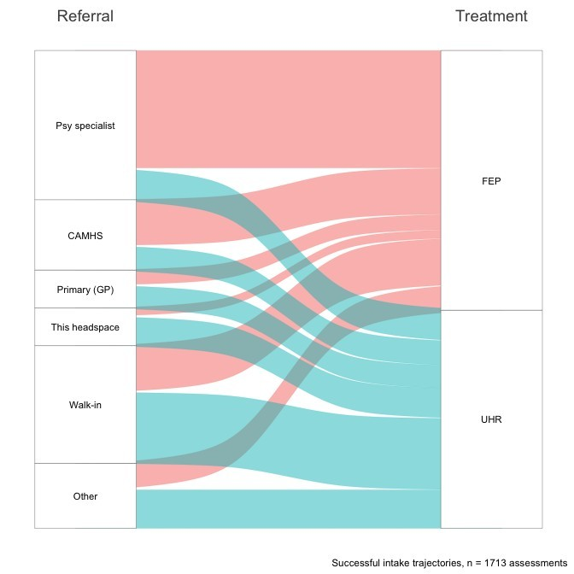

*Legend: “Psy specialist” included public or private specialist (psychiatrist, paediatrician, inpatient service, allied health in the original referral sources); CAMHS included community-based mental health services (CAMHS and AMHS); “Walk-in” included self-referral or family member, and “Other” included school-based services, other headspace, community-based allied health, community service, legal, justice and corrections services, child protection, alcohol and drug services, employment agencies, and friends.*

Intake rate of referrals

The intake rate is an estimate of how well targeted referrals are and how much resource is spent triaging people that are ultimately deemed ineligible. If the intake rate is too high, it is likely that many potentially suitable clients are not being referred to the services; too low and valuable resources are being expended on intake and referral on to other services rather than treatment activities.

Figure 23 shows that the national intake rate was approximately 50 percent (0.52). VIC and NSW had the highest intake rate (0.67 and 0.63), which may reflect tighter integration with referral sources, i.e. referrals were more appropriate. The other states all had similar intake rates (c. 40-50 percent). Consultation with staff did not highlight a reason for this variability across the clusters/services.

Figure 23: Estimated intake rate (hAPI data[69])

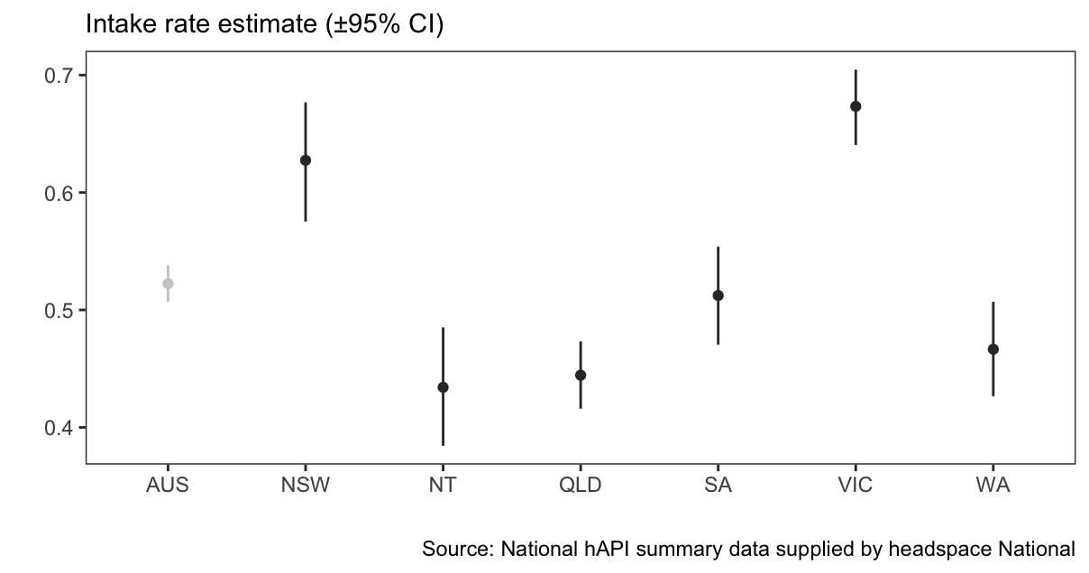

* + 1. Characteristics of the young people in headspace Early Psychosis

Table 13 describes the baseline characteristics of all episodes in the Evaluation sample, including episodes in each treatment arm (UHR *n* = 833, FEP *n* = 977), and episodes who were non-eligible (*n* = 866).

Compared to the general population, the EPYS clients were more likely to be:

* Male
* LGBQ
* Many of whom were either still in school or did not finish school, already in receipt of government benefits, with less vocational and educational participation than other young Australians
* Had a higher rate of substance use, particularly cannabis and smoking
* Indigenous people were overrepresented even when excluding Darwin.

When comparing headspace Early Psychosis treatment arms (FEP versus UHR versus non-eligible):

* The FEP cohort was different to the UHR and non-eligible cohort. They were older, less likely to be lesbian, gay, bisexual or questioning (LGBQ), more likely to be male, NEET, more likely to not have finished school, culturally diverse, on benefits, and be more frequent substance users with a particularly high rate of amphetamine use.
* In contrast, the UHR and non-eligible cohorts were indistinguishable from each other.
* There was a higher proportion of LGBQ in the UHR cohort, which was expected because this population does report a high prevalence of non-psychotic disorder.

Table 13: Client characteristics at assessment

|  | Variables | Everyone | % | UHR | % | FEP | % | Non-eligible | % | p.valuea | posthoc |
| --- | --- | --- | --- | --- | --- | --- | --- | --- | --- | --- | --- |
|  | N | 2676 |  | 833 |  | 977 |  | 866 |  |  |  |
| Demographics | Age (mean ±SD) | (19) | ±3 | (18) | ±3 | (20) | ±3 | (18) | ±3 | 0.00b | ±2b |
| NEET | 640 | 26 | 166 | 21 | 338 | 35 | 136 | 19 | 0.00 | FEP > exp. |
| Gender | Female | 1,106 | 42 | 424 | 51 | 318 | 33 | 364 | 44 | 0.00 | FEP < exp. |
| Male | 1,469 | 56 | 383 | 46 | 647 | 67 | 439 | 54 |  | FEP > exp. |
| Non-binary | 43 | 2 | 20 | 2 | 6 | 1 | 17 | 2 |  | FEP < exp. |
| Sexuality | Heterosexual | 1,531 | 69 | 463 | 66 | 551 | 71 | 517 | 71 | 0.00 |  |
| LGBQ* | 268 | 12 | 109 | 16 | 63 | 8 | 96 | 13 |  | FEP < exp. |
| Other/Unknown | 408 | 18 | 127 | 18 | 163 | 21 | 118 | 16 |  |  |
| Culture | Indigenous (ex. Darwin) | 158 | 7 | 45 | 6 | 58 | 6 | 55 | 8 | 0.23 |  |
| Indigenous (Darwin) | 69 | 25 | 17 | 15 | 14 | 35 | 38 | 31 | 0.00 | UHR < exp. |
| Born overseas | 358 | 14 | 81 | 10 | 184 | 19 | 93 | 12 | 0.00 | FEP > exp. |
| NESB* | 243 | 10 | 51 | 6 | 135 | 15 | 57 | 8 | 0.00 | FEP > exp. |
| Education | In school | 906 | 36 | 377 | 46 | 158 | 17 | 371 | 48 | 0.00 | FEP < exp. |
| High school | 648 | 26 | 156 | 19 | 338 | 37 | 154 | 20 |  | FEP > exp. |
| Certificate/Diploma | 152 | 6 | 48 | 6 | 58 | 6 | 46 | 6 |  |  |
| University degree | 60 | 2 | 15 | 2 | 35 | 4 | 10 | 1 |  | FEP > exp. |
| Did not finish | 693 | 28 | 209 | 26 | 296 | 33 | 188 | 24 |  | FEP > exp. |
| None of the above | 43 | 2 | 10 | 1 | 21 | 2 | 12 | 2 |  |  |
| Benefits | None | 1,638 | 67 | 585 | 72 | 533 | 57 | 520 | 76 | 0.00 | FEP < exp. |
| DSP* / Unemployment | 495 | 20 | 139 | 17 | 257 | 27 | 99 | 15 |  | FEP > exp. |
| Other | 306 | 13 | 90 | 11 | 153 | 16 | 63 | 9 |  | FEP > exp. |
| Home | Family home | 1,585 | 66 | 547 | 68 | 605 | 64 | 433 | 68 | 0.00 |  |
| Rented | 551 | 23 | 197 | 24 | 202 | 21 | 152 | 24 |  |  |
| Boarding house/hostel | 78 | 3 | 20 | 2 | 36 | 4 | 22 | 3 |  |  |
| Other | 183 | 8 | 44 | 5 | 107 | 11 | 32 | 5 |  | FEP > exp. |
| Frequent substance use | Tobacco (daily) | 708 | 34 | 197 | 26 | 378 | 45 | 133 | 26 | 0.00 | FEP > exp. |
| Alcohol (weekly) | 597 | 28 | 172 | 23 | 286 | 34 | 139 | 27 | 0.00 | FEP > exp. |
| Cannabis (daily) | 432 | 20 | 112 | 15 | 235 | 27 | 85 | 16 | 0.00 | FEP > exp. |
| Amphetamine (weekly) | 131 | 6 | 26 | 3 | 83 | 10 | 22 | 4 | 0.00 | FEP > exp. |
| Heroin/cocaine (weekly) | 44 | 2 | 10 | 1 | 26 | 3 | 8 | 2 | 0.03 | FEP > exp. |
| aPearson's Chi-squared test for independence | | | | | | | | | | | |
| bp-value and least significant difference from Tukey's Honestly Significant Difference test | | | | | | | | | | | |

*\*Legend: NEET is not in education, employment or training; Non-binary is neither “Female” nor “Male”; LGBQ is lesbian, gay, bisexual or questioning; NESB is non-English speaking background (determined by the language spoken at home); DSP is Disability Support Pension; Other benefits includes study payments, parenting payments, or other payments; Other home includes “Caravan”, “Crisis accommodation/Shelter/Refuge”, “Homeless”, “Hospital/Rehabilitation/Other health services”, “Other”; See Appendix I for complete descriptions of key variables.*

* + 1. The engagement of young people within headspace Early Psychosis

To determine engagement with the program, the baseline characteristics of young people enrolled in treatment for a minimum duration were compared to those who were discharged beforehand (I.e., “long” versus “short” engagement). The minimum engagement in UHR treatment was six-months because this was the duration of treatment.

The minimum engagement in FEP treatment was arbitrarily selected to be one-year because the hAPI evaluation data extract only contains two years of data. Episodes with commencement dates before 5 October 2018 and 3 April 2019, for FEP and UHR respectively (i.e., were eligible to have completed either a one-year or six-month program), were included in this analysis.

Table 14: Characteristics at assessment stratified by engagement with each treatment arm (hAPI data)

|  | Variables | UHR short | % | UHR long | % | p.valuea | FEP short | % | FEP long | % | p.valuea |
| --- | --- | --- | --- | --- | --- | --- | --- | --- | --- | --- | --- |
| Demographics | n | 354 | 49 | 368 | 51 |  | 383 | 63 | 227 | 37 |  |
| Age (Mean) ±SD | (18) | ±3 | (18) | ±3 | 0.120 | (20) | ±3 | (20) | ±3 | 0.354 |
| NEET | 82 | 23 | 60 | 16 | 0.026 | 127 | 33 | 77 | 34 | 0.917 |
| Gender | Female | 166 | 47 | 204 | 56 | 0.007 | 127 | 33 | 69 | 31 | 0.658 |
| Male | 172 | 49 | 160 | 44 |  | 251 | 66 | 155 | 69 |  |
| Non-binary | 12 | 3 | 3 | 1 |  | 3 | 1 | 1 | 0 |  |
| Sexuality | Heterosexual | 185 | 52 | 209 | 57 | 0.230 | 225 | 59 | 141 | 62 | 0.718 |
| LGBQ | 46 | 13 | 53 | 14 |  | 28 | 7 | 15 | 7 |  |
| Other/Unknown | 123 | 35 | 106 | 29 |  | 130 | 34 | 71 | 31 |  |
| Culture | Indigenous | 17 | 5 | 25 | 7 | 0.355 | 23 | 6 | 13 | 6 | 1.000 |
| Indigenous (Darwin) | 6 | 2 | 10 | 3 | 0.500 | 6 | 2 | 5 | 2 | 0.798 |
| NESB | 32 | 9 | 29 | 8 | 0.670 | 65 | 17 | 38 | 17 | 1.000 |
| Born overseas | 32 | 9 | 38 | 10 | 0.666 | 75 | 20 | 41 | 18 | 0.703 |
| Education | In school | 144 | 42 | 177 | 48 | 0.063 | 62 | 17 | 40 | 18 | 0.381 |
| High school | 71 | 21 | 68 | 19 |  | 133 | 36 | 83 | 37 |  |
| Certificate/Diploma | 27 | 8 | 16 | 4 |  | 20 | 5 | 20 | 9 |  |
| University degree | 3 | 1 | 11 | 3 |  | 12 | 3 | 10 | 5 |  |
| Did not finish | 95 | 27 | 90 | 25 |  | 132 | 36 | 65 | 29 |  |
| None of the above | 6 | 2 | 4 | 1 |  | 9 | 2 | 4 | 2 |  |
| Benefits | None | 229 | 67 | 276 | 76 | 0.032 | 199 | 55 | 119 | 54 | 0.599 |
| DSP / Unemployment | 76 | 22 | 48 | 13 |  | 104 | 29 | 63 | 28 |  |
| Other | 36 | 11 | 40 | 11 |  | 58 | 16 | 40 | 18 |  |
| Home | Family home | 220 | 65 | 251 | 70 | 0.469 | 221 | 60 | 149 | 67 | 0.043 |
| Rented | 91 | 27 | 81 | 22 |  | 75 | 20 | 50 | 22 |  |
| Boarding house/hostel | 7 | 2 | 10 | 3 |  | 19 | 5 | 10 | 4 |  |
| Other | 21 | 6 | 19 | 5 |  | 51 | 14 | 15 | 7 |  |
| Frequent substance use | Tobacco (daily) | 96 | 31 | 73 | 22 | 0.006 | 151 | 49 | 83 | 40 | 0.029 |
| Alcohol (weekly) | 86 | 28 | 67 | 20 | 0.019 | 112 | 36 | 73 | 34 | 0.638 |
| Cannabis (daily) | 46 | 15 | 51 | 15 | 1.000 | 105 | 34 | 47 | 22 | 0.002 |
| Amphetamine (weekly) | 13 | 4 | 7 | 2 | 0.116 | 38 | 13 | 9 | 4 | 0.002 |
| Heroin/cocaine (weekly) | 9 | 3 | 4 | 1 | 0.163 | 17 | 6 | 8 | 4 | 0.393 |
| aPearson's Chi-square test with Yates' continuity correction  p values in purple are significant | | | | | | | | | | | |

*Legend: NEET is not in education, employment or training; Non-binary is neither “Female” nor “Male”; LGBQ is lesbian, gay, bisexual or questioning; NESB is non-English speaking background (determined by the language spoken at home); DSP is Disability Support Pension; Other benefits includes study payments, parenting payments, or other payments; Other home includes “Caravan”, “Crisis accommodation/Shelter/Refuge”, “Homeless”, “Hospital/Rehabilitation/Other health services”, “Other”; See Appendix I for complete descriptions of key variables.*

* + 1. Focus of treatment by headspace Early Psychosis services on the target group

To determine whether the service was appropriately treating young people most in need (i.e. those with a diagnosis of a psychotic disorder or symptoms of psychosis), each client episode was categorised into one of the following assessment outcomes:

* Those accepted into the program, including FEP and UHR
* Those who were non-eligible, including:
  + “Other Psy”: If they were deemed ineligible for EPYS and formally referred to another psychiatric service (e.g. CAMHS, inpatient, psychiatrist, specialist psychiatric care, or another service provider)[70]
  + “Other”: The remaining episodes assessed as ineligible for EPYS and referred to a non-psychiatric service (i.e. a “low need” class).

These assessment outcome groups were compared in terms of symptom levels, and diagnosis to assess whether the clients entering the program had the characteristics for which the program was designed. Note: The analysis in this section excludes the entire South East Melbourne cluster, for which the “Other Psy” and “Other” classes were severely underrepresented in the sample.

There were several ways of determining if the program is reaching the population, including:

* Diagnosis at assessment
* Psychiatric symptom severity.

Diagnosis at assessment

Table 15 shows the primary diagnosis at assessment, stratified by clinical class. This table shows that:

* Over half of the FEP clients were diagnosed with schizophrenia
* 2.7 percent of clients in UHR had schizophrenia, which was unexpected given such a diagnosis would by definition, place a young person within the FEP treatment arm.

Table 15: Primary diagnosis at assessment stratified by clinical class (hAPI data)

| **Clinical class** | **Schizophrenia %** | **Bipolar %** | **Addiction %** | **Undetermined %** | **Other %** | **n** |
| --- | --- | --- | --- | --- | --- | --- |
| FEP | 51.2 | 6.0 | 6.3 | 25.0 | 11.5 | 729 |
| UHR | 2.7 | 1.4 | 1.6 | 47.4 | 46.9 | 623 |
| Other Psy | 9.3 | 1.5 | 1.5 | 44.6 | 43.1 | 204 |
| Other | 2.2 | 1.5 | 2.8 | 44.6 | 48.9 | 581 |

Psychiatric Symptom Severity

The Brief Psychiatric Rating Scale (BPRS) is a tool used to measure symptom levels using three standard subscales of psychiatric symptoms: (1) positive symptoms (hallucinations, delusions); (2) negative symptoms (lack of motivation, anhedonia, poverty of speech); and (3) general symptoms (anxiety, depression, suicidality). The higher the BPRS score, the worse the symptoms. Using Tukey’s Honestly Significant Difference test it was identified that the symptom levels of “Other Psy” and “Other” were significantly less than FEP and UHR (least significant difference *p* < .001).

Table 16 shows that regardless of diagnosis, the young people admitted into headspace Early Psychosis were the ones most in need (as determined by symptom severity).

Table 16: Average symptom levels using BPRS at assessment stratified by clinical class

| **Clinical class** | **Positive** | **Negative** | **General** | **missing %\*** | **n** |
| --- | --- | --- | --- | --- | --- |
| FEP | 10.4 | 10.1 | 22.3 | 7.5 | 683 |
| UHR | 8.8 | 8.8 | 23.8 | 4.2 | 600 |
| Other Psy | 4.5 | 4.6 | 13.1 | 16.7 | 180 |
| Other | 5.0 | 5.2 | 14.8 | 22.9 | 491 |
| *\*percentage of episodes (n) for which data is not available* | | | | | |

The UHR treatment arm clients

The EPYS Program aims to identify and treat young people who are “at risk of developing psychosis”. In the literature this is usually synonymous with the “at risk mental state” defined by attenuated psychotic symptoms (APS), brief limited intermittent psychotic symptoms (BLIPS) and trait vulnerability plus decline in psychosocial functioning (Genetic Risk and Deterioration Syndrome) using the CAARMs assessment developed by the team at Orygen. The headspace Early Psychosis services ascertain a broader definition of UHR by including young people who are identified as having only “a 30 percent or greater drop in functioning from a premorbid level, sustained for one month, occurring within past 12 months” without any of the specific symptoms or vulnerability.

Over half (53.3 percent) of the young people in the UHR treatment arm did not meet the criteria for an “at risk mental state”. However, the 12-month transition rate to psychosis was highest amongst those who *did not* meet criteria for “at risk mental state”.

Table 17: Eligibility for “at risk mental state” definition in the young people in the UHR treatment arm

| **CAARMS** | **N** | **%** | **12-mo (n)** | **Transitioned** | **Rate (12-mo)** |
| --- | --- | --- | --- | --- | --- |
| At-Risk Mental State | 389 | 46.7 | 225 | 6 | 2.67% |
| UHR treatment arm eligible only | 371 | 44.5 | 253 | 19 | 7.51% |
| Ineligible | 49 | 5.9 | 36 | 7 | 19.44% |
| (Missing) | 24 | 2.8 | 9 | 0 | 0% |

Based on Table 13 through to Table 17 the service overall targeted the referrals most in need of early intervention, based on diagnosis, symptom severity and transition rate, although the evidence base for the EPPIC model’s (cost)-effectiveness was not present for a large proportion of the clients in the UHR treatment arm. It is unclear if the latter group would be considered as youth severe. The diagnostic information does not suggest this, although the UHR treatment arm client symptom severity does suggest more clinical need in this group than those deemed ineligible.

* + 1. Geographical area of service provision for headspace Early Psychosis

In keeping with the model for headspace Centres, there were no defined catchment areas for the headspace Early Psychosis services. However, all services reported that they travelled up to one hour from the headspace Centre to provide services to young people. Young people who lived outside the geographic area who were eligible for the service were not always able to receive all the core components of the model; however, where they were able to attend the headspace Centre they had access to all the core components available. Given the hub and spoke model of the program, clusters reported running some group programs from the hubs only, this made it difficult for clients located away from the hub to attend group sessions. To assist with this, some services reported providing transport support.

Some local stakeholders queried the appropriateness and equity of service locations, for example, the presence of the headspace Early Psychosis service in an area which had a similar Local Hospital Network based Early Psychosis intervention service. Similarly, staff questioned if the hub was in the optimal location and, given the opportunity, they would consider having the hub elsewhere to improve the reach of the MATT. Having one MATT to service the entire region meant that it was not always possible to effectively leverage the team across the entire region – this was due to the travel required and the absence of supporting infrastructure, such as integrated eMRs between the hub and spokes for some services.

Although most headspace Early Psychosis clients were from a metropolitan area, staff in some clusters reported that the regions covered were geographically vast, not well serviced by other health services, were isolated and/or had poor public transport. The absence of catchment areas and the travel needed to deliver outreach services impacted clusters in different ways, for example:

**Good practice example**

In late-2019, Darwin headspace Early Psychosis and the Local Health Network commenced the use of secondary consultations to reach into rural communities. As part of this approach, headspace Early Psychosis clinicians provided psychoeducation to potential FEP clients when they first presented to the ward. When these patients were discharged to rural communities, the headspace Early Psychosis clinicians provided secondary consultations to Local Health Network clinicians during their community visits.

* Eastern based clusters, Western Sydney and South East Melbourne, reported that the one-hour travel radius resulted in a relatively smaller geographical reach as a result of traffic congestion.
* North Perth and Darwin considered the travel radius to be eastern centric, with the isolation of population catchments required to be reached not being recognised.

This geographic limitation increased equity of access issues in these areas. For example, Darwin staff reported that there was a huge need for a service like headspace Early Psychosis in regional, rural and remote communities where generally only rudimentary services have been available. In the absence of additional services, innovative approaches were needed to improve access to the program. Some stakeholders reported that technological solutions and telemedicine could provide a means to servicing a broader region (which may be in a more limited way) and may help address workforce shortage challenges seen in more remote areas.

* + 1. Representation of clients across special interest groups

The Indigenous Australian community

Services reported that ongoing effort was required to effectively engage the Indigenous Australian community in a meaningful and non-tokenistic way. Several services reported that funding for an Aboriginal Health Worker would be of considerable benefit in this regard. Some services reported that having more Indigenous Australian staff could potentially help with making the environment more welcoming for Indigenous clients and family members.

**headspace Early Psychosis clinician**

*“In terms of Indigenous engagement, this service works well, there is an Aboriginal liaison worker, there are more Indigenous patients here than anywhere I have worked, and we have developed connections with the local Aboriginal community”*

As shown in Table 13, 7 percent of clients within the headspace Early Psychosis (excluding Darwin) identified as Indigenous Australian and 25 percent of Darwin clients identified as Indigenous Australian. Given the general Indigenous Australian population represents 3.3 percent of the Australian population (2016 census data), Indigenous Australian youth may have been overrepresented in the EPYS Program. When these numbers were broken down by cluster/service, there were some differences in representation locally – some staff reported that young people who identified as Indigenous Australian were underrepresented although this cannot be confirmed without knowing the base rates. Most headspace Early Psychosis staff reported that cultural awareness and engagement of Indigenous Australian youth and communities would improve service equity associated with the program.

**headspace Early Psychosis staff**

“We have a very low level of diversity which is disappointing… [to improve, we] need to develop relationships with elders in the community…there isn’t trust built with the aboriginal community, they need to know it’s a safe space to come, it doesn’t matter how many flags you have in the reception”

The hAPI evaluation extract showed that Indigenous Australian young people were slightly more likely to be referred from school-based and community-based mental health services relative to other young people. Conversely, indigenous young people were slightly less likely to self-refer or be referred from family members.

Gender and sexually diverse community

The prevalence of mental health within the lesbian, gay and bi-sexual community is twice as high as that of the hetero-sexual population, with prevalence even higher amongst the transgender population,[71] making this community a special interest group within the program. hAPI data showed that 12 percent[72] of headspace Early Psychosis clients identified with a sexuality that was not heterosexual. This is significantly higher than the LGBQ population of Australia which is 3.2 percent.[73] This over representation of LGBQ clients is a positive indicator that the headspace Early Psychosis services has engaged with this special interest group and has overcome access barriers for this cohort. Consultations with peer workers, clients and staff indicated that headspace Early Psychosis services were engaging for the LGBQ community; this was partly attributed the non-stigmatising environment of headspace Centres, for example, all-inclusive bathrooms and lesbian, gay, bisexual, transgender, questioning and intersex friendly groups (PRISM).

Cultural and linguistically diverse community

Research from both Australia and overseas consistently highlights that immigrant and refugee populations are at higher risk of severe mental illness; they tend to have higher rates of diagnosis of psychosis upon presenting at acute inpatient units than the general population.

Data from the hAPI evaluation extract showed 10 percent of clients were from a non-English speaking background and 14 percent were born overseas. Note that it was not possible to determine ‘CALD’ clients the Australian Bureau of Statistics’ definition. headspace Early Psychosis services in areas that had a high CALD population identified some unique considerations associated with engaging this community. Stakeholders reported that CALD communities were less likely to identify that they had a mental health concern or seek treatment and that mental health was highly stigmatised in their communities. Stakeholders reported that CALD individuals were often migrants and refugees and, as such, were likely to have experienced significant trauma. Given this, there was potentially a greater need for UHR within these regions.

* + 1. Client, family and carer perception of EPYS Program reach

Program awareness

Clients and families reported a varied level of awareness of headspace Early Psychosis prior to entering the program. Branding and reputation were important factors for some clients and family members or carers. Commonly, clients and families or carers described learning about the service through word of mouth, internet searches, and referral from other professionals.

Descriptions of referral and accessibility of headspace Early Psychosis

Most clients and family members reported that they had accessed other community-based services to support their mental health prior to engagement with headspace Early Psychosis. Their support was predominately provided by private psychologists, GPs, private psychiatrist, and school counsellors. Comparisons between headspace Early Psychosis with these services are provided further in Section 6.1.

**Young person 7 (Parramatta)**

“So basically I went to school counsellor telling my symptoms that I had like I was hearing things and seeing things that were not really normal, I felt. … She gave me a card of all the headspace contacts and stuff like that, the kids help line. And so at the time, I did go to a private psychiatrist, private psychiatrist and psychologist. But they didn't really, I felt like they didn't really work for me. So I called headspace and I got an appointment”

Often, young people and their families reported seeking support from multiple community-based services before ending up either contacting headspace Early Psychosis (as a walk-in or with support from family, friends or health care providers) or being admitted to hospital.

Once in contact with headspace Early Psychosis, the predominant experience was that young people and families had easy access to the service (EPPIC model fidelity; easy access to service) and assessment took place in a variety of settings reflecting outreach capabilities of the service (EPPIC model fidelity; home based care and assessment), there were on a small number of cases where access difficulties were reported. Table 18 presents illustrative examples of easy and challenging access experiences.

Table 18: headspace integration with hospital referral process – Clients, Family Members and Carers

| Theme | Illustrative quotes |
| --- | --- |
| Easy access | *Family 1 (Penrith): And I rang, I spoke to headspace as well and he spoke to headspace. And then we were given an appointment, which was just the week after. I think it was quite quick.* |
| Access challenges | *Family 4 (Parramatta): So, I will have to get involved myself, I have to call headspace. I have to. Oh, yeah. I didn’t even have the right number to call, I remember what it was like, because I didn't realize that headspace, you know, has got three main offices. So I don't know which office to call actually because, yeah, I then I keep calling into the office, which is unmanned.* |

Approximately two thirds of young people and families in this sample reported having a public hospital admission which led to initial contact with headspace. Most of these young people and families reported the referral process between hospital and the headspace Early Psychosis MATT as quite well integrated and generally meeting their needs (EPPIC model fidelity; home based care and assessment). There were a small number of occasions where the young person or family member reported that the process of referral between hospital and headspace Early Psychosis was disjointed and/or delayed which impacted the young person negatively. Table 19 presents illustrative examples of integrated and disjointed experiences. Importantly, once they had their first meeting with the MATT, young people and families predominantly reported positive experiences.

Table 19: headspace integration with hospital referral process – Clients, Family Members and Carers

| Theme | Illustrative quotes |
| --- | --- |
| Integrated | *Young person 9 (Parramatta): I was in [hospital] and some someone from the MAT team, I think it was. He came down the me when I had an appointment with the doctor, and then just went from there. They apply for me to be here, when I was in there, and when I came out of the hospital I was here.* |
| Disjointed | *Young person 7 (Parramatta): I remember actually getting quite frustrated because I was meant to get discharged a couple of days earlier, but I couldn't get discharged until the doctor got in contact with headspace and I was just delayed... I just wasn't sure whose fault it was. But I just felt it was a bit disorganized.* |

The time in which a UHR or FEP case manager was allocated varied greatly, some young people and families described this as a fast process or did not comment. There was a small proportion of young people who were with the MATT for an extended period (See EPPIC model fidelity; continuing care case management).

Referrals from family and friends

Immediate family, close relatives and friends were significant sources of referral. Frequently, participants reported that they knew someone who had been previously supported at the headspace Centre, and had received a recommendation during the help seeking process. There were a small number of references to family or friend referrals being related to awareness of headspace through the centre’s branding, community awareness or advertisements. It was noted that when trying to refer others to the program in different geographical regions not all headspaces offered the same level of service. Themes are presented in Table 20.

Table 20: Referrals from family and friends – Clients, family and carers

| Theme | Illustrative quotes |
| --- | --- |
| Recommendation | *YP14TP1a[74]: My mum was traumatised about what happened, very confused and didn't know what was going on. It was my uncle who said, because my cousin had previous issues and he went to headspace, so my uncle, suggested you should go see these people at headspace.* |
| Centre branding | *YP17TP1a: I used to always go past it [headspace] when I was in school. I always used to wonder how confidential it would be. … I was told [by my family] that I was a mental case, from a young age … ever since I can remember. … My parents [both] have … Schizophrenia… My father … drove me here, and it was one of the few times he had bothered to drive me somewhere. But I thought maybe it’s worth it, because he’s putting so much time into it, and so I started talking to the MATT. They were lovely, really easy to talk to.… They always made sure I was okay with everything. So, I felt safe pretty much through and throughout.* |
| Geographical variation of access to service provision | *FC1TP1a: I think it’s unfortunate that what we have here, in Darwin, is not the same all-around Australia, because I know South Australia is not the same, because we have family there and I’ve said, ‘Go to headspace, it’s brilliant.’ But it’s not the same … there’s a long waiting list and they don’t offer as many services. Kids basically don’t get the help they need. They go, they have an appointment and they just basically don’t hear back and there’s no follow-up. I know there’s a long waiting list here at the moment, too, eight weeks. It’s not for the headspace Early Psychosis, but – I’m trying to get my stepson in. Darwin offers a great service, awesome service.* |

Program equity

As presented in Table 21, flexibility of the program which supported program equity was headspace Early Psychosis’ capacity and willingness to support the unique needs of young people with physical and/ or intellectual disabilities, where other mental health services had not. There was also some documented flexibility allowing clients to remain with the program beyond 25 years of age. This provision is aligned with the headspace Early Psychosis Operations Guide, which advocates for the use of “clinical discretion regarding the most appropriate service for a young person … particularly for those at the upper and lower ends of the age range” (headspace, 2015, p.7). However, a small number held concerns about discharge from the service which is discussed in Section 5.4.6.

Table 21: Program equity – Clients, Family Members and Carers

| Theme | Illustrative quotes |
| --- | --- |
| Access and support for young people with comorbid disabilities | *FC8DarwinTP1a: I really didn’t see how a service that catered for mainstream clients was going to be able to help him … [but] we really didn’t have any other places to turn … being in Darwin, it’s quite hard to get a psychiatrist, it’s quite hard to get any kind of care … [another service] had refused to take him before. … [his] private psychologist … had kind of reached what she could do. … He’s got a disability so then he’s not eligible for things that are in mental health so he was kind of stuck.*  *Int: So, he fell in the gaps between services?*  *FC8DarwinTP1a: Yes, very much so, very much so. … he’s just been very unusual as well because with the intellectual handicap and the autism, you know, he’s been quite different from the start for headspace …*  *Int: Hmm, and how did they respond to that?*  *FC8DarwinTP1a: Oh, they’ve been brilliant. They … admitted ‘we don’t have a lot of experience with this’, and listened, and took any suggestions that I made, were very flexible, would call me up and say, ‘What do you think? How’s it going?’ … just brilliant. … they were flexible about when they saw him, how often they saw him, how often they contacted us, they would drive out here, which is a 40-minute drive from headspace… They’d visit him at work … he’s gone into supported housing now, they helped with that process, they helped the staff where he’s living, they had in-services, talked them around what symptoms he would show, what the service was, everything that they can do, they did.* |
| Continued support for older age groups | *FC13MtDruittTP1a: headspace … they’ve done a lot … every time we brought [my son] here he’d run out smash the doors, go scream in the car park ‘I’m not sick!’ Then the doctor started coming home, which is the best thing for us. … with medication it’s kind of under control but [my son]’s got complex problems so it’s not just psychosis … he’s 27 now … I just take it day by day and give him the best life we can … they’ve been my only support. I refuse to go anywhere else because they’re just a bit different. (FC13Penrith)* |

* 1. How successfully was the EPYS Program integrated with the local health and other service systems?

This section covers:

* The local context of integration for headspace Early Psychosis
* Integration between headspace Early Psychosis lead agencies
* Integration with headspace Primary
* Integration with LHNs
* Integration with other service providers and partners
* Opportunities for improving integration with other services.
  + 1. The local context of integration for headspace Early Psychosis

headspace Early Psychosis services operated in a complex environment which required interaction and integration with many stakeholders. Internally, integration was required between different lead agencies within the cluster, with headspace Primary and between hubs and spokes as well as amongst internal teams – MATT, CCT and FRP as these were sometimes quite separate. Externally, partnerships and integration with a broad range of stakeholders was undertaken to successfully deliver services. Stakeholders included, for example: tertiary providers (for example, inpatient mental health units, community mental health teams and administrators); primary care providers (GPs and general practice staff); private providers (private psychiatrists, employment agencies); educators (schools and TAFE); and other government and non-government organisations (for example, NDIS providers, Housing and Accommodation support Initiative (HAS) providers, Centrelink and Reclink).

The extent of local integration was influenced by how complex local arrangements were; for example, some clusters had more than one PHN and/or lead agency and, as such, these relationships required more time and effort to foster. While services continually reported improvements in relationships with their local stakeholders over the Evaluation period, the impact that program funding changes and uncertainty had on integration and relationship building could not be underestimated. In late-2019, staff reported that they continued to be impacted by the funding wind down. Services were required to provide significant investment of time and effort to re-establish and re-build trust and stakeholder relationships in a proactive way. Whilst this impact had, in most part, been alleviated through the 2018 funding extension, services reported that the need to provide ongoing education and awareness of the program continued. Despite these challenges, the program established a positive reputation within the community and amongst most external stakeholders.

Services reported numerous ways in which networking took taking place to improve integration with other service providers. This included: attendance and participation at local mental health and psychosis networks; attendance at Early Psychosis forums; as well as linkage into peer worker networks and Facebook groups.

* + 1. Integration between headspace Early Psychosis lead agencies

In late-2019 clusters with two lead agencies reported improvements in working relationships between the two agencies. These improvements developed over time and required considerable effort by both leads and involved the establishment of protocols for clinical governance, administrative matters and information sharing.

These organisations highlighted the inherent challenges associated with having two lead agencies, for example:

* Insurance and contractual implications associated with sharing staff and resources (for example, fleet)
* Clinical governance challenges as each lead had their own clinical protocols and policies
* General governance challenges associated with having lead agencies that operated across PHNs Equity in funding distribution and allocation of resources for the lead agency who was responsible for the spoke and not the hub
* Information fragmentation resulting from separate systems and consent considerations i.e. some services were not able to share data or were not on the same system
* Perceived inequity around resource/funding distribution by the spoke (when the lead agency was different to that of the hub).

External stakeholders did not perceive that multiple or separate organisations were responsible for delivering the service and this united front was reported to be predominantly attributed to the shared headspace branding.

Lead agencies attributed the success of their integration to robust operational and clinical procedures, mutual respect, open communication and a sense of true partnership.

* + 1. Integration with headspace Primary

Consultation with staff highlighted the importance of successful integration between the headspace Early Psychosis and headspace Primary. Staff consistently reported that the two services were well integrated, with several examples of resource sharing and collaboration provided, including joint intake, triage and community engagement.

**headspace Early Psychosis clinician/ Local Health Network clinician**

*“Youth don’t just rock up for mental health appointments, they might not even think they have an issue. [Co-location with headspace Primary] works brilliantly, all you need to be is a young person and have some distress…Because we are all in the building we can see people at the very first appointment (at intake) this prevents youth having to repeat their story”*

It was reported that on occasion, headspace Primary clients presented with symptoms that resembled psychosis. As such, co-location with headspace Primary improved referrals into the program as headspace Primary clinicians were able to easily refer on.

During the Evaluation period, there was a change of lead agency for a headspace Primary service in one service within a cluster which added further complexity to stakeholder management and service governance. Efforts were undertaken between the two lead agencies to manage the change and foster integration. These efforts included establishing joint intake, shared functional recovery groups and shared community engagement efforts.

The key lessons learned from this experience were, there was a:

* Detrimental impact on information sharing and management as a result of having separate eMRs for each service – the impact of this was felt during the transition (i.e. transfer and loss of data) and remained ongoing (i.e. fragmented records).
* Need to re-obtain client consent due to client information being handled by a new business entity. Consequently, there was also the need to communicate the change appropriately and effectively to clients, families and carers.
* An impact on economies of scale through the reduced ability to leverage resources to service a greater client cohort (for example, splitting of reception functions and room allocations).
* Need to negotiate commercial arrangements (for example, the fraction of the lease to be paid and proportion of clinic rooms to be allocated). This highlighted potential challenges that could arise in the future for the service, for example, if a re-location was needed by one agency, how would this logistically and contractually take place – how would terms be negotiated and how would costs be divided?

**Local Hospital Network clinician**

“We don’t see the headspace Early Psychosis service as a separate service. The engagement with headspace has been about driving reform across the mental health system. It has been a great opportunity to build the service up from the ground so that we can bring our hope for youth psychosis to life. It has been a great opportunity to use a model on a high risk cohort in a primary setting”

* + 1. Integration with LHNs

The extent of integration between the headspace Early Psychosis program and LHNs improved over the Evaluation period. The extent to which the service had integrated with LHNs and their mental health services was very much dependant on local context as well as the culture of the local health system. This not only varied across clusters, but also by services within a cluster. Some services were impacted by the legacy of funding decisions for the EPYS Program more so than others. For example, some LHNs appeared to have been less willing to work collaboratively with some services due to the funding decision which saw the EPYS funding directed to primary care rather than states and territories.

**Local Hospital Network clinician**

*“The headspace Early Psychosis service is able to provide all the services the public system would like to but are not able to [due to funding and resources] … They have a very comprehensive service and the clinicians are very good at doing in-reach and are so dedicated”*

All LHNs reported that the demand for mental health services in their region was so great that they could not conquer the issue within their existing resources. Comparatively, LHNs highlighted that headspace Early Psychosis service benefited the health system through their ability to see UHR clients and deliver FRP – these were aspects of service provision that LHNs were not as well-resourced to do. As such, the headspace Early Psychosis program was reported by most LHNs as being a valuable service and if the program were to cease, it would likely result in longer wait times in the tertiary setting and would result in an increase in young people in adult mental health services.

The lead agency for the South East Melbourne headspace Early Psychosis cluster was the Local Hospital Network and, as such, integration with the Local Hospital Network was an inherent part of operations. Staff at this cluster reported many benefits associated with this arrangement including:

* *A shared eMR:* which allowed information transfer between the hospital services, community mental health and headspace Early Psychosis services
* *Shared clinical governance:* which reduced clinical risk, improved transfer of care and incorporated the headspace Early Psychosis service into the hospital accreditation process
* *Policies and frameworks:* which ensured a common understanding of minimum standards
* *An ability to undertake direct admissions*: allowing more streamlined and expedited acute care as well as improved ability to meet the 24/7 model fidelity component.
* *Staff employed on State awards:* allowing staff to have greater employment certainty and remuneration.
* *Consistency in leadership between headspace and the Local Hospital Network:* which ensured accountability between different services clients could be referred across Sole accountability across the patient/client journey
* *Potential for integrated intake:* allowing different teams to work seamlessly together to minimise clients “slipping through the cracks”.

The South East Melbourne cluster operated across two LHNs. As such, South East Melbourne was still exposed to similar integration challenges as other clusters. Staff reported that when they managed clients on Community Treatment Orders across LHNs it was at times “clunky” from a clinical governance perspective and sometimes led to delays in transfer of young people between the Local Hospital Network and the headspace Early Psychosis service. Management at the South East Melbourne headspace Early Psychosis service reported that whilst there was benefits associated with being a Local Hospital Network, it was important to ensure that program funds were appropriately quarantined within the Local Hospital Network’s operational budget –something the cluster reported to have done effectively. To this end, the Local Hospital Network reported that having the program funds quarantined by the Australian Government Department of Health at a program level, was important in ensuring the longevity of services.

The number of services that reported to have established Service Level Agreements or Memoranda of Understanding with their Local Hospital Network had increased across the Evaluation period, which indicated these services had become more integrated into the local health system. These agreements set out, for example, the process for referral, patient flow, in-service, roles and responsibilities for co-case management and permitted the headspace Early Psychosis staff to undertake direct hospital admissions to acute and sub-acute beds.

Services without these formal agreements in place also reported similar approaches to integration; including joint participation in meetings, participation in ward rounds, joint triage, in-reach when clients were admitted to hospital and participation in region-wide Early Psychosis network meetings.

Some factors which were reported to have helped with integration included:

* *An absence of alternate available options:* In locations where the headspace Early Psychosis program was the only youth early intervention model available to the community this appeared to have encouraged integration.
* *Registrar rotations:* The presence of rotating registrars shared between the Local Hospital Network and headspace Early Psychosis service was a sign of integration. However, these arrangements which were reported at several services also helped with establishing networks in the Local Hospital Network and had helped keep consultants informed on what was occurring within the state-funded health system.
* *Clinician networks:* Most services reported that they their clinicians had either fractionated appointments at the Local Hospital Network and the headspace Early Psychosis service or had previously worked at the Local Hospital Network and that this had facilitated working relationships. One example of integration which was fostered through clinician networks was between Darwin headspace Early Psychosis and the Local Hospital Network, through the commencement of secondary consultations (as explained in Section 5.3).

Most LHNs reported that the referral process to the headspace Early Psychosis service was simple and that clinicians were responsive and engaging. The perception by Local Hospital Network providers that the headspace Early Psychosis program should have been a tertiary-run service had decreased significantly by late-2019. This was an indication that the program successfully demonstrated value to external clinical stakeholders. Despite this, one Local Hospital Network reported that they had ceased referring to the service due to: the rigidity surrounding the acceptance criteria; paperwork and timeframes associated with referring into the program; limited geographical service reach; and fluidity surrounding accepted postcodes.

Where both a Local Hospital Network Early Psychosis service and headspace Early Psychosis existed, this appeared to have limited the extent of integration and referral (for FEP) for some services into the headspace Early Psychosis program. External stakeholders perceived the headspace Early Psychosis service as “competing”” with their own service; however, given the demand for mental health services was not perceived negatively. External stakeholders reported that Local Hospital Network services differed as they were, more medically orientated (and subsequently less therapeutic), more likely to see clients on community treatment orders and did not see UHR clients. It was perceived by some external stakeholders that headspace Early Psychosis clients were less complex than those seen by the Local Hospital Network.

Four of six headspace Early Psychosis clusters or services had authority to see clients on Community Treatment Orders. In services that did not have this authority, this appears to have been a factor that limited the extent of integration with the Local Hospital Network because of: (1) the Local Hospital Network being unable to refer a cohort of their clients on to the service; and (2) the perception that the headspace Early Psychosis was not able to treat the most complex clients.

One Local Hospital Network clinician reported that the program created a barrier, to an extent, for Local Hospital Network services in being accessible to young people, “the more headspace is promoted and funded as being the youth friendly panacea, the more this is done at the detriment of the Local Hospital Network. This then counteracts efforts the Local Hospital Network are undertaking to be more youth focused and perpetuates the stigma associated with mental health”.

Other factors which appeared to have adversely affected integration included:

* Poor culture and/or attitude of leadership and organisations involved in the programs regarding working collaboratively and in a more integrated way.
* Instability and uncertainty of headspace Early Psychosis and having to “close the books” to referrals which impacted the willingness of other services to refer and work collaboratively with headspace Early Psychosis.
* headspace Early Psychosis being viewed as an outsider to a well-established local system, which impacted the ease of referral into and out of that system given there were no automatic referral pathways.
* The inability to access shared information and data to enhance communication and information flow between services.
* Confusion or misunderstanding around how headspace Early Psychosis worked (including the hub and spoke model, the clinical governance of program, the skills and experience of the headspace Early Psychosis workforce) and the outcomes which can be achieved for young people.
* Passive or unsupportive role of the PHN regarding headspace Early Psychosis in some services
* Limited leadership and policy integration at the federal, state and regional levels which had not set up programs up for success regarding integration (for example, funding streams, partnerships, pathways etc.).
  + 1. Integration with other service providers and partners

headspace Early Psychosis staff reported that community organisations were generally easy and seamless to work with. As described above, headspace Early Psychosis services had been proactive in building (or rebuilding) their presence since funding of the program was reinstated.

Some stakeholders reported that one challenge to integration was the view that headspace Early Psychosis was well-funded in contrast to other services or was very selective in the clients the program would see. Another challenge was that it was viewed as taking “so long to get off the ground” which “tarnished the service in the eyes of the community”.

Consistently across services, examples of other successful partnerships and relationships were demonstrated. Examples of partnerships included:

* Joint research initiatives and projects (these were undertaken with LHNs, research bodies and NGOs)
* Joint care co-ordination, for example, with justice and housing NGOs
* The provision of functional recovery through Reclink
* Linkage with external providers which supported and enabled vocational education, for example, local football clubs, gyms, TAFE, employment agencies and Centrelink
* Integration and/or co-location with other agencies for example, drug and alcohol services and housing support services.

External local stakeholders reported that the absence of the headspace Early Psychosis service would likely lead to increased pressure on state-funded health services. As it would mean less capacity in the system to make a meaningful difference to the lives of vulnerable young people and their independence going forward. They reported that to lose more funding in this space would result in further pressure on everything else. Overall, they generally reported that the headspace Early Psychosis program helped to “bridge the gap” in the public health system and capacity to provide early intervention.

* + 1. Client, family and carer perceptions on headspace Early Psychosis integration with local health systems

Interactions of the service with state and territory hospital-based health services

Due to purposive sampling, all young people and families recruited to this component of the qualitative research had experienced some form of interaction with the public hospital system which was either presenting at the emergency department presentation or being admitted as a voluntary or involuntary patient (frequency of presentation or admission type is described further in this section within sub heading ‘Health Service Utilisation – hospitalisation’). Only one young person had an admission to a private hospital facility. Two described previously or currently accessing a clozapine clinic run out of the public hospital. In both cases, there was a preference for support at headspace rather than at hospital and were viewed as quite distinct services.

**FC3ParramattaTP2:**

*“We had lots of youth workers that were good, I didn't like a psychiatrist. But lots of youth workers which were all good. And they all change, which is fine because there are on call and what have you. But it took us many months to then get a case manager, so he was kind of in limbo for a long time where not much was happening.”*

Young people and families experience of integration between the hospital and headspace Early Psychosis was highly dependent on multiple contextual factors including geographical (e.g. geographical location of the hospital), temporal (e.g. when the hospitalisation occurred, the length of hospitalisation), organisational (e.g. the culture of the hospital, the strength of the established link between hospital and the headspace Early Psychosis) and individual (e.g. case-manager approach, client preference).

**YP4DarwinTP2:**

*There’s doctor review [at the clozapine clinic]. They give me my medication and headspace is just, they are just here for my mental not my medication, not my review. Yeah. So, it's totally separate ... I think headspace is more friendly. Coz in the clinic, they just do, take my obs, give me my medication, chat to the doctor to see if, what can they do with my medication. They only care about medication*.

Table 22 provides illustrative examples of contextual factors that influenced the level of experienced integration with hospital. Importantly, these examples of higher and lower level integration are drawn from the same individual’s experience at different times. Other factors to consider that influenced the hospitalisation experience for young people and families, which could also increase integration between hospital and headspace Early Psychosis are also presented further in Section 7.4.2 (e.g. support going into hospital, continuity of care, contact and support in hospital, planning mental health management a treatment approaches before, during and after hospital, and coordinating the transition out of hospital).

Table 22: headspace factors that could improve the hospitalisation experience and its effectiveness – Clients, Family Members and Carers

| Context | Participant | Illustrative quotes | |
| --- | --- | --- | --- |
| Higher level integration | Lower level integration |
| Geographical | FC1ParramattaTP2 | *Quite quickly, my son was in the hospital. They already, someone is there regularly, the MAT team is in there regularly. I'm not sure whether they already, because in the area, headspace is in the area. I'm not sure how they were in this system, but they're actually in the hospital. And I don't need to go for look for, they already offer. They got some kind of like headspace for the young people. If they're adult they've got community mental health team. They do approach to us in the hospital.* | *My daughter is in the episode of bipolar and my son is different, other illness, in, because my son was went into the [nearby] hospital which is, he was in the area. Yeah. But my daughter was the first to went into [hospital on other side of Sydney] but headspace wasn’t there … I don't know what kind of service I can got because there is, hospital on other side of Sydney] is out of my area … I don't know the kind of service I can get. Like, what is if she is discharged from the hospital, what can I do? But since I know headspace, so I immediately, they said, oh, if your daughter is stable and she can discharge, if it's, send her back to, send her back to your area.* |
| Organisational | FC3 ParramattaTP2 | *We use to have a weekly meeting with the team, I guess at [hospital 1] so the psychiatrist and the nurse and what have you. And there was pretty much always a representative from headspace there. Every Monday… I thought it was it was good to have a team of people because this was all very new to me … And it was good to know that when we got out, we weren't just being left. Yeah. And it was good to know that the people we were being left to had that history.* | *So they [hospital 2] didn't even know about headspace. Pretty much headspace turned up and called them. So if that was [my son]'s first visit and we had been to another facility, I wouldn't have known about headspace.* |
| Temporal | YP8ParramattaTP2 | *Participant: They [headspace] came in few times to check on me… A couple times a day. Well, not couple times a day, a couple times a week….I found it very calming. Knowing I could share my whole story. Like I consider a whole information about myself by piece by piece…*  *… Interviewer: And so you were in hospital for a fair amount of time? A little bit of time?*  *Participant: Six months.* | *Participant: A couple of times I’ve been in hospital. But sometimes it’s been more successful not staying in hospital .. Short, like nights or days stay in hospital… Their isolation room was destroyed. Very poor staff members. The staff there, being treated disappointingly, and my stuff. Yeah, they’ll get there. Sometimes we clients come in from mental wards and just want to go home*  *Interviewer: Right. And so going in, two very different experiences. But how was headspace involved in those times? Did they come and visit?*  *Participant: They checked on me after I was in hospital.*  *Interviewer: Okay, so you've already been discharged by the time that headspace checked on you?*  *Participant: Yeah. See how I am seeing what happened and tell me how I can do better next time*  *Interviewer: Would you like to have contact with them whilst you were in hospital?*  *Participant: No because one, there's no privacy you get from hospitals… Literally none… I didn't like [hospital] at all… [hospital] are like poorly mistreated, unwell.*  *Interviewer: Right, do you think if headspace had spoken to you at all, they could've helped that situation? Or was it..*  *Participant: Yes… Maybe moved me to a different hospital.* |
| Individual | YP7ParramattaTP2 | *[during the first hospital admission] I feel like the hospital staff and headspace staff knew each other well and that they could understand that the medication needs to be changed or that she has to understand the techniques better. So that was good…*  *… At the time my case manager changed, Sorry, at the time my case manager changed. So I had to re-explain everything. But the case manager that I had before that I had at the time was really, really good for me.* | *[in a subsequent hospital admission] and so then they took me to the hospital and then I had to explain the whole situation about the HSC to a psychologist. So I felt like it was needed that headspace was supposed to tell the hospital what was the scenario. But because headspace didn't tell the psychologist, the inpatient psychologist about what happened. I had to explain the whole situation again. Which was really tiresome.* |

Participants from state funded Early Psychosis services, chiefly reported very good integration with the hospital system — often commenting on the proximity of the service to the hospital being beneficial. Notably, there was also less variation in which hospital these young people accessed, compared to young people from headspace Early Psychosis. Overall, a high level of support, communication and planning was described by these participants on admission, during their time in hospital, and on discharge.

Interactions with other services before and after hospitalisation

Interactions that involved other services and headspace Early Psychosis that occurred when a young person was admitted into hospital were discussed at time point 2. In such cases it was generally ambulance, police and their housing support services that were involved. Table 23 presents illustrative quotes of some of these experiences. In the small number of circumstances when the police and ambulance were called by headspace, families and young people reported that the process was still supportive despite the circumstances. One young person highlighted that the experience of being involuntarily transported to hospital could break the feeling of trust, and the rebuilding process that could take time. In another young person’s experience, when other services were the main service responsible for contacting the police and ambulance for hospitalisation purposes, it appeared that headspace was not involved (and perhaps not made aware of the hospitalisation) until much later — whereas earlier contact whilst the young person was in hospital may have been beneficial.

Table 23: Interactions with headspace Early Psychosis and other services at the time of hospitalisation – Clients, Family Members and Carers

| Theme | Illustrative quotes |
| --- | --- |
| Supportive (family) | *FC2DarwinTP2: At the time it was really headspace that would really give me a hand at the time. Calling police, calling ambulance because I was over the phone…*  *… Interviewer: And so during that time in hospital, was headspace still involved?*  *Family 2 (Darwin): Yes they were still involved with the support. They're aware what's happening. But because he was under the care of the hospital, CMO [ community management order]. Something like that. So they can’t really take charge, but they are always in there. They keep on supporting us.* |
| Supportive (young person) | *YP5PenrithTP2: So I got picked up by the ambos from headspace and they were brilliant. There's two ladies who talked my hair off the whole way there pretty much just trying to keep me occupied because they knew what the f**k I was going to get myself into.* |
| Managing trust | *Interviewer: How did it feel seeing them again then, after you were pretty against going?*  *YP2PenrithTP2: You know, I had no makeup and my hair was everywhere and I was just like, just like staring at them like “why are you doing this to me?” so I thought it was their fault. Yeah, yeah... When I saw him in hospital, I didn't really like it that much because I felt like I was being judged… Yeah, because I trusted them. Like when it came out of hospital the first time. I was like okay, these people helping me. But when they came over to my house, they took me, they called the ambulance and the police. Yeah. Not the police, but the ambulance. And they took me to Cumberland I was like, oh, it's your fault. So yeah.*  *Interviewer: Yeah, how did you build that again?*  *Young person 2 (Penrith): Oh, the trust? ... It's like you forget. You can't blame anyone because you think it's everyone doing it. Yeah… You don't know who to blame. So you just come out of hospital and you are just used to go to headspace. So. Yeah…*  *Interviewer: So you do it*  *YP2PenrithTP2: So you do it. Yeah. Plus my mom made me.* |
| Earlier support | *Interviewer: So did they help you get to hospital those couple of times?*  *YP8ParramattaTP2: Oh no, mostly just the staff at [housing support service].*  *Interviewer: So the staff at your house, did the ambulance come?*  *YP8ParramattaTP2: Yes.*  *Interviewer: So they called the ambulance, and did the police come ever?*  *YP8ParramattaTP2: Once.*  *Interviewer: Once. Yeah. What was that like for you?*  *YP8ParramattaTP2: I was like “why are the police here?”… And I asked my friend “Did you do something again?”.*  *Interviewer: Yeah. Right. And so going in, two very different experiences. But how was headspace involved in those times? Did they come and visit?*  *YP8ParramattaTP2: They checked on me after I was in hospital.*  *Interviewer: Okay, so you'd already been discharged by the time that headspace checked on you?*  *YP8ParramattaTP2: Yeah. See how I am, seeing what happened, and tell me how I can do better next time…*  *… Interviewer: Right, do you think if headspace had kind of gotten, spoken to you at all, they could've helped that situation? Or was it..*  *YP8ParramattaTP2: Yes… Maybe moved me to a different hospital.* |

At discharge from hospital, young people and families described experiences where headspace Early Psychosis was involved to link them with other organisations and services. This was particularly with reference to assisting young people to resume their education.

**Interviewer:** And then, coming out of hospital, how was headspace involved in that part?

**YP2PenrithTP2:** headspace was great in helping me in a sort of recovery, you know, talking to the school about going back to school. Um, you know helping me to feel comfortable at home and they were really good in that part, very helpful… Organising with this school… It awesome the transition.

Interactions with other services whilst engaged with headspace Early Psychosis services

There was evidence that headspace Early Psychosis referred and supported clients with their interactions with other services such as government, housing, education, employment and other health or mental health support services. The strength of collaboration and communication between headspace Early Psychosis and these services varied greatly, however, this was frequently attributed to the young person’s needs and wants. There were a small number of cases where earlier identification of the young person’s needs and an appropriate referral would have been beneficial.

Table 24: Interactions with other services – Clients, Family Members and Carers

| Theme | Illustrative quotes |
| --- | --- |
| Level of communication tailored to young person | *YP3PenrithTP2: They came to our school multiple times where they would show up in person to have a face to face meeting. And, you know, you don't really get that from a lot of services or anything. And that was that was really good that they did that. And I found that it was amazing. You know, that did take time to come out and talk to our school and organize and plan with them. Not only did they find an email that whole communication, but they would have face to face meetings. And, you know, they were very, very supportive the whole way.* |
| Appropriate and timely referral | *FC4ParramattaTP2: So, also headspace help her to get those disabled support at uni... Help her to apply for example, for an extension of her assignment, and also provide her with a room for her exams.* |
| Interviewer: How do you think she finds that? | *YP1ParramattaTP2: … like I said, finding things like housing, and just integrating a bit more better when I got out of the hospital, which wasn't really done the last two times [whilst with headspace].* |

Descriptions of discharge planning from headspace Early Psychosis

A small proportion of young people and families reported that they were previously informed about the duration of the headspace Early Psychosis and were aware of its limits (EPPIC Model Fidelity; Continuing Care Case Management; Q32).

**YP3PenrithTP2:** They sort of briefly explained to us about the duration, three to five years I think. They talked to us about how it would help…

At time point two, approximately a quarter of young people and families reported that they might soon be discharged from headspace Early Psychosis, whether this be because of they were reaching the upper age limit or their length of time with the program. Half of these expressed great concern about what support would be available post discharge.

**FC3PenrithTP2:** … because once she leaves the program I want, I want to know where she should go… for some sort of guidance, you know, for the future… Yeah at the moment she went to headspace, headspace is looking after her, but you know , when this program finishes she has to go somewhere else, because I believe that there's not going to umm, it is a long-term thing so there will be some sort of ongoing support required… Yeah. That is the worry I have, once she finishes headspace, what do we do.

Most of these young people and families reported that they had not engaged in planning about their discharged from headspace Early Psychosis as yet, despite knowing that they could be discharged soon.

**YP2PenrithTP2:** I'm just scared for the future because I'm 25 now, so not going to be with headspace…So I haven't actually talked to anyone about what I'm going to do.

It was recommended that a consistent approach to engaging in early conversations and comprehensive planning around “graduation” from headspace Early Psychosis would be beneficial.

**FC3PenrithTP2:** That would be really critical and important for us and our peace of mind because at the moment she’s looked after well by headspace, but suddenly that support goes, you know we have got to have some backup.

1. Evaluation Question 2: Appropriateness of the EPYS Program design to deliver outcomes

This section details the findings for the following evaluation questions:

| Evaluation question | Secondary evaluation questions |
| --- | --- |
| 1. How appropriate is the EPYS Program design to deliver the program outcomes? | 1. To what extent is program design acceptable and relevant to clients and their families? 2. To what extent does the program design align with the policy and practice of the broader system of care for young people experiencing Early Psychosis or other severe mental illness? |

* 1. To what extent is program design acceptable and relevant to clients and their families

headspace Early Psychosis was generally viewed as acceptable and relevant for the vast majority of young people and families, with approximately three quarters of comments highlighting positive aspects of the program that suited the young person and family’s needs.

Compared to other services young people and families had accessed for mental health support, most held a preference for headspace Early Psychosis. As presented in Table 25, this was attributed to the accessibility and range of supports provided under one service, the targeted youth focus (EPPIC Model Fidelity; Easy Access to Service;) and their ability to support young people’s mental health needs more effectively.

Other factors surrounding headspace Early Psychosis that increased the acceptability and relevancy of the program included: an inclusive and welcoming environment where young people could feel comfortable (EPPIC Model Fidelity; Easy Access to Service); choice and flexibility engaging with the service which was tapered based on acuity of mental health needs at the time (EPPIC Model Fidelity; Continuing Care Case Management; mental health support and planning (EPPIC Model Fidelity; Continuing Care Case Management); holistic support that promoted a biopsychosocial approach; and involvement of young people in decision making about their care (EPPIC Model Fidelity; youth Participation and Peer Support).

These findings were in line with reports from the young people interviewed who were accessing state-funded Early Psychosis services.

Table 25: acceptability and relevancy of headspace Early Psychosis – Clients, Family Members and Carers

| Area | Theme | Illustrative quotes |
| --- | --- | --- |
| Comparisons with other services | Accessibility and range of support | ***Family 3 (Parramatta):*** *It was my first experience, I guess, of the mental health system in a public arena because [my son] had a private psychiatrist and [my son]'s got ADHD. So he's been seeing paediatricians and, you know, his whole life pretty much since he's about four or five, but we've always had to pay for it. So having been my first kind of public, apart from some counselling I had received, my first public non-paying thing. It was much better than the paid facilities…*  *… I think when you see a psychiatrist privately, they just write kind of that you medicate them. They don't really recommend that you see anyone else. And so then you have to try and find your own psychologist, which is, you know, it's hard to get a good one that you relate to. And then you try a few and you get disheartened and say don't worry about that. It's not because you don't see it as an absolute necessity, you just don't bother because life is like that.* |
| Youth focus of headspace Early Psychosis | ***Young person 5 (Penrith):*** *… fell in a bit of a rough patch when I was 15 or 16 and went to my GP they referred me to a place called [other service]. I think. I went in there for the first counselling session to be assessed and whatever, obviously, and went back for the second counselling session and the psychiatrist pretty much told me I didn’t need help and I was like ‘righto no dramas’ and then they referred me to headspace and I’ve been going there ever since.*  ***Interviewer:*** *Okay. So the they said they don't think they can help or they didn’t think you needed help?*  ***Young person 5 (Penrith):*** *I think it was I didn't think that they could help me. And I think they referred me to headspace because obviously it's a younger age thing. It’s full of the younger generation side of mental health. Whereas [other service] is for later on personal problems and adult s**t.* |
| Addressing the right issues | ***Young person 5 (Parramatta):*** *It was about a year before my hospitalisation that I, I wanted to see a [private] psychologist. And so I was seeing her for quite some time. And I feel like I wasn't really seeing this psychologist for the right reasons, and that just sort of drove me unwell.* |
| General factors | Inclusive and welcoming environment | ***Young person 2 (Darwin):*** *We just had a big discussion of what was happening with me and what are the ways I can help myself really with medication and other useful helpful tips and exercise…It was a bit frightening to talk about my situation being a man and being an indigenous person. So, we don’t really talk about that kind of stuff. It was frightening at first, but then I got used to it just talking about my emotions and mental health. So, it turned out for the best, really.*  ***Interviewer:*** *And given that difficulty, what do you think about headspace made it easier for you?*  ***Young person 2 (Darwin):*** *Everyone's well welcoming, in support of that, happy to see you. Happy to help you as well. Yeah, it was good.* |
| Mental Health Planning | ***Young person 7 (Parramatta):*** *That really makes me a lot happier about myself and a lot happier about headspace helping me, because that just shows. Goes to show that it's actually working, the services. But it just it's just me to be able to remind myself that this is that you know I have to filter the thoughts that I have, not to say that all my thoughts are bad. It's just that when I have those thoughts, I recognize that is it psychosis or is it my paranoia? And also because we have a recovery plan. It's called the mental health plan, I think, I don’t know. So, yeah, the mental health plan helps me a lot. Because I have one at home and I have my psychologist has one as well. And so I have that pinned up on in front of me at my desk. So any time I have those unhealthy paranoid thoughts. I know that it's one of my symptoms that might bring up a psychotic episode. So I know my symptoms and I know my warning signs. And that's really helpful. That's really like it. It's for the long-term as well. So that really helps me, I think that was like the highlight of the journey. Because I think I've had mental health plans all throughout every year. Every six months or every three months I think. But I was kind of ignorant to them. I didn't really include them in, to my understanding of my mental health. It's only recently that I realized that it's really beneficial for me to understand my mental health. And so that I think that's the highlight. Like I said, it's like it's like the massive thing that actually helped me overall.* |
| Biopsychosocial support | ***Young person 3 (Penrith):*** *I recognized I started to see some change in myself after I was recommended to different groups, like the stress tolerance and DBT. Hey. Yeah, definitely what I was doing in CBT therapy as well as a massive help, and I was sort of building slowly building up my defense system, and DBT, which was recommended to me by the Early Psychosis program actually helped to push it even further. And that was that was really fantastic as well. So, yeah, I've got massive strength from the services here.*  ***Interviewer:*** *What are the kinds of programs have you accessed here? So you have accessed some CBT, DBT.*  ***Young person 3 (Penrith):*** *Like I've come here a couple of times to do the art and like the craft space thing… And that's been great as well just to enjoy and discuss, and currently I'm doing like a music thing with [name] … Which has been awesome. Yeah. I love music. So they offer lots of programs and lots of different therapies as well.*  ***Interviewer:*** *What do you feel like you get out of those?*  ***Young person 3 (Penrith):*** *I feel like not only is a way for me to express myself. I also feel like I can relax in those. And I can, you know, I just slowly, slowly, they helped me come out of my shell more as well, because I interact with other people and it's really great.* |
| Choice with engagement | ***Young person 1 (Parramatta):*** *Sometimes from like my first relapse, I'd probably see them at once or like I'd probably see them once every three weeks, or just been avoiding appointments and stuff like that. But now I’ve just come back to how much I need them as opposed like I need to go. I guess I'm glad they've shown me that I really have any obligation to come here and I can choose to leave whenever I want.* |
| Involvement in service decisions | ***Young person 7 (Parramatta):*** *I think also because I'm part of the Youth Advisory Council. They allow peer support and youth advisory council to be part of the decision making. And so that's really helpful, especially when they employ clinicians, they have the Youth Advisory Council in the judging panel. So we get to see people and understand them and say, oh, do we get the good vibe or do we get a bad vibe from them? Do you think they should be able to help us, help young people? And that, like that never happened. Like they never had a youth advisory council in 2015. Whereas now they do.* |

Areas that could augment the acceptability and relevancy of the program were also discussed and are presented in Table 26. Often this related to the frequency of case manager turn over, consistency in communication and treatment programs, extending what headspace could offer, and a more personalised approach to after-hours support.

Table 26: Suggestions for augmenting the acceptability and relevancy of program – Clients, Family Members and Carers

| Theme | Illustrative quotes |
| --- | --- |
| Staff turnover | ***Family 2 (Darwin):*** *There's a constant change of staff. It's the reality. They get drained with the kind of support they are giving which I understand that because I also work in the health. So, yes, it's just something that we would be happy if we could get a regular support worker but I also know its draining on the support worker.*  ***Interviewer:*** *How many do you think you’ve had in terms of support workers?*  ***Family 2 (Darwin):*** *I think it’s more than ten*  ***Interviewer:*** *Over the three years, yeah that’s a lot. What's the impact of that for you and for him?*  ***Family 2 (Darwin):*** *Its quite hard because you know the staff knows you and you’re getting comfortable with them and then all of sudden here’s another person and you have to start over again. So the comfortableness, but that’s the reality.* |
| Consistency in communication about mental health and treatment | ***Young person 1 (Parramatta):*** *Yeah, I felt like I was just always kept in the dark about what I was diagnosed with. Initially, it was like schizophrenia and then it changed to schizoaffective disorder. Just knowing the difference or I guess the reasons why I was diagnosed with those things, because it did come as a shock to me to find out, like, that I had this disorder. And so, I guess I wish I knew. I wish I could have had more help with that… mainly because I just didn't want to take the medication that was given to me, and I didn’t understand, like, the consequences that could happen.* |
| Extending the provision of services and treatment | ***Young person 3 (Penrith):*** *But she [case manager] had a psychology degree. So she is pretty good. Yeah. But like. Yeah, the drug and alcohol counseling was more understanding, you know, more specific to my case … Yes, so, yeah, I reckon headspace should have like drug and alcohol counseling.* |
| Personalising after hours support | ***Young person 7 (Parramatta):*** *Most of the time they [MATT] just say, because they can search me up and search my mental health, so they look through my mental health plan and just remind me of the things that I already suggested at the time. I just need someone to calm me down and tell me it's going to be okay. That wasn't logical thinking. You need that kind of support like you're talking kind of conversation support. Yeah, that's what I needed from the MAT team. But some of the time they do it because they don't know the context yet. They just referred to my mental health plan and that can be a bit discouraging.*  ***Interviewer:*** *What would you have liked from them?*  ***Young person 7 (Parramatta):*** *Probably just a one on one conversation where I can explain the situation in context. But I feel like because of so many people that have MAT team as one of the references that they minimize the time allowed for MATT to contact you, for you to contact them, because I haven't had a conversation, where I mean, I have had a conversation where I could explain the context, but they always reference, oh, you should tell your case manager that. You should tell them what you're feeling about them. Whereas they can't tell me. They can't tell me. They can tell me techniques. But they don't help me calm myself. Like they don't tell me soothing words or I get that. Which is what that MAT team is for.* |

Client satisfaction of the service was also recorded within hAPI at each 90-day review. Generally, all clients who completed the survey rated the five aspects of the headspace Early Psychosis Program very highly. Overall, 90.91 percent of responses were ‘Satisfied’ or ‘Very satisfied’ (refer to Appendix J for further detail).

Satisfaction with headspace Early Psychosis was also reflected in the level of drop out from service. The dropout rate amongst all UHR and FEP discharged episodes was 22.12 and 21.46 percent, respectively (noting that this may not represent the true dropout rate, since a large portion of discharges have no information about future care decisions). headspace Early Psychosis staff reported that while clients do drop out of the service, it has not been as high as they expected and drop out occurs for a variety of reasons. For example, when a client is doing well, they might need less intensive treatment at that time and, as such, they do not require as many occasions of care or interactions with the service. Staff reported that the program can be quite intensive and time consuming for clients and their families. As such, having flexibility in the program is beneficial to focus on the priority for the young person at the time for example, finding employment, as this assists with engagement.

* 1. To what extent does the program design align with the policy and practice of the broader system of care for young people experiencing Early Psychosis or other severe mental illness

In most part, the EPYS Program design, as enabled through the EPPIC model, aligned with the broader system of care and future policy direction of the Australian mental health system.

* + 1. Australian mental health landscape overview

As detailed in Section 2.6, there are numerous policies, reforms and inquiries underway that will influence the broader system of care and the future environment in which the EPYS Program will operate within. Collectively, these efforts encourage the following:

* Early intervention for mental health conditions and a focus on suicide prevention
* Consumer centredness i.e. with clients actively engaged in treatment decisions and the involvement of people with lived experience to support a more consumer centred view
* Culturally appropriate care, particularly in respect to the needs of the Australian indigenous community
* Equitable access to care, ensuring people outside of metropolitan regions are able to access specialist care
* Care that is aligned to the local needs of the community i.e. whether that be through regional commissioning and/or local needs assessments
* Where appropriate, holistic (e.g. consideration of functional outcomes), primary and community-based care as opposed to hospital-based care
* Increased policy and service integration between state, tertiary and Australian Government funded programs and providers
* Provision of value-based outcome orientated care.
  + 1. EPPIC model

The EPPIC model which determined the design of the EPYS Program, was and is very much aligned to the broader system of care (as outlined above). The EPPIC model, pioneered in Australia is a world class evidence-based model that is considered an exemplar approach to early intervention. This is also supported through the wide adoption of the EPPIC model, both internationally and by state-funded health services in Australia. In fact, all usual care Early Psychosis services consulted for this evaluation, had adopted the EPPIC model (to varying degrees).

An important aspect of the EPPIC model, considering the broader system of care, is the provision of treatment for young people that are UHR. The provision of care to this cohort is a fundamental gap in the Australian mental health system and is an area which state-funded health services have had very limited reach into, to date. Subsequently the presence of the EPYS Program has offered a truly preventive mental health service, that has targeted clients before becoming acutely unwell.

The 16 model components (Section 2.3) and regular fidelity process encourage compliance and consistency. Namely, the components of ‘Easy access to services’, ‘Family programs and family peer support’, ‘Group programs’ ‘Youth participation and peer support’ and ‘Partnerships’ highlight the innovative approach to service delivery that align with the broader system of care which other Early Psychosis services have strived to work towards – As reported by external stakeholders during the Evaluation. A differentiating, yet valuable aspect of the model, consistently highlighted by external stakeholders, clients and families was the provision of functional recovery and the presence of peer support staff, these were aspects of care that external stakeholders considered to be a gap within the state-funded health system.

As services were still working towards maximum EPPIC model fidelity and varied in fidelity throughout assessment periods (see Section 5.2.3), opportunity to improve alignment with the broader system of care, relative to the EPPIC model, remain. Further detail on how services performed against the model components and how they aligned to the broader system of care in this manner is provided in response to Evaluation Question One.

* + 1. EPYS Program implementation and features

The implementation of the EPYS Program and other program design features indicate areas of alignment as well as opportunities to better align with the broader system of care. These program aspects have been detailed throughout Evaluation Question 1 (see Section 5), the most notable areas of alignment were:

* *Alignment with local needs:* The transitioning of the commissioning of the EPYS Program from headspace National to PHNs, aimed to support service delivery aligned to local need and service gaps. The local arrangements between services, lead agencies and PHNs also supported services in addressing local cultural requirements, particularly with the Indigenous Australian community.
* *Partnerships and integration:* Whilst services varied in the extent of integration with service providers, services were actively working toward a more maturing approach to integration at a local level, including through formal contractual arrangements and partnerships, with state-funded health services and NGOs and through informal mechanisms such as attendance on inpatient ward rounds (see Section 5.4).
* *Consumer centricity*: The delivery of the program in a youth friendly setting of headspace Centres, enabled clients to have easy access to community-based and youth orientated care in a one-stop-shop approach – this was highly favoured by clients and families (see Section 6.1).
* *Service equity:* Young people who were accessing service were able to do so without incurring out of pocket costs (i.e. through universal healthcare), furthermore, services helped facilitate client access to group programs through the provision of transport or transport training.

Elements of the EPYS Program design and implementation where alignment with the broader system of care could be improved included:

* *Reach of the program:* Given services were delivered in limited locations across Australia, access to the program was not equitable – particularly for young people located in regional and remote locations – which does not align with the policy and practice of the broader system of care. Improved engagement of CALD youth is an opportunity for the program in the future which could better improve equity of access.
* *PHN involvement in commissioning:* Given that commissioning of the EPYS Program transitioned from headspace National to PHNs in 2016, it has meant that PHNs have had limited input to date into service design and how the program best contributes to addressing local need and service gaps. The EPYS Program was the first time PHNs commissioned a specialist program, as a consequently time has been needed to build sufficient knowledge and capability in this space in order to guide future commissioning decisions. As such, there is an opportunity moving forward for PHNs to become more involved and collaborate with the various stakeholders involved in the program.

The opportunities associated with the above-mentioned program features are detailed in Section 11. Further detail on elements of program design which aligned with the broader system of care, as reported by clients, families and local stakeholders is provided below.

Primary and community-based care

While stakeholders agreed that the local community setting was appropriate for the treatment of psychosis – particularly for those young people at risk of or who experience their first episode of psychosis, there were challenges experienced in embedding the program in headspace. Stakeholders identified several benefits for the delivery of the program in the primary care setting, which include the ability to:

* Provide longer term and ongoing care and support, compared to the hospital setting
* Provide assertive outreach and flexible ways of engaging young people
* Focus on prevention and early intervention through the focus on UHR youth
* Provide a holistic approach which includes a strong focus and support for functional recovery, as well as working with and supporting the family/carer
* Provide education, support and linkages for young people with other services that they may not necessarily get in another setting
* Provide a more prompt, dynamic and engaged approach with young people and their family
* Assist with destigmatising psychosis through a non-diagnostic specific setting and ‘no wrong door’ approach
* Assist with referral pathways for psychosis as a result of being co-located with headspace Primary psychiatrist and GPS.

Value-based, outcome orientated care

Generally, local stakeholders reported that they believed the program offered value for money and was saving the system money, given there was likely to be fewer unplanned hospital admissions and shorter lengths of stay because of the work the program did. However, they recognised the limitations of data systems in the sector, and as such, the evidence remains only anecdotal.

Equity of access to care

Many local stakeholders reported that psychosis was low prevalence and, as such, a select proportion of the population received a select service. While they reported this was good for that cohort (and they should continue to receive it), it meant that many young people, including those with more prevalent conditions such as depression and anxiety were not receiving the similar levels of funding. These stakeholders reported that there was scope to use the model more broadly, by expanding the service to other conditions. However, they cautioned that this would have to be considered carefully, given the potential to impact fidelity to the model. Some stakeholders reported that additional funds would be needed to enable this expansion and that model only provides limited value in its current reach. It was also recognised that the program has had limited impact in rural areas in most services and that the limited acceptance criteria results in fewer complex clients being serviced.

The provision of universal (free to access) health care was an important aspect of service delivery which aligned with the broader system of care and improved service equity, particularly when considering the cost of accessing private psychiatric care. Several young people and families emphasised that they would have nowhere else to go to access meaningful, comprehensive care that was free of charge, in the way it was being delivered by headspace Early Psychosis. The intensity of the program – in terms of content, longevity and the ability to engage young people – was seen as essential in ensuring appropriate care by young people and their families. In addition, family members highlighted the superiority of headspace Early Psychosis in comparison to Medicare’s limited sessions, as these were insufficient to the care needs of these young people and encouraged the shuffling of people through different services. These program features align closely with priorities in the broader system of care such as those outlined in the 5th National Mental Health and Suicide Prevention Plan (Priority area 3: Coordinated treatment and supports for people with severe and complex mental illness; Priority area 5: Improving the physical health of people living with mental illness and reducing early mortality).

**Client and family perceptions**

*Where would you go if you didn’t come here (to a young person)? “Yeah, that’s right. Nowhere. This is it. So, it’s very important this place grows and becomes better. … I don’t know too much about the funding or what’s going on … but it has been close to going under a few times. It’s important. For people that have no family or friends, that’s pretty serious stuff”*

**FC3ParramattaTP2:** I think if I had to pay for this stuff. If you take away the cost of the private care. If I had to find a psychologist, a psychiatrist, someone to do therapy with [my son], someone to help him look for a job. So he would say five or six different people here and I see two people. So say there is six to eight people involved. If I had to go to them all separately. The time that that would take and the planning and the emotional toll would be huge. The fact that it's kind of a one stop shop, it's fantastic. Because when you have someone that's that ill in your family it's really hard to manage, like and you've got, most people have other kids or other commitments or jobs. So if you had to, kind of keep track of six different facilities and then tie them all in for the appointments. Whereas here they try and go, well, we're seeing you and [my son]'s here. So we can kind of tie it in that, the ease of it. It's really good. And it also means that you utilise those services because again, it's not just the cost, it’s the time. So I wouldn't bother getting counselling. Like I don't have time for that. But because someone said you need this and we want you to come and see us, like when I was, I was very dubious. How can these people help me? And they helped me more than I ever could have hoped for.

Suicide prevention

Features of headspace Early Psychosis delivery and impact which were described by young people and families within other areas of this Evaluation also align the 5th National Mental Health and Suicide Prevention Plan (e.g. Priority Area 2: effective suicide prevention, see section 7.3.1) and the First National Action Plan for the Health of Children and Young People (e.g. Priority Area 2: Empowering parents and caregivers to maximise healthy development, see section 7.7; Priority Area 3: Tackling mental health and risky behaviours, see Section 7.3.5; Priority Area 4: Addressing chronic conditions and preventive health, see section 7.3.5).

1. Evaluation Question 3: Effectiveness of the EPYS Program in achieving outcomes

This section details the findings for the following evaluation questions:

| Evaluation question | Secondary evaluation questions |
| --- | --- |
| 1. How effective is the EPYS Program in achieving outcomes for young people and their families? | 1. How effective is the EPYS Program in reducing the duration of untreated psychosis? 2. How effective is the EPYS Program in reducing the severity of symptoms for young people with or at risk of Early Psychosis? 3. How effective is the EPYS Program for young people with or at risk of Early Psychosis in reducing risk behaviours? 4. How effective is the EPYS Program in reducing the impact of young people with or at risk of Early Psychosis, on health service utilisation? 5. How effective is the EPYS Program in reducing or delaying the transition to full threshold psychosis? 6. How effective is the EPYS Program in restoring the functional trajectory of young people with or at risk of Early Psychosis? 7. How effective is the EPYS Program in improving the capacity of families to support and maintain relationships with young people with Early Psychosis? 8. How satisfied are clients and their families with the EPYS Program (explored through elements of perception, experience, expectation, baseline need)? |

Evaluation Question 3 can be grouped into two types of questions:

* Firstly, *service level questions* about the effectiveness of the program on broader service-level outcomes, such as the overall rate of transition to psychosis (secondary evaluation questions 3.1, 3.4, 3.5, 3.7, 3.8).
* Secondly, *individual level questions* about the effectiveness of the program on outcomes in young people, such as changes in symptom levels (secondary evaluation questions 3.2, 3.3, 3.6). In this case, the average change in individual outcomes over time are reported.

Please refer to Appendix K for the data sources used to answer Evaluation Question 3.

* 1. How effective is the EPYS Program in reducing the duration of untreated psychosis?

This section covers:

* Introduction into duration of untreated psychosis
* Patterns of antipsychotic and other drug treatment in the EPYS Program
* Average duration of untreated psychosis
* Measurement of DUP
* Client perceptions, observations and experience on DUP.
  + 1. Introduction into duration of untreated psychosis

A central assumption of the EPPIC model (on which the EPYS Program is based) is that better outcomes are achieved by reducing the duration of untreated psychosis (DUP), usually defined as duration from the first onset of psychotic symptoms to the first treatment with antipsychotic medication. A systematic review and meta-analysis of 28 independent studies (402 papers) has shown that individuals with shorter DUP have substantially fewer negative symptoms[75]. A shorter DUP is also associated with better outcomes in studies from the UK[76], rural China[77] and Canada[78] and Hong Kong[79].

To answer this evaluation question, this section presents:

* The patterns of prescription of antipsychotic drug treatment in the EPYS Program
* DUP as usually defined, in EPYS Program FEP clients, and compares this with published literature?
* A definition of “time to program assessment” that could be used as a metric to evaluate how quickly the EPYS Program engages young people with FEP in the Australian Health care system.
  + 1. Patterns of antipsychotic and other drug treatment in the EPYS Program

One of the primary modalities of treatment for psychosis is antipsychotic medication, with first prescription required for the definition of DUP. Non-compliance with antipsychotic medication is a major risk factor for relapse. The hAPI data records current medication prescribed for each young person at assessment (0 days), and at each 90-day review.

Antipsychotic drug prescription is shown in below for each cluster/service over the course of treatment (days), in each treatment arm (UHR, FEP).Psychotropic drug prescription is shown in Figure 24 below for each drug class over the course of treatment (days), in each treatment arm (UHR, FEP). At any one time point only 75-80 percent of FEP clients were recorded as being prescribed antipsychotic medication. The pattern of antipsychotic prescription varied between services:

* In Victoria only half of the FEP clients were being prescribed antipsychotic medication at assessment but prescription rates were almost 95 percent thereafter.
* In South Australia nearly all FEP clients were prescribed antipsychotic medication at entry to the program but this fell to only two-thirds being prescribed antipsychotic medication after one year.
* Other services showed more consistent prescription rates over time.

Specifically, the UHR antipsychotic treatment rate varied markedly by service:

* The rate of antipsychotic treatment in the UHR treatment arm generally increased over time, potentially reflecting use for other conditions, i.e. atypical antipsychotics are indicated for bipolar disorder.
* In three clusters/services the long-term UHR clients were nearly as likely to be prescribed antipsychotics as the FEP clients.

Figure 24: Proportion of EPYS clients in each cluster/service prescribed antipsychotic medication at assessment and subsequent review (source: hAPI evaluation extract)  
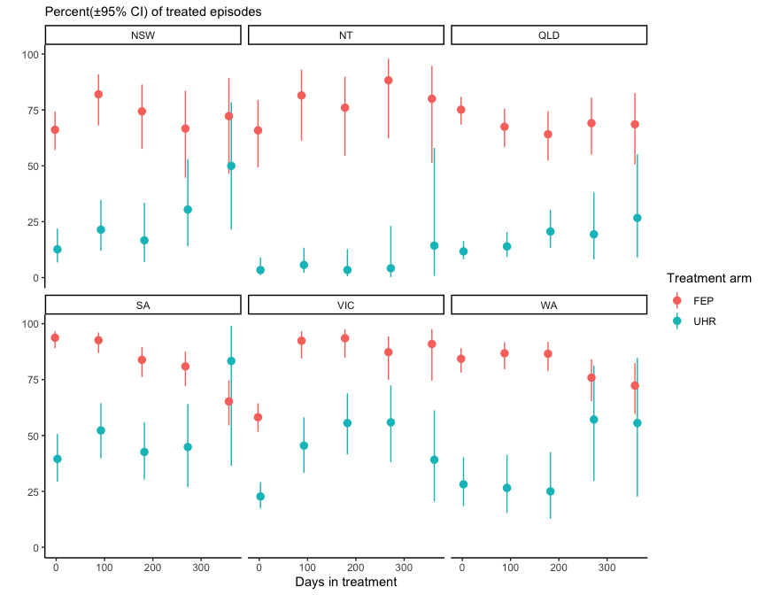

Figure 25 shows that antidepressant use increased with duration in the UHR treatment arm. Fewer than 15 percent of clients in either treatment arm were prescribed a non-antipsychotic mood stabilizer (e.g. lithium or sodium valproate) reflecting the low prevalence of bipolar diagnoses and there was also very little use of other psychotropic medication e.g. benzodiazepines or stimulants.

Figure 25: Proportion of EPYS Program clients prescribed each class of psychotropic treatment at assessment and subsequent review (source: hAPI evaluation extract)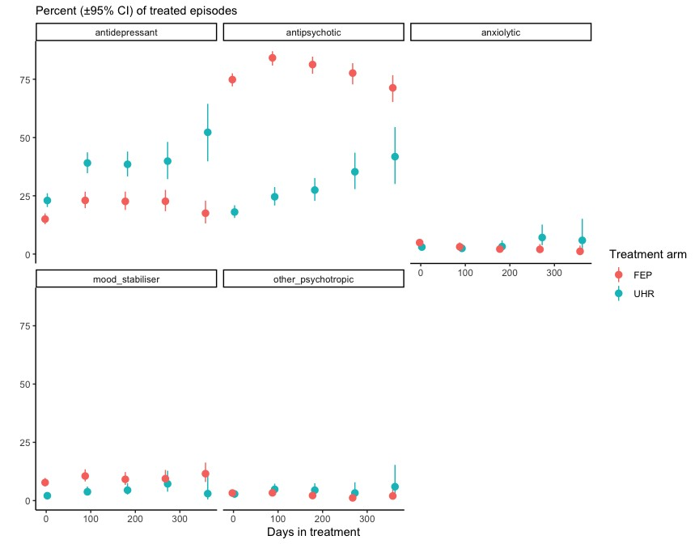

* + 1. Average duration of untreated psychosis (DUP)

The duration (weeks) of untreated psychosis was calculated according to the Nottingham onset schedule ([Singh et al 2005](https://www.sciencedirect.com/science/article/abs/pii/S0920996405001696)):

$$DUP \left(weeks\right)= Date commenced prescribed \left(not PRN\right) antipsychotic medication -date of first threshold level psychotic symptoms (FPS)$$

The dates to calculate DUP were recorded in hAPI by the assessment team but not by the treating team subsequently limiting any calculation of potential DUP to the 75 percent of FEP clients who were being prescribed antipsychotics at assessment, although the majority of these did not have valid dates recorded (e.g. the dates were missing or the date of antipsychotic prescription preceded the date of FPS). Of 977 FEP episodes, only 398 (41 percent) had valid information recorded to determine a DUP. A large minority of FEP clients had a previous episode of psychosis treated by other services and their DUP reflects this (Table 27). The median DUP was very short (three weeks) and the same in the FEP clients who had been prescribed antipsychotics prior to the EPYS Program and those prescribed antipsychotics by the EPYS Program.

DUP could not be ascertained for: (1) clients whose first prescription of antipsychotics occurred after assessment; and (2) any of the UHR clients who transitioned to FEP during the EPYS Program.

Although 49 UHR treatment arm clients transitioned to FEP during the EPYS Program these clients did not have an assessment recorded that provided any of the dates required to ascertain their DUP i.e. the only DUP that could be attributable to the program itself.

Table 27: Average duration of untreated psychosis (DUP) among episodes entering FEP treatment (source: hAPI evaluation extract)

| Previous treatment | Median (weeks) | Log-mean[80] (weeks) | Log-SD (weeks) | n |
| --- | --- | --- | --- | --- |
| First treated episode of psychosis | 3 | 3.4 | 7.5 | 280 |
| Previously treated episode of psychosis | 3 | 3.0 | 6.1 | 118 |

The comparison of DUP reported in other Early Psychosis cohorts within the literature is summarised below. Note that DUP follows a log-normal distribution, so median or log-mean is reported where possible:

* An early meta-analysis of 25 FEP studies reported the mean DUP was 103 weeks, with a range from 3.9 median weeks to 50 median weeks[81].
* The Australian EPPIC programme (Early Psychosis Prevention and Intervention Centre) reported a median DUP between 4.6 and 7.1 weeks among N = 354 and N = 211 FEP clients commencing treatment sometime between 1989-1992 (pre-EPPIC) or 1993-1997 (EPPIC)[82].
* The Scandinavian TIPS (early Treatment and Intervention in Psychosis) early detection program, resulted in a median DUP of five weeks in regions with the program relative to 16 weeks in comparable regions without the program[83].
  + 1. Measurement of DUP

Time to Program Assessment

As shown in Figure 22, a large proportion of EPYS Program FEP clients were referred from other secondary psychiatric services and Figure 24 demonstrates that three-quarters of clients were prescribed an antipsychotic at or before assessment. In a complex health system DUP, although a useful measure clinically, may not be a useful metric for evaluating how quickly a program engages a young person with FEP. A more useful measure to assess program engagement over time could be the duration between first threshold psychotic symptoms and the EPYS Program assessment – the “Time to Program Assessment (TPA)”:

TPA (weeks) = date commenced assessment — date of first threshold-level psychotic symptoms (FPS)

TPA (weeks) was calculated for the *N* = 526 FEP episodes with a valid FPS date (all episodes had a valid commencement date). 173 (31 percent) of these episodes had a previous episode of treatment.

Table 28 below shows that FEP clients in their first episode were assessed by the EPYS Program on average within one and half months of the onset of their first threshold-level psychotic symptoms. The TPA was twice the duration of the DUP.

Table 28: Average time from first threshold-level psychotic symptoms duration to EPYS assessment (TPA) among episodes entering FEP treatment (source: hAPI evaluation extract)

| Previous treatment | Median (weeks) | Log-mean (weeks) | Log-SD (weeks) | n |
| --- | --- | --- | --- | --- |
| No prior treatment | 6 | 6.6 | 4.9 | 353 |
| Prior treated episode | 35 | 24.3 | 4.7 | 173 |

Future data considerations

IF DUP is to be used a metric for program evaluation and clinical care the limitations identified here suggest that:

* Recording the dates required to ascertain DUP be a service priority
* The date (and reason) of first antipsychotic prescription needs to be recorded not just at assessment or review but when commenced
* A new full assessment is recorded when clients transition from the UHR to FEP treatment arms.
  + 1. Client perceptions, observations and experience of DUP

Young people reported a wide variety in the duration of time they had been experiencing either mental health issues or psychosis symptoms, from recent sudden onset to *“Since I was a young kid” (YP19PenrithTP1)*. The intensification of symptoms, or a particular crisis incident, generally was the impetus to seek help from headspace Early Psychosis.

**YP15PenrithTP1:** It’s been … close to 10 to 12 years, but it’s been real bad the last couple of years. … this is the first time I’ve ever actually seen a counsellor … [where] I’ve actually walked in.

Families generally reported deterioration in a young person’s behaviour, in relationships, or at school or work, prior to a crisis event. Most family members or carers who were new to the service reported described that the lead up to engagement was a period of great personal stress for them as a carer.

**FC4ParramattaTP2:** Because before she went into hospital [immediately before the headspace Early Psychosis referral], that was the period that was the most difficult for me. So and that's why I saw this, the EAP [Employee Assistance Program].

* 1. How effective is the EPYS Program in reducing the severity of symptoms for young people with or at risk of Early Psychosis?

This section covers:

* Change in general psychiatric symptoms - Brief Psychiatric Rating Scale (BPRS)
* Change in levels of distress - Kessler 10 (K10).

See Appendix G for comparison of symptom change between the EPYS Program and the Transitions study cohorts.

* + 1. Change in general psychiatric symptoms - Brief Psychiatric Rating Scale (BPRS)

Within the EPYS Program, the BPRS was obtained at assessment and at each 90-day review with each symptom rated 1-7 (“Not present” to “Extremely severe”) and 24 symptoms were scored.

Scores for the24 items were summed for each individual at each time point, and the difference from the first assessment and each 90-day review was calculated. The mean (SD) BPRS at assessment is presented in Table 29 for each subgroup – those with BPRS measurements at 90-days, 180-days, 270-days and 360-days.

Table 29: Assessment BPRS scores for each subgroup (source: hAPI evaluation extract)

| Subgroup | n | UHR Mean | SD | n | FEP Mean | SD |
| --- | --- | --- | --- | --- | --- | --- |
| 90 days | 174 | 39.5 | 16.2 | 124 | 43.8 | 23.2 |
| 180 days | 175 | 42.3 | 16.6 | 111 | 44.1 | 21.2 |
| 270 days | 72 | 44.8 | 15.6 | 83 | 44.0 | 22.8 |
| 360 days | 52 | 44.1 | 21.1 | 217 | 43.6 | 22.7 |

Figure 26 shows the average individual change in symptom levels since assessment, for each subgroup with 90-day, 180-day, 270-day and 360-day reviews. The ribbon around each line indicates the 95 percent confidence interval. The key findings were:

* At assessment, FEP clients had more severe general psychiatric symptoms but lower levels of distress than UHR clients.
* Overall clients showed significant reduction in psychiatric symptoms from assessment.
* FEP clients made almost all symptom gains in the first three months but appeared to continue to make small symptomatic gains with ongoing care.
* UHR clients showed ongoing symptom improvement with longer care.
* UHR clients with longer engagement had more severe general psychiatric symptoms at assessment (albeit non-significant), but no difference in distress.

Figure 26: Mean change in psychiatric symptoms (BPRS) at each review stratified by time in treatment (source: hAPI evaluation extract)

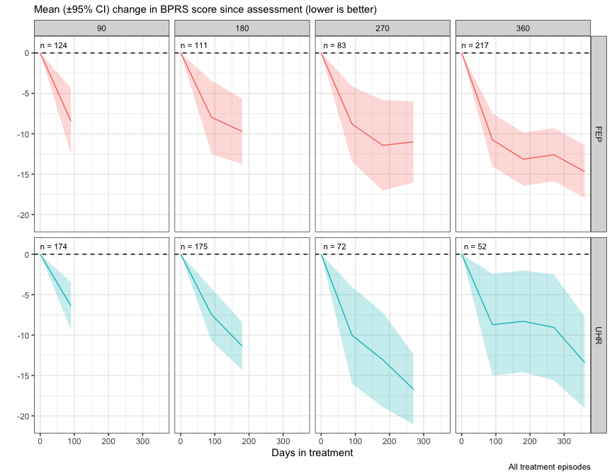

* + 1. Change in psychological distress – Kessler 10 Scale (K10)

The K10 is designed to measure anxiety and depression symptoms of distress through a 10-item questionnaire. It is the only measure of symptoms mandated for use in Australian adult secondary care psychiatric services, although it was not designed for use in psychosis. In the EPYS Program, the K10 was measured at assessment, every 90-day review.

Table 30 below shows the mean total K10 score for each subgroup at assessment. Figure 27 shows the change (delta) in total K10 score from assessment) and each subsequent timepoint calculated. The patterns observed in Figure 27 were similar as those described for Figure 26.

Table 30: Assessment Mean K10 scores for each subgroup

| Subgroup | n | UHR Mean | SD | n | FEP Mean | SD |
| --- | --- | --- | --- | --- | --- | --- |
| 90 days | 152 | 31.0 | 8.5 | 111 | 25.7 | 9.2 |
| 180 days | 187 | 31.1 | 8.6 | 99 | 24.8 | 8.6 |
| 270 days | 78 | 31.6 | 8.9 | 79 | 27.1 | 9.0 |
| 360 days | 59 | 29.9 | 8.5 | 219 | 23.5 | 8.4 |

Figure 27: Mean change in distress levels at each review stratified by time in treatment (source: hAPI evaluation extract)

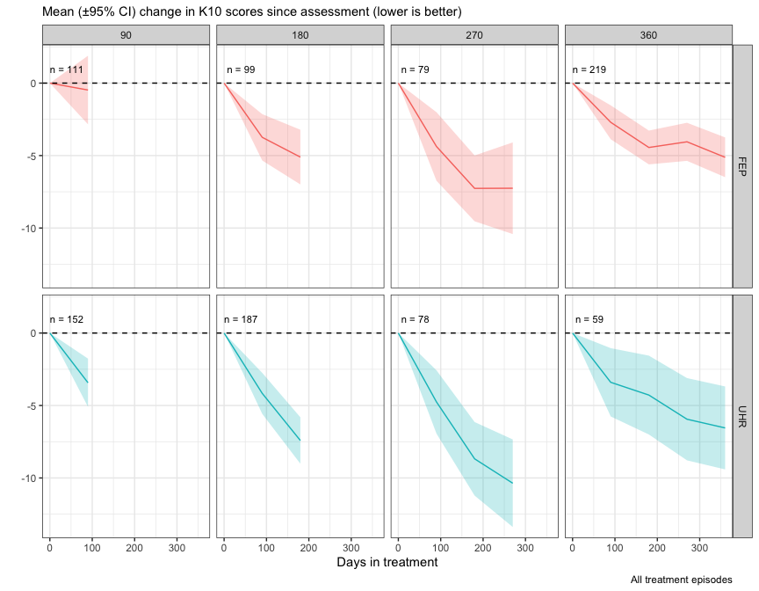

* + 1. Comparative utility of the K10 and BPRS in assessing the severity of symptoms of young people in the EPYS Program

The young people in the program had a broad range of diagnoses including first episode psychosis in the FEP treatment arm, and mood and other disorders in the UHR treatment arm, with half of the latter not being given a diagnostic label in the hAPI evaluation extract at assessment. The K10 is the mandated symptom measure in secondary mental health services in Australia but does not assess the psychosis specific symptoms which the BPRS does. As such, the use of the K10 to evaluate symptomatic outcome and effectiveness in FEP clients has been questioned.

To determine how well (or poorly) changes in K10 captured changes in the preferred measure – the BPRS, an intra-individual correlation (within subject z-scores), was undertaken for episode within the evaluation extract, this then determined the overall correlation. The analysis was limited to UHR clients with at least two post assessment observations (i.e., six months or more of follow-up) and FEP clients to those with at least four post assessment observations (one year or more of follow-up).

As can be seen in tables changes in the BPRS total and general scales are moderately strongly correlated (all are statistically significant) with changes in the K10. The correlations are in fact as strong, if not stronger, in the clients with psychosis than those with other disorders in the UHR stream.

Table 31: Correlation between changes in BPRS (sub) scales and K10 in UHR clients

|  | BPRS positive | BPRS negative | BPRS general | BPRS total | K10 |
| --- | --- | --- | --- | --- | --- |
| BPRS positive | - | 0.41 | 0.61 | 0.76 | 0.41 |
| BPRS negative | 0.41 | - | 0.50 | 0.62 | 0.26 |
| BPRS general | 0.61 | 0.50 | - | 0.93 | 0.44 |
| BPRS total | 0.76 | 0.62 | 0.93 | - | 0.47 |
| K10 | 0.41 | 0.26 | 0.44 | 0.47 | - |

Table 32: Correlation between changes in BPRS (sub) scales and K10 in FEP clients

|  | BPRS positive | BPRS negative | BPRS general | BPRS total | K10 |
| --- | --- | --- | --- | --- | --- |
| BPRS positive | - | 0.48 | 0.56 | 0.81 | 0.39 |
| BPRS negative | 0.48 | - | 0.52 | 0.69 | 0.43 |
| BPRS general | 0.56 | 0.52 | - | 0.85 | 0.49 |
| BPRS total | 0.81 | 0.69 | 0.85 | - | 0.51 |
| K10 | 0.39 | 0.43 | 0.49 | 0.51 | - |

* 1. How effective is the EPYS Program for young people with or at risk of Early Psychosis in reducing risk behaviours?

This section contains:

* Change in incidents of self-harm, aggression and suicide attempts
* Changes in suicidality
* Changes in frequency of substance use. 
  + 1. Incidents of harm

The number of harm incidents[84] was collected by the headspace Early Psychosis staff at each 90-day review. Most young people reported zero incidents over the three months prior to each review. As such, the proportion of people reporting at least one incident of each type at each 90-day review and the number of clients at that time point is shown in Figure 28. As can be seen, the proportion of clients reporting harm incidents were low and did not change over time. Self-harm was twice as common in UHR clients than FEP clients. The proportion of FEP and UHR clients reporting aggressive incidents and suicide attempts was similar.

Figure 28: Proportion of clients reporting an incident of harm in the previous 3 months over treatment (source: hAPI evaluation extract)

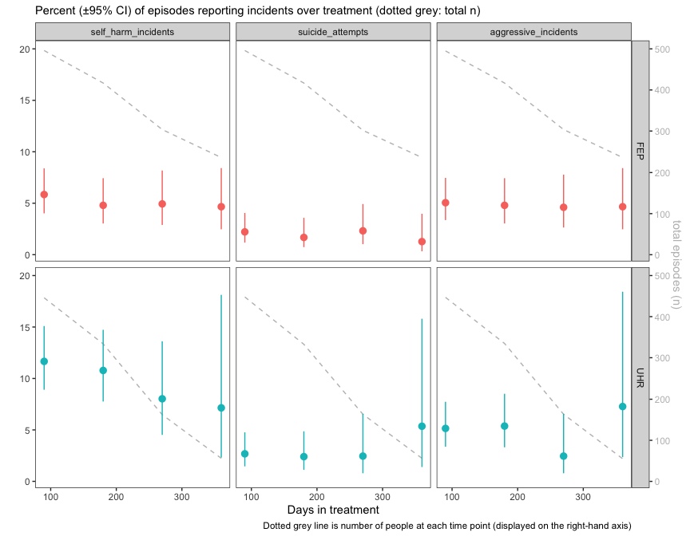

Comparison with Australian survey data

The second Australian Child and Adolescent Survey of Mental Health and Wellbeing (Kubrick et al 2015) showed that in any 12-month period, 11.6 percent of 16- 17-year-olds report engaging in self-harming behaviour without suicide intent. Eighteen percent (18.8 percent; 95 percent confidence interval [CI] = [14.5, 23.0]) of all 12- to 17-year-old young people with any mental health disorder measured by parent or carer report said that they had engaged in self-harm in the past 12 months.

* + 1. Change in suicidality (BPRS, item 4)

Suicidality was ascertained from a single item contained within the BPRS (item 4). Suicidality is assessed by a clinician ion a scale of 0-7 from “Not present” to “Extremely severe” over the past three months. The number and proportion of episodes rated at each severity level of suicidality at assessment is shown in Table 33 and at each review in Figure 29 and Figure 30. Most (67.5 percent) episodes were low risk (≤ 2 “Mild”) at assessment. One third (32.5 percent) of EPYS episodes were rated as at least moderate suicidality at assessment. There was a rapid and sustained decrease in clinician rated suicidality after initial assessment for both UHR and FEP. However, a quarter of clients with at least moderate suicidality continued to present this higher risk at subsequent reviews. Those reporting a low suicide risk at assessment generally sustained this; however, a small percentage of young people’s risk increased at least temporarily over time.

Table 33: BPRS scores at assessment

| BPRS item 4 score | UHR | % | FEP | % |
| --- | --- | --- | --- | --- |
| 0 “Not present” | 63 | 9.03 | 101 | 12.72 |
| 1 | 201 | 28.80 | 367 | 46.22 |
| 2 “Mild” | 141 | 20.20 | 134 | 16.88 |
| 3 “Moderate” | 142 | 20.34 | 108 | 13.60 |
| 4 | 96 | 13.75 | 44 | 5.54 |
| 5 | 39 | 5.59 | 29 | 3.65 |
| 6 | 13 | 1.86 | 8 | 1.01 |
| 7 “Extremely severe” | 3 | 0.43 | 3 | 0.38 |

Figure 29: Proportion of clients with at least moderate clinical-rated suicidality at assessment who were rated at a similar risk level (BPRS item-4 score > 2) at assessment, at 90-, 180-, 270-, and 360-day reviews (source: hAPI evaluation extract)

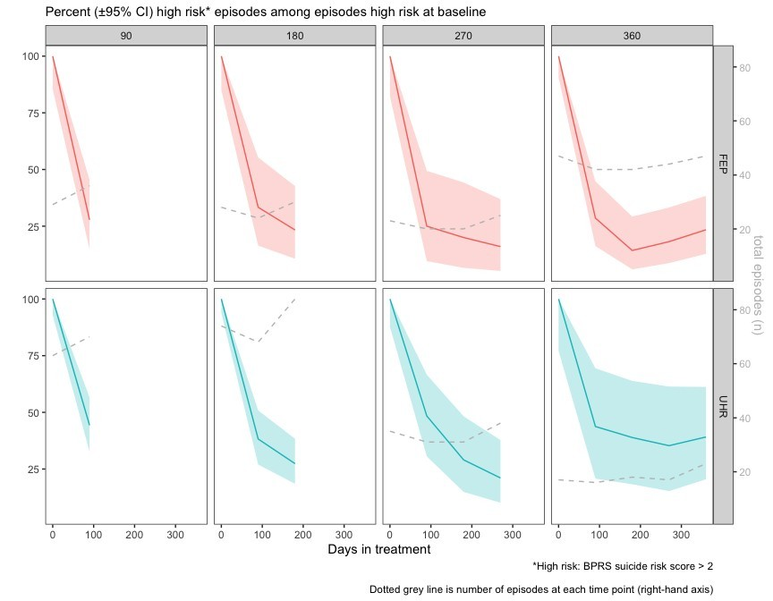Figure 30: Proportion of clients with low clinical-rated suicidality at assessment who were rated at a moderate risk level or greater (BPRS item-4 score > 2) at 90-, 180-, 270-, and 360-day reviews (source: hAPI evaluation extract)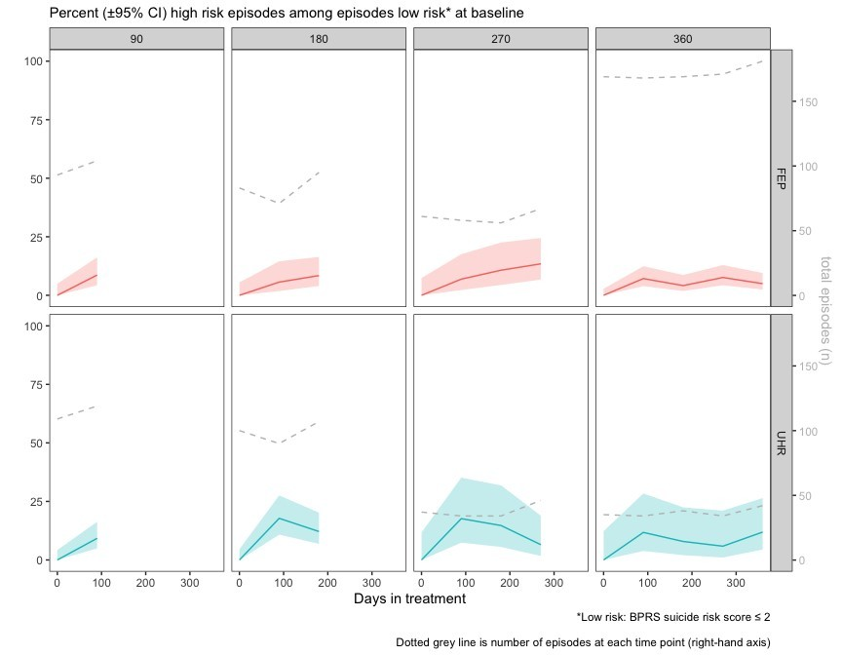

* + 1. Change in frequency of drug use over time

Frequency of Substance use

The hAPI data recorded the frequency of tobacco, alcohol, cannabis, cocaine, amphetamines, inhalants, sedatives, hallucinogens, and opioid usage at assessment and at each 90-day review. EPYS Program clients were asked to provide a frequency of substance usage in the last three months of: 0 = never, 1 = once or twice, 2 = monthly, 3 = weekly, 4 = Daily or almost daily.

Table 34 shows the percentage of users in each use category at assessment for EPYS treatment.

Table 34: Percentage of episodes at assessment by substance use frequency (source: hAPI evaluation extract)

| Drug | Never | Once | Monthly | Weekly | Daily | Total |
| --- | --- | --- | --- | --- | --- | --- |
| Alcohol | 32.00 | 25.14 | 14.29 | 22.96 | 5.61 | 1603 |
| Amphetamines | 76.70 | 11.87 | 4.55 | 4.67 | 2.21 | 1584 |
| Cannabis | 48.48 | 12.74 | 5.28 | 11.93 | 21.57 | 1609 |
| Cocaine | 90.19 | 6.74 | 1.73 | 0.96 | 0.38 | 1559 |
| Hallucinogens | 85.84 | 10.81 | 2.32 | 0.90 | 0.13 | 1554 |
| Inhalants | 96.50 | 2.27 | 0.52 | 0.71 | NA | 1543 |
| Opioids | 94.06 | 3.88 | 0.90 | 0.65 | 0.52 | 1548 |
| Sedatives | 81.87 | 9.74 | 1.47 | 3.97 | 2.95 | 1561 |
| Tobacco | 47.81 | 10.21 | 1.88 | 4.07 | 36.03 | 1596 |

Comparison with national data

EPYS Program clients had high levels of substance use compared to 2016 national data from the [Australian Institute of Health and Welfare](https://www.aihw.gov.au/reports/alcohol/alcohol-tobacco-other-drugs-australia/contents/priority-populations/young-people):[85]

* Tobacco: Over 36 percent of EPYS clients indicated they used tobacco daily compared to 11.6 percent of young people aged 18–24 in the general population
* Amphetamine: Over 11 percent used amphetamines at least monthly, while the Australian Institute of Health and Welfare reports 2.8 percent of 18-25-year old’s report amphetamine use in the past year
* Cannabis: One third of clients used cannabis weekly or more frequently compared to only 23.4 percent of 18-24-year old’s using cannabis in the past year in 2016 according to Australian Institute of Health and Welfare.
  + 1. Change in Frequent Substance Use over time in program.

As shown in Figures 29 and 30 “frequent users” in the past three months were defined according to type of substance:

* Frequent use of tobacco, and cannabis was defined as “daily or almost daily”,
* Frequent use of alcohol was defined as at least weekly
* Frequent use of the other substances was defined as at least “monthly”.

Figure 31 shows the proportion of *frequent* substance users in each treatment arm over time, among episodes which were defined as “frequent” users at assessment, (day 0). Figure 32 shows the proportion of frequent drug users who continued frequent use over treatment. Frequent amphetamine and alcohol users were less likely to be followed up in the program and so some of the reduction in the proportion of frequent users reflects this. These figures show that the greatest reduction in frequent substance users occurred in the first 90-days after assessment. About half of daily tobacco smokers and weekly alcohol drinkers continued to use these substances at the same frequency. Two thirds of daily cannabis users reduced the frequency of use by 90 days. At least a quarter of frequent amphetamine users continued to use at least monthly. The decrease in some substance use may be due to an actual reduction in drug use behaviour or by leaving treatment.

Figure 31: Proportion of frequent drug users who continue frequent use over treatment (source: hAPI evaluation extract)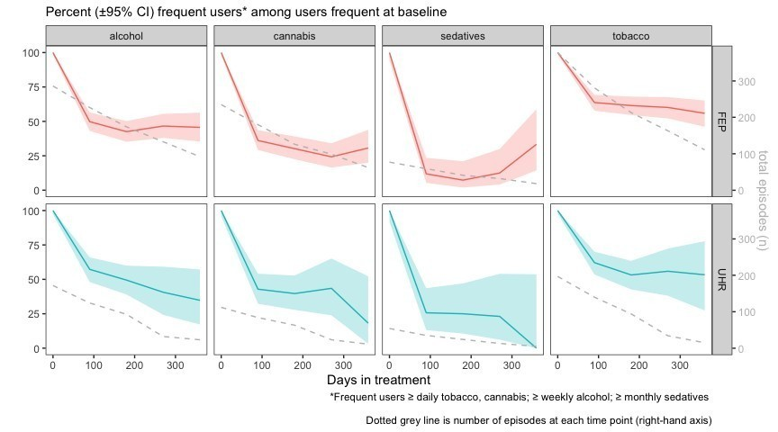

Figure 32: Proportion of frequent drug users who continue frequent use over treatment (source: hAPI evaluation extract)

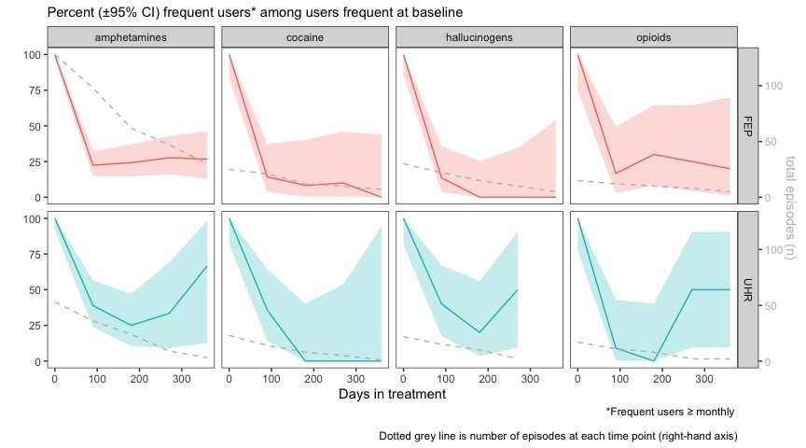

* + 1. Client, family and carer perceptions of EPYS Program impact on reducing risk behaviours

In terms of risk related behaviours, young people and families reported headspace Early Psychosis provided support to address self-harm, suicidal thoughts, behaviours and acts, and substance misuse. For self-harm and suicide related risk behaviours, headspace Early Psychosis provided assessment, practical and mental health support as well as relief for families (See Table 42). For example, the MATT was described as *“anti-suicide” (YP8 MtDruittTP1)*, while the impact of headspace Early Psychosis overall was emphasised: “*if I didn't come, I'm pretty sure I would've been dead by now” (YP12ParramattaTP1)*; and *“I think it's safe to say they saved my life” (YP14PenrithTP1).* Young people from the state-funded Early Psychosis comparison sites, also frequently described the service as “Just absolutely lifesaving” *(YP4CamperdownNSWhealth),* with intensive support to address self-harm, suicidal thoughts, behaviours and acts, and substance misuse concerns.

Table 35: Impact on self-harm, suicidal thoughts and behaviours, and substance misuse – Clients, Family Members and Carers

| Risk area | Theme | Illustrative quotes |
| --- | --- | --- |
| Suicide and self-harm | Assessment | *YP17MtDruittTP1: When I was suicidal, she [clinician] understood I was suicidal. She picked it up. At the time, I disliked the fact that she called the ambulance, because I actually was planning to do something right after she left. … She took the knife, and she told the paramedics who she was, and they were very caring …* |
| Practical support | *YP17MtDruittTP1: I really wanted something to kind of break that pattern, because I couldn’t. I always had a headache, and everything was just all over the place. I was hungry always. And they also helped me financially …. it just clicked in perfectly. I used to always be at Centrelink … [my previous employers] would just refuse to give me separation certificates, and every time my documents were never complete. I’ve tried several times. I gave up. Then when they helped me, they gave me support letters, and they really pushed me to kind of get back up. They topped up Opals for me to go around. To be honest, without that, I still would be [living in an abusive] home. … Before this, I just felt like I was not going to live another year. I was just done with everything. … I’d moved out earlier, but I came back home because of these [financial] issues where it felt like a closed door. Like, a sealed door. Sealed with concrete on the other side.* |
| Mental health support | *YP28DarwinTP1: I’m definitely not self-harming anywhere near as much, and I haven’t attempted suicide. Yeah, they are helpful in some ways, but sometimes it just isn’t. Depending on where I am, like if I’m really upset, then it comes to the point where nothing can really be helpful. But I feel like that’s not the fault of headspace, it’s more so letting myself come to the point where I can’t control myself anymore, which is what they’re trying to help me with, they have been helping me try and get under control.* |
| Relief for families | *FC3DarwinTP1: As I said before, I’m just grateful that this place exists, so my child has somewhere to be while I’m at work, after school, and I know that their wellbeing is being catered for. I don’t have to stress that he’s home with a knife block in the kitchen or any of those sorts of things, which at one point, it was [necessary to] take all the knives to bed with you at night* |
| Substance misuse | Comprehensive Support | *YP18MtDruittTP1: They’ve helped me with some drug use issues. … I’m going to try again to do the home detox so I can be fully prepared [for employment] … They came out to the house once and checked to see how I was going and that and I come into appointments while I’m doing it [home detox program] still, so they check up on how I’m doing and they ask if the medications are helping or if I’m experiencing any … symptoms of withdrawal that I didn’t have before. If I tell them I do, they’ll help me out. They’ll prescribe medication if it’s just feeling sick in the stomach or headaches or something like that. So yeah, they just help me out, I guess…they just keep like a positive vibe. They’re not like, ‘If you fail once, it’s all over.’ They say if you fail, you can always try again even if you failed again tonight or just started over.* |
|  | Individualised intervention | *They suggest it, but they don’t push it onto me. They don’t make me feel like I have to have it, it’s only if I ask for it, because … I used to be a prescription addict … so I don’t want to get hooked on it again. … They are good for support and how I want them to sort of be. …, its different for everybody. So, they are good at working out how it works for the individual. (YP25Darwin)* |

Many participants described physical health issues that predated the mental health issues, such as chronic fatigue, multiple surgeries, fractures, neurological and other chronic illnesses, while some described acquiring physical health issues associated with medications, such as weight gain (YP5DarwinTP1, YP6DarwinTP1, YP10ParramattaTP1, YP32DarwinTP1). To address this, headspace Early Psychosis offered nutrition and exercise education and activities were offered in group settings, with activities like gym, cooking, yoga, soccer and other sports. headspace Early Psychosis clinicians also offered individual walk and talk sessions with young people, and while there were limited medically-based physical health services described in the interviews and focus groups several participants mentioned receiving support with referrals to medical specialists as needed.

* 1. How effective is the EPYS Program in reducing the impact of young people with or at risk of Early Psychosis, on health service utilisation?

This section contains:

* Number of bed days
* Ecological analysis of health service utilisation
* Client, family and carer perceptions of EPYS Program impact on health service utilisation.
  + 1. Number of bed days

The number of days spent in inpatient units or sub-acute units, as well as the number of 28-day readmissions in the previous three months, was recorded[86] at every review and discharge by headspace Early Psychosis staff. Most people reported zero days hence the distribution is very skewed (zero-inflated).

Table 36 shows the proportion of young people reporting hospitalisation and bed day duration by treatment arm at each review date. Only one in 20 UHR and one in 10 FEP clients reported any admission in the previous three months at each review (within hAPI). The proportion of program clients hospitalised did not decline over time in the program.

The cumulative proportion of young people reporting hospitalisations (hospitalisation rate) was 35.5 percent over one year in the FEP treatment arm and 9.6 percent over 6 months in the UHR treatment arm. The most recent meta-analysis[87] shows a similar FEP hospitalisation rate of 47.9 percent over 2 years.

Table 36: Number (%) of clients reporting bed days (inpatient and sub-acute) in past 3 months at each review (source: hAPI evaluation extract)

|  |  | UHR | | FEP | |
| --- | --- | --- | --- | --- | --- |
| Review date | Bed days | n | % | n | % |
| 90 | No bed days | 632 | 95.18 | 651 | 87.03 |
| One week or less | 23 | 3.46 | 29 | 3.88 |
| Two weeks or less | 4 | 0.60 | 20 | 2.67 |
| More than two weeks | 5 | 0.75 | 48 | 6.42 |
| 180 | No bed days | 483 | 95.83 | 543 | 90.35 |
| One week or less | 14 | 2.78 | 20 | 3.33 |
| Two weeks or less | 2 | 0.40 | 18 | 3.00 |
| More than two weeks | 5 | 0.99 | 20 | 3.33 |
| 270 | No bed days | 252 | 95.09 | 381 | 88.81 |
| One week or less | 4 | 1.51 | 19 | 4.43 |
| Two weeks or less | 4 | 1.51 | 14 | 3.26 |
| More than two weeks | 5 | 1.89 | 15 | 3.50 |
| 360 | No bed days | 112 | 95.73 | 285 | 90.48 |
| One week or less | 3 | 2.56 | 10 | 3.17 |
| Two weeks or less | 1 | 0.85 | 10 | 3.17 |

* + 1. Ecological analysis of health service utilisation

Methods

To assess the potential impact of the program on health service utilisation, an “ecological” analysis was performed which compared health service utilisation outcomes in regions with and without the EPYS Program. The cohort for this analysis was individuals born between 1 July 1990 and 1 July 2006 who were hospitalised with an ICD-10 coded psychosis diagnosis (primary or other diagnosis) at least once from 1 July 2010 onwards.

For these eligible individuals, access was sought to their entire emergency department and inpatient service utilisation history (from 1 July 2010 until 1 July 2019), regardless of whether or not other OOS were related to psychosis. This was done by linking hospital admissions, emergency department presentations and deaths in NSW and WA (this linked data is referred to as ‘state hospitalisation data’ in this section).

The primary null hypothesis of the ecological analysis was that temporal changes in hospitalisation rates between July 2010 and July 2018 were the same in geographical areas that include the EPYS Program and those that do not.

The primary outcome measured were the number of hospitalisations (regardless of reason). Secondary outcomes of interest included:

* Number of hospital admissions with a primary diagnosis of psychosis
* Number of hospitalisations related to self-harm
* Number of hospital bed days
* Number of hospital bed days related to a primary diagnosis of psychosis
* Number of 28-day readmissions
* Number of emergency department presentations
* Number of emergency department presentations related to self-harm
* Number of days in psychiatric care
* Number of “Involuntary days in psychiatric unit”.

Raw rate or numbers of primary and secondary outcomes were calculated by month for each service region and presented on plots to help visualise trends of health service utilisation over time. Models were then used to compare health service utilisation outcomes between areas that have the EPYS Program and non-EPYS Program metropolitan (‘metro’) areas over time, using repeated-measure generalised linear models. For modelling purposes, data were aggregated by quarter instead of by month with each individual contributing one data point per quarter. Models included a fixed effect of the region (EPYS versus non-EPYS metropolitan), a fixed effect of the period (limited versus full service) as well as the interaction between the two. Covariates included all key socio-demographic characteristics as well as previous health service utilisation measured during 2014 (the baseline period). Hospitalisations were summarised as rates and analysed assuming a negative binomial distribution to account for over dispersion due to many individuals reporting no outcome (e.g. no hospitalisation). Rates were derived by only considering the time alive and out of hospital as the period at risk. Number of bed days and costs were summarised as means and analysed assuming a normal distribution.

Further details about the methodology, including region definitions as well as details of the ethics and data linkage processes are included in Appendix D.

Results

The ecological analysis explored baseline client characteristics within NSW and WA for EPYS and non-EPYS individuals. To be ‘eligible’ for the ecological analysis, individuals had to be born between 1 July 1990 and 1 July 2006 and have at least one hospitalisation with an ICD-10 coded psychosis diagnosis (primary or other) from 1 July 2010 onwards. In NSW 1,418 individuals met the eligibility criteria in the EPYS region, 3,402 in the non-EPYS metropolitan region and 3,809 in the non-EPYS regional region (see Table 37). The age and sex distribution of the cohort were similar across all three regions, with an average age of around 19.6 years and approximately 43 percent female. Baseline rates of health service utilisation were very similar between the EPYS and non-EPYS metropolitan regions; however, they were lower in the regional non-EPYS region.

In WA (see Table 38), 1,029 individuals met the eligibility criteria in the EPYS region (Perth North), 896 in the non-EPYS metropolitan (Peth South) and 565 individuals were included in the non-EPYS regional region. The age and sex distribution were consistent across all three regions; however, individuals in regional WA reported less bed days overall and less days in psychiatric care, but more emergency department presentations than individuals in the Perth North and Perth South PHNs.

Table 37: Baseline characteristics in NSW (source: state hospitalisation data)

| Characteristic | EPYS  (N=1418) | Non-EPYS (metro) (N=3402) | Non-EPYS (Regional) (N=3809) | p-value |
| --- | --- | --- | --- | --- |
| **Age** |  |  |  |  |
| Mean (SD) | 19.5 (3.16) | 19.6 (3.03) | 19.6 (3.06) | 0.3811 |
| Median (IQR) | 20.0 (17.0; 22.0) | 20.0 (18.0; 22.0) | 20.0 (18.0; 22.0) |  |
| Min, Max | 9; 24 | 9; 24 | 9; 24 |  |
| **Age categories** |  |  |  |  |
| < 15 | 112 (7.9%) | 227 (6.7%) | 253 (6.6%) | 0.2784 |
| 15 - 20 | 677 (47.7%) | 1670 (49.1%) | 1806 (47.4%) |  |
| > 20 | 629 (44.4%) | 1505 (44.2%) | 1750 (45.9%) |  |
| **Sex** |  |  |  |  |
| Female | 617 (43.5%) | 1504 (44.2%) | 1682 (44.2%) | 0.7798 |
| Male | 801 (56.5%) | 1897 (55.8%) | 2127 (55.8%) |  |
| **SEIFA* decile** |  |  |  |  |
| 01 | 0 (0.0%) | 219 (6.4%) | 188 (4.9%) | <.0001 |
| 02 | 1 (0.1%) | 32 (0.9%) | 330 (8.7%) |  |
| 03 | 0 (0.0%) | 461 (13.6%) | 106 (2.8%) |  |
| 04 | 0 (0.0%) | 287 (8.4%) | 245 (6.4%) |  |
| 05 | 0 (0.0%) | 0 (0.0%) | 631 (16.6%) |  |
| 06 | 0 (0.0%) | 0 (0.0%) | 503 (13.2%) |  |
| 07 | 445 (31.4%) | 0 (0.0%) | 1127 (29.6%) |  |
| 08 | 218 (15.4%) | 525 (15.4%) | 602 (15.8%) |  |
| 09 | 556 (39.2%) | 961 (28.2%) | 77 (2.0%) |  |
| 10 | 198 (14.0%) | 917 (27.0%) | 0 (0.0%) |  |
| **Number of hospitalisations for any reason** | | | | |
| Mean (SD) | 1.1 (2.78) | 1.1 (3.60) | 1.0 (2.76) | 0.0187 |
| Median (IQR) | 0.0 (0.0; 1.0) | 0.0 (0.0; 1.0) | 0.0 (0.0; 1.0) |  |
| Min, Max | 0; 34 | 0; 78 | 0; 100 |  |
| **Number of hospitalisations for psychosis** | | | | |
| Mean (SD) | 0.3 (0.95) | 0.3 (1.05) | 0.2 (0.85) | 0.0688 |
| Median (IQR) | 0.0 (0.0; 0.0) | 0.0 (0.0; 0.0) | 0.0 (0.0; 0.0) |  |
| Min, Max | 0; 17 | 0; 23 | 0; 17 |  |
| **Number of hospitalisations for self-harm** | | | | |
| Mean (SD) | 0.1 (0.34) | 0.1 (0.72) | 0.1 (0.32) | 0.2797 |
| Median (IQR) | 0.0 (0.0; 0.0) | 0.0 (0.0; 0.0) | 0.0 (0.0; 0.0) |  |
| Min, Max | 0; 6 | 0; 33 | 0; 7 |  |
| **Number of bed days for any reason** | | | | |
| Mean (SD) | 11.4 (33.84) | 11.4 (35.57) | 9.0 (29.86) | 0.0029 |
| Median (IQR) | 0.0 (0.0; 6.0) | 0.0 (0.0; 4.0) | 0.0 (0.0; 3.0) |  |
| Min, Max | 0; 364 | 0; 364 | 0; 364 |  |
| **Number of bed days for psychosis** | | | | |
| Mean (SD) | 6.5 (28.77) | 5.9 (27.40) | 4.1 (18.60) | 0.0005 |
| Median (IQR) | 0.0 (0.0; 0.0) | 0.0 (0.0; 0.0) | 0.0 (0.0; 0.0) |  |
| Min, Max | 0; 364 | 0; 364 | 0; 318 |  |
| **Number of hospitalisation for readmission** | | | | |
| Mean (SD) | 0.6 (2.28) | 0.6 (3.23) | 0.4 (2.38) | 0.0232 |
| Median (IQR) | 0.0 (0.0; 0.0) | 0.0 (0.0; 0.0) | 0.0 (0.0; 0.0) |  |
| Min, Max | 0; 32 | 0; 78 | 0; 100 |  |
| **Number of emergency department admissions for any reason** | | | | |
| Mean (SD) | 1.4 (3.83) | 1.3 (3.61) | 1.8 (4.06) | <.0001 |
| Median (IQR) | 0.0 (0.0; 1.0) | 0.0 (0.0; 1.0) | 1.0 (0.0; 2.0) |  |
| Min, Max | 0; 73 | 0; 70 | 0; 81 |  |
| **Number of emergency department admissions for self-harm** | | | | |
| Mean (SD) | 0.1 (0.34) | 0.1 (0.72) | 0.1 (0.32) | 0.2797 |
| Median (IQR) | 0.0 (0.0; 0.0) | 0.0 (0.0; 0.0) | 0.0 (0.0; 0.0) |  |
| Min, Max | 0; 6 | 0; 33 | 0; 7 |  |
| **Number of days in psychiatric care** | | | | |
| Mean (SD) | 9.7 (32.48) | 9.1 (33.37) | 7.6 (28.76) | 0.0347 |
| Median (IQR) | 0.0 (0.0; 1.0) | 0.0 (0.0; 0.0) | 0.0 (0.0; 0.0) |  |
| Min, Max | 0; 364 | 0; 364 | 0; 364 |  |
| **Number of involuntary days in psychiatric care** | | | | |
| Mean (SD) | 4.7 (25.23) | 4.6 (24.37) | 3.8 (20.36) | 0.3112 |
| Median (IQR) | 0.0 (0.0; 0.0) | 0.0 (0.0; 0.0) | 0.0 (0.0; 0.0) |  |
| Min, Max | 0; 364 | 0; 364 | 0; 364 |  |

*SEIFA: Socio-Economic Indexes for Areas

Table 38: Baseline characteristics in WA (source: state hospitalisation data)

| Characteristic | EPYS  (N=1029) | Non EPYS (metro) (N=896) | Non-EPYS (Regional) (N=565) | p-value |
| --- | --- | --- | --- | --- |
| **Age** |  |  |  |  |
| Mean (SD) | 19.8 (2.96) | 19.7 (2.94) | 19.6 (3.17) | 0.5126 |
| Median (IQR) | 20.0 (18.0; 22.0) | 20.0 (18.0; 22.0) | 20.0 (18.0; 22.0) |  |
| Min, Max | 10; 24 | 9; 24 | 8; 24 |  |
| **Age** **categories** |  |  |  |  |
| < 15 | 58 (5.6%) | 51 (5.7%) | 41 (7.3%) | 0.6051 |
| 15 - 20 | 490 (47.6%) | 442 (49.3%) | 264 (46.7%) |  |
| > 20 | 481 (46.7%) | 403 (45.0%) | 260 (46.0%) |  |
| **Sex** |  |  |  |  |
| Female | 474 (46.1%) | 371 (41.4%) | 224 (39.6%) | 0.0565 |
| Male | 555 (53.9%) | 524 (58.5%) | 341 (60.4%) |  |
| **SEIFA decile** |  |  |  |  |
| 01 | 0 (0.0%) | 0 (0.0%) | 63 (11.2%) | <.0001 |
| 02 | 0 (0.0%) | 0 (0.0%) | 95 (16.8%) |  |
| 03 | 0 (0.0%) | 5 (0.6%) | 40 (7.1%) |  |
| 04 | 0 (0.0%) | 136 (15.2%) | 96 (17.0%) |  |
| 05 | 0 (0.0%) | 36 (4.0%) | 46 (8.1%) |  |
| 06 | 6 (0.6%) | 214 (23.9%) | 34 (6.0%) |  |
| 07 | 204 (19.8%) | 157 (17.6%) | 90 (15.9%) |  |
| 08 | 381 (37.0%) | 125 (14.0%) | 48 (8.5%) |  |
| 09 | 129 (12.5%) | 90 (10.1%) | 51 (9.0%) |  |
| 10 | 309 (30.0%) | 131 (14.7%) | 2 (0.4%) |  |
| **Number of new hospitalisations for any reason** | | | | |
| Mean (SD) | 0.9 (1.89) | 0.8 (1.64) | 0.9 (2.16) | 0.2033 |
| Median (IQR) | 0.0 (0.0; 1.0) | 0.0 (0.0; 1.0) | 0.0 (0.0; 1.0) |  |
| Min, Max | 0; 26 | 0; 23 | 0; 33 |  |
| **Number of new hospitalisations for psychosis** | | | | |
| Mean (SD) | 0.2 (0.75) | 0.2 (0.58) | 0.2 (0.63) | 0.4588 |
| Median (IQR) | 0.0 (0.0; 0.0) | 0.0 (0.0; 0.0) | 0.0 (0.0; 0.0) |  |
| Min, Max | 0; 9 | 0; 4 | 0; 5 |  |
| **Number of new hospitalisations for self-harm** | | | | |
| Mean (SD) | 0.1 (0.53) | 0.1 (0.41) | 0.1 (0.40) | 0.3002 |
| Median (IQR) | 0.0 (0.0; 0.0) | 0.0 (0.0; 0.0) | 0.0 (0.0; 0.0) |  |
| Min, Max | 0; 9 | 0; 4 | 0; 5 |  |
| **Number of bed days for any reason** | | | | |
| Mean (SD) | 9.2 (26.02) | 8.7 (25.31) | 5.5 (14.57) | 0.0076 |
| Median (IQR) | 0.0 (0.0; 5.0) | 0.0 (0.0; 4.0) | 0.0 (0.0; 2.0) |  |
| Min, Max | 0; 297 | 0; 357 | 0; 145 |  |
| **Number of bed days for psychosis** | | | | |
| Mean (SD) | 4.5 (18.47) | 4.4 (18.58) | 2.9 (10.59) | 0.1729 |
| Median (IQR) | 0.0 (0.0; 0.0) | 0.0 (0.0; 0.0) | 0.0 (0.0; 0.0) |  |
| Min, Max | 0; 297 | 0; 357 | 0; 96 |  |
| **Number of new hospitalisation readmissions** | | | | |
| Mean (SD) | 0.3 (1.31) | 0.2 (1.05) | 0.4 (1.72) | 0.2758 |
| Median (IQR) | 0.0 (0.0; 0.0) | 0.0 (0.0; 0.0) | 0.0 (0.0; 0.0) |  |
| Min, Max | 0; 24 | 0; 21 | 0; 31 |  |
| **Number of emergency department presentations** | | | | |
| Mean (SD) | 1.3 (2.65) | 1.4 (3.34) | 2.5 (4.50) | <.0001 |
| Median (IQR) | 0.0 (0.0; 2.0) | 0.0 (0.0; 2.0) | 1.0 (0.0; 3.0) |  |
| Min, Max | 0; 36 | 0; 64 | 0; 45 |  |
| **Number of emergency department admissions for self-harm** | | | | |
| Mean (SD) | 0.1 (0.42) | 0.1 (0.40) | 0.0 (0.10) | 0.0076 |
| Median (IQR) | 0.0 (0.0; 0.0) | 0.0 (0.0; 0.0) | 0.0 (0.0; 0.0) |  |
| Min, Max | 0; 9 | 0; 6 | 0; 1 |  |
| **Number of days in psychiatric care** | | | | |
| Mean (SD) | 8.5 (25.33) | 8.2 (24.99) | 4.5 (13.51) | 0.0018 |
| Median (IQR) | 0.0 (0.0; 2.0) | 0.0 (0.0; 1.0) | 0.0 (0.0; 0.0) |  |
| Min, Max | 0; 297 | 0; 357 | 0; 119 |  |

Figure 33 and Figure 34 below show the raw number of hospital admissions occurring in NSW and WA between 2010 and 2019. Vertical shaded regions indicate the baseline period (1 January 2014 – 31 December 2014), the period of limited service (1 January 2015 – 30 June 2017) and the period of full service (1 July 2017 onward). As can be seen, in NSW there was a sudden drop in hospital admissions occurring in July 2018. This was due to data from private hospitals being unavailable after that date. Analyses of hospitalisations were therefore truncated on 30 June 2018 (NSW only).

Figure 33. NSW raw number of hospital admissions (source: state hospitalisation data)   
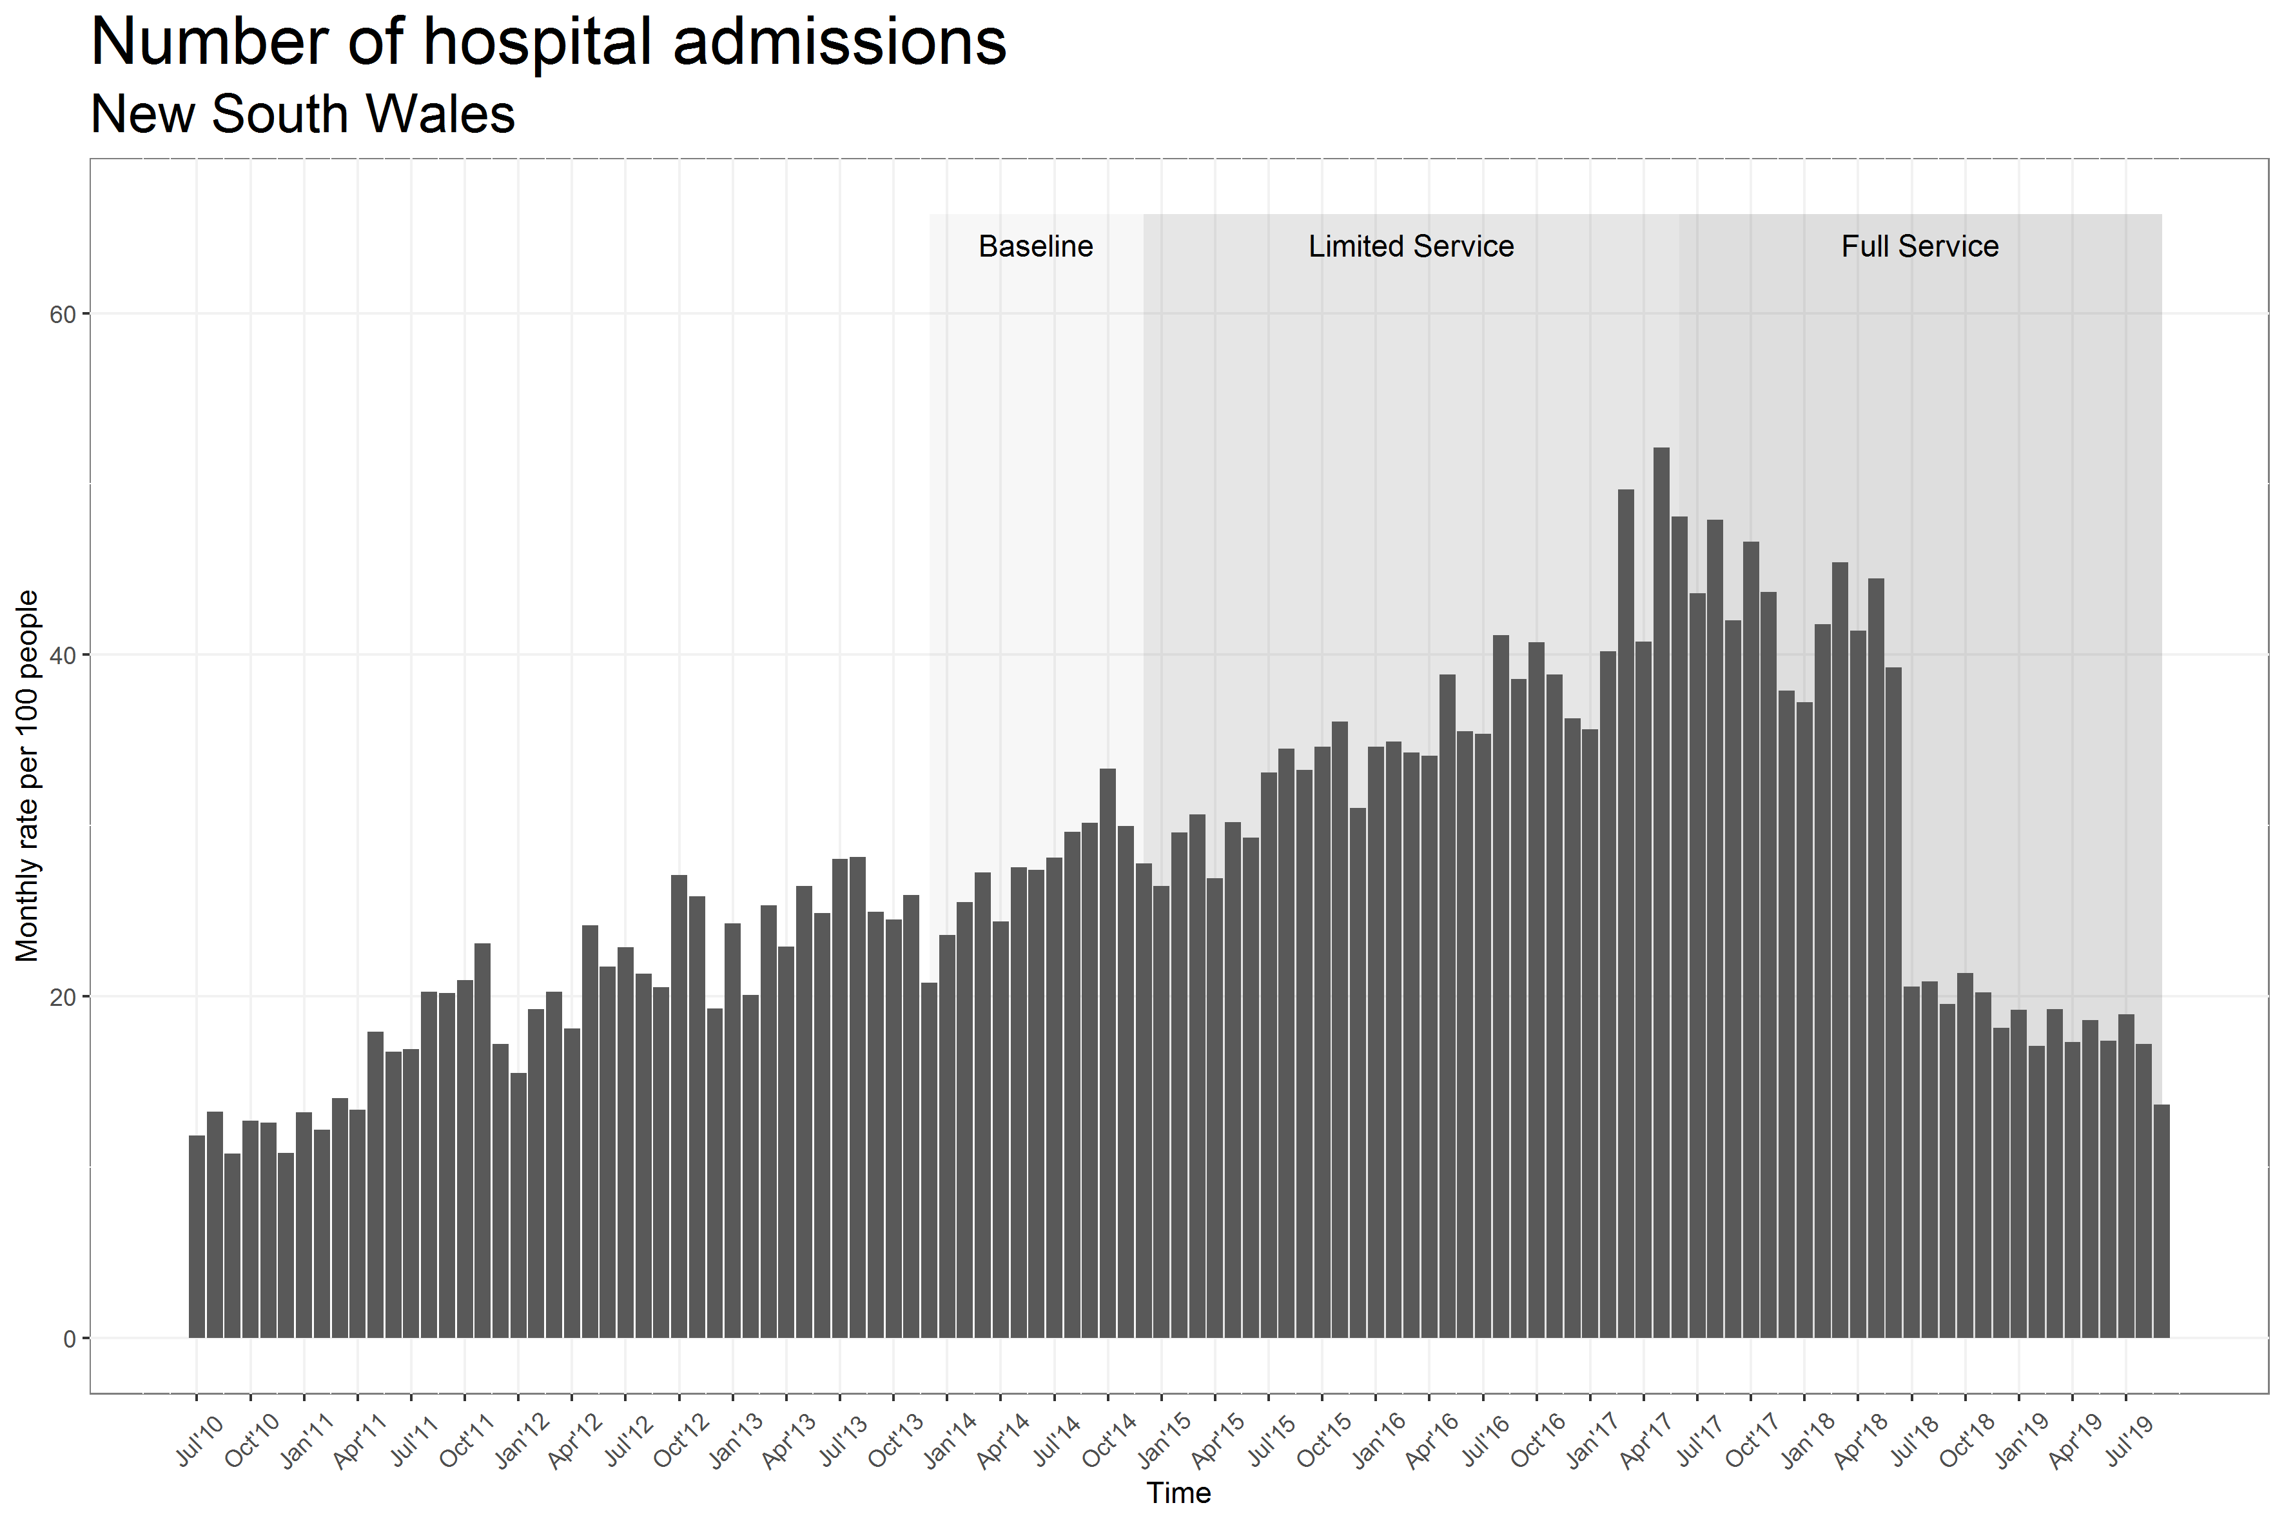

Figure 34: WA raw number of hospital admissions (source: state hospitalisation data)   
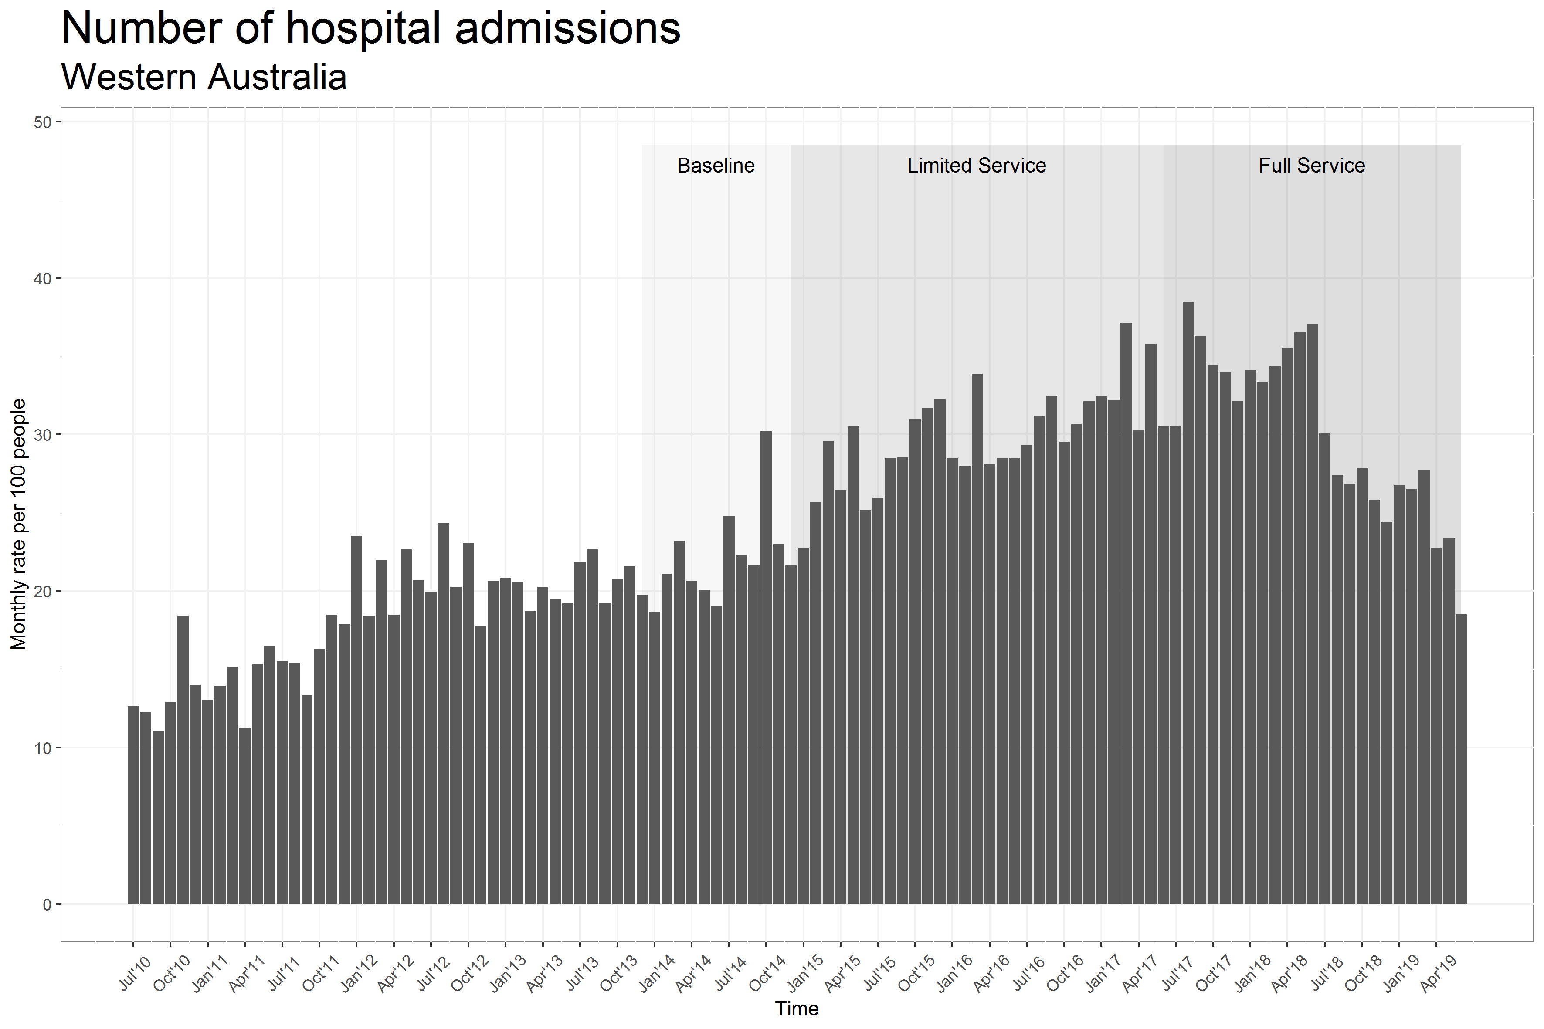

When comparing rates of health service utilisation in NSW between regions with the EPYS Program and other regions (see Figure 35), there was an increase in hospitalisation rates in EPYS regions compared to non-EPYS metropolitan regions around mid-2017. However, by mid-2018 the rates overlap between both EPYS and non-EPYS metropolitan regions. A similar, albeit more marked, trend was seen in WA with a sharp temporary increase in hospitalisations in EPYS regions, peaking around end of 2017 before going back to a level that was comparable to non-EPYS metropolitan regions.

In NSW, there appeared to be more emergency department presentations in the EPYS regions than in the non-EPYS metropolitan regions from early 2017 onwards. However, in WA, there was no clear difference in rates of emergency department presentations between EPYS and non-EPYS metropolitan regions.

From early 2016, the average number of bed days per person in NSW appeared to be greater in EPYS regions than in non-EPYS metropolitan regions. A similar pattern was seen for the number of bed days associated with psychosis-related hospitalisations and number of days in psychiatric care but not for involuntary days in psychiatric care where there was no clear difference between EPYS and non-EPYS metropolitan regions (see Figure 35 and Figure 36). In WA, apart from a temporary increase in bed days towards the end of 2017, a similar trend was observed across both EPYS and non-EPYS metropolitan regions.

Figure 35: Rates of hospital admissions by catchment (source: state hospitalisation data)

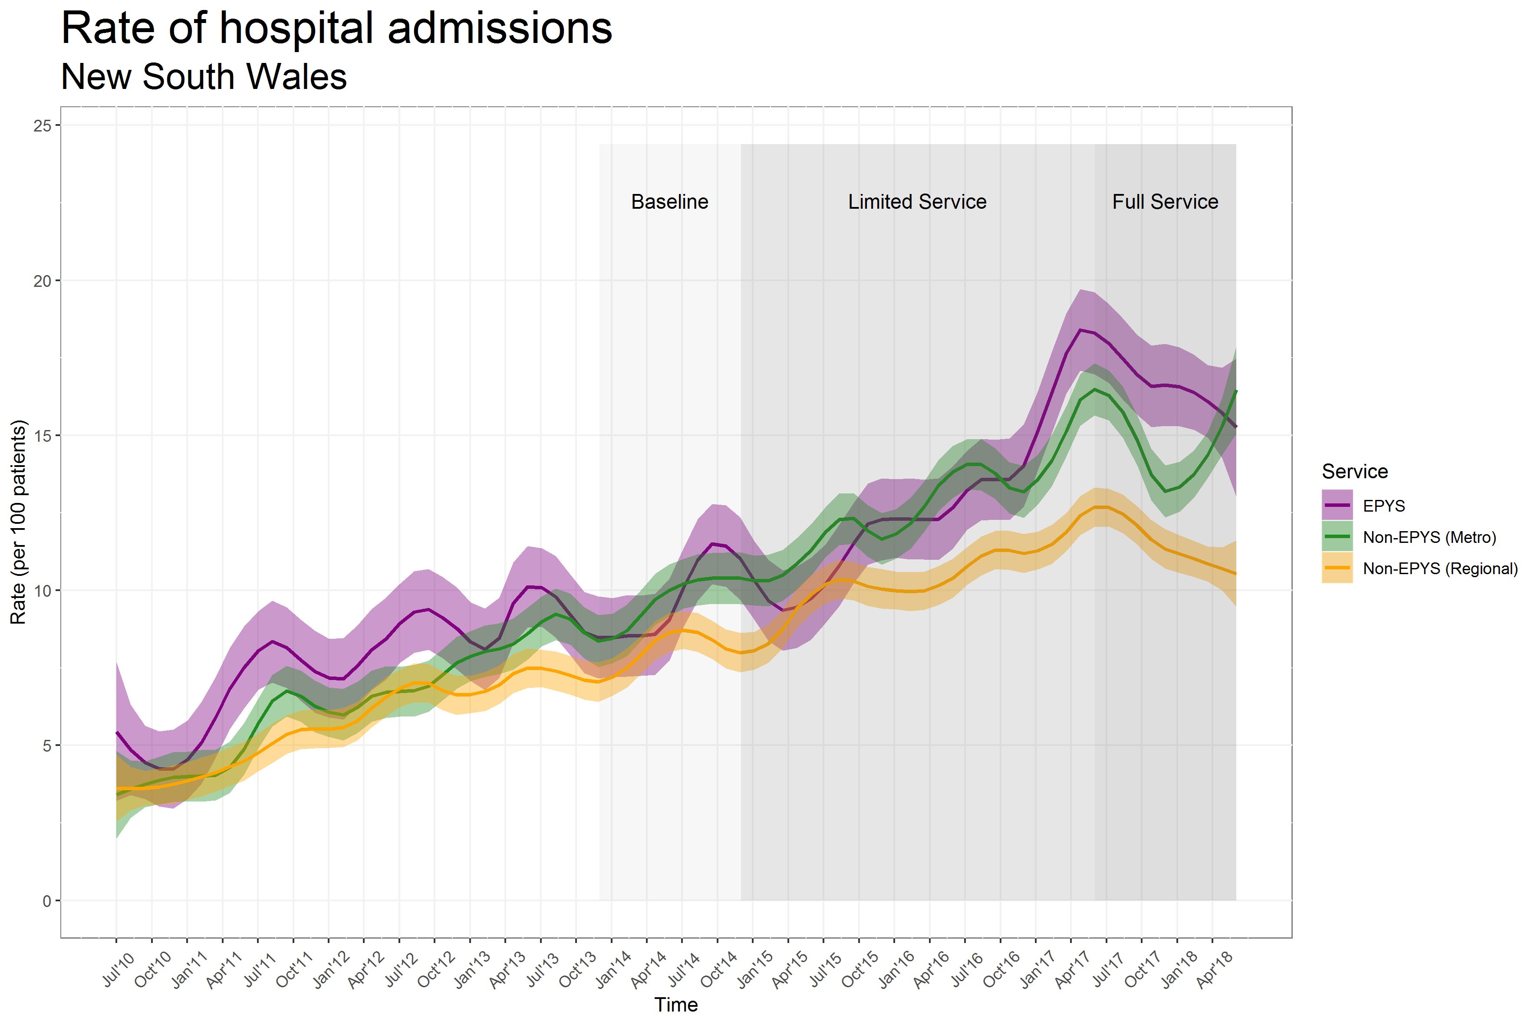

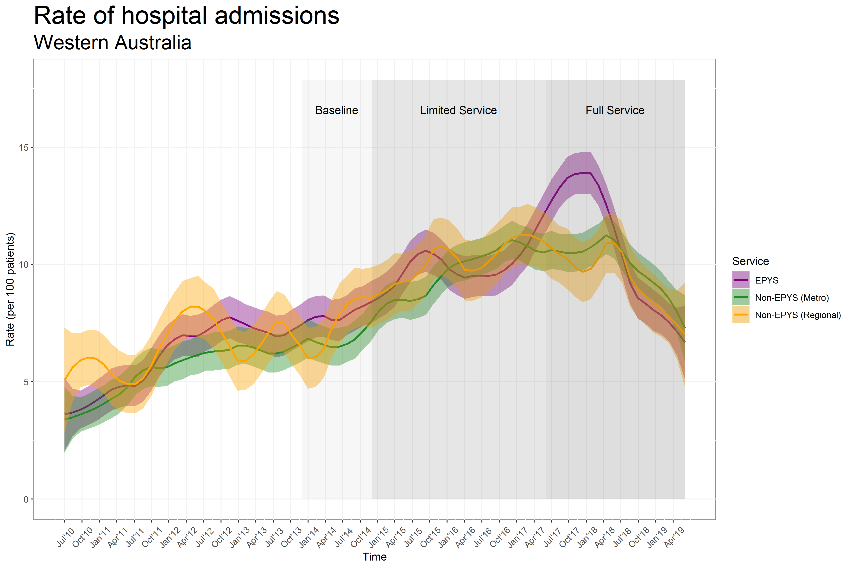

Figure 36: Rates of emergency department presentations by catchment (source: state hospitalisation data)

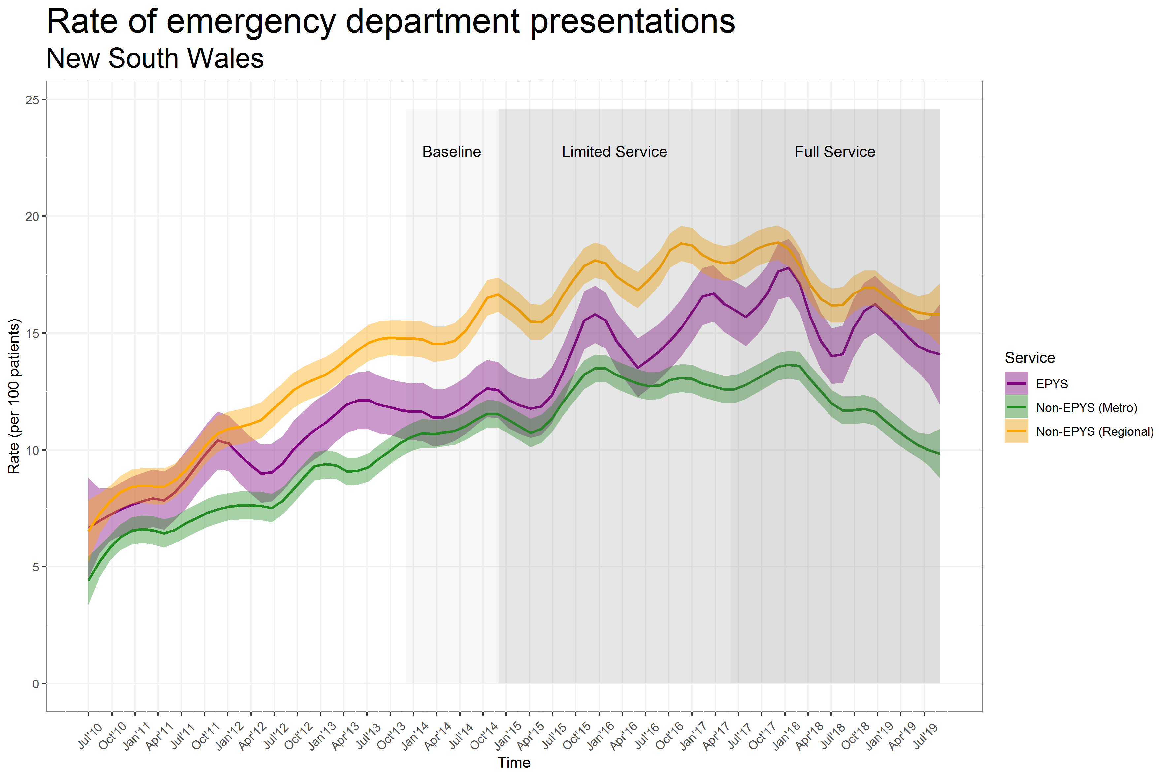

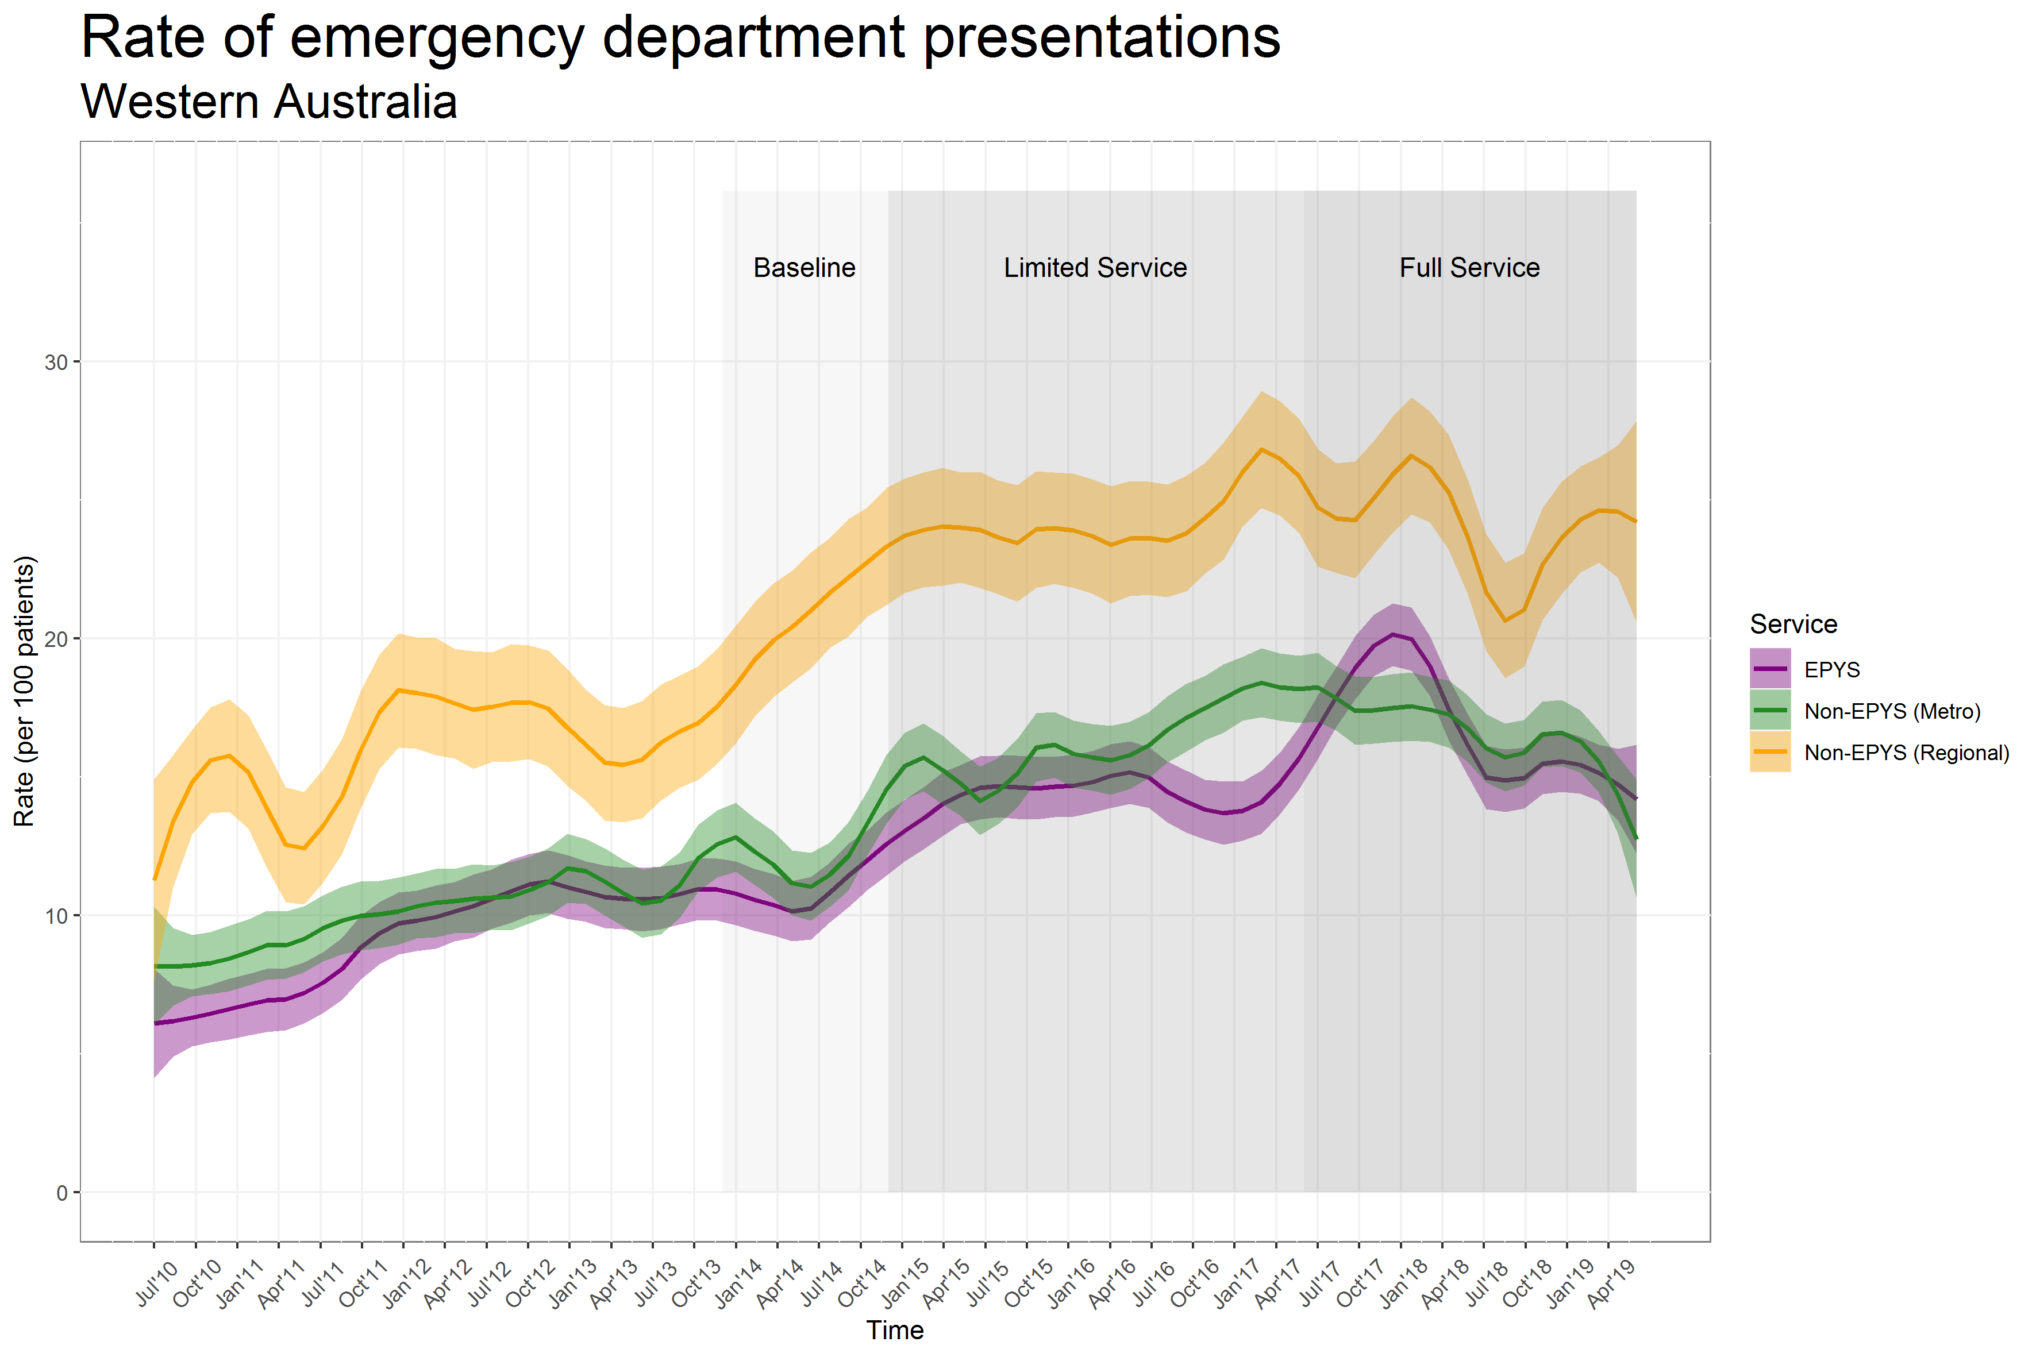

Results from the models estimating differences between EPYS regions and non-EPYS metropolitan regions are shown in Table 39 and Table 40 for NSW and WA respectively. Estimates represent yearly rates or means per patient. For example, a hospitalisation rate of 1.21 means that, on average, each person went to hospital 1.21 times per year. Rates were estimated both during the limited service period and the full-service period. The ‘overall’ row, combines both periods.

In NSW (Table 39), the yearly rate of hospitalisation was 1.15 and 1.40 in EPYS regions in the limited and full-service periods respectively compared to 1.04 and 1.34 in non-EPYS metropolitan regions. Overall rates were 1.21 in EPYS versus 1.12 in non-EPYS metropolitan regions, leading to a rate ratio of 1.09 (95 percent CI 0.97 to 1.21, p-value 0.13) which was not statistically different from unity (no effect).

A significant difference in the number of days in psychiatric care was observed with an average of 11 days per year for EPYS versus 9.2 for the non-EPYS metropolitan region (mean difference and 95 percent CI: 1.8 (0.3 to 3.4); p-value 0.022).

The overall rate of emergency department presentations was also significantly higher in EPYS versus non-EPYS regions (rate ratio and 95 percent CI: 1.19 (1.06 to 1.33); p-value: 0.002). There was some evidence of a difference in the number of involuntary days in psychiatric care with 9.0 and 11.7 days per year on average for EPYS and non-EPYS regions respectively (p=0.064).

Table 39: Adjusted yearly model estimates - NSW results (source: state hospitalisation data)

| Outcome / Period | Statistics | EPYS (N=1418) | Non-EPYS metro (N=3402) | Ratio or mean diff. EPYS vs non-EPYS metro | p-value |
| --- | --- | --- | --- | --- | --- |
| **All-cause hospitalisations** | | | | | |
| Limited service | Rate (SE) | 1.15 (0.060) | 1.04 (0.036) | 1.10 (0.98; 1.24) | 0.107 |
| Full service | Rate (SE) | 1.40 (0.098) | 1.34 (0.062) | 1.05 (0.89; 1.23) | 0.558 |
| Overall | Rate (SE) | 1.21 (0.060) | 1.12 (0.035) | 1.09 (0.97; 1.21) | 0.134 |
| **Bed days for any reason** | | | | | |
| Limited service | Mean (SE) | 11.6 (0.74) | 10.6 (0.45) | 1.1 (-0.6; 2.7) | 0.215 |
| Full service | Mean (SE) | 14.2 (0.96) | 12.6 (0.64) | 1.5 (-0.7; 3.8) | 0.178 |
| Overall | Mean (SE) | 12.5 (0.71) | 11.3 (0.44) | 1.2 (-0.4; 2.9) | 0.131 |
| **Hospitalisations for psychosis** | | | | | |
| Limited service | Rate (SE) | 0.30 (0.021) | 0.32 (0.017) | 0.92 (0.79; 1.08) | 0.316 |
| Full service | Rate (SE) | 0.47 (0.048) | 0.48 (0.029) | 0.98 (0.78; 1.23) | 0.866 |
| Overall | Rate (SE) | 0.33 (0.019) | 0.35 (0.016) | 0.94 (0.83; 1.07) | 0.363 |
| **Bed days for psychosis** | | | | | |
| Limited service | Mean (SE) | 7.0 (0.63) | 6.0 (0.38) | 1.0 (-0.4; 2.4) | 0.172 |
| Full service | Mean (SE) | 9.5 (0.83) | 7.9 (0.54) | 1.6 (-0.4; 3.5) | 0.114 |
| Overall | Mean (SE) | 7.9 (0.59) | 6.7 (0.37) | 1.2 (-0.2; 2.6) | 0.085 |
| **Hospitalisations for self-harm** | | | | | |
| Limited service | Rate (SE) | 0.07 (0.007) | 0.07 (0.004) | 1.06 (0.87; 1.30) | 0.543 |
| Full service | Rate (SE) | 0.10 (0.013) | 0.08 (0.006) | 1.29 (0.94; 1.76) | 0.113 |
| Overall | Rate (SE) | 0.08 (0.007) | 0.07 (0.004) | 1.12 (0.92; 1.35) | 0.267 |
| **Days in psychiatric care** | | | | | |
| Limited service | Mean (SE) | 10.1 (0.71) | 8.5 (0.42) | 1.6 (0.0; 3.2) | 0.053 |
| Full service | Mean (SE) | 12.8 (0.94) | 10.5 (0.60) | 2.3 (0.1; 4.5) | 0.042 |
| Overall | Mean (SE) | 11.0 (0.68) | 9.2 (0.41) | 1.8 (0.3; 3.4) | 0.022 |
| **28-day hospital readmissions** | | | | | |
| Limited service | Rate (SE) | 0.78 (0.065) | 0.66 (0.036) | 1.18 (0.98; 1.42) | 0.076 |
| Full service | Rate (SE) | 1.20 (0.111) | 1.10 (0.074) | 1.09 (0.88; 1.36) | 0.427 |
| Overall | Rate (SE) | 0.84 (0.064) | 0.75 (0.035) | 1.13 (0.96; 1.33) | 0.145 |
| **Involuntary days in psychiatric care** | | | | | |
| Limited service | Mean (SE) | 7.5 (1.07) | 9.9 (0.85) | -2.3 (-5.0; 0.4) | 0.094 |
| Full service | Mean (SE) | 11.8 (1.88) | 15.0 (1.59) | -3.2 (-8.1; 1.6) | 0.195 |
| Overall | Mean (SE) | 9.0 (1.16) | 11.7 (0.86) | -2.7 (-5.6; 0.2) | 0.064 |
| **Emergency department presentations** | | | | | |
| Limited service | Rate (SE) | 1.38 (0.074) | 1.17 (0.032) | 1.18 (1.05; 1.32) | 0.005 |
| Full service | Rate (SE) | 1.47 (0.101) | 1.21 (0.042) | 1.21 (1.04; 1.41) | 0.012 |
| Overall | Rate (SE) | 1.42 (0.073) | 1.19 (0.032) | 1.19 (1.06; 1.33) | 0.002 |
| **Total cost of hospitalisation** | | | | | |
| Limited service | Mean (SE) | 8954 (418) | 7822 (277) | 1132 (202; 2062) | 0.017 |
| Full service | Mean (SE) | 8261 (468) | 7452 (332) | 808 (-272; 1889) | 0.143 |
| Overall | Mean (SE) | 8678 (364) | 7688 (254) | 990 (178; 1803) | 0.017 |

***Notes:***

* *All rates and means represent yearly values (e.g. yearly rate of hospital admissions per individual or yearly average of bed days per individual)*
* *The following baseline covariates were adjusted for in all models: SEIFA, age, sex, previous hospitalisation with psychosis diagnosis, number of hospitalisations and number of bed days for any reason, number of hospitalisations and number of bed days for psychosis, number of days in psychiatric care, number of involuntary days in psychiatric care, number of emergency department presentations for any reason.*
* *For variables summarised as rates (i.e. hospitalisations and emergency department presentation) a negative binomial distribution was assumed and only the period alive and out of hospital was considered as the period at risk of event. For variables summarised as means (i.e. bed days and costs), a normal distribution was assumed.*
* *To adjust for correlations between multiple observations made within each subject, generalised estimating equations with a first order autoregressive correlation structure was used. For hospital readmission, we assumed independence due to convergence issues.*
* *For emergency department presentations and costs, data was truncated in July 2019. For all other outcomes, data was truncated in July 2018.*

In WA (Table 40), the yearly rate of hospitalisation was 0.86 and 0.89 in EPYS regions in the limited and full-service periods respectively compared to 0.89 and 0.91 in non-EPYS metropolitan regions. Overall rates were 0.90 in both EPYS and non-EPYS metropolitan regions, leading to a rate ratio of 1.01 (95 percent CI 0.87 to 1.16, p-value 0.94) not statistically different from unity (no effect). None of the secondary outcomes showed significant differences between EPYS and non-EPYS regions.

Table 40: Main model estimates - WA results (source: state hospitalisation data)

| Timing | Statistics | EPYS (N=1029) | Non-EPYS metro (N=896) | Ratio or mean diff. EPYS vs non-EPYS metro | p-value |
| --- | --- | --- | --- | --- | --- |
| **All-cause hospitalisations** | | | | | |
| Limited service | Rate (SE) | 0.86 (0.062) | 0.89 (0.055) | 0.97 (0.83; 1.12) | 0.669 |
| Full service | Rate (SE) | 0.97 (0.078) | 0.91 (0.071) | 1.07 (0.88; 1.30) | 0.474 |
| Overall | Rate (SE) | 0.90 (0.063) | 0.90 (0.053) | 1.01 (0.87; 1.16) | 0.944 |
| **Bed days for any reason** | | | | | |
| Limited service | Mean (SE) | 8.1 (0.74) | 9.0 (0.70) | -0.9 (-2.6; 0.8) | 0.311 |
| Full service | Mean (SE) | 9.1 (0.81) | 9.3 (0.76) | -0.2 (-2.1; 1.7) | 0.850 |
| Overall | Mean (SE) | 8.8 (0.69) | 9.3 (0.61) | -0.5 (-2.0; 1.0) | 0.499 |
| **Hospitalisations for psychosis** | | | | | |
| Limited service | Rate (SE) | 0.24 (0.023) | 0.26 (0.020) | 0.92 (0.77; 1.11) | 0.397 |
| Full service | Rate (SE) | 0.28 (0.024) | 0.30 (0.039) | 0.92 (0.69; 1.24) | 0.596 |
| Overall | Rate (SE) | 0.25 (0.021) | 0.28 (0.021) | 0.90 (0.75; 1.09) | 0.281 |
| **Bed days for psychosis** | | | | | |
| Limited service | Mean (SE) | 4.4 (0.55) | 5.1 (0.57) | -0.7 (-2.0; 0.6) | 0.300 |
| Full service | Mean (SE) | 5.5 (0.63) | 5.5 (0.62) | -0.0 (-1.6; 1.5) | 0.962 |
| Overall | Mean (SE) | 5.1 (0.52) | 5.4 (0.50) | -0.4 (-1.5; 0.8) | 0.532 |
| **Hospitalisations for self-harm** | | | | | |
| Limited service | Rate (SE) | 0.08 (0.011) | 0.08 (0.011) | 0.93 (0.65; 1.33) | 0.692 |
| Full service | Rate (SE) | 0.08 (0.012) | 0.08 (0.010) | 0.99 (0.69; 1.42) | 0.943 |
| Overall | Rate (SE) | 0.07 (0.009) | 0.08 (0.009) | 0.93 (0.69; 1.26) | 0.653 |
| **Days in psychiatric care** | | | | | |
| Limited service | Mean (SE) | 7.5 (0.72) | 8.2 (0.68) | -0.7 (-2.4; 0.9) | 0.382 |
| Full service | Mean (SE) | 8.5 (0.80) | 8.5 (0.74) | -0.0 (-1.9; 1.9) | 0.988 |
| Overall | Mean (SE) | 8.2 (0.67) | 8.6 (0.60) | -0.4 (-1.8; 1.1) | 0.617 |
| **28-day hospital readmissions** | | | | | |
| Limited service | Rate (SE) | 0.31 (0.047) | 0.33 (0.039) | 0.94 (0.71; 1.25) | 0.677 |
| Full service | Rate (SE) | 0.41 (0.061) | 0.32 (0.049) | 1.27 (0.89; 1.82) | 0.184 |
| Overall | Rate (SE) | 0.35 (0.050) | 0.33 (0.037) | 1.05 (0.80; 1.38) | 0.708 |
| **Emergency department presentations** | | | | | |
| Limited service | Rate (SE) | 1.36 (0.142) | 1.45 (0.105) | 0.94 (0.79; 1.12) | 0.495 |
| Full service | Rate (SE) | 1.72 (0.243) | 1.53 (0.119) | 1.12 (0.89; 1.43) | 0.336 |
| Overall | Rate (SE) | 1.51 (0.178) | 1.49 (0.102) | 1.01 (0.84; 1.22) | 0.883 |

***Notes:***

* *All rates and means represent yearly values (e.g. yearly rate of hospital admissions per individual or yearly average of bed days per individual)*
* *The following baseline covariates were adjusted for in all models: SEIFA, age, sex, previous hospitalisation with psychosis diagnosis, number of hospitalisations and number of bed days for any reason, number of hospitalisations and number of bed days for psychosis, number of days in psychiatric care, number of emergency department presentations for any reason.*
* *For variables summarised as rates (i.e. hospitalisations and emergency department admissions) a negative binomial distribution was assumed and only the period alive and out of hospital was considered as the period at risk of event. For variables summarised as means (i.e. bed days and costs), a normal distribution was assumed.*
* *To adjust for correlations between multiple observations made within each subject, generalised estimating equations with a first order autoregressive correlation structure was used. For hospital readmission, independence was assumed due to convergence issues.*
* *Data was truncated in July 2019.*

The similarities in health service utilisation between EPYS and non-EPYS regions highlights the complex nature of attributing cost benefits associated with the program and the need to consider broader societal and qualitative benefits. Importantly, these findings highlight that the EPYS Program acts as a complement to, rather than a substitute for state-funded health services. Therefore, future planning and service delivery of the EPYS Program must be closely integrated with the state-funded health system.

Sensitivity analyses

In NSW, a range of post-hoc sensitivity analyses were performed on key outcomes to assess the robustness of the results depending on the choice of time unit (quarter, semester or year), correlation structure (auto-regressive or exchangeable) and cut-off date (July 2018 or July 2019). The results (see Appendix D) show very consistent findings across sensitivity analyses. For hospitalisations, the overall rate ratio for EPYS versus non-EPYS metropolitan regions, varied between 1.08 and 1.10 depending on the assumptions (all p-value > 0.05).

Subgroup analyses

Analyses were performed to explore the potential heterogeneity in outcomes according to four pre-specified subgroups including: (1) age; (2) sex; (3) number of hospitalisations during the 12-month baseline; and (4) whether an individual had been hospitalised with a psychosis diagnosis before 1 January 2015. Overall, in both NSW and WA, the results remain consistent across subgroups. Although the point estimate for the rate ratio (EPYS versus non-EPYS metropolitan region) was below one in some subgroups, there was not enough evidence to suggest a true differential effect of the program as shown by the heterogeneity p-values which were all above 0.10.

* + 1. Client, family and carer perceptions of EPYS Program impact on health service utilisation

Health service utilisation (hospitalisation)

Every young person and family member interviewed at time point 2 had some level of hospital contact before and/or during their time with headspace Early Psychosis. The number of contacts with hospital varied — with over half of young people (or the young people the family member supported) having multiple admissions, a fifth having one admission only, and a small proportion presenting at the hospital emergency department without having an overnight admission. Hospital admission length ranged from overnight to six months. Approximately half of young people had a hospital admission which led to a headspace referral.

When considering impact of headspace Early Psychosis, approximately half of all young people and their families did attribute their involvement with headspace Early Psychosis to facilitating early discharge from hospital, avoiding rehospitalisation, or any admission to hospital as the young person could be effectively supported in the community. Conversely, a small proportion young people or family members did not feel that involvement from headspace Early Psychosis impacted their admission or the length of hospitalisation. This was chiefly attributed to headspace not being part of the decision-making process. Further, approximately a quarter of young people and families reported that headspace Early Psychosis missed opportunities that could have resulted in the young person avoiding hospitalisation — particularly because of issues with medication changes or compliance, communication issues with staff, or the young person or family member being unable to contact MATT after hours. See Table 41 for illustrative quotes for each area of impact.

Table 41: headspace Early Psychosis impact on hospitalisation – clients, family members and carers

| Theme | Illustrative quotes |
| --- | --- |
| Early discharge | *YP7ParramattaTP2: I think that was depending on me pushing for a shorter one. But headspace was ultimately saying, we don't want you to go to the hospital. Our whole main aim is to prevent you go to hospital and to prevent from any Early Psychosis. So they like embedded that into me. They were like, hospital is not a good thing. You don't want to go to a hospital, you want to stay at headspace and be able to manage your mental health …Yeah. So I think the admissions were shorter.* |
| Avoiding hospital readmission | *YP3DarwinTP2: Yeah, I think after my third discharge, being with headspace it helped me to stay at home. I didn't have to go back to hospital. My first program was with [another mental health service] and it didn’t work. I had to be admitted again after I had the meltdown. After that headspace was really there, like they were really focused on me. Every week they would visit me and we would have a full discussion of how I'm feeling. And they were monitoring those things and how I was feeling at that time and they were able to be able to discuss some things.* |
| Avoiding hospital admission | *Interviewer: Do you think being part of this program had any impact on whether she was put in hospital or not?*  *FC2ParramattaTP2: I don’t know. Because they said she’s seeing someone in headspace, they said to go back to headspace to let them know and they wrote a letter to headspace to tell them what happened.* |
| No impact on discharge | *YP1ParramattaTP2: …because it was up to the discretion of the psychiatrist in the hospital so they [headspace] didn't really have a say on how long I should stay or what was better for me.* |
| Missed opportunities | *FC2ParramattaTP2: …So we had a second psychosis. I picked him up from the train station and he said I need to go to hospital. So I called the after-hours emergency here [at headspace]. Yeah. It's about 6 o'clock on a must've been maybe a Saturday night or Sunday whatever night, it must be a Sunday night, and they called me back at one o'clock the next afternoon when he was already admitted. So I called them twice and left a message. And then that was, he went back into hospital. But I don't know if maybe they were available. We wouldn't have had to go through the whole thing again…. So going into your hospital because [my son] had come off his medication and the psychiatrist that I didn't love at the time said we don't really recommend it. And I said, but you've told him if he stops taking drugs and he's exercising and eating well, he won't have a psychosis. And he said “well, yes” and I said “well, I can't tell him, I can't make him take them then, because he's doing all of the right things”. And I've since found out at the presentation about the drugs [headspace facilitated] that you really have to be on them for a minimum of a year before you come off them. So if I, had I known that I would have forced him. So he wasn't taking any medication. If I had been able to get in contact with his MAT team, a psychiatrist might have been able to come out and say, take this, because the antipsychotics work pretty quickly… And when headspace did call me back, I was in the middle of nowhere I had no phone reception. But they said, ah, you know, you called and I said “You know what? It was 18 hours ago. He's in hospital now. Don't worry about it”.* |

Young people and families identified key areas that headspace Early Psychosis either did carry out or could implement more consistently in the future to improve the hospitalisation experience and its effectiveness (See Table 42). Approximately half of all comments relating to hospital related to what worked well, and the other half identified areas that could improve the hospitalisation experience and effectiveness. Specifically, the provision of contact (either visits or via phone) during hospital were generally highly acceptable although headspace Early Psychosis providing a choice for such contact was also appreciated. Contact in hospital could assist young people and their families with advocacy related concerns, promote greater continuity of care, decision making and choice, family involvement, and planning (mental health, relapse prevention, medication and managing the transition out of hospital). Most young people and their families cited that the transition points in and out of hospital, and intensified follow-along support post hospitalisation were critical, but approximately half suggested that such transitions would benefit from a more consistent approach being applied. The experience of hospitalisation was highly dependent on the case manager supporting the young person — as their support style, coordination of care, knowledge of the client, communication and assertive engagement could vary. Further, how well headspace Early Psychosis was integrated with the hospital system impacted the young person and their family’s experience. Details of service integration is outlined in Section 5.4.6.

Table 42: headspace factors that could improve the hospitalisation experience and effectiveness – Clients, Family Members and Carers

| Theme | Illustrative quotes | |
| --- | --- | --- |
| Best practice | Areas for improvement |
| Support going into hospital | *YP3PenrithTP2: And then headspace, helped to get us [case manager] called up…*  *FC2PenrithTP2: Got you a bed*  *YP3PenrithTP2: At the triage and helped get us into [ward name]*  *FC2PenrithTP2: Oh that was a lifesaver* | *YP7ParramattaTP2: So I felt like it was needed that headspace was supposed to tell the hospital what was the scenario. But because headspace didn't tell the psychologist, the inpatient psychologist about what happened. I had to explain the whole situation again. Which was really tiresome.* |
| Continuity of care | *YP3PenrithTP2: No, I didn't have to keep going “This is what's wrong. This is what's happened. This is what is happening.” I didn't have to keep doing that same thing over and over again. I could say information would be passed along and they were always there up to date with what I had to say or what I was feeling. So that was good.* | *YP1ParramattaTP2: Well, I think I felt very, like I was angry at my clinician and I just didn't want her to come and see me. I just felt like I was just one of those people that fell through the cracks sort of thing.*  *Interviewer: What made you feel like you'd fallen through the cracks?*  *YP1ParramattaTP2 I guess… Well, like the lack of understanding and well now, because they've gone through some changes and I've been through so many different people. I just felt like my case wasn’t really looked at properly. Yeah.* |
| Contact and support in hospital | *FC4ParramattaTP2: Just before when he was in hospital, his caseworker would go over, his case manager would go visit him in hospital, which was really good. And she was actually fantastic because last time he was in hospital, the hospital was hopeless at communicating. So she was quite good at kind of championing that.* | *YP7ParramattaTP2: Probably more MAT team. Meaning Mobile Assessment Team. For them to come to the hospital. Because in my first admission the MAT team came and talked to me. But then in my voluntary ones they don’t. So in my involuntary they do. Which makes sense because they know that this is the first time. And you don't think you're actually sick but you need you need extra support. So I think if the MAT team could come along more often it would be best.* |
| Planning mental health management a treatment approaches before, during and after hospital | *YP2DarwinTP2 It was stuff that I covered while I was in like the private hospital down south as well, but like being able to come up here and reinforce it. Yeah. And going over it and talking about it and being able to actually practice it up here as well.* | *YP7ParramattaTP2: I feel like it depends on your case manager. I actually don’t think that my first case manager when I went to my first hospital admission focused on it well… because when you do a mental health plan, they ask you what the techniques you should you think would be helpful for you. Yeah. But at the time, I didn't know that many. Yes. So I wasn't as it wasn't as helpful. But my second and third admission, I had the same case manager. So it was it was much easier for me to do the mental health plan. The techniques were thoroughly taught. So it really depends on the case manager. Yeah, but the whole time I had the same psychiatrist. So she was really. Well, great.* |
| Family involvement | *FC2PenrithTP2: Because [mum] would ring [case manager] quite readily and update, but we would also receive phone calls to see how [client] was going... Yeah. I think the back and forth like I think the involvement with the whole family with the process is very helpful.* | *YP2PenrithTP2: Having a support, other than headspace and hospital and stuff, like having your family with you that's the biggest help. Yeah, because you feel most, when you're in psychosis, you don't trust people very much, but with your family you do.* |
| Involvement in decision making | *YP2DarwinTP2: A few times, kind of relapses and that, maybe last year sometime. I was working and, I don’t know, I guess a lot of, under pressure and under stress. That kind of thing and bad sleeping routine as well, always arcs up my paranoia and I had to come in and had a chat with the doctors and that [caseworker] as well and they said you can either go hospital or go home and I chose to go home because it's just more comfortable. It felt safe at home instead of being at a hospital.* | *YP5DarwinTP2: I don't think that it was at the point where we were really coming up with a plan, because when I first came into headspace, we were coming up with a safety plan before I ended up in hospital. But I just didn't use it. Whilst I was in hospital I don't know if there was any communication. Because I don't think there was anything really to communicate. It was just kind of when I, when I was going to leave hospital, I was going to continue to go to headspace and get that treatment outside… I know that I had the right to refuse medication and besides that, I don't know what else I really had the rights to do.* |
| Coordinating the transition out of hospital | *YP3PenrithTP2: headspace was great in helping me in a sort of recovery, you know, talking to the school about going back to school. Um, you know helping me to feel comfortable at home and they were really good in that part, very helpful.* | *FC4ParramattaTP2: I think she was told by the doctor that she will be discharged and you know, possibly a couple of days beforehand, but actually I think she had been waiting for you know, for the assessment from headspace so her release from the hospital was that, you know, there was a couple of days delay and that caused her a big upset… So I rather headspace, you know, that the hospital and headspace or another agent, the same. So if they improve their communication they make this transition smoother.* |
| Medication support post hospitalisation | *YP7ParramattaTP2: My lithium dose was lowered [post hospital discharge] and then olanzapine made me feel really drowsy the entire time. So then I talked to my psychiatrist and she changed it … I talked to my parents and they said, oh, you should just tell the doctor that you’re experiencing any side effects, you change the medication. And I think the doctor gave us one or two or more options and talk about benefits, disadvantages and side effects.* | *YP5ParramattaTP2: …but now that I sort of think back on it [the time post hospitalisation], one of the things that I wasn't too happy with was them pushing to bump up my medication. But then that might be how they're trained because they're psychiatrists and that kind of conflicts with my values. Yeah. Well, not really values, but my ideas of not really being on medication.* |

* 1. How effective is the EPYS Program in reducing or delaying the transition to full threshold psychosis?

Within the literature (see Appendix A) there was evidence of a decline in transition rates in recent UHR cohorts, with rates as low as 8 to 28 percent in one year[88]. Although not published, the Transitions study (conducted in 2012) recorded a transition rate of approximately 8.09 percent (see Appendix G for a detailed comparison).

* + 1. Transition rate in the EPYS Program

To evaluate the one-year UHR to FEP transition rate, only UHR clients assessed at least one year prior to the date when the hAPI data extraction for the Evaluation occurred were included (n = 523).

Figure 37 shows the cumulative number of UHR clients who were subsequently accepted into the FEP treatment arm over the following year. Assuming that no clients who transitioned to FEP were lost to follow up or discharged to other services before the transition, the one-year transition rate in the EPYS Program was estimated to be 6.1/100/year (6.1 percent). The rate of transition appeared stable over time.

Given that up to 30 percent of clients in the UHR treatment arm may not meet formal CAARMS criteria, but rather they meet the broader headspace UHR definition of functional decline, the actual one-year transition rate compared to the published literature may be higher.

Figure 37: Cumulative number of transitions over time in the 523 young people who started the UHR treatment arm at least one year prior to the Evaluation date

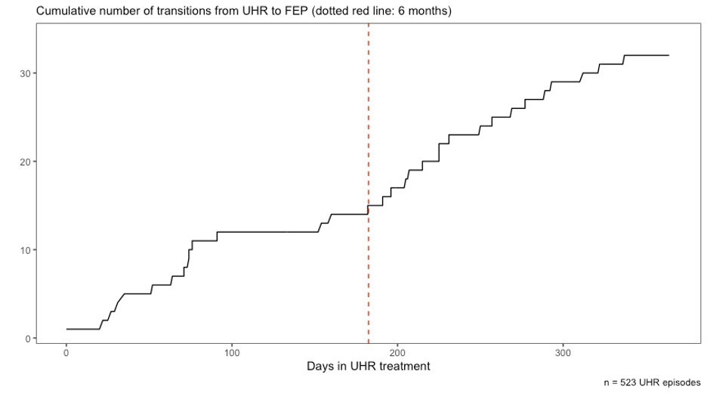

The total number of young people who started the UHR treatment arm and who were still engaged in the EPYS Program at each review who had transitioned to the FEP treatment is shown below. Only half of all UHR clients still engaged with EPYS after a year had *not* transitioned to FEP. This suggests that the UHR treatment arm engages high risk clients for a longer time than low risk clients.

Figure 38: Total number of UHR episodes and the cumulative number of transitions at each 90-day review interval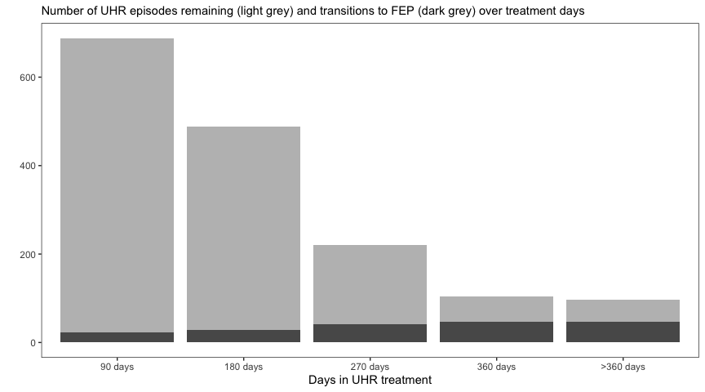

* 1. How effective is the EPYS Program in restoring the functional trajectory of young people with or at risk of Early Psychosis?

This section contains:

* Change in clinician-rated function - Social and Occupational Functioning Assessment Scale (SOFAS) Client, family and carer perceptions of EPYS Program impact on health service utilisation
* Change in proportion of young people Not in Education, Employment, or Training (NEET).

See Appendix G for comparison between the EPYS Program and the Transitions study.

* + 1. Change in Clinician rated function

The SOFAS (Social and Occupational Functioning Assessment Scale) is a clinician-rated global score representing the social and occupational functioning of an individual. Scores range from 100 (extremely high functioning) to 1 (severely impaired). A score of 41–50 is indicative of serious impairment in social, occupational, or school functioning; and a score of 91–100 is indicative of superior functioning in a wide range of activities. Within the EPYS Program, it was measured at assessment and at every 90-day review. Table 43 and Figure 39 show:

* The clinician rated Social and Occupational Functioning (SOFAS) increased over time in each treatment arm.
* The UHR treatment arm clients were less impaired at baseline and gained less over treatment.

Gains appeared to plateau after the 180-day review with mean SOFAS score still below 70 the level at which the young person has “some difficulty in social, occupational, or school functioning, but generally functioning well, has some meaningful interpersonal relationships.”

FEP clients, but not UHR clients, experienced a greater change than the like-service comparator.

Table 43: Assessment SOFAS scores by time-in-treatment and treatment arm (source: hAPI evaluation extract)

| Cohort | UHR | | | FEP | | |
| --- | --- | --- | --- | --- | --- | --- |
|  | **n** | **mean** | **SD** | **n** | **mean** | **SD** |
| 90 day cohort | 180 | 57.8 | 12.0 | 137 | 52.9 | 18.2 |
| 180 day cohort | 197 | 55.4 | 12.6 | 119 | 53.7 | 21.9 |
| 270 day cohort | 95 | 58.6 | 14.6 | 102 | 54.5 | 16.4 |
| 360 day cohort | 74 | 58.7 | 16.3 | 253 | 53.4 | 17.2 |

Figure 39: Individual change in SOFAS score stratified by time in treatment (source: hAPI evaluation extract)

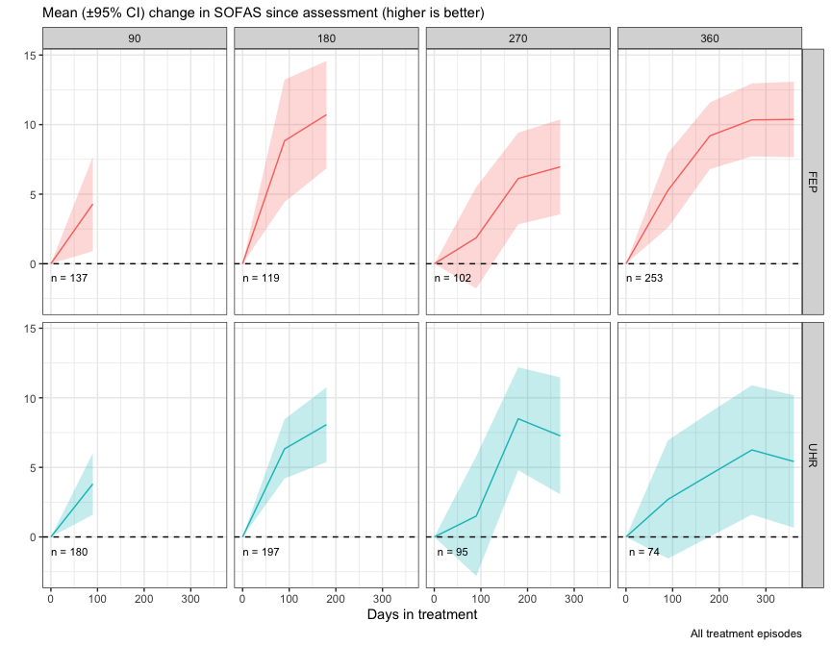

* + 1. Societal Participation (NEET: Not in education, employment or training)

Young people who are ‘Not in Education, Employment or Training’ (NEET) are important to clinicians, policymakers and researchers as this signifies an absolute disengagement from both the labor market and a major avenue of human development.

NEET was determined from assessment if the client indicated they were not enrolled in any education (either part-time or full-time) and they were currently unemployed and looking for work (either full-time, part-time or causal work). Figure 40 below shows:

* Improvement in the societal participation of young people in the program was seen in the first 6 month with little change if any after that.
* Those in the FEP treatment arm had higher rates of NEET status at assessment and around 1 in 5 remained NEET, higher than the rates in seen in the general young adult population in Australia.
* The UHR rates of NEET status after 180 days (approximately 10 percent) were similar to those seen in the general young adult population in Australia.
* Overall, the levels of NEET were lower among UHR episodes than FEP episodes, however NEET was similar among episodes which left treatment after 90 days.

Figure 40: Percentage of NEET stratified by time in treatment 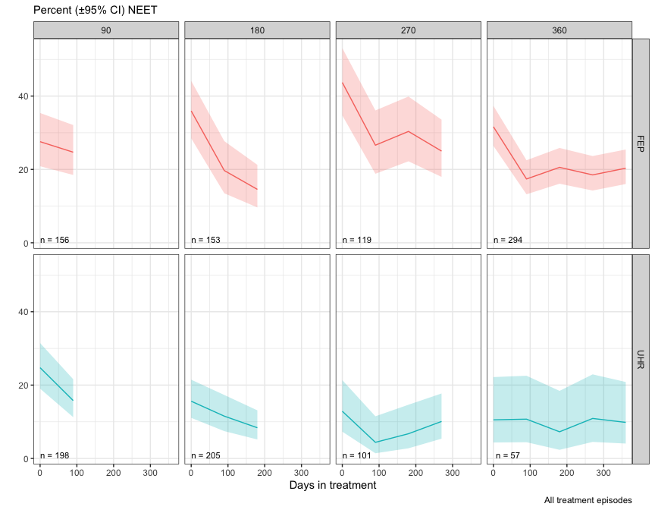

* + 1. Client, family and carer perceptions of EPYS Program impact on functional trajectory

Restoring functional trajectory (including educational and vocational outcomes)

Every young person and family member interviewed identified several areas of functioning in the young person’s life which had improved since commencing with headspace Early Psychosis. Approximately three quarters of overall comments about functional trajectory related to improvements in areas of young people’s lives. The most commonly reported shifts in functional trajectory related to education, employment and relationships and socialising.

In line with EPPIC Model Fidelity (FRP), considerable support was offered by headspace Early Psychosis to young people in areas of employment including: job seeking (such as exploring career interests, developing resumes, job search); job placement; motivational support; and support developing effective work strategies and communications. In terms of education, young people and families highlighted that headspace Early Psychosis provided support: returning to education after being unwell; linking with educational support services; developing effective strategies to cope in educational settings; requesting reasonable accommodations when unwell; and organising supported courses in partnership with TAFE. For the socialisation and relationships theme, young people and their families reported improvements in family relationships (discussed in further depth in section 1.22); re-establishment of friendships; development of new social networks; improvements in communication about mental health with others; and increased access to peer support and social options provided by headspace Early Psychosis (EPPIC Model Fidelity: Youth Participation & Peer Support Program).

Themes and illustrative quotes as to how headspace Early Psychosis supported these functional changes are presented in Table 44. Other notable changes in functioning included improvements in: day to day living skills; mental health self-management skills; level of independence; engagement in hobbies and leisure activities; and health and exercise.

Table 44: Identified functional recovery changes – Clients, family members and carers

| Areas | Theme | Illustrative quotes |
| --- | --- | --- |
| **Employment** | Job seeking | *YP1ParramattaTP2: … I feel like that's the strongest thing that I've gotten out of this. They’ve like they've helped with my resume with looking for jobs and you know, like I had sessions where we just like use the Internet and just job searched and stuff. Yeah.*  *Interviewer: And you have to get a job. Are you working at the moment?*  *YP1ParramattaTP2: Yeah… I have to two jobs. Yeah.* |
| Job placement | *YP5PenrithTP2: …Went into headspace that afternoon spoke to [case manager], I need a job, I’m f****d pretty much oh well I don't remember what the team is, but there’s a team at headspace that works with like the job side of things. Yeah. I was partnered with this bloke named [vocational support worker]. So I went into headspace on the Friday. Had an appointment with him on Monday, He had me a job interview by Tuesday and I started that job like on Wednesday.* |
| Motivational support | *YP2PenrithTP2:… So I talked to her [Vocational Staff] for a bit and she really motivated me to start working. So I was like, okay, I might get into childcare, but I ended up doing university. But she motivated me to kind of do [organisation name]. So, she gave me the idea to do children. So I just one day I looked up [organisation name] and those volunteering things.*  *Interviewer: Ah so you do that…*  *YP2PenrithTP2: Yeah. Every fortnight. Every Thursday. Yeah.* |
| Support when challenges arose at work | *YP3PenrithTP2: So I quit [work]. And then headspace sort of gave me the confidence and the ability to bounce back and say, you know what? I'm going to go again for this job. Yeah. And they took me straight back and they said, yeah, it's awesome to have you on the team.* |
| **Education** | Support returning to education | *YP3PenrithTP2:… because I think there's a point where school didn't even want me back. And then headspace….*  *FC2PenrithTP2: They [school] were “no way”, they [headspace] really fought for you.*  *YP3PenrithTP2: They was just thinking, you know, headspace was there and they said “no” we are going to bargain, this is what we're going to do.*  *FC3PenrithTP2: They [headspace] were about bringing, to be honest, the focus was on about... Okay. Let's get this back to normal. Let's get everything normal. Let's make it better. Let's not go slipping back, or treating anyone special, was like we've got to learn overcome obstacles.* |
| Linking with educational support services | *YP5ParramattaTP2: They [headspace] helped point me towards the right services within my uni, just to get the support that I needed to finish my degree. But it turns out I didn't really need that extra support. Yeah, but it's good just having that safety net anyways.* |
| Developing effective strategies | *YP5DarwinTP2: …it's a lot easier to go into, like these classes and actually talk to people in my class, talk to my lecturer, get their help and I don't feel any bit of embarrassment or anything if I don't understand anything. I would ask people for help and once upon a time I never would have done that. I never liked school when I was younger, but it's a big change you need to be able to go in and start learning again and doing something.* |
| Requesting reasonable accommodations when unwell | *YP7ParramattaTP2: Education wise, they've helped me a lot because most of the time when I have panic attacks, how when I feel really anxious or I feel like I’m having a psychotic episode or anything like that, like I'm hearing things or seeing things, stuff like that before an exam. They, and I don’t do the exam on the day, they write a letter that says, hey, she's a bit sick today.* |
| Organising supported courses in partnership with TAFE | *FC4ParramattaTP2: … so I mentioned about the cooking class, a few art class. Yeah. And also offer this six week program, you know, with animals and she looks after animals.*  *Interviewer: Yes. So that was that was with TAFE. Is that correct?*  *FC4ParramattaTP2: Yeah. I think she got a certificate.* |
| **Relationships and Socialising** | Improved family relationships | *FC3ParramattaTP2: My youngest daughter who hated her brother, now will talk to him and the middle daughter who had the worst relationship with him because he hated her. They now have a really good relationship. So out of all of that chaos, you know. So he was hated by his sisters, he didn't like one of them, was stealing, was taking drugs, is now not stealing, isn't taking drugs, is a valuable member of our family. That is because of headspace. Because they have supported us to be able to do that.* |
| Re-establishing friendships | *YP5ParramattaTP2: Well, yeah, I’m seeing my friends a lot more. Yeah, well, some of the older friends who I haven't seen in a long time, so I've seen like my uni friends a lot. But that's because theoretically I wasn't weird around them so to say. Yeah. Yeah. It's just stuff going a bit more self-accepting and I've just grown and so I'm more confident in being around people who probably have seen the very strange side of me. And so, yeah, I guess being around my old high school friends a lot more kind of shows that, you know, I’m more happy with who I am.* |
| Building new friendships | *YP5DarwinTP2: And it was hard for me to reach out and start talking to new people again. But once I started making new connections and making new friends, I felt a lot better because if I had anything on my mind, I knew that there was someone [headspace] that I could talk to for this issue or someone I can talk to about this issue and even just being there to talk to people when they need someone to talk to as well.* |
| Improved communication about mental health | *YP2DarwinTP2: It’s improved, um, a lot really letting my parents and my friends know, so they have an understanding of what is going on with me and don’t have to worry or stress about anything. I just let them know. So, it's good. It's changed a lot.* |
| Peer support and social options | *YP7ParramattaTP2: They have chill space, which is like it's like peer support run by other people who have gone through the same thing as me. And so that's helped me with my social anxiety. I feel much more confident in speaking with other people and like interacting with others that have gone through similar things. But we don't actually talk about it as often. We talk about it as a friendship friendly kind of like our friends. We've gone through the same thing. We know that. We talk about Christmas time and stuff like that. So it's really rewarding to go to headspace now because I’ve got chill space. And I have that kind of warmth and like family oriented, kind of friendly environment.* |

In approximately two thirds of examples provided in these interviews, participants attributed headspace Early Psychosis to providing support and/or guidance in these areas of functioning. In a third of cases, the young person or family member attributed changes in their current functioning to themselves, other people, and/or other organisations they were involved with rather than headspace Early Psychosis (see Table 45).

Table 45: Attribution of functional changes – Clients, family members and carers

| Attribution | Illustrative quotes |
| --- | --- |
| headspace Early Psychosis | *FC2DarwinTP2: Our journey was with headspace from the beginning, so it's it was a great help and support. I would credit most of our most of his recovery and a lot of what he achieved from them. And I think the service should continue because there's a lot of people that need help. Particularly our youth, so it's important that services is available and it's open, whether it's face to face or online. They should be aware that it’s available so that the early they can identify that there's a problem. The sooner the recovery, the sooner the support will be available. Yeah. Because when I was struggling I remember how much I called, it was really difficult.* |
| Other people, organisations or self | *YP2PenrithTP2: So then I went to, because in headspace they don’t have psychologists, they have a psychiatrist then caseworkers. So yeah. I ended up going to drug and alcohol counselling in [location]. Yes. Yeah. And I talked to him to get off the drug. Because I was using it to study.*  *Interviewer: Was that something that headspace referred to? Or was it…*  *YP2PenrithTP2: No, I did that myself. Yeah, yeah, yeah. Because I couldn't, like, I didn't know what to do. Yeah, yeah, yeah.*  *Interviewer: Sure. And how was that service?*  *YP2PenrithTP2: Brilliant. Yeah. Brilliant... He was great. His name was [name]. And he just he just listened and gave the best advice. And yeah. Like it only took me about like two months to get off it completely. So then I went to uni and I picked up three subjects.* |

The majority of participants from the state-funded Early Psychosis comparison sites, spoke of restoration of their functional trajectory in some areas of their life since accessing the service. This was chiefly attributed to the one-on-one counselling support provided by their care coordinator and the medication they were receiving. None reported accessing group-based support. For education, there was evidence of the service supporting the young person to liaise with places of study, such as University, about their mental health. For employment, support mostly consisted of counselling from their care coordinator, who predominately made referrals to external services when required. This was unlike headspace Early Psychosis which provided the vocational support in-house.

Service improvements to support functional recovery

There were additional areas identified by young people and families regarding service improvements that could be made in relation to the employment, education, and socialisation and relationships support provided.

Specifically, employment focused support could place a greater emphasis on: providing a more considered job seeking process; improving the established employment contacts headspace Early Psychosis has in the community; and providing more intensive support when starting or resuming employment. In terms of educational support headspace Early Psychosis could ensure that the support and advice provided encouraged young people to fully meet their potential. In terms of both employment and education, this feedback although provided only in some cases, was in slight contrast to the Supported Employment Fidelity Scale (formally called the IPS model fidelity scale) which is the gold standard recommended in the EPPIC model. Specifically: job choices should reflect client’s preferences; employment specialists spend 65 percent or more of total scheduled work hours in the community; and employment specialists have face-to-face contact within one week before starting a job, within three days after starting a job, weekly for the first month.

For the group programs (EPPIC Model Fidelity; Group Programs), the social groups facilitated by headspace Early Psychosis could benefit from greater attendance, despite strong evidence of headspace Early Psychosis staff promoting the groups. It is possible this is because some young people acknowledged that social groups, although offered, were hard for them to engage with — thus more could be done to elicit young people’s views on how social groups could be more relevant to them, such as increasing the inclusiveness of the groups on offer.

Table 46: Suggested areas of focus to improve functional changes – Clients, family members and carers

|  |  |  |
| --- | --- | --- |
| Areas | Theme | Illustrative quotes |
| **Employment** | Considered Processes | *YP5ParramattaTP2: I didn't really like how they were kind of just trying to throw me into finding a good job. Yeah. I feel like it was a bit rushed, but again at the time my situation was not really good.* |
| Improving employment contacts in the community | *FC3ParramattaTP2: I found the job helping pretty useless…. last time he got a job that I got him through Seek… And last week I applied for two jobs for him. And he's got he had an interview the other day, and then he's got someone they have they have forwarded on his résumé. So he has asked not to see the job person here anymore because he doesn't think it's useful. But I would have assumed they would have had some contacts in the community, but it doesn't seem that way.* |
| Providing more intensive support when starting or resuming employment | *YP1ParramattaTP2: … I just went straight back to work and back into my normal routine, and that was all just very stressful like I’d have like a little anxiety attacks and panic attacks. And I again, I wasn't really told about any of these things and so it was just like all new territory for me. Yeah.*  *Interviewer: Yeah. What do you think could have been done or improved with the transition out of hospital?*  *YP1ParramattaTP2: I think maybe like, sort of, help realizing that maybe people that come straight out of hospital I guess some of them sort of are not ready to go back into that routine, like I was, and maybe like brakes, or just like slowly, slowly getting back into things would have been better encouraged.* |
| **Education** | Fully meet client potential | *YP2PenrithTP2: … with [employment staff] I’ve just been talking about doing childcare this year. Yeah. So going to TAFE an also working... But I just thought uni.. because I saw on Indeed that a medical science thing doing research for 70/80 grand a year.* |
| **Relationships and Socialising** | Addressing low participation in social groups | *YP6ParramattaTP2: I feel like the numbers that attend the groups are quite low. And I remember once it was just I was the only person who showed up for [a] class. I wanted more people. And I think I just I feel like I just come from a very different background from other people I meet aside from one girl.* |
| Elicit views to improve social group relevancy | *YP4PenrithTP2: But I think that if yeah, if it can happen, I think school sort of mentorships, peer support programs of people from headspace and maybe like indigenous sectors within headspace to help indigenous students and working with other indigenous organizations, even specifically different people who might have different experiences or, you know, groups with diverse people see people of different sexualities and ethnicities and, you know, talking about what they go through.* |

* 1. How effective is the EPYS Program in improving the capacity of families to support and maintain relationships with young people with Early Psychosis?

Although some young people were hesitant about having their family or carers involved in their support at headspace Early Psychosis, they reported feeling supported to have agency in decisions around the level of involvement. Families who were not fully involved in the young person’s support, still reported sufficient levels of support from headspace Early Psychosis, despite the situation being challenging. The support offered by headspace often centred on the provision of psycho-education and support through family therapy, counselling, communication with case managers or psychiatrist and through information or family peer support sessions (EPPIC model Fidelity: Family Programs and Family Peer Support). Many young people and families suggested that the support had improved the family dynamics, the support and understanding the family can provide the young person, and a feeling of connection with other families facing similar situations. Table 47 presents these themes from the perspective of both young people and families.

Table 47: Impact on families – Clients, Family Members and Carers

| Theme | Perspective | Illustrative quotes |
| --- | --- | --- |
| **Choice to involve families** | Young person | *YP5DarwinTP2: I think like maybe the first two that I came in my right first thought my treatment was like during sessions with mum. But mum knows that she if she needs to know anything, she can get in contact with them. Like, my younger sister comes here as well and gets a lot of help through them. So mum’s like met a lot of the people through here anyway. So she, yeah, but like for my own recovery, I didn't always want mum there because I didn't want mum to know exactly what was going on in my personal life. But I know that they're, you know, happy to have mum in and they're happy to keep contact as long as I like I give consent unless I feel that I'm not safe from myself, I guess. But I think they do well with like supporting family if they need their support.* |
| Family | *FC3PenrithTP2: They [headspace Early Psychosis] responded really well but they were not allowed to divulge all the information because our daughter didn’t give the permission… so it was very hard for us… It was pretty hard and it has still been very hard. Because we only know bits and pieces. We don't know the full issue. It makes it really hard.*  *Interviewer: Yeah, and how does headspace manage that with you? Do they provide support to you as well? Or…*  *FC3PenrithTP2: Oh, if needed. I have gone and had a chat to a psychologist a few times. My wife is very busy so she was not able to go as many times as I did, but they provided us some support yeah.* |
| **Psycho-education** | Young person | *YP11ParramattaTP1: I guess it's because it's stressful for your own child to have a mental illness and not understand what's going on. So, headspace has provided a psychiatrist that speaks the same language as my mum so that helped her understand a little bit more about mental illness and how to prevent it as well. So, the parents, they're taught strategies on how to help and strategies that I'm taught as well, so they understand what I'm doing.* |
| Family | *FC3ParramttaTP2: So I've actually also been to, they give a talk every month. So the one on medication was so informative. I loved it. It made me understand how the medication works. Because there is heaps of stuff in Google about the medication, what it's used for, what side effects are, but it doesn't actually explain how it affects your brain and stuff. So that was really good.* |
| **Counselling/ family therapy** | Young person | *YP2ParramattaTP2: So they have things for your carers as well. And mom likes that. She sees someone like once a month to talk about me.*  *Interviewer: And how does she find that?*  *Speaker: She loves it. She knows how to handle me in stuff ... Cause like, like we need mum's mental health to be good. In order to take care of me. Yes so. So it's good to have her to talk with someone as well.* |
| Family | *FC3ParramttaTP2: But what headspace has done is probably saved [my son]'s life, perhaps saved my life, and meant that my two girls can have people to talk to and feel supported. So my youngest daughter... when we first went [to family counselling], she said, I don't need to go ... So I said “well that's okay, you don't have to come” but she said “I’ll come” and we got there and [family counsellor staff name] said, you know, my sister was this and that. And then my [daughter] just started crying and crying and crying. And the fact that someone can get through to her and that she feels supported and my girls will say when we when can we see them? And it's not because it's always fun. It's because the three of us can get together with them and they can talk about how awful it is to have somebody in your family like that... So having that support for them as well, to know that, you know, that are other people that are just having a shittier life, I think you can't put a price on that. And it makes me cross when the government says things. You know, we're always talking about mental health issues and unfortunately, mental health issues can't really, it's not like diabetes where there's a level of sugar or there's a, you know, a statistic, I guess.* |
| **Improvement in family dynamics** | Young person | *YP3PenrithTP2: would say I, especially with my family as well, they have helped me build more deeper trust relationships. I had the confidence now to come up to my dad, or my parents, or my brothers to say what I'm not feeling. Okay.* |
| Family | *FC4ParramttaTP2: …but I think I can tell you, I think, since she come here [headspace Early Psychosis] our relationship improve a lot.* |
| **Connected to other families in similar circumstances** | Young person | *YP6ParramttaTP2: I think they got something out of it [family information sessions] as well. I mean just talking to the other parents.* |
| Family | *FC4ParramttaTP2: I think it [family information session] was good to understand other parent’s experience, and to share them as well, share your own with them.* |

Although support was generally offered, some family members themselves did not always want support, and there were a small proportion of families who reported the support was also not the right fit for them (see Table 48). Further, although interested, some of the family education or peer support group sessions had access barriers so not all families could not easily engage.

Table 48: Family support engagement challenges – Clients, family members and carers

| Theme | Illustrative quotes |
| --- | --- |
| Not ready to engage | *FC2DarwinTP2: They already offer support, even for us, it's just me. I think I'm not too comfortable to seek more support even for me, for the family. They already told us that there’s family support. It's just for me. But the family, the time. Yeah. I'm aware that it's available. Just. Yeah. Maybe because of what we've been through. I am also hit rock bottom to be honest.* |
| Not the right fit when engaged | *FC2ParramattaTP2: Took a long time before she understood, because I did want to see the family care worker that I didn't want to see him. But she kept on saying it’d be good for you. I already know this stuff but it’s not helping me… Like how he [support worker] told me that anxiety is transferred from one person to another person. I just felt like I was being judged. I’m already trying to do the best that I possibly can do, I can't do any more, I can't change my personality. That's me.* |
| Access barriers to engagement | *FC1ParramattaTP2: … even though I don't go they still sending me those information. They probably come once a month in the evening here. Yeah. They have like the people the parents come together themselves and headspace was holding this, they have like, those are they are called, they do one every month they do one to run different ... topics. But it was at the main office at Mount Druitt.*  *Interviewer: Oh so that's difficult to get out there?*  *FC1ParramattaTP2: Yeah a bit difficult, but they usually at night. Even the timing, like run from 6 to 8. I got the information but I didn’t sign up to go.* |

Participants from the state-funded Early Psychosis comparison sites, reported satisfaction with the communication with, and provision of support for, families when it was needed. However, unlike headspace Early Psychosis, this was predominately offered informally by the care-coordinator rather than as a formal group or family counselling sessions.

For detail on the impact of the headspace Early Psychosis service on caregiver burden, refer to Appendix F for results of the family and carer survey which was conducted for the Evaluation in September 2018.

* 1. How satisfied are clients and their families with the EPYS Program (explored through elements of perception, experience, expectation, baseline need)?

Young people and families were predominantly very satisfied with headspace Early Psychosis in the interviews and focus groups (at all time-points from 2018 to 2020). Participants from the state-funded Early Psychosis comparison sites, also were highly satisfied with the service they received.

In terms of young people and families baseline needs when coming into the program, all participants spoke of a period of being acutely unwell whether this was experiencing psychosis or other mental health symptoms for which they were requiring support. This frequently was the cause of great distress for young people and families often was not being satisfactorily addressed by other services and thus led to headspace Early Psychosis or hospital engagement (later resulting in a headspace Early Psychosis referral as discussed in Section 5.4). Once receiving support from headspace Early Psychosis, young people and family’s expectations for the program were quite varied, ranging from wanting support for their mental health, access to psychiatry, strategies and treatment. Others reported wanting a quick “fix” to the issue, and others reported not knowing how headspace Early Psychosis could help. After a period of support from headspace Early Psychosis, program expectations were generally met or exceeded. Themes relating to baseline needs, expectations and how these were met by headspace Early Psychosis are presented in Table 49.

Table 49: Needs and expectations when initially accessing headspace Early Psychosis and how these were met – Clients, family members and carers

| Area | Theme | Illustrative quotes |
| --- | --- | --- |
| **Baseline need** | Needing support for untreated psychosis / exacerbated mental ill health | *YP5PenrithTP2: And so essentially in year seven I started to develop, well more so late 7 most of year 8, I developed pretty full on symptoms of psychosis. The first symptoms were only very minor and I got over them, put it down to just an overactive imagination. But then eventually, after a lot of bullying and other things, other traumatic events, I just sort of it became out of my control. And so essentially I went to headspace because, you know, I was like telling you like I was having depression as well. You know, my mom was really concerned because she couldn't handle it because even though she's had similar mental health experience as I have, no one you know , even those who are qualified , they say they still need to set time away from their patients to , you know , no one can deal with it all the time.* |
| Unmet need | *YP7ParramattaTP2: And so at the time, I did go to a private psychiatrist, private psychiatrist and psychologist. But they didn't really, I felt like they didn't really work for me ... They said they weren't sure what my problem was yet, but they diagnosed me with anxiety. And I remember, from what I remember, is that they didn’t say that I had schizophrenia, but they said that I had psychosis, but they didn't say that I had schizophrenia, whereas headspace tells me that I had schizophrenia.* |
| **Expectation** | Wanted help | *YP5DarwinTP2: I think because I left it too late, like I was pretty, pretty low when I first came in and I wanted to feel hopeful, but at that time I didn't really feel hopeful at all. I didn't really know exactly what I was doing. I was just there trying to get the help and I didn't know what the help would feel like or look like. I wasn't sure whether or not I was actually getting the help or what was happening.* |
| Access to professional support | *FC3ParramattaTP2: I was hoping that it was we would see a psychiatrist because it's really hard to get a psychiatrist for a young person. Yeah, and the only one I knew was the one that we had seen.* |
| Strategies | *YP2ParramattaTP2: And what were you hoping to get out of the program?*  *Speaker: I guess just, methods in a sense. Like a way to get back up, I guess. I know they can't exactly get rid of anything. Yeah, but if I could just loan. Strategies to improve my core being, I guess, on how to solve things in a better way. Just a change I guess.* |
| Treatment | *YP7ParramattaTP2: The whole point was to get the medications on board because I had several different medications and also to minimize like the stress level that I had during the HSC and try to get into university and be able to normalize.* |
| A quick solution | *FC1ParramattaTP2: Like, at that point. I was like, um, get like, I want my son to get better as soon as possible.* |
| Unsure | *FC3PenrithTP2: We had no idea, we had no experience before, so I was unsure what to expect.* |
| **Perception** | Met expectations | *Only I sort of I was hoping you know that I would be like, you know, I just I sort of hope for a normal, happy feeling, not having all these issues and stress to deal with. Yeah. And it did give me that, it 100 percent gave me that… [previously] It's great. I look at myself two years ago, I was too scared to even sleep. I was crying. I couldn't look at anyone in the eyes. I couldn't do anything. I saw things all around me. Now I'm confident, I, with all the help and support I have gotten, I feel like not only do I need that help and support, but I don't need it as much anymore, because it is shown me a way to be independent and show me a way I can look after myself. So it's been incredibly useful for me.* |
| Better than expected | *YP2ParramattaTP2: Honestly, I felt a bit hostile at first [engaging with headspace Early Psychosis], not going to lie. Just because I was a bit worried that they were gonna, I don’t know. I don’t know what I was worried about really. I just didn’t like them much. Probably because it's like, you know that kind of stigma with like having people coming out to your house to check on how you're doing. It just kind of felt like I should be the only one knowing that. But yeah, I’m glad I’m here.*  *Interviewer: Yeah. And when you were talking to them, how did it change or when did your views kind of change?*  *YP2ParramattaTP2: Well, at first it was honestly just kind of nice that someone that I could talk to, in that sense, without that judgment, I suppose. I'm sure there was some part that would kind of say this, but they weren't showing that, I guess. And like, I felt like I just could say anything because they didn't know me or anything like that. That kind of privacy, I guess was always nice. And rather than just listening, there was actually a solution that could be offered, which I found incredibly helpful obviously. Rather than just someone listening and saying, ha ha, I get it but they don’t really.* |

When considering their experience through the lens of satisfaction, young people and families reported that the multi-faceted youth-focused service (EPPIC Model Fidelity: Easy Access to Service Q9), with it’s highly supportive and flexible staff provided holistic and individualised support and outreach (EPPIC Model Fidelity: Mobile Outreach) that chiefly met their needs. Supports ranged from mental health focus treatments (such as counselling, psychological interventions, medication as per EPPIC Model Fidelity: Psychological Interventions, Medical Treatments) to functional supports (such as vocational, educational, social, family-based as per EPPIC Model Fidelity: FRP, Family Programs and Family Peer Support, Group Programs, Youth Participation & Peer Support Program) and were viewed as making a considerable impact on their mental health recovery, wellbeing and functional trajectory (See other impact findings as reported in Sections 7.1.5, 7.3.5, 7.4.2, 7.6.3).

**Interviewer:** What changes have you seen in yourself over the course of being part of this program?

**YP6ParramattaTP2:** I think I've recovered quite well, still recovering, but closer to the end of the journey.

The support provided coupled with the notable changes since being with the program could be attributed to producing the high levels of satisfaction with headspace Early Psychosis – often described as lifesaving.

**YP5PenrithTP2:** I had no idea what I'm getting myself into at the time to be completely honest.

**Interviewer:** Would you be able to reflect on what you think you actually needed?

**YP5PenrithTP2:** Oh, yeah. I would not be where I am today if it wasn’t for me walking in and getting help that day there would be no me. Nothing would be what it is without headspace in my opinion to be completely honest.

**Interviewer:** That's pretty powerful. What have they helped with?

**Participant:** All sort of stuff from dealing with my emotional problems dealing with breakups, just dealing with stresses, dealing with financial problems. They helped me get a job at one point. They're helping me sort out things to get on Centrelink at the moment because I don't have any income. Like everything I walk into headspace and say jump and they say how high?

Although overall satisfaction with headspace Early Psychosis was high, approximately a quarter of young people and families comments highlighted there were still opportunities for improvement based on their experiences. These frequently related to the need to address staff turnover to promote greater continuity of care, improvements in communication (at an individual and organisational level), and intensified support at transition points in a young person’s life (such as hospitalisation, medication changes, starting or ceasing employment, discharge from headspace Early Psychosis). Participants from the state-funded Early Psychosis comparison sites, however, all reported a high level of staff consistency and continuity of care from initial engagement. In terms of transition points, the vast majority reported highly integrated support at hospital transition points and satisfaction with the support around medication changes.

For detail on client satisfaction as collected at each 90-day review and subsequently reported in the hAPI MDS, refer to Appendix J.

1. Evaluation Question 4: How efficient and cost-effective is the EPYS Program?

This section details the findings for the following evaluation questions:

| Evaluation question | Secondary evaluation questions |
| --- | --- |
| 1. How efficient and cost-effective is the EPYS Program? | 1. How efficiently have EPYS Program resources been used? 2. How cost-effective is the EPYS Program compared with usual care?[89] 3. Is there a minimum target population size required for cost-effective delivery of the EPYS Program? |

* 1. Introduction

The EPYS Program was delivered across six services and clusters established across Western Sydney, South East Queensland, South East Melbourne, North Perth, Darwin and Adelaide over the past six years. The national rollout was multi-phased, meaning each service was at a different level of maturity. Funding uncertainty and the unique setting of service delivery impacted the cost, staffing profile (due to difficulties attracting some staff), and capacity to deliver services for each of these services – this is discussed further in Section 5. The efficiency and cost-effectiveness results reflect this variation between services and should be considered when interpreting the findings in this analysis.

* + 1. Cost efficiency

Cost-efficiency (subsequently just referred to as efficiency) is defined as the level of resources required to deliver the service on a per client basis. Several service delivery variables are examined that seek to explain the variation in the cost per client including:

* The number of direct OOS per client
* The proportion of clients assessed as UHR versus FEP
* Variation in the type and length of services delivered to client with a focus on face-to-face services
* Workforce composition
* Workforce productivity.

Efficiency is compared between the six service locations, but not with other state-funded Early Psychosis services. The purpose of the efficiency analysis is to:

* Assess how the performance of the different services varies from a cost perspective
* Identify what are the drivers of the differences in efficiency between services
* Estimate and inform the financial cost of a national rollout.

Differences in the relationships between headspace Early Psychosis and headspace Primary may also contribute to differences in cost-efficiency. Resources were shared between headspace Early Psychosis and headspace Primary. Some services may have shared more services with headspace Primary, allowing them to attain economies of scale in administrative tasks. This also makes the measure of EPYS Program service outputs inexact as some services may be shared but not recorded as such.

Results are presented for the 2017-18 to 2018-19 financial years. Financial data were collected directly from lead agencies and are based on the estimated cost to deliver the EPYS Program instead of the actual amount spent in each financial year. Services data were provided by headspace National as recorded in the hAPI evaluation data extract. Data determined to be unreliable were omitted as has been noted in the relevant sections below.

* + 1. Cost-effectiveness

Cost-effectiveness is defined here as the incremental cost per unit of health outcome.[90] An intervention is measured relative to a counterfactual - an alternative comparable service seeking to deliver the same outcome.

Given the evaluation did not involve a live control group, the counterfactual for the EPYS Program has been constructed from extensive consultations between the Evaluation Team and key stakeholders. The unique nature of service delivery under the EPYS and its place in the mental health treatment framework in Australia means that an appropriate counterfactual is not readily available. The ‘best-practice’ approach would be to examine the outcomes under ‘care-as-usual,’ where participants who were not admitted to the EPYS compared to those who were admitted. Such a comparison would be complicated, however, by the fact the program is not a complete substitute for ‘care-as-usual’ and clients continue to access some state-funded health services whilst receiving services through the EPYS Program.

A comparable cohort was constructed to compare outcomes under the EPYS with assumed outcomes for individuals with similar characteristics. It was assumed that individuals’ severity of symptoms in the comparable cohort were stable over the 12-month period. Given that the study was not being conducted on an incident cohort, this steady state assumption is not unreasonable. In any case, the assumption is tested in sensitivity analysis in which the change in the severity of symptoms experience in the *Transitions Study* cohort relative to the EPYS cohort has been factored in.[91] It is important to note the *Transitions Study* cohort is better characterised as an active comparator or positive control comparison of the EPYS service as it was based on a fundamentally similar service model to that of the EPYS. Therefore, it has been chosen as a sensitivity and not the base case for the analysis.

In estimating the potential cost-offsets it was necessary to determine the impact of the intervention on transition from UHR to FEP and then estimate the cost implications. To do so the observed transition rate in EPYS was compared with a ‘usual care’ comparator taken from the literature which recorded a transition rate of 34.6 percent for a similar cohort over a similar period.[92]

The purpose of the cost-effectiveness analysis was to estimate the value for money delivered by the headspace Early Psychosis. The calculation of cost-effectiveness analysis has been undertaken in three discrete parts:

* Estimating the net cost of the EPYS Program
* Estimating EPYS Program clinical effectiveness
* Estimating the incremental cost per improvement in unit of health outcome (QALY).
  1. How efficiently have EPYS Program resources been used?

This section covers:

* Defining and measuring efficiency
* Program resource inputs
* Service outputs
* Comparison of total costs
* Cost per client comparison
* Service workforce comparison
* Total service time comparison.
  + 1. Defining and measuring efficiency

Heterogeneity in cluster or service characteristics

There was variation in the size of the six services or clusters - the largest cluster is South East Melbourne and the smallest were the Adelaide and Darwin services. Figure 41 shows each cluster size and its lead agency.

Figure 41: Location and lead agency of each service in the EPYS Program

Figure 41 is an image of a map of Australia showing the location and lead agency of each service in the EPYS Program

Differences in the profile of each service’s clients impacted on the efficiency of each service. For example, the Darwin clients was more likely to be Indigenous Australians and living in remote areas (refer to Section 5.3.7). This was likely to have increased the cost of service delivery given the unique cultural and geographical challenges faced.

Two clusters, North Perth and South East Queensland,[93] have multiple lead agencies delivering services:

* The North Perth cluster had a Joondalup hub and Osborne Park spoke operated by Black Swan Health, while the Midland spoke was operated by Youth focus.
* The Southport and Meadowbrook services in South East Queensland were operated by different lead agencies (Lives Live Well and Aftercare, respectively).

Each service commenced the delivery of services at different points in time over an 18-month period. The Bentleigh, Frankston, and services in the Western Sydney cluster commenced delivering services in September 2014 (the most mature services), whereas the Adelaide service began delivering services in January 2016 – nearly 18 months later.

Defining and measuring efficiency

There are two types of economic efficiency considered for this analysis:

* Technical (productive) efficiency - Maximum productive efficiency requires that goods and services be produced at the lowest possible cost. A productively efficient outcome uses the least cost input mix required to produce a given output of any good or service.[94] In the context of the EPYS Program, this is the minimum financial cost and staff profile required to deliver the program.
* Allocative efficiency - The optimal mix of services towards achieving an outcome. In the context of this Evaluation, this is addressed through the question of whether investment in the EPYS Program over a comparative service represents value for money.

Technical efficiency of the EPYS Program is considered in this efficiency section of this report (Section 8.2). Allocative efficiency is addressed in the cost-effectiveness discussion (Section 8.3). Throughout this section, efficiency refers to technical efficiency.

Table 50 describes the two types of inputs and two types of outputs examined in the analysis.

Table 50: Definition of technical inputs and outputs in this section

| Category | Measure | Definition |
| --- | --- | --- |
| Inputs | Financial cost | Sum of the direct and indirect service costs.  Direct service costs included: salary and wages; travel expenses; staff training and development; and other direct service costs.  Indirect service costs included: rent, utilities, IT, communications, office and community awareness expenses. |
| Number of FTE employees | Number of full-time equivalent employees across the service. It includes administrative, management, and clinical care teams. |
| Outputs | Number of clients | Total registered unique clients over the evaluation period in a cluster.[95]  Registered unique clients have been defined as all individuals who were formally registered within the evaluation period to receive services.[96] This includes the total number of clients, irrespective of consent status. |
| Direct OOS | Number of services provided clients to registered individuals.  This comprises both services provided directly to clients (i.e. face-to-face consultations) as well data entry by the treating medical professional. It also includes occasions of repeated service to one participant over the evaluation period. |

The cost per client and five explanatory variables have been used to evaluate the degree of efficiency between and within clusters, shown in Table 51.

Table 51: Outcomes used to assess efficiency in this Evaluation

| Metric | Calculation | What does it measure? |
| --- | --- | --- |
| **Primary Metrics** | | |
| Cost per client | Total financial cost/Total unique clients | The average cost to deliver services to one client in a cluster |
| **Secondary Metrics** | | |
| Direct OOS per client | Total direct OOS in a financial year/Total unique clients in a financial year | The average number of direct OOS delivered per client |
| Client type | Number of FEP clients/Total number of accepted clients | The proportion of FEP to all accepted clients |
| Days of service delivery per client | Days of face-to-face service delivery/Total unique clients in each financial year  Days of service delivery (all modes)/Total unique clients in each financial year | Total days of service delivery per client |
| Length of services delivered by service mode | Number of direct OOS by mode x Average length of service delivery by mode | The average days of face-to-face service delivery per client over a financial year |
| Workforce composition | Number of clinical FTE/Total FTE | Percentage of clinical FTE |
| Workforce productivity | Days of face-to-face service delivery/FTE  Days of service delivery (all modes)/FTE  Cost per day of service delivery | Average number of days of service delivery per FTE |

The approach used to assess efficiency is to compare performance between services rather than with an external benchmark. This involves comparisons within clusters and between clusters/services.

* + 1. Program resource inputs

Program resources have been presented in terms of workforce and financial data. Workforce relates to the number and type of staff required to deliver the program in each cluster. Staff delivering the group or peer support programs (including volunteers) have not been included in the count of FTE.

Table 52: Disaggregation of workforce data

| **Staff type** | **Staff function** |
| --- | --- |
| Administration | Clinical and non-clinical administrative staff. |
| Management | Operations manager, quality and improvement manager, and coordinating management staff. |
| CCT | All members of the CCT. The CCT clinicians provided ongoing case management during regular business hours and are the young person’s primary point of contact with the service. CCT clinicians undertook comprehensive assessments of the young person’s mental health to determine their eligibility for the program. The CCT clinician had a therapeutic and coordination role for the client, working collaboratively with the young person and their family. Some of their primary tasks included engagement, developing the treatment plan, education of the young person and their family, risk management, developing a relapse prevention plan and discharge planning. CCT clinicians were also responsible for providing mobile outreach services and home-based care. There was a CCT based at each hub and spoke. |
| FRP | All members of the FRP. The FRP incorporated vocational and educational support on an individual or group program basis to provide recovery‑based treatment. This team was based at hub services, but functional recovery was available to all clients within the headspace Early Psychosis service. |
| MATT | All members of the MATT. MATT clinicians provided triage, assessment and intensive extended-hours home treatment service to young people referred to the EPYS Program service and current EPYS Program clients. The MATT were based at the hub and provided their services to the entire headspace Early Psychosis catchment. |

Financial data relates to the budgeted cost of program delivery for each cluster or service. Financial costs were provided by services and reflect budgeted amounts for services and have been aggregated to a cluster level to produce cluster results. Financial costs reflect budgeted amounts and not incurred costs because incurred costs and FTE were difficult to estimate with the turnover of staff. Services noted that staffing profiles fluctuated throughout the year, with some FTE performing part-time roles for less than a full year.

Table 53: Disaggregation of financial data

| Cost | Staff function |
| --- | --- |
| **Direct Service Costs** | |
| Salary and wages | Salary and wages of all staff including on-costs. |
| Travel expenses | Motor vehicle costs, staff travel expenses and/or transport brokerage. Data may be input as one summarised line or disaggregated. |
| Other direct costs | Other direct service costs not included in the above. |
| **Indirect Service Costs** | |
| Community awareness activities | Awareness/marketing campaigns, consumer care and participation and/or advertising and promotion. |
| Office expenses | Security, cleaning, staff amenities, stationary, repair and maintenance or subscriptions. |
| IT and communications expenses | Phone connection, fax connection, internet connection, hardware, software, electronic medical record licences or other licences. |
| Rent and utilities expenses | Electricity, lease costs, rates and taxes. |
| Program management fees | Human resource costs, finance fees, IT support or other program management fees. |
| Other expenses | Auditing fees, insurance, banking fees, and/or medical supplies, and other costs not included in the above. |

* + 1. Service outputs

Service outputs were reported in hAPI by headspace Early Psychosis. These data were based on aggregate client and OOS amounts - no individualised data were collected to respect the data consent provision. This includes all young people who received OOS during 2017-18 and 2018-19 financial years.

Two outcome measures have been used to measure the output of services (collectively termed ‘activities’), including:

* Direct OOS. A direct occasion of service is a service provided directly to the young person and/or their family. Clinical care, assessment, crisis response, and care planning are considered direct OOSs.
* Registered clients receiving services. Any client who received services at a service during the financial year. Each client has been counted once regardless of the amount of services received during the year. These counts include consenting and non-consenting clients as these estimates are based on aggregated rather than individualised data.

Indirect OOS are also considered as a possible explanatory variable for the variation in cost per direct OOS and cost per client. An *indirect OOS* is any other service provided on behalf of the young person and/or their family, but not provided directly to them. Clinical review, case notes, letter and report writing, data entry, eheadspace correspondence, liaising with other providers, case review, risk assessment, travel time, and other administrative tasks are considered indirect OOS. Information on the services has been aggregated based on financial year to make it comparable to financial and workforce information.

South East Melbourne delivered services to the most clients in each evaluation year, while Darwin provided the least – reflecting the size of these services. South East Queensland delivered services to more clients than North Perth, despite having one fewer spoke.

Figure 42: Clients serviced per annum per cluster/service

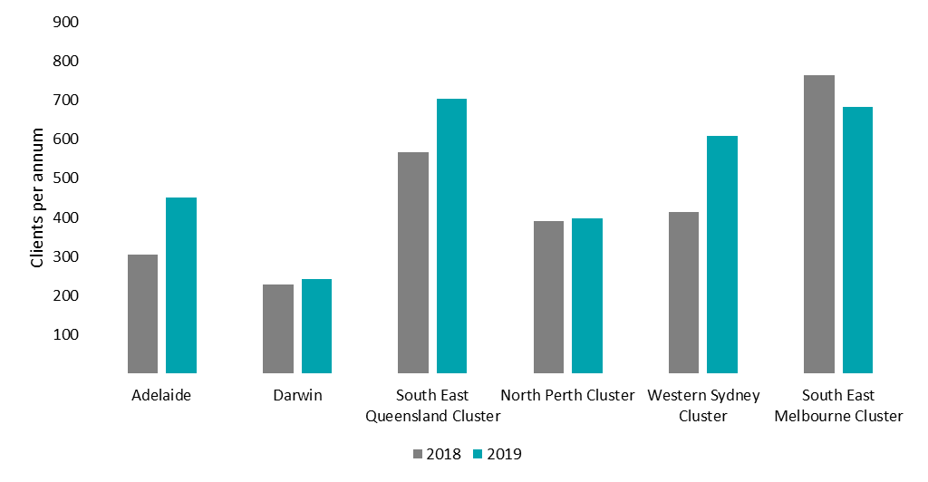

The North Perth cluster delivered the most direct OOS in 2019, despite having fewer clients than other similarly sized clusters. South East Queensland has disproportionately fewer direct OOS per client, despite having high unique client numbers.

Figure 43: Direct OOS per annum per cluster/service

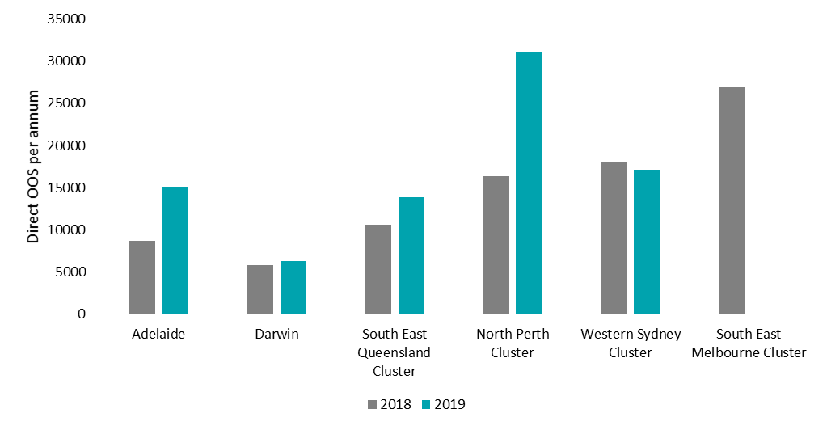

* + 1. Comparison of total costs

Total costs incurred for each financial year in the evaluation period are shown in Table 54. Costs were adjusted for inflation (presented in real $2020 values) and reflect the budgeted amounts for each service.

Costs varied with the size of the service or cluster, with larger clusters recording higher costs than the smaller services. The smallest service (Darwin) recorded the lowest financial costs. The South East Melbourne cluster was the largest and most expensive (one hub, three spokes). Average cost per cluster was $6.6m in 2018-19 financial year, including only services for which 2018 data was available – an increase of $0.6m from the previous year. This increase reflected funding increases (and subsequent activity increases – see Section 8.2.3) and is not an increase in cost of service delivery.

Some clusters with multiple spokes (e.g. South East Melbourne) may have distributed administrative costs across locations, servicing clients in spokes with fewer overheads. Other clusters (e.g. Darwin) did not have any spokes and were unable to spread administrative costs like other clusters.

Another potential difference was the amount of secondary consultations or other clinical activities provided by the service for clients outside the EPYS Program. For example, the Darwin service was conducting secondary consultations (see below) for Indigenous Australian youth living in remote areas. This utilised resources which may have otherwise been used to deliver other direct services for EPYS Program clients, which makes a comparison of the OOS of the Darwin service different to some other services offered within headspace Early Psychosis.

In general, hubs were more expensive to operate than spokes, and the cost of a hub rose when the number of spokes it serviced increased. Hubs had higher salary and wage costs than spokes, owing to the staff housed at the hub which service the cluster (e.g. the MATT and FRP Teams) plus it may also include administrative and management functions for the cluster. The Southport ($5.1m-$5.4m), Joondalup ($5.7m-$5.9m), Mt Druitt ($5.5m) hubs recorded similar costs, giving an approximate range of $5.0m-$6.0m to run a hub in a moderate-sized cluster.

The Adelaide service experienced the largest increase in costs between evaluation years ($1.8m) of all services recorded. The Adelaide service experienced significant funding uncertainty in the 2019 financial year which may also have contributed to this difference. Funding uncertainty was the result of an expiring lead agency contract, which limited the ability of the service to engage in long-term staff planning. Funding uncertainty made the attraction and retention of staff difficult, as staff could not be offered long-term contracts. This job insecurity may increase the salary required to attract staff and increases turnover, which limited the ability of the service to achieve service efficiency. The Bentleigh hub was the service with the highest cost ($7.1m). The spokes connected to the Bentleigh hub recorded the lowest financial costs, explaining the low average costs for the South East Melbourne cluster.

A spoke cost between $1.2 million (Dandenong) and $2.1 million (Midland) to operate annually. The relatively higher cost of the Midland service may have been due to it being operated by a separate lead agency, which may have limited its ability to achieve economies of scale across the cluster. The Dandenong spoke operated in a cluster with the highest cost hub (Bentleigh) and the Midland spoke operated in a cluster with the lowest cost hub, so this difference was likely to reflect different distributions of administrative tasks and staff within clusters.

Table 54: Financial costs for each year in the evaluation period

| Financial Year | FY2018 | FY2019 |
| --- | --- | --- |
| **Adelaide Total** | $4.7m | $6.3m |
| Adelaide | $4.7m | $6.3m |
| **Darwin Total** | $3.1m | $3.0m |
| Darwin | $3.1m | $3.0m |
| **South East Queensland Cluster Total** | $7.1m | $7.3m |
| Meadowbrook | $1.8m | $1.9m |
| Southport | $5.3m | $5.4m |
| **North Perth Cluster Total** | $7.9m | $9.5m |
| Joondalup | $6.2m | $5.7m |
| Midland | Data not available | $2.1m |
| Osborne Park | $1.8m | $1.6m |
| **Western Sydney Cluster Total** | $8.4m | $8.9m |
| Mount Druitt* | $6.7m | $5.5m |
| Parramatta | $1.7m |
| Penrith | $1.7m | $1.6m |
| **South East Melbourne Cluster Total** | Data not available | $11.3m |
| Bentleigh | Data not available | $7.1m |
| Dandenong | Data not available | $1.2m |
| Frankston | Data not available | $1.6m |
| Narre Warren | Data not available | $1.5m |
| **Average (per cluster)\*\*** | **$6.3m** | **$6.6m** |
| *Parramatta and Mount Druitt data was delivered as a combined total for the 2018 financial year  **Average accounts for missing data | | |

Split between direct and indirect costs

Total financial costs split by direct and indirect costs incurred for each financial year in the evaluation period have been shown in Table 55:

* Direct costs included salary and wages, travel costs, and other direct services costs.
* Indirect costs included office, IT and communications, rent and utilities, and program management expenses.

Direct service delivery costs were higher than indirect costs (approximately three times higher) for all clusters or services due to the client-facing nature of the service. The cost difference between large and small services can be explained by differences in staff costs.

The proportion of direct costs to indirect costs was consistent between clusters ranging from 75 percent in the Western Sydney cluster to 80 percent at the Adelaide service.

The size of the cluster did not impact the proportion of direct to indirect costs. The Darwin service (78 percent) recorded a similar proportion of direct the South East Melbourne cluster (77 percent), despite their size differences.

Figure 44: Direct costs as a percentage of total costs per cluster/service

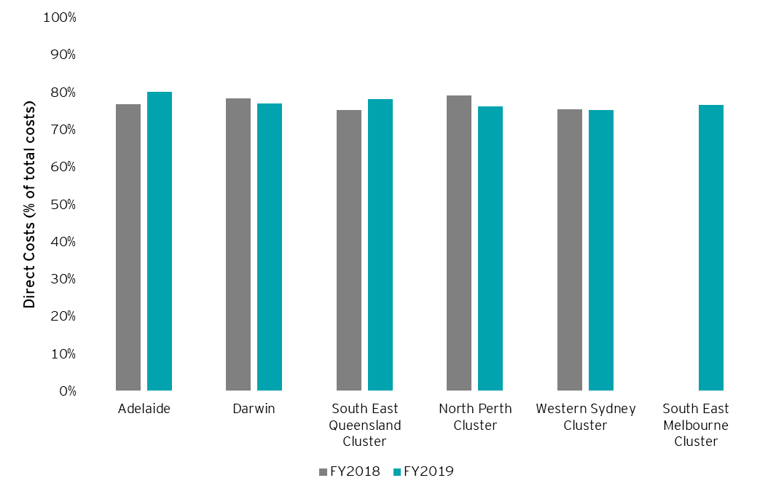

Hubs experienced a higher ratio of indirect costs to direct costs than spokes (three times higher on average). This was consistent with the design of the service model whereby the hub centralises many of the functions for the cluster. Rent and utilities and office expenses were the largest source of the discrepancy between hubs and spokes, indicating that the difference was a direct result of size differences.

There was a 24 percent average increase per cluster in direct costs between financial years. Adelaide experienced the largest year-on-year increase (28 percent) in direct costs due to an increase in salary and wages, attributable to: (1) experiencing the highest costs per staff member of any cluster (see 8.2.6); and (2) an increase in the amount of FTE at the cluster to provide additional capacity for clients.

Darwin experienced a small decrease (negative six percent) in direct costs between 2018 and 2019. This reflected a decrease of 1.2 FTE employees.

Average direct service costs per service were lower in the 2019 financial year compared with the previous year (a 13 percent decrease), reflecting the inclusion of the most efficient cluster per service (South East Melbourne). A similar difference in cluster average was obtained after omitting the clusters for which data was incomplete. Indirect service costs remained relatively constant between financial years after accounting for the difference in completeness of data ($1.4 million on average in indirect service costs each year per cluster) and so an increase in overall costs reflected higher direct costs.

Table 55: Detailed financial costs for each year in the evaluation period

|  | Direct Costs | | Indirect Costs | |
| --- | --- | --- | --- | --- |
| **Financial Year** | **FY2018** | **FY2019** | **FY2018** | **FY2019** |
| **Adelaide Total** | $3.6m | $5.1m | $1.1m | $1.3m |
| Adelaide | $3.6m | $5.1m | $1.1m | $1.3m |
| **Darwin Total** | $2.4m | $2.3m | $0.7m | $0.7m |
| Darwin | $2.4m | $2.3m | $0.7m | $0.7m |
| **South East Queensland Cluster Total** | $5.3m | $5.7m | $1.7m | $1.6m |
| Meadowbrook | $1.3m | $1.5m | $0.5m | $0.5m |
| Southport | $4.1m | $4.2m | $1.2m | $1.1m |
| **North Perth Cluster Total** | $6.3m | $7.3m | $1.7m | $2.3m |
| Joondalup | $4.9m | $4.4m | $1.3m | $1.3m |
| Midland | Data not available | $1.6m | Data not available | $0.6m |
| Osborne Park | $1.4m | $1.3m | $0.3m | $0.3m |
| **Western Sydney Cluster Total** | $6.3m | $6.7m | $2.1m | $2.2m |
| Mount Druitt | $5.1m | $4.4m | Data not available | $1.2m |
| Parramatta | $1.1m | $1.6m | $.6m |
| Penrith | $1.2m | $1.2m | $.5m | $.4m |
| **South East Melbourne Cluster Total** | Data not available | $8.7m | Data not available | $2.6m |
| Bentleigh | Data not available | $5.5m | Data not available | $1.5m |
| Dandenong | Data not available | $1.0m | Data not available | $0.2m |
| Frankston | Data not available | $1.1m | Data not available | $0.4m |
| Narre Warren | Data not available | $1.0m | Data not available | $0.5m |
| **Average (per cluster)\*** | **$4.4** | **$4.9** | **$1.4** | **$1.4** |
| * Average excludes the South East Melbourne and North Perth clusters due to data availability | | | | |

Comparison of budgeted costs and funding allocation

Clusters were allocated $7.8m on average in the 2019 financial year and $4.9 in the 2018 financial year (an increase of 59 percent). The South East Melbourne cluster was allocated the most funding for the 2019 financial year. The funding increase year-on-year (59 percent) translated to a 26 percent increase in the number of clients seen and a 65 percent increase in OOS, indicating that the additional funding increased the capacity of headspace Early Psychosis to deliver services.

|  |  |  |
| --- | --- | --- |
| **Financial Year** | **FY2018** | **FY2019** |
| Adelaide | $6,953,933 | $7,087,454 |
| Darwin | $1,110,840 | $2,757,385 |
| North Perth cluster | $5,555,553 | $9,545,592 |
| South East Melbourne cluster | $6,511,322 | $11,187,801 |
| South East Queensland cluster | $4,098,595 | $7,169,421 |
| Western Sydney cluster | $5,373,783 | $9,233,273 |
| **Average** | **$4,934,004** | **$7,830,154** |

Table 56: Base funding allocated for the EPYS Program per cluster/service

The South East Melbourne cluster was allocated the highest funding in 2019 ($11.2m in 2019), and Adelaide was allocated the most in the 2018 financial year ($7.0m). The South East Melbourne cluster was allocated the least funding in the 2019 ($2.8m in 2019) and the 2018 financial years ($1.1m).

Adelaide was the only service to record an underspend in the 2018 financial year. All other clusters (except South East Melbourne) recorded overspends in the 2018 financial year. The largest overspends were recorded by Darwin and Western Sydney.

Adelaide, South East Queensland North Perth all experienced underspends in 2019 financial year. The magnitude of these underspends was similar to the magnitude of the overspend in the previous year, suggesting that funding was smoothed over financial years. Darwin, Western Sydney and South East Melbourne experienced overspends in the 2019 financial year.

Figure 45: Degree of under-spend per cluster/service  
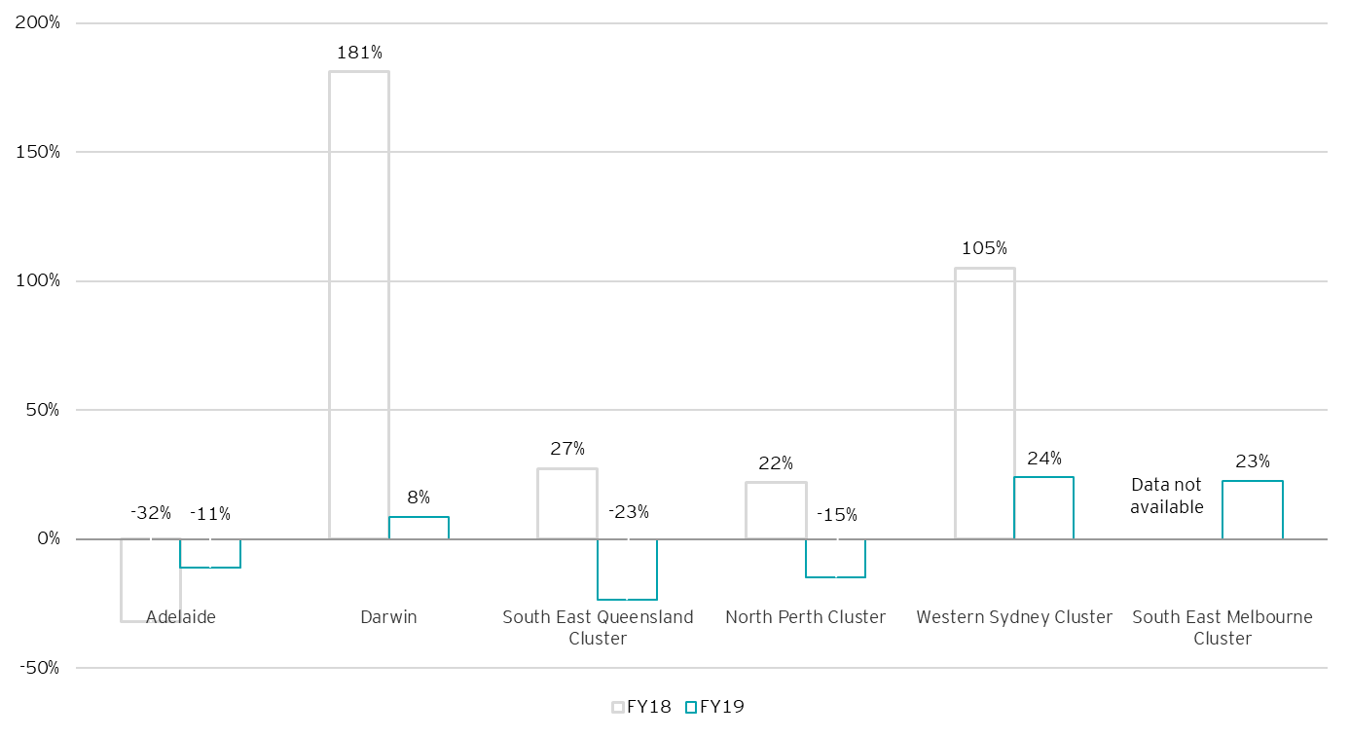

Further to the caseload analysis provided in Section 5.2.4, which looks at caseloads as reported during fidelity assessments, Table 57 below provides detail on the relationship between caseloads and costs (budgets).

Key points to note from this table include:

* There were some variances regarding the funding levels reported between the Department, PHN and services for FY19, these variances were generally insignificant. However, they resulted in an overall program variance of two percent between what funding the PHNs reported having provided and what services reported having received.
* The most notable variance between service and PHN reported financials was for Adelaide, a discrepancy of $800,000 (13 percent). Further investigation is needed to understand the discrepancy between PHN and cluster reported budgets for each service. Each PHN was requested to provide the Evaluation Team with the figures provided to each service. Services reported a level of underspend, or funding that was not passed on by PHNs, which does not entirely align with the figures provided below. It is possible that the discrepancy resulted from challenges in reconciling funding on both ends and this may signal an opportunity for improvement.
* Funding for the EPYS Program was closely linked to target caseloads with all services having a similar budget per caseload (approximately $22,000). However, for Darwin this was much higher at $30,000. This was in line with feedback from Orygen that a higher proportion of FTE were budgeted for Darwin relative to caseload due to the minimum staffing profile needed to deliver the service. This reflected the higher proportion of fixed costs associated with delivering headspace Early Psychosis in a smaller catchment – as described in further detail in Section 0.
* The higher proportion of budget received by Darwin may explain why Darwin was experiencing relatively better caseload performance compared to other services.
* Potential caseload per CCT FTE showed the number of caseload per CCT FTE based on the target set by Orygen. This should have ideally be 15-20, in line with the EPPIC model – anything more would have indicated that the service had too few CCT staff, anything less would indicate that the service had too many. The Western Sydney cluster and Darwin were the only services with a staffing profile within the appropriate range.
* The actual caseload per CCT FTE reflected the number of actual caseloads (averaged) by the number of CCT FTE. These numbers are considerably lower than the target range of 15-20 with clusters ranging from 6 to 18. It is noted that this result is less than what was reported in fidelity assessments and qualitatively reported to the Evaluation Team. However, these figures are reflective of the data provided to the Evaluation Team.
* Further investigation is needed to understand the cause of the caseload discrepancy to draw conclusive statements from this data. The discrepancy, however, mirrors the concerns raised by PHNs regarding ambiguity surrounding caseload performance. It also highlights the need to improve performance and financial reporting and the need to triangulate respective datasets.

Table 57: Caseload performance relative to budget for FY19

|  |  |  |  |  |  |  |  |  |  |
| --- | --- | --- | --- | --- | --- | --- | --- | --- | --- |
|  | **2018-19 cluster budgets**  **(information source)** | | |  | | | | | |
|  | **A** | **B** | **C** | **D** | **E** | **F** | **G** | **H** | **I** |
| **Cluster** | **Department** | **PHN** | **Cluster** | **Caseload target** | **Caseload average (actual)** | **Budget per target caseload (A/D)** | **CCT FTE (adjusted)** | **Potential caseload per CCT staff (D/G)** | **Actual caseload per CCT (E/G)** |
| Western Sydney | $9,200,000 | $9,200,000 | $8,900,000 | 444 | 240 | $21,000 | 23 | 19 | 10 |
| Darwin | $2,800,000 | $2,900,000 | $3,000,000 | 91 | 85 | $31,000 | 4.8 | 19 | 18 |
| SE Queensland | $7,200,000 | $7,200,000 | $7,300,000 | 312 | 175 | $23,000 | 22.2 | 14 | 8 |
| Adelaide | $7,100,000 | $7,100,000 | $6,300,000 | 320 | 205 | $22,000 | 13 | 25 | 16 |
| North Perth | $9,500,000 | $9,700,000 | $9,500,000 | 416 | 173 | $23,000 | 29.3 | 14 | 6 |
| SE Melbourne | $11,200,000 | $11,200,000 | $11,300,000 | 555 | 381 | $20,000 | 36.4 | 15 | 10 |

*Notes to the above data:*

* *Budgets have been rounded to the closest $1000,000 and budget per caseload to the nearest $1,000 for readability and comparability*
* *The three budget columns reflect each respective stakeholder understanding of the budget for the cluster as reported to the Evaluation Team, the figure reported by PHNs was to reflect the amount passed onto the cluster. The figure provided by each cluster was used for the economic evaluation*
* *Caseload targets are the targets set by Orygen and have been extracted from the caseload reports sent to the Department by Orygen*
* *Caseload average has been calculated using a caseload report provided by headspace National, this is an average of each monthly snapshot report and includes clients in assessment*
* *The CCT readjusted column is the number of staff reported as CCT within the dataset to the Evaluation Team by each cluster. Administrative staff, community engagement worker and aboriginal liaison staff that were reported within CCT have been removed from this count to improve caseload performance insight.*
  + 1. Cost per client comparison

Average cost per client

Comparison of the cost of service delivery between services or clusters requires an understanding of each of their unique settings and history. Some services (e.g. Darwin) cater to clients with different service needs which may require a different approach to service delivery. The outreach needs of each community impacted the cost of community engagement services, altering the financial balance between reaching all potential clients in the area and increasing the capacity to care for existing clients. This reflects the fact that clusters had limited resources and a need to balance assessment, care, and community outreach functions. This variability was reflected in the typical referral pathway (see Section 5.3.2) and mode of direct service delivery.

Though funding was reinstated for the EPYS Program in November 2016, a period of reduced funding impacted the cost-effectiveness of the services to varying degrees. The re-establishment period was particularly challenging and disrupted service delivery, especially for those services which had less organisational maturity. A range of stakeholders reported that the services had not yet had the time, or the stability, to fully embed and build the model in the primary care setting and demonstrate the possible outcomes. Change of lead agency, difficulties attracting and retaining staff, and other disruptions to service delivery are discussed in-depth in Section 5. Additional time spent on entry of data in hAPI may have been higher for some services, which may impact the variability in cost per client (by increasing costs through additional administrative staff or reducing client throughput).

The average cost per client was highest in the North Perth cluster ($20,262-$23,927), and lowest in the South East Queensland cluster ($10,405-$12,499). The main determinants of differences in the cost per client were:

1. The number of direct OOS per client
2. Client type (expressed in terms of the proportion of clients assessed as UHR versus FEP)
3. Variation in the type and length of services delivered to client with a focus on face-to-face services
4. Workforce composition
5. Workforce productivity
6. Cluster characteristics (single site versus hub and spoke model, single versus multiple lead agencies).

The North Perth cluster had the highest direct OOS per client, and the high proportion of FEP clients in its caseload (a higher proportion of FEP clients than other services). South East Queensland had the most geographical separation and the lowest proportion (with Darwin) of FEP clients. This suggests that the average cost per client is contingent on the proportion of FEP. Further, the number of direct OOS per client was positively correlated to cost per client. This suggests that clusters which delivered more direct OOS per client had higher costs per client, which is consistent with the idea that servicing each client required more staff time.

Western Sydney recorded the largest average cost per client decrease between evaluation years ($20,356 to $14,606). The number of unique clients increased by 47 percent between financial years while financial costs fell by five percent. This suggests that the Western Sydney cluster was operating under capacity in the 2018 financial year. Western Sydney recorded a 47 percent increase (413 to 608) in the number of unique clients receiving services, but a slight decrease in the number of direct OOS delivered. This resulted in a 57 percent decrease in the average direct OOS per client. This result suggests that the cluster may have been operating at capacity for direct OOS in the previous financial year. An influx of clients resulted in a similar number of direct OOS but fewer direct OOS per client. This change resulted in a decrease in cost per client, but an increase in the cost per direct OOS.

This suggests that clusters are limited in the number of direct OOS which can be delivered. This may be due to:

* The block funding model, which does not respond to increases in client numbers
* Staff attraction and retention, which acts as a capacity limiting factor for the physical delivery of services
* Other service delivery constraints, such as the physical size of the centre, which can constrict short-term supply capacity.

The volume of client demand varied between services, which was only partially captured by block funding differences, creating these differences in direct OOS per client. That is, some differences in client numbers resulted from the size of the cluster, though this effect was small. Clusters like Western Sydney which experienced large, unexpected increases in client demand are unable to quickly scale direct OOS delivery resulting in fewer direct OOS per client. The impact of this difference in direct OOS per client on fidelity is not the subject of this Evaluation.

The Darwin and Adelaide service had similar average costs per client, despite having a large discrepancy in unique client numbers. Darwin serviced 243 clients in 2019 compared to Adelaide which serviced 451. These differences may be explained by the unique circumstances of Darwin’s service delivery (see below).

**Darwin Remote Indigenous Australian Community Service Delivery**

headspace Early Psychosis Darwin provided both primary and secondary consultation, treatment and medication advice and planning for young people admitted to the Youth Inpatient Unit in Darwin following being care flighted in from remote communities across the Northern Territory. These OOS and registered clients were not included in the hAPI data evaluation extract.

Across one four-week period in the evaluation period, the centre provided extensive input into the assessment and treatment planning and initial family work to five young people. The service offered essential early psycho-education for young people and families for first episode psychosis who had found themselves in hospital in Darwin from remote communities. Of those five young people, four of the young people were of Australian Indigenous background from East Arnhem Land (including Ngukurr, Nhulunbuy) and the Remote Kimberly region in Norther WA.

This input was provided by the headspace Early Psychosis Consultant Psychiatrist and MATT clinicians and involved outreach to the inpatient unit to provide family sessions focusing on education. Education involved explaining first episode psychosis, medication and its use, and discussion around recovery.

In providing this support to young people and their families the service also upskilled and supported the medical and nursing staff within the Youth inpatient unit. In addition, the service spent time discussing best practice treatments for a first episode of psychosis.

These interventions typically occurred over a period of a few weeks, including treatment planning. Often English was a third or fourth language for these young people, and prior treatment had not been culturally or clinically appropriate. These OOS were not included in the hAPI evaluation extract despite using resources which were recorded in the financial and workforce data presented in this section.

In addition, the service was trialling the provision of ongoing case management interventions with young people who have access to skype remotely from Nhulunbuy to provide psychological interventions – however, this was in the early days during the Evaluation and will be very dependent on a young person and family’s access to the right technology, which is limited in remote communities.

The Southport and Meadowbrook services were more comparable to Adelaide or Darwin in their ability to achieve greater economies of scale than a typical spoke in South East Melbourne or Western Sydney. The Meadowbrook service recorded a cost per client of $553-$574, higher than the $418-$539 recorded by the Adelaide service. The Southport service also recorded higher cost per client ($521-$704 per client). Darwin recorded lower cost per client than all three of these services ($472-$537) suggesting that the size of the service is not a perfect explanatory variable for the cost per client of a service.

Mature services had more time to explore potential cost saving measures and had less variability in service delivery. Despite this rationale, there was no clear relationship between the maturity of a service and the cost per client in delivery. This could only be attributed to a small effect which could not be confidently measured due to number of services.

Figure 46: Relationship between cost per client and cost per direct OOS for the 2018 financial year

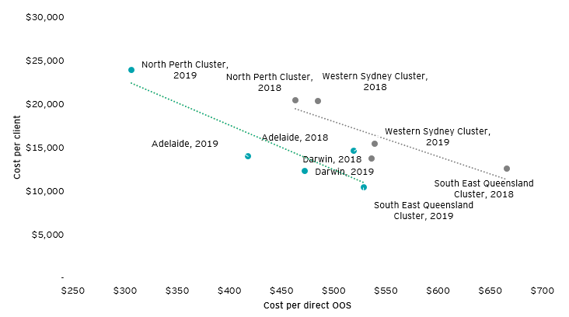

Data for the South East Melbourne cluster were not available for the 2018 financial year. In the 2019 financial year, the cluster recorded an average cost per client of $16,592, placing it between Western Sydney ($14,606) and North Perth ($23,927) as the second highest cost per client. This may be indicative of the high secondary consultations undertaken by the cluster.

Figure 47: Cost per client per cluster/service in each evaluation year

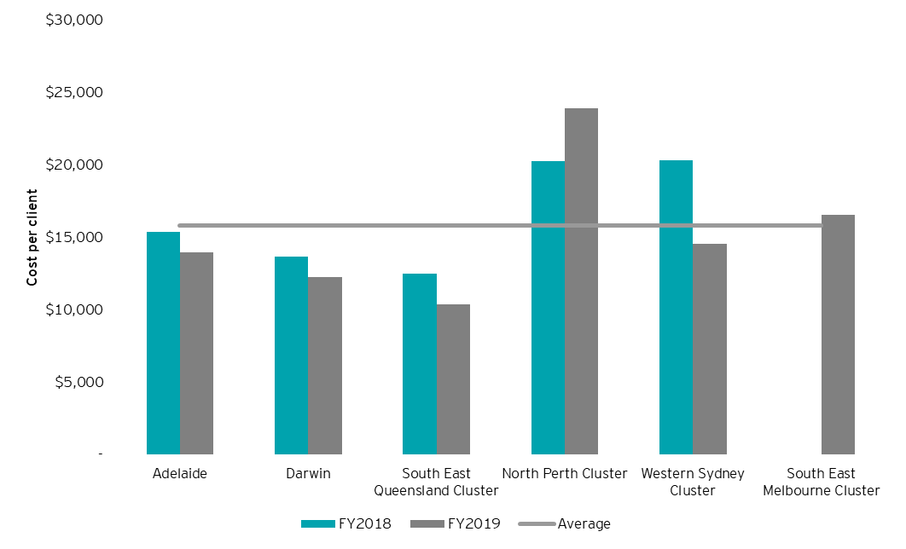

Figure 48 below shows a weak negative relationship between the cost per client and the number of unique registered clients receiving services in a service or cluster. Larger clusters (South East Melbourne, Western Sydney, South East Queensland) delivered services at a lower cost per client compared to smaller clusters or individual service with fewer clients (North Perth, Adelaide, Darwin). However, removing the North Perth cluster negates the relationship. This suggests that there was no clear economies of scale between the number of registered clients and the cost per client, due to the variation in the direct OOS per client. Economies of scale would be present in service delivery, if the direct OOS per client were held constant across clusters as there are economies of scale present in direct OOS delivery.

Figure 48: Relationship between the average cost per client and the number of clients serviced by a cluster/service

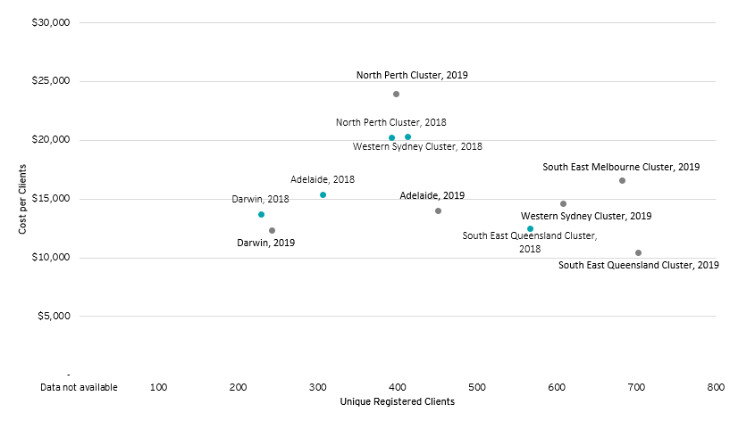

The North Perth cluster experienced the lowest cost per OOS ($306-$486). This was not the result of high costs, but of the high direct OOS per client in this cluster. Assuming there are fixed time costs associated with accepting a client (i.e. assessment and administrative requirements for acceptance), this cluster could deliver the same number of OOS to more clients for the same cost as other clusters with similar levels of direct OOS capacity.

The South East Queensland cluster experienced the highest cost per direct OOS ($529-$666). Consistent with analysis in Section 8.2.3 South East Queensland cluster had the least overlap in catchment areas between services and the lowest proportion of repeated clients. The two lead agencies and geographical distance between each service meant services functioned more like individual clusters. In this context, the Southport ($521) and Meadowbrook ($553) services were costlier per direct OOS than the Adelaide ($418) and Darwin ($472) services in 2019. As discussed in the previous section, this is indicative of more clients being serviced less frequently than other services.

The cost per direct OOS increased from $464 to $519 for the Western Sydney cluster supporting the idea that the decrease in average cost per client is not indicative of an increase in efficiency. As above, this is indicative of an increase in the number of clients receiving services. Darwin recorded the second highest cost per direct OOS ($472-$537). This can be attributed to the unique circumstances of service delivery in Darwin (see Section 8.2.3). The decrease in average cost per direct OOS may also represent an improvement in data collection between evaluation years, owing to the hiring of data, system and project managers.

Table 58: Average cost per direct OOS per cluster/service for each evaluation year

|  | **Average Cost per direct OOS** | |
| --- | --- | --- |
| **Service** | **FY2018** | **FY2019** |
| **Adelaide Total** | **$539** | **$418** |
| Adelaide | $539 | $418 |
| **Darwin Total** | **$537** | **$472** |
| Darwin | $537 | $472 |
| **South East Queensland Cluster Total** | **$666** | **$529** |
| Meadowbrook | $574 | $553 |
| Southport | $704 | $521 |
| **North Perth Cluster Total** | **$486** | **$306** |
| Joondalup | $734 | $371 |
| Midland | Data not available | $275 |
| Osborne Park | $412 | $209 |
| **Western Sydney Cluster Total** | **$464** | **$519** |
| Mount Druitt | $473 | $469 |
| Parramatta | $585 |
| Penrith | $430 | $689 |
| **South East Melbourne Cluster Total** | **Data not available** | **Data not available** |
| Bentleigh | Data not available | Data not available |
| Dandenong | Data not available | Data not available |
| Frankston | Data not available | Data not available |
| Narre Warren | Data not available | Data not available |
| **Average (per cluster)** | **$538** | **$449** |

Direct OOS per FTE

The North Perth cluster had the lowest FTE employee per registered client (six to seven), consistent with the finding that North Perth had the highest direct OOS per client. More OOS per client left staff with less time to service more clients. Similarly, services or clusters with lower OOS per client (South East Queensland, Darwin) had more clients per FTE employee compared to services or clusters with more OOS per client (North Perth, Adelaide).

Table 59: Unique registered clients per cluster for each evaluation year

|  |  |  |
| --- | --- | --- |
|  | **Clients per FTE employee** | |
| **Service** | **FY2018** | **FY2019** |
| **Adelaide** | 17 | 10 |
| **Darwin** | 11 | 11 |
| **South East Queensland Cluster** | 31 | 15 |
| **North Perth Cluster** | 7 | 6 |
| **Western Sydney Cluster** | Data not available | 12 |
| **South East Melbourne Cluster** | Data not available | 9 |
| **Average (per cluster)** | **16** | **10** |

Table 60 shows the average direct OOS delivered per FTE employee per year, for each cluster. The cluster with the most direct OOS per FTE employee was South East Queensland (286-470) and North Perth (278-449), and the fewest was Darwin (257-296).

Table 60: Direct OOS per FTE employee per cluster for each evaluation year

|  |  |  |
| --- | --- | --- |
|  | **Direct OOS per FTE employee** | |
| **Service** | **FY2018** | **FY2019** |
| **Adelaide** | 327 | 331 |
| **Darwin** | 257 | 296 |
| **South East Queensland Cluster** | 470 | 286 |
| **North Perth Cluster** | 278 | 449 |
| **Western Sydney Cluster** | Data not available | 338 |
| **South East Melbourne Cluster** | Data not available | 344 |
| **Average (per cluster)** | **335** | **343** |

Registered clients

The South East Melbourne cluster saw the most registered clients in 2018 (763) and second most in 2019 (703), while Darwin saw the least in both evaluation years (228 and 243, respectively). This is consistent with the difference in size of a cluster versus a single service. The number of registered clients receiving services increased by 16 percent per cluster on average between the evaluation years. Registered clients are defined as those individuals who were recorded in the hAPI dataset – this includes individuals who were assessed to be non-eligible.

The North Perth Cluster had fewer clients serviced (392-398) than South East Queensland (566-703), despite having fewer spokes (one compared to two spokes for North Perth).

There may be a few reasons for this difference:

1. The North Perth services were closer together geographically than the South East Queensland services, allowing clients to visit each of the services more easily. This leads to more repeat clients and fewer unique clients at a cluster level. This indicates that the lack of coordination between services may have led to over-servicing of clients.
2. The North Perth cluster recorded the highest proportion of FEP to non-FEP clients, suggesting that the difference in cost per client could be the result of more complex cases. This is supported by analysis around the direct OOS (see below).

Differences between service totals and cluster totals reflect (in part) differences in repeat clients. Client totals at a cluster level included clients who received services at multiple services once, resulting in a smaller cluster total of clients compared to the number of clients registered at services in the cluster. This led to a discrepancy between the client numbers recorded in individual services and the clients serviced at a cluster level. For example, if a client received services from a hub and two spokes in the evaluation period, each service would count one client (for a total of three), though this client would only be counted once in the cluster total.

The Adelaide service experienced the largest proportional increase in clients (47 percent year-on-year), with the North Perth cluster experiencing the smallest increase (two percent year-on-year). All clusters experienced an increase in the number of clients registered in 2019. The number of clients registered were broadly consistent with patterns seen in the financial data – hubs registered on average 80 percent more clients than individual spokes.

Services with the highest client registration numbers were Bentleigh (560), Adelaide (451), and Mount Druitt (586). These services also recorded the highest financial costs (see Section 8.2.3).

Table 61: Direct OOS and registered clients for each service in each year of the evaluation period

|  |  |  |  |  |
| --- | --- | --- | --- | --- |
|  | **Registered unique clients[97]** | | **Direct occasions of service** | |
| **Financial Year** | **FY2018** | **FY2019** | **FY2018** | **FY2019** |
| **Adelaide Total** | 306 | 451 | 8,743 | 15,092 |
| **Darwin Total** | 228 | 243 | 5,817 | 6,330 |
| **South East Queensland Cluster Total** | 566 | 703 | 10,619 | 13,833 |
| **North Perth Cluster Total** | 392 | 398 | 16,359 | 31,113 |
| **Western Sydney Cluster Total** | 413 | 608 | 18,137 | 17,099 |
| **South East Melbourne Cluster Total** | 763 | 682 | 26,894 | Data not available |
| **Average (per cluster)** | **445** | **514** | **14,428** | **16,693** |

Direct occasions of service

Direct OOS were highest in the Western Sydney (17,099-18,137) and South East Melbourne clusters (26,894), and lowest in Darwin (5,817-6,330). Direct OOS increased by 16 percent on average per cluster between the evaluation years, consistent with the change in the number of clients.

North Perth experienced the largest increase in direct OOS, despite a small increase (two percent) in the number of clients at a cluster level. North Perth had more than double the average direct OOS per client than the next closest service (78 compared to 33), suggesting that the difference is due to a different interpretation of direct OOS by North Perth over other clusters.

Table 62 shows that North Perth had the highest direct OOS per client, which suggests that fewer clients received more services across more locations in this cluster, compared to other clusters. This offers a partial explanation for the low number of clients serviced compared to the direct OOS results noted above.

Another key finding shown in Table 62 is the 57 percent decrease in direct OOS per client in the Western Sydney cluster between evaluation years. This is the result of a 47 percent increase in the number of unique clients serviced and a six percent decrease in the number of direct OOS delivered. Three possible explanations for this result are:

* The change in headspace Primary lead agency between the 2018 and 2019 financial years caused a change in the method of statistics collection, an increase in the number of referrals to the service, or other disruption in service delivery which reduced the overall direct OOS delivered.
* The cluster was at capacity in the 2018 financial year and faced increased demand in the 2019 financial year. Instead of turning clients away, the cluster registered clients to receive services but was unable to deliver as many direct OOS per client as in the previous year. This potentially reflects the difficulty in being able to quickly ramp up capability to meet client demand.
* The rise in client numbers and the incoming evaluation process created a large increase in the number of indirect OOS required to be completed which reduced the amount of time that clinical staff had to deliver direct OOS. This possibility is supported by the discussion of the relationship between cost per client and cost per direct OOS in Table 62.
* There is evidence supporting each of these explanations and it is likely some combination of all three created this result.

Adelaide experienced the second largest increase in direct OOS per cluster (73 percent), larger than its 47 percent increase in clients. Table 62 shows the direct OOS per client rose from 29 to 33 in 2019, which supports the idea that this is was disproportionate increase.

Table 62: Direct OOS per client for each cluster/service in each evaluation year

|  |  |  |
| --- | --- | --- |
|  | **Direct OOS per client** | |
| **Service** | **FY2018** | **FY2019** |
| **Adelaide** | 29 | 33 |
| **Darwin** | 26 | 26 |
| **South East Queensland Cluster** | 19 | 20 |
| **North Perth Cluster** | 42 | 78 |
| **Western Sydney Cluster** | 44 | 28 |
| **South East Melbourne Cluster** | 35 | Data not available |

Figure 49 shows that there was a positive relationship between the proportion of FEP clients and the direct OOS per client in a cluster. This suggests that FEP clients required more direct OOS. Clusters or services with a low proportion of FEP clients (Darwin, South East Queensland) had fewer direct OOS per client than services with a high proportion (North Perth, Western Sydney, South East Melbourne, Adelaide). The result is consistent for the 2019 financial year, if North Perth is excluded as an outlier.

Figure 49: Relationship between FEP as a proportion of total clients and direct OOS per client for FY2018**[98]**

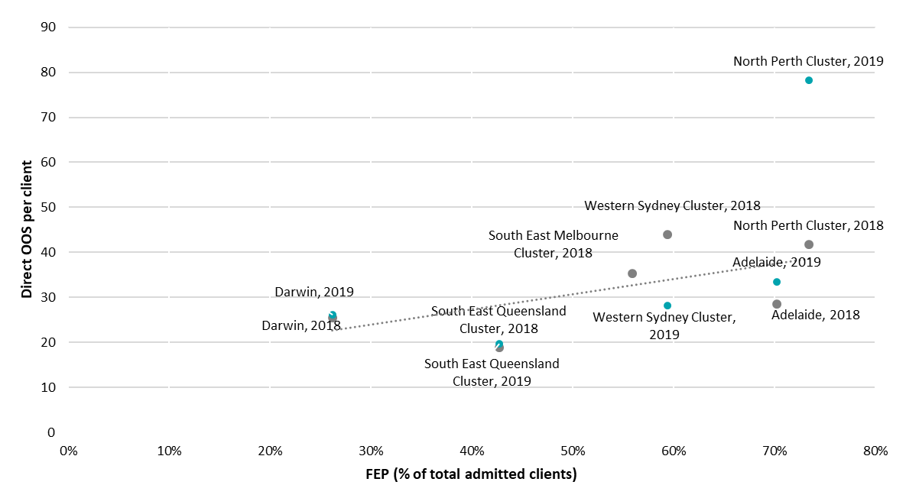

Figure 50 shows that there was a positive relationship between the number of FEP and direct OOS per client in the 2018 financial year. This suggests that staff achieved economies of scale in service delivery when delivering services to more FEP clients. This was consistent with the idea that there are economies of scale in direct OOS delivery, but not in cost per client (due to the variability in the number of direct OOS delivered per client). More FEP clients will result in each service receiving more direct OOS individually, as the cluster is able to increase the size of clinical staff and achieve greater flexibility and availability in delivering services to high-need clients. The result was consistent for the 2019 financial year, if North Perth is excluded as an outlier.

Figure 50: Relationship between FEP and direct OOS per client per cluster per evaluation year  
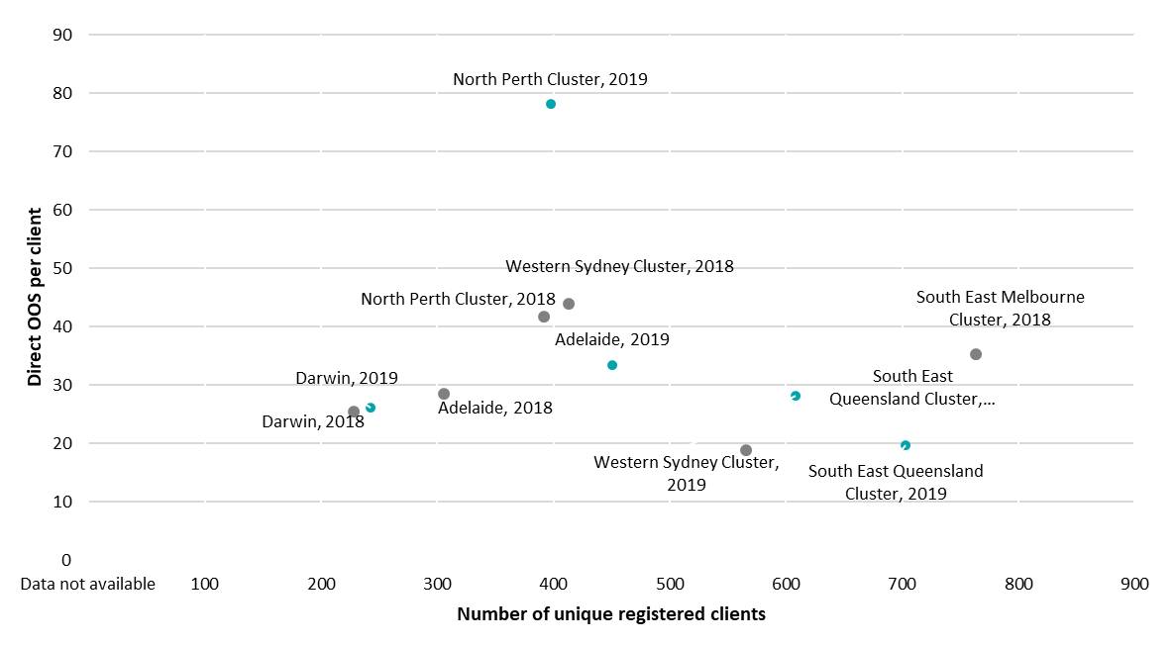

There was no clear relationship between the size of the service or cluster and the ratio of direct to indirect OOS. The highest ratio (the most direct OOS to indirect OOS) was recorded in the largest (South East Melbourne) and smallest (Darwin) service at a 5:4 ratio (five direct for every four indirect OOS).

There was also no clear relationship between direct OOS per client and the ratio of direct to indirect OOS. Clusters or services with higher direct OOS per client (North Perth, Adelaide) did not record abnormally low direct to indirect OOS compared to those with low direct OOS per client (South East Queensland). This suggests that having a higher proportion of unique clients (clients receiving services in only one location) did not significantly impact the degree of administrative and management requirement.

Table 63: Ratio of direct to indirect OOS for each cluster in each financial year**[99]**

|  | **Ratio of direct to indirect OOS** | |
| --- | --- | --- |
| **Service** | **FY2018** | **FY2019** |
| **Adelaide** | **0.8** | **0.7** |
| Adelaide | 0.8 | 0.7 |
| **Darwin** | **1.3** | **1.0** |
| Darwin | 1.3 | 1.0 |
| **South East Queensland Cluster** | **0.7** | **0.4** |
| Meadowbrook | 1.0 | 0.7 |
| Southport | 0.6 | 0.4 |
| **North Perth Cluster** | 0.7 | 0.5 |
| Joondalup | **0.7** | **0.5** |
| Midland | 0.7 | 0.6 |
| Osborne Park | 0.7 | 0.6 |
| **Western Sydney Cluster** | 0.8 | 0.3 |
| Mount Druitt | 0.9 | **0.3** |
| Parramatta | 0.4 |
| Penrith | 0.7 | 0.3 |
| **South East Melbourne Cluster** | **1.3** | **Data not available** |
| Bentleigh | 1.3 | Data not available |
| Dandenong | 1.1 | Data not available |
| Frankston | 1.3 | Data not available |
| Narre Warren | 1.4 | Data not available |
| **Average (per cluster)** | **0.9** | **0.6** |

Table 64 shows a consistent increase in indirect OOS across all service types indicating that administration and management requirement for each case was higher in the 2019 financial year. Data entry and other administrative tasks saw the largest increase year-on-year, comprising 17 percent of total indirect OOS for staff in 2018-19 financial year (an increase of four percent from the previous year). Liaising with other providers was the next most common indirect OOS, comprising 11.5 percent.

Table 64: Change in indirect OOS by service type

|  | **OOS** | | **Service Type (% of total)** | | |
| --- | --- | --- | --- | --- | --- |
| **Service Type** | **FY2018** | **FY2019** | | **FY2018** | **FY2019** |
| Care planning and review | 17,380 | 34,649 | | 11.3% | 12.0% |
| Case notes | 62,455 | 115,812 | | 40.6% | 40.2% |
| Clinical review | 8,717 | 18,793 | | 5.7% | 6.5% |
| Crisis response | 405 | 526 | | 0.3% | 0.2% |
| Data entry and other administrative tasks | 20,311 | 50,041 | | 13.2% | 17.4% |
| eheadspace correspondence | 116 | 132 | | 0.1% | 0.0% |
| Letter and report writing | 4,947 | 8,048 | | 3.2% | 2.8% |
| Liaising with other providers | 22,518 | 32,986 | | 14.6% | 11.5% |
| Risk assessment | 973 | 1599 | | 0.6% | 0.6% |
| Travel time | 14,240 | 22,886 | | 9.3% | 8.0% |
| Other | 1,808 | 2,390 | | 1.2% | 0.8% |

The mode of service delivery differed between the services and clusters. The largest differences were seen in the proportion of services delivered over the phone, with the highest proportion (46 percent) of all services delivered) in the South East Melbourne cluster and the lowest proportion (30 percent) in the North Perth cluster. The North Perth cluster also recorded 37 percent of services delivered by SMS, compared with the lowest (eight percent) in the South East Melbourne cluster. This demonstrates the variability of data entry between clusters.

Face-to-face service delivery was the most common mode of service delivery for each cluster. Adelaide and Darwin recorded the lowest proportions (38 percent in 2019), and the South East Queensland cluster recorded in highest (49 percent in 2018). Video and web-chat services were the least popular for each cluster (less than one percent for each cluster), indicating the absence of telemedicine services.

* + 1. Cluster or service workforce comparison

Across services, workforces differed in their composition (the number of clinical to administrative staff) and the level of salary paid to staff.

The South East Melbourne cluster recorded the highest number of FTE (77), while Darwin recorded the least (21). This is consistent with their status as the largest cluster and smallest service respectively. The North Perth cluster recorded an unusually a larger number of FTE (69) compared to the Western Sydney cluster, despite being of comparable size.

The Adelaide service experienced 70 percent growth in total FTE between the 2018 and 2019 financial years, the largest of any service or cluster. This growth was spread across admin (an additional five FTE), CCT (four), the FRP (five), and MATT (six). This increase was accompanied by an increase of one staff member (in terms of headcount), indicating that the existing staff worked more hours (i.e. moving from part-time to full-time), instead of the cluster hiring more staff members in total.

The average number of FTE employees per cluster increased by 11 from 36 to 47 (an increase of 31 percent). The largest increase was experienced by Adelaide (see above), followed by the North Perth cluster (a 17 percent increase). Data for the South East Queensland, Western Sydney, and South East Melbourne clusters was not available for the 2018 financial year.

Table 65: Total FTE per cluster across all functions for each financial year

| **Financial Year** | **FY2018** | **FY2019** |
| --- | --- | --- |
| **Adelaide** | 27 | 46 |
| **Darwin** | 23 | 21 |
| **South East Queensland Cluster** | Data not available | 48 |
| **North Perth Cluster** | 59 | 69 |
| **Western Sydney Cluster** | Data not available | 51 |
| **South East Melbourne Cluster** | Data not available | 77 |
| **Average (per service)** | **36** | **47** |

Figure 51 shows the total FTE by category in 2019. The largest category was the CCT. Darwin (28 percent of all FTE) and the South East Queensland cluster (32 percent of all FTE) had proportionately more MATT members compared to the remaining clusters (an average of 21 percent). This is likely to reflect their remote service delivery function. The North Perth (one percent) and South East Melbourne (one percent) clusters recorded low proportions of administrative staff, though this reflected the structure of data collection and not an indication of cluster efficiency. Both clusters characterised administrative staff into CCT, MATT, or FRP team functions instead of separating them as administrative staff.

The proportion of administrative staff fell from 14 percent of total FTE to seven percent of total FTE in the 2019 financial year.

Figure 51 shows the proportion of total FTE employees allocated to each function. The CCT had the most FTE employees (43 percent of all FTE employees), followed by the MATT (22 percent) and staff delivering the FRP (18 percent). Clinical team members comprised 88 percent of all staff, with the remaining staff either administration (six percent) or management (six percent).

The South East Melbourne and South East Queensland clusters recorded the highest proportion of clinical practitioners (92 percent of total workforce). Adelaide recorded the lowest (74 percent), with Darwin the next lowest (77 percent). This indicates that single services require a higher proportion of management and administrative staff to clinical staff, compared to larger clusters that can achieve economies of scale by centralising administrative work in each hub.

The proportion of administrative staff fell from 14 percent of total FTE to seven percent of total FTE in the 2019 financial year.

Figure 51: Total FTE by category in 2019 for each cluster/service

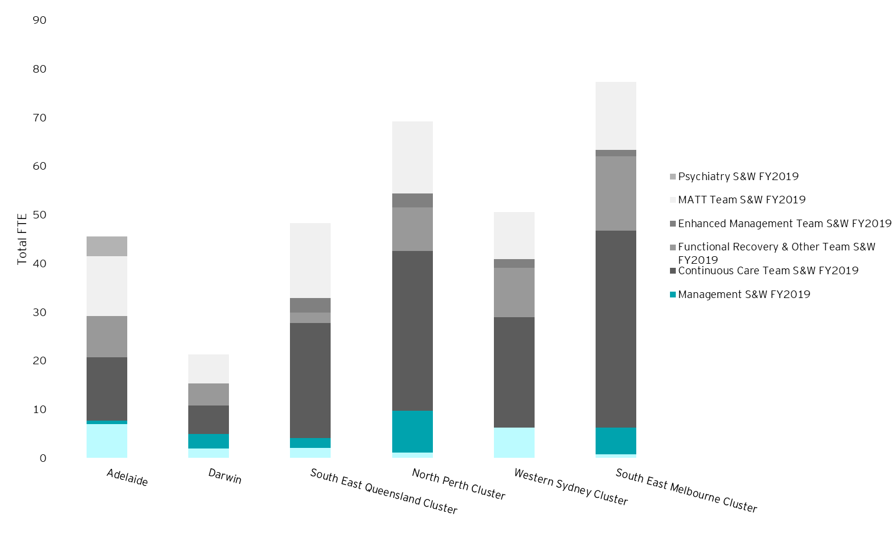

The largest annual change in FTE was experienced in the South East Queensland cluster, which experienced an increase of 34 FTE, mostly through the MATT (15) and CCT (16). The North Perth cluster experienced and 11 FTE increase, through a reallocation of resources towards administration, management, and CCT, and away from MATT, Enhanced Management team, and the FRP. This indicates a shift in the categorisation of workers, instead of a shift in clinical priorities. Adelaide experienced significant growth in several teams. Though as discussed above, this was an increase in the number of hours spent by existing staff and not an increase in the number of people working at the cluster.

Changes listed in Figure 52 do not indicate wholesale increases in the number of administration staff, as suggested in consultations.

Figure 52: Annual change in FTE by category between 2018 and 2019 for clusters (where data available)  
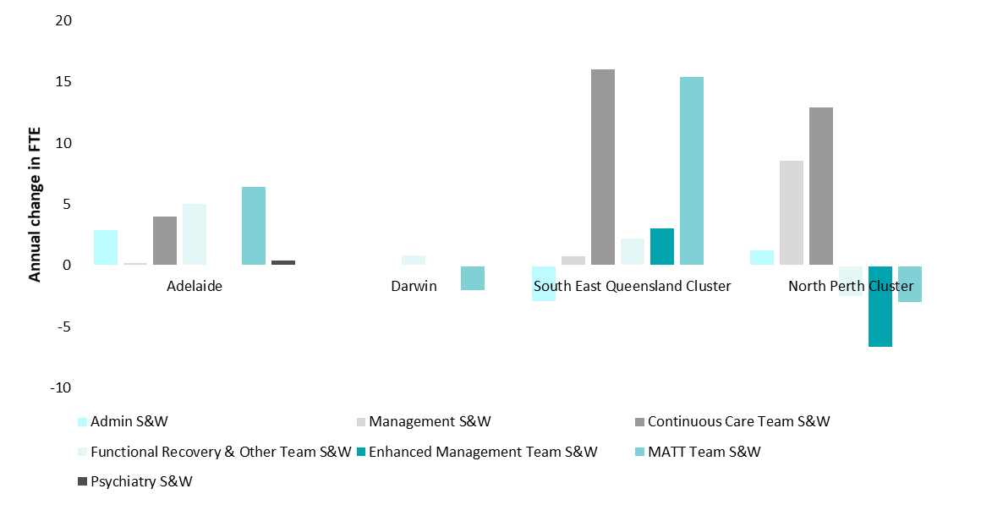

The salary cost per FTE varied from $83,587 (South East Queensland) to $129,955 (Adelaide). There was no clear relationship between the size of the service and the salary cost per FTE, or the proportion of clinical staff and the cost per FTE. Cost-of-living did not impact the ranking of costs, with South East Queensland recording lower costs than Adelaide (the lowest and highest cost respectively) despite Brisbane having a higher cost-of-living.[100]

Average salary costs per FTE were consistent between the evaluation years (decreasing by less than one percent from 2018 to 2019).

Table 66: Cost per FTE per cluster/service

|  |  |  |
| --- | --- | --- |
|  | **Salary cost per FTE** | |
| **Service** | **FY2018** | **FY2019** |
| **Adelaide** | $129,196 | $122,955 |
| **Darwin** | $98,460 | $100,764 |
| **South East Queensland Cluster** | Data not available | $83,587 |
| **North Perth Cluster** | $113,785 | $107,089 |
| **Western Sydney Cluster** | Data not available | $126,208 |
| **South East Melbourne Cluster** | Data not available | $110,843 |
| **Average (per cluster)** | **$106,123** | **$105,698** |

Adelaide ($133,913-$139,296 per FTE) and the Western Sydney ($129,698 per FTE) cluster had the highest relative cost per clinician. The high cost of clinicians for Adelaide is consistent with findings from consultations that Adelaide was required to pay medical officers at a relatively higher rate. Darwin recorded the lowest cost per clinician. Clinicians have been defined as any FTE not classified as administration or management.

The South East Queensland cluster recorded the largest decrease in the cost per clinical FTE of any cluster ($134,597 to $87,189). This is due to the omission of the Southport hub in the 2018 workforce data. The Meadowbrook spoke recorded an average cost per clinical FTE of $133,482, comparable to the previous year. The low cost of the Southport clinical staff reflects a difference in categorisation to other staff, with some administrative and management staff being categorised under the team that they operate within, though they do not deliver clinical services directly to clients. A large degree of this variation is unexplained.

Table 67: The cost per clinical FTE

|  |  |  |
| --- | --- | --- |
|  | **Cost per clinical FTE** | |
| **Service** | **FY2018** | **FY2019** |
| **Adelaide** | $139,296 | $133,913 |
| **Darwin** | $103,464 | $106,922 |
| **South East Queensland Cluster** | $134,597 | $87,189 |
| **North Perth Cluster** | $113,785 | $110,117 |
| **Western Sydney Cluster** | Data not available | $129,698 |
| **South East Melbourne Cluster** | Data not available | $110,723 |
| **Average (per cluster)** | **$117,282** | **$108,930** |

* + 1. Service delivery type and duration

The EPPIC service delivery model allows for service delivery through different modes, including:

* Face-to-face
* Phone
* Web-chat
* SMS
* Email
* Video.

Clinicians in each cluster record the length and type of service delivery when delivering services to clients. The following outcomes are examined in this section:

* Length and number of services delivered by mode
* Average service delivery per client per mode
* Average cost per service delivery day
* Service delivery days per FTE.

Length and number of services delivered by mode

The number of services delivered by each service is only an indicator of the number of services delivered. Due to variations in measurement across clusters, the total length of service is a more complete picture of the amount of services delivered by each cluster. The length and number of services were recorded by clinicians in the hAPI dataset, as with other data cited in this section.

Face-to-face service delivery was the most common mode of service delivery across all clusters. There was wide variation across clusters in the number of face-to-face direct OOS delivered across the 2019 financial year. Western Sydney delivered the most face-to-face direct OOS.

Figure 53: Direct OOS by mode

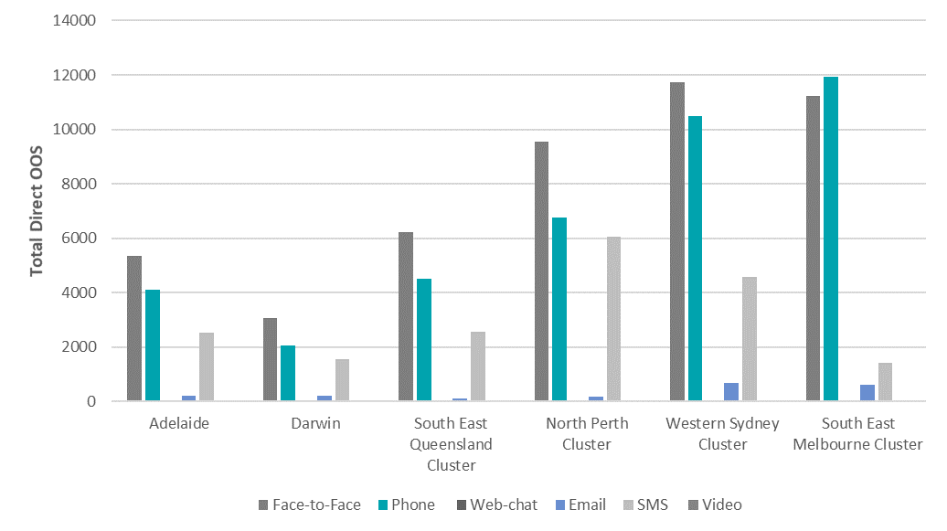  
The average minutes of service delivery per direct OOS varied between the clusters or services. Face-to-face service delivery varied the least, averaging over 80 minutes in each. Some service modes such as phone, email and webchat were excluded due to small sample size. The SMS service delivery mode varied the most, with North Perth recording the highest average minutes of service delivery per OOS (80 minutes) and South East Melbourne recording the least (42 minutes). This is consistent with the service delivery model in North Perth which emphasises proactive outreach, often through SMS.

Figure 54: Average minutes of direct service delivery per mode

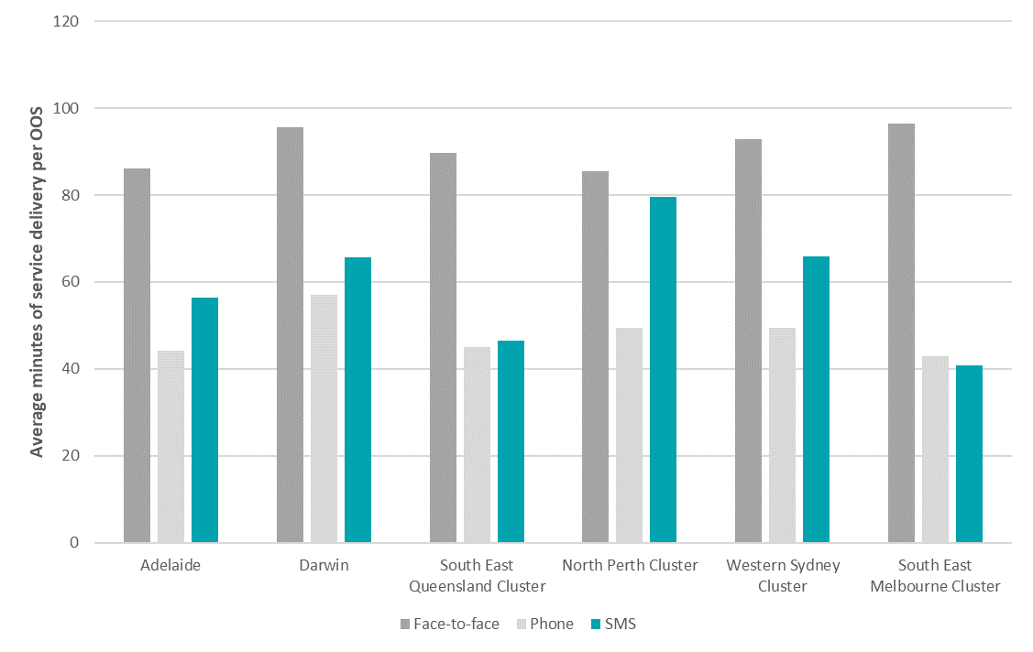

Average service delivery per client per mode

The North Perth cluster recorded more hours of service per client than any other cluster in 2019, for all service delivery types. North Perth delivered 65 hours of face-to-face service per client, 73 percent more than the average for all other clusters. Similarly, North Perth recorded 480 percent more SMS service delivery hours (17) per client than the average for the other clusters.

Similarly, South East Queensland delivered fewer average hours of service per client, compared to other clusters in 2019. The cluster delivered 48 percent fewer hours of face-to-face service delivery, and 75 percent fewer SMS hours of service delivery, compared to the average for other clusters.

The results presented in Figure 55 are consistent with the analysis presented Section 8.2.5. North Perth’s relatively high cost per client can be explained by its relatively high service delivery levels. Likewise, South East Queensland’s low cost per client can be explained by its relatively low service delivery per client, compared to other clusters. This suggests that if the service delivery amount was held consistent across clusters, the cost per client would be more uniform.

Figure 55: Hours of service delivery per client per cluster/service

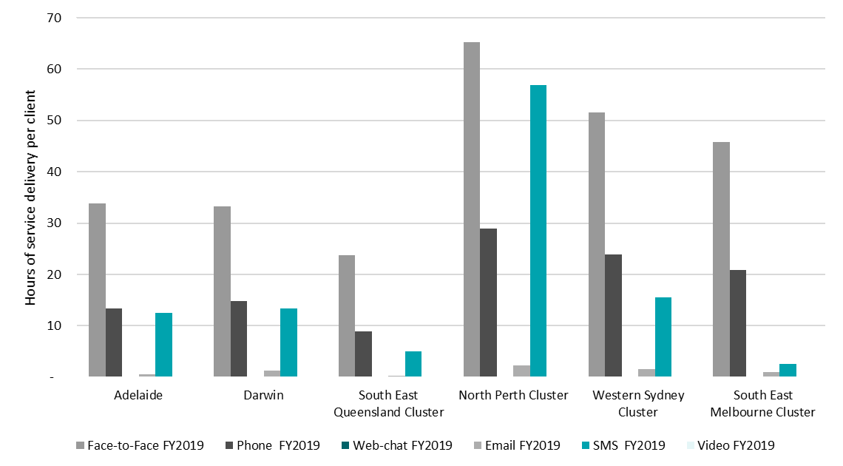

Figure 56 shows a positive relationship between the proportion of FEP clients and the days of face-to-face service delivery. This is an intuitive result and FEP clients are likely to require a higher level of service than UHR clients. Though the relationship is positive, it is not perfect, indicating that there are other factors which influence the relationship. Clusters/services above the fitted line (North Perth, Darwin, Western Sydney, South East Melbourne) provided more services than predicted per client and clusters/services below the trendline (South East Queensland, Adelaide) provide fewer services than predicted per client.

North Perth, South East Queensland and Adelaide were the main outliers on this graph. As discussed in previous sections, North Perth provides more direct OOS than other clusters per client. After consultation with North Perth, this was determined to be due to a difference in collection of statistics in the evaluation period. North Perth recorded each single SMS as an OOS. However, even after controlling for length per OOS, the total hours delivered by Perth North was higher than other clusters. This indicates that the cluster provided more services per client and this effect was not created by measurement error.

This figure suggests that Adelaide is providing fewer services per client than would be expected for the proportion of FEP/UHR clients would suggest, which has not previously been uncovered in the analysis. One possible reason for this is the uncertainty around funding arrangements for Adelaide which has been discussed in previous sections.

Figure 56: Relationship between FEP (% of total admitted clients) and days of face-to-face service per client

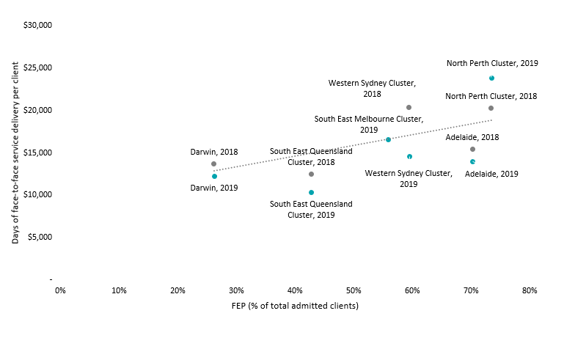

Average cost per service delivery day

There was a negative relationship between the cost per client and the cost per service delivery day. The negative relationship suggests that clusters with a high cost per client (North Perth, Western Sydney) did not have lower labour productivity than other clusters. The difference in cost per client is explained by some clusters delivering more services per client than other clusters.

The highest cost per day of face-to-face service delivery was South East Queensland in both evaluation years ($7,295 in 2018 and $3,502 in 2019).[101] This contrasts with the cost per client findings (where South East Queensland had the lowest cost per client) and suggests that South East Queensland had a low cost per client because it was providing fewer services per client than other clusters.

Western Sydney had the lowest cost per day of face-to-face service delivery in both evaluation years ($4,484 in 2018 and $2,268 in 2019). This contrasts with the cost per client result where Western Sydney was amongst the most expensive clusters (second most expensive in 2018 and third most expensive in 2019).

Table 68: Cost per day of face-to-face service delivery by cluster

|  |  |  |
| --- | --- | --- |
|  | **Cost per day of face-to-face service delivery** | |
|  | **FY2018** | **FY2019** |
| **Adelaide** | $5,691 | $3,302 |
| **Darwin** | $6,134 | $2,958 |
| **South East Queensland Cluster** | $7,295 | $3,502 |
| **North Perth Cluster** | $5,522 | $2,936 |
| **Western Sydney Cluster** | $4,484 | $2,268 |
| **South East Melbourne Cluster** | Data not available | $2,896 |
| **Average (per cluster)** | **$5,825** | **$2,977** |

The relationship between cost per client and days of face-to-face service delivery, as shown in Figure 57, was consistent across evaluation years, though shifted left in 2019. This is indicative of improved data capture in the second evaluation year and possibly some efficiency improvements.

Figure 57: Relationship between cost per client and days of face-to-face service delivery

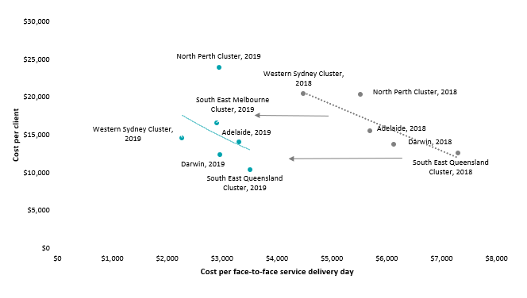

Including all modes of service delivery as shown in Figure 58 does not significantly change the results. The negative relationship persists and becomes ‘flatter’ – suggesting that including other modes of service delivery decreases the size of the relationship. This means that an incremental increase in cost per service delivery mode is less influential on cost per client.

Figure 58: Relationship between cost per client and days of face-to-face service delivery (all modes)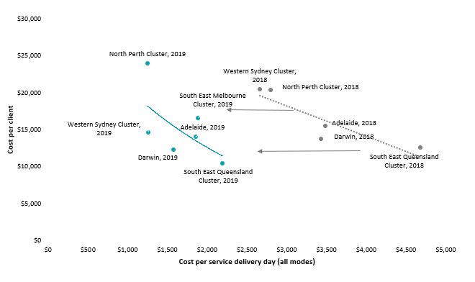

The service delivery days per FTE (Figure 59) shows a large variation in the number of days of face-to-face service delivery per FTE. The number of days of face-to-face service delivery is an indicator of client demand and labour productivity. If it is assumed that there is excess demand for services in each cluster, then the value can be assumed to be a direct indicator of labour productivity.

The Western Sydney cluster delivered the most hours of face-to-face service delivery (77) per FTE and Adelaide delivered the least (42) in 2019. There is no clear relationship to cost per client.

Figure 59: Average days of face-to-face service delivery per FTE

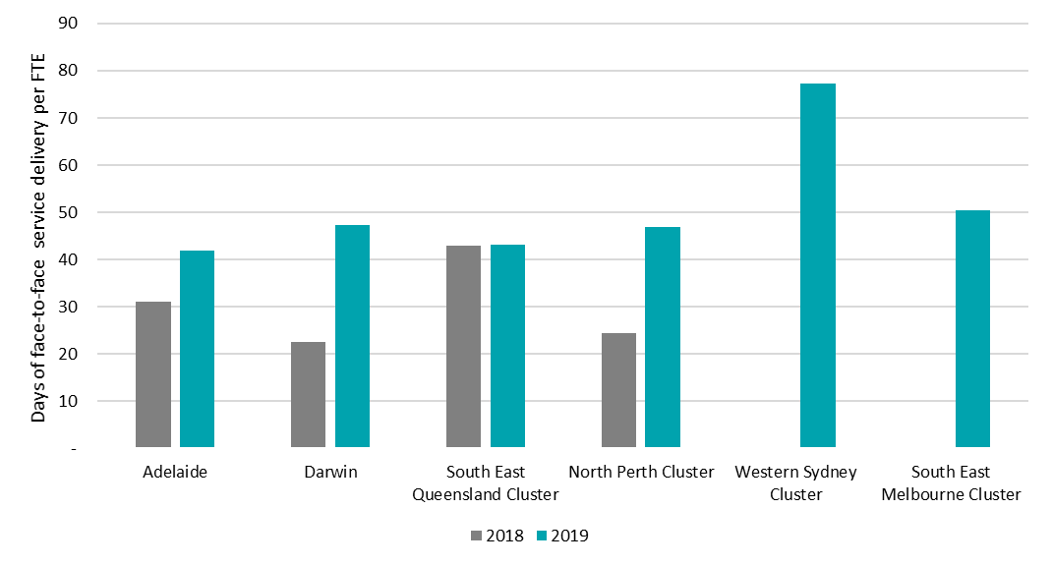

Including all services modes did not significantly change the ranking shown in Figure 59, with North Perth and Darwin benefitting the most from the expansion to all services mode. North Perth delivered a large proportion of services by SMS (see Figure 60). Similarly, Darwin delivered many hours of SMS and phone services (see Figure 60) proportionate to its face-to-face service delivery. Hence their inclusion improves Darwin’s labour productivity ranking overall, compared to other clusters.

Figure 60: Average days of service delivery per FTE (all modes)

Figure 60 is a grouped bar graph showing the average days of service delivery per FTE (all modes)

* 1. How cost-effective is the EPYS Program compared with usual care?

This section covers:

* Approach to economic cost-effectiveness analysis
* Cost-offset results
* Assessment of cost-effectiveness.
  + 1. Approach to economic cost-effectiveness analysis

This section presents the cost-effectiveness analysis. Consistent with the scope of the Evaluation, a health sector perspective has been taken. As a result, the broader societal impacts of the program were not sought to be quantified – as would be undertaken in a full cost-benefit analysis.

It should be noted there are likely to be additional non-health benefits which are impacted by the EPYS Program activities focused on improving clients’ function outcomes (see the literature review in Appendix A for further detail), which is an acknowledged limitation of this report.

The cost-effectiveness analysis is comprised of three key components:

* Average cost of the intervention – This is the cost to deliver the EPYS Program and constitutes staffing, office expenses, travel, etc. These estimates are drawn from the analyses presented in the previous section.
* Cost-offsets – These are the potential cost savings resulting from fewer hospitalisations for psychosis services. These results are calculated from the ecological analysis (see Section 7.4.2). The main outcome measure for this section is the difference in the annual hospitalisation costs attributed to the estimated reduction in rates of transition (from UHR to FEP).
* Health outcome - The relevant measure of health outcome is the QALY. This is a measure of survival adjusted by quality of life, and in this study is extrapolated from the observed improvements in K10 scores (see Section 7.2.2) noting that changes in K10 scores were found to be moderately strongly correlated with changes in BPRS which directly assess psychosis specific symptoms (see Section7.2.3) . As a result of using QALY as the relevant outcome measure, the approach adopted could be termed ‘Cost-Utility Analysis’. Cost-Utility Analysis is generally a specific category of cost-effectiveness analysis and given that cost-effectiveness analysis is the most commonly used term, this is what is adhered to in this report.

Further detail on the methodology for this analysis is provided in Appendix L.

* + 1. Cost-offset results

An ecological analysis was used to analyse whether individuals living in the EPYS catchments (see Section 7.4.2) accessed hospital services at a different level of intensity as a result of the program to individuals living in areas where there was no EPYS Program.

A longitudinal linear model was used to analyse the costs associated with hospitalisations in EPYS catchments and non-EPYS metropolitan catchments in NSW, using AR-DRG codes linked to public hospital admissions for any psychosis-related diagnosis. The model included data collected between July 2017 and July 2019 (the outcome measurement period). Individual cost data was aggregated per quarter. These costs did not include hospitalisation from private hospitals, and hence may understate the cost of hospitalisations to the entire health system.

The results of the modelling indicate the cost of hospital services accessed by individuals with psychosis living in the EPYS catchments was not statistically different than comparable individuals living in an area where there was no EPYS Program.

On the basis of these data, the average annual cost incurred by an individual experiencing a psychotic event was estimated to be $8821.

Table 69: Ecological analysis of average all-cause hospitalisation costs between EPYS and non-EPYS regions

|  | EPYS regions | Non-EPYS regions | Difference | P-value |
| --- | --- | --- | --- | --- |
| **Estimated cost[102]** | $8,261 | $7,452 | $808 | 0.14 |

All-cause hospitalisation was used instead of psychosis-specific hospitalisations because the reduction in the severity of symptoms may manifest to other related hospitalisations which may not be diagnosed as psychosis. Restricting the analysis to only psychosis-diagnoses incidents would have yielded a lower average cost compared to all-cause hospitalisations. When observing all-cause hospitalisations, there was no significant difference between EPYS and non-EPYS regions in the average cost per individual.

Table 70: Ecological analysis of average psychosis-diagnosed hospitalisation costs between EPYS and non-EPYS regions

|  | EPYS regions | Non-EPYS regions | Difference | P-value |
| --- | --- | --- | --- | --- |
| **Estimated cost[103]** | $5,132 | $4,506 | $627 | 0.15 |

Reduced demand for hospital services

The cost offset results were calculated through the average cost per hospitalisation and estimated difference in transition rate (from UHR to FEP) between the EPYS cohort and a counterfactual cohort identified within the literature [104]. The EPYS program had a 6.1 percent transition rate, compared to the counterfactual transition rate of 16.5 percent. The lower transition rate observed in the EPYS Program compared to the counterfactual suggests that an estimated 144 fewer individuals transitioned to FEP compared to what would be expected.

However, the classification of a client as UHR under the EPYS program is broader than the usual definition of “at risk mental state” used in research trials, meaning that this finding cannot be given a causal interpretation. This limits the conclusions which can be drawn from comparing the EPYS transition rate with the literature i.e. those classified as UHR within the EPYS program may have an inherently lower risk of transitioning. This means it cannot be determined that if the reduced transition rate can be wholly attributed to the EPYS program. This analysis proceeds with the assumption that there is some reduction in transition rate and seeks to quantify it by comparing to relevant literature. See Section 7.5 for more details.

Table 71 also shows the estimated cost of hospitalisations. The average cost per annum was $8,261 per FEP individual per annum (see Table 69).[105] Multiplying this average cost by the number of individuals transitioning under the EPYS Program and the counterfactual offers an estimate of the total cost of hospitalisations per annum. The cost of hospitalisations was $1.3m lower under the EPYS Program compared to the counterfactual due to fewer clients transitioning from UHR to FEP.

Table 71: Estimated cost of hospitalisations

| Variable | EPYS | Counterfactual | Difference |
| --- | --- | --- | --- |
| **Transitioned under EPYS** | 85 | 229 | 144 |
| **Transition rate** | 6.1% | 16.5% | 10.4% |
| **Estimated cost of hospitalisations (total)** | $0.7m | $2.0m | $1.3m |

The above yields a cost offset arising from reduced hospitalisations of $413 per client, per annum. This figure is obtained by dividing the reduction in hospitalisation costs ($1.3m) by the total number of clients in the 2019 financial year (3,085).

The adjusted cost per client can be interpreted as the cost per client to deliver the service after accounting for the hospitalisation cost offset. Subtracting this cost-offset from the cost per client calculated in Section 8.2.5 ($15,304) gives an adjusted cost per client of $14,891. This cost offset represents 3 percent of the average cost to deliver the program per client.

Table 72 Cost offset from reduction in hospitalisations

| Variable | Value |
| --- | --- |
| **Cost per hospitalisation (per annum)** | $8,261 |
| **Cost offset per client** | $413 |
| **Raw cost per client** | $15,304 |
| **Adjusted cost per client (incl. cost offset)** | $14,891 |

Results: cost-effectiveness

The ICER is an internationally recognised metric for assessing the cost-effectiveness of health initiatives. Its purpose is to allow comparison between health interventions and provide a measure that can be used to assess value for money.

The ICER is calculated as:

$$ICER=\frac{Incremental change in QALY}{Incremental change in cost}.$$

The ICER measures the change in QALY and the change in cost as a result of the health intervention. The incremental change in QALY has been captured through the change in K10. See Appendix L for a detailed methodology.

In this analysis the incremental cost of the program is the total cost of the program and is the adjusted cost per client.

The impact of the program was estimated by comparing the change in K10 scores between baseline and follow-up K10 scores (after 12 months) compared to the baseline in the comparative cohort.[106]

A sample of EPYS Program clients were included on the basis that they met the following criteria:

* There was no missing or incomplete data
* Clients had mental health outcomes recorded 12 months after treatment commenced
* The clients were admitted and received services in the program within the Evaluation period.

The resulting sample is smaller than the UHR and FEP samples presented in Section 5.3. The mean score (23.5 compared with 25.7) and proportion of FEP (79 percent) suggest that the sample tested here is more similar to the FEP client sample than the UHR sample.

Table 73: Sample characteristics compared to UHR and FEP EPYS cohorts

| Sample characteristics | Sample | UHR | FEP |
| --- | --- | --- | --- |
| Sample size | 104 | 139 | 331 |
| **Gender** | | | |
| Female (%) | 44% | 53% | 32% |
| Male (%) | 56% | 47% | 68% |
| **Assessment outcome** | | | |
| UHR (%) | 21% | 100% | 0% |
| FEP (%) | 79% | 0% | 100% |
| **Indigenous Status** | | | |
| Indigenous Australians (%) | 10% | 7% | 7% |
| **Age** | | | |
| Mean (years) | 19 | 18 | 20 |
| **Severity of symptoms** | | | |
| Baseline K10 | 23.5 | 31.0 | 25.7 |

As shown in Figure 61 below, the K10 score of EPYS Program participants gradually decreased across the 12-month period, supporting the assumption of a linear decline in K10 scores. This suggests that a six-month benefit period is a reasonable assumption. The baseline score for EPYS clients was 23.5 upon admission, which gradually declined throughout the evaluation period.

Figure 61: Average K10 score for the EPYS cohort at each follow-up assessment

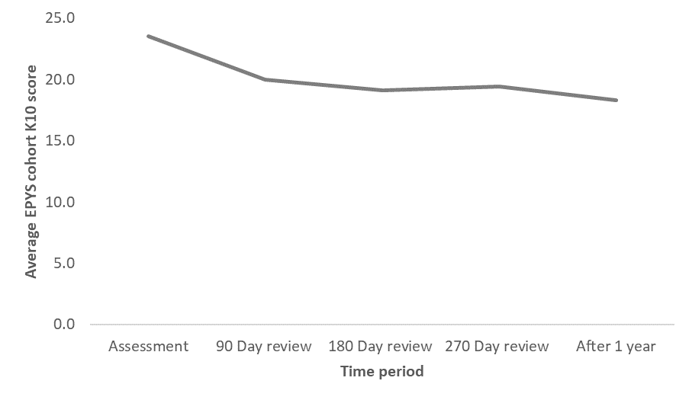

The estimated K10 score difference at 12 months was 18.3, compared to 23.5 at baseline. This suggests an improvement in the severity of symptoms as a result of the headspace Early Psychosis service. A reduction of 5.2 converts to a change in utility weight of 0.09, compared to no change in baseline utility score. It is assumed that clients only reap this benefit for six months of the year, as the reduction in K10 is not immediate or large as it is at the end of the 12-month period (see Appendix L for further details).

The K10 is the mandated symptom measure in secondary mental health services in Australia but does not assess the psychosis specific symptoms which the BPRS does. As such, the use of the K10 to evaluate symptomatic outcome and effectiveness in FEP clients has been questioned.

To determine how well (or poorly) changes in K10 captured changes in the preferred measure – the BPRS, an intra-individual correlation (within subject z-scores), was undertaken for episode within the evaluation extract, this then determined the overall correlation. The analysis was limited to UHR clients with at least two post assessment observations (i.e., six months or more of follow-up) and FEP clients to those with at least four post assessment observations (one year or more of follow-up).

Changes in the BPRS total and general scales are moderately strongly correlated (all are statistically significant) with changes in the K10 (see Section 7.2.3). The correlations are in fact as strong, if not stronger, in the clients with psychosis than those with other disorders in the UHR stream.

In conclusion, the estimated ICER for the program was $318,954 (Table 74). This value is above any of a range of benchmark ICER values used both domestically and internationally to assess cost effectiveness. Hence the EPYS Program does not represent value-for-money by this metric in its current format.

Table 74: Cost-effectiveness outcomes for the base case scenario analysed

| Variable | Value |
| --- | --- |
| Estimated baseline health utility weight | 0.72 |
| Estimated health utility weight at follow up | 0.82 |
| Estimated utility weight change | 0.09 |
| Incremental QALY change | 0.05 |
| **ICER** | **$318,954** |

* + 1. Assessment of cost-effectiveness

Cost-effectiveness is defined in this report as the incremental cost per unit of health outcome. An intervention (the EPYS Program) is measured relative to a counterfactual - an alternative comparable service seeking to deliver the same outcome., The Nelson 2016 study (previously mentioned) was used as the counterfactual in Section 8.3.2. In this section the counterfactual is a no-change scenario. A comparative service (The *Transitions* study) was used to isolate the effect of the EPYS program. Aggregation of service results to yield an overarching (single) measure of cost-effectiveness. The sensitivity analysis is separated into:

* ***Cost-effectiveness threshold scenario analysis:*** An assessment of the cost reduction or throughput increase required for the program to be considered cost-effective, holding current clinical outcomes constant
* ***Cohort testing:*** an estimation of the effect of the program on UHR or FEP individuals separately. This section of the sensitivity analysis considers whether the effects of the program depend on the condition of the client.

Cost-effectiveness threshold scenario analysis

A scenario analysis (below) was completed to identify the conditions under which the EPYS program could be considered cost-effective in the Australian policy context. The analysis was completed by calculating the varying the cost per client, incremental utility gain, and number of clients serviced to understand the critical values at which the program could be considered cost-effective. In each of the following calculations, the variables of interest (as listed below) were varied until the ICER reached a designated value – $50,000, $100,000 and $150,000. The three variables tested were:

* Cost per client, in which the cost per client was varied while the incremental utility gained and number of clients was held constant.
* Incremental utility, in which the incremental utility was varied while the cost per client and number of clients was held constant.
* Total number of clients serviced, in which the total number of clients serviced while the cost per client and incremental utility gained was held constant.

The program would record an ICER of the $50,000 per QALY threshold if any of the following held:

* The average cost per client would have to decrease by $12,556 per client, or 82 percent of its current level. At a cluster specific level:
* The lowest cost cluster (South East Queensland) recorded a cost of $10,405. The required cost per client to meet the ICER threshold is a 74 percent decrease on this figure.
* The highest cost per client was $23,927 (North Perth). The required cost per client to meet the ICER threshold is an 89 percent decrease on this figure.
* The incremental utility gain would need to increase from 0.05 (currently) to 0.3. The associated utility weight increase required would be 0.51. This would require a finishing utility weight of 1.24, which is outside the scale of utility measurement (which is normalised between 0 and 1). Therefore, achieving this figure is impossible at current levels.
* The number of clients serviced would need to increase from 3,085 to 20,225 per annum. The total estimated size of the market for youth psychosis services (both UHR and FEP) is 18,304 (see Section 9.1.1 for more details). Therefore, achieving this client size would require an increase in demand for services above the current level, and high market penetration.

Each of these scenarios is outlined in Table 75.

Table 75 Cost-effectiveness threshold ($50,000) scenario analysis

|  |  | Value | | |
| --- | --- | --- | --- | --- |
| **Variable changed** | **To achieve an ICER of $50,000 per QALY gained:** | **Incremental utility** | **Cost per client** | **Number of clients** |
| Incremental Utility | **0.3** | $15,304 | 3,085 |
| Cost per client[107] | 0.05 | **$2,747** | 3,085 |
| Number of clients | 0.05 | $15,304 | **20,225** |

The program would record an ICER of below the $100,000 per QALY if any of the following held:

* The average cost per client would have to decrease by $10,222 per client, or 67 percent of its current level.
* The incremental utility gain would need to increase from 0.05 (currently) to 0.2. The associated utility weight increase required would be 0.3. This would require a finishing utility weight of 1.02, which is outside the scale of utility measurement (which is normalised between 0 and 1). Therefore, achieving this figure is impossible at current levels.
* The number of clients serviced would need to increase from 3,085 to 10,113 per annum. The total estimated size of the market for youth psychosis services (both UHR and FEP) is 18,304 (see Section 9.1.1 for more details). Therefore, achieving this client size would require a market penetration of 55 percent.

Table 76: Cost-effectiveness threshold ($100,000) scenario analysis

|  |  | Value | | |
| --- | --- | --- | --- | --- |
| **Variable changed** | **To achieve an ICER of $100,000 per QALY gained:** | **Incremental utility** | **Cost per client** | **Number of clients** |
| Incremental Utility | **0.2** | $15,304 | 3,085 |
| Cost per client[108] | 0.05 | **$5,082** | 3,085 |
| Number of clients | 0.05 | $15,304 | **10,113** |

The program would record an ICER of $150,000 per QALY if any of the following held:

* The average cost per client would have to decrease by $7,888 per client, or 52 percent of its current level.
* The incremental utility gain would need to increase from 0.05 (currently) to 0.1. The associated utility weight increase required would be 0.2. This would require a finishing utility weight of 0.92.

The number of clients serviced would need to increase from 3,085 to 6,742 per annum. The total estimated size of the market for youth psychosis services (both UHR and FEP) is 18,304 (see Section 9.1.1 for more details). Therefore, achieving this client size would require a market penetration of 37 percent.

Table 77: Cost-effectiveness threshold ($150,000) scenario analysis

|  |  | Value | | |
| --- | --- | --- | --- | --- |
| **Variable changed** | **To achieve an ICER of $150,000 per QALY gained:** | **Incremental utility** | **Cost per client** | **Number of clients** |
| Incremental Utility | **0.1** | $15,304 | 3,085 |
| Cost per client[109] | 0.05 | **$7,416** | 3,085 |
| Number of clients | 0.05 | $15,304 | **6,742** |

Sensitivity Analysis – scenario cohort testing

A total of 104 EPYS Program clients and 206 comparative service cohort clients (derived from the Transitions Study) were included in the cost-utility analysis. Cohorts were selected through the same criteria as in the base case analysis. A comparison of the clients included in the analysis are shown below. EPYS Program clients were more likely to be male, FEP, Indigenous, older, and have a higher baseline K10 compared to the comparative service cohort.

Table 78: Sample characteristics for the EPYS and comparative service cohort

| Sample characteristics | EPYS Program | Comparative service |
| --- | --- | --- |
| Sample size | 104 | 206 |
| Gender | | |
| Female (%) | 44% | 68% |
| Male (%) | 56% | 32% |
| Category of client | | |
| UHR (%) | 21% | 75% |
| FEP (%) | 79% | 25% |
| Indigenous status | | |
| Indigenous Australians (%) | 10% | 6% |
| Age | | |
| Mean (years) | 19.2 | 18.6 |
| Mental health outcome metrics | | |
| Baseline K10 | 24 | 32 |

A regression model was specified and tested to estimate the effect of the EPYS Program on changes to K10 at follow-up at 12 months. The model was specified to account for the differences in sampling between the EPYS Program and the comparative service cohorts. Gender, age, and Indigenous status control variables were included because there is evidence that each of these influences the length and severity of symptoms. A baseline K10 and UHR status variables was also added to control for other potential sources of variation.

Figure 62: Base case model specification

Figure 62 is a calculation for base case model specification. The details are 𝐶ℎ𝑎𝑛𝑔𝑒 𝑖𝑛 𝐾10 𝑆𝑐𝑜𝑟𝑒𝑖=𝐵𝑎𝑠𝑒𝑙𝑖𝑛𝑒 𝐾10𝑖+𝑈𝐻𝑅𝑖+𝐹𝑒𝑚𝑎𝑙𝑒𝑖+𝐸𝑃𝑌𝑆𝑖+𝐴𝑇𝑆𝐼𝑖+𝐴𝑔𝑒𝑖 

Table 79: Definition of variables specified in the model

| Variable | Description |
| --- | --- |
| Change in K10 Score | Change between baseline and follow-up K10 score |
| Baseline K10 score | K10 score at the admission to the program |
| UHR | Dummy variable for UHR status |
| Female | Dummy variable for Female status |
| EPYS Program | Dummy variable for treatment through the EPYS Program |
| Age | Age of participant at admission |
| Subscript ‘i’ | Denotes that all estimates are conducted for participant ‘i’ (an arbitrary participant in the sample) |

The EPYS Program was found to have a significant, negative impact on the change in K10 score. This indicates that the EPYS Program reduced the severity of symptoms by more than the comparative service cohort. On average, the EPYS Program reduced the change in K10 scores by 4.7 points more than the comparative service study.

Table 80: Regression results for the base case

| Variable | Estimated impact on change in K10 score |
| --- | --- |
| Baseline K10 | -0.6** |
| Female | 1.7 |
| Age | 0.0 |
| Indigenous Australians | 1.3 |
| UHR | -1.7 |
| EPYS | -4.7** |
| *Significant at p<0.05; **Significant at p<0.01 | |

The regression results were cross-walked to utility values to calculate QALY values. EPYS Program clients who would transitioned from UHR to FEP would have experienced an estimated 0.5-point decrease in their K10 score at follow-up. EPYS Program clients experienced a 5.2-point decrease on average. This indicated that both programs would reduce the severity of symptoms, though the EPYS Program would reduce the severity of symptoms by more than the comparative service study.

As shown in Figure 63 below, the K10 score of EPYS Program participants gradually decreased across the 12-month period, supporting the assumption of a linear decline in K10 scores. This suggests that a six-month benefit period is a reasonable assumption. The baseline score for EPYS clients was 23.5 upon admission, which gradually declined throughout the evaluation period.

Figure 63: Average K10 score for the EPYS cohort at each follow up assessment



The estimated K10 score difference at 12 months was 18.3, compared to 23.5 at baseline. This suggests an improvement in the severity of symptoms as a result of the headspace Early Psychosis service. A reduction of 5.2 converts to a change in utility weight of 0.09, compared to no change in baseline utility score. It is assumed that clients only reap this benefit for six months of the year, as the reduction in K10 is not immediate or large as it is at the end of the 12-month period (see Appendix L for further details).

In conclusion, the estimated ICER for the program was $318,954 (Table 81). This value is above is above any of a range of benchmark ICER values used both domestically and internationally to assess cost effectiveness. Hence the EPYS Program does not represent value-for-money by this metric in its current format.

Table 81: Cost effectiveness outcomes for the base case scenario analysis

| Variable | Values |
| --- | --- |
| Estimated baseline health utility weight | 0.72 |
| Estimated health utility weight at follow up | 0.82 |
| Estimated utility weight change | 0.09 |
| Incremental QALY change | 0.05 |
| ICER | $318,954 |

The change in utility weights reflect, on average, an 11 per cent improvement in the quality of life of clients in the EPYS Program. When applied at a per client level, it is assumed that each client is at the improved health state for six months of the 12 months in the EPYS Program. This assumption reflects the idea that the reduction in K10 score follows a linear path over the 12 months. The final improvement in QALY is 0.03 for the EPYS Program and less than 0.01 for comparative service study, as it is assumed that benefits only occur for the last six months of the service.

Table 82: Estimated utility differences

| Variable | EPYS Program | Comparative service |
| --- | --- | --- |
| Estimated baseline health utility weight | 0.724 | 0.72 |
| Estimated health utility weight at follow up | 0.82 | 0.72 |
| Estimated utility weight change | 0.09 | 0.01 |
| Annual increase in QALY | 0.05 | 0.00 |

The EPYS Program yields a health improvement to clients equivalent to 0.09 QALYs. This represents the incremental benefit of the EPYS Program over the comparative service study.

Applying this against the value of a statistical life year, this represents an incremental cost of $318,954 per QALY gained. This is higher than the $50,000-70,000 value of a life-year typically assumed for health-economic evaluations[110] or the $213,000 specified by the Office of Best Practice and Regulation.[111]

Table 83: Outputs for EPYS Program compared to comparative service

| Variable | EPYS Program |
| --- | --- |
| Incremental QALY change (adjusted for benefit period) | 0.05 |
| Incremental cost-effectiveness ratio | $318,954 |

A sensitivity analysis was run by including two additional model specifications for the cost-effectiveness changes, each with a different outcome variable. These estimates form a range of possible QALY benefits of the program.

Splitting client cohorts between FEP and UHR will control for the effects of the program on two different types of client. Early intervention programs target UHR clients more than FEP clients, hence stratifying the two groups could yield different results if the effectiveness of each program differs. Specifications for each model are shown below.

Figure 64: Specification for sensitivity model one

Figure 64 is a calculation for specification for sensitivity model one. The details are 𝐶ℎ𝑎𝑛𝑔𝑒 𝑖𝑛 𝐾10 𝑆𝑐𝑜𝑟𝑒 𝑓𝑜𝑟 𝑈𝐻𝑅 𝑐𝑙𝑖𝑒𝑛𝑡𝑠𝑖 = 𝐵𝑎𝑠𝑒𝑙𝑖𝑛𝑒 𝐾10𝑖 + 𝐹𝑒𝑚𝑎𝑙𝑒𝑖 + 𝐸𝑃𝑌𝑆𝑖 + 𝐴𝑇𝑆𝐼𝑖 + 𝐴𝑔𝑒𝑖

Figure 65: Specification for sensitivity model two

Figure 65 is a calculation for specification for sensitivity model two. The details are 𝐶ℎ𝑎𝑛𝑔𝑒 𝑖𝑛 𝐾10 𝑆𝑐𝑜𝑟𝑒 𝑓𝑜𝑟 𝐹𝐸𝑃 𝑐𝑙𝑖𝑒𝑛𝑡𝑠𝑖 = 𝐵𝑎𝑠𝑒𝑙𝑖𝑛𝑒 𝐾10𝑖 + 𝐹𝑒𝑚𝑎𝑙𝑒𝑖 + 𝐸𝑃𝑌𝑆𝑖 + 𝐴𝑇𝑆𝐼𝑖 + 𝐴𝑔𝑒𝑖

Results for the sensitivity analysis support the base case findings. The EPYS had a significantly positive impact on the severity of symptoms relative to the. The estimates for the improvements for the UHR clients were lower than that of the FEP clients, suggesting that the EPYS is more beneficial for FEP clients than UHR clients. This is a function of:

1. The EPYS being more effective at reducing severity of symptoms than the comparative service study, and FEP clients starting with a more severe level of symptoms.
2. The UHR clients in the cohort being more likely to be complex cases as they have extended their stay in the program beyond the six-month recommendation. Hence this sample selection problem is likely to understatement the benefits for all UHR clients in the EPYS.

The incremental QALY change for the UHR clients was lower than the base case by three percent. The incremental QALY change for FEP clients was 13 percent higher. These results were converted to QALY values, as above, which form an estimated band of results for the cost-effectiveness of the program.

Table 84: Sensitivity outputs for EPYS compared to comparative service

| Variable | UHR clients | FEP clients |
| --- | --- | --- |
| Incremental QALY change (adjusted for benefit period) | 0.03 | 0.06 |
| Incremental cost-effectiveness ratio | $414,922 | $232,850 |

Alternative scenario

An alternative scenario was tested in which EPYS was considered a substitute service for the existing state-funded community mental health services available for FEP clients. A ‘substitute’ refers to a program which delivers a similar service to an existing service. The term refers to a health sector perspective in which FEP individuals can receive services from EPYS or a state-funded service – in this sense EPYS is a ‘substitute’ for a state-funded service. EPYS is assumed to be a complementary service for UHR individuals (complementary or ‘additional’ to the current health system – i.e. UHR individuals are unlikely to receive state-funded community services until their condition worsens to FEP).

Each of these assumptions impacts the calculation of the net cost of the EPYS Program. In the base case there is assumed to be no cost of state-funded community mental health services under the counterfactual for each client (both FEP and UHR) as the entire EPYS Program is considered a complement to the current health system. This means that the service is not replacing any existing services and therefore it is an additional cost on the system. Therefore, under the alternative scenario:

* EPYS is a service which acts as a substitute for state-funded community services. FEP clients would receive state-funded community services if EPYS did not exist (i.e. the counterfactual). Therefore, the cost of these community-based services offset the cost of EPYS such that only the incremental cost of service delivery is considered.
* EPYS is a service which acts as a complementary service for UHR clients. UHR clients would not receive services under the counterfactual (i.e. from state-funded services)[112]

In the alternative scenario, it is assumed that FEP individuals would have received services from a state-funded community mental health service in the counterfactual. The implication of this is that the gross cost of the EPYS program needs to be adjusted by an amount equal to the cost of services they would have received in a community setting in order to calculate the incremental cost of the EPYS program.

In this scenario, there are two sources of cost changes:

1. **Incremental intervention cost:** This isthe difference between the cost of treatment under EPYS and the cost of treatment under state-funded services, for FEP individuals.
2. **Cost offsets:** In the counterfactual, there was a higher rate of transition from UHR to FEP meaning there were a greater number of individuals who were FEP who were assumed to be accessing state-funded hospital and community-based mental health services. The costs arising from individuals accessing these services were assumed to be not incurred in the intervention case due to the superior health outcomes achieved by the EPYS program. As a result, these costs are avoided and need to be offset from the cost of the EPYS program.

Table 85: Detailed calculation of the incremental cost of intervention per client

|  |  |  |
| --- | --- | --- |
|  | **EPYS** | **Counterfactual** |
| Total clients | 3,085 | 3,085 |
| FEP clients | 1,388 | 1,388 |
| Cost per FEP client | $15,304 | $9,771[113],[114] |
| EPYS cost impacts | | |
| Net cost per FEP client | $5,533 | |
| Incremental intervention cost per client | $10,907* | |
| *\*Weighted cost of delivering the service to:*  *1,697 UHR at $15,304 per client*[115]  *1,388 FEP at a net cost of $5,533 per client.*[116] | | |

After adjusting for additional cost offsets from reduced health sector usage from a reduction in the transition rate, the cost offset from the incremental cost per client is $1,326 per client per annum. This cost offset is comprised of the avoided cost from reduced utilisation of community care services and reduced hospitalisations from psychosis-diagnosed events.

Table 86: Cost offset from reduced transition rate in the alternative scenario

|  |  |  |
| --- | --- | --- |
|  | **EPYS** | **Counterfactual** |
| Total clients | 3,085 | 3,085 |
| Number of UHR clients | 1,697 | 1,697 |
| Transition rate | 6.1% | 16.1%[117] |
| Number of UHR clients who transition to FEP | 104 | 280 |
| Cost offsets | | |
| Incremental number of clients assumed to have transitioned to FEP in counterfactual | 166 | |
| Average hospital costs per FEP client | $8,261 | |
| Average community care costs per FEP client | $9,771 | |
| EPYS cost impacts | | |
| Incremental intervention cost per client | $10,907 | |
| Cost offset from reduce community service utilisation from FEP clients | $913 | |
| Cost offset from reduced hospitalisation service utilisation | $413 | |
| Average cost offset per client | $1,326 | |
| Adjusted intervention cost per client | $9,581 | |

The health outcomes component of the ICER calculation also needs to be adjusted to reflect the assumed impact of state-funded community mental health services.

The analysis utilised the incremental utility change calculated the by isolating the effect of the EPYS compared to the comparative service cohort as a proxy for community-based mental health services. The adjusted cost under the EPYS per client is $9,581 after considering all cost offsets.

Table 87: Summary table of outcomes for the alternative scenario

|  |  |  |
| --- | --- | --- |
|  | **EPYS** | **Counterfactual** |
| Total clients | 3,085 | 3,085 |
| Raw cost per client | $15,304 | $9,771 |
| Incremental net cost per client | $10,907 | - |
| Average cost offset per client | $1,326 | - |
| Adjusted cost per client | $9,581 | - |
| QALY change per client | 0.05 | 0.01[118] |
| **ICER** | **$223,848** | |

The ICER under the alternative scenario is $223,848 per QALY. This is lower than the ICER presented in the base case but remains above the level at which health interventions are typically funded in Australia or internationally.

* 1. Is there a minimum target population size required for cost-effective delivery of the EPYS Program?
     1. Minimum target population size

The cost-effective minimum target population size is defined as the smallest total population in a defined catchment for which a service could deliver services while achieving clinical caseload targets (i.e. staff are fully utilised).

This analysis assumes that the service model remains unchanged. Estimates of the minimum viable population have been used to estimate the cost of regional rollout (Section 9.1.4).

This estimation has been calculated using hAPI data, prevalence data, and advice on the minimum staffing profile that can deliver the service whilst maintaining fidelity to the EPPIC model (which was provided through consultation with Orygen). Analysis has been performed to determine the minimum viable population for the program. Advice from Orygen was that the smallest CCT FTE team members was nine.

This involved the following steps:

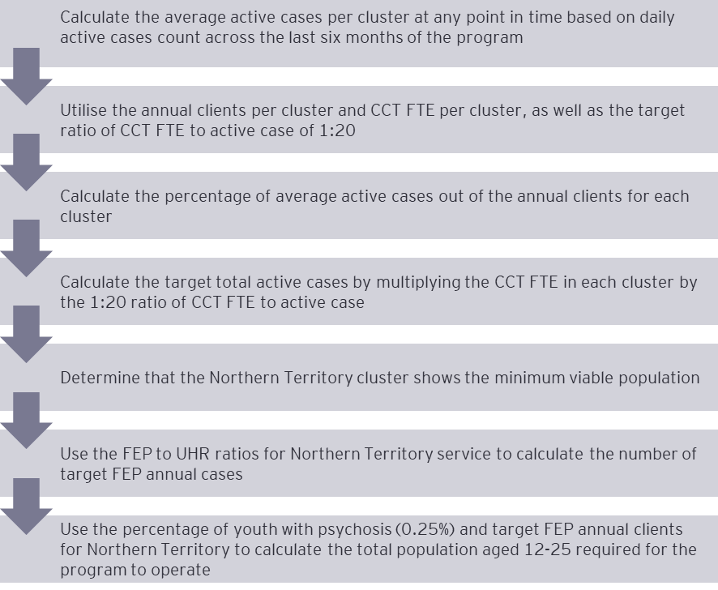

These steps conclude that a population of 400,000 is required for the program to operate at efficient levels.

Table 88: Outputs and assumptions for minimum viable population analysis

| Category | Result | Source |
| --- | --- | --- |
| Average active cases | 61 | hAPI dataset |
| Annual clients | 243 | Provided by headspace National |
| CCT FTE | 9 | Consultation with evaluation stakeholders |
| Active case target per CCT FTE | 20 | Consultation with evaluation group |
| Average active cases as percentage of annual clients | 25% | Calculated from above data |
| Target total active cases | 120 | Calculated from above data |
| Target annual cases | 479 | Calculated from above data |
| FEP percentage | 26% | hAPI dataset |
| FEP annual cases | 125 | Calculated from above data |
| Percentage of youth with psychosis | 0.25% | Consultation with evaluation stakeholders |
| Total population aged 12-25 required | 50,000 | Calculated from above data |
| Percentage of total population | 19% | Calculated using ABS population data |
| Total population | 400,000 | Calculated from above data |

1. Evaluation Question 5: What are the implications for the program inputs arising from a wider implementation of the EPYS model?

This section details the findings for the following evaluation questions:

| **Evaluation question** | **Secondary evaluation questions** |
| --- | --- |
| 1. What are the implications for the program inputs arising from a wider implementation of the EPYS model? | * 1. What would be the cost and service implications of a wider rollout of the EPYS model across Australia?   2. What economies of scale could be achieved through a wider rollout of the EPYS model? |

* 1. What would be the cost and service implications of a wider rollout of the EPYS model across Australia

This section covers:

* Addressing unmet demand for youth focussed Early Psychosis services
* Framework for considering the wider rollout of the EPYS Program
* Mechanisms for broadening geographical reach
* EPYS Program rollout constraints and considerations
* Cost implications of a wider rollout.

As detailed in Section 2.4, whilst the EPYS Program is a national program it does not have national reach – given it is not delivered in the ACT or Tasmania. Given the relatively low prevalence of psychosis in comparison to other conditions, the initial establishment of headspace Early Psychosis in regions with greater population density was logical and more financially viable. As the EPYS Program continues to mature, this evaluation question seeks to answer how the EPYS Program can be expanded to deliver a broader reach, whilst maintaining a level of fidelity to the EPPIC model and being sustainable.

* + 1. Addressing unmet demand for youth-focused Early Psychosis services

The demand for youth-focused psychosis services

The total demand for youth-focused psychosis services has been estimated by applying psychosis prevalence rates to the total youth population size nationally. The prevalence estimates were taken from averages across age groups and matched with ABS data for each age group. Prevalence rates ranged from 0.1 percent to 0.5 percent of young people (age 12 to 25). Rates varied with age and sex.

Table 89: Estimated prevalence rates for age and sex**[119]**

| Age range | Sex | % of age group[120],[121] |
| --- | --- | --- |
| 18 to 24 | Female | 0.2% |
| 18 to 24 | Male | 0.3% |
| 25 to 25 | Female | 0.3% |
| 25 to 25 | Male | 0.5% |
| 12 to 13 | Persons | 0.0% |
| 14 to 15 | Persons | 0.0% |
| 16 to 17 | Persons | 0.1% |
| 18 to 24 | Female | 0.2% |
| 18 to 24 | Male | 0.4% |
| 25 to 25 | Female | 0.4% |

Applying these prevalence rates to national population estimates[122] gives a total market size of 8,844 individuals (based on 2019 data). Currently there are 1,138 FEP individuals in the service, representing 13 percent of the total estimated market. This places the total unmet demand at 7,706 individuals.

Figure 66: Estimated individuals with psychosis at each age, by sex

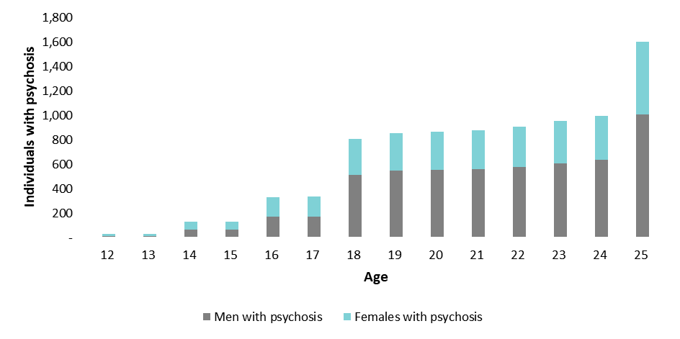

Estimating the demand for the EPYS Program from UHR individuals is more difficult. By definition, these individuals have not yet experienced a psychotic episode and so are not identified in the estimated population above. The approach taken for the analysis below was to take the average proportion of UHR to FEP clients in each of the existing service locations and apply them to the estimated number of FEP individuals in the area being modelled.

The total estimated demand (FEP and UHR individuals) nationally is 18,304, using existing ratios of FEP to UHR individuals from current services. There were 3,085 individuals registered to receive services in 2019, comprising 17 percent of the total estimated demand.

Figure 67: Estimated FEP and UHR individuals by age

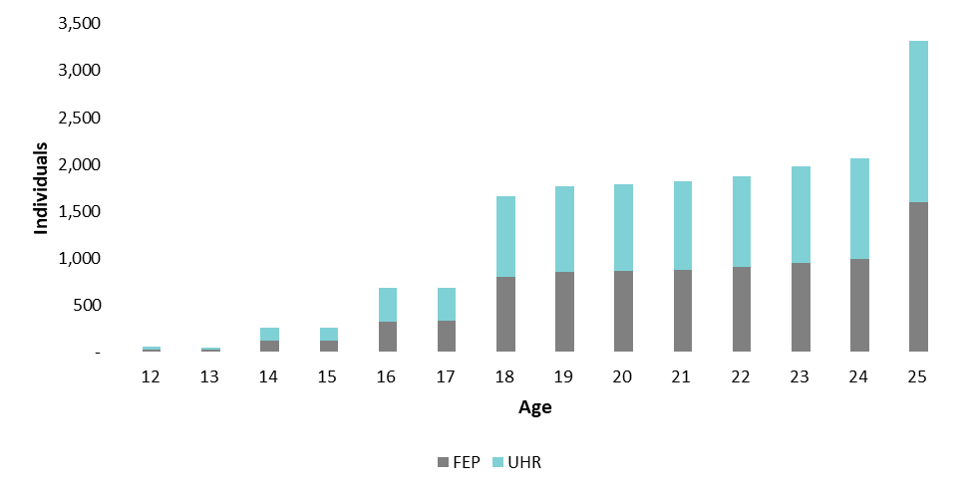

Services in place to address unmet demand

To determine the need to expand the EPYS Program, it is important to consider alternate providers of Early Psychosis services (public and privately funded). The usual care case studies identified that many LHNs provided some form of Early Psychosis service. However, the clinical focus and the early intervention focus of these services varied. As such, it was difficult to determine the extent to which these services were meeting demand, given that they were not directly comparable to headspace Early Psychosis services. As an example, all metropolitan LHNs in NSW had some form of state-funded Early Psychosis service. In addition to these services, several private and not-for-profit providers provide early Psychosis services or services for severe mental health conditions which may need to be considered in determining met and unmet need.

The most notable unmet need regarding the EPYS Program reach is the absence of services in Tasmania, the ACT and rural and regional locations. The extent to which the EPYS Program reached the target population within its geographical confinements, including targeted cohorts and opportunities to improve this reach are detailed in Section 5.3 and Section 11.1.4.

* + 1. Framework for considering the wider rollout of the EPYS service

To understand the implications of a wider roll-out, it is important to first understand what a wider roll-out could look like. A wider rollout of the model could be considered from two perspectives: (1), through a clinical expansion by broadening the diagnostic criteria; and (2) through a geographical widening of reach, i.e. through additional services. The focus of this evaluation question is focused on geographical expansion and how the EPYS Program can ensure greater coverage of the Early Psychosis youth population.

EPYS Program stakeholders reported that a broader rollout of the EPYS Program from a diagnostic perspective could be feasible, however these stakeholders reported that it is only with additional and appropriated funding, that the EPPIC model could be leveraged to service a broader diagnostic group. Whilst existing program infrastructure, such as hAPI and headspace Centres could facilitate this, staff did not indicate that there were considerable economies of scale to be realised by such an expansion – referencing the need for additional staff. A diagnostic expansion would support equity and access to care for young people experiencing other mental health conditions and would help achieve a critical mass needed for cost efficiency, particularly in remote areas. Furthermore, as UHR encompasses a broad range of conditions and diagnoses, an entry point for other diagnoses already exists within the EPYS Program that could be leveraged.

It is recognised that the expansion of the EPPIC model to other diagnoses is a fundamental shift in the model. Such a change requires considerable consultation, research and development of the evidence base. Importantly, this change would need to be aligned with supporting clinical evidence base. Furthermore, consideration of other existing early intervention mental health services (non-Psychosis specific) would be required.

Given these factors, the modelling of a wider diagnostic rollout is out of scope for this evaluation question. Instead the focus is on modelling the wider geographical rollout of the program, taking into consideration the minimum population required to deliver a headspace Early Psychosis service.

* + 1. Mechanisms for broadening geographic reach of the EPYS Program

Expansion of reach via the existing hub and spoke model

Consistently, a desire to service a wider geography was reported by local stakeholders. However, most stakeholders reported that this expansion would not be possible within existing resources or via current services – that is, additional hubs and spokes may be required to service a broader geographical area.

**headspace Early Psychosis staff**

*“It would be difficult to expand another satellite model i.e. in a rural/ regional area, would have to scale model elements down and therefore fidelity would be lost, there are also issues with prescribing medications via telemedicine which would have to be considered if services ran virtually”*

One option for expansion in this way would be to expand existing clusters (or hub only services) by adding new spokes. This approach however would realise a limited increase in reach due to the geographic proximity required between the existing hub and new spoke. One way to address this limitation is by adding a second MATT for the cluster to an existing spoke (one located furthest away from the hub), allowing the MATT to extend reach into a broader geographic region. Neither of these approaches however would be able to address the unmet need in rural and regional locations, ACT or Tasmania.

Expansion of the program to new locations

Given the limited increase in reach that would be achieved from the abovementioned approach. The expansion of the EPYS Program to new locations, leveraging available infrastructure (e.g. headspace Centres) as the infrastructure base would be required.

Some stakeholders reported that expanding the hub and spoke model to service rural areas would be difficult, as critical mass is needed to achieve cost efficiency and this may not be possible given the prevalence of psychosis and financial viability of running services in smaller populations (such as regional and rural locations) – the cost implication of this are explored further in Section 9.14. Staff reported that an expansion into rural areas would require the model to be scaled down as there would be an insufficient target population to provide a full scope of services, for example group programs and peer support. However, by adopting a scaled down version of the service, fidelity to the EPPIC model in its current format would be compromised. In discussion with Orygen, it is understood that a minimum population of 50,000 young people (400,000 total population) would be needed to make expansion of services viable and this population would not exist in remote and rural locations. As such, there would likely be a need to integrate with other services and leverage technology to deliver an adapted version of the EPPIC model to this cohort.

The use of technology to expand the reach of the EPYS Program

There were varying perspectives held by stakeholders regarding the extent to which telemedicine/ telehealth and other technology could be leveraged to support an expansion of the program. One stakeholder reported that there were issues associated with prescribing psychotic medications via telemedicine which would have to be considered if elements of service provision were to be provided virtually. Legislation and policy associated with virtual prescribing varies between states and territories and this would impact the extent to which a consistent telehealth rollout could be done nationally. Consideration is also needed regarding how model fidelity can be maintained if providing services digitally and recognition that digital solutions do not eliminate the need for face-to-face client and provider interactions.

Integration with existing state-funded health services to expand reach

Another suggested way to expand the geographic reach of the program is via consistent and improved integration of headspace Early Psychosis with state-funded health services – noting these services could vary, may not be psychosis specific and would play a key role in the ongoing case management of a client. This approach is already being undertaken by South East Melbourne and Darwin as previously highlighted. In Darwin, secondary consultations with the state-funded health services were undertaken to bolster mental health support for young people that are in receipt of community based mental health services in remote areas. headspace Early Psychosis clinicians provided advice to the treating team on how to manage a client when psychosis was suspected. These young people fall outside of the geographic reach of the headspace Early Psychosis service.

This type of integration would offer more psychosis focused treatment plans for clients being managed by state-funded health services, it would not necessarily guarantee provision of all components of the EPPIC model (e.g. functional recovery, youth participation and peer support). As these components would remain within the remit of the state-funded health service, it is unlikely that all elements of the EPPIC model can be provided in the way they are currently assessed as part of fidelity.

Usual care consultations highlighted that other elements of service delivery, such as functional recovery and group programs could be delivered via integration and brokerage with other providers, however this approach to delivering the EPPIC model has not been formally assessed for fidelity. Furthermore, to successfully deliver all EPPIC model components in this way it is likely that participating providers would have to co-commission the service to ensure referral pathways are seamless and joint accountability for client outcomes.

It is acknowledged, that whilst a distributed model that relies on integration between providers would allow fixed costs to be distributed across a broader population, it may impact client centricity of the program.

* + 1. Cost and service implications of a wider roll-out

Two stylised scenarios were developed to provide an indication of the costs and service implications of a wider rollout. It should be noted that the costs and service implications provided below are a top down estimate based on the assumptions detailed in the two scenarios and should not be considered a substitute for the comprehensive bottom up costing and implementation planning exercise that would be needed if wider rollout of the service was to be considered. Key assumptions and limitations underpinning the two scenarios include:

* The estimated costs only include the recurrent operating costs of providing the EPYS Program:
* No ramp up profile in the number of clients serviced has been assumed – all new services are assumed to be fully mature and at client capacity
* No capital costs relating to the construction of new facilities have been included (though rental expenses are included in the operating costs)
* No service planning or service establishment costs have been included
* No additional recruitment or training costs related to staffing additional services have been included (beyond those picked up in the current services recurrent operating costs and considered business as usual).
* No changes to the existing service delivery model are assumed
* The EPYS model is only expanded to locations where it is cost-efficient to do so (based on the existing service delivery model) – that is locations where the population exceeds the minimum viable population
* No consideration has been given to the coverage of any existing state-funded health services and the need to which this may influence the demand or need for the EPYS Program
* No analysis of the precise location of service hubs and/or spokes has been undertaken – whilst potential catchments have been broadly identified (Appendix M), further detailed work would need to be undertaken to determine the optimal locations and any limitations imposed by a lack of existing headspace Centres.

The specific modelled scenarios are outlined below.

Scenario one: Expanded metropolitan rollout

The expanded metropolitan rollout scenario estimates the cost of covering all major metropolitan centres (Adelaide, Brisbane, Canberra, Darwin, Hobart, Melbourne, Perth, Sydney). This scenario involves estimating the number of clusters required to cover each metropolitan centre, based on estimates of current catchment sizes for different clusters.

Cost estimates for this scenario assume that clusters can be duplicated across cities without significant changes in efficiency. Costs for each metropolitan centre are calculated by estimating the number and size (small, moderate, or large) of clusters required to service its population.

This scenario expands the coverage of the EPYS Program to approximately 68 percent of the total estimated target population of the service.

Scenario two: Expanded coverage into regional areas

Scenario two estimates the cost of metropolitan expansion (scenario one) plus expanded coverage into regional centres where the service can be delivered cost-efficiently. As such, regional centres are defined as cities with more than 400,000 people. Further expansion into smaller regional locations and Indigenous Australian communities was considered outside the scope of this report, as it would require adjustments to the current service delivery model.

This scenario expands the coverage of the EPYS Program to approximately 73 percent of the total estimated target population of the service.

Figure 68: Considerations for the scenario cost estimate

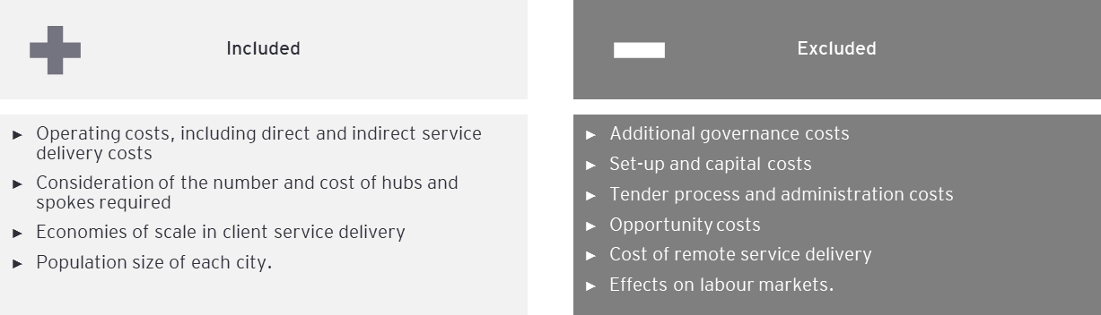

The cost of rollout was calculated by first determining the number of people in Australia within the 12-25 age group who were likely to have experienced or be at risk of psychosis, and then applying a cost per client. To estimate the number of people the following approach was taken:

* Use ABS population data to sum the total numbers of males and females in the 12-25 age group in each Australian capital city.
* Apply prevalence rates derived from two sources and across different age groups within the 12-25 age cohort (as shown in Table 90) to these totals to conclude the number of people within this age group who were likely to have experienced psychosis in each capital city.
* Using the ratios of UHR to FEP in each cluster, conclude the total market size for each capital city – this saw approximately a 40 percent increase from the totals concluded from the prevalence calculations.

Table 90: Psychosis prevalence rates across Australia

| Age range | Sex | % of age group[123],[124] |
| --- | --- | --- |
| 18 to 24 | Female | 0.2% |
| 18 to 24 | Male | 0.3% |
| 25 to 25 | Female | 0.3% |
| 25 to 25 | Male | 0.5% |
| 12 to 13 | Persons | 0.0% |
| 14 to 15 | Persons | 0.0% |
| 16 to 17 | Persons | 0.1% |
| 18 to 24 | Female | 0.2% |
| 18 to 24 | Male | 0.4% |
| 25 to 25 | Female | 0.4% |

To estimate the total costs per capital city and in total the following approach was taken:

* Multiply the total estimate of market size (i.e. number of people) by the minimum and maximum cost per client per annum from each cluster.
* For capital cities without corresponding clusters, average costs per client per annum (both minimum and maximum) across the other capital cities were used.

Proposed catchments

The proposed catchments for each metropolitan area have been based on the metropolitan boundaries, as defined by the ABS. Proposed catchments only capture the total population size and are not a recommendation of roll-out strategy.

The current service delivery model requires that any new EPYS services be co-located with existing headspace Centres, which may impact the feasibility of the catchments proposed here, refer to Appendix M for catchment boundaries.

Other issues such as overlapping PHN catchments and the impact this has on governance and accountability arrangements would also need to be given detailed consideration as part of an implementation strategy. Some of these are discussed further below.

Cost estimate results

Scenario one

The rollout cost for metropolitan areas were identified as all capital cities in each state. Some cities which sit below the minimum viable population (Hobart, Darwin) have been included, which reflects that they may not be able to achieve efficient service delivery.

The estimated cost of rollout to capital cities ranges between $159 million to $187 million per annum to service a total market of approximately 10,569 people (this includes both FEP and UHR clients). This compares to a current program cost of $72 million and 3,085 clients.

Figure 69: Estimated roll-out cost per capital city

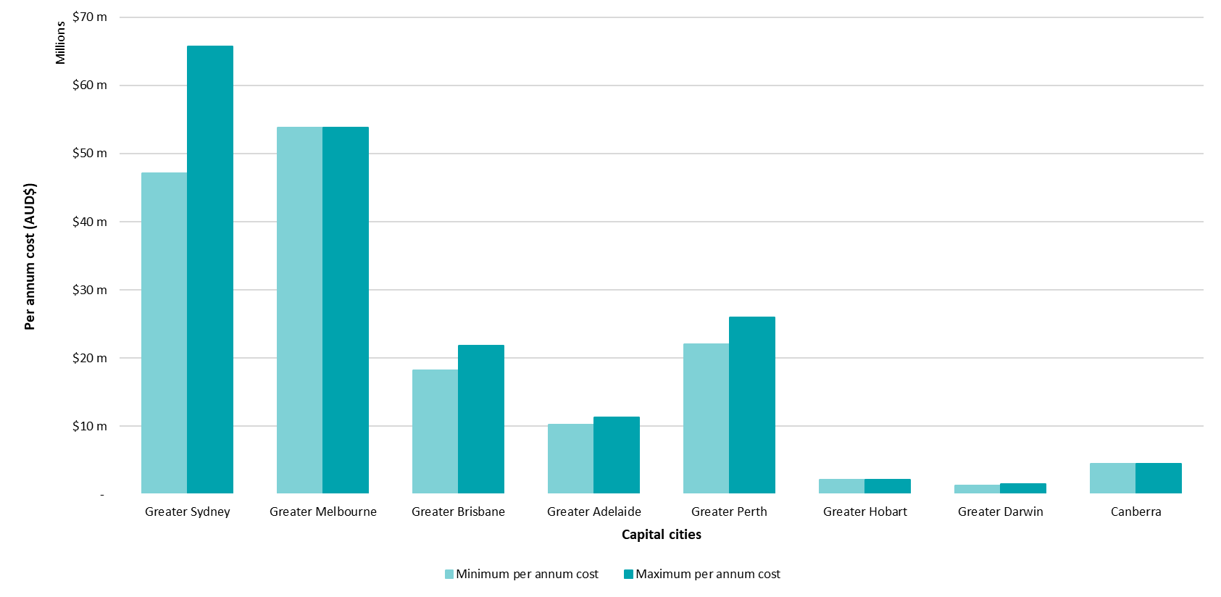

Scenario two

Regional areas were identified which were large enough to support a service delivering service costs efficiently, based on the minimum viable population analysis in Section 4.3. This approach to regional rollout assumes that there is no change in the delivery model of the service. Expanding to regional areas with a population smaller than 400,000 may require either:

* A change in service delivery model, which may impact the fidelity of the model
* A relaxing of the assumption of cost-efficient service delivery, as delivery services to populations under this threshold would require some staff to be underutilised compared to caseload targets.

Only two regional locations were assessed as large enough (in population terms) to meet the minimum viable population criteria: Gold Coast-Tweed Heads and Newcastle-Maitland.

Table 91: estimated total cost per regional centre

| Location | Population | Low FEP percentage | | High FEP percentage | |
| --- | --- | --- | --- | --- | --- |
| Low cost estimation | High cost estimation | Low cost estimation | High cost estimation |
| Gold Coast-Tweed Heads | 679,000 | $12.3m | $28.4m | $4.4m | $10.1m |
| Newcastle-Maitland | 486,700 | $8.6m | $19.8m | $3.0m | $7.0m |
| **Total** | **1,165,700** | **$20.9m** | **$48.2m** | **$7.4m** | **$17.1m** |

Combining the analysis for capital cities (Scenario one) and regional areas, of the estimated cost of rollout under Scenario two ranges from $169 million to $209 million per annum.

The FEP to UHR for states with existing clusters has been held constant in this analysis. For states without a cluster, an average of UHR to FEP ratios has been used.

Table 92: Estimated total cost for scenario two

| Location | Low cost estimation | High cost estimation |
| --- | --- | --- |
| Greater Sydney | $47.2m | $65.7m |
| Greater Melbourne | $53.8m | $53.8m |
| Greater Brisbane | $18.2m | $21.8m |
| Greater Adelaide | $10.3m | $11.3m |
| Greater Perth | $22.m | $26.m |
| Greater Hobart | $2.2m | $2.2m |
| Greater Darwin | $1.3m | $1.5m |
| Canberra | $4.5m | $4.5m |
| Gold Coast-Tweed Heads | $4.4m | $28.4m |
| Newcastle-Maitland | $3.m | $19.8m |
| **Total** | **$167m** | **$235m** |

* + 1. EPYS Program rollout constraints and considerations

Aside from financial and model fidelity considerations associated with a viable rollout, there are several other factors which may enable or inhibit a broader rollout.

Modifications to the existing design

Regardless of the approach taken to expand the EPYS Program, several modifications to the program could be made to facilitate a wider rollout. In most part, these modifications relate to the simplification of the setup of services. Such as commissioning one lead agency per cluster and having a shared lead agency with headspace Primary where feasible – these modifications are detailed in the opportunities for Evaluation Question 1.1 (See Section 5.1)

Workforce

An inherent challenge and consideration for a wider roll-out of the EPYS Program will be access to a suitably skilled workforce. Existing services reported challenges associated with recruiting staff due to the highly specialised nature of Early Psychosis and the challenge of remuneration in line with what is provided in state-funded health services. This challenge of workforce availability is even greater in less populated regions, where specialised health services are limited. As such, any expansion of the program must consider how to address this limitation, but also whether investment in local workforce development and establishment of a workforce strategy would be sufficient.

For the cost estimates provided in 9.1.4, it is assumed that workforce availability limitations will be managed and addressed to enable a wider roll-out.

Infrastructure

Access to appropriate infrastructure is an important consideration for a wider rollout of the program. If the program were to be expanded in its current form, then leveraging the existing network of headspace Centres would be a logical approach. Consideration of the geographic outreach capabilities and capacity constraints to house additional staff within these centres is required.

Alternatively, if headspace Early Psychosis services were delivered in a co-commissioned manner, then service agreements could be established to house headspace Early Psychosis, for example, co-location with the local Aboriginal Medical Service or community health centres.

If digital solutions were adopted to enable a broader Program reach, then existing digital solutions available via headspace National could be leveraged, but these may require enhancement.

Variability of providers across the health eco-system

In any scenario, future headspace Early Psychosis services will need to successfully integrate with their local health system. The variability and availability of associated state/territory and private mental health services across the country will complicate integration of EPYS Program delivery with other mental health services and social supports. Furthermore, whilst all efforts may be made by EPYS Program stakeholders to integrate with other service providers, successful integration is reliant on mutual interest and mutual gain.

* 1. What economies of scale could be achieved through a wider rollout of the EPYS model?
     1. What is meant by economics of scale?

Economies of scale refer to the reduction in the cost per unit of a good or service as the result of an increase in quantity. The ‘scale’ in economies of scale refers to the large quantity of goods or services required to produce the cost reduction. For example, increasing production from 100 to 200 units may require a 15 percent increase in costs, but moving from 1000 to 1100 units would only require a 5 percent increase in costs. In this case of the latter, it is said that this company has achieved ‘economies of scale.’

Economies of scale may result in health services from the distribution of administrative and management tasks. Salaries paid to administrative and management staff will be proportionately high at low client numbers, but as the number of clients and OOSs increase, the relative cost (relative to the number of OOSs) of management and administrative salaries will decrease as more clinical staff are required. Figure 70 shows this relationship visually.

Figure 70: Theoretical relationship depicting economies of scale

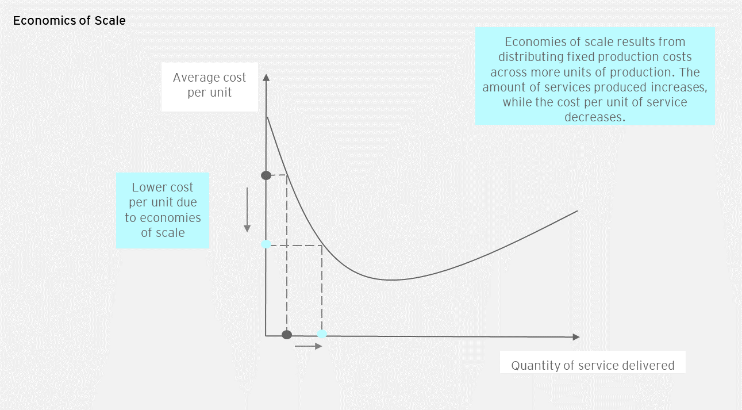

* + 1. Is there any evidence of economies of scale in the current delivery of services?

Economies of scale in the current service environment implies that larger clusters (those that deliver services to more clients) would record lower costs per service output. As demonstrated in the cost efficiency analysis of this Evaluation, there is no clear evidence that services recorded economies of scale in service delivery, in terms of cost per client. This was also supported in the views reported by headspace Early Psychosis staff during local consultations. Figure 71 shows the relationship between cost per client and registered clients. There is too much variability to support economies of scale in service delivery, in terms of number of clients. Comparing Adelaide and North Perth, for example, suggests that there is a hidden variable impacting the relationship beyond the number of registered clients. Therefore, there is no evidence in support of economies of scale being present.

Figure 71: Relationship between cost per client and registered clients, per cluster

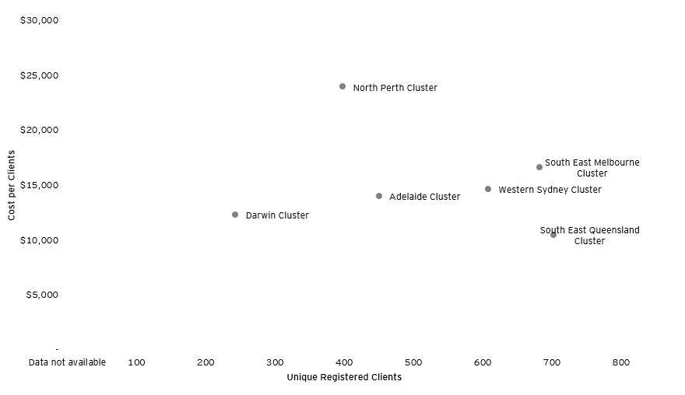

However, there is evidence of economies of scale in direct OOS delivery. Figure 72 shows a negative relationship between the number of annual direct OOS delivered per cluster, and the cost per direct OOS. This suggests that clusters which deliver more OOS deliver them cheaper than other clusters, on average.

Figure 72: Relationship between annual direct OOS and cost per direct OOS

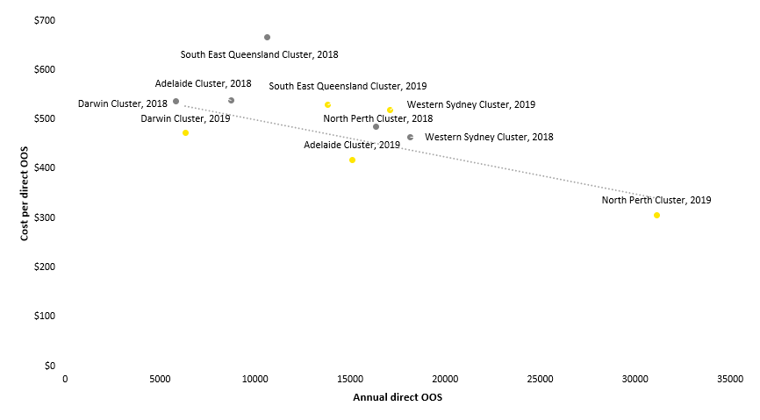

Combining the results from both figures suggests that the service could deliver economies of scale in cost per client, if the number of direct OOS per client was fixed between services.

* + 1. Opportunities for economies of scale through wider rollout

The efficiency analysis in Section 8.2 indicates there is considerable scope to improve the efficiency with which the EPYS service is delivered simply by optimising the utilisation of staff as well as providing greater consistency in the number of services delivered to comparable patients (whilst still being reflective of their individual needs).

For example, the fact that Adelaide and Darwin have a higher proportion of non-clinical staff in the sites coupled but can still achieve a lower average cost per client than some of the other bigger sites indicates there are economies of scale that could be realised in a more optimally utilised staffing model.

Other opportunities to realise economies of scale and program efficiencies could be achieved by leveraging program wide efforts undertaken to date, these include:

* *Overarching program costs:* Economies of scale could be achieved in relation to program level organisational and administrative costs such as the: hAPI system, program reporting efforts and data administration; Australian Government Department of Health administration of the Program and program monitoring and evaluation; marketing and brand management costs carried through headspace National and costs associated with training and resource development carried through Orygen. It is expected that some program wide costs would increase with an increase in services, but perhaps, in a proportionately smaller manner. For example, the cost (and time) associated with undertaking fidelity assessments.
* *Knowledge sharing:* Any further service expansion will benefit from the existing outlay of effort required in the setup of the Program. New services will be able to leverage existing knowledge and lessons associated with the implementation of headspace Early Psychosis services to streamline service implementation and fast track service maturity. This would subsequently allow headspace Early Psychosis services to achieve higher caseload numbers in a timelier manner. Furthermore, future services can access a wide pool of resources to obtain advice on aspects of service delivery. Knowledge sharing and the ability to leverage existing protocols would also extend to PHNs that commence commissioning headspace Early Psychosis services within their region. Should existing lead agencies be successful in leading future additional services similar efficiencies could be expected for these organisations. However, these benefits are dependent on a culture of knowledge sharing within the above respective organisations.
* *Relationships:* The establishment of relationships between headspace Early Psychosis services, PHNs and the local health system required considerable effort from staff, particularly regarding establishing referral pathways. If these existing relationships can be leveraged as part of service expansion, then it is possible that efficiencies can be achieved in this manner. However, this will likely only be an outcome limited to new services that are in proximity to existing headspace Early Psychosis services given that partnerships and stakeholders will vary region to region.

1. Discussion of the evaluation findings

This section provides discussion of the main findings from the evaluation, across all evaluation questions and data sources.

1. **POLICY ALIGNMENT IN EPYS PROGRAM DELIVERY: Clarity regarding the respective roles and responsibilities of the Australian Government and state and territory governments is imperative for the future delivery of the program.**

In Australia, specialist Early Psychosis services have historically been funded by state and territory health departments and delivered through LHNs. The introduction of the Australian Government funded Early Psychosis youth services was a change from these traditional responsibilities. It was not clear from the outset, whether these services were to be a complete substitute service (that is, standalone) or an add on for a specific client cohort. This resulted in some stakeholders reporting that headspace Early Psychosis services being duplicative with existing state-funded health services. Furthermore, variation in legislation and policy across states regarding headspace Early Psychosis services meant that only some services could treat clients on community treatment orders; thus limiting the severity and complexity of young people treated at some services. While the fiscal commitment of the EPYS Program falls upon the Australian Government, the states and territories are one of the prime economic beneficiaries of the program by decreasing the use of state and territory hospital and justice systems by young people with Early Psychosis. Thus, it is imperative that there is improved clarity regarding the respective roles and responsibilities of the Australian Government and state and territory governments in the prevention and treatment of Early Psychosis.

Overall, stakeholders agreed that EPYS would be a more efficient program if there was greater guidance on how to integrate headspace Early Psychosis and state-funded health services at a state and federal policy level. The future of the EPYS Program cannot be considered in isolation and should consider the direction of state-funded health services and other key providers, particularly given that some EPYS clients also have a need for services provided by the state-funded health system. Services should therefore look to complement, rather than replace or compete with one another.

Some stakeholders reported a preference for headspace Early Psychosis to sit within the state-funded health system. However, the majority would just prefer to see better linkages between the two, particularly in areas that have an existing FEP service and potentially sharing some resources e.g. Individual Placement and Support programs. Improved sharing of data between headspace Early Psychosis and state-funded health services was consistently reported as a critical area of opportunity for improving integration which cannot be underestimated. This would facilitate a more seamless experience for the young person across the care continuum and reduce unnecessary duplication of work by staff in repeated assessments.

Whilst the lead agency in one cluster was a Local Hospital Network, this did not correlate with a more cost-efficient service, nor were there obvious differences in client outcomes relative to other clusters and services. However, this arrangement appeared to have resulted in a range of other benefits that were not measured by the Evaluation; such as a high degree of integration, the ability to attract appropriately skilled staff, the ability to share or leverage resources across the services. Importantly the delivery of the program through a Local Hospital Network, highlighted the potential for the program to be implemented more broadly with, or by, the state-funded health system.

Whilst the policy direction shows support for the delivery of mental health care within the primary/community care setting, the delivery of specialist mental health care in this setting is somewhat unique to the EPYS Program. Whilst this approach is welcomed by clients and families, there are challenges which are yet to be fully overcome at a service and program level. From a commissioning perspective, PHNs may not necessarily have the appropriate experience and knowledge to commission such services, thus the need to leverage Orygen or other experts would likely continue into the future. The success of delivering a specialist service in the community also largely relies on having access to specialist skills – a challenge experienced by the EPYS Program. This further supports the need for improved integration with state-funded health services. Better integration and contractual arrangements could better support sharing of staff and the Australian Government’s National Medical Workforce Strategy could help to facilitate this.

The delivery of intensive services to young people in the UHR treatment arm in the EPYS regions creates significant geographical inequity as these people frequently would not meet the threshold for state-funded Early Psychosis services, except at time of crisis. The policy approach, delineation (or amalgamation), and targeting of services to this group and those provided via headspace Primary and PHN commissioned “youth severe” requires clarity.

The high rates of emergency department use by young people with psychosis in non-metropolitan areas suggests significant unmet clinical need in these areas.

1. **EPYS PROGRAM GOVERNANCE: The governance arrangements for the EPYS Program were complex at both the national and local levels. These were difficult to navigate, duplicative and increased burden of effort, impacting the effective implementation of the program.**

Governance of the EPYS Program was complex and involved multiple organisations and agencies, including the Australian Government Department of Health, Orygen, headspace National, PHNs and lead agencies. headspace Early Psychosis services were also required to navigate the local health policy environment, including state and territory governments, LHNs and co-located headspace Primary and other services. As such, the governance arrangements of the EPYS Program include “too many masters” with no clear accountability and subsequently there was ambiguity regarding role responsibilities and scope. Furthermore, the nature of how services were established meant that some clusters operated across two PHNs, LHNs, and/or had two lead agencies – adding to the complexity of local governance arrangements. This complexity flowed through to service delivery, resulting in clients having a fragmented experience at key transition points during their treatment (e.g. upon hospital admission and discharge, and discharge from the program).

The roles and functions associated with the contract management of headspace Early Psychosis services transitioned from headspace National to PHNs in July 2016. While PHNs had a role in increasing the efficiency and effectiveness of medical services for people in their communities, their inclusion was reported to have added an extra layer of complexity to program governance and reporting requirements. This was because it took time for the PHNs to “get up to speed” with understanding the complexity of the EPYS Program, given they did not have experience in commissioning services that address severe mental illness in the primary care setting.

Clusters that were larger (i.e. those with multiple spokes versus those with a single hub) and/or had more complex local governance arrangements (i.e. more than one lead agency or PHN) did not have distinguishably different cost efficiency results (as explained in Section 8.2). As such, it is difficult to quantitatively validate how local governance arrangements impacted service delivery as expected inefficiencies, such as having higher indirect costs, lower OOS and lower client numbers were not correlated.

1. **EPYS PROGRAM DESIGN: There was a lost opportunity to review the design and establishment of the EPYS Program following the 2016 evaluation and the reinstatement of program funding. The design of the program going forward needs to better reflect the lessons learned to date, this will be important in the future delivery of the EPYS Program.**

Whilst the EPYS Program and the EPPIC model were highly regarded, there are opportunities to enhance the design of the program (particularly local implementation and integration) going forward to better reflect the lessons learned to date, as well as the current primary care landscape.

The health system has become more sophisticated since the conception of the EPYS Program. For example, PHNs were established and have become more embedded into the Australian health system with an increasing role in regional commissioning (including co-commissioning). There has also been an increase in digital technologies which could allow headspace Early Psychosis services to be better integrated with the local health system, whilst also having a broader reach.

The 2016 evaluation of the EPYS Program highlighted opportunities to improve policy relating to the EPYS Program. However, at large, the long-term and strategic policy opportunities that could have improved service delivery remain unchanged. Such as opportunities relating to LHNs and headspace Early Psychosis undertaking regional commissioning. Subsequently, due to the continuation of overarching program policy and funding issues, it is difficult to solely attribute headspace Early Psychosis cost efficiency and cost effectiveness results to local implementation and service delivery. This inherently created ambiguity around the accountability of findings identified through the Evaluation.

Furthermore, with the wind-down of EPYS Program funding in 2016, services were ultimately required to re-set which resulted in delayed implementation maturity and reputational loss. It is important therefore, to recognise that a complex program like EPYS requires enough time to be designed and established, embedded in the local community and operate as business as usual. This has not always been achievable for the EPYS Program due to policy decisions. Therefore, the longer-term implications of future policy decision making needs to be well considered, including the impact on service delivery to this highly complex cohort of young people.

1. **SERVICE DESIGN AND SETTING: Generally, there is strong support for the EPYS service design being based on the EPPIC model. It provides easy access and entry points in the regions it services, the model of treatment was evidence-based with fidelity to the model regularly monitored, and the youth friendly service design is both relevant and acceptable to clients and families who use it – all of which is in line with the broader system of care.**

There was strong evidence to support the conclusion that the EPYS Program design is both relevant and acceptable to clients and families. A youth friendly approach is a feature of many youth mental health services in Australia and internationally. The delivery of an Early Psychosis program through the headspace platform was highly regarded by clients and families and in line with the direction of mental health policy, whereby care for those not in crisis should be provided in the community – primary care provides an easy access point to this care. As such, the headspace Centre and staff were seen as different from other more typical health care settings and professionals, and this difference was often about how the clinicians approached and interacted with young people as part of the service – and also the youth friendly setting in which it was delivered. The multidimensional nature of the program offered a structure that was consistent, while also ensuring that treatment could be tailored to the young person’s interests, needs and modes of expression.

The provision of the EPYS Program within the primary care setting was consistent with another pillar of Australian mental health policy, an emphasis on person-centred care in the community. With that said, it was important to recognise that due to the complexity and acuity of psychosis and the need to meet diagnostic criteria to be accepted into the program, the EPYS Program functioned much like a tertiary service. As such, integration and referral pathways with state-funded health services is essential going forward, particularly at client key transitions points (e.g. admission and discharge from hospital). Whilst young people were oftentimes ‘referred’ into the program, the primary care environment allowed many clients to self-refer or be referred by family (31 percent of referral for UHR and 17 percent for FEP), improving ease of access to the program.

When compared to state-funded Early Psychosis services (usual care), there were several key design differences that influenced service delivery and client experience of headspace Early Psychosis. Most notably, headspace Early Psychosis services were able to offer all elements of the EPPIC model in-house via the “one-stop-shop” youth friendly setting of headspace. Nevertheless, most services experienced challenges in integrating with tertiary services and as young people transitioned between services. Conversely, state-funded Early Psychosis services (which were also based on the EPPIC model) generally brokered elements of service delivery with other services (within the hospital or external) to deliver the model and were located within the hospital setting, making it seem less youth friendly for those not in crisis. However, the advantage of this model was that integration with inpatient and youth community mental health services was better achieved.

The adoption of the EPPIC model into the primary context was mostly considered appropriate, although opportunities exist to improve the fidelity assessment process to better reflect the primary care environment. For example, fidelity could place a greater emphasis on service integration with the local health system with the young person at the centre of the design.

1. **SERVICE IMPLEMENTATION: Effective implementation of the EPYS Program was impacted by program uncertainty resulting from policy and funding decisions in the early implementation phase. Over the evaluation period the program stabilised and services were demonstrating improved fidelity and maturity. Some challenges remain as areas for future program improvement, such as caseloads.**

From 1 July 2016, the Australian Government began to transition mental health program funding to PHNs to create a mental health flexible funding pool. PHNs were to increasingly commission early intervention support to young people with, or at risk of, a broader range of severe mental illness managed in the primary care setting, including those presenting with Early Psychosis. The resulting disruption to program funding between July and November 2016 had a significant impact on elements of local implementation of a new program. In particular, maintaining a stable workforce and hence the ability to meet model fidelity. The reputation and credibility of the services were also impacted, which hampered the development of local relationships to build service integration into the local health care system.

Whilst services had mostly recovered from the funding disruptions by late-2019, ongoing workforce challenges remained (such as workforce turnover and recruitment of appropriately skilled clinicians) which continued to impact model fidelity and caseloads. Caseloads are an important indication of the success of the EPYS Program implementation, as they indicate how successful the service is at reaching the target population relative to staffing profile and in line with EPPIC model guidelines. It is subsequently a factor which underpins a service cost efficiency. There appears to be a mismatch between the caseload performance reported as part of fidelity assessment to what has been calculated using the data inputs for this Evaluation (see Table 57), with the latter showing considerably less favourable results. This requires further investigation and highlights the need for more reconciled and triangulated data.

Further to the above, the block funded approach for the EPYS Program contrasts with the activity-based funding arrangements for psychosis services provided in a primary care landscape. This funding model is unresponsive to variances in activity from those budgeted, meaning there are no financial levers to drive improvements in cost-efficiency.

While the EPYS Program was a national program, it did not have national reach – as no services existed in the ACT or Tasmania and there were no services located outside of metropolitan areas. The awareness and reach of the program did build over the evaluation period. The most common referral sources were from a public psychiatric specialist service provider (e.g. psychiatrist, paediatrician, or in-patient service), a community-based mental health service, self-referral or a family member. Demonstrating that there was awareness amongst state-funded services and the community. The representation of young people in the EPYS Program across special interest groups was mixed – both Indigenous Australian youth (7 percent) and LGBQ clients (12 percent) were both well represented. Clients born overseas, or non-English speaking accounted for 10 and 14 percent of EPYS clients, this is relatively low compared to the CALD Australian youth population of 25 percent and signals an opportunity for improvement.

1. **EPYS** **PROGRAM PERFORMANCE MONITORING: It has been difficult to monitor EPYS Program performance nationally. This was due to limited longer-term program data on quality of care and the ability to link with routinely collected health service utilisation datasets and inconsistent national reporting based on clearly defined process and outcome key performance indicators.**

It is widely acknowledged that consistently collecting mental health service data can be a challenge when clinicians are focussed on delivering a service, however the EPYS Program has one of the most comprehensive metal health datasets in Australia. While this should be commended, there remains an absence of any consistent performance monitoring for the program nationally. Program data is driven by a national MDS and captured through hAPI, while there has been significant investment in improving the capture of program data over the last few years there remains several challenges and limitations to be addressed moving forward (i.e. primarily relating to data governance and incompleteness). While data challenges are being actively addressed by program stakeholders, there remains opportunity to further develop the process and outcome indicators and key data points to measure the longer-term performance, outcomes and value for money of the program outside of this Evaluation. Furthermore, reporting for the program as a whole should extend beyond hAPI to include financial and workforce data (actuals and budgeted amounts) and fidelity – the linkage of these datasets would establish a more meaningful assessment of program performance.

Existing consent protocols limited the extent of data completeness and prevented individual program data from being linked with routinely collected health service utilisation datasets. This linkage would have enabled more meaningful conclusions being made regarding client interactions between headspace Early Psychosis and other health services, as well as more accurate comparisons across services.

Consideration of the impact of headspace Early Psychosis on state-funded health services was not incorporated into any program reporting. This represents a fundamental reporting gap of the program, particularly as program benefits are shared by commonwealth and state-funded services. This gap also reflects the limited engagement state-funded health services had in commissioning services. Furthermore, Caseload reporting as undertaken by Orygen (through fidelity assessments and reports to the Australian Government Department of Health) is done at a cluster rather than service level. This reduced insights into the impact state-funded health services had on headspace Early Psychosis caseloads i.e. caseload number and distribution of clients between FEP and UHR. This inherently resulted in a missed opportunity to work with service providers to reduce duplication and improve service reach.

1. **EPYS PROGRAM EQUITY: The EPYS Program is generally equitable for those who can access the program. However, the underlying equity issue associated with the program relates to those who are located outside of the metropolitan regions where the service is currently delivered.**

Equity of access to the EPYS Program is inherently limited, due to the limited locations of headspace Early Psychosis services. It is however acknowledged that access to specialised Early Psychosis care within regional and rural town is limited within the state-funded mental health services as well. As the locations of some headspace Early Psychosis services overlapped with state-funded Early Psychosis services, some young people had the choice of two services whilst young people in other regions have access to neither. Some staff and stakeholders employed in these state-funded Early Psychosis services were concerned about service equity resulting from the location and distribution of headspace Early Psychosis services.

Despite the above, the EPYS Program, the EPPIC model and use of headspace Centres for the delivery of the program facilitated equitable care. This was seen in a number of ways, including: the absence of local catchments; flexibility in diagnostic criteria; flexibility in the age range accepted; an easy entry point through headspace Centres (and lack of need for a medical referral); and the generally welcoming environment associated with the headspace brand – particularly for sexually and gender diverse individuals (e.g. gender-neutral bathrooms and the use of pronouns). Clients and families provided positive feedback regarding the ease of access to the program and reported that acceptance criteria flexibility and ability to treat comorbid client was supportive of service equity.

Service equity was also seen within the client characteristics contained in the hAPI evaluation extract. In particular, the good representation of LGBQ youth, Indigenous Australian youth and the high rate of self-referrals. However, some local stakeholders reported that the program was very ‘middle class’ and ‘white’ – indicating that service access for CALD youth and those from a lower socio-economic background could be improved. Whilst the socio-economic status of clients could not be determined, the hAPI evaluation extract showed that engagement of CALD individuals, particularly within the UHR cohort, could be improved.

Given the current value for money of the program, considerable changes to the EPYS Program design would be required to deliver it in a more equitable way. This may involve, for example, a greater uptake of telemedicine and online platforms, as well as redesigned models of care that leverage state-funded health service resources and infrastructure. Some stakeholders reported that service equity could be achieved through a broader rollout of the program – which may include more locations and/or an expansion of the diagnostic criteria for the program. The latter, would improve access for youth with other mental health conditions – particularly given the high cost, low caseload nature of the EPYS Program. However, there is currently no evidence base to support the use of the EPPIC model for other mental health conditions.

1. **EPYS PROGRAM OUTCOMES: The program appeared to improve outcomes for young people, however limited data availability made it difficult to compare this improvement to usual care and conclusively determine the benefit of the program to the Australian health system.**

The outcome measures captured in the EPYS Program and examined in the Evaluation included: duration of untreated psychosis (DUP); symptom severity; at risk behaviours; health service utilisation; transition to full threshold psychosis; and functional trajectory.

Limited data availability made it difficult to make comparison with the outcomes of young people treated by other parts of the Australian health system i.e. due to different assessment tools and metrics used between state-funded health services and EPYS. Furthermore at least 5-10 percent of young people receiving headspace Early Psychosis services were also receiving other state-funded hospital services in any three-month period. Therefore, isolating the impact of the EPYS Program was made even more challenging – noting that hospitalisations are self-reported by clients so may not show the full number of EPYS clients receiving state-funded services.

The value of using DUP as a measure of performance for Early Psychosis service is questionable:

* Many young people entering FEP treatment were treated with antipsychotic medication at or before assessment. The median DUP at assessment was three weeks which compares favourably with the DUP reported previously in Australia (see Appendix A). However, there was no evidence that this advantage was attributable to the EPYS service rather than improvements in the mental health system; as the same short DUP was also observed in the large minority of FEP clients already treated at assessment and coming from other secondary psychiatric services.
* The data systems did not enable the DUP of young people transitioning in the service to be evaluated. This should be addressed.

The observed one-year transition rates were low (6.1 percent) and there was evidence the UHR treatment arm maintained longer service engagement for those at higher risk. As the young person only needed to have “a decline in function” to be considered eligible for the EPYS Program, this casts a much ‘wider net’ than other Early Psychosis services. In the literature it was difficult to discern how the UHR treatment arm eligibility boundaries for young people were defined and maintained, i.e. what determined whether a young person was deemed eligible or not. A small proportion of people deemed ineligible were actually treated and a larger minority would not have met standard UHR criteria. This dilutes the fidelity of the model. However, the similar transition rates in those “at risk” compared to other young people in the program suggests three (not necessarily exclusive) possibilities: (1) the traditional “at risk” definition is not discriminative in this setting; (2) the CAARMS was being misapplied or scored incorrectly; or (3) the clinicians in the program used clinical experience or other information to inform decisions on eligibility that proved prescient. Addressing the eligibility criteria for this service, how people are deemed ineligible with such a low apparent threshold, and how these fit with other youth services needs to be assessed.

Of the other clinical outcomes, distress, suicidality, and substance use decreased with treatment in young people in the program – with the largest decreases occurring in the first six months. The trajectories of both clinician-rated function and vocational/educational participation rates improved from the levels at assessment by six months, again with few gains seen after that time. Functional trajectories were similar in both treatment arms; but participation in education, training or employment remained lower among FEP clients than the general young adult population after one year. Several outcomes (e.g. hospitalisation, self-harm and harm rates) showed no change over time in treatment.

This fits with the “acute treatment” versus “maintenance” focus of mainstream psychiatric services for those with chronic conditions. Whether the same intensity of service provision is required after this time, is an open question from this Evaluation. Although service providers suggested that longer treatment was necessary to obtain gains in some areas, such as function and substance use, there was no observation of a significant effect of this. In addition, a sizeable minority of young people continued to use substance frequently, including those specifically associated with psychotic relapse (cannabis and amphetamine).

To improve outcomes further, the service might consider the focus and intensity of care, type of service provider etc. The rhetoric and targets of mental health advocacy are very stretching; for example, “zero suicides”, prevention of hospitalisation, “recovery”, and “full participation” such as “restoration of functional trajectory”. Complex and severe chronic psychiatric disorders are just that: complex and impairing, rather than representing a single episode of illness. What constitutes successful outcomes may need to be negotiated.

The lack of information on the future care and referrals of EPYS clients hindered an evaluation of key outcomes and was highlighted by families and young people as being frustrating at times. This again underpins establishing how the EPYS Program fits into the health system overall as many, if not most, of these young people will continue to have need for mental health service provision.

The young people reporting surprisingly low levels of harmful behaviours, such as self-harm (approximately 10 percent) and suicide attempts (less than five percent), were low and there was no observable change in the occurrence of these behaviours over the treatment period. Nor was there any change in hospitalisation rates once the young person had commenced the program, with 1 in 20 UHR clients and 1 in 10 FEP clients reporting hospitalisation every three months. Service integration aspects of hospitalisation were raised in the qualitative study (less than five percent of episodes). When comparing rates of health service utilisation between regions with EPYS and those without, there was no evidence of a difference across a range of outcomes – although higher than the very low levels in people with long-term psychosis.

Client and family satisfaction levels with EPYS were very high, and did not vary with treatment arm, time in program or State/cluster, and were reiterated frequently in the interviews and focus groups.

1. **DIFFERENCES AND SIMILARITIES WITH USUAL CARE[125]: Usual care services shared a number of similarities with headspace Early Psychosis services.**

The key cost driver in the delivery of Early Psychosis services were labour costs. Cost efficiency is relative therefore to the number of staff (and their salaries) and the number of clients within the service, with other costs such as rent having less of an impact. The salaries headspace Early Psychosis service staff received were reported to be less than state-funded services. The caseload target per case-manager (or equivalent) and therefore the desired caseload numbers were comparable – with all services attempting to adhere with the EPPIC guidelines. Some usual care services aimed for lower caseloads than what the EPPIC model suggested, i.e. 12-14 per case manager. As such, with all other things being equal, headspace Early Psychosis services *could* be more cost efficient than usual care.

headspace Early Psychosis services costs are centralised to just the one service, costs within usual care are distributed with indirect aspects of care provided in a distributed manner, i.e. intake and functional recovery staff are not dedicated to the Early Psychosis service. This means the fixed costs are distributed across a larger client cohort, potentially resulting in relative cost efficiencies, particularly if/when client capacity for Early Psychosis is not met. This distributed model however, may be less client centric with clients having to access multiple providers and locations whom may have different acceptance criteria.

A key differentiator of the EPYS Program was the presence of UHR treatment, which state-funded health services did not offer. In the absence of the EPYS Program, these clients would unlikely have access to care until they became unwell enough to require acute treatment. Subsequently, the acuity of the EPYS Program, which encompassed both UHR and FEP clients would also be different to that of usual care Early Psychosis services.

As usual care services tended to have non-dedicated intake teams, clients were readily diverted to several different programs co-located within the health service. This meant that efforts and associated resources were not wasted if a young person was not appropriate for the Early Psychosis service but could be referred to another team. headspace Early Psychosis services on the other hand did not have this flexibility as their intake operates in silo to the service they refer on to. Whilst headspace Primary could be an exception to this, headspace Primary is still at large, a separate service with separate funding, different leadership and contractual arrangements.

For both usual care and headspace Early Psychosis services, most referrals come from specialists, oftentimes after an admission. Clients that are referred from an inpatient bed to a usual care Early Psychosis services had a streamlined referral pathway. Referrals into headspace Early Psychosis services, however, required a considerable amount of assessment and paperwork. With approximately 17 percent of program clients sitting within the assessment phase at any given time, this impacts service caseload numbers and time available to treat accepted clients.

headspace Early Psychosis services experienced high turnover of staff (anecdotally, at a rate much higher than that of state-funded health services). There is an inherent productivity loss associated with turnover and training of new staff, which creates challenges for efficiency comparison to usual care services. Given the constrained workforce capacity which exists across the mental health sector, identifying ways resources can be more effectively leveraged across a range of settings – which are either Commonwealth or state-funded – ought to be considered as part of the future planning for the EPYS program.

The ability to ascertain cost efficiency of headspace comparative to usual care is made more difficult by the considerable variation in cost efficiency seen across clusters, particularly in relation to the average number of clients (relative to staffing) and average OOS provided to clients (when aggregated at a cluster level).

1. **VALUE FOR MONEY OF THE EPYS PROGRAM: The EPYS Program has not represented good value for money over the evaluation period, but there is significant scope for it to be improved**

The incremental cost-effectiveness ratio (ICER) of the program was $318,954 per QALY gained, which was well above the standard threshold for funding health interventions domestically or internationally.

An alternative scenario was tested in which EPYS was considered a substitute service for the existing state-funded community services available for FEP clients. A ‘substitute’ refers to a program which delivers a similar service to an existing service. The ICER under the alternative scenario was $223,848 per QALY. This is lower than the ICER presented in the base case, but remains above the level at which health interventions are typically funded in Australia or internationally.

**PHN**

“The model is what it is, I don’t think the PHN can have an opinion about value, it would appear to be an expensive model, but need to measure outcomes over a lifetime to really understand value. If my child had psychosis, I would definitely want them to receive this model of care.”

During the Evaluation, and in undertaking the analysis, it was evident there were some clear mechanisms to improve value for money through either reducing costs, increasing benefits or both.

The program could reduce the cost per client by improving the utilisation of staff. The caseload per staff member for most clusters is below the target level. Increasing the caseloads of clinical staff would increase the throughput of the program, reducing the cost per client and improving the ICER. The Evaluation revealed that there is scope to improve client throughput in some services without impacting on the number of direct OOS per client. The considerable variation between clusters in the utilisation of staff (in terms of days of direct OOS delivery per FTE) makes it difficult to estimate the size of the potential improvement. The program could also reduce costs by improving the efficiency of fidelity assessments and reduced duplication in governance arrangements. Reducing the time staff are required to spend on these activities would free up capacity to increase the number of clients serviced.

The process of evaluating and accepting clients is time intensive and reduces the capacity of staff to deliver services to eligible clients. Reducing the proportion of clients assessed who are deemed ineligible for the service, for example through a dynamic referral process that provided real time feedback in situations where inappropriate clients continue to be referred into the service, would similarly free up staff capacity and increase the number of eligible clients which could be serviced.

The benefits delivered by the EPYS service could be increased by taking a longer-term view of the service and including improvements in functional outcomes that occur outside the evaluation period. Considerable benefits are likely to arise in from preventing individuals from transitioning to FEP (and more effective treatment of youths with psychosis) in the form of lower life-time health treatment costs as well as better workforce engagement outcomes.

Finally, moving away from a block funding model may allow funding to be better matched with activity and provide an incentive for increased efficiency. However, care would need to be taken that the incentive for increased throughput did not an unintended, negative consequences on the quality of the service and the fidelity of the EPYS model.

It will be important consider (as described previously) how the governance, design and implementation of the service can be optimised to create a scalable and sustainable model in the future, particularly as significant economies of scale are not expected to be achieved from a broader rollout of the model (in its current form), as discussed below.

1. **BROADER ROLLOUT OF THE EPYS PROGRAM: A broader rollout of the program must first address the underlying cost efficiency issues associated with the program to then determine the desired population reach.**

As stated in the section above, the EPYS Program is a high cost program for the incremental health benefits that it delivers, resulting in it having a significantly higher ICER compared to other health sector interventions (when considered solely from a health system perspective). If the EPYS Program was to be rolled out further, addressing the underlying factors contributing to this high ICER is necessary. Making improvements in the cost effectiveness and efficiency of the Program requires addressing the funding, policy and governance surrounding the program as well as looking at how services may be commissioned and delivered in a more cost-effective manner in the future.

If the program were to be rolled out in its current form, i.e. the EPPIC model and current caseload target ratios, a wider rollout would be limited to regions with populations of approximately 400,000 or more (or with a youth population of 50,000). This approach would reach 73 percent of the population (over 10,000 clients) at an estimated cost of between $169 – $209 million per annum– most regional and all rural and remote towns would, however, continue to miss out. Additional considerations including increasing costs of outreach for hard-to-reach clients, the requirement to co-locate with headspace services, and establishment costs for each service means that this cost estimate represents a minimum estimated range for continued operation, and not a total estimated cost.

It is important to note that this is an indication of potential reach rather than likely reach. The EPYS Program in its current form is only reaching approximately 13 percent of the psychosis population which is significantly less than its current potential reach of 23 percent. Without significant changes to the program, the reach possible through a wider rollout, remains largely theoretical.

If the goal of the Australian Government Department of Health was for all young Australians to have equitable access to Early Psychosis services, a paradigm shift in the delivery of the EPPIC model and model fidelity would be needed. Feedback from stakeholders reiterated that in order to deliver the EPPIC model in smaller populations, the model would have to be scaled down and this would subsequently result in model fidelity loss. This is not to say however, that an evidence-based model adapted from EPPIC could not be developed and pioneered within Australian regional/rural locations.

The EPPIC model was pioneered in Australia and the EPYS Program represented the first time the model had been implemented into the primary care context. These achievements by Orygen, which are internationally recognised as leading practice and the subsequent funding support provided by the Australian Government must be applauded. With that said, an opportunity for further healthcare service delivery innovation exists with an adaption of the EPPIC model for smaller populations – if this is the desired ultimate outcome. Such an adaption would be necessary for complete population reach and would entail provisions for service integration with other providers such as the Aboriginal Medical Services and state-funded health services, as well the embracing of digital health solutions such as telehealth and web chats. Services would ideally be established through a co-commissioned approach and reflect the local needs of the community; this may mean servicing a broader diagnostic group to ensure service feasibility. Whilst it is acknowledged that such a model may not currently have the clinical evidence to support it, in pioneering such a model, the clinical evidence could be developed.

1. Opportunities for EPYS Program improvement and conclusion

The opportunities for the EPYS Program have been grouped into two categories: (1) priority opportunities, those which are critical to the program’s effectiveness, efficiency and equity (see Section 11.1); and (2) secondary opportunities which are important, but less critical to the program (see Section 11.2).

* 1. Priority opportunities for the EPYS Program

The following priority opportunities (Table 93), were identified through the Evaluation to enhance and support the sustainability of the EPYS Program into the future. These opportunities were grouped into short, medium and longer-term opportunities, based on the ease and potential timeframe for implementation.

Table 93: Overview of priority opportunities for the EPYS Program

| *Legend:* | *Short-term* | *Medium-term* | | *Longer-term* |
| --- | --- | --- | --- | --- |
| Opportunity area | Timing | | Opportunity | | |
| EPYS Program governance and design |  | | Review, clarify and streamline the roles and responsibilities of each stakeholder with a role in the governance of the EPYS Program nationally | | |
|  | | Improve PHN capability and capacity in commissioning specialist mental health services and ensure a holistic approach is adopted | | |
|  | | Commission headspace Early Psychosis services (both recommissioning and commissioning new services) in a consistent and cohesive way that better engages the range of key stakeholders in the process | | |
|  | | Work towards the simplification of existing local service arrangements (and for any future services) through a codesigned approach to commissioning | | |
| Policy impacting service delivery and implementation |  | | Work collaboratively between Commonwealth, state and territory governments to develop an appropriate funding model for the program | | |
|  | | Provide greater stability and certainty on the longer-term future of the program through improved funding arrangements which span three to five years | | |
|  | | Review the funding model to ensure it is appropriate and equitable for the EPYS Program into the future and fosters ongoing service improvement and innovation | | |
| EPYS Program performance monitoring and program outcomes |  | | Establish consistent and clear process and outcome based key performance indicators to monitor performance for the EPYS Program | | |
|  | | Collaboratively determine between respective program stakeholders, the reporting requirements of the program at each level of governance | | |
|  | | Improve governance and consistency over existing program data to support program reporting | | |
|  | | Triangulate existing program datasets to improve reporting insights | | |
|  | | Change consent protocols and enable EPYS client data to be linked with other datasets, including state funded health data MBS and PBS | | |
|  | | Extend the period in which clients are followed up, following discharge from the program to better understand the long-term impacts of the program | | |
|  | | Improve financial systems so that reconciliation and reporting on service expenditure can easily take place | | |
|  | | Integrate data between hAPI and service eMRs to improve data completeness and reliability | | |
|  | | Undertake ongoing education and auditing to ensure data consistency | | |
|  | | Review the breadth and nature of data being collected to improve data utility and comparability | | |
| Service design and setting |  | | Improve service integration of headspace Early Psychosis with local state and Commonwealth funded providers to help deliver an equitable and efficient service | | |
|  | | Increase support and emphasis on how to best integrate headspace Early Psychosis and state-funded health services to better address client needs | | |
|  | | Improve sharing of data between service providers to facilitate a more seamless client experience | | |
|  | | Better leverage digital health technologies to improve the reach and efficiency of the program | | |
|  | | Integrate or coordinate better with substance abuse services to maximise access and engagement with this poorer prognosis group | | |
|  | | Broaden existing national education and communication efforts to have a greater impact on appropriate referrals into the program | | |
|  | | Undertake and invest in local engagement to encourage appropriate referrals into the service | | |
|  | | Improve awareness and engagement of the culturally and linguistically diverse (CALD) population to better reach into this special interest group | | |

The following sections provide detail on the opportunities that are considered a priority for the EPYS Program, based on findings outlined throughout this report. Several other secondary opportunities for program improvement were identified throughout the Evaluation and are provided in Section 11.2.

* + 1. EPYS Program governance and design

The discussion points relating to this opportunity are:

* The governance arrangements for the EPYS Program were complex at both the national and local levels. These were difficult to navigate, duplicative and increased burden of effort, impacting the effective implementation of the program (see the discussion of findings (2) in Section 10 and the detailed findings in Section 5).
* There was a lost opportunity to review the design and establishment of the EPYS Program following the 2016 evaluation and the reinstatement of program funding. The design of the program going forward needs to better reflect the lessons learned to date, this will be important in the future delivery of the EPYS Program (see the discussion of findings (3) in Section 10 and the detailed findings in Section 5).

The opportunities to address these are outlined below.

EPYS Program overarching governance

* **Review, clarify and streamline the roles and responsibilities of each stakeholder with a role in the governance of the EPYS Program nationally**: Clarifying, streamlining and building upon the roles and responsibilities of Orygen, headspace National and PHNs will help to minimise any duplication in effort and clarify accountabilities. It will also ensure the respective strengths and expertise of each stakeholder are best leveraged for the benefit of the program. For example, leveraging Orygen’s research focus to the betterment of the program and headspace National’s marketing capability and brand power to develop a strategic approach to marketing the program. Streamlining of roles will also facilitate a more young person centred approach, ensuring objectives for the program are aligned. Consideration of how these governance arrangements can best interconnect with state-funded health service governance arrangements is needed to ensure the EPYS Program and policy is integrated into the local health system.
* **Improve PHN capability and capacity in commissioning specialist mental health services and ensure a holistic view to mental health services is adopted if PHNs are to continue to commission the program**: Given the EPYS Program is a specialist service, there is a need to improve capability of PHN staff in understanding the unique requirements of specialist services and how these differ from standard primary care. Furthermore, this needs to adopt a holistic approach which considers the broader mental health setting – inclusive of other programs the PHNs are responsible for commissioning, for example headspace Primary and Youth Severe services. This would allow PHNs to adopt a more strategic approach to the delivery of mental health services within the primary care setting, identifying opportunities for policy alignment across mild, moderate and severe mental health. Focus should be on how economies of scale could be delivered across these programs and where there may be gaps and overlap in the target client or service scope, so better service equity is achieved relative to local need. If PHNs were to have this role, it may require funding to no longer being appropriated for the EPYS Program. Whilst Orygen has played a role in developing PHN capability and capacity, given the high turn-over of staff in PHNs who have had responsibility for the program, there is a need to consider how support can be provided in a sustainable and long-term manner. This includes how internal capability can be better strengthened and maintained over time to ensure appropriate evidence-based commissioning decisions – this will be integral if EPYS Program funding was no longer appropriated in the future.

Local establishment and service delivery arrangements

* **Improve commissioning of headspace Early Psychosis services (both recommissioning and commissioning of new services) so it is more consistent and cohesive and better engages the range of relevant stakeholders in the process**: Commissioning by PHNs typically involves a thorough needs assessment and co-design approach with the local community. This is done to ensure commissioning decisions best meet the needs of the local community, service disruptions are minimal, and there is alignment and integration with the local health system. Consideration should be given to how EPYS can be better embedded into the commissioning cycle and furthermore, how commissioning can be done in a more collaborative manner with state-funded health services and other PHN commissioned providers. With the National Mental Health Commission, the Productivity Commission inquiry into mental health and the Royal Commission into Victoria’s mental health system and several strategies already underway, it is timely to review the approach to commissioning the EPYS Program in line with the direction of the broader range of mental health policy. Improvements to commissioning could be achieved in a number of ways, including via joint commissioning or co-design between state and Commonwealth funded providers. This approach would ultimately improve service integration and reduce potential for adversarial competition between providers. It would involve PHNs, LHNs, Orygen, headspace National and other relevant service providers engaging with one another to establish joint objectives for the program from the outset, it should strive to achieve:
* Alignment on how services are delivered between PHNs (where two PHNs are involved): Given the hub and spoke arrangement of services, absence of defined geographical catchments, low prevalence and high cost nature of service delivery – future service delivery of a headspace Early Psychosis cluster may continue to span more than one PHN. It is imperative therefore, that PHNs involved in commissioning these services are aligned in their expectations for the program, particularly if program funding ceases being appropriated.
* True integration with LHNs and other service providers: The aim of effective commissioning would be young people and their carers/families receiving one seamless service according to need regardless of provider. This would fundamentally address several pain points youth have with the program and mental health services more broadly. Streamlined referral pathways between headspace Early Psychosis services, Local Hospital Network mental health service and NGOs would exist and funding for youth psychosis would be distributed appropriately across these providers to encourage integration. There are a number of examples where co-commissioning has been undertaken within Australia and abroad to achieve such objectives (e.g. Integrated Chronic Care Program, Health Care Homes in Australia, health alliance in New Zealand, London Central and West unscheduled collaborative in the U.K).
* Appropriate recognition and integration of existing state-funded Early Psychosis services in the local design and commissioning of headspace Early Psychosis services. This may include having FEP target caseload targets shared between the two providers – this was witnessed between a WA state-funded Early Psychosis services and an NGO.
* Improved service cost distribution and reach: If services are truly integrated this would allow each participating provider to contribute accordingly to the model, leveraging existing infrastructure and resources where appropriate, for example:
  + - LHNs providing medical resources (or other difficult to recruit positions). If staffing appointments are fractionated this would allow the same medical staff to work across the inpatient and outpatient continuum, or across both headspace Early Psychosis services and state-funded Early Psychosis services – as seen in WA. This may also improve the ability to attract medical staff to the program.
    - Providers working collectively to ensure the target population is reached and there is equitable access to services – rather than duplication in some areas and no services in other areas.
    - headspace Centres used as the base for service delivery, leveraging the open, one stop shop and youth friendly experience that it offers.

It is important to note that whilst the above-mentioned commissioning opportunities can establish the foundation for integration and cooperation, integration must equally be driven at a service and operational level (as described in Section 11.2.4).

* **Work towards the simplification of existing local service arrangements (and for any future services) through a codesigned approach to commissioning**: The future commissioning decisions of PHNs should ideally consider:
* Commissioning headspace Early Psychosis clusters to have just one lead agency across the services. This would enable better integration of services across a cluster and equitable distribution of resources. Systems, processes and clinical governance would be consistent and integrated, change management would be simplified and there would be the potential for greater cost efficiencies in service management and delivery under one lead agency.
* Commissioning headspace Primary and headspace Early Psychosis to have the same lead agency to enable more integrated service delivery. Whilst this may not be essential, or always appropriate, it would facilitate sharing of resources i.e. for intake and reception and data sharing as patients are referred to the program from headspace Primary.
* Consistency regarding how headspace Early Psychosis service locations are determined in the future if a broader roll-out of the program is to occur – ensuring that this decision is based on where there is greatest need. Should the EPYS Program be expanded in its current form, expansion should focus on areas without an existing state-funded Early Psychosis service.
* With so few UHR clients transitioning into the FEP treatment arm consideration should be given on how best to locally provide services to young people who are either Ultra High Risk or with other types of severe mental ill-health, what is the best service model for this group, and whether combining headspace based services for FEP, UHR and/or Youth Severe is appropriate for the location.
  + 1. Policy impacting service delivery and implementation

The discussion points relating service delivery and implementation are:

* Clarity regarding the respective roles and responsibilities of the Australian Government and state and territory governments is imperative for the future delivery of the program (see the discussion of findings (1) in Section 10 and the detailed findings in Section 5).
* Effective implementation of the EPYS Program was impacted by program uncertainty resulting from policy and funding decisions in the early implementation phase. Over the evaluation period the program stabilised and services were demonstrating improved fidelity and maturity. Some challenges remain as areas for future program improvement, such as caseloads (see the discussion of findings (5) in Section 10 and the detailed findings in Section 5).

The opportunities to address these are outlined below.

* **Work collaboratively between Commonwealth, state and territory governments to develop an appropriate funding model for the program**. Given many benefits of the program sit outside of the Commonwealth health system, inclusion of states/territories and other Government agencies should be considered i.e. justice, housing etc. This strategic approach to policy and funding would establish the necessary foundation for local service integration, implementation and co-commissioning of services.
* **Provide greater stability and certainty on the longer-term future of the program through improved funding arrangements which span three to five years**: Providing the necessary lead time when potential policy or funding changes are anticipated would be of benefit in mitigating issues experienced relating to client care and staffing arrangements. Program certainty and longer funding cycles would better enable investment in infrastructure, research, workforce development and quality improvement. The Australian Government Department of Health has moved to three-year rolling contracts for PHN core operational funding. This approach could extend to EPYS Program funding. This would enable greater stability and certainty in service provision and the ability to better plan for the future of service delivery. For example, developing partnerships with LHNs for improved coordination and integration of care, investment in research utilising program data to build the evidence base on the model, further developing technology and infrastructure to support more efficient service delivery and improved program data, and the ability to offer longer employment contracts reducing staff anxiety regarding their future.
* **Review the funding model to ensure it is appropriate and equitable for the EPYS Program into the future and fosters ongoing service improvement and innovation:** The funding arrangements for the program have not been reviewed since the program was established. Given the program and services are maturing, and considering the findings of evaluation question four, the opportunities associated with funding include:
* Incorporate CPI into funding contracts: The lack of CPI in funding arrangements resulted in: (1) less desirable remuneration arrangements; or (2) staffing levels being reduced to allow staff pay to increase. CPI incorporated into annual budgets would therefore help address the staffing challenges services experienced.
* Transition toward a funding model where funding can be more readily adjusted, which could be in the form of carry over payments into subsequent years if there is an underspend. Funding may need to better risk weighted, beyond UHR FEP, i.e. adjustment for lower socio-economic status, rurality and indigenous population.
* Review the model used to determine funding allocations and caseload distributions for services and clusters: Numerous evaluation inputs indicate that there is a potential mismatch between the funding model of the program (which includes staffing and caseload estimates) to what has been implemented.
* Target caseloads and compositions across services to ensure appropriateness and attainability: Ambiguity surrounding caseload performance was a pain point for PHNs. In addition, the following could be undertaken:

**headspace Early Psychosis staff**

*“**We are exploring strategies to better meet the targets, UHR is hard given the way different cultural groups identify mental health and psychosis. We are doing community engagement and reaching into schools, looking at expanding criteria, there is more UHR at one of our sites as there is a state-funded FEP service. The* timeframe for UHR influences whether clients get taken in or not, this can be restrictive”

* + - Review target caseloads for UHR and FEP to help ensure the performance targets are appropriate, attainable and aligned to funding: This is particularly important given that no cluster achieved their target and that some clusters had underspend. Furthermore, the block funding arrangement in conjunction with the lack of clarity around caseload targets creates incentives for cost-shifting onto the state system. A review of caseload targets in conjunction with an updated approach to reporting (mentioned above) will alleviate confusion around actual cluster performance. A revised target for UHR and FEP may also allow headspace Early Psychosis services to work more collaboratively and in partnership with state-funded Early Psychosis services and therefore better meet local needs. For example, where a state-funded Early Psychosis service exists the headspace Early Psychosis Service may dedicate more resources towards the UHR cohort.
    - Consider removing designated UHR to FEP targets, with a focus on overarching caseload targets instead: A removal of designated targets for each treatment arm may allow services to better focus on local need, i.e. where there are state-funded Early Psychosis services, a greater emphasis may be placed on UHR instead.
    1. EPYS Program performance monitoring and program outcomes

The key discussion relating to this opportunity are:

* It has been difficult to monitor EPYS Program performance nationally. This was due to limited longer-term program data on quality of care and the ability to link with routinely-collected health service utilisation datasets and inconsistent national reporting based on clearly defined process and outcome key performance indicators (see the discussion of findings (6) in Section 10 and the detailed findings in Sections 5, 6 and 7).
* Generally, the program appeared to improve outcomes for young people, however limited data comparability made it difficult to compare this improvement to usual care and conclusively determine the benefit of the program to the Australian health system (see the discussion of findings (7) in Section 10 and the detailed findings in Section 7).

The opportunities to address this are outlined below.

* **Establish consistent and clear, process and outcome based key performance indicators to monitor performance for the EPYS Program**: Although reporting was done through Orygen, headspace National and PHNs, there has been no program-wide reporting that collated and synthesised these inputs. Whilst the Evaluation addressed this gap in the interim, a longer-term approach to performance which is tied to funding agreements is required. Consideration should be given as to how reporting changes can best be incorporated into existing staffing and organisational arrangements.
* **Collaboratively determine, between respective program stakeholders, the reporting requirements of the program at each level of governance**: This includes consideration of the following questions:
* Who are the stakeholders that have an interest in the EPYS Program performance?
* What do stakeholders want to know about the EPYS Program?
* What Key Performance Indicators and outcomes are necessary to determine success?
* What core data needs to be collected, and how, to measure these?
* How the data are triangulated (e.g. fidelity assessments, local financial and workforce data and hAPI data)?
* Who should be responsible for this data collection and triangulation?
* How can data be triangulated in a seamless and timely manner?
* Should performance of the program be a national (Australian Government Department of Health) or local (PHN) interest and responsibility?
* How can comparability of key data and outcomes with the rest of the health system be ensured?
* **Improve governance and consistency over existing program data to support program reporting:** Opportunities for data governance improvement were identified and evidence by the data omission issue that was detailed in Section 5.2.3, as well as the extent and variability of missing data within hAPI (as explained in Section 3.5). Further consistency in the way in which different services collect data and report is also required to better support cluster comparative reporting.
* **Triangulate existing program datasets to improve reporting insights:** The EPYS Program already has several reporting mechanisms in place including hAPI, fidelity assessments, reporting sent to the Australian Government Department of Health by Orygen and PHNs and localised reporting to the PHNs. Consultations with PHNs highlight the potential benefit triangulated data could have in improving insights, cost effectiveness and acceptability of the program, examples of this could include:
* Caseload insights: This would consist of a comparison of actual caseloads, funding and staffing to targeted caseloads allocated funding (reflective of underspend), and budgeted staffing. Distinguishing between all staff and CCT staff would be of benefit as this would align with the approach in fidelity assessments and would highlight the proportion of non-caseload bearing staff at each service. It is important to note that the key concern PHNs had with the EPYS Program was the low caseloads relative to program funding and the challenges that some services had in reaching caseload targets. Furthermore, increasing FTE profiles, did not necessarily result in caseloads rising. Making the suggested changes to caseload reporting would provide greater transparency and help alleviate these concerns.
* Staffing impact on fidelity This would consist of linking staffing and fidelity data to better understand the relationship between the two. Staff reported vacancies impacted fidelity performance and as such having the necessary data in one place would validate this concern and demonstrate correlation.

**PHN**

“We are looking at a separate data set to help us drill down into the program’s performance, using both the eMR and hAPI, we have just started doing revise caseload reporting… caseloads are still relatively low, we hope that Orygen can provide some sharing and insights on this.”

* **Change consent protocols and enable EPYS client data to be linked with other datasets, including state funded health data MBS and PBS**: Without the ability to link EPYS Program data with other sources of routinely-collected data such as hospital admission and emergency department data, it is difficult to clearly ascertain the potential impact of the EPYS Program on health service utilisation. Furthermore, given the focus on functional and participation outcomes, carefully managed linkage of individual EPYS client data, to educational, social service, NDIS and forensic datasets should be encouraged. This will increase the understanding of the course of illness, and potentially enhance service targeting and triage. Importantly, the absence of individual linked data has limited health service use comparison between EPYS and other services to an ecological level. The availability of linked data would allow an accurate determination of service inputs on client outcomes throughout the care continuum and would reflect a more system-wide perspective, for example impact of the EPYS Program on hospital utilisation at a local level. This would also help drive shared quality improvement initiatives that require investment from state-funded health services and headspace Early Psychosis.
* **Extend the time period in which clients are followed up to better understand long-term impacts of the program:** The long-term benefits of the program in terms of improvements in functional recovery and better engagement with education and consequently the labour force may take a long-term to manifest (relative to a counterfactual). As such, longer term follow-up of clients (using linked data), after program completion will enable an understanding of the sustained impacts of the program and whether EPYS client’s relapse.
* **Improve financial systems so that reconciliation and reporting on service expenditure can easily take place:** Given headspace Early Psychosis services are public funded services, accurate and reliable financial information regarding service budget and expenditure should be an expected component of service delivery. The evaluation data collection process highlighted that services are not collecting financial information as regularly or accurately as they could be, which subsequently impacted the quality of data received for the evaluation.

Program data collection

This section provides opportunities to support future monitoring and evaluation of the program through improved program data processes. Further to the ongoing improvements to the program data outlined in this report, the following opportunities associated with data collection may also help improve future monitoring:

* **Integrate data between hAPI and service eMRs to improve data completeness and reliability:**  Integration between hAPI and the lead agencies eMR (which is the clinical source of information and initial data entry system) is a significant opportunity for the program that could help improve data completeness. Furthermore, data incompleteness creates a strong risk of bias if those clients with incomplete data vary significantly in outcomes to those who have data completed. Staff reported that the requirement to enter data in both hAPI and the eMR drove the level of data completeness.
* **Undertake ongoing education and auditing to ensure data consistency:** As demonstrated in response to Evaluation Questions 3 and 4, there is variability across services and clusters with respect to how data is captured. In particular, the rigor applied to entering OOS within hAPI. It is recognised that variability will naturally exist within any national program, however, ongoing education and auditing should occur to ensure that: (1) MDS fields are clearly and consistently understood and applied; and (2) there is consistency in the entering of OOS. Integration between lead agency eMR will be a significant factor in improving data collection and consistency as duplication of data entering is a contributing factor for data variability.
* **Review the breadth and nature of data being collected to improve data utility and comparability**: This includes consideration of the following:
* Reduce the number of outcome measures collected in hAPI to capture essential and meaningful data: Staff reported that that the number of outcome measures being captured were excessive. This was also reflected in the limited completeness of some assessments. Whilst some assessments might be valuable for service delivery, tools such as the My Life Tracker and Recovery Star may be better positioned as clinical tools recorded in the eMR.
* Improve the utility and value of the current assessment tools for clinicians and clients in hAPI: Feedback from both clinicians and clients indicated that there is opportunity for data collection to be more collaborative. Enabling clients and clinicians to visualise these data to show they are tracking and how this reflects intervention and client feedback in a more dynamic manner is an opportunity to enhance care and service engagement.
* Use more comparable measures in order to better compare outcomes with other services: For instance, the current client satisfaction survey recorded in hAPI cannot be compared to the Your Experience of Service (YES) survey. This is a nationally recognised survey established in accordance with mental health guidelines. Similar opportunities to enable comparison of symptom and functional outcomes.
* Three opportunities exist that would have enhanced analysis of DUP associated with the Evaluation: If DUP is to be a key service indicator within hAPI to better reflect EPYS Program engagement: A longer DUP is associated with poorer outcomes for people with FEP, as such reduction of DUP is a key strategy of Early Psychosis services.[126] However, as stated in Section 7.1.4 there are limitations associated with how DUP can be appropriately determined within the existing hAPI data as it does not accurately reflect how quickly the EPYS Program engaged with young people. If DUP is to be used as a metric for program evaluation and clinical care, the limitations identified within the evaluation suggest that:

1. Recording the dates required to ascertain DUP be a service priority
2. The date (and reason) of first antipsychotic prescription needs to be recorded not just at assessment or review, but when commenced – this is important, particularly for patients who transition from UHR to FEP as a second assessment is not undertaken
3. A new full assessment is recorded when clients transition from the UHR to FEP treatment arms.
   * 1. Service design and setting

The key discussion points relating to this opportunity are:

* Generally, there is strong support for the EPYS Program design being based on the EPPIC model. It provides easy access and entry points in the regions it services, the model of treatment is evidence-based with fidelity to the model regularly monitored, and the youth friendly service design is both relevant and acceptable to clients and families who use it – all of which is in line with the broader system of care (see the discussion of findings (4) in Section 10 and the detailed findings in Section 6).
* There was a lost opportunity to review the design and establishment of the EPYS Program following the 2016 evaluation and the reinstatement of program funding. The design of the program going forward needs to better reflect the lessons learned to date, this will be important in the future delivery of the EPYS Program see the discussion of findings (3) in Section 10 and the detailed findings in Section 5).

The opportunities to address this are outlined below.

Service integration

As stated earlier in this section, the EPYS Program must co-exist and therefore integrate with the state-funded health system, this requires efforts being made at both a policy level (as described in Section 11.1.1) and service level (described in this section).

* **Improve service integration of headspace Early Psychosis with local state and Commonwealth funded providers to help deliver an equitable and efficient service: This may include the following:**
* Establish Memoranda of Understanding or Service Level Agreements to identify and formalise pathways of care, ways of working and sharing of staff.
* Share staff and resources, such as psychiatric registrars, with the LHNs. This helps with sharing of information on the model, how the model works and how effective it can be.
* A collaborative intake process to support client centredness, timely treatment and a reduced chance of young people slipping through the gaps.
* Increase partnerships with other organisations and sectors, such as schools, universities, TAFE and the justice system. As well as with organisations that can complement the FRP, such as gyms and sports clubs.
* Offer jointly run services or initiatives, such as research projects, which enable interaction between providers in a clinical environment.
* Have enough time, consistency and stability in headspace Early Psychosis to develop trust with other services, leading to the development of relationships and partnerships.
* Co-case manage and improve information sharing for clients being managed across different government sector programs (e.g. Housing and Social Services), with the supporting policies and procedures, facilitating wrap-around care for the young person in the community.
* Develop strong clinical leadership and presence within headspace Early Psychosis, with solid clinical governance to build trust in the service. This includes having consistency in staff, especially the headspace Early Psychosis psychiatrists.
* Promote the ability of headspace Early Psychosis to treat complex clients with good outcomes, along with positive stories from young people and their families. This includes providing regular feedback on the progress made in the service, including regular in-depth case examples, the work being done and the outcomes.
* Establish new headspace Early Psychosis services near state-funded health service to assist with working relationships on the ground between services and clinicians.

**headspace** **Early Psychosis staff**

“We would like the service more embedded in the community, considered business as usual and not a luxury service, we would like it to be taken more seriously as a clinical/ medical program”

* PHNs to take a more active role in facilitating and improving the relationships and integration between service providers.
* **Increase support and emphasis on how to best integrate headspace Early Psychosis and state-funded health services to better address client needs: The EPYS Program policy needs to recognise how EPYS is positioned within the broader health system, and importantly how EPYS will complement rather than compete with existing services. This is particularly important for existing services that may not be re-commissioned through a co-commissioning lens. A lack of a system wide lens and policy which is apparent with the EPYS Program can result in cost shifting, and system fragmentation which ultimately impacts client experience of care. This is evident within the program data, as close to half of the EPYS population do not have a diagnosis of psychosis, which indicates the target population is slipping through the gaps or being managed by other providers.**
* **Improve sharing of data between service providers to facilitate a more seamless client experience:** The absence of shared data reflects the limited level of integration with state-funded health services and the isolated view to which client outcomes are observed. The ability to share client data between headspace Early Psychosis and state-funded health services was an ongoing challenge, impacting both care provision and the client experience. There are means in which data is already being shared between other PHN commissioned primary care services and LHNs which could be leveraged, for example, data linkage using LUMOS is undertaken within Western Sydney between private practices and the Local Health District. Data sharing would reduce the number of assessments, the number of times the young person and family repeat information, treatment duplication and/or error, and “falling through the cracks” etc all of which lead to direct or opportunity cost. Health information technology is mature enough to enable this but there exist numerous organisational, custodial, privacy and ethical barriers to implementation which if addressed would enhance care.
* **Better leverage digital health technologies to improve the reach and efficiency of the program:** Given the limited geographic reach and relatively high cost of the program, the greater integration of digital health modalities into service delivery could improve reach and cost efficiency of the program. It is recognised that such technologies would complement rather than replace the need for face to face treatment and would need to be established in an evidence-based manner. The uptake of digital health solutions would require a collaboration between Orygen, headspace National and headspace Early Psychosis services to ensure value is delivered i.e. that client outcomes are achieved.
* **Integrate or coordinate better with substance abuse services to maximise access and engagement with this poorer prognosis group**: The very low number of referrals from drug and alcohol services, higher attrition of those with substance use, and plateauing of the level of substance use in clients after six months suggests that there is opportunity to improve engagement with relevant service providers.

Awareness of the EPYS Program

Opportunity to improve awareness of the EPYS Program was primarily highlighted by: (1) most clients and family members reporting that they were unaware of the service prior to being referred; (2) most referrals coming from ‘other psychiatric services’ (per hAPI evaluation extract); and (3) services not reaching their caseload targets.

Opportunities to improve broad program awareness include:

* **Broaden existing national education and communication efforts to have a greater impact on appropriate referrals into the program:** This may include the following:
* Targeting awareness campaigns toward other providers: Extending the awareness campaign to psychiatrists, psychologists and school counsellors would be beneficial in facilitating an earlier referral to headspace Early Psychosis.
* Targeting awareness toward the public: Broader engagement with young people, parents, carers and other providers could be valuable in enhancing referrals, particularly when considering the inclination for young people to self-diagnose via online platforms.
* Undertaking a strategic marketing campaign: A strategic approach can ensure campaigns are tailored to market segments and preferences within each region, by factoring in local demographics such as the Indigenous Australian and CALD populations as well as preferred engagement platforms.

National marketing campaigns will need to be cognisant of the limited regions in which the headspace Early Psychosis services are offered as well as the potential influx in demand that may result.

* **Undertake and invest in local engagement to encourage appropriate referrals into the service:** This may include the following:
* Provide greater clarity on what headspace Early Psychosis does, the target population and the outcomes the service can achieve: This includes using local data and evidence to target and tailor communication and engagement and increase engagement with adjacent Local Health Services, given young people may present to different services in the region.
* Further support local investment in targeted awareness raising to improve case detection: To complement the above efforts, further investment could be made in providing support and developing the knowledge and understanding of GPs, teachers and other professionals who are likely to be exposed to at risk youth. This education and support would also provide advice on how to treat or refer on. An integrated approach with state-funded health services and other providers could also be adopted to improve case detection and referral pathways within local communities.

Reach into special interest groups

* **Improve awareness and engagement of the CALD population to better reach into this special interest group:** Special interest groups are generally well represented within the EPYS Program, with a high representation of LGBQ (12 percent of clients) and Indigenous Australian clients (seven percent of clients, excluding Darwin). There is however opportunity to improve the engagement of NESB and overseas-borne clients, particularly those in UHR which represents 6 and 10 percent of clients respectively. Opportunities to improve engagement of youth from NESB and those born overseas include:
* Undertake awareness campaigns targeted towards CALD populations: This includes ensuring awareness campaigns and collateral are culturally appropriate and developed in languages commonly spoken within each region. Furthermore, engaging with local community leaders and religious groups may be an effective way of reaching into this cohort.
* Promote family group sessions to improve CALD engagement: CALD communities tend to associate well with family orientated mechanisms to service delivery and the promotion of group sessions may be a means to attracting this cohort.
* Ongoing investment in case detection: A consistent increase of presence and education in hospital inpatient units, youth and community groups and schools may improve identification of individuals from CALD backgrounds and those at risk more broadly.

It is acknowledged, that lower CALD representation within mental health services is not a unique challenge to the EPYS Program, but rather a reflection of how ethnic groups may interpret or associate with mental illness.

* 1. Secondary opportunities for the EPYS Program

Several other opportunities for program improvement were identified throughout the evaluation and are provided below, which should be considered in the future design and delivery of the EPYS Program.

* + 1. The EPPIC model

While the ideal is adherence to all 16 elements of the EPPIC model, the model itself is adaptive and requires flexibility to allow for adjustments to the local environment. Suggestions from EPYS Program staff on how the EPPIC model could be better adapted for the EPYS Program context include:

* **Review the UHR acceptance criteria and treatment duration to improve appropriateness and acceptance of clients into the program:** Staff reported instances where more than six months of treatment for a UHR client may be required. The conditions of a UHR client can be severe, yet ambiguous. Therefore assessment, determining the appropriate course of treatment and referral to alternate services (where appropriate) may be more time intensive than for someone who presents with a clear diagnosis of FEP. This can result in: (1) clients staying in the UHR treatment arm longer than six months; (2) services being less willing to take on particular clients, knowing that they may not be appropriate for a program which limits them to six months of treatment; or (3) UHR clients without a clear diagnosis of psychosis ending up in the FEP treatment arm given there may be no suitable alternative. Given the EPPIC model is orientated toward FEP rather than UHR, further review of the UHR scope and purpose within the EPYS Program may be of value. Some opportunities in this regard include:
* Further review as to whether the EPYS Program is the most suitable program to deliver care to UHR clients, or if UHR could be better managed as a separate program or integrated with an existing program i.e. the Youth Severe services being commissioned by PHNs
* Broader system considerations of how UHR can best be managed, given that the Youth Severe Service as it currently stands may not be sufficient.
* **Reflect diagnostic flexibility into outcome monitoring and objectives of the program:** Flexibility in diagnosis within both UHR and FEP exists, however local interpretation of the model has meant that some clusters have been more flexible than others. Whilst flexibility may help with increasing caseloads, there is a need to recognise that this may impact on outcomes and subsequently comparison of outcomes across services. Some opportunities in this regard may include:
* A reappraisal of the inclusion and exclusion scope for the EPYS Program
* Further investigation on the impact this flexibility has (both positive and negative)
* Determining whether a consistent or localised interpretation to the model is most appropriate.
* **Extend the availability of and/or duration of youth peer support to better support young people:** The peer workforce is a valuable yet somewhat unique component of the service, as it is not always fully, or consistently adopted within state-funded Early Psychosis services. Young people highlighted the value of having access to peer support works and a desire for greater access. As some young people take time to warm up to the idea of engaging with a peer support worker, an extension of the duration beyond the current six-month threshold that is offered for FEP clients would better support young people through their recovery journey where required.
  + 1. The fidelity assessment process

Several opportunities regarding the fidelity assessment process were identified by staff – some of which were being explored by Orygen at the time of the Evaluation. These include:

* **Adapt the EPPIC model and fidelity assessments to be more relevant to the EPYS Program context:** Given the environment in which the EPYS Program has been implemented, fidelity assessments could place more emphasis on how to better integrate with state-funded health services to enable better access, i.e. having criteria for MOUs and SLAs. Given that some services have already adopted these additional features into service delivery, drawing from lessons learned would be of value.
* **Reduce the frequency of fidelity assessments to reduce administrative burden on services:** Staff consistently reported that the frequency and depth of fidelity assessments was becoming burdensome, particularly given that services were generally receiving high-superior fidelity scores and there were other internal clinical auditing processes undertaken by lead agencies. Staff reported that having less frequent assessments would still achieve the necessary purpose, whilst also reducing the amount of administrative and time investment in the process. The reduction in frequency would also help alleviate the staff perceptions of being “excessively scrutinised”.
* **Alter the focus of fidelity assessments to enable a greater service quality focus:** Given the EPYS Program has moved beyond the establishment phase, the purpose of fidelity assessments could be revised to have a greater quality improvement focus and to better reflect the primary care environment. This could include quality metrics, such as ensuring mental health plans are not only in place but are reviewed by a senior clinician and feedback provided to staff. Staff also reported that there were inherent challenges associated with delivering the model in primary care which should be considered as part of fidelity assessments. For example, operating a medical-orientated model and obtaining registrars, or the extent of effort needed to develop partnerships with external stakeholders. As such, fidelity assessments could have a greater focus on how to best overcome challenges such as these.
  + 1. Staffing and contractual arrangements

Further to the policy opportunities in Section 11.1.2 other opportunities that could foster recruitment and retention in the future include:

* **Leverage the positive side of working within the EPYS Program to attract staff:** Whilst challenges associated with recruitment and retention were reported, staff reported just as consistently the positive aspects of working in the service – a greater sense of fulfilment, positive team culture and high specialisation. These positive aspects of working in the headspace Early Psychosis services, in conjunction with the powerful headspace branding, should not be overlooked as a means of attracting talent.

**External clinician perceptions**

“I was lured [to headspace Early Psychosis] from tertiary because the service here is first rate, its world class…The different types of programs we offer here and actually being young person centred is the difference.”

* **Establish a consistent and streamlined processes for recruitment and use of underspend to facilitate timely and appropriate recruitment:**As there was variability across PHNs regarding access to underspend and time to approve recruitment. There may be benefit in providing services with clarity on; what underspend can be used for; expectations around recruitment and approval of positions and; if and how underspend positions can transition to permanency.
  + 1. Service delivery

Opportunities to improve service delivery in line with feedback provided from clients and family members are outlined below.

Consistency in service delivery

In addition to the staffing opportunities identified above, the following could help with achieving greater consistency in service delivery:

* **Emphasise service expectations and best practice when delivering staff training:** For example, establishing expectations for attendance on wards when clients are admitted or follow-up after discharge.
* **Improve communication and consistency around client transition points to better prepare clients:** For example, at times clients escalate and require admission or are discharged. This could encompass improving mental health management and treatment planning before, during and after hospital.
* **Improved communication regarding changes to medications:** For example, ensuring clients fully understand the impact of why antipsychotic dosages are changed as well as impact of not taking antipsychotics.

Discharge from the EPYS Program

Opportunities to improve discharge planning include:

* Communicating discharge expectations for the client from the outset, i.e. being clear on the duration of the program
* Undertaking earlier planning for discharge including what the client’s journey will likely look like after headspace Early Psychosis
* Having clients involved in their transition of care
* Using the term ‘graduation’ from the program as this positive connotation has helped with managing fear and anxiety as clients have come of age.

Functional recovery support

Opportunities to improve functional recovery support include:

* **Employment focused support could place a greater emphasis on certain aspects which are important to young people**: This includes providing a more considered job seeking process, improving the established employment contacts headspace Early Psychosis has in the community and providing more intensive support when starting or resuming employment.
* **Educational support could ensure that the support and advice provided encourage young people to fully meet their potential:** This is in terms of both employment and education.
* **The social groups facilitated by headspace Early Psychosis could benefit from greater attendance, despite strong evidence of headspace Early Psychosis staff promoting the groups:** More could potentially be done at some services to elicit young people’s views on how social groups could be more relevant to them, such as increasing the inclusiveness of the groups on offer. Due to the relatively small client population, headspace Early Psychosis services could look to integrate with other services to delivery this component of the model, this will minimise duplication and improve efficiency. However, these services will, have to be appropriately customised to support the specific needs of young people with FEP or UHR with streamlined referral processes in place.

These opportunities may also highlight why functional recovery improvements tended to plateau after six months of engagement with the program.

* 1. Conclusion

The Evaluation sought to examine the appropriateness, effectiveness, efficiency and equity of the EPYS Program to determine its impact and inform future policy direction. The program was effective to an extent in delivering good outcomes for young people and this was also reflected in the positive feedback provided by clients, families and external stakeholders. The current design of the EPYS program was not shown to be as efficient or cost effective as it could be, nor was it sustainable for a broader expansion in its current format. With that said, there were unique challenges associated with delivering a specialist service in a primary care setting, and these challenges were exacerbated by funding disruptions which led to services being less mature than expected. The program design offered limited equity of access – with reach into only approximately 23 percent of the population.

A lot has changed in the healthcare landscape since the EPYS Program was established in 2014. For example, PHNs are now established as regional commissioners for a range of services, including mental health, and there are several reviews and reforms underway in the mental health sector which may influence the EPYS Program into the future. Now is the time to harness the strengths of the EPPIC model and improve the EPYS Program for the benefit of young people, including greater integration with state-funded health services, non-government organisations and other health care providers to provide mental health services for young people in the community which are person-centred and less fragmented.

EY | Assurance | Tax | Transactions | Advisory

About EY

EY is a global leader in assurance, tax, transaction and advisory services. The insights and quality services we deliver help build trust and confidence in the capital markets and in economies the world over. We develop outstanding leaders who team to deliver on our promises to all of our stakeholders. In so doing, we play a critical role in building a better working world for our people, for our clients and for our communities.

EY refers to the global organization, and may refer to one or more, of the member firms of Ernst & Young Global Limited, each of which is a separate legal entity. Ernst & Young Global Limited, a UK company limited by guarantee, does not provide services to clients. Information about how EY collects and uses personal data and a description of the rights individuals have under data protection legislation is available via ey.com/privacy. For more information about our organization, please visit ey.com.

© 2020 Ernst & Young, Australia  
All Rights Reserved.

Liability limited by a scheme approved under Professional Standards Legislation.

ED 0820

In line with EY’s commitment to minimize its impact on the environment, this document has been printed on paper with a high recycled content.

Ernst & Young is a registered trademark.

Our report may be relied upon by The Australian Government Department of Health for the purpose of the EPYS Program only pursuant to the terms of our engagement. We disclaim all responsibility to any other party for any loss or liability that the other party may suffer or incur arising from or relating to or in any way connected with the contents of our report, the provision of our report to the other party or the reliance upon our report by the other party.

ey.com

1. NSW and WA data included public and private hospitalisation records, emergency department records and death registry data. NSW also provided ambulatory mental health data. In NSW, death, hospital and emergency department data covers the period between 1-Jul-2010 and 30-Sep-2019; however, hospitalisation data from private hospitals stops at 30-Jun-2018. NSW Ambulatory Mental Health data includes services provided between 01-Nov-2011 and 31-Dec-2018. WA data covers the period between 01-Jul-2010 and 30-Jun-2019 (for hospitalisations), 30-Nov-2019 (for emergency department presentations) or 31-Dec-2019 (for deaths).
2. Albiston, D., et al. *Australian clinical guidelines for Early Psychosis*, Orygen, The National Centre of Excellence in Youth Mental Health 2010, IBSN: 978-0-9805541-8-2.
3. Morgan VA, Wattereus A, Jablensky A, Mackinnon A, McGrath JJ, Carr V, et al. People living with psychotic illnesses

   2010: Report on the second Australian national survey. Canberra; 2011.
4. Australian Bureau of Statistics, 2020, Australian Demographic Statistics, Australia, 'Table 59. Estimated Resident Population by Single Year of Age', Time series spreadsheet, viewed 2 June 2020
5. McFarlane et al, Clinical and Functional Outcomes After 2 Years in the Early Detection and Intervention for the Prevention of

   Psychosis Multisite Effectiveness Trial, 2015, Schizophrenia Bulletin vol. 41 no. 1 pp. 30-43, doi:10.1093/schbul/sbu108 14 Covadonga, M. et al, Predictors of outcome in early-onset psychosis: a systematic review, 2015, pj Schizophrenia doi:10.1038/npjschz.2014.5
6. The 16 core components of the EPPIC Model: 1. Community education and awareness; 2. Easy access to services; 3. Home-based care and assessment (Youth Access Team); 4. Access to streamed youth-friendly inpatient care; 5. Access to youth-friendly sub-acute beds; 6. Continuing-care case management; 7. Medical treatments; 8. Psychological interventions; 9. Functional Recovery Program; 10. Mobile outreach; 11. Group programs; 12. Family programs and family peer support; 13. Youth participation and peer support; 14. Partnerships; 15. Workforce development; 16. Ultra-high risk detection
7. Reference to ‘High’ to ‘Superior’ fidelity in this report refers to a total fidelity percentage of 83 or greater across all assessed components. Fidelity assessments did not assess ‘Access to streamed youth-friendly inpatient care’ and ‘Access to youth-friendly sub-acute beds’ components.
8. The term Local Hospital Network is the term used in this report to represent the local administration of hospital services in each state or territory. It is noted that locally these may be referred to as Local Health Districts/Networks or Health and Hospital Services.
9. Jan S and Taylor C, Economic evaluation of medicine, *Australian Prescriber,* 40 (2), 2017.
10. Paulden M, Recent amendments to NICE’s value-based assessment of health technologies: implicitly inequitable?, Expert Review of Pharmacoeconomics & Outcomes Research, 17:3, 239-242 (2017).
11. Ubel PA, Hirth RA, Chernew ME, Fendrick AM. What is the price of life and why doesn’t it increase at the rate of inflation? Arch Intern Med. 2003 Jul 28;163(14):1637–41.
12. Choosing interventions that are cost-effective [Internet]. Geneva: World Health Organization; 2014. Available from: http://www.who.int/choice/en/ [cited 2014 Nov 27].
13. SADO, M., INAGAKI, A., KOREKI, A., KNAPP, M., LEE, A.K., MIMURA, M. and YOSHIMURA, K., 2013. The cost of schizophrenia in Japan. Neuropsychiatric Disease and Treatment, 9, pp. 787-798.
14. The ERG and Australian Government Department of Health provided advice to the evaluation team to exclude other benefits from the ICER
15. Australian Government Department of Health, 2015, *Australian Government Response to Contributing Lives, Thriving Communities – Review of Mental Health Programmes and Services*, viewed July 2019, <https://health.gov.au/internet/main/publishing.nsf/Content/0DBEF2D78F7CB9E7CA257F07001ACC6D/$File/Australian%20Government%20Response%20%20the%20Review%20of%20Mental%20Health%20Programmes%20and%20Services.docx>.
16. Australian Bureau of Statistics, 2018, *National Health Survey: First Results, 2017-18,* viewed July 2019, <https://www.abs.gov.au/ausstats/abs@.nsf/mf/4364.0.55.001>.
17. Australian Bureau of Statistics, 2007 *National Survey of Mental Health and Wellbeing: Summary of Results, 2007,* Catalogue No: 4326.0, Canberra, viewed July 2019, <https://www.abs.gov.au/ausstats/abs@.nsf/mf/4326.0>.
18. Adapted from Department of Health and Ageing, 2012*, E-Mental Health Strategy for Australia*, viewed July 2019, <https://www.health.gov.au/internet/main/publishing.nsf/Content/7C7B0BFEB985D0EBCA257BF0001BB0A6/$File/emstrat.pdf>.
19. <https://www1.health.gov.au/internet/main/publishing.nsf/Content/2126B045A8DA90FDCA257F6500018260/$File/Report-of-the-PHN-Advisory-Panel-on-Mental-Health.pdf>
20. Australian Institute of Health and Welfare, 2018, *Mental health services in Australia,* viewed May 2020 <https://www.aihw.gov.au/reports/mental-health-services/mental-health-services-in-australia/report-contents/summary-of-mental-health-services-in-australia/overview>.
21. The term Local Hospital Network is the term used in this report to describe the local administration of hospital services in each state. It is noted that locally these may be referred to as Local Health Districts/Networks or Health and Hospital Services.
22. Australian Institute of Health and Welfare, 2018, *Mental health services in Australia,* viewed May 2020
23. Combination of Black Dog Institute <<https://www.blackdoginstitute.org.au/>>; headspace<<https://headspace.org.au/>>; beyondblue <<https://www.beyondblue.org.au/>> and lifeline <<https://www.lifeline.org.au/>>, all viewed May 2020.
24. Australian Institute of Health and Welfare, 2018, *Mental health services in Australia,* viewed May 2020
25. Albiston, D., et al. *Australian clinical guidelines for Early Psychosis*, Orygen, The National Centre of Excellence in Youth Mental Health 2010, IBSN: 978-0-9805541-8-2.
26. Creek, R., Fraser, S., O’Donoghue, B., Hughes, F., Crlenjak, C., *A shared understanding: psychoeducation in Early Psychosis*.

    Orygen, The National Centre of Excellence in Youth Mental Health, 2015.
27. Stalvey, H., Hughes, F., Pennel, K., McGorry, P.D., Purcell, R., *EPPIC Model and Service Implementation*, Orygen Youth Health Research Centre, Melbourne 2013.
28. Morgan VA, Wattereus A, Jablensky A, Mackinnon A, McGrath JJ, Carr V, et al. People living with psychotic illnesses

    2010: Report on the second Australian national survey. Canberra; 2011.
29. Australian Bureau of Statistics, 2020, Australian Demographic Statistics, Australia, 'Table 59. Estimated Resident Population by Single Year of Age', Time series spreadsheet, viewed 2 June 2020
30. Albiston, D., et al. *Australian clinical guidelines for Early Psychosis*, Orygen, The National Centre of Excellence in Youth Mental Health 2010, IBSN: 978-0-9805541-8-2.
31. McGorry, P. et al, *Age of onset and timing of treatment for mental and substance use disorders: implications for preventive intervention strategies and models of care*, Current Opinion in Psychiatry 2011, 24:301-306
32. McFarlane et al, *Clinical and Functional Outcomes After 2 Years in the Early Detection and Intervention for the Prevention of*

    *Psychosis Multisite Effectiveness Trial*, 2015, Schizophrenia Bulletin vol. 41 no. 1 pp. 30-43, doi:10.1093/schbul/sbu108 14 Covadonga, M. et al, *Predictors of outcome in early-onset psychosis: a systematic review*, 2015, pj Schizophrenia doi:10.1038/npjschz.2014.5
33. Iver, S. et al., *Early intervention for psychosis: a Canadian perspective*, (2015), J Nerv Ment Dis., 203(5):356-64. doi: 10.1097/NMD.0000000000000288.
34. Stalvey, H., Hughes, F., Pennel, K., McGorry, P.D., Purcell, R., *EPPIC Model and Service Implementation*, Orygen Youth Health Research Centre, Melbourne 2013.
35. Stalvey, H., Hughes, F., Pennel, K., McGorry, P.D., Purcell, R., *EPPIC Model and Service Implementation*, Orygen Youth Health Research Centre, Melbourne 2013.
36. Orygen Youth Health Research Centre, EPPIC Model Briefing Pack, 2012
37. Adelaide opened in August 2015, however they did not have a psychiatrist and therefore services commenced in 2016
38. Adelaide headspace Early Psychosis lead agency changed from headspace Services Limited (who was the interim service provider) to Sonder in October 2019
39. With the full service operational in January 2015 in Southport
40. Alfred Health operate headspace Primary at Bentleigh, while two non-government organisation operate the other three headspace Primary centres (Frankston, Dandenong, Narre Warren)
41. The headspace Primary lead agency changed from Uniting care to Flourish in mid-2019
42. National Mental Health Commission (2014), Contributing Lives, Thriving Communities – Report of the National Review of Mental Health Programmes and Services: NMHC
43. Mental Health Australia, 2019 Budget Summary, 2019
44. Productivity Commission 2020, Mental Health, Final Report, Canberra, 2020
45. Australian Government Department of Health, National Medical Workforce Strategy, accessed 02/07/20, https://www1.health.gov.au/internet/main/publishing.nsf/Content/Health%20Workforce-nat-med-strategy
46. Senator the Hon Richard Colbeck, Australian Youth Development Index 2020, accessed 02/07/2020, https://www.health.gov.au/ministers/senator-the-hon-richard-colbeck/media/australian-youth-development-index-2020
47. The Australian Youth Development Index, Youth Action, accessed 02/07/20, http://www.youthaction.org.au/australian_ydi
48. The concept of ‘usual care’ encompasses a spectrum of usual care including both well-resourced, well-integrated and established state and territory services as well as poorly resourced, poorly integrated and less established services.
49. Creswell, J. W., Klassen, A. C., Plano Clark, V. L., & Smith, K. C. (2011). Best practices for mixed methods research in the health sciences. National Institutes of Health.
50. The Evaluation Plan was delivered by the Evaluation Team to the Australian Government Department of Health in July 2019.
51. “When EQ-5D data are not available, these data can be estimated by mapping other health-related quality of life measures or health-related benefits observed in the relevant clinical trial(s) to EQ-5D. The mapping function chosen should be based on data sets containing both health-related quality of life” *Guide to the methods of technology appraisal 2013,* National Institute of Health and Care Excellence (NICE).
52. “Non preference-based patient-reported outcome measures will require a mapping algorithm to be transformed into preference-based measures to estimate utilities. Where this occurs, detail the source of the mapping algorithm.” *‘*The Pharmaceutical Benefits Advisory Committee Guidelines*: 3.5A Health Outcomes’,* The Pharmaceutical Benefits Advisory Committee (PBAC), *Accessed from:* <https://pbac.pbs.gov.au/section-3a/3a-5-health-outcomes.html>
53. The term maximum fidelity in this report refers to a 100 percent score against a particular fidelity component during fidelity assessment and as reported by Orygen to the Evaluation Team
54. WILSON, Tom; SHALLEY, Fiona. Estimates of Australia’s LGBQ population. Australian Population Studies, [S.l.], v. 2, n. 1, p. 26-38, May 2018. ISSN 2208-8482. Available at: <<http://www.australianpopulationstudies.org/index.php/aps/article/view/23>>. Date accessed: 16 Jan. 2020.
55. MYAN, Youth census report, 2014, <https://myan.org.au/wp-content/uploads/2018/11/cald-census-report-2014.pdf>
56. Recorded in hAPI under “days_inpatient_unit”, “days_sub_acute_unit”, “readmissions_28_days”
57. Nelson B, Yuen HP, Lin A, et al. Further examination of the reducing transition rate in ultra high risk for psychosis samples: the possible role of earlier intervention. Schizophr Res 2016; 174:43–49.
58. The concept of ‘usual care’ encompasses a spectrum of usual care including both well-resourced, well-integrated and established state and territory services as well as poorly resourced, poorly integrated and less established services.
59. The concept of ‘usual care’ encompasses a spectrum of usual care including both well-resourced, well-integrated and established state and territory services as well as poorly resourced, poorly integrated and less established services.
60. Jan S and Taylor C, Economic evaluation of medicine, Australian Prescriber, 40 (2), 2017.
61. Paulden M, Recent amendments to NICE’s value-based assessment of health technologies: implicitly inequitable? Expert Review of Pharmacoeconomics & Outcomes Research, 17:3, 239-242 (2017).
62. Ubel PA, Hirth RA, Chernew ME, Fendrick AM. What is the price of life and why doesn’t it increase at the rate of inflation? Arch Intern Med. 2003 Jul 28;163(14):1637–41.
63. Choosing interventions that are cost-effective [Internet]. Geneva: World Health Organization; 2014. Available from: http://www.who.int/choice/en/ [cited 2014 Nov 27].
64. Mental Health, Australian Government Department of Social Services, accessed 09.01.20, https://www.dss.gov.au/mental-health-programs-services/individual-placement-and-support-ips-trial
65. Orygen 2016, headspace Early Psychosis Fidelity Project: EPPIC Model Integrity Tool – Application Guide.
66. Morgan VA, Wattereus A, Jablensky A, Mackinnon A, McGrath JJ, Carr V, et al. People living with psychotic illnesses

    2010: Report on the second Australian national survey. Canberra; 2011.
67. Australian Bureau of Statistics, 2020, Australian Demographic Statistics, Australia, 'Table 59. Estimated Resident Population by Single Year of Age', Time series spreadsheet, viewed 2 June 2020
68. This has been derived from the Assessment interview recorded in hAPI.
69. The upper bound in the figure has been calculated in the following manner: Proportion of episodes in treatment (FEP + UHR) / all assessments (FEP + UHR + Non-Eligible). The lower bound also includes ‘unknown’ clients in the denominator which encompasses clients that had an unconfirmed program status.
70. Determined from the “assessment_outcome” or “future_care_decision” fields within hAPI.
71. Statistics, Beyond Blue, <https://www.beyondblue.org.au/media/statistics>, accessed 16.01.20
72. Clients without data entered or preferred not to identify are not included in the denominator
73. WILSON, Tom; SHALLEY, Fiona. Estimates of Australia’s LGBQ population. Australian Population Studies, [S.l.], v. 2, n. 1, p. 26-38, May 2018. ISSN 2208-8482. Available at: <<http://www.australianpopulationstudies.org/index.php/aps/article/view/23>>. Date accessed: 16 Jan. 2020.
74. Young people, family and carers were interviewed at different timepoints throughout the Evaluation and have been assigned a coded name accordingly, for further detail refer to Appendix C.
75. Boonstra N, Klaassen R, Sytema S, Marshall M, De Haan L, Wunderink L *et al* (2012). Duration of untreated psychosis and negative symptoms—a systematic review and meta-analysis of individual patient data. *Schizophr Res* **142**: 12–19
76. Birchwood M, Connor C, Lester H, Patterson P, Freemantle N, Marshall M, Fowler D, Lewis S, Jones P, Amos T, Everard L, Singh SP. ( 2013) Reducing duration of untreated psychosis: Care pathways to early intervention in psychosis services. Br J Psychiatry. 203: 58– 64.
77. Ran M-S, Xiao Y, Chui C, Hu X, Yu Y, Peng M, Mao W, Liu B, Chen E and Chan C (2018) Duration of untreated psychosis (DUP) and outcome of people with schizophrenia in rural China: 14-year follow-up study. Psychiatry Research 267, 340–345.
78. Dama M, Shah J, Norman R, Iyer S, Joober R, Schmitz N, Abdel‐Baki A and Malla A (2019) Short duration of untreated psychosis enhances negative symptom remission in extended early intervention service for psychosis. Acta Psychiatrica Scandinavica 140, 65–76.
79. Tang J, Chang WC, Hui C, Wong GH, Chan S, Lee E, Yeung WS, Wong C and Tang W (2014) Prospective relationship between duration of untreated psychosis and 13-year clinical outcome: a first-episode psychosis study. Schizophrenia Research 153, 1–8
80. The DUP follows a log-normal distribution and so median, log mean and log SD have been presented to enable comparison

    The DUP (weeks) was calculated for the 566 FEP episodes with valid date entries. All episodes from Victoria have been excluded since there was no date of antipsychotic prescription or FPS recorded. The calculation of DUP (weeks) resulted in negative values when the antipsychotic was recorded as prescribed prior to the FPS date. 168 Episodes with a negative DUP value were excluded.
81. Marshall, M., Lewis, S., Lockwood, A., Drake, R., Jones, P.,& Croudace, T. (2005). Association between duration of untreated psychosis and outcome in cohorts of first-episode patients: A systematic review. Archives of General Psychiatry, 62(9), 975–983.
82. Harrigan SM, McGorry PD, Krstev H. Does treatment delay in first-episode psychosis really matter?. Psychol Med. 2003;33(1):97-110. doi:10.1017/s003329170200675x
83. Larsen TK, Melle I, Auestad B, et al. Early detection of first-episode psychosis: the effect on 1-year outcome. Schizophr Bull. 2006;32(4):758-764. doi:10.1093/schbul/sbl005
84. As recorded in the hAPI evaluation extract as “aggressive_incidents”, “self_harm_incidents”, “suicide_attempts”
85. Australian Institute of Health and Welfare. 2020. *Alcohol, Tobacco & Other Drugs In Australia, Younger People - Australian Institute Of Health And Welfare*. [online] Available at: https://www.aihw.gov.au/reports/alcohol/alcohol-tobacco-other-drugs-australia/contents/priority-populations/young-people
86. Recorded in hAPI under “days_inpatient_unit”, “days_sub_acute_unit”, “readmissions_28_days”
87. Ajnakina O, Stubbs B, Francis E, Gaughran F, David AS, Murray RM, Lally J (2020). Hospitalisation and length of hospital

    stay following first-episode psychosis: systematic review and meta-analysis of longitudinal studies. Psychological Medicine

    50, 991–1001. https://doi.org/10.1017/S0033291719000904
88. Nelson B, Yuen HP, Lin A, et al. Further examination of the reducing transition rate in ultra high risk for psychosis samples: the possible role of earlier intervention. Schizophr Res 2016; 174:43–49.
89. The concept of ‘usual care’ encompasses a spectrum of usual care including both well-resourced, well-integrated and established state and territory services as well as poorly resourced, poorly integrated and less established services.
90. Drummond et al. (2015). *Methods for the Economic Evaluation of health Care Programmes.* Fourth Edition, Oxford University Press.
91. Also referred to as the comparative service study or comparative service cohort.
92. Drummond et al. (2015). *Methods for the Economic Evaluation of health Care Programmes.* Fourth Edition, Oxford University Press.
93. These hubs were considered to be one cluster for this analysis.
94. Productivity Commission 2013 On efficiency and effectiveness: some definitions, Staff Research Note, Canberra.
95. Some clients visited multiple services in the same cluster in the same financial year. These clients have only been counted once, hence they are referred to as unique clients. Clients who visited multiple services in the same cluster are referred to as ‘duplicate’ as they were ‘duplicated’ in the dataset.
96. As recorded in the hAPI dataset.
97. Cluster totals are reported as unique clients serviced at a cluster level, and service totals are unique clients serviced at a cluster level.
98. Proportion of FEP to UHR has not been calculated for each evaluation year – an average across all evaluation years was used.
99. Further disaggregation of indirect OOS by staff type is not possible. However, given that most staff are clinical (more than 70% for each cluster) it is likely that the majority of these indirect OOS are carried out by clinical staff.
100. *Cost of living city ranking****,*** Mercer*,* accessible at: www.mobility/exchange.mercer.com/Insights/cost-of-living-rankings**.**
101. Days of service delivery was defined by the number of hours in a working day (8).
102. Prices have been adjusted from 2012-13 to 2018-19 financial year prices consistent with changes in the IHPA National Efficient Price.
103. Prices have been adjusted from 2012-13 to 2018-19 financial year prices consistent with changes in the IHPA National Efficient Price.
104. Nelson et. al. Long-term Follow-up of a Group at Ultra High Risk (“Prodromal”) for Psychosis, JAMA Psychiatry (2013), 70 (8), 793-802.
105. Individuals were included if they had at least one hospitalisation in the baseline (2014) and treatment (2017-2019) periods. Data is included for NSW only.
106. This change was calculated by estimating a regression based on the model specification (Appendix L). This produced an impact of the EPYS Program and other relevant characteristics on the change in K10 score at follow-up. Average K10 scores were then produced for each of the cohorts (EPYS and the comparative cohort). Setting the difference in K10 score at follow-up for the comparative cohort to zero and subtracting the estimated K10 score for the EPYS cohort gave the final calculated difference in K10 score.
107. This scenario does not account for the additional cost offset. It shows the raw cost per cluster.
108. This scenario does not account for the additional cost offset. It shows the raw cost per cluster.
109. This scenario does not account for the additional cost offset. It shows the raw cost per cluster.
110.
111. Department of Prime Minister and Cabinet Office of Best Practice Regulation (2019). Best Practice Regulation Guidance Note - Value of statistical life.
112. Under the assumption that UHR clients would not receive intensive multi-disciplinary case management in the counterfactual scenario. On some rare occasions UHR clients would be eligible for state-funded community mental health services, though these have not been considered here due to the lack of data availability on these individuals
113. Escalated to $2020 values based on average IHPA price increases over the past 10 years.
114. Neil, A. L., Carr, V. J., Mihalopoulos, C, Mackinnon, A., Morgan, V. A. *Costs of psychosis in 2010: Findings from the second Australian National Survey of Psychosis.* Australian & New Zealand Journal of Psychiatry 2014, 48 (2) 169–182

     DOI: 10.1177/0004867413500352
115. Under the assumption that EPYS is a service in addition to (complementary to) community-based care for UHR clients
116. Under the assumption that EPYS is a service which is replaces (is a substitute for) community-based care for FEP clients
117. Nelson et. al., *Long-term follow up of a group at Ultra High Risk for Psychosis.*
118. Obtained by comparing outcomes from the EPYS to the Transitions Study, a service comparator
119. Age ranges presented are a result of a literature review into prevalence rates. Averages are used where applicable.
120. Morgan VA, Wattereus A, Jablensky A, Mackinnon A, McGrath JJ, Carr V, et al. People living with psychotic illnesses

     2010: Report on the second Australian national survey. Canberra; 2011.
121. Gillberg C, Wahlstrom J, Forsman A, Hellgren L, Gillberg IC. Teenage psychoses--epidemiology, classification and

     reduced optimality in the pre-, peri- and neonatal periods. J Child Psychol Psychiatry. 1986;27(1):87-98.
122. Australian Bureau of Statistics, 2020, Australian Demographic Statistics, Australia, 'Table 59. Estimated Resident Population by Single Year of Age', Time series spreadsheet, viewed 2 June 2020
123. Morgan VA, Wattereus A, Jablensky A, Mackinnon A, McGrath JJ, Carr V, et al. People living with psychotic illnesses

     2010: Report on the second Australian national survey. Canberra; 2011.
124. Gillberg C, Wahlstrom J, Forsman A, Hellgren L, Gillberg IC. Teenage psychoses--epidemiology, classification and

     reduced optimality in the pre-, peri- and neonatal periods. J Child Psychol Psychiatry. 1986;27(1):87-98.
125. Refers to services consulted during the Evaluation
126. Oliver, D, Davies, C, Crossland, G, Lim, S, Gifford, G, McGuire, P, Fusar-Poli, P, Can We Reduce the Duration of Untreated Psychosis? A Systematic Review and Meta-Analysis of Controlled Interventional Studies, Schizophrenia Bulletin, Volume 44, Issue 6, November 2018, Pages 1362–1372, <https://doi.org/10.1093/schbul/sbx166>