Evaluation of the Early Psychosis Youth Services Program

Final Report Appendices

26 August 2020

Table of contents

Appendix A Literature review 3

Introduction……………………………………………………………………………………………………………………………………………………………3

Key studies identified 3

Identification of most comparable studies 12

Appendix B Program logic for the EPYS Program 40

Appendix C Qualitative interview method 42

Client, family and carer interview limitations 42

Detailed methodology for client and family interview and focus groups 42

Appendix D Ecological analysis: supplemental material 52

Overview ………………………………………………………………………………………………………………………………………………………………52

Ethics……………………………………………………………………………………………………………………………………………………………………52

Study population definition and data linkage 52

Definition of EPYS and non-EPYS catchments 53

Analysis plan…………………………………………………………………………………………………………………………………………………………53

Health service utilisation trends in NSW 54

Health service utilisation trends in WA 59

Sensitivity analyses 63

Appendix E Detailed findings: Case studies of usual care 65

Summary of key findings 65

Case studies of each usual care service 67

Appendix F Evaluation Question 3.7: Findings from the family and carer survey 75

Overview of survey approach 75

Comparison of caregiver burden 76

Client perceptions, observations of the impact of the service on improving the capacity of families 78

Appendix G Transitions study - comparative service cohort 82

A comparative service - the Transitions study (Purcell et al 2015) 82

The Transitions study 82

The EPYS comparison cohort (ECC) 82

Comparison of symptom change 84

Comparison of transition rate to psychosis 85

Comparison of functional change 86

Comparison of drugs 87

Appendix H Evaluation Reference Group membership and Terms of Reference 89

Evaluation reference group members 89

Evaluation Reference Group Terms of Reference 89

Appendix I hAPI key variables 91

Appendix J Client satisfaction survey as reported in hAPI 93

Client Satisfaction 93

Family satisfaction 97

Appendix K Data sources for Evaluation Question 3 100

hAPI data ……………………………………………………………………………………………………………………………………………………………100

Transitions study data 100

Client, family and carer data 100

Appendix L Cost effectiveness methodology for Evaluation Question 4.2 101

Methodology: primary analysis 101

Estimating QALYs 105

Estimate of cost-effectiveness 107

Appendix M Proposed “catchments” for Evaluation Question 5 109

Regional centre boundaries 113

1. Literature review

Introduction

There is a substantial body of evidence which has built up over the last three decades demonstrating the effectiveness of early identification and intervention programs for people with or at risk of early phase psychosis.[1][2][3][4] The results from this literature combined with the magnitude of the impact mental illness imposes not just by the individuals experiencing mental illness but also by families, friends, employers, insurers, governments and the broader community[5], strongly supports the need to incorporate early intervention into the Australian mental health system.

This literature review does not seek to revalidate the effectiveness of early identification and intervention programs as this is not in question. Rather, it is targeted at identifying the magnitude of impact (quantum of change) such programs have across a range of output and outcome metrics that are considered in this evaluation. These will then be used to compare and contrast against the findings coming out of this evaluation.

To identify relevant articles we used PubMed, Psychinfo and the University of Sydney library. We used key search terms such as psychosis, first episode psychosis, meta-analysis, systematic review, regression, early intervention, ultra-high risk, early phase psychosis, treatment as usual, economic analysis.

Key studies identified

The search initially focused on identifying meta analyses examining relevant outputs and outcomes, with more targeted searches then undertaken around any remaining gaps. An outline of the relevant literature identified is provided in the below table.

Table 1: Outline of literature relevant to the EPYS evaluation

| **Title of study** | **Year published** | **Country of study** | **Study type**  **(RCT, other)** | **Number of participants in study** | **Age range of participants in study** | **Timing of participant follow up** | **Outputs/outcomes examined** | **Metrics examined** |
| --- | --- | --- | --- | --- | --- | --- | --- | --- |
| TIPS (Melle et al, 2004) | 2004 | Norway | Quasi-experimental design with historical and parallel control - early detection program | 281 | 18-65 | 3 months,1 and 2 years.  (At the time of publication 5-year follow-ups had been started, and 10-year follow-up was planned) | DUP | DUP  PANNS |
| EPIP (Chong et al, 2005) | 2005 | Singapore | Historical control design | 384 | 28-38 | 2 years | DUP, Severity of symptoms | DUP |
| EASY (Chan et al) | 2018 | Hong Kong | Controlled Trial | 479. Two groups, under 25 n = 126, over 25 n = 353. | Two groups, those above 25, those below 25 | 12-24 months | DUP | DUP |
| EASY (Chan et al) | 2015 | Hong Kong | Historical control design | 214 | 32 | 10 years | DUP, Severity of symptoms | PANSS, SANS, CDSS. SOFAS, Role Functioning Scale, demographic conditions. |
| EDEN IMAGES (Padilla et al, 2015) | 2015 | Argentina |  | 53 | 18-65 | 7 years | DUP | DUP |
| CIEIS (Lloyd-Evans et al, 2011) | 2011 | UK | Controlled Trial | 180 | 18-35 | 12 months | DUP | DUP |
| LEO (Power et al, 2007) | 2007 | UK | Cluster randomised trial | 113 | 16-35 | 27 months | DUP  Severity of symptoms | DUP, rates of relapse to specialised care, readmission to hospital. |
| PEPP (Malla et al, 2005) | 2005 | Canada | Quasi-experimental historical controlled trial | 188 | 16-50 | 2 years | DUP | DUP |
| REDIRECT (Lester et al, 2009) | 2009 | UK | Stratified cluster randomised trial | 83 | 14-30 | 30 months | DUP | DUP |
| STEP (Srihari et al) | 2017 | USA | Quasi-experimental trial | Not available, 18 months into program |  | 36 months | DUP | DUP |
| EPPIC1 (McGorry) | 1996 | Australia | Pre-post matched control quasi-experimental design, parallel comparison group | 102 | 16-30 | 12months (BPRS and SANS at 3 or 6months and 12months only) | DUP, severity of symptoms, health service utilisation | BPRS, SANS, QLS, GAF, bed days. |
| EPPIC 2 (Krstev et al) | 2004 | Australia | Quasi-experimental parallel design | 98 | 16-30 | 12months | DUP, severity of symptoms | DUP, duration of prodrome, BPRS, SOFAS, SANS |
| ECIP (Malla et al) | 2005 | Canada | Quasi-experimental historical control design | 188 | 16-50 | 26 months | DUP | DUP |
| LEO (Craig et al) | 2004 | UK | RCT | 144 | 16-40 | 18months | Severity of symptoms, health service utilisation, continuity of service. | Reducing severity of symptoms, Reduction in all cause treatment discontinuation, reduction in hospitalisation rates, reduction in bed days |
| COAST | 2004 | UK | RCT | 59 | 16-40 | Service contact within the last 5 years, evaluated at baseline 6months and 9 months | Severity of symptoms, Health service utilisation, Continuity of service. | PANNS, MANSA, BDI, GAF, CSRI, CANSAS and bed days, carers outcomes. |
| JCEP | 2014 | Hong Kong | RCT | 360 into the RCT, and 740 into the 2-year naturalistic study. Prospective, longitudinal follow-up assessments of these patients are still underway. | 26-55 | 2 years | Severity of symptoms, Health service utilisation, Continuity of service, cost effectiveness. | PANNS, Calgary Depression Scale for Schizophrenia, Simpson Angus Scale, Abnormal Involuntary Movement Scale, Barnes Akathisia Rating Scale, Udvalg for Kliniske Undersogelser, SOFAS, Life functioning Assessment Inventory, WAIS, Wisconsin Card Sorting Test, neurological soft signs, health costs, hospitalisation rate. |
| OPUS I follow up (Bertelsen et al) | 2008 | Denmark | Randomised Multicenter Trial | 547 | 18-45 | 2 years and 5 year | Severity of symptoms, Functional Outcomes, Health service utilisation. | Psychotic, PANNS, use of services, GAF, substance abuse, depression, suicidal behaviour, global functioning |
| OPUS I (Petersen) | 2005 | Denmark | Randomised Multicenter Trial | 547 | 18 to 45 | 1 and 2 year F/U | Severity of symptoms, Functional Outcomes, Health service utilisation. | PANSS, SCAN, SAPS, SANS, GAF, Social outcomes measured by living independently, fewer hospitalisations and with competitive jobs or studying |
| OPUS II (Albert et al) | 2017 | Denmark | Randomised, superiority, parallel group trial with blinded outcome assessment. | 400 | 18-35 | 5 years | Severity of symptoms, Functional Outcomes, Health service utilisation. | Negative symptoms, both negative and psychotic symptoms, psychotic symptoms, suicidal ideation, substance abuse, compliance with medical treatment, adherence with treatment, client satisfaction, days in hospital care and labour market affiliation. |
| GET UP PIANO (Ruggeri et al,) | 2015 | Northern Italy | Cluster randomisation 117 community mental health centres | 444 | 18 to 54 | 9months | Severity of symptoms, Health service utilisation, Continuity of service. | PANSS, PSYRATS, GAF, HAM-D) and Verona Interview for Treatment Termination, case records, and local data bases for service disengagement, in-hospital stay based on days of hospitalisation. |
| RAISE-ETP (Kane et al) | 2016 | US | Intervention treatment - Cluster randomisation and included 34 clinics | 404 | 15-40 | 2 years | DUP, Severity of symptoms, Functional Outcomes, Health service utilisation, Continuity of service. | Heinrichs-Carpenter Quality of life scale, psychopathology, positive and negative syndrome scales, Calgary depression scale for Schizophrenia, Clinical Global impressions severity scale, duration of lifetime antipsychotic medication at consent, involvement in work and school, DUP |
| STEP (Srihari) | 2015 | USA | Quasi-experimental trial | Not available, 18months into program | 16-45 | 36 months | DUP, Severity of symptoms, Functional Outcomes, Health service utilisation. | DUP, PANSS, in-hospital stay based on days of hospitalisation, GAF, service engagement. |
| OTP (Grawe et al) | 2006 | Norway | RCT | 50 | 18-35 | 2 years | Severity of symptoms, Health service utilisation, Continuity of service. | Psychopathology, functioning, hospitalisation and suicidal behaviours, PANSS, BPRS, GAF, hospitalisation rates. |
| Valencia | 2012 | Mexico | RCT | 73 | 24 | 1 year | Severity of symptoms, Functional Outcomes, Health service utilisation. | PANSS, GAF, relapse, rehospitalisation, medication compliance and therapeutic adherence. Symptomatic remission and functional recovery |
| Valencia | 2017 | Mexico | RCT | 102 | 26 | 6 months and over time | Severity of symptoms, health service utilisation, | PANSS, symptomatic remission RSWG, GAF, relapse and rehospitalisation rates, compliance with medication and therapeutic adherence. |
| Agius | 2007 | UK | Quasi-experimental | n = 80, EI = 40, Control = 40 | 14-35 years | 3 years | Employment or education | Employment Part or Full time at follow up |
| Chen (2011) | 2011 | Hong Kong | Historical control | 700 | 15-25 | 3 years | Severity of symptoms, Functional Outcomes, Health service utilisation. | Clinical outcomes CGI-S, Kaplan-Meier estimate, full time employment longer than 6 months, hospitalisation rates and length, percentage of compulsory admissions, engagement with clinicians, positive and negative symptom severity, |
| Eack (2011) | 2011 | USA | RCT | n = 46, EI = 24, C=22 | 25.9 | 2 years | Functional outcomes | Competitive employment at 2 years |
| Hegelstad (2012) | 2012 | Norway | Quasi-experimental | N = 174, EI = 101, C = 73 | 18 to 65 | 10 years | Functional outcomes | Full Time employment |
| Mihalopoulos (2009) | 2009 | Australia | Matched historical control | N = 65, EI=32, C = 33 | 14-30 | 8 years | Functional outcomes | Any paid employment in the last 2 years |
| Porteous (2007) | 2007 | NZ | One group perspective - uncontrolled evaluations | C1=110, C2: 125 | 26 | Up to 24 months | Functional outcomes | Employment rate |
| Porteous (2009) | 2009 | NZ | One group perspective - uncontrolled evaluations | 135 | 14-16 | Up to 24 months | Functional outcomes | Employment rate |
| Rinaldi (2004) | 2004 | UK | One group perspective - uncontrolled evaluations | 40 | 18-32 | 6mth | Functional outcomes | Employment rate |
| Rinaldi (2010b) | 2010 | UK | One group perspective - uncontrolled evaluations | 142 | 17-32 | 12 months | Functional outcomes | Employment rate |
| Killackey (2008) | 2008 | Australia | RCT | n = 41, SE = 20, C=21 | 15-25 | 6months | Functional outcomes | Employment rate |
| Killackey (2012) | 2012 | Australia | RCT | n = 126, SE = 67, C=59 | 20 | 6 months | Functional outcomes | Employment rate |
| Major (2010) | 2010 | UK | Quasi-experimental | n=114, SE=44, C=70 | 17-34 | 12months | Functional outcomes | Employment rate |
| Nuechterlein (2014) | 2014 | USA | RCT | n=51, SE = 36, C=15 | 18-45 | 18months | Functional outcomes | Employment rate |
| Dudley (2014) | 2014 | UK | Cross-sectional series | N= 194, SE=104, C=90 | 23-24 | Up to 1 year | Functional outcomes | Employment and education rate |
| Fowler (2009a) | 2009 | UK | Historical control | N = 171, SE = 102, C = 69 | 22-24 | 24 months | Functional outcomes | 15 h / week in paid work or education |
| Singh (2007) | 2007 | UK | One group perspective | 121 | 22-23 | 1 year | Functional outcomes | Employment and education rate |
| Abdel-Baki (2013) | 2013 | Canada | One group perspective | 66 | 23-24 | 4 years | Functional outcomes | Employment and education rate |
| HEART EIPS (Kelly, 2009) | 2009 | UK | Retrospective survey | 30 | 14-35 | Not stated | Functional outcomes | self-report work or school |
| Parlato (1999) | 1999 | Australia | Retrospective survey | 21 | 18-25 | Not stated | Functional outcomes | Part-time employment |
| Poon (2010) | 2010 | Hong Kong | Retrospective survey | 147 | 15-25 | 3months | Functional outcomes | 3months in supported placement or comp emp |
| Garety (2006) | 2006 | UK | RCT | n=132, EI = 67, C = 65 | 26 | 18months | Functional outcomes | 6months in FT work or school |
| Henry (2010) | 2010 | Australia | One group perspective | 456 | 21-22 | 7 years | Functional outcomes | Employed PT or FT at follow up |
| Bertelsen (2008) | 2008 | Denmark | RCT | N = 80, EI = 40, Control = 40 | 26-27 | 5 years | Functional outcomes | Employment and education rate |
| Cullberg (2006) | 2006 | Sweden | Historical control | N=101, EI = 60, C = 41 | 27-29 | 3years | Functional outcomes | Employment and education rate |
| Bechdolf (2007) | 2007 | Germany | RCT | N = 67, EI = 29, C = 38 | 25-26 | 12months | Functional outcomes | SAS II work subscale |
| Fowler (2009) | 2009 | UK | RCT | N= 71, EI = 33, C = 38 | 27-30 | 9months | Functional outcomes | SOFAS |
| Macneil (2012) | 2012 | Australia | Matched controls | N = 40, EI = 20, C = 20 | 21 | 18months | Functional outcomes | SOFAS |
| Penn (2011) | 2011 | USA | RCT | N = 44, EI = 22, C = 22 | 22 | 3months | Functional outcomes | RFS work subscale |
| EIPS (Turner) | 2004 | New Zealand | Clinical trial | 136 completed treatment, but 236 were eligible. | 16-30 | 6, 12 and 24 months | Functional outcomes, severity of symptoms. | HoNOS, Quality of life scale, PANSS, GAF.  Unemployment, substance abuse, functioning, quality of life and psychopathology. |

Identification of most comparable studies

A rubric was developed to identify the most comparable results to the EPYS Evaluation based on a selection of relevant criteria.

Criteria were selected based on the impact on the results of the study. Criteria which were assumed to have a greater impact on results were selected over factors which are unlikely to impact results. Omitted criteria are a possible source of variation in results, but that has not been explored here.

Seven criteria were identified:

1. Country whereby the study took place is split between Australia or elsewhere.
2. Interval of follow-up is the time period from when the study started to when patient outcomes were measured.
3. Treatment setting is whether treatment was taking place in Primary or Secondary care.
4. Control is split between being a randomised controlled trial, not being a randomised control trial but having some type of other control, or having no control.
5. Age of patients in study in years.
6. Cohort type is split between being a First Episode Psychosis only patient/not classified, Ultra High Risk patients only, or both First Episode Psychosis and Ultra High Risk patients.
7. Sample size was the total number of participants in the study which is split to less than 50, between 50 and 200 or over 200.

Weightings were assigned to each selection criteria to enable the identification of those studies which are most comparable to the Evaluation.

Country of origin was given the largest weight (25 percent). The Australian health system is unique and internationally comparison is difficult without caveats. Its inclusion as the highest weighted criteria ensures that international studies must pass a higher standard of similarity to be considered as a significant comparator to the EPYS study.

Age of patients in study was given the equal-second largest weight (20 percent) alongside interval of follow-up (20 percent) because outcomes (especially clinical outcomes) are likely to vary substantially with the length of the treatment period. Comparing study participants who have undertaken 10 years of treatment to those undertaking 6 months of treatment can give a bias result.

Treatment setting was given the fourth largest weight (15 percent) because the delivery of this program in a primary care setting differentiates it from other hospital-based treatments.

Cohort type was given the third lowest weight (10 percent) to account for differences in the severity of illness amongst participants. A comparable cohort to the EPYS Evaluation has both UHR and FEP participants.

Control was given the equal-lowest weight (5 percent) to account for the robustness of results. Studies without a control group can produce results which are difficult to interpret and do not account for factors specific to a study environment. This can make the results difficult to interpret across studies.

Sample size was given the equal-lowest weight (5 percent) to weight studies with a higher sample size more than those with a lower sample size. Lower sample size studies are more susceptible to high variance in outcomes and are less likely to be indicative of the effects on the population than larger sample size studies.

Table 2: Literature selection criteria rubric

| **Criteria Number** | **Criteria** | **Weighting** | **Scoring value** |
| --- | --- | --- | --- |
| 1 | Country | 25% | International = 0  Australia = 2 |
| 2 | Interval of follow-up | 20% | Follow up at <12 months  Follow up at >12 months  Follow up at 12 months = 2 |
| 3 | Treatment setting | 15% | Hospital care (any non-primary care setting) = 0  Specialised care in a primary setting = 2 |
| 4 | Control | 5% | No control, other control = 0  Historical counterfactual, clinical trial, cluster control trial, quasi trial (not RCT) = 1  RCT = 2 |
| 5 | Age of patients in study | 20% | >25 = 0  Some aged 12-25, but also with older than 25 = 1  12-25 = 2 |
| 6 | Cohort type | 10% | FEP only/not classified = 0  UHR only = 1  UHR and FEP = 2 |
| 7 | Sample size | 5% | Sample size {<50} = 0  Sample size {50 -200} = 1  Sample size {>200} = 2 |

Results

Results below are presented from applying the rubric described previously to the relevant literature.

Results are separated into the following:

* Duration of untreated psychosis
* Severity of symptoms (also includes clinical effectiveness)
* Health service utilisation
* Functional Outcomes
* Continuity of Service
* Transition rate to full threshold psychosis
* Cost-effectiveness.

Duration of untreated psychosis

The most similar studies to the EPYS Program are TIPS, EPPIC 1, EPPIC 2, CIEIS, EASY, and Guo et. al.

Few articles scored low on country of origin (Criteria 1), suggesting that there are few Australian studies which examine the duration of untreated psychosis. Most articles scored high on criteria 3 (treatment setting) suggesting that most studies included involved specialised care in a primary care setting. Most articles also scored high on criteria 7 (sample size) which suggests that results have a large enough sample size to be statistically valid.

Table 3: Outcomes from studies identified examining DUP

| **Study** | **Criteria 1** | **Criteria 2** | **Criteria 3** | **Criteria 4** | **Criteria 5** | **Criteria 6** | **Criteria 7** | **% Score** |
| --- | --- | --- | --- | --- | --- | --- | --- | --- |
| TIPS | 0 | 2 | 2 | 1 | 1 | 0 | 2 | 53% |
| EPIP | 0 | 1 | 2 | 1 | 0 | 0 | 2 | 33% |
| OPUS 2005 | 0 | 2 | 0 | 2 | 1 | 0 | 2 | 40% |
| EASY (2018) | 0 | 1 | 2 | 2 | 1 | 0 | 2 | 45% |
| EDEN (Padilla et al) | 0 | 1 | 2 | 0 | 1 | 0 | 0 | 35% |
| RAISE | 0 | 1 | 2 | 1 | 1 | 0 | 2 | 43% |
| EPPIC 1 (McGorry et al, 1996) | 2 | 2 | 2 | 1 | 1 | 0 | 1 | 75% |
| EPPIC 2 (Krstev et al 2004) | 2 | 2 | 2 | 1 | 1 | 0 | 1 | 75% |
| GET UP PIANO | 0 | 0 | 2 | 2 | 1 | 0 | 2 | 35% |
| CIEIS | 0 | 2 | 2 | 2 | 1 | 0 | 1 | 53% |
| EASY | 0 | 2 | 2 | 2 | 1 | 0 | 2 | 55% |
| LEO 2007 | 0 | 1 | 2 | 2 | 1 | 0 | 1 | 43% |
| PEPP (Malla, 2005, norman scholten, A community) | 0 | 1 | 2 | 1 | 1 | 0 | 1 | 40% |
| REDIRECT | 0 | 1 | 2 | 2 | 1 | 0 | 1 | 43% |
| STEP (Srihara et al 2017) | 0 | 1 | 2 | 1 | 0 | 0 | 0 | 28% |
| ECIP Malla, 2005, second 2005 in references, A community) | 0 | 1 | 2 | 1 | 1 | 0 | 1 | 40% |
| Guo et al, 2010 | 0 | 2 | 2 | 2 | 1 | 1 | 2 | 60% |

Severity of symptoms (also includes clinical effectiveness)

The most similar studies to the EPYS study are EASY, CHEN. Three studies scored higher than 50 percent similarity.

Two studies scored above zero on country of origin (criteria 1) indicating that there are two Australian studies to compare the EPYS study to in this Evaluation.

Most articles scored high on criteria 4, suggesting that the outcomes described in these studies have a robust control group with which to compare results. Most studies have used randomised control trials, one of the most robust study techniques. Inference from these study results is more statistically valid than other counterfactuals (e.g. historical counterfactuals).

Table 4: Outcomes from studies identified examining Severity of Symptoms

| **Article** | **Criteria 1** | **Criteria 2** | **Criteria 3** | **Criteria 4** | **Criteria 5** | **Criteria 6** | **Criteria 7** | **% Score** |
| --- | --- | --- | --- | --- | --- | --- | --- | --- |
| LEO 2004 | 0 | 1 | 2 | 2 | 1 | 0 | 1 | 43% |
| COAST | 0 | 0 | 2 | 2 | 1 | 0 | 1 | 33% |
| JCEP | 0 | 1 | 0 | 2 | 0 | 0 | 2 | 10% |
| OPUS 2005 | 0 | 2 | 0 | 2 | 1 | 0 | 2 | 40% |
| OTP | 0 | 1 | 2 | 2 | 1 | 0 | 1 | 43% |
| GET UP PIANO | 0 | 0 | 2 | 2 | 1 | 0 | 2 | 35% |
| RAISE | 0 | 1 | 2 | 1 | 1 | 0 | 2 | 43% |
| STEP | 0 | 1 | 2 | 1 | 0 | 0 | 0 | 28% |
| VALENCIA (2012) | 0 | 0 | 0 | 2 | 2 | 0 | 1 | 28% |
| VALENCIA (2017) | 0 | 1 | 0 | 2 | 0 | 0 | 1 | 38% |
| EASY (2015) | 0 | 1 | 2 | 1 | 2 | 0 | 2 | 53% |
| CHEN (2011) | 0 | 1 | 2 | 1 | 2 | 0 | 2 | 53% |
| EPPIC 1 (1996) | 2 | 2 | 2 | 1 | 1 | 0 | 1 | 75% |
| EPPIC 2 (Krstev et al 2004) | 2 | 2 | 2 | 1 | 1 | 0 | 1 | 75% |

Health service utilisation

The most similar studies to the EPYS study are the CHEN and EASY. They are the only studies that scored higher than 50 percent similarity.

Two studies scored above zero on country of origin (criteria 1) indicating that there are two Australian studies to compare the EPYS study to in this Evaluation.

Most articles scored high on criteria 4, suggesting that the outcomes described in these studies have a robust control group with which to compare results. Most studies have used randomised control trials, one of the most robust study techniques. Inference from these study results is more statistically valid than other counterfactuals (e.g. historical counterfactuals).

Table 5: Outcomes from studies identified examining Health Service Utilisation

|  |  |  |  |  |  |  |  |  |
| --- | --- | --- | --- | --- | --- | --- | --- | --- |
| **Article** | **Criteria**  **1** | **Criteria 2** | **Criteria 3** | **Criteria 4** | **Criteria 5** | **Criteria 6** | **Criteria 7** | **% Score** |
|  | **Country** | **FU** | **Special Setting** | **RCT** | **Age** | **Cohort** | **Sample size** |  |
| COAST | 0 | 0 | 2 | 2 | 1 | 0 | 1 | 35% |
| JCEP | 0 | 1 | 0 | 2 | 0 | 0 | 2 | 20% |
| LEO | 0 | 1 | 2 | 2 | 1 | 0 | 1 | 43% |
| OPUS 2005 | 0 | 2 | 0 | 2 | 1 | 0 | 2 | 40% |
| GET UP PIANO | 0 | 0 | 2 | 2 | 1 | 0 | 2 | 35% |
| RAISE | 0 | 1 | 2 | 1 | 1 | 0 | 2 | 43% |
| STEP | 0 | 1 | 2 | 1 | 0 | 0 | 0 | 28% |
| OTP | 0 | 1 | 2 | 2 | 1 | 0 | 1 | 43% |
| CHEN | 0 | 1 | 2 | 1 | 2 | 0 | 2 | 53% |
| EASY (2015) | 0 | 1 | 2 | 1 | 2 | 0 | 2 | 53% |
| VALENCIA (2012) | 0 | 0 | 0 | 2 | 2 | 0 | 1 | 28% |
| VALENCIA (2017) | 0 | 1 | 0 | 2 | 0 | 0 | 1 | 38% |
| EPPIC 1 (1996) | 2 | 2 | 2 | 1 | 1 | 0 | 1 | 75% |

Functional outcomes

There are 13 studies that score higher than 50 percent similarity with the EPYS Evaluation. The median degree of similarity for this outcome area was 45 percent.

Most articles scored high on the age of cohort criteria (criteria 5) indicating that most studies focus on the 15-25 age group. Most studies scored low on the country of origin criteria (criteria 1), consistent with other outcomes showing that Australian evidence is thin overall.

Table 6: Outcomes from studies identified examining Functional Outcomes

| **Article** | **Criteria 1** | **Criteria 2** | **Criteria 3** | **Criteria 4** | **Criteria 5** | **Criteria 6** | **Criteria 7** | **% Score** |
| --- | --- | --- | --- | --- | --- | --- | --- | --- |
| Agius | 0 | 1 | 2 | 1 | 1 | 0 | 1 | 40% |
| Chen (2011) | 0 | 1 | 2 | 1 | 2 | 0 | 2 | 53% |
| Eack (2011) | 0 | 1 | 0 | 2 | 0 | 0 | 0 | 15% |
| Hegelstad (2012) | 0 | 1 | 0 | 1 | 1 | 0 | 1 | 25% |
| Mihalopoulos (2009) | 2 | 1 | 2 | 1 | 1 | 0 | 1 | 65% |
| Porteous (2007) | 0 | 1 | 0 | 1 | 0 | 0 | 1 | 15% |
| Porteous (2009) | 0 | 1 | 2 | 1 | 2 | 0 | 1 | 50% |
| Rinaldi (2004) | 0 | 0 | 0 | 1 | 1 | 0 | 0 | 13% |
| Rinaldi (2010b) | 0 | 2 | 0 | 1 | 1 | 0 | 1 | 35% |
| Killackey (2008) | 2 | 0 | 0 | 2 | 2 | 0 | 1 | 28% |
| Killackey (2012) | 2 | 2 | 2 | 2 | 2 | 0 | 1 | 88% |
| Major (2010) | 0 | 2 | 2 | 1 | 1 | 0 | 1 | 50% |
| Nuechterlein (2014) | 0 | 1 | 0 | 2 | 1 | 0 | 1 | 28% |
| Dudley (2014) | 0 | 2 | 2 | 1 | 2 | 0 | 1 | 60% |
| Fowler (2009a) | 0 | 1 | 2 | 1 | 2 | 0 | 1 | 50% |
| Singh (2007) | 0 | 2 | 2 | 0 | 2 | 0 | 1 | 58% |
| Abdel-Baki (2013) | 0 | 1 | 0 | 0 | 2 | 0 | 1 | 33% |
| HEART EIPS (Kelly, 2009) | 2 | 0 | 2 | 1 | 1 | 0 | 0 | 53% |
| Parlato (1999) | 2 | 0 | 2 | 1 | 2 | 0 | 0 | 63% |
| Poon (2010) | 0 | 0 | 0 | 1 | 2 | 0 | 0 | 23% |
| Garety (2006) | 0 | 1 | 0 | 2 | 0 | 0 | 1 | 18% |
| Henry (2010) | 2 | 1 | 2 | 0 | 2 | 0 | 2 | 75% |
| Bertelsen (2008) | 0 | 1 | 0 | 2 | 0 | 0 | 1 | 18% |
| Cullberg (2006) | 0 | 1 | 0 | 1 | 0 | 0 | 1 | 15% |
| Bechdolf (2007) | 0 | 2 | 2 | 2 | 1 | 0 | 1 | 53% |
| Fowler (2009) | 0 | 2 | 0 | 2 | 0 | 0 | 1 | 28% |
| Macneil (2012) | 2 | 1 | 2 | 1 | 2 | 0 | 0 | 73% |
| Penn (2011) | 0 | 0 | 0 | 2 | 2 | 0 | 0 | 25% |
| EIPS (2004) | 0 | 2 | 2 | 1 | 1 | 0 | 2 | 53% |
| STEP | 0 | 1 | 2 | 1 | 0 | 0 | 0 | 28% |

Continuity of Service

Table 7: Outcomes from studies identified examining Continuity of Service

| **Article** | **Criteria 1** | **Criteria 2** | **Criteria 3** | **Criteria 4** | **Criteria 5** | **Criteria 6** | **Criteria 7** | **% Score** |
| --- | --- | --- | --- | --- | --- | --- | --- | --- |
| LEO 2004 | 0 | 1 | 2 | 2 | 1 | 0 | 1 | 43% |

Transition rates to full threshold psychosis

The most comparable transitions cohort relates to that of the Transitions Study (Purcell et al, 2015) and the studies conducted on the PACE centre cohorts. This study and comparisons to the EPYS Program are detailed in Appendix G.

Australian studies recorded using participants at the PACE clinic recorded were included in this literature review. Each study was Australian and was conducted in a specialised setting. The average degree of similarly for these studies was high, at 78 percent. The most comparable study was conducted by Phillips et. al. 2007.

Table 8: Outcomes from studies identified examining Transition Rates

| **Article** | **Criteria 1** | **Criteria 2** | **Criteria 3** | **Criteria 4** | **Criteria 5** | **Criteria 6** | **Criteria 7** | **% Score** |
| --- | --- | --- | --- | --- | --- | --- | --- | --- |
| Yung et. al. 2004 | 2 | 2 | 2 | 0 | 1 | 1 | 1 | 78% |
| Nelson and Young, 2010 | 2 | 2 | 2 | 0 | 1 | 1 | 1 | 78% |
| Bechdolf et. al. 2010 | 2 | 1 | 2 | 0 | 2 | 1 | 1 | 78% |
| Phillips et. al. 2007 | 2 | 2 | 2 | 2 | 1 | 1 | 1 | 83% |
| Yung et. al. 2008 | 2 | 1 | 2 | 0 | 2 | 1 | 2 | 80% |
| Nelson et. al. 2013 | 2 | 1 | 2 | 0 | 1 | 1 | 2 | 70% |

Cost-effectiveness

Table 9: Outcomes from studies identified examining Cost-effectiveness

|  |  |  |  |  |  |  |  |  |
| --- | --- | --- | --- | --- | --- | --- | --- | --- |
| **Article** | **Criteria 1** | **Criteria 2** | **Criteria 3** | **Criteria 4** | **Criteria 5** | **Criteria 6** | **Criteria 7** | **% Score** |
| Mihalopoulos (2009) | 2 | 1 | 2 | 1 | 1 | 0 | 1 | 70% |
| Behan (2014) | 0 | 2 | 2 | 1 | 0 | 0 | 1 | 40% |
| Goldberg et. al. (2006) | 0 | 1 | 2 | 1 | 1 | 0 | 1 | 40% |
| Valmaggia (2009) | 0 | 1 | 2 | 1 | 0 | 2 | 1 | 40% |
| Hastrup et. al. | 0 | 1 | 2 | 2 | 0 | 0 | 1 | 33% |

Key findings by output/outcome

Duration of Untreated Psychosis

The duration of untreated psychosis (DUP) refers to the emergence of psychotic symptoms in relation to the start of treatment [6].

There is a strong body of evidence showing that long DUP is linked to poorer outcomes[7] and poorer quality of life at first contact with health services [8]. Although it is unclear if the link is causal or long DUP is an indication of another more severe form of psychosis.

Across the literature the key metrics used to assess the output/outcome of reducing DUP included:

1. Reduction in the number of days from the emergence of psychotic symptoms to being treated for psychosis.[9]

Key findings from most comparable studies

No reduction in DUP was the most common result (three out of five studies). This includes the only two studies conducted in Melbourne (EPPIC1 and EPPIC2) which both found no reduction in DUP. This suggests that the implementation of an early-psychosis service does not always have a significant impact on the average level of DUP. EPPIC’s early intervention service when compared to treatment as usual (TAU) found a shorter DUP but could not replicate this in a more robust assessment of the same EPPIC service (Australia) [10].

The highest reduction recorded was from the TIPS study (86 percent reduction in estimated DUP). This study examines only FEP clients which could contribute to a longer baseline DUP for participants than studies which include only UHR participants. The TIPS study where the shorter DUP was a result of establishing an early intervention service in conjunction with a public awareness campaign, when the campaigns discontinued, the DUP increased again [11].

The other study with a significant reduction was the EASY study, which recorded a 47 percent average reduction in DUP. This also included only FEP participants.

Results from the most comparable studies in early detection intervention programs include:

* TIPS (Melle et al, 2004). DUP was reduced from 36 weeks to 5 weeks. This is a difference of 86.1 percent.
* EASY (Chan et al, 2018). Adults reduced from 25 weeks to 13.2 weeks. This is a difference of 47 percent.
* CIEIS (Lloyd-Evans et al, 2011). Did not record a statistically significant difference in DUP.
* EPPIC1 (McGorry). Did not record a statistically significant difference in DUP.
* EPPIC 2 (Krstev et al, 2004). Did not record a statistically difference reduction in DUP.

Key findings from other studies

Most of the remaining studies (five of the remaining seven) identified showed no significant change in DUP.

EPIP (Chong et al, 2005) recorded the greatest reduction of DUP overall (a 93 percent reduction). The study recorded a statistically significant negative difference of 225 weeks at baseline to 16 weeks for the treatment group. The EPIP study included only FEP participants, similar to those identified above.

EDEN IMAGES (Padilla et al, 2015) had a large percent reduction of 78 percent, though ended with the highest DUP of 76.5 weeks which means that patients still spent 76.5 weeks of psychosis before seeking treatment which is linked to worse clinical outcomes.

The EDEN study found that consecutive years of training of health agents aimed at raising awareness of symptoms of mental health disorders, when coupled with an effective system to refer case to speciality care, correlates with reductions in DUP in new cases detected in a rural environment.

Table 10: Outcomes from studies identified examining DUP

| **Title of study** | **Metric examined** | **Key findings** | **Magnitude of change**  **(include CI)** | **P value** |
| --- | --- | --- | --- | --- |
| TIPS (Melle et al, 2004) | DUP | DUP was reduced | DUP was reduced from 36 weeks to 5 weeks. This is a reduction by 86.11%  CI 95% | SIG  P < 0.003 |
| EPIP (Chong et al, 2005) | DUP | DUP was reduced | DUP was reduced from 225 weeks to 16 weeks. This is a reduction by 93%  CI 95% | SIG  P < 0.002 |
| EASY (Chan et al,2018) | DUP | DUP reduced in Adults only, not youths. | Adults reduced from 25 weeks to 13.2 weeks. This is a reduction by 47%. | SIG  P = 0.01 Adults |
| EDEN IMAGES (Padilla et al, 2015) | DUP | DUP was reduced | DUP was reduced from 366 weeks to 76.5 weeks. This is a reduction by 79%.  CI 95% | SIG  P = 0.002 |
| CIEIS (Lloyd-Evans et al, 2011) | DUP | DUP was not reduced | DUP was not reduced | NS  P > 0.05 |
| LEO (Power et al, 2007) | DUP, rates of relapse to specialised care, readmission to hospital. | DUP was not reduced | DUP was not reduced | NS  P > 0.05 |
| PEPP (Malla et al, 2005) | DUP | DUP was not reduced | DUP was not reduced | NS  P > 0.05 |
| REDIRECT (Lester et al, 2009) | DUP | DUP was not reduced | DUP was not reduced | NS  P > 0.05 |
| STEP (Srihari et al 2017) | DUP | DUP was not reduced | DUP was not reduced | NS  P > 0.05 |
| EPPIC1 (McGorry) | DUP | DUP was not reduced | DUP was not reduced | NS  P > 0.05 |
| EPPIC 2 (Krstev et al, 2004 | DUP | Although DUP was not significantly reduced, when outliers were removed, the mean and median DUP in the intervention group was reduced. | DUP was not reduced | NS  P > 0.05 |
| ECIP (Malla et al, 2005) | DUP | DUP was not reduced | DUP was not reduced | NS  P > 0.05 |

Severity of symptoms (also includes clinical effectiveness)

The primary outcomes are all-cause treatment discontinuation and at least one psychiatric hospitalisation during the treatment period. Treatment discontinuation is a commonly used outcome in psychiatric research because it is a good indicator of treatment failure for lack of efficacy or tolerability, safety, or acceptability, while hospitalisations are an indicator of a marked symptom exacerbation or relapse, as well as of increased health care costs. Therefore, these coprimary outcomes are good indicators of real-life feasibility, acceptability, and effectiveness of an intervention. Additional outcomes include involvement in work or school, total symptom severity, positive symptom severity, negative symptom severity. The secondary outcomes represent the illness itself, as well as additional burden of the disease that leads to a poor long-term prognosis[12]. They are used as indicators for the EPYS Evaluation to determine if its reducing all-cause treatment discontinuation and psychiatric hospitalisations during the treatment period.

These outcomes are used as a outcome metric in evaluation question 3:

1. Psychotic symptoms: Positive and Negative
2. Global Functioning
3. Major psychotic experiences

Key findings from most comparable studies

The most similar study to the EPYS Program is equally EPPIC1 and EPPIC 2 (75 percent), then equally EASY and CHEN (53 percent). Only these two later studies scored higher than 50 percent similarity.

EPPIC1 & 2 were directly comparable to the EPYS study on Criteria 1 (Country), 2 (Interval follow up) and 3 (Treatment setting). EPPIC1 found highly significant differences between the early intervention and control group. The study found significant changes in QLS and inpatient bed days at the 12 months follow up, but not BPRS or SANS. EPPIC 2 found that DUP, BPRS, SANS and SOFAS in intervention group weren’t significantly different to the comparison group.

EASY and CHEN were in a primary care setting (Criteria 3), had a comparable age bracket (Criteria 5) and had a sample size over 200 participants (Criteria 7) indicating those criteria could be directly compared to the EPYS study.

The only two studies that scored above zero on country of origin (criteria 1) was both EPPIC studies, indicating that there are two Australian studies to compare to in this evaluation. In addition, no study scored above zero for criteria 6 (Cohort type) therefore there is no study to compare the EPYS Program for both UHR and FEP patients.

EASY showed significant reductions in suicide rates, fewer number and shorter duration of hospitalisation, longer employment periods and fewer suicide attempts over 10 years.

Chen showed a significant increase in full time employment or study, fewer days of hospitalisation, less severe positive symptoms, less severe negative symptoms, fewer suicides and fewer disengagements.

Key findings from other studies

Most articles scored high on criteria 4 (Control), suggesting that the outcomes described in these studies have a robust control group with which to compare results. Most studies have used randomised control trials, one of the most robust study techniques. Inference from these study results is more statistically valid than other counterfactuals (e.g. historical counterfactuals).

Most of the studies had a follow up period over 12 months, which wasn’t directly comparable to the EPYS program at 12 months.

Majority of the studies found that integrated treatment improved clinical outcomes such as psychotic symptoms and PANSS.

Table 11: Outcomes from studies identified examining Severity of Symptoms

| **Title of study** | **Metric examined** | **Key findings** | **Magnitude of change**  **(include CI)** | **P value** |
| --- | --- | --- | --- | --- |
| LEO (2004) | Rates of relapse, readmission to hospital. | Rate of relapse and readmission became less likely and more likely to be in recovery at 18months follow up. | Significant reductions in rates of relapse (specialised care 30% and controls 48%, CI 95%) and readmission to hospital (specialised care .4, control .8, CI 95%). | SIG  P < 0.05 |
| COAST | PANNS, MANSA, BDI, GAF, CSRI, CANSAS and bed days, carers outcomes. | Overall, both COAST and TAU clients improved over time, but there was no significant improvements for COAST clients. There was a trend for bed days to reduce and carers quality of life to increase but neither were significant. | No significant improvements | NS  P > 0.05 |
| JCEP | PANNS, Calgary Depression Scale for Schizophrenia, Simpson Angus Scale, Abnormal Involuntary Movement Scale, Barnes Akathisia Rating Scale, Udvalg for Kliniske Undersogelser, SOFAS, Life functioning Assessment Inventory, WAIS, Wisconsin Card Sorting Test, neurological soft signs, health costs, hospitalisation rate. . | This new EI development targets adults over 25 and is trying to understand the optimal EI duration. | Not stated. Needs more data for optimal duration of EU, either 2 or 4 years. | NA |
| OPUS 2005 | PANSS, SCAN, SAPS, SANS, GAF, Social outcomes measured by living independently, fewer hospitalisations and with competitive jobs or studying | Integrated treatment improved clinical outcomes and adherence to treatment. The improvement in clinical outcomes was consistent at 1 and 2 year follow ups. | At 1 years follow up:  Psychotic symptoms changed favourably (95% CI, P =0.02).  Negative symptoms changed favourably (CI 95%, P < 0.001.  At 2 years follow up:  Psychotic symptoms (CI 95%, P = 0.02)  Negative symptoms (CI 95%, P < 0.001) | SIG  P < 0.05 |
| OTP (Grawe et al, 2006) | PANSS, BPRS, GAF, hospitalisation rates. | Integrated care proved superior to standard care in reducing negative symptoms, minor psychotic episodes and in stabilising positive symptoms, but did not reduce hospital admissions or major psychotic recurrences. | GAF scores for the overall cohort improved from a mean of 49.8 to 56.1, the intervention cohort showed a significant improvement over time. | SIG  P < 0.05 |
| GET UP PIANO | PANSS, in-hospital stay based on days of hospitalisation. | Primary outcomes showed greater reductions in overall symptom severity (PANSS), while no difference for days of hospitalisation.  Secondary outcomes, greater improvements were detected in the experimental arm for global functioning, emotional well-being, and subjective burden of auditory hallucinations. | Primary SIG was  PANSS total  P = 0.044  Secondary SIG was GAF, HAMILTON, PSYRAT, PSY DS distress and PSY DS cognitive.  CI 95% | SIG |
| RAISE-ETP (Kane et al, 2016) | DUP, PANSS, Heinrichs-Carpenter Quality of Life Scale, Calgary Depression scale, Clinical Global, Duration of lifetime antipsychotic medication. | Those in the NAVIGATE intervention remained in treatment longer, experienced greater improvement in quality of life and psychopathology and experienced greater involvement in work and school. Rates of hospitalisation were relatively low. | NAVIGATE Participants remained in treatment longer than community care patients (17months compared to 23 months.). Their Quality of Life increased by a mean of 5.9, their PANSS scores reduced by a mean of 4.324 | SIG  P < 0.05 |
| STEP (Srihari, 2015) | DUP, PANSS, in-hospital stay based on days of hospitalisation, GAF, service engagement. | After 1 year STEP participants had less inpatient utilisation compared to those in usual treatment: no psychiatric hospitalisations, lower mean hospitalisations, and lower mean bed-days, better vocational engagement and showed salutary trends in global functioning measures. | STEP participants PANSS total score significantly reduced by 13.56.  Their GAF score’s reduced but it wasn’t significant. | SIG |
| VALENCIA (2012) | PANSS, GAF, relapse, rehospitalisation, medication compliance and therapeutic adherence. Symptomatic remission and functional recovery | Patients who  received the integrated approach demonstrated statistically  signiﬁcant improvements in symptomatology, psychosocial  functioning, lower relapse and rehospitalisation rates, higher  compliance with medication, and high therapeutic adherence | PANSS significantly reduced in patients from 86.9 to 40.2. GAF significantly increased from 44.2 to 68.0. | SIG |
| VALENCIA (2017) | PANSS, symptomatic remission RSWG, GAF, relapse and rehospitalisation rates, compliance with medication and therapeutic adherence. | Significantly statistical improvements in symptomatology were found over 6 months of treatment according to mean changes scores, as rated by the PANSS, in positive and negative symptoms, general psychopathology and in total PANSS score for both groups under study. | PANSS, positive and negative symptoms, general psychopathology, psychosocial functioning.  Significant improvement in psychosocial functioning was also found for patients of integrated treatment but not for patients of standard treatment since they remained at the same level of functioning (41 – 50) as rated by the GAF, from baseline to post treatment assessment. Standard treatment patients improved two levels of functioning from 41 – 50 at baseline to 61 – 70 at the end of treatment. Effect size was large for integrated treatment and small for standard treatment (Table 2). | SIG |
| EASY | DUP, PANSS, SOFAS, RFS | Significantly reduced global functioning and more favourable outcomes in independent living, work, productivity and relationships, reduced suicide rates, fewer number and shorter duration of hospitalisation, longer employment periods and fewer suicide attempts over 10 years.  Not significant was that at 10 years, no difference was found in psychotic symptoms, symptomatic remission and functional recovery. | After 12 months the intervention group has significantly better global functioning, as revealed by higher SOFAS (57.5 to 64.8) and RFS (19.2 to 22.1) total scores, and more favourable outcomes in independent living skills, work productivity, and relationships of both immediate and extended social networks as measured by RFS subscales, than those in control group. The intervention group had significantly fewer negative and depressive symptoms (intervention group at 19.2 and control at 8.6), lower PANSS general psychopathology scores | SIG |
| CHEN (2011) | GCI-S, service utilisation, suicidal behaviour, functional outcomes. | Significant increase in full time employment or study, fewer days of hospitalisation, less severe positive symptoms, less severe negative symptoms, fewer suicides and fewer disengagements. | The intervention groups had lower overall levels of positive (1.6 compared to 1.7 in control) and negative symptoms (1.5 compared to 1.6 in control) than the control patients. | SIG |
| EPPIC 1 | BPRS, SANS, QLS, GAF | Significant improvement in symptomatic and functional outcome when the second-generation model is contrasted with the first. | QLS significantly increase at 12months.  Inpatient bed days significantly reduced at 12 months.  BPRS did not significantly change at 12 months.  SANS did not significantly change at 12 months. | NS  (SIG QLS) |
| EPPIC 2 | DUP, duration of prodrome, BPRS, SOFAS, SANS | Although DUP was not significantly reduced, when outliers were removed, the mean and median DUP in the intervention group was reduced. | DUP, BPRS, SANS and SOFAS in intervention group weren’t significantly different to the comparison group. | NS |

Health service utilisation

The health service utilisation will use coprimary outcomes, being all-cause treatment discontinuation and at least one psychiatric hospitalisation during the treatment period. Treatment discontinuation is a commonly used outcome in psychiatric research because it is a good indicator of treatment failure for lack of efficacy or tolerability, safety, or acceptability, while hospitalisations are an indicator of a marked symptom exacerbation or relapse, as well as of increased health care costs. Therefore, these coprimary outcomes are good indicators of real-life feasibility, acceptability, and effectiveness of an intervention.

Treatment discontinuation and at least one psychiatric hospitalisation during the treatment period is used as an outcome indicator for the EPYS Evaluation to show whether it is reducing the impact of young people with or at risk of Early Psychosis on health service utilisation. It’s trying to determine the use of services by persons for purpose of preventing and curing health problems.

Poor health service utilisation can indicate that those at risk of developing psychosis or who have had FEP aren’t using the health services available and are instead leaving treatment and / or ending up in hospital. Treatment discontinuation and at least one psychiatric hospitalisation during the treatment period is used as a outcome metric in evaluation question 3 within the report.

Analysing health service utilisation as a key outcome is important for the EPYS evaluation as it relates to the primary Evaluation question 3.4 How effective is the EPYS program in reducing the impact of young people with or at risk of Early Psychosis, on health service utilisation?

These outcomes are used as an outcome metric in body of the report.

1. Hospitalisation rates[13]
2. Bed days in hospital
3. Rates of relapse and readmission

Key findings from most comparable studies

The most similar study to the EPYS study is EPPIC1 (75%), then equally EASY and CHEN (53%). Only these two later studies scored higher than 50% similarity.

EPPIC1 was directly comparable to the EPYS study on Criteria 1 (Country), 2 (Interval follow up) and 3 (Treatment setting). EPPIC1 study found significant changes in QLS and inpatient bed days at the 12 months follow up, but not BPRS or SANS.

The only study that scored above zero on country of origin (criteria 1) was the EPPIC study, indicating that there is only Australian studies to compare the EPYS study to.

EASY and CHEN are directly comparable to EPYS on Criteria 3 (Treatment setting), Criteria 5 (Age) and Criteria 7 (Sample size).

EASY and CHEN were not directly comparable on Criteria 1 (Country), Criteria 2 (Interval or follow-up), Criteria 4 (Control) and Criteria 6 (Sample size).

No studies were directly comparable to EPYS on Criteria 1 (Country) and Criteria 6 (Sample size).

Chen found significantly fewer days of hospitalisation, less severe positive symptoms, less severe negative symptoms, fewer suicides and fewer disengagements.

EASY found a significant reduction in suicide rates, fewer number and shorter duration of hospitalisation and fewer suicide attempts over 10 years. Though at 10 years, no significant difference was found in psychotic symptoms, symptomatic remission and functional recovery.

Key findings from other studies

Correl et al systematic review, meta-analysis and Meta-regression (2018)[14] compared 10 studies on early intervention services (EIS) with treatment as usual (TAU) for early-phase psychosis. Its key secondary outcomes were involvement in school or work, total symptom severity improvement and global functioning. These areas represent the illness itself as well of the burden of disease that leads to a poor long-term prognosis. The results showed that Global functioning in 7 studies among 1005 patients improved significantly more in Early Intervention services than Treatment as Usual. The proportion of patients in school or employed in 6 studies among 1743 patients was significantly higher with Early Intervention than with Treatment as Usual.

Table 12: Outcomes from studies identified examining Health Service Utilisation

| **Title of study** | **Metric examined** | **Key findings** | **Magnitude of change**  **(include CI)** | **P value** |
| --- | --- | --- | --- | --- |
| COAST (Kuipers et al, 2004) | GAF, MANSA, PANNS, CANSAS, bed days, carers outcomes. | Both EI and control increased overall in outcomes overtime but there were no significant improvements. There was a trend for EI carers quality of life to increase. Bed days were also less, but not significantly | Bed days reduced but not significantly  CI 95% | NS |
| JCEP (Hui, 2014) | PANNS, Calgary Depression Scale for Schizophrenia, Simpson Angus Scale, Abnormal Involuntary Movement Scale, Barnes Akathisia Rating Scale, Udvalg for Kliniske Undersogelser, SOFAS, Life functioning Assessment Inventory, WAIS, Wisconsin Card Sorting Test, neurological soft signs, health costs, hospitalisation rate. . | Patients with EI service were found to have  shorter delay in presentation, fewer negative symptoms, less suicidal behaviours, better functional  outcome, and fewer hospitalisations at year 3 following ﬁrst illness onset when compared to historical control group before launching of EASY. A  subsequent study showed that EI led to a better  outcome and was cost neutral.  Prospective, longitudinal follow-up assessments of these patients are still underway. | Not stated. Needs more data for optimal duration of EU, either 2 or 4 years. The study did show fewer hospitalisations at year 3 following ﬁrst illness onset when compared to historical control group before launching of EASY | NA |
| LEO (Craig et al, 2004) | Rates of relapse, readmission to hospital. | Rate of relapse and readmission became less likely and more likely to be recovery at 18months follow up. | Significant reductions in rates of relapse (specialised care 30% and controls 48%, CI 95%) and readmission to hospital (specialised care .4, control .8, CI 95%). | SIG  P < .05 |
| OPUS (Petersen, 2005) | PANSS, SCAN, SAPS, SANS, GAF, Social outcomes measured by living independently, fewer hospitalisations and with competitive jobs or studying | Integrated treatment improved clinical outcomes and adherence to treatment. Patients were significantly less likely to discontinue integrated treatment for at least a month and patients with EI used 22% fewer bed days.  The improvement in clinical outcomes was consistent at 1 and 2 year follow ups. | At 1 years follow up:  Psychotic symptoms changed favourably (95% CI, P =0.02).  Negative symptoms changed favourably (CI 95%, P < 0.001.  Patients were significantly less likely to discontinue integrated treatment for at least a month and patients with EI used 22% fewer bed days.  At 2 years follow up:  Psychotic symptoms (CI 95%, P = 0.02)  Negative symptoms (CI 95%, P < 0.001) | SIG  P < 0.05 |
| GET UP PIANO (Ruggeri et al, 2015) | PANSS, PSYRATS, GAF, HAM-D) and Verona Interview for Treatment Termination, case records, and local data bases for service disengagement, in-hospital stay based on days of hospitalisation. | Primary outcomes showed greater reductions in overall symptom severity (PANSS), while no difference for day of hospitalisation.  Secondary outcomes, greater improvements were detected in the experimental arm for global functioning, emotional well-being, and subjective burden of auditory hallucinations. | CI 95%  Primary SIG was  PANSS total  P = 0.044  Secondary SIG was GAF, HAMILTON, PSYRAT, PSY DS distress and PSY DS cognitive | NS for days of hospitalisations |
| RAISE-ETP (Kane et al, 2016) | DUP, PANSS, Heinrichs-Carpenter Quality of Life Scale, Calgary Depression scale, Clinical Global, Duration of lifetime antipsychotic medication. | Those in the NAVIGATE intervention remained in treatment longer, experienced greater improvement in quality of life and psychopathology and experienced greater involvement in work and school. | The average rate of hospitalisation was 3.2% per month  for NAVIGATE participants and 3.7% per month for com-  munity care participants. Over the 2 years, 34% of the  NAVIGATE group and 37% of the community care group  (adjusted for length of exposure) had been hospitalized for  psychiatric indications (n.s.). | SIG  P < 0.05 |
| STEP (Srihari, 2015) | DUP, PANSS, in-hospital stay based on days of hospitalisation, GAF, service engagement. | After 1 year STEP participants had less inpatient utilisation compared to those in usual treatment: no psychiatric hospitalisations, lower mean hospitalisations, and lower mean bed-days, better vocational engagement and showed salutary trends in global functioning measures. | After one year, STEP participants had less inpatient utilization compared with those in usual treatment: no psychiatric hospitalisations, 77% versus 56% (risk ratio [RR]=1.38, 95% confidence interval [CI]=1.08-1.58); mean hospitalisations, .33±.70 versus .68±.92 (p=.02); and mean bed-days, 5.34±13.53 versus 11.51±15.04 (p=.05). For every five patients allocated to STEP versus usual treatment, one additional patient avoided hospitalisation over the first year (number needed to treat=5; CI=2.7-26.5). | SIG |
| OTP (Grawe et al, 2006) | PANSS, BPRS, GAF, hospitalisation rates. | Integrated care proved superior to standard care in reducing negative symptoms, minor psychotic episodes and in stabilising positive symptoms, but did not reduce hospital admissions or major psychotic recurrences. | Half the patients in the ST group were admitted to hospital over the 2 years, compared to one-third of the IT group, with six ST (30%) and four (13%) IT cases having multiple admissions. Seventeen  patients (34%) suﬀered a major and 16 (32%) a  minor recurrence. There were signiﬁcantly more  minor recurrences in the ST group (P ¼0.03). | NS for reducing hospital admissions  P > 0.05 |
| CHEN (2011) | GCI-S, service utilisation, suicidal behaviour, functional outcomes. | Significant increase in full time employment or study, fewer days of hospitalisation, less severe positive symptoms, less severe negative symptoms, fewer suicides and fewer disengagements. | Duration of hospitals days reduced significantly (61.6 compared to 11.7) as did number of hospitalisations (1.0 compared to 1.8 in the control). | SIG |
| EASY (2015) | DUP, PANSS, SOFAS, RFS | Significant for reduced suicide rates, fewer number and shorter duration of hospitalisation, longer employment periods and fewer suicide attempts over 10 years.  Not significant was that at 10 years, no difference was found in psychotic symptoms, symptomatic remission and functional recovery. |  | SIG |
| VALENCIA (2012) | PANSS, GAF, relapse, rehospitalisation, medication compliance and therapeutic adherence. Symptomatic remission and functional recovery | Patients who  received the integrated approach demonstrated statistically  signiﬁcant improvements in symptomatology, psychosocial  functioning, lower relapse and rehospitalisation rates, higher  compliance with medication, and high therapeutic adherence | Relapse and rehospitalisation rates as well  as medication compliance and therapeutic adherence were  measured during treatment. At the end of treatment lower  relapse (10.3%; P < .01) and rehospitalisation rates (5.1%)  were found in the experimental group compared to 35.7%  and 10.7%, respectively, for the group that received medication alone. | SIG |
| VALENCIA (2017) | PANSS, symptomatic remission RSWG, GAF, relapse and rehospitalisation rates, compliance with medication and therapeutic adherence. | Significantly statistical improvements in symptomatology were found over 6 months of treatment according to mean changes scores, as rated by the PANSS, in positive and negative symptoms, general psychopathology and in total PANSS score for both groups under study. | Integrated treatment patients had lower relapse: 9.3%, (p < .01) and re-hospitalisation rates: 5.6%, at the end of treatment compared to 32.5% and 10% respectively for the standard treatment group that received medication alone. | SIG |
| EPPIC1 (McGorry) | Bed days in hospital | Significant improvement in symptomatic and functional outcome when the second-generation model is contrasted with the first. | Highly significant differences were found between the early intervention and control group for bed days in early intervention group after 12 months was 12 days, before the program was 79.5. | SIG |

Functional outcomes (education, training, employment)

Young adults experiencing Early Psychosis want to work [15], and many also want to pursue education, either in conjunction with employment or as a preparation for employment [16]. Providing employment services can serve as an engagement strategy for enhancing participation in treatment [17], help them to achieve competitive employment [18], prevent disability[19] and strengthen adults and in particular young people[20] to achieve stability and prevent relapses.

Employment and education is used as an outcome indicator for the EPYS Evaluation to show if the program is restoring functional trajectory of young people with or at risk of Early Psychosis. Not being engaged with work or education could lead to worse functional outcomes, less engagement in their treatment, have less competitive employment and increase the chance of disability. Employment and Education is used as a outcome metric evaluation question 3.

Analysing employment and education as key outcomes is important for the EPYS evaluation as it relates to the primary Evaluation question 3.6 *How effective is the EPYS program in restoring the functional trajectory of young people with or at risk of Early Psychosis?* [Note: including educational and vocational outcomes]

These outcomes include:

Employment only:

1. Employment rate
2. Full time employment
3. Part-time employment
4. Vocational engagement
5. 3 months supported placement or competitive employment
6. Competitive employment at 2 years
7. Any paid employment in last 2 years
8. RFS work subscale: Role Functioning Scale.

Employment or Education:

1. Employment or education
2. Self-reported work or school
3. 6months full time work or school
4. 15 h/week in paid work or education
5. SOFAS: Social and Occupational Functioning Assessment Scale
6. SAS II work subscale: Social adjustment scale
7. Global Assessment of functioning.

Key findings from most comparable studies

The most similar study to the EPYS Program is Killackey et al (2012), followed by Henry et al (2010), at 88 percent and 75 percent respectively.

Killackey was similar to the EPYS Program on all criteria’s except that their cohort was FEP only (Criteria 6), and their sample size was between 50-200 (Criteria 7). Killackey measured both employment and education rates finding that both increased from the baseline, though neither was statistically significant. The estimated increase from baseline in employment was 50 percent for those in the intervention and 37 percent for the controls. For education, the increase from baseline was 38 percent for those in the intervention and 22 percent for the controls.

Henry measured employment Part time or Full time at a 7-year follow-up and found that 39 percent were employed.

There are 13 studies that score higher than 50 percent similarity with the EPYS Evaluation. The median degree of similarity for this outcome area was 45 percent.

Most articles scored high on the age of cohort criteria (Criteria 5) indicating that most studies focus on the 15-25 age group. Most studies scored low on the country of origin criteria (Criteria 1), consistent with other outcomes showing that Australian evidence is thin overall.

Key findings from other studies

Bond et al [21] conducted a systematic review of employment and education outcomes for early intervention programmes. The findings showed that supported employment moderately increases employment rates, but not rates for enrolment in education. The review distinguished 3 programme types: (1) those providing supported employment, (2) those providing unspecified vocational services and (3) those without vocational services. Of the 11 studies evaluated, those early intervention programmes providing supported employment, 8 studies reported employment outcomes separately from education outcomes, the employment rate during follow up for supported employment patients was 49 percent, compared with 29 percent for patients receiving usual services. The two groups did not differ on enrolment in education. In four controlled studies, meta-analysis showed that the employment rate for supported employment participants was significantly higher than for control participants.

In addition, Correl’s review [22] showed that the proportion of patients in school or employed studies was significantly higher with early intervention services than with treatment as usual. They also found that superior involvement in school or work and global functioning were associated only with provision of vocational intervention and family therapy, respectively. These findings suggest that family involvement might independently improve symptomatic and functional outcomes, whereas educational and vocational rehabilitation succeeded in improving involvement in school and work.

Table 13: Outcomes from studies identified examining Functional Outcomes

| **Title of study** | **Metric examined** | **Key findings** | **Magnitude of change**  **(include CI)** | **P value** |
| --- | --- | --- | --- | --- |
| **Employment only** | | | | |
| Hegelstad (2012) | Full time employment | There was a significant increase in those with full time employment | For employment in the early intervention was 28% compared to 11% in the control group. | Significant |
| Chen (2011) | Full time employment greater than 6 months | There was a significant increase in those with full time employment greater than 6 months | Functional outcomes significantly improved. Full time employment greater than 6 months was 450 (64%) participants in the intervention group compared to 339 (48%) in the control. And the duration engaged in full time employment, months was 15.2, compared to 10.5 in the control. | Significant |
| Chen (2011) | Full time employment greater than 6months | Full time employment greater than 6months increased significantly | For employment in the early intervention was 64% compared to 48% in the control group. | Significant |
| Eack (2011) | Competitive employment at 2 years | There was a significant increase in competitive employment at 2 years | For employment in the early intervention was 54% compared to 18% in the control group. | Significant |
| Mihalopoulos (2009) | Any paid employment in last 2 years | There was a significant increase in any paid employment over the last 2 years | For employment in the early intervention was 56% compared to 33% in the control group. | Significant |
| Parlato (1999) | Part-time employment | Part time employment increased but was not significant | Employment in the early intervention was 19%. | NS |
| Poon (2010) | 3 months supported placement or competitive employment | 3 months supported placement or competitive employment increased but was not significant | Employment in the early intervention was 27%. | NS |
| **Employment or Education** | | | | |
| Henry (2010) | Employment Part time or Full time at follow up | Employment part or full time increased but was not significant | Employment in the early intervention was 39% | NS |
| Agius (2007) | Employment or Education rate | There was a significant increase in work or school | For employment or education, in the early intervention was 65% compared to 48% in the control group. | Significant |
| Porteous (2007) | Employment or Education rate | Employment increased from the baseline, as did education but neither significantly. | Employment Increase from baseline in employment: 36%  Education increase from baseline: 13% | NS |
| Porteous (2009) | Employment or Education rate | Employment increased from the baseline, as did education but neither significantly. | Increase from baseline in employment: 59%  Education increase from baseline: 16% | NS |
| Rinaldi (2004) | Employment or Education rate | Employment increased from the baseline but not significantly. Education did not increase. | Increase from baseline in employment: 18%  Education increase from baseline: 0% | NS |
| Rinaldi (2010b) | Employment or Education rate | Employment increased from the baseline, as did education but neither significantly. | Increase from baseline in employment: 31%  Education increase from baseline: 3% | NS |
| Killackey (2008) | Employment or Education rate | Employment increased from the baseline, as did education but neither significantly. | Employment rate for those in early intervention was 60% compared to 0% in the control group.  Education rate for those in early administration was 35% compared to 24% in control. | NS |
| Killackey (2012) | Employment or Education rate | Employment increased from the baseline, as did education but neither significantly. | Employment rate for those in early intervention was 50% compared to 37% in the control group.  Education rate for those in early administration was 38% compared to 22% in control. | NS |
| Major (2010) | Employment or Education rate | Employment increased from the baseline, Education increased too, but the control group increased more. Neither findings were significant. | Employment rate for those in early intervention was 23% compared to 5% in the control group.  Education rate for those in early administration was 41% compared to 44% in control. | NS |
| Nuechterlein (2014) | Employment or Education rate | Employment increased from the baseline, Education increased too, but the control group increased more. Neither findings were significant. | Employment rate for those in early intervention was 45% compared to 16% in the control group.  Education rate for those in early administration was 41% compared to 44% in control. | NS |
| Dudley (2014) | Employment or Education rate | Unemployment was high in both services during the baseline period (approximately 75% in both), but in the service receiving the intervention this reduced to 62% whereas it remained high in the service that did not introduce the vocational specialist. Following the withdrawal of the vocational specialist the improvement was lost. | Participants in the early intervention group reduced from 75% to 62%, whereas it remained high in the service that did not introduce the  vocational specialist. | Not significant for employment, but Significant for SE having higher education |
| Singh (2007) | Employment or Education rate | Education or employment increase but was not significant | Employment or education Increased from 29% to 42% in the early intervention group. | NS |
| Abdel-Baki (2013) | Employment or Education rate | Work or school increased but was not significant | Employment or education Increased from 47 to 70% in the early intervention group | NS |
| Kelly (2009) | Self-report employment or education rate | Self-reported work or school increased but was not significant | Employment or education was reported at 57% for the early intervention group | NS |
| Garety (2006) | 6months full time work or school | 6months full time work or school increased significantly | Employment or education was reported at 49% for the early intervention group and 29% for the control group | Significant |
| Fowler (2009) | 15 h/week in paid work or education | There was a significant increase in those with 15 h/week with paid work or education | Employment or education was reported at 44% for the early intervention group and 15% for the control group | Significant. |
| Bertelsen (2008) | Employment or Education rate | Work or school rates increased but the control group increase more, neither were significant | Employment or education was reported at 42% for the early intervention group and 46% for the control group | NS |
| Cullberg (2006) | Employment or Education rate | Work or school increased but was not significant | Employment or education was reported at 51% for the early intervention group and 49% for the control group | NS |
| Bechdolf (2007) | SAS II work subscale | There was no difference in the SAS II work subscale | No difference | NS |
| Fowler (2009) | SOFAS | There was no difference in their SOFAS | No difference | NS |
| Macneil (2012) | SOFAS | Their SOFAS increased but it was not significant | Employment or education was reported higher in the early intervention group than the control group. | NS |
| Penn (2011) | RFS work subscale | Their RFS increased but was not significant | Employment or education was reported higher in the early intervention group than the control group. | NS |
| EIPS Early intervention for psychosis service (2004) | HoNOS, Quality of life scale, PANSS, GAF.  Unemployment, substance abuse, functioning, quality of life and psychopathology | There were significant improvements in unemployment, quality of life and daily functioning. No significant improvements were found in symptomology. There was a high rate of drop out. | Significant improvements in unemployment, quality of life and daily functioning. No significant improvements were found in symptomology. | Significant |
| STEP (Srihari, 2015) | DUP, PANSS, in-hospital stay based on days of hospitalisation, GAF, service engagement, vocational engagement. | After 1 year STEP participants had less inpatient utilisation compared to those in usual treatment: no psychiatric hospitalisations, lower mean hospitalisations, and lower mean bed-days, better vocational engagement and showed salutary trends in global functioning measures. | STEP participants also demonstrated better vocational engagement (91.7% versus 66.7%; RR=1.40, CI=1.18-1.48). | SIG |
| Valencia (2012) | PANSS, GAF, relapse, rehospitalisation, medication compliance and therapeutic adherence. Symptomatic remission and functional recovery | Functional remission was improved. | Functional remission was achieved by 56.4%  of patients of the experimental group compared to 3.6%  of the control group at the end of treatment | SIG |

Continuity of service

The continuity of service will use coprimary outcomes, being all-cause treatment discontinuation and at least 1 psychiatric hospitalisation during the treatment period. Treatment discontinuation is a commonly used outcome in psychiatric research because it is a good indicator of treatment failure for lack of efficacy or tolerability, safety, or acceptability, while hospitalisations are an indicator of a marked symptom exacerbation or relapse, as well as of increased health care costs. Therefore, these coprimary outcomes are good indicators of real-life feasibility, acceptability, and effectiveness of an intervention.

Treatment discontinuation and at least 1 psychiatric hospitalisation during the treatment period is used as an outcome indicator for the EPYS Evaluation to show whether it is reducing the impact of young people with or at risk of Early Psychosis on continuing to use health services.

Treatment discontinuation and at least 1 psychiatric hospitalisation during the treatment period is used as an outcome metric in evaluation question 3.

These outcomes include:

1. All cause treatment discontinuation
2. Rate of relapse to specialised service

Key findings from most comparable studies

Correl et al systematic review, meta-analysis and Meta-regression (2018)[23] compared 10 studies on early intervention services (EIS) with treatment as usual (TAU) for early-phase psychosis. It used coprimary outcomes of all-cause treatment discontinuation and at least 1 psychiatric hospitalisation during the treatment period. These areas represent the illness itself as well of the burden of disease that leads to a poor long-term prognosis.

All cause treatment discontinuation was significantly lower with EIS than with TAU in the 10 studies among 2173 patients. The risk of at least 1 psychiatric hospitalisation in 10 studies among 2105 patients was significantly lower with EIS than TAU. The number of psychiatric hospitalisations for EIS and the number of bed-days during treatment for EIs and for TAU were significantly lower in EIS than in TAU.

Table 14: Outcomes from studies identified examining Continuity of Service

|  |  |  |  |  |
| --- | --- | --- | --- | --- |
| **Title of study** | **Metric examined** | **Key findings** | **Magnitude of change**  **(include CI)** | **P value** |
| LEO (2004) | Rates of relapse, readmission to hospital. | Rate of relapse and readmission became less likely and more likely to be in recovery at 18months follow up. | Significant reductions in rates of relapse (specialised care 30% and controls 48%, CI 95%) and readmission to hospital (specialised care .4, control .8, CI 95%). | SIG  P < 0.05 |

Transition rates to full threshold psychosis

Key findings from most comparable studies

Each of the studies claimed to be the most comparable, were conducted using participants in the PACE clinic which utilises the EPICC model. The range of outcomes produced by these papers is 8.9-34.9 percent. These outcomes are likely to be lower than what would be experienced in a non-early intervention environment, as early intervention has been shown to reduce transition rates.

The lowest transition rate was observed in the Nelson & Yung study (2010) (8.9 percent). The purpose of the study was to identify the accuracy of the predictive power of physicians, and not to assess the effectiveness of treatment. The authors note that the transition rate recorded was ‘low,’ suggesting that this transition rate is a outlier and not an appropriate indicator of care as usual.

The highest transition rates were recorded in the Yung et. al. (2004) and Nelson et. al. (2013) studies. These have been used as the base case for the cost-effectiveness comparison. Over recent years, a decrease has been observed in the rate of transition of UHR clients to a psychotic disorder. According to Nelson, et al (2016) [24] reducing transition rate in UHR samples seems to be a complex

phenomenon, not reducible to a single cause.

Table 15: Outcomes from studies identified examining Transition Rates

| **Title of study** | **Metric examined** | **Key findings** | **Magnitude of change**  **(include CI)** | **P value** |
| --- | --- | --- | --- | --- |
| Yung et al (2003) | Transition to psychosis from UHR | 34.6% developed frank psychotic symptoms within 12 months | 34.6% transition rate | N/A |
| Nelson & Yung (2010) | Transition to psychosis from UHR | 8.9% developed frank psychotic symptoms within 12 months | 8.9% transition rate | N/A |
| Bechdolf et al (2010) | Transition to psychosis from UHR | 21.7% developed frank psychotic symptoms within 12 months | 21.7% transition rate | N/A |
| Phillips et al (2007) | Transition to psychosis from UHR | 27.9% developed frank psychotic symptoms within 12 months, and a further 13.9% developed psychosis within 4 years | 27.9% transition rate at 12 months | N/A |
| Yung et al (2018) | Transition to psychosis from UHR | 16% developed frank psychotic symptoms within 2 years | 16% transition rate at 2 years | N/A |
| Nelson et al (2013) | Transition to psychosis from UHR | 34.9% developed frank psychotic symptoms over the evaluation period | 34.9% transition rate overall; estimated 16.5% at 12 months | N/A |

Cost-effectiveness

Cost-effectiveness measures attempt to quantify the benefits of early intervention programs in economic terms. A measure of cost-effectiveness allows policymakers to compare the efficacy of projects between health and other sectors. Cost-effectiveness is evaluated in this Evaluation in the

There are three main output variables in the studies evaluated:

1. Hospitalisation cost-offsets
2. Total care costs (including all treatment types)
3. A comparison of care costs and care outcomes (cost-utility).

Key findings from most comparable studies

The most comparable study, Mihalopoulos[25] (2009), found that direct mental health treatment costs per patient were lower (AUD$3445 per annum) to treat compared with to the control group (AUD$9503). The conclusion was that specialized Early Psychosis programs can deliver a higher recovery rate at one-third the cost of standard public mental health services. Direct public mental health service costs incurred subsequent to the first year of treatment and symptomatic and functional outcomes of 32 participants initially treated for up to 2 years at EPPIC were compared with a matched cohort of 33 participants initially treated by generic mental health services.

Key findings from other studies

Most studies found a positive significant effect of early intervention on cost-effectiveness.

The study aimed to investigate whether the introduction of an early intervention in psychosis service resulted in any change to the number and duration of hospital admissions in people with ﬁrst-episode psychosis in the ﬁrst year.

A study by Behan in 2015[26] highlights the need for economic evaluation of all new mental health programme initiatives as it is a priority area for the National Clinical Programme Plan for mental health services and the national health budget has been reduced. The average cost per admission was €19,365 in the historical cohort and €16, 622 in the EI cohort applying 2011 prices.

The OPUS study (201323) cost-effectiveness modelling showed that the early intervention treatment was less costly and more effective in 70 percent of the modelling scenarios. Projected costs over 5 years were not significantly different from that of standard treatment, however functioning outcomes were significantly better under the early intervention program. Hence, the incremental cost-effectiveness analysis showed that there was a high probability of the early intervention treatment being cost-effective when clinical outcomes were considered.

A meta-analysis was conducted by Amos[27] in 2012. Nine of the eleven studies included suggested there was some positive difference in cost-effectiveness between early-intervention and TAU groups. One small case-control study concluded annual early-intervention costs were one-third of treatment-as-usual costs. No studies appropriately valued outpatient costs or addressed the feasibility of realizing reduced hospitalisation in reduced costs.

Table 16: Outcomes from studies identified examining Cost Effectiveness

| **Title of study** | **Metric examined** | **Key findings** | **Magnitude of change**  **(include CI)** | **P value** |
| --- | --- | --- | --- | --- |
| **Hospitalisation cost-offsets** | | | | |
| Mihalopoulos (2009) | Direct public mental health service costs incurred | Costs per patient per annum were lower, on average, for the early intervention group. | A$3445 per annum  to treat compared with controls, who each costs A$9503 per annum. | >0.01 |
| Behan (2015) | Average cost of admission | The average cost of admission was significantly lower for the early intervention cohort | The average cost of admission declined from 15,821 to 9,398 in the early intervention cohort. | - |
| Golberg et. al. (2006) | Inpatient costs | Reduction in costs per case of regular hospital bed use and emergency visits. | Regular hospital bed use was $1028 for the control group and $792.28 for EI.  Cost per emergency visit was $519 for the control group and $353 for the EI cohort | >0.01 >0.01 |
| **Total care costs (including all treatment types)** | | | | |
| Valmaggia (2009) | Net cost of program considering treatment costs and employment impacts | Services that permit early detection of people at high risk of psychosis may be cost saving | After 24 months the program had a net benefit of £961 compared to care as usual | - |
| **A comparison of care costs and care outcomes (cost-utility)** | | | | |
| Hastrup et. al. | Cost-effectiveness of the program in terms of GAF | There was a high probability of OPUS being cost-effective compared with standard treatment. | For a willingness-to-pay up to €50,000 the probability that OPUS was cost-effective was more than 80% | - |

1. Program logic for the EPYS Program

The program logic detailed on the following page is a schematic representation of the EPYS Program and reflects its intended design and delivery. The program logic lists the programs inputs, activities and outputs and how they relate to program outcomes in the short, medium and long-term. The program logic includes key contextual elements that have influenced the design and implementation of the EPYS Program. It was developed collaboratively with the Department, headspace National and Orygen.

The purpose of using the program logic is to map the EPYS Program theory of change and inform the development of this *Evaluation Plan* by identifying key areas for examination. It shows how the activities and outputs of national program development, local program set-up and implementation and local program delivery (headspace Early Psychosis) work together to achieve the intended program outcomes. The logic will be used to engage with stakeholders in the Evaluation to inform discussions and to understand how implementation has differed across locations.

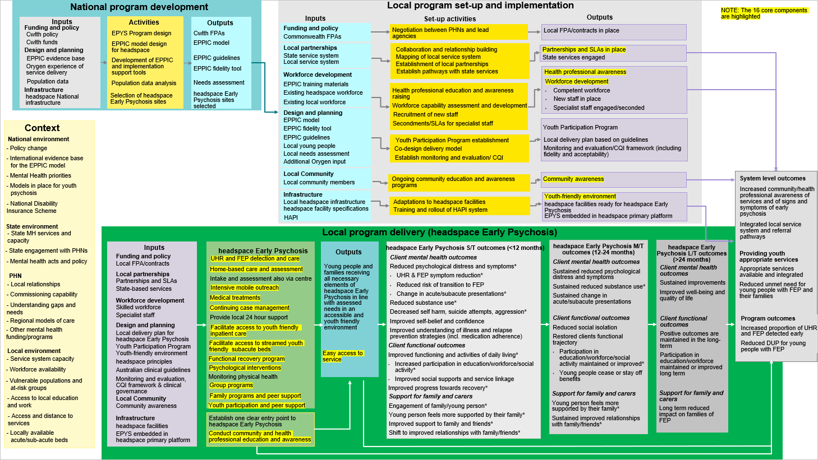

1. Qualitative interview method

Client, family and carer interview limitations

While recruitment of participants through clinicians at respective headspace Early Psychosis services was essential, it also represents a significant limitation of the study in terms of selection bias. For example:

* Due to the limited recruitment window, researchers may not have had access to the views of clients who were currently unwell, and more motivated clinicians may have made a greater number of referrals to the researchers.
* It is also possible that clients and families with a more negative experience of headspace Early Psychosis may not engage in an interview nor be referred. Efforts were made to mitigate these concerns through purposive sampling which appeared to be successful in terms of participant demographics.

Specifically, the young people participating in these qualitative interviews at ‘time point 2’ were generally reflective of the broader headspace Early Psychosis population. One exception to this was that the median length of time in program at ‘time point 2’ was longer for these participants (21 months) compared to what was reflected in the hAPI data — where the median length of time in program from young people accessing FEP support (derived from discharged cases) was approximately six months. Due to this lengthier period with the service, it is possible that these interviewed participants had greater access to program features that support functional recovery and had more instances of accessing hospital. Whereas, the median length of time in the service was shorter (11 months) for young people from the state-funded services who were interviewed.

Two further limitations of qualitative research in general included a reliance on participant recall and interviewer presence possibly influencing the participant responses due to social desirability effects. To ensure that young people and families felt comfortable during the interview process to share their honest viewpoints, they were reminded of the confidential and anonymous nature of participation. For state-funded services, Nepean Blue Mountains Local Health District did not recruit any participants before data collection ceased and only one interview took place at the Western Sydney Local Health District. This is attributed to the limited recruitment window for these LHDs because of lengthy Site Specific Application (SSA) approval processes combined with the impacts of the emergence of the global pandemic COVID-19 (where clinicians moved to remote working environments, making recruitment of participants more challenging). Thus, most of the state-funded service data was extracted from two services operating within SLHD. Further, due to COVID-19, phone rather than face-to-face interviews took place for all participants at all participating state-funded Early Psychosis services and for some participants from headspace Early Psychosis (Penrith).

Detailed methodology for client and family interview and focus groups

Client satisfaction in hAPI stratified by cluster

The primary aim of the qualitative client, family and carer interviews and focus groups (method 4) was to collect information on first-hand experience of the EPYS Program. Data were collected across three time points, which were April to July 2018 (time point 1a); November 2018 (time point 1b); and, December 2019 to March 2020 (time point 2). At time points 1a and 1b, the qualitative research focused specifically on client, family and carer perspectives on the implementation, appropriateness, effectiveness, efficiency and equity of the EPYS Program. At time point 3, the research focused in further depth on the hospitalisation experiences and functional outcomes of clients of the EPYS Program.

Analysis and findings of Phase 2 complement other aspects of the evaluation by interfacing with method 1 (Consultation with overarching EPYS Program stakeholders), method 2 (Consultation with local stakeholders with direct experience of headspace Early Psychosis) method 3 (Case studies of usual care models (state-funded services)) and method 6 (headspace Early Psychosis specific data). Specifically, findings are discussed in relation to the secondary evaluation questions as outlined below in Table 17.

Table 17: Primary and Secondary Evaluation Questions relevant to Methods 3 & 4

|  |  |  |
| --- | --- | --- |
| **Primary Evaluation Questions** | **Secondary Evaluation Questions** | **Time point data source** |
| 1. How effective has the implementation of the EPYS program been to date and what can we learn from it? | 1.3 To what extent has the EPYS Program reached the target population? | 1 and 2 |
| 1.4 How successfully has the EPYS Program integrated within the local health and other service systems? | 1 and 2 |
| 2. How appropriate is the EPYS program design to deliver the program outcomes? | 2.1 To what extent is program design acceptable and relevant to clients and their families? | 2 |
| 2.2 To what extent does the program design align with the policy and practice of the broader system of care for young people experiencing Early Psychosis or other severe mental illness? | 1 and 2 |
| 3. How effective is the EPYS program in achieving outcomes for young people and their families? | 3.3 How effective is the EPYS program for young people with or at risk of Early Psychosis in reducing risk behaviours? | 1 |
| 3.4 How effective is the EPYS Program in reducing the impact of young people with or at risk of Early Psychosis, on health service utilisation [hospitalisation]? | 2 |
| 3.6 How effective is the EPYS program in restoring the functional trajectory of young people with or at risk of Early Psychosis? [Note: including educational and vocational outcomes] | 1 and 2 |
| 3.7 How effective is the EPYS program in improving the capacity of families to support and maintain relationships with young people with Early Psychosis? | 2 |
| 3.8 How satisfied are clients and their families with the EPYS program (explored through elements of perception, experience, expectation, baseline need)? | 2 |

Method

Ethical Approval

Ethical approval was granted on 9 April 2018 by the Ethics Review Committee at the Royal Prince Alfred Hospital, Sydney Local Health District (SLHD), as *Protocol No. X17-0398 & HREC/17/RPAH/596 “Qualitative Study: Early Psychosis Youth Services Program Evaluation*”. External Entity Agreements were engaged with each PHN and are valid to provide the SLHD jurisdiction for a period of five years.

For state-funded Early Psychosis services, Site Specific Applications (SSAs) were approved by Governance in each participating LHD, noting SSA approval dates varied: SLHD (30th Jan 2020) WSLHD (26th March 2020) and NBMLHD (14th April 2020).

Setting

The EPYS Program is offered at several headspace sites across Australia. In consultation with the Australian Government Department of Heath, two clusters (Western Sydney and Darwin) were selected to take part in method 4 of the evaluation. A brief overview of the context of these clusters is provided below.

**Cluster 1:** The Western Sydney cluster is comprised of three sites: the hub is located in Mount Druitt and the spokes are located in Parramatta and Penrith. This large cluster commenced headspace Early Psychosis services in September 2014, led by Uniting Care. It is the only headspace Early Psychosis service in NSW. The Mount Druitt and Parramatta sites are supported by the Western Sydney PHN and liaise with the Western Sydney LHD, while the Penrith site is supported by the Nepean Blue Mountains PHN and liaises with the Nepean Blue Mountains LHD. Both LHD’s offer early interventions programs for young people with psychosis. The Penrith site is co-located with the Child and Youth Mental Health Service in Nepean Blue Mountain LHD (in the same office building). The Mount Druitt site was originally co-located with Western Sydney LHD Child and Youth Mental Health Service, but is not currently co-located. There have been many funding shifts over time with the services, and implications for funding of the early intervention programs offered by the state LHDs as well.

**Cluster 2:** The Darwin cluster is comprised of a single site in the suburb of Casuarina. It commenced services in April 2015, but in a limited capacity because funding was ‘frozen’ in May 2015. Since, there have been various funding shifts, The Darwin headspace Early Psychosis service is supported by the NT PHN and liaises with the Top End Mental Health Services (TEMHS). In the NT, there are no other early intervention programs for young people with FEP.

In addition, four state-funded Early Psychosis services from three different LHDs (Sydney Local Health District (SLHD); Western Sydney Local Health District (WSLHD); Nepean Blue Mountains Local Health District (NBMLHD)) were recruited to take part for comparative purposes. Due to the limited recruitment window based on SSA approvals and the impacts of COVID-19, NBMLHD did not recruit any participants before data collection ceased.

Design

In 2018 (time-point 1a and 1b) data collection was conducted with two cohorts:

* **Cohort 1:** clients and family members or carers were who had recently been through the assessment process (MATT) and were less than 6 months into their journey with EPYS. Data collection was conducted in two rounds using a *rolling cohort study design*. Initial and follow up interviews with young people and focus groups with family members or carers were conducted with the same participants approximately three months apart.
* **Cohort 2:** clients and family members or carers who were engaged with the headspace Early Psychosis for longer than 6 months at the time of interview or focus group.

The rationale for this two cohort design was to develop an understanding the needs, expectations, experience and the impact of the support for clients and their families at all stages of engagement with headspace Early Psychosis — that is, from early on in their engagement with the program to discharge.

In 2019 and 2020 (time point 2) additional one-off in-depth interviews with clients, family members and carers were used to capture their first-hand experiences of service use, with a particular focus on their experiences of hospitalisation and functional recovery outcomes. This included two cohorts:

* **Cohort 1**: clients and family members or carers of headspace Early Psychosis who met eligibility requirements.
* **Cohort 2**: clients and family members or carers of participating state-funded Early Psychosis services who met eligibility requirements.

Participants and recruitment

Clients

Eligible clients of the EPYS program were recruited through clinician referral. Client eligibility requirements are presented in Table 18.

Table 18: Client Eligibility

|  |
| --- |
| **Eligibility** |
| * Between the ages of 12-25 years * Clinician nomination assessment of stability of mental health * Completion of EPYS Program initial assessment and service engagement (minimum two weeks) * Parent/guardian consent for young people between the ages of 12 and 15 years, and when advised by the clinician, for young people between the ages of 16 and 18 years |

Purposive sampling was also used to recruit a sample that represented the diversity of the headspace Early Psychosis (and state-funded Early Psychosis) client population. Clinicians nominated suitable clients according to clinical status, capacity to consent, representation of special interest groups and client experience of hospitalisation. The sample included a mixture of clients who:

* were of various ages between 12 and 25 years
* presented with symptoms consistent with FEP or UHR
* identified across genders
* identified as Aboriginal or Torres Strait Islander
* identified as culturally and linguistically diverse (CALD)
* hospitalisation experience (time point 2 only).

A two-stage consent process was used, outlined in Figure 1. Clinicians briefly described the study and what was involved to clients who they considered to be suitable to participate in a semi-structured interview of approximately one hour. Clinicians invited clients to participate, scheduled a mutually agreeable time for the interview and introduced clients to the evaluation team member.

Figure 1: headspace Early Psychosis client interview consent process

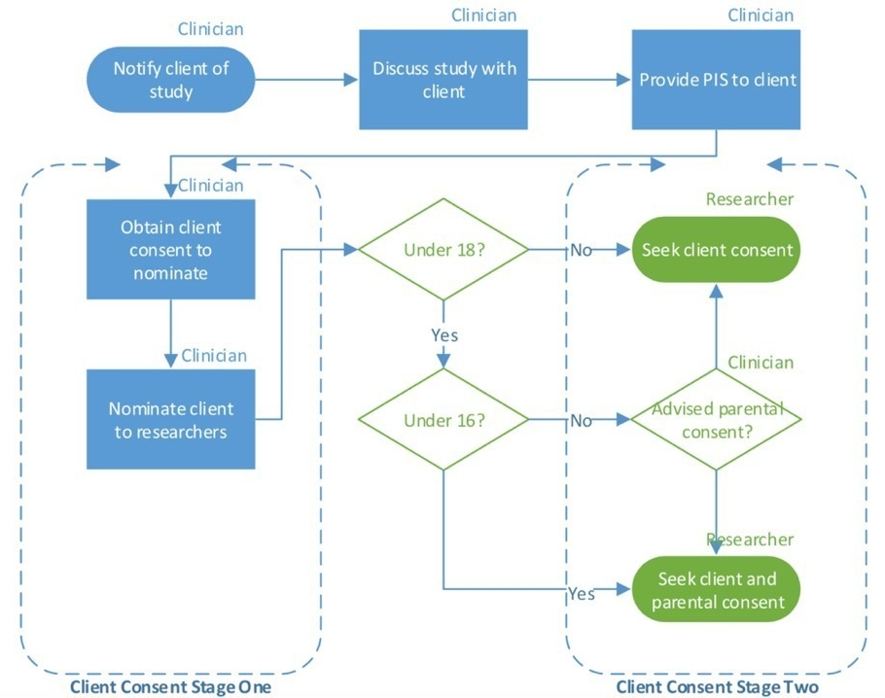

Specific consent to participate in the study was obtained by the researcher in accordance with National Health and Medical Research Council guidelines. In addition to the young person’s consent, clients aged 12-15 years required parental co-consent, and those between 16-18 years of age required parental consent subject to clinician advice and state specific laws. Clients were welcome to include their parent/carer or friend(s) in the semi-structured interview if they wished. To ensure participants were not disadvantaged, they were reimbursed in the form of a gift certificate for $25 from supermarket retailers.

Clients

Adult family members and carers of young people accessing headspace Early Psychosis (and state-funded Early Psychosis) were recruited through clinician referral and existing family and carer groups. Eligibility criteria to participate in the interviews were broad (see Table 19).

Table 19: Family Member or Carer Eligibility

|  |
| --- |
| **Eligibility** |
| * At least 18 years of age * Parent, guardian, family member or friend of a current client of headspace Early Psychosis |

Purposive sampling was also used to recruit a sample that represented the diversity of the family and carer population. The sample included a mixture of family members and carers who:

* were of various ages
* identified across genders
* identified as culturally and linguistically diverse (CALD)
* supported a young person through a hospitalisation experience (time point 2 only).

Semi-structured interviews and focus groups

At time point 1, all interviews and focus groups were conducted by qualitative researchers from Susan Wakil School of Nursing and Midwifery at University of Sydney. At time point 2, the members of the evaluation team who conducted the interviews at time point 2 included a psychologist and psychiatry registrar from the University of Sydney’s Faculty of Medicine and Health.

During all interviews[28], clients, family and carers were asked about their engagement with and perceptions of:

* their experience coming into the program (access and expectations);
* their satisfaction and engagement with the program, including their perceptions of program appropriateness;
* how the headspace Early Psychosis compared if they had experiences with mental health or other related services;
* treatment (medication, cognitive behaviour therapy, family care);
* ongoing community care, mobile outreach and group programs;
* family programs and family peer support; and
* youth participation and peer support program.

At time point 2, interviews clients and family/ carers were also asked about:

* Their hospitalisation experiences before and during their engagement with the EPYS program; and
* Changes in the young person’s functional outcomes (e.g. employment, education, socialisation and relationships, self-care) and the influence the local headspace Early Psychosis and other services/people had on any identified changes.

The average duration of interviews at time points 1a and 1b was 52 minutes with young people, one hour and 21 minutes for focus groups, and 54 minutes for family and carer interviews. The average duration of all interviews at time point 2 at headspace Early Psychosis was 58 minutes for young people and 68 minutes for family and carers. At state-funded Early Psychosis services average interview length was 54 minutes for young people and 70 minutes for family and carers.

Analysis

Time points 1 and 2 were analysed separately as they had a different research focus, although a similar analysis approach was used. The analysis approach across all time points is outlined in Table 20.

Table 20: Qualitative thematic analysis at time point 1a, 1b and 2

| **Qualitative analysis stage** | **Details** |
| --- | --- |
| Interviews | Audio recorded. |
| Transcription | Interviews and focus groups transcribed and all identifiers were removed or camouflaged. |
| Method | *Timepoint 1a and 1b:* Data was interpreted thematically using methods outlined by (Coffey & Atkinson, 1996).  *Timepoint 2:* Data was interpreted thematically using both inductive and deductive methods outlined by Braun and Clarke (2006). |
| Coding framework | *Time point 1a and 1b:* The texts were then coded and analysed collaboratively by qualitative researchers. At time point 1, researchers from Susan Wakil School of Nursing and Midwifery at University of Sydney used an open coding approach and independently coded a subset of transcripts (six client interview transcripts and four focus group transcripts). They then met to review their coding, discuss possible themes, and a coding scheme was developed collaboratively. A coding scheme was used to organise and manage the large volume of data.  *Time point 2:* Interview transcripts were coded and analysed collaboratively by the qualitative research team at University of Sydney which consisted of a psychologist, a psychiatry registrar, a lived experience researcher and an adjacent heath professional (pharmacist). The research team used a thematic coding approach targeting each key evaluation question. The researchers independently coded the transcripts (six interview transcripts) and met to review their coding, discuss emerging themes, and develop a coding framework. |
| Coding and analysis | *Time point 1a and 1b:* Coding was done in the NVivo11 software for qualitative data management, and thematic analysis was conducted. Data analysis was done iteratively along with data collection. The analysis was then reviewed with an orientation to collecting and sharing insights into the implementation, appropriateness and effectiveness of the headspace Early Psychosis service, from the perspective of young people and family members or carers. Themes were organised in response to the evaluation questions. Data from the initial and follow up interviews and focus groups were compared and analysed. Data across sites were compared and analysed.  *Time point 2:* All data was coded thematically in NVivo12 software by one researcher, which was reviewed by another team member to check agreement. Data analysis was iterative, so that any new emerging themes could be incorporated. Similarities and differences in opinion were examined, and differences dealt with through discussion to reach consensus. |

Sample characteristics

From April to July 2018 (time point 1a), 33 initial in-depth semi-structured interviews were conducted with young people, 11 focus groups (n=27) were conducted with family and carers at Darwin, Parramatta, Penrith, Mount Druitt headspaces. Family members or carers who could not attend were offered an opportunity for an interview (n=7) during this time period. One family and carer from Cohort 1 withdrew from the study. From July to November 2018 (time point 1b), seven follow-up interviews were conducted with young people. Follow-up focus groups and interviews were conducted with 10 family and carers. A breakdown of participant type and number across sites and time points is presented in Table 21.

Table 21: Client interviews across sites at time point 1a and 1b

|  | **Site** | **Cohort 1**  **Engaged in program < 6 months**  **(n)** | | **Cohort 2**  **Engaged in program > 6 months**  **(n)** | |
| --- | --- | --- | --- | --- | --- |
| **Participants** | **Site** | **Initial Interview** | **Follow up** | **Single Interview** | **Follow up[29]** |
| Client | Darwin | 11 | 3 | 9 | 1 |
| Mt Druitt | 3 | 1 | 2 | - |
| Penrith | 3 | 2 | 2 | - |
| Parramatta | - | - | 3 | - |
|  | **Total** | **17** | **6** | **16** | **1** |
| Family and carer | Darwin | 6 | 3 | 8 | 2 |
| Mt Druitt | 5 | 5 | 5 | - |
| Penrith | 3 | 2 | 4 | - |
| Parramatta | - | - | 4 |  |
|  | **Total** | **14** | **10** | **19** | **2** |

At time-point 2, semi-structured interviews with 19 young people and 10 family and carers were conducted at Darwin, Parramatta and Penrith headspace Early Psychosis from December 2019 to March 2020. From March to May 2020, these interviews were conducted at state-funded services located in Camperdown and Parramatta. A breakdown of participant type and number across sites is presented in Table 22.

Table 22: Numbers of clients and family/carers who participated across sites at time point 2

| **Funding** | **Site** | **Clients (n)** | **Family/ carers (n)** |
| --- | --- | --- | --- |
| headspace Early Psychosis | Darwin | 5 | 3 |
| Parramatta | 9 | 4 |
| Penrith | 5 | 3 |
|  | **Total** | **19** | **10** |
| State-funded services | Camperdown Early Intervention Team | 3 | 1 |
| Camperdown Early Intervention in Psychosis Service | 4 | 1 |
| Parramatta Early Intervention Recovery Service | 1 | 0 |
|  | **Total** | **8** | **2** |

At all time points, clinicians at each site supported the recruitment of clients and family members or carers that were representative of those in the headspace Early Psychosis. Sampling did not require researcher access to the client record. Basic demographic data was collected directly from the participant at prior to the interview of focus group (Table 23 and Table 24).

Table 23: Sample Demographics – Clients

| **Clients n=33** | | **All sites** | |
| --- | --- | --- | --- |
| **Demographics** | | **n** | **%** |
| Time in program (3 weeks – 3 years) | < 6 months | 17 | 51.5 |
| > 6 months | 16 | 48.5 |
| Age (14-26 years) | 14 – 16 years | 6 | 18.2 |
| 17 – 19 years | 12 | 36.4 |
| 20 – 22 years | 10 | 30.3 |
| 23 – 25 years | 4 | 12.1 |
| 26 years | 1 | 3.0 |
| Gender | Male | 19 | 57.6 |
| Female | 11 | 33.3 |
| Transgender | 1 | 3.0 |
| Non-binary | 2 | 6.1 |
| Living Situation | Parent(s) | 25 | 75.8 |
| Siblings or grandparent(s) | 3 | 9.1 |
| Partner/husband/wife | 3 | 9.1 |
| Friend(s) | 1 | 3.0 |
| State appointed carer | 1 | 3.0 |
| Identifies as an Aboriginal or Torres Strait Islander | Yes | 4 | 12.1 |
| No | 29 | 87.9 |
| Speaks two or more languages | Yes | 10 | 30.3 |
| No | 23 | 69.7 |
| Immigrated to Australia | Yes | 6 | 18.2 |
| No | 27 | 81.8 |

Table 24: Sample Demographics – Family Members and Carers

|  |  |  |  |
| --- | --- | --- | --- |
| **Family Members/Carers n=33** | | **All sites** | |
| **Demographics** | | **n** | **%** |
| Time in program (1 month – 5 years) | < 6 months | 14 | 42.3 |
| > 6 months | 19 | 57.6 |
| Gender | Male | 9 | 27.3 |
| Female | 24 | 72.7 |
| Identifies as an Aboriginal or Torres Strait Islander | Yes | 0 | 0 |
| No | 33 | 100.0 |
| Speaks two or more languages | Yes | 10 | 30.3 |
| No | 23 | 69.7 |
| Immigrated to Australia | Yes | 13 | 39.4 |
| No | 20 | 60.6 |

At time point 2, demographic data were collected at the time of interview or afterwards and are presented in Table 25 and Table 26.

Table 25: Sample Demographics – Clients

| **Clients n=19** | | **State-funded sites** | | **All headspace Early Psychosis sites** | | **Darwin headspace Early Psychosis** | | **Penrith headspace Early Psychosis** | | | **Parramatta headspace Early Psychosis** | | |
| --- | --- | --- | --- | --- | --- | --- | --- | --- | --- | --- | --- | --- | --- |
| **Demographics** | | **Median** | **Range** | **Median** | **Range** | **Median** | **Range** | **Median** | **Range** | | **Median** | | **Range** |
| Time in program | Months | 11 | 1 to 29 | 21 | 6 to 55 | 21 | 6 to 29 | 43 | | 9 to 55 | 15 | | 9 to 48 |
|  |  | **n** | **%** | **n** | **%** | **n** | **%** | **n** | | **%** | **n** | **%** | |
| FEP or UHR | FEP | 5 | 62.5 | 17 | 89.5 | 4 | 80.0 | 4 | | 80.0 | 9 | 100.0 | |
| UHR | 3 | 37.5 | 2 | 10.5 | 1 | 20.0 | 1 | | 20.0 | 0 | 0.0 | |
| Age | 14 – 16 years | 1 | 12.5 | 2 | 10.5 | 1 | 20.0 | 1 | | 20.0 | 0 | 0.0 | |
| 17 – 19 years | 0 | 0.0 | 6 | 31.6 | 0 | 0.0 | 2 | | 40.0 | 4 | 44.4 | |
| 20 – 22 years | 2 | 25.0 | 7 | 36.8 | 3 | 60.0 | 1 | | 20.0 | 3 | 33.3 | |
| 23 – 25 years | 4 | 50.0 | 3 | 15.8 | 1 | 20.0 | 1 | | 20.0 | 1 | 11.1 | |
| 26 years + | 1 | 12.5 | 1 | 5.3 | 0 | 0.0 | 0 | | 0.0 | 1 | 11.1 | |
| Gender | Male | 6 | 75.0 | 10 | 52.6 | 3 | 60.0 | 2 | | 40.0 | 5 | 44.4 | |
| Female | 2 | 25.0 | 9 | 47.4 | 2 | 40.0 | 3 | | 60.0 | 4 | 55.6 | |
| Transgender | 0 | 0.0 | 0 | 0.0 | 0 | 0.0 | 0 | | 0.0 | 0 | 0.0 | |
| Non-binary | 0 | 0.0 | 0 | 0.0 | 0 | 0.0 | 0 | | 0.0 | 0 | 0.0 | |
| Living Situation | Family | 5 | 62.5 | 13 | 68.4 | 3 | 60.0 | 3 | | 60.0 | 7 | 77.8 | |
| Partner/ husband/ wife | 1 | 12.5 | 1 | 5.3 | 0 | 0.0 | 1 | | 20.0 | 0 | 0.0 | |
| Friend(s) | 1 | 12.5 | 1 | 5.3 | 1 | 20.0 | 0 | | 0.0 | 0 | 0.0 | |
| State appointed carer | 0 | 0.0 | 1 | 5.3 | 0 | 0.0 | 0 | | 0.0 | 1 | 11.1 | |
| By self | 1 | 12.5 | 0 | 0.0 | 0 | 0.0 | 0 | | 0.0 | 0 | 0.0 | |
| Not specified | 0 | 0.0 | 3 | 15.8 | 1 | 20.0 | 1 | | 20.0 | 1 | 11.1 | |
| Identifies as an Aboriginal or Torres Strait Islander | Yes | 1 | 12.5 | 2 | 10.5 | 1 | 20.0 | 1 | | 20.0 | 0 | 0.0 | |
| No | 7 | 87.5 | 17 | 89.5 | 4 | 80.0 | 4 | | 80.0 | 9 | 100.0 | |
| Non English Speaking Background | Yes | 3 | 37.5 | 6 | 31.6 | 3 | 60.0 | 0 | | 0.0 | 3 | 33.3 | |
| No | 5 | 62.5 | 13 | 68.4 | 2 | 40.0 | 5 | | 5.0 | 6 | 66.6 | |
| Currently in education | Yes | 5 | 62.5 | 12 | 63.2 | 3 | 60.0 | 4 | | 80.0 | 5 | 44.4 | |
| No | 3 | 37.5 | 7 | 36.8 | 2 | 40.0 | 1 | | 20.0 | 4 | 55.6 | |
| Currently in employment | Yes | 4 | 50.0 | 6 | 31.6 | 2 | 40.0 | 1 | | 20.0 | 3 | 33.3 | |
| No | 4 | 50.0 | 9 | 47.4 | 3 | 60.0 | 0 | | 0.0 | 6 | 66.6 | |
| Education, training or employment | Yes | 8 | 100.00 | 13 | 68.4 | 3 | 60.0 | 4 | | 80.0 | 6 | 66.6 | |
| No | 0 | 0.0 | 6 | 31.6 | 2 | 40.0 | 1 | | 0.0 | 3 | 33.3 | |

Table 26: Sample Demographics – Family Members and Carers

|  |  |  |  |  |  |  |  |  |  |  |  |
| --- | --- | --- | --- | --- | --- | --- | --- | --- | --- | --- | --- |
| **Family/carers n=10** | | **State-funded sites** | | **All headspace Early Psychosis sites** | | **Darwin** | | **Penrith** | | **Parramatta** | |
|  | | **Median** | **Range** | **Median** | **Range** | **Median** | **Range** | **Median** | **Range** | **Median** | **Range** |
| Time in program | Months | 8 | 7 to 9 | 14 | 6 to 50 | 14 | 7 to 29 | 14 | 9 to 50 | 12 | 6 to 48 |
|  |  | **n** | **%** | **n** | **%** | **n** | **%** | **n** | **%** | **n** | **%** |
| FEP or UHR | FEP | 1 | 50.0 | 9 | 90.0 | 3 | 100.0 | 2 | 66.7 | 4 | 100.0 |
| UHR | 1 | 50.0 | 1 | 10.0 | 0 | 0.0 | 1 | 33.3 | 0 | 0.0 |
| Gender | Male | 1 | 50.0 | 3 | 30.0 | 0 | 0.0 | 2 | 66.7 | 1 | 25.0 |
| Female | 1 | 50.0 | 7 | 70.0 | 3 | 100.0 | 1 | 33.3 | 3 | 75.0 |
| Transgender | 0 | 0.0 | 0 | 0.0 | 0 | 0.0 | 0 | 0.0 | 0 | 0.0 |
| Non-binary | 0 | 0.0 | 0 | 0.0 | 0 | 0.0 | 0 | 0.0 | 0 | 0.0 |
| Identifies as an Aboriginal or Torres Strait Islander | Yes | 0 | 0.0 | 0 | 0.0 | 0 | 0.0 | 0 | 0.0 | 0 | 0.0 |
| No | 2 | 100.0 | 10 | 100.0 | 3 | 100.0 | 3 | 100.0 | 4 | 100.0 |
| Non English Speaking Background | Yes | 1 | 50.0 | 7 | 70.0 | 3 | 100.0 | 1 | 33.3 | 3 | 75.0 |
| No | 1 | 50.0 | 3 | 30.0 | 0 | 0.0 | 2 | 66.7 | 1 | 25.0 |
| Education, training or employment | Yes | 1 | 50.0 | 6 | 60.0 | 1 | 33.3 | 3 | 100.0 | 2 | 50.0 |
| No | 1 | 50.0 | 2 | 20.0 | 0 | 0.0 | 0 | 0.0 | 2 | 50.0 |
| Not described | 0 | 0.0 | 2 | 20.0 | 2 | 66.6 | 0 | 0.0 | 0 | 0.0 |

References

Braun, V., & Clarke, V. (2006). Using thematic analysis in psychology. *Qualitative research in psychology*, *3*(2), 77-101.

Coffey, A., & Atkinson, P. (1996). *Making sense of qualitative data: complementary research strategies*. Thousand Oaks: Sage Publications.

1. Ecological analysis: supplemental material

Overview

The aim of the ecological analysis was to analyse temporal changes in health service utilisation in young people with Early Psychosis and compare temporal change between geographical areas that include an EPYS cluster and those that do not. The ecological analysis used a retrospective cohort design using routinely collected data. The primary null hypothesis tested was that health service utilisation between 2015 and 2019 was the same between geographical areas that include the EPYS Program and those that do not.

Ethics

Ethical approval was obtained in NSW and WA. In both jurisdictions, a waiver of consent was sought as this was the best way to ensure the validity of the approach while protecting individual privacy. Following approval from the data custodians and the ethics committees and linkage from the Data Linkage Unit (WA) and the Centre for Health Record Linkage (NSW), de-identified data was securely transferred to A/Prof Laurent Billot at the George Institute for Global Health. Data was stored on the George Institute server in a folder accessible only to Laurent Billot, Sandrine Stepien and Anna Campain, the three statisticians from the George Institute who worked on the ecological analysis.

WA Ethics:

* Lead HREC: Department of Health WA Human Research Ethics Committee
* PRN: RGS0000001176.

NSW Ethics:

* Lead HREC: NSW Population & Health Services Research Ethics Committee
* CI NSW Study Reference Number: 2018HRE0803
* AU RED Study Reference Number: HREC/18/CIPHS/36
* HREC reference number: 2019/PID01925 (parent) & 2019/ETH01582 (amendment).

Study population definition and data linkage

The ecological analysis cohort was defined as individuals born between 1 July 1990 and 1 July 2006 who were hospitalised with an ICD-10 coded psychosis diagnosis (primary or other diagnosis) at least once from 1 July 2010 onwards. For these eligible individuals, access to their entire ED and inpatient service utilisation history (from 1 July 2010 until 1 July 2019) was sought, whether other occasions of service were related to psychosis or not. This was done by linking hospital admissions, emergency department presentations and deaths in NSW and WA. In NSW, ambulatory mental health occasions of services were linked as well, in order to identify individuals who had been in contact with state-funded early-psychosis services.

Table 27: Number of records and individuals included in the ecological analysis for each data source in WA and NSW

|  | **Western Australia (WA)** | | | **New South Wales (NSW)** | | |
| --- | --- | --- | --- | --- | --- | --- |
| **Data source** | **Date range** | **# individuals** | **# records** | **Date range** | **# individuals** | **# records** |
| Hospital admissions * | 01.07.2010 30.06.2019 | 2,968 | 24,769 | 01.07.2010 30.09.2019 | 10,767 | 91,544 |
| ED presentations | 01.07.2010 30.11.2019 | 2,911 | 46,540 | 01.07.2010 30.09.2019 | 10,429 | 134,613 |
| Deaths | 01.07.2010 31.12.2019 | 50 | 50 | 01.07.2011 30.09.2019 | 148 | 148 |
| Ambulatory mental health services | -N/A- | | | 01.11.2011 31.12.2018 | 9,657 | 1,578,621 |

* In NSW, private hospital data was only available up to 30 June 2018

Definition of EPYS and non-EPYS catchments

The table below shows how mental health service (MHS) areas were grouped to build the EPYS and non-EPYS catchments used for the main comparisons and to estimate the effect of EPYS verse non-EPYS on health service utilisation outcomes. Three MHS areas were considered as EPYS: Blacktown Mt Druitt, Parramatta Hills Merrylands and Nepean and Plains while thirteen areas were included in the non-EPYS metro comparator.

Table 28: Grouping of EPYS to non-EPYS catchments

|  |  |
| --- | --- |
| **EPYS region** | **Non-EPYS metro region** |
| Blacktown Mt Druitt | Bankstown |
| Parramatta Hills Merrylands | Blue mountains |
| Nepean and Plains | Concord |
|  | Eastern suburbs |
|  | Hornsby Ku-Ring-Gai |
|  | Liverpool |
|  | Lower North Shore |
|  | Macarthur |
|  | Northern Beaches |
|  | Royal Prince Alfred |
|  | Ryde |
|  | St George |
|  | Sutherland |

In WA, Perth North (EPYS) was compared to Perth South (non-EPYS metro).

Analysis plan

Hospitalisation rates were derived using the number of separations per subject recorded in the hospitalisation dataset. The rate of hospitalisations per 100 persons was calculated per unit of time (either monthly, quarterly or six-monthly depending on the data). Exposure, or time ‘at-risk’, was calculated as the time alive and out of hospital (i.e. individuals were considered at risk of hospitalisation only while they were alive and not already in hospital). The number and rate of hospitalisations with a principal diagnosis of psychosis were derived similarly using psychosis-related codes recorded in the principal diagnosis (All ICD10 codes F20, F21, F22, F23, F24, F25, F28, F29, F30, F31, F32.3 and F33.3). The number and rate of hospitalisations related to self-harm (external causes with a code of X60-X84, X85-Y09) were also derived. Number of bed days, overall and related to a primary psychosis diagnosis were derived by using length of stay combined with the code associated to the principal and co-diagnosis. Number of days in psychiatric care was analysed to quantify use of psychiatric services. The first hospitalisation associated with any diagnosis of psychosis (primary or other) was used to calculate the time of the first episode of psychosis. Standard emergency department record information including the presentation date and the principal diagnosis was used to derive rates of emergency department presentations and quantify emergency department presentations related to self-harm diagnoses. Geolocation information was used to identify the catchment area.

The primary analysis consisted of comparing rates of hospitalisations between EPYS and non-EPYS regions over time. This was done using longitudinal models with a negative-binomial distribution. Models included exposure to the EPYS Program, the effect of time (month) and was adjusted for baseline covariates including socio-demographic characteristics and previous service utilisation. Within-individual correlations were modelled using generalised estimating equations with an auto-regressive correlation structure. The effect of exposure (EPYS Program) was estimated as the difference in hospitalisation rate; here corresponding to the rate ratio between EPYS and non-EPYS regions. Three time periods were considered:

1. **Baseline** period: before establishment of the EPYS Program (before September 2014)
2. **Limited service** period: while limited services were available (January 2015 to June 2017),
3. **Full-service** period: post full-EPYS Program establishment (July 2017 onwards).

The difference in health service utilisation between EPYS and non-EPYS regions was estimated separately within the limited and full-service periods as well as by combining the two periods to derive an overall difference. The baseline period was used to derive model covariates.

Health service utilisation trends in NSW

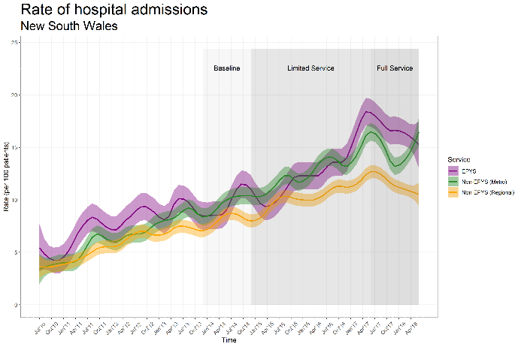

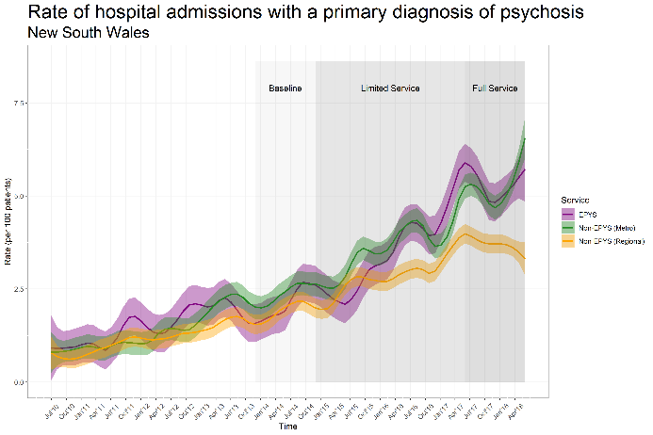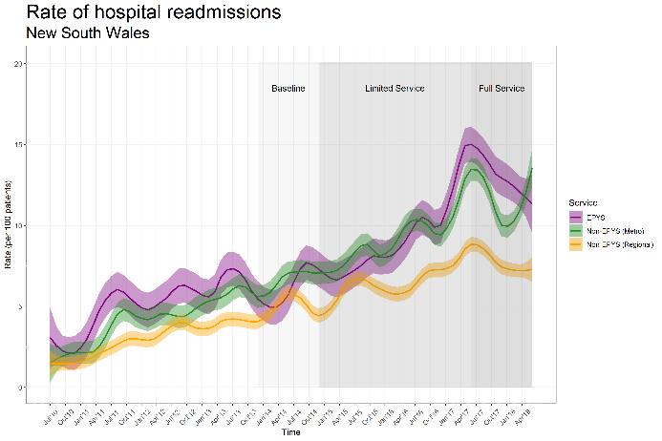

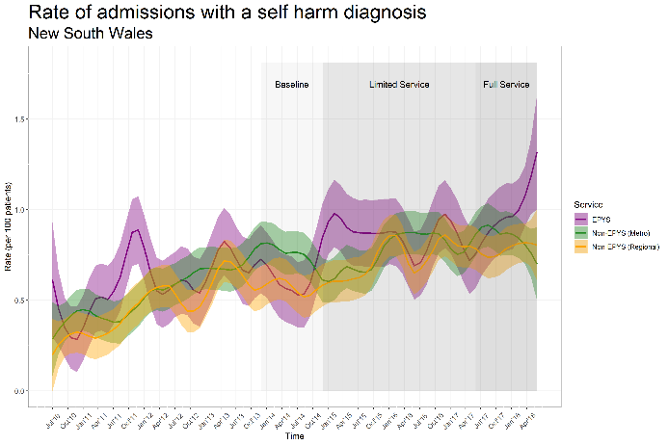

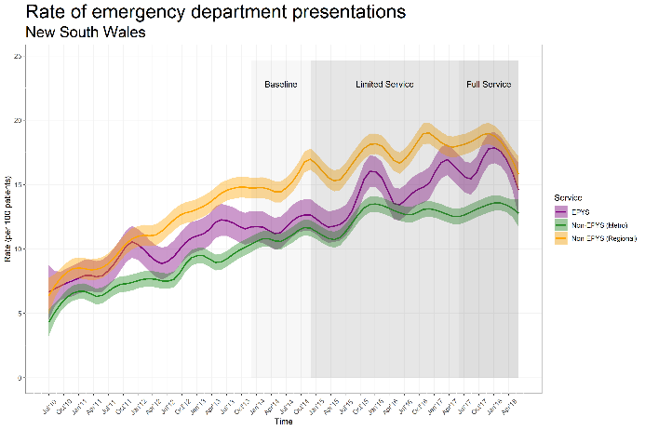

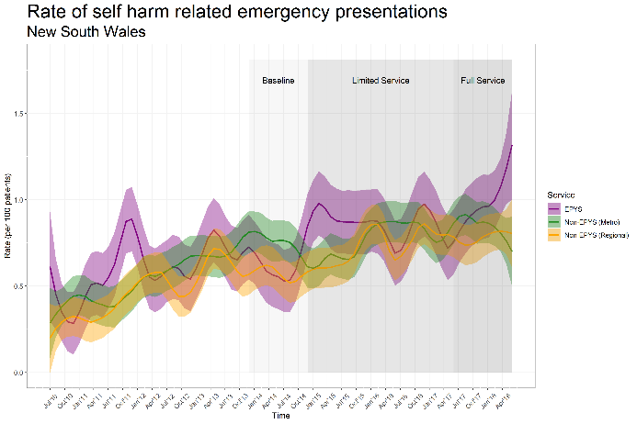

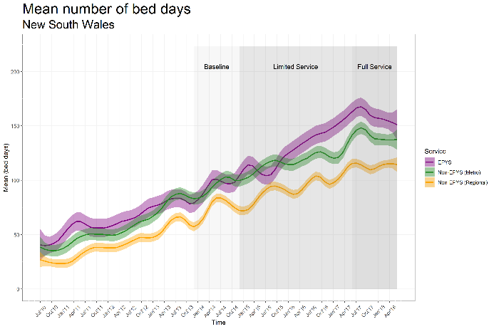

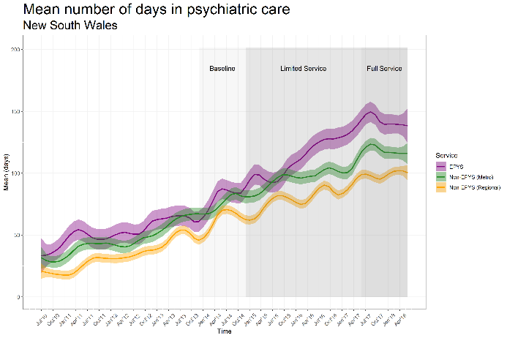

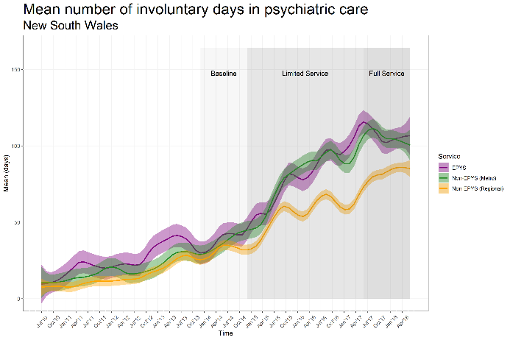

Health service utilisation trends in WA

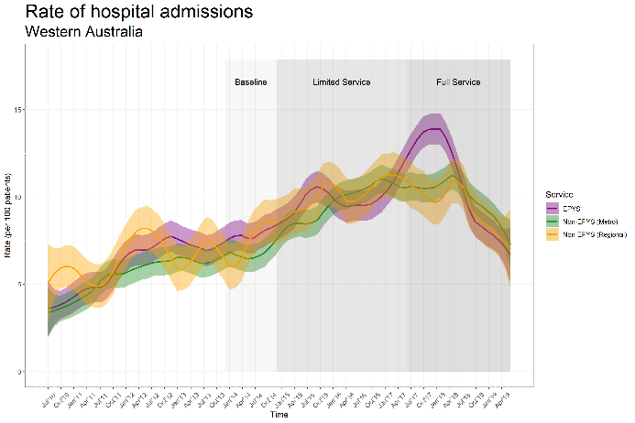

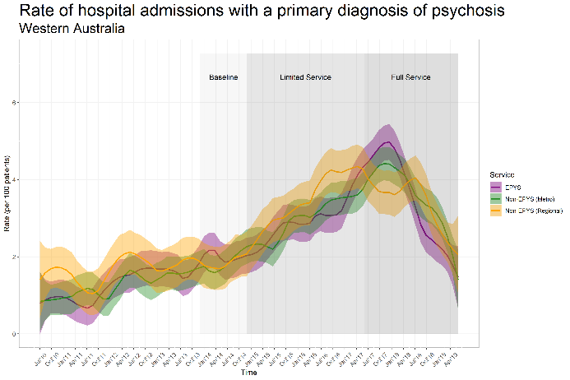

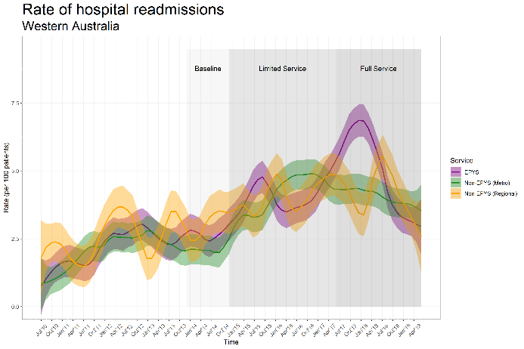

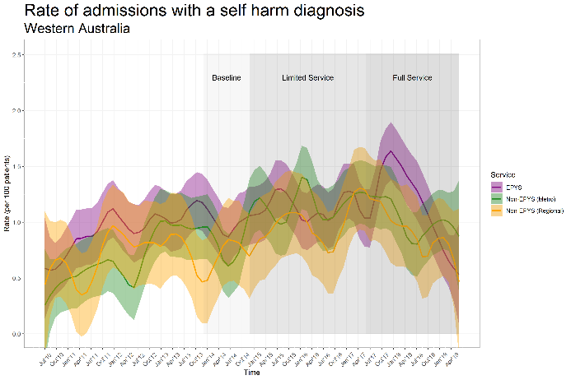

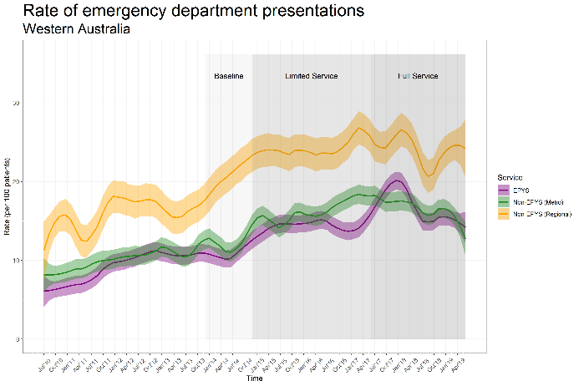

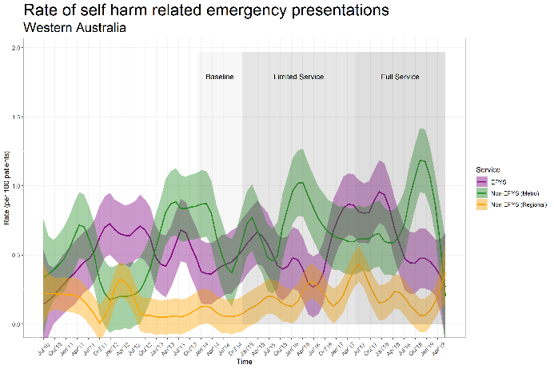

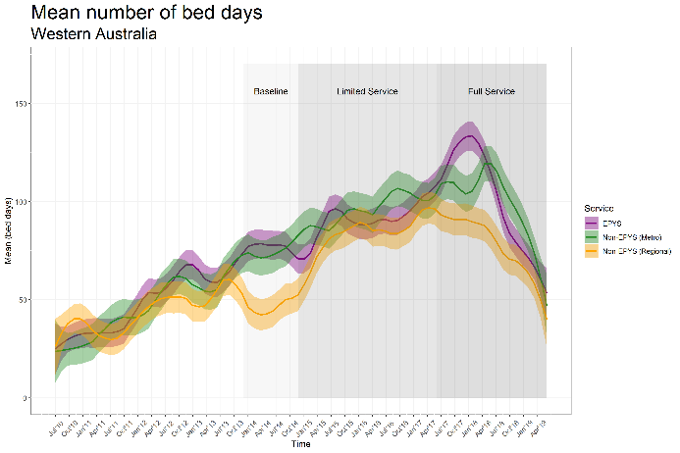

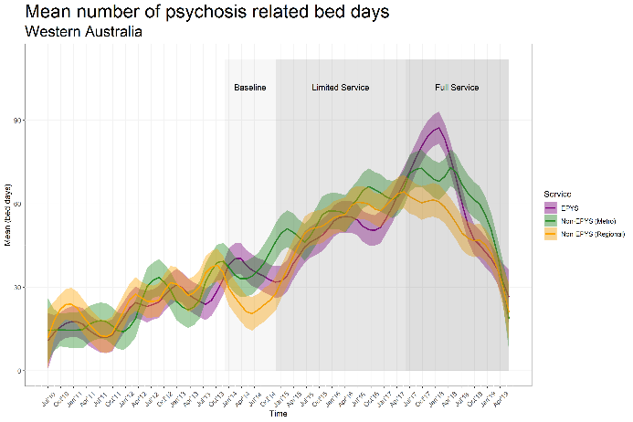

Sensitivity analyses

Sensitivity analyses applied to the respective stat datasets are provided in the below tables.

Table 29: NSW Sensitivity analyses

| **Outcome /**  **Time unit; correlation structure; cutoff** | **EPYS Rate or Mean (SE)** | **Non-EPYS Metro Rate or Mean (SE)** | **Ratio or Mean difference (95% CI)** | **P-value** |
| --- | --- | --- | --- | --- |
| **Hospitalisations (rate)** | | | | |
| Quarter; AR; 1 July 2018 | 1.21 (0.060) | 1.12 (0.035) | 1.09 (0.97; 1.21) | 0.134 |
| Quarter; AR; 1 July 2019 | 1.01 (0.048) | 0.91 (0.029) | 1.10 (0.99; 1.22) | 0.067 |
| Semester; CS; 1 July 2018 | 1.15 (0.058) | 1.06 (0.037) | 1.08 (0.97; 1.21) | 0.172 |
| Yearly; AR; 1 July 2018 | 1.27 (0.067) | 1.17 (0.040) | 1.08 (0.96; 1.22) | 0.179 |
| **Emergency department presentations (rate)** | | | | |
| Quarter; AR; 1 July 2018 | 1.42 (0.066) | 1.23 (0.031) | 1.16 ( 1.05; 1.28) | 0.004 |
| Quarter; AR; 1 July 2019 | 1.42 (0.073) | 1.19 (0.032) | 1.19 ( 1.06; 1.33) | 0.002 |
| Semester; CS; 1 July 2018 | 1.36 (0.064) | 1.19 (0.032) | 1.14 ( 1.03; 1.27) | 0.012 |
| Yearly; AR; 1 July 2018 | 1.48 (0.075) | 1.26 (0.035) | 1.18 ( 1.06; 1.31) | 0.003 |
| **Number of bed days (mean)** | | | | |
| Quarter; AR; 1 July 2018 | 12.5 (0.71) | 11.3 (0.44) | 1.2 (-0.4; 2.9) | 0.131 |
| Quarter; AR; 1 July 2019 | 11.2 (0.61) | 10.2 (0.38) | 1.0 (-0.3; 2.4) | 0.141 |
| Semester; CS; 1 July 2018 | 12.5 (0.71) | 11.2 (0.44) | 1.3 (-0.3; 2.9) | 0.123 |
| Yearly; AR; 1 July 2018 | 12.9 (0.78) | 11.4 (0.48) | 1.4 (-0.3; 3.2) | 0.111 |
| **Number of involuntary days (mean)** | | | | |
| Quarter; AR; 1 July 2018 | 9.0 (1.16) | 11.7 (0.86) | -2.7 (-5.6; 0.2) | 0.064 |
| Quarter; AR; 1 July 2019 | 7.8 (0.89) | 9.7 (0.65) | -1.9 (-4.1; 0.3) | 0.085 |
| Semester; CS; 1 July 2018 | 11.5 (2.11) | 17.2 (1.51) | -5.7 ( -11; -0.4) | 0.033 |
| Yearly; AR; 1 July 2018 | 17.8 (4.90) | 31.4 (3.43) | -14 ( -26; -1.4) | 0.030 |
| **Hospitalisation costs (mean)** | | | | |
| Quarter; AR; 1 July 2018 | 9259 (391) | 8187 (264) | 1073 (206; 1939) | 0.015 |
| Quarter; AR; 1 July 2019 | 8678 (364) | 7688 (254) | 990 ( 178; 1803) | 0.017 |
| Semester; CS; 1 July 2018 | 9294 (392) | 8212 (265) | 1082 ( 213; 1951) | 0.015 |
| Yearly; AR; 1 July 2018 | 9628 (432) | 8332 (290) | 1296 (336; 2257) | 0.008 |

Table 30: NSW: Subgroup analyses

| **Timing** | **Category** | **N** | **EPYS (N=1418)** | **Non-EPYS Metro (N=3402)** | **Ratio EPYS verse non-EPYS Metro** | **P-value** |
| --- | --- | --- | --- | --- | --- | --- |
| **Age (years)** | | | | | | |
| Limited service | < 15 | 1184 | 0.86 (0.66; 1.11) | 0.60 (0.49; 0.73) | 1.43 (1.04; 1.96) | 0.115 |
| 15 - 20 | 8304 | 1.10 (0.96; 1.26) | 1.09 (0.99; 1.20) | 1.01 (0.86; 1.18) |  |
| > 20 | 7768 | 1.27 (1.08; 1.49) | 1.07 (0.97; 1.18) | 1.18 (0.98; 1.43) |  |
| Full service | < 15 | 1184 | 1.60 (1.23; 2.10) | 1.31 (1.05; 1.63) | 1.22 (0.87; 1.72) | 0.310 |
| 15 - 20 | 8304 | 1.35 (1.10; 1.66) | 1.46 (1.30; 1.65) | 0.92 (0.73; 1.17) |  |
| > 20 | 7768 | 1.43 (1.16; 1.75) | 1.19 (1.02; 1.39) | 1.20 (0.93; 1.54) |  |
| **Sex** | | | | | | |
| Limited service | Female | 3803 | 1.43 (1.21; 1.69) | 1.23 (1.12; 1.36) | 1.16 (0.96; 1.41) |  |
| Male | 4825 | 0.92 (0.82; 1.03) | 0.88 (0.81; 0.97) | 1.04 (0.91; 1.20) | 0.318 |
| Full service | Female | 3803 | 1.78 (1.46; 2.16) | 1.62 (1.41; 1.87) | 1.10 (0.86; 1.40) |  |
| Male | 4825 | 1.12 (0.93; 1.34) | 1.11 (0.99; 1.23) | 1.01 (0.82; 1.24) | 0.773 |
| **Number of hospitalisations** | | | | | | |
| Limited service | 0 | 5457 | 0.78 (0.68; 0.90) | 0.70 (0.64; 0.78) | 1.12 (0.97; 1.29) | 0.566 |
| 1 | 1469 | 1.26 (1.02; 1.56) | 1.34 (1.15; 1.56) | 0.94 (0.73; 1.22) |  |
| >=2 | 1702 | 2.15 (1.76; 2.62) | 2.06 (1.77; 2.39) | 1.04 (0.82; 1.34) |  |
| Full service | 0 | 5457 | 1.13 (0.92; 1.37) | 1.16 (1.02; 1.31) | 0.97 (0.78; 1.21) | 0.429 |
| 1 | 1469 | 1.66 (1.23; 2.25) | 1.18 (0.97; 1.43) | 1.41 (0.99; 2.01) |  |
| >=2 | 1702 | 1.65 (1.29; 2.10) | 1.75 (1.40; 2.19) | 0.94 (0.68; 1.30) |  |
| **Previous hospitalisation with diagnosis of psychosis** | | | | | | |
| Limited service | No | 4663 | 2.12 (1.88; 2.39) | 2.03 (1.86; 2.21) | 1.04 (0.90; 1.21) | 0.265 |
| Yes | 3965 | 0.97 (0.83; 1.14) | 0.82 (0.74; 0.91) | 1.18 (0.98; 1.43) |  |
| Full service | No | 4663 | 3.26 (2.78; 3.83) | 3.12 (2.80; 3.47) | 1.05 (0.86; 1.27) | 0.837 |
| Yes | 3965 | 0.83 (0.66; 1.05) | 0.79 (0.67; 0.92) | 1.06 (0.80; 1.39) |  |

Table 31: WA: Subgroup analyses

| **Timing** | **Category** | **N** | **EPYS (N=1029)** | **Non-EPYS Metro (N=896)** | **Ratio EPYS verse non-EPYS Metro** | **P-value** |
| --- | --- | --- | --- | --- | --- | --- |
| **Age (years)** | | | | | | |
| Limited service | < 15 | 150 | 0.86 (0.57; 1.30) | 0.60 (0.41; 0.90) | 1.42 (0.81; 2.47) | 0.182 |
| 15 - 20 | 1195 | 0.82 (0.71; 0.96) | 1.00 (0.84; 1.19) | 0.82 (0.66; 1.02) |  |
| > 20 | 1144 | 0.90 (0.74; 1.09) | 0.81 (0.70; 0.93) | 1.11 (0.91; 1.36) |  |
| Full service | < 15 | 150 | 1.61 (1.06; 2.45) | 1.12 (0.77; 1.64) | 1.43 (0.83; 2.47) | 0.282 |
| 15 - 20 | 1195 | 1.03 (0.84; 1.27) | 1.09 (0.87; 1.37) | 0.94 (0.70; 1.27) |  |
| > 20 | 1144 | 0.84 (0.68; 1.04) | 0.69 (0.58; 0.81) | 1.22 (0.96; 1.55) |  |
| **Sex** | | | | | | |
| Limited service | Female | 1069 | 1.08 (0.89; 1.32) | 1.02 (0.85; 1.23) | 1.06 (0.83; 1.35) | 0.411 |
| Male | 1420 | 0.68 (0.60; 0.78) | 0.77 (0.67; 0.88) | 0.89 (0.75; 1.05) |  |
| Full service | Female | 1069 | 1.23 (0.99; 1.54) | 1.07 (0.82; 1.39) | 1.15 (0.83; 1.61) | 0.712 |
| Male | 1420 | 0.76 (0.64; 0.91) | 0.76 (0.66; 0.89) | 1.00 (0.81; 1.23) |  |
| **Number of hospitalisations** | | | | | | |
| Limited service | 0 | 1539 | 0.60 (0.51; 0.70) | 0.70 (0.58; 0.83) | 0.86 (0.70; 1.05) | 0.287 |
| 1 | 458 | 0.98 (0.79; 1.20) | 0.80 (0.67; 0.96) | 1.21 (0.93; 1.58) |  |
| >=2 | 492 | 1.58 (1.23; 2.05) | 1.58 (1.29; 1.95) | 1.00 (0.74; 1.35) |  |
| Full service | 0 | 1539 | 0.74 (0.63; 0.87) | 0.77 (0.63; 0.96) | 0.96 (0.75; 1.22) | 0.246 |
| 1 | 458 | 1.08 (0.85; 1.37) | 0.74 (0.56; 0.99) | 1.45 (1.01; 2.07) |  |
| >=2 | 492 | 1.51 (1.03; 2.21) | 1.36 (1.03; 1.79) | 1.11 (0.72; 1.71) |  |
| **Previous hospitalisation with diagnosis of psychosis** | | | | | | |
| Limited service | No | 1431 | 1.33 (1.19; 1.49) | 1.41 (1.23; 1.62) | 0.94 (0.79; 1.12) | 0.810 |
| Yes | 1058 | 0.80 (0.66; 0.97) | 0.78 (0.66; 0.93) | 1.02 (0.80; 1.30) |  |
| Full service | No | 1431 | 1.67 (1.47; 1.89) | 1.65 (1.38; 1.97) | 1.01 (0.81; 1.27) | 0.595 |
| Yes | 1058 | 0.76 (0.56; 1.02) | 0.62 (0.50; 0.77) | 1.22 (0.86; 1.74) |  |

1. Detailed findings: Case studies of usual care

Six state-funded early intervention psychosis services were selected across Perth and Sydney to qualitatively understand key differences to that of headspace Early Psychosis – case studies of usual care. The intent of this comparison was to help contextualise findings from this evaluation, particularly in relation to the ecological analysis and cost effectiveness analysis. NSW and WA were selected for these case studies to allow consistency with the state-funded health service data collected for the ecological counterfactual for this evaluation. Usual care services in NSW and WA were selected in consultation with headspace Early Psychosis Clinical Directors in both states.

Summary of key findings

A summary of differences between the usual care services and headspace Early Psychosis services as identified through the case studies of usual care are provided below.

* There were differences in the target cohort and client criteria between headspace Early Psychosis and the usual care services:
* Usual care typically did not offer UHR services and, as such, had less of a preventative focus – in the sense that clients often were referred to the program after having already been admitted to hospital with psychosis. As such, usual care services reported that most referrals came from inpatient services, these referrals commenced during admission.
* The accepted age range for usual care varied across services, for example one service accepted clients as young as 12. While two services reporting seeing clients up to the age of 35. The treatment duration was generally up to two years and extension beyond this period was a very rare exception due to funding limitations.
* The complexity of usual care clients could be greater than that of headspace Early Psychosis services. For example, usual care services reported taking clients who were re-admitted to hospital following drug induced psychosis, whereas these clients tended to be out of scope for headspace Early Psychosis. Furthermore, due to the legislation in each state not all headspace Early Psychosis were able to treat patients on a CTO. As such, Early Psychosis services within Local Hospital Networks had to deliver care to this cohort.
* The client catchment area of usual care services varied to that of headspace Early Psychosis services. Whilst headspace Early Psychosis had no defined catchment, usual care services had catchments defined to respective Local Government Areas (LGAs). The distance covered (in time) varied across the usual care services but were typically no more than 40 minutes from the service ‘hub’ but could be greater than one hour. Consultation with local stakeholders external to headspace Early Psychosis highlighted that conventional child and adolescent mental health service had an even broader reach.
* All usual care services who participated in the case study process adopted the EPPIC model, but differed to the headspace Early Psychosis services in regard to fidelity and operationalisation:
* In accordance with the EPPIC model, the assertive nature of service delivery requires clinicians to carry lower caseloads to that of child and adolescent mental health services. Given the consulted usual care services used the EPPIC model as the basis of service delivery, the target caseload was consistent with those at the headspace Early Psychosis services. In some instances, the usual care services reported aiming for lower caseloads than that of the EPPIC model (for example, 14 compared to 15-20) as there was a perceived clinical risk of carrying a higher caseload due to the complexity of clients.
* Usual care staff appeared to have less control over their workload and work composition compared to the headspace Early Psychosis services. For one of the usual care services, higher caseloads occurred (beyond the EPPIC recommendations) in response to a need to discharge patients from an acute inpatient bed into the hospital’s early intervention psychosis service. Usual care staff also reported having to work across other services to cover staffing shortages elsewhere within the health service. As such, this impacted caseloads and occasions of services relative to budgeted staffing profile. This also impacted the extent to which usual care staff could undertake other activities in line with the EPPIC model, such as community engagement, education and development of partnerships.
* Some components of the model delivered at usual care services were delivered by other services in a coordinated or partnered manner. For some of usual care services consulted, functional recovery, physical health services, assessment and referral intake were shared broadly across youth mental health services. In contrast, headspace Early Psychosis services provided most, if not all, components of service delivery in-house.
* Usual care services did not have resources to undertake community engagement and education. As mentioned above, any spare clinical capacity was typically used to support other health services and teams.
* The ability to meet physical health needs varied. Whilst usual care services did not offer a metabolic clinic, physical health needs were addressed either through shared resources (within the Local Hospital Network) or by working closely with the GP. It was reported that this linkage did not fully address client needs due to difficulties accessing care and differences in referral intake criteria.
* There was no process equivalent to the headspace Early Psychosis fidelity assessments undertaken by the consulted usual care services. Although the usual care services had based their service off the EPPIC model, it was not possible to determine the extent which the model was upheld. Usual care services were however able to leverage broader Local Hospital Network protocols for maintaining clinical standards, but these were not psychosis specific.
* Usual care services had been part of the local health system much longer than headspace Early Psychosis services. As such, this allowed a level of maturity in service delivery and partnerships that the headspace Early Psychosis services had not yet been able to reach.
* The usual care services consulted had integrated health records between the service, inpatients and emergency, but less robust data capture and monitoring than the headspace Early Psychosis services:
* In the usual care services, information technology permitted integrated health record keeping between the usual care service, inpatient, outpatient and emergency services. In the headspace Early Psychosis services, service data was not integrated with the local public health system (except for South East Melbourne) and service data captured in hAPI was not integrated with the lead agencies eMR, thus duplicating effort.
* Usual care services were generally less innovative (more risk adverse) in terms of embracing technology to engage clients, such as the use of text messages, social media and online forums, which headspace Early Psychosis services were open to, or were using.
* headspace Early Psychosis services invested more time and effort in capturing outcome measures and undertaking data entry – this was a core component of service delivery with staff recognising the benefits of doing so. Whilst the EPPIC model had been adopted by the usual care services consulted, the number, frequency and type of measures collected were typically less than that of headspace Early Psychosis services. Furthermore, the analysis of outcomes at a service (rather than client) level was either ad-hoc or non-existent in the usual care services.
* The usual care services consulted had more funding stability and had several costs absorbed by other services:
* Usual care services were budgeted differently to headspace Early Psychosis services. For example, operational overhead such as fleet belonged to different budgets and were typically pooled across multiple services. Similarly, usual care services did not bear the costs of services that clients were referred to internally i.e. functional recovery.
* All headspace Early Psychosis clusters rented the building they occupied, and the cost associated with this varied. In contrast, usual care services typically (but not always) resided in buildings owned by the Local Hospital Network (or leased from the Crown) and the cost of this was reported to not be contained within cost centre budgets.
* Usual care services reported that there was somewhat greater funding stability as part of being part of the state budget (in comparison to being funded as an NGO). However, usual care services felt they had to constantly ‘defend the service’ to internal stakeholders to ensure funding was not taken away locally.

Case studies of each usual care service

This section provides a one-page case study on each usual care service consulted; each service has been anonymised.

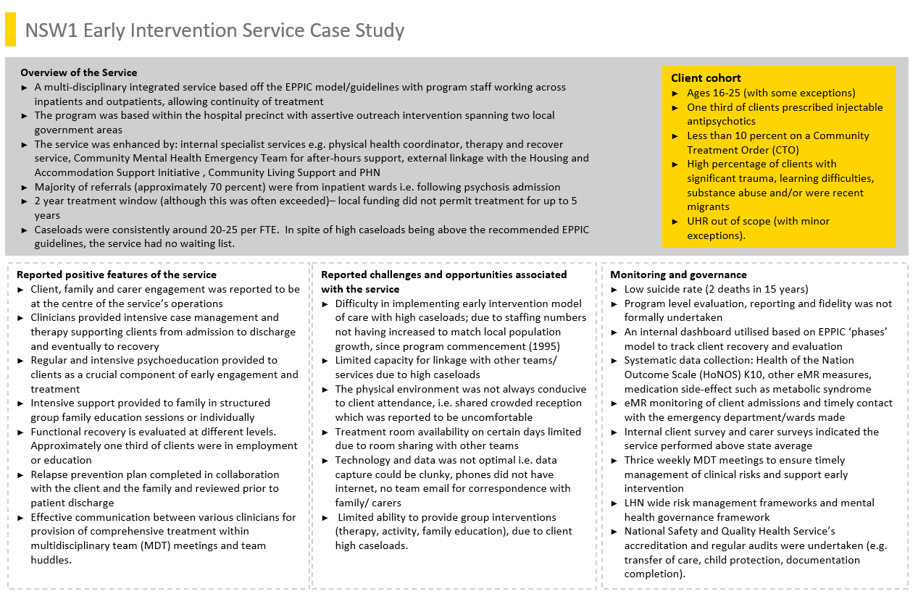

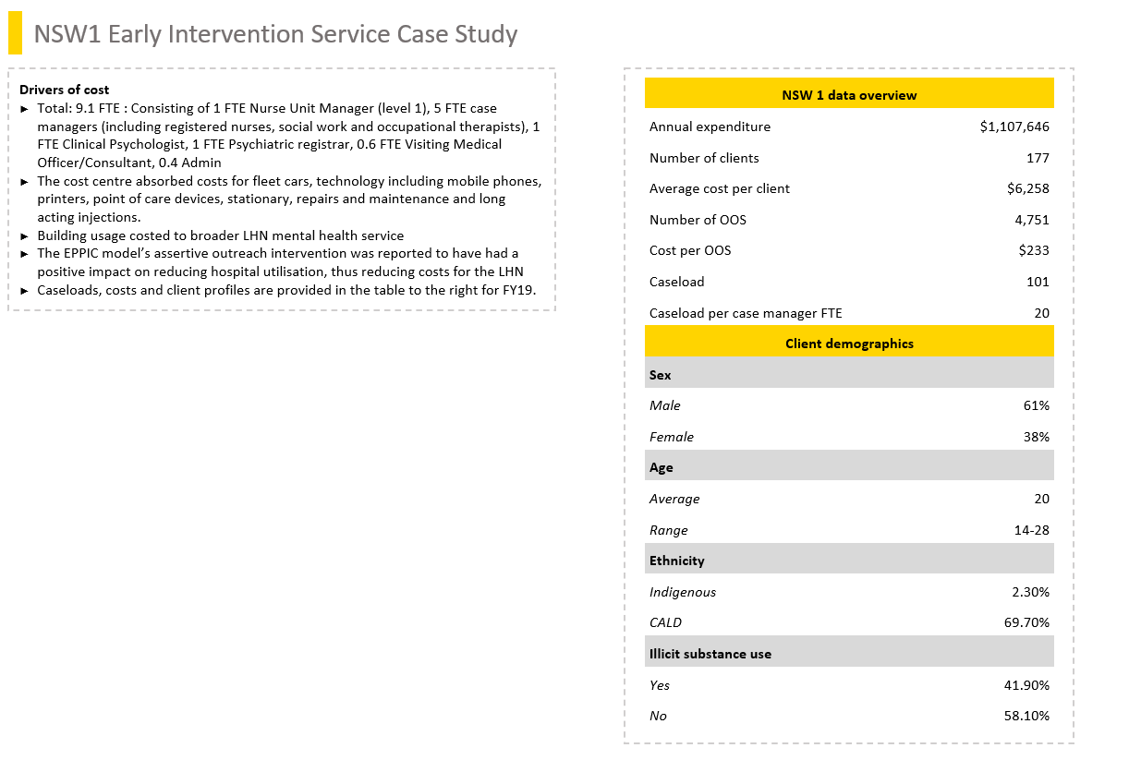

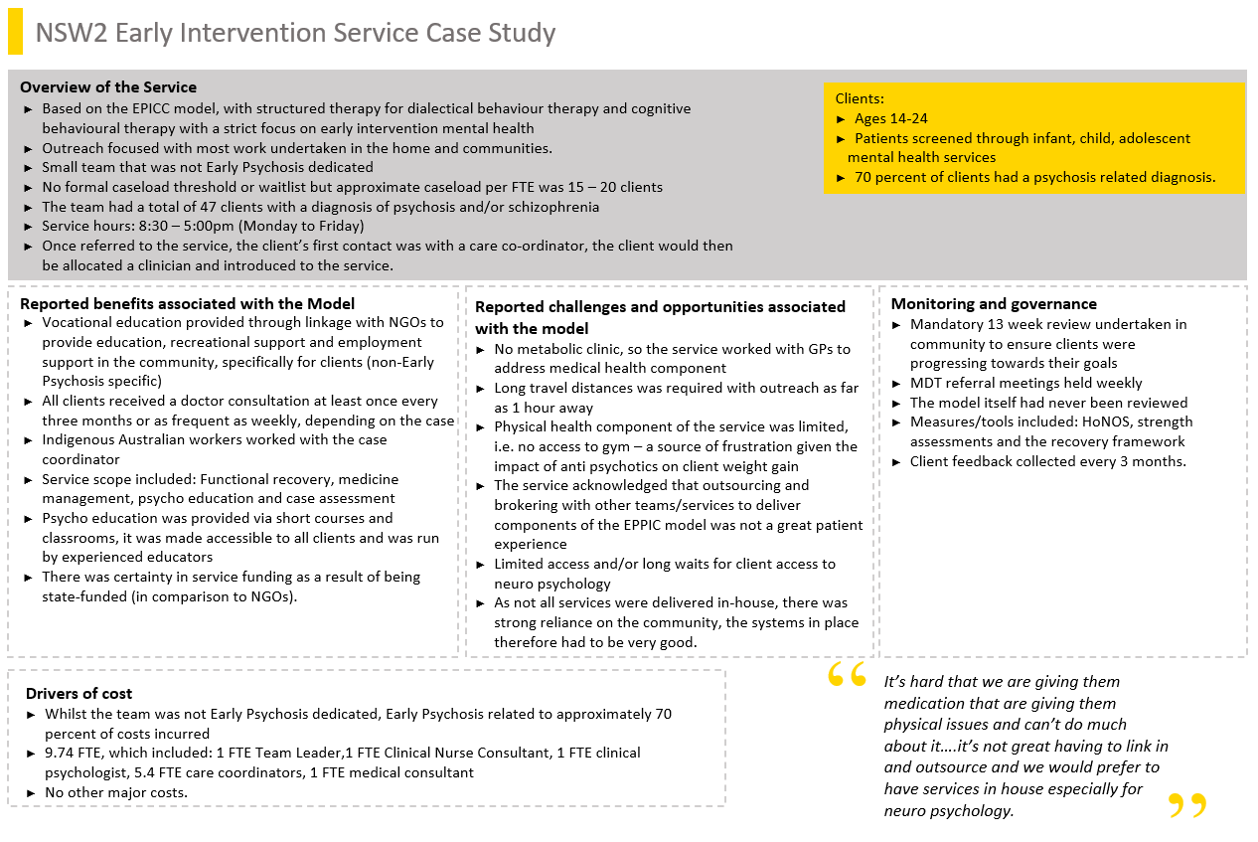

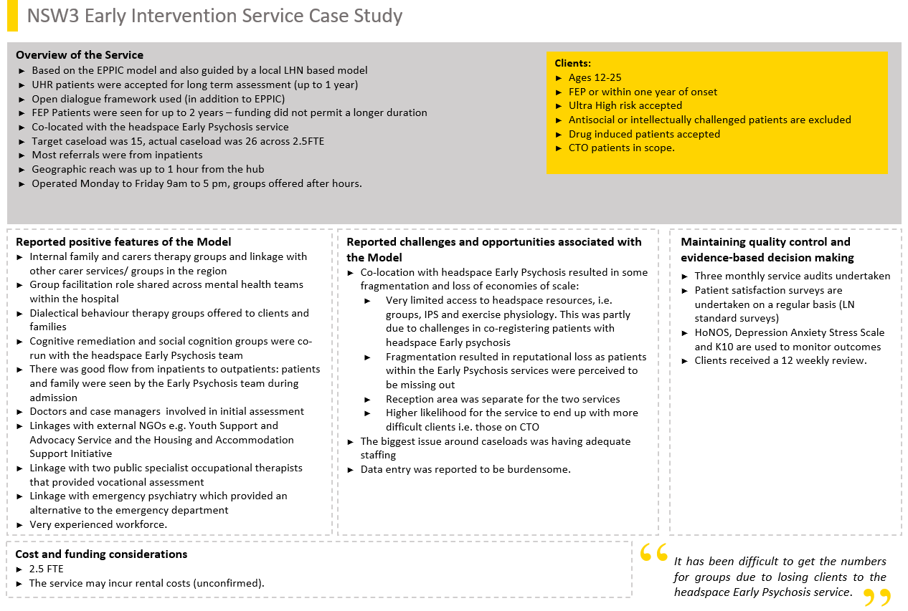

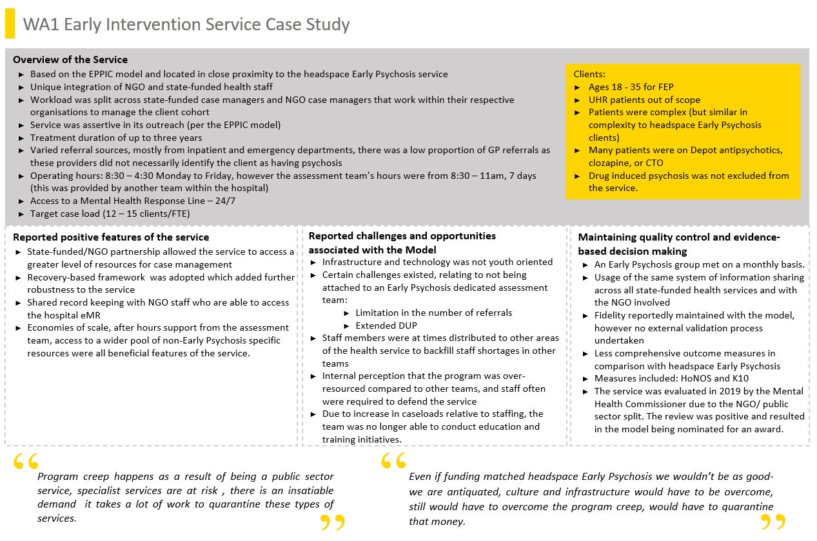

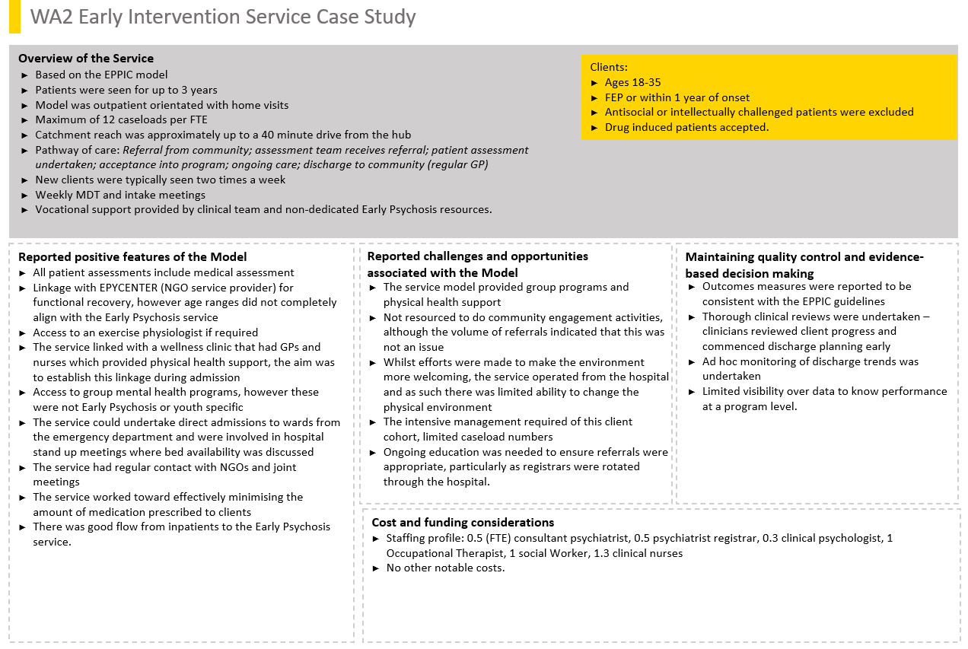

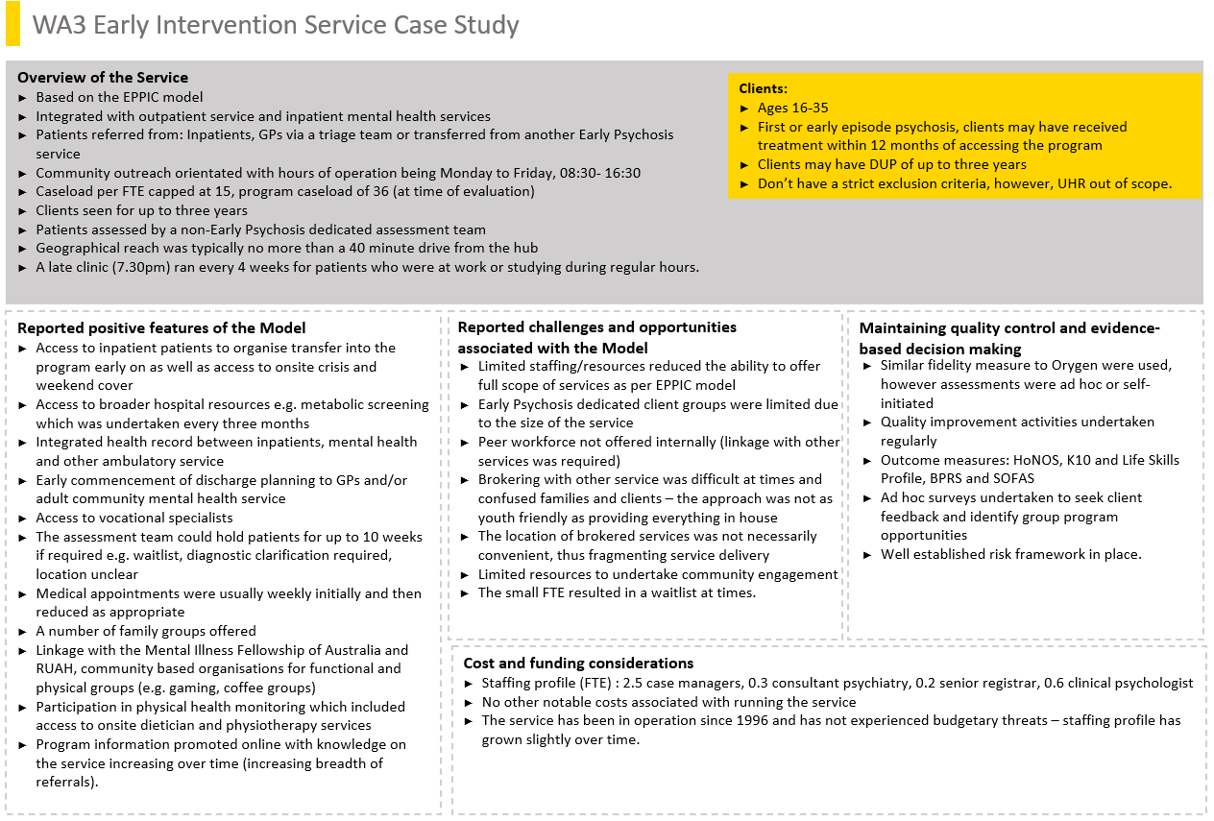

1. Evaluation Question 3.7: Findings from the family and carer survey

This section covers:

* Comparison of caregiver burden
* Client perceptions, observations of the impact of the service on improving the capacity of families.

In this section compares the levels of caregiver burden between a sample of carers from the EPYS and a sample from the State services comparator.

Overview of survey approach

The evaluation surveyed carers of young people in early intervention services around Australia. A quantitative online survey was rolled out in March 2018, and a paper survey was distributed in September 2018. Responses to questions covering demographics, service use, customer satisfaction, carer burden and emotional involvement were collected until mid-November 2018. The online survey was repeated at 90-day intervals if the respondent volunteered their contact details. Survey data were collected and managed using REDCap electronic data capture tools hosted at the University of Sydney.1 Sites were identified as part of the headspace Early Psychosis program, and state-funded services (where available) were used as a comparator.

In total, the Family and Carer Survey involved 14 headspace Early Psychosis services and enrolled 12 state-funded services as comparators.

Table 32: Services involved in the family and carer survey

| **headspace Early Psychosis** | **State-funded services** |
| --- | --- |
| Parramatta Mission, Parramatta NSW | PEIRS, Parramatta NSW |
| headspace, Penrith NSW | EPIS, Penrith NSW |
| headspace, Mt Druitt NSW | EPP, Bondi Jct NSW |
| Lives Lived Well, Southport QLD | EIP, Camperdown NSW |
| Aftercare, Meadowbrook QLD | EIP, Croyden NSW |
| Black Swan Health, Joondalup WA | EIP, Canterbury NSW |
| Black Swan Health, Osborne Park WA | EEP, Peel WA |
| Youth Focus, Midland WA | EEP, Rockingham WA |
| Alfred Health, Bentleigh VIC | RAPPS, Berwick VIC |
| Alfred Health, Narre Warren VIC | RAPPS, East Hampton VIC |
| Alfred Health, Frankston VIC | RAPPS, Clayton VIC |
| Alfred Health, Dandenong VIC | RAPPS, Dandenong VIC |
| headspace, Adelaide SA |  |
| Anglicare, Darwin NT |  |

By the end of the data collection period (1 December 2018), the survey had responses from the following sites:

Table 33: Family and carer survey responses

| **headspace Early Psychosis** | **n** | **Comparator** | **n** |
| --- | --- | --- | --- |
| Adelaide, SA | 28 | Camperdown, NSW | 7 |
| Joondalup, WA | 23 | Dandenong (RAPPS), VIC | 4 |
| Bentleigh, VIC | 12 | Nepean, NSW | 4 |
| Mount Druitt, NSW | 5 | Berwick (RAPPS), VIC | 2 |
| Parramatta, NSW | 5 | Unlabelled | 2 |
| Southport, QLD | 5 | Bondi Jct, NSW | 1 |
| Midland, WA | 4 | Parramatta (PEIRS), NSW | 1 |
| Darwin, NT | 3 |  |  |
| Unlabeled | 3 |  |  |
| Osborne Park, WA | 2 |  |  |
| Dandenong, VIC | 1 |  |  |
| Penrith, NSW | 1 |  |  |

The table below compares the basic demographic features of the carers from headspace Early Psychosis with the comparator. Most carers are mothers living with the young person in both services.

Table 34: Comparison of demographic features of the carers from headspace Early Psychosis with the comparator

| **Demographic feature** | **headspace Early Psychosis** | **State** |
| --- | --- | --- |
| **Sex** | | |
| Female | 70.59 | 78.57 |
| Male | 29.41 | 21.43 |
| **Relationship** | | |
| Parent | 85.71 | 85.71 |
| Other | 14.29 | 14.29 |
| **Living** | | |
| Full-time | 81.32 | 66.67 |
| Part-time | 4.40 | 4.76 |
| Separate | 14.29 | 28.57 |
| **Language** | | |
| English | 81.16 | 64.29 |
| Non-English | 18.84 | 35.71 |
| **Employment** | | |
| Employed | 65.22 | 85.71 |
| Other | 18.84 | 7.14 |
| Retired | 8.70 | 7.14 |
| Unemployed | 7.25 |  |
| **Home** | | |
| Owner | 72.86 | 71.43 |
| Public housing | 10.00 |  |
| Renting | 17.14 | 28.57 |

Comparison of caregiver burden

Because of the low number of responses from individual sites, the evaluation compared responses between headspace Early Psychosis and State services, ignoring site differences. However, no counterfactual responses had been in the service less than 90 days, so the headspace Early Psychosis responses were split by the amount of time in service.

Client satisfaction in hAPI stratified by cluster

Carer burden was assessed by the Experience of Caregiving Inventory (ECI). The evaluation has included seven subscales from the ECI, with scores ranging from 0 to 4. Two subscales are positively valenced and reflect good aspects of the carer experience: positive personal experiences (personal) and positive aspects of the relationship (bond). Higher scores in these scales are better. The other five are negatively valenced, so lower scores are better (i.e., less burden).

The figure below shows the different burden components, arranged by time in service alongside the comparator. The boxplots indicate the largest component of burden is dependency and symptoms. The bottom row of plots indicate positive aspects of caregiving. The confidence intervals (notches) suggest that dependency may be reduced by the amount of time in headspace Early Psychosis service.

Figure 2: Experience Caregiving Inventory (ECI) subscales

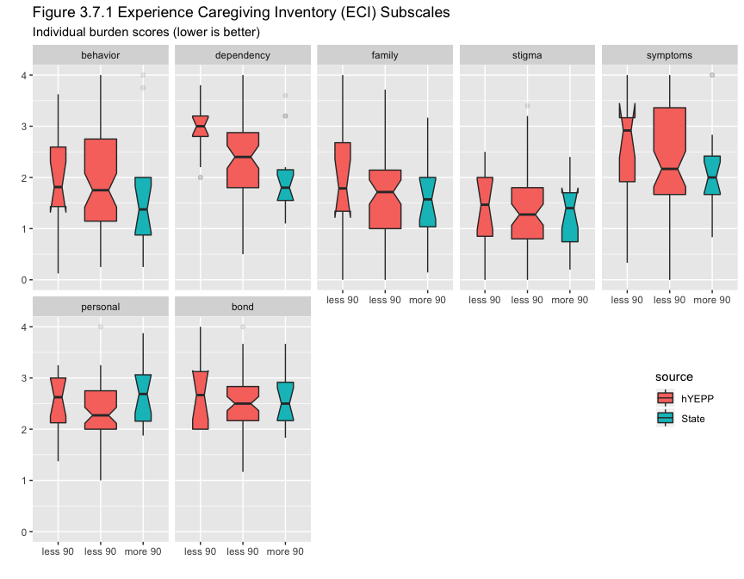

Uncorrected t-tests on each subscale revealed a higher burden of dependency in the headspace Early Psychosis cohort than the State service comparator (*p* = .048). This difference was not significant when comparing only those with more than 90 days in service. The overall pattern of results suggests burden is reduced by length of time in service, with no differences between headspace Early Psychosis and State services after 90 days in service.

The Family Questionnaire

The Family Questionnaire measures emotional over-involvement and is an indicator of treatment success in Early Psychosis treatment. There was no significant difference between headspace Early Psychosis and the State service comparator (*p* = 0.55).

Figure 3: Emotional over-involvement

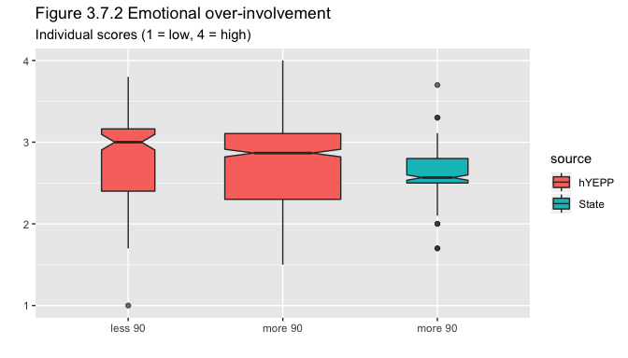

Client perceptions, observations of the impact of the service on improving the capacity of families

Improving the ability of families to support client

As described in the findings of evaluation question 3 young people were often hesitant about having their carers involved in the program but were supported to have agency in decisions around the level of their carers’ involvement. Despite some reservation, most young people’s carers were involved to some degree with the headspace Early Psychosis program and the clinicians, and the clients appreciated how the clinicians could enrich their carers’ ability to support them in meaningful ways. A key approach was that young people felt headspace Early Psychosis staff supported educating their parents and carers about their mental health.

One young person in Paramatta who had been in the headspace Early Psychosis program for years described the approach used to support her family, and the importance of this support to her:

*YP11: They take her [my mum] in separately. They ask her … how she's going as well, which I think is really good because they give support to the parents as well, which is much needed. They ask her how I am as well in terms of mood and [from] a different perspective.*

*Int: Okay. You said that's much needed that your mum gets support. Can you tell me a bit about that?*

*YP11: I guess it's because it's stressful for your own child to have a mental illness and not understand what's going on. So, headspace has provided a psychiatrist that speaks the same language as my mum so that helped her understand a little bit more about mental illness and how to prevent it as well. So, the parents, they're taught strategies on how to help and strategies that I'm taught as well, so they understand what I'm doing.*

Similarly, another young person in Penrith who was relatively new to the program described how having her family aware of how things were going for, allowed them to be more supportive.

*Int: Do your parents often come to your sessions? …*

*YP19: Like every now and then really. Every three, or four sessions maybe.*

*Int: Can you tell me a bit about how it has been helpful for you?*

*YP19: Because then my family is on board, so they know what is going on for me. … They know what is going on for me, so they can help me with it. They are not really in the dark with it. … My team can word it for me better than I could. So, yeah, and they can give them resources and stuff like that.*

The headspace Early Psychosis clinicians supported this young person to find ways to communicate her feelings and experiences so that her family could better understand how to help her, yet at this stage there was a reliance on the clinicians in this regard.

Maintaining family relationships with client

Young people described headspace Early Psychosis as supporting them to maintain relationships with their family. As described in response to evaluation question 2, young people were encouraged to engage their family in their care and progress. One participant from Penrith described how since being unwell and working with headspace Early Psychosis, she felt even closer to her family than previously. From her perspective headspace Early Psychosis supported opportunities for *“catching up and just knowing what’s going on with her family” (YP13Penrith).*

Family/carer reported perceptions/observations and experience of the service

Family member and carer perceptions of their capacity to support and maintain relationships with young people were generally very positive, despite some variability in the degree of family involvement. Notably, family members and carers usually described being in a state of shock or crisis early in their engagement with the service, but over the course of care became better able to cope, despite the trajectory of the young person’s illness. While this was not always the case, it was a notable pattern demonstrated in the data in both the initial and follow-up discussions with family members and carers from Cohort 1, as well as in discussions with family members and carers who were reflecting on their experience in headspace Early Psychosis (Cohort 2).

For example, parents relatively new to the Penrith service described how prior to engaging with headspace Early Psychosis they felt excluded from their daughter’s care, which they found impaired their ability to help. They reported that headspace Early Psychosis could involve them while still preserving their daughter’s sense of agency and confidentiality. This family described how this inclusion facilitated greater knowledge about their daughter’s mental health issues, collaboration in care planning, and supported them to feel in control, enhancing their ability to respond effectively, if and when they needed. *“It’s definitely helped change our thinking and our approach. I don’t think we are in crisis mode anymore, it’s kind of BAU [business as usual] and just go with the flow” (FC25Penrith).* These parents discussed further how this shift had occurred,

*FC25: We’re learning a lot more. It’s very inclusive. When we first brought [my daughter] down here, we didn’t realise the seriousness of what we were dealing with. …*

*FC26: They have been saying it’s very unusual for someone so young to have this and it’s been going on for years. We didn’t know. No idea. Amazing at hiding it. But we’re joining the dots now. … plenty of dots, yeah, but … you wouldn’t dream of it. There’s no history in either family. Why would you think that, you know? But now we’re saying, ‘Oh, okay’.*

*FC25: … we’ve had the MATT team call us and check-up. We’ve now got a crisis care contact … it’s knowing where you should go and what you should do. So, we’ve got all that sorted out now. … if we do have that crisis at 11 o’clock at night or 1 o’clock in the morning where she’s really in a bad way, we can take her somewhere. We’ve got the information, off we go. … So, I feel like we’ve got control back.*

*Other parents who had been engaged in the service for several years (Cohort 2) at the Mount Druitt site also described how the headspace Early Psychosis program was supportive of them. Some family members described headspace Early Psychosis as essential to build fundamental mental health literacy, and how their knowledge helped them to avoid exacerbating the young person’s suffering and support the young person in their care. They explained,*

*FC11: I think headspace is the essential thing to have when you have a mentally ill child*

*FC13: There’s nowhere else.*

*FC11: It’s, you have to have headspace, it’s a must. It’s like Primary School for parents. ... because the thing is that you have your child or an adult that suffers from a mental illness and 99 percent of the time you have no answers and you don’t know what to do. So, headspace, it guides you and teaches you what you have to do. So, by doing that, you’re learning, little step by little step at what to do. So, everyone’s behaviours are going to change the condition of the person that’s suffering. You keep yourself in check, you go home, and you think about everything that was said here, everything that was talked about here, and obviously going to have to change a few things.*

*FC13: You do change, little, like we’re doing it without knowing we’ve changed, we’ve actually changed a lot.*

*Only one parent reported something that seemed like a formal family therapy whilst most reported concurrent or sequential check-ins with the clinician. He described,*

*FC20: They [the psychiatrist and counsellor] involved everyone [my wife, son and his siblings]. They would ask each person to comment on how they felt or what thoughts they had at that given moment. And then it would go right around, and everyone would give their thoughts. And then if there was something that the psychiatrist felt struck a chord somewhere within the dynamics, family dynamic, we'd zero in on that. And he'd ask more questions and then he'd ask everyone else to comment on that or what they thought in the same situation or scenario. It was quite a thorough washing up and then several times go up to the board and did a diagram of the whole family set up and explain how, for example, I would talk. With the kids I always felt that information was important and airing it all out there. And if my wife was having anxious issues or whatever issues then I would tell the kids, explain it to the kids. Not the youngest one when she was too young, I kept her out of it, but then he explained to me that the problems need to be sorted out between me and my wife. And when he introduced the children into it, it then gave the children a what's the word, a conundrum whether to support mum or dad. All these sorts of things and they were very informative in explaining how it all worked. And then gave methods of how hard start-ups and soft start-ups in conversations, because if you had a hard start up, that would trigger things with the other person and create withdrawal. And as soon as you get withdrawal then things don't sort themselves out. Just so on and so forth, it was very professional and effective I found.*

*Int: What kinds of things have come out of that for you as a family?*

*FC20: More understanding, more patience. Using soft start-ups instead of hard start-ups. Like [instead of] ‘You shouldn't have done that’, more like ‘When you do that it makes me feel like this’. It's a constructive interaction. Soft start-up rather than a hard start up. And because all this conflict's happening, we all withdraw and then he was encouraging each of us to spend an hour every week with me, with a one-on-one with a child, whether it's sitting down having a chat or going shopping together or something like that. Just to sort of reconnect. All those sorts of things yeah.*

*Int: Strategies.*

*FC20: Strategies that's right. And they have proved to be very effective. Pardon the explanation, but it's like lancing a boil. You've got all this infection and build up and then they give you strategies and you can talk about it, it relieves the pressure. And explained to us that you'll step back into the old habit, because it's been going on for so long, but you've just got to use these strategies to overcome it. So, it's helped [my son] but it's also helped us as a family unit.*

*Int: It's interesting the analogy you give of lancing a boil, because then after that's done you start to heal too.*

*FC20: That’s right.*

This parent found this family therapy very useful and his experience offers important insights into how headspace Early Psychosis could expand to include more structured family involvement in the future.

1. Transitions study - comparative service cohort

A comparative service - the Transitions study (Purcell et al 2015)

For Evaluation questions 3.2, 3.5, and 3.6 the EPYS Program was compared to a comparative service: *the Transitions study* (Purcell et al 2015). The comparative service was a like-service control comparison comprising of clients from a similar EPPIC-based, Early Psychosis youth service within Australia. It represented a cohort of young people, who sought help from one of four headspace Centres in Melbourne and Sydney between January 2011 to August 2012. These headspace Centres were in major metropolitan regions of Melbourne (n = 2) and Sydney (n = 2) and were selected on the basis of being affiliated with the investigators’ research centres as part of their governance models. Three of the centres were located in outer-metropolitan suburbs that were characterized by socio-economic disadvantage and minimal private sector mental health services, while the fourth centre was located in a relatively affluent inner-city suburb.

These centres provided a broader range of care than standard headspace services generally available then, including psychiatrists, vocational interventions and clinical psychologists. They also accepted a more severe clientele than the standard headspace service, including young people that met the Comprehensive Assessment of At Risk Mental State (CAARMS) criteria for Ultra High-Risk (UHR) and First-Episode Psychosis (FEP). As such these services represented an integrated service with a significant proportion of UHR and FEP clients, which demonstrated potential outcomes of integrated services prior to the EPYS Program being implemented.

The Transitions study

For the Evaluation, two comparable sub-cohorts from the Transitions study were identified that enabled comparison to young people within the EPYS UHR and FEP treatment arms.

* FEP – Defined by clinician diagnosis or meeting the criteria for frank psychosis as defined by the CAARMS (i.e. a global rating score of 6 on unusual thought content, non-bizarre ideas or disorganized speech; n = 40.
* UHR –Defined in the same way is in the EPYS program using the CAARMS; n = 173.

These two sub-cohorts are referred to collectively as the ‘comparative service cohort’ (CSC)

The EPYS comparison cohort (ECC)

A sub-set of EPYS clients were selected for comparison to the Transition study that:

* matched the Transitions study for baseline assessment (i.e., based on CAARMS criteria for UHR and FEP, and psychiatric diagnosis) and;
* had a program follow up duration (approximately 1-year) to allow for a similar exposure to treatment.

This resulted in an ‘EPYS comparison cohort’ (UHR n = 139, FEP n = 331).

To determine whether the young people selected for the ECC differed from the wider cohort in the EPYS Program, Table 35 below compares the selected ECC in each treatment arm (UHR and FEP) with the remaining episodes who were not selected for the ECC (i.e., discharged before one-year follow up). P-values (p < .05 marked in purple) indicated there were some differences in the proportion of frequent substance use. There was also some evidence that young people followed up in the UHR stream (ECC) were more psychotic (e.g., BPRS) than the discharged UHR group, and lower functioning (SOFAS, MyLifeTracker).

Table 35: Baseline characteristics in the EPYS comparison cohort (ECC) relative to other EPYS episodes (i.e., discharged)

|  | **Variables** | **UHR ECC** | **UHR discharged** | **p.valuea** | **FEP ECC** | **FEP discharged** | **p.valuea** |
| --- | --- | --- | --- | --- | --- | --- | --- |
| Demographics | n | 139 | 414 |  | 331 | 328 |  |
| Age (mean) | (18) | (18) | 0.3055 | (20) | (20) | 0.4547 |
| NEET | 14 | 21 | 0.1139 | 34 | 35 | 0.6912 |
| Gender | Female | 53 | 51 | 0.2059 | 32 | 32 | 0.7586 |
| Male | 47 | 46 | 67 | 67 |
| Non-binary | 0 | 2 | 1 | 0 |
| Sexuality | Heterosexual | 68 | 67 | 0.5952 | 69 | 74 | 0.2034 |
| LGBQ | 12 | 15 | 8 | 9 |
| Other/Unknown | 21 | 18 | 23 | 17 |
| Culture | Indigenous | 7 | 9 | 0.7111 | 7 | 9 | 0.2999 |
| NESB | 5 | 6 | 0.5247 | 16 | 13 | 0.2624 |
| Born overseas | 9 | 9 | 1.0000 | 19 | 19 | 0.8401 |
| Education | In school | 44 | 46 | 0.8131 | 15 | 18 | 0.1694 |
| High school | 24 | 19 | 40 | 33 |
| Certificate/Diploma | 6 | 5 | 8 | 6 |
| University degree | 2 | 2 | 5 | 3 |
| Did not finish | 23 | 27 | 31 | 37 |
| None of the above | 1 | 1 | 2 | 3 |
| Home | Family home | 72 | 64 | 0.4988 | 64 | 62 | 0.6312 |
| Rented | 22 | 27 | 22 | 20 |
| Boarding house/hostel | 2 | 2 | 4 | 5 |
| Other | 4 | 6 | 10 | 13 |
| Benefits | None | 72 | 72 | 0.1074 | 54 | 55 | 0.4128 |
| DSP / Unemployment | 13 | 18 | 28 | 31 |
| Other | 16 | 10 | 18 | 15 |
| Frequent substance use | heroin/cocaine (weekly) | 0 | 2 | 0.2064 | 3 | 4 | 0.8181 |
| amphetamines (weekly) | 2 | 4 | 0.2724 | 6 | 14 | 0.0020 |
| alcohol (weekly) | 25 | 23 | 0.8051 | 35 | 37 | 0.6622 |
| tobacco (daily) | 17 | 29 | 0.0070 | 40 | 51 | 0.0125 |
| cannabis (daily) | 15 | 15 | 1.0000 | 24 | 35 | 0.0030 |
| Symptoms | BPRS (mean) | (42) | (46) | 0.0319 | (44) | (44) | 0.9120 |
| K10 (mean) | (31) | (30) | 0.6121 | (25) | (24) | 0.0984 |
| Function | SOFAS (mean) | (57) | (60) | 0.0058 | (57) | (57) | 0.5665 |
| MyLifeTracker (mean) | (44) | (51) | 0.0060 | (53) | (55) | 0.2974 |
| RecoveryStar (mean) | (54) | (52) | 0.5805 | (55) | (58) | 0.3066 |
| aPearson's Chi-square test for group categories, or independent two-tailed t-test for group means | | | | | | | |

The characteristics at assessment of the EPYS (ECC) and comparative service cohort (CSC) is provided in Table 36 below. The FEP cases in the ECC tended to be older, less distressed, and more likely to be male, sexually diverse, and from a non-English speaking background than the CSC. Among the UHR cohorts, the ECC were again more likely to be male and sexually diverse, but less likely to heavily smoke, and had slightly lower levels of function (SOFAS).

Table 36: EPYS comparison cohort (ECC) and Comparative service cohort (CSC) at baseline

|  | **Variables** | **UHR ECC** | **UHR CSC** | **p.valuea** | **FEP ECC** | **FEP CSC** | **p.valuea** |
| --- | --- | --- | --- | --- | --- | --- | --- |
| Demographics | n | 139 | 173 |  | 331 | 40 |  |
| Age (mean) | (18) | (18) | 0.797 | (20) | (18) | 0.000 |
| NEET | 14 | 18 | 0.380 | 34 | 26 | 0.369 |
| Gender | Female | 53 | 68 | 0.010 | 32 | 68 | 0.002 |
| Male | 47 | 32 | 67 | 32 |
| Non-binary | 0 | 0 | 1 | 0 |
| Sexuality | Heterosexual | 68 | 69 | 0.000 | 69 | 62 | 0.010 |
| LGBQ | 12 | 24 | 8 | 23 |
| Other/Unknown | 21 | 7 | 23 | 15 |
| Culture | Indigenous | 7 | 6 | 0.639 | 7 | 5 | 0.754 |
| NESB | 5 | 2 | 0.175 | 16 | 3 | 0.025 |
| Born overseas | 9 | 10 | 0.840 | 19 | 10 | 0.176 |
| Education | In school | 44 | 42 | 0.079 | 15 | 36 | 0.030 |
| High school | 24 | 26 | 40 | 28 |
| Certificate/Diploma | 6 | 11 | 8 | 10 |
| University degree | 2 | 6 | 5 | 5 |
| Did not finish | 23 | 15 | 31 | 21 |
| None of the above | 1 | 0 | 2 | 0 |
| Home | Family home | 72 | 75 | 0.658 | 64 | 64 | 0.399 |
| Rented | 22 | 20 | 22 | 26 |
| Boarding house/hostel | 2 | 1 | 4 | 8 |
| Other | 4 | 4 | 10 | 3 |
| Benefits | None | 72 | 61 | 0.090 | 54 | 58 | 0.149 |
| DSP / Unemployment | 13 | 13 | 28 | 15 |
| Other | 16 | 25 | 18 | 28 |
| Frequent substance use | heroin/cocaine (weekly) | 0 | 1 | 0.516 | 3 | 2 | 1.000 |
| amphetamines (weekly) | 2 | 1 | 1.000 | 6 | 2 | 0.493 |
| alcohol (weekly) | 25 | 29 | 0.425 | 35 | 30 | 0.602 |
| tobacco (daily) | 17 | 29 | 0.015 | 40 | 35 | 0.610 |
| cannabis (daily) | 15 | 9 | 0.087 | 24 | 12 | 0.118 |
| Symptoms | K10 (mean) | (30) | (31) | 0.387 | (24) | (36) | 0.000 |
| Function | SOFAS (mean) | (60) | (63) | 0.027 | (57) | (57) | 0.751 |
| aPearson's Chi-square test for group categories, or independent two-tailed t-test for group means | | | | | | | |

Comparison of symptom change

There was no significant difference in the change in distress levels over one year in either FEP or UHR clients between the EPYS comparison cohort (ECC) and the comparative service cohort (CSC).

Symptoms of distress change were assessed using K10 within both the EPYS comparison cohort (UHR n = 139, FEP n = 331) and the comparative service cohort (UHR n = 173, FEP n = 40). On average, distress decreased in both cohorts over one-year (shown below in Figure 4), however there was no significant difference between cohorts in the amount of decrease over one-year (UHR cohort interaction *p* = .13, FEP cohort interaction *p* = .19).

Figure 4: Individual change in distress over one-year follow up in the EPYS comparison cohort (ECC) and comparative service cohort (CSC)

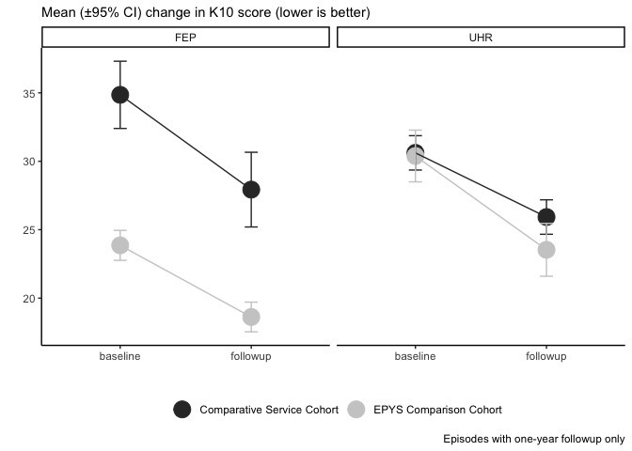

Comparison of transition rate to psychosis

Comparing rates of transition for UHR between the EPYS comparison cohort and the comparative service cohort depends heavily on the assumptions made. If the comparison is between all young people with complete follow up for the full 295 days then the EPYS comparison cohort has a higher transition rate (17 percent) than the comparative service cohort (8 percent).If the assumption is made that all clients lost to follow up or discharged prior to the 295 days do not transition to FEP then the EPYS “Intention-To-Treat” has a similar transition rate (6 percent) to the comparative service cohort’s “Intention-To-Treat” (5 percent).

In the comparative service cohort, a total of 280 young people were ascertained as meeting UHR criteria at baseline, of whom 107 were lost to attrition, leaving 173 were assessed at follow-up.

In the EPYS comparison cohort a total of 552 young people were ascertained as meeting UHR criteria at baseline at least 295 days prior to the censor date, of whom 415 were lost to attrition or discharged, leaving 137 who were assessed at follow-up 1-year later.

Table 37: Comparison of transition rates in EPYS comparison cohort and the comparative service cohort

| **Cohort** | **Transitioned** | **Total** | **Rate** | **p.valuea** |
| --- | --- | --- | --- | --- |
| Comparative service cohort | 14 | 173 | 0.08 |  |
| EPYS comparison cohort | 23 | 137 | 0.17 | 0.030 |
| Comparative service intention-to-treat | 14 | 280 | 0.05 |  |
| EPYS Intention-to-treat | 33 | 552 | 0.06 | 0.675 |
| aChi-square test against comparative service | | | | |

Comparison of functional change

EPYS comparison cohort (ECC) FEP clients experienced a greater improvement in clinician-rated function levels over 1-year than the comparative service FEP clients. Both EPYS comparison cohort and the comparative service UHR clients showed similar, and smaller, functional gains. A similar pattern of greater reduction in the proportion of clients ascertained as NEET in the EPYS comparison FEP cohort compared to the comparative service FEP cohort (where there was an increase observed).

Clinician-rated Social and occupational functioning (SOFAS)

Figure 5: Mean individual change in clinician-rated function over one-year follow up in FEP and UHR clients in the EPYS comparison cohort and Comparative service cohorts (ECC & CSC)

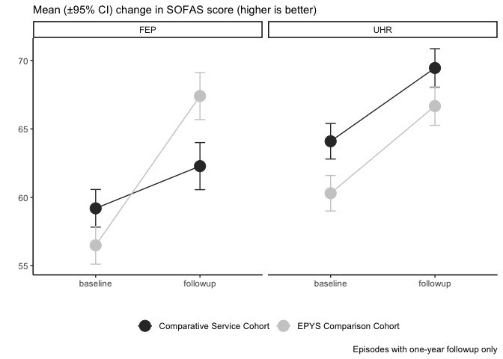

NEET: Not in education, employment or training

Note, there were no differences in prevalence of NEET status between the EPYS Comparison Cohort and the comparative service cohort at baseline in table above (*p* > .05).

Figure 6: Individual change in NEET status over one-year follow up in EPYS comparison cohort and comparative service cohort

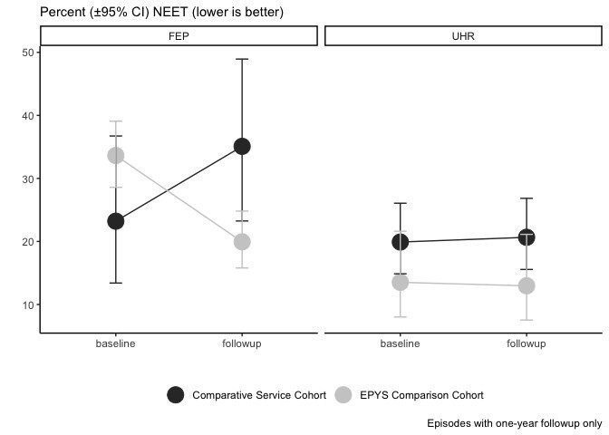

The proportion of FEP clients defined NEET *decreased* in the EPYS comparison cohort while it *increased* in the comparative service cohort (interaction *F* = 8.1, *p* = 0.004). There was no change in the proportion of UHR NEET (*p* = 0.84), however the EPYS comparison UHR cohort had lower NEET overall than the comparative service UHR cohort, main effect of source *F* = 5.07, *p* = 0.02.

Comparison of drugs

**Key point**

* There were no significant differences in the change prevalence of frequent drug use over one year between the EPYS Comparison Cohort and the comparative service cohort.

Figure 7.1: Drug usage in EPYS comparison cohort and comparative service cohort  
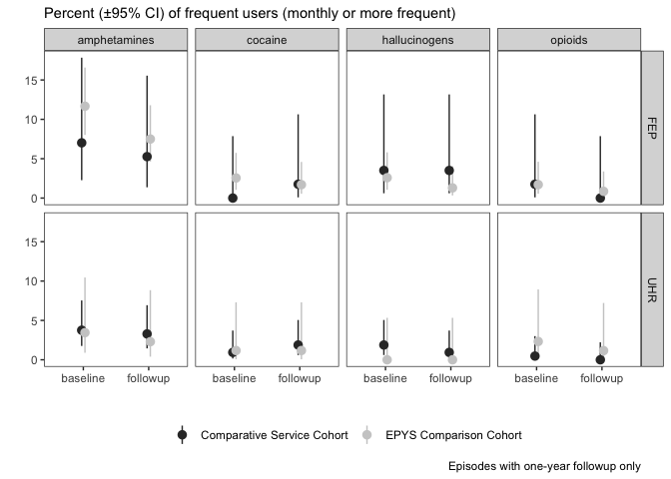

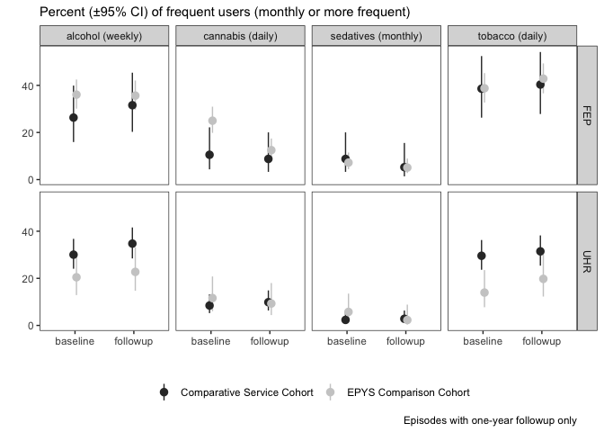

1. Evaluation Reference Group membership and Terms of Reference

Evaluation reference group members

The below provides a list of individuals who were members of the Evaluation Reference Group at the time the Evaluation Final Report was submitted.

* Chris Bedford (Chair), Australian Government Department of Health
* Dianne Braggett, Australian Government Department of Health
* Allyson Essex, Australian Government Department of Health
* Associate Professor Grant Sara, NSW Health
* Dr Peter Brann, Monash University
* Susan E. Adam, carer representative
* Sophie Whitecross, consumer representative
* Professor Paul Scuffham, Griffith University
* Dr Jackie Curtis, University of New South Wales
* Associate Professor Beth Kotze, University of New South Wales
* Sue Lee, PHN representative, from August 2019.

Evaluation Reference Group Terms of Reference

Purpose

The role of the Evaluation Reference Group will be to support the EPYS Program evaluation by providing strategic advice to the Australian Government Department of Health and the evaluators, assist in resolving issues that arise during the evaluation, and to advise on aspects of evaluation design, methodology and interpretation of findings.

Role and Function

The Evaluation Reference Group will report to the Australian Government Department of Health.

The Evaluation Reference Group will:

* provide strategic, expert and technical advice in relation to:
  + mental health service planning and commissioning,
  + mental health needs and clinical treatment of young people,
  + mental health data, and
  + evaluation design, research methodology and conduct of the evaluation;
* provide feedback on the interim, draft and final evaluation reports to the evaluator, through the Department of Health, and
* ensure that consumer and carer perspectives are considered throughout the evaluation.

Composition

The Chair of the Evaluation Reference Group is the Assistant Secretary, Mental Health Services and Evidence Branch Australian Government Department of Health.

The Evaluation Reference Group membership comprises of the Chair, Australian Government Department of Health officers, a consumer and a carer representative, technical and expert advisors external to the Department and a representative from a Primary Health Network (PHN) with expertise in commissioning the EPYS program. Members possess expertise in wide range of areas required to support the Evaluation, including mental health service planning, mental health service commissioning, mental health needs of young people, mental health data, evaluation design, research methodology, clinical expertise, and consumer and carer perspectives in mental health. Membership is based on individual expertise rather than being representative of organisations, with the exception of the PHN representative.

Deliverables

The Evaluation Reference Group will not be expected to produce pre-defined deliverables but is expected to provide advice to the Australian Government Department of Health and the evaluator in a timely and appropriate manner.

Timeframes

The Evaluation Reference Group will be appointed for the duration of the EPYS evaluation project.

The Evaluation Reference Group will consider matters on an out of session basis as required. Additional teleconferences will be held as required.

Secretariat

The Australian Government Department of Health (Child and Youth Mental Health section) and the evaluators will provide secretariat support for the Evaluation Reference Group. The Australian Government Department of Health will be responsible for arranging meetings and members’ travel for official business of the Evaluation Reference Group, and the evaluators will assist with drafting agendas and briefing papers for meetings.

1. hAPI key variables

| **Variable** | **Determinant** |
| --- | --- |
| Age | Determined by the number of years (rounded) between the “date_of_birth” and “commencement_date” recorded in registration. |
| NEET | Determined from assessment if the client indicated they were not enrolled in any education (either part-time or full-time) and they were currently unemployed and looking for work (either full-time, part-time or causal work). If the client indicated they were not in the labour force and not looking for work (due to home duties, childcare etc.), then we further tested if they were receiving disability or unemployment benefits and included them if so. |
| Gender | Gender Diverse and Indeterminate were collapsed into “Non-binary” |
| Sexual orientation | Lesbian, Gay, Bisexual, and Questioning were collapsed into “LGBQ”. No answer and Other were collapsed into “Other/Unknown”. |
| Indigenous status | Determined by whether the client indicated they were “Aboriginal”, “Torres Strait Islander” or both. Note this variable was split into non-Darwin episodes (“Indigenous”) and Darwin episodes (“Indigenous (Darwin)”). |
| Born overseas | Determined by whether the client indicated their birth country was not Australia. |
| NESB | Non-English-speaking background was determined by whether the language spoken at home was neither English nor any other Australian indigenous language. |
| Education | Education was determined from registration “Highest level of education completed” (“client_education_level”). The levels were collapsed into “High school”, “Certificate/Diploma”, “University degree”. “In school” indicates the client is less than 18, so legally* still in school. “Did not finish” indicates the client is 18 or older and responded with an answer less than “Year 12”.  * NSW, VIC, ACT, NT are in school until 17; QLD, Tas, SA are in school until 16; and WA is in school until 18 |
| Benefits | From assessment, we collapsed “current_benefits” into the following categories:  “DSP / Unemployment = “Unemployment payments”, “Disability Support Pension” Other = “Other payments”, “Study payments”, “Parenting payments |
| Living situation | Living situation was determined from assessment, where we collapsed the various levels of “living_situation_who” into simpler levels:  Family home = “Family home or unit (with or without board)”, “Own home or unit (with or without mortgage)” Rented = “Privately rented house or unit”, “Public rented house or unit” Boarding house/hostel = “Boarding house / Rooming house / Hostel”, “Group home / Supported accommodation” Other = “Caravan”, “Crisis accommodation / Shelter / Refuge”, “Homeless”, “Hospital / Rehabilitation / Other health services”, “Other” |
| Substance use | Frequency of drug use over the past 3 months is indicated for 9 different classes of drugs at assessment. Response categories included “Daily”, “Weekly”, “Monthly”, “Once or twice”, and “Never”. We counted episodes indicating frequent substance use for alcohol, heroin/cocaine and amphetamine as weekly or daily; and for tobacco and cannabis as daily.  Nb. Hallucinogens, inhalents, and sedatives are currently ignored in this table. |
| BPRS and K10 | Calculated as the *sum* of each subscale score at assessment. |
| SOFAS | A single clinician-rated score at assessment. Note that zero entries indicate not enough information was available for an assessment and are excluded here. |
| MyLifeTracker | Calculated as the *mean* of the 5 subscales at assessment. |
| RecoveryStar | Calculated as the *sum* of the 10 subscales at assessment.  Note we used a strict definition for calculating the summary scores whereby any episode with a missing subscale was invalid. |

2. Client satisfaction survey as reported in hAPI

*Time to Program Assessment (TPA) Dr RW Morris, School of Medicine, University of Sydney. Date compiled 24 April 2020.*

Client Satisfaction

Satisfaction of clients and families with the centre, the treatment outcome, the staff and generally was obtained at each 90-day review.

Generally, all clients rated the five aspects of the headspace Early Psychosis Program very highly. Overall, 90.91 percent of responses were ‘Satisfied’ or ‘Very satisfied’.

Client satisfaction in hAPI stratified by cluster

**Key point**

* Satisfaction patterns are very similar between all clusters (“satisfied” or greater)

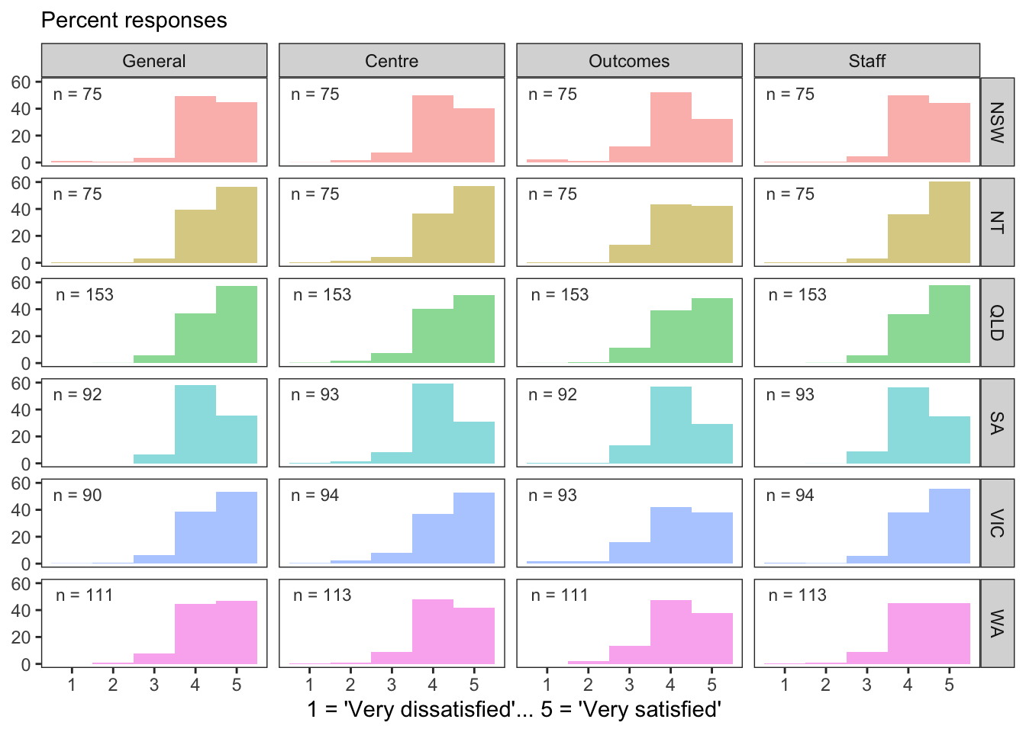

Client satisfaction by total days in treatment

**Key point**

* Satisfaction patterns are very similar regardless of the total time in treatment (90-, 180-, 270- or 360-days)

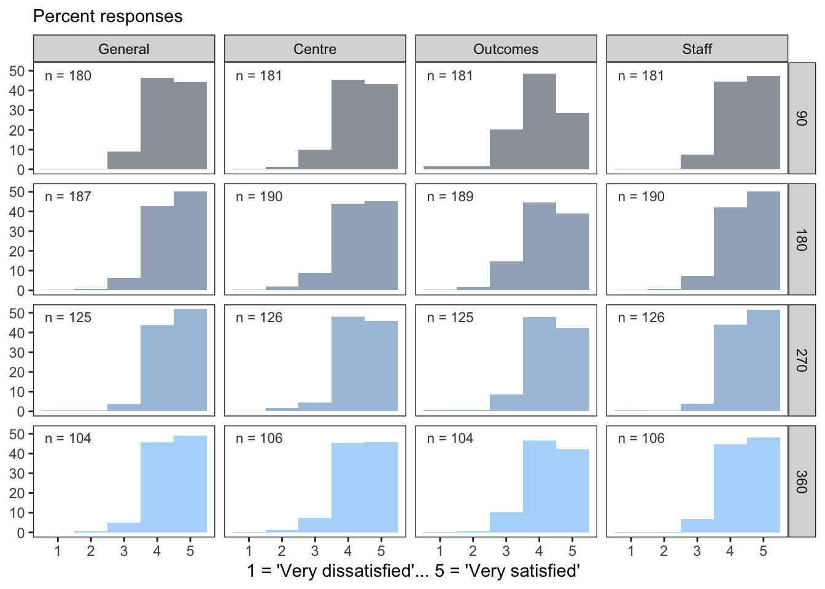

Client satisfaction by treatment arm

**Key point**

* Satisfaction patterns are very similar in both treatment arms (UHR or FEP)

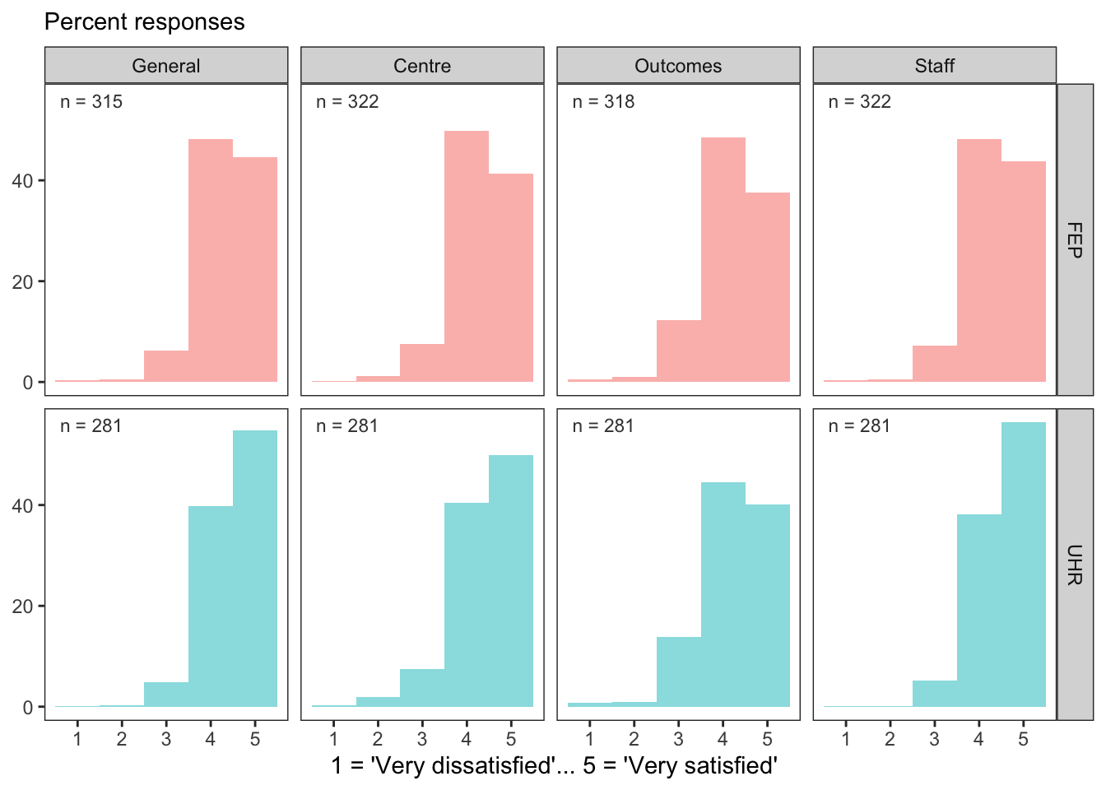

Client satisfaction over time

**Key point**

* Satisfaction levels are high and do not change with time in treatment (“satisfied” or greater)

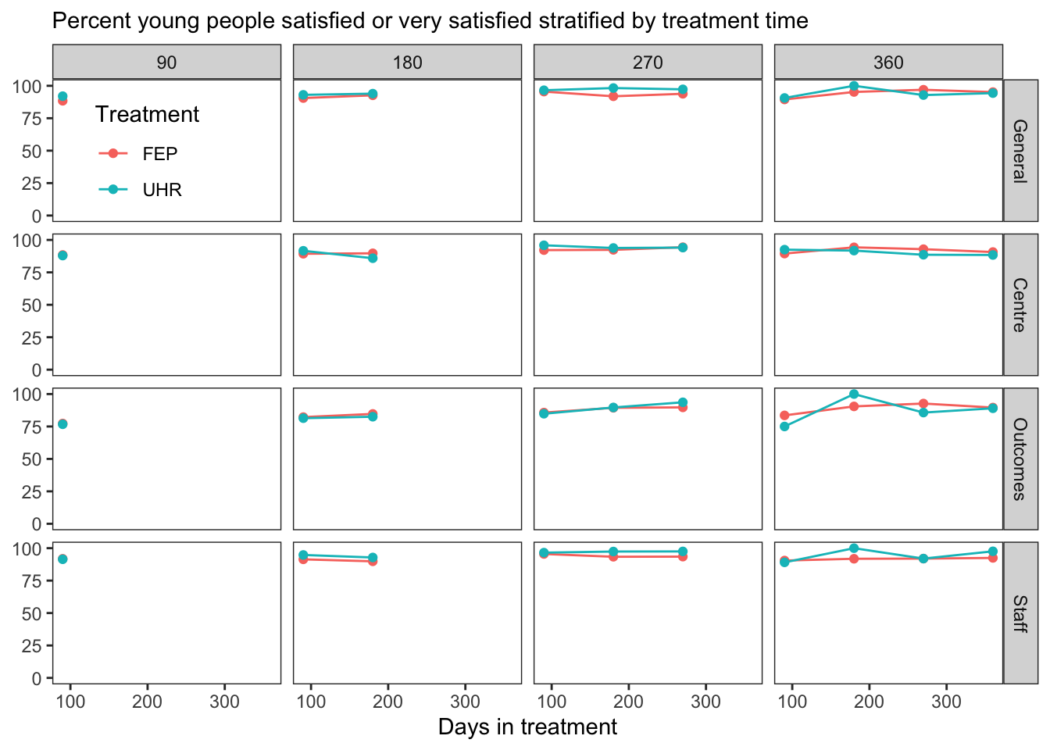

Family satisfaction

Generally, all families rated the six aspects of the headspace Early Psychosis Program very highly. Overall, 92.03 percent of responses were ‘Satisfied’ or ‘Very satisfied’.

Family satisfaction in hAPI stratified by cluster

**Key points**

* Satisfaction patterns are very similar between all clusters (“satisfied” or greater)
* The most variable response-item was “Satisfaction with the help headspace provided” (Help).

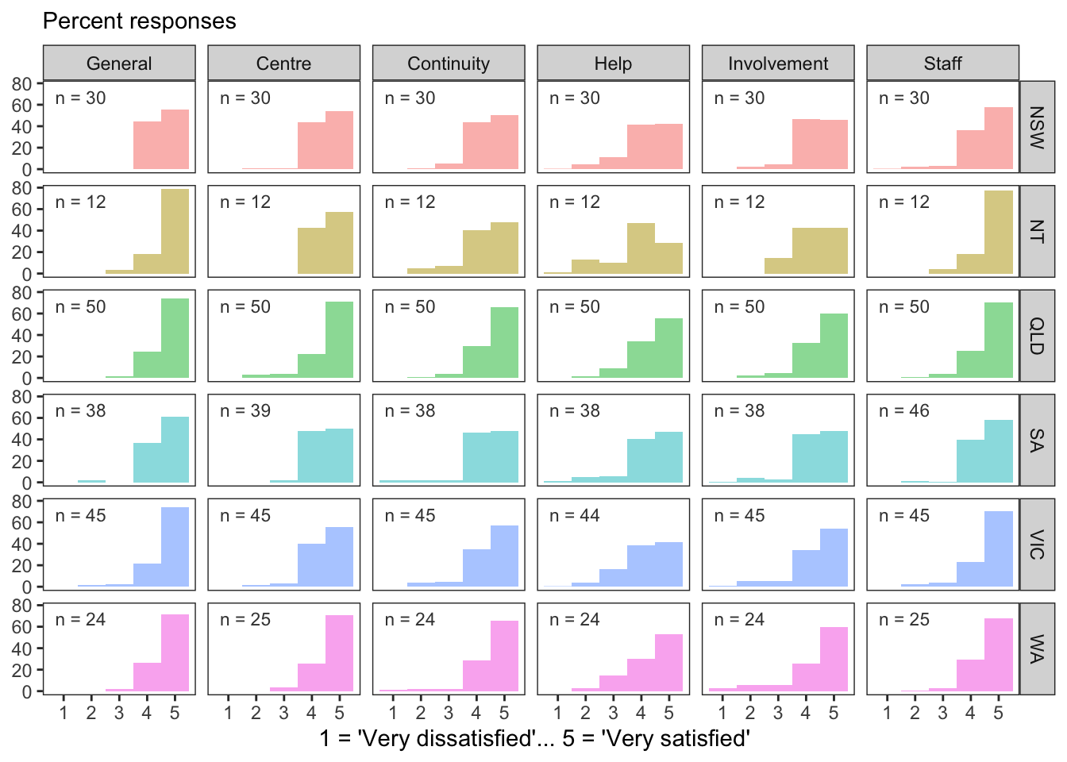

Family satisfaction by total days in treatment

**Key point**

* Satisfaction patterns are very similar regardless of the total time in treatment (90-, 180-, 270- or 360-days)

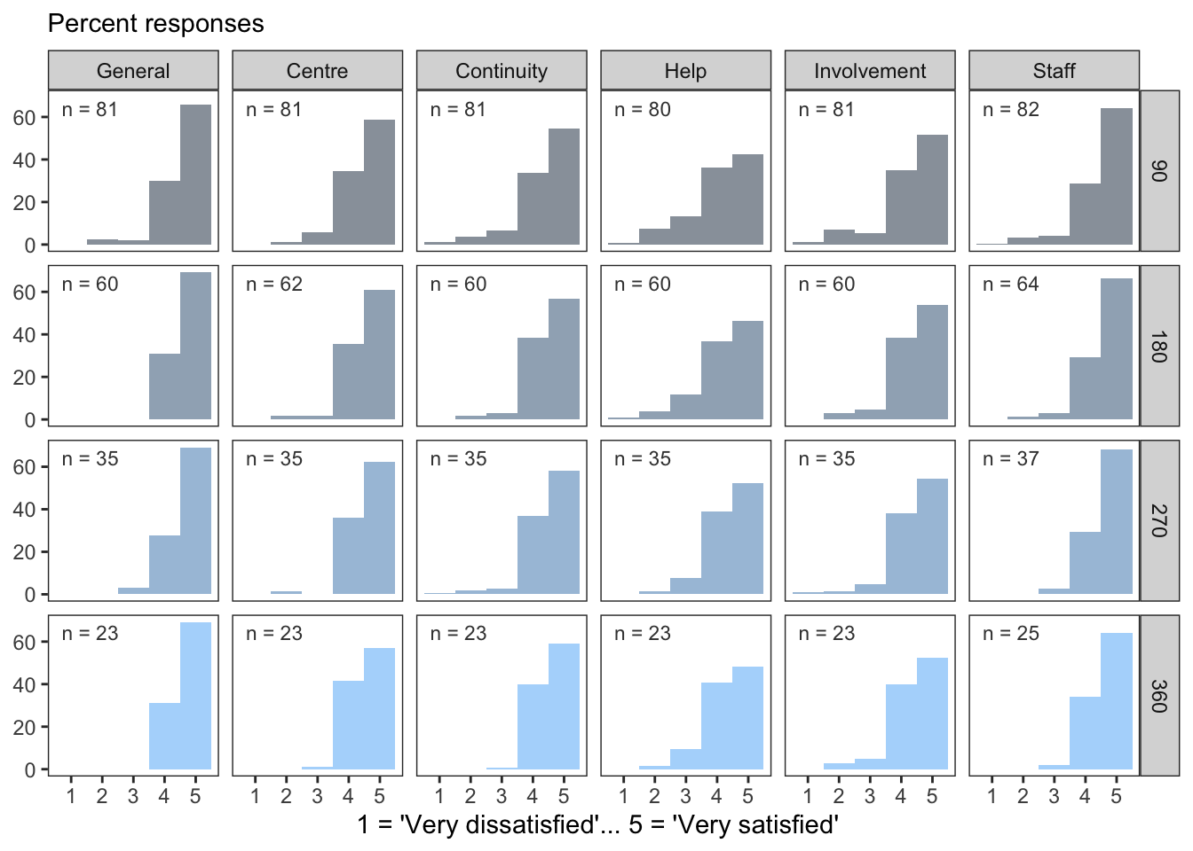

Family satisfaction by treatment arm

**Key point**

* Satisfaction patterns are very similar in both treatment arms (UHR or FEP)

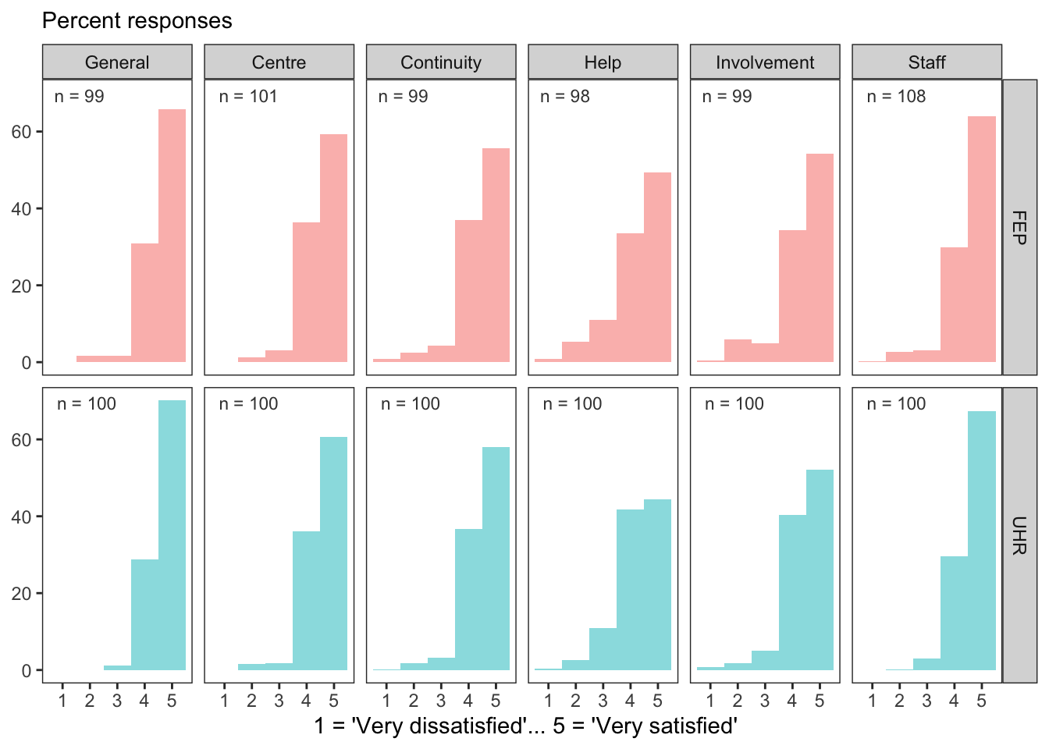

1. Data sources for Evaluation Question 3

The data sources used to answer evaluation 3 include the hAPI data, transitions study data and client, family and carer data. Each of which are described in further detail below.

hAPI data

hAPI data extracted on 30 September 2019 for the Evaluation (‘hAPI evaluation extract’), containing *consenting* episodes of care commencing after 19th June 2017 (see Evaluation Question 1 Table 1.1.3a for baseline demographics).

Each young person’s clinical status was measured at assessment, and then at each 90-day review and discharge. One young person might have only been in the program for 100 days and thus have a baseline assessment and one 90-day review, whilst another would have been treated for 300 days, received a bigger “dose” of the service and have additional 180 and 270 day reviews. To evaluate the effect of duration of treatment on individual change each panel within the figures (that observe change at each review) represents a different subgroup rather than a cumulative cohort, i.e. those appearing in the 180 day subgroup would not be represented in the 90 day subgroup, and those in the 270 day subgroup would not be represented in the 180 day subgroup, and so on. Those discharged between reviews have their discharge assessment shown as being at the subsequent planned review date This ensures the changes observed reflect changes *within* individuals rather than differences *between* subgroups.

Refer to Appendix G for the hAPI data key variables.

Transitions study data

The Transitions study data refers to the data derived from the Transitions Study (Purcell et al, 2015). This data enabled a like-service comparison to clients within the EPYS Program. Data extracted from the Transitions study relates to evaluation sub-questions 3.2, 3.5, 3.6 only. Given the Transitions study data was compared to a cohort of clients within the EPYS Program (and not the EPYS Program as a whole), comparative findings associated with these two cohorts have been reported separately in Appendix K.

Client, family and carer data

The client, family and carer derived data consists of three separate data components:

* Client, family and carer interviews and focus groups: Findings from this relate to evaluation sub-questions 3.1, 3.4, 3.5, 3.6, 3.7, 3.8 and 3.9
* Carer and family survey data: Findings from this relate to sub-question 3.8 and have been provided in Appendix F.
* Client self-report satisfaction data which was reported in hAPI at each 90-day review: Findings from this relate to sub question 3.9 and have been provided in Appendix J.

1. Cost effectiveness methodology for Evaluation Question 4.2

Methodology: primary analysis

The calculation of cost-effectiveness has been undertaken through a three-stage process:

1. Calculating the net cost per client of the EPYS Program
2. Estimating the QALY gain from the EPYS Program
3. Calculating an incremental cost effectiveness ratio.

Calculating the net cost of the EPYS Program

This analysis estimates the costs of delivering the program, and then offsets this against potential savings to the health system arising from reductions in expenditure due to lower utilisation of services due to the program’s effectiveness in reducing FEP (primary analysis).

Calculating the net cost of the EPYS Program includes three steps:

1. Calculate the intervention cost of the EPYS Program per client
2. Calculate any cost offset to the health system arising from the EPYS Program
3. Determine the net cost of the EPYS Program per client by subtracting the result of (B) from (A).

Calculating the net cost of the EPYS Program per client

This calculation was presented in the efficiency analysis, presented as average cost per client (as shown in the cost efficiency analysis of the main report.

Calculating the cost offset to the health system

The cost-offset (savings) per EPYS Program client has been calculated in terms of reduced hospital expenditure arising from:

* Lower utilisation of hospital services by EPYS Program clients.
* The avoidance of hospitalisation episodes for psychosis due to a lower proportion of UHR EPYS Program clients not transitioning to First Episode Psychosis than in the counterfactual.

There are additional savings to the health system from a reduction in hospitalisations, unrelated to the direct cost of providing medical services. This may include transportation and the avoided cost of other outreach programs. Due to the lack of available data these have been not been considered in this analysis.

**Key terms:**

**Hospital service costs**

Hospital service usage were estimated for individual routine public hospital admissions and emergency department presentations for 12-27-year old’s based on ICD-10 codes (International Statistical Classification of Diseases version 10) for all psychosis diagnosis (F20-29, F30 and F31, F32.3). Costs were attached to this activity using the National Efficient Price (NEP) Determination published by the Independent Hospital Pricing Authority (IHPA) . Weights associated with specific healthcare services, paediatric adjustments and Indigenous adjustments were multiplied by the NEP published by the IHPA to determine the average cost of specified services.

**Propensity score matching**

Individuals in comparison PHNs were matched based on like-for-like characteristics to ensure an unbiased estimate. Treatment and control groups within each population were matched by age, sex, SEIFA, geographic/catchment area and baseline hospital service usage.

**Treatment and control groups**

Treatment and control groups were defined by EPYS Program catchment areas (as specified in the ecological analysis that informed estimates of the cost offsets). Catchment areas were defined based on the most recent residential address of each individual.

Treatment group is defined as the individuals within a public health network catchment area where the EPYS Program exists. Control group is defined as the individuals within a public health network catchment area where the EPYS Program does not exist.

Reduced hospital service costs (Step 2.1)

This relates to the incremental difference in hospital service usage within an area where the EPYS Program exists compared to hospital service usage within an area in which the EPYS Program does not exist. This includes reduced hospital service costs relating to clients admitted to hospital or presented to emergency departments with a psychosis related diagnosis (Step 2.1), and reduced number of clients going to hospital with a psychosis related diagnosis (Step 2.2).

Step 2.1.1 – Estimate the average hospital services costs within 2017-18 financial year for all individuals residing in select comparison PHNs.

This step involves the estimation of a hospital services costs within 2017-18 financial year for all individuals residing in select comparison PHNs using the NEP Determination method outlined by the IHPA.

The NEP is a benchmark figure commonly used by governments and healthcare providers as a price signal of the average cost of a health service (on a national basis). Weights associated with specific healthcare services, paediatric adjustments and Indigenous adjustments are multiplied by the NEP published by the IHPA to determine the average cost of a specified service.

Reduced number of clients going to hospital

This relates to the EPYS Program impacting upon the transition rate from UHR to FEP – estimated as the difference in transition rate (converted to number of clients) between an EPYS Program area and non-EPYS Program area. A lower transition rate in the intervention group relative to the control group determined whether there were cost offsets that could be attributed to the program.

For example, a client diagnosed with psychosis may typically cost $7,000 in hospital events related to psychosis per year (in absence of the EPYS Program). If the EPYS Program is found to reduce the number of clients admitted to hospital by 30 clients (because they did not transition from UHR to FEP), this then equates to $210,000 in savings. This is then averaged over the entire patient intervention cohort in order to derive an average cost saving per patient.

Figure 8: Illustrative example of cost offset estimation

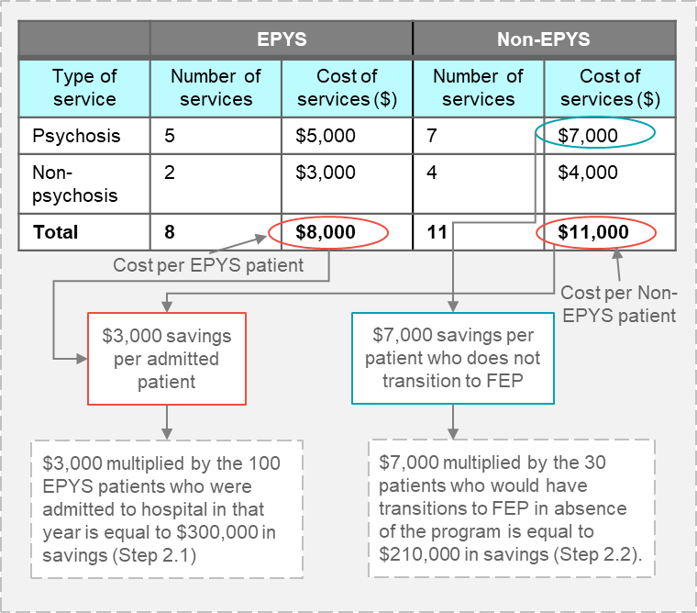

Step 2.1.2 – Use propensity score matching to construct test and control groups.

Propensity score matching was used to determine the incremental difference in cost of hospital service usage between EPYS Program treatment and control groups.

* The treatment group is defined as the number of events within a public health network where the EPYS Program exists (i.e. North Perth PHN).
* The control group outcome is defined as the number of events with a public health network where the EPYS Program does not exist (i.e. South-Perth PHN, North Perth Country Health Service).

Treatment and control groups within each population were matched by age, sex, SEIFA, geographic/catchment area and baseline measures of hospital service usage prior to the 2018 financial year.

Figure 9: The propensity score matching process detailed in step 2.1.2

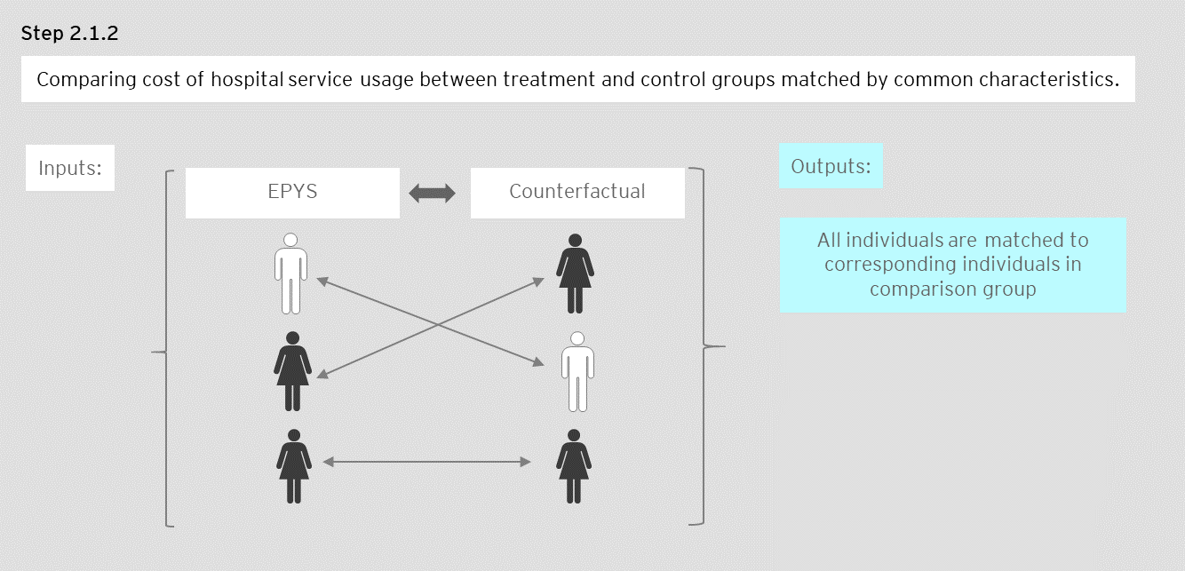

Step 2.1.3 – Estimate the difference in hospital service costs between matched individuals.

Assign costs of hospital service utilisation to each pair.

Step 2.1.4 – Take an average of the differences in hospital service costs.

Calculate the average difference in hospital utilisation costs for each matched pairing from step 2.1.2.

Step 2.2 Estimate the total number of clients who avoided transition

Determine the total number of EPYS Program clients that avoided transition from Ultra High Risk to First Episode Psychosis. Multiply this figure by the average hospital service usage cost of EPYS Program clients estimated in Step 2.1. Divide by total number of EPYS Program clients to determine savings per client.

Figure 10: Calculations performed in step 2.2

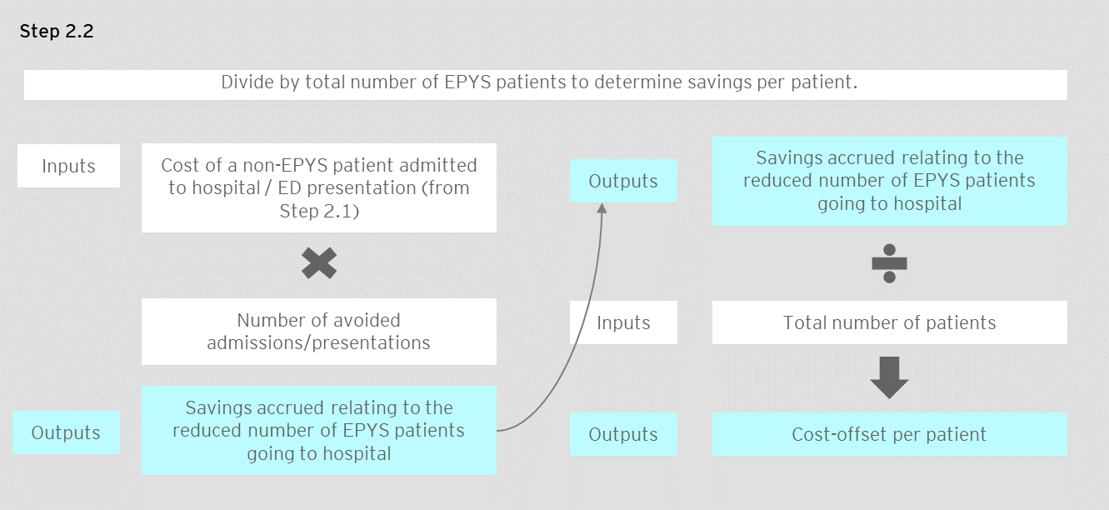

Step 2.3 Calculate the total cost-offset per patient

Sum the savings estimated in Step two and divide by the total number of EPYS Program clients to determine the cost-offset per EPYS Program client.

Figure 11: Calculations performed in step 2.3

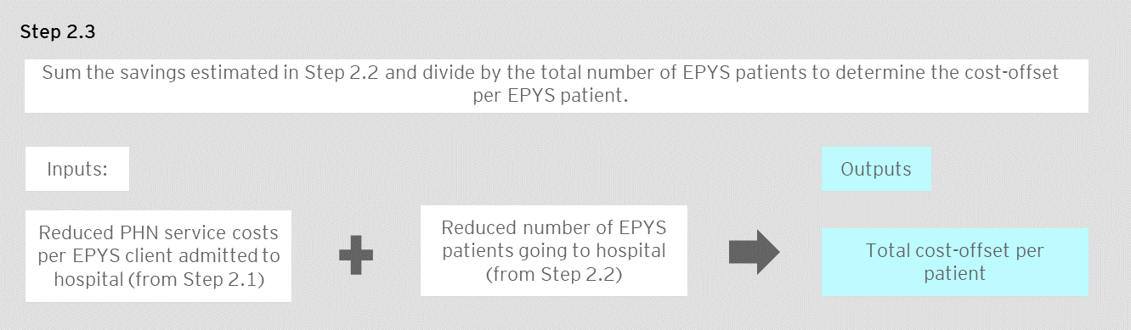

Estimating QALYs

The assessment of clinical effectiveness leveraged the findings from Evaluation Question two. The economic analysis took the findings in relation to the change in K10 and converted it into QALYs. The process of estimating the incremental change in QALYs is outlined below:

* Step one – Estimate the effect of EPYS Program on K10 values for clients in the EPYS Program for 12 months.
* Step two – Calculate the change in K10 scores between baseline and follow-up for the EPYS cohort, adjusted for differences in demographic and clinical characteristics between this cohort and comparator
* Step three – Translate the improvement in K10 score into a *utility weight* gained per client in the EPYS Program.
* Step four – Produce final QALYs outcome estimate.

**Stage Two: Key Terms**

**Quality Adjusted Life Years (QALYs)**

The QALY is commonly used in health economic evaluations as a means of quantifying the health effect of a medical intervention or a prevention program.

A QALY is calculated by multiplying an individual’s Years of Life by a utility weight related to their health-related quality of life during that period of time. A Utility weight of 1 means the individual is in perfect health, whilst a weight of 0 means the individual is in a health state equivalent to death. For example, if a person’s Utility weight is 0.5 for 3 Years of Life, then they have 1.5 QALYs.

**Kesler Psychological Distress Scale-10 (K10)**

K10 scores measure psychological distress. These scores are collected every 90 days for EPYS Program clients in the hAPI dataset. In the absence of QALYs data relating to the EPYS Program, K10 data will be cross-walked into Utility Values to determine QALYs. This was be done from data presented in the literature that measures K10 and utility weights in the same subjects.

**Determining years of life**

Years of life have been contained to the most recent data relating to clients who have been in the EPYS Program for at least one year to ensure a balanced comparison with the Transitions cohort. This means that the average difference in Utility Value was multiplied by only one year to produce a QALYs estimate.

Step one: estimate the effect of EPYS Program on K10 values for clients in the program for 12 months

Step one estimates the incremental difference in average Utility Value of clients within the EPYS Program with those in the counterfactual group using an ordinary-least squares regression model. Data was gathered on explanatory variables for the EPYS Program and comparable cohort over a 12-month period. Detail on the model specifications is in Section 2.3.5 below.

Using the sample characteristics of the EPYS Program cohort, a follow-up K10 score was estimated for EPYS Program and a counterfactual that assumes no change in baseline K10 score at follow-up. The estimated change in the EPYS Program and the comparative service is estimated by taking the difference between these estimated follow-up scores, and the average baseline score for the EPYS Program cohort. The result is a ‘counterfactual’ for what the K10 score would have been for the individuals with the same characteristics as the EPYS Program cohort, had they been in the historical counterfactual program.

Step two: calculate the change in K10 scores for the EPYS cohort

Calculate the change in K10 scores between baseline and follow-up for the EPYS cohort, adjusted for differences in demographic and clinical characteristics between this cohort and comparator. The difference between baseline and follow-up values after accounting for these sample characteristics is the final K10 change resulting from the Program.

Step three: calculate the Utility Value gained per client in the EPYS Program

The difference in K10 value changes must be collected and transformed into a utility value that enables the QALYs estimation.

Step three involves transforming the difference in recorded K10 scores into the utility instrument, AQol-8D. AQol-8D is a standardised instrument for measuring generic health status. It is widely used in population health surveys, clinical studies, economic evaluation and in routine outcome measurement in the delivery of operational healthcare.

The Evaluation utilised the results from analysis by Mihalopoulos[30] that converted K10 scores into estimated health state utilities using a statistically derived conversion formula. The original utility scores in that study were measured on the AQol-8D. AQol-8D is a standardised instrument for measuring generic health status. It is widely used in population health surveys, clinical studies, economic evaluation and in routine outcome measurement in the delivery of operational healthcare.

Table 38: Transformation of K10 scores into utility values

| **K10 category** | **Corresponding AQoL-8D utility value[31]** |
| --- | --- |
| Likely to be well (score 10-19) | 0.78 |
| Mild depression/anxiety (score 20-24) | 0.70 |
| Moderate depression/anxiety (score 25-29) | 0.66 |
| Severe depression/anxiety (score 30-50) | 0.47 |

The incremental difference in utility estimated in step three was multiplied by 0.5 to reflect an estimate of difference in QALYs. This value was taken to reflect the assumption that clients would reap the full benefit in quality of life over the last six months of the EPYS Program. It is an assumption that the reduction in K10 score over the 12 months is linear (see below).

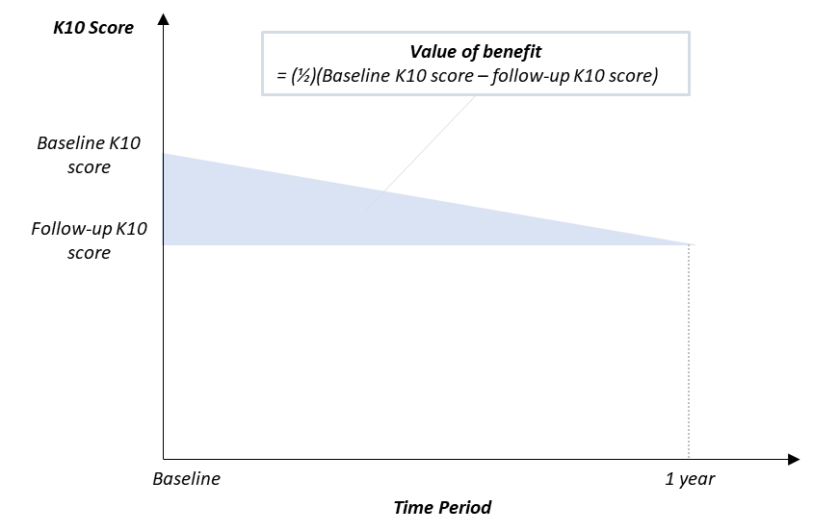

Figure 12: Estimation of benefit period based on change in K10 scores

Estimate of cost-effectiveness

The estimate of cost-effectiveness is the final stage in estimating the cost-effectiveness of the EPYS Program and includes only one step:

*Divide the net cost per client of the EPYS Program (estimated in Stage one) by the incremental difference in QALYs for clients in the EPYS Program (estimated in Stage two).*

Figure 13: Calculation of cost-effectiveness of the program (ICER)

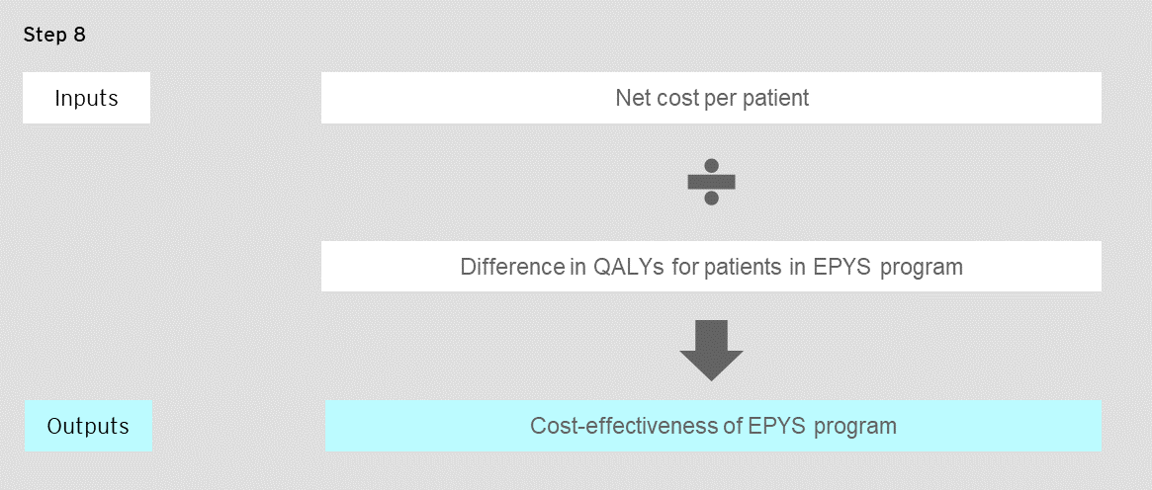

1. Proposed “catchments” for Evaluation Question 5

The proposed catchments have been based on the boundaries, as defined by the ABS. Proposed catchments only capture the total population size and are not a recommendation of roll-out strategy.

Figure 14: Adelaide catchment boundaries

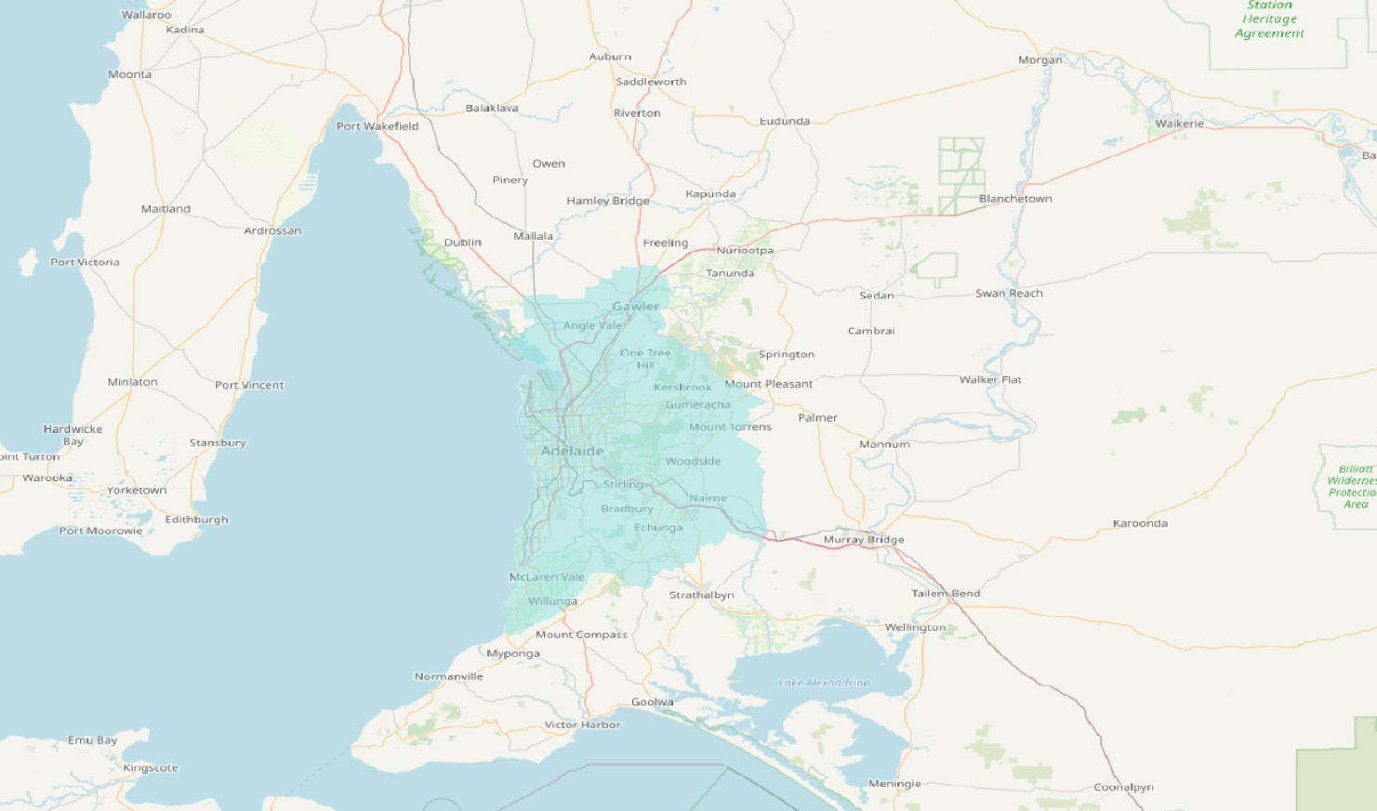

Figure 15: Canberra catchment boundaries

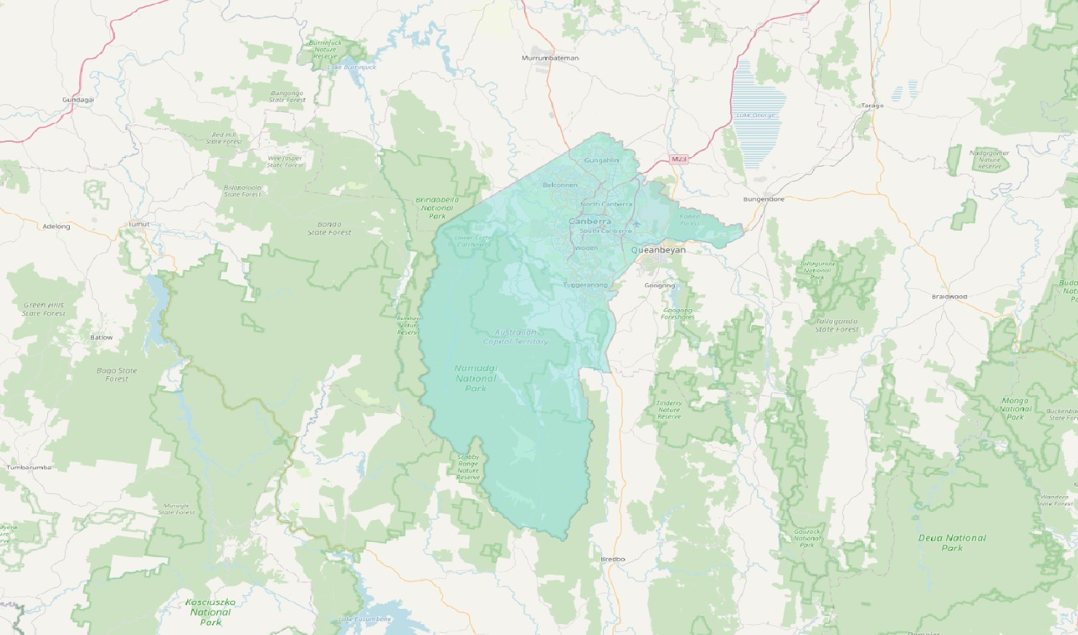

Figure 16: Brisbane catchment boundaries

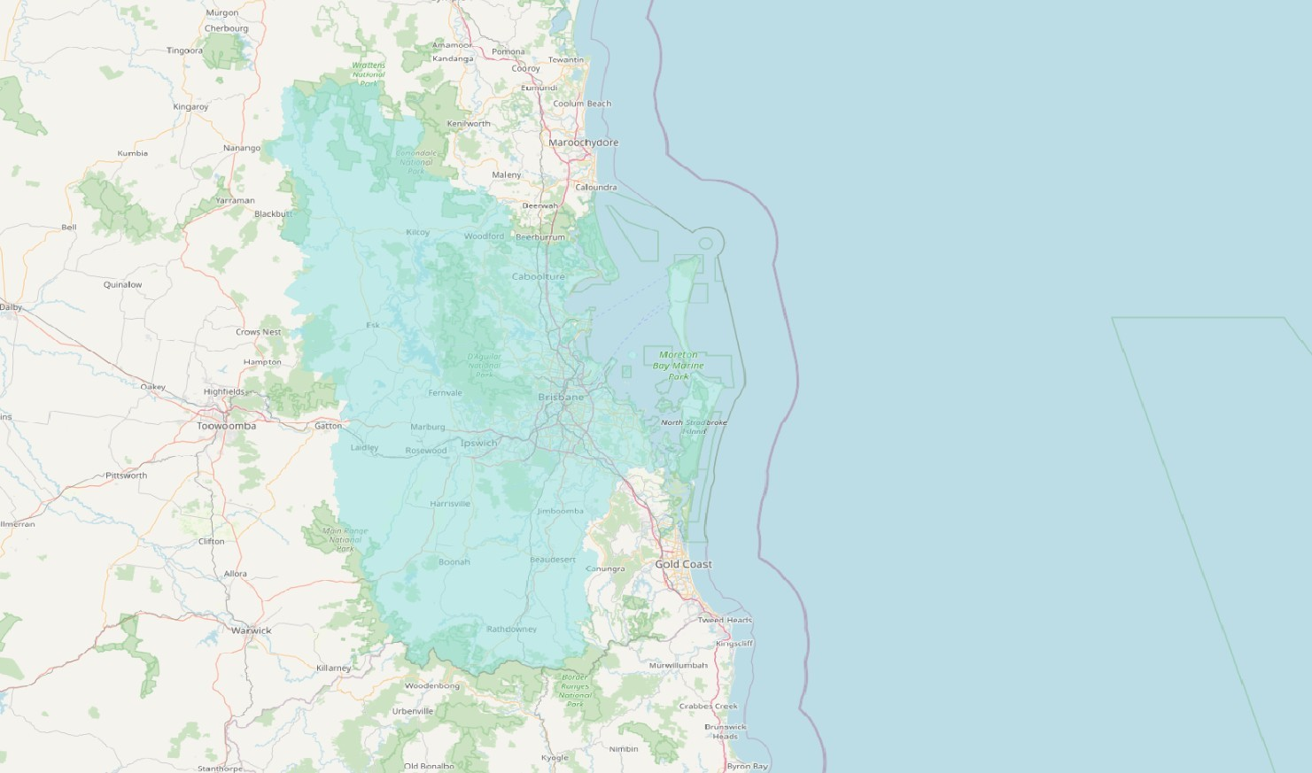

Figure 17: Sydney catchment boundaries

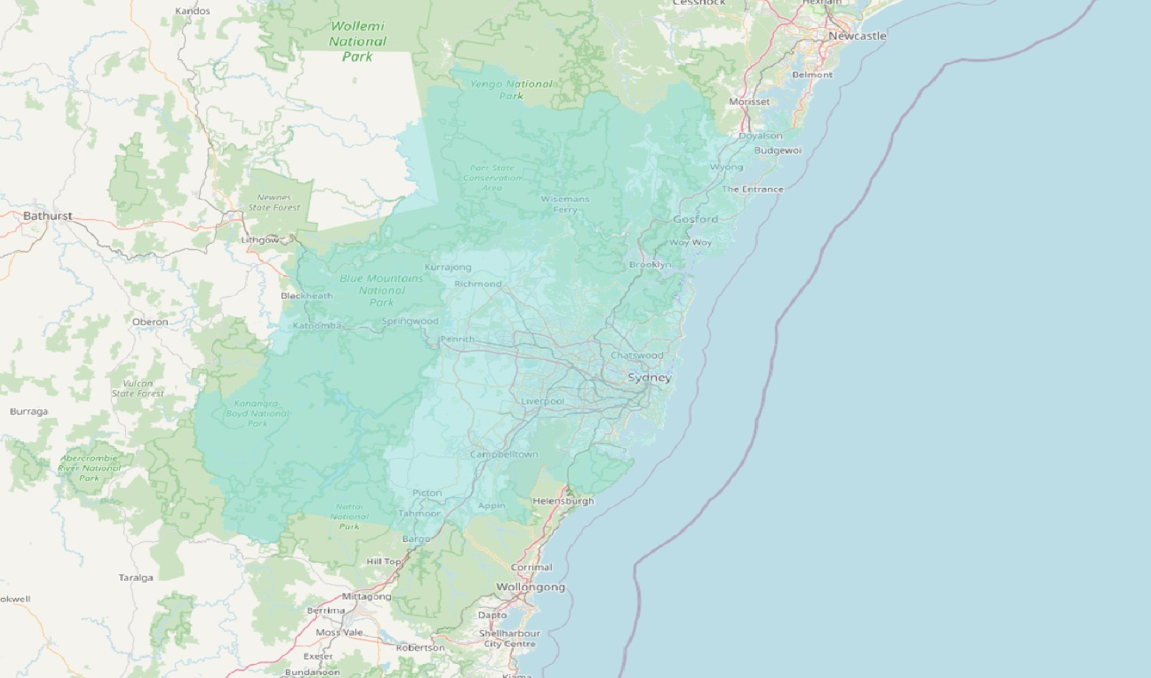

Figure 18: Perth catchment boundaries

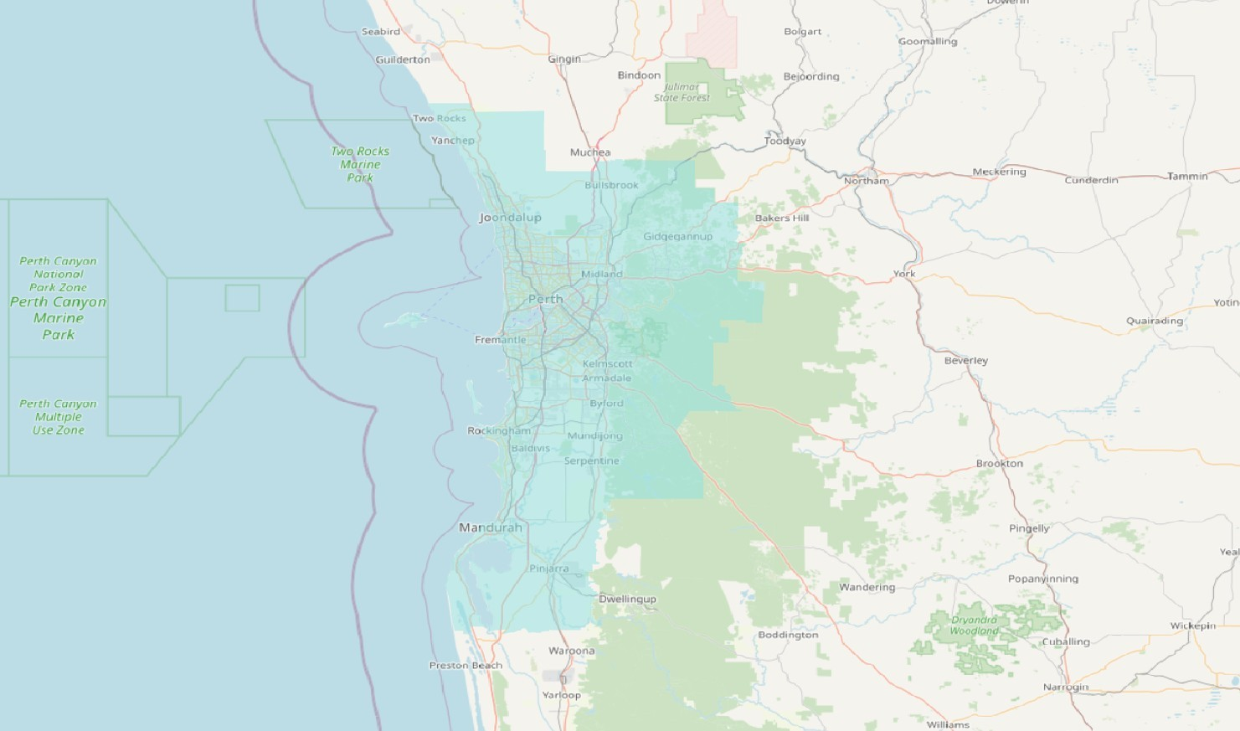

Figure 19: Darwin catchment boundaries

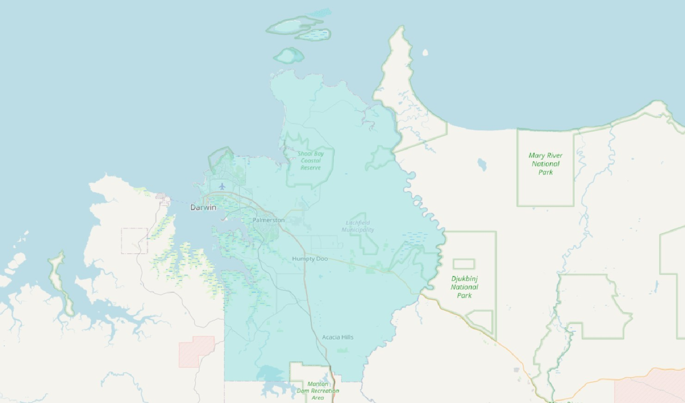

Figure 20: Melbourne catchment boundaries

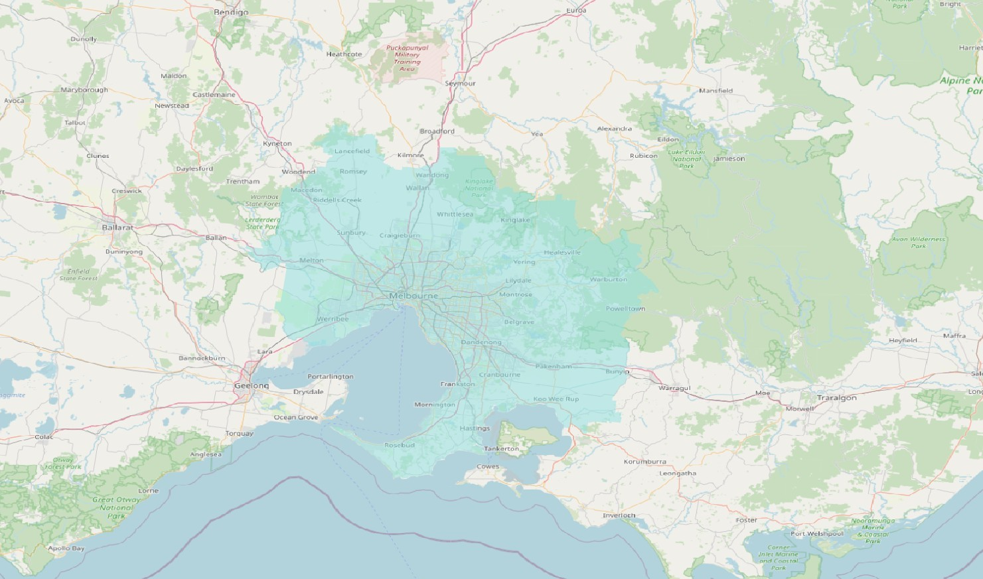

Figure 21: Hobart catchment boundaries

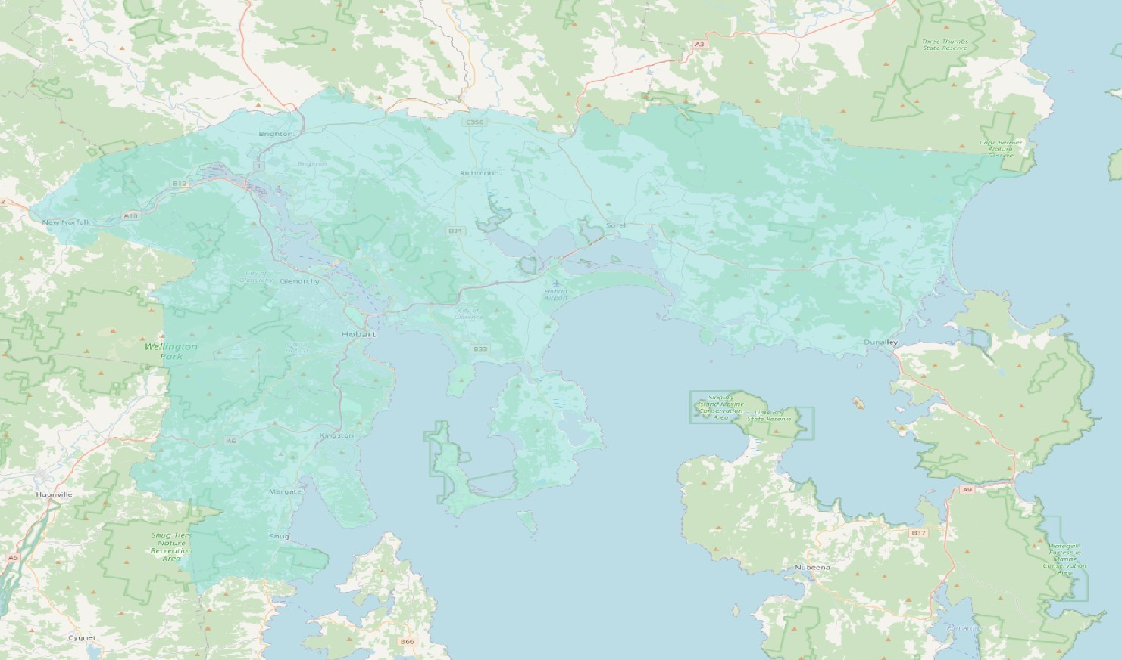

Regional centre boundaries

Figure 22: Gold coast catchment Boundaries

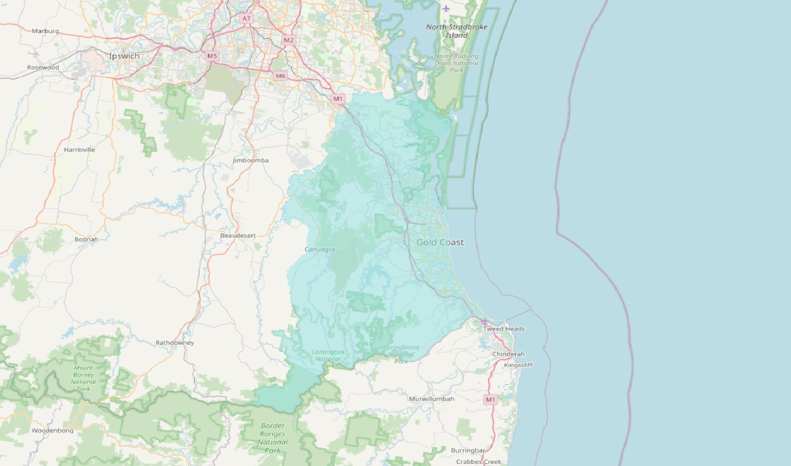

Figure 23: Newcastle catchment boundaries

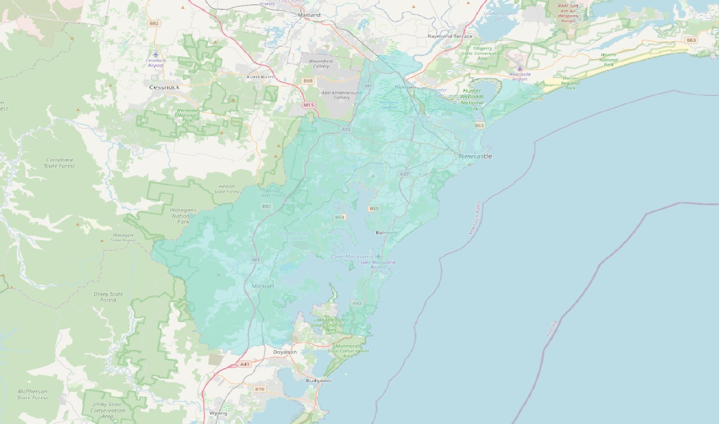

EY | Assurance | Tax | Transactions | Advisory

About EY

EY is a global leader in assurance, tax, transaction and advisory services. The insights and quality services we deliver help build trust and confidence in the capital markets and in economies the world over. We develop outstanding leaders who team to deliver on our promises to all of our stakeholders. In so doing, we play a critical role in building a better working world for our people, for our clients and for our communities.

EY refers to the global organization, and may refer to one or more, of the member firms of Ernst & Young Global Limited, each of which is a separate legal entity. Ernst & Young Global Limited, a UK company limited by guarantee, does not provide services to clients. Information about how EY collects and uses personal data and a description of the rights individuals have under data protection legislation is available via ey.com/privacy. For more information about our organization, please visit ey.com.

© 2020 Ernst & Young, Australia  
All Rights Reserved.

Liability limited by a scheme approved under Professional Standards Legislation.

ED 0820

In line with EY’s commitment to minimize its impact on the environment, this document has been printed on paper with a high recycled content.

Ernst & Young is a registered trademark.

Our report may be relied upon by The Australian Government Department of Health for the purpose of the EPYS Program only pursuant to the terms of our engagement. We disclaim all responsibility to any other party for any loss or liability that the other party may suffer or incur arising from or relating to or in any way connected with the contents of our report, the provision of our report to the other party or the reliance upon our report by the other party.

ey.com

1. Jääskeläinen E, Juola P, Hirvonen N, et al. A systematic review and meta-analysis of recovery in schizophrenia. Schizophr Bull. 39(6):1296-1306. (2013).
2. Correl et al, Comparison of Early Intervention Services verse Treatment as Usual for Early-Phase Psychosis. A systematic Review, Meta-analysis, and Meta-regression. (2018).
3. Nordentoft M, Rasmussen JØ, Melau M, Hjorthøj CR, Thorup AA. How successful are first episode programs? a review of the evidence for specialized assertive early intervention. Curr Opin Psychiatry. 27(3):167-172. (2014).
4. Correl et al, Comparison of Early Intervention Services verse Treatment as Usual for Early-Phase Psychosis. A systematic Review, Meta-analysis, and Meta-regression. (2018).
5. Productivity Commission. Mental Health – Draft Report. (2019).
6. Albert, N., Authen Weibell, M. The outcome of early intervention in first episode psychosis, International review of Psychiatry, (2019)
7. Marshall, M., Lewis, S., Lockwood, A., Drake, R., Jones, P.,& Croudace, T. (2005). Association between duration of untreated psychosis and outcome in cohorts of first-episode patients: A systematic review. Archives of General Psychiatry, 62(9), 975–983.
8. Marshall, M., Lewis, S., Lockwood, A., Drake, R., Jones, P.,& Croudace, T. (2005). Association between duration of untreated psychosis and outcome in cohorts of first-episode patients: A systematic review. Archives of General Psychiatry, 62(9), 975–983.
9. This number of days also relates to other metrics: The time being reduced between having first psychotic symptom to first contact with Early Intervention Service; Reduction in the time period between onset of any psychotic symptoms and receipt of antipsychotic treatment; Reduction in the time from onset of psychosis to hospital admission; Reduction in the time between the onset of psychosis and having a definitive diagnosis and treatment established; Reduction in the time from a score of 4 or higher on at least one PANSS positive sub-scale item, throughout the day for several days or several days a week to initiation of adequate treatment.
10. McGorry, P., Edwards, J., Mihalopoulos, C., Harrigan, S., Jackson, H., EPPIC: An evolving system of early detection and optimal management. Schizophrenia Bulletin, 22(2), 305. (1996).
11. Joa, I., Johannessen, J. O., Auestad, B., Friis, S., McGlashan, T., Melle, I., … Larsen, T. K. The key to reducing duration of untreated first psychosis: Information campaigns. Schizophrenia Bulletin, 34(3), 466-472, (2008)
12. Correll, Christoph et al. “Comparison of Early Intervention Services Vs Treatment as usual for Early-Phase Psychosis. A systematic review, meta-analysis and meta-regression” JAMA Psychiatry 75.6: 555-565. (2018)
13. Rate of Hospitalisation also includes rate of readmission to hospital
14. Correl Christoph et al, Comparison of Early Intervention Services verse Treatment as Usual for Early-Phase Psychosis. A systematic Review, Meta-analysis, and Meta-regression. JAMA Psychiatry, 75.6: 555-565. (2018).
15. Iyer SN, Mangala R, Anitha J, Thara R, Malla AK. An examination of patient-identified goals for treatment in a

    first-episode programme in Chennai, India. Early Intervention in Psychiatry 5, 360–365. (2011).
16. Nuechterlein KH, Subotnik KL, Turner LR, Ventura J, Becker DR, Drake RE. Individual Placement and Support for individuals with recent-onset schizophrenia:Integrating supported education and supported employment. Psychiatric Rehabilitation Journal 31, 340–349. (2008).
17. Marshall T, Goldberg RW, Braude L, Dougherty RH, Daniels AS, Ghose SS, George P, Delphin-Rittmon ME. Supported employment: assessing the evidence. Psychiatric Services 65, 16–23. (2014).
18. Marshall T, Goldberg RW, Braude L, Dougherty RH, Daniels AS, Ghose SS, George P, Delphin-Rittmon ME. Supported employment: assessing the evidence. Psychiatric Services 65, 16–23. (2014).
19. Bassett J, Lloyd C. Work issues for young people with psychosis: barriers to employment. British Journal of

    Occupational Therapy 64, 66–72. (2001).
20. Browne DJ, Waghorn G. Employment services as an early intervention for young people with mental illness. Early Intervention in Psychiatry 4, 327–335. (2012).
21. Bond, G., Drake, R., Luciano, A., Employment and educational outcomes in early intervention programmes for Early Psychosis: a systematic review, 24, 446-457, Cambridge University Press, Epidemiology and Psychiatric Sciences, (2015).
22. Correl Christoph et al, Comparison of Early Intervention Services verse Treatment as Usual for Early-Phase Psychosis. A systematic Review, Meta-analysis, and Meta-regression. JAMA Psychiatry, 75.6: 555-565. (2018).
23. Correl Christoph et al, Comparison of Early Intervention Services verse Treatment as Usual for Early-Phase Psychosis. A systematic Review, Meta-analysis, and Meta-regression. JAMA Psychiatry, 75.6: 555-565. (2018).
24. Nelson, B., Yuen, H., Lin, A., Wood, S., McGorry, P., Hartmann, J., & Yung, A., Further examination of the reducing transition rate in ultra high risk for psychosis samples: The possible role of earlier intervention. (2016)
25. Mihalopoulos, C., Harris, M., Henry, L., Harrigan, S., & McGorry, P., Is early intervention in psychosis cost-effective over the long term? Deakin Health economics, Deakin University, Orygen Research Centre, Department of Psychiatry, The University of Melbourne, Australia, (2009).
26. Behan, C., Turner, N., Owens, E., Lau, A., Kinsella, A., Cullinan, J., Kennelly, B., Clarke, M., DETECT, University of College Dublin. Estimating the cost and effect of early intervention on in-patient admission in the first episode psychosis. DETECT Early Intervention in Psychosis Service; North Shore LIJ System New York; Molecular & Cellular therapeutics and U Partnership, Royal College of Surgeons in Ireland, Dublin, Ireland; National University of Ireland, Galway, (2015).
27. Amos, A., Assessing the cost of early intervention in psychosis: A systematic review, the Australia & New Zealand Journal of Psychiatry, 46, (*), 719-734, (2012).
28.
29. While follow up interviews were not intended for Cohort 2, some participant expressed interest following up with the researchers on the site visit.
30. Mihalopoulos, C., Chen, G., Iezzi, A., and Khan M., 2014, Assessing outcomes for cost-utility analysis in depression: comparison of five multi-attribute utility instruments with two depression-specific outcome measures, The British Journal of Psychiatry, 205, 290-397.
31. A further assumption was made to allow for the complete mapping of K10 scores to utility weights. Each utility weight above is assigned to a category, meaning that a direct mapping of K10 scores would not capture improvements in K10 scores between intervals. Instead it is assumed that the decrease over the interval is linear, assuming that the utility score at the minimum K10 score in the interval is the maximum utility value for the interval, and linearly decreasing the utility score until the base utility score for the next category is reached. To enable calculation between 10-19, a utility score of 1 was assumed at a K10 score of 10 as this is the minimum possible score on the scale and indicates perfect health ceteris paribus.