# Diversity and Aims of the Australian Medical Research Advisory Board 2021-2026

## How will members’ experiences contribute to the work of AMRAB?

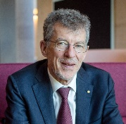**Professor Ian Frazer AC, AMRAB Chair**

Ian helped develop new preventive strategies for health through vaccination. As a board member of several biotech companies he understands that to commercialise a health research program you need a sound value proposition. ‘It’s one thing to say that you've got a better way of doing something. But if it’s not competitive then it’s not going to be used.’ Interacting with industry helps set the milestones for developing novel technologies. ‘The best possible care for patients is provided within a budget. Therefore you want to look for value for money and patient value.’

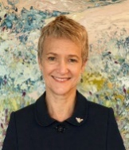**Professor Caroline Homer AO, AMRAB Deputy-Chair**

Caroline has developed and evaluated midwifery and maternity services in Australia and the Asia-Pacific. This work strengthened midwifery capacity and skills by developing evidence-based practice. Caroline developed and implemented innovative models of care, improved the quality of care provision and translated research into clinical practice. ‘For me disease prevention starts preconception. What we do to keep women well in pregnancy and support their families makes a difference long term.’

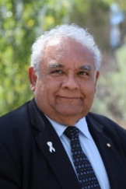**Professor Tom Calma AO**

In 2005, Tom wrote the *Social Justice Report: The Indigenous Health Challenge*. This Report’s call for parity in indigenous health outcomes led to the Government adopting the ‘Closing the Gap’ policy. Tom also tackles Indigenous smoking and is a Chief Investigator on projects funded by the Medical Research Future Fund (MRFF) on mental health and scabies. Tom is on the Australian Genomics’ Independent Advisory Board and chairs an Indigenous company that is a member of a consortium reforming primary health care in Papua New Guinea.

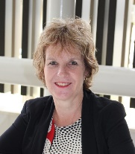**Professor Denise Doolan**

As a James Cook University Professor based in Cairns, Denise has a regional and remote perspective. Being born and raised in Papua New Guinea set her on the path to researching basic immunology. Denise has moved projects through the pipeline from preclinical research to clinical testing and worked in the United States regulatory environment. As an expert in tropical and infectious diseases, she knows how infectious diseases such as COVID-19 can travel quickly between countries. For this reason ‘it is to our advantage to look to our Pacific neighbours’ health as well as our own.’

**Mr Yasser El-Ansary**

Yasser comes from an economics and financial background. ‘My skillset is to ask all those frustrating questions. I aim to help AMRAB achieve the MRFF’s purpose in the most efficient way possible.’ Yasser believes AMRAB’s focus on innovation and public health economics is an important reason for MRFF’s success.

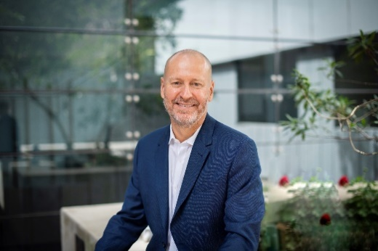**Professor Doug Hilton AO**

Doug has been a health and medical researcher for 35 years. ‘I am a collaborator at heart who enjoys working with medical professionals, industry colleagues and other laboratory scientists to translate basic research into improved health. To achieve this result, we need to solve long-term, difficult problems. I want AMRAB to create an environment in Australia that allows the organisations and researchers who do this important work to thrive.’

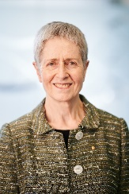**Professor Anne Kelso AO, Ex-Officio Member**

As the CEO of the National Health and Medical Research Council (NHMRC), Anne contributes an NHMRC perspective to AMRAB. Anne spent most of her career in biomedical research, also serving as Director of the Cooperative Research Centre for Vaccine Technology and the World Health Organisation Collaborating Centre for Reference and Research on Influenza. Engaging with international medical research funding agencies has made Anne aware of policy issues funders face around the world. Anne’s diverse background provides ‘a breadth of experience that affects everything I do.’

**Ms Imelda Lynch**

Imelda’s long career in health includes nursing in the acute health care setting for many years. She then worked in the ethics of human research, led a not-for-profit health charity and has various health related board positions. ‘Understanding each of those health settings adds to the diversity of the skillset and experience of AMRAB.’

## Looking forward to the next five years

The new AMRAB’s first job was a review of the five-yearly Australian Medical Research and Innovation Strategy and related two-yearly Priorities for the MRFF.

The review took stock of changes in the health and medical research landscape in Australia over the past 5 years. This enabled AMRAB to see emerging needs and continue to support priority-driven health and medical research and innovation.

During the first five years, the MRFF set up its operating procedures and matured to a capital base of $20 billion. The MRFF is now expected to provide funding of approximately $650 million a year.

Through a consultation approach, AMRAB advises the Government on where and how the MRFF can tackle our most significant health challenges. This means setting the right priorities and attracting gifted and collaborative teams to work with us.

As part of this process, AMRAB still sees a need to get the word out about the opportunities created by the MRFF. The MRFF supports researchers and organisations to develop major partnerships with industry, health systems and governments.

## Consultation is key

Consultation is key to AMRAB helping government to achieve the best possible benefits and greatest value for the community.

AMRAB members consult with members of the community such as researchers, consumer advocates, biotech companies and health system consumers. Their views inform AMRAB of opinions, perspectives, and new issues that need more attention.

Hearing first-hand from patients and their families and carers about the impacts of disease and other health issues helps AMRAB to stay focused. This information improves the quality and relevance of AMRAB’s advice to government.