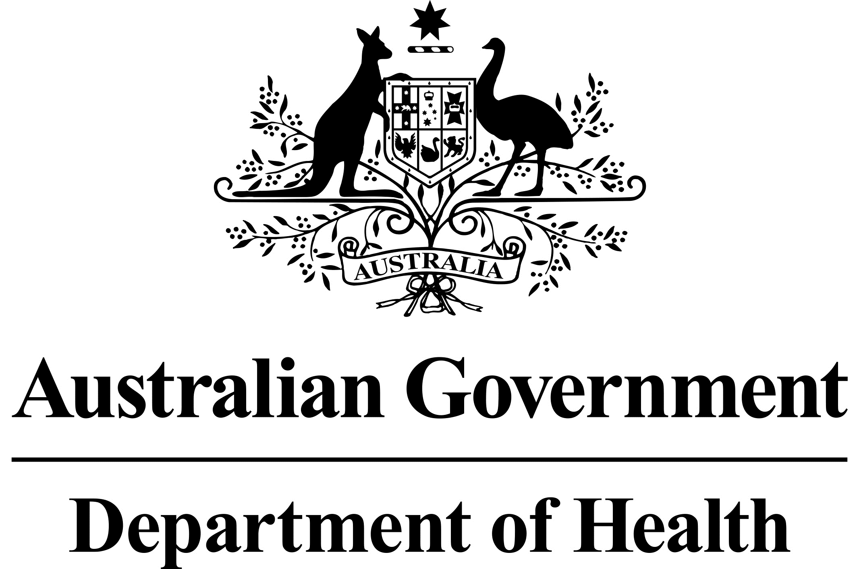

***Tobacco Advertising Prohibition Act 1992***

**Historic Motorsport Vehicle Liveries - Circular**

November 2021

The Department of Health (the Department) is aware of potential non-compliance of the [*Tobacco Advertising Prohibition Act 1992*](https://www.legislation.gov.au/Details/C2017C00302) (the Act) in relation to the display, publication or promotion of historic motorsport vehicle liveries.

Tobacco sponsorship liveries on historic motorsport vehicles are likely to meet the basic meaning of a tobacco advertisement under Section 9(1) of the Act because they give publicity to, or promote the purchase of, tobacco products and smoking. As such, their publication may breach Section 15 (Tobacco advertisements not to be published) and/or Section 15A (Tobacco advertisements not to be published electronically) of the Act.

The Department believes that there are distinguishable differences between historic race vehicles, replica vehicles and tribute vehicles, and how they may relate to compliance with the Act. The Department’s determination on what constitutes each of these is as follows:

|  |
| --- |
| Original historic vehicles An original historic race vehicle is a vehicle that actively competed in motorsports with tobacco sponsorship livery in races that pre-dated the Act. Generally, such vehicles are deemed to be an exception under the Act. |
| Replica historic vehicles A replica historic race vehicle is a vehicle of the same make and model to an original historic race vehicle, designed to replicate an original historic vehicle, including tobacco sponsorship livery. |
| Tribute vehicles A tribute vehicle is a vehicle of a different model or series to an original historic race vehicle, designed to honour or evoke memories of the original historic vehicle, including the application of the original vehicle’s tobacco sponsorship livery. |

Generally, where tobacco advertising liveries are applied to replica or tribute vehicles prior to the commencement of the Act on 24 December 1992, or applied pursuant to a contract which was entered into before the commencement of the Act, are likely to qualify as an exemption under the Act.

Where tobacco advertising liveries are applied to replica or tribute vehicles after the commencement of the Act, generally, it is not likely that an exemption would apply.

These circumstances are likely to constitute a breach of the Act.

In respect to the maintenance of existing tobacco sponsorship liveries on original historic race vehicles, the Department considers refurbishing or reapplying livery for restoration purpose is likely to qualify as an exception under the Act.

However, this is highly dependent on the context and nature of any maintenance or restoration undertaken. It would be necessary to have regard to all the relevant factors, including whether the restoration resulted in an altered design, or if any additional benefit was received by the vehicle owner under the Act.

For further information, please email [tobaccoadvertising@health.gov.au](mailto:tobaccoadvertising@health.gov.au).

**Disclaimer: This information is provided for general informational purposes only as it is not exhaustive, nor does it does not constitute legal advice. Please seek your own independent and private legal advice before relying on any information provided by the Department.**

**The Department does not certify compliance with the *Tobacco Advertising Prohibition Act 1992* or any other tobacco control legislation that it administers.**