# My Aged Care Quick Reference Guide – How to access and use the Quality Indicators application

This guide is designed to inform ‘team leaders’, ‘staff members’ and ‘administrators’ about accessing and using the Quality Indicator application in the My Aged Care provider portal.

The guide is spilt into sections as follows:

* What am I able to do based on my role?
* How do I grant access to the quality indicator Application?
* How do I upload my quality indicator data in a file?
* How do I manually enter the quarterly quality indicator data for a facility?
* More information

## What am I able to do based on my role?

|  |  |
| --- | --- |
| Role | Description of access |
| Administrator | * Enter, save, submit and re–submit quality indicator data and targets * View data in the QI Program Dashboard |
| Team Leader, Staff Members assigned with the QI Role |
| Administrator | * Manage staff access to the Quality Indicator Application and the QI Program Dashboard |

## How do I grant access to the quality indicator Application?

Only an Administrator can add the Quality Indicator Application for Staff Members and Team Leaders.

To add the Quality Indicator tile, the Administrator must:

1. Log in to the My Aged Care provider portal
2. Select ‘Staff administration’ from the Provider Portal home page

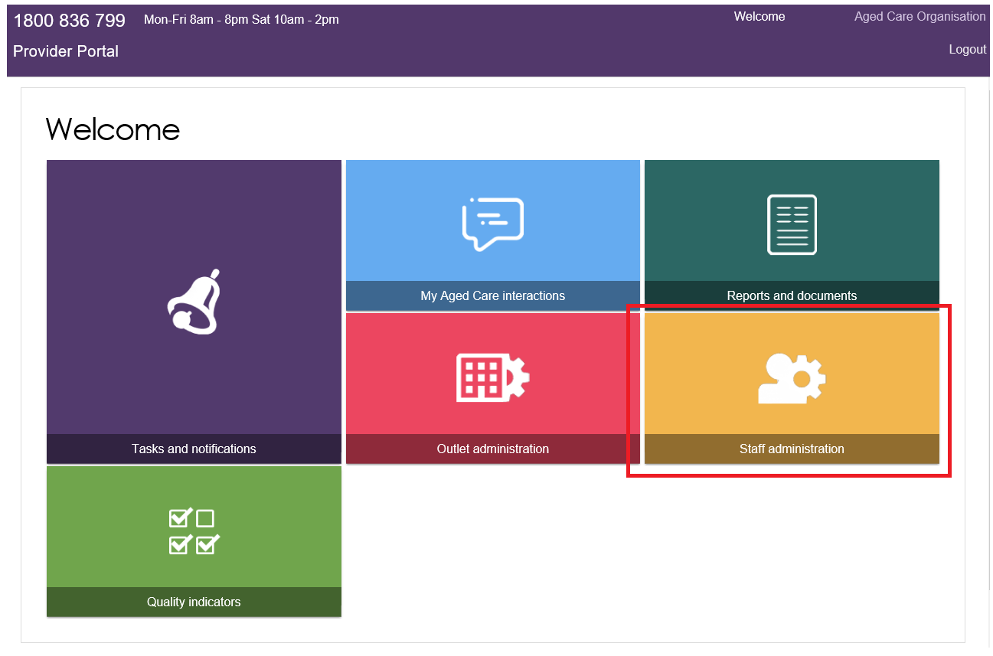

1. On the ‘Staff administration' page, click on the person you would like to give access to the Quality Indicator Application.

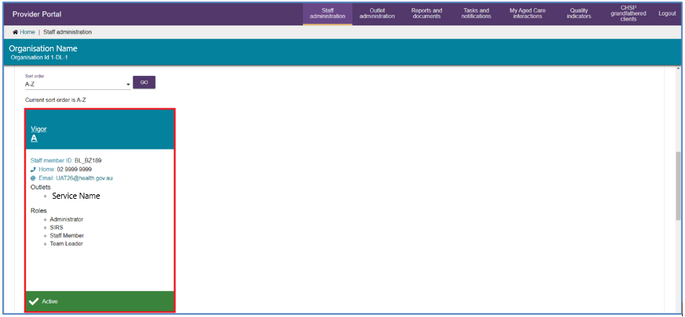

 For information about how to add a staff member to your facility in the My Aged Care provider portal, please refer to the [My Aged Care provider portal user guide part one - administrator functions](https://www.health.gov.au/resources/publications/my-aged-care-provider-portal-user-guide-part-1-administrator-functions).

1. Select ‘Edit staff details’.

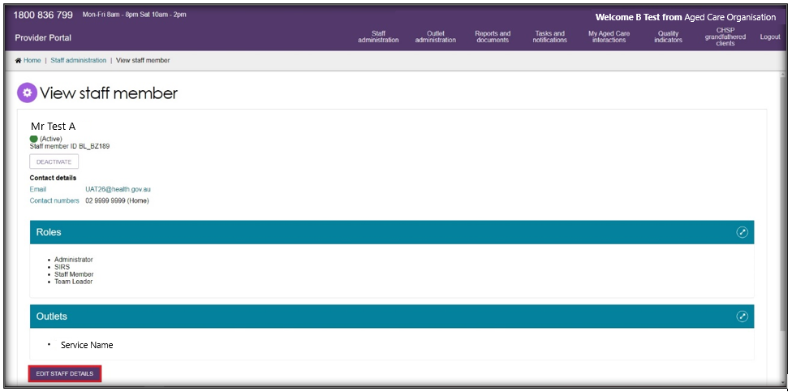

1. Scroll down and click ‘Manage Roles’.

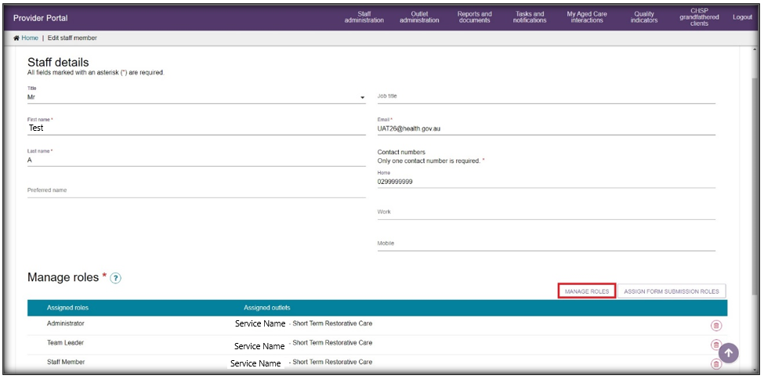

1. Select ‘Quality Indicators’ followed by ‘Next’.

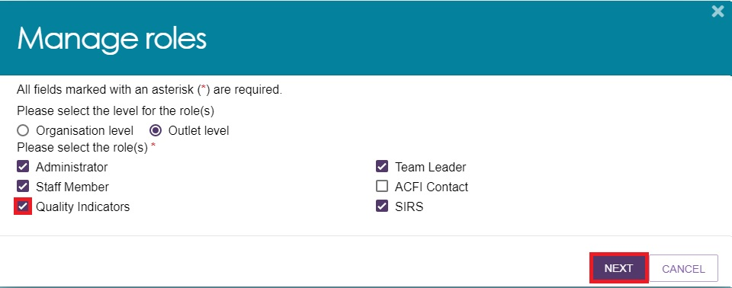

*Please note: Administrators will have access to the ‘Quality Indicator’ tile, although the ‘Quality Indicator’ role may not appear*

1. Check the correct outlets are selected and click ‘Save Roles’.

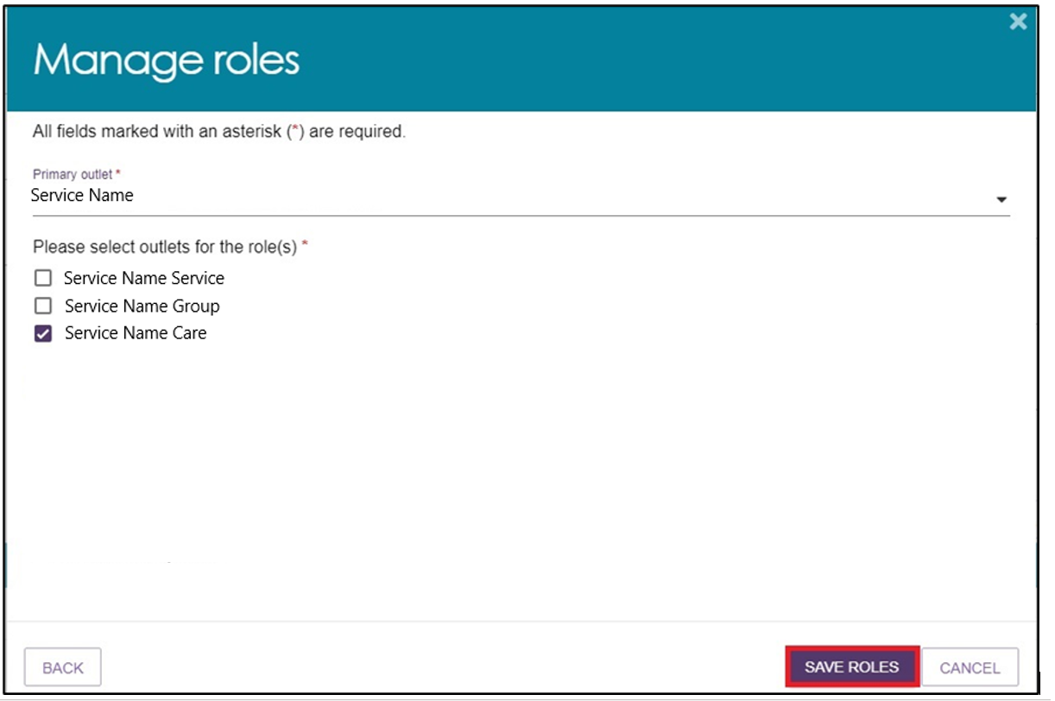

1. A green box will appear to inform you the new Role has been saved, click ‘Save’.

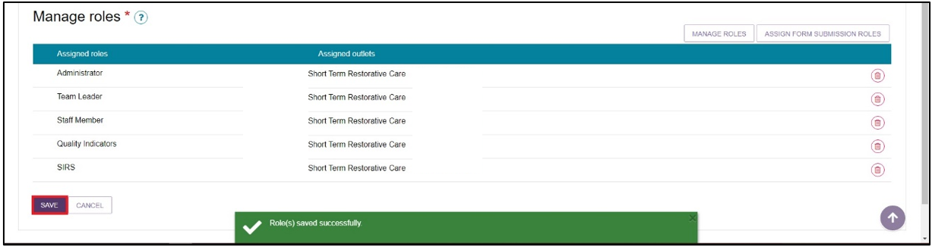

1. The Staff member will now have the Quality Indicators tile active on the Provider Portal home page.

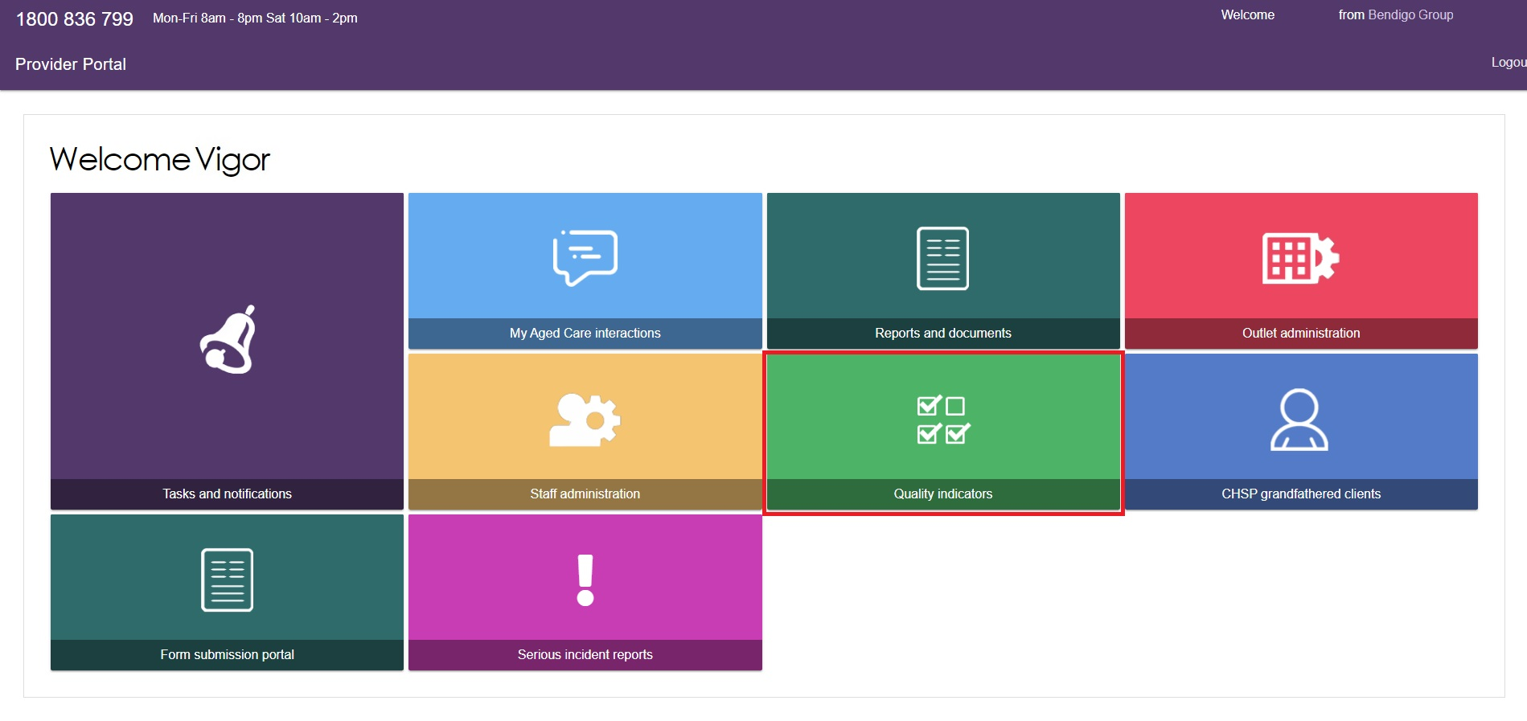

## How do I upload my quality indicator data in a file?

You are able to upload a file to enter multiple services’ quality indicator data at once.

To upload a file, follow the steps below.

1. From the Provider Portal home page, click on the “Quality Indicators” tile.

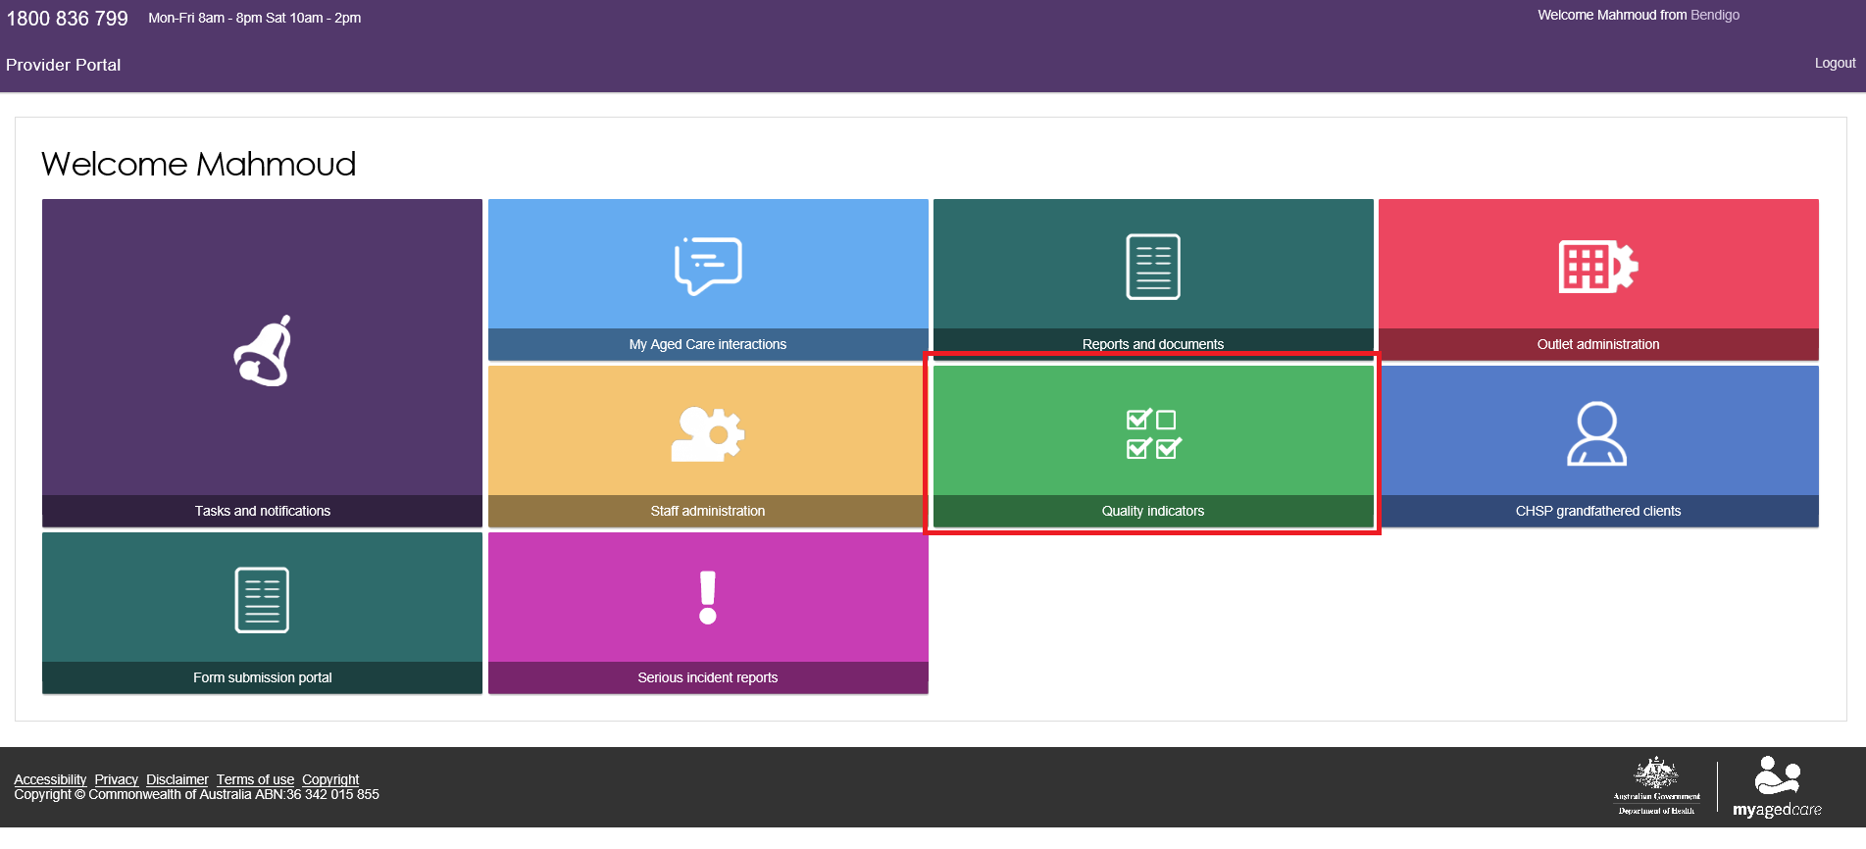

1. Select the service you wish to upload data for.

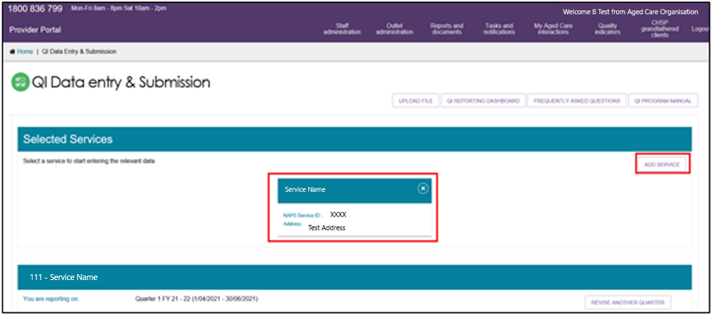

1. Click the “Upload file for QI data” button.

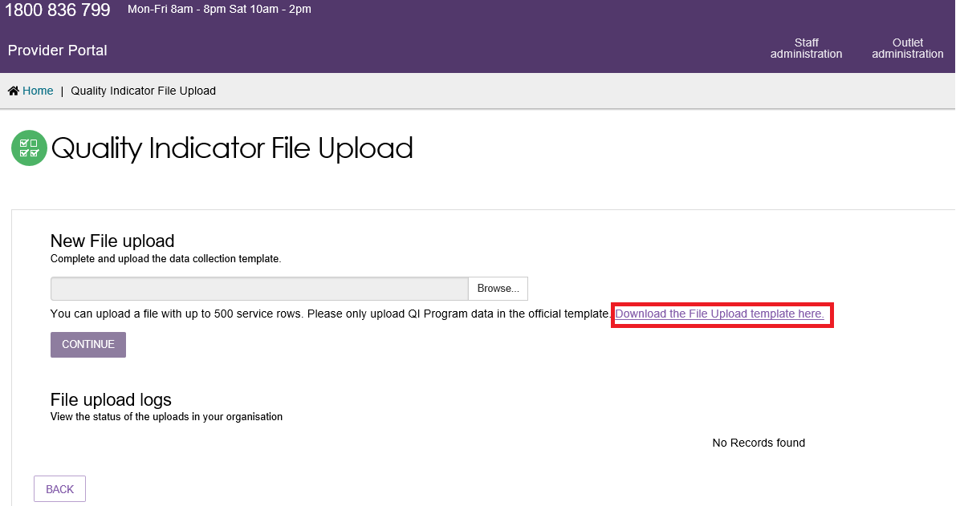

1. Download the File Upload template. Fill in all required data fields then save the file.

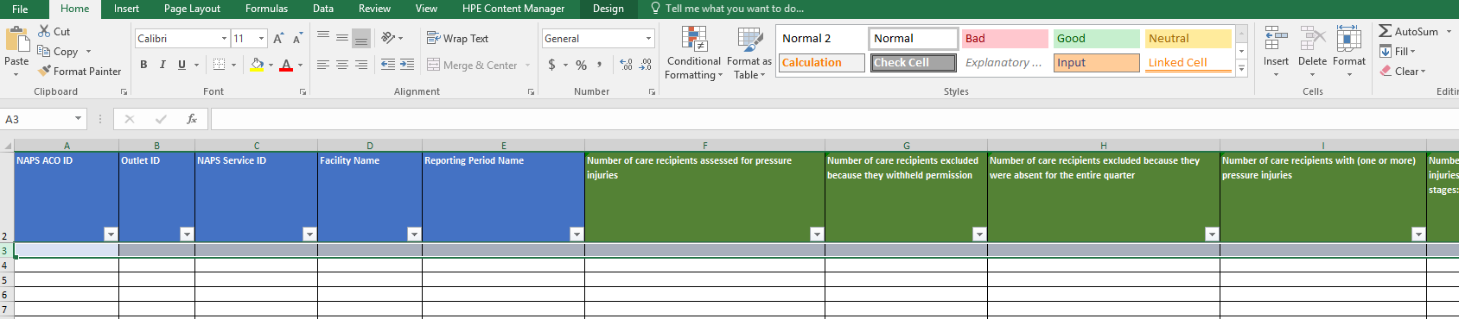

1. To upload to completed file, browse for the file. Then click “continue’ to upload it.

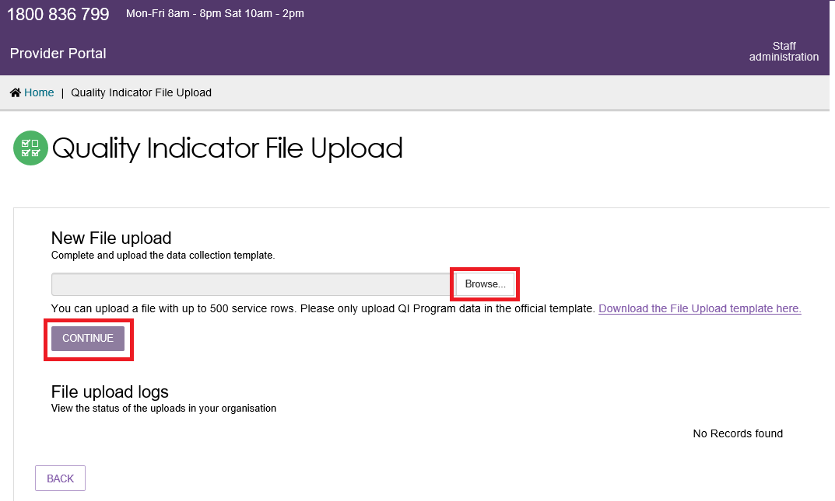

1. Follow the prompts on screen to match valid services.

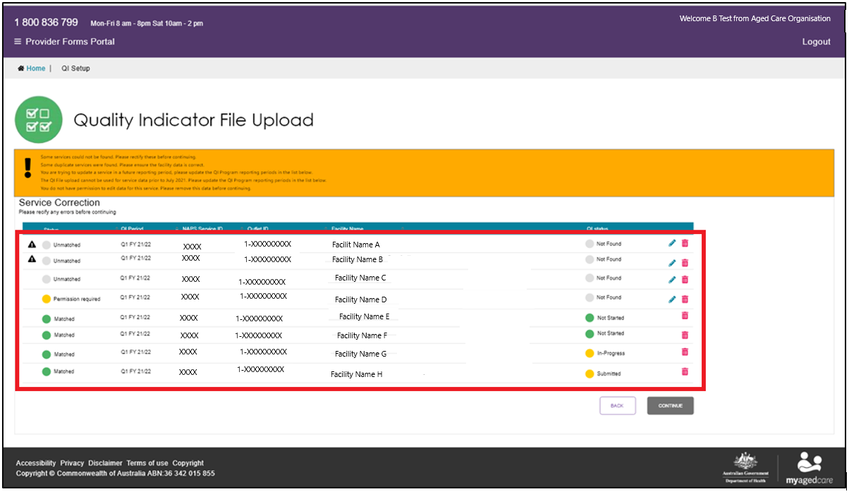

1. Rectify unmatched services by looking up correct service details.

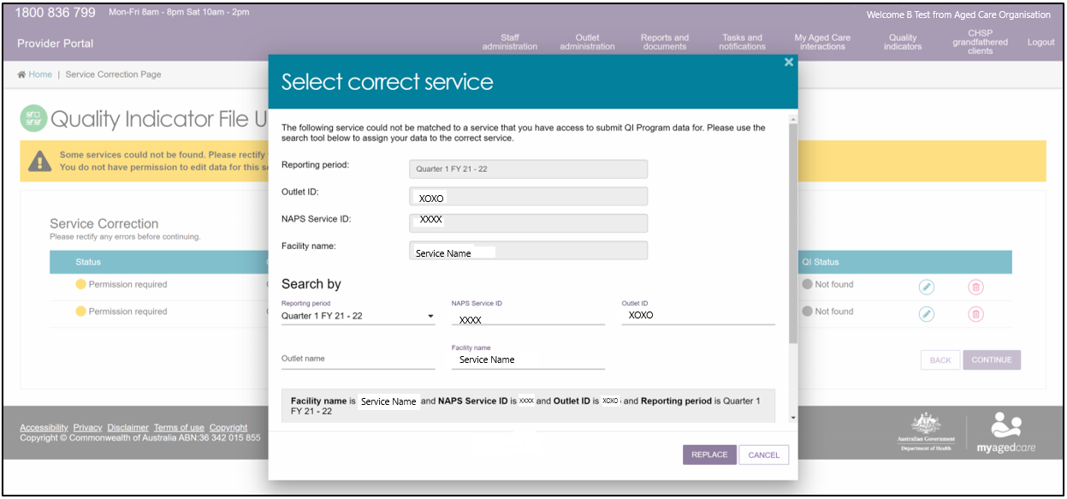

1. Delete data for services that you cannot match.

 You must re-upload for the services you have removed, or you can enter them manually.

## How do I manually enter the quality indicator data for a service?



From the Provider Portal home page, click on the ‘Quality Indicators’ tile.

1. Select the service you wish to enter quality indicator data.

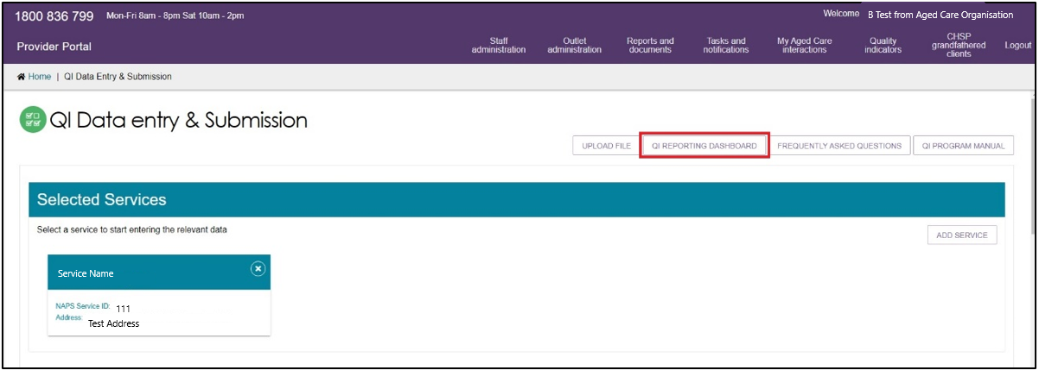

1. Scroll downward on the screen. The Quality Indicator questionnaire is displayed for your selected service.

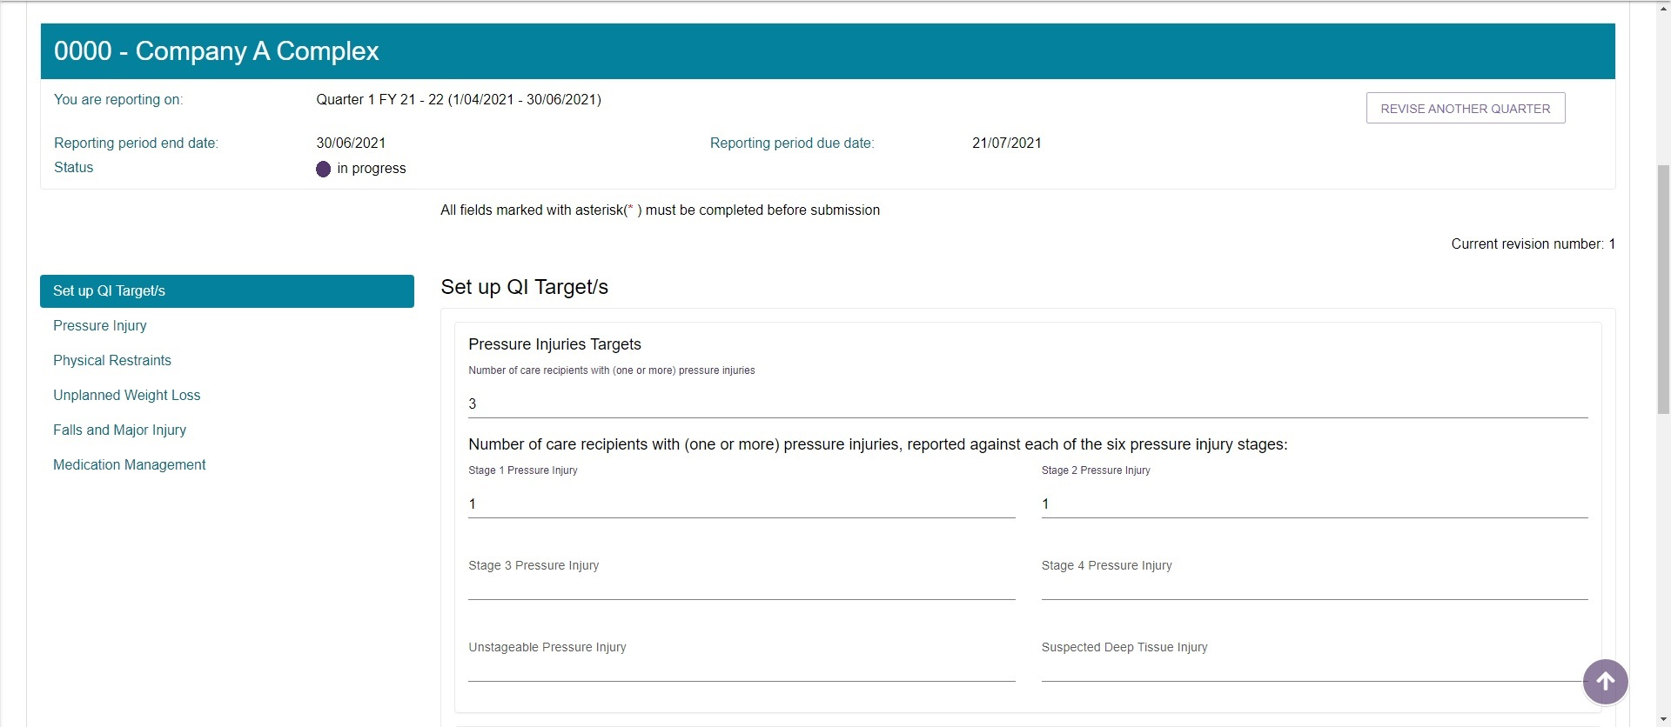

1. Enter data for:

* Set up QI targets (optional)
* Pressure Injuries (mandatory)
* Physical Restraint (mandatory)
* Unplanned Weight Loss (mandatory)
* Falls and Major Injury (mandatory)
* Medication Management (mandatory)

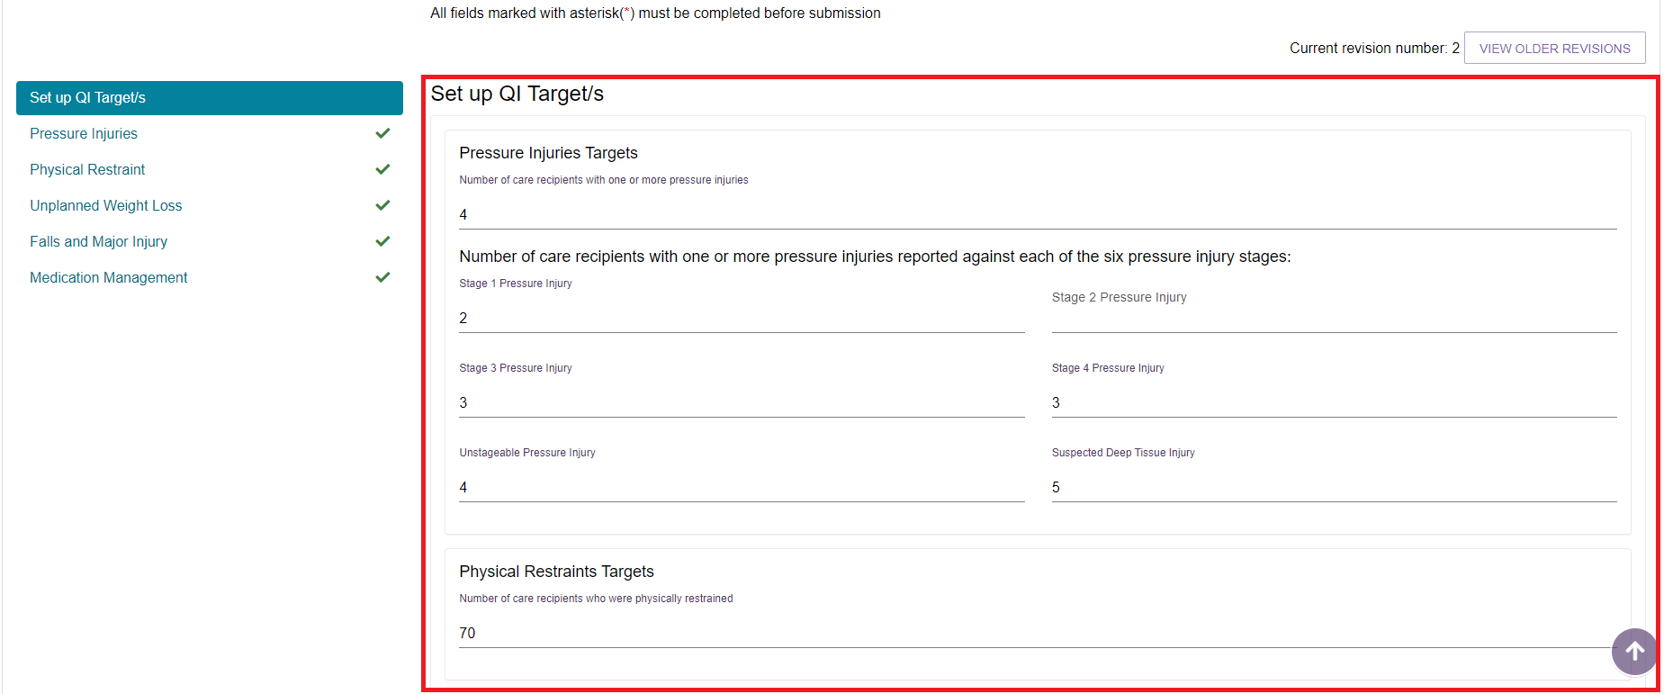

 Validation checks will be presented if you need to update data. A green tick will be displayed next to the quality indicator once you have correctly inputted your facility’s service data.

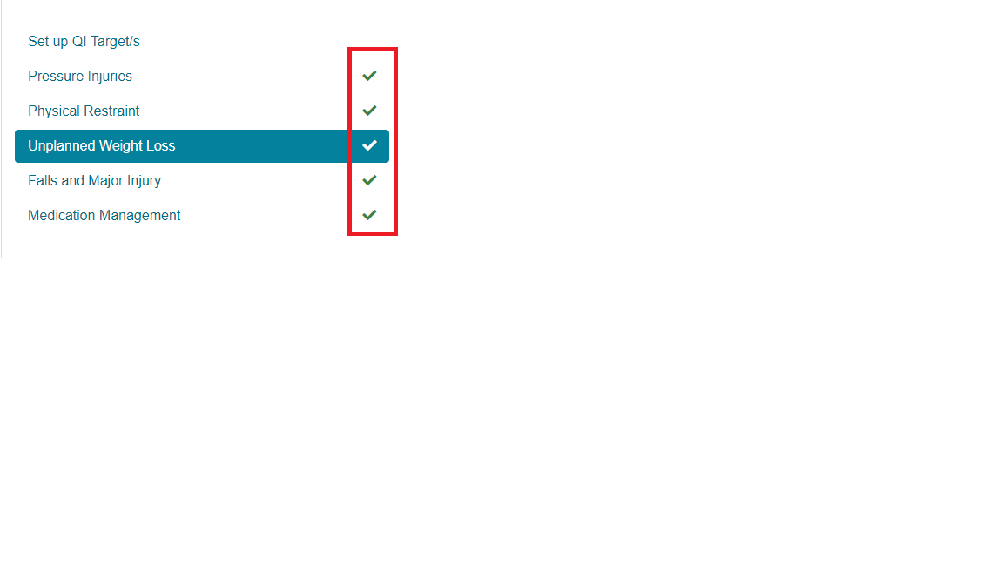

1. Click ‘submit’ or save as a draft.

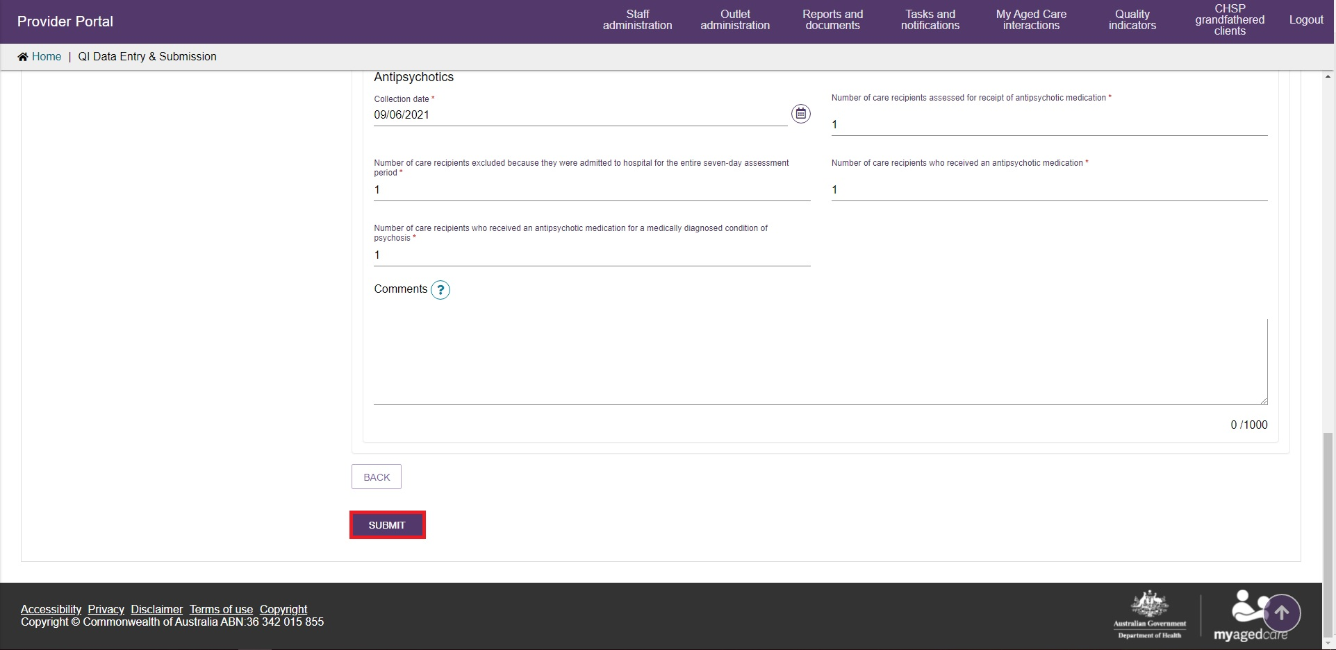

1. A green box will appear at the bottom of the screen to inform your data has been successfully submitted.



## More information

For further information refer to the [National Aged Care Mandatory Quality Indicator Program Manual](https://www.health.gov.au/resources/publications/national-aged-care-mandatory-quality-indicator-program-manual) which can be downloaded from the Department of Health website [www.health.gov.au](http://www.health.gov.au).

You can also call the My Aged Care Service Provider and Assessor Helpline on **1800 836 799**. If you have a technical issue, don’t forget you can ask the call centre staff to escalate your query to the tier 2 team for resolution.