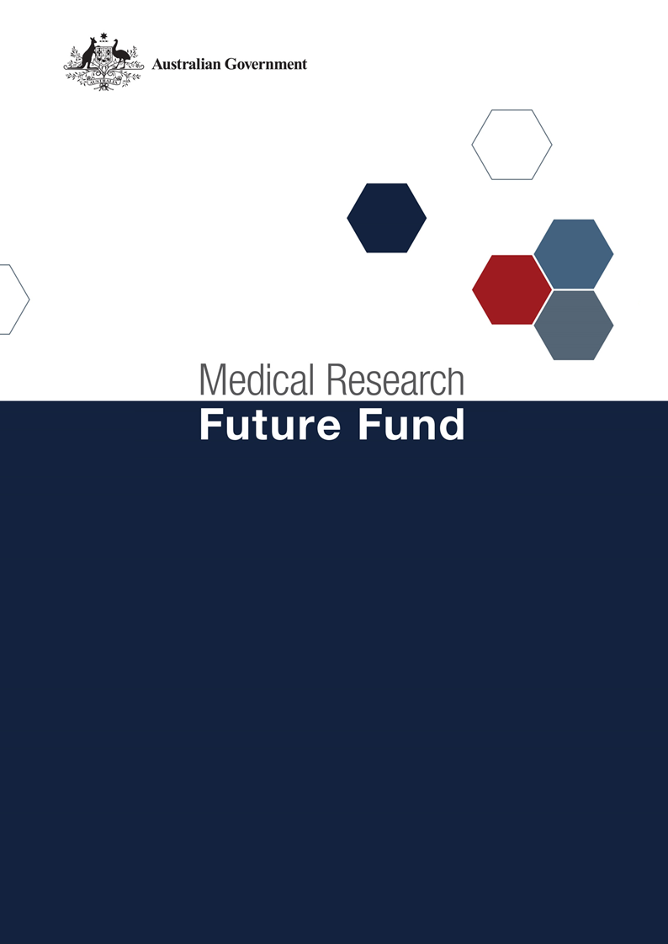

**Stem Cell Therapies Mission  
Roadmap and Implementation Plan  
National Consultation Report  
  
September 2021**

Table of Contents

Introduction 2

Community participation and submissions 3

Responses to national consultation submissions 4

# Introduction

The Medical Research Future Fund’s (MRFF) Stem Cell Therapies Mission (the Mission) was announced as part of the 2019-20 budget. The Mission will provide $150 million over 9 years to support research designed to develop innovative, safe and effective treatments accessible to all Australians who need them.

An Expert Advisory Panel was established to provide advice to the Minister for Health and Aged Care on the strategic priorities for research investment through the Mission. As per the Minister for Health and Aged Care’s agreed [Governance arrangements for MRFF Missions](https://www.health.gov.au/resources/publications/mrff-mission-governance), the Expert Advisory Panel has provided advice on priorities for research investment through the Mission by developing a Roadmap and Implementation Plan.

The Mission’s Roadmap is a high-level strategic document that includes the aim, vision, goal and priorities for investment for the Mission. To support the Roadmap, the Implementation Plan outlines the priorities for investment (short, medium and long term), evaluation approaches and measures, supporting activities, and collaborative opportunities. The Roadmap and Implementation Plan will be used by the Department of Health to design and implement Mission’s investments via Grant Opportunities promoted through GrantConnect ([grants.gov.au](https://www.grants.gov.au/)).

A draft Roadmap and Implementation Plan developed by the Expert Advisory Panel underwent international review on 20 November 2020; the outcome of the review is outlined in a report endorsed by the [International Review Panel](https://consultations.health.gov.au/health-economics-and-research-division/mrff-sct-mission/).

A national consultation to seek feedback from the community on the Mission’s draft Roadmap and Implementation Plan was conducted over the period 14 December 2020 to 23 April 2021, during which time submissions were accepted through the Department’s [consultation hub](https://consultations.health.gov.au/health-economics-and-research-division/mrff-sct-mission/).

During the consultation, the Co-Chairs of the Expert Advisory Panel hosted two webinars, on 5 February and 26 March 2021. This gave an opportunity for the community to gain a greater understanding of the purpose of the Roadmap and Implementation Plan and ask questions, prior to providing written submissions to the consultation.

The following questions were provided on the consultation hub to guide submissions:

1. Are the priority areas for investment identified in the Implementation Plan the most effective way for delivering on the Traumatic Brain Injury Mission’s goal and aims?
2. Are there existing research activities which could be utilised to contribute to the Traumatic Brain Injury Mission Roadmap and/or Implementation Plan aims and priority areas for investment? How can these be leveraged?
3. Are the ‘Evaluation approach and measures’ appropriate for assessing and monitoring progress towards the Traumatic Brain Injury Mission’s goal and aims?

This report summarises the national consultation through webinar participation and written submissions.

## Community participation and submissions

14 stakeholders (from 29 registrations) attended the two webinars from across Australia. A diverse range of stakeholders participated including those from: research organisations (including universities and medical research institutes); consumer advocacy groups; state government (health) departments; and individual community members.

At the close of the consultation period, ten (10) written submissions were received via the consultation hub, representing medical research institutes, and national and state-based consumer organisations.

The Expert Advisory Panel considered all responses from the national consultation and, where relevant, revised the Roadmap and Implementation Plan. A summary of the feedback from the submissions and the Expert Advisory Panel’s responses are outlined below.

# Responses to national consultation submissions

|  |  |  |
| --- | --- | --- |
| **Consultation Question** | **Submission Feedback / Themes** | **Action by Expert Advisory Panel** |
| **Are the priority areas for investment identified in the implementation plan the most effective way for delivering on the Mission’s goal and aims?** | Priority areas should be revised to:   * include the international panel review recommendations * incorporate Aim 3 in to Aims 1 and 2. | * The Panel agreed that greater detail of some research priority area descriptions in the Implementation Plan is required based on recommendations from the international review. Additional text has been included in the Implementation Plan. * The panel agreed that Aim 3 should remain, but that elements of it can also be incorporated/performed alongside projects in Priority Areas 1.2 and 2.2. Changes to the Implementation Plan have been made. |
| Consideration of Indigenous, rural/remote and other disadvantaged populations need to be captured more clearly in the Mission, including how the Mission will ensure the delivery of high quality but equitable healthcare to all Australians. | The Panel agreed that there needed to be explicit reference to all Australians within the Roadmap. Additional text was included in the Roadmap under Funding Principles. |
| Greater focus on collaboration and commercialisation is required. | Collaboration is integral to the Mission. Reference is made within the Roadmap and Implementation Plan. The Panel recommended no further additions were required. |
| Greater emphasis on discovery research to provide basic knowledge to enable future stem cell therapies is required. | Basic research is supported in Priority Areas 1.1 and 2.1. Text has been modified to make clear that the Mission supports the development of novel stem cell-based treatments. |
| Larger programmatic funding of multi-disciplinary teams is required to achieve Mission objectives. | Multi-disciplinary research is encapsulated in Priority Areas 1.2 and 2.2. Further detail has been included in the Roadmap under ‘Funding Principles’ and in the Implementation Plan. |
| Clarification is required on the meaning of stem cell based human disease models – are models derived from only human cells a priority or any origin of stem cells applicable. | The Panel agreed that the Mission should fund only human stem cell-based disease models, not human stem cells in animal models of disease. Text has been modified in Priority Area 2.1 to provide clarity. |
| Concerns that the inclusion of cancer stem cells may divert research funds/focus from other intractable diseases. | The panel noted this concern and agreed to the use of cancer stem cells over tumour stem cells was more appropriate, and to state which stem cells are eligible for funding in a Priority Area. |
| Development of novel methods of study as well as methods and assessment of novel models was recommended. | The Panel agreed no further action was required as the recommendation was focused on funding non-disease based methodology. |
| Funding allocation should be determined by priority area:   * Length and amount of funding for Priority Area 1.2 and 2.2 needs to be large enough to facilitate significant outcomes. | The Panel agreed that the quantum of funding across the Implementation Plan would differ across the Priority Areas for investment and provided advice to the Department. |
| **Are there existing research activities which could be utilised to contribute to the Mission’s Roadmap and/or Implementation Plan aims and priority areas for investment? How can these be leveraged?** | Evaluation of existing research activities is required to determine if research investment has provided value for money. | The Panel agreed evaluation is important and text has been inserted into the Implementation Plan regarding the MRFF Evaluation Strategy. |
| **Are the ‘Evaluation approach and measures’ appropriate for assessing and monitoring progress towards the Mission’s goal and aims?** | It was stated that several evaluation criteria are not quantifiable e.g. identified unmet needs, value of business plans, number of proof-of-concept studies and number of clinical cellular candidates ready. | The Panel noted the comments and agreed that evaluation metrics are important. Text has been included in the Implementation Plan regarding the MRFF Monitoring, Evaluation and Learning Strategy, noting that metrics will be captured at the grant level. |