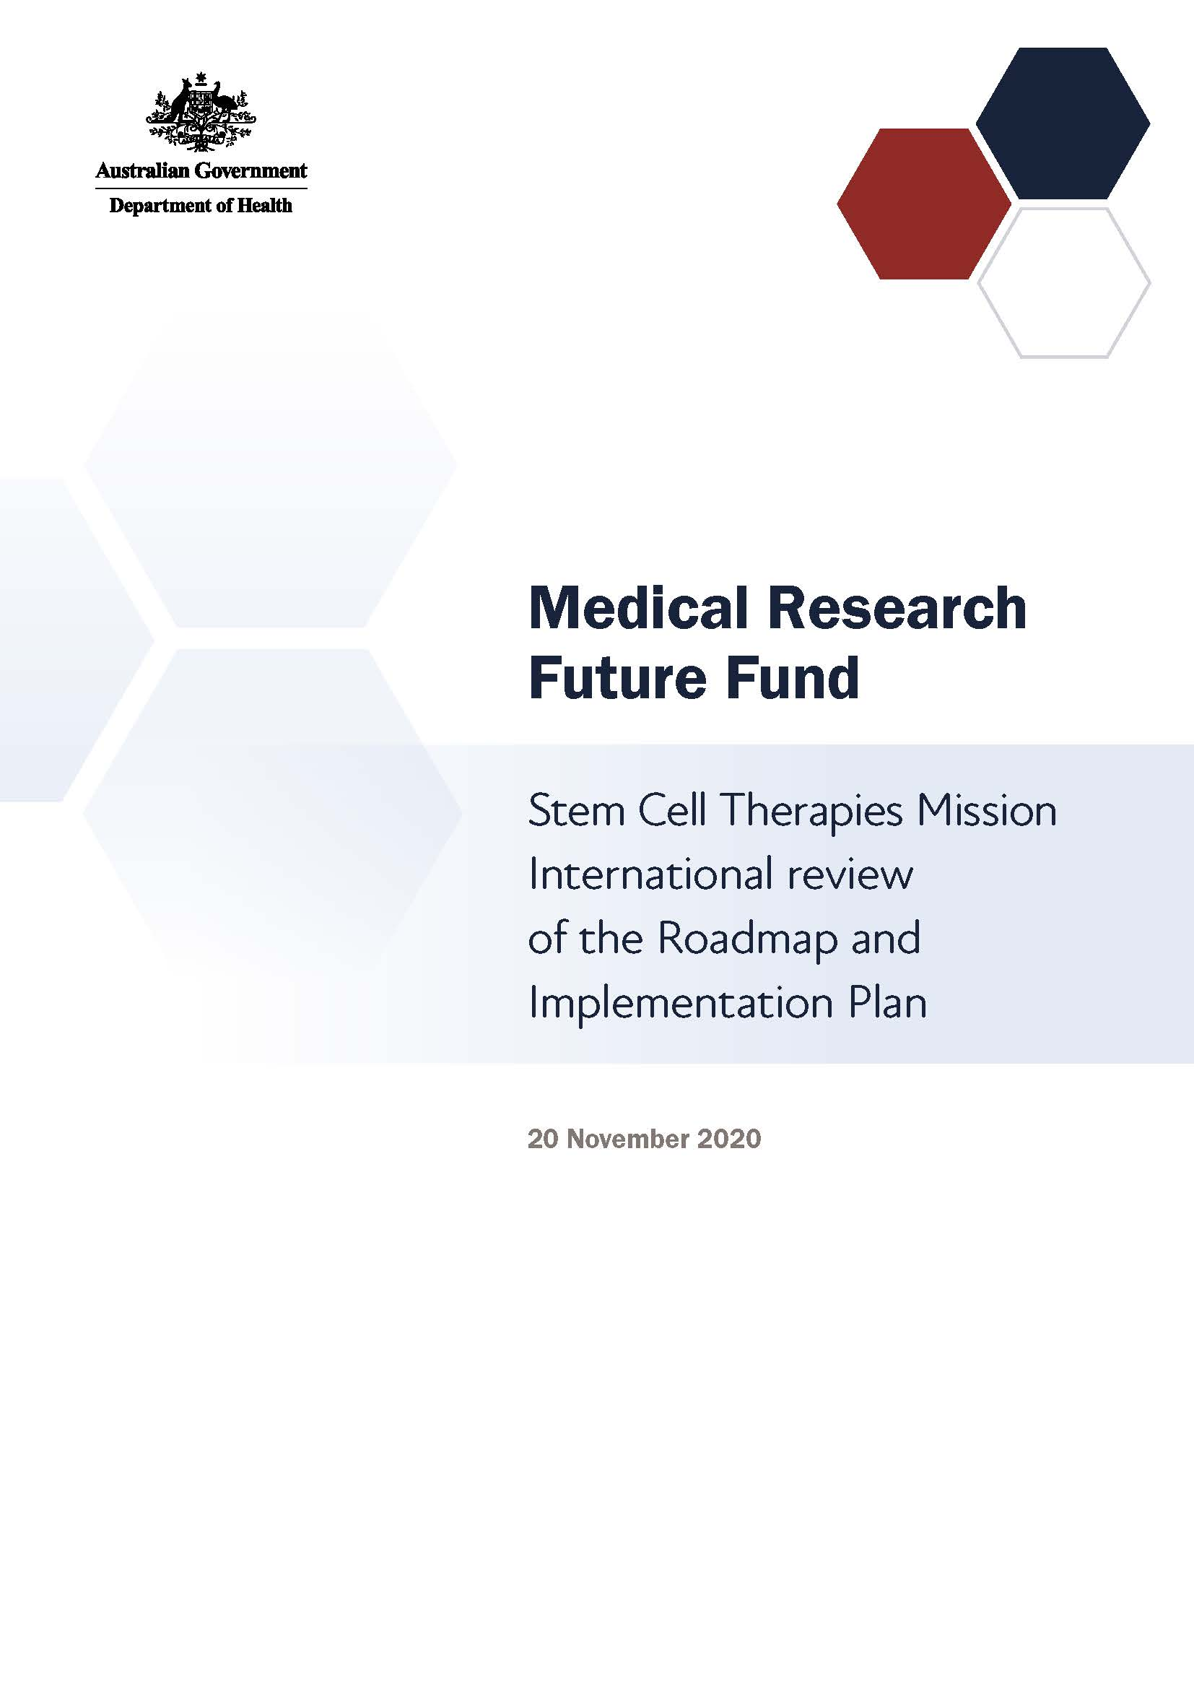

# Introduction

The Medical Research Future Fund (MRFF) is a $20 billion long-term investment supporting Australian health and medical research. The MRFF aims to transform health and medical research and innovation to improve lives, build the economy and contribute to health system sustainability.

The Stem Cell Therapies Mission will provide A$150 million over 9 years under the MRFF to support world-leading translational stem cell research that develops and delivers innovative, safe and effective stem cell medicines to improve health outcomes, in partnership with patients and carers.

## Stem Cell Therapies Mission Expert Advisory Panel

A Stem Cell Therapies Mission Expert Advisory Panel was established to advise the Australian Minister for Health on the strategic priorities for research investment through the Stem Cell Therapies Mission.

The Stem Cell Therapies Mission Expert Advisory Panel’s role is to define evidence and knowledge gaps that should be addressed through mission research funding, to help transform health care and health outcomes for individuals and communities. This role includes defining key research questions that — if answered — will deliver meaningful change to patients through the translation of research.

**Our mission**

To use stem cells and their derivatives to develop innovative, safe and effective treatments that are accessible to all Australians who need them.

**Our goal**

To support world-leading translational stem cell research that develops and delivers innovative, safe and effective stem cell medicines to improve health outcomes, in partnership with patients and carers.

The Stem Cell Therapies Mission Expert Advisory Panel developed a Roadmap and Implementation Plan to advise about priorities for research investment through the Stem Cell Therapies Mission.

The Roadmap includes:

* the mission statement and goal
* possible themes and priorities for investment

The Implementation Plan includes:

* 3 aims that outline how the Stem Cell Therapies Mission will benefit Australians
* priorities for investment in the short, medium and long term
* opportunities for leveraging additional investment
* activities needed to support the Stem Cell Therapies Mission’s outcomes and facilitate their implementation

Stem Cell Therapies Mission Expert Advisory Panel members will consult and engage with other researchers, industry, and consumer and patient groups, and participate in media and public activities to build awareness of, and facilitate interaction with, the mission and with other MRFF-funded research.

# Stem Cell Therapies Mission International Review Panel

The Stem Cell Therapies Mission International Review Panel’s role was to provide expert feedback and experiential advice in the context of relevant activities occurring internationally, which can inform the strategic direction of the Stem Cell Therapies Mission’s Roadmap and Implementation Plan.

The Stem Cell Therapies Panel members were asked to:

1. Advise on the applicability of the Stem Cell Therapies Mission’s goal to the international context; specifically, whether the goal duplicates or contributes to international research activities
2. Advise on the likely effectiveness of the research priorities (including their sequencing) to achieve the goal
3. Provide learnings from international research activities in the field
4. Identify opportunities for leveraging and complementing international research activities to achieve the goal
5. Advise on the appropriateness of the proposed measures for evaluating progress towards meeting the goal

The Stem Cell Therapies Panel comprised 4 members representing expertise in a variety of clinical and scientific research areas:

* Prof Paolo De Coppi — Nuffield Professor of Paediatric Surgery; Head of Stem Cells & Regenerative Medicine Section, Developmental Biology & Cancer Programme; Consultant Paediatric Surgeon, Great Ormond Street Hospital (UK)
* Dr Emanuele Ostuni — Head of Europe, Cell and Gene Therapy, Novartis Oncology (Switzerland)
* Prof Sir Peng Khaw — Consultant Ophthalmic Surgeon, University College London, Moorfields Eye Hospital (UK)
* Prof Christine Hauskeller — Professor of Sociology and Philosophy, University of Exeter (UK)

# Consultation discussion

The Stem Cell Therapies Panel met on Friday 20 November 2020 to discuss the Stem Cell Therapies Mission’s Roadmap and Implementation Plan.

All participants at the meeting were required to declare any conflicts of interest and relevant collaborations. None of the declared interests were considered material to the meeting.

**Key points**

* The Stem Cell Therapies Panel noted that the Stem Cell Therapies Mission provides an important opportunity for Australia to advance stem cell therapies research
* For stem cell therapies to be successful, they must be developed within the right ecosystem. Such an ecosystem will need to encompass the whole therapy development pathway, even if the MRFF does not directly fund all points of the pathway
* International partnerships and linkages are an important opportunity for capacity and ecosystem development, and should be leveraged to maximise the value of investments through the mission
* The evaluation measurements should be individualised and better reflect the outcomes and aims of the projects that are funded
* Research priority areas can be identified by considering the health outcomes for patients and clinicians, and what is clinically relevant for them

The Stem Cell Therapies Panel highlighted the importance of this MRFF mission, and noted that it is a genuine opportunity for Australia to advance stem cell therapies research.

## Establish an ecosystem for stem cell therapy development

The panel emphasised the importance of having a stem cell therapies ecosystem developed for Australian research in this area. Such an ecosystem should encompass the whole process of therapy development — from basic science to Phase IV clinical trials and marketing.

Although the MRFF focuses on a certain aspect of the ecosystem — namely, it is an enabler funding program that helps therapies cross the ‘valley of death’ — therapies cannot be developed successfully if the whole development pathway is not sufficiently established. Activities that are not funded by the MRFF still need to be considered and financially accounted for.

The mission can therefore have a catalytic effect on the ecosystem through demonstrating a clear research agenda and the enablers that are required to achieve the goals and vision set out in the Stem Cell Therapy Mission’s Roadmap.

The panel also noted that the gap in expertise for commercialising stem cell therapies is deeper than for other technologies, such as medical devices and small molecules. A mix of expertise must therefore be considered as part of the stem cell therapies ecosystem, and that this goes beyond researchers (non-PhD) and clinicians.

The panel identified that most of the expertise and infrastructure required is most likely to come from specialised biomedical research centres, which have a reputation for delivering large returns on investment. Such centres require considerable skills, infrastructure and overall management.

The panel noted that there is an opportunity to partner with international organisations and collaborations to facilitate capacity and ecosystem development in Australia. These links would leverage Australia’s leadership in stem cell research and provide pathways for companies to enter the ecosystem.

Some of the physical manufacturing infrastructure may exist overseas, and there may be opportunities to capitalise on this.

## Ensure there are key links between the funded projects and how their success is measured

The panel noted that the evaluation measurements described in the Implementation Plan should be redesigned to more closely align with the priority areas for investment. There appears to be a disconnect between the type of program being funded and the outcome measures. In addition, there would be value in considering quality vs quantity indicators, as quantity indicators may inadvertently drive a focus away from the quality of research and outputs.

Further, each research project should have milestones and outcomes articulated specifically for that project to ensure a focus on performance.

## Consider establishing an external panel to advise on research activities

As a way to reduce project risk, the panel believed that expert input along the entire development pathway is important to identify potentially successful therapies, and then to help ensure they do become successful and marketable. Therapies will not be able to progress past certain points unless there is an accompanying scaling-up strategy, and external expert panels, comprising of researchers, pharmaceutical industry experts and others, can contribute significantly to these strategies. The panel noted that this would be important throughout the process, including for small grants.

The panel considered a useful model may be to start with smaller incubator grants, then help the researchers define a long-term plan for the research so it can be taken to market. The plan should focus on transitioning researchers and associated staff through the pathway, as the lack of this transitioning education is a pitfall for many projects.

## Consider clinical needs to help identify priority research areas

The panel advised that MRFF funding needs to consider how treatments are approved and used clinically. For example, a therapy that is expensive and offers minimal improvement over an existing therapy is less likely to be clinically relevant than a therapy that addresses a clear unmet clinical need that can benefit many patients.

The panel suggested potential strategies for narrowing the focus of the mission to achieve measurable improvements in priority areas. This included the potential selection of specific stem cell types or prioritising particular conditions. However, it was accepted that this had the potential to prevent progress where there is particular excellence within Australia and that predetermination could inadvertently prevent high-quality research from being funded. It was agreed that priorities may become clearer as the mission progresses and successful projects begin to emerge.

## Additional comments

* The panel noted that Aim 3 required more detail to better explain the goals of this aim. Ethical, legal and societal implications (ELSI) activities should be a component of large teams funded within Priority Areas 1 and 2; however, there remain some broad ELSI research questions that stand alone
* The panel felt that investing in stem cell line registries and repositories could absorb a lot of funding, and that a better investment would be ensuring that researchers have access to current Good Manufacturing Practice cell lines

# Recommendations

* Ensure MRFF funding through the Stem Cell Therapies Mission leverages the existing Australian ecosystem to help ensure therapies move through the development process and become marketable products
* Ensure there are key links between the funded projects and how their success is measured
* Identify research priority areas by considering the health outcomes and what is clinically relevant for clinicians and patients
* Expand the detail underpinning Aim 3