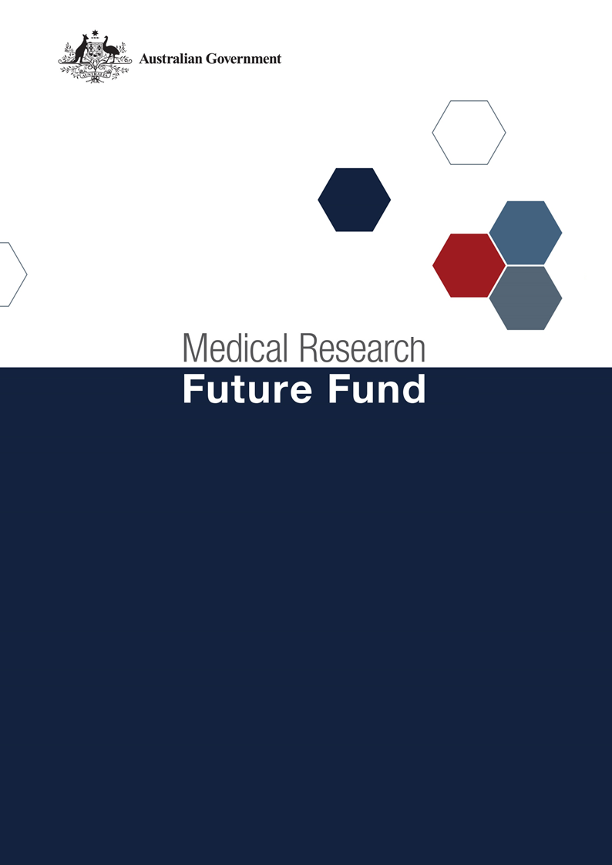

**MRFF Genomics Health Futures Mission Roadmap and Implementation Plan National Consultation Report  
  
September 2021**

Table of Contents

Introduction 2

Community participation and submissions 3

Responses to national consultation submissions 4

# Introduction

The Medical Research Future Fund (MRFF) is a $20 billion long-term investment supporting Australian health and medical research. The MRFF aims to transform health and medical research and innovation to improve lives, build the economy and contribute to health system sustainability. The Genomics Health Futures Mission (the GHFM) was announced as part of the 2019-20 budget. The GHFM will provide $500 million over 10 years under the MRFF to help save or transform lives of more than 200,000 Australians through genomics research into better testing, diagnosis and treatment.

An Expert Advisory Committee was appointed in May 2019 to provide advice to the Minister for Health and Aged Care on the strategic priorities for research investment through the GHFM. As per the [MRFF Mission Governance document](https://www.health.gov.au/resources/publications/mrff-mission-governance), the Expert Advisory Committee provides advice on strategic priorities for research investment through the GHFM by developing a Roadmap and Implementation Plan.

The GHFM’s Roadmap is a high-level strategic document that includes the aim, vision, goal and priorities for investment for the GHFM. To support the Roadmap, the Implementation Plan outlines the priorities for investment (short, medium and long term), evaluation approaches and measures, supporting activities, and collaborative opportunities. The Roadmap and Implementation Plan will be used by the Department of Health to design and implement GHFM’s investments via Grant Opportunities promoted through GrantConnect ([grants.gov.au](https://www.grants.gov.au/)).

A draft Roadmap and Implementation Plan developed by the Expert Advisory Committee underwent international review on 11 November 2020. The International review report was made available to the public as part of the consultation process.

A national consultation to seek feedback from the community on the GHFM’s draft Roadmap and Implementation Plan opened on 14 December 2020 and closed on 23 April 2021, during which time submissions were accepted through the Department’s [consultation hub](https://consultations.health.gov.au/health-economics-and-research-division/mrff-ghfm/).

During the consultation, the Chair of the Expert Advisory Committee hosted two webinars, on 16 and 25 March 2021, to provide an opportunity for the community to gain a greater understanding of the purpose of the Roadmap and Implementation Plan and ask questions, prior to providing written submissions to the consultation.

The following questions were provided on the consultation hub to guide submissions:

1. Are the priority areas for investment identified in the Implementation Plan the most effective way for delivering on the Genomics Health Futures Mission’s goal and aims?
2. Are there existing research activities which could be utilised to contribute to the Genomics Health Futures Mission Roadmap and/or Implementation Plan aims and priority areas for investment? How can these be leveraged?
3. Are the ‘Evaluation approach and measures’ appropriate for assessing and monitoring progress towards the Genomics Health Futures Mission’s goal and aims?

This report summarises the national consultation through webinar participation and written submissions.

## Community participation and submissions

97 stakeholders (from 190 registrations) attended the two webinars from across all states and territories of Australia. A diverse range of stakeholders participated including those from: research organisations (including universities and medical research institutes); industry; consultancy organisations; consumer advocacy groups; state government (health) departments; and individual community members.

At the close of the consultation period, twenty-six (26) written submissions were received via the consultation hub, representing universities, medical research institutes, pharmaceutical, industry, and national and state-based consumer organisations.

The Expert Advisory Committee considered all responses from the national consultation and, where relevant, revised the Roadmap and Implementation Plan. A summary of the feedback from the submissions and the Expert Advisory Committee’s responses are outlined below.

# Responses to national consultation submissions

| **Consultation Question** | **Submission Feedback / Themes** | **Action by Expert Advisory Committee (The Committee)** |
| --- | --- | --- |
| **Are the priority areas for investment identified in the implementation plan the most effective way for delivering on the Genomics Health Futures Mission’s goal and aims?** | Large projects of national strategic importance in key priority areas, to foster cross-institutional collaboration are required | The Committee agreed and standard words have been included in the Roadmap (under “Funding Principles”) and the Implementation Plan (under “Implementation Strategy”) outlining the intent of the GHFM to facilitate establishment of large, national collaborative networks and projects of national significance and strategic importance to foster cross-institutional collaboration.  A focus on collaboration will also be reflected in Grant Opportunities |
| Workforce education for implementation of testing and to enable research/clinic integration should be included | While out of scope for the GHFM, it is inherent in the translational implementation of research funded through the GHFM and there will be elements of this covered as part of the Australian Genomics 2.0 activity – therefore no changes were recommended |
| New diagnoses which lead to new interventions, which lead to increased awareness in public and healthcare | This is covered throughout the Implementation Plan – therefore no changes were recommended |
| A number of disease-specific areas e.g., cardiac genomics, Familial Hypercholesterolemia, were recommended to be included in the GHFM | The Committee agreed that there will be no barrier to funding these specific areas (or others) as long as they are relevant to a grant opportunity |
| A number of approaches were recommended, including:   1. Transcriptomics, proteomics and metabolomics 2. Repurposing of existing targeted therapies, facilitating a shift to tumour agnostic therapies, and expediting access, reimbursement and integration of current genomic technologies into standard clinical care 3. Functional genomics and its use in monitoring treatment response and disease progression, the development of clinical decision support tools that complement and integrate with genomic diagnostic testing technologies, and real-world evidence generation to support implementation and integration of genomic technologies | 1. These approaches are partly covered in Priority 1.1 of the Implementation Plan (functional genomics); the GHFM will fund the downstream impacts of these approaches 2. This is included in Priority 2.3 of the Implementation Plan (gene-related therapies) 3. This is included in Priority 1.1 of the Implementation Plan (platform technologies and diagnosis rates) |
| A number of engagement opportunities were recommended, including:   1. consumers/patient support/advocacy organisations in all stages of the research cycle 2. Aboriginal and Torres Strait Islander health across all aims/priority areas 3. industry, Federal and State regulators, peak bodies including colleges of medicine, and other organisations early in the research process to ensure success | 1. Engagement with consumers is an integral component of the GHFM 2. An additional point is included in the GHFM enablers section of the Implementation Plan around Aboriginal and Torres Strait Islander leadership 3. Applicants will be required to demonstrate engagement (at all levels) and requirements will be emphasised within the grant guidelines   Engagement is also part of the remit of the Australian Genomics 2.0; Involve Australia emphasises early consumer involvement and an Indigenous reference group has been established |
| The themes of data sovereignty, data access and sharing were included in several submissions, including:   1. Greater emphasis needed on the importance of data sovereignty, security and public trust 2. Developing a centralised capability for data integration and governance beyond the scope of Australian Genome Reference Database is needed 3. Appropriate legislative and policy environments to support access, integration and adoption of genomic technologies such as workforce capacity and capability and data related issues are required to ensure translation into practice 4. Data sharing should be mandatory for any MRFF-funded project that generates genomic data but should be supported appropriately (e.g. supporting enhanced ethics required) | 1. Most of these activities will be supported by the Australian Genomics 2.0 (AG 2.0) data stream 2. Australian Genomics 2.0 is planning the implementation of the National Approach to Information Management blueprint – developed by the Project Reference Group of the Australian Health Ministers Advisory Council 3. Australian Genomics 2.0 is in the process of undertaking an international/national landscape analysis of data usage and implementing a process for national consent for clinical data and data sharing 4. The Committee noted this recommendation |
| Aim 1   * Include the development of polices for patient and consumer involvement to guide and enrich GHFM-funded projects * Needs to include common complex diseases   Priority 1.5   * Focus on adult genomic screening for medically actionable conditions * Focus on screening at birth for rare and ultra-rare diseases (noting ethical and scientific concerns about the use of genomic testing as a first-line test in newborns) * Broaden to include common complex diseases | Aim 1   * Development of policies will be captured at the grant level * Common complex diseases are covered in Priority areas 2.1 and 2.2 of the Implementation Plan   Priority 1.5   * This priority is intentionally limited in its focus.  Applicants are not excluded from focusing on adult genomic screening for medically actionable conditions under other priority areas * This type of research would not be precluded from this priority * This is captured in Priority 2.2 of the Implementation Plan |
| Aim 2   * Priority 2.2: Polygenic risk score priority areas should be agnostic and need to be supported by well-planned and supported registries * Priority 2.3: Organ-focused research investment should also include the brain * Priority 2.4: Inclusion of workforce development and training needed | Aim 2   * Priority 2.2: This is implied in this priority – ‘agnostic’ applications are not excluded * Priority 2.3: This is implied in this priority – applications focusing on the brain are not excluded * Priority 2.4: While this is out of scope for the GHFM, it is inherent in the translational implementation of research funded through the GHFM |
| Aim 3   * Include COVID-19 research to accelerate understanding the societal and economic value of genomics in health care * Suggest replacing 3.2 and 3.4 with developing state-of-the-art data management and national/international integration of data * Ethics research needs to include normative research   Priority 3.1   * The focus should also include ethical implementation of genomic technologies and the medium-term goal needs to include engaging with patients and consumer groups | Aim 3   * While not explicit, this type of research is not excluded * Data is already covered within the Implementation Plan more broadly and is part of the Australian Genomics 2.0 implementation of the National Approach to Genomic Information Management (NAGIM) blueprint – no additions recommended * This type of research is not excluded   Priority 3.1   * This type of research is not excluded with patient/consumer engagement being a strong focus of the GHFM |
|  | | |
| **Are there existing research activities which could be utilised to contribute to the Genomics Health Futures Mission’s Roadmap and/or Implementation Plan aims and priority areas for investment? How can these be leveraged?** | Leverage existing:   * population-based longitudinal cohorts to address adult genomic screening for personal disease risk * peak bodies who represent the genomic, research, scientific and clinical health professionals underpinning the implementation of the GHFM | Language in the Implementation Plan has been changed to enable the inclusion of additional activities/groups etc |
| How will the work from GHFM interface with, and contribute to larger (often international) genomics consortia? | Through collaboration with groups such as Australian Genomics and Global Alliance for Genomics and Health |
| Develop a federated model of clinical genomics integrated into healthcare delivery systems in Australia that is sustainable, beyond the life of the funding opportunity | While out of scope for the GHFM, this is a priority area for the Australian Genomics 2.0 |
| A number of specific activities were recommended | Language in the Implementation Plan has been changed to enable the inclusion of additional activities. The Committee agreed that it is unfeasible to list every research activity that is in scope |
|  | | |
| **Are the ‘Evaluation approach and measures’ appropriate for assessing and monitoring progress towards the Genomics Health Futures Mission’s goal and aims?** | ‘Measurable’ metrics are needed for some evaluation measures as well as timelines | The Committee felt that the metrics are quite specific already – therefore no were changes recommended |
| There is a lack of detail on how the improvement in health care and outcomes will be measured to assess the various novel applications that use genomic data | Metrics such as these, where applicable, will be required within applications under the ‘Measures of Success’ statement (requirements will be emphasised within the grant guidelines) |
| Enabling and measuring an improved process of industry engagement and partnership to leverage innovation pipelines, co-development opportunities and realise potential commercialisation and future investment opportunities is needed | The Committee agreed this is important and can be achieved at the grant level.  Reference to the MRFF Strategy has been included in the Implementation Plan (at the conclusion of the GHFM Implementation Strategy paragraph) |
| A number of general and specific evaluation considerations were recommended, including:   * Consumer engagement and clinical service integration on a per grant perspective * Value and measures of the scale of success relative to investment * Capability development * Implementation of genomic technologies conforming to ethical principles * Integration of new genomic technologies and targeted therapies and their successes * The number of clinical trial partnerships, industry engagement, and commercialisation * Aim 1: the possible harms of new predictive and prognostic approaches, especially those that may be used in screening rather than clinical testing contexts, where no family history information may be available * Aim 3: metrics around ethically robust research or ELSI research resulting in new ethical insights (beyond public acceptance) | The Committee noted the recommendations and agreed that they would be required at the grant application level, if applicable.  Overall, these evaluation measures among others are underpinned by the MRFF Monitoring, Evaluation and Learning Strategy which provides an overarching framework for assessing the performance of the MRFF. Additional detail on the Strategy has been included in the Implementation Plan |