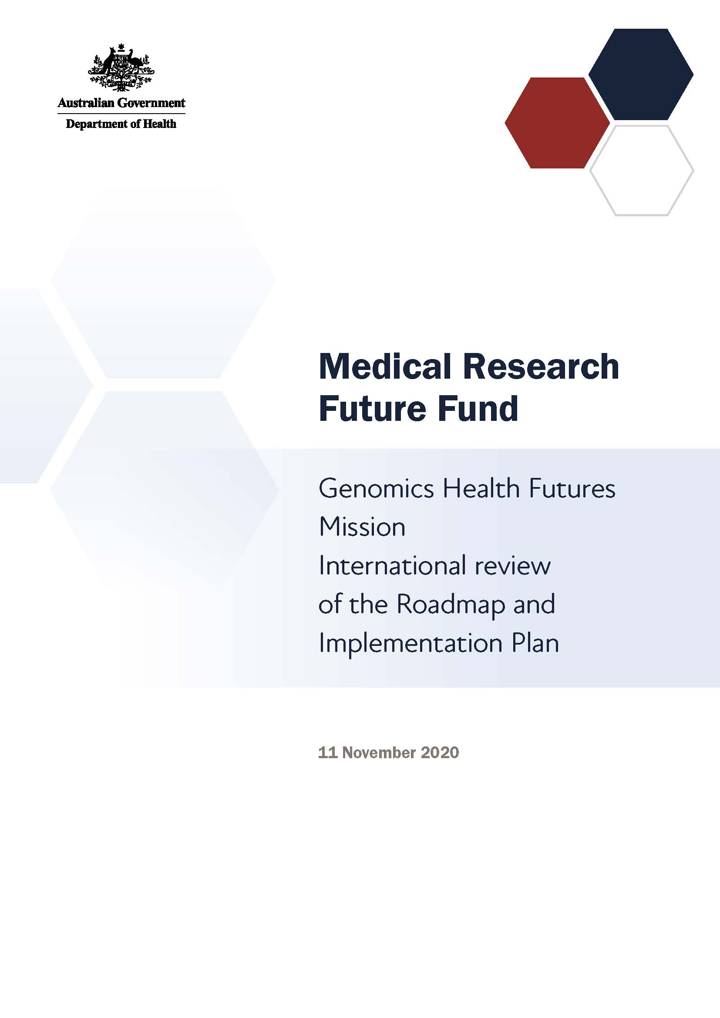

# Introduction

The Medical Research Future Fund (MRFF) is a $20 billion long-term investment supporting Australian health and medical research. The MRFF aims to transform health and medical research and innovation to improve lives, build the economy and contribute to health system sustainability.

The GHFM will provide A$500 million over 10 years under the MRFF to improve testing and diagnosis for genetic diseases, help personalise treatment options to better target and improve health outcomes, and reduce unnecessary interventions and associated health costs for all Australians. The GHFM will also advance precision medicine in partnership with Aboriginal and/or Torres Strait Islander people to deliver genomics research that is scientifically sound, culturally safe and competent to address inequity in research participation and outcomes.

## GHFM Expert Advisory Committee

A GHFM Expert Advisory Committee was established to advise the Australian Minister for Health on the strategic priorities for research investment through the GHFM.

The GHFM Expert Advisory Committee’s role is to define evidence and knowledge gaps that should be addressed through mission research funding, to help transform health care and health outcomes for individuals and communities. This role includes defining key research questions that — if answered — will deliver meaningful change to patients through the translation of research.

**Our mission**

To improve the lives of Australians by accelerating research that delivers more effective testing, diagnosis and treatment; facilitates the adoption of new interventions; and consolidates Australia’s international leadership in genomics.

**Our goal**

To save or transform the lives of more than 200,000 Australians through genomic research to deliver better testing, diagnosis and treatment.

The GHFM Expert Advisory Committee developed a Roadmap and Implementation Plan, to advise about priorities for research investment through the GHFM.

The Roadmap includes:

* the mission statement and goal
* proposed themes and priorities for investment

The Implementation Plan includes:

* 3 aims that outline how the GHFM will benefit Australians
* 13 priorities for investment in the short, medium and long term
* opportunities for leveraging additional investment
* activities needed to support the GHFM’s outcomes and facilitate their implementation

GHFM Expert Advisory Committee members will consult and engage with other researchers, industry, and consumer and patient groups, and participate in media and public activities to build awareness of, and facilitate interaction with, the mission and with other MRFF-funded research.

# GHFM International Review Panel

The GHFM International Review Panel’s role was to provide expert feedback and experiential advice in the context of relevant activities occurring internationally, which can inform the strategic direction of the GHFM’s Roadmap and Implementation Plan.

The GHFM Panel members were asked to:

1. Advise on the applicability of the GHFM’s goal to the international context; specifically, whether the goal duplicates or contributes to international research activities
2. Advise on the likely effectiveness of the research priorities (including their sequencing) to achieve the goal
3. Provide learnings from international research activities in the field
4. Identify opportunities for leveraging and complementing international research activities to achieve the goal
5. Advise on the appropriateness of the proposed measures for evaluating progress towards meeting the goal

The GHFM Panel comprised 8 members representing expertise in a variety of clinical, scientific and associated research areas:

* Prof Ken Smith — Professor of Medicine and Head of the Department of Medicine, University of Cambridge, UK
* Prof Dame Sally Davies — UK Special Envoy on Antimicrobial Resistance, Department of Health and Social Care, NHS England, UK
* Mr Peter Goodhand — Chief Executive Officer of the Global Alliance for Genomics and Health (GA4GH), Toronto, Canada and Cambridge, USA
* Dr Teri Manolio — Director, Division of Genomic Medicine, National Human Genome Research Institute, National Institutes of Health, USA
* Dr Kenneth Park — Vice President, Offering Development in Real World and Analytic Solutions, IQVIA, USA
* A/Prof Maui Hudson — Associate Professor and Director of Te Kotahi Research Institute, University of Waikato, NZ
* Mr Simon Denegri — Executive Director, Academy of Medical Sciences, UK
* Professor Nina Hallowell — Professor of Social and Ethical Aspects of Genomics, Big Data Institute, Nuffield Department of Population Health, University of Oxford, UK

# Consultation discussion

The GHFM Panel met on Wednesday 11 November 2020 to discuss the GHFM’s Roadmap and Implementation Plan.

All participants at the meeting were required to declare any conflicts of interest and relevant collaborations. None of the declared interests were considered material to the meeting.

**Key points**

* The panel was optimistic about the GHFM and believed it would be important in the global context, especially Australia’s leadership potential in the areas of infectious disease and Aboriginal and/or Torres Strait Islander genomics
* The panel also noted that the GHFM scope and identified priorities are broad and ambitious and the allocated funding may not be sufficient to achieve all identified aims
* Access to clinical data is integral to advancing genomics research and translating research outcomes into practice
* Australians are seen to be health conscious, and there are opportunities to capitalise on, for example, polygenic risk scores as a conduit to behaviour change and health improvements
* Data-sharing policies and procedures will need to be carefully considered at the onset of the program, including terms and language used, databases, privacy and how to transition to an open state
* Establishing public trust in genomics research is important for creating an environment for success for the GHFM
* Research investment needs to be accompanied by proactive efforts to advance involvement of people from diverse backgrounds
* The proposed evaluation metrics sound more like goals than metric approaches, and these should be made more specific. The metrics should also avoid reliance on external actors (eg clinicians) as the research has no influence on this

## Applicability of the mission’s goal internationally

Is the mission’s goal applicable to the international context? Specifically, does the goal duplicate or contribute to international research activities?

The GHFM Panel was optimistic about the mission in general and believed it would be important in the global context. The panel agreed that duplication of goals with the international community was not a negative; rather, this complementarity could help push research forward — especially in the area of rare diseases and in Aboriginal and Torres Strait Islander communities — because of the importance of collecting data.

The panel noted that the Implementation Plan did not include much detail about how Australia would contribute to, or benefit from, international datasets, and indicated further consideration on how this would be achieved would be beneficial.

## Efficacy of research priorities to achieve the mission’s goal

What is the likely efficacy of the research priorities (including their sequencing) to achieve the goal?

The GHFM Panel noted that ELSI (ethical, legal and social implications) research would need to be embedded at the start of the mission to be effective; it should not be considered only at the end of the 10-year program or as an add-on to other research streams. The research would have a unique Australian perspective.

The panel suggested prioritising research on Aboriginal and/or Torres Strait Islander genomics because this is an area of strength and potential leadership for Australia.

The panel believed that a 70% rare diseases diagnostic rate by 2025 was overly ambitious and likely unachievable, as current available technology limits progress in this area. While supporting the ambition, the panel advised it would be worth reconsidering this target to allow a more pragmatic target to be set.

The GHFM Panel applauded the separate priority areas for rare diseases and cancer, and suggested ensuring these remain separate when engaging and collaborating with consumers and patients. These are two different patient communities with specific needs that make it difficult to consider them within a single process, as is sometimes done during research projects.

The panel agreed with prioritising polygenic risk scores, and advised that research should consider how these can be brought into clinical practice to make a real difference to patient health outcomes and how they can be used to alter consumer behaviour. The panel considered Australians to be generally health conscious, and there are potential opportunities to capitalise on this.

The GHFM Panel noted that Australians are cautious about sharing of genomic and clinical data — especially with private companies — and this must be considered when establishing data-sharing programs (also see ‘Learning from international research activities’). The panel also discussed the issue of equity for Aboriginal and/or Torres Strait Islander communities and agreed that building trust regarding data (collection, storage and use) is critical. Community levels of trust regarding genomics information is recognised as being related to participation in research and equity of outcomes and benefits.

## Learning from international research activities

What have we learned from international research activities in the field?

The GHFM Panel suggested carefully considering the terms and language used for data-sharing when developing policies and procedures. Also, the panel noted that international advances in infrastructure and methodological approaches make it unlikely that a centralised repository for all of the project data would be the preferred approach for managing data, and suggested providing some funding for research into federated analytics and approaches for multisite research programs that access and combine data from various sources. There are currently cloud-based solutions and online genomic ‘data visiting’ (this refers to analysing data in place without ever transferring them), which is becoming a trend globally. The trends have shifted the focus towards the scale of data, Indigenous data sovereignty and privacy.

The panel again referred to the issue of public trust, especially around genomics data. In the United Kingdom, researchers have been able to increase public trust in sharing their data by researching the causes of mistrust and strategies for addressing them. Another suggestion was to work closely with patient groups who have a strong understanding of the value of research and are able to articulate these benefits more broadly.

The panel stressed the importance of engaging the clinical workforce and advised researching the preparedness of the workforce for adopting genomics into practice, and how training can be used to help this workforce adapt to emerging technologies. The collaboration among England’s National Health Service, Health Education England, and Genomics England to produce a comprehensive genomic education program for clinicians at every level is a model that can be borrowed and built on. The panel also noted the importance of accessing high-quality clinical data to complement genomics information in research programs and to translate research outcomes into clinical practice.

The GHFM Panel noted that there is a need to consider rare and common diseases together as it is not clear that the genetic basis for both groups are distinct. Genomic disease datasets could therefore be linked together, to investigate the full spectrum of genetic diseases.

Finally, the panel recommended the use of ISO standard classifications for phenotyping.

## Leveraging and complementing international research activities

What are the opportunities to leverage and complement international research activities already underway to achieve the mission’s goal?

The GHFM Panel suggested liaising and collaborating with the following international programs and research groups:

* Genomics England (patient, family and community engagement)
* Involve UK (family and community engagement)
* NHS Genomic Medicine Service (UK)
* Health Education England (UK)
* UK–Franco consortium (ELSI issues)
* Cangene Corporation (Canada)
* CanGene–CanVar, Cancer Research UK Catalyst award (UK)
* PHG Foundation (governance and ELSI issues; UK)
* International Rare Diseases Research Consortium (IRDiRC)
* ClinGen (National Institutes of Health, US)
* Genomics Aotearoa

The panel also suggested moving beyond the typical US–Canada–UK linkages, as countries such as Japan and South Korea can also contribute valuable information.

## Evaluating progress towards meeting the goal

Are the proposed measures appropriate to evaluate progress towards meeting the goal?

The GHFM Panel noted that the proposed metrics are more like goals than metric approaches, and suggested making them more specific. It is important to be able to measure and establish a baseline before the research starts. The metrics should also have a timeframe. In addition, the panel advised against linking the MRFF’s success to genomics being embedded within clinical settings, noting the MRFF’s direct focus on research rather than on clinical practice.

The panel noted the need for evaluating consumer involvement and engagement, and to have a robust measurement strategy at the start of research programs.

## Additional advice

Additional feedback from the panel included the following:

* The incubator grants approach that is intended to provide funding for developmental research to drive areas of research potential is fantastic
* Research should include working with the Minister for Health, states and territories to develop a clinical service delivery system that is willing and able to embed genomics into health care
* The focus on infectious diseases is great, because Australia is geographically unique. The rest of the world can learn from Australian research in this area
* Australia has a clear strength with its genomic diversity, including Aboriginal and/or Torres Strait Islander communities. Researchers should seek out international collaborations to capitalise on this strength and to strengthen the statistical power to allow study of genetic groups which exist in Australia, but at population levels that are too small for robust genetic studies
* Supporting Indigenous capacity-building and addressing the issue of Indigenous data sovereignty will be essential to advancing work in this area
* Research should include engaging with the clinical workforce so findings are translated to clinical practice
* Research should build on strengths; consider what Australia can achieve with the funding and people in place
* The research program is comprehensive and offers an opportunity for Australia to capitalise on its strengths; however, it may be overly ambitious given the resources available
* Consider when funding should begin to realise ‘long term’ priorities, noting this means some research will need to commence earlier in the 10-year program
* The target of 70% diagnostic rate of rare diseases by 2025 is likely overly ambitious, and will be difficult to meet due to technological constraints (Priority Area 1.1)

# Recommendations

* Consider rewording the proposed evaluation metrics to be more specific; they should be focused on research and avoid reliance on external actors for success (eg clinical uptake or implementation) as the research has no influence over this
* Reduce the target of 70% diagnostic rate of rare diseases by 2025, as this is likely overly ambitious and will be difficult to meet
* Prioritise research in the area of infectious disease and within Aboriginal and/or Torres Strait Islander communities
* Address public trust issues for data collecting and sharing
* Capitalise on Australians’ positive attitudes towards good health by, for example, using polygenic risk scores as a conduit to behaviour change and health improvements
* Carefully consider data-sharing policies and procedures at the onset of the program and continue to be active in international genomic efforts