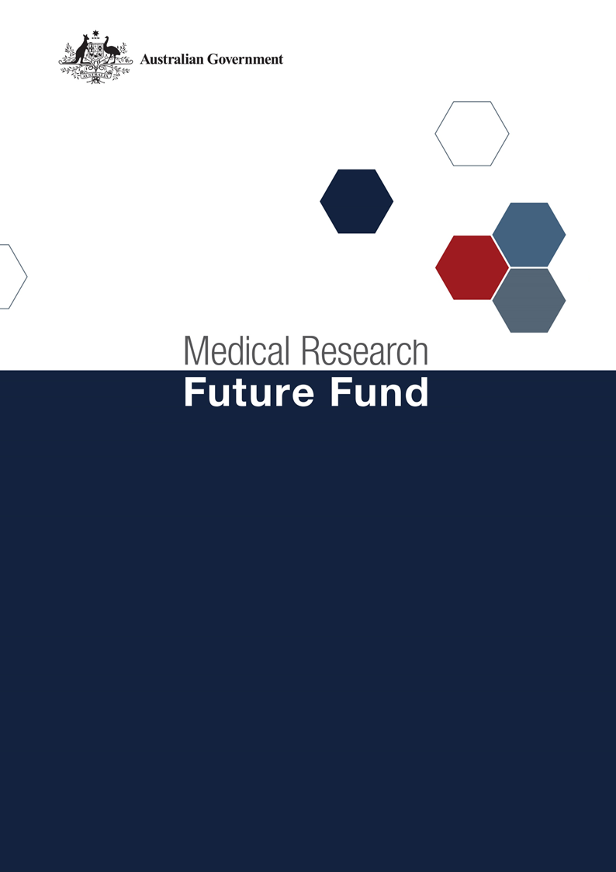

**MRFF Cardiovascular Health Mission   
Roadmap and Implementation Plan   
National Consultation Report  
  
September 2021**

Table of Contents

Introduction 2

Community participation and submissions 3

Responses to public consultation submissions 4

# Introduction

The Medical Research Future Fund’s (MRFF) Cardiovascular Health Mission (the Mission) was announced as part of the 2019-20 budget. The Mission will provide $220 million over 10 years to support research to improve cardiovascular health and stroke for all Australians.

An Expert Advisory Panel was established to provide advice to the Minister for Health and Aged Care on the strategic priorities for research investment through the Mission. As per the Minister’s agreed [Governance arrangements for MRFF Missions](https://www.health.gov.au/resources/publications/mrff-mission-governance), the Expert Advisory Panel has provided advice on priorities for research investment through the Mission by developing a Roadmap and Implementation Plan.

The Mission’s Roadmap is a high-level strategic document that includes the aim, vision, goal and priorities for investment for the Mission. To support the Roadmap, the Implementation Plan outlines the priorities for investment (short, medium and long term), evaluation approaches and measures, supporting activities, and collaborative opportunities. The Roadmap and Implementation Plan will be used by the Department of Health to design and implement Mission investments via Grant Opportunities promoted through GrantConnect ([grants.gov.au](https://www.grants.gov.au/)).

A draft Roadmap and Implementation Plan developed by the Expert Advisory Panel underwent international review on 12 November 2020; the outcome of the review is outlined in a report endorsed by the International Review Panel.

A national consultation to seek feedback from the community on the Mission’s draft Roadmap and Implementation Plan was conducted over the period 14 December 2020 to 23 April 2021, during which time submissions were accepted through the Department’s [consultation hub](https://consultations.health.gov.au/health-economics-and-research-division/mrff-cvd-health-mission/).

During the consultation, the Chair of the Expert Advisory Panel hosted two webinars, on 23 February and 10 March 2021. This gave an opportunity for the community to gain a greater understanding of the purpose of the Roadmap and Implementation Plan and ask questions, prior to providing written submissions to the consultation.

The following questions were provided on the consultation hub to guide submissions:

1. Are the priority areas for investment identified in the Implementation Plan the most effective way for delivering on the Cardiovascular Health Mission’s goal and aims?
2. Are there existing research activities which could be utilised to contribute to the Cardiovascular Health Mission Roadmap and/or Implementation Plan aims and priority areas for investment? How can these be leveraged?
3. Are the ‘Evaluation approach and measures’ appropriate for assessing and monitoring progress towards the Cardiovascular Health Mission’s goal and aims?

This report summarises the national consultation through webinar participation and written submissions.

## Community participation and submissions

85 stakeholders (from 141 registrations) attended the two webinars from across all states and territories of Australia. A diverse range of stakeholders participated including those from: research organisations (including universities and Medical Research Institutes); consultancy organisations, consumer advocacy groups; state government (health) departments; and individual community members.

At the close of the consultation period, 16 written submissions were received via the consultation hub, representing universities, medical research institutes, and national and state-based consumer organisations.

The Expert Advisory Panel considered all responses from the national consultation and, where relevant, revised the Roadmap and Implementation Plan. A summary of the feedback from the submissions and the Expert Advisory Panel’s responses are outlined below.

# Responses to national consultation submissions

| **Consultation Question** | **Submission Feedback / Themes** | **Action by Expert Advisory Panel (the Panel)** |
| --- | --- | --- |
| **Are the priority areas for investment identified in the implementation plan the most effective way for delivering on the Mission’s goal and aims?** | Greater emphasis is needed in the *Aims* and *Priority Areas* on prevention and broader public health interventions, as opposed to mainly research that addresses outcomes and recovery from cardiovascular events. | Prevention and public health interventions are reflected in the Roadmap and Implementation Plan. No changes were recommended. |
| Increasing collaboration and funding across the research pipeline, from discovery research to translation into clinical practice. | The goal of the Mission is to see material change and outcomes in the life of the Mission (10 years). Funding will focus across the research pipeline noting that funding models will be tailored to each grant opportunity. |
| Disaggregate stroke from cardiovascular disease to allow more targeted research and outcomes more accurately disease focussed. | The Panel noted this recommendation, however agreed that no changes are required as applicants will be required to demonstrate the importance of their research according to the objectives of the grant opportunity. |
| Clearer articulation of how the *Aims* were generated and how they complement one another to improve cardiovascular health. | The Panel agreed and additional wording has been added to the Implementation Plan. |
| Undertake an analysis and identification of critical and strategic areas where Australia may do the best with a relatively limited budget. | As part of the development of the Roadmap and Implementation Plan, the Panel agreed on the priorities for investment noting the Mission’s budget. The Mission will undergo an evaluation in coming years, which will provide an opportunity to review the priority areas identified for investment. |
| A number of submissions identified the need to:   * + include rural and regional Australians alongside Aboriginal and Torres Strait Islander people * increase consumer/stakeholder engagement throughout entire research process * have greater focus on capacity building. | * The Panel agreed that it was important that the priorities target all Australians, including rural and regional populations. Additional wording in the Implementation Plan has been included. * The Panel agreed that consumer/stakeholder engagement is critical throughout the research process and noted this is reflected in the Roadmap and Implementation Plan. The grant opportunity guidelines will also require applicants to address their process for consumer engagement. * While this is out of scope for the Mission, capacity building is inherent in all grant opportunities. |
| A number of research topics were suggested for funding including:   * proprietary molecules, data, methods, and models that position Australia at the forefront internationally * technical development, disease modelling and drug screening platforms providing fundamental knowledge to enable future cardiovascular therapies * identifying inequity in access to healthcare and in outcomes as a priority area * environmental risks and solutions for cardiovascular health * effective interventions and models of care into health systems * implementation, health economics and policy research. | The Panel agreed that there will be no barrier to funding these specific areas (or others) as long as they are relevant to a grant opportunity. |
| A number of specific changes were recommended to priority areas, including:   * **Priority 1.2** - Broaden the focus to include public health approaches (e.g. implementing tobacco control in populations with continued high prevalence smoking rates) * **Priority 2.1** - Long-term investment currently focused on uptake of best-practice care. However, research addressing the gap between current evidence and current practice offers a large and immediate opportunity to improve CV health. * **Priority 3.2** - Strengthen by including: * large cohort studies to improve understanding of the natural history of recovery * studies to improve understanding of the neurobiology of spontaneous and treatment-induced recovery. | The Panel agreed that there will be no barrier to funding these specific areas (or others) as long as they are relevant to a grant opportunity. |
| **Are there existing research activities which could be utilised to contribute to the Mission’s Roadmap and/or Implementation Plan aims and priority areas for investment? How can these be leveraged?** | A number of general and more specific activities were recommended including:   * state based cardiovascular research networks * within and across the Mission and broader cardiovascular researcher community enabling complementarity, consistency and communication across funders. | Language in the Implementation Plan has been changed to enable the inclusion of additional activities. The Panel agreed that while it is not feasible to list every research activity that is in scope, applicants are encouraged to partner with organisations/activities as part of their research program. |
| Joint funding calls between missions and/or providing secondary support schemes for near miss grants through other funding bodies should be supported. | While no changes are recommended, this will be considered for future MRFF investments more broadly. |
| **Are the ‘Evaluation approach and measures’ appropriate for assessing and monitoring progress towards the Mission’s goal and aims?** | A number of general and specific evaluation metrics were recommended including:   * Increasing the number of targets and quantitative measures to assess impact and progress towards Mission’s Aims * ensuring outcomes of and access to studies have proportional representation from rural, regional and remote Australians * setting a significant ambition, for example, eliminate high cholesterol as a cardiovascular disease risk factor * having clearer targets for the discovery and implementation of new biomarkers * including cost-effectiveness and health system affordability of new and existing prevention, early detection and treatment interventions * Aim 1 – include: * the prevalence of key cardiovascular and stroke risk factors, including smoking and hypertension, are reduced * Aim 3 – include: * a greater proportion of stroke survivors receive effective rehabilitation therapies. | The Panel agreed with most of the recommendations, noting that:   * explicit benchmarks and key milestones will be required within applications and assessed appropriately (requirements will be emphasised within the grant guidelines) * some quantifiable targets require dedicated consultation with and commitment from the research sector * reference to the MRFF Monitoring, evaluation and learning strategy has been included in the revised Implementation Plan for this and all other Missions. |