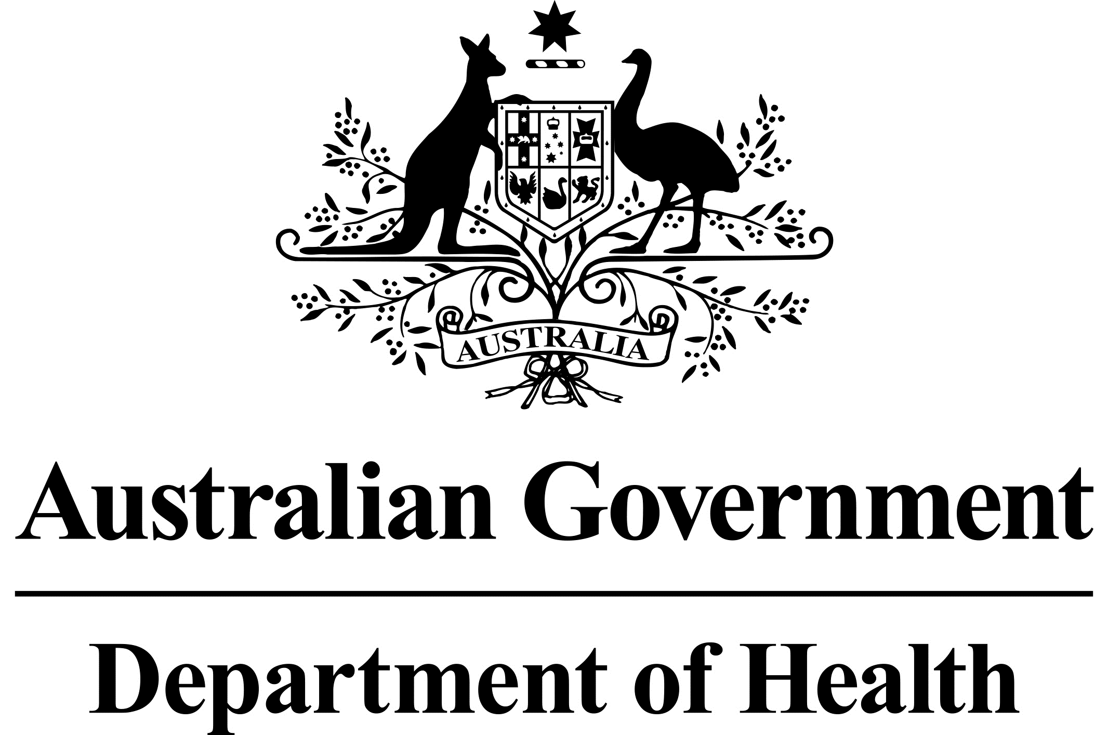

[Correspondent Name]

[Correspondent Street]

[Suburb] [State] [Post Code]

Dear [Correspondent Name]

I am writing to inform you about changes that the Australian Government is implementing to make the aged care system more transparent for care recipients, their families, and their carers.

From 1 September 2021, the Government will only pay home care providers for the care and services that they have actually delivered to you. If you do not use all of your package level funding in a particular month, the Government will hold these funds until you need them for future care and services.

Your home care fees, as agreed and documented in your home care agreement, remain unchanged.

Information on these changes is included in the enclosed fact sheet and you may wish to discuss these changes with your provider. You can also call My Aged Care on 1800 200 422.

You also have the right to speak to an aged care advocate. You can access free, confidential and independent aged care advocacy through the Older Persons Advocacy Network (OPAN) on 1800 700 600 or visit [www.opan.org.au](http://www.opan.com.au).

Yours sincerely

Assistant Secretary

Home Care and Assessments Branch

Department of Health

October 2021