# Keep your disability workforce up to date by circulating this alert widely in your organisation

# Disability provider alert

6 October 2021

## Information on current hubs offering vaccination services

There are many vaccination hubs offering services for people with disability, their carers and disability workers.

The list of these services is now available on the Australian Government Department of Health website: <https://www.health.gov.au/initiatives-and-programs/covid-19-vaccines/disability-sector/service-providers>. The table is updated as new information is received.

In the table, you can now click on a column heading to sort, or start typing in the search box to find the information you need. Swipe left or right to see more of the table if you're on a mobile device.

If you have a vaccination clinic or hub you’d like to promote, [let us know](mailto:COVID19VacTFDisabilityServices1A@Health.gov.au).

Our disability landing page has been updated to be more user friendly and easier to navigate and find information. It also includes a listing of accessible state and territory clinics: [Information for people with disability about COVID-19 vaccines | Australian Government Department of Health](https://www.health.gov.au/initiatives-and-programs/covid-19-vaccines/disability-sector/people-with-disability). **Please distribute this information to your workforce.**

## Vaccine clinic finder

The Eligibility Checker has been simplified to allow consumers to more easily gain access to COVID-19 vaccines. It is now called the Vaccine Clinic Finder: [COVID-19 Vaccine Clinic Finder | Australian Government Department of Health](https://www.health.gov.au/resources/apps-and-tools/covid-19-vaccine-clinic-finder).

The national Vaccine Clinic Finder is a complete list of all clinics in Australia. Details of over 10,000 vaccination clinics and participating pharmacies are available.

It is the best way to compare clinics, check availability and book an appointment in one place. New clinics are added all the time. A [downloadable point-in-time list of all vaccine clinics in Australia](https://health.govcms.gov.au/node/28096) is also available.

The latest release of the Vaccine Clinic Finder includes:

* the option of the Moderna or Pfizer vaccines for 12-18 year olds
* an outcomes screen that advises COVID-19 vaccines are not currently approved for people under 12 years of age, if an appointment for this age group is sought
* all vaccine and clinic types for all people over the age of 18 years. There are some caveats that recommend the COVID-19 Comirnaty (Pfizer) vaccine or the Spikevax (Moderna) vaccine for people aged 12 to 59 years; and the Vaxzevria (AstraZeneca) vaccine for people aged 60 years and over
* Commonwealth, state and territory clinics and pharmacies for consumers who are not eligible for Medicare
* pharmacies that are being onboarded with Moderna.

[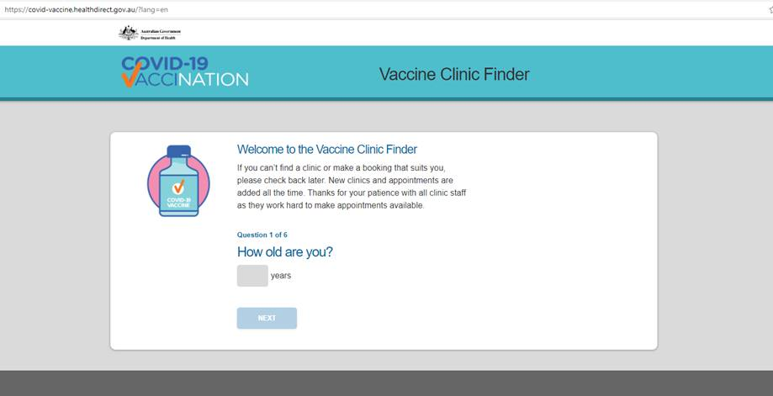](https://covid-vaccine.healthdirect.gov.au/?lang=en)