**Evaluation of the BreastScreen Australia program’s expansion of the target age for active recruitment to include women aged 70–74 years: Final Report (Accessible Version)**

Australian Government Department of Health

26 March 2021

Contents

Glossary, acronyms and abbreviations 3

Acknowledgements 4

Executive Summary 5

Summary of findings 6

Recommendations 8

Future Considerations 11

Background and context 12

2 Evaluation methodology 14

3.1 Purpose and scope of the evaluation 14

3.2 Evaluation type and principles 15

3.3 Program Logic 15

3.4 Ethics approval 17

3.5 Key questions guiding the evaluation 17

3.6 Desktop research 17

3.7 Consultations 19

3.8 Program data analysis 21

3.9 Limitations 22

3 Overview: Program expansion aim and impact on participation rates 25

3.1 The Program expansion represented a noteworthy change to the target age range for the BreastScreen Australia Program 25

3.2 The Program expansion was successfully implemented, with participation rates for women aged 70–74 years increasing to be on par with other age cohorts in the target age range 28

3.3 The increase in participation for women aged 70–74 years has resulted in a logical increase in the number of invasive and DCIS cancers detected for women 70–74-years-old 36

3.4 Engagement with BreastScreen increased for women aged 70–74 years after expansion, with minimal lasting impact on other target cohorts 38

3.5 Invitations and reminders are integral to supporting participation of women aged 70–74 years ……………………………………………………………………………………………………………………………………………….....39

4 Program expansion design and implementation 43

4.1 The expansion design was facilitated through two specific Project Agreements 43

4.2 Expansion funding was critical and necessary to implement the expansion 44

4.3 Funding was subject to the achievement of performance benchmarks 45

4.4 The expansion design and implementation could have been strengthened by deeper and streamlined consultation with jurisdictional Program management 50

4.5 Successful implementation of population breast screening and program changes require support at policy, system and delivery levels 52

5 The expansion’s impact on the experience of BreastScreen service staff 55

5.1 Staff experience and operations were impacted during the initial transition period, however the expansion is now ‘business-as-usual’ 55

5.2 The overall impact of the expansion on the capacity of services, as determined by consultations and proxy measures, indicates variability and a two-year transition period 56

6 The expansion’s impact on the experience of women and their intention to screen 62

6.1 Women surveyed and interviewed report high satisfaction with the BreastScreen service before and after Program expansion 62

6.2 Women aged 70–74 years had variable awareness and understanding of the Program expansion and the target age range 65

6.3 Messaging for women once they reach the age of 75 years is challenging 67

6.4 There are many reasons why women aged 70–74 years do and do not participate in breast screening……………………………………………………………………………………………………………………………………………..69

6.5 Barriers and enablers to participation for women aged 70–74 years vary across population groups ……………………………………………………………………………………………………………………………………………….. 72

6.6 Tailored approaches to engagement can improve participation rates of priority cohorts 77

Appendices …………………………………………………………………………………………………………………………………………… 83

### Glossary, acronyms and abbreviations

| Term | Full text |
| --- | --- |
| Aboriginal and Torres Strait Islander | Refers to a person who identifies as an Aboriginal and/or Torres Strait Islander and is accepted as such by the community with which he or she lives.[1] |
| ABS | Australian Bureau of Statistics |
| ACT | Australian Capital Territory |
| AHMAC | Australian Health Ministers’ Advisory Council |
| AIHW | Australian Institute of Health and Welfare |
| AMS | Aboriginal Medical Service |
| BSTRG | Department of Health BreastScreen Technical Reference Group |
| Culturally and Linguistically Diverse (CALD) | Culturally and linguistically diverse individuals are those born overseas in countries where English is not the primary language spoken and/or individuals born in Australia whose preferred language spoken is not English.[2] |
| Ductal carcinoma in situ (DCIS) | Ductal carcinoma in situ is the presence of abnormal cells inside a milk duct in the breast. DCIS is considered the earliest form of breast cancer. DCIS is non-invasive, meaning it hasn't spread out of the milk duct to invade other parts of the breast. |
| Higher risk women | A collective term used to refer to women at a higher risk of breast cancer – for example, women with family history, women with a past history of breast cancer or DCIS or women with symptoms. |
| HREC | Human research ethics committee |
| IARC | International Agency for Research against Cancer |
| ICR | International Comparator Review |
| IRSD | SEIFA Index of Relative Socio-economic Disadvantage |
| KLEs | Key Lines of Enquiry |
| NAS | BreastScreen Australia’s National Accreditation Standards |
| PHN | Primary Health Network |
| Program manager | Program managers are responsible for management of all Program functions at the jurisdictional level and ensure that service delivery is client-focused, efficient and of the highest standard. The role includes financial performance, statutory compliance of service delivery and management of human resources.[3] |
| RA | Remoteness areas |
| Rescreening | The proportion of women who return for screening in the Program within the recommended screening interval. BreastScreen Australia’s recommended screening interval is twice yearly. |
| SES | Socio-economic status |
| WHO | World Health Organization |

### Acknowledgements

The Department of Health (the Department) has engaged Nous Group (Nous) to undertake an implementation evaluation of BreastScreen Australia’s expansion of the target age to 70–74 years for active recruitment into the Program. Nous has been working with the Department and BreastScreen Programs since March 2018 to undertake this evaluation. The process to date has included substantial consultation with stakeholders and each jurisdictional program, with dedicated time for qualitative data collection through on-site stakeholder consultations. Each jurisdictional program has significantly contributed to the data collection and stakeholder perspectives that underpin this evaluation.

Nous Group respectfully acknowledges Aboriginal and Torres Strait Islander peoples as the First Australians and the traditional custodians of the land.

We pay respect to Elders past, present and emerging in maintaining the culture, country and their spiritual connection to the land.



*This artwork was developed by Marcus Lee Design who is a proud Karajarri man born and raised in Darwin, NT. Nous Group commissioned the piece to reflect the Nous Reconciliation Action Plan and our aspirations for respectful and productive engagement with Aboriginal and Torres Strait Islander peoples and communities.*

# Executive Summary

The BreastScreen Australia Program has played a pivotal role in reducing breast cancer mortality and morbidity for Australian women. The Program contributes to improving health outcomes through population-based screening, detection and early diagnosis of breast cancer. From 2013–14, the target age range for screening was expanded from women aged 50–69 years to include women aged 70–74 years (aligned with one of the 2009 BreastScreen Australia Evaluation recommendations). Program expansion was supported by initial Commonwealth funding of $55.7 million over four years, from 2013–17. A subsequent further commitment of $64.3 million continued funding the Program expansion to June 2021. The Program expansion to include women aged 70–74 years in the target age range for recruitment was a significant policy change.

Program expansion is now well advanced in each jurisdiction. Implementation of the Program expansion has been shaped by differing local needs and priorities in each State and Territory. While program diversity created analytical complexity for the evaluation, it also offered the potential to understand differing approaches to the shared issues associated with implementation nationally.

**This report presents the findings and recommendations from an independent evaluation of the implementation and early impact of the expansion**

The Department of Health (the Department) engaged Nous Group to evaluate the implementation and early impact of BreastScreen Australia’s Program expansion of the target age for active recruitment to include women aged 70 – 74 years. The evaluation focused on how the implementation of the evaluation impacted screening participation rates and the experiences of clients, staff and stakeholders. The findings provide important evidence to guide improvements to future program delivery planning and funding beyond the current program funding commitment. The evaluation considers the implementation progress and lessons learnt.

The evaluation activities began in 2018 and were finalised in 2021. Some contextual factors to note about this time period include:

* As of March 2021, including 70–74 year old women in active recruitment is not yet deemed an ongoing national policy, and is being reviewed on a four yearly basis.
* Some evaluation activities took place in 2020, including consultations with BreastScreen clients and women aged 70–74. Consultation themes may have been impacted and influenced by service changes in response to the COVID-19 pandemic. This is explored further in Section 6 and in Appendix D.

**The evaluation methodology tested for effectiveness of the implementation, the impact on participation rates and opportunities for sustainability**

The evaluation approach tested the theory of change that an investment in targeted awareness-raising and expansion of the national target age-range will increase participation rates and cancer detection in women aged 70–74 years. Drawing on a program logic model, the evaluation explored both formative (implementation) and summative (impact) aspects of the Program expansion. Evaluation questions are organised under three key lines of enquiry (KLE):

1. How effective were the implementation processes and activities?
2. How has Program expansion impacted screening participation in the target group? What barriers or enablers to participation have been encountered?
3. What opportunities are available to improve and sustain the Program expansion?

The evaluation scope focused specifically on impacts associated with screening program participation. Issues concerning diagnostic accuracy of screening and the clinical management of screening results in women aged 70–74 are outside the scope of this evaluation.

The evaluation had a focus on four priority cohorts aligned with the special groups identified in the BreastScreen National Accreditation Standards (NAS). These were Aboriginal and Torres Strait Islander women, women who are culturally and linguistically diverse (CALD), women from high disadvantage (low socioeconomic) areas, and women living in regional/remote areas.

The mixed methodology for data collection and analysis was an iterative, cyclical process across 2018–2021 inclusive. The analysis drew on published and grey literature concerning Australian and international screening programs, nationally collected program and population health data and individual jurisdictional data. This evidence was complemented by primary collection of stakeholder consultation data during State and Territory program site visits, repeated consultations with BreastScreen leadership teams and staff, broader stakeholders from the cancer control sector, and surveys and interviews with women in the target age group (both current BreastScreen clients and a sample from the general population).

## Summary of findings

The evaluation insights and findings are set out below. It is important to note that not all the findings are necessarily directly attributable to the Program expansion. Trends in the data may also be due to the complexities and diversity of the context in which the Program operates nationally, and other historical policy changes (for example the roll out of digital mammography in 2009). The details of these findings are presented and discussed in the body of this report across Sections 3–6, supported by a suite of Appendices in a separate, complementary document.

|  |
| --- |
| KEY OVERALL FINDING |
| Program expansion was successfully implemented with some variation across jurisdictions and population groups. While screening women aged 70–74 years is now ‘business-as-usual’, there are opportunities to make further improvements for women in the target age range, and considerations for the program overall. |

|  |
| --- |
| SECTION 3 | Program expansion impact on participation rates |
| * The Program expansion represented a noteworthy change to the target age range for the BreastScreen Australia Program |
| * The Program expansion was successfully implemented by programs, with participation rates for women aged 70–74 years increasing to be on par with other age cohorts in the target age range |
| * By 2018, the Program saw an increase of almost 200,000 women aged 70–74 years screened following the program expansion (2011–12). The number of women aged 70–74 years screened increased from 97,957 in 2011–12 to 280,351 in 2017–18 (see Appendix F for further detail) |
| * The increase in participation for women aged 70–74 years has resulted in a logical increase in the number of invasive and DCIS cancers detected for women 70–74 years old |
| * By 2018, the Program saw an additional 700 invasive cancers and 110 DCIS cancers detected early for women aged 70–74 years following the program expansion (2011–12). Between 2011–12 to 2017–18, the number of invasive cancers detected for women 70–74 year old increased from 432 to 1,121 and the number of DCIS cancers detected increased from 147 to 261 |
| * Engagement with BreastScreen increased for women aged 70–74 years after expansion, with minimal lasting impact on other target cohorts |
| * Invitations and reminders are integral to supporting participation of women aged 70–74 years. |

|  |
| --- |
| SECTION 4 | Program design and implementation |
| * The expansion design was facilitated through two specific Project Agreements |
| * Expansion funding was critical and necessary to implement the expansion |
| * Funding was subject to the achievement of performance benchmarks |
| * The expansion design and implementation could have been strengthened by deeper and streamlined consultation with jurisdictional Program management |
| * Successful implementation of population breast screening and program changes require support at policy, system and delivery levels. |

|  |
| --- |
| SECTION 5 | Program expansion’s impact on the experience of BreastScreen staff |
| * Staff experience and operations were impacted during the initial transition period, however the expansion is now ‘business-as-usual’ |
| * The overall impact of the expansion on the capacity of services, as determined by consultations and proxy measures, indicates variability and a two year transition period. |

|  |
| --- |
| SECTION 6 | Program expansion’s impact on the experience of women and their intention to screen |
| * Women surveyed and interviewed reported high satisfaction with the BreastScreen service before and after Program expansion |
| * Women aged 70–74 years had variable awareness and understanding of the Program expansion and the target age range |
| * Messaging for women once they reach the age of 75 years is challenging |
| * There are many reasons why women aged 70–74 years do and do not participate in breast screening |
| * Barriers and enablers to participation for women aged 70–74 years vary across population groups |
| * Tailored approaches to engagement can improve participation rates of priority cohorts. |

## Recommendations

The evaluation findings support four recommendations detailed below. Report sections are referenced based on data source rather than correlating specifically to a recommendation. The right column in the table below indicates the report sections which contain information and or rationale relevant to the corresponding recommendation.

|  |  |
| --- | --- |
| 1 Funding to support breast cancer screening of women aged 70–74 years should continue beyond June 2021 | REPORT SECTIONS TO REFERENCE FOR RATIONALE: |
| 1.1  A third project agreement, including performance benchmarks, should be implemented to support the ongoing access to screening for women aged 70–74 years prior to the planned broader funding review of BreastScreen taking place.  *The broader funding review of BreastScreen is currently on hold due to the cessation of AHMAC and the prioritisation of Australia’s response to the COVID-19 pandemic.* | SECTION 4.1  SECTION 4.2  SECTION 4.3 |
| 1.2  Ongoing funding for screening women aged 70–74 years would benefit from further consideration of jurisdictional differences to account for:   * Regionality and the increased cost to screen outside metropolitan areas using the Modified Monash Model (MMM) to identify population values geographically * Aging populations (specifically the projections for women aged 70–74 years and over) in each jurisdiction that will impact capacity and demand * Increasing costs-per-screen due to inflation, workforce salaries and dispersed populations * Capital expenditure to support expansion of facilities, new equipment and maintenance of equipment. |
| 1.3  The broader funding review of BreastScreen (noted in 1.1) could consider ongoing funding for 70–74 year old women as part of the comprehensive funding required for BreastScreen service delivery. |

|  |  |  |
| --- | --- | --- |
| 2 Strengthened national coordination, consistency and direction in messaging and policy will improve program effectiveness and capacity | REPORT SECTIONS TO REFERENCE FOR RATIONALE: | |
| 2.1  Clear messaging for Australian women about the target age range and the risks and benefits of continuing to screen or cease screening beyond the target age range should be national, consistent and developed through early consultation with programs – BreastScreen Australia should continue to use best practice principles of health promotion.   * A focus should be given to messaging regarding risks and benefits of continued screening for women transitioning out of the target age group (i.e., women aged 75 years and over) * Clear messaging should consider effective national alignment and coordination of marketing, and potentially branding. | | SECTION 4.2  SECTION 5.2  SECTION 6.2  SECTION 6.3 |
| 2.2  Explore models of personalised, risk-stratification as an alternative to standard biennial invitations for women in the target age range. Provide support or grants for interested programs to design and deliver demonstration projects or trials with the dual goals of increasing capacity in screening services and providing tailored, person-centred screening for women.  The demonstration projects should consider the appropriate cohorts of women to include and be evaluated for effectiveness and their applicability for use in other jurisdictions or regions across the country. | |

|  |  |
| --- | --- |
| 3 At the program level, continued efforts to overcome barriers to participation, particularly for priority groups, and a focus on clear messages by key workforce roles will improve program effectiveness | REPORT SECTIONS TO REFERENCE FOR RATIONALE: |
| 3.1  State and territory programs should continue their efforts to enable increased participation in the BreastScreen Program by focusing on overcoming or navigating known barriers for their populations and communities, based on their own context and data   * Barriers and enablers for all women include those summarised in Section 6.5 * Barriers and enablers for priority populations (Aboriginal and Torres Strait Islander women, women with CALD backgrounds, women living in high disadvantaged areas, and women living in remote locations) include those summarised in Section 6.6. | SECTION 3.2  SECTION 6.1  SECTION 6.4  SECTION 6.5  SECTION 6.6 |
| 3.2  State and territory programs should maximise the impact of key roles across the BreastScreen client journey, including receptionists, radiographers and GPs by ensuring all roles have training and protocols to communicate clear messaging, and risks and benefits of screening within the target age range (see related Recommendation 2.1 for national consistency) |

|  |  |  |
| --- | --- | --- |
| 4 Future large-scale national policy changes for the BreastScreen Program would benefit from a strategic, consultative, and planned implementation process | | REPORT SECTIONS TO REFERENCE FOR RATIONALE: |
| 4.1  Prior to any future noteworthy change to the BreastScreen Program, early consultation should take place with all eight jurisdictional BreastScreen services, key BreastScreen staff and independent advisors to the Department with clinical, operational, and public health expertise. Consultation should consider:   * strategic outcomes and short to medium term goals for the BreastScreen Program * balancing national consistency with jurisdictional needs and population profiles * challenges in regional, rural and remote locations in relation to specialised workforce recruitment and retention, and increased costs of service delivery * adequate lead times for implementation for programs to prepare, plan and execute including securing the required workforce and minimal disruption to services for women. | SECTION 4.4 SECTION 5.1 SECTION 5.2 | |

## Future Considerations

In addition to the four recommendations above, the evaluation findings suggest three future considerations (detailed below) be noted.

|  |
| --- |
| 1. Review the clinical efficacy and effectiveness of screening women aged 70–74 years |
| *Rationale*: This evaluation has assessed the process and implementation of a noteworthy policy change to the BreastScreen Program, however the clinical outcomes of screening women aged 70–74 years was outside of scope. While the evaluation has demonstrated the Program expansion was successfully implemented by jurisdictional programs with the latest participation rates for women aged 70–74 years on par with other age cohorts in the target age range (50–69 years); understanding the clinical efficacy and impact on morbidity and mortality will provide a comprehensive view of the impact of the policy change. |

|  |
| --- |
| 1. Consider and assess the benefits, costs, evidence and potential operational and clinical impacts of expanding BreastScreen’s target age range to include women aged 45–49 years |
| *Rationale:* This evaluation has shown the considerable cost and effort for programs to implement the Program expansion, the 18 month – 2 year transition period and appropriate lead times required. Previous evaluations and key stakeholders consulted for this evaluation highlighted the potential benefit to expand the target age to screening women aged 45–49 years (including greater years of life saved compared to women aged 70–74 years), *and* the substantial cost and operational impact this would have on the BreastScreen Program. An evidence-based cost-benefit analysis and in-depth consultation with jurisdictional programs should be conducted prior to any policy change or decision-making in this regard. |

|  |
| --- |
| 1. Within each jurisdiction’s legislative and ethical/consent context, explore the feasibility of collecting email addresses and mobile numbers of BreastScreen clients of all ages as standard practice to support future research, evaluation, client experience feedback and dissemination of health promotion messages |
| *Rationale:* The evaluation confirms the established critical role an invitation letter plays for BreastScreen participation rates in the target age group. An additional observation during the data collection for this evaluation highlights the efficiency and acceptability of digital communication mechanisms for many BreastScreen clients aged 70–74 years (noting this does not extend to all priority groups). Clients aged 70–74 years were invited to participate in an online evaluation survey via a variety of channels based on the capacity, systems and legislative or consent arrangements in each jurisdiction (e.g., email, SMS, letter or brochures in services). The responses from those women contacted directly by digital means (email and SMS) were overwhelmingly swift and resulted in higher response rates and engagement compared to women in jurisdictions using paper-based methods of invitation or promotion. |

1. Background and context

The BreastScreen Australia Program is an important component of Australia’s Population Based Screening Framework, providing early detection and diagnosis to improve health outcomes. This section outlines an understanding of the BreastScreen Australia Program as ascertained through the evaluation, as well as the relevant nuances of the Program expansion that have been uncovered in this process.

**Early detection to improve breast cancer outcomes and survival is the cornerstone of breast cancer control globally.**

The World Health Organization promotes breast cancer control within the context of comprehensive national cancer control programs.[4] Organised national screening programs for breast cancer are active in several countries including Canada, Denmark, England, France, Ireland, Japan, South Korea, New Zealand, Sweden, and The Netherlands. Age targets and participation rates in screening programs vary markedly across global regions.[5]

**BreastScreen Australia has a pivotal role in reducing breast cancer mortality and morbidity.**

Breast cancer is the most common cancer for women in Australia, with an estimated 19,371 women diagnosed with breast cancer in 2019. Breast cancer (in both males and females) is estimated to constitute 14 per cent of all new cancer diagnoses in Australia in 2019.[6]

Australia, through a joint Commonwealth and State and Territory initiative, invites healthy, asymptomatic women aged 50–74 years to free biennial mammograms, across 600 fixed and mobile sites.[7]

The BreastScreen Australia Program is an important component of Australia’s Population Based Screening Framework, based on the WHO principles for screening.[8] It provides early detection and diagnosis to improve health outcomes, with a recent expansion of the target age for screening. The 2009 Program evaluation recommended the expansion of the target age for biennial screening to include women aged 70–74 years, above the previous 50–69 years. That evaluation found that for women aged 70 years and over, the cancer detection rate is around 50 per cent greater than that for women aged 50–69 years. The modelled mortality reduction for providing biennial screening for the expanded age group was approximately 12 per cent.[9]

**The BreastScreen Australia Program’s expansion of the target age for active recruitment to include women aged 70–74 years was a significant policy change implemented in 2013–14.**

The Commonwealth Government provided $55.7 million over four years (2013–14 to 2016–17) to support the Program expansion. This funding was intended for additional services, communication activities, direct invitations and reminders, as well as enhancements to service delivery and system capacity, including capital and information technology infrastructure and workforce. Ongoing funding for 2017–18 to 2020–21 ($64.3 million) has enabled continuation of the Program expansion to include women aged 70–74 years.[10] Further funding decisions will be informed by this evaluation.

**BreastScreen Australia operates within a complex policy and stakeholder environment.**

Other reforms resulting from the 2009 evaluation have occurred in parallel to the Program expansion. This has created complexity for the attribution of Program achievements and impact. The Australian Health Minister’s Advisory Council (AHMAC)[11] has worked towards consistent national policy, a 70 per cent participation rate[12] and increased re-screening rates; BreastScreen Australia’s National Accreditation Standards (NAS) currently aim for 70 per cent or more of women in the target age range to participate in screening.

There are several Department initiated projects and evaluations underway or in train for the BreastScreen Australia Program including:

* an evaluation of the national accreditation system by the University of South Australia
* a project to review and manage screening in women aged 75 and over
* a project to review annual screening; and
* development of technical standards for tomo synthesis in BreastScreen Australia.

Figure 1 below shows a high-level summary of the stakeholders for the Program.

Figure 1 | High level stakeholder environment for BreastScreen Australia

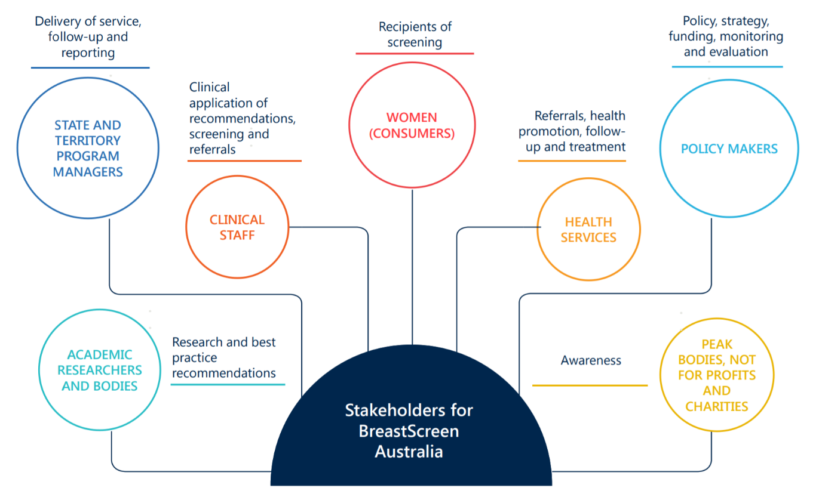

1. Evaluation methodology

The evaluation methodology is in line with the evaluation plan agreed with the Department and the ethics approval provided for the evaluation activities. It was informed by the expertise of Nous in delivering national, multi-year health evaluations and experience engaging with health and BreastScreen stakeholders across multiple jurisdictions. The sections below outline:

* the purpose and scope of the evaluation (see section 2.1)
* overarching principles applied to this evaluation (see section 2.2)
* the Program logic model guiding the evaluation (see section 2.3)
* commitment to ethical requirements for the evaluation design (see section 2.4)
* the key questions guiding the evaluation (see section 2.5 and Appendix A for the key lines of enquiry)
* a synopsis of the desktop research conducted as part of the evaluation (see section 2.6)
* data collection and analysis methods (see sections 2.7–2.8); and
* limitations of the evaluation (see section 2.9).

## Purpose and scope of the evaluation

BreastScreen Australia’s expansion of the target age to include women aged 70–74 years was intended to increase early detection and detection for older Australian women through increased participation whilst not affecting the existing target population for women aged 50–69 years. The evaluation had the following objectives:

* to assess the effectiveness of the implementation of the Program expansion
* to assess the initial impact of the Program expansion on screening participation rates in women aged 70–74 years; and
* to identify opportunities to improve or strengthen screening participation rates in women aged 70–74 years.

The evaluation plan defines a clear scope, as outlined in Table 1 below.

Table 1 | Scope of the evaluation

|  |  |
| --- | --- |
| In scope aspects of the evaluation | * BreastScreen Australia’s current and previous (i.e., prior to the expansion) service delivery model. |
| Out of scope aspects of the evaluation | * Assessment of BreastScreen Australia’s accreditation and quality improvement processes * Assessment and management of women at higher risk of breast cancer * The clinical appropriateness of the BreastScreen Australia Program in general * Assessment of alternative service-delivery models for the BreastScreen Australia Program * Long-term outcomes (e.g., mortality) due to the timing and availability of data and retrospective nature of the evaluation. |

## Evaluation type and principles

### Type of evaluation

The evaluation focused on identifying ongoing improvements to the Program and short-term outcomes. To enable this, the evaluation incorporated formative and summative elements, described below:

* Formative: initial phase of the evaluation. This enabled an understanding of change over time and identification of further opportunities to improve evaluation activities as the project continued into later stages.
* Summative: secondary phase of the evaluation. This reviewed the overall effectiveness of the expansion, including the short-term outcomes.

### Overarching principles

The overarching principles that underpinned the evaluation activities included the following:

* Balance – the evaluation balanced feasibility, appropriateness and rigour to ensure the effectiveness of evaluation activities, whilst maintaining the validity of key findings and insights.
* Leverage service provider and clinical experience – the evaluation leveraged service provider and clinical expertise to ensure evaluation activities reflected an understanding of day-to-day practice and that evaluation recommendations are feasible and appropriate from a broad range of perspectives.
* Efficiency – the evaluation made best use of existing data to optimise the efficiency of evaluation activities.
* Engagement – the evaluation included sustained engagement with key stakeholders throughout the project. Particular focus was placed on understanding the perspectives of BreastScreen Australia’s clients and how BreastScreen Australia can deliver the best outcomes for women in the target age group.
* Dignity – the evaluation designed, conducted and reported activities in a manner that respected the rights, privacy, dignity, entitlements and knowledge of different stakeholder groups.
* Consider unintended consequences – the evaluation considered negative consequences of the expansion including considering changes to participation for women aged 50–69 years and the impact of the funding structure on States and Territories.
* Iterative reporting – the evaluation reported on findings, including opportunities for key stakeholders to review the materials and provide feedback on the insights drawn from the analyses conducted. The Interim Report included insights drawn from data analysis and consultations with staff from all jurisdictional programs. The final report supplements this analysis with client survey results, insights drawn from the International Comparator Review,[13] and recently released data trends (up to 2018).

## Program Logic

The evaluation was guided by a Program logic model. The Program logic model articulates the relationship between desired outcomes, and the required inputs, activities and outputs. These relationships, and the underlying assumptions that support the theory of change, have been tested throughout the evaluation.

The Program logic that guided the evaluation is provided in Figure 2. While long-term outcomes are noted in the Program logic theory of change, they are out-of-scope for the evaluation as noted in Table 1.

Figure 2 | Program logic for the evaluation

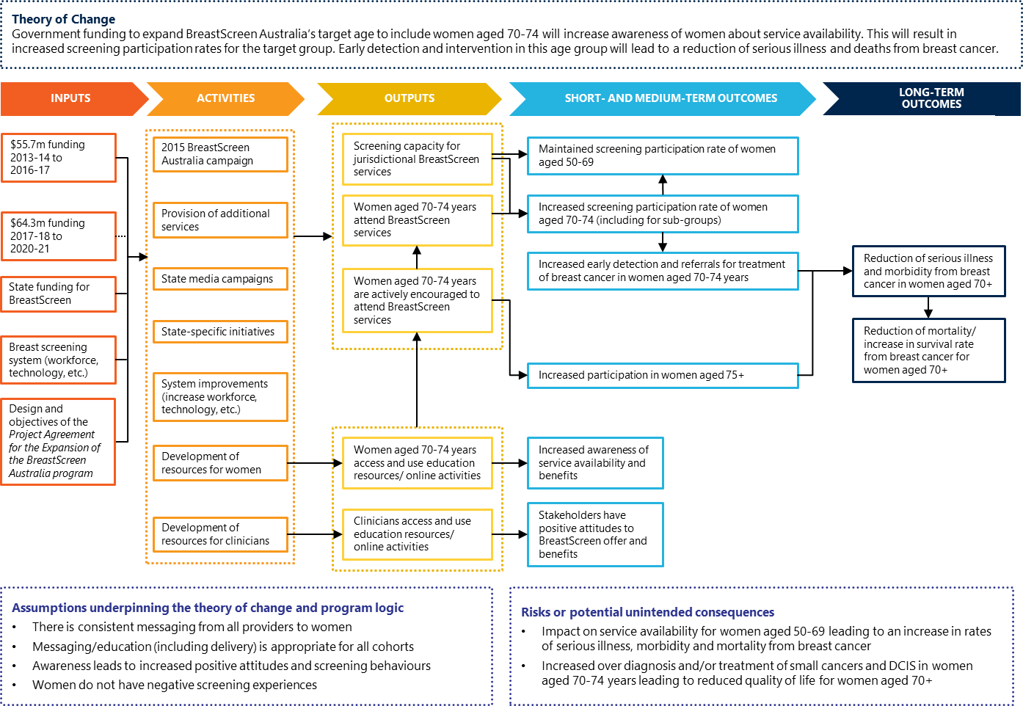

## Ethics approval

Nous understands the importance of ensuring that the highest standards of ethical conduct apply to the evaluation, including arrangements to protect the privacy of women being consulted and the importance of designing questions that do not cause distress for a priority client group.

The evaluation obtained ethics approval through the Australian Institute of Health and Welfare Human Research Ethics Committee in October 2018 for the duration of the evaluation.

Nous ensured the design and implementation of the evaluation was consistent with National Health and Medical Research Council (NHMRC) advice and the ethical requirements for evaluation specified in the *Guidelines for the Ethical Conduct of Evaluations* published by the Australasian Evaluation Society (2000).

## Key questions guiding the evaluation

Three key lines of enquiry (KLEs) guided and structured evaluation activities. These have been mapped to the elements of the Program logic, as shown in Figure 3 below.

Figure 3 | Alignment of the Program logic and KLEs

Flow chart describing how the three key lines of enquiry fit into the program logic. The three key lines of enquiry are as follows:
1) How effective have the implementation processes and activities supporting the expansion been?
2) How effective has the program expansion been in increasing screening participation rates of women in the age group 70-74 years, and what have been the key barriers and enablers?
3) What opportunities are there to improve or strengthen the participation in screening of women in the age group 70 to 74 years?

Each KLE was supported by a series of research, and detailed sub-research, questions. The KLEs and associated research questions, and high-level data collection methods are provided in Appendix A. Data collection methods are detailed further in the following sections.

## Desktop research

The evaluation was informed by desktop research throughout the project. This included:

* a domestic component which aimed to:
  + confirm the stakeholder landscape
  + confirm relevant health policy or system settings; and
  + understand the current state nationally and across all jurisdictions.
* an International Comparator Review (ICR) component which aimed to:
  + identify comparable international programs, drawing out the similarities and differences
  + identify valuable learnings from these comparable international programs; and
  + assess applicability of comparable international programs within an Australian context.

The domestic research and ICR were informed by peer-reviewed, grey and media data sources, outlined in Table 2.

Table 2 | Types of sources for desktop research

| Type of source | Description |
| --- | --- |
| Peer-reviewed literature | Peer-reviewed sources have been assessed for quality and importance by experts in the field. For example, articles published in academic journals, by professional scholarly societies, professional associations or university departments. |
| Grey literature | Grey literature sources are documents produced at all levels of government, academia, business and industry who are considered authorities on their content, however, are not controlled by commercial publishers. For example, reports, conferencing proceedings, doctoral theses/dissertations, newsletters, technical notes, working papers and white papers. |
| Media data | Media data sources are articles published in print and online newspapers, magazines, and other forms of media (accessed online). |

The ICR targeted ten countries, with a primary focus on Europe and New Zealand, and kept abreast of any emerging programs throughout the course of the evaluation. Countries were selected for the ICR from a list provided by the Department as a part of the 2009 evaluation and have been amended to include other countries that undertake screening of a similar population and remove countries that do not screen women aged 70–74 (e.g., Norway). Feedback from program managers and Technical Reference Group members also contributed to the final inclusion list as follows:

* Canada
* Denmark
* England
* France
* Ireland
* Japan
* South Korea
* New Zealand
* Sweden; and
* The Netherlands.

Research analysis was driven by relevant KLEs, research questions, and sub-questions. Following identification of all relevant documents, sources were scanned for key data and prioritised for an in-depth review. A summary of key findings is in Appendix B. The method for prioritising and synthesising findings is described in Figure 4.

Figure 4 | Prioritisation and synthesis of findings

Diagram of an inverted triangle showing the prioritisation and synthesis of findings of the desktop research. The triangle starts broadest at the top with the scope of the search, then narrows as the parameter and inclusion criteria are identified to narrow down the search. The triangle continues to narrow as the assessment criteria are applied and then the analysis is done for key insights. 

## Consultations

The evaluation data collection comprised multiple conversations with key stakeholders.

### An online national survey of BreastScreen Australia Program staff and broad stakeholder groups

A short online survey was distributed to BreastScreen Australia Program managers and administrative and clinical/front-line delivery staff in all jurisdictions, as well as broader stakeholder groups (such as PHNs, Aboriginal Medical Services and a selection of Colleges). The purpose was to gather a broad range of views on the implementation of the Program expansion, including differences between jurisdictions, and to identify themes for investigation. The survey focused on appropriate KLEs, specifically:

* perceived effectiveness of the processes and activities supporting the expansion
* experience of the implementation of the Program expansion
* perceived benefits and challenges of targeted recruitment of 70–74-year-old women; and
* perceived impact on capacity from the Program expansion.

A waterfall approach for survey distribution was used. Jurisdictional program managers were asked to distribute the survey to regional managers and then onto administrative and front-line staff. Limited responses to the survey were received (n = 39 across 5 jurisdictions). Due to the lack of representative responses, Nous was unable to use this data source as a representative tool to inform insights, but rather was considered in conjunction with other qualitative and quantitative information to form insights.

### Consultations with government, program managers and BreastScreen Australia staff

The purpose of these consultations was to analyse the perceived impact, benefits and challenges relating to the active recruitment of women in the 70–74 years age group. Consultations included:

* Interviews with Department and AIHW stakeholders: The interviews provided a macro understanding of implementation, data issues or limitations (with AIHW specifically) and the context of population cancer screening programs. Best practice approaches used across jurisdictions were explored.
* Site visits including face-to-face consultations with BreastScreen staff in each jurisdiction: The consultations explored the perceived impact, benefits and challenges of program expansion (including the effect on service capacity). The differences in implementation across jurisdictions and providers were examined, enabling comparison to participation rates and short-term impacts. The consultation day in each jurisdiction consisted of a mix of interviews with program managers and service providers (both administrative staff and frontline delivery staff/clinicians). Regional and rural providers were invited to join the discussions via teleconference.

### Consultation with current BreastScreen clients and a sample of Australian women aged 70–74 years

The purpose of engaging women was to understand in greater depth the experience, perceived impact, and benefits of program expansion for women in the target age range (70–74 years). The evaluation engaged women using three distinct methods:

1. A survey of a random sample of Australian women aged 70–74 years from the general population. This survey included women who had a history of engagement in the BreastScreen Program and women who did not. This survey was conducted via telephone. Nationally 743 survey responses were received. Of these respondents, 417 women provided qualitative comments to supplement their survey response.
2. A survey of current BreastScreen clients aged 70–74 years. This survey was disseminated by each Program in each jurisdiction via different means aligned with jurisdictional consent requirements and system functionality (e.g., some women were invited by letter, some by email or SMS and some invited via a brochure). Nationally 4,295 survey responses were obtained. Of these respondents, 2,717 women provided qualitative comments to supplement their survey response.
3. Individual interviews with current BreastScreen clients aged 70–74 years. These were conducted via telephone. Most women interviewed chose to participate in an interview after completing the BreastScreen client survey, however there was also a small proportion of women referred directly from jurisdictions. Nationally, 37 women were interviewed.

### Ongoing engagement with program managers, Program Advisory Group meetings, the Department, and key cancer control stakeholders

The evaluation involved continuous engagement with key stakeholders in the BreastScreen Program to ensure the evaluation methodology was best placed to address all elements of the expansion. This included phone calls with the Department every two weeks, and scheduled time for program managers to review draft findings as they became available. Nous provided progress reports and sought advice from the program managers at key points of the project at the bimonthly national Program Manager Group meetings, convened by the Department.

Subsequently, Nous established a Program Advisory Group with representatives from five programs to ensure a more regular line of communication with the Program Manager Group. Nous convened several meetings of the Program Advisory Group to work through feasible methodology and validate analysis and preliminary findings and to contextualise the evaluation insights.

Additionally, representatives from three national cancer organisations (Breast Cancer Network Australia, Cancer Council Australia, and Cancer Australia) were consulted following the evaluation data collection to seek their perspectives on the emerging findings and any additional context.

## Program data analysis

Nous undertook statistical analysis of population and BreastScreen Program data to evaluate implementation effectiveness and program performance. Quantitative analysis added robustness to the evaluation. In addition, it enabled the triangulation of findings against the International Comparator Review and stakeholder engagement, and the data analysis informed areas of interest or issues to explore in consultations.

Following numerous discussions with program managers and the Program Advisory Group, select data points were chosen to conduct the statistical analysis. This included BreastScreen Program data which was supplied annually to the AIHW. This program data formed the basis of the majority of the evaluation’s quantitative analyses. This was further supplemented by National Accreditation Standards (NAS) data reported to the National Qualifications Management Committee (NQMC) annually. The National Accreditation Standards (NAS) require programs to submit performance data, from which two measurement points were used as proxy indicators to understand changes in performance over time.

The analysis highlighted in this report is based on the most up-to-date information. High level participation data is presented from 2007–2018 based on AIHW data. Participation data categorised by key demographic groups from AIHW illustrate the trends from 2011–2018, while all other data points from AIHW illustrate the trends from 2011–2017. Analysis presented based on NAS data illustrates the trends from 2010–2017.

An overview of the datasets collected, cleaned and analysed is outlined in Table 3.

Table 3 | Overview of datasets

| Dataset | Data source | Description | Purpose |
| --- | --- | --- | --- |
| National BreastScreen Australia program data | AIHW | * BreastScreen Australia performance indicators (participation, recall to assessment, invasive breast cancer detection, DCIS detection, cancer incidence) * demographic and geographic data (including remoteness, Aboriginal and Torres Strait Islander and CALD status, and SES for Areas [SEIFA]) | * analysis of program performance, efficiency and effectiveness * sub-group analysis |
| National Accreditation Standards Reports | NQMC database | * indicators of program capacity (rescreening rates and waiting times) | * supplement the AIHW-held data to evaluate change in performance, where necessary |
| Population data | Australian Bureau of Statistics (ABS) | * Population and demographic statistics | * SEIFA Index of Socioeconomic disadvantage, English as another language, and remoteness areas were used to evaluate sub-group analysis * verification of population denominators in national or state and territory metrics |

### National BreastScreen Australia program data

The National BreastScreen Australia program data was used to analyse program performance, efficiency and effectiveness. Table 4 presents the specific indicators used in the analysis.

Table 4 | Indicators collected from national BreastScreen Australia AIHW data

| Supplied by AIHW BreastScreen Program data |
| --- |
| * Study ID * Indigenous status * Main language other than English spoken at home * Date of attendance for screen * Attendance round * Recall to assessment status * State (derived from state/territory who supplied data) * Cancer status (derived from screen-detected cancer status) * Ductal carcinoma in situ (DCIS) flag (derived from screen-detected cancer status) * Age at screen (derived from date of attendance and date of birth using standard AIHW method of calculation) * Year of screen (derived from date of attendance for screen) |

### National Accreditation Standards

The NAS performance data was used to analyse program capacity to perform efficiently following the Program expansion. The following performance metrics were analysed:

* NAS Measure 4.1.1 (a): ≥90 per cent of women aged 50–74 years attend for a screening appointment within 28 calendar days of their booking date (fixed sites only).
  + The per centage of women who attend for a screening appointment within 28 calendar days of their booking date.
* NAS Measure 4.1.2: ≥90 per cent of women have a documented notification of the results of screening within 14 calendar days of the date of screening.
  + The per centage of women who have documented notification of the results of screening within 14 calendar days of the date of screening.

## Limitations

There are a number of limitations inherent in the evaluation methodology. This is in part due to the feasibility of accessing operational data. Information and data on cost-effectiveness were not available to the evaluation. Table 5 outlines the main limitations which must be considered when reviewing the evaluation insights and findings:

Table 5 | Data sources and analysis limitations

|  |  |
| --- | --- |
| Data source | Limitations |
| AIHW National BreastScreen Australia program data | Under the required ethical approval, the AIHW released record-level client data including a number of performance indicators (e.g., cancer detection, recall to assessment, attendance round) and demographics (e.g., postcode, CALD status, Aboriginal and Torres Strait Islander status). The data provided from AIHW was from 2012-2018.  Nous conducted statistical analyses using these datapoints to evaluate changes in participation, and the effectiveness and efficiency of the Program before and after the expansion of program services.  The same datapoints which were released to Nous are also publicly reported in annual monitoring reports published by AIHW. These reports outline similar indicators as to those included in Nous’ analysis. Due to the datapoints available, Nous was limited in providing insights far beyond those already published.  Nous presented the data specifically focussing on the changing trends over time and segregating cohorts to focus on the effects on 70–74-year-old women in comparison to other groups in order to illustrate the data in a different light to that in AIHW monitoring reports. |
| NQMC National Accreditation Standards (NAS) data | Nous coordinated with NQMC to release aggregate performance data which the NQMC collects from each jurisdiction on an annual basis in line with the National Accreditation Standards (NAS). Following approval from BreastScreen Program managers, Nous coordinated with the NQMC to release data from 2012 to 2018. Given Nous received data for half of the year in 2018 rather than 11 months as had been released for other years (due to data availability at time of data request), data in this report is presented from 2012 to 2017.  The data which Nous received was missing several datapoints from services for some years, and there were broad variations in reporting periods. This limited the like-for-like comparison, as the data was too fragmented.  Nous employed predictive modelling techniques, including quasi-Poisson and quasi-binomial regressions, to fill gaps present in the dataset that was received. The methodology for this modelling is explained further in Appendix C.  Consideration should be taken when reviewing this data, as the trends do not consider variations that may have existed. |
| Online national survey of BreastScreen Australia Program staff | Nous conducted an online survey which was distributed to BreastScreen Australia program managers and administrative and clinical/front-line delivery staff in all jurisdictions. A waterfall approach for survey distribution was used. Jurisdictional program managers were asked to distribute the survey to regional managers and then onto administrative and front-line staff.  There were numerous re-distributions of the short online survey, to provide opportunity for staff and stakeholders to provide responses. The required sample size for BreastScreen staff was 208. As a result of heavy workloads, many staff members who wanted to engage with the survey did not have the opportunity to do so—the survey yielded 39 responses across 5 jurisdictions. Due to the lack of representative responses, Nous was unable to use this data source as a representative tool to inform insights, but rather was considered in conjunction with other qualitative and quantitative information to form insights. Perspectives from BreastScreen staff were gathered during the jurisdictions and regional site visits via focus groups and interviews. |
| Online national survey of BreastScreen clients aged 70–74 years | Nous coordinated with each jurisdiction to invite BreastScreen clients aged 70–74 years to participate in a short online survey. Each jurisdiction chose a different approach to distribute invitations to women, including social media posts, letters, SMS, email and brochures.  4,295 women from across Australia responded to the survey. Four jurisdictions met the required sample size goal to draw inferences about the population. All responses were weighted based on the number of BreastScreen clients aged 70–74 in 2017–2018 in each jurisdiction, by remoteness area (Major Cities and Regional/Remote Australia). See Appendix C and Appendix E for further detail.  The survey received 23 responses from women who identify as Aboriginal and/or Torres Strait Islander. Given the small representation from this cohort, inferences were not able to be drawn about the broader population. |
| Telephone survey of women aged 70–74 years | Nous worked with TKW Research Group (TKW) to conduct telephone surveys of a sample of Australian women from the general population. TKW is a data collection agency that provides data collection services within Australia and New Zealand across all field methodologies. The 10-minute phone surveys with women aged over 70 years aimed to explore the awareness, views and experiences of Australian women regarding the BreastScreen expansion.  A random sample of 4,054 Australian women were contacted via phone from existing pre-consented databases and invited to participate in the phone survey (stratified by metropolitan and regional/remote). 743 women engaged in the survey resulting in an 18 per cent response rate. Women were engaged from all states across Australia, with stronger representation from larger states (NSW, Vic, Qld). See Appendix C and Appendix E for further detail.  Women were asked to self-identify if they belong to key demographical groups including; Aboriginal and/or Torres Strait Islander, culturally and linguistically diverse, living in an aged care facility, or currently in the workforce. There was low representation across all key demographical cohorts and therefore insights from these groups could not be generalised to women from these cohorts more broadly. Three women identified as Aboriginal and/or Torres Strait Islanders, 56 women identified as coming from a CALD background, 18 women identified as currently in the workforce, and 25 women identified as currently living in a care facility. |

1. Overview: Program expansion aim and impact on participation rates

## The Program expansion represented a noteworthy change to the target age range for the BreastScreen Australia Program

### The Program expansion added women aged 70–74 years into the target age range

The BreastScreen Program is part of Australia’s Population Based Screening Framework.[14] The Program initially invited women aged 50–69 to have a free two-yearly breast cancer screening, and in 2013–14, the target age range was expanded to include women aged 70–74 years. Women aged 40–49 and 75 or over are also eligible to attend.[15] Between 1996 and 2005 (before the expansion) there was variation in participation by women aged 70–74 years in part due to some state and territory BreastScreen services (namely, Queensland and Tasmania) inviting women in this age bracket to subsequent-round screening by mail.[16] Participation by women aged 70–74 years averaged 52 per cent in jurisdictions where they were invited and 24 per cent where they were not.[17]

### The Program expansion aimed to reduce mortality in women aged 70–74 years, and set participation targets for each jurisdiction

The Program expansion followed a recommendation made in the BreastScreen Program evaluation carried out in 2009 to include this age cohort. The modelled mortality reduction for providing biennial screening for the expanded age group was 12 per cent.[18] Cumulative targets were set for screening women aged 70–74 years in each jurisdiction under the Program Agreement[19] for the initial funding period (2013–14 to 2017–18).

### The Program expansion brings Australia in line with policies in some comparable countries also screening women aged 70–74 years

Background research for this evaluation included an International Comparator Review (completed in 2018) of 10 comparator countries: Canada, England, Denmark, France, Ireland, the Netherlands, New Zealand, Japan, South Korea and Sweden.[20] Of these countries, half screen women aged 70–74 years (Netherlands, Canada, France, Japan, and South Korea). In Canada, the national recommendation for screening is 50–74 years, however the age at which Canadian women are invited to attend screening differs by province. England is currently trialling an extension to their target age to include women over 70 years. This was first announced in 2007 with the trial beginning shortly afterwards whereby women aged between 47–50 and 70–73, within certain regions, are invited to attend.[21] (Moser et al., 2011). New Zealand has recently agreed on a policy to progressively increase the age for free breast-screening to women aged 74 years. A feasibility analysis has been undertaken but no further updates on the expansion are available at this time.[22]

Australian participation rates are lower than many of the comparator countries for all target age groups, including women aged over 70 years. Australia is ranked eighth for participation rates compared to the ten countries in scope, and fifth out of six countries which screen women aged 70 years and over.[23]

### Participation in screening services for specific populations requires support and focus

Participation in breast screening is influenced by income, education level, age, general health or co-morbidities, access to health and screening services, age, residential geography, cultural background, knowledge and/or worry about breast cancer and screening. In March 2018 the Australian Institute of Health and Welfare (AIHW) released a report on cancer in the Aboriginal and Torres Strait Islander population in Australia. Key findings included a higher rate of positive screening, lower rate of survival for breast cancer and 16 per cent lower screening participation for Aboriginal and Torres Strait Islander people.[24]

This evaluation focuses on analysing data and experiences for four target population sub-groups: Aboriginal and Torres Strait Islander women, women who are culturally and linguistically diverse (CALD), women of lower socioeconomic status, and women living in remote areas,[25] aligned with the special groups outlined in the National Accreditation Standards.

Mechanisms to support equity of access is varied and centers on economic and social disadvantage. One paper was identified in the International Comparator Review[26] that described the approach to reducing inequity in breast screening for in-scope countries located in Europe with a significant variation in approaches. These approaches are outlined in Table 6.

Table 6 | Equity of access across ICR countries

| Country | High level approach to equity of access[27] |
| --- | --- |
| Denmark | Provides access to all women and does not include objectives to tackle social inequalities in participation. |
| England | Provides access to all women and the Public Health Outcome Framework of the National Health System has an objective to tackle inequalities in screening: “to improve and protect the nation’s health and wellbeing and improve the health of the poorest fastest.” |
| France | Provides access to all women and has objectives to “inform GPs, physicians and medical staff working in prisons, local and national social organisations, immigrant groups and NGOs’ and ‘to improve accessibility by mobile screening bus.” |
| Ireland | Provides access to all women and has objectives to “‘inform hard to reach’ target populations and to address barriers of specific subgroups to increase accessibility. Some of the initiatives includes; information sessions, community courses and the development of information leaflets in different formats and languages.” |
| Netherlands | Only provides screening to women who are registered in the basic municipal register. However, they have an objective to “regularly test and evaluate education and communication materials among low SES groups.” |
| Sweden | Only provides screening to women with residence permits and has a general objective to invite every woman in the right age group with a residence permit. |

Numerous methods of supporting the participation of vulnerable or minority groups have been identified globally. The international evidence suggests that service delivery is enhanced through consumer involvement in the co-design of health promotion materials and culturally-sensitive processes and environments[28]

Other initiatives identified in the literature across in-scope countries which aim to increase the participation of ethnic minority and Indigenous women include:

* patient navigation[29]
* home visits by lay health advisors[30]
* involving cancer survivors from the community as screening advocates[31]
* group transportation[32]
* language and sign interpreters[33]
* proactively re-booking appointments[34]
* offering appointments outside work hours and on weekends[35]
* a day dedicated to screening priority group women[36]
* community champions[37]
* a joined-up approach with other health services[38]
* fixed sites in high minority population areas[39]
* providing more services managed by members of priority groups[40]
* targeted use of local community groups to promote screening (e.g., church groups).[41]

## The Program expansion was successfully implemented, with participation rates for women aged 70–74 years increasing to be on par with other age cohorts in the target age range

**The Program expansion achieved targets quickly and maintained them; participation of the 70–74 cohort is now broadly consistent with other age groups**

There was a steep increase in the participation of women aged 70–74, from 30.8 per cent in 2012–2013 to 55.8 per cent in 2017–2018 following the expansion of services to that age cohort. Other target age cohorts’ participation rates remained fairly consistent across this period, although the 55–64 year old target group’s participation rate declined slightly by 1–1.5 per cent. Out-of-target age cohorts also remained fairly consistent, with younger cohorts’ (40–49) participation declining slightly. The 75–79 year old cohort’s participation increased from 12.8 per cent in 2012–2013 to 14.5 per cent in 2017–2018. Figure 5 below illustrates these trends over a ten year timeframe to 2017–2018.

Figure 5 | Participation rates for 5-year age groups before and after program expansion – proportion of women participating in BreastScreen over time

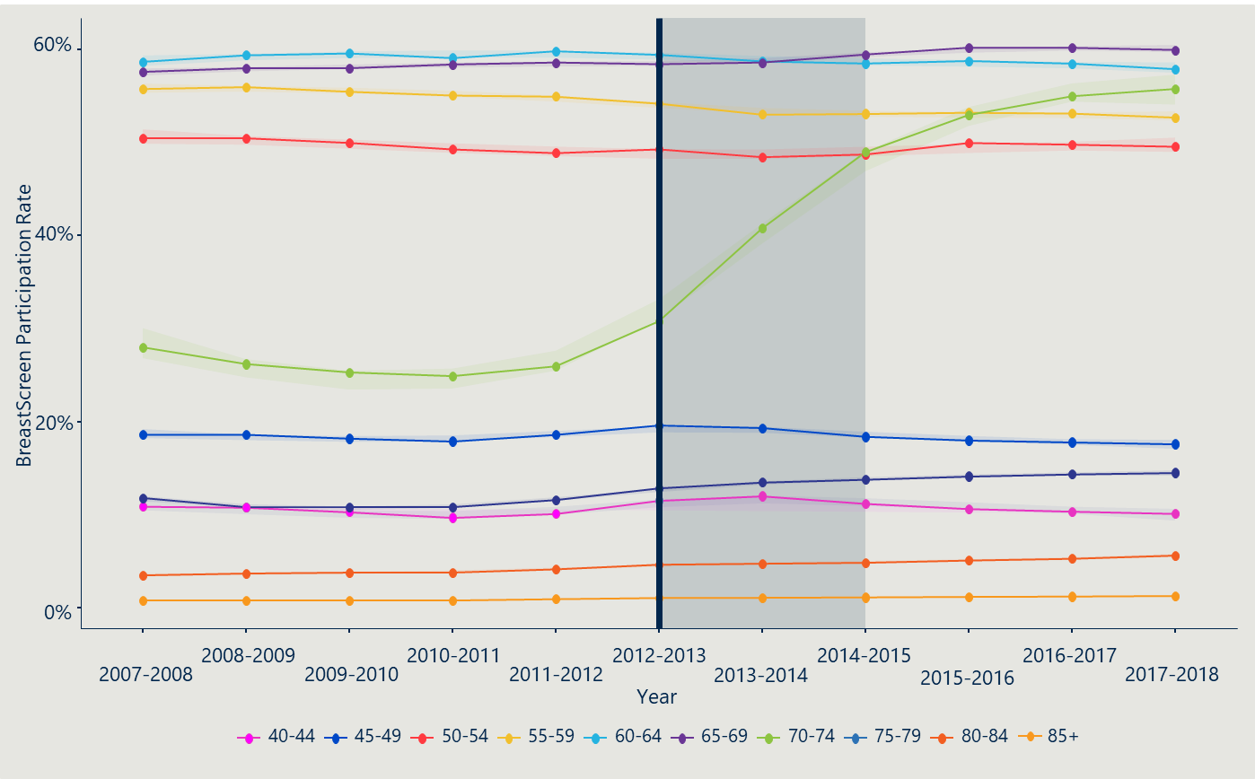

This data largely supports themes that emerged through staff consultations and site visits indicating that participation rates of women aged 70–74 years increased after the Program expansion, while participation in other target age groups has not been affected. Contrary to this trend, one large program reported a decline in participation for women aged 50–69 years in the immediate years after the expansion.

All stakeholders reported participation rates of 70–74 year old women increased since the Program expansion, including in the four priority population groups (e.g., Indigenous, CALD). Many stakeholders also believed the Program expansion did not affect screening rates of other target age cohorts e.g., 50–69 years, with the exception of those in the large program mentioned above. Many stakeholders noted that the Program was finding cancers in women aged 70–74, and this is an important success measure for women and the Program.

Some stakeholders reported that the expansion may ultimately increase participation rates in the 75–79 year old cohort as many women are reluctant to discontinue once they reach the out-of-target age. As shown in Figure 5 above, there has been some increase in the number of 75–79 year old women screening each year since the expansion commenced, from 12.8 per cent in 2012–2013 to 14.5 per cent in 2017–2018.

**The increase in participation rates varied between jurisdictions due to different implementation approaches and contextual factors**

The BreastScreen Program is managed independently in each jurisdiction, so that each program had discretion over when and how to implement the Program expansion. This led to some variation in when and how screening patterns changed for different age groups (particularly women aged 70–74). In some jurisdictions, the expansion was phased in by year – i.e. by first inviting 70 year old women to participation, then 71 year old women and so on. This allowed for resources to adjust gradually to the increased participation. For those jurisdictions who were inviting participation of women aged 70–74 years in some capacity prior to the Program expansion, the transition into the Program expansion was less marked. These differences should be considered when reviewing trends across individual jurisdictions.

Queensland and the Northern Territory in particular experienced quite different trajectories in screening rates before and after Program expansion. In Queensland, reminders were already being sent to women aged 50–74 years before the expansion. The NT program is influenced by geographical and remoteness challenges, a transient and younger population, and nuances in serving a large population of Aboriginal women.

Figure 6 overleaf shows participation rates for 5-year age groups before and after Program expansion by individual jurisdiction.

Figure 6 | Participation rates for 5-year age groups before and after Program expansion – Proportion of 70–74 year old women participating in BreastScreen over time across jurisdictions

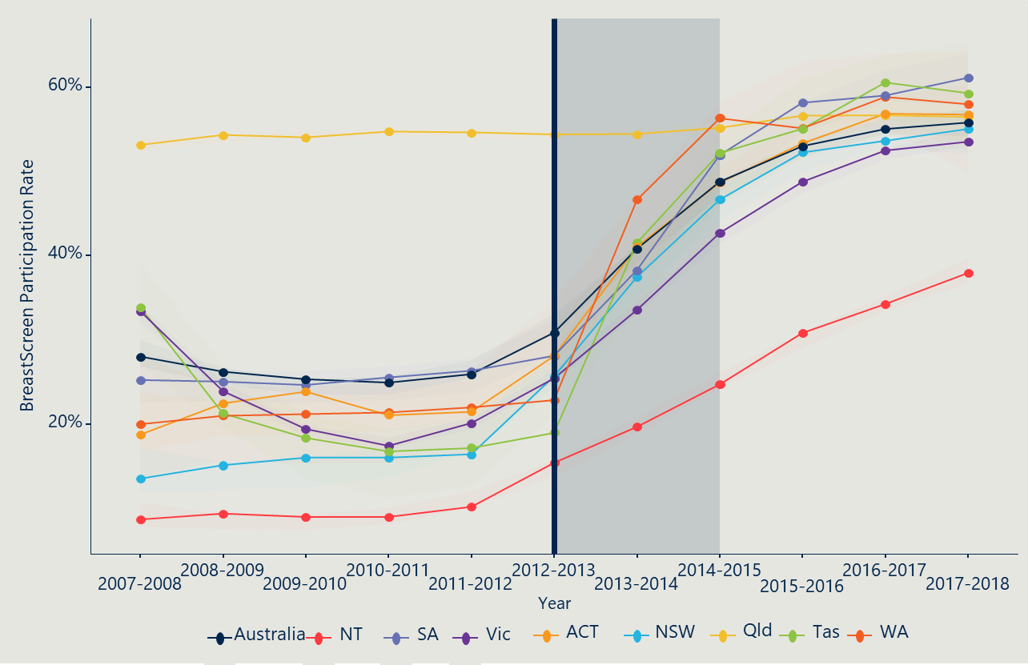

**The expansion impacted priority populations of women aged 70–74 at different rates, highlighting challenges around equity, access, and barriers to screening**

There are four specific populations of particular note for the Program expansion evaluation: women who are Aboriginal or Torres Strait Islanders, of CALD background, who live in high disadvantaged areas, or who live in remote and very remote areas. These populations groups are reported by the programs through the NAS and have targeted recruitment efforts, as they are typically viewed as ‘hard to reach’ populations requiring particular attention to ensure equitable access to the BreastScreen Program.

Each of these four subgroups showed increased participation following the Program expansion. However, there is considerable range and variation within and between jurisdictions, reflecting the different population profiles, geographic regions and screening practices between jurisdictions.

Figure 7 overleaf shows the increase in participation rates nationally for these four sub-groups over time.

Figure 7 | Participation rates for 5-year age groups before and after Program expansion – participation rate for 70–74 year old women living in high disadvantaged areas, those living in remote areas, CALD women, and Indigenous women compared to overall participation over time

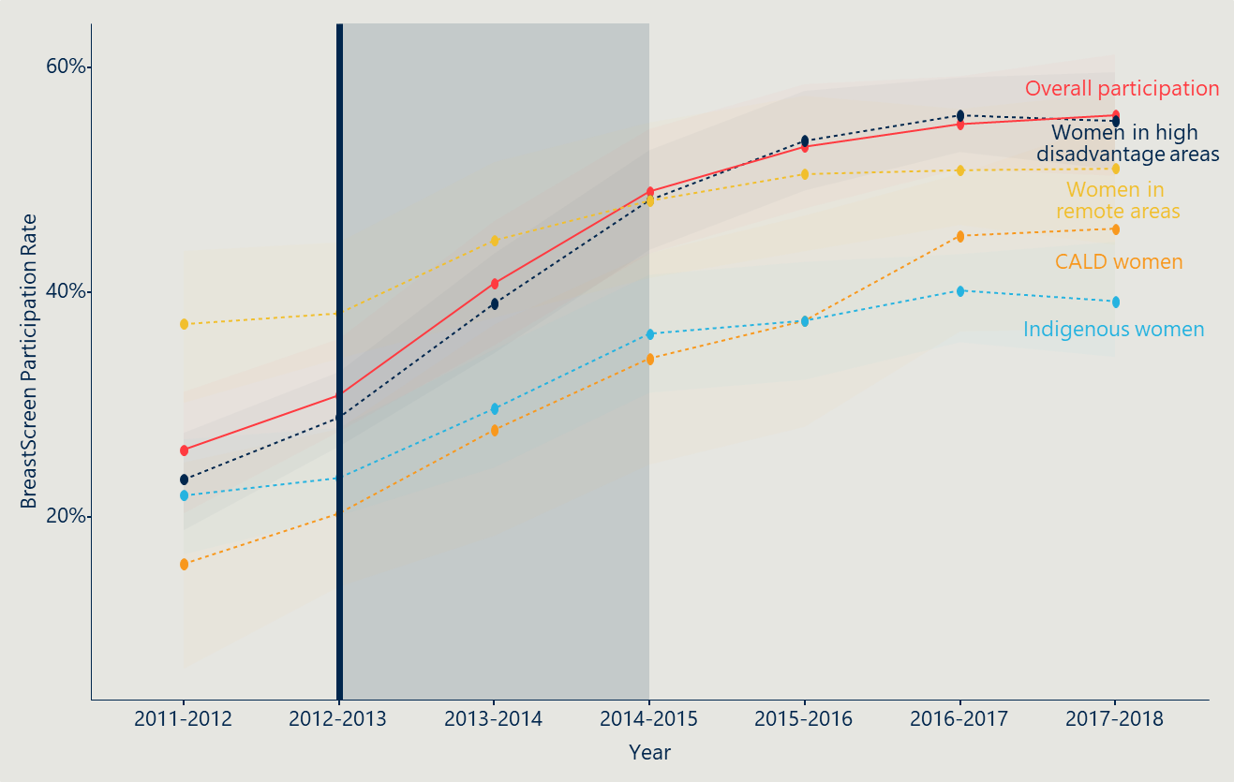

As illustrated, participation by women living in high disadvantaged areas has followed a similar trend to the increase in overall participation for 70–74 year old women before and after the expansion of services (from 28.8 per cent to 55.3 per cent in 2017–2018).

Women aged 70–74 years living in remote and very remote areas saw a 12.7 per centage point increase in participation (from 38.2 per cent in 2012–2013 to 51 per cent in 2017–2018), which is a smaller increase relative to other population groups.

Culturally and linguistically diverse (CALD) 70–74 year old women’s participation saw the highest growth in participation, relative to other population groups, from 20.3 per cent before the expansion of services to 45.6 per cent in 2017–2018.

Indigenous women aged 70–74 years old had the lowest participation rate (39.2 per cent) relative to other population groups as at 2017–2018, although their participation has almost doubled following the expansion of services (from 23.5 per cent to 39.2 per cent).

The following charts show more detail, comparing the participation rates of these sub-groups across all age cohorts. Section 6.5 discusses potential barriers and enablers for participation for all women and each target population that were raised through consultations.

### Indigenous women

As illustrated in Figure 8 below, participation for Indigenous women aged 70–74 years rose steadily during the two-year period following the expansion of services (from 23.5 per cent to 36.3 per cent) but has since seen lower rates of growth. All other cohorts have simultaneously experienced increases in participation rates during this period until 2017–2018. Over the last year reported, there has been a decrease in participation across all target cohorts with a 3–4 per centage points for 50–69 year old cohorts, and a slight (1 per centage point decrease) drop for the 70–74 year old cohort.

Figure 8 | Participation rates for 5-year age groups before and after Program expansion – proportion of Indigenous women participating in BreastScreen over time

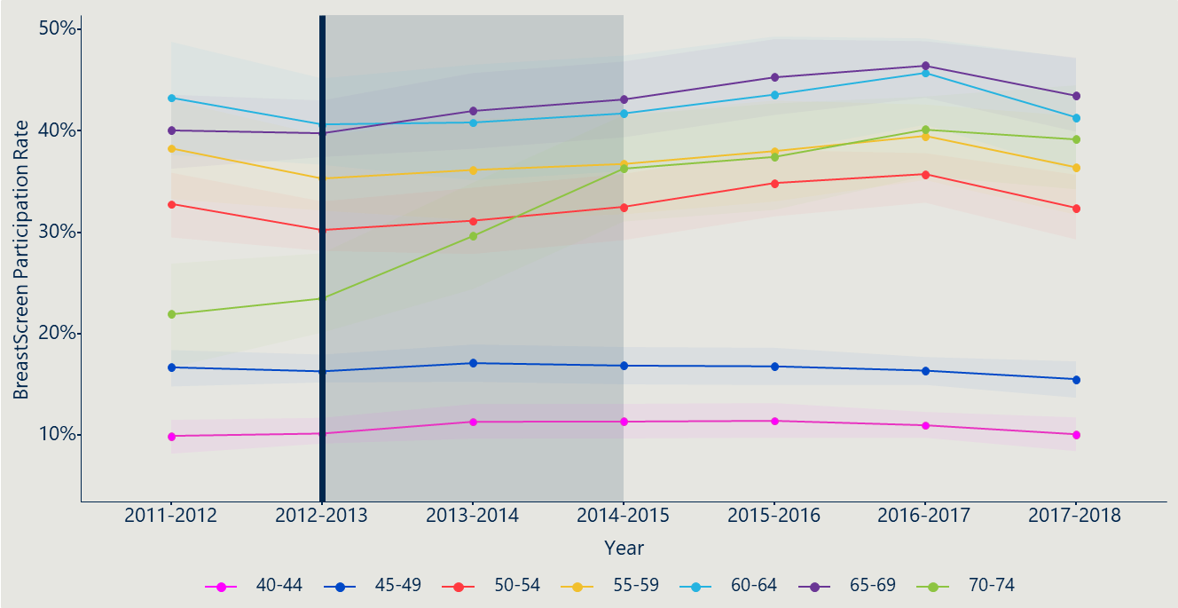

### Women with CALD backgrounds

The participation of 70–74-year-old CALD women increased from 20.3 per cent before the expansion of services to 45.6 per cent in 2017–2018, as illustrated in Figure 9 below. Participation of 55–64-year-old CALD women dropped by around 4.5–5 per centage points from 2015–2016 to 2016–2017, falling below 70–74-year-old participation at the time. From 2015–2016 to 2016–2017, there was a decline in participation across the whole target group, except for women 70–74 years old. As of 2017–2018, this had normalised to show similar trends across the target age group.

Participation across jurisdictions varied, with some jurisdictions noting the slow uptake in CALD communities. This is particularly due to the nature of building trust and disseminating the new information within these communities, which some jurisdictions mentioned was an ongoing challenge. To spread the news of the expansion in these communities, jurisdictions needed to re-develop marketing material in multiple languages, which took some time to enact.

Figure 9 | Participation rates for 5-year age groups before and after Program expansion – proportion of CALD women participating in BreastScreen over time[42]

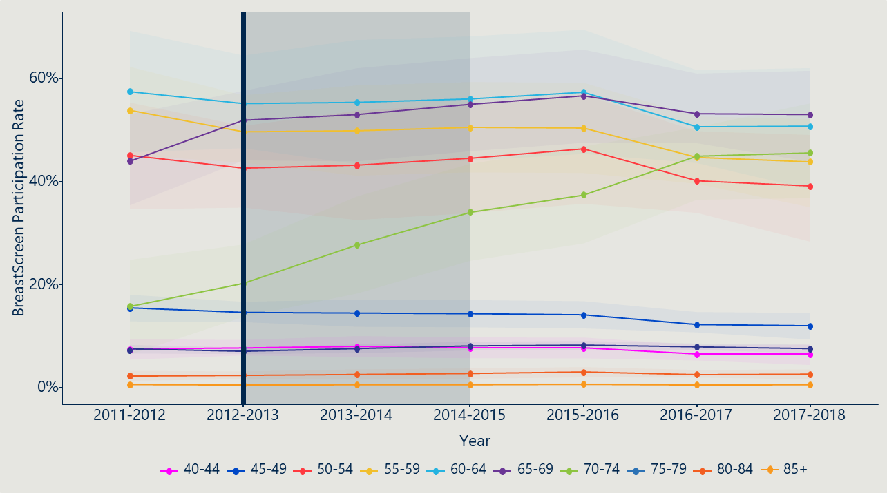

### Women in regional and remote areas

Participation for 70–74-year-old women in remote and very remote areas increased by 12.7 per centage points before and after Program expansion, as illustrated in Figure 10 below. During the same period, participation for 60–64 year old women in remote and very remote areas decreased by around 5.2 per centage points.

Figure 10 | Participation rates for 5-year age groups before and after Program expansion – proportion of women in remote areas participating in BreastScreen over time[43]

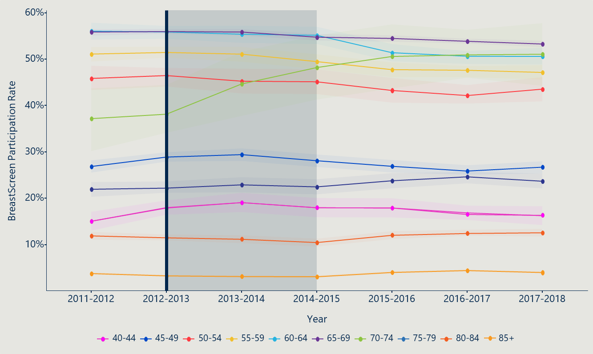

### Women in socioeconomically disadvantaged areas

Participation for 70–74-year-old women in high disadvantaged areas (associated with low socioeconomic status) rose significantly by 31.9 per centage points between 2011–2012 and 2017–2018, as illustrated in Figure 11 below. Participation remained relatively constant for other cohorts, with participation for women aged 75–79 years in high disadvantaged areas increasing slightly by 2.7 per centage points.

Simultaneously, participation for 70–74-year-old women from low disadvantaged areas (associated with high socioeconomic status) rose significantly by 28.9 per centage points between 2011–2012 and 2017–2018. Participation for 70–74-year-old women from middle class areas (3rd decile on the socioeconomic disadvantage scale) rose by 27.9 per centage points. This indicates that efforts to encourage women across low socioeconomic areas to participate were successful, while efforts in high socioeconomic and middle class areas had less success.

Figure 11 | Participation rates for 5-year age groups before and after Program expansion – proportion of women in high disadvantaged areas participating in BreastScreen over time[44]

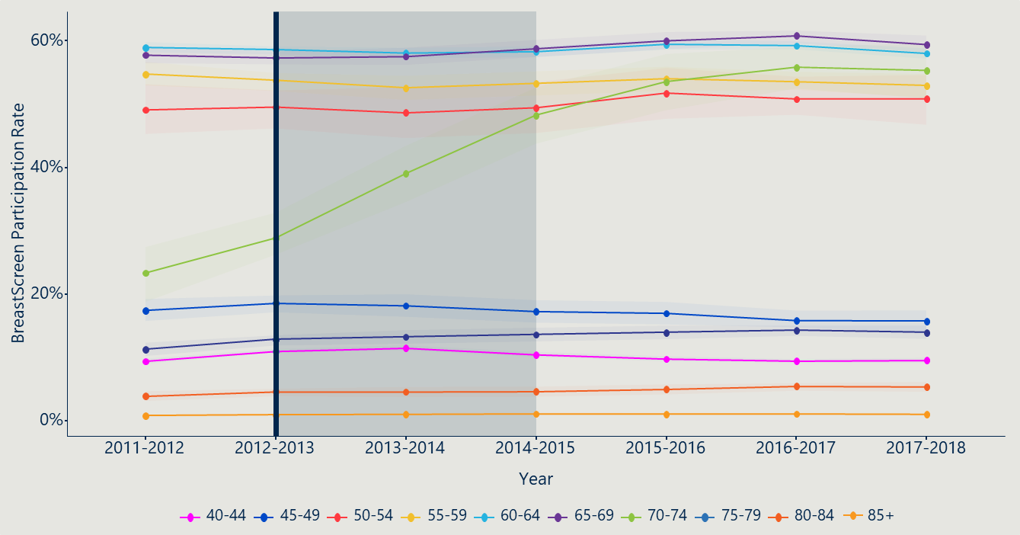

## The increase in participation for women aged 70–74 years has resulted in a logical increase in the number of invasive and DCIS cancers detected for women 70–74-years-old

The number of invasive cancers and DCIS detected for women 70–74 years old nationwide has increased in both first and subsequent screens following the expansion of Program services. This reflects the increase in participation. Figure 12 below and Figure 13 overleaf show the changes in invasive cancer and DCIS detections over time. While the absolute numbers have increased, the proportion of invasive cancers detected per 10,000 women screened has remained steady, with a slight decrease across first and subsequent screeners. The rate of DCIS detected per 10,000 women screened for their first time has remained constant and low. See the Appendix F for charts showing more detail for cancer and DCIS detection.

Jurisdictions highlighted that digital mammography was first introduced from 2009 and implementation occurred over a number of years through to 2014–15, with some jurisdictions still transitioning. As such, variations in cancer and DCIS detections over the 2012–2013 period may be influenced by the transition to digital mammography, the Program expansion and a number of other contextual complexities of the BreastScreen Program.

Figure 12 | Cancers detected over time for 70–74 year old women: Number and rate of invasive cancers detected per 10,000 women screened by screening round (first screen, subsequent screen)

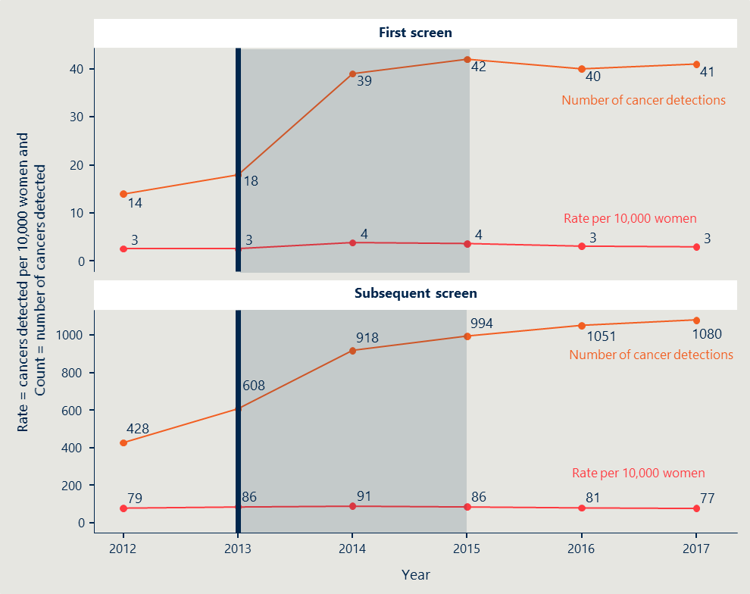

In the graph, the orange line refers to the number of DCIS flags for 70–74 year old women. The red line refers to the rate of DCIS flags per 10,000 70–74 year old women screened. The vertical line at 2013 represents the Program expansion policy implementation start date, and the grey area shows an indicative two-year transition period. Graphs have different scales.

The number of cancers detected for women 70–74 years old nationwide has increased in both first and subsequent screens following the expansion of Program services.

The rate of cancers detected per 10,000 women screened illustrates that while the absolute number may have increased, the proportion of cancers detected based on participants in the Program has remained fairly steady, with a slight decrease across first and subsequent screeners.

Figure 13 | DCIS detection over time for 70–74 year old women; Number and rate of DCIS detection per 10,000 70–74 year old women screened by screening round (first screen, subsequent screen)

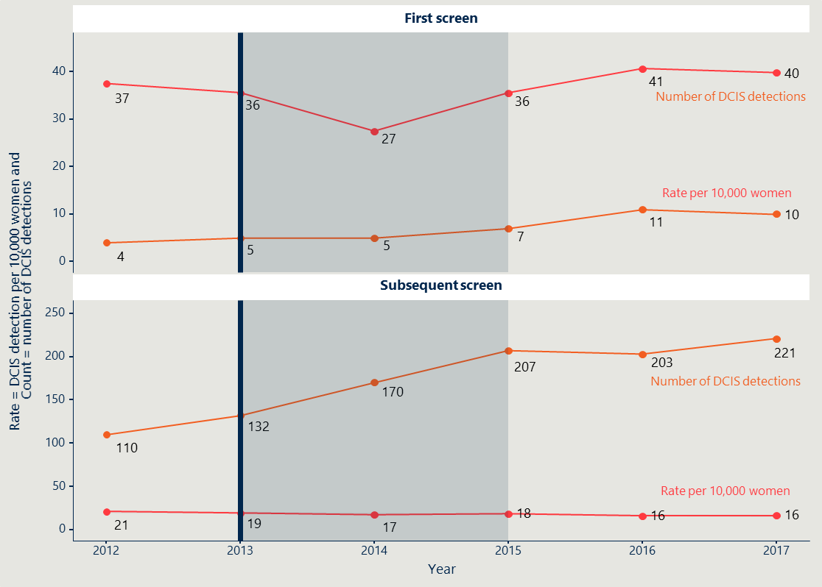

In the graph, the orange line refers to the number of DCIS flags for 70–74 year old women. The red line refers to the rate of DCIS flags per 10,000 70–74 year old women screened. The vertical line at 2013 represents the Program expansion policy implementation start date, and the grey area shows an indicative two-year transition period. Graphs have different scales.

The number of DCIS detections for women 70–74 years old nationwide has increased in both first and subsequent screens following the expansion of program services.

The rate of DCIS detected per 10,000 women screened for their first time has remained constant and low. The rate for 70–74 year old subsequent screeners has decreased over the same period but has remained fairly constant following the expansion of program services.

## Engagement with BreastScreen increased for women aged 70–74 years after expansion, with minimal lasting impact on other target cohorts

All stakeholders reported participation rates of women aged 70–74 years increased following the Program expansion, including in the identified priority groups. Attendance rounds can serve as a proxy for investigating the extent to which this increased participation stems from participants already engaged in the Program (having screened at least 10 times or almost all screens from ages 50–69 during the previous target age group eligibility). It can also be used to look at whether participants who had attended fewer screens (3–5 screens) or did not previously engage (first or second screeners) were drawn to the Program following the expansion. This could represent a positive outcome of the expansion, and a reflection of successful marketing campaign efforts.

Following the expansion, the proportion of women who had been screened every two years (10+ screens) is demonstrated in Figure 14.

Figure 14 | 70–74-year-old women’s engagement with BreastScreen over time

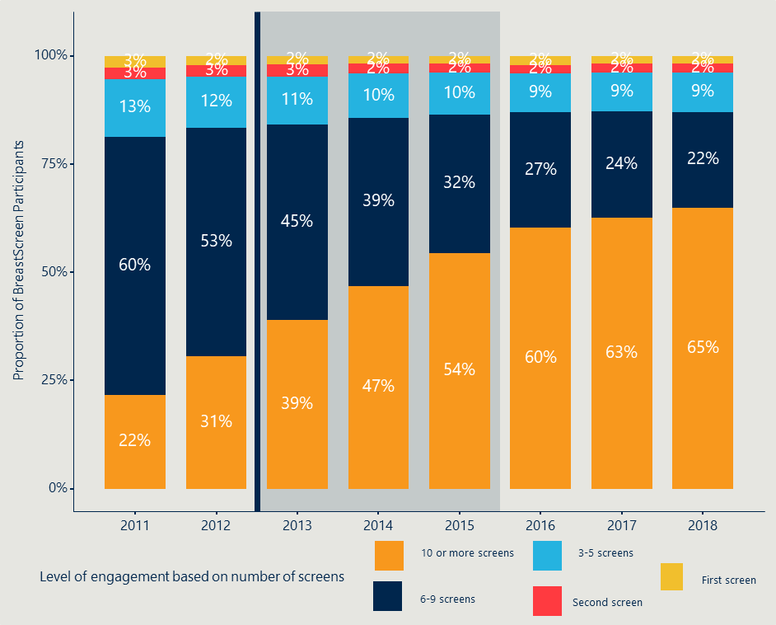

The proportion of 70–74-year-old women participating in the Program who had previously attended 10 or more screens (effectively all invited screens based on a two-yearly invitation) increased between 2011 – 2018 (from 22 per cent to 65 per cent). This highly engaged group became the highest proportion of screeners over this period. This may be due to the additional screening rounds which took place during the 70–74-year-old period, and therefore reflects participants who had consistently attended before the age of 70, continuing to be engaged with the BreastScreen Program. The proportion of participants in this category increased by seven to eight per centage points each year during the transition period (2013–2015). The increase may be associated with a positive reaction to the expansion by women already highly engaged with the Program and seamlessly transitioning into ongoing screens while aged 70–74 years.

There was a slight increase (from 2.4 per cent to 3.4 per cent) in the proportion of second time screeners immediately following the Program expansion announcement in 2013. This represents just over 300 70–74-year-old additional women engaging with the BreastScreen Program for their second screen. This initial increase following the expansion may reflect a positive reaction by the public to the Program expansion marketing campaigns.

## Invitations and reminders are integral to supporting participation of women aged 70–74 years

Analysis of the results of the two surveys of women conducted for the evaluation showed clearly that participation rates for the expansion were strongly influenced by reminders and invitations sent by the BreastScreen Programs. The method for the two surveys are described in detail in Section 2.7.

The key learnings from these two survey consultations include:

* Over 88 per cent of survey respondents among existing BreastScreen clients aged 70–74 and 45 per cent of women aged 70 and over in the general population surveyed have attended a BreastScreen since turning 70
* Most (87 per cent) of survey respondents among existing BreastScreen clients aged 70–74 and 41 per cent of women aged 70+ surveyed from the general population reported they received an invitation letter/reminder since turning 70.

These key insights and broader insights from the two surveys are explored further below and in Section 6. Information gathered from all survey questions are included in Appendix D and Appendix E.

### Over 88 per cent of survey respondents among existing BreastScreen clients aged 70–74 and 45 per cent of women aged 70 and over in the general population surveyed have attended a BreastScreen since turning 70

The BreastScreen client survey engaged 4,035 responses from women across Australia, from both major cities and regional/remote areas.[45] The majority of existing BreastScreen clients surveyed (88 per cent overall) reported they had attended a BreastScreen since turning 70 – this is broken down further by remoteness area (major city and regional/remote areas) in Figure 15 below.

Figure 15 | Proportion of existing BreastScreen clients aged 70–74 years surveyed who attended a screening at BreastScreen since turning 70, by remoteness area[46]

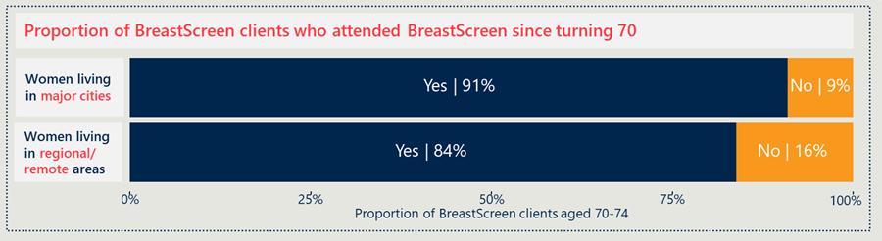  
Source: BreastScreen Client Survey (n = 4,295). Proportions calculated based on weighting of number of BreastScreen clients aged 70–74 in 2017/18 by remoteness area.

Less than half of women aged 70+ in the general population surveyed (45 per cent) chose to attend a BreastScreen since turning 70. As illustrated in Figure 16 below, this is consistent across women living in major cities, and regional/remote areas. This is somewhat expected given the national participation rate for Australia for women aged 70–74 years was 55.8 per cent in 2017–2018 (see Figure 5).

Figure 16 | Proportion of women aged 70+ years in the general population surveyed who attended a screening at BreastScreen since turning 70, categorised by remoteness area[47]

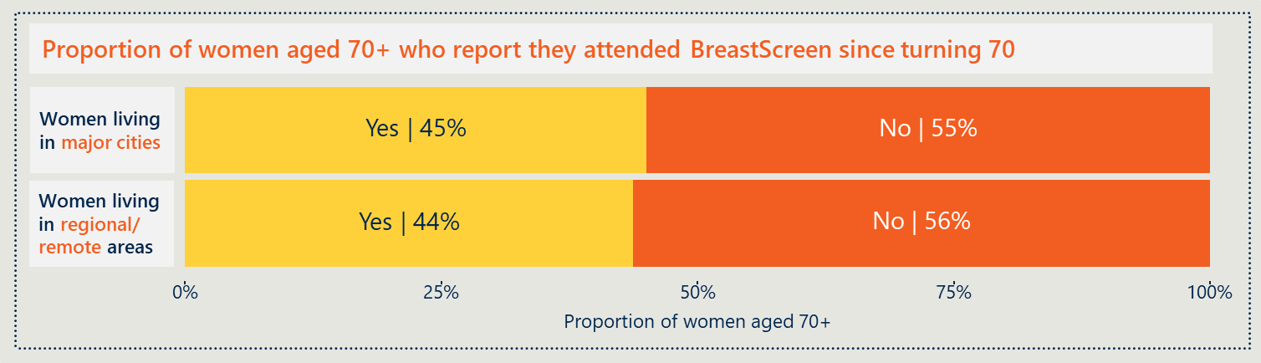  
Source: Phone Survey to women aged 70+ (n = 743). Proportions calculated based on weighting of population of women aged 70+ in metro/remote areas in 2017.

### Most (87 per cent) of survey respondents among existing BreastScreen clients aged 70–74 and 41 per cent of women aged 70+ surveyed from the general population reported they received an invitation letter/reminder since turning 70

The majority of BreastScreen clients surveyed (89 per cent of women in major cities, and 82 per cent of women in regional/remote areas) reported they received an invitation to attend a free breast screen since turning 70. This aligns with the high number of clients noting this as the main reason for attending (see Section 0) and consequently the number of women who reported they attended (Figure 15).

Figure 17 | BreastScreen clients aged 70–74 years who received an invitation to participate over the age of 70

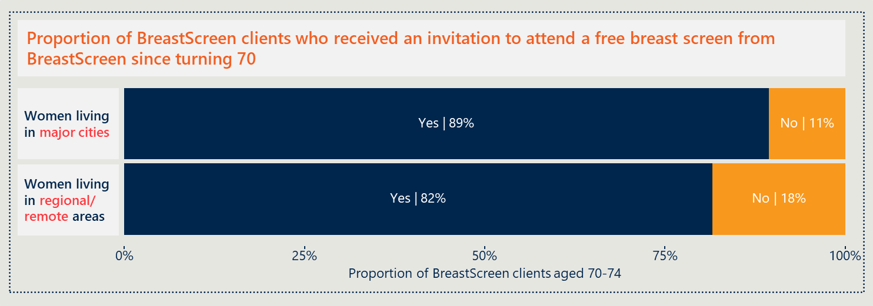  
Source: BreastScreen Client Survey (n = 4,295). Proportions calculated based on weighting of number of BreastScreen clients aged 70–74 in 2017/18 by remoteness area (Major Cities and Regional/Remote).

Women aged 70+ surveyed in the general population were asked whether they have ever received an invitation from BreastScreen to participate. Most women had received an invitation in the past (71 per cent of women in major cities, and 77 per cent of women in regional/remote areas). Women were then asked whether they received an invitation since turning 70. As illustrated in the bottom graph in Figure 18 below, this reduces the number of women by around 30 per centage points, with only 41 per cent of women receiving an invitation since turning 70.

Figure 18 | Women aged 70+ surveyed in the general population who received an invitation to participate before turning 70, and those who received an invitation since turning 70

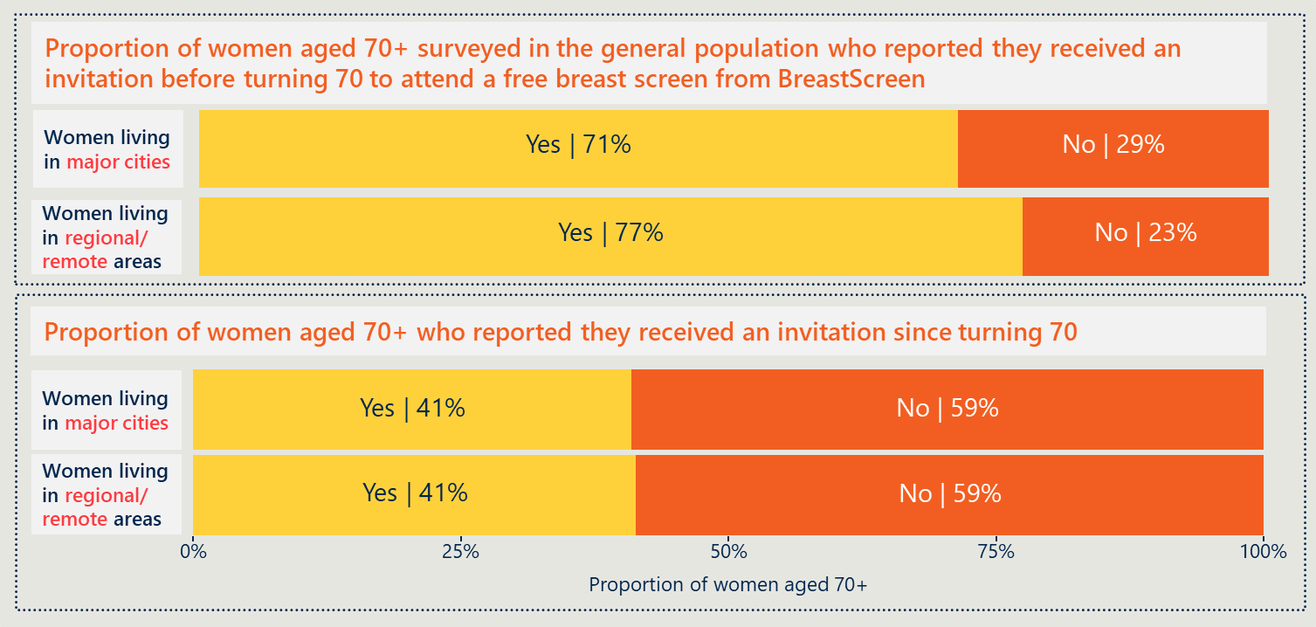  
Source: Phone Survey to women aged 70+ (n = 743). Proportions calculated based on weighting of population of women aged 70+ in metro/remote areas in 2017.

## Conclusion

Findings presented in Section 3 related to the impact of the program expansion on participation rates are summarised below.

|  |
| --- |
| SECTION 3 | Program expansion impact on participation rates |
| * The Program expansion represented a noteworthy change to the target age range for the BreastScreen Australia Program |
| * The Program expansion was successfully implemented by programs, with participation rates for women aged 70–74 years increasing to be on par with other age cohorts in the target age range |
| * By 2018, the Program saw an increase of almost 200,000 women aged 70–74 years screened following the program expansion (2011–12). The number of women aged 70–74 years screened increased from 97,957 in 2011–12 to 280,351 in 2017–18 (see Appendix F for further detail) |
| * The increase in participation for women aged 70–74 years has resulted in a logical increase in the number of invasive and DCIS cancers detected for women 70–74 years old |
| * By 2018, the Program saw an additional 700 invasive cancers and 110 DCIS cancers detected early for women aged 70–74 years following the program expansion (2011–12). Between 2011–12 to 2017–18, the number of invasive cancers detected for women 70–74 year old increased from 432 to 1,121 and the number of DCIS cancers detected increased from 147 to 261 |
| * Engagement with BreastScreen increased for women aged 70–74 years after expansion, with minimal lasting impact on other target cohorts |
| * Invitations and reminders are integral to supporting participation of women aged 70–74 years. |

The findings presented in this section support the following recommendations:

|  |  |  |
| --- | --- | --- |
| RECOMMENDATION |  | RELEVANT SECTIONS |
| 3 At the program level, continued efforts to overcome barriers to participation, particularly for priority groups, and a focus on clear messages by key workforce roles will improve program effectiveness |  | SECTION 3.2 |

1. Program expansion design and implementation

## The expansion design was facilitated through two specific Project Agreements

The Program expansion was facilitated by two four-year Project Agreements, which provided funding for the expansion and included screening targets. The initial design of the Program expansion was outlined in an initial Project Agreement (PA1) from 2013–2017,[48] which was updated in a second Project Agreement (PA2) from 2017–2021.[49]

The outputs specified in PA1 were:

* provision of breast screen services for women aged 70–74 years in line with national policy and accreditation standards
* improved capacity to support BreastScreen activities, and
* delivery of a targeted national communications strategy for women and health professionals.[50]

In PA2 the outputs were updated to replace the mention of the national communications strategy with recruitment activities in general, including activities targeting under-screened groups such as Aboriginal and Torres Strait Islander women, CALD women and women in remote areas.[51]

This change reflects a shift of focus from broadly increasing participation through marketing and communications for 70–74-year-old women, towards refinement approaches and strategies to increase participation across priority groups. In response to this heightened approach to priority groups, multiple jurisdictions highlighted specific initiatives which they implemented to encourage increases in participation for women across priority groups. This included translated materials for CALD populations, and community trust-building exercises with elders in Aboriginal communities.

### The Program expansion design included a national advertising and awareness campaign for women aged 70–74 years

The national awareness campaign released nationwide messaging regarding the expansion of the Program to include women age 70–74 years across radio, television, and newspapers. Further advertisements were released by multiple jurisdictions, resulting in duplicated campaign efforts. Some jurisdictions reported that messages were at times duplicated in the same medium, resulting in negative public feedback noting a perceived frivolous use of resources. Many jurisdictions highlighted the lack of consultation between the national Program efforts and jurisdictions which overlooked alignment of the national and local campaigns for timing and consistency of messaging. This suggests an area for improvement in the future.

Both national and jurisdictional marketing campaigns were implemented directly following the Program expansion announcement (as discussed further in Section 4.4). As the participation graphs illustrated earlier (Figure 5), participation rates spiked during the transition period (2013 – 2015), which implies the communication strategy contributed to a successful implementation as it resulted in additional women aged 70–74 years old being screened.

## Expansion funding was critical and necessary to implement the expansion

The Program expansion was supported by initial Commonwealth funding of $55.7 million over four years, from 2013–17. A further commitment of $64.3 million was made in PA2 to continue funding the expansion to June 2021.

### The Program expansion included funding to deliver more screens and capital to invest in screening services’ capacity or capability

Program stakeholders indicated that the capital investment was a critical enabler to implement the expansion. As part of PA1, each jurisdiction was allocated $500,000 to “undertake system improvements and capacity building required to support BreastScreen Australia services, registries, accreditation and reporting functions.”[52] This injection of funds was distributed during the first PA1 reporting period to provide support for changes to implement the expansion.

Program stakeholders welcomed the expansion funding. The expansion funding was used by jurisdictions to ensure appropriate staff capacity and resources to accommodate the increase in participation. Many stakeholders, particularly Program managers, indicated the expansion would not have been possible without the funding to address required capital expenditure, resources and capacity to deliver services under the Project Agreements.

“The initial funding was welcomed, necessary and required to meet our targets.”

Funding was used to hire radiologists and nurses, invest in more infrastructure, expand services through additional service centres and mobile screening centres. Program managers and BreastScreen staff noted that the funding was critical to the Program expansion success.

The duration of the funding (four-year cycles) allowed a period of stability and operational certainty. Should a third project agreement be entered into to support future delivery of the Program to women aged 70–74, a four-year funding agreement would be preferable to shorter cycles to minimise disruption to the service for staff and women.

### Programs appreciated the level of specificity of Program expansion funding

All stakeholders appreciated that the expansion funding was transparently earmarked through the use of a Project Agreement – effectively providing a separate ‘line item’ for the Program expansion, rather than being rolled up into the broader National Health Reform Agreement. Programs found the earmarking of separate funding very helpful for better understanding the relationship and expectations between funding and performance benchmarks.

The separate earmarking of the funding allowed for effective program planning, including forethought for securing workforce contracts, and clarity on the intended purpose of the funding. The performance benchmarks made it clear that this funding was to be associated with increasing participation for a specific target cohort. The earmarking also provided clarity on the funding bodies’ contributions to the expansion, highlighting the relative priorities and expectations of both the Commonwealth and the state. With this knowledge, jurisdictions were able to strategically plan to respond to these expectations more effectively.

### Funding uncertainty has led to operational difficulties, including guaranteeing and sustaining key personnel resources

Funding to support screening women aged 70–74 years is limited to the ‘life’ of the project agreements i.e. until June 2021. The uncertainty of continued funding for 70–74-year-old women can be operationally problematic. All stakeholders noted the current funding notification periods do not provide enough lead time to operationally plan and creates operational risk, and the uncertainty about ongoing funding adds to concerns. This has an adverse impact on resourcing necessary roles supported through the expansion funds for service delivery. Staff with contracts are expecting renewals, and managers require confirmation for critical positions to ensure the required resources are available, at a minimum of six months in advance to plan their budget and enable future planning for recruitment if needed.

## Funding was subject to the achievement of performance benchmarks

The project agreements provided funding for each jurisdiction subject to specific targets for screening women aged 70–74 years in each jurisdiction.

### The PA1 performance requirement was met nationally

PA1 included performance benchmarks for the number of additional women aged 70–74 years to be screened, above the AIHW reported baseline for 2011 and 2012, for each year of PA1 (between 2013 and 2017).[53] These benchmarks were specified for each jurisdiction against an initial, national annual baseline of 48,974 women screened, and calculated at a pro-rata rate for the length of the reporting period. For example, as illustrated in Table 7, the first reporting period for PA1 was from 1 Jul 2013 to 30 Apr 2014 which represented 83 per cent of a full year, therefore the baseline for that reporting period is 83 per cent of the annual baseline (i.e. 40,810 women screened). The final PA1 reporting period was 6 months – 1 January 2017 to 30 June 2017 – therefore the baseline for that reporting period was half the annual baseline, which equated to 24,487 women screened. The cumulative, national performance benchmark total of additional women aged 70–74 years to be screened by 30 June 2017 was 222,633. The overall national performance requirement, including baseline and additional women to be screened by June 2017, was 418,529 women in the 70–74 age group.

Within this total performance requirement, each jurisdiction had its own specific baseline and a graduated performance benchmark for additional women screened for each reporting period.[54] As outlined in Table 7 below, all jurisdictions met their specified performance target in the first reporting period from 1 July 2013 to 30 April 2014. Performance varied across the remaining reporting periods, with some jurisdictions meeting and exceeding the performance requirement while others did not. While some jurisdictions did not meet the performance requirement in a given reporting period, overall the national cumulative performance requirement of 418,000 was exceeded by 44,117 women, with 462,646 women aged 70 to 74 screened between 1 July 2013 and 30 June 2017 (see Table 7).

Table 7 | National performance requirements for Project Agreement 1

|  |  |  |  |  |  |
| --- | --- | --- | --- | --- | --- |
|  | BASELINE: Annual baseline* (pro–rata based on reporting period length) | PERFORMANCE BENCHMARK: Target– additional women screened | PERFORMANCE REQUIREMENT:  Total number of women to be screened (baseline + target additional women) | ACTUAL PERFORMANCE: Total number of women screened | MET PERFORMANCE REQUIREMENT: Summary of jurisdictions that met or exceeded their respective performance requirement in each reporting period |
| 1 Jul  2013 –  30 Apr  2014 | 40,810  *cumulative* | 7,917  ***7,917*** | 48,727  ***48,727*** | 71,189  ***71,189*** | 8 out of 8 jurisdictions exceeded their respective performance requirement,  3 jurisdictions exceeded the requirement by ~50% and 2 jurisdictions screened more than doubled the requirement |
| 1 May  2014 –  31 Dec 2014 | 32,651  *cumulative* | 35,599  ***43,516*** | 68,250  ***116,977*** | 75,130  ***146,319*** | 6 out of 8 jurisdictions met their performance requirement. 2 jurisdictions doubled their requirement. 7 out of 8 jurisdictions met their cumulative performance requirement (i.e. a jurisdiction exceeded their requirement in the first reporting period) |
| 1 Jan 2015 – 31 Dec 2015 | 48,974  *cumulative* | 66,983  ***110,499*** | 115,957  ***232,934*** | 115,302  ***261,621*** | 3 out of 8 jurisdictions met and exceeded their performance requirement. 5 out of 8 jurisdictions met their cumulative performance requirement. |
| 1 Jan 2016 – 31 Dec 2016 | 48,974  *cumulative* | 75,718  ***186,217*** | 124,692  ***357,626*** | 130,381  ***392,002*** | 6 out of 8 jurisdictions met their performance requirement. 5 jurisdictions exceeded the requirement by more than 10%, and 2 by more than 30%. |
| 1 Jan 2017 –  30 Jun 2017 | 24,487  Cumulative total | 36,416  222,633 | 60,903  418,529 | 70,644  462,646 | 6 out of 8 jurisdictions met their performance requirement. 4 jurisdictions exceeded their requirement by more than 10%, and 2 by more than 30%. |

*Source: Project Agreement 1 and Performance Reports submitted by each jurisdiction, each reporting period as per Project Agreement 1 reporting requirements. See Appendix C for further detail.*  
*\*Annual baseline calculated based on AIHW reported participation data for 2011–2012*

### PA2 targets are on track to be met

PA2 included a schedule of annual payments subject to programs meeting performance requirements up to 31 May 2021. After achievement of the targeted increase during the first four year agreement, the second four year agreement took a less granular approach, with performance requirements being less specific, and instead required an unspecified increase each year in the level of screening activity for women aged 70–74 years above the baseline (i.e., the minimum performance requirement was that one more woman should be screened above the annual baseline). The national baseline for PA2 was 104,352 based on AIHW reported 2014–15 screening participation data.

Table 8 | Performance requirements for Project Agreement 2

|  |  |  |
| --- | --- | --- |
|  | BASELINE: Annual baseline* | PERFORMANCE REQUIREMENT:  Total number of women to be screened (baseline + target additional women) |
| 1 July 2017 – 30 April 2018 | 104,352 | > 104,352  *cumulative* > 104,352 |
| 1 May 2018 – 30 April 2019 | 104,352 | > 104,352  *cumulative* > 208,704 |
| 1 May 2019 – 30 April 2020 | 104,352 | > 104,352  *cumulative* > 313,056 |
| 1 May 2020 – 30 April 2021 | 104,352 | > 104,352  *cumulative* > 417,408 |

*Source: Project Agreement 2. See Appendix C for further detail.  
*Annual baseline calculated based on AIHW reported participation data for 2014–2015*

The individual jurisdictional baselines for PA2 were informed by that jurisdiction’s performance during the 2014–2015 reporting period for PA1 benchmarks. This meant that where a jurisdiction outperformed its requirement (baseline plus addition women to be screened) during PA1, its baseline reflected that higher level of achievement. Some jurisdictions felt that exceeding requirements in PA1 increased the pressure on them to perform during PA2. The increases baselines and women screened show continued strong performance of all jurisdictions. The cumulative national total to reach is greater than 417,408 women aged 70–74 years to be screened nationally by 30 April 2021. At the time of this report, jurisdictions were on track to meet this target.[55]

A second requirement for PA2 was the delivery of recruitment and support activities for women aged 70–74 years including in under-screened groups, e.g., Aboriginal and Torres Strait Islander women, Culturally and Linguistically Diverse women, and women in remote and very remote areas.[56] Noting there was no quantitative performance benchmark set for these groups.

### Performance benchmarks for the expansion are separate to the core performance measures (participation rates) for the Program as a whole

Overall program goals and performance for the BreastScreen Program are determined by the National Accreditation Standards (NAS standards) which include a range of performance measures. The NAS requires services to meet NAS Measure 1.1.1(b) to screen ≥70 per cent of women aged 50–69 years. Participation rates will be reported for women aged 50–69 years and 70–74 years; however, services will only be assessed against accreditation measures for women aged 50–69 years.[57]

One of the challenges raised by jurisdictions in consultations was programs being measured on two sets of performance targets: one set in the Project Agreements for the expansion, on which their funding depends, and the other set in the NAS, on which their accreditation depends. Some jurisdictions argued that the inconsistency between funding linked to number of screens and overall performance linked to participation rates can make operational planning and prioritisation challenging. However, the evaluation understands it was a necessary device to ensure the Program expansion funding was measurable by being linked to specific outputs. The evaluation also notes that the NQMC indicates that the intention is to move towards one target for accreditation measures for women aged 50–74 years (the holistic target age group) once the national policy is confirmed as ongoing. As of March 2021, including 70–74 year old women in active recruitment is not yet deemed an ongoing national policy, and is being reviewed on a four yearly basis.

### Funding per screen varied between PA1 and PA2

The current funding model sets performance benchmarks for additional women screened, and provides funding based on jurisdictions achieving these targets. Exploring the funding per screen provides another perspective to explore the nuances for future funding models. Based on the funding and number of women to be screened (see the performance requirement in Table 7) in PA1, the average funding per screen in the 70–74 year old age group across Australia was $101 and varied across jurisdictions from $70 to $151 per screen (excluding an initial injection of funds for service capacity building).[58] In PA2, the average funding per screen across Australia was $144 per screen, and the allocation across jurisdictions ranged from $109 to $621 per screen. See Appendix C for further detail.

### Future funding requirements will be driven by a range of factors

Consultations with BreastScreen operational management and other stakeholders, and the International Comparator Review,[59] provided insights into better aligning funding with demand and context.

The various funding considerations raised during the course of the evaluation are outlined in Table 9.

Table 9 | Future funding considerations for screening women aged 70–74 years

|  |  |
| --- | --- |
| Regional loading for provision of services in regional areas | Service delivery in regional, rural or remote areas is significantly more costly, including mobile screening maintenance, time needed for travel, and availability of specialised workforce. A report from The Royal Australian and New Zealand College of radiologists[60] found that the rural and regional shortage of radiologists persists (of all registered radiologists, only 2 per cent work in outer regional areas, and none report working in remote or very remote areas), and that these professionals are older (46.9 per cent of radiologists in outer regional and remote areas are 60 years or older) and hence more likely to retire in the next five to ten years.  As noted in Section 3.2, participation of women in remote areas is consistently lower than that of the broader population. Increasing participation in these areas for women aged 70–74 requires time, investment and targeted and sustained effort. Inclusion of a regional loading should consider using the Modified Monash Model (MMM) to accurately identify population values geographically. |
| Increasing costs-per-screen to accommodate inflation | There are annual increases to cost-per-screen due to inflation, increased operational costs, and salary increases. The project agreements for the expansion assumed costs would remain constant through the duration of the four year agreement period. The 2009 BreastScreen Australia Evaluation[61] was the most recent thorough assessment that analysed cost per screen. |
| Service demand will increase as a result of population increases and changes, requiring further service capacity | There will be a need for increased capacity to accommodate service demand driven by expanding numbers in the target age range. It is projected that the population of women aged 70–74 years will increase by around 30 per cent in the next 20 years – an additional 180,000 women between 2020 to 2040 (ranging from 12 per cent to 50 per cent increase across jurisdictions).[62] Simultaneously, the number of women in the broader target age group from 50–69 years is also expected to grow by around 24 per cent in the next 20 years (an additional 710,000 women between 2020 to 2040).[63] Some programs are already experiencing capacity constraints to respond to demand to participate (see Section 5.2 for further detail).  Given the 2017–2018 national average participation of 55.8% (see Section 3) and presumed growth into the future, an increase in the population of women aged 70–74 years will lead to an increase in additional screening and recall appointments.  The capacity of BreastScreen services will need to meet this demand and respond to evolving demographics. For example, increased numbers of women in priority cohorts (e.g., CALD, high disadvantage, Aboriginal and Torres Strait Islander), and increased dispersal across major cities and regional/remote areas will impact the resources needed to encourage participation among priority cohorts. Given participation rates in these groups are already lower than the general population (ranging from 3 per cent to 20 per cent lower than the general population, see Figure 3 for comparison), additional effort or resources will likely be needed to increase participation.  Data was not available to the evaluation to thoroughly examine cost effectiveness. However, once operational efficiencies are explored fully, creating more capacity to screen the expected increasing numbers may require capital expenditure for new infrastructure or site extensions, additional workforce, and new equipment and/or maintenance. |

## The expansion design and implementation could have been strengthened by deeper and streamlined consultation with jurisdictional Program management

### Jurisdictional programs reported limited-to-no consultation in the lead up to the policy decision to expand the Program, and minimal lead time between announcement and implementation

Consultation with programs prior to the expansion decision and announcement was limited or non-existent, with most programs also reporting minimal consultation between the announcement and implementation. In some cases, programs noted that the Program expansion policy decision was announced publicly before programs were notified. Stakeholders reported this delayed the implementation of the expansion and created further confusion for women regarding eligibility to participate in the Program.

“For some of us, we heard the announcement on the tv along with the public.”

The Program expansion was implemented differently across programs based on capacity and locally-determined strategies to accommodate increased participation by population demographics. Stakeholders consulted suggested that national coordination of the expansion could have been strengthened through national consultation with the programs.

The lead time from policy decision announcement to implementation was around six to eight weeks, which caused extra upfront load on services in the first year of the expansion. Stakeholders felt that historic and operational variability across programs was not incorporated into the expansion planning. Programs with central coordination units considered that the expansion was more easily implemented and coordinated given the centralised governance. For some jurisdictions, they were welcoming women aged 70–74 years prior to the Program expansion, which led to a more seamless transition. Generally, stakeholders consulted reported there was a need for further time to strategise how best to phase in the expansion in each setting and coordinate nationally.

### The first and second project agreements did not necessarily align with jurisdictional program goals

To appropriately implement the Program expansion to meet the performance benchmarks set out in the project agreements, the funding models could have been more aligned with current jurisdictional approaches, such as the recruitment of sub-groups. PA1 and PA2 did not disaggregate specific subgroups for baseline performance benchmarks, including Aboriginal and Torres Strait Islander women, CALD women, and women in remote and very remote areas. Deeper consultation in the planning may have allowed the agreements to reflect how programs tailor their recruitment to each subgroup.

Some programs reported varying strategies across services based on community demographics and needs. For example, recruitment strategies require more time and resources, yet this is not considered as part of the Program expansion funding model. Others noted that efficient and effective management is required to oversee an evolving Program.

### The different timing of national and jurisdiction marketing campaigns caused confusion

National marketing campaigns on the Program expansion were welcomed in some programs, however the timing was sometimes problematic. The public do not distinguish between national and jurisdictional programs. One large jurisdiction noted that coordination of national campaigns conflicted with local campaigns, which led to issues raised by community members – for example, negative perceptions emerged of the program’s management of funds and complaints about the appropriate imagery in marketing materials.

In some cases, the national campaigns duplicated existing local jurisdictional promotion and were seen by the public and services as wasteful or confusing; and some programs received complaints about the imagery used in the national campaigns.

“We ran one of our advertisements in the same newspaper as the Commonwealth … we also had local radio ads ahead or behind the mobile unit schedule; it wasn’t helpful.”

Some programs chose to phase the Program expansion across different geographies and for different groups using multiple marketing campaigns to effectively market to that group. This resulted in confusion as there was inconsistent messaging from the national campaigns.

### Governance or oversight could have been strengthened at the national level

Some stakeholders consulted highlighted that stronger governance over the broad BreastScreen Australia Program could have helped to support the locally driven approach to service delivery, or cross-jurisdictional learning or collaboration. Each program has its own governance structures, which function to effectively address the locale-specific needs and facilitate population screening most effectively. However, one jurisdiction noted that the expansion exacerbated jurisdictional program differences, which added another layer of complexity to operations. Interoperability between jurisdictions has become increasingly more difficult. This may have been reduced through broader consultation and oversight for the Program as a whole.

Some programs noted the increased popularity for women in the target age group living nomadically across the country (e.g., long-term caravan trips), or frequently relocating has led to women participating in multiple programs across the nation. This was especially prevalent in two jurisdictions who noted the impact of transient populations on consistency of services (for example those programs with services covering cross-border populations, or those with notable tourist/travelling women in the target age group). There are different principles for delivery across programs, which ultimately leads to confusion for women, with most stakeholders noting an opportunity for more consistency for Australian women.

“We need a national approach to a national program that addresses inconsistencies across jurisdictions.”

Staff support for the expansion was appropriately provided or delivered on a program basis however there may have been a missed opportunity to nationally coordinate overall guidance and greater consistency at the national level.

## Successful implementation of population breast screening and program changes require support at policy, system and delivery levels

Implementation of breast screening services requires support, understanding and commitment from all stakeholders. A review of international literature through the International Comparator Review[64] (ICR) identified that there are three elements essential to implementation: policy from government; systems; and delivery. These elements do not exist in isolation and instead influence each other – e.g., policy may be informed by the existing system, but changes in policy will impact upon the system and delivery. The three elements, and associated barriers and enablers to successful implementation, are discussed in turn below. See Appendix B for further detail.

Table 10 | Policy, system and delivery components necessary for successful implementation

|  |  |
| --- | --- |
| Policy | **Policy** from governments must appropriately financially resource breast screening and put in place frameworks to monitor performance and advancements. Policy’s role within breast screening programs is to provide the parameters (e.g., quality or funding) in which the system and program delivery operate.  Enablers:   * Performance frameworks and audit processes * A common set of performance indicators, with set targets   Barriers:   * Difficulty in maintenance and promotion of evidence-based screening interventions * Difficulty in promotion of screening participation while also supporting informed decision-making * Pressures of economic accountability and provision of additional services in constrained fiscal environment * Difficulty in increasing access whilst managing funding pressures |
| Systems | **Systems** refers to the health system structures that enable the delivery of breast screening programs. Systems must be set up for screening structures (e.g., organised or opportunistic), health promotion initiatives and campaigns, and information to facilitate access and improve quality of care.  Enablers:   * Existing population-level screening initiatives * Appropriate information systems capable of evaluating cancer trends   Barriers:   * Dual systems for breast screening (opportunistic referrals and a fixed program) * Devolved operations, which can lead to differences across services * Structural organisation of the healthcare system that decreases equity of access * Absence of active health promotion initiatives or campaigns |
| Delivery | **Delivery** refers to the way in which the screening program is provided to women. It is influenced by the policy set by government and the system in which it operates. Delivery processes work best when they adapt to changing needs of the population and the realities of program delivery.  Enablers:   * A health-literate population supported by quality information * Social media use as a method of recruitment * Existence of neighbourhood health structures to overcome low geographical accessibility * Use of mobile cancer screening services   Barriers:   * Health professionals supporting informed decision-making about cancer screening * Deprived communities and low health literacy among the population * Inadequate GP awareness of up-to-date breast screening program information * Lack of adequate resources to manage growing numbers of eligible women * Lack of continuity of care from screening * Burden of multiple datasets or data entry points |

The BreastScreen Program expansion took place in the context of many of the policy, system and delivery enablers and barriers outlined in Table 1, including:

* **Policy:** the policy set out in the Project Agreement implemented performance indicators and audit processes through regular reporting requirements on project outputs. As discussed earlier in Section 4, programs continue to strive to increase access for larger proportions of women to access screening in line with the policy while managing funding pressures.
* **System:** population-level screening and information systems were in place Australia-wide. The devolved and multi-faceted nature of the BreastScreen system (whereby each program mandates service delivery specific to their jurisdiction) could present barriers for implementing a nationwide policy. The success of the Program expansion implementation indicates these barriers can be overcome—further coordination on a national level could help strengthen this, as discussed in Section 6.
* **Delivery:** most of the delivery enablers were embedded and leveraged as part of the program expansion implementation. This includes the use of social media recruitment, and mobile cancer screening services, which were already in place in many jurisdictions prior to the expansion policy. Some jurisdictions referenced the use of existing neighbourhood health structures, such as using cultural organisations to connect with Aboriginal and Torres Strait Islander or CALD women to encourage participation.

## Conclusion

Findings presented in Section 4 related to the expansion program design and implementation are summarised below.

|  |
| --- |
| Program design and implementation |
| * The expansion design was facilitated through two specific Project Agreements |
| * Expansion funding was critical and necessary to implement the expansion |
| * Funding was subject to the achievement of performance benchmarks |
| * The expansion design and implementation could have been strengthened by deeper and streamlined consultation with jurisdictional Program management |
| * Successful implementation of population breast screening and program changes require support at policy, system and delivery levels. |

The findings presented in this section support the following recommendations:

|  |  |
| --- | --- |
| RECOMMENDATION | RELEVANT SECTIONS |
| 1 Funding to support breast cancer screening of women aged 70–74 years should continue beyond June 2021 | SECTION 4.1 |
| SECTION 4.2 |
| SECTION 4.3 |
| 2 Strengthened national coordination, consistency and direction in messaging and policy will improve program effectiveness and capacity | SECTION 4.2 |
| 4 Future large-scale national policy changes for the BreastScreen Program would benefit from a strategic, consultative and planned implementation process | SECTION 4.4 |

1. The expansion’s impact on the experience of BreastScreen service staff

## Staff experience and operations were impacted during the initial transition period, however the expansion is now ‘business-as-usual’

### Limited lead-in time from policy decision to implementation placed pressure on program staff

Similar to consultation reports discussed in Section 6, program staff reported they were informed of the policy change with limited lead-in time to prepare for the implementation of the Program expansion. This was demanding on all service staff for the transition period (this period was reported by stakeholders as up to 18 to 24 months).

### Initial uplift in services and existing resources/capacity was required across almost every jurisdiction to accommodate Program expansion in the short lead-in timeframe

“A massive investment was required for the expansion – it was lots of work centrally as well as in conjunction with the Department” *– Program manager*

Consultations with program staff revealed that the transition period was highly resource-intensive, both in FTE staff and supporting resources for service provision. This is true for all but one program, who reported no significant impact on operations due to the relatively small number of women currently being screened (due to remoteness challenges and cultural factors).

The rate at which jurisdictions were able to implement the expansion changes differed between jurisdictions. Typically, jurisdictions with fewer sites managed to implement changes more quickly. One jurisdiction, with only one service centre, noted this as a significant impacting factor for responding to the Program expansion.

In terms of specific examples of operational impact, one jurisdiction reported a shortage of radiologists and radiographers, coupled with a limited number of FTE, meant that service expansion initially led to a significantly increased workload for all program staff (until further staff could be recruited). Another jurisdiction also noted an increased workload for radiologists due to Program expansion. Activities in this jurisdiction such as a state-wide mailout and phone calls to women aged 70–74 years, created a labour-intensive time period for program staff. One smaller program cited dated infrastructure and limited resources mean there is an increasing burden with Program expansion on sharing history and images electronically between jurisdictions.

### Following the initial labour-intensive period, operations and service for women aged 70–74 years more-or-less business as usual

The majority of frontline staff report little impact on day-to-day screening operations during the evaluation consultation period (2019, six years post expansion). Expanded service provision is now business-as-usual for all jurisdictions. However, funding uncertainty (as discussed in Section 4) remains a pressure felt by all staff across every program, with most frontline staff and program managers noting the impact of funding uncertainty on staff morale and permanency of roles.

Program staff feel that women aged 70–74 years have not been significantly more burdensome or complex to screen. All program staff that were consulted reported negligible age-related burdens in screening women aged 70–74 years, despite theories or hypotheses that increased comorbidities and mobility limitations in the 70–74-year-old cohort would hamper screening efforts and impact appointment times (Note: anecdotal reports through consultations indicate that the number of women with comorbidities or mobility issues impacting screening capacity and resourcing increases in the 75–80+ cohort). Some jurisdictions also note that the increase in population screening has revealed issues relating to obesity and other public health challenges.

## The overall impact of the expansion on the capacity of services, as determined by consultations and proxy measures, indicates variability and a two-year transition period

### Some programs are closer to their current capacity limit than others

Stakeholders reported that some programs seamlessly transitioned into implementing the Program expansion as they were already inviting women aged 70–74 years old to participate. One program noted that the expansion and subsequent increased numbers of women screening has caused a maldistribution of attendance across screening and assessment centres, influenced by accessibility issues (transport and parking, and wheelchair accessibility). This, along with demographic factors of certain jurisdictions with largely ageing populations and population growth has resulted in some services being closer to their capacity limits and others with slight capacity surpluses.

Overall, program staff reported there was increased pressure on operations following the expansion, as noted above. Objective measures to determine the extent of this pressure are difficult to identify, however proxy or potential indicators obtained from performance data submitted to NQMC as part of the NAS standards between 2010–2017 were reviewed as presented below.

### Capacity to accommodate screening appointments decreased slightly following the Program expansion, which may be an indicator of pressure on service capacity

Figure 19 overleaf, outlines the average performance trend for NAS measure 4.1.1(a) across services nationwide.[65] This measure shows the proportion of women who attend a screening appointment within 28 days and was used as a proxy indicator for potential capacity impact as a result of the expansion of Program services.

The orange national average trend line indicates a decrease in performance on average following the 2013 expansion, that lifted to be on par with pre 2013 performance by 2017. The grey lines indicate jurisdictional variations in the changes following the expansion, but that generally services’ performance for this standard changed after 2013. The 90 per cent confidence interval (opaque orange shaded trend) reflects the more nuanced illustration of the average performance trend as it accounts for standards of error in the regression model. In this case, it shows that the average performance mostly aligns with the NAS 90 per cent target, with a slight decrease following Program expansion. Based on this proxy indicator, services’ capacity for screening appointments may have been slightly impacted following the expansion of the Program but have since recovered – however there may be other variables affecting this shift. Further, the graph shows that some program’s services were impacted more than others.

Figure 19 | Average number of women who attend a screening appointment within 28 days of booking[66]

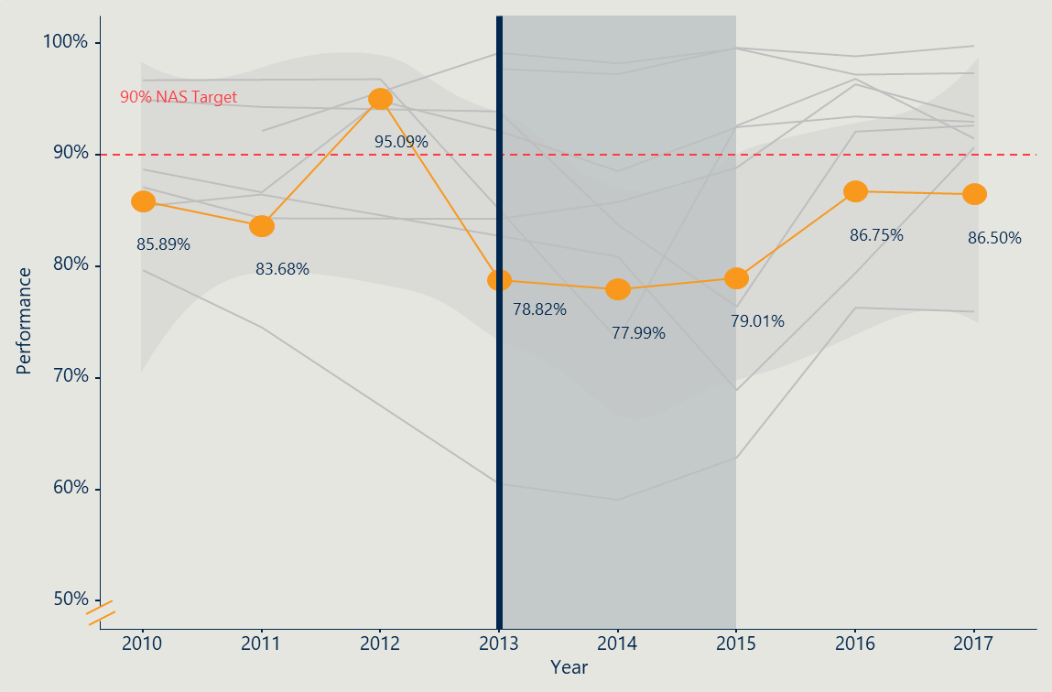

### Rates of women being notified of their results within 14 days improved following Program expansion

Figure 20 overleaf outlines the average performance trend for NAS measure 4.1.2 across services nationwide.[67] This measure shows the proportion of women who are notified of their results within 14 days of their screening appointment and was used as another proxy indicator of capacity impacts.

In this case, there was a significant improvement on average following the Program expansion, which remained relatively stable. The majority of the services are now above the NAS target (and were prior to the expansion), with two programs experiencing considerable challenges following the expansion. The 90 per cent confidence interval (opaque orange shaded trend) reflects the more nuanced illustration of the average performance trend as it accounts for standards of error in the regression model. In this case, it shows that the average is consistently hovering around the NAS 90 per cent target. Based on this proxy indicator, services’ capacity to maintain a prompt notification rate remained high on average with a few services impacted. This may indicate minimal adverse impact on the experience of women due to capacity constraints.

Figure 20 | Average notification rate of results within 14 days of screening appointment[68]

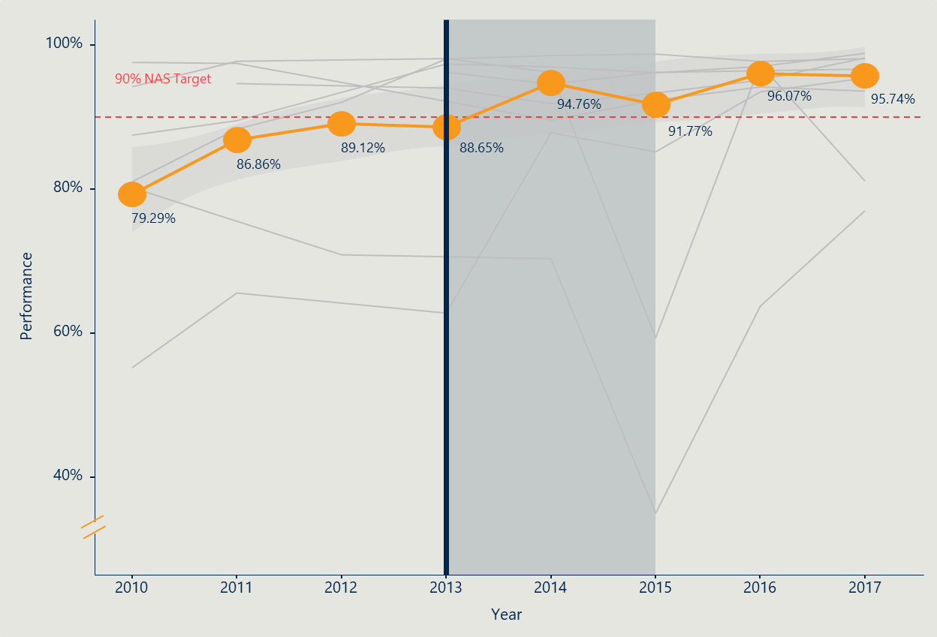

### Recall rates for women in all cohorts increased after Program expansion, with variable impact across the jurisdictions

Just over half of program staff consulted indicated that the flow-on effects of the increased workload placed a burden on staff, which took some years to alleviate. Other programs absorbed the increased workload into business-as-usual processes with little effects noted.

Figure 21 overleaf illustrates a general increase nationally in recalls to assessment for first screeners following the expansion of Program services across cohorts. Specifically, there are higher incidences of women being recalled in their first screen relative to subsequent screens, with a higher proportion of younger (50–54) and older (75–85+) cohorts recalled for assessment. For subsequent screeners, there was an initial increase in recalls to assessment, with a slight decline following the expansion of Program services across cohorts.

Jurisdictions noted that the implementation of digital mammography not only impacted the number of invasive cancer and DCIS detections through the 2012–2013 period (see Section 2), but also may have resulted in additional recalls to assessment. As such, variations in recalls to assessment over the 2012–2013 period may be because of this transitionary period and must be considered in conjunction with the effect of increased participation.

Figure 21 | Proportion of women recalled for an assessment over time, by screening round[69]

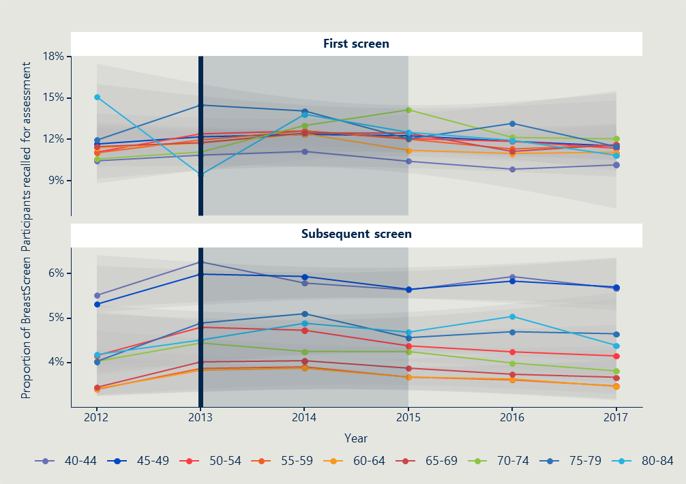

### Exploring alternative approaches to invitations to screen other than biennial screening (e.g., risk-stratified screening) could alleviate pressures on service capacity

The International Comparator Review[70] explored new models for breast screening services that are being considered globally. Risk stratified breast cancer screening is a future program design option being considered by some countries including the UK, the Netherlands, and Sweden. Risk-stratified breast screening involves high-risk women (identified by indicators such as mammographic density; hormonal, reproductive, and genetic information; and family history) being screened more frequently, and low-risk women attending less frequently. Recent evidence has demonstrated the predictive value of breast cancer risk models[71] on both impact to women and operational efficiencies.

A study of women’s perceptions of risk-stratified screening from three countries found that the concept is generally agreed upon in principle, but factors such as information needs, risk communication format, risk counselling and education of healthcare professionals needs to be considered.[72]

It appears that the UK is more advanced in assessing the feasibility of risk stratification, with current trials assessing the implementation of a risk-stratified breast screening approach. One study[73] investigated the acceptability and feasibility of risk-stratified breast screening from the perspective of UK women, clinicians and policy makers. Findings suggest that, in principle, implementing less-frequent screening for women at low risk is acceptable however findings concerning high-risk women have not yet been reported.

Research[74] into the feasibility of risk-stratified screening has provided clear indications of where BreastScreen Australia could invest effort to explore or progress this approach to screening. Further research into the following challenges are needed prior to implementation of risk-stratified screening:

* producing robust evidence of the safety and cost-effectiveness of risk-stratified breast screening that demonstrates extending screening intervals for women at low-risk is safe to implement, with minimal risk of developing aggressive, less treatable cancers during longer intervals
* undertaking adequate research to demonstrate the accuracy and stability of models used to calculate breast cancer risk
* improving current breast screening program capacity and capability to deliver a service where women receive invites at different intervals.

Exploring risk-stratified models of screening may contribute to alleviating capacity pressures in Australia.

## Conclusion

Findings presented in Section 5 related to the program expansion’s impact on the experience of BreastScreen staff are summarised below.

|  |
| --- |
| Program expansion’s impact on the experience of BreastScreen staff |
| * Staff experience and operations were impacted during the initial transition period, however the expansion is now ‘business-as-usual’ |
| * The overall impact of the expansion on the capacity of services, as determined by consultations and proxy measures, indicates variability and a two year transition period. |

The findings presented in this section support the following recommendations:

|  |  |
| --- | --- |
| RECOMMENDATION | RELEVANT SECTIONS |
| 2 Strengthened national coordination, consistency and direction in messaging and policy will improve program effectiveness and capacity | SECTION 5.2 |
| 4 Future large-scale national policy changes for the BreastScreen Program would benefit from a strategic, consultative, and planned implementation process | SECTION 5.1 |
| SECTION 5.2 |

1. The expansion’s impact on the experience of women and their intention to screen

This section is primarily drawn from survey and consultation consultations with women aged 70–74 years across all jurisdictions in Australia. Further detail on the consultation methodology is found in Section 2.7.

## Women surveyed and interviewed report high satisfaction with the BreastScreen service before and after Program expansion

### The program’s expansion did not appear to impact on the experience of BreastScreen services for women aged 70–74 years (at the time of the evaluation)

Overall women’s experience of BreastScreen, as reported by current BreastScreen clients via survey and interviews, is highly positive both prior to and after the expansion. Ninety-five per cent of women in metropolitan areas and 94 per cent of women in remote areas reported either a very good or good experience (see Figure 22). Women reported high satisfaction with the service regardless of their location, remoteness, or demographics.[75]

Figure 22 | BreastScreen clients rate their experience with the BreastScreen service

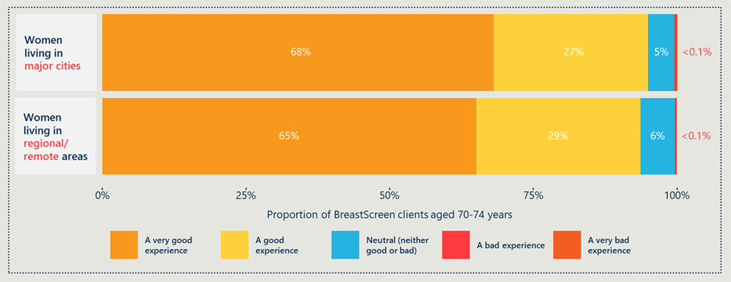  
Source: BreastScreen Client Survey (n = 4,295). Proportions calculated based on weighting of number of BreastScreen clients aged 70–74 in 2017/18 by remoteness area (Major Cities and Regional/Remote).

Of the women surveyed, none reported any impact or problematic change linked to the expansion in relation to their care or experience as they entered the 70–74-year-old age range. This perspective supports the findings in Section 3.2 that the expansion was implemented well and is now well embedded.

The women interviewed consistently reported no disruption to their invitations or service changes in or around 2013 (when the Program expansion came into effect). There was no negative feedback across all the women consulted regarding a lag in service efficiency at any time. As discussed in Section 5.2, this finding is supported by the NAS data outlining the per centage of women who attend for a screening appointment within 28 calendar days of their booking date.

The reasons why women rated their experience highly are discussed in more depth below.

### BreastScreen offers a welcoming service with professional, pleasant staff

“I found that the [staff] were absolutely marvellous. Their manner cannot be faulted. They are friendly and…there was no embarrassment. They do a very good job of instilling confidence in the [client].”

*Current BreastScreen client*

Many BreastScreen clients (34 per cent) who responded to the survey said that ‘friendly staff’ is the main reason for their positive rating.[76] Women report that staff “…*have always been a pleasure to deal with…*” and they are “…*pleasant and knowledgeable…*”. Many women who have been recalled for assessment said that the staff who were involved with delivery of the news and subsequent processes were “…*empathetic and caring…*”, and that this applied to all clinical and non-clinical roles. Women also said that having BreastScreen sites staffed exclusively by females makes them feel comfortable and at ease (13 per cent).

### Women’s experience during and after appointments is heavily dependent on frontline staff

Women aged 70–74 years report that the BreastScreen experience is shaped by the receptionist, and a positive interaction or experience is valued by women. Women also report that the radiographer is the most vital person in terms of overall experience and communicating information. Nationally,158 BreastScreen clients (8 per cent of total respondents) explicitly commented on the receptionist experience and 76 per cent of those women reported that they were highly satisfied with the receptionists they had dealt with, noting that they were welcoming and friendly, and that they treated clients “…*with respect and kindness…*”, “…*made [clients] feel comfortable…*” and subsequently attending BreastScreen feels “…*safe…*” and “…*welcoming…*”.

“From the lady who answered the phone when I rang for an appointment, to the receptionist and the technician, they were all so happy to help me.”

*Current BreastScreen client*

However, the interaction and experience with receptionists was variable between jurisdictions. Survey respondents said that a poor initial interaction with the receptionist frequently diminished the rest of the experience. One woman noted that “…*it is a more positive experience if the receptionists treat you with respect. Last time I went I was treated rudely and in a very offhand and not a professional manner*.” Another commented that “…*the receptionists need to be reminded that this is frequently an anxious time for women*”.

As well as the receptionist, women consistently implied how critical the radiographer is in communicating information during the actual mammogram. This was observed mainly in relation to screening results and program eligibility.

One interviewee reported that the radiographer always said ‘that’s fine’ after completing her mammogram, but the last time she attended the radiographer did not say this, which caused her concern. She was under the impression she was receiving the all clear when the radiographer commented ‘that’s fine’ (i.e. no breast cancer detected), and in the absence of that comment, believed something had been detected. Another current client reported that at her last visit the radiographer said that she could keep coming to be routinely screened (even though she would be 76 at her next visit). As women can feel vulnerable during the mammogram procedure, the role of the radiographer as a trusted health professional is critical to women’s experience of BreastScreen.

These two roles are critical to the experience of women and their understanding of eligibility and next steps.

### BreastScreen clients aged 70–74 years report an efficient and effective service

Overall, 95 per cent of women reported either a good or very good experience attending a BreastScreen service (see Figure 22). From an operational perspective, 24 per cent of BreastScreen clients responding to the survey explicitly mentioned that they are highly satisfied because the service is prompt and punctual. Women report that their “…*visits are fairly quick…*”, service staff are “…*prompt and efficient…*” and “…*always on time…*”. These BreastScreen clients reported their satisfaction with an efficient service in relation to routine screening appointments. A number of BreastScreen clients also reported their satisfaction with the service during recalls and subsequent diagnostic procedures. One woman commented that a lump was detected at one of her routine visits, and that “…*the subsequent processes were excellent.*” She was booked in for a follow-up appointment the following day and it was clearly explained to her as to what to expect.

There were a very small number of comments from current BreastScreen clients regarding dissatisfaction with the service.[77] Of the women who provided these comments, most reported that the actual procedure was painful, but they were satisfied with all other aspects of the service. For example, one woman commented *“How can you give the highest [satisfaction] rating when you have pain involved? But the staff are amazing.”*

### Women aged 70–74 years have around 20 years’ experience of BreastScreen services and report the procedure, process and comfort have improved

Women aged 70–74 years report that the service is quicker, and the procedure seems less uncomfortable now compared to when they first started attending[78]. BreastScreen clients report that the service is now more streamlined and efficient “…*with far less waiting time for an appointment, more screening centres open and a different approach to the process*”. One interviewee observed that the “…*customer service is much better…*” and that it’s a “…*quicker process now…I don’t feel rushed to get out*”. For example, survey respondents and women interviewed said that the experience is better “…*now white gowns do not have to be worn*”. Women appreciate the simplicity of not having to change, and like how the exclusion of gowns makes the service feel less clinical.

Women aged 70–74 years (in both surveys), report that the actual mammogram procedure has improved in terms of comfort, compared to when they first started attending. However, there seems to be consensus that the procedure is still uncomfortable. One woman observed that “…*breast screening methods have improved greatly since I first started having a mammogram when they manually screwed down the x-ray plate*.” Another said that “…*when I first started [attending BreastScreen] the machine was different and it did hurt…*”, but that now it’s “…*so much more pleasant…*” and she leaves feeling “…*not as sore…*”. Another interviewee observed that when she first started going, she “…*felt a bit ‘ruff and tumbled…’*”, but that “…*over time [the staff] have become more caring…*”.

Women’s reported comfort was a key contributor to their overall positive experience.

## Women aged 70–74 years had variable awareness and understanding of the Program expansion and the target age range

### There is variable understanding among women consulted about the Program expansion and target age range

Overall, it appears the message about the Program expansion has been variably received across Australia by women aged 70–74 years. Nationally, 15.5 per cent of survey respondents[79] were aware that BreastScreen had started inviting women aged 70–74 years to attend a free breast screen. The highest rate of awareness of program expansion is in metro areas (17 per cent), and the lowest is in remote areas (14 per cent)[80]. However, when asked if they had attended a BreastScreen service after the age of 70 years, 44.5 per cent of women said they had[81]. This implies that women in the general population are aware they can keep attending for free screens beyond the age of 70 years.

Of the 15.5 per cent of Australian women who are aware of the Program expansion, 26 per cent (n=195) report hearing about the expansion via a BreastScreen letter. This feedback aligns with women’s reports on the importance of hard copy communications from BreastScreen (discussed in Section 6.5). Women also report that ‘print ads’, ‘General Practitioners (GPs)’ and ‘common knowledge’ are other common avenues through which women were made aware of the Program expansion. One woman commented that “…*my GP informed me that the over 70s can have a breast screen. I'm pleased to hear that this is now available*.” The role of GPs in promoting BreastScreen is discussed in more depth in Section 6.5.

These findings highlight the importance of clear and consistent messaging across a range of different channels to communicate with women about the target age range.

### The majority (84 per cent) of women surveyed from the general population (aged 70+) were not aware BreastScreen had started inviting women aged 70–74 years old to attend a free breast screen

Most women (84 per cent) in the general population survey were not aware BreastScreen had expanded the target age range to include women 70–74 years. A few women who did attend a screening since turning 70 (n=5) were not aware of the expansion but had arranged to attend the screening regardless.

Figure 23 below illustrates that the lack of awareness about the Program expansion is fairly consistent across both major cities and regional/remote areas, slightly more so in regional/remote areas (86 per cent of women noted they were not aware).

Figure 23 | Women aged 70–74 years consulted as part of the evaluation who were aware of the BreastScreen Program expansion

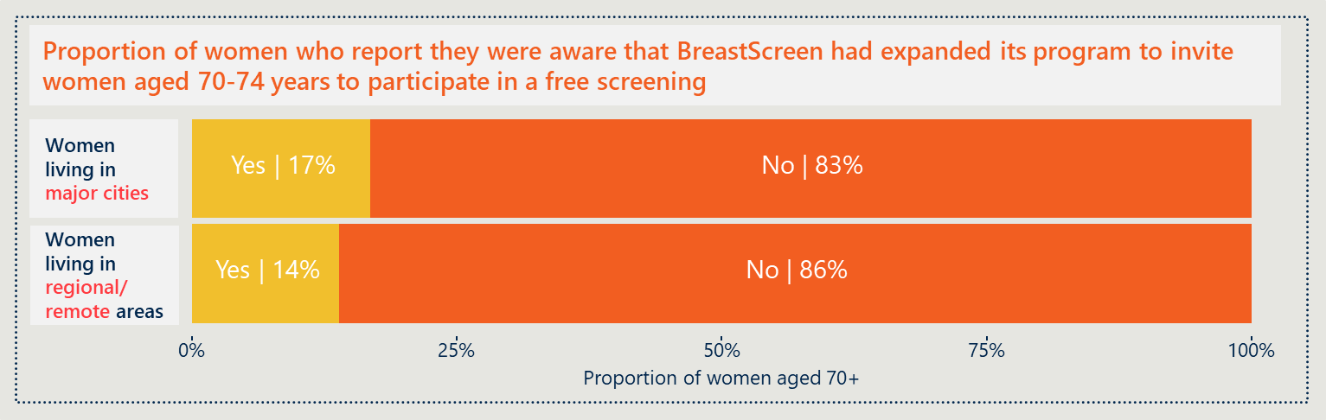  
Source: Phone Survey to women aged 70+ (n = 743). Proportions calculated based on weighting of population of women aged 70+ by remoteness area (Major Cities and Regional/Remote) in 2017.

The majority (46 per cent) of women aged 70+ surveyed in the general population reported that they heard about the Program expansion through the letter/reminder they received. Other reasons included print advertisements (16 per cent), a GP referral/recommendation (14 per cent), and from family/friends (seven per cent).

### Current BreastScreen clients report that they will likely continue screening even without a reminder letter

Of the current BreastScreen clients aged 70–74 years who were surveyed and interviewed, a large proportion expressed a strong intention to keep screening beyond the age of 74. Twenty per cent of survey respondents, and all but one interviewee, were adamant that they will continue having routine two-yearly screening for the foreseeable future. Women expressed that they would continue screening even if they had to pay for screening, for example through private mammography.

Many women who responded to the surveys[82] reported that they do, and will continue to, proactively engage with BreastScreen – for example one woman said, “*I just ring up when the times right to make an appointment every two years*.” Another mentioned that “…*this year I turned 73 and I haven't had a reminder, I'm thinking I will have to get in touch with them as I want to keep going*.” Other women, as previously discussed, still attend for breast screens even if they don’t get a reminder.

As previously discussed, this intent is driven by a range of factors including ensuring ongoing peace of mind; women’s proactive and preventive health approach; and a lack of information on why routine screening invitations end at 74 and the subsequent available options.

“I would continue to have the [screens] after 74 years if possible, even if I had to pay”.

*Current BreastScreen client*

Nine per cent of current BreastScreen clients report they understand routine reminder/invitation letters will cease after the age of 74 years, but that the lack of letter will not change their intent to continue screening past the age of 74. These women noted that the lack of letter would be an inconvenience (as they may forget to make an appointment), but they did not connect the lack of letter with a decision to stop screening. One woman commented that she has “…*friends that thought when you turned 74, you stop having [routine screens] because they had stopped receiving the reminders. They don't know that you can still get breast screening done after 74 years old too.*”

## Messaging for women once they reach the age of 75 years is challenging

### Women felt that the ‘cut-off’ age of 75 undervalues older women

Approximately half (n=19) of the current BreastScreen clients who were interviewed said that having a ‘cut off’ age for invitations being sent for the BreastScreen Program made them feel dispensable and ‘old’. This sentiment was expressed across all jurisdictions and did not appear to be linked to broader messaging from services. Interviewees talked at length about how they feel they are perceived by others in relation to their age. These feelings have also been compounded by the impact of COVID-19 on older adults, contributing to a message that people aged 70+ are ‘old’ and ‘frail’.

“I was disappointed that [BreastScreen] stopped at 70 years old and I could never get another free screening. As you get to a certain age, they start saying you are too old for most medical things…which really cheeses me off.”

*Member of general public*

The women who reported this feeling in interviews acknowledged that their dislike of the ‘cut off’ age is tied to a set of factors related to ageing in general. Having the target age range end at 74 years is one more input into a broader sense of their value in society. One woman commented that “…*the message of stopping screening at a certain age seems to me to suggest that the lives of over 70s are not as valued as younger people in the community*.” Another interviewee said, “…*just because we are older does not mean that we aren't as caring of our health or deserving of preventative health care*.”

“I was very surprised when they stopped inviting me to come – it was as if at that age it didn’t matter anymore, but it does to me.”

*Member of general public*

The interviewees report that their feelings related to being in the 70–74-year-old age cohort are complex and driven by a range of factors. In some cases, women imply that the fact society sends a message (via many conscious and unconscious channels, with BreastScreen’s target age range being just one) that being aged 70–74+ years is ‘old’ motivates them to keep screening as they seek to rebuke this perception. Motivators to keep screening are discussed in more depth in Section 6.6.

Consultations with BreastScreen staff confirm this perception (of being ‘dispensable’) is a common perspective expressed by clients they communicate with when they reach the end of the target age range.

### Challenges around communicating when to stop screening have always existed and are now delayed until women are 75 years old

Women who responded to the general population survey, who are also current BreastScreen clients, report an array of views on the age at which they are no longer in the target age range (and therefore stop receiving invitations to participate in the Program). Women report that they feel ‘eligible’ or ‘ineligible’ to participate in the BreastScreen program according to their age (rather than ‘in the target age range’ or ‘outside of the target age range’). BreastScreen Australia policy confirms all women over 40 years can attend (with no upper age limit) and that women under 40 are ineligible.[83] This suggests that the messaging around eligibility, ineligibility and target age range could be clearer and/or not completely understood by women.

“I think I am ‘past it’ now, so I’m not sure if I will be getting any more reminders.”

“I didn’t realise it stopped, and I was expecting a call.”

The breadth of comments received from women responding to both surveys (women in the general population and current BreastScreen clients) on their understanding of the recommended age to cease screening (and why) indicates that this message has been inconsistently and unclearly communicated across Programs. Some comments include: “*I understood they finished at the 70 mark and I haven't had them for many years*”; “*I thought at my age of 81 that they don't include us anymore*”; “*I was under the impression that once you turned 75 it ceased*”. Some women[84] (9 per cent) remarked that they thought once they were 70 that the Program was no longer available to them.

The challenges of communicating when to cease screening, as observed in women’s feedback, are also supported by comments made by Program managers and BreastScreen staff. Staff expressed that challenges have always existed around communicating the options and choice about future screens to women who reach the end of the target age range. BreastScreen staff commented that the Program expansion exacerbated the communication challenges during the transition period (generally estimated to be 18 months to two years after the policy change) as the change needed to be explained, and now that the expansion is well embedded, the communication challenges on the issue are now happen when women reach the age of 75.

Women aged 70–74 years who responded to the surveys (both in the general population and current BreastScreen clients) report that their understanding is impacted by their perception that there is a lack of information on the purpose of, and evidence behind, Program expansion, as well as inconsistent messaging from front-line service staff, GPs, and through word-of-mouth.

As previously noted, health promotion messages around target age ranges can be difficult to communicate. Current communication regarding the target age for screening and options available to women after they reach 75 years, is not clear and not accessible (as reported by women). Comments from women consulted in the evaluation indicate that messaging from BreastScreen on “…*why the program ends at 74…*” would be valued. One woman remarked that “*I cannot understand why [BreastScreen] stops screening over 74 years – I'm 77 this year… why can't I still have them?*”

The evaluation observed there were differences (sometimes providing appropriate tailored messaging) between jurisdictions and between individual services’ marketing material for women on this issue. Within some jurisdictions different frontline staff members reported communicating different messages to women about booking in for screens beyond the age of 75 years. Some programs used waitlists for women 75 years and over in order to prioritise screening women in the target age range where there was tight capacity, while others accepted bookings initiated by women aged 75 years and over as they would for those in the target age. The variability in women’s understanding of why there is a target age range for screening may be associated with the lack of a unified, national policy on what age BreastScreen recommends women stop screening.

### Consultation with women about their understanding of the target age range highlights the complexity of communicating breast cancer risk to the general population

Some women consulted (both in the general population (two per cent) and current BreastScreen clients (two per cent), implied that their misunderstanding about the target age range was contributed to by their perception of a lack of information on the risk of being diagnosed with breast cancer after the age of 74 years. Comments questioning the relative risk were made by women across all jurisdictions and remoteness.

“I felt that having reached this age (70-74), I was unlikely to contract breast cancer, but after talking to someone who was aware of a person in her eighties having breast cancer, I realised it does not recognise age.”

*Current BreastScreen client*

Eleven women interviewed (current BreastScreen clients aged 70–74 years) also expressed they were unclear about the risk of developing breast cancer over the age of 74. This was regardless of their educational and/or professional backgrounds; one woman who is an ex-public servant in a health department commented that even with her background she still doesn’t know the risk post-74 and why it is that women aged 74 and over are no longer receiving invitation or reminder letters. Another woman interview, who currently works in the government in a health-related department, believes that the evidence underpinning policy decisions is not up-to-date, and therefore the risk is greater now that women are living longer in better health—she questioned; “…*doesn’t risk increase with age?”.* In comparison, another interviewee, who was formerly a school Principal, said she was confident that if the program ended at 74 years it was for a good reason and was under the impression the risk of developing breast cancer 74+ was negligible.

These findings support the generally accepted concept that communicating breast cancer risk to a diverse population with variable health literacy is difficult. It should be noted that there were low numbers of culturally and linguistically diverse (CALD) and Indigenous women who responded to the surveys, however evidence is clear (see Section 6.6) that tailored messaging for CALD groups or culturally appropriate communication for Indigenous women is necessary. More widely available, accessible, and nationally consistent information on risk and the evidence underpinning the target age range would be valued by women. This may help increase women’s understanding, inform their decisions about screening after age 75 and support conversations between BreastScreen staff and women.

“I thought if you’d be getting breast cancer, you’d have had it by now.”

*BreastScreen client, aged 72*

## There are many reasons why women aged 70–74 years do and do not participate in breast screening

### ‘Peace of mind’ was the most reported reason for attending a breast screen by the majority of women

Overall, BreastScreen clients reported that reassurance and peace of mind are the main drivers of their continued engagement with the BreastScreen Program. The second most popular reason was receiving an invitation/reminder to attend (26 per cent of women living in major cities, and 17 per cent of women living in remote areas). Women who reported that they regularly attended screenings, were concerned about their health, family history, or were recommended by a health professional to attend.

Figure 24 | Reasons women aged 70+ years in the general population surveyed attended a breast screen[85], categorised by remoteness area

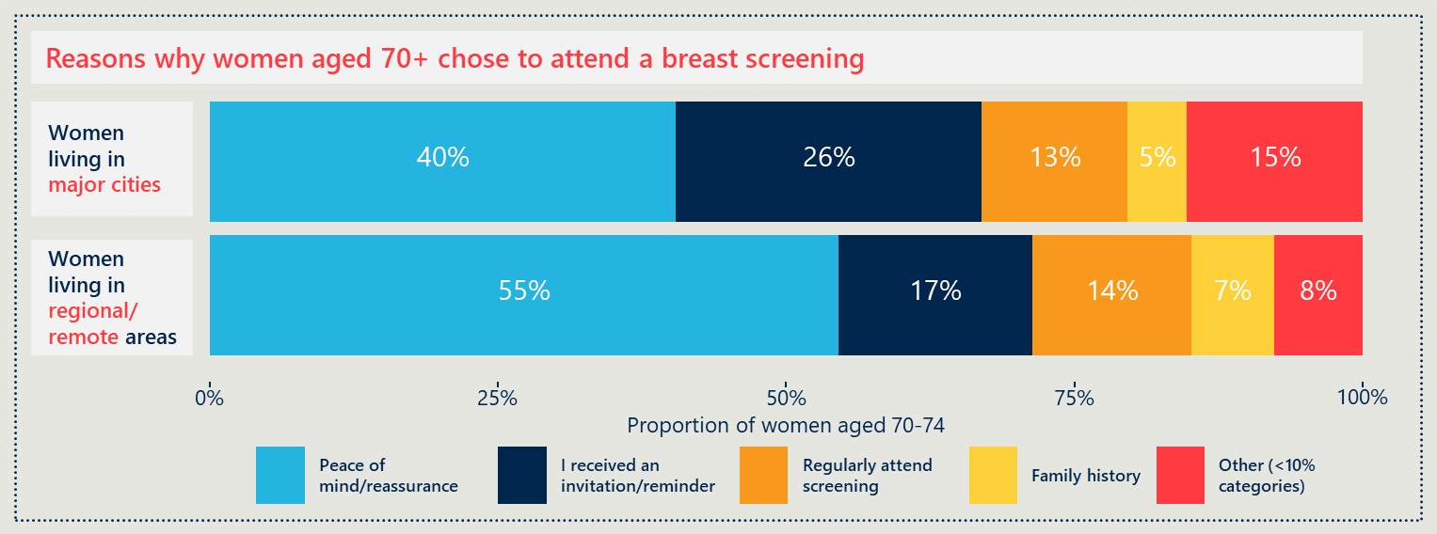  
Source: Phone Survey to women aged 70+ (n = 743). Proportions calculated based on weighting of population of women aged 70+ by remoteness area (Major Cities and Regional/Remote) in 2017.

Women value the longer years of reassurance they now have afforded to them due to the Program expansion. Nationally, 45.6 per cent of women reported that they engage with BreastScreen for peace of mind/reassurance. [86] Thirty-five per cent of BreastScreen clients surveyed directly cited peace of mind as the main reason they attended their last screen. One woman commented that “…*for those of us who have been attending clinics for years, the testing has provided reassurance*”. As women in this age cohort are nearing the end of the target age range of 74 years, many commented that they “…*would like the reassurance to continue…*” and are acutely aware of the absence of this peace of mind when they are no longer receiving an invitation or reminder letter to screen (and may not understand they can still attend if they wish).

”Having breast screens is worthwhile and reassuring for me.”

*BreastScreen client*

Nine of the BreastScreen clients interviewed reported that they have a highly proactive and preventative approach to their health. The reasons why women in this age cohort are so proactive were not explicitly discussed, however women reported that from their perspective they implied women’s health has historically been deprioritised, and services such as BreastScreen were not available to past generations of women. As such, these women cited a strong belief that the present-day availability of services and emphasis on early detection should be embraced. One woman commented that she continues to attend BreastScreen because “…*it aligns with my health philosophy to take advantage of preventive measures, rather than wait for treatment which may be expensive, dangerous or critical…*”, and that she plans to continue to screen “…*even once I am too old to receive reminders, as it gives me peace of mind.*”

### Women aged 70+ in the general population reported many reasons why they did not attend their last breast screen

The variety of reasons women aged 70+ years surveyed in the general population reported why they did not attend their last breast screen further illustrates that the reason can vary greatly by individual. The main reason reported was because women attended private mammograms. A small number of women (17) from the general population survey respondents reported attending a private clinic for a breast screen despite being aware of and being invited to screen at BreastScreen. Most of these women (12) were from major cities, but the sample came from multiple states. All of these women were either aware of the Program expansion or had received an invitation to attend since turning 70. In a few cases, these women reported attending a private clinic for a breast screen due to ongoing medical treatment following diagnosis, not due to past experiences with BreastScreen.

Other specified reasons included not yet due for another screening, thought they didn’t need to, forgetting, not receiving a reminder, accessibility issues, concerns of pain, competing health issues, and COVID-19 implications (see Figure 25 for further detail).

Figure 25 | Reasons women aged 70+ years in the general population surveyed did not attend a breast screen[87], categorised by remoteness area

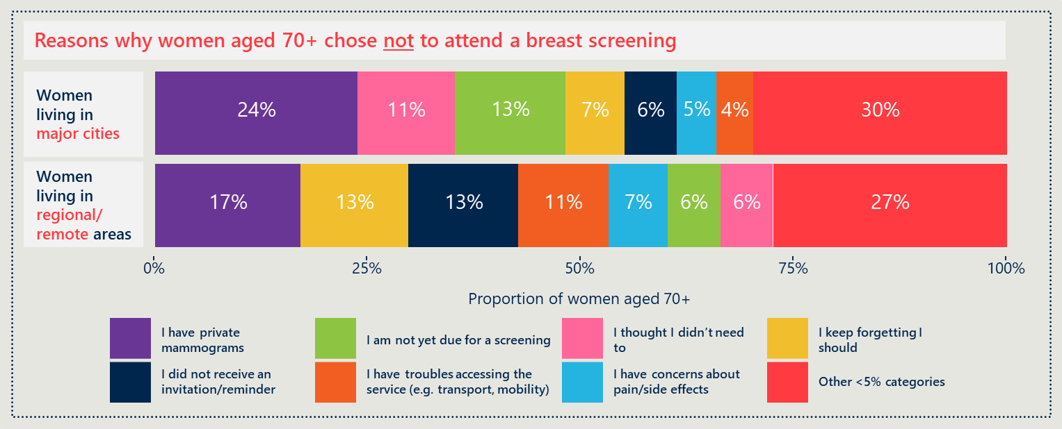  
Source: Phone Survey to women aged 70+ (n = 743). Proportions calculated based on weighting of population of women aged 70+ by remoteness area (Major Cities and Regional/Remote) in 2017.

### Women value the access to preventative healthcare interventions that BreastScreen provides

Many respondents[88] remarked that they are motivated to screen because they feel they are entitled to preventative health interventions just as much as younger women – they are healthy and active contributors to their communities.

“Women in their 70s are often/usually still very active, useful members of the community. I see no reason why we should not have the same access to preventative health care as the rest of the community.”

*Current BreastScreen client*

Seven per cent of current BreastScreen clients who responded to the survey and four interviewees explicitly commented on today’s increased life expectancy, and the impact this has on women no longer receiving reminders at 74. These women observed that people are living longer and in better health for longer than previous generations. Some women think that 75 would be an acceptable age to cease reminders, while others think the targeting should be available to women in their late 80s.

### Having a family member or friends diagnosed with breast and other cancers is a strong motivator for screening

Another common reason to screen reported by women surveyed (eight per cent) and interviewed (n=12) is a family history of breast and/or other cancers. Women with family members or friends diagnosed with breast cancer feel screening is a mandatory, non-negotiable activity. When asked during interviews why they screen, many women cited their experience of a family member or friend being diagnosed with breast cancer as a contributing factor. One woman commented that routine screening is “…*a necessary and worthwhile check, especially as my sister has had breast cancer*.”

“I am concerned that they said once I get to 70, I wouldn’t need breast screening anymore. My sister died from breast cancer, so it’s always been in the back of my mind. I would still like to get checked, maybe not every two years, but at least once.”

*Member of general public*

Women consulted across both surveys (18 per cent) and through interviews (n=9) consistently mentioned that they were motivated to screen because they know women their age or older who have been diagnosed with breast cancer. Women report that this instils a sense of fear that they too could still be diagnosed with breast cancer, even past the age of 74, and it’s this fear that drives them to continue screening. This also adds to the unclear messaging about breast cancer risk in older women (as discussed previously).

“I would like to see the service extended for women over 74 years. My sister-in-law was diagnosed with breast cancer when she was almost 75 and I am aware of others being diagnosed well into their 70s.”

*Current BreastScreen client*

For these women, this also serves as a reason to further expand the BreastScreen target age range to women 75+. Approximately ten per cent of all survey respondents[89] “…*believe that the [BreastScreen Program] should extend beyond the current age of 75 as many women [they’ve known], including [family], had breast cancer diagnosed in their late 70's*”.

## Barriers and enablers to participation for women aged 70–74 years vary across population groups

### There are common enablers and barriers for screening across all age groups and priority population groups

Women’s survey feedback[90] indicates that there are common factors that make it easier or harder to have a breast screening mammogram, regardless of women’s age, location, and demographics. These enablers and barriers have been verified through individual program’s consumer research, women’s survey feedback, and in more depth during interviews with current BreastScreen clients.

In interviews, women said that the importance of having a regular breast screen trumps any other factors that impact on the convenience of attending. A clear sentiment was one of ‘having a regular breast screen is just something you do regardless’. When asked specifically about enablers and barriers, most women noted that factors such as travel time, public transport accessibility, and parking all make participation in screening more convenient, but that longer travel time or a lack of parking (for example) would not stop them attending.

Table 11, below, outlines a summary of the common enablers and barriers identified throughout the evaluation (from BreastScreen staff, women aged 70–74 years in the general public and current BreastScreen clients, and the International Comparator Review). Where strong themes emerged on particular enablers and barriers through consultation with Australian women and current BreastScreen clients, these are discussed following the summary table.

Table 11 | Summary of enablers and barriers to screening for all women

| Target population group | Enablers of access | Barriers to access |
| --- | --- | --- |
| All women | * Tandem or group bookings (e.g., mothers and daughters) * Existing engagement in the Program (particularly when engaged women enter the 70–74-year-old cohort) * Written communication for older women * Easy-to-use website for booking online * Marketing materials informed and tested by consumer reference groups (e.g., to strike the right tone) * Personalised approach (in smaller services like ACT): e.g., nurse counsellors calling women and following up after appointments * Communicating to clients in the ways that work best for them (consumer-centred) * Better professional education and materials for GPs * Higher levels of health literacy | * Concerns around pain or discomfort in the screening process * Lack of knowledge about why screening is important * Other health concerns take higher priority (particularly for women with comorbidities) * Limited screening hours, which particularly impacts women working during the day * Issues with transport and parking * Inconsistent messaging or marketing materials around eligibility * Lack of accessible facilities for women with disabilities |

The International Comparator Review[91] found that General Practitioners (GPs) are a critical barrier or enabler for communicating awareness and the importance of breast screening. Interviews with current BreastScreen clients aged 70–74 years revealed that the gender of their GP and the type of relationship women have with them are the specific factors that determine if women discuss breast screening with their GP. Interviewed women with female GPs (n=11) were much more likely to have discussed breast screening than those with male GPs. One woman mentioned that she had been attending a female health clinic for most of her life, which was actually how she was first introduced to the BreastScreen Program. Others said that their female GPs had proactively brought up the importance of attending BreastScreen with them, and usually checked in with women’s attendance at annual health check-ups.

In contrast, those women with male GPs (n=16) unanimously reported that their GP had not proactively discussed breast screening with them[92]. This finding suggests that engagement with GPs could become more targeted to ensure that all women are likely to have their GP proactively discuss the importance of breast screening with them.

Accessibility challenges for women with disabilities were mentioned explicitly as a barrier to attending BreastScreen services. Survey respondents[93] from three jurisdictions observed that the reason they did not attend their last screen was due to accessibility issues – for example their disability limited their independence, or they live regionally and are unable to drive. One woman observed that the “…*collapsible steps to gain access to [the mobile van] are very steep…as I have increased in age…*”. While this comment was made in relation specifically to being aged 70–74 years, interviews with other women in this age cohort did not highlight this is as a significant issue. Some women who said they were unable to navigate stairs remarked that they simply attended a service without stairs (versus the mobile van). This finding is in alignment with the broader observation that women aged 70–74 years are highly engaged with the program and place such importance on attending for a breast screen that travel distance to an established clinic would not necessarily factor into the decision whether or not to screen.

### Receiving or not receiving a reminder from BreastScreen is the most important determinant of whether women aged 70–74 years will attend for screening

Overall, women aged 70–74 years reported that being reminded/invited to screen by BreastScreen was the most influential factor in determining whether or not they attended for screening. During interviews with current BreastScreen clients aged 70–74 years, the importance of the BreastScreen letter was consistently mentioned as a critical factor for program engagement. This observation was made both irrespective of and within the context of ‘enablers and barriers.’

“I am glad they sent reminders otherwise I would probably have forgotten to go”.

*Current BreastScreen client*

Most BreastScreen clients’ (63 per cent in major cities, 67 per cent in regional/remote areas) who did attend their last breast screening reported they did so because they received a reminder (see Figure 26 below). A reasonable proportion (32 per cent in remote areas, 28 per cent in metro areas) of BreastScreen clients who were consulted noted that they attend regularly and note this as the reason they attended their last breast screening regardless of receiving an invitation. Responses were similar across women living in remote areas and those in metropolitan areas.

Figure 26 | Reasons BreastScreen clients aged 70–74 years did attend a breast screening, categorised by remoteness area[94]

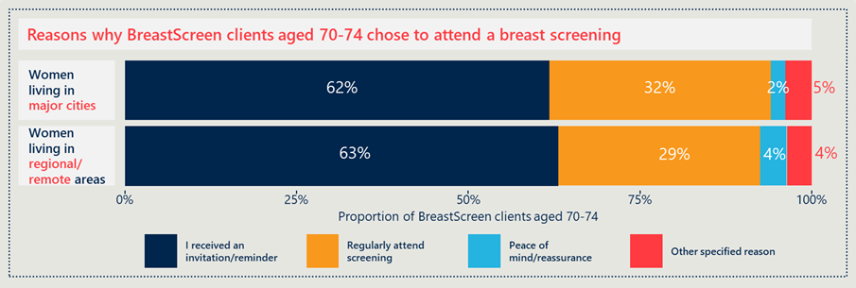  
Source: BreastScreen Client Survey (n = 4,295). Proportions calculated based on weighting of number of BreastScreen clients aged 70–74 in 2017/18 by remoteness area (Major Cities and Regional/Remote).

Of those survey respondents who had not had a mammogram with BreastScreen since turning 70, 53.5 per cent cited that it was because they did not receive a letter. Across all respondents to the BreastScreen client survey, only 41 per cent of women said that they had received a letter since turning 70.[95]

BreastScreen clients aged 70–74 years surveyed reported that the main reason they did not attend their last breast screen is because of the lack of a reminder. This was particularly the case for women in regional/remote areas, with 61 per cent of women noting this as the main reason for not attending their last breast screen (see Figure 27 below).

Other reasons for attending or not attending can vary greatly from individual to individual. BreastScreen clients responded with varying other reasons for not attending including; only recently turned 70 (16 per cent), not yet due for biennial screening (13 per cent), upcoming appointment booked (7 per cent), and a few other reasons (categories reported from <5 per cent of respondents).[96]

Figure 27 | Reasons BreastScreen clients aged 70–74 years did not attend a breast screen[97], categorised by remoteness area[98]

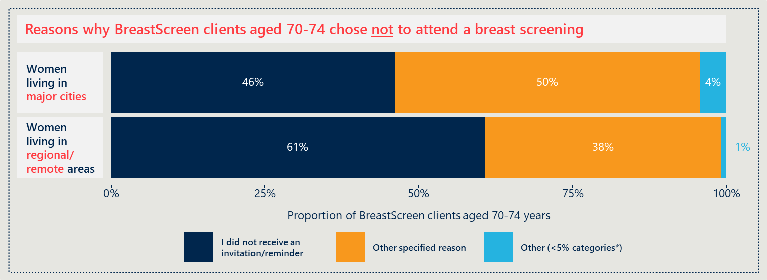  
Source: BreastScreen client survey (n = 4,295). Proportions calculated based on weighting of number of BreastScreen clients aged 70–74 in 2017/18 by remoteness area (Major Cities and Regional/Remote).

Nationally, up to 58 per cent of respondents have not engaged with BreastScreen because they did not receive a reminder. [99] While 73 per cent of respondents nationally have received a BreastScreen reminder at some point, of these women only 56 per cent received an invitation after they were aged 70. This data highlights that variability in letter coverage still exists across all jurisdictions in Australia, and that this variability is impacting participation rates.

“I very strongly want the routine reminders from BreastScreen to continue past 70 years old.”

*Current BreastScreen client*

Current BreastScreen clients aged 70–74 years and those consulted through the survey of Australian women said that they rated the importance of the letter so highly because it helps them remember when they’re due, which is especially important for two-yearly program engagement.

Women who did not receive a reminder said that this signals that they are ineligible for program participation, or they simply forget.

Internationally, reminders to screen are the most common and effective method at recruiting women. Recruitment approaches form a critical element of organised, population-based breast screening programs. Across the in-scope countries approaches to recruit women were largely similar to each other and Australia. Common procedures included invitations to attend prompted at the agreed screening interval (either two or three years). Marketing and advertising campaigns were also commonly deployed. Differences include the use of pre-set appointments, and the sub-groups targeted in marketing campaigns. Although all in-scope countries send out either biennial or triennial invitations to targeted women, the method of invitation distribution varies. This difference may be a contributor to the variations in participation rates. For example, Denmark sends an invite with a pre-set time and has a recorded participation rate of 82 per cent. This is the same practice as seen in Tasmania, where the participation rate is 59.2 per cent (which is greater than the Australia-wide average of 55.8 per cent).

### The impact of the COVID-19 pandemic created an unusual temporary barrier to access for some women

Interaction with the Australian health system during the height of the COVID-19 pandemic was disrupted to some degree across all BreastScreen services jurisdictions in 2020. Engagement with BreastScreen clients aged 70–74 years was undertaken during the COVID-19 pandemic. Of the BreastScreen clients who were surveyed, most women (97.2 per cent) responded “No” when asked if COVID-19 implications had impacted their likelihood to attend their BreastScreen mammogram. While this was the consensus, the necessary precautions including closures put in place during the pandemic meant that women who were due for an appointment in 2020 sometimes were unable to attend. In some instances, women also delayed their appointment due to concerns of COVID-19 transmission.

A few BreastScreen clients and women surveyed in the general population noted this as the “Other specified reason” they did not attend breast screening. Barriers to accessing clinics during the height of the pandemic were noted by approximately five per cent of BreastScreen clients surveyed across most jurisdictions in Australia. Factors included services being closed and public transport not being a feasible option for travelling to a service. In Victoria, where the impact of COVID-19 was felt most acutely and for the longest period of time, many women who reported that COVID-19 had impacted or changed their decision to screen said that it was due to concerns of virus transmission. A small number of respondents also said that due to lockdown and travel restrictions they did not believe they were lawfully allowed to travel to a screening clinic that was outside of their restricted zone.[100]

“I got a letter to get screening done this year, but because of the COVID-19 virus, I was not able to go.”

*Member of the general public*

Further effects of COVID-19 on routine screening (both in Australia and internationally) are discussed in Appendix B.

## Tailored approaches to engagement can improve participation rates of priority cohorts

### Responses from women in key demographic groups indicate a need to strengthen awareness and understanding within particular sub-groups

Although the two surveys did not include representative samples from women in different demographic categories, the responses nevertheless highlight some important points about the breast screen behaviour of women.

Some women from the general population survey respondents who lived in care facilities, were in the workforce, or were from CALD backgrounds reported they were unaware of the Program expansion and did not receive an invitation to attend. Further insights from these women are discussed below in turn.

* Twenty-five women identified as currently living in a care facility—one of these women was aware of the BreastScreen Program expansion. Seven women who were not aware of the expansion had nevertheless attended a breast screen since turning 70. Nine women reported they had received an invitation to participate since turning 70.
* Eighteen women identified as being in the workforce. Of these working women, three were aware of the BreastScreen Program expansion. Twelve of these women were not aware of the Program expansion and did not receive an invitation to attend, nor had they attended for a breast screen since turning 70. Other than not receiving a reminder to attend, working women who didn’t attend also noted they had forgotten they should attend, they self-check, or attended private mammograms as other reasons why they chose not to attend.
* Fifty-six women identified as being from a CALD background. Only seven of these women were aware of the BreastScreen Program expansion although almost half of them (25 out of 56, or 45 per cent) had attended a breast screen since turning 70. Most of these women chose to attend for peace of mind/reassurance, or because they received a letter. More than half of the CALD women surveyed (57 per cent) did not receive a reminder/invitation.

### There are specific enablers, barriers, and challenges for screening for priority groups

Consultations with BreastScreen Program leaders and staff and analysis of the program’s consumer research indicates that there are a range of specific enablers and barriers for target priority groups. Many of the individual enablers and barriers were unable to be validated by women in the corresponding priority groups (due to low numbers of respondents in priority groups, the responses are not representative, and insights cannot be generalised to groups more broadly). Of the women consulted throughout the evaluation who identified as being from a priority group, none made any specific remarks regarding enablers or barriers to access.

Table 12 summarises the enablers and barriers faced by women in different priority groups (as reported by jurisdictional programs). These may explain some of the disparities in screening participation across the specific population groups after the Program expansion (see Section 3.2). It is noted that these enablers and barriers are not necessarily specific to the 70–74-year-old age cohort, although the consultations were framed in that context. Many Program stakeholders agreed that participation and experience of BreastScreen was determined more by women’s demographics (such as the priority population groups) than their age.

Table 12 | Enablers and barriers for access to screening for priority groups

| **Target population group** | **Enablers of access** | **Barriers to access** |
| --- | --- | --- |
| Aboriginal and Torres Strait Islander women | * Older women participating can help encourage younger women * Group bookings, particularly in remote communities * Support from local services to provide transport or encouragement to screen, especially in very remote areas | * Breast cancer can be a low priority compared to other health concerns * Some women can have many aliases, uncertain age, frequently changing addresses, or be without Medicare cards * Questions around effective or informed consent where women are not likely to screen without strong encouragement from others * National marketing campaigns and materials are less useful for Indigenous women |
| CALD women | * Dedicated materials to reach CALD women * Pictorial resources, interpreters, and information available in different languages * Group bookings and/or information sessions organised by CALD officers | * Constraint of religious or cultural norms, and can be more apprised to living with these issues, rather than knowing and treating * Language barriers – and a time lag to the new health messages reaching communities * Transportation issues, due to lack of driving license or ability to use public transport * Driven by their priority to look after their families over themselves, they can de-prioritise their breast screening |
| Women living in high disadvantaged areas | * Connect with community leaders to build trust and rapport to welcome mobile services * Providing out-of-work hours appointment availabilities | * Transportation issues * Time poor * Prioritising others and other needs * Healthy literacy |
| Women in remote areas | * Mobile screening | * Infrequent screening availability in remote areas due to logistics, distances, and weather at certain times of year * Difficulty finding skilled screening staff to work in remote areas (e.g., radiographers) |

**Consultations revealed suggestions for further initiatives to ensure BreastScreen is truly inclusive for all women**

It is acknowledged that BreastScreen Australia already places great emphasis on engagement of women in priority groups. Interventions currently in place have improved participation of women in these groups in line with all women aged 70–74 years since Program expansion. During consultations with current BreastScreen clients aged 70–74 years, a small number of women (n=3) raised suggestions for initiatives that may help further increase the participation rate across all groups.

”I was surprised to note that none of the photos [in the BreastScreen reception area] were of women of other ethnic groups, and particularly disturbed to note that none were of Aboriginal and Torres Strait Islander women. The location of the clinic I attend has a high Indigenous population.”

*Current BreastScreen client*

Some women felt that more could be done to actively reach women located in very remote settings. One woman in a very remote location noted that she “…*has no experience of [BreastScreen]…*” because she “…*was out on a sheep station for years*”. For this reason, another interviewee questioned whether there was “…*any form of assistance from the government for remote women to get screening…*”, observing that “…*there has to be considerable support…*” to make women in remote areas aware of BreastScreen and then facilitate their access to the service in a practical manner.

Several current BreastScreen clients also raised suggestions through the survey and interviews to further improve the inclusivity of BreastScreen services, particularly for women from culturally and linguistically diverse (CALD) backgrounds, and women who may be questioning their sexuality, or who identify as trans or gender diverse. One interviewee, who identified as being from a regional location and working closely with young women from refugee backgrounds, observed that while there are resources for CALD women at BreastScreen services, these need to be better disseminated throughout the community for maximum effect (e.g., schools, churches, cultural events etc.). She mentioned that she is “…*not seeing resources in the community for CALD cohorts…*” and that given “…*there’s still a lot of taboos in these communities [regarding breast screening]…*” that any resources that are developed and disseminated “…*need to be done proactively and very sensitively*”. It was suggested that BreastScreen Australia could have a strategy to target younger women and girls from CALD backgrounds (who are more likely to speak English and/or actively engage with health promotion messages) so that they can in turn disseminate the information to the older women in their family (those within the target age range for screening).

### International literature describes several targeted interventions to increase participation in priority groups

Looking globally at in-scope comparison countries[101], international examples prove that there are a range of targeted interventions that can increase participation in priority groups. The international evidence suggests that service delivery is enhanced through consumer involvement in the co-design of health promotion materials and culturally sensitive processes and environments. Some of the resulting interventions include:

* home visits by lay health advisors[102]
* involving cancer survivors from the community as screening advocates
* group transportation
* language and sign interpreters
* offering appointments outside work hours and on weekends
* a day dedicated to screening priority group women
* community champions
* fixed sites in high minority population areas
* providing more services managed by members of priority groups
* targeted use of local community groups to promote screening (e.g., church groups).

### International examples show that tailored promotion and recruitment tools can help improve participation rates of older women

The International Comparator Review found that there are various methods used to specifically increase participation rates of older women in several in-scope comparison countries. These examples include the differences in content in invitations sent, proactiveness of the invitation, methods in which the invitations were sent, and various other initiatives. These are discussed in greater detail below.

Countries that provide set appointment times in their initial letters of invitation all boast high participation rates. This suggests that proactive engagement may increase the likelihood of participation. However, research also indicates that flexibility is required to accommodate women’s different needs, which are likely unknown at the time of invitation.

Text messaging was also identified as being a useful tool to reach women and encourage participation in breast screening. Recent market research studies have shown that a very high per centage of smartphone users aged 65+ years use their device for texts, calls, and emails on a regular basis.

There are several other initiatives identified in the literature across in-scope countries which aim to increase the participation of older women:

* Targeted information on risk factors to enable more informed choices for older women who are not well informed.
* Neutral, complete, and clear information on the risk and benefits of screening made available for the public and healthcare professionals.
* Ensure the process for guideline development is transparent and reflexive to new evidence on the appropriateness of breast cancer screening.
* Alternative modes of information delivery, such as text messaging, employed appropriately to improve the reach of public health messages.
* GP services must ensure they have up to date contact information for all their patients including physical addresses and mobile numbers.

### Transportation to breast screening services is an area of focus for several countries

The literature reviewed in the International Comparator Review[103] indicates that a lack of or inconvenient transport is a barrier to participation. This is especially exacerbated for women with a disability and those without access to a car (as noted earlier in Section 6.5). In Australia, a couple of women aged 70–74 years said that having BreastScreen-provided transport was valued by regional women who may otherwise struggle to access the service. Internationally, in-scope countries manage this in a variety of ways, described below.

Mobile vans are used in Sweden, New Zealand, Canada, and England to improve access for women, whether by offering drop-in services in shopping centres or visiting remote areas. The use of mobile vans currently occurs in Australia to try to mitigate transport barriers however, barriers do remain.

Other initiatives identified in the literature across in-scope countries that aim to increase the participation of women through addressing physical access issues include:

* Allowing group bookings for women who live in the same household or are related.
* Endorsement of mobile vans by the Indigenous population. British Columbia, Canada recently released several vans to service First Nations women. These were endorsed by First Nations representatives and the vans were to attend First Nations reserves for screening. Ensuring Australia’s mobile vans are equipped to service remote and rural areas will be important to improving Indigenous participation in screening.
* England has begun to use a combination of mobile vans with drop in screening, rather than set appointments, to increase the physical convenience of screening.

## Conclusion

Findings presented in Section 6 related to the program expansion’s impact on the experience of women and their intention to screen are summarised below.

|  |
| --- |
| Program expansion’s impact on the experience of women and their intention to screen |
| * Women surveyed and interviewed reported high satisfaction with the BreastScreen service before and after Program expansion |
| * Women aged 70–74 years had variable awareness and understanding of the Program expansion and the target age range |
| * Messaging for women once they reach the age of 75 years is challenging |
| * There are many reasons why women aged 70–74 years do and do not participate in breast screening |
| * Barriers and enablers to participation for women aged 70–74 years vary across population groups |
| * Tailored approaches to engagement can improve participation rates of priority cohorts. |

The findings presented in this section support the following recommendations:

|  |  |
| --- | --- |
| RECOMMENDATION | RELEVANT SECTIONS |
| 2 Strengthened national coordination, consistency and direction in messaging and policy will improve program effectiveness and capacity | SECTION 6.2 |
| SECTION 6.3 |
| 3 At the program level, continued efforts to overcome barriers to participation, particularly for priority groups, and a focus on clear messages by key workforce roles will improve program effectiveness | SECTION 6.1 |
| SECTION 6.4 |
| SECTION 6.5 |
| SECTION 6.6 |

# Appendices

The report is supported by a suite of appendices provided in an accompanying, separate document. Descriptions of each Appendix is included below:

## Appendix A

Key lines of enquiry, research and sub-research questions

This appendix outlines the key lines of enquiry (KLEs), the associated research and sub-research questions set at the outset of the evaluation, and high-level data collection methods. Three KLEs have guided and structured evaluation activities, including:

1. How effective were the implementation processes and activities?
2. How has Program expansion impacted screening participation in the target group? What barriers or enablers to participation have been encountered?
3. What opportunities are available to improve and sustain the Program expansion?

## Appendix B

International Comparator Review

This appendix contains the key findings from the International Comparator Review (ICR), which was originally developed in Stage 1 of the evaluation and initially presented to evaluation stakeholders in 2018. It has been updated with current information and references up to late 2020 for the purpose of being included in the Final Report.

## Appendix C

Data methodology, assumptions and rationale

This appendix details the methodology and rationale for the data analysis of each data source included in the final report. Data sources include:

* AIHW National BreastScreen Program Data, 2012 – 2017.
* NQMC National Accreditation Standards (NAS) Program Performance Data, 2010 – 2017.
* BreastScreen client survey.
* Australian women survey.

## Appendix D

BreastScreen client survey stats/results

This appendix details the recruitment approach and results from the BreastScreen client survey of women aged 70–74 years. Nous coordinated with each jurisdiction to invite BreastScreen clients aged 70–74 to participate in a short online survey. Each jurisdiction chose a different approach to invite women including; brochure, SMS, email, letter, social media post, and website advertisement.

## Appendix E

Australian women survey summary results

This appendix details the recruitment results from the of women in the general population aged 70–74 years. Nous engaged TKW Research Group (TKW) as sub-contractors to conduct telephone surveys of a sample of Australian women from the general population. TKW is a data collection agency that provides data collection services within Australia and New Zealand across all field methodologies. The 10-minute phone conversations with women aged over 70 years aimed to explore the awareness, views, and experiences of Australian women regarding the BreastScreen expansion. The phone interviews also aimed to understand barriers or enablers to participation which women may have encountered.

## Appendix F

Selected charts from data analysis (national level)

This appendix provides supplementary charts of analysis from BreastScreen AIHW data regarding cancers and DCIS detection rates, including:

* Cancers detected over time for 70–74 year old women: Number and rate of invasive cancers detected per 10,000 women screened by screening round (first screen, subsequent screen).
* DCIS detection over time for 70–74 year old women; Number and rate of DCIS detection per 10,000 70–74 year old women screened by screening round (first screen, subsequent screen).
* Cancer detection rate over time across age cohorts; Invasive cancer detected per 10,000 women screened by screening round (first screen, subsequent screen).
* Number of cancers detected over time across age cohorts; Invasive cancer detection across age cohorts (first screen, subsequent screen).
* DCIS detection rate over time across age cohorts; DCIS detection rate per 10,000 women screened by screening round (first screen, subsequent screen).
* Number of DCIS detected over time across age cohorts; DCIS detection by screening round (first screen, subsequent screen).
* Number of 70–74 year old women screened 2011–12 to 2017–18 by state and nationwide
* Number of women screened 2011–12 to 2017–18 in Australia by age cohort
* Number of women screened 2011–12 to 2017–18 by age cohort, by state

1. BreastScreen Australia. (2005) Data Dictionary.
2. Department of Health. (2009). BreastScreen Australia Evaluation. Retrieved from [Department of Health Website](http://www.cancerscreening.gov.au/).
3. Ibid.
4. World Health Organisation (2018). Breast cancer: prevention and control. Retrieved from [World Health Organisation Website: Breast Cancer](https://www.who.int/cancer/detection/breastcancer/en/)
5. International Agency for Research on Cancer (2016). IARC Handbooks of Cancer Prevention: Breast Cancer Screening Volume 15, World Health Organisation.
6. Cancer Australia (2020). Breast cancer. Retrieved from [Cancer Australia Breast Cancer in Australia Statistics](https://breast-cancer.canceraustralia.gov.au/statistics)
7. BreastScreen Australia (2016). About the Program. Retrieved from [BreastScreen Australia cancer screening programs](http://cancerscreening.gov.au/internet/screening/publishing.nsf/Content/about-the-program)
8. Department of Health. (2018). Population Based Screening Framework. Retrieved from [Department of Health website](https://www.health.gov.au/sites/default/files/documents/2019/09/population-based-screening-framework_0.pdf)
9. Department of Health. (2009). BreastScreen Australia Evaluation. Retrieved from [Department of Health Archive: BreastScreen Australia Evaluation](https://webarchive.nla.gov.au/awa/20140320030052/http:/www.cancerscreening.gov.au/internet/screening/publishing.nsf/Content/br-evaluation-lp)
10. Department of Health. (2014). Expansion of BreastScreen Australia. Retrieved from [Department of Health Website](http://www.cancerscreening.gov.au/internet/screening/publishing.nsf/Content/expansion-of-breastscreen-Australia)
11. The Australian Health Minister’s Advisory Council (AHMAC) is no longer active following a 2020 National Cabinet Review of the former COAG Councils, for which the AHMAC was included. The National Cabinet accepted the recommendation to reduce the number of ministerial forums, including the AHMAC. See further: [Department of Prime Minister and Cabinet Website](https://www.pmc.gov.au/domestic-policy/effective-commonwealth-state-relations)
12. Department of Health. (2009). BreastScreen Australia Evaluation. Retrieved from [Department of Health Website](http://www.cancerscreening.gov.au/)
13. The International Comparator Review reviewed literature across 10 in-scope countries. See Appendix B for further detail.
14. [Department of Health Website](http://www.cancerscreening.gov.au/internet/screening/publishing.nsf/Content/population-based-screening-framework)
15. [Department of Health Website](http://www.cancerscreening.gov.au/internet/screening/publishing.nsf/Content/policy)
16. Nickson, C, Mason, K and Kavanagh, A. (2014). Breast cancer screening of women aged 70-74 years: results from a natural experiment across Australia. Breast Cancer Research and Treatment 143: 367-372.
17. Nickson, C, Mason, K and Kavanagh, A. (2014). Breast cancer screening of women aged 70-74 years: results from a natural experiment across Australia. Breast Cancer Research and Treatment 143: 367-372.
18. Department of Health. (2009). BreastScreen Australia Evaluation. Retrieved from [Department of Health Archive: BreastScreen Australia Evaluation](https://webarchive.nla.gov.au/awa/20140320030052/http:/www.cancerscreening.gov.au/internet/screening/publishing.nsf/Content/br-evaluation-lp) 
19. Available from [Council of Australian Governments Project Agreement for the Expansion of the BreastScreen Australia Program](http://www.federalfinancialrelations.gov.au/content/npa/health/_archive/breastscreen/expansion_national_partnership_2014b.PDF).
20. See Appendix B, B.1.
21. Moser et al. (2011). Extending the age range for breast screening in England: pilot study to assess the feasibility and acceptability of randomization. *Journal of Medical Screening, 13*, 59-61.
22. Ministry of Health (2019)
23. See Appendix B, B.1.1, Table 1 | Ranking of in-scope countries by participation rate.
24. Australian Institute of Health and Welfare (2018). Cancer in Aboriginal & Torres Strait Islander people of Australia. Retrieved from [Australian Institute of Health and Welfare Website](https://www.aihw.gov.au/reports/cancer/cancer-in-indigenous-australians/contents/table-of-contents)
25. Evaluation Plan, Key Lines of Enquiry, p14-15.
26. Deandrea, S., et al. (2016). Presence, characteristics and equity of access to breast cancer screening programs in 27 European countries in 2010 and 2014: results from an international survey. *Preventative Medicine, 91*, 250-263.
27. Ibid.
28. See Appendix B.5 for further information. BC Cancer Agency, 2016; Best Practice Advocacy Centre New Zealand, 2009; Deandrea et al., 2016; Espey et al., 2014; Jack, Robson & Davies, 2015; Lam, Kwok & Lee, 2017; Ogunsiji, Kwok & Fan, 2017
29. See Appendix B.5 for further information. Espey et al., 2014.
30. See Appendix B.5 for further information. Zhu, 2012
31. Ibid.
32. Ibid.
33. See Appendix B.5 for further information. Deandrea et al., 2016
34. See Appendix B.5 for further information. Best Practice Advocacy Centre New Zealand, 2009
35. See Appendix B.5 for further information. Ministry of Health, 2019
36. Ibid.
37. Ibid.
38. Ibid.
39. See Appendix B.5 for further information. Taranaki District Health Board, 2019)
40. Ibid.
41. See Appendix B.5 for further information. Hanson et al., 2009, Ministry of Health 2019
42. CALD status is self-reported; therefore, accuracy of Indigenous and CALD participation rates will be affected if women choose not to identify as Indigenous/CALD at the time of screening.
43. Remoteness areas were assigned using the woman’s residential postcode according to the Australian Statistical Geography Standard (ASGS) for 2016. There is a margin of error that must be considered when reviewing data regarding remote participation as postcodes do not necessarily align with residential street addresses. Therefore, those participants who collect their mail from a PO box in another postcode may be mis-categorised.
44. Women were allocated to a socioeconomic area using their residential postcode according to the Socio-Economic Indexes for Areas (SEIFA) Index of Relative Socio-Economic Disadvantage for 2016.
45. Further information on the number of survey responses is include in Appendix D.
46. Remoteness categories are based on the ASGS Remoteness Area classification of remoteness and correspond to the postcode reported by each survey respondent. “Women living in metro areas” refers to women living in postcodes of “Major Cities of Australia.” “Women living in remote areas” refers to women living in postcodes of “Inner Regional Australia,” “Outer Regional Australia,” “Remote Australia,” and “Very Remote Australia.”
47. Ibid.
48. PA1: [Council of Australian Governments Project Agreement for the Expansion of the BreastScreen Australia Program.](http://www.federalfinancialrelations.gov.au/content/npa/health/_archive/breastscreen/expansion_national_partnership_2014b.PDF)
49. PA2: [Project Agreement for the expansion of the BreastScreen Australia program](https://www.federalfinancialrelations.gov.au/content/npa/health/project-agreement/BSA_Final_PA.pdf)
50. PA1 clause 5.
51. PA2 clause 8.
52. PA1 Table 1, p4
53. PA1 Table 2, p6. [Council of Australian Governments Project Agreement for the Expansion of the BreastScreen Australia Program.](http://www.federalfinancialrelations.gov.au/content/npa/health/_archive/breastscreen/expansion_national_partnership_2014b.PDF)
54. PA1 Table 2, p6.
55. Estimated based on the most recently available participation data (AIHW Monitoring Report 2020) indicating the number of women aged 70-74 years screened from 1 January 2017 to 31 December 2018 was 280,351 across Australia.
56. PA2 Table 1, p4.
57. BreastScreen Australia National Accreditation Standards (update 16 January 2019) Accessed via: [Department of Health Website](http://www.cancerscreening.gov.au/internet/screening/publishing.nsf/Content/CA8C934AA0B7BA64CA257EFA001C67D7/$File/BSA%20NAS%20Commentary%20January%202019%20FINAL.pdf)
58. Excluding $500,000 allocated to each jurisdiction to enable service capacity building implementation costs associated with the program expansion. This initial injection of funds was excluded to provide a direct comparison to the funds per screen provided in PA2.
59. The International Comparator Review reviewed literature from 10 in scope countries. See Appendix B for further detail.
60. The Royal Australian and New Zealand College of Radiologists (RANZCR) 2016, *RANZCR clinical radiology workforce census report: Australia*. Accessed via: [Faculty of Clinical Radiology 2016 Workforce Survey Report Australia](https://www.ranzcr.com/documents/4624-2016-clinical-radiology-workforce-census-report-australia/file)
61. Australian Government Department of Health and Ageing 2009. Evaluation of the BreastScreen Australia Program – Evaluation Final Report. Accessed via: [Department of Health Archive](https://webarchive.nla.gov.au/awa/20140411191217/http:/www.cancerscreening.gov.au/internet/screening/publishing.nsf/Content/br-evaluation-report-cnt)
62. Population projections, 2017 (base) to 2032 for all states and territories at Statistical Area Level 2 (SA2) by sex and age, AIHW September 2019. Accessed from [Australia Institute of Health and Welfare Website](http://www.gen-agedcaredata.gov.au/Resources/Access-data/2019/September/Population-projections,-2017-(base)-to-2032-for-al)
63. Ibid.
64. See Appendix B.
65. Nous developed the graph above based on available performance data submitted to NQMC between 2010-2017. To illustrate the average performance trend across services nationwide, Nous applied a quasi-binomial and quasi-Poisson regression model to determine the predicted performance levels for instances where data was not otherwise available. This predictive modelling method takes into consideration performance values in other years, and by other services to estimate the average performance.
66. The grey bars illustrate the variations in performance across jurisdictional services. The vertical line at 2013 represents the Program expansion policy implementation start date, and the grey area shows an indicative two-year transition period. The opaque orange section represents the 90 per cent confidence interval for the model.  
    Note: data was available from 2012 to 2017 at the time of report development. Information reported in the graph indicates values based on an 11-month period for each year. Data available for 2018 was available for a six-month period rather than a full year and therefore was not included to avoid skewed data points in 2018 which do not conflate to the other years of complete data.
67. Nous developed this graph based on available performance data submitted to NQMC between 2010-2017. To illustrate the average performance trend across services nationwide, Nous applied a quasi-binomial and quasi-Poisson regression model to determine the predicted performance levels for instances where data was not otherwise available. This predictive modelling method takes into consideration performance values in other years, and by other services to estimate the average performance.
68. The grey bars illustrate the variations in performance across jurisdictional services. The vertical line at 2013 represents the Program expansion policy implementation start date, and the grey area shows an indicative two-year transition period. The opaque orange section represents the 90 per cent confidence interval for the model.  
    Note: data was available from 2012 to 2017 at time of report development. Information reported in the graph indicates values based on an 11-month period for each year. Data for 2018 was available for a six-month period rather than full year and therefore was not included.
69. Each coloured line indicates a different age cohort, as indicated in the legend. The vertical line at 2013 represents the Program expansion policy implementation start date, and the grey area shows an indicative two-year transition period. Graphs have different scales. The opaque grey boundaries behind each line represent the 95 per cent confidence intervals for the trend lines for each age cohort.  
    Note: data only available from 2012 to 2017 at time of report development. Reference AIHW Monitoring reports for further updated information.
70. The International Comparator Review reviewed literature from 10 in scope countries. See Appendix B for further detail.
71. Brentnall, A.R., Cuzick, J., Buist, D.S.M., & Bowles, E.J.A. (2018). Long-term accuracy of breast cancer risk assessment combining classic risk factors and breast density. *JAMA Oncology, 4*(9).
72. Rainey, L., et al. (2020). European women’s perceptions of the implementation and organisation of risk-based breast cancer screening and prevention: a qualitative study. *BMC Cancer, 20,* 247. [BMC Cancer Journal Website](https://doi.org/10.1186/s12885-020-06745-0)
73. McWilliams, L., Woof, V.G., Donnelly, L.S., Howell, A., Evans, D.G, & French, D.P. (2020). Risk stratified breast cancer screening: UK healthcare policy decision-making stakeholders’ views on a low-risk breast screening pathway. *BMC Cancer, 20*, 680. [BMC Cancer Journal Website](https://dx.doi.org/10.1186%2Fs12885-020-07158-9)
74. Ibid (2020).
75. See Appendix D.
76. See Appendix D– BreastScreen client survey statistics/results for more information.
77. Less than 10 comments from 2,717 total qualitative responses.
78. N=75. Most women consulted started attending BreastScreen when they were ~50 years old. Average engagement with BreastScreen for survey respondents was ~20 years.
79. Survey of Australian women in the general population.
80. See Figure 23
81. See Figure 16 and Figure 24
82. Survey of Australian women and BreastScreen client survey.
83. [Department of Health Website](http://www.cancerscreening.gov.au/internet/screening/publishing.nsf/Content/policy)
84. Covers proportion of respondents to both surveys.
85. Note: survey responses were collected during the COVID-19 pandemic, which may have impacted results. A further question related to the impact of COVID-19 on women’s likelihood to participate is detailed in Appendix D.
86. Survey of Australian women in the general population.
87. Note: survey responses were collected during the COVID-19 pandemic, which may have impacted results. A further question related to the impact of COVID-19 on women’s likelihood to participate is detailed in Appendix D.
88. Survey of Australian women and BreastScreen client survey.
89. Survey of Australian women and BreastScreen client survey.
90. Ibid.
91. See Appendix Bfor more information.
92. Three interviewees said that they themselves had brought up the topic with their GP.
93. Survey of Australian women, and BreastScreen client survey.
94. Remoteness categories are based on the ASGS Remoteness Area classification of remoteness and correspond to the postcode reported by each survey respondent.
95. Of those women who reported they had not received an invitation, there is no indication as to whether they are due to receive an invitation. Women who explicitly noted they “were not due [for their screen]” were excluded from this count.
96. *Other (<5 per cent) specified reasons include: "I attended a breast screen in a private clinic", "COVID-19", “Can't remember", "Health concern", "Recently moved", "I had a previous negative experience", I had issues getting to the service centre, e.g., transport, parking", "I was not able to book an appropriate appointment time".
97. Note**:** survey responses were collected during the COVID-19 pandemic, which may have impacted results. A further question related to the impact of COVID-19 on women’s likelihood to participate is detailed in Appendix D.
98. Remoteness categories are based on the ASGS Remoteness Area classification of remoteness and correspond to the postcode reported by each survey respondent. “Women living in metro areas” refers to women living in postcodes of “Major Cities of Australia.” “Women living in remote areas” refers to women living in postcodes of “Inner Regional Australia,” “Outer Regional Australia,” “Remote Australia,” and “Very Remote Australia.”
99. As inferred by respondents to the survey of Australian women.
100. The Victorian government imposed strict 5km travel restrictions, during which time it may have been unclear to women aged 70-74 years whether travelling further than 5km to attend a BreastScreen clinic was lawfully allowed.
101. The International Comparator Review reviewed literature across ten in-scope countries. See Appendix B for further detail.
102. Lay advisors are individuals in the community that have a reputation as a ‘natural helper’ and are trusted by friends, family and neighbours. They provide education and promote public health activities. A model commonly seen in North America and Canada. Accessed via: [Lay Health Adviser (LHA) Training Manual](https://ebccp.cancercontrol.cancer.gov/uploads/RTIPS/-=RT=-/WHE/DoHHS/NIH/NCI/DCCPS/7504.pdf;jsessionid=B34DD3A3B49AAB70640739B336BD82FB#:~:text=The%20lay%20health%20advisors%20are,the%20word%20about%20early%20detection).
103. The International Comparator Review reviewed literature across 10 in-scope countries. See Appendix B for further detail.