Background Paper

Aligning regulation across Australia’s care and support sectors

Australian Government, Regulatory Alignment Across Care and Support

Cover image contains imagery of
Veterans walking on Anzac Day
Boy with his dog
Senior Australian Couple with carer

# Contents

Introduction 3

Purpose 3

What does regulatory alignment mean? 4

Australia’s care and support sectors 4

Aged Care 5

NDIS and other disability services 5

Veterans’ care 6

The challenge 6

Cross-Agency Taskforce on Regulatory Alignment 7

Guiding principles 7

Short-term alignment 7

Roadmap for medium to long term alignment 8

Related regulatory reform projects 8

Aged care reforms and reviews 9

NDIS reforms and reviews 9

Veterans’ care reforms and reviews 10

Engaging on a future state 11

The approach to consultation and engagement 11

Next steps 12

Contact us 12

# Introduction

In the 2021–22 Budget the Australian Government committed to align regulation of Commonwealth-funded care and support to improve protections and ensure consistent quality and safety for participants and consumers. This commitment was in addition to a range of comprehensive reforms to aged care.

Bringing different regulations into line with one another will make it easier for service providers and workers to deliver care and supports across the aged care, disability support and veterans’ care sectors.

For consumers and participants, this means care and support will:

* uphold and respect their legal and human rights
* be held to consistent levels of quality and safety
* be person-centred and address the different care and supports any individual needs
* enable more choice by reducing barriers to providers with the necessary capabilities operating across sectors.

For providers and workers in the care and support sectors, this means:

* regulatory obligations will be proportionate, clear and consistent across sectors
* resources and skills can be directed to service quality improvement
* providers and workers will have increased flexibility and mobility to operate across sectors.

## Purpose

This background paper introduces the work that the Government is doing to align regulation (rules and requirements) to ensure the quality and safety of care and support is more consistent across sectors. By aligning and improving regulation, providers and workers will be able to deliver better quality and safety of care for Australians, with resources and efforts focused on continuous improvement.

To make sure aligning regulation meets the needs and wants of the people who use care and supports, this work will be informed by the experiences and opinions of:

* people who use care and supports (consumers/participants)
* families, carers, guardians and advocates
* service providers
* workers
* peak and professional bodies
* others.

This paper includes information about:

* the work we are doing to align regulation across the sectors
* how you can be involved
* background information and questions to help you to tell us what you think.

## What does regulatory alignment mean?

In simple terms, regulation means obligations that individuals, businesses or community organisations are expected to comply with.

At the Commonwealth level, regulation is established through legislation and rules, guidelines, reporting requirements, and other ways of setting expectations for how supports and services should be delivered and how they will be monitored.

To regulate care and support, the Government does things such as:

* provide information and educate
* make rules, codes of conduct or standards
* give or cancel approvals or registration of providers
* promote quality services, and monitor and assess how providers and workers meet the regulations
* handle complaints from the public about services
* make providers and workers meet the regulations.

These are the ways regulators ensure quality and provide safeguards for participants and users of aged care, disability support and veterans’ care.

Regulatory alignment refers to the process of making regulation more consistent across agencies, sectors or jurisdictions. Changes may be:

* minor, such as adjusting reporting requirements
* major, such as making laws the same.

Alignment means that regulation can better do what it is designed to do. In this case, making sure users of aged care, disability support and veterans’ care receive high quality, safe care and supports.

## Australia’s care and support sectors

Australia’s care and support sectors include a wide range of supports and services that help Australians to live safely, with dignity and independence, including:

* aged care
* the National Disability Insurance Scheme (NDIS) and other disability services
* veterans’ care.

Australians who use care and supports could include:

* senior Australians, through in-home, residential and flexible care services
* any person with disability including children, young people and adults, through the NDIS and other disability services
* veterans and their families, through programs administered by the Department of Veterans’ Affairs.

Figure 1: Overview of Australia’s care and support sectors

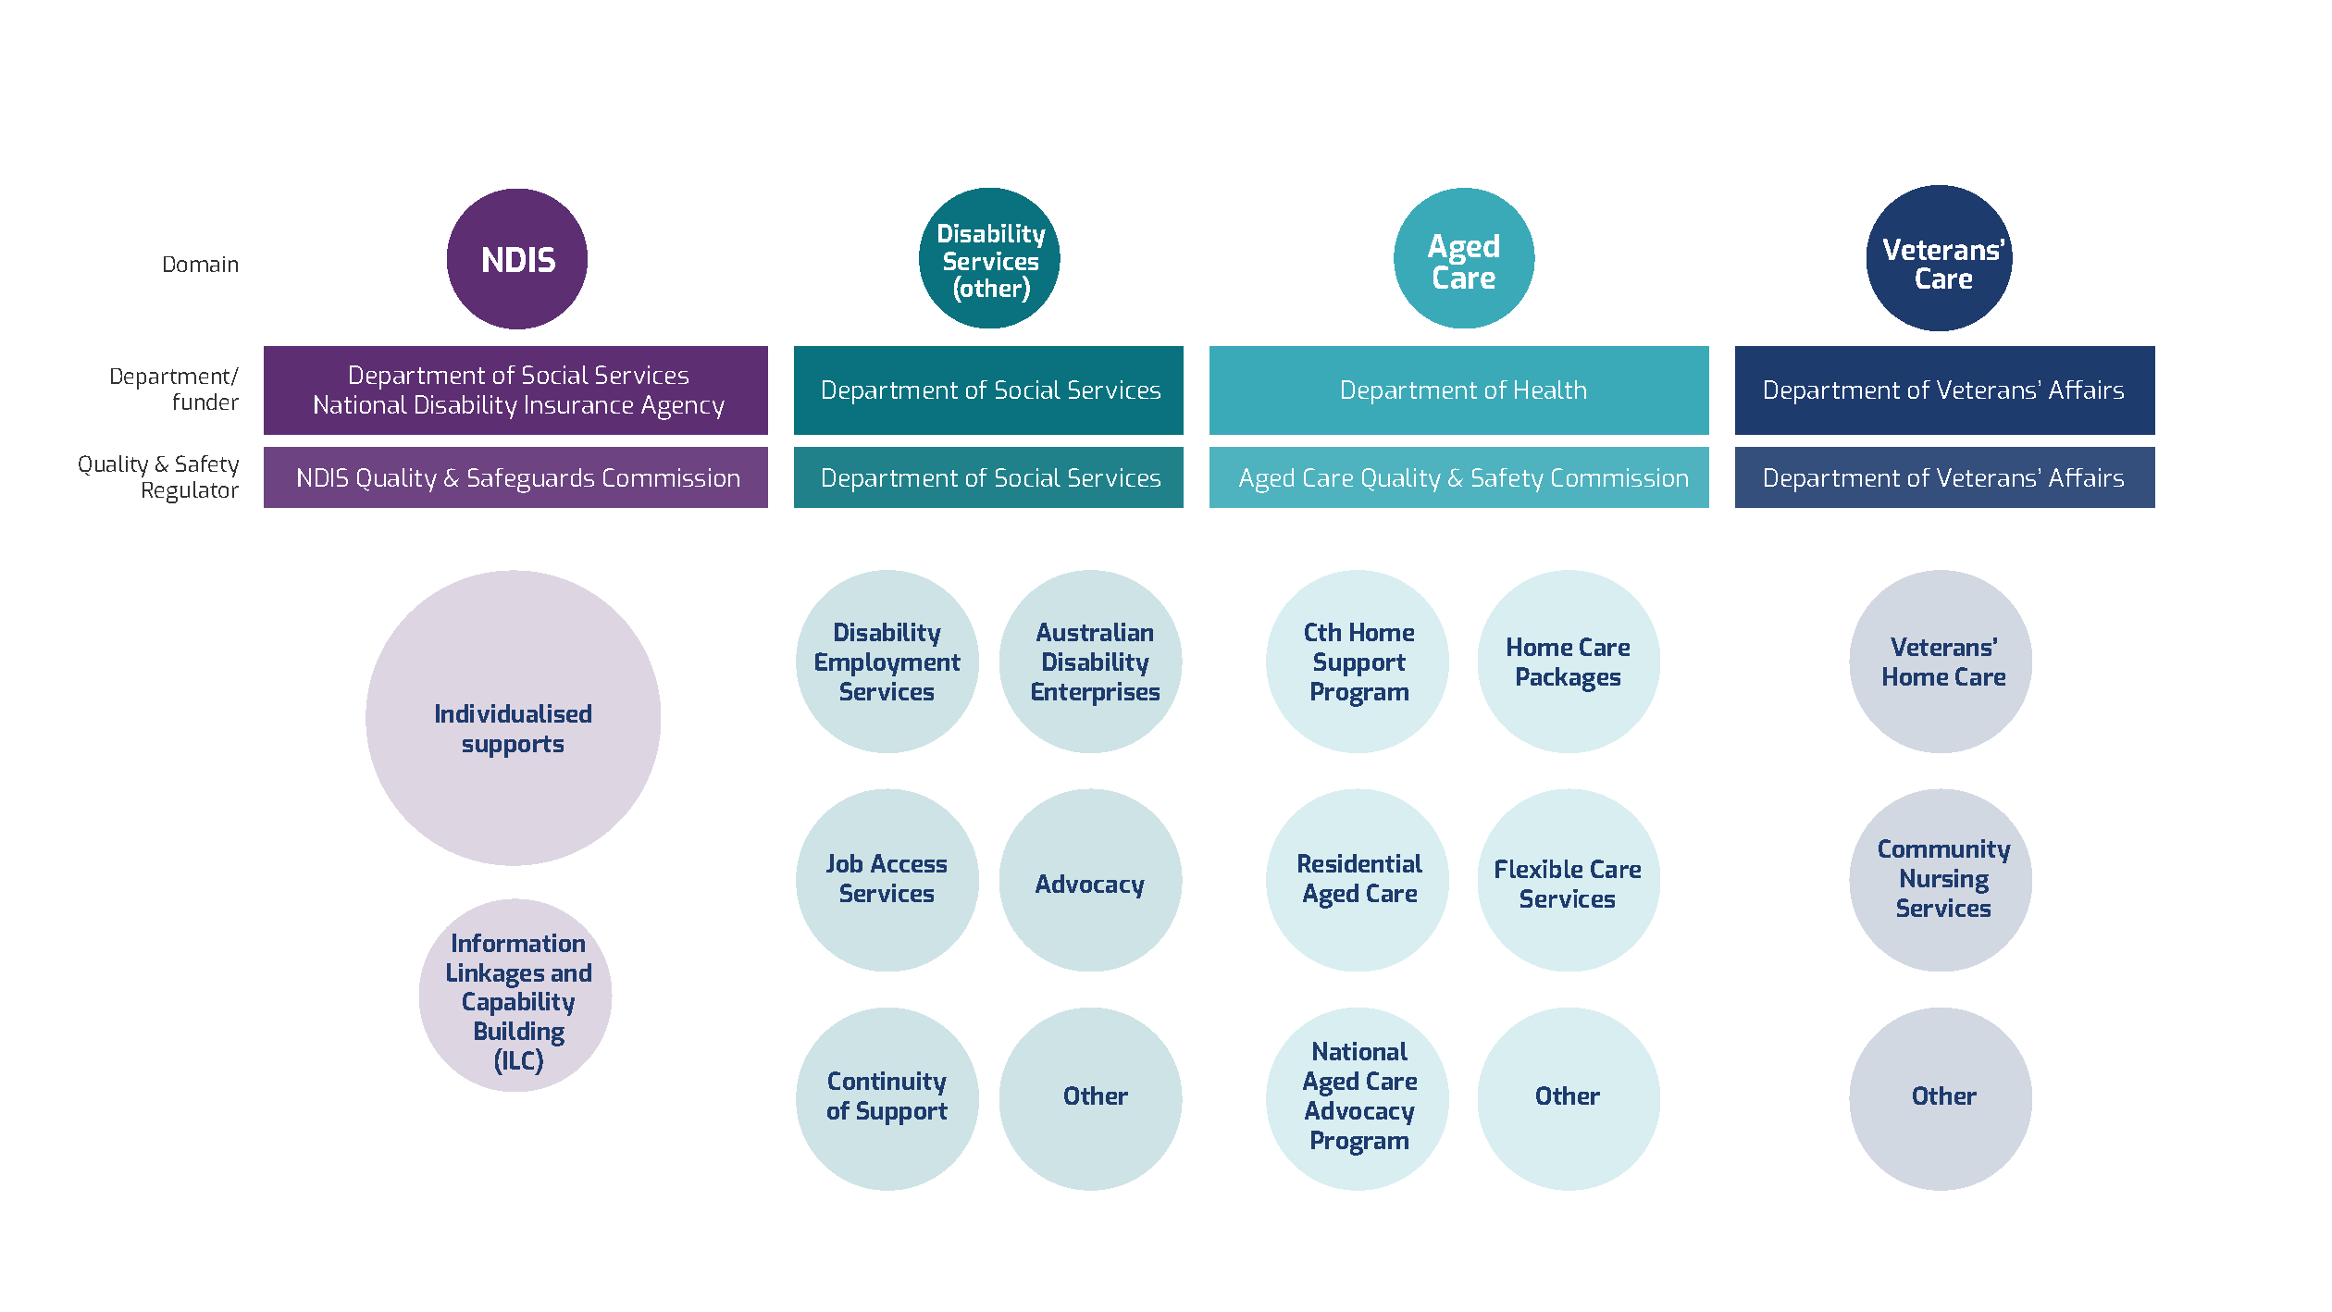

### Aged Care

Aged care in Australia includes supports with everyday living, health care, accommodation and equipment for older people in their own home, in the community, or in a residential aged care setting. In 2019–20, over 1.3 million people received some form of aged care. Programs funded by the Commonwealth include Residential Aged Care, the Commonwealth Home Support Program, Home Care Packages, Respite Care, and flexible care services. Aged care is regulated by the Department of Health and the Aged Care Quality and Safety Commission (ACQSC).

### NDIS and other disability services

The NDIS is Australia’s first national Scheme for people with disability. Under the NDIS, eligible people with a permanent and significant disability are provided with personalised budgets, enabling them to exercise choice and control over supports and services that help them in their daily life, to participate in the community and to reach their goals. There were 391,999

active NDIS participants at the end of the 2019-20 year, which grew to 466,619 at the end of 2020-21. Quality and safety in the NDIS is regulated by the NDIS Quality and Safeguards Commission (NDIS Commission) and the Scheme is operated by the National Disability Insurance Agency (NDIA).

Not all people with disability are eligible for the NDIS and some other disability supports continue to be funded by Commonwealth, state and territory governments, largely through grant-based programs. Some states and territories also continue to directly provide supports and services to people with a disability. Commonwealth disability service programs include Disability Employment Services (support to help people with disability find and keep a job) and disability advocacy services.

The National Disability Strategy 2010-2020 agreed by Commonwealth, state and territory governments, is a framework for Australia to meet its obligations under the United Nations Convention on the Rights of Persons with Disabilities (CRPD), and sets out strategies to enable people with disability to fulfil their potential as equal citizens. These strategies include ensuring mainstream supports are inclusive and accessible so people with disability can participate in all areas of Australian life. A new Strategy, ‘Australia’s Disability Strategy 2021- 2031’, will be released in late 2021 once formally endorsed by all governments.

### Veterans’ care

The Department of Veterans’ Affairs (DVA) funds a range of services to support the health and wellbeing of veterans and their families, including Veterans’ Home Care, Community Nursing and other related services. These care programs are administered by DVA through contractual arrangements and require service providers to comply with other government standards and professional regulatory frameworks. In 2019-20, there were 250,611 DVA clients with entitlement for health and care services, with 39,816 receiving Veterans’ Home Care and 14,126 receiving community nursing services.

## The challenge

Similar services are provided across aged care, disability support and veterans’ care, yet there are separate and overlapping regulatory frameworks. There are also different objectives and outcomes sought for Australians who access these services, but at the centre is the health, safety and wellbeing of the person receiving services. Providers that operate in these sectors often have a focus on improving the lives of Australians who may be more vulnerable to risk than other people in their community. While some differences across settings are appropriate, duplication in regulatory requirements may be a barrier to consistent quality and safety for consumers and participants. It may also be a barrier to the overall efficiency of the market, add to providers’ costs and discourage market development and growth.

For example, approximately 36 per cent of providers operating in the aged care sector also provide services in the disability support or veterans’ care sectors. This is less so for NDIS providers, which may be due to the diversity of the NDIS population, which includes people of all ages, and the many smaller providers operating in the NDIS. Of the providers operating in key veterans’ care programs, including community nursing and home care services, most providers operate in other sectors too.

Figure 2 below shows how provider activities in the aged care, disability support and veterans’ care sectors cross over.

Figure 2: Overview of Australia’s care and support sectors

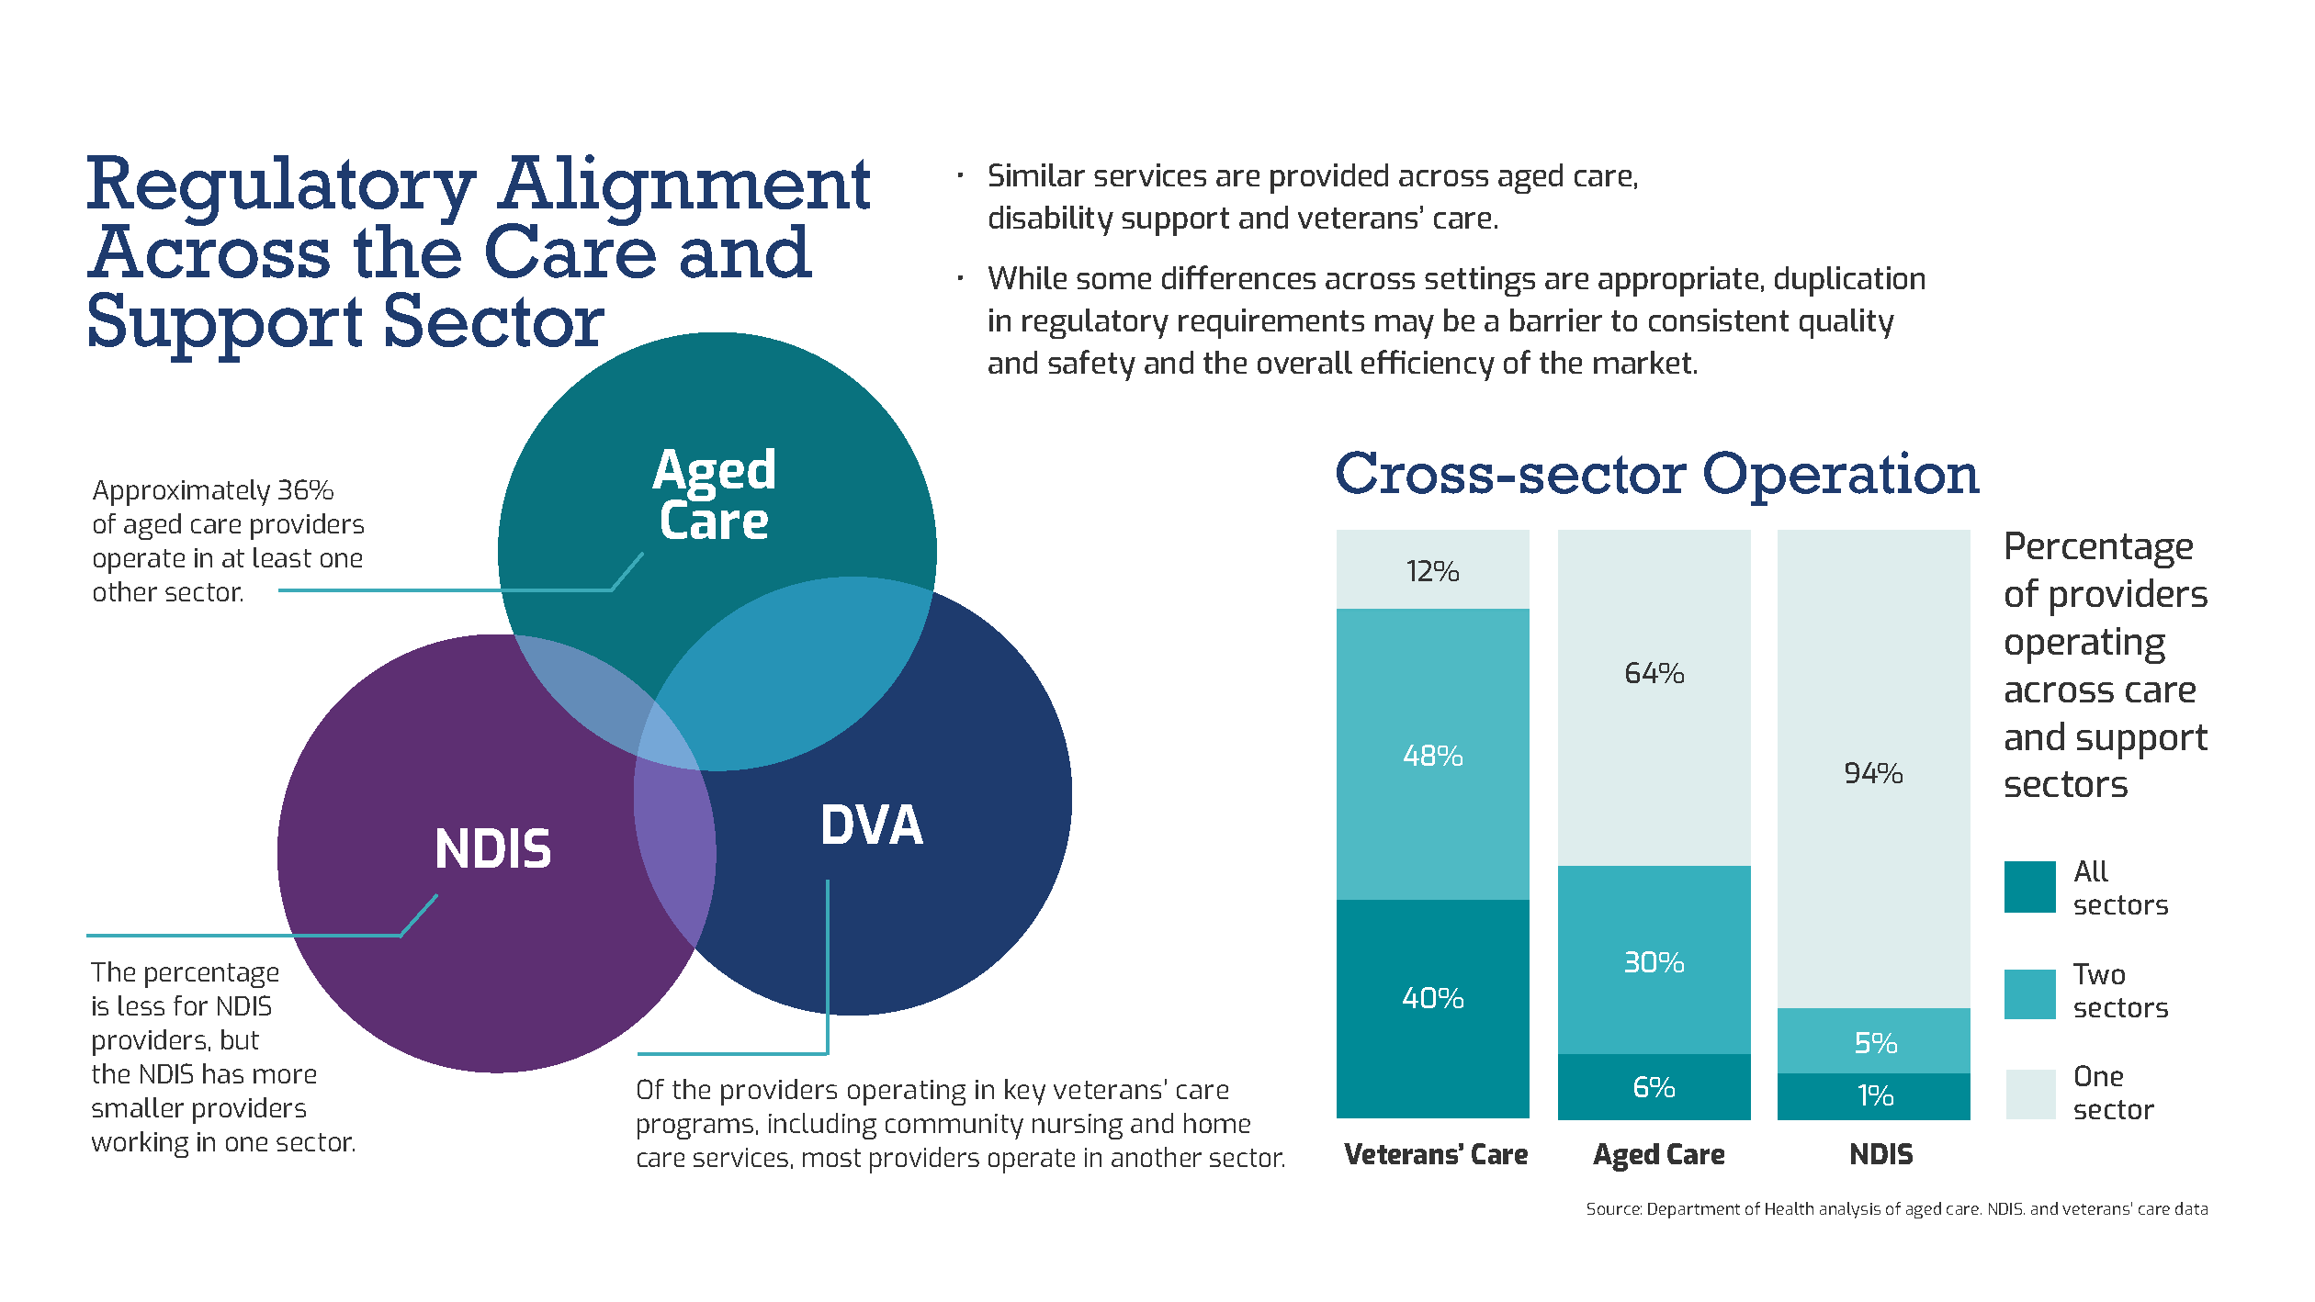

# Cross-Agency Taskforce on Regulatory Alignment

To align regulation across the care and support sectors, the Government has established the Cross-Agency Taskforce on Regulatory Alignment (the Taskforce). The Taskforce includes representation from:

* the Department of Health
* the Department of Social Services
* the Department of Veterans’ Affairs
* the NDIS Quality and Safeguards Commission, and
* the Aged Care Quality and Safety Commission.

## Guiding principles

These are the principles the Taskforce will use to guide the approach to aligning regulation:

1. uphold the rights of, and promote the health, safety and wellbeing of any person receiving services across the care and support sectors
2. align regulations where we can, unless there is a particular reason not to because of differences across settings
3. recognise there are strengths and opportunities for improvement in each sector
4. create efficiencies in regulatory systems, and avoid duplication and unnecessary regulatory effort, while not diminishing protections for any Australians receiving care or supports
5. be evidence-based, using best practice approaches that are proportionate to the level of risk
6. ensure there are appropriate quality and safeguards protections in place for participants and consumers
7. drive continuous improvement in provider and worker conduct and performance across the sectors
8. promote equity and choice in service access and person-centred care and supports
9. implement a collaborative and innovative consultation approach.

## Short-term alignment

The Government has already identified a number of shorter-term activities to align care and support sector regulation, including:

* changing laws to improve how regulators share information, and aligning the compliance and enforcement powers between regulators
* exploring ways to align requirements for behaviour support and restrictive practices to better protect people who receive care and support
* trialling combined assessments/audits for aged care and the NDIS, reducing costs for providers while still achieving the goals of the audit and assessment processes
* reviewing standards to work towards a shared core set of care and support standards
* assessing quality and safeguarding in grants, procurement and panels and looking for ways to align requirements and processes
* reviewing the regulatory frameworks and looking for ways to align registration and accreditation processes to make it easier for providers to expand across the care and support sectors
* a Care and Support Worker Screening Check to screen workers to avoid risk of harm, while making it easier for workers to work across the care and support sectors
* a common Code of Conduct to establish common foundational obligations for providers and workers

## Roadmap for medium to long term alignment

The focus of the Taskforce is to also develop a roadmap for medium to longer term regulatory alignment (the Roadmap), to be presented to Government in 2022. The Roadmap will outline the outcomes we are seeking from regulatory alignment and the steps to achieve them.

The options for medium to long term alignment are open, with no set plan for what is to be achieved. Options might include, for example, aligning approval or registration systems for providers. Or they may be as simple as streamlining the reporting of information to multiple regulators – reporting once to meet multiple obligations.

The Taskforce will consult with stakeholders from across the care and support sectors to inform the regulatory alignment steps and outcomes. The various stakeholder perspectives will provide guidance and direction to ensure the best outcomes are achieved.

Figure 3: Overview of the consultation process

Figure 3: Overview of the consultation process
Stage 1 - Discover
Stage 2 - Describe and refine
Stage 3 - Share

The Roadmap consultation process will include the short-term alignment activities and will consider related regulatory reform projects as relevant to regulatory alignment.

## Related regulatory reform projects

The Taskforce’s cross-sector reform work is running alongside a program of regulatory reforms and reviews in each of the care and support sectors, including significant reforms to aged care. The Taskforce is working closely with teams across the agencies and departments leading this work to identify opportunities for regulatory alignment.

### Aged care reforms and reviews

The Government is committed to delivering aged care reforms that provide high quality and safe care for senior Australians. The aged care system will be simpler to navigate, with new face-to-face services to help people access care.

The Government’s reforms will deliver aged care that Australians can have confidence in, with stronger regulation of the care a person receives, and increased transparency and reporting to hold providers to account and help senior Australians make informed choices. Aligning regulation across Australia’s care and support sectors will support this work. Key aged care reform projects that relate to aligning regulation include:

* [Design of a new Aged Care Act](https://www.health.gov.au/sites/default/files/documents/2021/05/governance-pillar-5-of-the-royal-commission-response-a-new-aged-care-act.pdf)

The Australian Government is developing a new Aged Care Act to underpin fundamental and generational reform across aged care.

* [Redesign of in-home and community care for older people requiring care](https://www.health.gov.au/sites/default/files/documents/2021/05/home-care-pillar-1-of-the-royal-commission-response-future-design-and-funding.pdf)

New Support at Home Program to be designed and implemented to support senior Australians to stay in their homes and keep connected to their communities.

* [Behaviour support and restrictive practices](https://www.health.gov.au/sites/default/files/documents/2021/05/residential-aged-care-quality-and-safety-pillar-3-of-the-royal-commission-response-strengthening-provider-quality.pdf)

Reforms to strengthen regulation of restraint (restrictive practices) and enhance behaviour support capability in residential aged care, including through legislation introduced in September 2021 and the appointment of a Senior Practitioner to the ACQSC to lead education of providers and provide an independent review mechanism.

* [Serious Incident Response Scheme](https://www.agedcarequality.gov.au/sirs)

Expansion of the Serious Incident Response Scheme (SIRS) from residential care into home and community care. SIRS sets new arrangements for providers to manage, prevent and report serious incidents, with a focus on the safety, health and well-being of aged care consumers.

* [Quality indicators and star ratings](https://www.health.gov.au/sites/default/files/documents/2021/05/residential-aged-care-quality-and-safety-pillar-3-of-the-royal-commission-response-empowering-consumers-of-aged-care-with-information-to-exercise-choice.pdf)

A simple ‘at-a-glance’ Star Rating on My Aged Care for residential aged care services, the National Aged Care Mandatory Quality Indicator Program to report crucial measures of care in the home, and additional quality indicators across critical care areas in residential care.

* [Aged Care Standards Review](https://www.health.gov.au/health-topics/aged-care/aged-care-reforms-and-reviews/royal-commission-into-aged-care-quality-and-safety/review-of-the-aged-care-quality-standards)

Review of the aged care standards, as well as development by the Australian Commission on Safety and Quality in Health Care of strengthened clinical care standards.

### NDIS reforms and reviews

There are a number of reviews that will inform future reform of the NDIS.   
These include:

* NDIS Quality and Safeguarding Framework Review

The NDIS Quality and Safeguarding Framework Review will identify any changes and adjustments to the Framework to address quality and safeguarding gaps, and identify longer term reforms to the Framework to ensure it is fit-for-purpose in current market and NDIS policy conditions. This will inform future regulatory reforms that may be required and inform the care and support regulatory alignment measure.

* [Robertson Review](https://www.ndiscommission.gov.au/document/2101)

This review was commissioned by the NDIS Quality and Safeguards Commission into the NDIS Commission oversight and the death of Ann-Marie Smith. Most of the recommendations have been addressed and further consideration of the recommendations is being undertaken that will inform potential future reforms.

* [Joint Standing Committee into the NDIS](https://www.aph.gov.au/Parliamentary_Business/Committees/Joint/National_Disability_Insurance_Scheme)

The Committee has undertaken a number of inquiries since its establishment in 2019 in relation to the implementation and performance of the NDIS as well as individual cases. The Government has responded to a number of final reports from the Committee that outline activities and actions undertaken, being undertaken or will be undertaken to respond to these inquiries.

* [Royal Commission into Violence, Abuse, Neglect and Exploitation of People with Disability](https://disability.royalcommission.gov.au/)

The Royal Commission was established in April 2019 and will deliver its final report to the Government by 29 September 2023. Recommendations from the Royal Commission will be considered by Government following receipt of the final report.

### Veterans’ care reforms and reviews

DVA is participating in the broader reforms across government for the care and support sectors relating to veteran services, as well as the following:

* [Royal Commission into Defence and Veteran Suicide](https://defenceveteransuicide.royalcommission.gov.au/)

The Royal Commission was established in July 2021 and is required to produce an interim report by 11 August 2022 and a final report by 15 June 2023.

* Review of veterans’ care and support

DVA is undertaking a comprehensive review of Veterans’ Home Care, community nursing and related programs to consider options to address existing price regulations, harmonise program structures, and consider the implications of broader reforms proposed across the care and support sectors; in particular, reforms to aged care in-home support programs.

# Engaging on a future state

## The approach to consultation and engagement

The consultation approach recognises the importance of ongoing stakeholder input and collaboration toward developing the Roadmap. To ensure a staged consultation approach in developing and delivering a Roadmap for regulatory alignment that reflects stakeholder sentiment and the broader community’s input, the Taskforce is committed to:

* bringing people from all sectors together, building trust and prioritising relationships
* slowing down to listen, facilitating discovery and conversations
* recognising complexity, solving problems and designing solutions
* delivering outcome focussed consultation through tailored and targeted discussion
* presenting inclusive opportunities to engage on the work by offering choice through multiple platforms and multiple sessions for participation
* recognising stakeholder diversity across sectors with a broad representation from consumer groups including people from culturally and linguistically diverse backgrounds and Aboriginal and Torres Strait Islander people.

The three stages of the consultation approach are illustrated in Figure 4.

Figure 4: The Roadmap consultation process

Road Map process
Stage 1 Discover and develop. Define problems and gain insights.
Stage 2 Describe and define potential solutions
Stage 3 Share consultation findings and the delivery of solutions that work

# Next steps

**The Taskforce invites you to participate in upcoming consultation processes. There will be a number of ways you can participate, these will include:**

* provide a written submission
* respond to a survey
* take part in a workshop
* ask to be interviewed – to share your experience as a cross-sector consumer, provider or worker.

It is expected that consultations will commence in October 2021. For further information please visit the website [https://www.health.gov.au/initiatives-and-programs/aligning-](https://www.health.gov.au/initiatives-and-programs/aligning-regulation-across-the-care-and-support-sectors) [regulation-across-the-care-and-support-sectors](https://www.health.gov.au/initiatives-and-programs/aligning-regulation-across-the-care-and-support-sectors) or email [RegulatoryAlignmentTaskforce@](mailto:RegulatoryAlignmentTaskforce@health.gov.au) [health.gov.au](mailto:RegulatoryAlignmentTaskforce@health.gov.au)

If you wish to get involved in consultations for any related regulatory projects, for example worker regulation as it relates to worker screening, further information will become available on the Engagement Hub located at <https://agedcareengagement.health.gov.au/>

## Contact us

For further information please visit the website [https://www.health.gov.au/initiatives-and-](https://www.health.gov.au/initiatives-and-programs/aligning-regulation-across-the-care-and-support-sectors) [programs/aligning-regulation-across-the-care-and-support-sector](https://www.health.gov.au/initiatives-and-programs/aligning-regulation-across-the-care-and-support-sectors)s or email [RegulatoryAlignmentTaskforce@health.gov.au](mailto:RegulatoryAlignmentTaskforce@health.gov.au)