Aged Care Financing Authority

Ninth report on the Funding and Financing of the Aged Care Sector

June 2021

Contents

Foreword 1

Executive Summary 3

1. This report 10

1.1 Aged care in Australia 10

1.2 About the Aged Care Financing Authority 10

1.3 The Annual Report on the Funding and Financing of the Aged Care Sector 11

1.3.1 Methodology 11

1.3.2 Navigating the 2021 annual report 14

2. Aged care in Australia 15

2.1 Overview 15

2.2 Current aged care 16

2.3 Australian Government expenditure on aged care 19

2.4 Consumer contributions 20

2.5 Aged care providers 21

2.6 Aged care workforce 23

2.7 Aged care reforms 25

2.7.1 Future reform following the Royal Commission 26

3. Access to aged care 29

3.1 Supply of subsidised aged care 29

3.2 Aged Care Approvals Round 31

3.3 Access to aged care 32

3.4 Access to home care 32

3.4.1 Release of home care packages 33

3.4.2 Demand for home care packages 34

3.4.3 Length of stay in home care 34

3.5 Access to residential care 36

3.5.1 Occupancy in residential care 36

3.5.2 Admissions to residential care 39

3.5.3 Length of stay in residential care 40

3.6 Residential respite care 42

3.6.1 Length and frequency of stay in residential respite care 43

3.6.2 High and low residential respite care 44

3.7 Supported residents 45

3.8 Age profile across care types 46

3.9 Access by Culturally and Linguistically Diverse and Indigenous Australians 48

3.9.1 Culturally and Linguistically Diverse Australians 48

3.9.2 Indigenous Australians 49

3.10 Looking ahead 50

4. Home support 51

4.1 Introduction 51

4.2 Consumers of the CHSP 51

4.3 Providers of the CHSP 54

4.4 Funding for the CHSP 54

4.4.1 Consumer contributions 57

4.5 Looking ahead 57

5. Home care 58

5.1 Overview of the sector 58

5.1.1 The Home Care Packages Program 58

5.1.2 Providers and consumers of home care 59

5.2 Operational performance 62

5.2.1 Methodology 62

5.2.2 Analysis of 2019-20 financial performance of home care providers 63

5.2.3 Revenue 64

5.2.4 Expenditure 67

5.2.5 Profit 69

5.2.6 Unspent funds 73

5.3 Developments in 2020-21 and looking ahead 74

6. Residential care 75

6.1 Overview of the sector 76

6.1.1 Supply of residential care 76

6.1.2 Residential care providers 77

6.1.3 Ownership type 78

6.1.4 Provider scale 79

6.1.5 Provider location 80

6.1.6 Residential care facility size and room configuration 80

6.1.7 Provisionally allocated places 81

6.1.8 Extra service 83

6.1.9 Additional services 84

6.2 Residential care funding sources 85

6.2.1 Operational funding 85

6.2.2 Commonwealth operational funding 86

6.2.3 Basic care subsidies 87

6.2.4 Residential care supplements 87

6.2.5 Payments for residential respite care 89

6.2.6 Resident operational funding 90

6.3 Operational performance in 2019‑20 90

6.3.1 Revenue 90

6.3.2 Expenses 95

6.3.3 Financial results 99

6.3.4 Developments in 2020-21 and looking ahead 108

7. Residential care: capital investment 109

7.1 Capital financing 109

7.1.1 Residents as a source capital 110

7.1.2 Commonwealth as a source of capital 110

7.1.3 Other sources of capital finance 111

7.2 Accommodation deposits 111

7.2.1 Accommodation deposit prices 115

7.3 Financing status - balance sheet 116

7.3.1 Balance sheet analysis by ownership type 118

7.3.2 Balance sheet performance ratios 121

7.3.3 Recent trends in building and investment in residential care 127

8. Future demand for aged care 129

8.1 Future demand for aged care services 129

8.1.1 Determinants of demand 129

8.1.2 An ageing population – older people demand more aged care 130

8.1.3 Consumer preference 131

8.1.4 Availability of alternative care types 132

8.1.5 Economic factors 133

8.2 Current demand for aged care 133

8.2.1 Residential care 134

8.2.2 Home care 134

8.3 Projecting future demand 135

8.3.1 Substitution of residential care and home care 135

8.3.2 Updated projections 137

8.3.3 Planning for the supply of aged care 138

8.4 Investment requirements for residential care 139

8.5 The investment environment 141

8.5.1 Access to capital 142

9. A reflection, then looking ahead 143

9.1 A reflection on change to date 143

9.2 Looking ahead 144

9.2.1 Attributes of a sustainable aged care system 145

9.2.2 Financial pressures and long-term sustainability 146

9.2.3 Consumer choice and investment 147

9.2.4 Workforce 148

9.2.5 Governance 149

9.2.6 Prudential oversight 150

9.3 Conclusion 150

Appendix A: ACFA Membership 152

Appendix B: ACFA reports and Submissions 153

Appendix C: ACFA’s stakeholder engagement 154

Appendix D: Aged care workforce 155

Appendix E: Means testing arrangements 157

Appendix F: Financial ratios by provider ownership type 160

Appendix G: Residential care subsidies and supplements 164

Appendix H: Residential care subsidies and supplements rates 166

Appendix I: Residential care financing structures and balance sheets 170

Appendix J: Home care revenue and expenditure 172

Appendix K: Home care subsidies and supplements 175

Appendix L: Residential care and home care financial data 178

Appendix M: References 179

Glossary 181

# Foreword

I am pleased to present the Aged Care Financing Authority’s (ACFA) 2021 Report on the Funding and Financing of the Aged Care Sector. This is ACFA’s ninth annual report. Following announcements flowing from the Government’s May 2021 Budget response to the Royal Commission into Aged Care Quality and Safety, this will be ACFA’s final report and as at 30 June 2021 ACFA ceased to operate.

ACFA’s ninth annual report comes at a crucial time for the aged care sector in Australia following the final report of the Royal Commission into Aged Care Quality and Safety in February 2021 and the Government’s response through the May 2021 Budget. The Government has announced $17.7 billion of additional funding for aged care over the next four years to 2024-25 as well as significant structural changes. These announced changes come on the back of the COVID-19 pandemic which caused significant upheaval and cost to aged care providers and consumers, as it did the entire community, and which has the potential to continue to do so.

This report is based largely on the financial performance of providers for 2019‑20. The COVID-19 pandemic started to affect the community late in 2019‑20 so the effects, while somewhat evident in 2019‑20, were more prominent in 2020‑21.

In last year’s annual report, ACFA noted the uncertainty being felt by aged care providers from not only COVID-19 but uncertainty over the possible findings of the Royal Commission and more importantly the Government’s response. The residential aged care sector was also facing a significant deterioration in its financial position, which deepened in 2019-20, for which there was no immediate relief in sight.

The Government’s response in the May 2021 Budget to the Royal Commission’s recommendations provides a platform for a better resourced sector, but with an expectation of a significant improvement in the quality of care and quality of life that the sector provides older Australians. The operating environment for individual providers will become more competitive as consumer choice and control is increased and providers are exposed to significantly increased regulatory, accountability, transparency and prudential requirements.

Providers with the capacity to adapt to the new operating environment can expect to do well under the new arrangements. Providers who are slow to adjust to the new environment, or fail to improve their performance, will have to reconsider their future role in the sector.

Most of the more transformative changes that have been announced, development of which was already in train for several years, are subject to considerable design development, consultative processes and implementation risks which will need to be successfully negotiated before the potential benefits for future older Australians will be realised.

Under current arrangements, the announced reforms will also add significantly to the cost of future aged care services for Government, and therefore future taxpayers, and raises concerns about the sustainability of future aged care services which remain to be resolved.

Securing a sufficient, well trained and empathetic workforce will need ongoing and priority attention by Government, training institutions and providers.

Overall, the outlook for aged care providers is demanding but holds significant promise for efficient providers who deliver quality aged care services.

As this is ACFA’s final annual report, I am also taking this opportunity to reflect on the role and achievements of ACFA.

ACFA was established as a statutory committee in 2012 in response to the Productivity Commission’s Report *Caring for Older Australians* whose recommendations for reforming aged care included the creation of an independent regulatory body to report on the costs of delivering aged care services and transparently recommend a schedule of prices and subsidies for aged care services.

The role given to ACFA stopped short of recommending prices and subsidies. ACFA instead was tasked with providing independent and transparent annual advice to the Minister responsible for aged care on the funding and financing of the aged care sector. This included advice on the viability and sustainability of the aged care sector; the ability of aged care consumers to access quality aged care; the aged care workforce; and on any other matters referred by the Minister.

Feedback from the sector has confirmed that ACFA’s annual reports have become a valuable source of information and analysis for the sector, and ACFA’s reports on issues referred by the Minister for advice have informed Government and the sector on the operation of the aged care sector and reforms to improve aged care services. A list of the reports on issues referred by the Minister is provided at Appendix B.

In its May 2021 Budget following the Royal Commission into Aged Care Quality and Safety, the Government announced that it will now establish independent and transparent processes for determining aged care prices, as originally recommended by the Productivity Commission. This is to be achieved by extending the role of the Independent Hospital Pricing Authority, complemented by a new National Aged Care Advisory Council. ACFA urges that these arrangements provide for the continuation and further development of ACFA’s work, including an annual report on the funding and financing of the aged care sector, because it provides a valuable insight into and understanding of the operations and finances of the aged care sector to inform future policy.

In concluding, I would acknowledge the contribution to the work of ACFA of its past and current members, and in particular ACFA’s two substantive Chairs, Lynda O’Grady and Mike Callaghan AM PSM. A special acknowledgement and thank you also to the small Secretariat in the Commonwealth Department of Health who have ably supported the work of ACFA.

Signature of Nicolas Mersiades
Acting Chair
Aged Care Financing Authority


Nicolas Mersiades

Acting Chair  
Aged Care Financing Authority

# Executive Summary

Aged care in Australia

In 2019-20, Government subsidised aged care services were provided to over 1.3 million people. The majority of these received services through the three major programs discussed in this report: The Commonwealth Home Support Programme (CHSP), the Home Care Packages Program and residential care. It is estimated that by 2023‑24 around 1.5 million people will be accessing subsidised aged care services. Many older Australians continue to purchase support services on the open market and/or receive assistance from volunteers and charitable organisations.

Australian Government expenditure on aged care in 2019-20 was $21.2 billion, up from $19.9 billion in 2018-19. This is projected to increase to over $27 billion by 2023‑24. The aged care sector makes a significant contribution to the Australian economy, currently representing 1.2 per cent of Gross Domestic Product (GDP).

In 2019-20, subsidised aged care services were provided by:

* 1,452 CHSP providers (1,458 in 2018-19);
* 920 home care providers (928 in 2018-19); and
* 845 residential care providers (873 in 2018-19).

Consumer expenditure on aged care was around $5.4 billion in 2019-20 (excluding refundable accommodation deposits), compared with $5.1 billion in 2018‑19. Fees for everyday living expenses in residential care (the basic daily fee) represents two-thirds of consumer expenditure.

There are over 366,000 paid workers in aged care with a further 68,000 volunteers[1].

Access to aged care

In 2019-20 the number of home care consumers continued to increase significantly, up to 173,743 from 133,439 in 2018-19, an increase of 30 per cent.

The number of consumers of residential care increased from 242,612 in 2018-19 to 244,363 in 2019-20.

The number of CHSP consumers in 2019-20 was 839,373, the second year that the CHSP operated as a fully national program. This was down slightly from 840,984 in 2018‑19.

Since the Living Longer Living Better (LLLB) reforms in 2012, the Government’s overall aged care provision target ratio was being adjusted to progressively increase from the target of 113 operational places per 1,000 people aged 70 and over that applied prior to 2012 to 125 by 2021‑22. Over the same period the target for home care packages was increasing from 27 to 45, while the residential care target will reduce from 86 to 78. The remaining two places are for the Short Term Restorative Care Programme (STRC).

ACFA notes the significant number of additional home care packages that have been released in recent years in response to increasing consumer preference to remain at home and the large number of people in the National Prioritisation System. These recent increases have already resulted in the target of 45 home care places being exceeded, with an achieved ratio of 53.6 mainstream packages available per 1,000 people aged 70 and over at 30 June 2020.

The Government has accepted in-principle the Royal Commission’s recommendation that service planning be based on need, not rationed, but added that the structure of the future planning regime, including the role of the aged care provision ratio or another mechanism, will be determined as part of the design for a new support at home program which will combine CHSP and home care packages. The release of a further 80,000 packages by June 2023 in response to the Royal Commission will allow the current home care provision target to continue to be exceeded until the new combined support at home program is introduced.

The proportion of people using home care and residential care at age 85 and over is more than three times that of people aged 70 and over, as has been the case in recent years.

During 2019-20, across all residential care, access to services for supported residents (excluding residents receiving extra services) was stable, as has been the case in previous years.

In residential care, average occupancy continues to fall, down to 88.3 per cent in 2019‑20 from 89.4 per cent in 2018-19 and 90.3 per cent in 2017‑18. It was noted in last year’s annual report that the spread of COVID-19 could impact occupancy rates. While there were some short‑term effects in 2019-20, and noting that some COVID-19 impact would also have been felt in 2020‑21, it does not appear that overall occupancy across the sector has been affected, noting that the gradual downward trend was already evident and has continued in 2019‑20. Nevertheless, some providers with services in areas that experienced high levels of community transmission will have incurred more pronounced reductions in occupancy.

ACFA also notes that initial data from the Department of Health indicates that the gradual decline in occupancy has continued in the first half of 2020‑21. This is also supported by the December 2020 quarterly report that StewartBrown produce, which reported that, based on their provider survey group, occupancy has continued to fall slightly in the six months to December 2020.

Commonwealth Home Support Programme (CHSP)

In 2019-20 the CHSP provided services to 839,373 older Australians. Total Australian Government expenditure on the CHSP in 2019-20 was $2.8 billion, which included emergency COVID-19 funding and $158.1 million to My Aged Care, Regional Assessment Services and other initiatives in support of the CHSP, with $2.6 billion being for service delivery.

As part of its Budget announcements in response to the final report of the Royal Commission, the Government re-affirmed its intention, first announced in 2016, to move towards a single unified system for care of older people at home by 2023. The unified system will combine the existing CHSP and the Home Care Packages Program.

Home care

Australian Government expenditure on home care packages in 2019-20 was $3.4 billion, up from $2.5 billion in 2018‑19. Services were provided to 173,743 consumers, up from 133,439.

* Consumers of home care contributed $102 million toward the cost of their care through the basic daily fee and income tested fees.

At 30 June 2020, the number of operational home care providers was 920, down slightly from 928 at 30 June 2019. The slight decline follows three years of significantly increasing numbers of providers of home care.

Not-for-profit providers continue to be the largest provider group in the home care sector, with 52 per cent, stable from 2018-19. Sixty-eight per cent of consumers had their home care package with not‑for‑profit providers at 30 June 2020, down from 72 per cent in 2018‑19.

Seventy-two per cent of home care providers achieved a net profit in 2019‑20, up from 69 per cent in 2018‑19. Across the sector, providers achieved an average EBITDA of $1,369 per consumer, up from $1,211 in 2018‑19 and $1,217 in 2017‑18. This is still significantly lower than the three years up to 2016‑17 which saw EBITDA of around $3,000 per consumer. The decline in EBITDA since 2016-17 coincides with the assignment of home care packages to consumers from 27 February 2017 and a significant increase (85 per cent) in the number of approved home care providers.

The for‑profit providers, after being the strongest performing provider group up to 2016‑17, reported by far the worst results for the third year in a row, albeit with improved performance compared with 2018‑19. The for‑profit providers recorded average EBITDA per consumer of $1,063 ($728 in 2018‑19) compared with $1,463 reported by the not-for-profit providers ($1,320 in 2018‑19).

Unspent funds continued to increase significantly in 2019‑20 with home care providers holding $1.2 billion at 30 June 2020, an increase of almost 60 per cent from $751 million at 30 June 2019. ACFA noted in last year’s report that based on the rate at which unspent funds were increasing, unspent funds could be around $1 billion by 30 June 2020. The change in February 2021 to subsidy payment arrangements which resulted in home care subsidies and supplements to home care providers being paid in arrears rather than in advance, to be followed in September 2021 by payment in arrears for services provided, will eventually lead to the Commonwealth holding the unspent funds, rather than the provider.

Residential care

Australian Government expenditure on residential care in 2019-20 was $13.4 billion, up from $13.0 billion in 2018‑19. Services were provided to 244,363 residents. At 30 June 2020 there were 217,145 operational places, up from 213,397 at 30 June 2019.

In 2019-20, residents contributed $3.6 billion toward their living expenses (the basic daily fee), $646 million towards their care costs (means tested fees) and $845 million towards their accommodation (excluding refundable lump sum accommodation deposits).

* As at 30 June 2020, there were 845 residential care providers, down from 873 in 2018-19, continuing the consolidation of recent years, with the number of residential care places increasing while the number of providers gradually decreases.
* Not-for-profit providers continue to represent the largest proportion of ownership type in residential care, with 56 per cent of providers and 55 per cent of places.
* Residential care providers generated total revenue of $20.5 billion in 2019‑20, up from $19.3 billion in 2018‑19, an increase of 6.4 per cent, equating to revenue of $296.64 per resident per day, an increase of 4.6 per cent from $283.54 in 2018‑19.
* Total expenses in 2019‑20 were $21.3 billion, up from $19.0 billion in 2018-19, an increase of 11.7 per cent, equating to $307.27 per resident per day, compared with $279.65 in 2018‑19, an increase of 9.9 per cent. The increase in costs continues to outstrip the increase in revenue, evident in financial reports since 2017‑18.
* Residential care providers as a whole reported an overall **loss** of $736 million in 2019‑20, compared with a total profit of $264 million in 2018‑19.
* The residential care sector reported average EBITDA per resident of $6,445, down from $8,523 in 2018‑19, a 24.4 per cent decrease. This is the third year in a row of decreasing financial performance, with average EBITDA having decreased by almost 44 per cent since 2017-18.
* ACFA notes the additional funding provided by the Government specifically to assist providers during the COVID-19 pandemic meet the additional COVID‑19 related expenses. Analysis shows that without the additional revenues and expenses reported by providers[2], the average EBITDA would have been $5,950 or a 30.2 per cent decrease, although noting this analysis is dependent on the accuracy of how providers reported their COVID related expenses.

The decline in EBITDA over the years since 2016‑17 has been far greater for providers in the bottom two quartiles (62 per cent and 132 per cent respectively) compared with those in the top two quartiles (17 per cent and 23 per cent respectively), indicating that the better performing providers have weathered the financial pressures of recent years far better.

* ACFA also notes that the December 2020 quarterly report from sector analysts StewartBrown indicates a slight worsening of residential care provider financial performance in the six months to 31 December 2020. The StewartBrown report is based on a survey of around 40 per cent of providers.

Residential care: capital investment

* At 30 June 2020, the residential care sector held total assets of $56.4 billion (up from $52.6 billion) and total liabilities of $44.8 billion (up from $39.0 billion). Total liabilities included $32.2 billion of refundable accommodation deposits, up from $30.2 billion at 30 June 2019.
* Residential care providers recorded an average return on equity of 10.6 per cent in 2019‑20, down from 12.5 per cent in 2018‑19. The average return on assets was 2.2 per cent, down from 3.0 per cent in 2018‑19.

Net worth/total equity as a proportion of assets decreased to 20.5 per cent after being around 24‑26 per cent for the previous four years. This decrease was a direct result of the sector making a large loss ($736 million) in 2019-20.

* As at 30 June 2020, $5.7 billion of building works were either completed or in-progress compared with $5.3 billion at 30 June 2019. However, planned building activity remained significantly lower for the third year in a row compared with the previous years. The deteriorating financial performance of providers as well as uncertainty associated with the Royal Commission into aged care has likely contributed to depressed investment intentions.

Future demand for aged care

While average occupancy in residential care has been trending down in recent years, in the longer term the demand for all aged care services and support required by older Australians, including subsidised services, will continue to expand with the ageing of the population.

It is not currently possible to accurately measure demand or to reliably establish consumer preference for residential and home care, due to existing supply constraints. The announcement in May 2021 of an additional 80,000 home care packages on top of what was already planned will significantly reduce unmet demand for home care by 2023. A key challenge to be addressed by the proposed integrated single home care and support program flagged to take effect from 1 July 2023, is to align growth in the availability of care with demand for in-home care that is expected to grow at a faster rate than that allowed for under the current provision target.

The structural ageing of the Australian population over the next 20 years will see the size of the 70 years and over cohort increase by over one million people each decade; this is on a base of 2.8 million people in 2020. Underneath this, the older age groups will more than double over this period; for example, the 85 years and over cohort will increase from around 500,000 people in 2020 to over one million people by 2040.

At the same time that population ageing is putting pressure on the demand for aged care, the relative supply of informal carers is diminishing.

Looking ahead

In recent years, residential care providers have been experiencing an unsustainable deterioration in financial performance, which deepened in 2019‑20. Home care providers have also been experiencing declining financial performance as they adapted to a more competitive operating environment following the assignment of home care packages to individuals rather than to providers.

The prospect of further reform following the Royal Commission, and doubts about the shape and direction that might take, added further uncertainty, while at the same time presenting as a potential opportunity for positive long-term reform to improve the sustainability and quality of aged care services. Nevertheless, this uncertainty and the deterioration in financial performance, together with the demands of managing the COVID-19 pandemic, have resulted in a reluctance by many residential care providers to embark on new investments.

The Government’s response to the Royal Commission’s Final Report is substantial and involves a very significant increase in Government funding and structural change. From the perspective of older Australians, the announced reforms are positive and hold out the prospect of improved access and improved care standards. But these reforms come at a considerable cost. Without reform of consumer funding contributions, the Government and therefore future taxpayers will be facing significant sustainability concerns.

In residential care, the $10 per resident per day Government-funded increase in the basic daily fee should bring some relief for the immeditate future. For the longer term, the ongoing financial viability of residential care providers will be heavily influenced by whether the new Australian National Aged Care Classification (AN-ACC) funding model and the independent and transparent pricing arrangements will result in prices that reflect the cost for efficient providers to deliver quality of care and quality of life outcomes that meet community expectations.

While the Government’s reforms fall short of uncapping the supply of aged care services and ending service rationing, there have been significant steps to increase consumer choice and control. These include the release of an additional 80,000 home care packages, changes to community and residential respite, the assignment of residential care subsidies to individuals, and the prospect of a new home-based care program which extends consumer choice and control.

ACFA also notes that the Government will consider options that could reduce the current dependence on Refundable Accommodation Deposits (RADs) as a mechanism to raise capital in the residential aged care sector, while not putting any timeframe on this. Any move to reduce the current dependence on RADs will need to ensure that providers can access alternative capital, including being able to meet the commercial terms required by financiers and equity investors.

The Government’s response to the Royal Commission includes funding for more training and incentives for aged care workers, and a campaign to attract more workers to the sector. It also has mandated minimum average care staff minutes per resident to apply in residential care from July 2023 and announced a significant increase in home care packages by June 2023. Implementation of these measures within these timeframes will require a greater supply of skilled workers.

ACFA notes that the attraction and retention of a skilled workforce was not fully addressed in the Government’s response to the Royal Commission, with no provision or commitment included in the 2021-22 Budget to improve the remuneration of workers in the sector. Instead, the Government is allowing the current Health Services Union application before the Fair Work Commission to run its course, and to allow the outcome of the application to be addressed under the new independent price determination arrangements. Additionally, with over 30 per cent of residential care workers and over 20 per cent of home care workers born overseas, the prospect of continuing border restrictions will impact on the availability of workers.

The response to the Royal Commission also includes measures that will make management and governance of residential aged care services more demanding, including greater transparency and accountability provisions and increased reporting requirements, as well as increased quality regulatory activities and strengthened prudential requirements. In addition, the increased competitive pressures arising from the removal of the Aged Care Approvals Round (ACAR) from July 2024, more opportunities for older people to choose care at home as a result of the increased supply of home care packages and increased transparency will require providers to be more responsive to consumer preferences in order to succeed.

In combination, the increasingly competitive aged care service environment and greater transparency and accountability will increase pressures already evident for structural adjustment. ACFA has previously noted that some structural adjustment of the sector was likely as a result of reforms already in train, and indeed needed.

Taken together, the changes flowing from the Government’s response to the Royal Commission entail further significant reform and transformation of the aged care sector and a period of significant adjustment for the industry. Most of the more transformative changes are subject to considerable design development, systems development, consultative processes and implementation risk which will need to be successfully negotiated before the potential benefits for older Australians can be realised. Overall, the reforms provide the platform that should allow providers with the capacity to adapt to the new operating environment to do well. Accordingly, the outlook for the delivery of high quality, safe and efficient aged care is promising for older Australians who need publicly subsidised care and support.

The Aged Care Financing Authority and the 2021 Annual Sector Report

# This report

## Aged care in Australia

The aged care sector in Australia provides services to over 1.3 million Australians and generates annual revenues totalling over $25.8 billion[3]. The sector makes a significant contribution to the Australian economy, representing 1.2 per cent of Gross Domestic Product (GDP).

The sector is heavily reliant on taxpayer funding, receiving $21.2 billion in Commonwealth funding in 2019-20, an increase of 6.7 per cent from 2018-19. The majority of the increase was due to the increase in home care consumers, up 30 per cent in 2019‑20 to 173,743 from 133,439 in 2018‑19. There was also an increase of people in permanent residential care, up to 183,989 at 30 June 2020, from 182,705 at 30 June 2019. Almost 66 per cent of total funding ($13.4 billion) was for residential care.

Given the amount of taxpayer funding, objective and thorough analysis of the funding and financing of the sector is of central importance to the Government, aged care consumers and providers.

## About the Aged Care Financing Authority

The Aged Care Financing Authority (ACFA) was established in 2012 as a statutory committee whose role was to provide independent and transparent advice to the Australian Government on funding and financing issues in the aged care sector. ACFA considered issues in the context of maintaining a viable and sustainable aged care sector and accessible services that balance the needs of consumers, providers, the workforce, taxpayers, investors and financiers.

ACFA was led by an independent Chair and Deputy Chair, complemented by seven members with aged care or finance sector expertise. Figure 1.1 shows the ACFA membership and structure as at 30 June 2021. Further details about each member are provided in Appendix A. There were three non-voting Australian Government representatives on ACFA.

Figure 1.1: ACFA Membership[4]

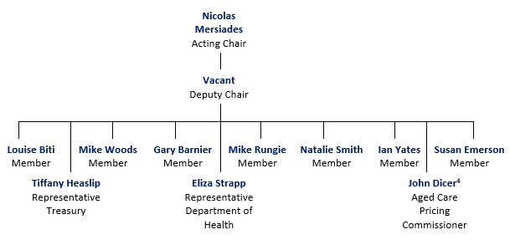

## The Annual Report on the Funding and Financing of the Aged Care Sector

Each year ACFA provided the Minister responsible for aged care with a report on the funding and financing of the aged care sector.

Over time, each annual report has built upon the last, producing a substantial body of in-time as well as trend data on the funding and financing of the aged care sector. This is the ninth annual report published. Although ACFA ceased to operate from 30 June 2021, all previous ACFA reports provided to the Minister, including the nine annual reports, can be accessed at <https://agedcare.health.gov.au/aged-care-reform/aged-care-financing-authority>.

### Methodology

The 2021 annual report mainly presents and analyses 2019-20 data provided by aged care providers and data held by the Department of Health. This is supplemented by more recent data sources, where available, along with consultations with sector participants.

The principal data sources are financial and administrative data collected by the Department of Health:

* From Commonwealth Home Support Programme (CHSP) providers (Home and Community Care providers in WA prior to 2018-19):
  + CHSP Data Exchange; and
  + Home and Community Care (HACC) Minimum Data Set (WA) prior to 2018-19.
* From home care providers:
  + Aged Care Financial Reports (ACFR).
* From residential care providers:
  + Aged Care Financial Reports (ACFR);
  + General Purpose Financial Reports (GPFR) prior to 2016-17;
  + Annual Survey of Aged Care Homes (SACH); and
  + Published aged care accommodation prices (My Aged Care website).
* Other general data:
  + The 2019‑20 Report on the Operation of the Aged Care Act 1997 (ROACA), and previous editions;
  + Quarterly home care data reports;
  + The 2016 National Aged Care Workforce Census and Survey; and
  + Relevant supplementary information from sector analysts, including StewartBrown.

In addition to these listed data sources, ACFA consulted with the sector, relevant financiers and other key stakeholders to gain an insight into current factors impacting on the sector, although noting that consultations for this report were limited due to COVID‑19.

When discussing the financial performance of providers in this report, Earnings Before Interest, Tax, Depreciation and Amortisation (EBITDA) is the main measure used to analyse profitability. This is because EBITDA excludes items such as interest (both income and expense) and tax expenditures, which can vary depending on the financing decisions of an organisation; and non‑cash expenses, such as depreciation and amortisation which can vary greatly based on the size and age of facilities and other assets, and on ownership type and depreciation methods.

EBITDA therefore can be used to compare organisations with each other and against industry averages and is a good measure of core profit trends because it eliminates some of the extraneous factors mentioned above. This is particularly important when analysing aged care given the diversity of ownership and capital structures. EBITDA helps to smooth out these factors.

This report also refers to Net Profit Before Tax (NPBT) which also assists in making comparisons between organisations that are subject to different tax treatments.

Financial information regarding home care and residential care reported in this report has been collected through the Aged Care Financial Report (ACFR). *The Accountability Principles 2014*, made under Section 96-1 of the *Aged Care Act 1997*, require approved providers to submit a financial report in a form approved by the Secretary of the Department of Health. For providers of residential care, the ACFR must be accompanied by an audited General Purpose Financial Report and accompanying audit opinion. The ACFR submitted by home care providers is not required to be audited and should not be considered a GPFR.

ACFA notes that changes made for the 2020‑21 ACFR and beyond will result in more financial performance information being collected at the facility level, which had not been possible previously.

The financial analysis and commentary in this report does not include National Aboriginal and Torres Strait Islander Flexible Care Program providers, providers operating Multi-Purpose Services or providers under the Short Term Restorative Care Program.

As discussed in previous annual reports, it is important to be mindful of the sector composition and the varying objectives of providers when interpreting the data. The aged care sector continues to be dominated by not‑for‑profit providers. Traditional profit-based measures are not always consistent with the mission and objectives of not-for-profit providers.

#### Considerations and limitations

As significant reforms in aged care continue, some forms of service delivery, and therefore data collection, are changing. For this reason, analysis is not always directly comparable with analysis contained in previous reports. Where this is the case, it is noted.

Since 2016-17, the Aged Care Financial Reports (ACFR) were used by home care and residential care providers to report financial data to the Department of Health. Providers previously reported their financial information using different methodologies meaning comparisons with 2015-16 and earlier years are not always possible.

The vast majority of financial data available to ACFA regarding home and residential care is at the approved provider level. Because many providers have services in multiple locations, ACFA is constrained in its ability to analyse performance at facility or service level or the impact of locational factors on funding, financing and financial performance of services. ACFA notes however that changes to financial data collection made by the Department of Health in 2021 will result in more service level data being available for future years.

### Navigating the 2021 annual report

The 2021 annual report is structured as follows:

* Chapter 2 - Aged care in Australia**:** Provides an overview of the aged care sector in Australia.
* Chapter 3 - Access to aged care**:** Discusses the supply of, and access to, subsidised aged care in Australia.
* Chapter 4 - Home support**:** Provides an overview of home support through the Commonwealth Home Support Programme.
* Chapter 5 - Home care**:** Provides an overview of the Home Care Packages Program and a summary of financial performance of home care providers in 2019‑20.
* Chapter 6 - Residential care**:** Provides an overview of residential aged care and a summary of financial performance of residential care providers in 2019‑20.
* Chapter 7 - Residential care: capital investment**:** Provides discussion and analysis of residential care provider balance sheets and capital investments, as well as building trends in the sector.
* Chapter 8 - Future demand for aged care**:** Discusses the future demand for aged care in the short, medium and long-term.
* Chapter 9 - A reflection, then looking ahead.

Analysis of providers in this report is generally presented in four ways:

* Whole of sector (refers to all providers operating a particular type of care);
* Ownership type (not-for-profit, for-profit or government owned);
* Location (metropolitan, regional[5] or a mix of metropolitan and regional); and
* Scale (number of services[6] operated by a home care provider or number of facilities operated by a residential care provider).

When referring to facility ‘size’ the report is referring to the number of beds operated by a single residential care facility.

When referring to ‘government owned’, the report is referring to services owned and operated by state, territory and local governments. The Australian Government does not own or operate aged care facilities or services.

# Aged care in Australia

**This chapter discusses**:

* Types of subsidised aged care in Australia;
* providers of aged care;
* the regulation of the supply of subsidised aged care services;
* Commonwealth and consumer expenditure on aged care; and
* the aged care workforce.

**This chapter reports that:**

* Australian Government total expenditure on aged care was $21.2 billion in 2019-20, up from $19.9 billion in 2018-19;
* total expenditure is expected to be $24.6 billion in 2020‑21, and to increase to $32.8 billion by 2024-25;
* services were provided to over 1.3 million people in 2019-20 including:  
  - 173,743 consumers of home care, up from 133,439 in 2018‑19;  
  - 183,989 permanent residents as at 30 June 2020, up from 182,705 at 30 June 2019;  
  - 839,373 consumers of CHSP, down from 840,984 in 2018‑19.
* services were provided by:
  + 1,452 Commonwealth Home Support Programme providers, down from 1,458 in 2018-19;
  + 920 home care providers, down from 928 in 2018-19;
  + 845 residential care providers, down from 873 in 2018-19.

## Overview

The aged care system has been in a state of reform since 2012 when the Living Longer Living Better reforms were announced. The substantial suite of reforms announced by Government in the May 2021 Budget, in response to the Royal Commission into Aged Care Quality and Safety, begins a new wave of reforms.

Older Australians can access a spectrum of aged care, ranging from home-based care and support through to 24-hour care provided in residential settings.

My Aged Care, administered by the Department of Health, is responsible for arranging an assessment of a person’s eligibility for Commonwealth subsidised aged care services. The assessment determines the level of care and support for which the individual may be eligible.

Means testing conducted by Services Australia (formerly the Department of Human Services) determines whether an individual is required to make a contribution towards the cost of their care and accommodation, and the amount of the contribution.

## Current aged care

In this report, as was the case with previous ACFA annual reports, the aged care sector is discussed in terms of the three main programs:

* **Commonwealth Home Support Programme (CHSP):** Provides services for those who require basic services to assist with remaining in their own homes. On 1 July 2015, the CHSP was implemented, combining the previous Commonwealth HACC program[7], the National Respite for Carers Program, Day Therapy Centres and Assistance with Care and Housing for the Aged. On 1 July 2016, the HACC Program in Victoria transitioned to the CHSP and on 1 July 2018 HACC services in Western Australia were also incorporated into the CHSP. All states and territories now operate under the CHSP.
* **Home Care Packages Program:** Provides services for those who have greater care needs and wish to remain living at home. Care and support is provided through a package of home care services purchased using an individual budget.
* **Residential care:** Providesaccommodation and 24-hour care for those who have greater care needs and choose, or need, to be cared for, in an aged care facility. Care can be provided on either a temporary (respite) or permanent basis.

Table 2.1 shows the number of providers, services, places and consumers as well as Commonwealth and consumer funding for each of the three care types for the five years to 2019‑20.

In addition, there are flexible care types about which, due to a lack of financial data, ACFA does not provide analysis or commentary. These include:

* **Transition care:**The Transition Care Programme (TCP) provides short-term care that seeks to optimise the functioning and independence of older people after a hospital stay. Transition care is goal-oriented, time-limited and therapy-focused. The Transition Care Programme seeks to optimise the functioning and independence of older people after a hospital stay, enabling them to return home rather than enter residential care. Unlike the STRC, the Transition Care Programme is a joint Commonwealth-State funded program.
* **Restorative care:**Services that focus on enhancing the physical and cognitive function of people who have lost or are at risk of losing condition and independence. The Short-Term Restorative Care (STRC) Programme, which commenced in February 2017, aims to reverse and/or slow ‘functional decline’ in older people and improve their wellbeing through the delivery of a time-limited, goal-oriented, multi-disciplinary and co-ordinated range of services.
* **Multi-Purpose Services:**   
  The Multi-Purpose Services (MPS) Program is a long-standing, joint initiative between the Australian Government and state and territory governments. The MPS program provides integrated health and aged care services in small rural and remote communities in all states, the Northern Territory and Norfolk Island. It focuses on providing health and aged care services to older people in the rural and remote communities where they live.
* **National Aboriginal and Torres Strait Islander Flexible Aged Care Program (NATSIFAC):**   
  The NATSIFAC Program provides culturally safe aged care to older Aboriginal and Torres Strait Islander people to remain close to home and community. Providers are located mainly in remote areas. Services can be delivered in either a residential or home care setting.
* **Innovative care services:**
* The Innovative Care Program supports the development and testing of flexible models of service delivery in areas where mainstream aged care services may not appropriately meet the needs of a location or target group.

Table 2.1: Aged care in Australia 2015-16 to 2019-20

|  | 2015-16 | | | 2016-17 | | | 2017-18 | | | 2018-19 | | | 2019-20 | | |
| --- | --- | --- | --- | --- | --- | --- | --- | --- | --- | --- | --- | --- | --- | --- | --- |
|  | Home support | Home care | Residential care | Home support | Home care | Residential care | Home support | Home care | Residential care | Home support | Home care | Residential care | Home support | Home care | Residential care |
| Number of providers | 1,686 | 496 | 949 | 1,621 | 702 | 902 | 1,547 | 873 | 886 | 1,458 | 928 | 873 | 1,452 | 920 | 845 |
| Numbers of services/facilities | N/A | 2,099 | 2,669 | N/A | 2,367 | 2,672 | N/A | 2,599 | 2,695 | N/A | 2,691 | 2,717 | N/A | 2,650 | 2,722 |
| Number of operational places | N/A | 78,956 | 195,825 | N/A | N/A[8] | 200,689 | N/A | N/A | 207,142 | N/A | N/A | 213,397 | N/A | N/A | 217,145 |
| Number of consumers | 925,432 | 88,875 | 234,931 | 784,927 | 97,516 | 239,379 | 847,534 | 116,843 | 241,723 | 840,984 | 133,439 | 242,612 | 839,373 | 173,743 | 244,363 |
| Commonwealth funding | $2.2b | $1.5b | $11.4b | $2.4b | $1.6b | $11.9b | $2.4b | $2.0b | $12.2b | $2.6b | $2.5b | $13.0b | $2.8b | $3.4b | $13.4b |
| Consumer contribution | N/A | $127m | $4.5b | $204m | $128m | $4.5b | $219m | $122m | $4.5b | $252m | $107m | $4.8b | $251m | $102m | $4.9b |

**Notes:**

1. Home support for 2015-16 comprises CHSP as well as VIC and WA HACC and in 2016-17 and 2017-18 comprises CHSP as well as WA HACC.
2. Commonwealth funding for home support in 2015‑16, 2016‑17 and 2018-19 includes funding for My Aged Care and Regional Assessment Service (RAS) to support the CHSP ($148 million in 2015-16, $123 million in 2016-17, $128 million in 2018-19 and $158 million in 2019‑20).
3. The number of consumers of home support in 2015-16 (925,432) includes 285,432 for Vic and WA HACC and an estimate of over 640,000 in the CHSP as accurate data was not available. Due to the lack of accurate data and differences in counting methods the CHSP consumers for 2015‑16 are likely overstated.

## Australian Government expenditure on aged care

The Australian Government spent $21.2 billion on aged care in 2019-20, up from $19.9 billion in 2018-19. Australian Government funding is expected to increase to $24.6 billion in 2020‑21 with over $32 billion budgeted for 2024-25. Chart 2.1 shows Commonwealth funding in aged care since 2016‑17 and budgeted expenditure to 2023‑24.

Almost all of the $1.3 billion increase in Australian Government funding for aged care during 2019‑20 was for the residential and home care programs. Residential care expenditure increased by $415 million, an increase of 3.2 per cent, and home care expenditure increased by $881 million, an increase of 36 per cent.

The growth in residential care expenditure can be attributed to a 1.0 per cent increase in the number of days of care provided during the year due to an increase in the number of residents ($134 million), and a 2.1 per cent increase in average care subsidy and supplement payments ($278 million), the latter resulting primarily from the COVID-19 Support Payment and increase to subsidies that formed part of the Government's COVID-19 Aged Care response plan. There is also a small interaction effect ($3 million) due to the combined effect of growth in volume and price.

The increase in home care expenditure in 2019-20 is mainly due to a 32.1 per cent increase in the number of days of care provided during the year (due to the rapid expansion in the number of packages being released).

Chart 2.1: Australian Government total aged care expenditure, 2016‑17 to 2019‑20 and total budgeted aged care expenditure, 2020-21 to 2023-24

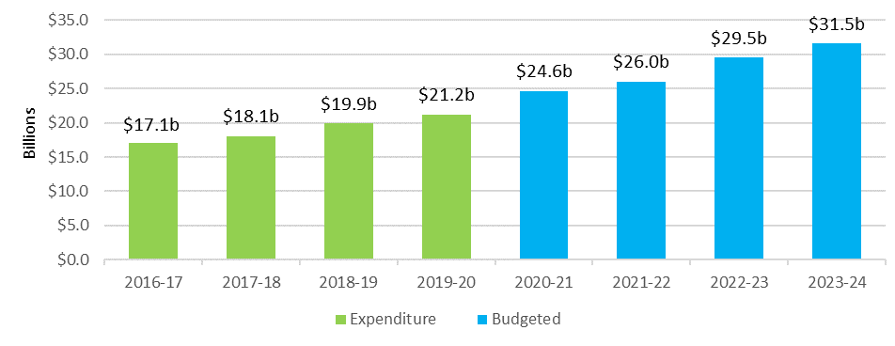

Funding for residential care is by far the largest proportion of the Commonwealth expenditure at 63.3 per cent, although noting this is down from around 65-66 per cent in recent years, due mainly to the rapid increase in the number of home care packages. The proportions of Commonwealth expenditure in 2019-20 across the sector are illustrated in Chart 2.2.

Chart 2.2: Australian Government total aged care expenditure, by major program, 2019-20

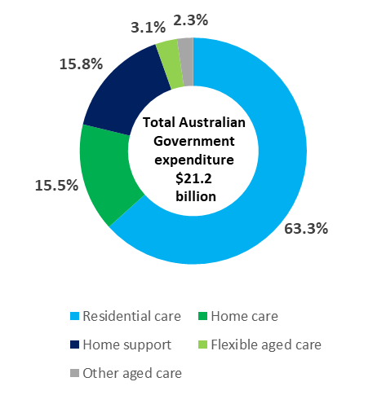

Australian Government expenditure on aged care is projected by the 2021 Intergenerational Report to nearly double as a share of the economy, from 1.2 per cent currently to 2.1 per cent of GDP by 2060-61[9]. This projection is based on current policy settings and therefore includes policy changes announced in the Government’s response to the Royal Commission into Quality and Safety in Aged Care. The Intergenerational Report also notes that the design of the new in-home care program, to which the Government is committed, will require careful consideration to ensure the system remains sustainable, and that developments in wages for the aged care workforce will be a key determinant of system costs.

Costs of care will also be influenced by developments in labour productivity, techological innovation, changes in models of care, the increasing complexity of chronic health conditions in ageing populations, demand and consumer preferences, all of which entail a degree of uncertainty.

ACFA has previously noted that the shift in the balance of care in favour of home care over residential care was expected to improve affordability for taxpayers over the long term. This is because the costs of subsidising accommodation associated with residential care are not incurred with home care, and because, on average, under current policies, higher care subsidies apply in residential care where 24 hour care is provided. However, the design of the new in-home care program could change this situation.

## Consumer contributions

Most aged care consumers contribute to their aged care costs. The level of contribution is subject to an assessment of affordability and vary according to cost type.

Residential care consumers all contribute 85 per cent of the basic rate of single age pension towards their living expenses (through the basic daily fee[10]) and, subject to means testing, may be required to contribute towards their accommodation and care costs.

In 2019-20, residents contributed $3.5 billion towards their living expenses, $845 million towards accommodation costs by those who chose to pay through a Daily Accommodation Payment (DAP) (which excludes those choosing to pay through a refundable lump sum deposit) and $646 million towards care costs. Overall, contributions from residents (excluding lump sum deposits) represent 26.2 per cent of total residential care provider revenue (up from 24.6 per cent in 2018‑19), 66 per cent of which comprises the basic daily fee for everyday living expenses.

Consumers of home care packages contributed around $102 million to their care and support costs in 2019‑20, representing 4 per cent of home care providers’ revenue, down from 4.2 per cent in 2018‑19. Commonwealth Home Support Programme consumers contributed $251 million in 2019‑20, which represents 9 per cent of total expenditure on home support.

Table 2.2 shows the total Government and consumer contribution across service types since 2015‑16.

Table 2.2: Australian Government expenditure and consumer contribution, by service type, 2015‑16 to 2019‑20

|  |  | 2015-16 | 2016-17 | 2017-18 | 2018-19 | 2019-20 |
| --- | --- | --- | --- | --- | --- | --- |
| Home care | Government | $1.5b | $1.6b | $2.0b | $2.5b | $3.4b |
| Consumer | $127m | $126m | $122m | $107m | $102m |
| Residential care | Government | $11.4b | $11.9b | $12.2b | $13.0b | $13.4b |
| Consumer | $4.5b | $4.5b | $4.5b | $4.8b | $4.9b |
| Home support | Government | $2.2b | $2.4b | $2.4b | $2.5b | $2.6b |
| Consumer | N/A | $204m | $219m | $252m | $251m |

Note: Consumer contributions for home support were not available until 2016-17.

Consumers may also pay additional amounts to a provider to access additional levels of care or services (e.g. for additional care and services that would not otherwise be covered by their Home Care Package, or to purchase services in residential care that are additional to those required to be provided under the *Aged Care Act 1997).*

## Aged care providers

In this report, as with previous annual reports, providers of the three main types of Government subsidised aged care in Australia are discussed. These are CHSP, home care and residential care.

There are over 3,000 providers who provide these services to older Australians. Table 2.3 shows the number of providers over the last seven years. The number of home care providers was stable in 2019‑20 after increasing dramatically over the previous three years. By contrast, the number of residential care and CHSP providers have declined over the seven years. The changing number of home care and residential care providers is discussed in Chapter 3.

Table 2.3: Number of aged care providers, by service type, 2013-14 to 2019‑20

|  | Home support | Home care | Residential care |
| --- | --- | --- | --- |
| 2013-14 | 1,676 | 504 | 1,016 |
| 2014-15 | 1,628 | 504 | 972 |
| 2015-16 | 1,686 | 496 | 949 |
| 2016-17 | 1,621 | 702 | 902 |
| 2017-18 | 1,547 | 873 | 886 |
| 2018-19 | 1,458 | 928 | 873 |
| 2019-20 | 1,452 | 920 | 845 |

While the majority of providers operate only one type of aged care service, some operate two or all three of the major types. Chart 2.3 shows the number of providers providing only one type, two types and all three types of services in 2019-20.[11]

Chart 2.3: Proportion of aged care providers providing more than one type of aged care service, 2019-20

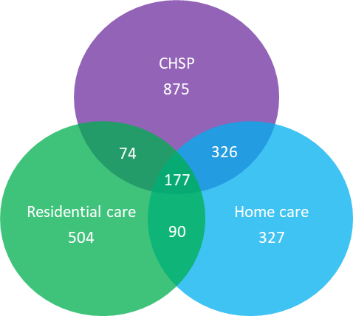

As shown, and as has been the case in previous years, there is a high degree of specialisation in terms of service types offered by providers, partly reflecting the fact that the three care types evolved as separately funded programs. However, the proportion of providers who have diversified into more than one type of care is continuing to increase, albeit very slowly, as shown in Table 2.4. Of the 177 organisations who provide all three major types of care, only six are for‑profit providers (four in the previous two years).

Table 2.4: Proportion of aged care providers providing more than one type of service, 2013‑14 to 2019-20

|  | One type only | Two types | All three types |
| --- | --- | --- | --- |
| 2013-14 | 85% | 13% | 2% |
| 2014-15 | 84% | 14% | 2% |
| 2015-16 | 78% | 16% | 6% |
| 2016-17 | 76% | 17% | 7% |
| 2017-18 | 74% | 19% | 7% |
| 2018-19 | 73% | 20% | 7% |
| 2019-20 | 72% | 21% | 7% |

There may be more occurrences of providers providing more than one type of service than reported here, however as previously noted, separate provider registration in the three different sub-sectors means this is not always apparent, as providers often have different ABNs and different trading names.

## Aged care workforce

The availability of an appropriately skilled aged care workforce has long been identified as a key issue. Providers have had difficulty attracting and retaining a skilled workforce to meet growing demand.

ACFA has previously discussed that the aged care workforce is a shared responsibility between the Australian Government and the aged care sector, with many of the levers to influence the workforce resting with employers/providers. The Australian Government can support the sector through setting policy with appropriate funding that aims to foster viability, flexibility, responsiveness and innovation, and supporting competitive labour markets. It can also support the sector through funding and regulating the higher education and the vocational education and training systems.

A National Aged Care Workforce Census and Survey[12] is conducted approximately every four years. In its 2017 annual report, ACFA provided a summary of the findings of the 2016 Survey. The 2016 census reported the number of paid workers in the aged care sector was around 366,000, with an additional 68,000 volunteers.

Total paid workers in residential care in 2016 was estimated at 235,764, of whom 153,854 were direct care workers. Total paid workers in home support and home care were estimated at 130,263, of whom 86,463 were in direct care roles.

Of the reported 434,443 people working in aged care in 2016, 60 per cent were in residential care. The remainder of the workforce were in home support and home care. Chart 2.4 shows the composition of the aged care workforce as reported in 2016.

Chart 2.4: Aged care workforce composition, 2016

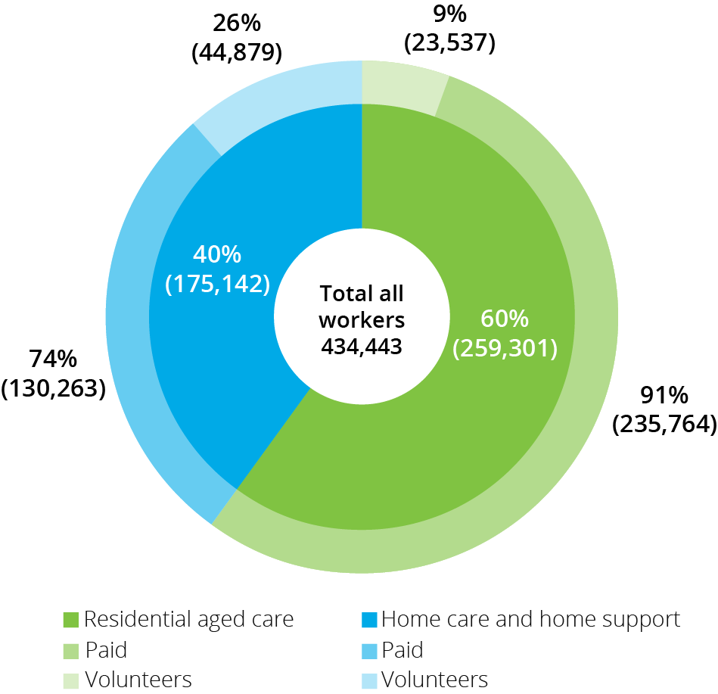

The average age of the residential direct care workforce decreased from 48 to 46 between 2012 and 2016. In contrast, the average age of the direct care workforce in home support and home care increased from 50 in 2012 to 52 in 2016.

Overseas born workers make up a very significant proportion of the aged care workforce. In 2016, the proportion in residential direct care was highest with 32 per cent of workers born overseas, while in home support and home care the proportion was 23 per cent. This compares with 35 per cent in residential care and 28 per cent in home support and home care in 2012. Given the high proportion of overseas born people working in aged care, the continuing restrictions on people entering Australia due to COVID‑19 will have an impact on the availability of workers.

Although aged care remains a female dominated sector, the proportion of males in the workforce is continuing to grow, albeit slowly and from a small base. In residential care, 13 per cent of direct care workers were male (compared with 11 per cent in 2012). In the home support and home care sectors, men represented 11 per cent of all direct care workers (10 per cent in 2012).

More detailed information from the 2016 National Census and Survey is provided in Appendix D. The next census is planned to commence in late 2021.

Following the Royal Commission into Aged Care Quality and Safety, the Government announced in its May 2021 Budget a range of measures designed to improve the aged care workforce. The measures include funding for more training and incentives for aged care workers to remain working in the sector, and a campaign to attract more workers to the sector. The Government has also mandated minimum average care staff minutes per resident to apply in residential care from July 2023 and announced a significant increase in home care packages. The successful implementation of both of these measures will require that a supply of skilled workers will be available.

Additionally, in response to the pressures resulting from COVID-19, the Government provided in 2020, funding of $440 million for a COVID-19 retention bonus to recognise the commitment of direct care workers in residential aged care and home care.

Additional funding was also provided to upskill aged care workers in infection control, enable residential and home aged care providers to hire extra nurses and aged care workers, and increase aged care staff and training to facilities during an outbreak.

It is noteworthy that despite the Royal Commission’s recommendation that the Australian Government join with employers and employees in a joint submission to the Fair Work Commission to increase minimum award wages, the Government has opted to allow the current submission to the Fair Work Commission by the Health Services Union to take its course.

## Aged care reforms

The aged care sector has undergone substantial change since the 2012 Living Longer Living Better package and will continue to undergo further reforms as signalled by the Government’s response to the Royal Commission into Aged Care Quality and Safety. The aim of the reforms is to improve the quality and sustainability of aged care services and to increase consumer choice and control.

The major changes since 2012, and prior to the major changes arising from the Government’s response to the Royal Commission, are summarised below according to the care type they relate to, that is, CHSP, home care, residential care or cross-program.

Commonwealth Home Support Programme (CHSP)

* From 1 July 2015, the CHSP commenced by combining the former Commonwealth-State Home and Community Care (HACC) programs in all states and territories except Victoria and Western Australia, and the Commonwealth National Respite for Carers, Day Therapy Centres and Assistance with Care and Housing for the Aged programs;
* Regional Assessment Services established in 2015 to assess eligibility for CHSP services; and
* Victoria transitioned their HACC services to the CHSP on 1 July 2016 and Western Australia transitioned to the CHSP on 1 July 2018.

Home care

* New home care packages (levels 1-4) commenced from 1 August 2013;
* income testing with subsidy reduction, including annual and lifetime caps, commenced on 1 July 2014;
* all packages required to be consumer directed care (CDC), with individualised budgets, from 1 July 2015;
* from 27 February 2017:
  + creation of a consistent National Prioritisation System (NPS) to assign home care packages; and
  + home care packages assigned to the consumer rather than allocated to the provider;
* home care providers required to publish their current pricing information on the My Aged Care Service Finder, from 30 November 2018;
* home care providers required to publish their pricing information in a new standardised schedule from 1 July 2019;
* reduction of the level of basic daily fee to be proportionate to the level of home care package from 1 July 2019;
* home care package payments to providers made in arrears from February 2021; and
* home care package payments to providers to be based on services delivered from September 2021.

Residential care

* New means testing (combining income and assets test), including annual and lifetime caps, commenced on 1 July 2014;
* new accommodation payment arrangements from 1 July 2014 which allow market-based accommodation prices for all non-supported residents, accompanied by consumer choice to pay by lump sum, daily payment or a combination of both;
* requirements for providers to publish the maximum price they charge for accommodation and extra services, from 1 July 2014;
* higher accommodation supplement payable for supported residents in residential care facilities that were newly built or significantly refurbished since 20 April 2012;
* creation of an Aged Care Pricing Commissioner position in October 2013; and
* rental income from the former home became assessable for all residents who enter care from 1 July 2016 (formerly exempt for residents who made a daily payment for their accommodation).

Cross-program

* Overall target provision ratio for Government subsidised aged care places to increase from 113 places for every 1,000 people aged 70+ to 125 places over the period 2012-13 to 2021-22;
* creation of a single budget item for home care packages and residential care places from 1 July 2018 that allows flexibility for the Government to direct available funding to home care or residential care in response to consumer preferences;
* establishing the Aged Care Quality and Safety Commission from January 2019 and the commencement of a single set of quality standards across all aged care from 1 July 2019;
* from 1 July 2019, all Commonwealth subsidised residential care facilities required to collect and provide clinical quality indicator data to the Department of Health through the National Aged Care Quality Indicator Program. The program had initially started in 2016 as a voluntary program; and
* from 1 July 2019, a new Charter of Aged Care Rights provides the same rights to all consumers, regardless of the type of Commonwealth subsided care and services they receive.

### Future reform following the Royal Commission

The Royal Commission into Aged Care Quality and Safety was established in October 2018 to examine the aged care system in Australia, and to consider how to meet the challenges and the opportunities of delivering aged care services now and into the future.

The Royal Commission conducted its inquiry during 2019 and 2020 and released its final report in February 2021. The final report[13] included 148 recommendations.

In May 2021 the Government announced its response[14] to the final report as well as announcing a significant suite of aged care reform measures in the Budget.

The major reforms and their cost over the forward estimates are summarised below:

**Home Care.**  The main reforms include:

* 80,000 additional Home Care Packages – 40,000 released in 2021–22 and 40,000 in 2022‑23, resulting in 275,598 packages by June 2023 ($6.5 billion);
* 8,400 additional respite services each year ($798.3 million); and
* Enhanced support and face-to-face services to assist in navigating the aged care system ($272.5 m).

Residential aged care services and sustainability. The main reforms include:

* Increased care minutes delivered to residents, mandated at average of 200 minutes per day, including 40 minutes with a registered nurse ($3.9 billion);
* A new basic daily fee supplement of $10 per resident per day ($3.2billion);
* Moving to assigning residential aged care places directly to consumers instead of providers, as is currently done for home care ($102.1 million);
* Expand the role of the Independent Hospital Pricing Authority to include aged care. This will help ensure that aged care costs are directly related to the care provided ($49.1 million);
* The new Australian National Aged Care Classification (AN-ACC) will begin operation from October 2022, replacing the ACFI ($189.3 million).

Residential aged care quality and safety: The main reforms include:

* Improved access to primary care for consumers, including the transition between aged care and health care settings ($365.7 million);
* Improved capacity and powers for the Aged Care Quality and Safety Commission (ACQSC) ($262.5 million);
* Additional resources within residential care for residents with dementia, including additional funding for the Dementia Behaviour Management Advisory Service and the Severe Behaviour Response Teams ($74.8 million); and
* The introduction of a star rating system to highlight the quality of aged care services, to better inform consumers and their families, including expanding advocacy services ($200.1 million).

**Workforce:**  The main reforms include:

* Additional training for upskilling the existing workforce and training of new aged care workers, including 33,800 subsidised Vocational Education and Training places through JobTrainer;
* Creation of a single assessment workforce to undertake all assessments, simplifying the assessment experience for consumers entering he aged care system ($228.2 million);
* Financial support for aged care nurses of up to $3,700 for nursing scholarships and places in the Aged Care Transition to Practice Program ($135.6 million); and
* Extending the national recruitment campaign, to help increase the aged care workforce ($9.8 million).

**Governance:**  The main reforms include:

* Establishment of new governance and advisory structures, including a National Aged Care Advisory Council, and a Council of Elders, and to work towards establishment of an office of the Inspector-General of Aged Care ($21.1 million);
* Additional funding to improve access for consumer in regional, rural and remote areas; including those with First Nations backgrounds and special needs groups ($630.2 million); and
* Development of a new Aged Care Act to enshrine the Government’s reforms in legislation by mid-2023.

The reforms will be introduced through a five year plan, including:

2021

* Release of 40,000 of the 80,000 additional home care packages.
* Introduction of the new $10 per day basic daily fee supplement.
* Establishment of the Independent Pricing Authority.
* Begin phasing in enhanced financial and prudential oversight.
* Enhanced regulatory and monitoring powers for the Aged Care Quality and Safety Commission.
* Additional training places for new and existing aged care workers, including scholarships.
* Establishment of the Council of the Elders and Inspector-General of Aged Care.

2022

* Release of the remaining 40,000 additional home care packages.
* Residential aged care transition to AN-ACC funding model, including increase in funding base.
* Enhanced aged care quality and safety: Serious Incident Response Scheme (SIRS) expanded to home and community care; reporting of staffing hours; worker screening (workforce register) and code of conduct introduced; and stage one implementation of Star Ratings.
* Workforce initiatives including: single assessment workforce for residential care; financial incentive payments for registered nurses; and more additional training places for new and existing workers.

2023

* Single in-home care program, combining home care and CHSP.
* Introduction of mandatory care time (average of 200 care minutes) in residential care.
* National Aged Care Minimum Dataset and expanded National Mandatory Quality Indicator Program (NMQIP).
* Single assessment workforce model in home care.
* New Aged Care Act commences.

 2024

* Reformed residential aged care accommodation framework implemented.
* Discontinue the Aged Care Approvals Round process from 1 July 2024.
* Full implementation of Star Ratings in residential care.

2025

* Young People in Residential Aged Care targets due to be met - no people under 65 living in residential aged care.

# Access to aged care

**This chapter discusses:**

* Access to subsidised aged care for older Australians;
* the supply of subsidised aged care; and
* usage of aged care by age cohorts.

**This chapter reports that:**

* The number of consumers of CHSP decreased slightly from 840,984 in 2018‑19 to 839,373 in 2019-20;
* The number of consumers of home care increased from 133,439 in 2018-19 to 173,743 in 2019-20;
* the number of consumers of residential care increased from 242,612 in 2018-19 to 244,363 in 2019-20;
* average occupancy in residential care continues to fall; 88.3 per cent in 2019‑20, down from 89.4 per cent in 2018‑19. Occupancy has decreased every year for the last five years since it was 92.4 per cent in 2015-16;
* the proportion of people using home care and residential care at age 85 and over is more than three times that of people aged 70 and over, which has been the case for several years; and
* the average age of people in permanent residential care in 2019‑20 was 84.9 compared with 82.5 in home care and 79.1 in the CHSP.

## Supply of subsidised aged care

Ensuring access to appropriate quality care is a fundamental policy objective for the Australian Government in the funding and financing of aged care. This was one of the areas addressed by the Royal Commission and subsequent Government response.

The Government regulates the supply of services offered through the Commonwealth Home Support Programme (CHSP) through a capped funding amount that is indexed annually. This is discussed in Chapter 4.

The Government regulates the supply of home care packages and residential aged care places it funds by specifying targets. These targets, known as the aged care target provision ratios, are based on the number of people aged 70 and over.

The overall aged care target provision ratio was first set in 1985 at 100 operational residential care places per 1,000 people aged 70 and over. The overall provision ratio was increased to 108 in 2004, further increased to 113 in 2007, and in 2012 was adjusted to increase progressively to 125 operational places by 2021-22. Home care packages were first introduced into the ratio in the early 1990s and since then successive Governments have gradually increased home care as a proportion of the overall target provision ratio.

This population-based target provision formula is designed to allow the overall supply of services to increase in line with the ageing of the population, while also defining the total number of places/packages and, thereby, helping control the Commonwealth’s expenditure on aged care.

As set in 2012, within the current overall target provision ratio of 125, the mix of home care and residential care is being significantly rebalanced in favour of home care. Over the period 2012 to 2022 the target for home care was planned to increase from 27 to 45 operational places, while the residential care target is reducing from 86 to 78. The remaining two places are for the Short Term Restorative Care Programme (STRC).

In response to the large number of people in the National Prioritisation System for home care packages, which was introduced in 2017, the Government has been progressively releasing additional home care packages. As a result, the home care target ratio has already been exceeded, reaching 53.6 mainstream home care packages available for every 1,000 people aged 70 and over at 30 June 2020.

The Government has accepted in-principle the Royal Commission’s recommendation that service planning be based on need, not rationed, but added that the structure of the future planning regime, including the role of the aged care provision ratio or another mechanism, will be determined as part of the design for a new support at home program which will combine CHSP and home care packages. It is estimated that the additional 80,000 packages announced in the 2021-22 Budget will enable the current home care provision target to continue to be exceeded until the new combined program is introduced from July 2023.

Chart 3.1 shows the achieved residential care ratios for the eight years to 30 June 2020.

Chart 3.1: Residential care achieved ratios, 2012-13 to 2019‑20

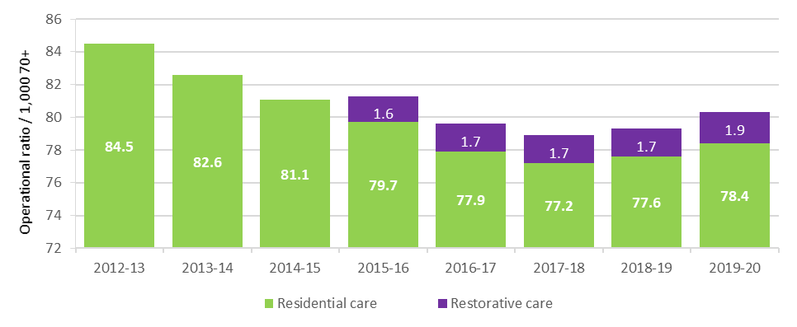

Chart 3.2 shows the number of consumers with a home care package as at 30 June for each of the previous seven years, as well as the target number of packages to 2023‑24. The target number includes the release of an additional 90,000 home care packages announced in the 2020 MYEFO and 2021-22 Budget in response to the Royal Commission into Aged Care Quality and Safety. While the historical and forward estimates numbers are not directly comparable, the chart gives some indication of the increase in home care packages that has occurred and the increase that is planned to be released.

Chart 3.2: Home care consumers in a package at 30 June, 2013‑14 to 2019‑20 and target packages, 2020‑21 to 2022-23

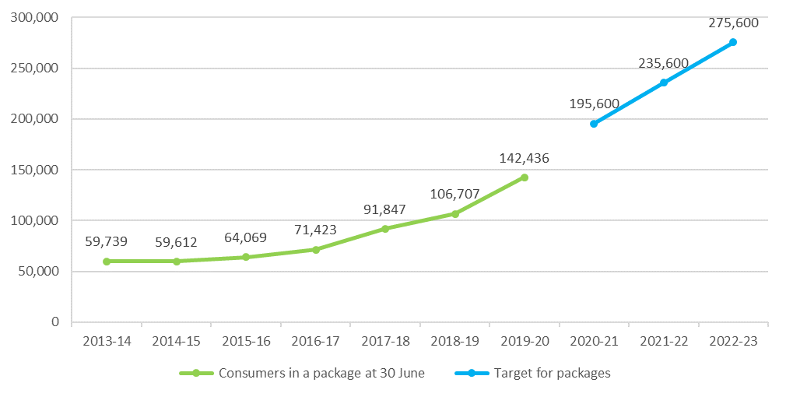

The target ratio approach applied to home care packages and residential care places does not apply to the supply of care through the CHSP. Instead, CHSP funding is subject to an annual capped funding allocation, and CHSP providers are grant funded to provide contracted home support services. Consumers who are assessed as eligible through their Regional Assessment Service (RAS) to receive CHSP services can then access those services through a provider who delivers the services for which they have been assessed.

In May 2021 the Government announced its response to the Royal Commission into Aged Care Quality and Safety. Included in the package were a number of measures regarding access to care. These are discussed at the end of this chapter.

## Aged Care Approvals Round

Unlike home care packages, residential care places are still currently allocated to providers through a competitive Aged Care Approvals Round (ACAR). However, the Government announced as part of the 2021 Budget, that the current 2020-21 ACAR would be the last and instead, from 1 July 2024, residential care places will be assigned directly to eligible consumers rather than allocated to providers. In the 2018‑19 Budget, the Government announced in-principle support for this move, and undertook a detailed impact analysis to investigate options and implications for stakeholders.

The last completed ACAR was the 2018‑19 ACAR. Through that ACAR, 13,500 new residential care places were allocated which represented an increase of 36 per cent on the 2016–17 ACAR. The 2020 ACAR, which was delayed due to COVID-19, opened in December 2020 and closed in March 2021. It is planned that it will release significantly fewer new residential care places (2,000), 1,028 short-term restorative care places and up to $150 million in capital grants for residential aged care. Results of the ACAR are expected around the middle of 2021.

In terms of provider ownership, a trend evident for the last four ACARs is that the for‑profit providers have been successful in gaining around two thirds of allocated residential care places, as shown in Table 3.1.

Table 3.1: Aged Care Approval Rounds, proportion of allocated places, by ownership, 2012‑13 to 2018‑19

| Allocated places | 2012-13 | 2014 | 2015 | 2016-17 | 2018-19 |
| --- | --- | --- | --- | --- | --- |
| For-profits | 57% | 68% | 70% | 64% | 67% |
| Not-for-profits | 42% | 31% | 30% | 35% | 32% |

## Access to aged care

In 2019-20 over 1.3 million older Australians accessed some form of Government subsidised aged care. Table 3.2 shows the number of consumers of the three types of aged care that this report mainly discusses (CHSP, home care and residential care) since 2015-16.

Table 3.2: Aged care in Australia, number of consumers, 2015-16 to 2019-20

|  | 2015-16 | 2016-17 | 2017-18 | 2018-19 | 2019-20 |
| --- | --- | --- | --- | --- | --- |
| Home support | 925,432 | 784,927 | 847,534 | 840,984 | 839,373 |
| Home care | 88,875 | 97,516 | 116,843 | 133,439 | 173,743 |
| Residential care | 234,931 | 239,379 | 241,723 | 242,612 | 244,363 |

CHSP client numbers for 2018-19 are not perfectly comparable with home support client numbers reported for previous years, which combine CHSP client counts with the HACC programs that operated in Victoria and Western Australia. These HACC programs have now ceased providing aged care. The methods used to collect data and measure client numbers are different across programs, and any comparisons over time should be treated with caution.

Home support consumers for 2015-16 were likely overstated.

## Access to home care

The number of older Australians who received subsidised home care during 2019-20 was 173,743, an increase of 30 per cent from 133,439 in 2018-19. As at 30 June 2020 there were 142,436 consumers in a package, up from 106,707 as at 30 June 2019. Chart 3.3 shows the significant increase in overall home care consumer numbers, particularly since 30 June 2017. Chart 3.4 shows the number of consumers, by package levels, since 2014‑15.

Chart 3.3: Number of home care consumers in a package, 30 June 2014 to 30 June 2020

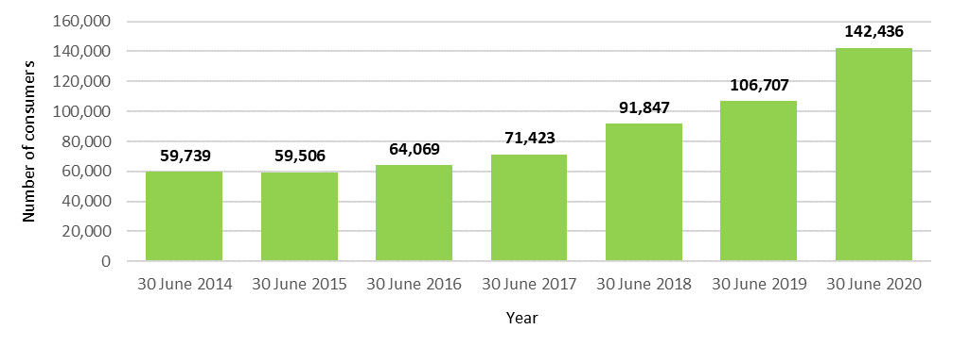

Chart 3.4: Number of home care consumers, by package level, 2014-15 to 2019-20

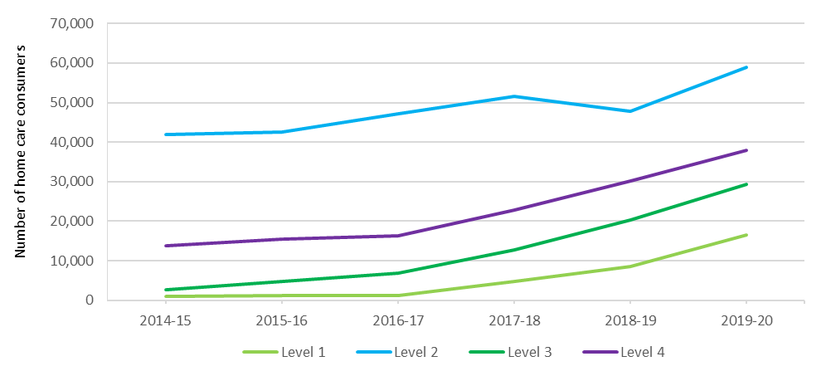

### Release of home care packages

Since February 2017, home care packages have been assigned directly to consumers rather than allocated to providers. This allows consumers to direct their package to the provider of their choice as well as to change providers.

Older Australians assessed as requiring home care are placed on the National Prioritisation System (NPS) based on how long they have been waiting for care and their individual needs and circumstances, regardless of where they live. Packages are periodically released and assigned directly to consumers by the Department of Health within My Aged Care. Packages are assigned to consumers according to when they were approved for home care and urgency of need.

The number of packages released at each level takes into account the number of new packages that are available (including the number of new packages at each package level), the number of packages that consumers have exited or not accepted in previous weeks, as well as the amount of unspent Commonwealth funds that have been returned when consumers leave home care.

### Demand for home care packages

ACFA has previously noted that unmet demand for home care was not able to be quantified until implementation of the NPS for assigning packages directly to consumers.

Data from the Department of Health shows that at 31 March 2021, there were 87,162 people in the NPS waiting for a Home Care Package at their approved level. This is a decrease of 9,697 since 31 December 2020. There were 27,131 approvals for home care in the three months to 31 March 2021, of which 58 per cent were for higher level (3 and 4) packages. Around 61 per cent of those in the NPS also had approval for permanent residential care. One of the factors influencing declining occupancy rates in residential care is the preference of older people for home-based aged care services.

Of the 87,162 people waiting for a home care package at their approved level at 31 March 2021, 31,679 had been offered an interim level package, while the remainder were waiting for a package offer. Of the 87,162 people, 85,238 had been approved for assistance through the Commonwealth Home Support Programme.

Wait times for people to be assigned a package vary depending on assessed priority and package level. People assessed as a high priority are being assigned a level 1 or 2 package within a couple of weeks of approval and a level 3 or 4 package within 3 months. People with a medium priority are being assigned a level 1 package within 3-6 months with the wait for a level 2, 3 or 4 package being between 9-12 months.

In response to this strong demand for packages, the Government announced the release of an additional 80,000 packages in the 2021-22 Budget at a cost of around $6.5 billion. This is in addition to the 10,000 packages announced as part of the 2020-21 MYEFO in December 2020.

This investment will bring the total number of packages to over 275,000 by June 2023, and it is expected that all people currently on the NPS will be able to access a package in line with their assessed care needs by this time.

### Length of stay in home care

In 2019-20, for all home care package levels combined, the median time spent in the home care program at discharge was around 16 months and the average was around 27 months (Chart 3.5).

Chart 3.5: Median and average length of stay in home care, by year of discharge

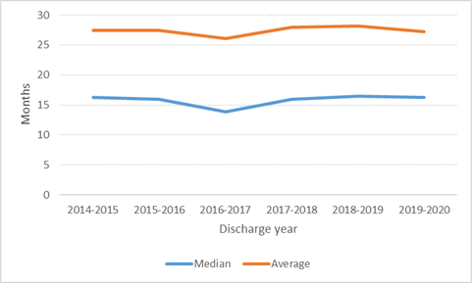

The length of time that people are spending in home care is likely to increase over the next couple of years. While this is not yet evident in the discharge lengths of stay outlined above, it can be seen clearly in Chart 3.6 that fewer people from each annual entry cohort are leaving home care in their first year. This is likely because people are accessing home care earlier and supported for longer due to the increased availability of packages across all care levels.

Chart 3.6: Cumulative proportion of home care recipients leaving home care during their first year by year of entry

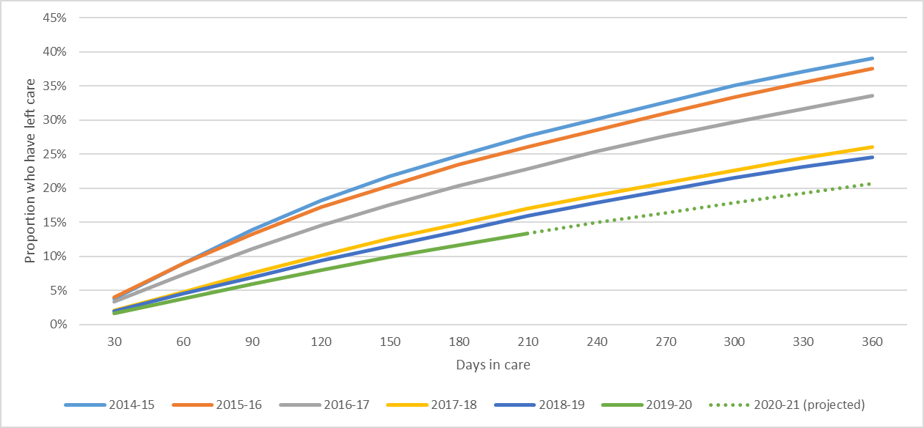

## Access to residential care

The number of older Australians who received permanent residential care during 2019-20 was 244,363, up from 242,612 in 2018-19. At 30 June 2020 there were 183,989 permanent residents in care.

The number of people who accessed residential respite care in 2019-20 was 66,873, an increase of 2.1 per cent from 65,523 in 2018-19. Residential respite care usage is discussed later in this chapter.

### Occupancy in residential care

Occupancy is measured as the total number of days an allocated place is occupied by a resident, divided by the total number of days an allocated place was available to be occupied. The subsequent rates therefore reflect both demand for care (i.e. the number of residents accessing places) and the supply of places made available by providers.

ACFA noted last year that a major immediate risk facing residential care providers was the spread of COVID-19 within a facility which has the potential to cause a sizeable decline in occupancy through both departures and delays in new admissions. A sudden decline in occupancy could have a major impact on the financial position of the facility and the provider. While the risk of a significant decline in sector-wide occupancy due to COVID‑19 did not eventuate, there were some providers with services in areas of high community transmission who experienced severe outbreaks, with consequential occupancy and financial pressures, particularly in the case where providers have a capital structure heavily dependent on RADs. In June 2021 the Government announced it was offering zero-interest loans to eligible providers who had experienced a significant decline in their RAD balance due to a sudden drop in occupancy due to COVID‑19.

In 2019-20, the average occupancy rate across all residential care places was 88.3 per cent, down from 89.4 per cent in 2018‑19 and 90.3 per cent in 2017‑18. As noted above, a sector-wide sudden decline in occupancy due to COVID‑19 did not eventuate, however the sector continues to experience a continuation of the decline evident in recent years. The recent decline follows relative stability for several years at above 92 per cent. While the final occupancy data for 2020‑21 is not yet available, initial data from the Department of Health indicates that occupancy has continued to decline slightly in 2020‑21.

The overall average occupancy rate in residential care peaked at 97.1 per cent in 2003‑04.

The 1.2 percentage point decline in the occupancy rate in 2019-20 was contributed to by the growth in the number of bed days available (2.6 per cent) which grew at two times the rate of the growth in care days provided (1.3 per cent). Both the for-profit and not-for-profit sectors had faster growth in the available bed days compared with days of care provided (Table 3.3).

|  |  |  |
| --- | --- | --- |
| Table 3.3: Growth in residential care claims and growth in available beds between 2018-19 and 2019-20 | | |
| Provider type | Claim day growth | Bed day growth |
| Not-for-profit | 1.0% | 2.2% |
| For-profit | 2.1% | 3.5% |
| Government | -2.2% | 0.2% |
| All providers | 1.3% | 2.6% |

In terms of ownership type, all three ownership types reported a decrease in occupancy when compared with 2018‑19 (Table 3.4). Not-for-profit providers continue to have the highest occupancy, reporting 90.5 per cent in 2019‑20, down from 91.5 per cent. For‑profit providers recorded a similar decrease, down to 85.3 per cent from 86.5 per cent in 2018‑19.

Table 3.4: Occupancy rates, by organisation type, 2015-16 to 2019-20

| Provider type | 2015-16 | 2016-17 | 2017-18 | 2018-19 | 2019‑20 |
| --- | --- | --- | --- | --- | --- |
| Not-for-profit | 94.0% | 93.0% | 92.1% | 91.5% | 90.5% |
| For-profit | 91.0% | 90.0% | 87.9% | 86.5% | 85.3% |
| Government | 90.0% | 90.0% | 90.3% | 90.4% | 88.3% |
| All providers | 92.4% | 91.8% | 90.3% | 89.4% | 88.3% |

There continue to be variations in average occupancy by state and territory. The Northern Territory continues to have the highest occupancy with 94.0 per cent while Queensland again reported the lowest with 86.7 per cent. While all states and territories reported a decrease in occupancy in 2019‑20, the decreases in the Northern Territory, ACT and South Australia were very small (0.2-0.3 percentage points) whereas all other states reported a decrease of between 1 and 2 percentage points. Table 3.5 shows average occupancy by state and territory for the last five years.

Table 3.5: Occupancy in residential care, by state and territory, 2015-16 to 2019-20

| State/territory | 2015-16 | 2016-17 | 2017-18 | 2018-19 | 2019‑20 |
| --- | --- | --- | --- | --- | --- |
| New South Wales | 92.3% | 91.1% | 89.5% | 89.2% | 88.0% |
| Victoria | 91.7% | 91.1% | 90.2% | 89.0% | 87.9% |
| Queensland | 92.2% | 92.3% | 89.1% | 88.3% | 86.7% |
| Western Australia | 94.5% | 93.8% | 93.2% | 90.3% | 89.4% |
| South Australia | 93.7% | 93.5% | 93.4% | 92.8% | 92.5% |
| Tasmania | 91.0% | 91.2% | 90.2% | 89.9% | 88.7% |
| Australian Capital Territory | 88.6% | 90.1% | 91.0% | 89.6% | 89.4% |
| Northern Territory | 95.0% | 95.4% | 94.4% | 94.3% | 94.0% |
| Australia | 92.4% | 91.8% | 90.3% | 89.4% | 88.3% |

There also remains a variation in occupancy rates by remoteness location. In 2019-20 the occupancy in outer regional and remote areas decreased significantly (around 3 percentage points) when compared with major cities and inner regional areas which reported a decrease of around 1 percentage point. Occupancy in remote areas is also between 3-5 per cent lower than in the cities and regional areas.

Table 3.6 shows average occupancy in residential care by location over the last five years.

Table 3.6: Occupancy in residential care, by location, 2015-16 to 2019-20

| Provider location | 2015-16 | 2016-17 | 2017-18 | 2018-19 | 2019-20 |
| --- | --- | --- | --- | --- | --- |
| Major cities | 92.4% | 91.4% | 90.0% | 88.9% | 88.0% |
| Inner regional | 92.5% | 92.7% | 91.4% | 91.1% | 89.8% |
| Outer regional | 92.0% | 92.2% | 90.8% | 90.0% | 87.2% |
| Remote | 89.7% | 91.7% | 88.4% | 87.6% | 84.4% |
| Very remote | 80.0% | 77.4% | 77.1% | 71.9% | 72.6% |
| Australia | 92.4% | 91.8% | 90.3% | 89.4% | 88.3% |

In recent annual reports and in its 2021 report on refundable accommodation deposits[15], ACFA noted that some providers had expressed concern that falling occupancy rates would put pressure on their viability. The continued fall in occupancy during 2019‑20 indicates that this pressure may be increasing. The announcement by Government, as part of their response to the Royal Commission, that residential care places will be assigned directly to consumers from 1 July 2024, will create greater competition for consumer custom. This could potentially put further pressure on occupancy rates for some providers. The potential impact of increased competition on occupancy rates as a result of assigning residential places to consumers was considered as part of the impact analysis[16] of this policy change.

### Admissions to residential care

Elapsed time between when a resident is assessed as eligible for residential care and entering permanent care has been increasing steadily in recent years as shown in Chart 3.7, despite declining average occupancy rates. This trend has been evident since 2011‑12, however stabilised in 2019-20:

* 7 per cent of people entering care did so within one week of being assessed by an ACAT (18 per cent in 2011-12);
* 21 per cent did so within one month (44 per cent in 2011-12); and
* 59 per cent did so within nine months (89 per cent in 2011-12).

ACFA has previously noted that the elapsed time between an assessment of eligibility and a person entering care could be due to consumer choice and not necessarily delays in the system. Also, the increasing availability of and preference for home care, and the increased usage of residential respite care, could be contributing to the longer time between assessment and entering permanent care.

Chart 3.7: Elapsed time between assessment and entering permanent residential care, 2011-12 to 2019‑20 (%)

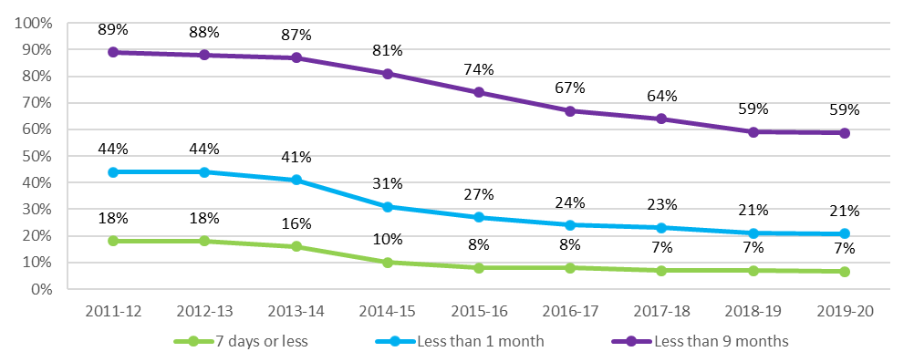

#### Consumers transitioning from home care to residential care

Chart 3.8 shows the proportion of consumers who enter permanent residential care after leaving home care. The proportion entering residential care has been dropping consistently since 2015-16 and fell to 58 per cent in 2019-20. This is likely partly explained by the significant increase in higher level home care packages in recent years, and the number of home care packages overall.

Chart 3.8: Proportion of consumers entering permanent residential care after leaving home care, 2013‑14 to 2019‑20

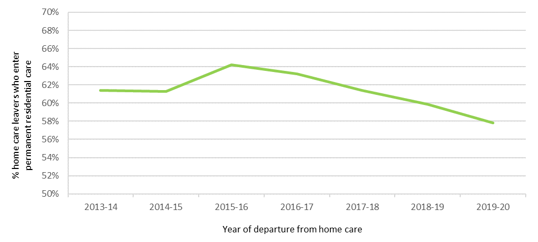

### Length of stay in residential care

In 2019-20, the average total length of stay of those leaving residential care was 2.9 years. As can be seen in Chart 3.9, the total length of stay has been around this level since 2011-12 with a slight increase evident in 2019‑20. Within this, females stay on average around 13 months longer than males.

Chart 3.9: Average length of stay in residential care, by gender and year of entry, 2012 to 2020

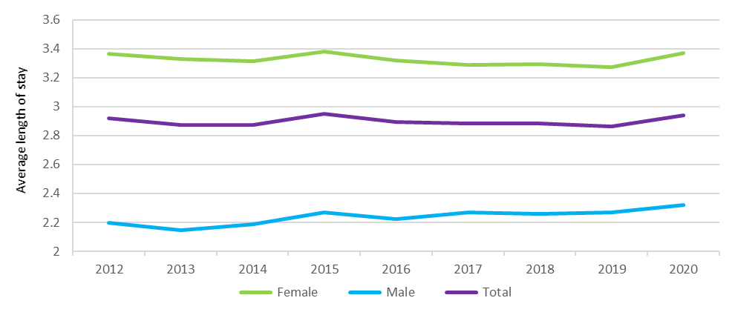

The proportion of permanent residents that leave within 3, 6 or 12 months of first entry has decreased slightly since 2012 (Chart 3.10).

Chart 3.10: Proportion of permanent residents that leave within 3, 6 or 12 months of first entry, 2011‑12 to 2019‑20

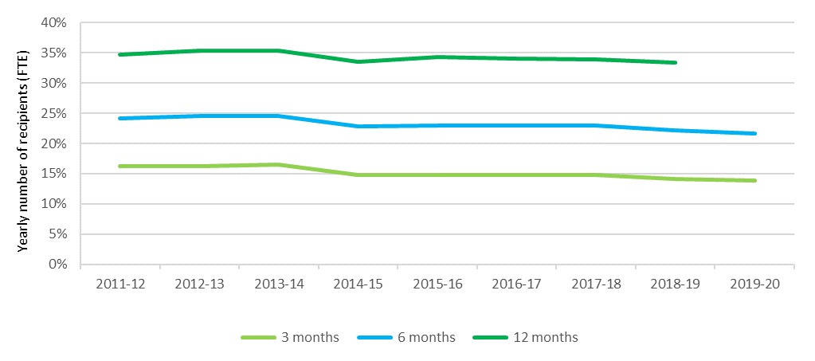

#### Dementia

Since 2008-09, the proportion of people entering residential care with a diagnosis of dementia has been consistently between around 43 per cent and 45 per cent of all permanent residents entering care. The average age at admission for people with dementia was around six months older than for those without a diagnosis of dementia.

Chart 3.11 shows the proportion of people still in care over time by dementia status (diagnosis of dementia recorded within first 28 days of admission). It shows that half of the people entering without a dementia diagnosis died or left care within 22 months, compared with around 25 months for people entering care with an initial diagnosis of dementia. People with dementia are less likely to die or leave care in the initial period after entry, however in the longer-term, proportionally fewer people with dementia have longer lengths of stays when compared with those that do not.

Chart 3.11: Proportion of residents in care over time, with and without dementia

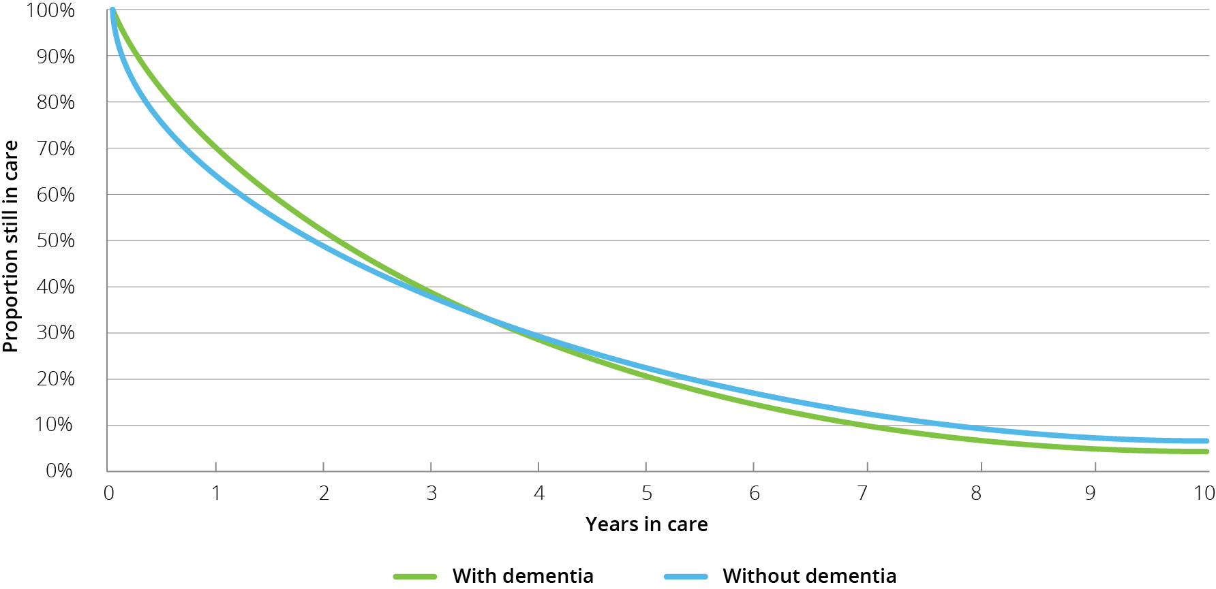

## Residential respite care

Residential respite care is short-term care delivered within an aged care facility[17] on either a planned or emergency basis. People are assessed for eligibility by an Aged Care Assessment Team (ACAT), who will approve someone for low care respite or high care respite. The distinction between high and low care was not removed from respite care when it was removed from permanent residential care on 1 July 2014. A consumer can access subsidised residential respite for up to 63 days per financial year, with extensions possible when an ACAT considers it necessary.

As noted previously, a significant difference in respite care compared with permanent residential care is that respite residents do not pay any means-tested accommodation or care contributions. They can however be asked to pay the basic daily fee for living expenses, which is at the same rate as permanent residents. Respite residents can also purchase additional services, in the same manner as a permanent resident.

Residential care providers have a proportion of their allocated residential care places which may be used for the provision of respite care, and it is up to each provider what mix of permanent and respite care that they provide. Providers can vary this proportion, however currently they have to contact the Department of Health to seek approval.

Access to respite services will depend on a person’s need/choice to access this type of care and on an approved provider’s willingness and ability to provide respite care.

ACFA notes that changes announced to funding arrangements for residential respite as part of the new AN-ACC classification and funding model for residential aged care should improve consumer access to residential respite (see 3.6.2 for details).

### Length and frequency of stay in residential respite care

During 2019-20, 66,873 people received residential respite care. Of these, on average, each person had 1.2 respite stays[18]. Up until 2018‑19 the average number of stays per respite resident each year had been 1.4 but has declined slightly in the last two years.

On average, each stay was 27.3 days[19], a significant increase from 25.8 in 2018-19. Until 2014-15 the average stay had been stable at just below 24 days however it has since been rising as shown in Chart 3.12.For home care package consumers who access residential respite care, the average length of stay is considerably shorter. In 2019‑20 the average stay for home care consumers was just under 20 days. In recent years it had remained relatively stable at around 21 days.

Chart 3.12: Average length of stay (days) in residential respite care, 2013‑14 to 2019‑20

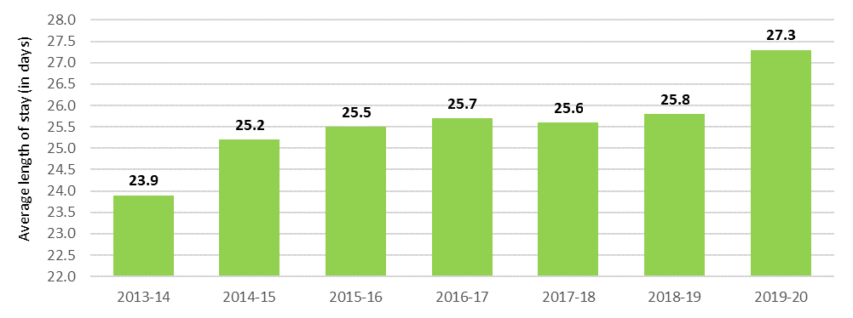

ACFA has noted previously a clear pattern of respite care usage that it is usually for stays of whole weeks at a time (Chart 3.13). Two weeks is by far the most common residential respite care length of stay. One, three and four weeks are the next most common lengths of stay. Around 4 per cent used the maximum of 63 days in one stay. These usage trends have been stable in recent years.

Chart 3.13: Frequency of length of respite care stays, 2019-20

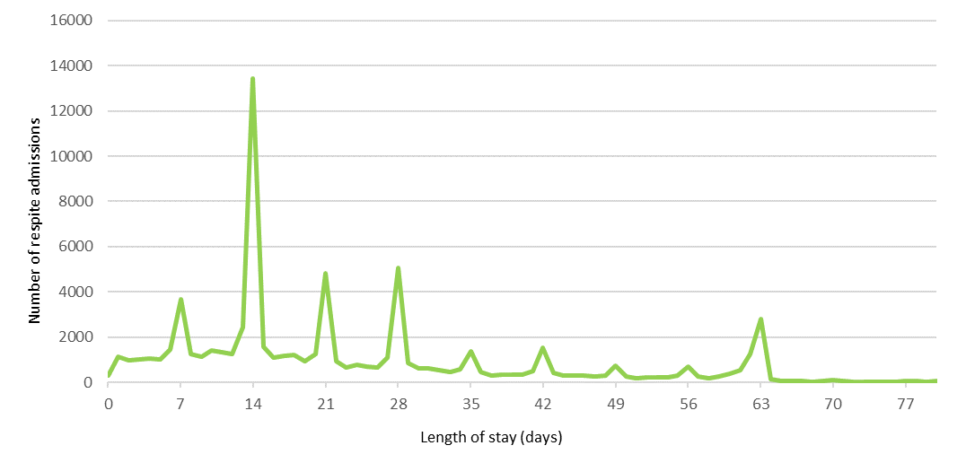

ACFA noted in its 2018 report on respite care that this pattern of respite use is largely provider driven. This is primarily due to the relatively high cost of the admission process in residential care. Feedback was that for many providers offering respite care, providing less than two weeks of residential respite is financially unviable. The feedback from consultation with consumers, however, suggested they would prefer access to shorter periods of respite care.

### High and low residential respite care

A trend that has been occurring since 2014‑15 is the number of respite consumers accessing high level respite care is increasing while the number accessing low level respite care is decreasing. This trend continued in 2019-20 as shown in Chart 3.14. This was also discussed in ACFA’s report on respite care[20], with ACFA noting the significant difference in funding for providers between high and low care was likely serving as a disincentive to providers taking respite consumers who had only been approved for low level care. As can be seen, the number of days of high and low level respite care provided was almost the same in 2013‑14, whereas in 2019‑20, 79 per cent of respite days were for high care respite residents.

Chart 3.14: Number of residential respite care days, by level, 2013-14 to 2019‑20

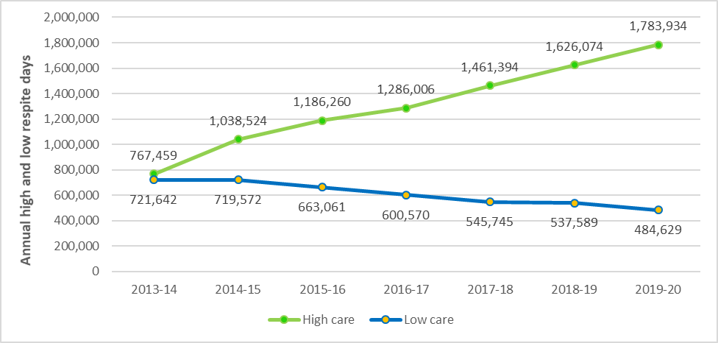

One of the recommendations from ACFA’s 2018 Respite care report was that funding for respite care should be neutral between respite care and permanent residential care and also neutral between high and low care respite consumers, so that providers did not face a financial disincentive to provide respite care.

ACFA notes that from 1 October 2022 funding for residential respite care will be more closely aligned with funding for permanent residential care under the AN‑ACC model. Individuals will be independently assessed at the time of their approval for respite care using a component of the AN‑ACC assessment tool and will be placed into one of three AN‑ACC respite classes. Funding for AN‑ACC respite classes will be commensurate with that provided for permanent care for those with similar care needs, and will be adjusted over time based on advice from the Independent Hospital and Aged Care Pricing Authority. ACFA considers that these measures will go a long way towards addressing the recommendations of the 2018 Respite care report.

## Supported residents

The Australian Government supports access to permanent residential care by consumers who are assessed as not being able to meet all or part of their own accommodation costs by paying providers an accommodation supplement on their behalf. These residents are known as supported (or low-means) residents.

Since the aged care reforms of 1 July 2014, eligibility for a full or partial accommodation supplement is determined by a combined assessment of an individual’s income and assets (the means test).

The amount of accommodation supplement received by a provider on behalf of a supported resident depends on:

* the outcome of the resident’s means test assessment;
* whether the residential care facility has been built or significantly refurbished since 20 April 2012; and
* whether the facility provides more than 40 per cent of its care days to supported residents.

Providers have discretion to determine the proportion of supported residents in their facilities. However, providers with 40 per cent or fewer supported residents in a facility (excluding those residents receiving extra services) have the accommodation supplement they receive for all supported residents in that facility reduced by 25 per cent.

As shown in Table 3.7 and Table 3.8, the proportion of supported residents across Australia has been consistently above 40 per cent since 2014‑15, though there has been a slight decrease in recent years, including in 2019‑20. The trend evident in recent years of there being a higher proportion of supported residents in regional and remote locations compared with metropolitan areas has continued in 2019-20. Also, not-for-profit providers continue to have a higher proportion of supported residents compared with for-profit providers.

The analysis used to determine the proportion of supported residents is based on claims submitted by providers on behalf of their residents.

Table 3.7: Proportion of claims for supported residents, by location, 2014-15 to 2019-20

| Location | 2014-15 | 2015-16 | 2016-17 | 2017-18 | 2018-19 | 2019-20 |
| --- | --- | --- | --- | --- | --- | --- |
| Metropolitan | 49.1% | 50.1% | 48.7% | 47.9% | 47.1% | 46.2% |
| Regional | 53.2% | 54.0% | 52.8% | 51.8% | 50.9% | 49.6% |
| Remote | 66.0% | 68.1% | 67.9% | 65.9% | 63.6% | 63.4% |
| Australia | 50.5% | 51.5% | 50.2% | 49.3% | 48.4% | 47.4% |

Table 3.8: Proportion of claims for supported residents, by ownership type, 2014‑15 to 2019‑20

| Ownership type | 2014-15 | 2015-16 | 2016-17 |  | 2017-18 | 2018-19 | 2019-20 |
| --- | --- | --- | --- | --- | --- | --- | --- |
| Not-for-profit | 52.4% | 53.1% | 51.9% |  | 50.7% | 49.9% | 48.8% |
| For-profit | 46.3% | 47.7% | 46.6% |  | 46.2% | 45.4% | 44.6% |
| Government | 56.5% | 57.8% | 55.9% |  | 54.6% | 53.8% | 52.3% |
| All providers | 50.5% | 51.5% | 50.2% |  | 49.3% | 48.4% | 47.4% |

The relative stability in recent years in the number of supported residents in care seems to indicate that the incentive of the higher accommodation supplement for having a resident profile with more than 40 per cent supported residents, along with the higher accommodation supplement payment for facilities newly built or significantly refurbished, are combining to ensure access to care continues for this cohort of older Australians. This is consistent with ACFA’s conclusions in its 2018 report on supported residents.

## Age profile across care types

As consumers of aged care get older, the types of care they access changes. Chart 3.15 shows the proportion of older Australians using home support (CHSP), home care packages and residential care in 2019-20, based on age brackets. As has been the case previously, the proportion using home care and residential care increases around three-fold in the 85 and over age bracket compared with those aged 70 and over.

Chart 3.15: Proportion of the population 70+ and 85+ accessing aged care, at 30 June 2020

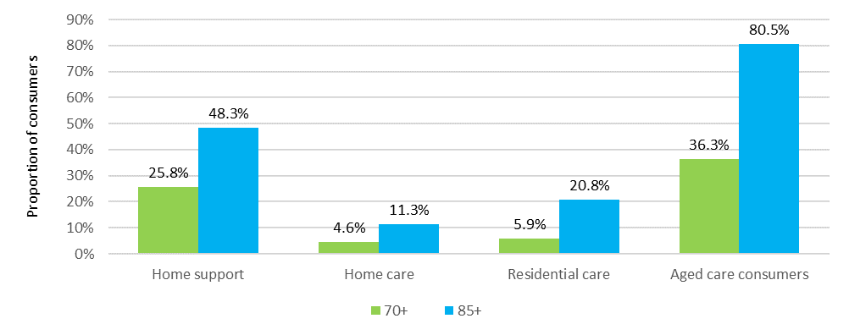

Chart 3.16 shows the age profile for consumers of home care over the five years to 30 June 2020. The proportion of those aged 65-74 and those aged 95 and over have been steady in recent years. The proportion of those aged 75-84 has steadily increased in the last 5 years and the proportion of those aged 85-94 has been gradually decreasing.

Chart 3.16: Age profile of people in home care, 30 June 2016 to 30 June 2020

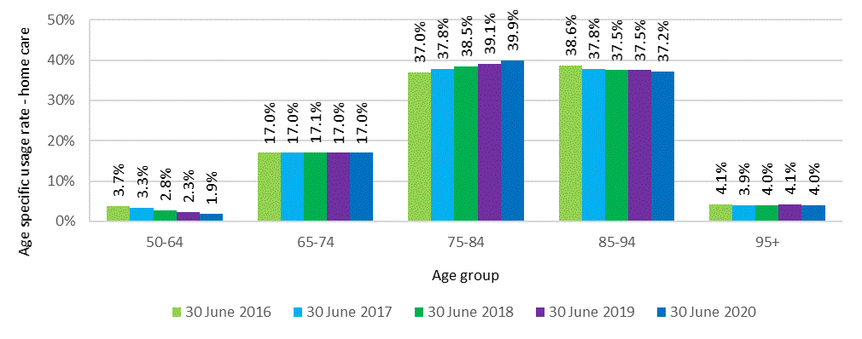

In residential care, the trends evident in recent years have generally continued in 2019-20 (Chart 3.17). The proportion of people aged 85-94 has continued to decrease gradually, down to 47.1 per cent at 30 June 2020 (from 49.6 per cent in 2016), and the proportion of those aged 95 and over has increased every year over the five years. Interestingly, while the proportion of those aged 85-94 has gradually decreased, the proportion of those aged 75-84 has slightly increased in the last three years.

Chart 3.17: Age profile of people in residential care, 30 June 2016 to 30 June 2020

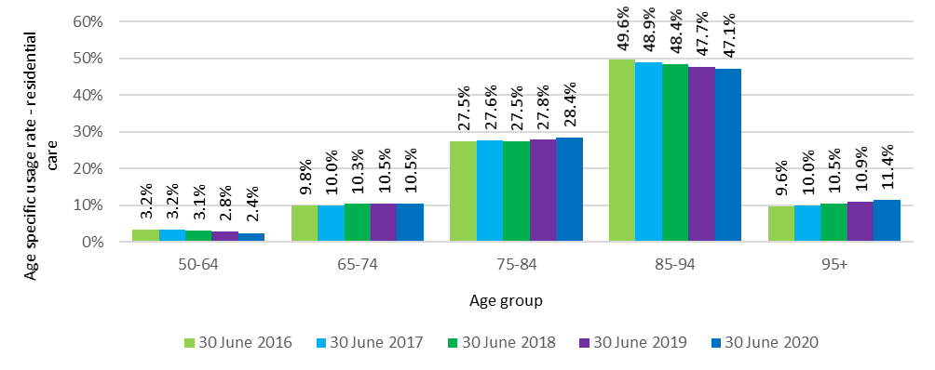

Detailed data regarding the age of consumers in CHSP is not readily available to enable the same level of analysis as undertaken for home care and residential care. However, the overall average age of consumers in CHSP in 2019‑20 was 79.1 compared with 80.0 in 2018‑19, 79.6 in 2017-18 and 79.5 in 2016‑17. The average age of people in home care and residential care as at 30 June 2020 was 82.5 and 84.9 respectively.

## Access by Culturally and Linguistically Diverse and Indigenous Australians

### Culturally and Linguistically Diverse Australians

There is significant cultural diversity among Australians and many people from culturally and linguistically diverse (CALD)[21] backgrounds are seeking culturally appropriate aged care. This is an area where aged care is changing and will continue to change as providers respond to the cultural needs of consumers.

To assist this, the Australian Government provides aged care website information for people who do not speak English, or for whom English is a second language. The My Aged Care website provides translated material in 18 languages. In 2019-20, there were 30,402 visits to the translation pages.

Chart 3.18 shows the number of CALD home care and residential care consumers over the last five years as well as the number of CALD consumers of the CHSP for the last four years (as previous years data was not available).

There were 38,740 older Australians from CALD backgrounds in a home care package as at 30 June 2020, up from 27,427 at 30 June 2019. This represents around 27 per cent of total home care consumers, a slight increase from around 26 per cent in recent years. In residential care, as at 30 June 2020, there were 36,806 older Australians from CALD backgrounds in permanent or respite care (36,344 at 30 June 2019), which represents around 20 per cent of all residents, stable from recent years. In 2019‑20, 172,006 consumers from a CALD background accessed home support (21 per cent of all consumers), up from 166,755 in 2018‑19.

Chart 3.18: CALD consumers in aged care, 2015‑16 to 2019‑20

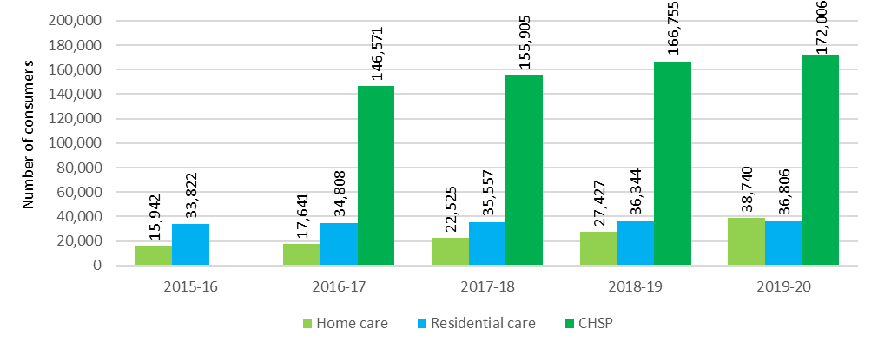

### Indigenous Australians

Chart 3.19 shows the number of Indigenous Australians accessing home care and residential care over the last five years, and the number accessing home support over the last four years (as previous years are not available).

The number of Indigenous Australians accessing all three types of services continued to increase gradually in 2019‑20.

Chart 3.19: Indigenous Australians in aged care, 2015‑16 to 2019‑20

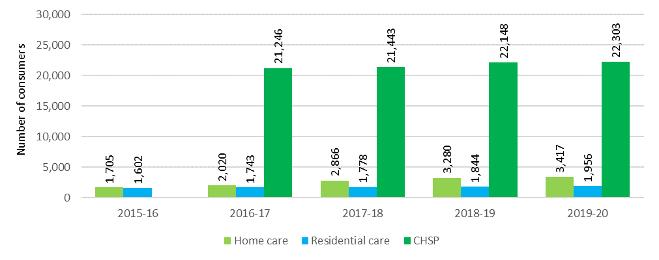

## Looking ahead

As part of the response to the Royal Commission, a range of measures designed to improve access were announced by Government.

These include supports for consumers to navigate the aged care system and to access the services they need, including:

* The creation of a single assessment workforce for consumers seeking access to aged care, designed to improve the quality and consistency of assessments;
* The creation of new face-to-face services in Services Australia service centres designed to make it easier for consumers to use My Aged Care and access services;
* Additional funding for improvements in information provided through advocacy services, as well as an expansion to the independent advocacy support services;
* Improved consumer transparency through the introduction of a star rating system, additional quality indicators and improved data collection; and
* The introduction of a network of local Community Care Finders to improve engagement with vulnerable senior Australians (such as people who are homeless).

A major change announced that will improve consumer access to their preferred residential aged care service is the assigning of residential places to consumers rather than providers from 1 July 2024. This will give consumers more choice and control as they will be free to choose their preferred residential care provider. ACFA notes that the Government also announced that supports will be provided to residential care providers to assist them move to a more competitive market. ACFA has previously noted that a move to places being assigned directly to consumers could be a difficult adjustment for some providers who are not well versed in competing in the market.

Access to home care will be greatly improved, at least in the short-term, by the release of an additional 80,000 home care packages over the next two years. This increase in packages is designed to allow all consumers who are currently waiting for a home care package to access a package at their assessed level within two years.

In addition, the Government announced measures specifically to improve access for people with a wide range of personal experiences and circumstances and from diverse backgrounds. These measures include additional translating and interpreting services for culturally diverse older Australians and certification for providers who offer services that meet diverse needs.

The Government will also invest $397 million to enable providers of services for First Nations people and special needs groups to make improvements to their buildings and build new services in areas where senior Australians currently do not have access, or where staff caring for their needs do not have suitable housing.

# Home support

**This chapter discusses:**

* The operation of the Commonwealth Home Support Programme (CHSP);
* the supply and usage of CHSP; and
* the funding of the CHSP.

**This chapter reports that in 2019-20:**

* The Commonwealth funded 1,452 providers to deliver CHSP, compared with 1,458 in 2018‑19
* the CHSP provided services to 839,373 older Australians nationally, compared with 840,984 in 2018-19
* the Australian Government contributed $2.8 billion to home support, up from $2.6 billion in 2019-20. This comprised $2.6 billion for service delivery plus $158 million to support access and assessment.

## Introduction

Home support, delivered through the Commonwealth Home Support Programme (CHSP), provides entry-level support services for frail, older people aged 65 years and older (or 50 years and older for Aboriginal and Torres Strait Islander people) who need assistance to keep living independently at home and in their community. CHSP entry level support is being increasingly underpinned by a ‘wellness approach’, which is about building on older people’s strengths, capacity and goals to help them remain independent and to live safely at home.

The CHSP also supports homeless people, or people at risk of homelessness, to access care and housing. To be eligible for assistance with care and housing services through the CHSP, a person must be: prematurely aged; 50 years and over (45 years and over for Aboriginal and Torres Strait Islander people); on a low income; and be homeless or at risk of homelessness as a result of experiencing housing stress or not having secure accommodation.

My Aged Care is the Australian Government’s single entry point for aged care services. Access to CHSP services is coordinated through My Aged Care and Regional Assessment Services.

In 2019‑20, as it did in 2018‑19, the CHSP operated as a fully national program.

## Consumers of the CHSP

The CHSP was formed in July 2015 by combining the following programs:

• The Commonwealth Home and Community Care (HACC) Program

• The National Respite for Carers Program (NRCP)

• The Day Therapy Centres (DTC) Program

• The Assistance with Care and Housing for the Aged (ACHA) Program.

Initially, HACC services for older people aged 65 years and over (or 50 years and over for Aboriginal and Torres Strait Islander people) in Victoria and Western Australia remained separate from the CHSP. Victorian HACC services transitioned to the CHSP in July 2016 and Western Australian HACC services transitioned in July 2018 making it a fully National program.

In 2019‑20 there were 839,373 consumers of the CHSP, down from 840,984 in 2018‑19. This slight decrease is despite the total Government funding of the CHSP increasing from $2.6 billion in 2018‑19 to 2.8 billion in 2019‑20. ACFA has been unable definitively to discern an explanation for this unexpected decline, though reluctance to access services because of the COVID-19 pandemic may have contributed.

On average, CHSP consumers received services to the value of $3,025 per annum in 2019‑20, however as noted previously, there is significant variation in funding between consumers.

Table 4.1 sets out the types of services that may be accessed through the CHSP. In 2019‑20 around 50 per cent of CHSP consumers received one type of service (53 per cent in 2018‑19), 43 per cent received between two and four types of service (41 per cent in 2018‑19) and the remainder accessed five or more types of services.

Table 4.1: CHSP services: by sub-program and service type

| Sub-program | Community and home support | Care relationships and carer support | Assistance with care and housing | Service system development |
| --- | --- | --- | --- | --- |
| Objective | To provide entry-level support services to assist frail, older people to live independently at home and in the community. | To support and maintain care relationships between carers and consumers, through providing good quality respite care for frail, older people so that regular carers can take a break. | To support those who are homeless or at risk of homelessness, to access appropriate and sustainable housing as well as community care and other support services, specifically targeted at avoiding homelessness or reducing the impact of homelessness. | To support the development of the community aged care service system in a way that meets the aims of the CHSP and broader aged care system. |
| Service types funded | * Meals * Other food services * Transport * Domestic assistance * Personal care * Home maintenance * Home modifications * Social support-individual * Social support-group (formerly centre-based day care) * Nursing * Allied health and therapy services * Goods, equipment and assistive technology * Specialised support services | * Flexible respite * In-home day respite * In-home overnight respite * Community access - individual respite * Host family day respite * Host family overnight respite * Mobile respite * Other planned respite * Centre-based respite: * Centre based day respite * Residential day respite * Community access-group respite * Cottage respite (overnight community) | Assistance with care and housing (a person must be: prematurely aged; 50 years and over (45 years and over for Aboriginal and Torres Strait Islander people); on a low income; and be homeless or at risk of homelessness as a result of experiencing housing stress or not having secure accommodation). | Sector support and development activities. |

## Providers of the CHSP

In 2019-20, there were 1,452 providers delivering services through the CHSP, down from 1,458 in 2018-19.

CHSP services are predominately provided by not-for-profit organisations. This has been the case since inception of the CHSP in 2015-16, and was the case for the former programs that combined to create the CHSP. In 2019‑20, 69 per cent of providers were not‑for‑profit (Chart 4.1). For-profit providers make up only 7 per cent of all providers, with government providers representing almost one-quarter.

Chart 4.1: CHSP providers by ownership type, 2019‑20

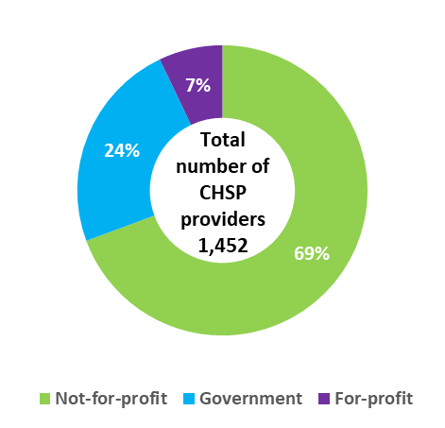

## Funding for the CHSP

In 2019‑20, total Commonwealth expenditure on the CHSP was $2.8 billion, up from $2.6 billion in 2018‑19. The 2019‑20 total included $2.6 billion for service delivery with the remainder ($158 million) being for assessment and other support activities. This is up from 2018‑19 when expenditure on service delivery was $2.5 billion with a further $128 million being for assessment and other support activities.

Total Commonwealth funding for home support continues to increase each year. Chart 4.2 shows total expenditure on home support service delivery since 2016‑17, along with budgeted expenditure to 2023‑24.

Chart 4.2: Government expenditure and budgeted expenditure for service delivery of CHSP[22] and Western Australian HACC program[23], 2016-17 to 2023-24

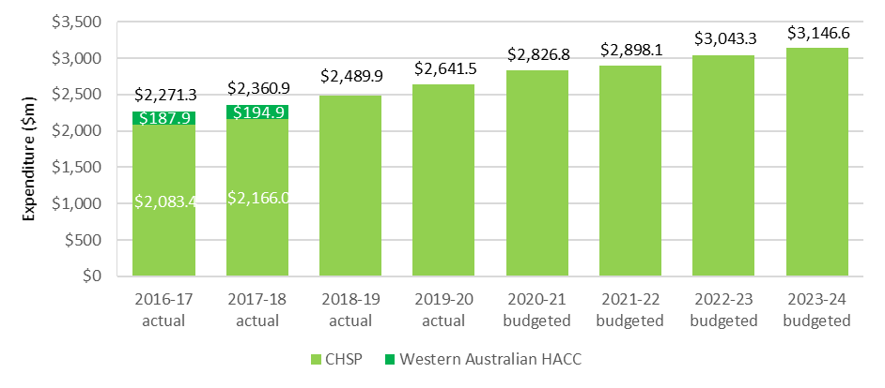

Chart 4.3 shows Commonwealth expenditure for service delivery in the CHSP in 2019‑20, by state and territory.

Chart 4.3: Commonwealth expenditure on CHSP services, by state and territory, 2019‑20 ($m)

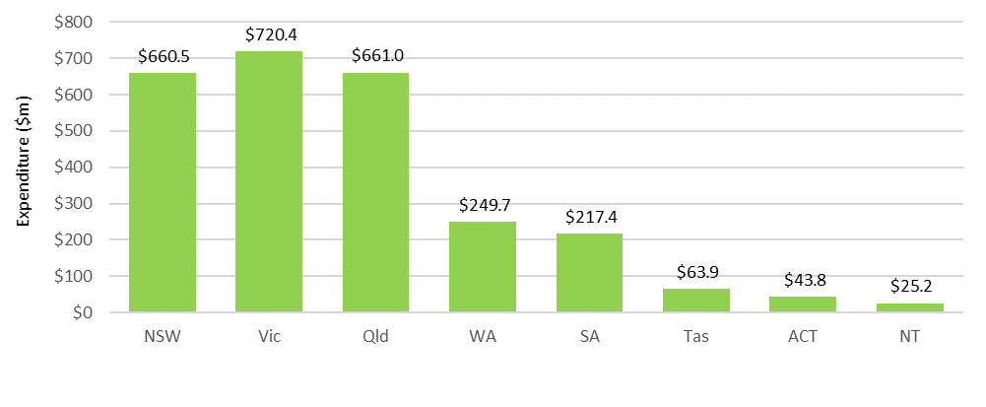

As part of the 2014‑15 Budget, the Australian Government announced a reduction in the annual real rate of growth for the CHSP from 6 per cent to 2.8 per cent in 2015‑16, 1.5 per cent in 2016‑17, and 2.4 per cent in 2017‑18, moving to 3.5 per cent in each year from 2018-19. This rate broadly aligns with the annual growth in the population aged 65 and over. Real growth is in addition to annual indexation. Growth funding enables the CHSP to respond to the changing needs of CHSP consumers and to align with the growth in Australia’s aged population. Grants under the CHSP are indexed each year by WCI-3[24] (1.5 per cent in 2019-20).

Table 4.2 shows a breakdown of the size of grants provided through the CHSP in 2019‑20 by organisation type. As has been the case in recent years, the majority of grants to providers under the CHSP are for less than $1 million. Aaround 70 per cent of providers received less than $1 million and of those, around 75 per cent received less than $500,000.

Table 4.2: CHSP grants, by size of grant and provider ownership, 2019-20

| Grant size | Not-for-profit | For-profit | Government | Total |
| --- | --- | --- | --- | --- |
| Less than $500,000 | 614 | 67 | 115 | 796 |
| $500,000 - $1 million | 127 | 17 | 79 | 223 |
| $1-10 million | 218 | 26 | 141 | 385 |
| $10-50 million | 22 | 1 | 9 | 32 |
| Over $50 million | 4 | 1 | 1 | 6 |

CHSP expenditure for 2018‑19 and 2019-20 on each of the major service types is detailed in Table 4.3.

Table 4.3: CHSP expenditure by service type 2018‑19 to 2019‑20

| Service | 2018‑19 ($m) | 2019‑20 ($m) |
| --- | --- | --- |
| Social support | $519.4m | $527.4m |
| Domestic assistance | $492.2m | $516.6m |
| Nursing | $271.0m | $276.5m |
| Respite | $267.9m | $277.0m |
| Allied health and therapy services | $237.3m | $250.1m |
| Personal care | $195.9m | $203.2m |
| Transport | $184.3m | $181.7m |
| Home modifications and maintenance | $161.3m | $165.5m |
| Meals and other food services | $85.2m | $83.8m |
| Sector support and development | $52.6m | $43.7m |
| Assistance with care and housing | $12.8m | $13.6m |

### Consumer contributions

The Client Contribution Framework and the National Guide to the CHSP Client Contribution Framework set out principles to guide CHSP providers in setting and implementing their own consumer contribution policy.

The principles are designed to introduce fairness and consistency, with a view to ensuring that those who can afford to contribute do so, whilst protecting the most vulnerable.

Recommendation 16 of the Legislated Review of Aged Care 2017 recommended that mandatory consumer contributions based on an individual’s financial capacity be introduced for services under the CHSP. This would bring the CHSP fees policy more in line with those under other aged care programs. The Government has not yet responded to this recommendation.

In 2019-20, consumer contributions totalled around $251 million, which represents around 9 per cent of total CHSP funding. This is relatively stable from 10 per cent in recent years.

## Looking ahead

In the 2020-21 Budget, the Australian Government extended funding agreements with CHSP providers by a further two years, after a similar two year extension in the 2017‑18 Budget. This means the CHSP and Home Care Packages Program will continue to operate as separate programs until at least mid‑2023.

As part of its response to the Royal Commission in May 2021, the Government reaffirmed its intention to integrate CHSP and home care into a single home care and support program from 1 July 2023. This was first flagged in 2015‑16.

No decisions have been made about the scope, model or funding of the future program, the design of which still requires significant development work and consultations. The design ultimately settled upon for the combined home care and support program, including eligibility assessment and classification, funding models, supply regulation and user contribution policies, will have significant implications for the future shape of the aged care system.

# Home care

**This chapter discusses:**

* The operation of the Home Care Packages Program;
* the funding of the home care sector; and
* the financial performance of home care providers in 2019-20.

**The chapter reports that:**

* There were 920 home care providers as at 30 June 2020, down from 928 at 30 June 2019.
* the sector continues to be predominately not-for-profit with 52 per cent of providers who service 68 per cent of consumers, although there has been a gradual shift in recent years to more consumers having their package with for‑profit providers; and
* home care services were provided to 173,743 consumers during 2019‑20, up from 133,439 in 2018‑19.

**Key findings on financial performance in 2019-20:**

* Home care providers received an estimated $3.13 billion in revenue, paid $2.99 billion in expenses and generated $145 million in profit, up from $90 million in 2018-19;
* 72 per cent of home care package providers achieved a net profit, up from 69 per cent in 2018‑19;
* average EBITDA was $1,369 per consumer, up from $1,211 in 2018‑19 and $1,217 in 2017‑18, following a significant decline from around $3,000 for the previous three years;
* EBITDA margin was 5.5 per cent, up from 4.5 per cent in 2018‑19; and
* as at 30 June 2020 home care providers held $1.2 billion in unspent funds, up from $752 million at 30 June 2019.

## Overview of the sector

### The Home Care Packages Program

The Home Care Packages Program commenced on 1 August 2013, replacing the former home care programs – Community Aged Care Packages (CACPs), Extended Aged Care at Home (EACH) packages and Extended Aged Care at Home Dementia (EACH-D) packages.

Home care packages allow consumers to purchase a range of services and equipment which assist them living in their own home. Packages are delivered on a Consumer Directed Care (CDC) basis with consumers having an individualised budget which allows them to decide what type of care and services they purchase and who delivers the services.

From 27 February 2017, home care packages began being assigned directly to the consumer, rather than allocated to the provider. This means that consumers have the choice of provider to deliver their services and can opt to change providers.

Home care consumers may use their package funds to purchase the following:

* **Personal services.** Examples include help with showering or bathing, dressing and mobility;
* **Support services.** Examples include help with washing and ironing, house cleaning, gardening, basic home maintenance, home modifications related to care needs, transport to help with shopping, doctor visits or attending social activities;
* **Care related services.** Examples include nursing and other health support including physiotherapy (exercise, mobility, strength and balance), services of a dietitian (nutrition assessment, food and nutrition advice, dietary changes) and hearing and vision services; and
* **Care management.** Coordinating care and services that will help consumers achieve the goals identified in their care plan.

In addition, providers may charge consumers a package management fee, which covers regulatory-related costs such as issuing monthly financial statements and managing unspent package funds on behalf of consumers.

For many consumers, home care packages offer an opportunity to remain living at home instead of entering residential care. Packages are categorised into four levels with level 1 being for people with basic care needs through to level 4 which supports people with higher care needs.

To obtain access to a home care package, individuals are first assessed by an independent Aged Care Assessment Team (ACAT) which determines eligibility for a package. Many people assessed as eligible to receive a package are also assessed as eligible for residential care. Once assessed as eligible for home care, an individual can elect to opt in to the National Priority System (NPS). They will be offered a home care package when one becomes available. A person’s place in the NPS is based on their date of approval and priority as assessed by an ACAT. The NPS is discussed later in this chapter.

Due to there being a wait for packages once a consumer is placed on the NSP, the majority of consumers (97 per cent) are offered basic services under the Commonwealth Home Support Programme in the interim.

### Providers and consumers of home care

Chart 5.1 shows overall home care provider numbers, as well as the proportion by ownership type, over the seven years to June 2020.

In the three years following the changes in February 2017 that assigned home care packages directly to consumers rather than to providers, there was a significant increase in home care providers with many new providers entering the market seeking to compete for consumers. During 2019‑20, however, the number of providers has stabilised with 920 providers at 30 June 2020 compared with 928 at 30 June 2019.

Chart 5.1: Number of home care providers, by proportion of ownership type, 30 June 2014 to 30 June 2020

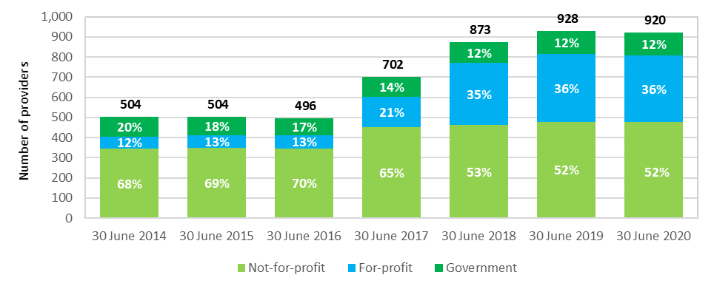

Table 5.1 presents a breakdown of home care providers by ownership type and location in 2019‑20.

Table 5.1: Provider numbers and number of consumers, at 30 June 2020

|  |  | | Ownership type | | | Location | | |
| --- | --- | --- | --- | --- | --- | --- | --- | --- |
|  | 30 June 2019 | 30 June 2020 | Not-for-profit | For-profit | Government | Metropolitan | Regional | Metropolitan & regional |
| Number of providers | 928 | 920 | 477  52% | 331  36% | 112  12% | 512  56% | 316  34% | 92  10% |
| Number of consumers | 106,707 | 142,436 | 96,185  68% | 37,043  26% | 9,208  6% | 91,821  64% | 50,615  36% | n/a  n/a |

As shown in Chart 5.1 and Table 5.2, the mix of provider ownership has been stable in the last two years following two years of change.

Up until the February 2017 changes, around two-thirds of home care providers were not‑for‑profit (Chart 5.1). However, following the changes, the majority of new providers entering the market in 2016‑17 and 2017‑18 were for‑profit, which resulted in the proportion of for‑profit providers increasing from 13 per cent in 2015‑16 to 35 per cent at 30 June 2018. At 30 June 2020, not‑for‑profit providers represented 52 per cent of the sector while for‑profit providers made up 36 per cent.

Table 5.2: Change in number of providers and ownership, 30 June 2018 to 30 June 2020

|  | 30 June 2018 | Proportion of total | 30 June 2019 | Proportion of total | 30 June 2020 | Proportion of total |
| --- | --- | --- | --- | --- | --- | --- |
| Not-for-profit | 461 | 53% | 479 | 52% | 477 | 52% |
| For-profit | 309 | 35% | 335 | 36% | 331 | 36% |
| Government | 103 | 12% | 114 | 12% | 112 | 12% |
| Total | 873 | 100% | 928 | 100% | 920 | 100% |

At 30 June 2020, there were 142,436 consumers in a home care package, compared with 106,707 at 30 June 2019. During 2019-20, 173,743 older Australians were in receipt of a home care package at some time (up from 133,439 in 2018-19).

As at 30 June 2020, 53 per cent of packages were levels 1 or 2 while 47 per cent were levels 3 or 4 (Table 5.3). This is stable from 2018‑19. However, as shown, the proportion of level 1 packages increased by three percentage points with a commensurate decrease in the proportion of level 2 packages, and the proportion of level 3 packages increased by two percentage points with a commensurate decrease in level 4 packages. In recent years there has been a rebalancing of package level proportions, reflecting recent Government policy to increase the proportion of higher level packages in response to older Australians’ preference to stay living in their homes longer.

Table 5.3: Home care consumers, by package level and proportion of total, 2016-17 to 2019‑20

|  | 2016-17 | % of total | 2017-18 | % of total | 2018-19 | % of total | 2019‑20 | % of total |
| --- | --- | --- | --- | --- | --- | --- | --- | --- |
| Level 1 | 1,168 | 1.6% | 4,841 | 5.3% | 8,516 | 8.0% | 16,418 | 11.5% |
| Level 2 | 47,268 | 66.2% | 51,496 | 56.1% | 47,734 | 44.7% | 58,842 | 41.3% |
| Level 3 | 6,750 | 9.5% | 12,693 | 13.8% | 20,193 | 18.9% | 29,336 | 20.6% |
| Level 4 | 16,237 | 22.7% | 22,817 | 24.8% | 30,264 | 28.4% | 37,840 | 26.6% |
| Total | 71,423 | 100.0 | 91,847 | 100.0 | 106,707 | 100.0 | 142,436 | 100.0 |

As shown in Chart 5.2, the proportion of home care consumers receiving services from for-profit providers has been increasing since the changes of February 2017. In 2019‑20 the proportion was 26 per cent, up from 21 per cent in 2018‑19 and 17 per cent in 2017-18. There has been a commensurate decline in the proportion of consumers receiving services from not-for-profit providers. This continues the trend of for-profit providers increasing their share of the market, albeit from a relatively small base.

Chart 5.2: Home care consumers, by provider ownership type, 30 June 2015 to 30 June 2020

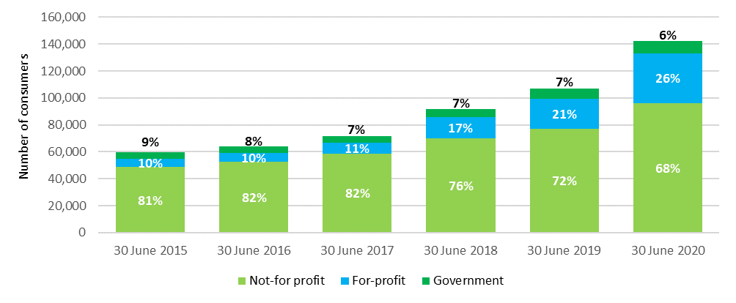

Across Australia, around 69 per cent of home care consumers are in major cities, around 23 per cent are in inner regional locations, around 7 per cent are in outer regional locations, and the remaining 1 per cent are in remote and very remote areas. These proportions have been steady in recent years.

## Operational performance

### Methodology

The discussion of financial performance in this chapter predominantly relates to Earnings Before Interest, Tax, Depreciation and Amortisation (EBITDA). EBITDA is the commonly used metric for analysis and comparison of the profitability of providers and the sector. Net Profit Before Tax (NPBT), which takes interest, depreciation and amortisation into the calculation, is also used on occasion.

Financial information reported in this chapter has been collected through the Aged Care Financial Report (ACFR). The Accountability Principles 2014, made under Section 96-1 of the Aged Care Act 1997, require each home care provider to submit a financial report in a form approved by the Secretary of the Department of Health. The ACFR submitted by home care providers is not required to be audited and should not be considered to be a General Purpose Financial Report.

Until the 2018 ACFA report, financial performance of home care providers was largely summarised on a ‘per package’ basis as the packages were previously allocated to providers after a competitive tender through an ACAR. Analysis on this basis included the provider’s packages that were not fully utilised for whatever reason in a financial year. The reform changes of February 2017 have resulted in packages being assigned to consumers and as a result, the analysis is now calculated on a ‘per consumer’ basis. EBITDA calculated on a ‘per consumer’ basis is generally higher when compared with EBITDA calculated on a ‘per package’ basis as unutilised packages are excluded. When trend data is analysed, previous years have been re‑calculated on the ‘per‑consumer’ basis to allow for direct comparison between years.

### Analysis of 2019-20 financial performance of home care providers

2019-20 saw a slight improvement in the overall financial performance of home care providers compared with the previous two years. Average EBITDA per consumer across the sector was $1,369, up from $1,211 in 2018‑19 and $1,217 in 2017-18. This followed an annual average over the three years to 2016‑17 of around $3,000.

Chart 5.3 shows the whole of sector average EBITDA per consumer of all home care providers since 2014‑15.

Chart 5.3: Home care providers average EBITDA per consumer per year, 2014-15 to 2019‑20

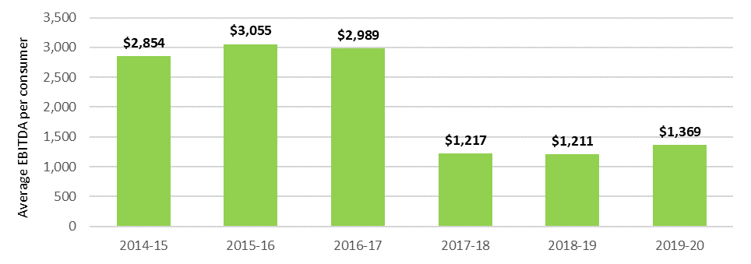

Table 5.4 provides an overview of the 2019-20 financial performance of home care providers, including a breakdown by ownership type, location and scale.

Table 5.4: Summary of financial performance of home care providers, 2019-20

|  | All providers | Not-for-profit | For-profit | Government | Metropolitan | Regional | Metropolitan & regional | Single service | Two to six services | Seven or more services |
| --- | --- | --- | --- | --- | --- | --- | --- | --- | --- | --- |
| Total revenue ($m) | $3,135.0 | $2,176.4 | $767.4 | $191.2 | $1,893.3 | $434.2 | $807.5 | $811.7 | $659.1 | $1,664.2 |
| Total expenses ($m) | $2,989.8 | $2,065.5 | $747.1 | $177.2 | $1,796.0 | $402.0 | $791.8 | $768.0 | $605.6 | $1,616.2 |
| Profit ($m) | $145.2 | $110.89 | $20.34 | $13.96 | $97.27 | $32.24 | $15.68 | $43.69 | $53.55 | $47.96 |
| EBITDA ($m) | $172.0 | $125.54 | $31.72 | $14.73 | $115.69 | $35.32 | $20.98 | $51.14 | $58.15 | $62.70 |
| Average EBITDA per consumer | $1,369 | $1,436 | $1,063 | $1,760 | $1,579 | $1,899 | $622 | $1,649 | $2,151 | $928 |
| Average NPBT per consumer | $1,156 | $1,269 | $682 | $1,668 | $1,327 | $1,733 | $465 | $1,409 | $1,981 | $710 |
| EBITDA margin | 5.5% | 5.8% | 4.1% | 7.7% | 6.1% | 8.1% | 2.6% | 6.3% | 8.8% | 3.8% |
| NPBT margin | 4.6% | 5.1% | 2.7% | 7.3% | 5.1% | 7.4% | 1.9% | 5.4% | 8.1% | 2.9% |

### Revenue

Home care revenue consists of Commonwealth contributions in the form of subsidies and supplements paid on behalf of home care package holders, and a small contribution from consumers (the basic daily fee and income tested fees). Total revenue can also include other revenue sources (such as consumer contributions for non-home care related services, interest income and state and territory government payments).

In 2019-20, total Commonwealth expenditure on home care subsidies and supplements was $3.4 billion, up from $2.5 billion in 2018-19.

The basic subsidy for home care is indexed annually based on Wage Cost Index 9 (WCI‑9), the same index as applies for the care subsidy in residential care. WCI-9 is a composite index constructed by the Department of Finance that comprises a wage cost component (weighted at 75 per cent) and a non-wage cost component (weighted at 25 per cent). For all Wage Cost Indices, the value of the wage cost component is based on the dollar increase in the national minimum wage (as determined annually by the Fair Work Commission) expressed as a percentage of the latest available estimate of average weekly ordinary time earnings (AWOTE) published by the Australian Bureau of Statistics as at November of each year. The value of the non‑wage cost component of WCI-9 is based on changes in the Consumer Price Index (CPI) between March quarters each year.

Some home care supplements are also indexed by WCI-9, including the dementia and cognition and Veterans’ supplements, while the remainder, such as the oxygen and enteral feeding supplements, are indexed annually using the Consumer Price Index (CPI).

#### Commonwealth funding (subsidies and supplements)

Commonwealth funding is determined per consumer based on the level of package accessed. It is calculated on a daily basis and until February 2021 was paid to the provider monthly in advance[25]. Each package level has a fixed maximum amount of annual funding set by the Commonwealth. Table 5.5 shows the maximum annual subsidy applicable for each home care level in 2019‑20 and 2020‑21. Supplements can also be paid in circumstances where the consumer requires additional care and/or services.

Table 5.5: Home care basic subsidy payments per annum, 2019-20 to 2020-21

| Package level | Annualised subsidy 2019-20 | Annualised subsidy 2020-21 |
| --- | --- | --- |
| Level 1 | $8,810 | $8,928 |
| Level 2 | $15,500 | $15,706 |
| Level 3 | $33,731 | $34,175 |
| Level 4 | $51,130 | $51,808 |

Note: The annualised subsidy amounts above do not account for the temporary 1.2 per cent increase to the daily subsidy rates from 1 March to 31 August 2020.

Supplements in home care are paid in addition to the amount of basic subsidy applicable at each package level. Supplements are paid if a consumer is eligible due to a specific care need or circumstance. The supplements that apply to home care are at Appendix K. All supplements payable are included in the consumer’s individualised budget.

#### Consumer contributions

Depending on their package level, consumers may be asked to pay a basic daily fee up to 17.5 per cent of the single basic age pension ($10.85 a day/$3,960 per annum as at 20 March 2021). The basic daily fee is not subject to an income or asset test and all consumers can be asked to pay unless they prove financial hardship, in which case the Commonwealth pays the provider on their behalf. The basic daily fee, when charged by the service provider, must be included in the individualised budget for the consumer.

Additionally, consumers may be asked to make a contribution towards the cost of their care through an income tested fee. The package amount paid by the Commonwealth on behalf of a consumer is reduced by the amount of the income tested fee regardless of whether the fee is collected by the provider or not.

Consumer contributions in 2019-20 reported by providers totalled around $102 million, compared with $107 million for 2018-19. This contribution is made up of $64 million from the basic daily fee ($66 million in 2018‑19) and $39 million in income-tested care fees ($42 million in 2018‑19). As noted previously, feedback from providers suggest many are foregoing charging their consumers, many of whom are pensioners, the basic daily fee, or are reducing that fee, likely due to the recent increase in competition in the home care market. ACFA notes this practice seems to be increasing among home care providers.

#### Unspent funds

Prior to the changes that occurred in February 2017, when home care consumers moved between providers or exited care (often to enter residential care), unspent package funds could be retained by their former provider. As part of the changes introduced in February 2017, unspent package funds now follow the consumer to their new provider or are returned to the Commonwealth and the consumer (based on their respective proportions paid) when the consumer leaves home care.

The unspent home care amount is the total amount of each consumer’s individual budget (comprising home care subsidy, supplements and home care fees) that has not been spent or committed for the consumer’s care, less any agreed exit amount. Unspent package funds will not generally, and should not, be recognised as income by the provider until the funds have been spent or are committed for the consumer’s care.

Unspent funds are discussed in more detail at 5.2.6.

#### Total revenue

In 2019-20, total sector revenue for all home care providers was $3.13 billion, up from $2.53 billion in 2018-19, an increase of 23.7 per cent. The increase mainly reflects the significant increase in the number of home care packages.

Commonwealth contributions represent more than 90 per cent of the total revenue received by home care providers. Unspent funds held by providers ($1.2 billion at 30 June 2020) are not treated as revenue.

The average income per consumer per day in 2019-20 was $68.37 ($25,086 per annum), a 7 per cent decrease from $73.62 ($26,871 per annum) in 2018-19. The main drivers for the decrease are a $2.44 per consumer per day decline in the income received for provision of care services, either direct or sub-contracted, and a $3.04 decline per consumer per day in administration charges. These are likely, in part at least, due to some consumers electing to receive fewer services or to put services on hold during the COVID‑19 pandemic.

Table 5.6 shows provider income per consumer per day for the last three years, split by the major types of income. As shown, there is a significant amount charged for care management and administration costs, similar to recent years. In 2019-20, care management and administration charges are almost 29 per cent of provider income. In recent years, some providers have indicated that this relatively high proportion of income derived from care management and administration reflects the costs for providers of delivering care on a CDC basis, including regulatory-related costs such as providers being required to provide consumers with full transparency regarding their packages, negotiating an individualised budget, providing monthly itemised expenditure statements, and having to administer unspent funds in a prudentially appropriate way. It will be worth monitoring whether the move during 2021 to providers only being paid for services delivered, and the eventual removal of unspent funds being held by providers, reduces these administrative costs.

Under the comparative pricing schedule that has been required to be published on My Aged Care since July 2019, providers distinguish between care management fees and package management fees. Normal business overheads are required to be included in the fees set for services.

Table 5.6: Home care provider income per consumer per day, 2017‑18 to 2019‑20

| Income type | 2017-18 | % of total | 2018-19 | % of total | 2019-20 | % of total |
| --- | --- | --- | --- | --- | --- | --- |
| Provision of care / direct care service | $47.94 | 66.5 | $49.57 | 67.3 | $35.38 | 51.7 |
| Provision of care / sub-contracted services | N/A | N/A | N/A | N/A | $11.75 | 17.2 |
| Care management fees charged to consumers | $9.72 | 13.5 | $10.35 | 14.1 | $11.05 | 16.2 |
| Administration of packages charged to consumers | $12.10 | 16.8 | $11.49 | 15.6 | $8.55 | 12.5 |
| Unspent funds and exit amounts deducted | $0.16 | 0.2 | $0.15 | 0.2 | $0.11 | 0.2 |
| COVID-19 funding | N/A | N/A | N/A | N/A | $0.56 | 0.8 |
| Other revenue | $2.11 | 2.9 | $2.07 | 2.8 | $0.97 | 1.4 |
| Total | $72.03 | 100 | $73.62 | 100 | $68.37 | 100 |

1. Provision of care/services charged to consumers includes income recognised from consumers' packages and private home care consumers. This amount will include Government subsidies and supplements, consumer contributions in the form of the basic daily fee, income tested care fees, top-ups and private contributions.
2. Care management fees charged to consumers is the amount of income recognised for on-going management and coordination of the consumers’ packages and care requirements.
3. Administration fees charged to consumers is the amount of income recognised for on-going administration of consumers’ packages.
4. Income derived from unspent package funds reflects income remaining from a consumer’s care package when a consumer left the home care service (prior to the February 2017 changes). No income can be derived from unspent funds since the change. Exit amounts deducted by the provider when ceasing to provide home care to a consumer may be charged after this date.
5. Other revenue includes other sources of income generated from running the home care services such as state and territory payments, consumer payments for non-home care services, trust distribution, donations and bequests, interest earned on investments, insurance and gains from the sale of assets.

### Expenditure

Total sector expenditure in 2018-19 was $2.99 billion, up from $2.43 billion in 2018‑19. The average expenditure per consumer per day in 2019‑20 was $65.21 ($23,802 per annum), down from $70.89 in 2018‑19 (Table 5.7). The decrease was due to an 8 per cent decrease in care costs and a 9 per cent decrease in administration costs.

Table 5.7: Home care expenditure per consumer per day, 2016-17 to 2019-20

| Expenses | 2016-17 | 2017-18 | 2018-19 | 2019-20 |
| --- | --- | --- | --- | --- |
| Care costs |  |  |  |  |
| Wages and salaries - care staff | $28.78 | $29.99 | $28.83 | $25.49 |
| Subcontracted customer services | $10.30 | $10.32 | $11.47 | $11.50 |
| Other care related expenses | $5.64 | $6.94 | $8.01 | $7.69 |
| Total care costs | $44.72 | $47.25 | $48.32 | $44.68 |
| Administration costs |  |  |  |  |
| Wages and salaries - administration staff | $8.00 | $9.26 | $9.58 | $9.52 |
| Non-wage related administration and management costs | $10.18 | $10.26 | $10.28 | $7.96 |
| Depreciation and interest costs | $0.42 | $0.74 | $0.69 | $0.58 |
| COVID-19 expenses | - | - | - | $0.39 |
| Motor vehicle expenses | - | - | - | $0.62 |
| Other expenses | $1.62 | $1.94 | $2.03 | $1.45 |
| Total administration costs | $20.22 | $22.20 | $22.57 | $20.52 |
| Total costs | $64.94 | $69.45 | $70.89 | $65.21 |

Care related expenses represent 68 per cent of total expenses per consumer per day, while administration costs (which includes care management costs) represent 32 per cent of total costs, which is significant. This is consistent with recent years.

Table 5.8 provides a breakdown of expenditure according to ownership type, location and scale for 2019‑20.

In terms of ownership, not‑for‑profit providers continue to incur lower expenses per consumer than for‑profit providers, $64.74 per day compared with $68.59. This is the third year in a row this has occurred. The main driver behind this difference is the administration and non-care related salaries where not‑for‑profits on average incurred around $3.50 per day less than for‑profit providers.

As has been the case in recent years, regional providers reported less average expense per consumer per day ($59.21) than their metropolitan counterparts ($67.15).

In terms of scale, single service providers once again recorded the highest expenses per consumer per day with $67.84 compared with larger scale providers ($61.38 for two to six services and $65.53 for providers with seven or more services).

Table 5.8: Home care expenditure per consumer per day, by ownership type, location and scale, 2019‑20

|  |  | Care related salaries | Admin and non-care related salaries | | Non-wage related adminn and management costs | | Other care related expenses | | Other expenses and non-direct costs | | | Total |
| --- | --- | --- | --- | --- | --- | --- | --- | --- | --- | --- | --- | --- |
| Ownership |  |  | |  | |  | |  | |  |
| Not-for-profit | $25.46 | $8.86 | | $8.62 | | $18.72 | | $3.08 | | $64.74 |
| For-profit | $27.72 | $12.13 | | $6.78 | | $18.79 | | $3.16 | | $68.59 |
| Government | $17.89 | $7.17 | | $5.26 | | $25.51 | | $2.19 | | $58.02 |
| Location |  |  | |  | |  | |  | |  |
| Metropolitan | $25.65 | $9.82 | | $7.95 | | $20.89 | | $2.84 | | $67.15 |
| Regional | $23.09 | $8.87 | | $6.38 | | $17.60 | | $3.29 | | $59.21 |
| Metropolitan & regional | $26.46 | $9.24 | | $8.85 | | $16.39 | | $3.34 | | $64.29 |
| Scale |  |  | |  | |  | |  | |  |
| Single service | $28.74 | $10.89 | | $7.47 | | $17.36 | | $3.37 | | $67.84 |
| Two to six services | $22.49 | $8.61 | | $6.34 | | $21.70 | | $2.24 | | $61.38 |
| Seven or more services | $25.20 | $9.26 | | $8.83 | | $19.03 | | $3.21 | | $65.53 |
| Total sector | $25.49 | $9.52 | | $7.96 | | $19.19 | | $3.04 | | $65.21 |

### Profit

In 2019-20, home care providers generated $145 million in total profit, up from $90 million in 2018‑19. In terms of profit per consumer (Table 5.9), the average EBITDA increased to $1,369 from $1,211 in 2018‑19 while the average NPBT increased to $1,156 from $959.

Prior to 2017-18, the average EBITDA per annum per consumer had been around $3,000 for the previous three years.

Table 5.9: Summary of financial performance of home care providers, per consumer per year, 2014‑15 to 2019‑20

|  | 2014-15 | 2015-16 | 2016-17 | 2017-18 | 2018-19 | 2019-20 |
| --- | --- | --- | --- | --- | --- | --- |
| Average EBITDA per consumer | $2,854 | $3,055 | $2,989 | $1,217 | $1,211 | $1,369 |
| Average NPBT per consumer | $2,657 | $2,854 | $2,832 | $947 | $959 | $1,156 |

Approximately 72 per cent of home care providers achieved a profit in 2019-20, compared with 69 per cent in 2018-19.

Chart 5.4 shows average EBITDA per consumer by quartile. As has been the case previously, EBITDA varies considerably across the sector with the top quartile of providers performing substantially better than the rest of the home care sector, although noting that all but the top quartile improved in 2019‑20 compared to 2018‑19.

Chart 5.4: Home care average EBITDA per consumer, by quartile (number of providers in parentheses), 2016‑17 to 2019‑20

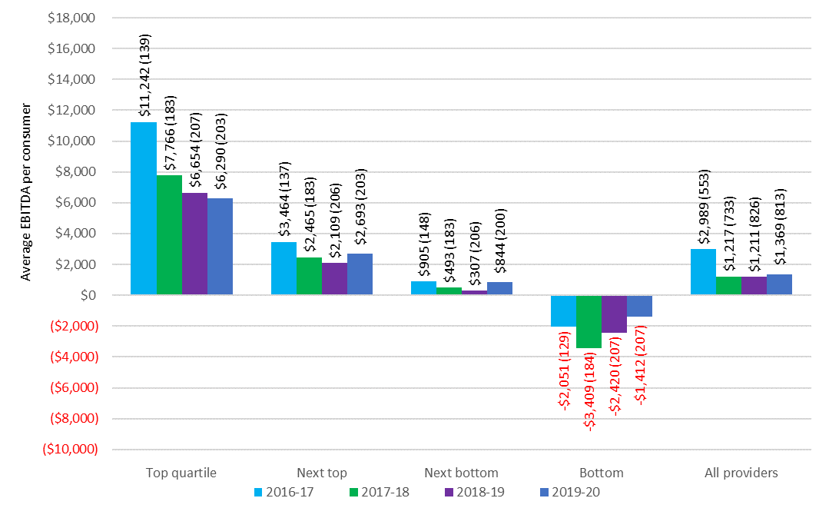

Chart 5.5 shows the quartile analysis of the average EBITDA per consumer for home care providers by ownership in 2019-20, while Chart 5.6 shows the overall average EBITDA per consumer by ownership over the last five years.

For the third year in a row the for‑profit providers reported the worst results in 2019‑20 compared with not‑for‑profit and government providers (Chart 5.6). In 2019‑20 the for‑profit providers recorded average EBITDA per consumer of $1,063 compared with $1,436 reported by the not‑for‑profit providers.

Despite the overall poor results of for‑profit providers, the 88 for‑profit providers (32 per cent) in the top quartile recorded average EBITDA of $7,644 (Chart 5.5) which was above that of the 96 not‑for‑profit providers in the top quartile ($5,668). As has been noted previously, the poorer financial performance of for‑profit providers likely reflects that the influx of new providers following the changes of February 2017 was largely for-profit providers and it could be expected that new entrants into a market may make a loss as they seek to establish market presence and refine their operations.

Chart 5.5: Home care average EBITDA per consumer per year, by quartile and ownership type, 2019‑20 (number of providers in parentheses)

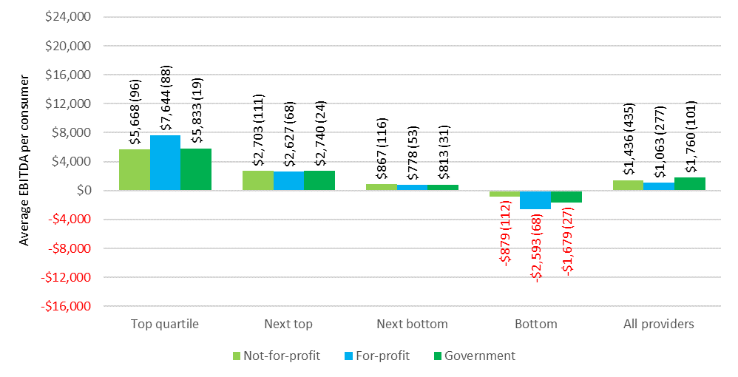

Chart 5.6: Home care average EBITDA per consumer per year, by ownership type, 2014-15 to 2019-20

When performance is considered by location, providers in regional areas reported a significant improvement in performance, achieving an average EBITDA of $1,899 compared with $974 in 2018‑19 (Chart 5.8). Metropolitan providers reported a slight increase, with an average EBITDA of $1,570 in 2019‑20, up from $1,470.

In terms of quartile analysis (Chart 5.7), metropolitan providers in the top quartile outperformed regional providers but were by far the worst performers in the bottom quartile.

Chart 5.7: Home care average EBITDA per consumer per year, by quartile and provider location, 2019-20 (number of providers in parentheses)

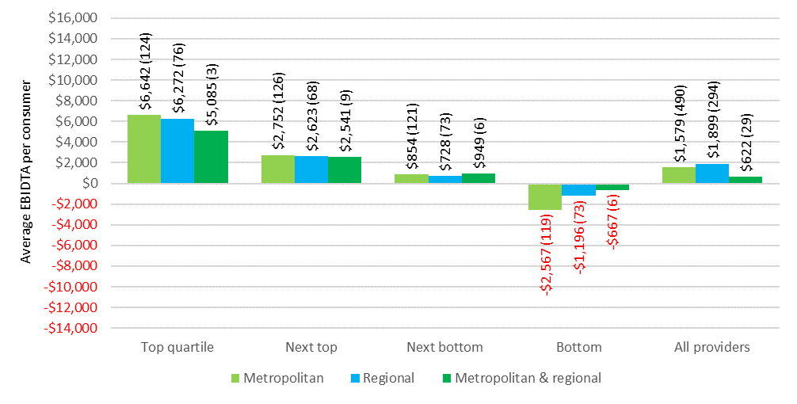

Chart 5.8: Home care average EBITDA per consumer, by provider location, 2014-15 to 2019-20

When performance is considered by scale (Chart 5.9 and Chart 5.10), for the third year in a row, providers who operate seven or more services were the worst performers when compared with providers operating two to six services and single service providers. The providers who operate seven or more services reported an EBITDA of $928 per consumer compared with $1,649 for single service providers and $2,151 for providers with two to six services.

Chart 5.9: Home care average EBITDA per consumer per annum, 2019-20, by quartile and provider scale (number of providers in parentheses)

Chart 5.10: Home care average EBITDA per consumer per annum, by provider scale, 2014-15 to 2019-20

### Unspent funds

Over the last four years, unspent funds held by providers on behalf of consumers have been increasing significantly. At 30 June 2020, home care providers reported holding unspent funds of $1.2 billion. This is up from $751 million at 30 June 2019 and $539 million at 30 June 2018. ACFA noted last year that based on the current rate of growth of unspent funds, the amount could reach $1 billion by 30 June 2020, especially given some consumers were electing to defer or reduce the amount of services they seek during the COVID-19 pandemic.

Unspent funds accumulate for a variety of reasons, including because consumers wish to save a proportion of their budget for future events; the services that the consumer wants are not available; the consumer is reluctant to allow people into their home; misconceptions that the money not spent under the package belongs to the consumer; or because the consumer does not require all the funds allocated to them. ACFA commented previously that if the consumer does not need all the funds they have been allocated, these funds could be used more effectively elsewhere, including meeting unmet demand.

The Department of Health does take into account unspent Commonwealth funds that are returned when a consumer leaves home care as an input in determining the number of new home care packages to be released.

ACFA notes that the Budget measure which takes effect in September 2021, which will see providers paid in arrears for services actually provided, will eventually lead to all unspent funds being held by the Commonwealth instead of providers.

## Developments in 2020-21 and looking ahead

Home care providers seem to be adjusting gradually to the changes introduced in February 2017 which assigned home care packages directly to consumers, with consumers having a choice of provider and the ability to change providers. Following this change, a more competitive market saw more providers enter the market and profits declined significantly.

However, the number of home care providers has stabilised and overall profits were slightly higher in 2019-20 than the previous two years. There has also been a significant increase in the number of home care consumers (30 per cent over 2018‑19) due to Government policy increasing the number of available packages, which means there is a larger market for the increased number of providers.

From 1 February 2021, home care providers began receiving funds in arrears, rather than in advance. From 1 September 2021, providers will receive funding based on the actual services delivered to care recipients. These changes will reduce prudential risk over time as holdings of unspent funds by providers reduce.

The decision by Government in response to the Royal Commission to release an additional 80,000 packages over the next two years, on top of the other recently announced additional package releases and stability in the provider profile, may mean that the improvement in performance in 2019‑20 will continue in coming years.

The Government is also introducing measures to put downward pressure on administrative costs by conducting program assurance reviews of providers and improved pricing transparency. This will help ensure the majority of home care funds are spent on care and services for older Australians, assisting them to remain in their homes for as long as possible. In addition to this, the Aged Care Quality and Safety Commission received funding in the 2021-22 Budget to increase resourcing for quality and safety checks for home care packages. This funding will include conducting more than 250 additional quality reviews and assessments each year from 2022. This increase in reviews and assessments is roughly proportional to the increase in the size of the program.

Also, as part of its response to the Royal Commission, the Government reaffirmed its support for the combining of the Home Care Packages Program with the Commonwealth Home Support Program, Short-Term Restorative Care and residential respite care. This is due to be from July 2023.

ACFA notes there remain significant workforce issues in home care, similar to those faced by residential care providers. Some home care providers have difficulty recruiting and retaining suitably qualified staff and the additional packages coming in the next two years will amplify these issues.

# Residential care

**This chapter discusses:**

* The operation of residential care;
* the ownership, locational and scale characteristics of residential care providers;
* the funding arrangements in residential care; and
* the financial performance of residential care providers in 2019-20.

**This chapter reports that:**

* At 30 June 2020 there were 217,145 operational places, up from 213,397 at 30 June 2019;
* during 2019-20 residential care was provided to 244,363 older Australians, up from 242,612 in 2018-19;
* at 30 June 2020 there were 845 residential care providers, down from 873 in 2018-19, continuing the gradual consolidation of providers in recent years; and
* not-for-profit providers continue to represent the largest proportion of ownership type in residential care, with 56 per cent of providers and 55 per cent of places.

**Key findings on financial performance in 2019-20 compared with 2018-19:**

* Total revenue of $20.5 billion, up from $19.3 billion, an increase of 6.4 per cent, equating to revenue of $296.64 per resident per day, an increase of 4.6 per cent from $283.54;
* total expenses of $21.3 billion, up from $19.0 billion, an increase of 11.7 per cent, equating to $307.27 per resident per day, compared with $279.65, an increase of 9.9 per cent;
* average EBITDA per resident per annum of $6,445 compared with $8,523, a decrease of 24.4 per cent, noting without the additional COVID‑19 funding and expenses incurred the EBITDA would have been $5,950, or a decrease of 30.2 per cent;
* total **loss** of $736 million compared with a total profit of $264 million; and
* 46 per cent of providers achieved a net profit, compared with 58 per cent.

## Overview of the sector

### Supply of residential care

The Australian Government uses a population based planning ratio (target provision ratio) to determine the number of subsidised operational residential care places. This is outlined in Chapter 3.

Table 6.1 shows the number of providers, facilities[26], places and residents since 30 June 2016. The number of providers continues to decrease each year through consolidation, while the number of places and residents continues to increase. The number of facilities has increased gradually.

Table 6.1 also shows the achieved provision ratio in residential care, as well as provisionally allocated places and respite residents.

Table 6.1: Number of residential care providers, facilities, places and residents, 30 June 2016 to 30 June 2020

|  | 30 June 2016 | 30 June 2017 | 30 June 2018 | 30 June 2019 | 30 June 2020 |
| --- | --- | --- | --- | --- | --- |
| Providers | 949 | 902 | 886 | 873 | 845 |
| Facilities | 2,669 | 2,672 | 2,695 | 2,717 | 2,722 |
| Allocated places | 238,843 | 247,907 | 246,536 | 258,934 | 256,986 |
| Operational places | 195,825 | 200,689 | 207,142 | 213,397 | 217,145 |
| Provisionally allocated places | 35,124 | 39,294 | 31,603 | 36,905 | 31,234 |
| Provisionally allocated places as proportion of allocated places | 14.7% | 15.9% | 12.8% | 14.3% | 12.2% |
| Occupancy | 92.4% | 91.8% | 90.3% | 89.4% | 88.3% |
| Total residents | 181,048 | 184,077 | 186,597 | 188,773 | 189,954 |
| - Permanent residents | 175,989 | 178,713 | 180,923 | 182,705 | 183,989 |
| - Respite residents | 5,059 | 5,364 | 5,674 | 6,068 | 5,965 |

1. The number of allocated residential care places was less at 30 June 2018 than it was at 30 June 2017, and again less at 30 June 2020 than it was at 30 June 2019. The overall reduction in allocated places over these periods was due to no new places being allocated during 2017-18 or during 2019-20 (due to there being no ACAR) and provisionally allocated places were either surrendered by providers or revoked by the Department during that period.

Table 6.2 shows a breakdown of residential care providers as at 30 June 2020, presented by ownership type, location and scale.

Table 6.2: Number of providers, facilities, places and residents in residential care, by ownership, location and scale, 30 June 2020

|  |  |  | Ownership type | | | Location | | | Scale | | | |
| --- | --- | --- | --- | --- | --- | --- | --- | --- | --- | --- | --- | --- |
|  |  | Total sector 2019-20 | Not-for-profit | For-profit | Government | Metropolitan | Regional | Metropolitan & regional | Single facilities | Two to six facilities | Seven to 19 facilities | 20 or more facilities |
| Providers |  | 845 | 473 | 279 | 93 | 430 | 326 | 89 | 534 | 233 | 54 | 24 |
| Facilities |  | 2,722 | 1,552 | 935 | 235 | 1,709 | 1,013 | N/A | 534 | 668 | 601 | 919 |
| Operational places |  | 217,145 | 119,276 | 89,439 | 8,430 | 153,372 | 63,773 | N/A | 42,401 | 47,575 | 48,802 | 78,367 |
| Occupancy |  | 88.3% | 90.5% | 85.3% | 88.3% | 88.0% | 89.0% | N/A | 87.7% | 87.8% | 89.4% | 88.1% |
| Total residents |  | 189,954 | 106,705 | 75,915 | 7,334 | 133,470 | 56,484 | N/A | 36,697 | 41,120 | 43,415 | 68,722 |
| -Permanent residents |  | 183,989 | 103,818 | 73,043 | 7,128 | 129,480 | 54,509 | N/A | 35,513 | 39,771 | 42,167 | 66,538 |
| - Respite residents |  | 5,965 | 2,887 | 2,872 | 206 | 3,990 | 1,975 | N/A | 1,184 | 1,349 | 1,248 | 2,184 |

### Residential care providers

At 30 June 2020, there were 845 residential care providers operating 217,145 residential care places in Australia. This compares with 873 providers operating 213,397 places at 30 June 2019. As has been the case in recent years, some providers are continuing to expand the scale of their businesses. As a result there has been a consolidation of residential care providers over a number of years. Chart 6.1 and Chart 6.2 show the decreasing provider numbers but increasing operational places since 2010‑11.

Chart 6.1: Number of residential care providers, 2010‑11 to 2019-20

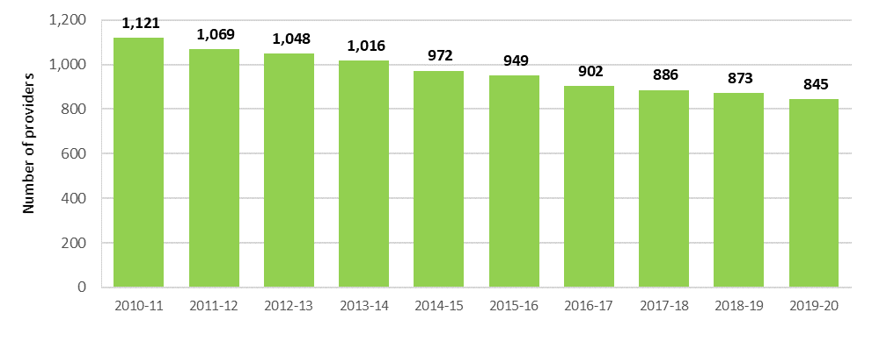

Chart 6.2: Number of operational residential care places, 2010-11 to 2019-20

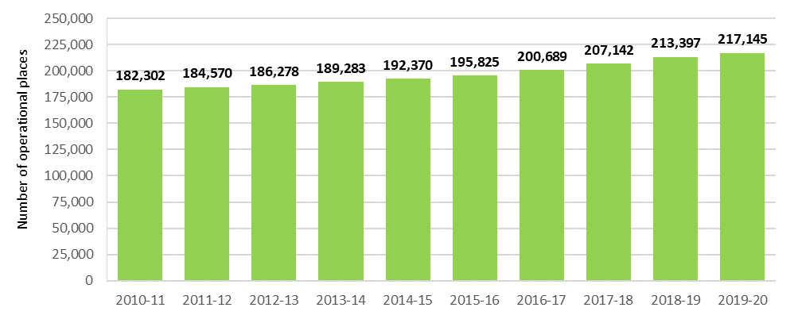

### Ownership type

As shown in Chart 6.3, the largest provider group remains the not-for-profit group (religious, charitable and community-based organisations). They represent 56 per cent of providers and operate 55 per cent of all residential aged care places. For-profit providers account for 33 per cent of providers and 41 per cent of places. The remaining providers and places are state and territory and local government-owned providers. This distribution has been stable in recent years.

Not-for-profit providers continue to operate proportionally more of the residential care places in rural and regional areas compared with for‑profit providers. As at 30 June 2020, not‑for‑profit providers were operating 66 per cent of regional places (55 per cent of all places). Conversely, and also similar to previous years, for-profit providers operated 41 per cent of all places and only 24 per cent of regional places. Government providers operated the remaining regional places.

Chart 6.3: Residential care provider and operational places by ownership type, 2016-17 to 2019-20

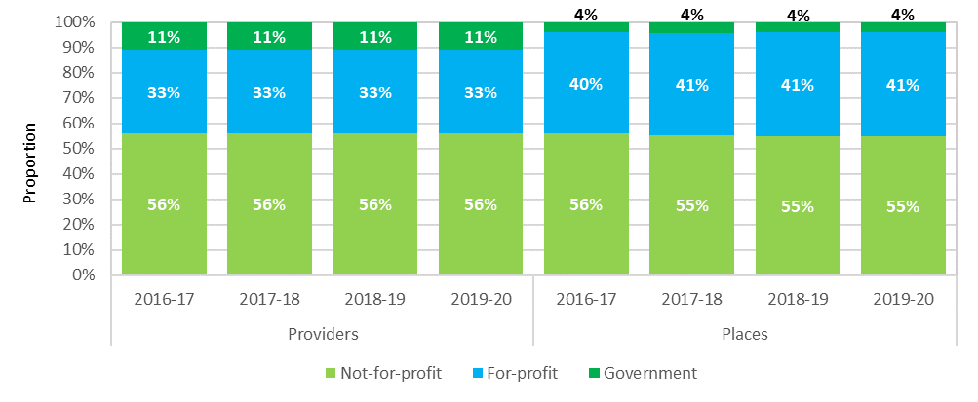

### Provider scale

The majority of residential care providers (63 per cent) operate only one residential care facility (Chart 6.4). These single aged care facility providers account for 20 per cent of all operational residential care places. However this proportion is very gradually declining (23 per cent in 2015-16). Of the 63 per cent of providers operating one facility only, 56 per cent are not‑for‑profit, 36 per cent are for‑profit and 8 per cent are government owned.

Conversely, 3 per cent (24 providers in total) operate more than 20 facilities, but they account for 36 per cent of operational places. This proportion is gradually increasing (27 per cent in 2015-16). Seventeen of the 24 larger providers are not‑for‑profit and the remaining seven are for‑profit.

Chart 6.4: Residential care provider and operational places by provider scale, 2016-17 to 2019-20

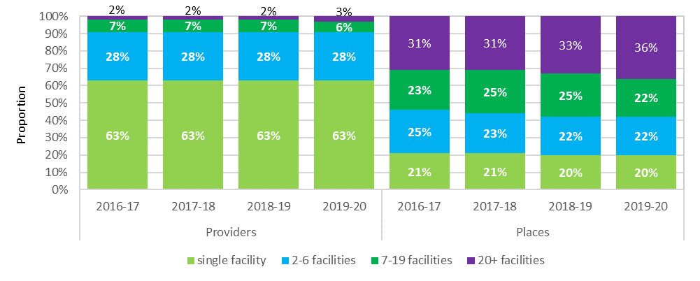

As shown in Table 6.3, for-profit and not-for-profit providers have, on average, just over three facilities per provider. However within those facilities, for-profit providers, on average, operate around 96 residential care places per facility, compared with not‑for‑profit providers who operate around 77 places per facility. This likely reflects both some for‑profit providers expanding their facilities and also reflecting the not‑for‑profit sector’s bigger presence in regional locations where facility size is usually smaller.

Table 6.3: Number of residential care facilities per provider, by ownership type, 30 June 2020

| Organisation type | Number of providers | Number of facilities | Average facilities per provider | Total operational places | Average places per provider | Average places per facility |
| --- | --- | --- | --- | --- | --- | --- |
| Not-for-profit | 473 | 1,552 | 3.3 | 119,276 | 252.2 | 76.9 |
| For-profit | 279 | 935 | 3.4 | 89,439 | 320.6 | 95.7 |
| Government | 93 | 235 | 2.5 | 8,430 | 90.6 | 35.9 |

### Provider location

ACFA generally categorises residential care providers as those operating only in metropolitan areas, those operating only in regional[27] areas, and those who have facilities in both metropolitan and regional areas. A provider is categorised as being regional if more than 70 per cent of their residents are in facilities in regional areas.

Chart 6.5 shows that 51 per cent of providers operate only in metropolitan areas and 39 per cent operate only in regional areas. This has been steady for the last five years.

Chart 6.5: Residential care providers, by location, 2014-15 to 2019-20

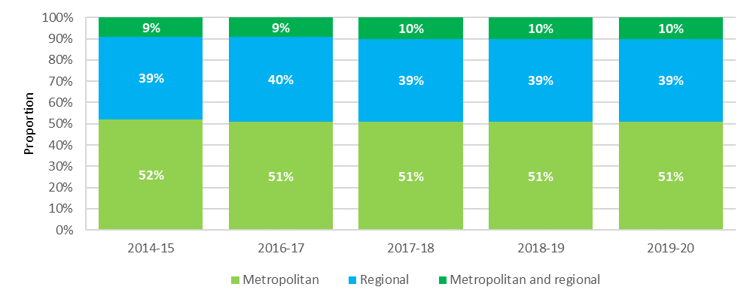

### Residential care facility size and room configuration

The average size of residential care facilities has been increasing over the last 10 years. In 2009‑10, 44 per cent of facilities had over 60 places. This has increased to 61 per cent in 2019‑20. By contrast, the proportion of facilities with 60 places or less has been consistently decreasing. This trend seems particularly evident in the for‑profit sector, as discussed in Section 6.1.4, with for‑profit providers having, on average, 19 more places per facility than the not‑for‑profits.

Table 6.4: Size of residential care facilities, 2010 to 2020

| Number of places | June 2010 | June 2011 | June 2012 | June 2013 | June 2014 | June 2015 | June 2016 | June 2017 | June 2018 | June 2019 | June 2020 |
| --- | --- | --- | --- | --- | --- | --- | --- | --- | --- | --- | --- |
| Proportion of facilities (%) | | | | | | | | | | | |  |
| 1–20 places | 6.5 | 6.2 | 6.2 | 6.0 | 5.5 | 5.4 | 5.4 | 5.3 | 5.0 | 4.7 | 4.6 |
| 21–40 places | 21.1 | 20.4 | 19.5 | 19.4 | 18.6 | 18.0 | 17.2 | 16.5 | 16.1 | 15.6 | 15.0 |
| 41–60 places | 28.7 | 28.2 | 27.0 | 26.3 | 25.0 | 24.4 | 23.5 | 22.5 | 21.2 | 19.9 | 19.3 |
| 61+ places | 43.7 | 45.1 | 47.3 | 48.4 | 50.9 | 52.2 | 54.0 | 55.7 | 57.7 | 59.7 | 61.2 |

There has been an increasing trend in terms of room configuration for residential care facilities towards single-bed rooms with an ensuite. In 2019‑20, around 82 per cent of rooms were single-bed rooms with an ensuite. This proportion had been gradually increasing (80 per cent in 2017-18 and 77 per cent in 2016-17), but has been stable since 2018‑19. Conversely, in 2019‑20 and 2018‑19, 10 per cent of residential care rooms could be considered ‘ward style’ which are shared and have a common shared bathroom. This is down from 14 per cent in 2017-18 and 18 per cent in 2016-17.

### Provisionally allocated places

Under current arrangements, the Commonwealth releases residential care places through the ACAR[28]. After a place is allocated to an approved provider, there is usually a period during which the place is considered ‘provisional’ while the provider constructs the facility or extends the current facility. Once the place is available to be occupied by a resident, it becomes ‘operational’. The average time it takes providers to bring places online is around four years.

At 30 June 2020, there were 31,234 provisional residential care places. This represents around 12 per cent of all allocated places, and compares with 14 per cent at 30 June 2019 and 13 per cent at 30 June 2018. The provisional allocations are held by around 16 per cent of all facilities, compared with 18 per cent in 2018‑19 and 23 per cent in 2017‑18.

As has been the case in recent years, Western Australia has the highest proportion of provisionally allocated places with 23 per cent. The ACT has also been high in recent years and was also 23 per cent at 30 June 2020. South Australia and Tasmania have once again the lowest proportion of provisionally allocated places with less than 5 per cent (Table 6.5).

Not-for-profit providers, who have 55 per cent of operational places, have only 35 per cent of provisionally allocated places, whereas the for-profit providers, who have 41 per cent of operational places, have 65 per cent of the provisionally allocated places. This is similar to previous years.

In addition, there were also 8,619 formerly operational places that were offline[29] at 30 June 2020 pending refurbishment or redevelopment, or pending sale to another provider.

Table 6.5: Provisionally allocated residential care places, by state and territory, at 30 June 2020

| State/territory | Provisionally allocated places | All allocated places | Proportion |
| --- | --- | --- | --- |
| New South Wales | 9,156 | 85,036 | 10.8% |
| Victoria | 6,470 | 66,324 | 9.8% |
| Queensland | 7,854 | 51,436 | 15.3% |
| Western Australia | 5,723 | 24,946 | 22.9% |
| South Australia | 839 | 19,416 | 4.3% |
| Tasmania | 265 | 5,518 | 4.8% |
| Australian Capital Territory | 812 | 3,590 | 22.6% |
| Northern Territory | 115 | 720 | 16.0% |
| Australia | 31,234 | 256,986 | 12.2% |

Changes introduced in 2016 were designed to encourage providers to operationalise their provisional places in a timely manner. The changes limit the provisional allocation period to four years (noting that up to two extensions of 12 months each may be granted by the Department of Health, and further extensions in exceptional circumstances). At the end of this time, the provisional allocations lapse and the places return to the Department for redistribution in a future ACAR.

In 2019‑20, 1,359 (657 in 2018‑19 and 1,371 in 2017-18) provisionally allocated places were surrendered by providers. The majority of these were surrendered as the six years expired and the provider did not apply for an extension.

Table 6.6 and Table 6.7 show the distribution of the age of provisionally allocated places by location and state and territory.

Table 6.6: Provisionally allocated residential care places by location and year of distribution, at 30 June 2020

|  | <1 year old | 1-2 years old | 2-4 years old | 4-6 years old | 6-8 years old | 8-10 years old | 10+ years | Total |
| --- | --- | --- | --- | --- | --- | --- | --- | --- |
| Metropolitan | 0 | 7,653 | 5,099 | 7,392 | 1,212 | 275 | 317 | 21,948 |
| Inner regional | 0 | 4,446 | 1,705 | 1,665 | 175 | 0 | 0 | 7,991 |
| Outer regional | 0 | 475 | 243 | 532 | 0 | 0 | 0 | 1,250 |
| Remote | 0 | 25 | 0 | 20 | 0 | 0 | 0 | 45 |
| Total | 0 | 12,599 | 7,047 | 9,609 | 1,387 | 275 | 317 | 31,234 |

Table 6.7: Provisionally allocated residential care places by state and territory and year of distribution, at 30 June 2020

|  | <1 year old | 1-2 years old | 2-4 years old | 4-6 years old | 6-8 years old | 8-10 years old | 10+ years | Total |
| --- | --- | --- | --- | --- | --- | --- | --- | --- |
| NSW | 0 | 3,387 | 1,761 | 3,033 | 693 | 112 | 170 | 9,156 |
| VIC | 0 | 1,371 | 2,066 | 2,770 | 174 | 89 | 0 | 6,470 |
| QLD | 0 | 4,058 | 1,617 | 1,873 | 296 | 0 | 10 | 7,854 |
| WA | 0 | 2,921 | 1,192 | 1,306 | 183 | 0 | 121 | 5,723 |
| SA | 0 | 476 | 186 | 177 | 0 | 0 | 0 | 839 |
| TAS | 0 | 134 | 81 | 50 | 0 | 0 | 0 | 265 |
| ACT | 0 | 202 | 144 | 335 | 41 | 74 | 16 | 812 |
| NT | 0 | 50 | 0 | 65 | 0 | 0 | 0 | 115 |
| Total | 0 | 12,599 | 7,047 | 9,609 | 1,387 | 275 | 317 | 31,234 |

#### Transferring residential care places

Residential aged care places (both provisionally allocated and operational) may be transferred between providers. A transfer of places commonly occurs as the result of a business transaction between two approved providers where a decision has been made by the transferor to sell all or some of their residential care places. Transfers of places need to be approved by the Department of Health.

As a general rule, when places transfer between providers, the planning region in respect of which the places are allocated does not change. This rule, and the need for approval by the Department of Health, are designed to discourage attempts to subvert the competitive allocation process and to maintain care delivery in the region where the places were originally allocated.

Data from the Department of Health shows that in 2019-20 around 8,200 operational places and 1,100 provisionally allocated places were transferred between providers. This compares with 5,800 operational places and 800 provisionally allocated places in 2018-19 and 1,400 provisional places transferred in 2017-18.

### Extra service

Providers with extra service status are able to charge an extra service fee for residents occupying an extra service place for the duration of their stay. Extra service status involves the provision of a higher than average standard of services, including accommodation, range and quality of food, and non-care services such as recreational and personal interest activities.

Providers that have been granted extra service status apply to the Aged Care Pricing Commissioner for approval of their proposed extra service fees, including proposed increases to current extra service fees.

For extra service status places that are occupied by a resident who was in care prior to 1 July 2014 and who is covered under the pre-reform fee arrangements, the care subsidy is reduced by 25 per cent of the approved extra service fee for that place. This is known as the Extra Service Subsidy Reduction. The provider can charge a continuing care recipient an amount equal to the extra service fee plus the extra service reduction for receiving extra service. Extra service subsidy reduction does not apply to residents entering care on or after 1 July 2014.

There was a significant decrease in 2014-15 and 2015‑16 in the number of places with extra service status (Chart 6.6). This was likely because changes made to accommodation pricing on 1 July 2014 reduced the need and motivation for providers to have extra service status, partly because:

* lump sum accommodation payments can now be made for all care types – previously they were restricted to low care or high care with extra service;
* market-based prices determined by the provider apply for all new non-supported residents; and
* providers can offer additional care and services for additional fees outside the extra service framework.
* Providers who had relinquished their Extra Service places began offering residents ‘fee for additional service’ arrangements instead. However, ACFA notes that due to the ongoing uncertainty about the regulation of additional services fees, some providers have reconsidered letting their Extra Service places lapse in recent years, which has resulted in the number of active Extra Service places stabilising since 2015-16, though a further small decline was evident following 2017‑18.
* ACFA also notes that there have been no new Extra Service places released through the ACAR since the 2012 Living Longer Living Better package and that the current 2020-21 ACAR will be the last ACAR, meaning that there will no new Extra Service places in future.

Chart 6.6: Number of operational extra service residential care places, 30 June 2014 to 30 June 2020

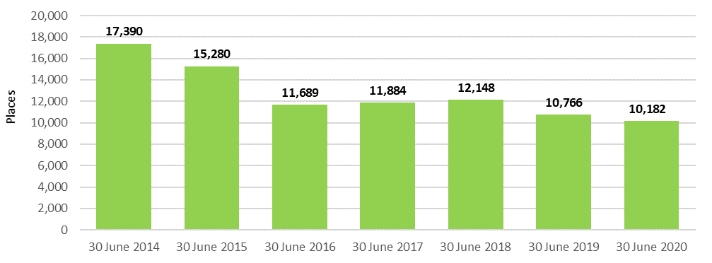

### Additional services

Additional services are care and other services that residential care providers can make available to residents above those that they are legislatively required to provide under the Schedule of Specified Care and Services[30] for residential care services. Additional services vary greatly but may include items such as the provision of pay TV, hairdressing, additional beverage offerings (e.g. wine and beer) and access to a gym. Additional services may be offered individually or as part of a bundle of services. These services incur an additional fee for residents.

An additional service fee can only be charged for services that have been agreed to by the resident, that are over and above those paid for by the Commonwealth under the Schedule of Specified Care and Services, and from which aged care residents receive a direct and tangible benefit.

As noted previously there still remains very limited data available on additional services.

Also as noted previously, there still remains some uncertainty for both providers and consumers over the regulatory arrangements concerning fees for additional services. Nevertheless, this is an area that is receiving increasing attention from providers and there is an increasing trend towards bundling services and charging a packaged fee that is compulsory for consumers entering into that facility. The Department of Health has been working with the sector to provide additional clarity and transparency for both providers and residents on the operation of additional services.

ACFA notes that policy regarding fees for additional services was not addressed in either the Final Report of the Royal Commission into Aged Care Quality and Safety or the Government’s May 2020‑21 Budget response.

## Residential care funding sources

### Operational funding

Funding for residential care is made up of operational funding and capital financing.

Operational funding supports day-to-day services such as nursing and personal care, living expenses and accommodation expenses. Capital financing supports the construction of new residential care facilities and the refurbishment of existing facilities. Capital financing is discussed in Chapter 7.

A combination of Australian Government and resident contributions provides the operational funding for residential care. Figure 6.1 shows the different funding types from the Commonwealth and residents for operational funding.

Figure 6.1: Residential care services

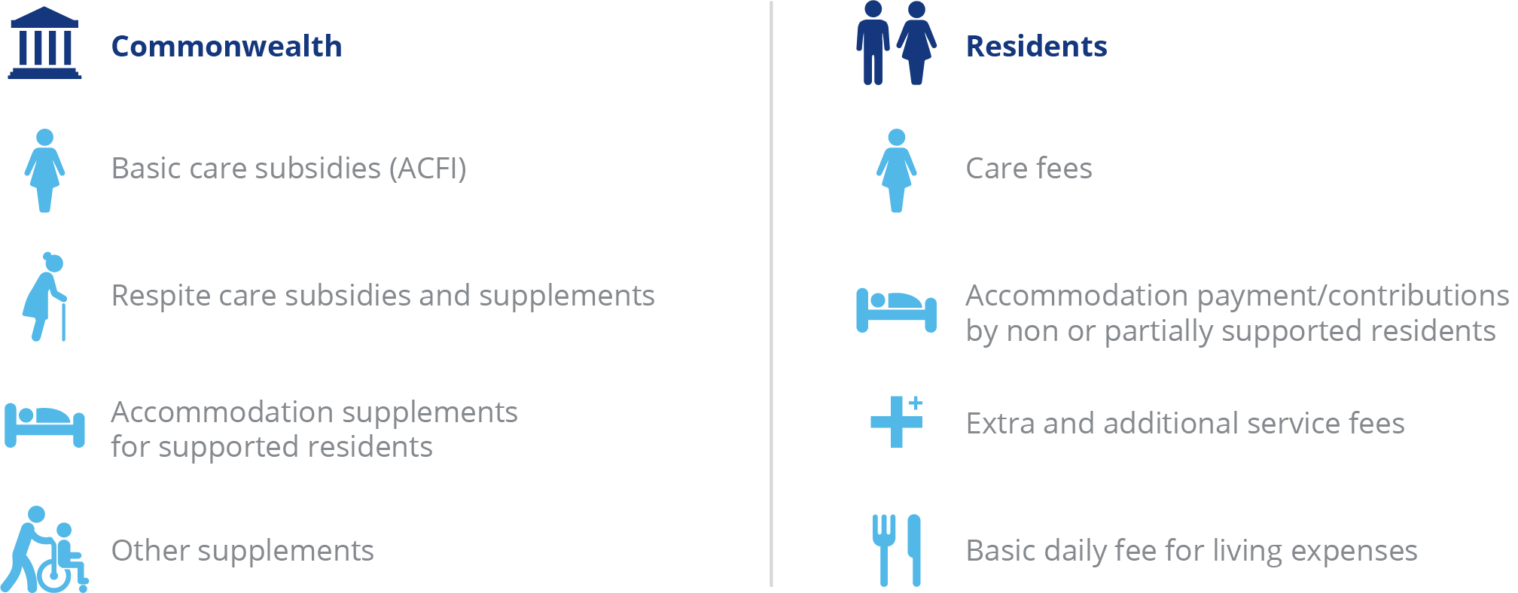

The Commonwealth determines its contributions on behalf of permanent residents in residential care by setting:

* A basic care subsidy for personal and nursing care;
* the rates of supplements paid to support aspects of residential care that incur higher costs to deliver; and
* the maximum rate of accommodation supplement.

With regard to respite care, the Commonwealth sets the basic respite care subsidy at two levels (low or high) depending on the level of respite care the consumer is approved for by the Aged Care Assessment Team (ACAT).

The Commonwealth also sets the maximum levels for contributions made by residents for the following:

* the maximum rate of the basic daily fee for living expenses (permanent and respite); and
* the maximum means tested care fee that may be charged by providers (permanent only).

### Commonwealth operational funding

Commonwealth payments for residential care can be classified as:

* basic care subsidies
* respite care subsidies and supplements
* accommodation supplements
* viability supplements
* other supplements

A full list of subsidies and supplements is at Appendix G:

Commonwealth subsidies and supplements are generally indexed either biannually (accommodation related) or annually (care related).

The indexation currently applied to the basic care subsidy for residential care is the Wage Cost Index 9 (WCI‑9), which is a composite index constructed by the Department of Finance that comprises a wage cost component (weighted at 75 per cent) and a non-wage cost component (weighted at 25 per cent). For all Wage Cost Indices the value of the wage cost component is based on the dollar increase in the national minimum wage (as determined annually by the Fair Work Commission) expressed as a percentage of the latest available estimate of Average Weekly Ordinary Time Earnings (AWOTE) published by the Australian Bureau of Statistics as at November of each year. The value of the non-wage cost component of WCI-9 is based on changes in the Consumer Price Index between the March quarters each year.

Accommodation related supplements are indexed using the Consumer Price Index (CPI) and are indexed twice a year in line with the age pension.

### Basic care subsidies

* **The basic care subsidy** is a payment to support the costs of providing personal and nursing services for permanent residents. It is calculated based on the assessed need of each permanent resident as determined by the provider by applying the Aged Care Funding Instrument[31] (ACFI).The Commonwealth determines the level of payments on behalf of residents by setting the prices and rules for claiming ACFI care subsidies.
* **The residential respite subsidy[32]** is a payment to support the costs of providing personal and nursing services for respite consumers. Respite consumers are assessed by an ACAT as requiring either low or high level respite care, with payment amounts for each set by the Commonwealth.

#### The Aged Care Funding Instrument (ACFI)

The ACFI is the funding allocation tool currently used to determine the amount of funding paid to a provider on behalf of a resident for their care. It assesses the care needs of permanent residents as a basis for allocating care funding by focusing the funding allocation around the main areas that differentiate relative care needs and costs among residents.

The ACFI consists of 12 questions about assessed care needs, each having four ratings (A, B, C or D) and two diagnostic sections. ACFI is self-assessed by providers, but is subject to audits by the Department of Health.

In the May 2021 Budget, Government announced the ACFI will be replaced by a new Australian National Aged Care Classification (AN-ACC) funding tool in October 2022.

### Residential care supplements

Residential care supplements are payments by the Commonwealth in addition to the basic daily subsidy (ACFI). There are two types of supplements:

* primary supplements, which provide additional funds to meet specific care needs. These include the oxygen supplement and enteral feeding supplement; and
* other supplements, which are accommodation-based and assist providers with costs related to the operation of a residential care facility. Other supplements include accommodation supplements, the viability supplement and homeless supplement.

The types and amounts of supplements that a residential care facility may receive depends on the provider and/or resident meeting the eligibility requirements for those supplements.

The major supplements are summarised below and a full list of supplements, including rates and expenditure over the last three years are included at Appendices G and H.

#### Accommodation supplements

Accommodation supplements are paid by the Commonwealth to assist with the accommodation costs of permanent residents who do not have the means to meet all of that cost themselves (supported residents). These supplements include both the current accommodation supplement and grand-parented supplements under previous policies. Accommodation supplements (or accommodation payments) do not apply for consumers accessing residential respite care.

The Commonwealth determines the amount of accommodation supplement payable by setting the maximum rate of accommodation supplement and determining the share paid by residents based on a means test.

Two significant reforms from 1 July 2014 affected accommodation payments. A new means test that combined the formerly separate income and assets tests was introduced for residents entering residential care after 1 July 2014, and the accommodation supplement paid by the Commonwealth to a provider on behalf of supported residents living in aged care facilities that have been built or significantly refurbished since 20 April 2012 was significantly increased.

#### Viability supplement

The viability supplement aims to improve the financial position of smaller, rural and remote residential care facilities that incur additional costs due to their location and are constrained in their ability to realise economies of scale due to smaller numbers of beds. In addition, the viability supplement also supports providers who specialise in aged care services for Indigenous people, or people who are homeless or who are at risk of becoming homeless, in recognition of the often higher costs associated with providing these services.

The supplement is available to residential care facilities, home care services, Multi-Purpose Services and Aboriginal and Torres Strait Islander Flexible services. In 2019-20, on average, the viability supplement provided around $15,000 per resident per annum for residential care facilities in remote and very remote areas, directly improving their financial results.

At 30 June 2020, 455 residential services were receiving the viability supplement on behalf of 13,659 residents. During 2019-20, $82.3 million in viability supplement was paid to providers.

Over the last decade the amount paid per resident per day for the viability supplement has increased by over 100 per cent. The increases or expansions to the viability supplement include:

* A 40 per cent increase from 2009-10;
* An expansion of the supplement from 2011-12 to provide additional support to facilities in remote to moderately accessible locations that target low care residents or who provide specialist care to Indigenous Australians or people with a history of (or who may be at severe risk of) homelessness;
* A 20 per cent increase from 2014-15;
* A flat rate increase of $2.12 per resident per day from 2017-18;
* A 30 per cent increase from March 2019; and
* A temporary 30 per cent COVID-related increase from March 2020 to June 2021[33].

#### Homeless supplement

A homeless supplement is paid to providers for each resident of an eligible aged care facility. Eligibility for the supplement is based on the facility having more than 50 per cent of its residents with complex behavioural needs who are identified as being homeless, or at risk of becoming homeless.

The homeless supplement is in addition to the funding provided under the viability supplement.

At 30 June 2020, 40 residential services were receiving the homeless supplement on behalf of 1,680 residents. During 2019-20, $13.3 million in homeless supplement was paid to providers.

A 30 per cent increase to the rate of the homeless supplement took effect from March 2019. As part of the response to COVID-19, the Government temporarily increased the Homeless supplement by an additional 30 per cent from 1 March 2020 to 30 June 2021[34].

### Payments for residential respite care

The Australian Government pays the provider a residential respite subsidy and a respite supplement for each eligible respite resident.

The subsidy and supplement are paid at either a low or high rate depending on the level of respite care the consumer is approved for by the ACAT. Additionally, facilities that use 70 per cent or more of their respite allocation over a 12 month period receive a higher daily respite supplement rate per eligible high care recipient. Respite subsidies are indexed on 1 July each year. Respite supplements are indexed on 20 March and 20 September each year in line with pension indexation. Table 6.8 shows the residential care respite rates applicable as at 20 March 2021.

ACFA notes that as part of the Government’s response to the Royal Commission, from 1 October 2022, funding for residential respite care will be more closely aligned with funding for permanent residential care under the AN-ACC model (see 3.6.2 for more detail).

Table 6.8: Residential respite care subsidies and supplement rates, at 20 March 2021

|  | Daily subsidy | Daily supplement | Total paid per day |
| --- | --- | --- | --- |
| Low level respite care | $48.15 | $40.21 | $88.36 |
| High level respite care | $135.01 | $56.36 | $191.37 |
| High level respite care when a facility uses 70% or more of respite allocation | $135.01 | $95.90 | $230.91 |

In addition, residential respite consumers can be eligible for other supplements, such as oxygen supplement, where there is an assessed need.

Chart 6.7 shows total Commonwealth payments for residential respite care since 2013‑14. Respite care is also discussed in Chapter 3.

Chart 6.7: Total residential respite care expenditure, 2013-14 to 2019-20 ($m)

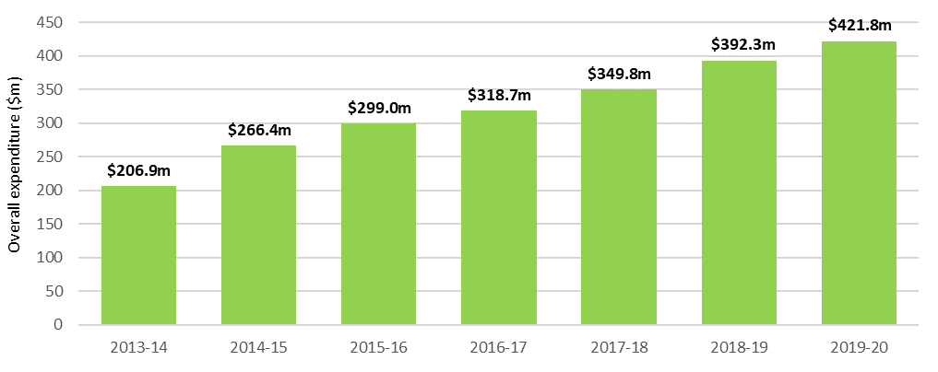

### Resident operational funding

* Contributions by permanent residents for operational funding are made up of:
* **A basic daily fee,** which is a contribution all residents make towards everyday living expenses such as meals, laundry services, utilities and toiletries. The price is set by the Commonwealth, and is set at a maximum of 85 per cent of the single basic age pension.
* **A means tested care fee,** which is a contribution some residents make towards their care costs (personal and nursing) based on their assessable income and assets. Annual and lifetime caps on care contributions apply as a consumer protection. As at 20 March 2021, the annual cap for a means tested care fee was $28,338.71, with a lifetime cap of $68,012.98 also applying.
* **Accommodation payments,** which are daily payments for accommodation in an aged care facility. Lump sum accommodation deposits are not treated as revenue, but as capital financing (discussed in Chapter 7).
* **Extra service fees,** which residents in aged care facilities with extra service status may be asked to pay for significantly higher standards of accommodation, food and non-care services. These vary from facility to facility, and are subject to approval by the Aged Care Pricing Commissioner.
* **Additional services fees,** which are for care and services in non-extra service facilities that are over and above those that providers are required to deliver under the Specified Care and Services Schedule of the Aged Care Act 1997, and must be agreed between the resident and provider. These vary from facility to facility, and are not payable at all facilities.

## Operational performance in 2019‑20

### Revenue

ACFA broadly describes revenue for residential care providers in four categories: care related, living expenses, accommodation and other. Table 6.9 provides a breakdown of the revenue reported by residential care providers in 2019-20 compared with the previous two years.

Table 6.9: Revenue sources for residential care providers, by care, accommodation, living and ‘other’, 2017‑18 to 2019‑20 ($m).

|  |  |  |  |  |  |
| --- | --- | --- | --- | --- | --- |
| Revenue sources | 2017-18 ($million) | 2018-19 ($million) | Change ($million) | 2019-20 ($million) | Change ($million) |
| Care Related |  |  |  |  |  |
| Basic care subsidy (ACFI) | $10,812.3 | $11,286.2 | $473.9 | $11,386.3 | $100.1 |
| Respite subsidy & supplements | $346.9 | $383.0 | $36.1 | $415.6 | $32.6 |
| COVID-19 funding | $0.0 | $0.0 | $0.0 | $301.1 | $301.1 |
| Other supplements | $84.5 | $106.5 | $22.0 | $127.0 | $20.5 |
| Resident means tested fee | $504.0 | $586.0 | $82.0 | $648.0 | $62.0 |
| Resident other care fees | $48.7 | $79.2 | $30.5 | $52.3 | -$26.9 |
| Total care revenue | $11,796.4 | $12,440.8 | $644.5 | $12,930.3 | $489.5 |
| Living Related |  |  |  |  |  |
| Resident basic daily fee | $3,253.4 | $3,425.8 | $172.4 | $3,574.0 | $148.2 |
| Extra service fee | $119.3 | $118.4 | -$0.9 | $123.4 | $5.0 |
| Additional services fees | $96.7 | $122.2 | $25.5 | $158.1 | $35.9 |
| Total living related revenue | $3,469.4 | $3,666.4 | $197.0 | $3,855.5 | $189.1 |
| Accommodation related |  |  |  |  |  |
| Accommodation supplement | $1,008.1 | $1,158.6 | $150.5 | $1,287.8 | $129.2 |
| Accommodation payments from residents | $781.0 | $828.7 | $47.7 | $847.9 | $19.2 |
| Capital Grants | $56.5 | $70.0 | $13.6 | $71.4 | $1.4 |
| Total Accommodation related revenue | $1,845.5 | $2,057.3 | $211.8 | $2,207.0 | $149.7 |
| Other income |  |  |  |  |  |
| Interest | $326.2 | $334.6 | $8.4 | $304.4 | -$30.2 |
| Donations and fundraising | $29.0 | $24.2 | -$4.8 | $37.9 | $13.7 |
| Gain on sale of assets | $23.2 | $54.8 | $31.6 | $45.9 | -$8.9 |
| Revaluation of assets | $37.9 | $108.3 | $70.5 | $42.2 | -$66.1 |
| Imputed Interest on RADs - AASB 16 Leases | $0.0 | $0.0 | $0.0 | $551.4 | $551.4 |
| Other | $538.6 | $615.1 | $76.5 | $562.0 | -$53.1 |
| Total other revenue | $954.9 | $1,137.1 | $182.2 | $1,543.7 | $406.6 |
| Total residential provider revenue | $18,066.2 | $19,301.6 | $1,235.4 | $20,536.5 | $1,234.9 |

1. COVID-19 funding includes the total amount of funding received for residential care operations through aged care specific COVID‑19 measures provided by Government, including the Workforce Retention Bonus, as well as non-aged care measures, such as Job Keeper.
2. ‘Resident other care fees’ are fees and charges received from a resident in respect of occasional care services like consultation, medication, treatment or procedures provided in addition to services required to be delivered under Schedule 1 of the Aged Care Act 1997.
3. The decreases in Resident Other Care fees is largely due to allocation into other income categories such as COVID-19 funding and ‘donations and fundraising’.

In 2019-20, care related revenue ($12.9 billion) formed the majority (63 per cent) of total revenueearned by residential care providers. This has been the case in previous years. Livingrelated revenue received from residents, which includes the basic daily fee, extra services fees and additional service fees, accounted for 19 per cent ($3.8 billion) of total revenue, again similar to previous years.

Accommodation payments, consisting of accommodation supplements paid by the Government and daily accommodation payments paid by residents, accounted for 11 per cent ($2.2 billion) of total provider revenue.

Other income of $1.5 billion made up the remaining 8 per cent of total residential care provider revenue in 2019‑20. Interest revenue makes up around a fifth of total ‘other’ income.

Changes in accounting standards (AASB 16 Leases) which applied from the 2019‑20 financial year resulted in numerous providers disclosing Imputed Interest Income and Imputed Interest Expense on Refundable Accommodation Deposits (RADs). Imputed Interest on RADs accounts for another third of ‘Other Income’. The corresponding Imputed Interest Expense is separately disclosed under Other Expenses in Chart 6.14. Some providers may have netted off the income and the expense, but this does not impact the overall profitability of the sector.

Chart 6.8 shows the proportions of all revenue sources for residential care providers in 2019‑20.

Chart 6.8: Proportions of total residential care provider revenue, 2019-20 ($m).

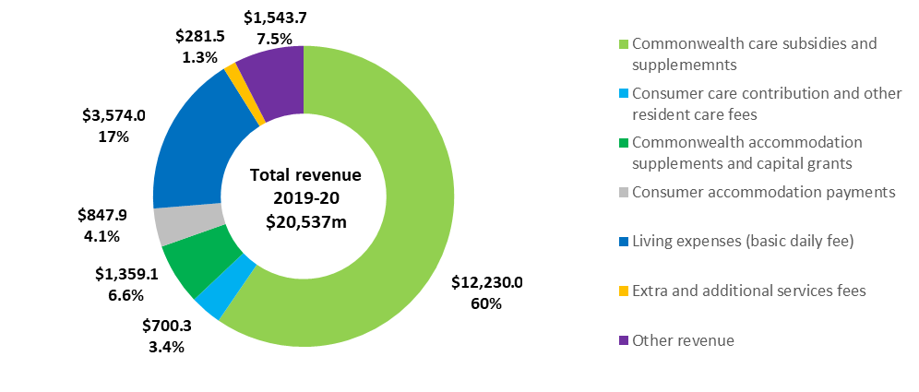

ACFA also analyses revenue sources in terms of those sources provided by the Commonwealth compared with those provided by residents. Table 6.10 shows provider revenue sources for 2019‑20 compared with the previous two years.

Table 6.10: Revenue sources for residential care providers, Commonwealth, resident and ‘other’, 2017-18 to 2019-20 ($m).

|  |  |  |  |  |  |
| --- | --- | --- | --- | --- | --- |
| Revenue sources | 2017-18 ($million) | 2018-19 ($million) | Change ($million) | 2019-20 ($million) | Change ($million) |
| Commonwealth |  |  |  |  |  |
| Basic care subsidy (ACFI) | $10,812.3 | $11,286.2 | $473.9 | $11,386.3 | $100.1 |
| Respite subsidy & supplements | $346.9 | $383.0 | $36.1 | $415.6 | $32.6 |
| COVID-19 funding | - | - | - | $301.1 | $301.1 |
| Other supplements | $84.5 | $106.5 | $22.0 | $127.0 | $20.5 |
| Accommodation supplement | $1,008.1 | $1,158.6 | $150.5 | $1,287.8 | $129.2 |
| Capital Grants | $56.5 | $70.0 | $13.6 | $71.4 | $1.4 |
| Commonwealth funding sources | $12,308.2 | $13,004.3 | $696.1 | $13,589.2 | $584.9 |
| Resident |  |  |  |  |  |
| Resident basic daily fee | $3,253.4 | $3,425.8 | $172.4 | $3,574.0 | $148.2 |
| Resident means tested fee | $504.0 | $586.0 | $82.0 | $648.0 | $62.0 |
| Resident other care fees | $48.7 | $79.2 | $30.5 | $52.3 | -$26.9 |
| Accommodation payments from residents | $781.0 | $828.7 | $47.7 | $847.9 | $19.2 |
| Extra service fee | $119.3 | $118.4 | -$0.9 | $123.4 | $5.0 |
| Additional services fees | $96.7 | $122.2 | $25.5 | $158.1 | $35.9 |
| Resident funding sources | $4,803.1 | $5,160.3 | $357.2 | $5,403.6 | $243.3 |
| Other income |  |  |  |  |  |
| Interest | $326.2 | $334.6 | $8.4 | $304.4 | -$30.2 |
| Donations and fundraising | $29.0 | $24.2 | -$4.8 | $37.9 | $13.7 |
| Gain on sale of assets | $23.2 | $54.8 | $31.6 | $45.9 | -$8.9 |
| Revaluation of assets | $37.9 | $108.3 | $70.5 | $42.2 | -$66.1 |
| Imputed Interest on RADs - AASB 16 Leases | $0.0 | $0.0 | $0.0 | $551.4 | $551.4 |
| Other | $538.6 | $615.1 | $76.5 | $562.0 | -$53.1 |
| Other funding sources | $954.9 | $1,137.1 | $182.2 | $1,543.7 | $406.6 |
| Total revenue | $18,066.2 | $19,301.6 | $1,235.4 | $20,536.5 | $1,234.9 |

1. Extra service subsidy reduction does not apply to new residents entering care from 1 July 2014, however it still applies to residents in ESS places who were in care prior to 1 July 2014.

Overall in 2019-20, the Commonwealth contributed 66 per cent of total provider funding ($13.6 billion) and residents contributed 26.2 per cent ($5.4 billion). This is consistent with previous years.

Chart 6.9 shows the proportion of revenue that residential care providers received from the Commonwealth in 2019-20. Basic subsidies (ACFI) comprised by far the greatest share at 84 per cent.

Chart 6.9: Proportions of provider revenue from the Commonwealth, 2019‑20 ($m)

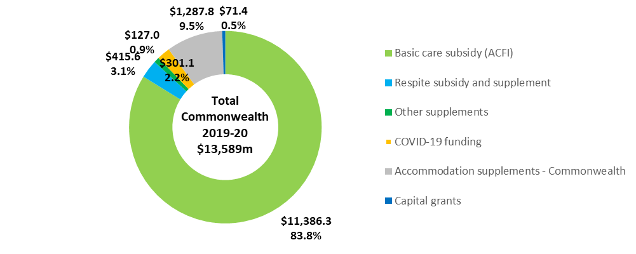

Chart 6.10 shows the proportion of total revenue that residential care providers receive from residents. Consistent with previous years, the basic daily fee forms the greatest share (66 per cent), accommodation payments (Daily Accommodation Payments) formed a further 16 per cent of the revenue received and means tested care fees represented 12 per cent.

Chart 6.10: Proportions of residential care provider revenue from residents, 2019‑20 ($m)

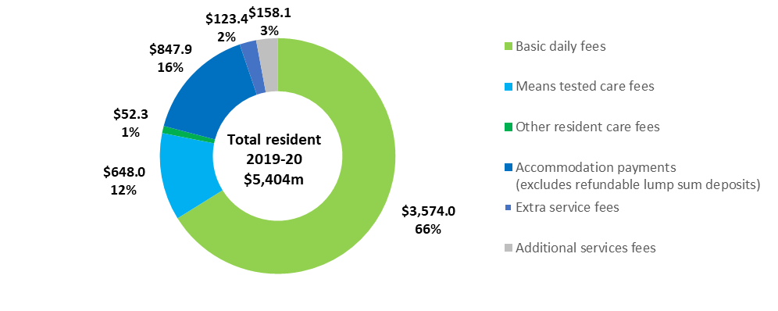

Table 6.11 shows total revenue per resident per day in 2019-20 compared with the previous two years. Total revenue per resident per day was $296.64, an increase of 4.6 per cent from 2018-19 ($283.54).

Table 6.11: Residential care provider revenue sources per resident per day, 2017-18 to 2019-20.

|  |  |  |  |  |  |
| --- | --- | --- | --- | --- | --- |
|  | 2017-18 | 2018-19 | Change ($) | 2019-20 | Change ($) |
| Commonwealth |  |  |  |  |  |
| Basic care subsidy (ACFI) | $162.88 | $165.79 | $2.91 | $164.47 | -$1.32 |
| Respite subsidy & supplements | $5.23 | $5.63 | $0.40 | $6.00 | $0.37 |
| COVID-19 funding | - | - | - | $4.35 | $4.35 |
| Other supplements | $1.27 | $1.56 | $0.29 | $1.83 | $0.27 |
| Accommodation supplement | $15.19 | $17.02 | $1.83 | $18.60 | $1.58 |
| Capital Grants | $0.85 | $1.03 | $0.18 | $1.03 | $0.00 |
| Commonwealth funding sources | $185.42 | $191.03 | $5.61 | $196.29 | $5.26 |
| Resident |  |  |  |  |  |
| Resident basic daily fee | $49.01 | $50.32 | $1.31 | $51.62 | $1.30 |
| Resident means tested fee | $7.59 | $8.61 | $1.02 | $9.36 | $0.75 |
| Resident other care fees | $0.73 | $1.16 | $0.43 | $0.76 | -$0.40 |
| Accommodation payments from residents | $11.77 | $12.17 | $0.40 | $12.25 | $0.08 |
| Extra service fee | $1.80 | $1.74 | -$0.06 | $1.78 | $0.04 |
| Additional services fees | $1.46 | $1.80 | $0.34 | $2.28 | $0.48 |
| Resident funding sources | $72.36 | $75.80 | $3.44 | $78.05 | $2.25 |
| Other |  |  |  |  |  |
| Imputed interest on RADs - AASB 16 Leases | - | - | - | $7.96 | $7.96 |
| Other income | 14.38 | $16.70 | $2.32 | $14.33 | -$2.37 |
| Other | 14.38 | $16.70 | $2.32 | $22.30 | $5.60 |
| Total revenue | $272.16 | $283.54 | $11.37 | $296.64 | $13.10 |

1. Extra service subsidy reduction does not apply to new residents entering care from 1 July 2014, however it still applies to residents in ESS places who were in care prior to 1 July 2014.

### Expenses

Total expenditure in 2019-20 for residential care providers was $21.3 billion, up 11.7 per cent from $19.0 billion in 2019-20. Chart 6.11 shows total expenses for the seven years to 2019‑20.

Chart 6.11: Total expenses, residential care providers, 2013-14 to 2019-20 ($b)

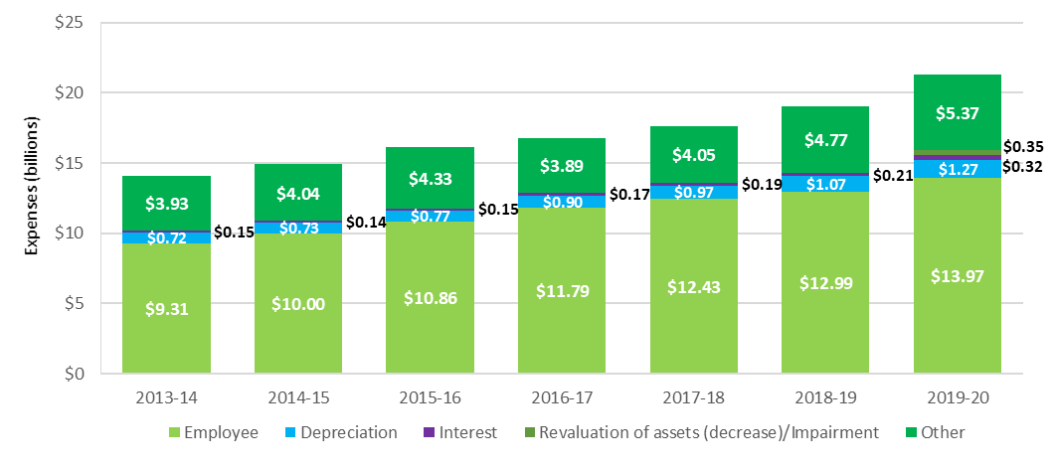

Table 6.12 shows the expenses for residential care providers in 2019-20 compared with the previous two years. Chart 6.12 presents the expenses for 2019-20 as a proportion of total expenses.

Table 6.12: Summary of expenses, residential care providers, 2017-18 to 2019-20 ($m)

|  |  |  |  |  |  |
| --- | --- | --- | --- | --- | --- |
| Expenses | 2017-18 ($m) | 2018-19 ($m) | Change ($m) | 2019-20 ($m) | Change ($m) |
| Employee | $12,426.7 | $12,994.2 | $567.5 | $13,965.1 | $970.9 |
| Depreciation | $968.9 | $1,067.0 | $98.1 | $1,267.3 | $200.3 |
| Interest | $186.7 | $205.7 | $19.0 | $323.6 | $117.9 |
| Revaluation of assets (decrease)/Impairment | N/A | N/A | N/A | $351.6 | $351.6 |
| Other expenses | $4,048.8 | $4,770.4 | $721.6 | $5,365.3 | $594.9 |
| Total expenses | $17,631.1 | $19,037.3 | $1,406.2 | $21,272.9 | $2,235.6 |

Employee costs represent 66 per cent of the total expenses incurred by providers, an increase of 7.3 per cent over 2018‑19. This followed a 4.6 per cent increase from 2017‑18.

‘Other’ expenses represented 25 per cent of total costs. ‘Other’ expenses include building repairs and maintenance expenses, rent, utilities and costs associated with employment support activities, cleaning and administration. Depreciation accounts for 6 per cent of total costs, stable from previous years while interest costs and revaluation of assets account for the remaining 2 per cent.

Chart 6.12: Proportion of residential care provider total expenses, 2019-20 ($m)

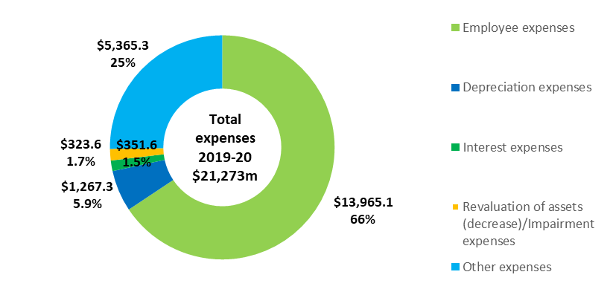

Table 6.13 shows the major expense types for providers, per resident per day, for the six years to 2019‑20. Total expenses per resident per day have generally increased each year by between 4‑6 per cent until 2019‑20 which saw a significant increase of 9.2 per cent.

Table 6.13: Summary of residential care provider expenses, per resident per day, 2014‑15 to 2019‑20

| Expenses | 2014-15 | 2015-16 | 2016-17 | 2017-18 | 2018-19 | 2019-20 |
| --- | --- | --- | --- | --- | --- | --- |
| Employee | $157.68 | $166.84 | $179.01 | $187.21 | $190.88 | $201.72 |
| Depreciation | $11.49 | $11.87 | $13.59 | $14.60 | $15.67 | $8.31 |
| Interest | $2.21 | $2.30 | $2.60 | $2.81 | $3.02 | $4.67 |
| Revaluation of assets (decrease)/Impairment | N/A | N/A | N/A | N/A | N/A | $5.08 |
| Other | $63.67 | $66.57 | $59.09 | $61.00 | $70.08 | $77.50 |
| Total expenses | $235.05 | $247.58 | $254.29 | $265.61 | $279.65 | $307.27 |

As noted in recent annual reports, since 2016‑17, a new breakdown of expenditure data was collected through the introduction of the ACFR. This has enabled the collection of more detailed expenditure information. Table 6.14 shows provider expenditure in 2019-20, compared with the previous two years, using the categories collected through the ACFR.

Table 6.14: Breakdown of residential care provider expenses, 2017-18 to 2019-20 ($m)

|  |  |  |  |  |  |  |  |  |  |  |  |  |  |  |  |  |  |  |  |  |  |  |  |  |  |  |  |  |  |  |  |  |  |  |  |  |  |  |  |  |  |  |  |  |  |  |  |  |  |  |  |  |  |  |  |  |  |  |  |  |  |  |  |  |  |  |  |  |  |  |  |  |  |  |  |  |  |  |  |  |  |  |  |  |  |  |  |  |  |  |  |  |  |  |  |  |  |  |  |  |  |  |  |  |  |  |  |  |  |  |  |  |  |  |  |  |  |  |  |  |  |  |  |  |  |  |  |  |  |  |  |  |  |  |  |  |  |  |  |  |  |  |  |  |  |  |  |  |  |  |  |  |  |  |  |  |  |  |  |  |  |  |  |  |  |  |  |  |  |  |  |  |  |  |  |  |  |  |  |  |  |  |  |  |  |  |  |  |  |  |  |  |  |  |  |  |  |  |  |  |  |  |  |  |  |  |  |  |  |  |  |  |  |  |  |  |  |  |  |  |  |  |  |  |  |  |  |  |  |  |  |  |  |  |  |  |  |  |  |  |  |  |  |  |  |  |  |  |  |  |  |  |  |  |  |  |  |  |  |  |  |  |  |  |  |  |  |  |  |  |  |  |  |  |  |  |  |  |  |  |  |  |  |  |  |  |  |  |  |  |  |  |  |
| --- | --- | --- | --- | --- | --- | --- | --- | --- | --- | --- | --- | --- | --- | --- | --- | --- | --- | --- | --- | --- | --- | --- | --- | --- | --- | --- | --- | --- | --- | --- | --- | --- | --- | --- | --- | --- | --- | --- | --- | --- | --- | --- | --- | --- | --- | --- | --- | --- | --- | --- | --- | --- | --- | --- | --- | --- | --- | --- | --- | --- | --- | --- | --- | --- | --- | --- | --- | --- | --- | --- | --- | --- | --- | --- | --- | --- | --- | --- | --- | --- | --- | --- | --- | --- | --- | --- | --- | --- | --- | --- | --- | --- | --- | --- | --- | --- | --- | --- | --- | --- | --- | --- | --- | --- | --- | --- | --- | --- | --- | --- | --- | --- | --- | --- | --- | --- | --- | --- | --- | --- | --- | --- | --- | --- | --- | --- | --- | --- | --- | --- | --- | --- | --- | --- | --- | --- | --- | --- | --- | --- | --- | --- | --- | --- | --- | --- | --- | --- | --- | --- | --- | --- | --- | --- | --- | --- | --- | --- | --- | --- | --- | --- | --- | --- | --- | --- | --- | --- | --- | --- | --- | --- | --- | --- | --- | --- | --- | --- | --- | --- | --- | --- | --- | --- | --- | --- | --- | --- | --- | --- | --- | --- | --- | --- | --- | --- | --- | --- | --- | --- | --- | --- | --- | --- | --- | --- | --- | --- | --- | --- | --- | --- | --- | --- | --- | --- | --- | --- | --- | --- | --- | --- | --- | --- | --- | --- | --- | --- | --- | --- | --- | --- | --- | --- | --- | --- | --- | --- | --- | --- | --- | --- | --- | --- | --- | --- | --- | --- | --- | --- | --- | --- | --- | --- | --- | --- | --- | --- | --- | --- | --- | --- | --- | --- | --- | --- | --- | --- | --- | --- | --- | --- | --- | --- | --- | --- | --- | --- | --- | --- | --- | --- | --- | --- | --- | --- | --- | --- | --- | --- | --- | --- | --- |
| |  | 2017-18 ($m) | 2018-19 ($m) | Change ($m) | 2019-20 ($m) | Change ($m) | % of total expenses | | --- | --- | --- | --- | --- | --- | --- | | Care |  |  |  |  |  |  | | Employee expenses | $8,968.7 | $9,449.6 | $480.9 | $10,162.4 | $712.8 | 47.8% | | Contracted services | $0.0 | $278.0 | $278.0 | $296.3 | $18.3 | 1.4% | | Other | $588.4 | $594.0 | $5.6 | $644.8 | $50.8 | 3.0% | | Total care expenses | $9,557.0 | $10,321.6 | $764.6 | $11,103.5 | $781.9 | 52.2% | | Accommodation |  |  |  |  |  |  | | Employee expenses | $283.7 | $315.1 | $31.4 | $320.5 | $5.4 | 1.5% | | Repairs & maintenance | $477.6 | $450.8 | -$26.8 | $472.6 | $21.8 | 2.2% | | Rent | $357.0 | $423.5 | $66.5 | $247.0 | -$176.5 | 1.2% | | Other | $497.8 | $530.8 | $33.0 | $541.3 | $10.5 | 2.5% | | Total accommodation expenses | $1,616.2 | $1,720.2 | $104.0 | $1,581.4 | -$138.8 | 7.4% | | Hotel |  |  |  |  |  |  | | Employee expenses | $1,600.4 | $1,691.7 | $91.3 | $1,784.7 | $93.0 | 8.4% | | Contracted services | $495.9 | $533.4 | $37.5 | $561.8 | $28.4 | 2.6% | | Other | $722.4 | $764.9 | $42.5 | $791.9 | $27.0 | 3.7% | | Total hotel expenses | $2,818.7 | $2,990.0 | $171.3 | $3,138.4 | $148.4 | 14.8% | | Administration |  |  |  |  |  |  | | Employee expenses | $970.4 | $967.3 | -$3.1 | $1,091.5 | $124.2 | 5.1% | | Management fees | $603.5 | $570.4 | -$33.1 | $606.0 | $35.6 | 2.8% | | Other | $662.4 | $713.2 | $50.8 | $751.3 | $38.1 | 3.5% | | Total administration expenses | $2,236.2 | $2,251.0 | $14.8 | $2,448.7 | $197.7 | 11.5% | | Financing |  |  |  |  |  |  | | Depreciation | $942.9 | $1,067.0 | $124.1 | $1,267.3 | $200.3 | 6.0% | | Amortisation | $26.0 | $52.6 | $26.6 | $58.4 | $5.8 | 0.3% | | Interest | $186.7 | $205.7 | $19.0 | $323.6 | $117.9 | 1.5% | | Total financing expenses | $1,155.6 | $1,325.3 | $169.7 | $1,649.3 | $324.0 | 7.8% | | COVID-19 |  |  |  |  |  |  | | Labour Costs | N/A | N/A | N/A | $120.4 | N/A | N/A | | Resident Support | N/A | N/A | N/A | $20.2 | N/A | N/A | | Preventative Measures | N/A | N/A | N/A | $53.2 | N/A | N/A | | Other Expenses | N/A | N/A | N/A | $13.4 | N/A | N/A | | Total COVID-19 expenses | N/A | N/A | N/A | $207.2 | N/A | N/A | | Other |  |  |  |  |  |  | | Revaluation of assets (decrease)/impairment | $38.7 | $48.3 | $9.6 | $351.6 | $303.3 | 1.7% | | Loss on sale of assets | $9.4 | $18.8 | $9.4 | $17.5 | -$1.3 | 0.1% | | Imputed Interest Expenses on RADs - AASB 16 Leases | - | - | $0.0 | $561.0 | $561.0 | 2.6% | | Other | $199.3 | $362.2 | $162.9 | $214.2 | -$148.0 | 1.0% | | Total other expenses | $247.4 | $429.2 | $181.8 | $1,144.3 | $715.1 | 5.4% | | Total expenses | $17,631.1 | $19,037.3 | $1,406.2 | $21,272.9 | $2,028.4 | 100.0% | |  |  |  |  |  |  |  | |  |  |  |  |  |  |
| Notes:  1. Management fees are expenses that are paid to another person/organisation to govern and manage operations of the facility on behalf of the provider (includes management fees paid to both related and non-related parties).  2. AASB 16 Leases, a new accounting standard, now requires leasees to recognise most rental contracts on their balance sheets as right of use assets and corresponding lease liabilities.  3. For leased assets recognised in the balance sheet, rent expense is replaced by depreciation and interest expense that is calculated on the value of the leased asset.  4. Short term leases and low value leases are exempt and can still be shown as rent expense (similar to previous years). |  |  |  |  |  |  |

Care expenditure relates to the direct costs incurred in providing care for residents within residential care facilities. Care related employee expenses make up 93 per cent of total care expenses, and 48 per cent of total expenditure, making it the largest single expense for providers. This is consistent with recent years. Employee expenses include payments made to doctors, nursing, therapists, nutritionists, case managers, health assistants and support staff.

Other care expenses include items such as resident medication, oxygen and related equipment, treatments and procedures, incontinence aids, items that assist mobility, recreation and social activities, rehabilitation support, personal grooming and specific cultural and social events.

Accommodation expenditure, which represents 7 per cent of total expenses (9 per cent in 2018‑19), relates to the costs incurred in providing accommodation to residents. This includes accommodation employee expenses, repairs and maintenance and rent.

Hotel expenditure (which represents 15 per cent of total expenses) relates to the costs incurred in the provision of everyday living expenses to residents, including employees, contracted services and other. Contracted services are payments made to external providers or internal divisions for the provision of catering, cleaning or laundry. Other expenses consist of expenses such as meals, refreshments, other food consumables, bedding materials, toiletry and sanitary goods, cleaning items and laundry items.

Financing expenditure relates to depreciation incurred on property, plant and equipment, amortisation of intangible assets, and interest paid on borrowing used to fund the capital requirements of facilities. Financing accounted for 8 per cent of total expenditure in 2019‑20, stable from 7 per cent in 2018-19.

Other expenses relate to expenditure not covered in any of the above categories.

### Financial results

The financial performance of residential care providers is affected by variations in both revenue and expenditure. It can also vary depending on the location in which care is delivered.

Chart 6.13 shows the average EBITDA per resident per annum for all residential care providers since 2010‑11. Overall, the financial performance of residential care providers continued to fall for the third year in a row. The average EBITDA per resident decreased to $6,445 from $8,523 in 2018‑19 (a 24.4 per cent decrease). In 2016‑17 it was $11,481 and has dropped almost 44 per cent in the three years since. ACFA also notes, based on Department of Health analysis that excluded both additional COVID‑19 funding provided by Government and COVID-19 related expenses[35], average EBITDA per resident across the sector would have been $5,950 (a decrease of 30.2 per cent). It should be remembered that this analysis is based on the accuracy of providers reporting their COVID related income and expenses which in some cases, particularly expenses, may not be easy to separate COVID related and non-COVID related.

Chart 6.13: Residential care provider average EBITDA per resident per annum, 2010-11 to 2019-20.

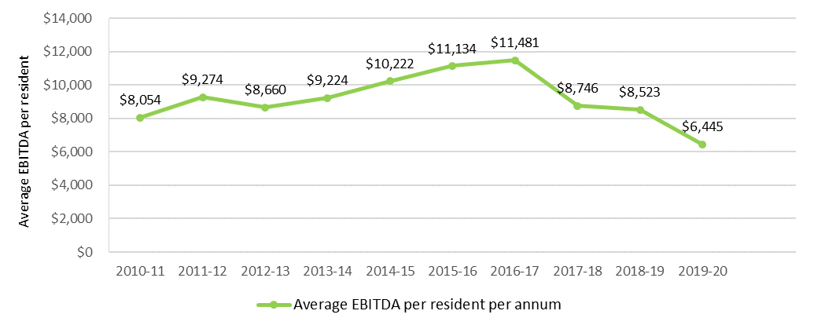

Table 6.15 provides a summary of the overall financial performance of residential care providers since 2014-15. As shown the overall profit of the sector has been declining significantly since 2017‑18 and was negative $736 million in 2019‑20, dropping below zero for the first time. The average EBITDA per resident has also been declining since 2017‑18 and dropped again from $8,523 in 2018‑19 to $6,445.

Table 6.15: Summary of financial performance of residential care providers, 2014-15 to 2019-20

|  | 2014-15 | 2015-16 | 2016-17 | 2017-18 | 2018-19 | 2019-20 |
| --- | --- | --- | --- | --- | --- | --- |
| Revenue ($m) | $15,810 | $17,172 | $17,757 | $18,066 | $19,302 | $20,536 |
| Expenses ($m) | $14,903 | $16,109 | $16,751 | $17,631 | $19,037 | $21,273 |
| NPBT ($m) | $907 | $1,063 | $1,006 | $435 | $264 | -$736 |
| NPBT margin | 5.7% | 6.2% | 5.7% | 2.4% | 1.4% | -3.6% |
| EBITDA ($m) | $1,776 | $1,985 | $2,072 | $1,591 | $1,590 | $1,222 |
| Average EBITDA p.r.p.a | $10,222 | $11,134 | $11,481 | $8,746 | $8,523 | $6,445 |
| EBITDA margin | 11.2% | 11.6% | 11.7% | 8.8% | 8.2% | 6.0% |

Table 6.16 shows the financial performance of providers in 2019‑20 by ownership type, location and scale. In general terms, based on EBITDA per resident, for‑profit providers outperformed not‑for‑profit providers and metropolitan providers significantly outperformed regional and rural providers. This is similar to the last two years. More detailed discussion of performance based on ownership, location and scale is included later in this section.

Table 6.16: Summary of financial performance of residential care providers, by ownership, location and scale, 2019‑20

|  |  |  | Ownership type | | | | | Location | | | | | | Scale | | | | | | | |
| --- | --- | --- | --- | --- | --- | --- | --- | --- | --- | --- | --- | --- | --- | --- | --- | --- | --- | --- | --- | --- | --- |
|  |  | Total sector 2019-20 | Not-for-profit | | For-profit | | Government | Metropolitan | | Regional | | Metropolitan & regional | | Single facility | | Two to six facilities | | Seven to 19 facilities | | 20 or more facilities | |
| Revenue ($m) |  | $20,536 | $11,125 | $8,495 | | $916 | | | $13,349 | | $2,887 | | $4,301 | | $3,902 | | $4,381 | | $4,827 | | $7,426 | |
| Expenses ($m) |  | $21,273 | $11,475 | $8,718 | | $1,080 | | | $13,796 | | $3,058 | | $4,419 | | $3,928 | | $4,644 | | $4,909 | | $7,792 | |
| Profit ($m) |  | -$736 | -$349 | -$223 | | -$164 | | | -$448 | | -$172 | | -$117 | | -$25 | | -$263 | | -$82 | | -$366 | |
| EBITDA ($m) |  | $1,222 | $598 | $726 | | -$101 | | | $979 | | $31 | | $213 | | $289 | | $134 | | $378 | | $422 | |
| EBITDA p.r.p.a ($m) |  | $6,445 | $5,593 | $9,632 | | -$13,547 | | | $8,055 | | $1,138 | | $5,165 | | $7,872 | | $3,247 | | $8,755 | | $6,143 | |
| EBITDA margin |  | 6.0% | 5.4% | 8.5% | | -11.0% | | | 7.3% | | 1.1% | | 4.9% | | 7.4% | | 3.0% | | 7.8% | | 5.7% | |
| NPBT margin |  | -3.6% | -3.1% | -2.6% | | -17.9% | | | -3.4% | | -6.0% | | -2.7% | | -0.6% | | -5.99% | | -1.7% | | -4.9% | |

As noted, the financial performance of the residential care sector overall declined significantly in 2019‑20, continuing a general decline in recent years. In 2019‑20 providers reported an average EBITDA per resident of $6,445 down from $8,523 in 2018‑19. These recent years of poorer financial performance follow five years of improving financial performance up to 2016‑17. Forty‑six per cent of residential care providers reported a net profit in 2019‑20, down from 58 per cent in 2018‑19. This continues a trend of a decreasing proportion of providers reporting a profit in recent years (69 per cent in 2015-16).

The EBITDA margin was 6.0 per cent, down from 8.2 per cent in 2018‑19. The NPBT margin continued to decline, to negative 3.6 per cent in 2018-19, down from 1.4 per cent in 2018‑19.

Chart 6.14 presents the EBITDA per resident for 2016-17 to 2019‑20 by provider performance quartiles. As shown, the average EBITDA per resident declined in all quartiles. It is worth noting that the decline over the years since 2016‑17 has been far greater for providers in the bottom two quartiles (62 per cent and 132 per cent respectively) than for those in the top two quartiles (17 per cent and 23 per cent respectively). This indicates the better performing providers have weathered the financial pressures of recent years far better.

Chart 6.14: Residential care provider comparative EBITDA per resident per annum, 2016-17 to 2019-20, by quartile.

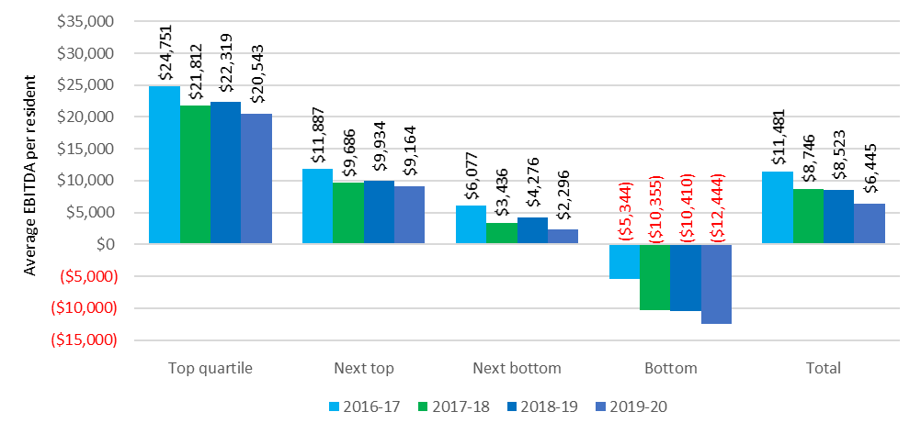

Operating performance has traditionally varied across provider ownership type, location and scale. The following commentary provides analysis across the segments of providers.

#### By provider ownership type

Chart 6.17 shows the performance ratios for the last three years by ownership type, and Chart 6.18 shows the average EBITDA per resident per annum for the last four years, by ownership type.

While the not‑for‑profit providers reported a noticeable decline in performance in 2019‑20 compared with 2018‑19, the for‑profits reported a slight improvement, up to an EBITDA per resident of $9,632 from $9,528 in 2018‑19. The trend of for‑profit providers outperforming not‑for‑profit providers, which has been evident for some time, continued in 2019‑20.

However, this measure needs to be considered carefully because providers in the not-for-profit and government sectors often have different business motives, business models and funding sources and often operate in areas affected by the impacts of remoteness and facility size.

As noted previously, commentary from the not-for-profit sector indicates that the generally lower operating financial results may be consistent with their community or religious missions. They may fulfil their charters in a range of ways that might be difficult or inappropriate in a more commercial environment where investors are seeking returns.

Specifically, not-for-profit providers may choose to invest in or expend funds on amenities and services for which they are not funded through regulated sources. Not‑for‑profit providers may be assisted to do this through a range of funding pathways and tax benefits, including payroll tax relief, income tax exemptions and tax deductible donations. However, where these costs are not covered by such incremental revenue, the comparatively lower EBITDA for many not‑for‑profit providers may be the product of the delivery of additional “community benefits” or “social impacts” or returns which are not recognised in the annual financial accounts.

Chart 6.15: Residential care provider operating performance ratios, by ownership type, 2017‑18 to 2019‑20.

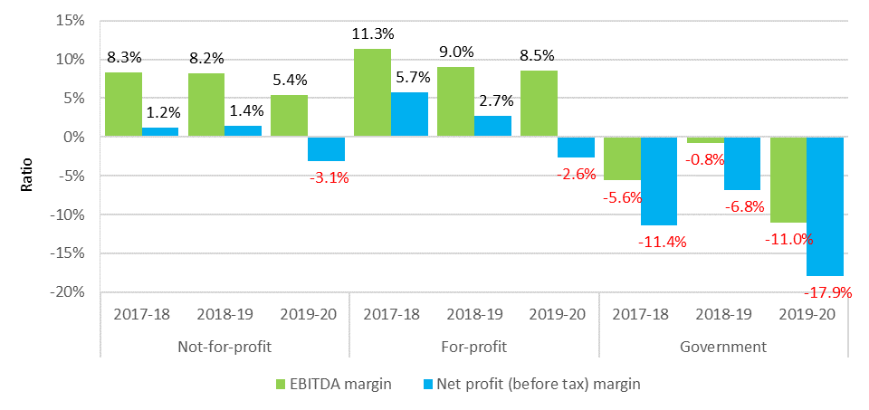

Chart 6.16 shows the average EBITDA for the four years to 2018-19 by ownership type. The for‑profit providers reported a slight improvement, with an EBITDA per resident of $9,632, up from $9,528 in 2018‑19. By contrast the not‑for‑profit providers reported a 34 per cent decrease, down to $5,593 from $8,520 in 2018‑19.

Chart 6.16: EBITDA per resident, by ownership type, 2016-17 to 2019-20.

As shown in Chart 6.17 and Chart 6.18, a significantly higher proportion (39 per cent) of for‑profit providers were present in the top quartile of EBITDA per resident compared with not‑for‑profit providers with 20 per cent. This has been the case in recent years.

As has been the case with all previous years, there is some representation of all ownership types in each quartile.

Chart 6.17: Residential care provider average EBITDA per resident per annum, by quartile (number of providers in parentheses) – by ownership type, 2019-20.

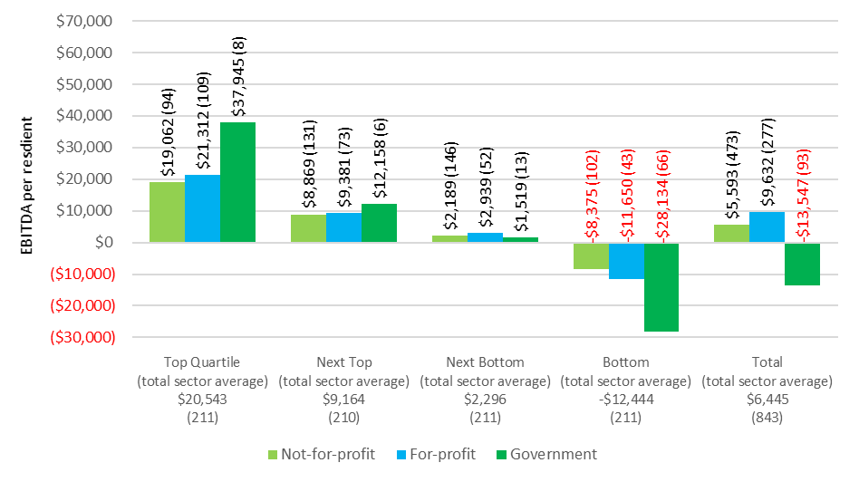

Chart 6.18: Residential care provider distribution between quartile of average EBITDA per resident per annum – by provider ownership type, 2019-20.

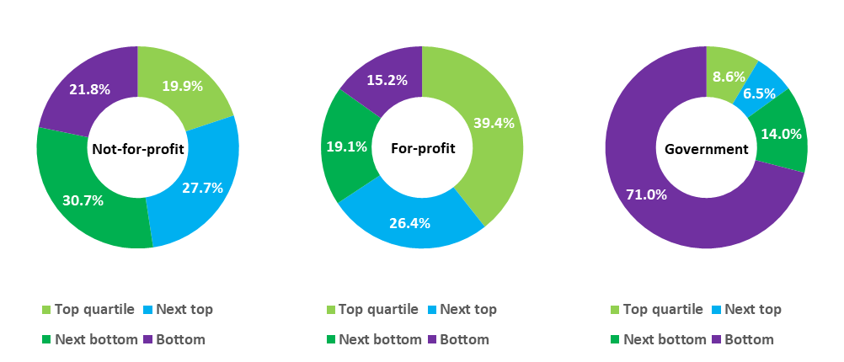

#### By provider location

As shown in Chart 6.19, metropolitan providers once again significantly outperformed regional providers with an EBITDA per resident of $8,055 compared with only $1,138 for regional providers. Metropolitan providers did report a decline in their financial performance, down from $9,790 in 2018‑19 however the decline for regional providers was much greater, down from $4,916.

Chart 6.19: Residential care provider EBITDA per resident, by provider location, 2016-17 to 2019-20

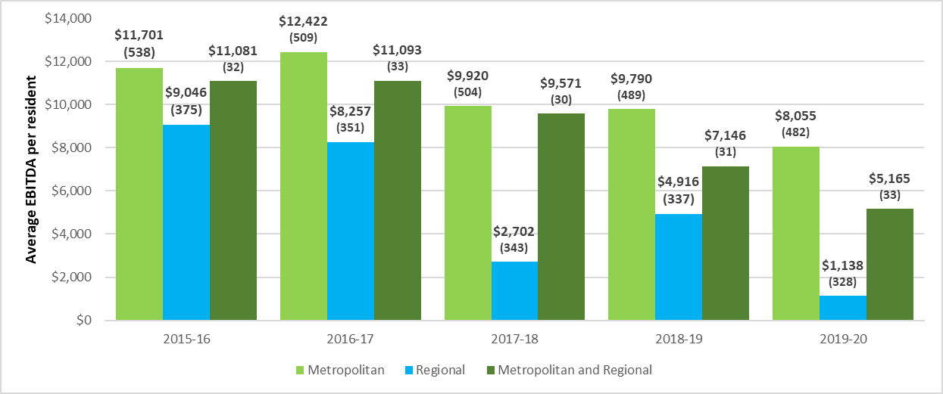

As with previous years, a higher proportion (30 per cent) of metropolitan providers are present in the top quartile of ranking by EBITDA per resident compared with regional providers (19 per cent), as shown in Chart 6.20 and Chart 6.21. However the regional providers (63 in total) that are in the top quartile reported a significantly higher EBITDA ($26,896) than the 142 metropolitan providers who were in the top quartile ($20,182). Also consistent with recent years, a significantly higher proportion of regional providers (32 per cent) were represented in the bottom quartile compared with 21 per cent of metropolitan providers.

As was the case with analysis based on ownership type, providers from all locations are present in each quartile.

Chart 6.20: Residential care provider average EBITDA per resident per annum, by quartile (number of providers in parentheses) – by location, 2019-20.

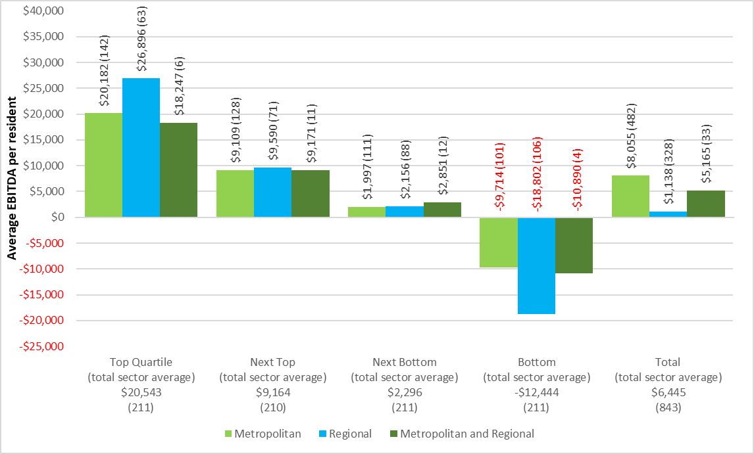

Chart 6.21: Residential care provider distribution between quartile of average EBITDA per resident per annum – by location, 2019-20.

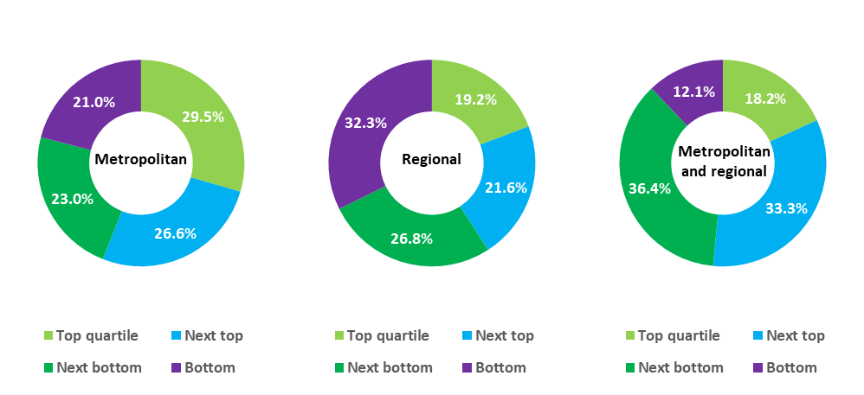

#### By provider scale

In 2019-20, providers with between 7 and 19 facilities were the best performing, reporting an average EBITDA of $8,755. Single facility providers were the next best with EBITDA per resident of $7,872.

Interestingly, providers with between 2 and 6 facilities were the worst performers for the third year in a row, recording an average EBITDA per resident of only $3,247.

Chart 6.22: Residential care provider EBITDA per resident per day, by provider scale, 2016‑17 to 2019-20.

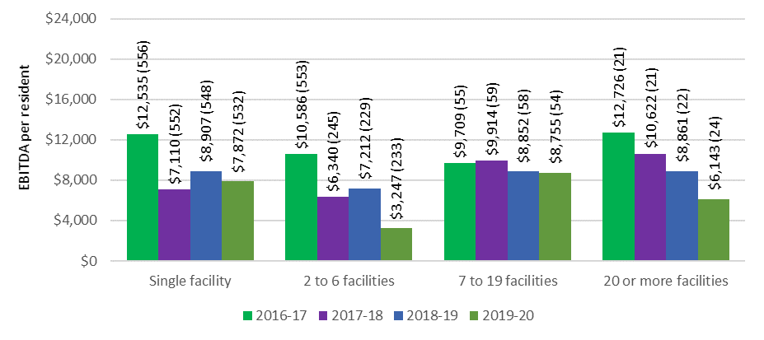

In 2019‑20, as was the case in 2018-19, more than 60 per cent of providers with between 7 and 19 facilities were in the top two quartiles (Chart 6.23 and Chart 6.24). Twelve of the 24 providers (50 per cent) who own more than 20 facilities were also in the top two quartiles of ranking by EBITDA per resident per annum, although this has been declining from 17 of these providers who were in the top quartile in 2017-18.

The 149 single facility providers (28 per cent) who were in the top quartile of performers actually reported a far higher EBITDA per resident than the larger scale providers who were also in the top quartile. This cohort of single facility providers report EBITA of $26,868 compared with the next best performers in the top quartile of $21,419 for the providers with 2 to 6 facilities.

As was the case in previous years, providers from all the scale classifications are represented in all four quartiles.

Chart 6.23: Residential care provider average EBITDA per resident per annum, by quartile (number of providers in parentheses), by provider scale, 2019-20

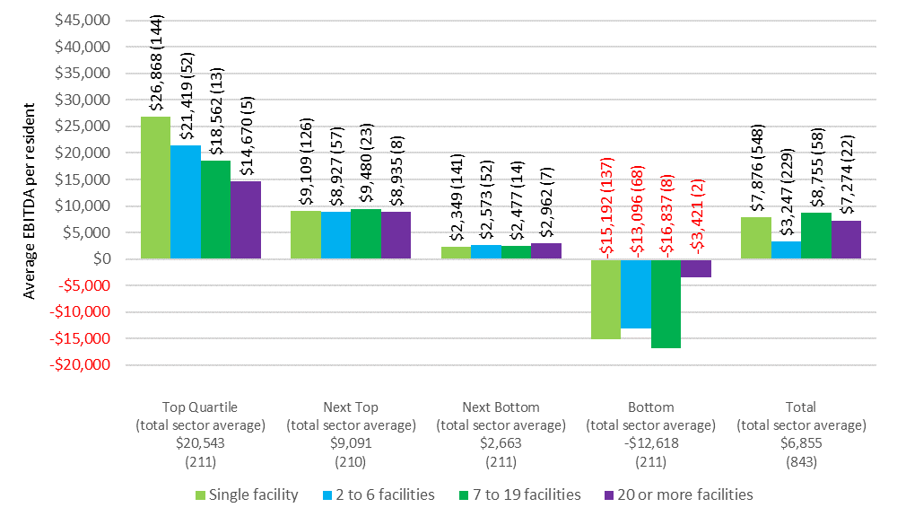

Chart 6.24: Residential care provider distribution between quartile of average EBITDA per resident per annum – by provider scale, 2019-20

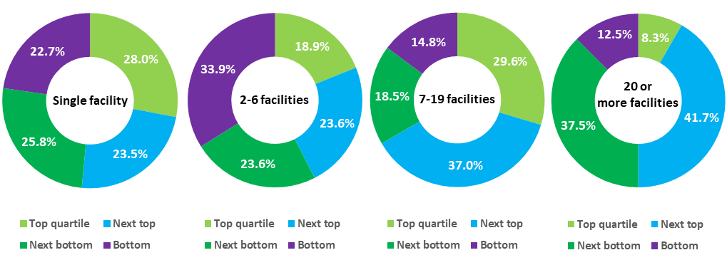

### Developments in 2020-21 and looking ahead

There are indications, including through the December 2020 quarterly financial reports from sector analysts StewartBrown, that the decline in financial performance seen in recent years continued in the first half of 2020‑21, albeit only slightly. ACFA notes that in the first half of 2020‑21, an additional $245 million in COVID‑19 support funding was provided to residential care providers, equating to $975 per resident in major metropolitan areas and around $1,435 per resident in all other areas.

The Government’s response to the final report of the Royal Commission into Aged Care Quality and Safety announced additional funding for residential care in response to the current financial pressures. In particular, the Government accepted the Royal Commission’s recommendation that a new $10 per resident per day basic daily fee supplement should be introduced to help address immediate financial pressures. This will provide an additional $3.2 billion over the next four years and should help relieve some of the financial pressure.

ACFA has pointed out in previous reports that the formula used for indexing care payments under ACFI does not cover wage cost movements and, in effect, entails an expectation of significant productivity improvements. Pending the move to independent price determination based on costing studies, the use of the current indexation formula will continue to be a contributor to the financial pressure experienced by providers. A moderating factor has been the recent increase in the real growth of ACFI payments per resident per day. After real growth of less than 1 per cent in each of the years between 2017-18 and 2019-20 (which includes a short period when indexation was paused), real growth has steadily increased since January 2020, averaging 2.4 per cent for 2020.

Looking ahead, the move to independent and transparent price determination arrangements based on regular costing studies, and the introduction of AN-ACC to replace the ACFI, provides the opportunity to remove the volatility in funding that has characterised ACFI and to base price determination on evidence of the contemporary cost of the efficient delivery of aged care.

ACFA noted last year that an immediate risk facing residential care providers was the spread of COVID-19 which has the potential to cause a sizeable decline in occupancy through both departures and delays in new admissions, with consequential financial pressures. While the risk of a significant decline in sector-wide occupancy due to COVID‑19 did not eventuate, there were some providers with services in areas of high community transmission who experienced severe outbreaks. In June 2021 the Government announced it was offering zero-interest loans to eligible providers who had experienced a significant decline in their RAD balance due to a sudden drop in occupancy due to COVID‑19.

# Residential care: capital investment

**This chapter discusses:**

* The sources of capital financing for the residential care sector, including the role of Refundable Accommodation Deposits (RADs)[36];
* key balance sheet metrics for residential care providers for 2019-20; and
* building and investment trends in the residential care sector.

**On 30 June 2020, compared with 30 June 2019, the residential care sector had:**

* Total assets of $56.4 billion, up from $52.6 billion, which includes:
* $14.1 billion of current assets, a decrease of $100 million; and
* $42.1 billion of non-current assets, up from $38.2 billion.
* total liabilities of $44.8 billion, up from $39.0 billion. This includes $32.2 billion of accommodation deposits held by the sector, up from $30.2 billion;
* net assets of $11.5 billion, a decrease of $1.1 billion;
* average return on equity was 10.6 per cent, down from 12.5 per cent;
* average return on assets was 2.2 per cent, down from 3.0 per cent; and
* cash held as percentage of accommodation deposit balances was 19.9 per cent, down from 20.8 per cent

**Recent building trends:**

* $5.7 billion of building works were either completed or in-progress as at 30 June 2020 compared with $5.3 billion at 30 June 2019; and

planned building activity remains subdued.

## Capital financing

Capital for residential care providers is comprised of:

* equity, including retained earnings;
* loans from financial or other institutions;
* interest free loans from residents in the form of lump sum Refundable Accommodation Deposits (bonds pre 1 July 2014);
* capital investment support from Government by way of capital grants for eligible projects; and
* capital endowments.

### Residents as a source capital

Lump sum Refundable Accommodation Deposits (RADs) by residents, which act as interest free loans to providers, are a significant source of funding for capital investment in residential care. At 30 June 2020, a total of $32.2 billion of accommodation deposits was held by providers. The investment of accommodation deposits held by providers is a source of interest income that is included in the other income reported by providers in their operating statement.

As an alternative to RADs, residents can choose to a pay a Daily Accommodation Payment (DAP) or a combination of a RAD and DAP.

Partially supported residents contribute towards accommodation as a Refundable Accommodation Contribution (RAC) or Daily Accommodation Contribution (DAC). In this report, references to RADs also include RACs and references to DAPs include DACs.

In February 2020, the Minister for Aged Care tasked ACFA with reviewing the role of RADs in residential aged care. ACFA’s report on refundable accommodation deposits and their use into the future[37] concluded:

* That RADs had, and continue to, provide a low cost and accessible form of capital for many providers and have contributed to the significant investment in residential aged care in recent years.
* While there has been an overall shift away from RADs, to date it has been modest, gradual and manageable.
* A rapid shift away from RADs to DAPs would significantly impact the business model of some providers who rely on RADs, and that the sector as a whole would be unlikely to be able to sustain a rapid shift.
* There is no immediate alternative to RADs and that any move away from RADs would need to be gradual and with early sector engagement. Additionally, the Government would need to provide some support to some providers who may face financial pressure if RADs were ceased.

### Commonwealth as a source of capital

The Australian Government makes capital grants available through the ACAR (via the Rural, Regional and Other Special Needs Building Fund) for services that target communities and geographic areas where there may be insufficient access to capital from other sources. Through the current 2020‑21 ACAR, up to $150 million in capital grants has been made available under the Fund.

Additionally, the higher accommodation supplement, payable where a facility has been built or significantly refurbished since 20 April 2012, is encouraging investment in residential care. Although not strictly a form of capital for providers, it provides an increased rate of return on the capital invested.

The higher accommodation supplement is $58.69 per eligible resident per day compared with $44.02 for the standard accommodation supplement (20 March 2021 rates). As at 31 December 2020, 1,818 facilities (1,622 at 31 December 2019) or 61.5 per cent of all facilities qualified for the higher accommodation supplement. Of these, 1,612 were significantly refurbished and 206 were newly built facilities.

### Other sources of capital finance

Residential care providers also obtain capital finance from investors, loans from financial and other institutions and donations/endowments. ACFA does not have data across the sector on debt and equity financing, other than that reported in the aggregated balance sheets, which are discussed in this chapter.

## Accommodation deposits

At 30 June 2020, refundable accommodation deposits (including accommodation bonds) held by residential care providers totalled $32.2 billion, and comprised 57 per cent of total assets ($56.4 billion) and 79 per cent of liabilities ($44.8 billion).

At 30 June 2020, there were 96,609 refundable accommodation deposits held by providers (94,870 at 30 June 2019), with an average value of $334,000 ($318,000 in 2018‑19). As shown in Table 7.1, the average value of accommodation deposits continues to increase each year.

Table 7.1: Average value of refundable accommodation deposits held by providers, 2013-14 to 2019‑20

| 2013-14 | 2014-15 | 2015-16 | 2016-17 | 2017-18 | 2018-19 | 2019-20 |
| --- | --- | --- | --- | --- | --- | --- |
| $229,000 | $248,000 | $267,000 | $283,000 | $303,000 | $318,000 | $334,000 |

Residents who are assessed as having low financial capacity are eligible for Commonwealth assistance with their accommodation costs as either a partially supported or fully supported resident. Partially supported residents may be asked to contribute towards the cost of accommodation, depending on their means. They can choose to pay their accommodation contribution by a lump sum refundable accommodation contribution (RAC), a daily accommodation contribution (DAC), or a combination of the two. Fully supported residents cannot be asked to make a contribution and have their accommodation costs met in full by Government. In 2019‑20, around 47 per cent of all residents were supported, either fully or partially.

Residents who are not eligible for Commonwealth assistance for all of their accommodation costs, pay the accommodation price they agreed before they entered care. The agreed price cannot exceed the published price for the room.

Residents can choose (within 28 days of admission) to pay their accommodation costs by a lump sum refundable accommodation deposit/contribution (RAD/RAC), a daily accommodation payment/contribution (DAP/DAC) or a combination of the two. The maximum permissible interest rate (MPIR) is used to maintain equivalence between daily payments and lump sums[38].

Chart 7.1 shows the total pool of accommodation deposits held by providers since 2013‑14, as well as the number of deposits held.

Chart 7.1: Total value and total number of accommodation deposits held, 2013-14 to 2019-20

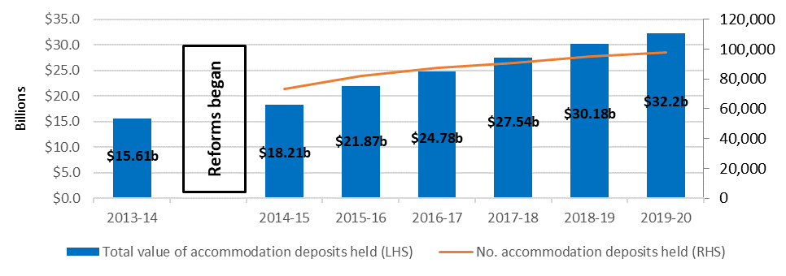

While the pool of accommodation deposits continues to grow, there is a gradual trend away from RADs in favour of DAPs, as shown in Chart 7.2. The proportion of people choosing RAD/RACs has dropped every year, albeit slightly, since 2014‑15. The proportion of residents choosing DAP/DACs has gradually increased over the four years from 33 per cent in 2014–15 to 43 per cent in 2019‑20. This trend has not been caused by a change in the proportion of non-supported residents as that has been relatively stable at around 50 per cent since 2014‑15 (although did drop to 47.4 per cent in 2019‑20) which indicates a trend in consumer payment preferences. .

Further, as noted earlier, while ACFA noted the overall shift away from RADs to date has been modest, gradual and manageable, feedback from consultations reported that some providers are concerned about a move towards DAPs. ACFA acknowledged, however, that a rapid shift away from RADs to DAPs would significantly impact the business model of some providers who rely on RADs, and that the sector as a whole would be unlikely to be able to sustain a rapid shift.

Chart 7.2: Resident method of accommodation payment, 2014-15 to 2019-20

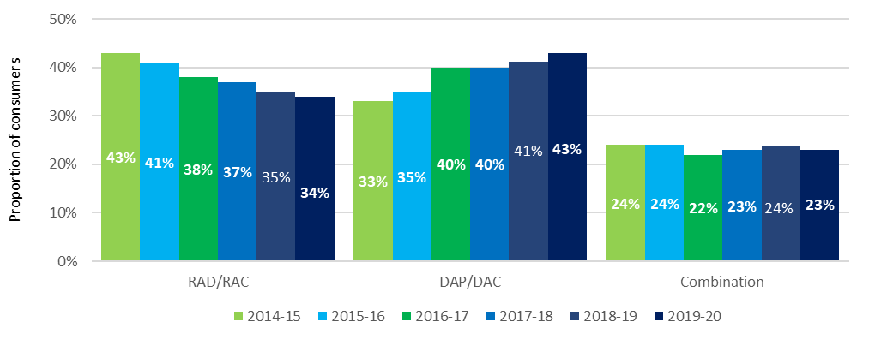

ACFA has previously noted there are several factors that a consumer might take into consideration when determining how to pay the accommodation payment. These include: the rate of the Maximum Permissable Interest Rate (MPIR), (if interest rates fall, equivalent daily payments will fall for non-supported residents and vice versa); expected length of stay (if shorter, then more likely to pay by daily payment); personal financial circumstances; and the length of time it takes to sell the family home.

Feedback from providers also suggests that the movement in house prices and conditions in the housing market are important factors in influencing the choice between RADs or DAPs.

In terms of the MPIR influencing decisions on accommodation payments in aged care, there is the potential for movement from lump sums to daily payments if the equivalence rate is set too low. The current record low interest rates have seen the equivalent daily accommodation payment for a $550,000 RAD fall from $100.89 in July 2014, when the equivalence formula was introduced, to $60.42 currently. High interest rates would see a reversal of this situation.

If all other things are equal, and consumers can achieve a better return, they may be inclined to invest the lump sum and pay the daily payment out of investment earnings. On the other hand, some residents see daily payments as interest charged on the outstanding lump sum. From this perspective, residents see the MPIR (4.04 per cent as at 1 July 2021) as a punitively high rate of interest.

As ACFA noted in last year’s annual report, part of the reduction in the proportion of residents paying by lump sum could also be transitional and may reflect a greater understanding by consumers of their ability to choose how to pay for their accommodation, as was intended by the reforms implemented in 2014.

The decrease in the proportion of RAD/RACs has been most noticeable for not‑for-profit providers, where the proportion has dropped steadily from 42 per cent in 2014-15 to 30 per cent in the last two years (Chart 7.3). For the for‑profit providers, the proportion of residents choosing RAD/RACs has consistently been higher than the not‑for‑profits, although is also declining and was 40 per cent in 2019-20 compared with 46 per cent in 2014‑15 when the reforms began.

Chart 7.3: Resident choice of payment method, by ownership, 2014-15 to 2019‑20

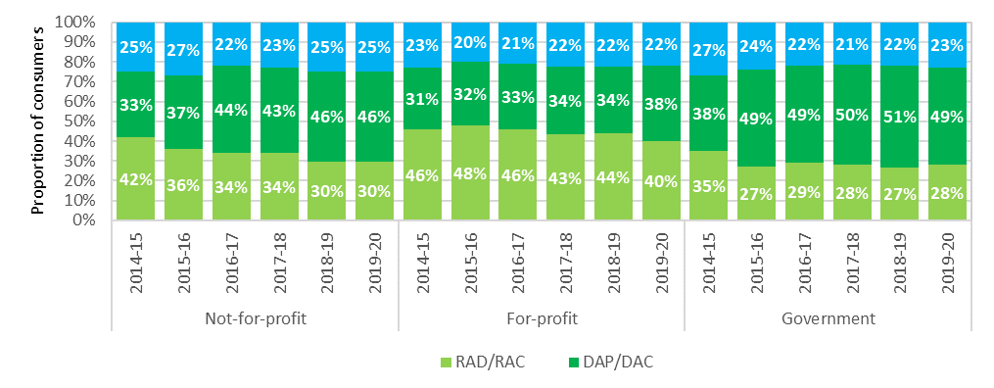

When analysed in terms of location, lump sum payments continued to drop, albeit slightly, in metropolitan areas, falling to 36 per cent in 2019‑20 from 37 per cent in 2018-19 (45 per cent in 2014‑15) (Chart 7.4). In regional areas, there was also a drop in the number of residents choosing RADs, 29 per cent, down from 32 per cent in 2018‑19. The choice of payment type in remote areas was stable.

Chart 7.4: Resident choice of payment method, by location, 2015-16 to 2019‑20

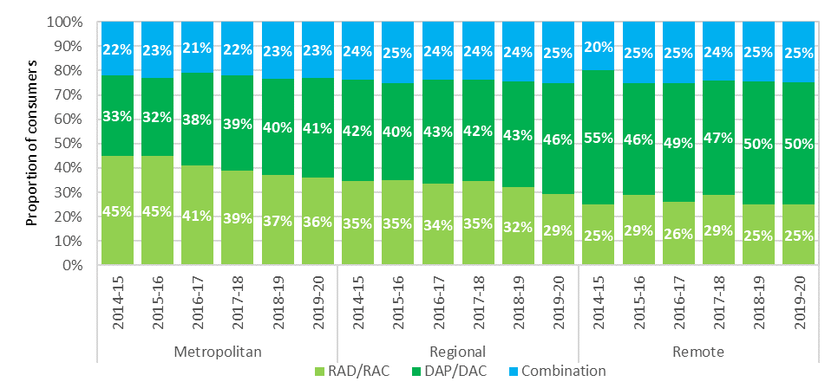

There continues to be a very significant difference in choice of payment between non-supported residents and partially supported residents, as shown in Chart 7.5. Forty-two per cent of non-supported residents chose to pay their accommodation payment by a RAD whereas only 4 per cent of partially supported residents chose this option, although the proportion of non‑supported residents paying a RAD has also been decreasing steadily over the four years since, from 51 per cent in 2015-16. The proportion of residents paying by lump sum may include residents who had commenced to pay full or partial daily payments, and then paid a lump sum during the year. Similarly, residents paying a daily payment may subsequently pay a lump sum (e.g. once their house is sold).

Chart 7.5: Resident choice of payment method, by partially supported and non-supported residents, 2015-16 to 2019-20

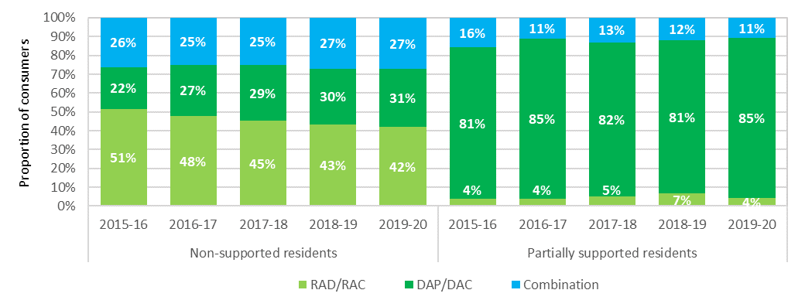

### Accommodation deposit prices

On 1 July 2014, new accommodation pricing arrangements came into effect. The changes were:

* Lump sum accommodation payments became known as Refundable Accommodation Deposits (RADs) instead of Accommodation Bonds;
* providers were able to charge a RAD to any resident whereas they had previously only been able to charge an Accommodation Bond for low care residents, or a high care resident in Extra Service facilities;
* providers were no longer able to deduct a retention amount from the RAD;
* residents became able to, at their discretion, choose to pay a RAD, a Daily Accommodation payment (DAP) or any combination of RAD and DAP; and
* providers were required to publish the maximum price for their rooms, or part of a room, in their aged care facilities. Residents may negotiate a lower price (known as the agreed price) but cannot be asked to pay more than the published price.

Charts 7.6 and 7.7 show the average published and agreed accommodation prices since 1 July 2014, presented by provider ownership type and location. This data includes RADs, DAPs and combination payments and covers the price of a residential care room, not the method of payment.

In terms of provider ownership (Chart 7.6), agreed prices for both the for‑profit and the not‑for‑profit providers are consistently lower than the published prices. In 2018‑19 the overall average agreed price for the sector was around $60,000 less than the average published price.

Also as shown, for‑profit providers have consistently higher published and agreed prices than not‑for‑profit providers. The average agreed price is less than the average published price because residents may, and often do, negotiate a lower price.

Chart 7.6: Average agreed and published accommodation prices (lump sum equivalent), by ownership, 2014‑15 to 2019-20

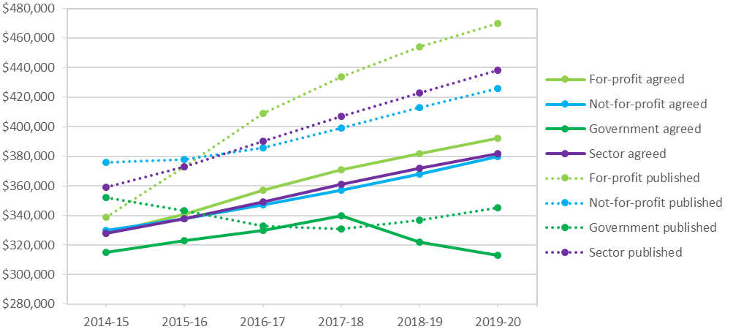

In terms of location (Chart 7.7), as has been the case in previous years, the average published and agreed price in metropolitan areas was significantly higher than in regional and remote areas. This is to be expected given the difference in house prices across these areas.

Chart 7.7: Average agreed and published accommodation prices (lump sum equivalent), by location, 2014-15 to 2019-20

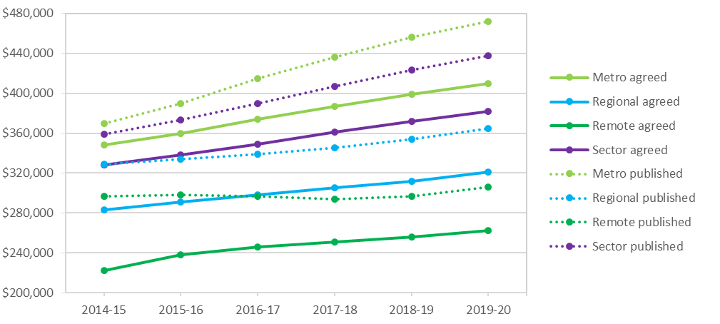

## Financing status - balance sheet

This section focuses on the balance sheet of the residential care sector, showing the liabilities, assets and net assets.

In 2016‑17 the Department of Health began collecting financial data from providers via the Aged Care Financial Report (ACFR). This has allowed greater disaggregation of the total assets and liabilities compared with earlier years which is used in some of the analysis. Table 7.2 shows a high level balance sheet summary for residential care providers for the last five years.

Table 7.2: Balance sheet of residential care providers, 2015‑16 to 2019‑20

| Assets/liabilities | 2015-16 ($m) | 2016-17 ($m) | 2017-18 ($m) | 2018-19 ($m) | 2019‑20 ($m) |
| --- | --- | --- | --- | --- | --- |
| Financial assets | $5,611 | $8,199 | $9,047 | $9,248 | $8,931 |
| Fixed assets | $11,455 | $22,963 | $24,061 | $27,997 | $27,675 |
| Right of use assets | - | - |  |  | $2,933 |
| Other assets | $23,629 | $13,855 | $15,292 | $15,323 | $16,862 |
| Total assets | $40,695 | $45,017 | $48,400 | $52,568 | $56,401 |
| Refundable accommodation deposits | $21,872 | $24,710 | $27,523 | $30,183 | $32,205 |
| Lease liabilities | - | - |  |  | $2,976 |
| Other liabilities | $7,878 | $8,981 | $9,050 | $9,703 | $9,663 |
| Total liabilities | $29,750 | $33,691 | $36,573 | $39,886 | $44,844 |
| Net worth/equity | $10,945 | $11,326 | $11,827 | $12,682 | $11,557 |

Notes:

1. AASB 16 Leases, a new accounting standard, now requires leasees to recognise most rental contracts on their balance sheets as ‘right of use assets’ and corresponding lease liabilities. For leased assets recognise in the balance sheet, rent expense is replaced by depreciation and interest expense that is calculated on the value of the leased asset.
2. Short-term leases and low value leases are exempt and can still be shown as rent expense (similar to previous years).

At 30 June 2020, the sector as a whole had total assets of $56.4 billion (an increase of $3.9 billion or 7.4 per cent since 30 June 2019). Current assets were $14.1 billion, a slight decrease from 2018‑19 and fixed assets decreased to $27.7 billion from $28 billion. Accommodation deposits continued to increased, up to $32.2 billion from $30.1 billion (an increase of 7 per cent).

Total liabilities were $44.8 billion, up from $39.9 billion in 2018‑19. This includes the $32.2 billion of accommodation deposits held by the sector. Total liabilities as a proportion of total assets is a measure that indicates an organisation’s leverage and shows the proportion of total assets financed through borrowings. As shown in Chart 7.8, this proportion was 79.5 per cent in 2019‑20 and has been gradually increasing for four years from 73.1 per cent in 2015‑16.

Overall, net worth/total equity in the sector was $11.6 billion in 2019‑20, down from $12.7 billion in 2018‑19.

Other liabilities, which include secured bank and related party lenders, creditors and provisions, increased to over 22 per cent from around 18.5 per cent the previous two years (Chart 7.8).

Net worth/total equity as a proportion of assets decreased noticeably to 20.5 per cent after being around 24-26 per cent for the previous four years. This is a measure of the share of an organisation which is contributed by and held beneficially by the owners/shareholders. The decrease in equity which contributed to reduction in this ratio was a direct result of the sector making a large loss ($736 million) in 2029-20.

Chart 7.8: Residential care provider liability types as a proportion of total assets, 2015-16 to 2019-20

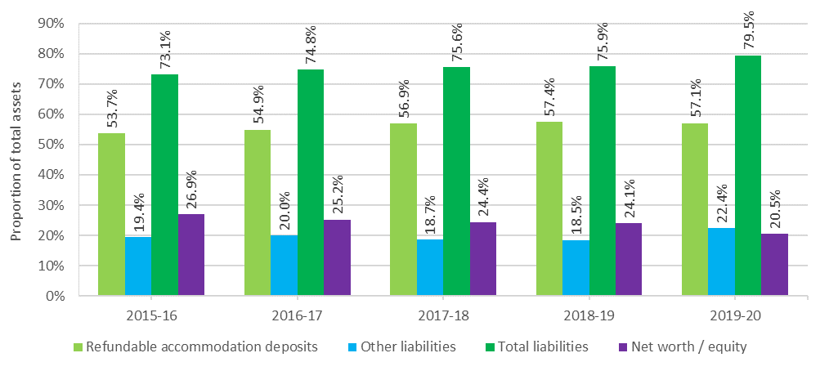

### Balance sheet analysis by ownership type

Assets and liabilities have been analysed by ownership type in order to identify differences between not-for-profit, for-profit and government providers. Table 7.3 shows liabilities and net worth/equity as a proportion of total assets by ownership type, while Chart 7.9 shows the proportions for the past three years.

At 30 June 2020, for the not-for-profit providers, refundable accommodation deposits (RAD) funded 57 per cent of their total assets of $29.4 billion. This compares with the for‑profit providers whose RADs funded 59 per cent of their total assets of $25.1 billion.

As has been the case in previous years, the for-profit sector has a significantly higher proportion of liabilities, with their total liabilities being 94 per cent (88 per cent in 2018‑19) of their total assets, compared with the not‑for‑profit providers with 70 per cent (65 per cent in 2018‑19). This significant difference is representative of the way the for-profits operate in terms of higher leveraging. It is worth noting that both the not‑for‑profit and the for‑profit providers had an increase of 5 per cent.

Table 7.3: Balance sheet, by ownership type, at 30 June 2020 ($m)

|  | Not-for-profit ($m) | For-profit ($m) | Government ($m) | Total sector ($m) |
| --- | --- | --- | --- | --- |
| Total assets funded by: | $29,358 | $25,083 | $1,961 | $56,401 |
| Refundable accommodation deposits | $16,620 | $14,910 | $676 | $32,205 |
| Other liabilities | $3,881 | $8,561 | $197 | $12,639 |
| Total liabilities | $20,501 | $23,470 | $873 | $44,844 |
| Net worth/equity | $8,856 | $1,612 | $1,088 | $11,557 |
| As a % of total assets |  |  |  |  |
| Refundable accommodation deposits | 56.61% | 59.44% | 34.46% | 57.10% |
| Other liabilities | 13.22% | 34.13% | 10.06% | 22.41% |
| Total liabilities | 69.83% | 93.57% | 44.51% | 79.51% |
| Net worth/equity | 30.17% | 6.43% | 55.49% | 20.49% |

Chart 7.9: Liabilities and net worth as a proportion of total assets, by provider ownership type, 2017-18 to 2019-20

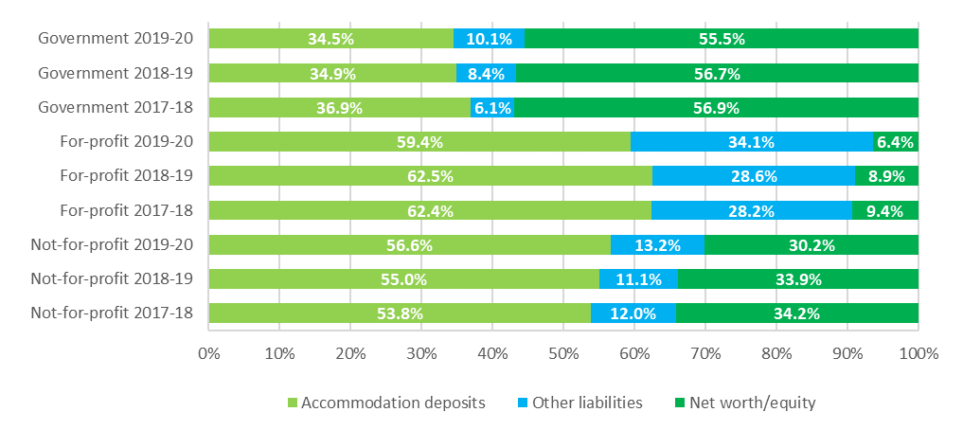

Table 7.4 presents the consolidated balance sheet at segment and organisation level for 2019‑20.

Table 7.4: Disaggregated balance sheet by provider ownership type, at 30 June 2020 ($m)

|  | Not-for-profit ($m) | For-profit ($m) | Government ($m) | All providers ($m) |
| --- | --- | --- | --- | --- |
| Assets |  |  |  |  |
| Current assets |  |  |  |  |
| Cash | $4,538 | $1,397 | $353 | $6,287 |
| Financial assets | $1,906 | $101 | $125 | $2,133 |
| Trade receivables | $613 | $302 | $57 | $971 |
| RADs & RACs receivable | $439 | $326 | $47 | $812 |
| Related party loans | $315 | $2,949 | $0 | $3,264 |
| Other current assets | $382 | $245 | $53 | $680 |
| Total current assets | $8,192 | $5,320 | $635 | $14,147 |
| Non-current assets |  |  |  |  |
| Financial assets | $365 | $142 | $4 | $511 |
| Related party loans | $258 | $3,632 | $0 | $3,890 |
| Work in progress | $763 | $350 | $8 | $1,120 |
| Intangibles - bed licences | $1,055 | $2,389 | $26 | $3,470 |
| Intangibles - other | $408 | $1,674 | $15 | $2,097 |
| Fixed assets | $17,549 | $8,862 | $1,264 | $27,675 |
| Right of use assets | $693 | $2,236 | $5 | $2,933 |
| Other non-current assets | $74 | $478 | $5 | $557 |
| Total non-current assets | $21,165 | $19,762 | $1,326 | $42,254 |
| Total assets | $29,358 | $25,083 | $1,961 | $56,401 |
| Liabilities |  |  |  |  |
| Current liabilities |  |  |  |  |
| Accommodation deposits (incl. bonds) | $16,620 | $14,910 | $676 | $32,205 |
| Bank borrowings | $183 | $713 | $0 | $897 |
| Related party loans | $185 | $1,116 | $1 | $1,301 |
| Employee provisions | $931 | $581 | $110 | $1,622 |
| Lease liabilities | $135 | $240 | $3 | $379 |
| Other current liabilities | $1,013 | $1,258 | $8 | $2,278 |
| Total current liabilities | $19,068 | $18,817 | $797 | $38,682 |
| Non-current liabilities |  |  |  |  |
| Bank borrowings | $491 | $891 | $25 | $1,407 |
| Related party loans | $77 | $1,107 | $0 | $1,184 |
| Employee provisions | $160 | $108 | $25 | $293 |
| Lease liabilities | $463 | $2,130 | $3 | $2,597 |
| Other non-current liabilities | $242 | $417 | $22 | $681 |
| Total non-current liabilities | $1,434 | $4,653 | $76 | $6,162 |
| Total liabilities | $20,501 | $23,470 | $873 | $44,844 |
| Net assets | $8,856 | $1,612 | $1,088 | $11,557 |
|  |  |  |  |  |

As shown in Table 7.3, fixed assets – predominantly residential aged care facilities - are the single largest asset category held by providers ($27.7 billion or 49 per cent of total assets). This is consistent with previous years. In terms of ownership type, fixed assets represent 60 per cent of total assets for the not‑for‑profit providers, whereas for the for-profit providers it represents 35 per cent. This is also consistent with recent years. The significant difference is likely explained in part by providers in the for-profit sector being more likely to rent the facilities in which they provide residential services, often under arrangements where the facilities are rented from related party entities.

For the sector, cash ($6.3 billion) and financial assets ($2.1 billion) represent 15 per cent (16.6 per cent in 2018‑19) of total assets and 60 per cent of current assets. Again, there are differences between ownership types with the not-for-profit providers holding 79 per cent of current assets in cash and financial assets, while for-profit providers hold only 30 per cent. For‑profit providers are more active in placing their funds in other categories of assets, including related party entities.

Intangible assets make up 10 per cent, or $5.6 billion of total sector assets (stable from recent years). Of this, bed licences make up 63 per cent, or $3.5 billion, and other intangibles of $2.1 billion, consisting mostly of goodwill held by the for-profit sector, make up the remainder. For‑profit providers hold 73 per cent of the intangibles balance for the sector.

Fifty-three per cent of for-profit providers (52 per cent in 2018‑19) have recognised the value of bed licences. In contrast, only 27 per cent of not-for-profit providers (28 per cent in 2018‑19) have recognised the value of their bed licences.

ACFA notes the Government’s announcement in response to the Royal Commission that, from 1 July 2024, residential care places will be assigned directly to consumers rather than to providers. This is a change that Government had been considering previously (before the Royal Commission), including undertaking an impact analysis to examine the potential implications of moving away from allocating residential care places to providers. This included consideration of the implications for bed licences and intangible assets. ACFA notes that proposed changes to remove the allocation of places to providers will affect the intangible assets of those providers who currently recognise the value of their bed licences.

### Balance sheet performance ratios

Balance sheet ratios provide a guide as to the financial health of providers through an analysis of their profitability, liquidity and efficiency as well as their net worth.

#### Balance sheet performance ratios – definitions

##### Current Ratio

Current ratio is a measure of an organisation’s ability to meet its short‑term obligations (current liabilities) from its current assets. The current ratio measures an organisation’s liquidity and provides an indication of risk that the organisation may not be able to meet its short‑term obligations as and when they fall due. It is calculated by dividing current assets of an organisation by its current liabilities.

Generally, a current ratio of at least 1.0, shows that an organisation has sufficient current assets to meet its short‑term obligations. However the requirement to categorise accommodation deposits as current liabilities[39] on the balance sheet of providers means that the current ratio needs to be treated with some caution and considered in conjunction with other financial indicators of liquidity for aged care organisations. For example, although RADs are required to be repaid when a resident leaves care, they are often repaid after a stay of longer than one year. The average length of stay for residents is currently just over three years.

##### Cash as a proportion of accommodation deposits

Cash and cash equivalents in the form of financial assets, as a proportion of refundable accommodation deposit balances provides an indication of an organisation’s capacity to repay the accommodation deposit balances with liquid resources.

##### Net Assets Value

The net assets value provides an indication of the value of an organisation. The net assets value is determined by taking the total assets of an organisation and subtracting total liabilities. A low net assets value or a decrease in the value over time indicates higher levels of financial risk for lenders and consumers.

##### Debt Ratio

The debt ratio is calculated by dividing an organisation’s total liabilities by its total assets and provides an indication of the degree of financing of an organisation. Within the aged care sector, total liabilities will consist of an organisation’s refundable accommodation deposits as well as other secured and unsecured debt balances. An organisation’s total assets will include cash and asset balances to which the refundable accommodation deposits may have been applied. As total liabilities increase as a proportion of total assets, the higher levels of debt could reflect the use of additional borrowings used to fund an organisation’s improvements and expansions.

##### EBITDA to total assets ratio

The EBITDA to total assets ratio measures the operating return generated from an organisation’s total assets. The ratio is a measure of financial performance and is calculated by taking the earnings, before interest, tax, depreciation and amortisation (EBITDA) and dividing this by the organisation’s total assets. Generally, the higher the EBITDA to total assets ratio, the better the level of return generated from the organisation’s total assets.

##### Equity to total assets ratio

Net worth/total equity as a proportion of total assets provides an indication of solvency. For the for-profit providers, it shows the proportion of an organisation’s assets which have been contributed by the owners/shareholders. For the not-for-profit and government providers, equity typically consists of retained earnings and revaluation reserves. The lower the ratio suggests that an organisation has used more debt to fund its asset balances.

As shown in Chart 7.10 the current ratio for the whole sector continued to decrease in 2019‑20, down to 0.37 from 0.40 in 2018‑19. The sector’s current ratio had been 0.48 in 2014‑15. The decrease indicates a slight increase in the risk that organisations may not be able to meet their current liabilities from the current asset balances.

In terms of ownership type, all three ownership types recorded decreases in their current ratios in 2019‑20 compared with 2018‑19. The current ratio for not‑for‑profit providers decreased to 0.43 from 0.47 in 2018‑19. The current ratio for for‑profit providers dropped slightly to 0.28 from 0.30. As has been the case for several years, the current ratio for the not-for-profits was higher than the current ratio achieved by the for-profits.

A current ratio of less than 1.0 ordinarily indicates an organisation has insufficient assets to meet their obligations when they become due and payable. However, although RADs can become repayable at any time and are classified as current liabilities, in practice, the repayment period for accommodation deposit balances will vary in line with each resident’s tenure. This means that the current ratio result should be used with caution and considered with other financial indicators in the residential aged care sector.

Chart 7.10: Current ratio, by provider ownership, 2014‑15 to 2019‑20

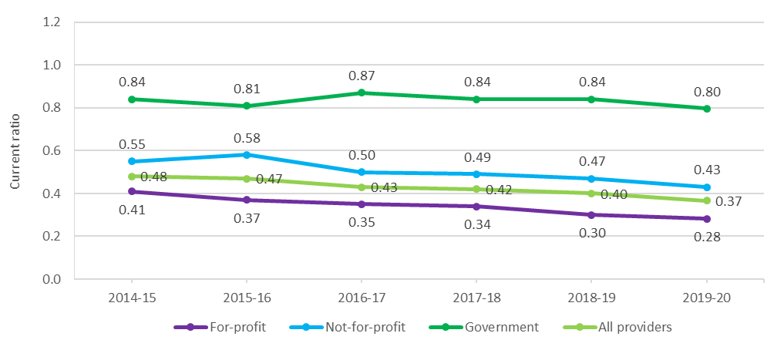

As shown in Chart 7.11, the EBITDA to total assets has been trending downwards in recent years, falling for the whole sector from 3 per cent in 2018-19 to 2.3 per cent in 2019-20. This is likely due mainly to the deterioration in financial performance of the sector in recent years. In terms of ownership, the for‑profit providers were steady at 3.2 per cent but have generally declined in recent years (5.3 per cent in 2015‑16). The decline has been even greater for the not‑for‑profit providers, down to 2 per cent from 3.2 per cent in 2018-19 and 4.9 per cent in 2015‑16. The EBITDA to total assets ratio measures the operating return generated from an organisation’s total assets.

Chart 7.11: EBITDA to total assets, by provider ownership, 2015-16 to 2019-20

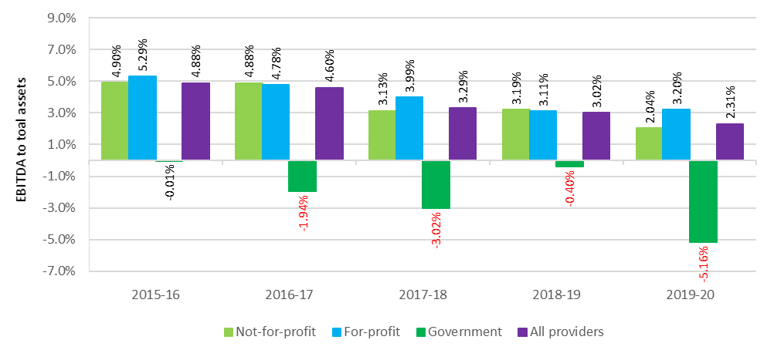

There continues to be a significant difference between provider types when looking at the results for the equity to total assets ratio, as shown in Chart 7.12. Not-for-profit providers are generally around 20-24 percentage points higher than the for‑profits, with both types reporting a decline in 2019‑20 compared with 2018‑19. The not‑for‑profits dropped to 30.2 per cent from 34 per cent and the for‑profits reported 6.4 per cent from 8.9 per cent. As can be seen, the results for all provider types have been gradually decreasing over a number of years, suggesting a preference for debt to fund the growth in assets.

Chart 7.12: Equity to total assets, by provider ownership, 2014-15 to 2019-20

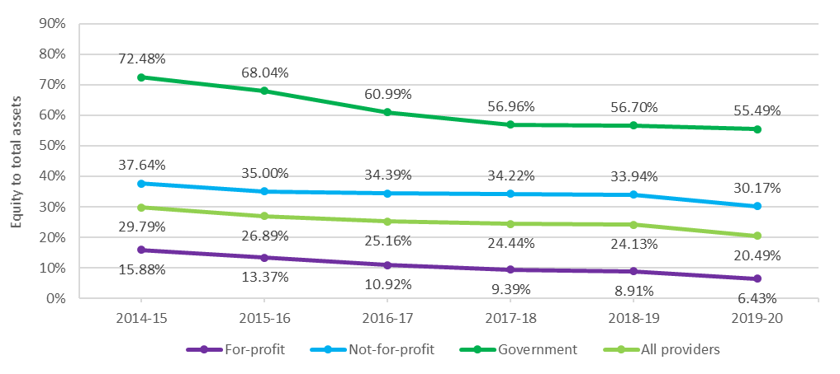

The average debt ratio across the sector has been increasing gradually over the last five years from 0.70 in 2014‑15 to 0.80 in 2019‑20 (Chart 7.13). Both the for‑profit and not‑for‑profit providers have reported a similar increase over the last five years. In 2019‑20 the for‑profits reported a small increase from 0.91 to 0.94 and the not‑for‑profits reported an increase from 0.66 to 0.70. The average debt ratio shows the proportion of organisational assets that are financed through debt. A ratio of more than 1.0 indicates that an organisation has a higher debt level than the value of its assets.

Chart 7.13: Average debt ratio, by provider ownership, 2014-15 to 2019-20

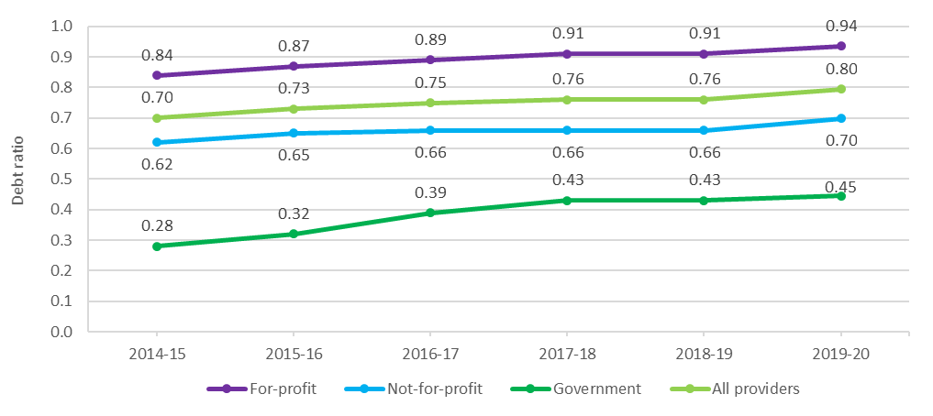

The net asset position for the sector as a whole had been increasing since 2014-15, however it declined from $12.7 billion in 2018-19 to $11.6 billion (Chart 7.14). For‑profit providers decreased from $2.0 billion to $1.6 billion and not‑for‑profit providers decreased from $9.6 billion in 2018‑19 to $8.9 billion in 2019‑20.

Chart 7.14: Net assets, by provider ownership, 2014-15 to 2019-20

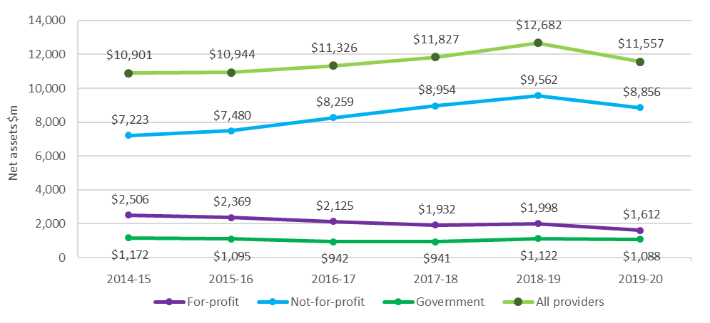

Cash held as a percentage of accommodation balances provides an indication of an organisation’s capacity to repay the accommodation deposit balances from liquid resources (Chart 7.15).

The levels of cash and cash equivalents held by the for‑profit providers has been around half that of the not‑for‑profit providers but has been proportionally decreasing in recent years. In 2019‑20 it decreased to 9.4 per cent from 12.9 per cent in 2018-19 and 14.3 per cent in 2017‑18. Conversely, the not‑for–profit providers were stable at 27.3 per cent in 2019‑20. This is some indication of the declining performance of the for‑profit providers, although noting that all provider types have generally declined in the last two years. It should also be noted that for‑profit providers generally have a greater appetite for risk and therefore invest more of their liquid assets compared with not‑for‑profit providers.

Chart 7.15: Cash held as percentage of accommodation deposit balances, by provider ownership, 2017‑18 to 2019-20

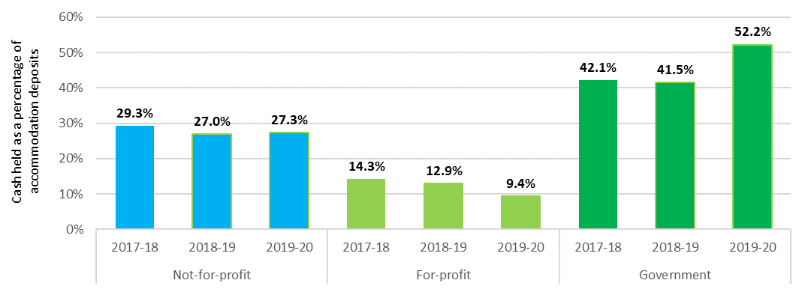

Chart 7.16 shows total assets, net worth/equity and average accommodation deposit value per resident, by ownership type in 2019‑20, compared with 2018‑19. For the whole sector, average accommodation deposits held increased to $333,931 per resident from $318,283 in 2018‑19, an increase of 4 per cent. This metric measures the average value of all bonds (pre 1 July 2014) and accommodation deposits (post 1 July 2014) that providers hold. The average value of bonds/RADs has been steadily increasing in recent years.

In terms of net worth/equity, all providers recorded a decrease, down to $60,929 in 2019-20 from $69,026 in 2018‑19. The value of total assets per resident for both the for‑profit and not‑for‑profit providers increased in 2019‑20 compared with 2018‑19.

Chart 7.16 total assets, net worth/equity and average accommodation deposit value per resident, by ownership type, 2018-19 and 2019-20

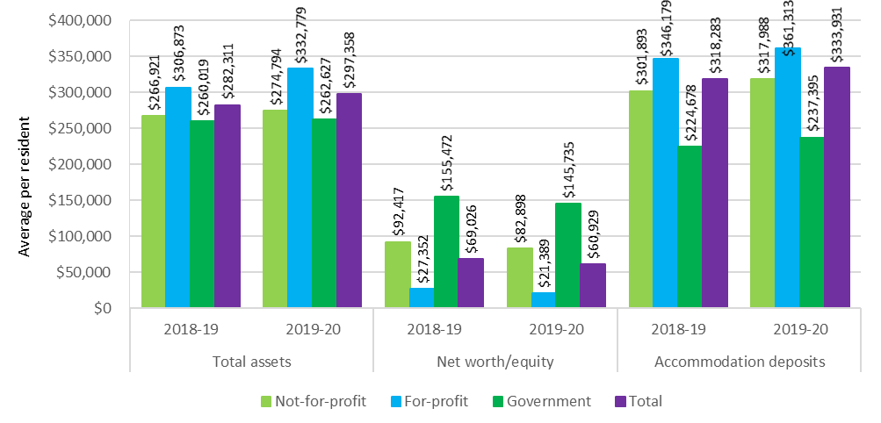

### Recent trends in building and investment in residential care

In 2019‑20 the total completed or in-progress work was $5.7 billion, compared with $5.3 billion in 2018‑19 and $4.9 billion in 2017-18 (Chart 7.17). This continues the trend of increasing value of building works in residential care in recent years, despite the trend of fewer providers indicating that they are looking to build in the near future. This is likely due to the number of years between when a provider gains a place through an ACAR and when the building is complete, which is currently around four years.

As noted, there remains a significantly lower proportion of providers reporting an intention to rebuild or upgrade compared with 2016-17 and the years preceding. In 2019‑20, there was a further slight decline in providers reporting that they are planning to upgrade (4 per cent down from 5 per cent in 2018‑19), while the proportion reporting they intend to re-build facilities was stable at 1 per cent (Chart 7.18). In 2015‑16 the proportion of facilities planning to upgrade or rebuild was at its strongest, with 14 per cent and 5 per cent respectively.

As noted in ACFA’s last two annual reports, feedback from providers indicated that some had curtailed or delayed investment plans in the residential care sector, citing depressed returns and policy and regulatory uncertainty along with the potential impact of increased home care packages. Providers had indicated that a contributing factor was also uncertainty over the future direction of aged care following the completion of the Royal Commission into Aged Care Quality and Safety.

For-profit providers have previously emphasised that the current return on capital employed in aged care was below the cost of capital and, in the absence of any change, this would curtail additional investment in the sector. Uncertainty around the implementation of reforms following the Royal Commission may continue to delay some investment plans in the residential aged care sector. It will be important to monitor whether sentiment changes following the Government’s response to the Royal Commission’s final report.

Chart 7.17: Residential care building activity (completed or in-progress), 2014-15 to 2019-20

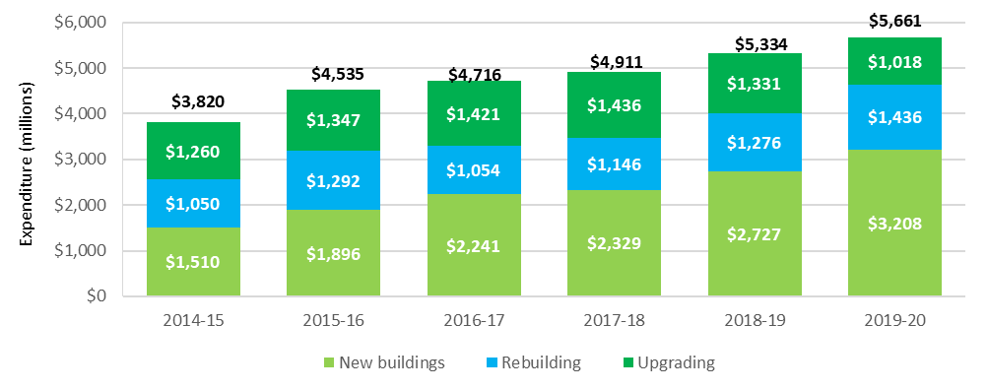

Chart 7.18: Proportion of facilities planning to either upgrade or rebuild, 2014‑15 to 2019‑20

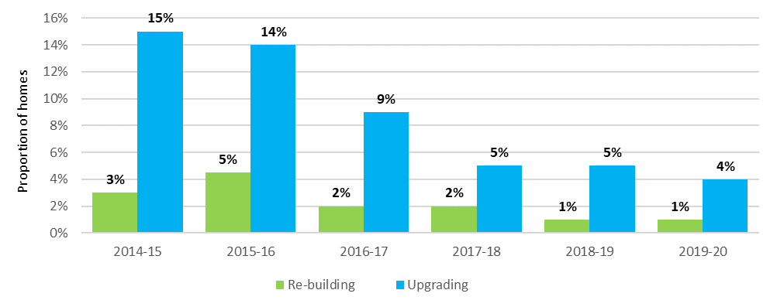

The decline in planned building activity discussed above is also evident, albeit less significantly, in data regarding aged care building approvals from the Australian Bureau of Statistics. The total number of builds dropped in 2019-20 for the fourth year in a row, down to 316 from 336 in 2018‑19, and a recent peak of 416 in 2016-17 (Chart 7.19).

Chart 7.19: Number of building approvals, by value of building work, 2014‑15 to 2019‑20

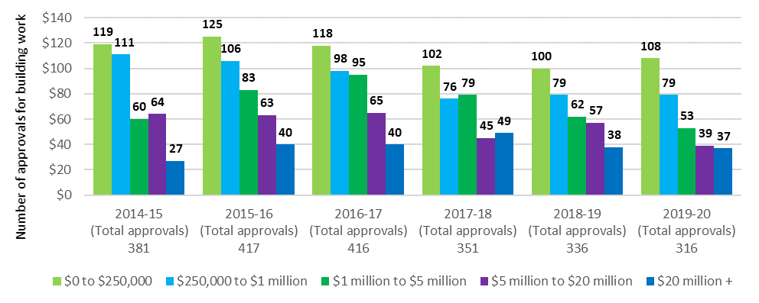

# Future demand for aged care

|  |
| --- |
| This chapter discusses:   * The factors that affect demand for aged care; * demand for the different types of subsidised aged care; * changing population of older Australians requiring aged care; and * changing preferences of consumers seeking aged care. |

## Future demand for aged care services

The demand for aged care services will expand with the ageing of the population. This chapter discusses the factors that affect demand for the relevant aged care types, how this is likely to look in the future, and the investment that is needed to ensure the aged care system can adequately cater for the expected future requirements of an ageing population.

An investigation into demand and supply of aged care services was undertaken by David Tune AO PSM in the Legislated Review of Aged Care 2017. The Review concluded that there was insufficient data available and that “robust measures of demand and unmet demand in aged care are a significant way off”. The Review also noted however that there is no doubt that demographic factors will lead to significant growth in service provision and expenditure requirements.

It is still currently not possible to accurately determine consumer preference for residential and home care, due to existing supply constraints. However, some better evidence about unmet need and consumer preference is being revealed since the creation of the National Prioritisation System (NPS) for home care packages and the decline in average residential care occupancy despite a large proportion of older people on the home care queue also being approved for permanent residential care, but choosing to remain living at home. The introduction of flexibility to switch funding across care types, ie. from residential care to home care packages in response to consumer demand, may also help to inform consumer preferences.

The other variables include how providers might respond to increased consumer choice, such as innovation in accommodation options for older people and innovation in service delivery models, and how consumers might respond to changes in entitlements and user contributions across different service types, especially across home care and residential care.

The analysis in this chapter focuses on projections based on current use of aged care and population growth, and should not be treated as forecasts of what is likely to happen in terms of future demand for types of aged care.

### Determinants of demand

Demand for aged care services is complex and dependent on a range of demographic, service need, and economic factors. The Productivity Commission noted in its 2011 report, Caring for Older Australians, that “The demand for aged care services depends on the number of older people needing care and support. However, care needs are not homogenous and the nature and location of aged care services demanded will depend on the physical and mental health of older people, their capacity and willingness to pay, their preferences, and the availability of informal carers.”

Figure 8.1: Factors affecting the extent and type of aged care service demand

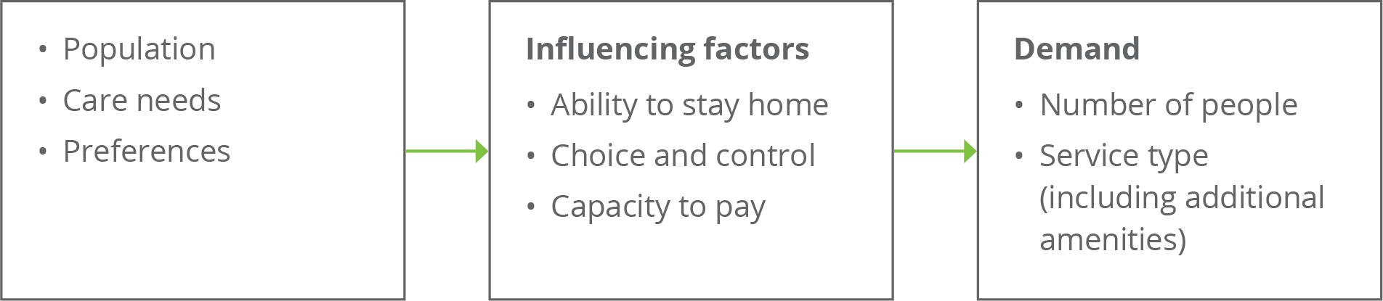

Source: adapted from Caring for older Australians (Productivity Commission, 2011)

### An ageing population – older people demand more aged care

The structural ageing of the Australian population over the next 20 years will see the size of the 70 years and over cohort increase by around one million people each decade; this is on a base of 2.9 million people in 2020 (Chart 8.1). Underneath this, the older age groups will more than double over this period; for example, the 85 years and over cohort will increase from just over 500,000 people in 2020 to just over one million people by 2040.

Chart 8.1: Number of people aged 70 years and over, by 5 year age cohort, 2020 to 2040

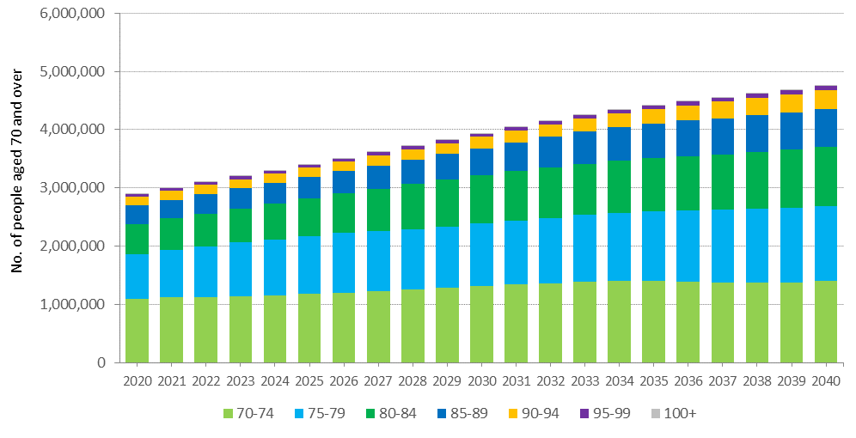

Because the baby boomers are such a large group compared with the pre-war generation, the proportion of the 70 and over population who are aged 85 and over will actually reduce over the next decade before subsequently increasing, as shown in Chart 8.2. This implies that the challenge of ensuring there is sufficient aged care supply to meet demand arising from the baby boomer generation is likely to be most strongly felt in 10–15 years (from the late 2020s) rather than over the next decade.

Chart 8.2: Proportion of 70 years and over age group who are aged 85 and over, 2020 to 2040

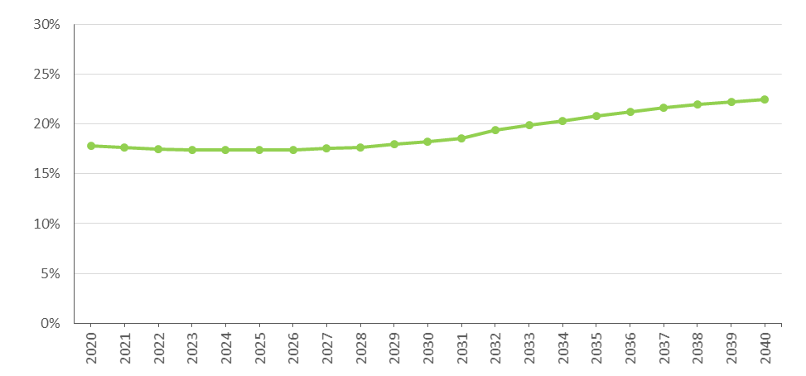

### Consumer preference

A key characteristic of the baby boomer generation is that they are wealthier than previous generations[40]. The bulk of the people likely to be demanding care in the next two decades have benefitted from high growth in property prices while paying down their mortgage, and are the first generation to have compulsory superannuation. It is reasonable to assume that they will both expect and be able to afford higher standards of residential accommodation, lifestyle amenities and quality of life than previous generations have been willing to accept. Like the current generation, however, baby boomers can be expected to prefer to remain living in their own home for as long as possible as they age.

The consequences of these trends are that while the demand for aged care will grow with the ageing of the population, consumers may be more demanding in the range and quality of aged care services they are seeking, along with having a greater capacity to pay for these services. Nevertheless, with the Age Pension being the main source of income for current retirees and those entering aged care over coming decades, maintaining equity in access to aged care services will continue to be important and a robust safety net will continue to be necessary.

ACFA has noted previously that to compete in this environment providers will need to be more responsive in meeting consumer needs and expectations, including in particular the desire to stay at home for as long as possible. This may require the introduction of new business models and changes in the interaction between retirement living, home care and residential care. The aged care regulatory system will also need to adapt to enable providers greater flexibility to pursue new business models and innovation.

Reforms as a result of the Royal Commission, such as the changes to respite services and the creation of a single home-based care and support program, will also influence consumer preferences.

### Availability of alternative care types

According to the 2015 Survey of Disability, Ageing, and Carers[41], around 1 in 9 Australians, or 2.7 million people, were informal carers. Almost all carers cared for a family member. The assistance provided by informal carers can avoid or delay entry into residential care, including with the support of home-based care (noting though that informal carers are also an important source of support for some in residential care).

At the same time that ageing population structures (discussed earlier) are putting pressure on the demand for care, the relative supply of informal carers will be diminishing. This is due to increased participation of women in the workforce, and changing family structures with fewer children being born per family (1.7 babies per woman in 2017 compared with nearly three in 1970[42]), generational differences in marriage and divorce rates, and more people living alone.

All else equal, this will increase the demand for formal aged care for older people.

In terms of demand for specific types of aged care, the relative availability of places within each care type under current regulated supply arrangements will also affect the rates at which people access them and to the extent they are not available, redirect demand across care types. As previously outlined in this report, the Government is changing the mix of residential and home care over time through adjustments to the provisional target ratios, and has implemented mechanisms whereby funding for unused residential care places can be redirected into home care where, at least over the short term, demand is expected to be more acute.

Recent years have also seen a rapid increase in home care packages being allocated and an increase in the supply of aged care services overall as the provision target of 125 places per 1,000 people aged 70 and over is exceeded following the Budget 2021-22 announcement of 80,000 additional home care packages. The current budgeted levels of residential and home care allow for between 150 and 160 places per 1,000 people aged 70+ over the current forward estimates.

In addition, a key objective of the Legislated Review of Aged Care 2017 was “to trigger changes that are prerequisites for a fully consumer-driven system”, and outlined recommendations that were “intended as the next steps on the road to consumer-driven care”. Most of the Legislated Review’s recommendations in this regard have not been acted upon.

The unknown, therefore, is the extent to which the modes of delivering care may develop in the future in response to consumer preferences, such as further relaxation or removal of supply constraints, the availability of more higher level home care packages and closer integration between retirement living accommodation models and home care. New ways of service delivery and innovation may widen the scope of aged care services available, which in turn may result in significant shifts in demand for different types of services.

The direction of future aged care policy regarding the regulation of the supply of aged care services and service types will be an important influence in this regard. The Government has accepted in principle the Royal Commission’s recommendation that service planning be based on need, not rationed, and has indicated that the structure of the future planning regime, including the role of the aged care provision ratio or another mechanism, will be determined as part of the design for the new support at home program.

### Economic factors

The demand for different types of care, and the way consumers distinguish between services in the same type of care, is affected by the price they can be asked to pay and the perceived value of that contribution. Demand may also reflect the relative subsidies that apply for different care types.

Consumers of residential and home care are currently required to make a contribution to the cost of their care (and residential accommodation) if they can afford to do so. However, as noted previously, the amount and proportion of contribution required to be made by a consumer varies between residential care and home care, including in relation to capacity to pay. Such anomalies have the potential to influence the demand for types of care or additional services.

Nevertheless, a challenge remains for Government to establish funding policies that ensure access to aged care services for all older Australians needing aged care and support at a level that meet the community’s quality of life expectations, irrespective of their means and social and cultural circumstances. Incentives in funding arrangements are also important in influencing the type of care supplied, for example if funding arrangements have no incentive for reablement services and a provider loses funding if there is an improvement in the level of acuity of a consumer, then there will likely be limited supply of services promoting reablement.

## Current demand for aged care

An understanding of the current profile of aged care usage is helpful for undertaking projections of future demand.

As shown in Chart 8.3, the proportion of each age group who currently use residential and home care package services increases dramatically with age. By age 80, the proportion of people using either permanent residential care or a home care package is around 7 per cent; this doubles by aged 85; and more than doubles again by age 90.

Chart 8.3: Proportion of people of each age using residential care and home care, by gender and age, 30 June 2020

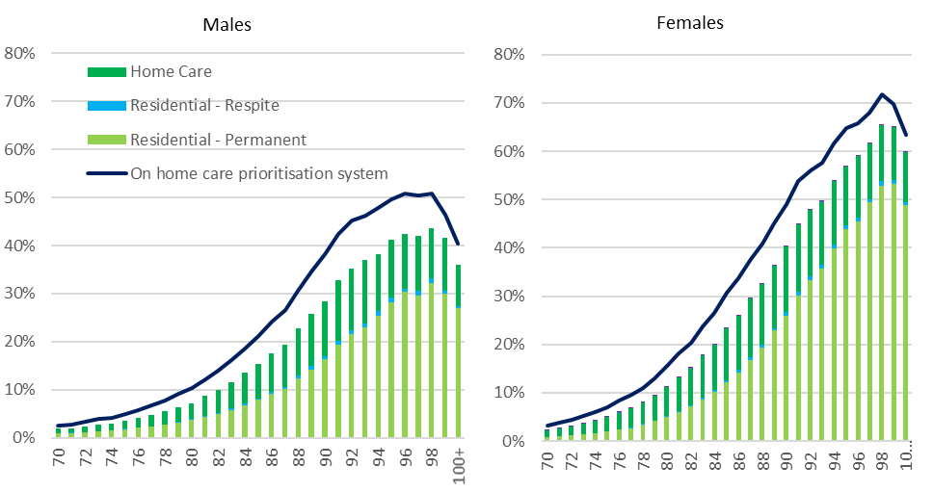

Note: Home care consumers receiving care in an interim level package are counted as using home care. People counted as waiting for a home care package are only those consumers who do not have a package at any level.

This projection is based on current usage, which may well not reflect the extent to which consumers are having their needs and preferences met by current regulated supply. True demand is much harder to measure given the current highly regulated supply system.

### Residential care

There are indicators which suggest that the overall demand for residential care is currently being met. The average occupancy rate in 2019‑20 was 88.3 per cent. Occupancy has been declining since 2015‑16 when it was 92.4 per cent. The average occupancy rate in residential care peaked at 97.1 per cent in 2003-04. There may, nevertheless, be pockets or regions of the country where people are waiting to access residential care. The Tune Review asked stakeholders about the level of unmet demand and received little feedback to suggest that there is significant unmet demand.

Residential care usage may, however, be artificially high as result of people entering residential care prematurely as an alternative to waiting on the allocation of a home care package, notwithstanding that a large number of people waiting for a package also have a residential care approval which they are choosing not to exercise. Current usage also does not reflect the potential for residential care services in a more competitive and flexible system to offer a more attractive service that includes more opportunities for higher quality and meaningful life delivered in a secure environment.

### Home care

ACFA has previously noted there is evidence of unmet demand for home care. As noted in section 3.4.2, as at 31 March 2021 there was around 87,000 people waiting for their approved level home care package (including those already receiving lower level home care) through the NPS. That section also notes that the recent release of an additional 90,000 packages – bringing the total number to over 275,000 by June 2023 – is expected to ensure that people currently on the NPS will be able to access a package at their assessed care level by this time.

## Projecting future demand

Previous ACFA reports contained a projection of demand for residential care over the next 20 years based on current age-specific use and the current residential aged care target provision ratio which is based on the number of people aged 70 years and over.

A projection on this basis suggests that the projected number of operational places is likely to exceed demand for residential care to 2027. This is because places are linked to growth in the 70+ population, which due to baby boomers entering their 70s, is growing at a faster rate than people who currently are using residential care, who are the 80 plus cohort of the population. Following 2027, as the baby boomers enter their 80s, demand for care is expected to rise faster than the release of places in line with the provision target ratio.

Care is needed in interpreting such projections because they are limited to residential care and do not take into account changes in consumer preferences and changes in modes of delivery of aged care. In particular, no account is taken for substitution of residential care for home care as the number of home care packages continue to expand.

### Substitution of residential care and home care

One of the factors that has to be taken into account in projecting demand for aged care is the potential substitutability of service types. The introduction of the NPS indicates there is significant unmet demand for home care services. It is also possible that some people have entered residential care because a home care place at a suitable level was not available.

The proportion of people in each age group (age-specific use) who are in either residential care or home care has remained stable (Chart 8.4, first column) over a long period of time. However, the amount of home care packages available has increased significantly as a share of these two care types (Chart 8.4, second column). As the amount of home care has expanded, there has been a reduction in the age-specific use of residential care (Chart 8.4, third column and Chart 8.5 which gives a cross-section of Chart 8.4). This would indicate that home care is substituting for residential care.

It is not known what the level of home care availability is that would be needed before all people who wish to remain in their home with a home care package can do so, and do not have to enter residential care. The substantial increase in home care packages announced in the 2021-22 Budget will likely go some way to ensure that those who wish to remain in their home can do so.

Chart 8.4: Utilisation of residential care and home care, 2000 to 2020

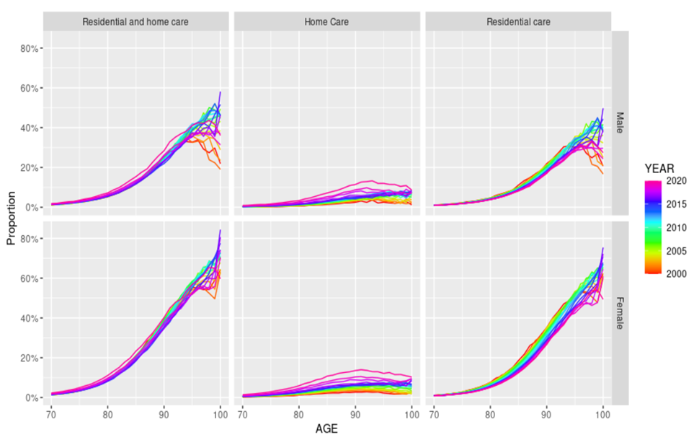

Chart 8.5: Utilisation of residential care and home care for 85-89 year olds, 2000 to 2020

2 stacked bar 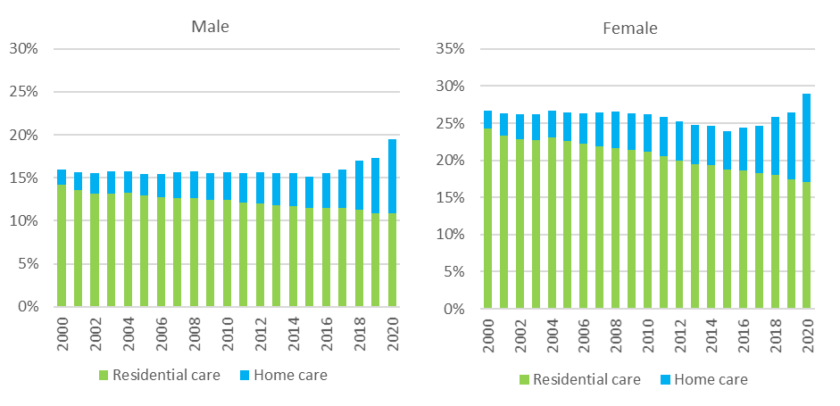

The expansion of home care is likely to not only divert people from entering residential care for longer or at all, but it will also have an impact on people receiving care from informal carers and through other programs such as the Commonwealth Home Support Program (CHSP).

### Updated projections

The projected demand based on the current age-sex specific usage of residential care is one approach to projecting future demand for residential aged care. However, with the expansion of the home care program and the concomitant fall in the usage of residential care in all age groups (Chart 8.4 and Chart 8.5), such projections may over estimate demand for residential care. Chart 8.6 shows the number of people using residential care proportional to growth in the population (using Australian Bureau of Statistics single-year-age and sex population projections).

It is evident from Chart 8.6 that, if the growth in the number of residential care places grows in line with the current target provision ratio (purple line) and is not impacted by any other factors, occupancy rates will continue to fall over the 2020s, before rising in the 2030s.

Chart 8.6: Projected demand for and supply of residential care places, 2020 to 2040

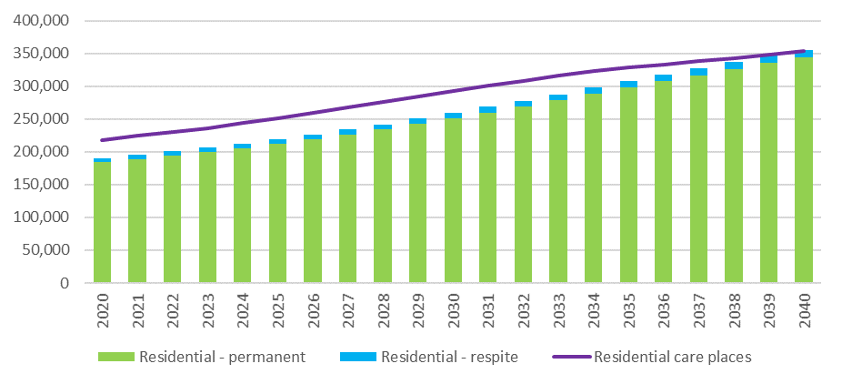

A projection of total demand for home care packages is provided in Chart 8.7. It should be noted however that the current Home Care Packages program will not continue in its current form beyond 30 June 2023 (as noted in section 4.5).

The projection of demand is based on the current level of expressed demand at June 2021; this is defined to be all people receiving care, people who have been assigned a package but are not yet in care, and all people with approval for care but not receiving a package. It is assumed that demand will grow in line with population projections at each year of age. The grey bars for periods 2024 and beyond reflect projected demand for packages but given the proposal to reform the home care support system, these should only be considered the sub-group of people that would have sought care at the levels provided for under the current home care system. In addition, it is worth noting that these projections do not include the growth in demand above population growth that has been observed since 2017.

Chart 8.7 also shows that the number of packages available (black line) following the recent MYEFO and Budget announcements is expected to exceed demand for packages by 2023. The supply of packages by 2023 is projected to be sufficient to ensure a package is available for all people expected to be in the NPS.

The Government’s intention to integrate CHSP and home care into a single home care and support program from 1 July 2023 presents an opportunity to address the longer term impacts of the high demand for care in the home and population ageing. A key consideration for policy makers to note is that growth in the population of people actually demanding care is likely to be higher than allowed for under the current planning targets based on the population aged 70 and over.

Under this projection, demand is expected to be just over half a million people by 2040.

Chart 8.7 shows that the number of packages available (black line) following the recent MYEFO and Budget announceme

Chart 8.7: Projected demand for and supply of home care packages, 2020 to 2040

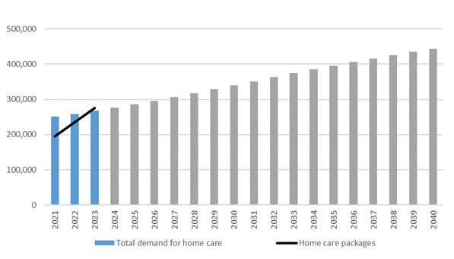

### Planning for the supply of aged care

As noted previously, if residential care places increased in line with the current target provision ratio and current age-specific use rates continued, there would be an excess supply of residential care over most of the 2020s. As the baby boomers start to enter their 80s in the 2030s, this demand could start to put pressure on the sector and its ability to ensure there is adequate supply of residential care. This has been flagged in previous ACFA reports and in the Tune Review.

As noted, there is excess demand for home care, and this is likely to remain the pressure point in the supply of aged care over the projection period. At least part of this undersupply can be met through a reduction in residential care places as currently provided for in the target provision ratio.

The Tune Review report recommended changes to the target planning ratio. The current ratio denominator of the 70+ population is not aligned to the cohort of the population more likely to use aged care services, and results in the observed periods of relative oversupply and undersupply. ACFA supports the Tune Review recommendation to change the denominator in the ratio to the 75+ cohort of the population following the achievement of the 125 ratio in 2021-22.

Since 2017, Home Care Packages have been allocated directly to consumers, rather than to providers, and in the Budget 2021‑22, Government announced the cessation of the Aged Care Allocation Rounds with a move to allocate places according to consumer preferences. Given this, ACFA notes that the target ratio formulation will need to change since operational places will no longer exist in the same sense as they do currently. ACFA recommends that the formula for the provision ratio instead use the number of consumers as the numerator - in place of operational places - whilst a supply cap remains in place. ACFA notes that the figures for residential care reported against this reframed ratio will be around 10 per cent lower than the current levels reported since not all operational places have consumers occupying them.

The following analysis shows the supply of aged care places under the 70+ population and 80+ population. The equivalent rates (converted as at 30 June 2023) are 194 per 1,000 people aged 75+ and 351 per 1,000 people aged 80+. As can be seen in Chart 8.8 the expected growth in the number of consumers (blue line) more closely follows the 75+ population growth over the medium term to the mid 2030’s.

Chart 8.8: Cumulative growth in aged care places, 2023 to 2040

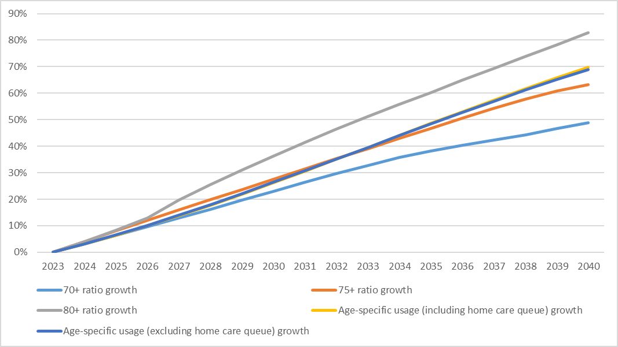

## Investment requirements for residential care

As noted above, there are many variables that will influence the future demand for residential aged care. Nevertheless, it is evident given the ageing of the population, along with increasing consumer expectations, that there will need to be significant future investment in the residential sector to both build new facilities and to refurbish existing facilities.

Based on the current target provision ratio to project the future supply of residential aged care, and not taking into account the impact of increased home care on the demand for residential care, the sector will need to build nearly 79,000 places over the next decade. At the same time, the sector will need to rebuild or refurbish a substantial proportion of the current stock of aged care facilities. It is assumed that over the next decade around a quarter of the existing stock of buildings, covering around 60,000 places will need to be rebuilt or refurbished (at an even rate over the period).

Chart 8.9: Number of operational residential aged care places required 2019-20 to 2029-30

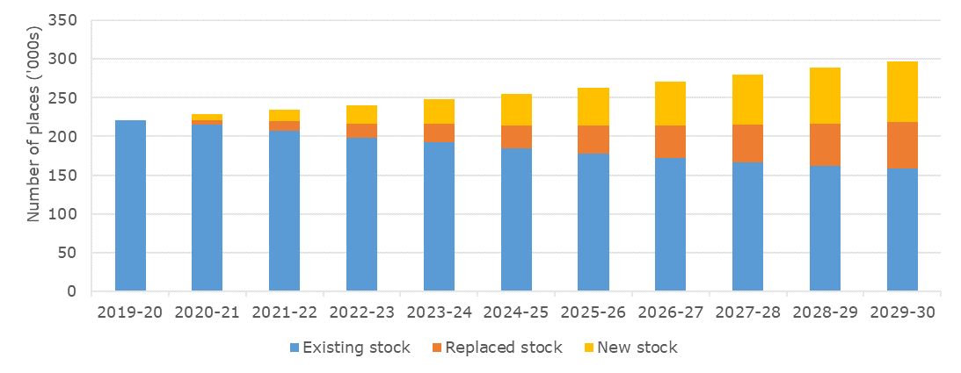

On the basis of the above assumptions, the combined total investment for new and rebuilt places over the next decade would be around $55 billion. The net present value that is the value in today’s prices, of this estimate is approximately $48 billion. This compares with an estimate of around $20 billion (in present value) in building and upgrade work completed between 2011 and 2020. However, as previously noted, these projections are based on particular assumptions and should be treated with care.

It is also worth noting that while the total number of residential care places increased from 182,302 to 217,145 over the last 10 years, the number of mainstream facilities has remained fairly constant. This means that, on average, the investment in new places was primarily through expansion of existing facilities. There is a limit to how big existing facilities can expand and future investment to increase the supply of residential places may have to be increasingly through greenfield projects.

Chart 8.10: Future annual investment requirement, 2020-21 to 2029-30

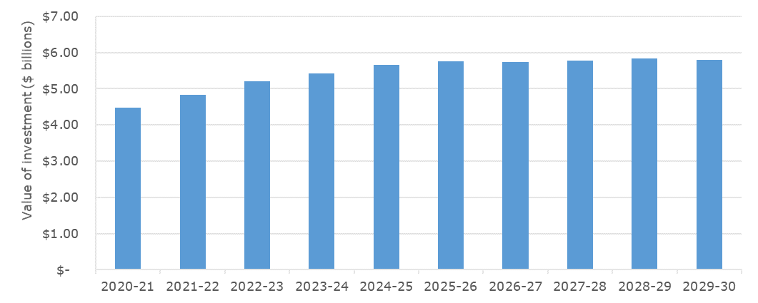

The model used to determine the investment requirements was developed for the Department in 2018 by Deloitte Access Economics. The assumptions behind the analysis are:

* Total place requirements (i.e. the total of all new and rebuilt stock) that is estimated to be operational at each point in the future is based on the Department’s projections which take into account the current stock of provisionally allocated places; the historical rate of building; and the expected number of flexible residential care places that also contribute to the overall residential care target.
* The share of places that are rebuilt each year is estimated using a flat rate assumption of 2.5 per cent of the stock in that year, i.e. a 40 year average building lifetime.
* The cost of construction differs by region. The base construction costs in 2019‑20 of $288,000 per new place, $213,000 per rebuild, and $24,000 per upgrade (from the Survey of Aged Care Homes) have been adjusted by using indices that scale up costs in regional areas relative to the nearest capital city.
* The cost of construction is indexed over time using a 10 year average of Rawlinson’s Building Cost Index for each state’s metropolitan and regional areas (averaging out at 2.4 per cent per annum nationally).
* The cost of land is sourced from ABS land price data for each state’s metropolitan areas and again adjusted using the relevant regional index for that state.
* The cost of land is indexed over time using a flat rate of 4.4 per cent per annum for all areas based on ABS residential property price data.

The value of building work completed and in progress during 2019-20, and other indicators of construction and investment in the sector is discussed in Chapter 7.

## The investment environment

The significant capital investment needed to meet the future demand for aged care services will largely come from the non-government sector, both for-profit and not-for-profit sectors. As noted in recent years by ACFA, one of the challenges facing the Government is to ensure that the funding and regulatory arrangements in the aged sector are such that it provides the ongoing environment that facilitates the needed investment. A key requirement in this regard is that the non-government sector has confidence in the direction and stability of Government policies and those providers receive a return such that it will attract the necessary capital and labour resources. The funding arrangements will also need to be flexible so that providers can respond and adapt to changes in consumers’ preferences for aged care services as well as innovate and embrace new technologies.

### Access to capital

Capital investment in the residential aged care sector is required to expand and refurbish existing facilities, as well as building to meet future capacity. To attract investment the sector needs to generate consistent rates of return that are appropriate for the risk involved and are competitive with returns in other sectors that have similar attributes.

Viable and well-run providers are best placed to attract the financial capital, experienced management and quality staff required to deliver long term sector sustainability and growth. Key ingredients of well-run providers include the exercise of good governance that oversees the implementation of strategic investment plans and the ability to successfully monitor their operational performance against those plans.

To be viable, a provider, whether not-for-profit, for-profit or government owned, must have access to sufficient funds to repair and replace their capital stock, be able to maintain working capital to support their operations, and use capital efficiently relative to the other purposes to which it could be deployed. These outcomes are underpinned by sound financial management that effectively manages costs and sets appropriate pricing strategies to derive the revenue stream to support sustainable capital returns.

Investment activity requires equity investor and debt provider confidence in the capacity of providers to deliver sustainable returns on capital and of the sector overall. The amount of (and change in) invested capital is one key metric of sustainability.

Capital investment in the residential sector can include: equity injections or retained earnings; loans from financial institutions or investors which require sufficient profits to be generated to meet the interest costs and repayment amounts; and interest-free loans from residents in the form of lump sum accommodation payments. Where providers are unable to meet the whole cost of essential capital works, limited capital grant funding is available from the Government-funded Rural, Regional and Other Special Needs Building Fund.

# A reflection, then looking ahead

**This chapter discusses:**

* The changes that have taken place in the aged care sector prior to the Government’s response to the final report of the Royal Commission into Aged Care Quality and Safety, and how this response addresses current issues relating to the sector. Specific issues in focus are financial pressures for providers and long term sustainability for Government and taxpayers, consumer choice and investment, workforce, governance and prudential oversight.

## A reflection on change to date

Ongoing change and reform in response to an ageing population and rising community expectations has been a feature of the provision of nursing care and support for older Australians, with successive changes providing the platform for further reform.

In the period prior to the 2012 *Living Longer Living Better* package, some of the more notable changes to the design and regulation of aged care included:

* the integration of regulatory and subsidy arrangements for the former hostels and nursing homes;
* the introduction of home care packages as an alternative to residential care;
* introduction of respite services to support home-based care;
* nationally consistent eligibility assessment for residential care and home care packages;
* the introduction of care quality and building standards, service accreditation and complaints handling processes;
* population based target provision ratios which ensured that services expanded in line with the ageing of the population and, applied at a regional level, ensured an equitable distribution of available subsidised services;
* a more systematic regime of Government subsidies for care and accommodation to ensure access by all assessed as needing care; and
* regulated user contributions towards accommodation and everyday living expenses.

The major changes since the 2012 *Living Longer Living Better* package and prior to the May 2021 Budget focussed on improving consumer choice and control and access, improving the viability of residential aged care services and improving the effectiveness of the quality regulatory framework.

Access to aged care services and consumer choice and control have been improved by increasing the target provision ratio which significantly increased the supply of aged care services (but stopped short of removing service rationing); substantially rebalancing the supply of aged care services in favour of home-based care to reflect consumer preference to receive services in their own home; assigning home care subsidy entitlements (in the form of individual budgets) to eligible consumers which they can direct to their preferred service provider; legislating for consumer choice of accommodation payment method (lump sum deposit or daily payment); and progressively upgrading My Aged Care to hold system and comparative service level information, including accommodation prices and home care prices.

The Government had also given in-principle support for assigning residential care entitlements to consumers; the integration of the home care package program and the CHSP into a single home-based care program; and extending nationally consistent eligibility assessment across all aged care services. Planning to give effect to these reforms was at various stages of development prior to the Royal Commission.

Changes to improve the financial viability of residential aged care services addressed care subsidies and access to capital.

In response to a significant fall in investment in new and rebuilt residential aged care facilities, access to capital funding was improved by introducing market-informed fully refundable accommodation deposits (RADs), accompanied by prudential regulation, across all residential aged care for non-supported residents and giving non-supported residents the choice to make accommodation payments through a RAD or a daily payment, or a combination of both. In addition, the accommodation supplement for supported residents living in new or significantly refurbished residential care facilities was increased significantly.

Responding to the volatility inherent in the design of ACFI, the Department of Health had substantially developed and piloted a new classification and funding model for residential aged care (AN-ACC).

The importance of a more independent and capable quality regulatory framework was recognised by separating administrative responsibility for quality regulation from the policy and funding responsibilities of the Department of Health by creating a separate quality regulatory agency, culminating in the establishment of the Aged Care Quality and Safety Commission. The capacity of the Commission to undertake its role has been progressively increased through measures such as unannounced visits, strengthened quality standards, compulsory reporting requirements, enhanced complaints handling processes, an initial set of mandatory quality indicators, regulations concerning physical and chemical restraint, and increased resourcing.

## Looking ahead

In last year’s annual report, ACFA noted that although COVID‑19 represented a serious and immediate threat to aged care and older Australians, the aged care sector was also facing significant underlying issues that needed to be addressed.

ACFA noted that COVID-19 was impacting an sector that was already facing a period of transformation as a result on ongoing reform. Residential care providers were also experiencing an unsustainable deterioration in financial performance, which deepened further in 2019‑20, because expenses had been growing faster than revenue from Government ACFI care payments and the basic daily fee paid by consumers (and faster than indexation), with no prospect of relief under current funding arrangements.

Home care providers were experiencing declining financial performance as they adapted to a more competitive operating environment following the assignment of home care packages to individuals rather than to providers.

The prospect of further reform following the Royal Commission, and doubts about the shape and direction that might take, added further uncertainty, while at the same time presenting as a potential opportunity for positive long-term reform to improve the sustainability and quality of aged care services.

This margin pressure and uncertainty was being reflected in many residential providers putting their investment plans on hold.

Meanwhile, timely access by consumers to subsidised aged care services of their choice was not being delivered, starkly illustrated by the queue under the National Prioritisation System (NPS) for accessing home care packages that met individuals’ assessed care and support needs.

These concerns, and others, were documented in the Royal Commission’s Final Report, demonstrating that the reform process still has a long way to go before Australia can be assured that all older people assessed as needing care have timely access to high quality care and a high quality of life.

### Attributes of a sustainable aged care system

Mindful of these underlying issues, ACFA had identified in its recent reports and in its submission to the Royal Commission that a sustainable and high quality aged care system needed the Government’s response to the Royal Commission to result in an aged care system with the following inter-related attributes:

* reduced uncertainty for consumers, providers and financiers,
* stable, predictable and effective pricing and funding allocation arrangements which create an environment that supports investment and innovation in aged care,
* pricing and funding arrangements that enable efficient providers of quality aged care services that meet community expectations to achieve an adequate rate of return,
* equitable contributions by consumers towards the cost of their aged care based on their capacity to pay,
* better informed and supported consumers to facilitate more effective engagement with the aged care system and the exercise of choice and control,
* effective prudential oversight, and
* sound management and governance arrangements.

In responding to the Royal Commission’s 148 recommendations, of which 123 were joint, and 25 were specific to the individual Commissioners requiring a decision by Government, Government accepted or accepted in-principle 126 recommendations. The Government supported alternative options on four of the recommendations, 12 recommendations are subject to further consideration and six were not accepted.

The Government’s response to the Royal Commission’s Final Report is substantial and involves a very significant increase in Government funding. From the perspective of older Australians, the announced reforms are positive and hold out the prospect of improved access and improved care standards. But these reforms come at a considerable cost. Without reform of consumer funding contributions, the Government and therefore future taxpayers will be facing significant sustainability concerns.

### Financial pressures and long-term sustainability

There has long been significant variation in the financial performance of aged care providers, with a proportion at any time operating at a loss. However, as previously noted by ACFA and the sector and confirmed by the Royal Commission, the recent trend of deteriorating financial performance of providers, especially providers in rural and remote locations, was not sustainable and needed immediate attention.

The Government has responded by introducing a Government-paid $10 per resident per day Basic Daily Fee Supplement for all residents for everyday living expenses and by extending the 30 per cent increase in the viability and homeless supplements, both to apply from 1 July 2021. This additional funding and other funding and related initiatives discussed below should bring some relief for providers for the immediate future. ACFA notes however that given the wide range of performance across the sector, some providers will continue making a loss unless they improve their performance in the short term.

For the longer term, the Government has confirmed that it will replace ACFI with the new AN-ACC classification and funding model from October 2022 and will introduce independent and transparent price determination arrangements based on periodic costing studies to inform price setting by Government from 1 July 2023. These changes have the potential to bring much needed stability in aged care prices compared with the volatility experienced under ACFI, as well as prices that reflect the efficient cost of delivering the quality of care and quality of life outcomes expected by the community.

The Independent Hospital Pricing Authority, which will have its remit extended to cover aged care pricing, will need to adapt its approach to determining prices to take into account the distinctive aged care operating and financing environment. This includes that aged care is provided in a competitive environment by a diversity of provider entities and types operating in diverse locations. The majority need to achieve an ongoing commercial rate of return to remain viable and to attract commercial finance and some others in the not-for-profit sector cannot cross-subsidise aged care from their other funding sources forever. Prices must also take into account that quality must encompass quality of life outcomes in addition to nursing care, and that user contributions and fees for additional services have an important role in meeting consumer preferences.

ACFA notes that the $10 Basic Daily Fee Supplement will be folded into the AN-ACC care funding base when AN-ACC is introduced from October 2022, leaving the revenue stream for everyday living expenses (the basic daily fee paid by all residents) anchored at 85 per cent of the basic single age pension, thereby limiting quality of life options for residents. There is some scope for providers to respond to resident quality of life preferences through charging fees for additional services. However, the lack of clarity about the regulatory arrangements governing what constitutes additional services for which additional fees may be charged remains unaddressed, with negative implications for provider viability and community perceptions about the availability of quality of life preferences.

While acknowledging these initiatives, ACFA is concerned that the Government’s response does not address the long-term sustainability of aged care for Government and taxpayers. Even before the Government added substantially to the structural cost of the Commonwealth Budget through its response to the Royal Commission, it was recognised that the combination of current funding arrangements, rising community expectations and an ageing population meant that the projected rapidly increasing cost of aged care for the Budget and taxpayers was not sustainable. ACFA stated that there has to be “*an appropriate balance between the Government subsidy for consumers who cannot afford the aged care services they require and those consumers who can afford to contribute to the cost of the care and support they want as they age, such that the overall cost of aged care to taxpayers is sustainable.”*

ACFA reiterates the conclusion in its previous reports that sustainable aged care funding arrangements will require consumers who can afford to do so, to make a greater contribution towards the cost of their care, complemented by greater choice of high-quality services. Given the substantial increase in funding announced and the ageing of Australia’s population, it is unsustainable to not address the proportion that consumers contribute.

Moreover, ACFA notes that an aged care system which remains overwhelmingly dependent on consolidated revenue, and without an appropriate balance between Budget and individual contributions, perpetuates the risk for the future funding and quality of aged care that was clearly demonstrated by the Royal Commission.

ACFA has previously suggested that to achieve more equitable treatment between homeowners and non-homeowners and to ensure consumers are contributing to the cost of their care based on their means, the cap on the value of the consumer’s home included in the residential means test, along with the taper rates, needed to be reviewed. A benefit from consumers making a larger contribution is not only to reduce the fiscal pressure on Government but to contribute to improving the overall efficiency of the industry as consumers would likely take a more active interest in ensuring they are receiving the level and quality of services that meets their needs.

ACFA also considers, however, that given the wide range of performance across the sector, many providers will need to improve their management, overcome inefficiencies in their operations, attract more permanent and higher skilled workforces and be more responsive to consumer preferences. The alternative, of continuing to make a loss, would inevitably lead to some departing the sector.

### Consumer choice and investment

In residential care, investment is needed to continue to update existing accommodation and to meet increasing demand given the ageing population. However, volatility, margin pressure and uncertainty have been resulting in some residential care providers and potential new investors putting their investment plans on hold while they assess the future direction of aged care policy. With the announcement of an increase in funding from 1 July 2021, new funding arrangements to replace ACFI and policy changes relating to consumer choice and the regulation of quality and safety, some of this uncertainty will be eased.

One of the Government’s responses that has significant investment implications was the announcement that the ACAR that is currently underway will be the last and that from 1 July 2024, residential care places will be assigned directly to consumers rather than to providers.

The removal of the ACAR will have a positive effect for investment by well managed providers as they will be free to build new, or expand existing, aged care accommodation as they see fit. However, a consequence may be that some providers may be less successful in attracting residents and face a drop in occupancy. The further significant expansion of home care packages and changes to respite services that were announced as part of the Government’s response are likely to put further pressure on occupancy. Lowering occupancy has been identified by providers as being a risk to their business.

ACFA has previously noted that consumers exercising choice of services is a key ingredient to driving competition between providers, which will help in leading to improvements in efficiency, innovation and quality. But many consumers are vulnerable, poorly prepared, reluctantly accessing aged care and have no basis to make comparisons. The measures in the Government’s response to the Royal Commission to fund more ways for consumers to access information and be guided regarding their aged care are essential in ensuring that the move to better consumer choice in residential care is based on being informed and empowered and delivers better outcomes for the consumers.

While the Government’s reforms fall short of uncapping the supply of aged care services and ending service rationing, there have been significant steps in that direction. These include the release of an additional 80,000 home care packages, changes to community and residential respite, the assignment of residential care subsidies to individuals, and the prospect of a new home-based care program which extends consumer choice and control. Together, these changes will have important implications for investment in aged care services, including potentially for more innovative and responsive models of care and the design of accommodation for older people.

ACFA also notes that the Government will consider options that could reduce the current dependence on RADs as a mechanism to raise capital in the residential aged care sector, while not putting any timeframe on this. ACFA’s recent report to Government on the future role of RADs notes that there appears to be no immediate replacement for them. Any move away from RADs would need to be gradual so as not to place some providers at risk, and there would need to be confidence that the financial performance of efficient providers is capable of attracting and servicing capital on commercial terms.

### Workforce

ACFA identified the employment of sufficient numbers of skilled workers as one of the required attributes of a successful aged care industry. However, the availability of an appropriately skilled aged care workforce has long been identified as a key issue and providers have had difficulty attracting and retaining such a workforce to meet growing demand.

The Government’s response to the Royal Commission includes funding for more training and incentives for aged care workers to remain working in the sector, and a campaign to attract more workers to the sector.

In addition, the Government has mandated minimum average care staff minutes per resident to apply in residential care from July 2023 and announced a significant increase in home care packages. The successful implementation of both of these measures will require a greater supply of skilled workers.

ACFA has previously noted, including in its report on Attributes for Sustainable Aged Care, that aged care in Australia still had relatively low community status and at times esteem, particularly amongst aged care workers. This has contributed to the sector struggling to attract and retain staff, including managers, when compared with better resourced and more dynamic industries.

Another of the factors influencing workforce supply is the sector’s capacity to offer competitive remuneration that reflects work value so that workers feel recognised and rewarded. ACFA notes that no provision was included in the 2021-22 Budget to improve the remuneration of workers in the sector. Instead, the Government noted that a wage claim has been lodged with the Fair Work Commission, with the implication that the new independent price determination arrangements will take into account the outcome of the wage claim when it recommends care prices from July 2023.

The COVID‑19 crisis increased the staffing costs for aged care providers as well as the pressure aged care workers were under. The Government provided additional funding to assist staff and providers deal with these pressures, however, this funding was temporary and responded to the immediate impact of COVID-19, but did not deal with underlying workforce sustainability.

It is also noteworthy that with over 30 per cent of residential care workers and over 20 per cent of home care workers born overseas, the prospect of continuing border restrictions will have some impact on the availability of workers.

Looking ahead, the industry will be relying on the creation of a workforce planning capacity in the Department of Health to undertake long-term modelling of the supply and demand of aged care workers, and a collaborative effort across the Department’s workforce planning team, the Aged Care Industry Workforce Council and the Human Services Skills Organisation in the Education, Skills and Employment portfolio to help ensure that skilled workers see aged care as a valuable career that is appropriately rewarded.

### Governance

Beyond the specific requirements imposed on providers to deliver aged care in line with the responsibilities, quality standards and safety requirements specified in the *Aged Care Act 1997*, there is a community expectation that providers will operate efficiently, effectively and ethically in meeting the care needs of older Australians. The financial performance and viability of each provider, as well as their capacity to meet community expectations and the legislated standards, depends on their management skills, internal governance arrangements and business acumen.

Along with the significant additional funding for the sector in the Government’s response to the Royal Commission, there are also measures that will make management and governance of residential aged care services more demanding, especially for many smaller providers who lack economies of scale.

These measures include greater transparency and accountability provisions and increased reporting requirements, as well as increased regulatory activities and strengthened prudential requirements. These will mean that many providers will need to strengthen their management and governance.

In addition, the increased competitive pressures arising from the removal of the ACAR from July 2024, more opportunities for older people to choose care at home as a result of the increased supply of home care packages and increased transparency will require providers to be more responsive to consumer preferences in order to succeed in the industry.

It has long been identified, including by ACFA, that some structural adjustment of the sector was likely as a result of reforms already in train, and indeed needed. The reforms flowing from the Government’s recent Budget announcements will increase pressures for structural adjustment. In anticipation of further changes in the make-up of the industry, and to avoid unplanned and disruptive exits from the industry, more funding has been provided for the Business Advisory Service and funding has been provided for a Viability Fund and a Structural Adjustment Program to support providers to improve or change their operations.

### Prudential oversight

Effective prudential oversight is important to maintaining stability and confidence in the aged care industry. This is particularly important with the current accommodation payment arrangements that include the Government’s guarantee of RADs. ACFA noted previously that the Government needs proactive oversight arrangements that identify providers facing financial difficulties and has arrangements to facilitate the withdrawal of providers while protecting consumers.

The Royal Commission, through its recommendations, and the Government through its response, have identified that providers should be subject to more rigorous regulatory, accountability and reporting requirements. Reforms announced include new financial monitoring and compliance arrangements for residential aged care providers, including new prudential standards for refundable accommodation deposits which includes continuous disclosure provisions and minimum liquidity and capital adequacy standards.

## Conclusion

The Government’s response to the Royal Commission foreshadows further significant reform and transformation of the aged care sector and a period of significant adjustment for the industry. While the changes provide the platform for a better resourced sector, the operating environment for individual providers will become more competitive as consumer choice and control is increased and providers are exposed to significantly increased regulatory, accountability, transparency and prudential requirements.

Most of the more transformative changes are subject to considerable design development, consultative processes and implementation risk which will need to be successfully negotiated before the potential benefits for future older Australians will be realised.

Overall, providers with the capacity to adapt to the demands of the new operating environment can expect to do well under the new arrangements. Accordingly, the outlook for the delivery of high quality, safe and efficient aged care is promising for older Australians who need publicly subsidised care and support.

Appendices

1. ACFA Membership

Members

| ACFA position | Name | Organisation |
| --- | --- | --- |
| Acting Chair | Mr Nicolas Mersiades | Director Aged Care, Catholic Health Australia |
| Deputy chair | Currently vacant |  |
| Member | Mr Ian Yates AM | Chief Executive, COTA Australia |
| Member | Mr Gary Barnier | Partner, Cooperage Capital |
| Member | Ms Natalie Smith | Head of Business Execution, Business and Private Bank, ANZ |
| Member | Prof Michael Woods | Professor, Centre for Health Economics Research and Evaluation, UTS Business School |
| Member | Dr Mike Rungie | Global Centre for Modern Ageing |
| Member | Ms Susan Emerson | Independent aged care sector expert |
| Member | Ms Louise Biti | Director, Aged Care Steps |

Government representatives

| ACFA position | Name | Organisation |
| --- | --- | --- |
| Representative | Ms Eliza Strapp | First Assistant Secretary, Ageing and Aged Care Group, Department of Health |
| Representative | Mr John Dicer | Aged Care Pricing Commissioner[43] |
| Representative | Ms Jessica Clark | Manager, Health and Disability Social Policy Division, Department of the Treasury |

1. ACFA reports and Submissions[44] [45]

| Work | Date of completion |
| --- | --- |
| ‘The role of the Basic Daily Fee in residential aged care’ | Published April 2021. |
| ‘[Review of the current and future role of Refundable Accommodation Deposits in aged care](https://www.health.gov.au/resources/collections/review-of-the-current-and-future-role-of-refundable-accommodation-deposits-in-aged-care)’ | Published March 2021. |
| ‘Consideration of the financial impact on home care providers as a result of changes in payment arrangements’ | Published January 2020. |
| ‘Attributes for sustainable aged care’ | Published November 2019. |
| Submission to the Royal Commission into Aged Care Quality and Safety | Published May 2019. |
| ‘Understanding how consumers plan and finance aged care’ | Published December 2018. |
| ‘Report on respite care for aged care recipients’ | Published November 2018. |
| ‘Update on funding and financing issues in the residential aged care industry’ | Published November 2018. |
| ‘Application of the Base Interest Rate’ | Published June 2017. |
| ‘Bond Guarantee Scheme’ | Published May 2017. |
| ‘Report to Inform the 2016-17 Review of Amendments to the Aged Care Act 1997’ | Published June 2017. |
| ‘Access to Residential Care by Supported residents’ | Published February 2017. |
| ‘Report on issues affecting the financial performance of rural and remote providers, residential and home care’ | Published February 2016. |
| ‘Factors influencing the financial performance of residential aged care providers’ | Published May 2015. |
| ‘Improving the Collection of Financial Data from Aged Care Providers’ | Published October 2014. |
| ‘The impact of the July 2014 financial reforms on the aged care sector’ | Published September 2014. |
| ‘Accommodation Payments – Equivalence Methodology to Convert DAPs to RADs’ | Published June 2013. |
| ‘ACFA Recommendations on Accommodation Payments’ | Published November 2013. |

1. ACFA’s stakeholder engagement

ACFA regularly consults with representatives from the investment and financing industries, providers and consumers. This engagement is critical to ACFA’s understanding of the key issues, developments and challenges facing the industry. While some of the usual engagement was not possible during 2020 and early 2021 due to COVID-19, ACFA was able to gain an insight of the key issues.

1. Aged care workforce

Table D.1: Full-time equivalent (FTE) direct care employees in the residential aged care workforce, by occupation: 2003, 2007, 2012 and 2016 (estimated FTE and per cent)

| Occupation | 2003 | 2007 | 2012 | 2016 |
| --- | --- | --- | --- | --- |
| Nurse practitioner | n/a | n/a | 190 | 293 |
| Registered nurse | 16,265 | 13,247 | 13,939 | 14,564 |
| Enrolled nurse | 10,945 | 9,856 | 10,999 | 9,126 |
| Personal care attendant | 42,943 | 50,542 | 64,669 | 69,983 |
| Allied health professional | 5,776 | 5,204 | 1,612 | 1,092 |
| Allied health assistant | 3,414 | 2,862 |
| Total number of employees (FTE) | 75,929 | 78,849 | 94,823 | 97,920 |
| As a % of total employees |  |  |  |  |
| Nurse practitioner | n/a | n/a | 0.2% | 0.3% |
| Registered nurse | 21.4% | 16.8% | 14.7% | 14.9% |
| Enrolled nurse | 14.4% | 12.5% | 11.6% | 9.3% |
| Personal care attendant | 56.5% | 64.1% | 68.2% | 71.5% |
| Allied health professional | 7.6% | 6.6% | 1.7% | 1.1% |
| Allied health assistant | 3.6% | 2.9% |

Table D.2: Size of the home support and home care workforce, all PAYG employees and direct care employees: 2007, 2012 and 2016

| Occupation | 2007 | 2012 | 2016 |
| --- | --- | --- | --- |
| All PAYG employees | 87,478 | 149,801 | 130,263 |
| Direct care employees | 74,067 | 93,359 | 86,463 |

Table D.3: Direct care employees in the home support and home care workforce, by occupation: 2007, 2012 and 2016 (estimated FTE and per cent)

| Occupation | 2007 | 2012 | 2016 |
| --- | --- | --- | --- |
| Nurse practitioner | n/a | 55 | 41 |
| Registered nurse | 6,079 | 6,544 | 4,651 |
| Enrolled nurse | 1,197 | 2,345 | 1,143 |
| Community care worker | 35,832 | 41,394 | 34,712 |
| Allied health professional | 2,948 | 2,618 | 2,785 |
| Allied health assistant | 1,581 | 755 |
| Total number of employees (FTE) | 46,056 | 54,537 | 44,087 |
| As a % of total employees |  |  |  |
| Nurse practitioner | n/a | 0.1% | 0.1% |
| Registered nurse | 13.2% | 12.0% | 10.5% |
| Enrolled nurse | 2.6% | 4.3% | 2.6% |
| Community care worker | 77.8% | 75.9% | 78.7% |
| Allied health professional | 6.4% | 4.8% | 6.3% |
| Allied health assistant | 2.9% | 1.7% |

1. Means testing arrangements

Home care

In addition to the basic daily fee, an income-tested care fee was introduced in home care from 1 July 2014. Unlike the arrangements for the basic daily fee, the Commonwealth payment received by the provider is reduced by the amount of the income-tested care fee. Accordingly, to receive an amount equivalent to the full subsidy the provider needs to charge the appropriate income-tested care fee.

Annual income-tested care fees in home care are currently capped at $5,667.73 for part-pensioners and $11,335.48 for non-pensioners (March 2021 rate). A lifetime cap of $68,012.98 per consumer currently applies for care contributions across home care and residential care (March 2021 rate). Full pensioners are not required to contribute to their care costs and may only be required to pay the basic daily fee. It should be noted that it is the cap amount current at the time the care recipient reaches that cap that applies.

Figure E.1: Current income testing for home care (post 1 July 2014)

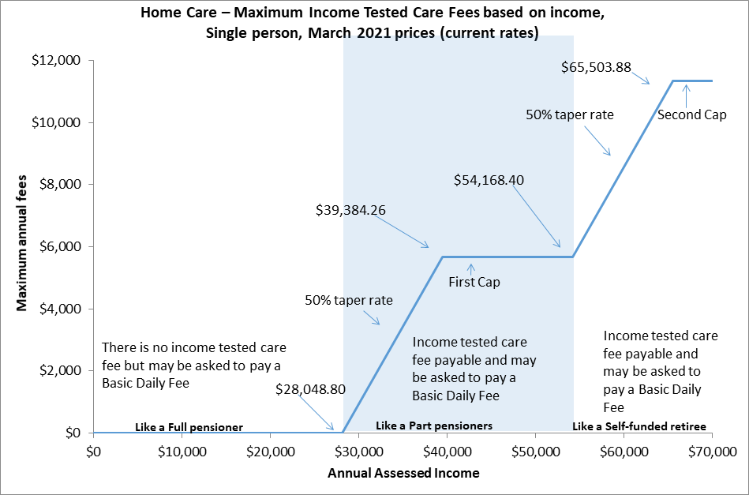

Residential care

Changes to residential care from 1 July 2014 introduced more comprehensive means testing arrangements by way of a combined assets and income assessment and a new fees structure.

Annual and lifetime caps were also introduced, with an annual cap of $28,338.71 applying to the means‑tested care fee and a lifetime cap of $68,012.98 for care contributions (March 2021 rate). It is the cap amount current at the time the care recipient reaches that cap that applies.

Figure E.2 demonstrates how the means testing arrangements created three tiers of consumer contributions in residential care:

* consumers with low means, who are required to pay only the basic daily fee (85 per cent of the single basic age pension) as a contribution towards their daily living expenses, while their accommodation and care costs are funded by the Australian Government;
* consumers with moderate means, who in addition to contributing towards their daily living expenses by paying the basic daily fee, also make a capped contribution towards their accommodation costs; and
* consumers with greater means, who in addition to contributing towards their daily living expenses, also pay the basic daily fee for their accommodation costs in full and make a capped contribution towards their care costs.

Figure E.2: Current means testing for residential care (post 1 July 2014)

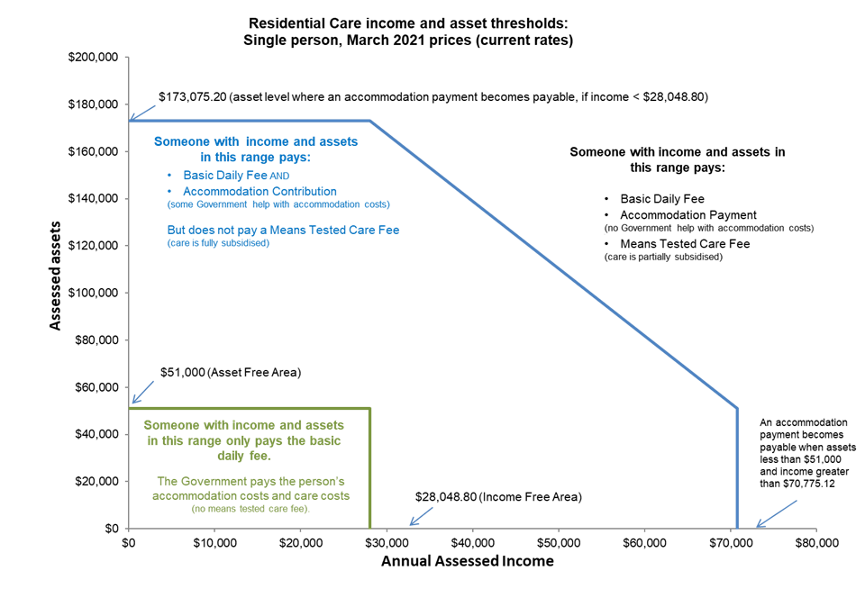

1. Financial ratios by provider ownership type

Table F.1: Financial ratios of total sector by provider type, 2019-20

|  | Not-for-profit | For-profit | Government | Total sector |
| --- | --- | --- | --- | --- |
| Total RADs ($m) | $16,620 | $15,012 | $676 | $32,308 |
| No. of providers | 473 | 277 | 93 | 843 |
| EBITDA p.r.p.a | $5,594 | $10,662 | -$13,547 | $6,855 |
| Capital structure |  |  |  |  |
| Assets p.r.p.a | $274,788 | $333,306 | $262,627 | $297,563 |
| No. of RADs | 52,376 | 42,115 | 2,840 | 97,331 |
| Avg RAD per resident | $317,325 | $356,458 | $237,878 | $331,940 |
| Net worth p.r.p.a | $82,888 | $22,411 | $145,719 | $61,328 |
| Working capital p.r.p.a | -$101,796 | -$177,887 | -$21,797 | -$128,884 |
| Non-current liabilities as % of total assets | 4.88% | 18.12% | 3.85% | 10.74% |
| RADs as % of total assets | 56.61% | 59.76% | 34.46% | 57.24% |
| Net worth as % total assets | 30.16% | 6.72% | 55.49% | 20.61% |
| Viability |  |  |  |  |
| Current ratio | 0.43 | 0.29 | 0.80 | 0.37 |
| Interest coverage | 7.6 times | 3.3 times | -39.8 times | 4.0 times |
| NPBT margin | -3.1% | -1.8% | -17.9% | -3.2% |
| Occupancy | 90.5% | 85.4% | 88.3% | 88.3% |
| % EBITDA to total assets | 2.04% | 3.20% | -5.16% | 2.30% |
| % EBITDA to net worth | 6.75% | 47.58% | -9.30% | 11.18% |
| RADs asset cover (T.A.) | 1.8 times | 1.7 times | 2.9 times | 1.7 times |

Table F.2: Financial ratios for not-for-profit providers, 2019‑20

|  | Top | Next top | Next bottom | Bottom | Total |
| --- | --- | --- | --- | --- | --- |
| No. of providers | 94 | 131 | 145 | 103 | 473 |
| EBITDA p.r.p.a | $19,062 | $8,869 | $2,343 | -$7,907 | $5,594 |
| Capital structure |  |  |  |  |  |
| T. Assets p.r.p.a | $284,852 | $272,287 | $266,822 | $286,533 | $274,788 |
| No. of RADs | 7,497 | 19,147 | 16,623 | 9,109 | 52,376 |
| Avg RAD per resident | $338,868 | $305,511 | $318,793 | $321,748 | $317,325 |
| Net Worth p.r.p.a | $92,777 | $94,729 | $70,585 | $70,298 | $82,888 |
| Working Capital p.r.p.a | -$99,291 | -$77,792 | -$110,755 | -$141,827 | -$101,796 |
| Non.Curr Liab as % of T.Asts. | 3.6% | 3.9% | 6.0% | 6.3% | 4.9% |
| RADs as % of T. Asts | 56.1% | 53.7% | 59.5% | 58.3% | 56.6% |
| Net Worth as % T.Asts | 32.6% | 34.8% | 26.5% | 24.5% | 30.2% |
| Viability |  |  |  |  |  |
| Current ratio | 0.45 | 0.53 | 0.39 | 0.28 | 0.43 |
| Interest coverage | 20.1 times | 12.2 times | 3.3 times | -13.6 times | 7.6 times |
| NPBT margin | 8.4% | 0.0% | -6.1% | -16.7% | -3.1% |
| Occupancy | 91.0% | 92.3% | 90.5% | 86.3% | 90.5% |
| %EBITDA to T. Assets | 6.7% | 3.3% | 0.9% | -2.8% | 2.0% |
| %EBITDA to Net Worth | 20.5% | 9.4% | 3.3% | -11.2% | 6.7% |
| RADs Asset Cover (T.A.) | 1.8 times | 1.9 times | 1.7 times | 1.7 times | 1.8 times |

Table F.3: Financial ratios of government providers, 2019‑20

|  | Top | Next Top | Next Bottom | Bottom | Total |
| --- | --- | --- | --- | --- | --- |
| No. of providers | 8 | 6 | 13 | 66 | 93 |
| EBITDA p.r.p.a | $37,945 | $12,158 | $1,519 | -$28,134 | -$13,547 |
| Capital structure |  |  |  |  |  |
| T. Assets p.r.p.a | $305,309 | $231,596 | $272,216 | $266,280 | $262,627 |
| No. of RADs | 130 | 405 | 467 | 1,838 | 2,840 |
| Avg RAD per resident | $198,528 | $240,284 | $222,197 | $244,116 | $237,878 |
| Net Worth p.r.p.a | $211,223 | $167,894 | $128,945 | $138,064 | $145,719 |
| Working Capital p.r.p.a | $3,901 | -$5,352 | -$44,792 | -$23,445 | -$21,797 |
| Non.Curr Liab as % of T.Asts. | 7.5% | 0.6% | 6.7% | 3.7% | 3.9% |
| RADs as % of T. Asts | 23.8% | 30.9% | 36.9% | 35.7% | 34.5% |
| Net Worth as % T.Asts | 69.2% | 72.5% | 47.4% | 51.8% | 55.5% |
| Viability |  |  |  |  |  |
| Current ratio | 1.05 | 0.91 | 0.64 | 0.80 | 0.80 |
| Interest coverage | 985.3 times | 10.8 times | 10.1 times | -156.4 times | -39.8 times |
| NPBT margin | 20.5% | 0.4% | -5.4% | -31.7% | -17.9% |
| Occupancy | 88.8% | 93.8% | 89.9% | 86.4% | 88.3% |
| %EBITDA to T. Assets | 12.4% | 5.2% | 0.6% | -10.6% | -5.2% |
| %EBITDA to Net Worth | 18.0% | 7.2% | 1.2% | -20.4% | -9.3% |
| RADs Asset Cover (T.A.) | 4.2 times | 3.2 times | 2.7 times | 2.8 times | 2.9 times |

Table F.4: Financial ratios of for-profit providers, 2019‑20

|  | Top | Next Top | Next Bottom | Bottom | Total |
| --- | --- | --- | --- | --- | --- |
| No. of providers | 109 | 73 | 53 | 42 | 277 |
| EBITDA p.r.p.a | $21,312 | $9,222 | $3,574 | -$15,129 | $10,662 |
| Capital structure |  |  |  |  |  |
| T. Assets p.r.p.a | $356,079 | $306,888 | $305,542 | $545,637 | $333,306 |
| No. of RADs | 12,271 | 20,449 | 7,300 | 2,095 | 42,115 |
| Avg RAD per resident | $355,281 | $356,006 | $339,018 | $428,539 | $356,458 |
| Net Worth p.r.p.a | $42,907 | $3,639 | $34,178 | $38,074 | $22,411 |
| Working Capital p.r.p.a | -$168,294 | -$201,561 | -$130,155 | -$174,235 | -$177,887 |
| Non.Curr Liab as % of T.Asts. | 16.8% | 16.7% | 14.2% | 38.5% | 18.1% |
| RADs as % of T. Asts | 54.1% | 65.9% | 62.2% | 43.8% | 59.8% |
| Net Worth as % T.Asts | 12.0% | 1.2% | 11.2% | 7.0% | 6.7% |
| Viability |  |  |  |  |  |
| Current ratio | 0.34 | 0.20 | 0.43 | 0.41 | 0.29 |
| Interest coverage | 5.4 times | 3.2 times | 1.6 times | -2.9 times | 3.3 times |
| NPBT margin | 2.6% | -1.7% | -3.7% | -24.8% | -1.8% |
| Occupancy | 88.2% | 86.8% | 83.1% | 67.9% | 85.4% |
| %EBITDA to T. Assets | 6.0% | 3.0% | 1.2% | -2.8% | 3.2% |
| %EBITDA to Net Worth | 49.7% | 253.4% | 10.5% | -39.7% | 47.6% |
| RADs Asset Cover (T.A.) | 1.8 times | 1.5 times | 1.6 times | 2.3 times | 1.7 times |

1. Residential care subsidies and supplements

Table G.1: Total expenditure for subsidies and supplements in residential care, 2016-17 to 2019-20

|  | 2016-17 $m | 2017-18 $m | 2018-19 $m | 2019-20  $m |
| --- | --- | --- | --- | --- |
| Basic Care subsidies |  |  |  |  |
| Permanent | 11,024.2 | 11,163.5 | 11,947.4 | 12,012.7 |
| Respite | 280.6 | 312.3 | 348.8 | 371.3 |
| Primary care supplements |  |  |  |  |
| Oxygen | 17.5 | 18.3 | 18.3 | 16.8 |
| Enteral feeding | 5.9 | 5.9 | 5.2 | 5.0 |
| Respite incentive | 30.1 | 34.6 | 40.6 | 46.8 |
| Hardship |  |  |  |  |
| Hardship | 4.9 | 4.0 | 3.9 | 6.5 |
| Accommodation supplements |  |  |  |  |
| Accommodation supplement | 907.5 | 1,029.6 | 1,134.2 | 1,225.1 |
| Hardship accommodation | 2.9 | 2.6 | 2.5 | 1.9 |
| Transitional accommodation Supplement | 15.5 | 10.7 | 7.6 | 5.4 |
| Concessional | 64.0 | 55.6 | 51.3 | 40.2 |
| Accommodation charge top-up | 2.1 | 1.4 | 1.0 | 0.4 |
| Pensioner supplement | 36.3 | 27.2 | 20.7 | 12.8 |
| Viability Supplement |  |  |  |  |
| Viability | 43.2 | 55.8 | 62.0 | 82.3 |
| Supplements relating to grand parenting |  |  |  |  |
| Transitional | 6.0 | 4.8 | 3.8 | 2.6 |
| Charge exempt | 3.8 | 2.0 | 1.8 | 1.4 |
| Basic daily fee | 0.6 | 0.4 | 0.3 | 0.1 |
| Other supplements |  |  |  |  |
| Veterans’ | 1.1 | 1.6 | 1.7 | 1.5 |
| Homeless | 8.3 | 8.6 | 9.8 | 13.3 |
| Reductions |  |  |  |  |
| Means testing reduction | -560.8 | -564.0 | -627.2 | -648.2 |
| Other | 31.5 | 42.0 | -9.1 | 231.7 |
| TOTAL | 11,903.8 | 12,204.4 | 13,014.3 | 13,429.7 |

1. Residential care subsidies and supplements rates

Table H.1: ACFI rates ($ per day), 2018-19 to 2020-21

| ACFI | 2018-19 | 2019-20 | 2020-21 |
| --- | --- | --- | --- |
| Activities of daily living (ADL) |  |  |  |
| Low | $37.16 | $37.68 | $38.28 |
| Medium | $80.92 | $82.05 | $83.36 |
| High | $112.10 | $113.67 | $115.49 |
| Behaviour (BEH) |  |  |  |
| Low | $8.49 | $8.61 | $8.75 |
| Medium | $17.60 | $17.85 | $18.14 |
| High | $36.70 | $37.21 | $37.81 |
| Complex Health Care (CHC) |  |  |  |
| Low | $16.48 | $16.71 | $16.98 |
| Medium | $46.95 | $47.61 | $48.37 |
| High | $67.79 | $68.74 | $69.84 |
| Interim rate for new residents pending ACFI assessment | $57.01 | $57.81 | $58.73 |

Note: these rates do not include a temporary additional daily amount of 1.2% applied to these rates from 1 March to 31 August 2020.

| Daily residential respite subsidy rates | 2018-19 | 2019-20 | 2020-21 |
| --- | --- | --- | --- |
| Low | $46.74 | $47.39 | $48.15 |
| High | $131.05 | $132.88 | $135.01 |

Note: these rates do not include a temporary additional daily amount of 1.2% applied to these rates from 1 March to 31 August 2020.

Table H.2: Residential care supplements table, 2018-19 to 2020-21

| Residential care | 2018-19 | 2019-20 | 2020-21 |
| --- | --- | --- | --- |
| Oxygen supplement | $11.57 | $11.72 | $11.98 |
| Enteral Feeding supplement – Bolus | $18.33 | $18.57 | $18.98 |
| Enteral Feeding supplement – Non-bolus | $20.59 | $20.86 | $21.32 |
| Adjusted Subsidy Reduction | $13.21 | $13.39 | $13.60 |
| Veterans’ supplement | $7.08 | $7.18 | $7.29 |
| Homeless supplement | $21.01 | $21.30 | $21.64 |

Note: the homeless supplement rate shown here does not include the temporary 30% increase applied from 1 March 2020 to 30 June 2021.

Table H.3: Residential care supplements (accommodation and hotel related)

| Residential care | 20/09/19 | 20/03/20 | 20/03/20 |
| --- | --- | --- | --- |
| Higher accommodation supplement - newly built or significantly refurbished facilities | $57.49 | $58.19 | $58.69 |
| Accommodation supplement - facilities that are not newly built or significantly refurbished but do meet set building requirements | $37.47 | $37.93 | $38.26 |
| Accommodation supplement – facilities that are not newly built or significantly refurbished and don’t meet set building requirements | $31.48 | $31.86 | $32.13 |
| Concessional resident supplement (concessional and assisted residents) - newly built or significantly refurbished facilities | $57.49 | $58.19 | $58.69 |
| Concessional resident supplement (concessional residents) – facilities that are not newly built or refurbished | $22.91 | $23.19 | $23.39 |
| Concessional resident supplement (assisted residents) - facilities that are not newly built or significantly refurbished | $9.42 | $9.53 | $9.61 |
| After 19 March 2008 and before 20 September 2010 | $8.57 | $8.67 | $8.74 |
| After 19 September 2010 and before 20 March 2011 | $5.71 | $5.78 | $5.83 |
| After 19 March 2011 and before 20 September 2011 | $2.86 | $2.89 | $2.91 |
| Transitional supplement | $22.91 | $23.19 | $23.39 |
| Basic Daily Fee supplement | $0.60 | $0.61 | $0.62 |
| Respite supplement – high level is equal to or greater than 70% of the specified proportion of respite care for the approved provider | $93.94 | $95.08 | $95.90 |
| Respite supplement – high level is less than 70% of the specified proportion of respite care for the approved provider | $55.21 | $55.88 | $56.51 |
| Respite supplement – low level | $39.39 | $39.87 | $39.87 |

Note: these rates do not include a temporary additional daily amount of 1.2% applied to these rates from 1 March to 31 August 2020.

Table H.3: Residential care supplements (accommodation and hotel related)

| Residential care | 20/03/20 | 20/09/20 | 20/03/21 |
| --- | --- | --- | --- |
| Higher accommodation supplement - newly built or significantly refurbished facilities | $58.19 | $58.19 | $58.69 |
| Accommodation supplement - facilities that are not newly built or significantly refurbished but do meet set building requirements | $37.93 | $37.93 | $38.26 |
| Accommodation supplement – facilities that are not newly built or significantly refurbished and don’t meet set building requirements | $31.86 | $31.86 | $32.13 |
| Concessional resident supplement (concessional and assisted residents) - newly built or significantly refurbished facilities | $58.19 | $58.19 | $58.69 |
| Concessional resident supplement (concessional residents) – facilities that are not newly built or refurbished | $23.19 | $23.19 | $23.39 |
| Concessional resident supplement (assisted residents) - facilities that are not newly built or significantly refurbished | $9.53 | $9.53 | $9.61 |
| Transitional Accommodation Supplement |  |  |  |
| After 19 March 2008 and before 20 September 2010 | $8.67 | $8.67 | $8.74 |
| After 19 September 2010 and before 20 March 2011 | $5.78 | $5.78 | $5.83 |
| After 19 March 2011 and before 20 September 2011 | $2.89 | $2.89 | $2.91 |
| Transitional supplement | $23.19 | $23.19 | $23.39 |
| Basic Daily Fee supplement | $0.61 | $0.61 | $0.62 |
| Respite supplement – high level is equal to or greater than 70% of the specified proportion of respite care for the approved provider | $95.08 | $95.08 | $95.90 |
| Respite supplement – high level is less than 70% of the specified proportion of respite care for the approved provider | $55.88 | $55.88 | $56.36 |
| Respite supplement – low level | $39.87 | $39.87 | $40.21 |

Note: There was no increase to rates on 20 September 2020 due to there being no increase to the age pension.

Table H.4: Residential aged care viability supplement

|  |  |  |  |
| --- | --- | --- | --- |
| 2017 Scheme Services (Modified Monash Model) | 2018-19 | 2019-20 | 2020-21 |
| Eligibility score of 100 | $73.94 | $74.98 | $76.18 |
| Eligibility score of 95 | $65.85 | $66.77 | $67.84 |
| Eligibility score of 90 | $59.40 | $60.23 | $61.19 |
| Eligibility score of 85 | $51.34 | $52.06 | $52.89 |
| Eligibility score of 80 | $43.19 | $43.79 | $44.49 |
| Eligibility score of 75 | $33.58 | $34.05 | $34.59 |
| Eligibility score of 70 | $25.17 | $25.52 | $25.93 |
| Eligibility score of 65 | $18.12 | $18.37 | $18.66 |
| Eligibility score of 60 | $15.33 | $15.54 | $15.79 |
| Eligibility score of 55 | $11.18 | $11.34 | $11.52 |
| Eligibility score of 50 | $8.39 | $8.51 | $8.65 |
| Eligibility score of 45 | $0.00 | $0.00 | $0.00 |
| Eligibility score of 40 | $0.00 | $0.00 | $0.00 |
| Less than a score of 40 | $0.00 | $0.00 | $0.00 |

Notes:

The Modified Monash Model classification scale was implemented on 1 January 2017.

The rates shown here do not include the temporary 30% increase applied from 1 March 2020 to 30 June 2021.

1. Residential care financing structures and balance sheets

Table I.1: Distribution of average lump sum accommodation deposits by ownership and quartile of EBITDA, 2019‑20

|  |  |  |  |  |  |
| --- | --- | --- | --- | --- | --- |
| Not for Profit | Top | Next top | Next bottom | Bottom | Total |
| No. of providers | 94 | 131 | 146 | 103 | 474 |
| No. of providers that held RADs | 91 | 130 | 144 | 100 | 465 |
| Proportion of residents that paid RADs in facilities, where RADs were held | 48.4% | 49.2% | 51.8% | 54.2% | 50.7% |
| Avg RAD per resident | $338,868 | $305,511 | $318,793 | $321,748 | $317,325 |
| For Profit | Top | Next top | Next bottom | Bottom | Total |
| No. of providers | 109 | 73 | 53 | 42 | 277 |
| No. of providers that held RADs | 108 | 73 | 53 | 42 | 276 |
| Proportion of residents that paid RADs in facilities, where RADs were held | 56.9% | 58.5% | 58.1% | 53.9% | 57.7% |
| Avg RAD per resident | $355,281 | $356,006 | $339,018 | $428,539 | $356,458 |
| Government | Top | Next top | Next bottom | Bottom | Total |
| No. of providers | 8 | 6 | 13 | 66 | 93 |
| No. of providers that held RADs | 6 | 6 | 13 | 64 | 89 |
| Proportion of residents that paid RADs in facilities, where RADs were held | 45.3% | 30.9% | 47.4% | 41.1% | 40.2% |
| Avg RAD per resident | $198,528 | $240,284 | $222,197 | $244,116 | $237,878 |
| All providers | Top | Next top | Next bottom | Bottom | Total |
| No. of providers | 211 | 210 | 211 | 211 | 843 |
| No. of providers that held RADs | 205 | 209 | 210 | 206 | 830 |
| Proportion of residents that paid RADs in facilities, where RADs were held | 53.3% | 53.2% | 53.4% | 51.8% | 53.1% |
| Avg RAD per resident | $348,073 | $330,664 | $322,997 | $327,962 | $331,940 |

1. Home care revenue and expenditure

Table J.1: Financial performance results of home care providers per consumer per day, by ownership type, by quartile, 2019-20

| Not-for-profit | Top quartile | Next top | Next bottom | Bottom | Total |
| --- | --- | --- | --- | --- | --- |
| Number of providers | 96 | 111 | 116 | 112 | 435 |
| Provision of Care / Direct Care Services | $42.64 | $31.50 | $33.72 | $38.31 | $35.51 |
| Provision of Care / Sub-contracted Services | $7.75 | $12.37 | $10.51 | $9.09 | $10.27 |
| Client/case management fees charged | $11.34 | $12.00 | $11.74 | $13.29 | $12.20 |
| Admin and management of packages | $9.11 | $10.14 | $9.35 | $6.52 | $8.72 |
| Exit amounts deducted | $0.19 | $0.15 | $0.11 | $0.15 | $0.14 |
| COVID-19 Funding | $2.36 | $0.40 | $0.24 | $0.25 | $0.54 |
| Other income | $1.28 | $0.87 | $0.50 | $0.98 | $0.83 |
| Total expenses | $59.66 | $60.64 | $64.12 | $71.43 | $64.74 |
| Net Profit Before Tax | $15.02 | $6.79 | $2.04 | -$2.84 | $3.48 |
| For-profit |  |  |  |  |  |
| Number of providers | 88 | 68 | 53 | 68 | 277 |
| Provision of Care / Direct Care Services | $80.66 | $34.26 | $22.83 | $34.19 | $39.17 |
| Provision of Care / Sub-contracted Services | $4.24 | $13.70 | $25.67 | $10.83 | $14.40 |
| Client/case management fees charged | $9.01 | $7.96 | $5.47 | $8.04 | $7.46 |
| Admin and management of packages | $8.67 | $6.22 | $6.97 | $7.27 | $7.25 |
| Exit amounts deducted | $0.08 | $0.04 | -$0.08 | $0.03 | $0.01 |
| COVID-19 Funding | $1.46 | $1.48 | $0.34 | $0.21 | $0.68 |
| Other income | $4.61 | $1.45 | $1.03 | $0.34 | $1.48 |
| Total expenses | $88.86 | $58.67 | $60.42 | $69.73 | $68.59 |
| Net Profit Before Tax | $19.88 | $6.43 | $1.80 | -$8.82 | $1.87 |
| Government |  |  |  |  |  |
| Number of providers | 19 | 24 | 31 | 27 | 101 |
| Provision of Care / Direct Care Services | $23.85 | $28.34 | $11.61 | $30.98 | $20.43 |
| Provision of Care / Sub-contracted Services | $17.04 | $11.65 | $23.81 | $10.65 | $17.85 |
| Client/case management fees charged | $17.46 | $12.94 | $10.20 | $8.90 | $11.86 |
| Admin and management of packages | $7.73 | $8.91 | $14.38 | $9.72 | $11.31 |
| Exit amounts deducted | $0.26 | $0.22 | $0.21 | $0.12 | $0.21 |
| COVID-19 Funding | $0.20 | $0.67 | $0.18 | $0.14 | $0.31 |
| Other income | $1.05 | $0.57 | $0.08 | $2.08 | $0.62 |
| Total expenses | $52.03 | $56.05 | $58.40 | $67.58 | $58.02 |
| Net Profit Before Tax | $15.55 | $7.25 | $2.08 | -$4.99 | $4.57 |
| All Providers |  |  |  |  |  |
| Number of providers | 203 | 203 | 200 | 207 | 813 |
| Provision of Care / Direct Care Services | $52.97 | $31.72 | $29.42 | $36.86 | $35.38 |
| Provision of Care / Sub-contracted Services | $7.37 | $12.54 | $14.89 | $9.65 | $11.75 |
| Client/case management fees charged | $11.09 | $11.40 | $10.29 | $11.60 | $11.05 |
| Admin and management of packages | $8.87 | $9.40 | $9.32 | $6.84 | $8.55 |
| Exit amounts deducted | $0.16 | $0.14 | $0.08 | $0.11 | $0.11 |
| COVID-19 Funding | $1.92 | $0.60 | $0.26 | $0.23 | $0.56 |
| Other income | $2.29 | $0.94 | $0.57 | $0.83 | $0.97 |
| Total expenses | $68.10 | $59.99 | $62.82 | $70.81 | $65.21 |
| Net Profit Before Tax | $16.56 | $6.76 | $1.99 | -$4.68 | $3.17 |

Table J.2: Financial package results for home care providers per consumer per day, by ownership type, by quartile, 2019-20

|  | Top quartile | Next top | Next bottom | Bottom | Total |
| --- | --- | --- | --- | --- | --- |
| **Not-for-profit** |  |  |  |  |  |
| Number of providers | 96 | 111 | 116 | 112 | 435 |
| Total revenue per consumer | $27,259 | $24,612 | $24,149 | $25,034 | $24,899 |
| Total expenses per consumer | $21,777 | $22,135 | $23,405 | $26,071 | $23,630 |
| NPBT per consumer | $5,482 | $2,477 | $744 | -$1,036 | $1,269 |
| **For-profit** |  |  |  |  |  |
| Number of providers | 88 | 68 | 53 | 68 | 277 |
| Total revenue per consumer | $39,688 | $23,761 | $22,712 | $22,231 | $25,716 |
| Total expenses per consumer | $32,433 | $21,416 | $22,053 | $25,450 | $25,034 |
| NPBT per consumer | $7,255 | $2,346 | $659 | -$3,219 | $682 |
| **Government** |  |  |  |  |  |
| Number of providers | 19 | 24 | 31 | 27 | 101 |
| Total revenue per consumer | $24,669 | $23,107 | $22,073 | $22,844 | $22,845 |
| Total expenses per consumer | $18,992 | $20,459 | $21,316 | $24,666 | $21,177 |
| NPBT per consumer | $5,677 | $2,647 | $758 | -$1,823 | $1,668 |
| **Total** |  |  |  |  |  |
| Number of providers | 203 | 203 | 200 | 207 | 813 |
| Total revenue per consumer | $30,902 | $24,363 | $23,658 | $24,136 | $24,956 |
| Total expenses per consumer | $24,858 | $21,896 | $22,931 | $25,844 | $23,800 |
| NPBT per consumer | $6,044 | $2,468 | $728 | -$1,709 | $1,156 |

1. Home care subsidies and supplements

Table K.1: Home care subsidies per day, 2018-19 to 2020-21

| Package level | 2018-19 | Annual | 2019‑20* | Annual | 2020-21* | Annual |
| --- | --- | --- | --- | --- | --- | --- |
| Level 1 | $22.66 | $8,270.90 | $24.07 | $8,809.62 | $24.46 | $8,927.90 |
| Level 2 | $41.22 | $15,045.30 | $42.35 | $15,500.10 | $43.03 | $15,705.95 |
| Level 3 | $90.62 | $33,076.30 | $92.16 | $33,730.56 | $93.63 | $34,174.95 |
| Level 4 | $137.77 | $50,286.05 | $139.70 | $51,130.20 | $141.94 | $51,808.10 |

Note: Figures for 2019-20 and 2020-21 do not include the temporary increase of 1.2 per cent of the daily subsidy rate that was paid for the period 1 March to 31 August 2020.

Table K.2: Home care supplement amounts per day, 2018-19 to 2020-21

| Home care supplements | 2018-19 | 2019‑20 | 2020-21 |
| --- | --- | --- | --- |
| Dementia and Cognition and Veterans’ supplement (11.5% of basic care subsidy) |  |  |  |
| Level 1 | $2.67 | $2.77 | $2.81 |
| Level 2 | $4.12 | $4.87 | $4.95 |
| Level 3 | $9.06 | $10.60 | $10.77 |
| Level 4 | $13.78 | $16.07 | $16.32 |
| Other |  |  |  |
| Notes:  1. The rate of both the Dementia and Cognition supplement and the Veterans’ supplement in home care were increased from 10 per cent of the basic subsidy to 11.5 per cent from 20 March 2019.  2. Figures for 2019-20 and 2020-21 do not include the temporary increase of 1.2 per cent of the daily subsidy rate that was paid for the period 1 March to 31 August 2020. | | | |
| EACH-D Top Up supplement | $2.73 | $2.77 | $2.81 |
| Oxygen Supplement | $11.57 | $11.72 | $11.98 |
| Enteral Feeding supplement – Bolus | $18.33 | $18.57 | $18.98 |
| Enteral Feeding supplement – Non–bolus | $20.59 | $20.86 | $21.32 |
| Home Care Viability supplement – Modified Monash Model classification |  |  |  |
| MMM 1,2,3 | $0.00 | $0.00 | $0.00 |
| MMM 4 | $1.05 | $1.06 | $1.08 |
| MMM 5 | $2.32 | $2.35 | $2.39 |
| MMM 6 | $15.37 | $15.59 | $15.84 |
| MMM 7 | $18.45 | $18.71 | $19.01 |

Notes:

1. The MMM classification scale was implement on 1 January 2017.

2. Figures for 2019-20 and 2020-21 do not include the temporary increase of 30 per cent applied to the rate of Viability supplement for the period 1 March 2020 to 30 June 2021.

| Home Care Viability supplement – ARIA value viability supplement amount | 2018-19 | 2019‑20 | 2020-21 |
| --- | --- | --- | --- |
| ARIA Score 0 to 3.51 inclusive | $0.00 | $0.00 | $0.00 |
| ARIA Score 3.52 to 4.66 inclusive | $5.45 | $5.53 | $5.62 |
| ARIA Score 4.67 to 5.80 inclusive | $6.54 | $6.63 | $6.74 |
| ARIA Score 5.81 to 7.44 inclusive | $9.15 | $9.28 | $9.43 |
| ARIA Score 7.45 to 9.08 inclusive | $10.99 | $11.14 | $11.32 |
| ARIA Score 9.09 to 10.54 inclusive | $15.37 | $15.59 | $15.84 |
| ARIA Score 10.55 to 12.00 inclusive | $18.45 | $18.71 | $19.01 |

Note: Figures for 2019-20 and 2020-21 do not include the temporary increase of 30 per cent applied to the rate of Viability supplement for the period 1 March 2020 to 30 June 2021.

Table K.3: Summary of Australian Government payments of subsidies and supplements of home care, 2016‑17 to 2019-20

| Supplement | 2016-17 | 2017-18 | 2018‑19 | 2019-20 |
| --- | --- | --- | --- | --- |
| Dementia and cognition supplement | $24.7m | $29.3m | $36.2m | $49.5m |
| Veterans’ supplement | $0.2m | $0.3m | $0.4m | $0.5m |
| Oxygen supplement | $2.4m | $3.1m | $3.7m | $4.5m |
| Enteral feeding supplement | $0.7m | $0.9m | $0.9m | $0.8m |
| Viability supplement | $11.4m | $16.0m | $18.1m | $25.1m |
| Hardship supplement | $0.2m | $0.3m | $0.2m | $0.1m |

Supplements in home care:

**Dementia and cognition supplement:** provides additional funding in recognition of the extra costs of caring for people with cognitive impairment associated with dementia and other conditions. This supplement is available across all levels of home care packages. The supplement is payable at a rate of 11.5 per cent of the basic subsidy payable for the level of home care package.

**Veterans’ supplement:** provides additional funding for veterans with a mental health condition accepted by the Department of Veterans’ Affairs (DVA) as related to their service. This supplement is available across all levels of home care packages. The supplement is payable at a rate of 11.5 per cent of the basic subsidy payable for the level of home care package.

**Oxygen supplement:** provides additional funding for consumers who have a specified medical need for the continual administration of oxygen.

**Enteral Feeding supplement:** provides additional funding for care recipients with a specified medical need for enteral feeding.

**Viability supplement:** is paid in recognition of the higher costs of providing services in rural and remote areas.

**Hardship supplement:** is available to home care consumers who are having difficulty paying their aged care fees for reasons beyond their control.

1. Residential care and home care financial data

* Residential care and home care providers’ financial data is obtained from Aged Care Financial Reports (ACFRs) required to be prepared and submitted by providers of residential aged care under the Accountability Principles 2014 (Section 35, 35A, 36, 37 and 37A) made under Section 96-1 of the Aged Care Act 1997.
* Residential and home care financial data and analysis given in this report includes financial information for only those services that were operational from 1 July 2019 to 30 June 2020 and whose financial information is received by the Department of Health.
* Approximately 99 per cent of residential aged care and home care providers submitted their ACFRs.
* Financial information contained in ACFRs varies from provider to provider. Accounting standards are subject to interpretation and it is possible that interpretations may differ between providers. The Department of Health has not verified providers’ interpretation and application of the accounting standards.
* The information in the ACFR is not audited. It is however tested for reasonableness to the Approved Provider’s audited General Purpose Financial Report which is also submitted annually. Whilst some verification of data is undertaken by the Department, a significant portion of data submitted through the ACFR has not been independently verified.
* Analysis of financial data may be affected by incomplete, aggregated data provided in ACFRs. As a result, averages stated in the report may not fully represent the sector.
* Discrepancies occur in the ACFR home care income statement which can impact the overall average results of the sector. For example, there are instances where the details of the expenses are aggregated to other expenses or total expenses. There are also instances where income and expenditure through brokered services are not disclosed in their entirety thus understating revenue and expenditure. These instances result in inconsistency and limitations in deriving various metrics and measurements.
* The ACFR home care income and expenses are aggregated for Commonwealth Government funded package consumers and private consumers. Therefore, the analysis used in this report is not interpretable for any particular group of clients who are receiving/paying any particular funding type.
* Assets and liabilities reported in the residential aged care balance sheet contain, where not already fully verifiable, some proportional allocations based on the historical and sector trends from other sources within provider ACFRs and GPFRs. These allocations have not been verified.

1. References

Aged Care Financing Authority – Report on attributes for sustainable aged care, available at <https://agedcare.health.gov.au/acfas-report-on-attributes-of-sustainable-aged-care>

Aged Care Financing Authority - Submission to the Royal Commission into Aged Care Quality and Safety, available at <https://agedcare.health.gov.au/reform/acfas-submission-to-the-royal-commission-into-aged-care-quality-and-safety>

Aged Care Financing Authority- Consideration of the financial impact on home care providers as a result of changes in payment arrangements’ report, available at <https://www.health.gov.au/resources/publications/consideration-of-the-financial-impact-on-home-care-providers-as-a-result-of-changes-in-payment-arrangements>

Aged Care Financing Authority- Report on the Funding and Financing of the Aged Care Industry - Various editions, available at <https://agedcare.health.gov.au/aged-care-reform/aged-care-financing-authority>

Aged Care Financing Authority (2016), Report on Issues Affecting the Financial Performance of Rural and Remote Providers, both Residential and Home Care Providers, available at <https://agedcare.health.gov.au/aged-care-reform/aged-care-financing-authority>

Aged Care Financing Authority (2016), Report to inform the 2016-17 review of amendments to the Aged Care Act 1997, available at <https://agedcare.health.gov.au/reform/report-to-inform-the-2016-17-review-of-amendments-to-the-aged-care-act-1997>

Aged Care financing Authority (2018) Report on respite for aged care recipients, available at <https://agedcare.health.gov.au/acfas-report-on-respite-for-aged-care-recipients>

Aged Care financing Authority (2018) ACFA Update on funding and financing issues in the residential aged care industry, available at <https://agedcare.health.gov.au/reform/acfa-update-on-funding-and-financing-issues-in-the-residential-aged-care-industry>

Australian Accounting Standards Board, Accounting Standard AASB 101 Presentation of Financial Statements, Commonwealth of Australia, Melbourne, available at: [AASB](http://www.aasb.gov.au/Pronouncements/Current-standards.aspx)

Australian Bureau of Statistics (ABS), Australian Demographic Statistics, Jun 2016 Cat No. 3101.0 Commonwealth of Australia, available at [the ABS website](http://www.abs.gov.au/)

Australian Bureau of Statistics (ABS), Building Activity, Cat No. 8762.0 Commonwealth of Australia, Canberra, available at: [www.abs.gov.au](http://www.abs.gov.au/)

Australian Bureau of Statistics (ABS), Building Approvals, Cat No. 8731.0 Commonwealth of Australia, Canberra, available at: [www.abs.gov.au](http://www.abs.gov.au/)

The National Aged Care Workforce Census and Survey – The Aged Care Workforce, 2016 Final Report, Commonwealth of Australia, Canberra

David Tune, Legislated Review of Aged Care 2017, available at <https://agedcare.health.gov.au/legislated-review-of-aged-care-2017-report>

Department of Health (Australia), 2019-20 Report on the Operation of the Aged Care Act *1997* (ROACA), Commonwealth of Australia Canberra (and earlier editions)

Department of the Treasury (Australia), 2015 Intergenerational Report: Australia in 2055. Department of the Treasury (Australia)

Department of the Treasury (Australia), 2021 Intergenerational Report*,* Commonwealth of Australia, Canberra

StewartBrown, Aged Care Financial Performance Surveys: Home Care Report – various editions

StewartBrown, Aged Care Financial Performance Survey: Residential Aged Care Report – various editions

# Glossary

| Term | Definition |
| --- | --- |
| **Accommodation supplement** | The accommodation supplement is payable on behalf of residents receiving permanent residential aged care who do not have the capacity to contribute to all or part of the cost of their accommodation. |
| **Aged and Community Services Australia (ACSA)** | A national peak body for not-for-profit providers of aged and community care in Australia. |
| Aged Care Act 1997 **(the Act)** | The primary legislation governing the provision of aged care services. In May 2021 the Government announced that a new act would be written to be operational by July 2023. |
| **Aged Care Approvals Round (ACAR)** | A competitive application process that enables prospective and existing approved providers of residential aged care to apply for a range of new Australian Government funded aged care places and financial assistance in the form of a capital grant. In May 2021 the Government announced that the 2021 ACAR would be the last round held and following this, residential care places will be allocated directly to consumers. |
| **Aged Care Assessment Team (ACAT)** | ACATs are teams of medical and allied health professionals who assess the physical, psychological, medical, restorative, cultural and social needs of frail older people and help them and their carers to access appropriate levels of support. |
| **Aged Care Financial Report (ACFR)** | A reporting template introduced for the 2016-17 reporting year that consolidates prudential and financial reporting information that was previously separately reported. The ACFR consolidates information previously reported through the Annual Prudential Compliance Statement, the Survey of Aged Care Homes, the Home Care Financial Report and the Short Term Restorative Care Financial Report. |
| **Aged Care Financing Authority (ACFA)** | ACFA was a statutory committee that provided independent advice to the Australian Government on funding and financing issues. ACFA operated from 2012 following the LLLB reforms until 30 June 2021 when it was discontinued. |
| **Aged Care Funding Instrument (ACFI)** | The classification instrument currently used to calculate subsidies to residential aged care facilities. The Government announced in May 2021 that the ACFI will be replaced by the Australian National Aged Care Classification (AN-ACC) from October 2022. |
| **Aged Care Pricing Commissioner (ACPC)** | The Aged Care Pricing Commissioner is an independent, statutory office holder appointed in 2012 following the LLLB reforms under the Aged Care Act 1997 and reports to the Minister for Aged Care. |
| **Aged Care Sector Committee**  **(ACSC)** | The ACSC was a representative committee of the aged care sector appointed by the Minister for Aged Care that provided advice to Government on aged care policy development and implementation. I was discontinued on 30 June 2021. |
| **Agreed accommodation price** | Accommodation prices agreed between providers and prospective residents prior to entry, as reported by providers through the Aged Care Entry Record. |
| **Approved provider** | An approved provider of aged care is an organisation that has been approved by the Secretary of the Department of Health to provide residential care, home care or flexible care under the Aged Care Act 1997. |
| **Assistance with Care and Housing for the Aged (ACHA)** | ACHA is a program which provides a range of supports for eligible clients, who are at risk of becoming homeless or are homeless, to remain in the community through accessing appropriate, sustainable and affordable housing and linking them to community care. From 1 July 2015 the ACHA program was incorporated into the new Commonwealth Home Support Programme. |
| **Australian Bureau of Statistics (ABS)** | The Government agency responsible for the production and dissemination of statistics in a range of key areas. |
| **Bed days** | The number of days for which a residential care place was available to be occupied by care recipients. |
| **Bond Asset Cover** | Provides an indication of the extent to which the accommodation bond liability is covered by assets. It is calculated as Total Assets/Total Accommodation Bonds. |
| **Brownfield site** | Site where an extension to an existing aged care operation is possible. |
| **Care days** | The number of days for which care was actually provided to a care recipient in an aged care place. |
| **Commonwealth Home Support Programme (CHSP)** | This program provides entry-level support services designed to help frail older people stay in their homes. It was introduced on 1 July 2015, consolidating four former programs: Commonwealth Home and Community Care (HACC); the National Respite for Carers Program (NRCP); Day Therapy Centres (DTC); and Assistance with Care and Housing for the Aged (ACHA). |
| **Community Aged Care Package (CACP)** | A package of services provided to a person in their own home. This type of care was replaced on 1 August 2013 when the new home care package levels 1-4 were introduced. A CACP package is generally consistent with the level of care provided in a level 2 home care package. |
| **Consumer Directed Care (CDC)** | Consumer Directed Care in home care gives consumers greater choice over their own lives by allowing them to decide what types of care and services they access and how those services are delivered. |
| **Consumer Price Index (CPI)** | CPI measures the changes in the price of a fixed basket of goods and services, acquired by household consumers who are resident in the eight state and territory capital cities. |
| **Culturally and Linguistically Diverse (CALD)** | Consumers who have particular cultural or linguistic affiliations due to their:   * place of birth or ethnic origin; * main language other than English spoken at home; or * proficiency in spoken English. |
| **Current Ratio** | Represents the ability to meet short term debt through current assets. A current ratio of more than one indicates that an organisation’s current assets exceed its current liabilities. It is calculated as Current Assets/Current Liabilities. In the aged care context, current ratio needs to be interpreted with caution given all accommodation deposits (bonds pre 1 July 2014) held by providers are treated as current liabilities. |
| **Daily Accommodation Contribution (DAC)** | An amount paid by a partially supported resident as a contribution toward their accommodation costs in a residential aged care facility, calculated on a daily basis and paid periodically. |
| **Daily Accommodation Payment (DAP)** | An amount paid by a non-supported resident towards their accommodation costs in a residential aged care facility calculated on a daily basis and paid periodically. |
| **Day Therapy Centres Program (DTC)** | The DTC program provides a wide range of therapy and services to eligible frail, aged people living in the community and to residents in Commonwealth funded residential aged care facilities. As of 1 July 2015 the DTC program became part of the new Commonwealth Home Support Programme (CHSP). |
| **Department of Health** | The department that administers the Aged Care Act 1997 and regulates the aged care industry on behalf of the Commonwealth. |
| **Earnings Before Interest, Tax, Depreciation and Amortisation (EBITDA)** | Net profit after tax with interest, tax, depreciation, and amortisation added back to it, and can be used to analyse and compare profitability between companies and industries because it eliminates the effects of financing and accounting decisions. |
| **EBITDA margin** | EBITDA margin shows the average net profit after tax (with interest, taxes, depreciation and amortisation added back into it) generated for each $1 of revenue earned. It’s calculated as EBITDA/total revenue. |
| **Extended Aged Care at Home**  **(EACH)** | Services previously provided to a person in their own home, who required a high level of care. This type of care was replaced on 1 August 2013 when the new home care package levels 1-4 were introduced. An EACH package was generally consistent with the level of care provided in a level 4 home care package. |
| **Extended Aged Care at Home Dementia (EACH-D)** | Services previously provided to a person in their own home, with dementia, who required a high level of care. This type of care was replaced on 1 August 2013 when the new home care package levels 1-4 were introduced. An EACH-D package was generally consistent with the level of care provided in a level 4 home care package, with the additional Dementia and Cognition supplement also being paid. |
| **Facility** | A residential aged care facility, approved under the Aged Care Act 1997 to provide government subsidised accommodation and care. |
| **Financial Accountability Reports (FARs)** | FARs were non-audited financial statements submitted by home care providers up until 2014-15 when they were replaced by the new Home Care Packages financial reports. In 2016-17 the Home Care Packages financial reports were subsequently replaced by the Aged Care Financial Reports. |
| **Flexible care** | For those in either a residential or home care setting, that may require a different care approach than that provided through mainstream residential and home care. |
| **General Purpose Financial Report (GPFR)** | An audited financial report that is submitted by providers with their unaudited Aged Care Financial Report (ACFR). While the ACFR provides a greater level of detail the GPFR is the only audited report and is used to verify information provided. |
| **Government provider** | In the context of this report, the term references a provider that is owned by a local, state or territory government. |
| **Greenfield site** | Site where an aged care operation is built for the first time. |
| **Gross Domestic Product (GDP)** | GDP is the market value of all officially recognised final goods and services produced within a country in a year, or over a given period of time. |
| **High care facility** | A facility where over 80 per cent of residents were classified as ‘high care’. The distinction between high care and low care in permanent residential care was removed from 1 July 2014. |
| **Higher accommodation supplement** | A higher maximum accommodation supplement was introduced on 1 July 2014 for aged care facilities that have been built or significantly refurbished since 20 April 2012. |
| **Home and Community Care (HACC)** | A previous program that provided basic support and maintenance to people living at home to help avoid premature or inappropriate admission to long-term residential care. The former Commonwealth HACC program was consolidated into the new CHSP from 1 July 2015. |
| **Home care** | Home based care provided through a home care package to help older Australians to remain in their own homes. Home care is provided through the Home Care Packages Program. |
| **Home care package** | A package of services, delivered though the Home Care Packages Program, tailored to meet the care needs of a person living at home. The package is coordinated by an approved home care provider, with funding provided by the Australian Government (with some contributions from the consumer). Home care packages range from level 1 to 4 depending on the care needs of the consumer. |
| **Home Care Packages Program** | An Australian Government funded program which has as its objectives to assist people to remain living at home and enable consumers to have choice and flexibility in the way that care and support is provided at home. The Home Care Packages Program commenced on 1 August 2013. |
| **Homeless supplement** | A supplement paid to better support residential aged care facilities that specialise in caring for people with a history of, or at risk of, homelessness. This funding is in addition to the funding provided under the viability supplement. |
| **Increasing choice in home care** | From 27 February 2017, funding for a home care package followed the consumer, replacing the former system where home care places were allocated to individual approved providers to deliver services in a particular location or region. |
| **Interest Coverage** | Shows the number of times that EBITDA will cover interest expense. Indicates an organisation’s ability to service the interest on its debt. It is calculated as EBITDA/Interest Expense. |
| **Leading Age Services Australia (LASA)** | LASA is a peak body for aged service providers. |
| **Location** | Indicates where a provider, service or consumer is located based on whether they are metropolitan or regional areas. Metropolitan is all major cities and regional is any area outside of a major city. A provider is classified as metropolitan if more than 70 per cent of its services are located in metropolitan areas and similarly classified as regional if more than 70 per cent of its services are located in regional areas. |
| **Low care facility** | A facility where over 80 per cent of residents were classified as ‘low care’. The distinction between high care and low care in permanent residential care was removed from 1 July 2014. |
| **Maximum accommodation price** | Maximum accommodation prices are set by residential care providers for a room (or bed in a shared room) and published on My Aged Care. These are maximum prices (providers and residents may agree lower amounts), that apply to residents who are not eligible for Government support for their accommodation costs. |
| **Maximum Permissible Interest Rate (MPIR)** | The MPIR is the rate used to calculate the equivalent daily payment of a Refundable Accommodation Deposit (RAD). The RAD is multiplied by the MPIR and divided by 365 days. The MPIR is determined in accordance with Section 6 of the Fees and Payments Principles 2014 (No. 2).The MPIR is available on the Department of Health website and is updated every three months. |
| **My Aged Care** | The main entry point to the aged care system in Australia. My Aged Care aims to make it easier for older people, their families, and carers to access information on ageing and aged care, have their needs assessed and be supported to find and access services. |
| **National Disability Insurance Scheme (NDIS)** | The NDIS offers support for Australians who are under 65 years of age with a significant and permanent disability, their families and their carers. |
| **National Respite for Carers Program (NRCP)** | The NRCP aims to support caring relationships between carers and their dependent family members or friends by facilitating access to information, respite care and other support appropriate to their individual needs and circumstances and those of the people for whom they care. The NRCP was integrated into the CHSP from 1 July 2015. |
| **National Prioritisation System** | People who have been approved for home care and have indicated they are actively seeking services are placed in the National Prioritisation System, with each person’s place in the system based on the time and date of their approval for home care and their priority for service (medium or high). |
| **Net Profit Before Tax (NPBT)** | The NPBT is determined by revenue minus expenses for the period except for taxes. |
| **Net Profit (Before Tax) Margin** | Shows the average profitability generated on each $1 of total revenue. It is calculated as Net Profit Before Tax / total revenue. |
| **Non-supported residents** | Residents who have been assessed (based on a means test) as able to pay the full cost of their accommodation and contribute toward their care costs. Non-supported residents pay a basic daily fee, accommodation payment and means-tested care fee (may still receive some assistance with care costs). |
| **Offline residential care places** | Previously operational places that are currently not being used due to renovations or rebuilding of facilities or pending sale to other providers. Providers do not receive Australian Government subsidies while places are offline. |
| **Operational places** | Operational place refers to a residential care place that was allocated to a provider and has since become available for a person to receive care. |
| **Partially supported residents** | Residents who have been assessed (based on a means test) as eligible for full Government assistance with their care costs, but able to make a part contribution to their accommodation costs. Partially-supported residents pay a basic daily fee and accommodation contribution. |
| **Pay as you go (PAYG)** | Pay as you go (PAYG) instalments is a system for making regular payments towards an employee’s expected annual income tax liability. |
| **Per consumer per annum (pcpa)** | An annual average financial figure relating to home care consumers. |
| **Per consumer per day (pcpd)** | A daily average financial figure relating to home care consumers. |
| **Per resident per annum (prpa)** | An annual average financial figure relating to residential aged care residents that converts financial data to daily amount per resident. |
| **Per resident per day (prpd)** | A daily average financial figure relating to residential aged care residents. |
| **Provisionally allocated places** | Residential care places allocated through Aged Care Approval Rounds that are not yet operational. |
| **Refundable Accommodation Contribution (RAC )** | An amount paid as a lump sum by a partially supported resident as a contribution toward their accommodation costs in a residential aged care facility. |
| **Refundable Accommodation Deposit (RAD)** | An amount paid as a lump sum by a non-supported resident for their accommodation costs in a residential aged care facility. |
| **Regional** | Geographic region outside of a major city and classified by the Australian Bureau of Statistics as inner regional, outer regional, remote and very remote. |
| **Regional Assessment Services (RAS)** | RAS provides in home, face to face assessments of new and existing clients/carers to assess their eligibility to access CHSP services. |
| **Report on the Operations of the *Aged Care Act 1997* (ROACA)** | A legal requirement under the Act, the ROACA is tabled in Parliament in November each year and presents an annual snapshot of facts and figures on Commonwealth funded aged care services in Australia. |
| **Resident Classification Scale (RCS)** | The basic tool for residential aged care funding prior to 20 March 2008, when it was replaced by the ACFI. A very small number of residents who entered care before 20 March 2008 are still classified using the RCS through grand-parenting arrangements. |
| **Residential aged care** | A program that provides a range of care options and accommodation for older people who choose not to continue living in their own homes. |
| **Restorative care** | * Care focusing on enhancing the physical and cognitive function of people who have lost or are at risk of losing condition and independence. The Short-Term Restorative Care (STRC) Programme, which commenced in February 2017, is a flexible care program to provide restorative care to older people to improve their capacity to stay independent and living in their own homes. |
| **Retained earnings** | Refers to the percentage of net earnings not paid out as dividends, but retained by the company to be reinvested in its core business, or to pay debt. This is recorded under shareholders' equity on the balance sheet. |
| **Retention amounts** | An amount that an approved provider was allowed to deduct per month from an accommodation bond for up to five years. The maximum retention amount was set by the Australian Government. Retentions were no longer permitted for residents entering residential aged care after 1 July 2014. |
| **Return on Assets** | Indicates the productivity of assets employed in the organisation. It is calculated as EBITDA/total assets. |
| **Return on Equity/ Return on Net Worth** | Indicates the productivity of equity/net worth employed in the organisation. It is calculated as EBITDA/net worth. |
| **Scale (providers)** | Refers to the number of facilities operated by a residential care provider or the number of services operated by a home care provider. |
| **Services Australia** | Services Australia, formerly the Department of Human Services, is an Executive Agency of the Australian Government responsible for delivering a range of welfare, health, child support payments and other services to the people of Australia |
| **Size (providers)** | Refers to the number of beds operated by a single residential aged care facility. |
| **Supported residents** | Residents who have been assessed (based on a means test) as eligible for full Government assistance with their care and accommodation costs. Supported residents only pay a basic daily fee. |
| **Survey of Aged Care Homes (SACH)** | Each year SACH seeks information on accommodation payments and planned and actual building activity during the previous financial year for each operating residential aged care service. |
| **Target provision ratio** | The Australian Government target of subsidised operational residential care places and allocated home care packages. These targets are based on the number of persons for every 1,000 people aged 70 years or over. The population-based provision formula ensures that the supply of services increases in line with the ageing of the population. |
| **Transition care** | For those requiring time-limited, goal-oriented and therapy-focused packages of services after a hospital stay. |
| **Viability supplement** | The viability supplement aims to improve the financial position of smaller, rural and remote aged care services that incur additional costs due to their location and are constrained in their ability to realise economies of scale due to smaller numbers of care recipients. The viability supplement also provides additional funding for residential care providers who specialise in services to Indigenous people, or people who are homeless or who are at risk of becoming homeless, in recognition of the often higher costs associated with providing care to these people. |
| **Working Capital** | Defined as current assets less current liabilities. |

1. This is as of 2016 when the most recent Workforce Census was conducted.
2. For 2019‑20 onwards, the ACFR provided to the Department each year by home care and residential care providers was amended so that COVID related income and expenses could be identified and tracked.
3. Excluding refundable accommodation deposits.
4. Mr John Dicer finished as Aged Care Pricing Commissioner on 23 May 2021. Mr David Weiss was appointed for a period of six months, commencing 24 May 2021.
5. ‘Regional’ refers to all areas outside of major cities.
6. A home care service is a location to which a consumer goes to interact with an approved home care provider regarding their package of services.
7. The Commonwealth Home and Community Care program was created on 1 July 2012 following agreement to the transfer of all formerly joint Commonwealth-state/territory HACC programs, except Victoria and Western Australia. All states and territories have now joined the CHSP.
8. Since the changes in February 2017, packages are no longer allocated to providers. Instead packages are assigned to consumers who choose their preferred service provider.
9. Department of the Treasury *Intergenerational Report, 2021*.
10. Unless due to hardship they are deemed unable to pay the basic daily fee and then the Government pays the provider the equivalent amount.
11. Some aged care providers, particularly not-for-profit providers, also provide disability services and seniors’ housing.
12. <https://agedcare.health.gov.au/news-and-resources/publications/2016-national-aged-care-workforce-census-and-survey-the-aged-care-workforce-2016>
13. <https://agedcare.royalcommission.gov.au/publications/final-report>
14. <https://www.health.gov.au/resources/publications/australian-government-response-to-the-final-report-of-the-royal-commission-into-aged-care-quality-and-safety>
15. <https://www.health.gov.au/resources/collections/review-of-the-current-and-future-role-of-refundable-accommodation-deposits-in-aged-care>
16. <https://www.health.gov.au/health-topics/aged-care/aged-care-reforms-and-reviews/impact-analysis-of-alternative-arrangements-for-allocating-residential-aged-care-places>
17. Other types of respite care can be accessed through the CHSP or through a home care package.
18. A residential respite ‘stay’ refers to a single stay and is from when they enter to when they exit, no matter the duration.
19. Note this figure excludes recipients of home care packages who access residential respite care.
20. https://www.health.gov.au/resources/publications/acfa-report-on-respite-for-aged-care-recipients
21. CALD status is derived from self-reported information provided by consumers.
22. CHSP expenditure here excludes expenditure on assessment of My Aged Care support services as these are not services to consumers.
23. The WA HACC services for older Australians became part of the CHSP on 1 July 2018.
24. WCI-3 is a composite index constructed by the Department of Finance that comprises a wage cost component (weighted at 60 per cent) and a non-wage cost component (weighted at 40 per cent). For all Wage Cost Indices the value of the wage cost component is based on the dollar increase in the national minimum wage (as determined annually by the Fair Work Commission) expressed as a percentage of the latest available estimate of average weekly ordinary time earnings (AWOTE) published by the ABS as at November of each year. The value of the non‑wage cost component of WCI-3 is based on changes in the CPI between March quarters each year.
25. In the 2019-20 Budget the Government announced it would move home care to a payment in arrears arrangement based on services delivered. The first phase of this, payment in arrears rather than advance, was implemented in February 2021. Payment in arrears based on services delivered will apply from September 2021.
26. In residential care, a ‘facility’ also refers to an aged care home or service.
27. In the aged care context, ‘regional’ includes rural and remote aged care areas.
28. In the May 2021 Budget the Government announced the 2021 ACAR would be the last and, from 1 July 2024, residential places would be assigned directly to consumers who can then choose their provider. The current provisional allocation arrangements will remain in place until 30 June 2024.
29. This accounts for places where a provider has advised the Department of Health the places are offline.
30. <https://www.legislation.gov.au/Details/F2014L00830>
31. As announced in the May 2021 Budget, the ACFI will be replaced by a new Australian National Aged Care Classification (AN-ACC) funding tool in October 2022.
32. In response to the Royal Commission, from 1 October 2022 under the AN‑ACC model, funding for residential respite care will be more closely aligned with funding for permanent residential care and will be adjusted over time based on advice from the Independent Hospital and Aged Care Pricing Authority. ACFA considers that this will give providers increased incentive to offer residential respite care.
33. As part of the response to the Royal Commission this 30 per cent increase has been continued and will be included in the base funding provided through the new AN‑ACC funding model when it is implemented in October 2022.
34. As part of the response to the Royal Commission this 30 per cent increase has been continued and will be included in the base funding provided through the new AN‑ACC funding model when it is implemented in October 2022.
35. For 2019‑20 onwards, the ACFR provided to the Department each year by home care and residential care providers was amended so that COVID related income and expenses could be identified and tracked.
36. Includes bonds prior to 1 July 2014.
37. <https://www.health.gov.au/resources/collections/review-of-the-current-and-future-role-of-refundable-accommodation-deposits-in-aged-care>
38. The lump sum RAD amount, which is agreed between the provider and the resident, is multiplied by the MPIR and divided by 365 days to calculate the daily DAP. Conversely, a daily DAC amount, which is advised by Services Australia, is divided by the MPIR and multiplied by 365 days to calculate the lump sum RAC. The MPIR is determined quarterly in accordance with Section 6 of the *Fees and Payments Principles 2014 (No. 2).* Current and historic rates of the MPIR are available on the Department of Health website.
39. The requirements for the presentation of financial statements is set out in AASB 101 and paragraph 69(d) relates to liabilities where there is no right to defer settlement of the liability for at least 12 months after the reporting period. The average length of stay of a resident is three years and as a result, the liability for repayment of an accommodation deposit can extend beyond 12 months after year end if the resident is still in care.
40. ABS, Household Income and Wealth 2017-18 (Cat no. 6253.0)
41. ABS, 2018 Survey of Disability, Ageing and Carers, Australia (Cat no. 4430.0)
42. ABS, *Births, Australia, 2018* (Cat no. 3301.0)
43. Mr John Dicer finished as the Aged Care Pricing Commissioner on 23 May 2021 following the Government’s response to the Royal Commission. Mr David Weiss has been appointed to the role by the Minister for a period of six months from 24 May 2021.
44. Excludes ACFA’s annual reports on the funding and financing of the aged care sector.
45. Although ACFA ceased to operate from 30 June 2021, all previous ACFA reports provided to the Minister, including the nine annual reports, can be accessed at <https://agedcare.health.gov.au/aged-care-reform/aged-care-financing-authority>.