# National Communicable Diseases Surveillance Report Fortnight 04, 2021 Summary Notes for Selected Diseases 15 February to 28 February 2021

**Infectious and congenital syphilis**

Increases in infectious syphilis notifications are attributed to an on-going outbreak occurring in young Aboriginal and Torres Strait Islander people residing in northern and central Australia, continued increases among men who have sex with men (MSM) in urban areas of Victoria (Vic) and New South Wales (NSW), and increases in non-Indigenous women residing in urban areas of Vic, NSW, Queensland (Qld) and Western Australia (WA).

Outbreak in remote Australia

In January 2011, an increase of infectious syphilis notifications among young (15-29 years) Aboriginal and Torres Strait Islander people was identified in the North West region of Qld, following a steady decline at a national level in remote communities. Subsequent increases in infectious syphilis notifications were reported in the Northern Territory (NT) in 2013, WA in 2014 and South Australia (SA) in 2016, following sustained periods of low notification rates. The outbreak is of significant public health concern given the: elevated rates of infectious syphilis among women of child-bearing age, increasing the risk of congenital syphilis; and the concomitant risk of HIV transmission. For the latest information on the infectious syphilis outbreak, refer to the Department’s website.

*Increases among MSM*

Since 2010, increases in notifications of infectious syphilis have been reported in MSM,predominately 20-39 years of age, residing in urban areas of Vic and NSW.

*Increases among non-Indigenous women*

Since 2016, increases in notifications of infectious syphilis have been reported in non-Indigenous women aged predominately 20-39 years of age residing in urban areas of NSW, Vic, Qld and

WA. As noted in the outbreak in remote Australia, increases in women of child-bearing age is of significant public health concern given the increased risk of congenital syphilis.

# Legionellosis

In the past 12 months (29 February 2020 to 28 February 2021), there have been 544 cases of legionellosis reported to the National Notifiable Diseases Surveillance System (NNDSS), comprising 51.3% Legionella longbeachae (279/544) and 44.3% Legionella pneumophila (241/544). This is 1.3 times higher than the historical five-year mean (n=403.6), which comprised a greater proportion of

L. pneumophila (55.9%) compared to L. longbeachae (41.2%) infections. Legionellosis notifications were reported in all jurisdictions of Australia in the past 12 months, although the distribution of species varied by jurisdiction (Figure 1 and Figure 2).

In the past fortnight (15 February 2021 to 28 February 2021), 18 cases of legionellosis were notified compared to 24 cases in the same reporting period in the previous year. Of the 18 cases reported in the past fortnight, all cases had a species reported, with 13 cases identified as L. pneumophila (72%) and five cases identified as L. longbeachae (28%). It is difficult to determine the extent to which the increase in legionellosis notifications is associated with increased testing of individuals with influenza-like symptoms or pneumonia in response to the COVID-19 pandemic over the past 12 months, or other factors.

**Figure 1. Notifications of *Legionella longbeachae*, Australia, 1 January 2016 to 28 February 2021, by state or territory and month and year of notification**

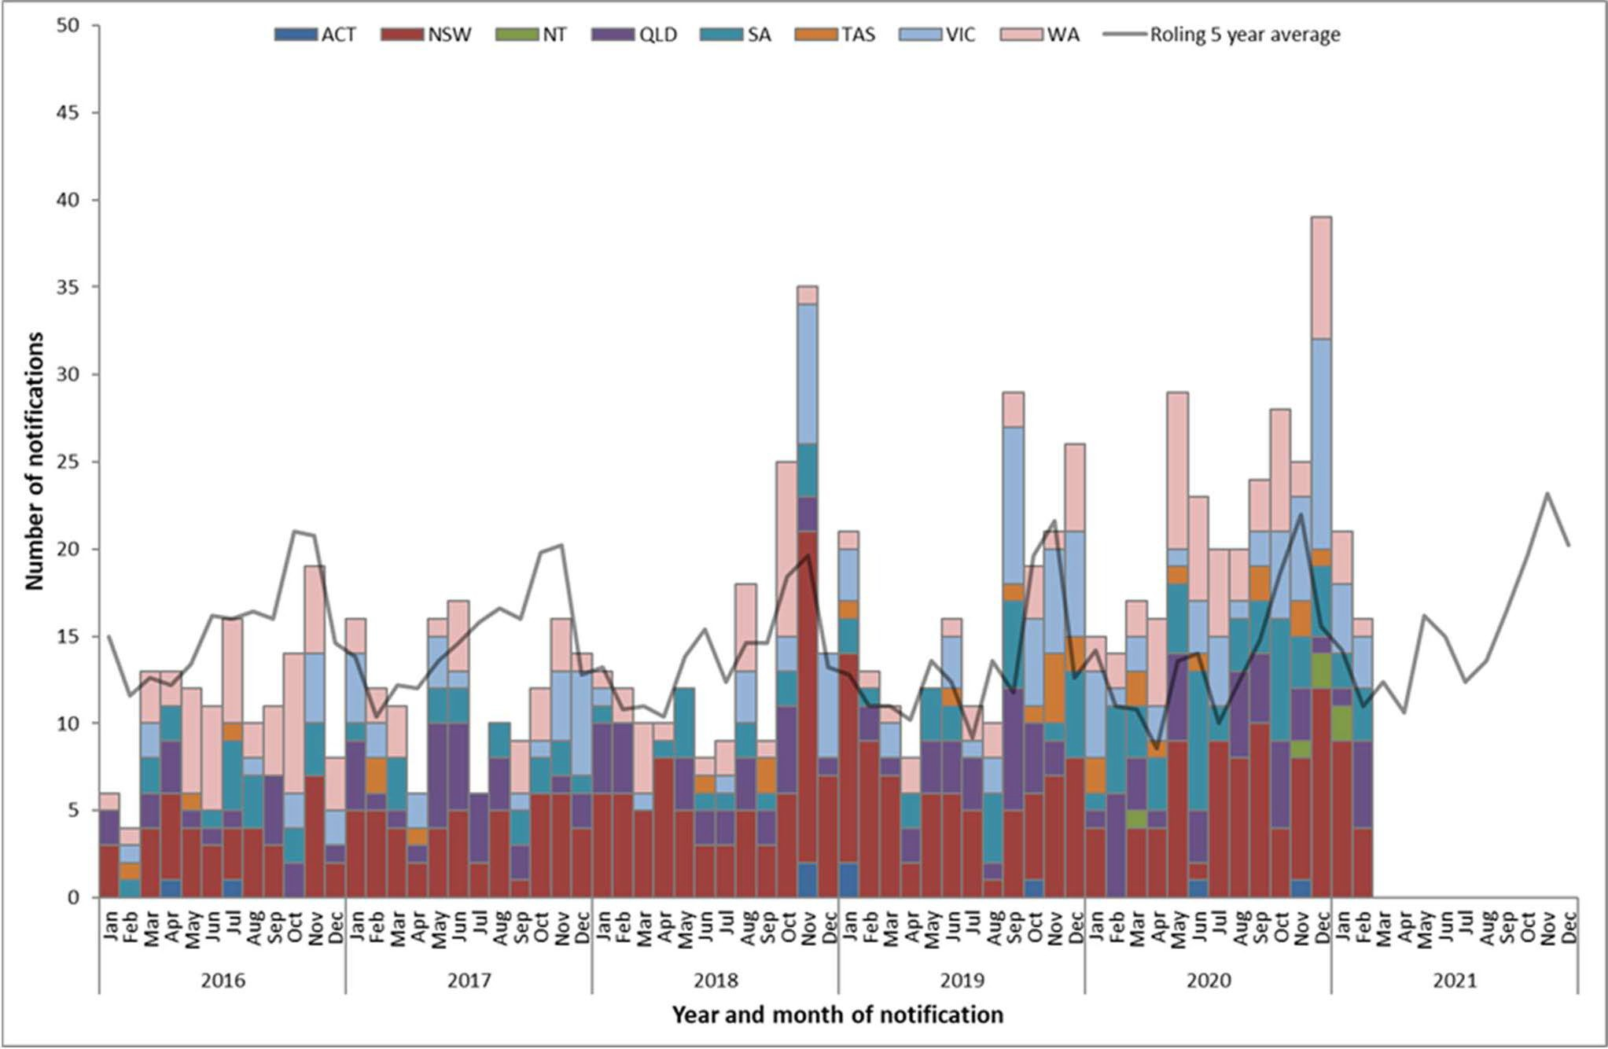

**Figure 2. Notifications of *Legionella pneumophila*, Australia, 1 January 2016 to 28 February 2021, by state or territory and month and year of notification**

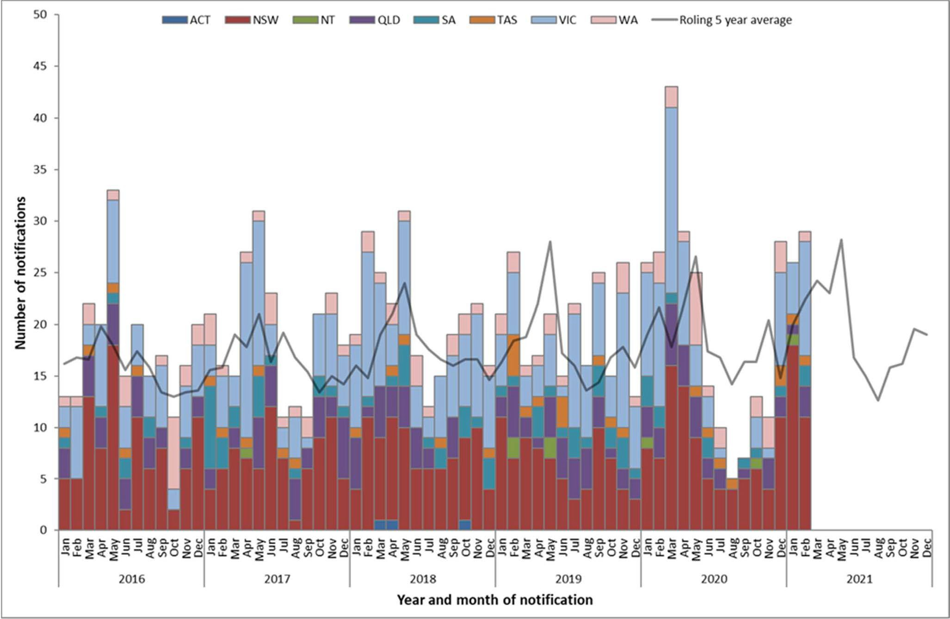

# Leptospirosis

In the past 12 months (29 February 2020 to 28 February 2021), there have been 119 cases of leptospirosis reported to the National Notifiable Diseases Surveillance System (NNDSS). This is slightly lower than the mean number of cases reported for the historical five-year mean (n=117.2). In the past fortnight (15 February 2021 to 28 February 2021), 9 cases of leptospirosis were notified compared to 14 cases in the same reporting period in the previous year. In the past quarter (1 December 2020 – 28 February 2021), 50 cases of leptospirosis were notified compared to the quarterly rolling five year mean of 29.2 notifications. Of the 50 cases notified in the past quarter, the highest number of notifications occurred in Queensland (26/50, 52%), followed by the Northern Territory (10/50, 20%) and New South Wales (8/50, 16%). Increased mouse and rat populations following recent wet weather in eastern Australian may be a contributing factor leading to increased case notifications in some areas.

***Interpretative Notes***

*Selected diseases are chosen each fortnight based on either exceeding two standard deviations from the 90 day and/or 365 day five year rolling mean or other disease issues of significance identified during the reporting period. All diseases reported are analysed by notification receive date. Data are extracted each Monday of a CDNA week.*

*Totals comprise data from all States and Territories. Cumulative figures are subject to retrospective revision so there may be discrepancies between the number of new notifications and the increment in the cumulative figure from the previous period.*

*1The past quarter (90 day) surveillance period includes the date range (01/12/2020 to 28/02/2021).*

*2The quarterly (90 day) five year rolling mean is the average of 5 intervals of 90 days up to 28/02/2021. The ratio is the notification activity in the past quarter (90 days) compared with the five year rolling mean for the same period.*

*3The past year (365 day) surveillance period includes the date range (29/02/2020 to 28/02/2021).*

*4The yearly (365 day) five year rolling mean is the average of 5 intervals of 365 days up to 28/02/2021. The ratio is the notification activity in the past year (365 days) compared with the five year rolling mean for the same period.*

*The five year rolling mean and the ratio of notifications compared with the five year rolling mean should be interpreted with caution. Changes in surveillance practice, diagnostic techniques and reporting may contribute to increases or decreases in the total notifications received over a five year period. Ratios are to be taken as a crude measure of current disease activity and may reflect changes in reporting rather than changes in disease activity.*

**Notification received date**

|  |  |  |  |  |  |  |  |  |  |  |  |  |  |  |  |  |  |  |  |  |  |  |
| --- | --- | --- | --- | --- | --- | --- | --- | --- | --- | --- | --- | --- | --- | --- | --- | --- | --- | --- | --- | --- | --- | --- |
|  | | | | | | | | | | | | | | | | | | | | | | |
| **ADT FN04/2021** | | | **State or Territory** | | | | | | | | **Totals for Australia** | | | | **Historical 90 Day Period** | | | | **Historical Yearly Period** | | | |
| **Disease group** | **Disease name** | **Disease code** | **ACT** | **NSW** | **NT** | **Qld** | **SA** | **Tas** | **Vic** | **WA** | **This reporting period**  **15/02/2021**  **28/02/2021** | **Previous reporting Period**  01/02/2021  14/02/2021 | **Same reporting period last year**  15/02/2020  28/02/2020 | **Current year YTD**  01/01/2021  28/02/2021 | **Past Quarter**  01/12/2020  28/02/2021 | **Quarterly rolling 5 year mean** | **Ratio past quarter/5 year mean\*** | **Exceeds quarterly rolling mean +2 SD by** | **Past Year**  29/02/2020  28/02/2021 | **Yearly rolling 5 year mean**  01/03/2015  29/02/2020 | **Ratio past year/5 year mean\*** | **Exceeds yearly rolling mean +2 SD by** |
| **Bloodborne diseases** | Hepatitis B (newly acquired) | 039 | - | 1 | - | 1 | - | - | - | 1 | 3 | - | 7 | 12 | 22 | 36.2 | 0.6 | - | 114 | 150.6 | 0.8 | - |
| Hepatitis B (unspecified) | 052 | 3 | 63 | - | 29 | 3 | 5 | 37 | 18 | 158 | 174 | 271 | 648 | 1,007 | 1,349.0 | 0.7 | - | 4,756 | 5,988.0 | 0.8 | - |
| Hepatitis C (newly acquired) | 040 | 1 | 1 | - | 17 | 2 | - | 1 | 1 | 23 | 29 | 32 | 104 | 151 | 176.2 | 0.9 | - | 650 | 723.2 | 0.9 | - |
| Hepatitis C (unspecified) | 053 | 2 | 96 | 6 | 41 | 1 | 6 | 46 | 50 | 248 | 325 | 372 | 1,130 | 1,701 | 2,277.0 | 0.7 | - | 7,230 | 9,797.2 | 0.7 | - |
| Hepatitis D | 050 | - | 5 | - | - | 1 | - | - | 1 | 7 | 3 | 3 | 14 | 22 | 14.6 | 1.5 | - | 72 | 67.6 | 1.1 | - |
| **Gastrointestinal diseases** | Botulism | 045 | - | - | - | - | - | - | - | - | - | 1 | - | 1 | 2 | 0.8 | 2.5 | - | 2 | 1.4 | 1.4 | - |
| Campylobacteriosis | 005 | 37 | 533 | 14 | 451 | 128 | 36 | 251 | 101 | 1,551 | 1,646 | 1,600 | 6,648 | 9,783 | 8,586.8 | 1.1 | - | 31,450 | 29,392.8 | 1.1 | - |
| Cryptosporidiosis | 061 | 2 | 82 | 7 | 27 | 2 | 1 | 4 | 6 | 131 | 81 | 286 | 392 | 491 | 1,280.2 | 0.4 | - | 1,933 | 4,031.0 | 0.5 | - |
| Haemolytic uraemic syndrome (HUS) | 055 | - | - | - | 1 | - | - | - | - | 1 | - | - | 2 | 2 | 4.2 | 0.5 | - | 14 | 16.4 | 0.9 | - |
| Hepatitis A | 038 | - | - | - | 1 | - | - | - | - | 1 | - | 9 | 3 | 3 | 74.6 | 0.0 | - | 56 | 241.4 | 0.2 | - |
| Hepatitis E | 051 | - | - | - | - | - | - | - | - | - | - | 2 | - | - | 13.8 | - | - | 26 | 45.4 | 0.6 | - |
| Listeriosis | 018 | - | 1 | - | - | - | - | - | - | 1 | 2 | 1 | 8 | 14 | 23.4 | 0.6 | - | 44 | 69.8 | 0.6 | - |
| Paratyphoid | 080 | - | - | - | - | - | - | - | - | - | - | 10 | - | - | 34.2 | - | - | 19 | 86.2 | 0.2 | - |
| STEC | 054 | - | 9 | - | 2 | 6 | - | 7 | 3 | 27 | 22 | 50 | 108 | 161 | 154.8 | 1.0 | - | 505 | 465.4 | 1.1 | - |
| Salmonellosis | 030 | 11 | 150 | 21 | 236 | 17 | 13 | 58 | 48 | 554 | 586 | 1,223 | 2,738 | 3,713 | 5,169.6 | 0.7 | - | 10,530 | 16,124.6 | 0.7 | - |
| Shigellosis | 031 | - | 5 | 6 | 4 | 1 | - | 2 | 3 | 21 | 21 | 199 | 90 | 137 | 632.8 | 0.2 | - | 963 | 2,082.4 | 0.5 | - |
| Typhoid Fever | 035 | - | - | - | 1 | - | - | - | - | 1 | 1 | 20 | 2 | 3 | 54.0 | 0.1 | - | 52 | 151.6 | 0.3 | - |
| **Quarantinable diseases** | Avian influenza in humans (AIH) | 076 | - | - | - | - | - | - | - | - | - | - | - | - | - | - |  | - | - | - |  | - |
| COVID-19 | 081 | - | 47 | 2 | 10 | 10 | - | 10 | 5 | 84 | 97 | 10 | 600 | 1,126 | 5.0 | 225.2 | 1,098.6 | 29,111 | 6.0 | 4,851.8 | 29,078.2 |
| Cholera | 008 | - | - | - | - | - | - | - | - | - | - | - | - | - | 0.4 | - | - | - | 1.4 | - | - |
| MERS-CoV | 079 | - | - | - | - | - | - | - | - | - | - | - | - | - | - |  | - | - | - |  | - |
| Plague | 025 | - | - | - | - | - | - | - | - | - | - | - | - | - | - |  | - | - | - |  | - |
| Rabies | 028 | - | - | - | - | - | - | - | - | - | - | - | - | - | - |  | - | - | - |  | - |
| Severe acute respiratory syndrome (SARS) | 071 | - | - | - | - | - | - | - | - | - | - | - | - | - | - |  | - | - | - |  | - |
| Smallpox | 069 | - | - | - | - | - | - | - | - | - | - | - | - | - | - |  | - | - | - |  | - |
| Viral haemorrhagic fever (NEC) | 036 | - | - | - | - | - | - | - | - | - | - | - | - | - | - |  | - | - | - |  | - |
| Yellow fever | 041 | - | - | - | - | - | - | - | - | - | - | - | - | - | - |  | - | - | - |  | - |
| **Sexually transmissible infections** | Chlamydial infection | 007 | 54 | 1,204 | 43 | 981 | 266 | 55 | 26 | 487 | 3,116 | 3,201 | 5,040 | 12,441 | 19,068 | 25,006.8 | 0.8 | - | 84,474 | 100,145.6 | 0.8 | - |
| Donovanosis | 010 | - | - | - | - | - | - | - | - | - | - | - | - | - | - |  | - | - | - |  | - |
| Gonococcal infection | 011 | 8 | 382 | 35 | 255 | 76 | 9 | 109 | 116 | 990 | 1,069 | 1,568 | 4,341 | 6,371 | 7,397.2 | 0.9 | - | 27,660 | 27,905.6 | 1.0 | - |
| Syphilis < 2 years | 066 | 5 | 39 | 9 | 20 | 10 | - | 58 | 28 | 169 | 199 | 214 | 767 | 1,157 | 1,117.6 | 1.0 | - | 5,057 | 4,424.0 | 1.1 | - |
| Syphilis > 2 years or unspecified duration | 067 | - | 2 | - | 4 | 1 | - | 37 | 4 | 48 | 68 | 82 | 255 | 402 | 512.4 | 0.8 | - | 1,881 | 2,190.2 | 0.9 | - |
| Syphilis congenital | 047 | - | - | - | - | - | - | - | - | - | 3 | - | 5 | 6 | 1.6 | 3.8 | - | 18 | 7.0 | 2.6 | 4.7 |
| **Vaccine preventable diseases** | Diphtheria | 009 | - | - | - | - | 1 | - | - | - | 1 | - | - | 1 | 3 | 2.4 | 1.3 | - | 9 | 7.6 | 1.2 | - |
| Haemophilus influenzae type b | 012 | - | - | - | - | - | - | - | - | - | 1 | - | 2 | 3 | 5.2 | 0.6 | - | 18 | 19.4 | 0.9 | - |
| Influenza (laboratory confirmed) | 062 | 1 | 1 | 1 | 9 | - | - | 2 | 5 | 19 | 30 | 3,588 | 118 | 185 | 11,823.6 | 0.0 | - | 7,994 | 165,432.2 | 0.0 | - |
| Measles | 021 | - | - | - | - | - | - | - | - | - | - | 1 | - | - | 33.2 | - | - | 1 | 131.4 | 0.0 | - |
| Mumps | 043 | - | - | - | - | - | - | - | - | - | 2 | 26 | 5 | 7 | 159.2 | 0.0 | - | 89 | 622.2 | 0.1 | - |
| Pertussis | 024 | 1 | 1 | 1 | 4 | 2 | - | 6 | 3 | 18 | 34 | 380 | 88 | 133 | 4,136.0 | 0.0 | - | 2,081 | 15,780.2 | 0.1 | - |
| Pneumococcal disease (invasive) | 065 | - | 14 | 1 | 8 | 7 | - | 4 | 4 | 38 | 26 | 45 | 133 | 242 | 288.6 | 0.8 | - | 1,034 | 1,895.6 | 0.5 | - |
| Poliovirus infection | 026 | - | - | - | - | - | - | - | - | - | - | - | - | - | - |  | - | - | - |  | - |
| Rotavirus | 077 | - | 7 | 1 | 12 | 7 | - | NN | 7 | 34 | 32 | 110 | 163 | 265 | 976.4 | 0.3 | - | 1,143 | 4,763.6 | 0.2 | - |
| Rubella | 029 | - | - | - | - | - | - | - | - | - | - | - | - | 1 | 3.0 | 0.3 | - | 2 | 14.8 | 0.1 | - |
| Rubella congenital | 046 | - | - | - | - | - | - | - | - | - | - | - | - | - | - |  | - | - | 0.2 | - | - |
| Tetanus | 033 | - | - | - | 1 | - | - | - | - | 1 | - | - | 2 | 3 | 0.8 | 3.8 | 1.3 | 7 | 3.8 | 1.8 | - |
| Varicella zoster (chickenpox) | 073 | 2 | NN | 1 | 1 | 10 | 1 | 10 | 22 | 47 | 57 | 126 | 225 | 428 | 839.0 | 0.5 | - | 2,401 | 3,585.4 | 0.7 | - |
| Varicella zoster (shingles) | 074 | 19 | NN | 15 | - | 87 | 14 | 55 | 91 | 281 | 339 | 743 | 1,334 | 2,079 | 2,996.8 | 0.7 | - | 13,397 | 10,870.4 | 1.2 | - |
| Varicella zoster (unspecified) | 075 | 8 | NN | 6 | 431 | 61 | 19 | 4 | 73 | 602 | 614 | 461 | 3,006 | 4,862 | 3,328.2 | 1.5 | 511.9 | 15,007 | 14,224.2 | 1.1 | - |
| **Vectorborne diseases** | Barmah Forest virus infection | 048 | - | 3 | - | 15 | - | - | - | 1 | 19 | 24 | 17 | 73 | 107 | 84.2 | 1.3 | - | 746 | 388.4 | 1.9 | 115.3 |
| Chikungunya virus infection | 078 | 1 | - | - | - | - | - | - | - | 1 | - | 7 | 2 | 2 | 22.0 | 0.1 | - | 11 | 88.0 | 0.1 | - |
| Dengue virus infection | 003 | - | - | - | - | - | - | - | - | - | - | 28 | 1 | 1 | 357.0 | 0.0 | - | 121 | 1,430.0 | 0.1 | - |
| Flavivirus infection (unspecified) | 001 | - | - | - | 1 | - | - | - | - | 1 | - | 2 | 2 | 4 | 10.4 | 0.4 | - | 12 | 33.0 | 0.4 | - |
| Japanese encephalitis virus infection | 059 | - | - | - | - | - | - | - | - | - | - | - | - | - | 0.2 | - | - | - | 1.2 | - | - |
| Malaria | 020 | - | - | - | - | - | - | 1 | - | 1 | 3 | 23 | 7 | 11 | 95.6 | 0.1 | - | 101 | 342.2 | 0.3 | - |
| Murray Valley encephalitis virus infection | 049 | - | - | - | - | - | - | - | - | - | - | - | - | - | - |  | - | - | 0.6 | - | - |
| Ross River virus infection | 002 | - | 30 | 12 | 31 | 8 | 3 | 99 | 53 | 236 | 327 | 61 | 1,082 | 1,385 | 1,171.0 | 1.2 | - | 7,039 | 4,783.8 | 1.5 | - |
| West Nile/Kunjin virus infection | 060 | - | - | - | - | - | - | - | - | - | - | - | - | - | 0.2 | - | - | - | 1.6 | - | - |
| **Zoonoses** | Anthrax | 058 | - | - | - | - | - | - | - | - | - | - | - | - | - | - |  | - | - | - |  | - |
| Australian bat lyssavirus infection | 063 | - | - | - | - | - | - | - | - | - | - | - | - | - | - |  | - | - | - |  | - |
| Brucellosis | 004 | - | - | - | - | - | - | - | - | - | 1 | - | 2 | 3 | 6.2 | 0.5 | - | 17 | 19.0 | 0.9 | - |
| Leptospirosis | 017 | - | 1 | 5 | 3 | - | - | - | - | 9 | 14 | 5 | 44 | 50 | 29.2 | 1.7 | 9.4 | 119 | 117.2 | 1.0 | - |
| Lyssavirus infection (NEC) | 064 | - | - | - | - | - | - | - | - | - | - | - | - | - | - |  | - | - | - |  | - |
| Ornithosis | 023 | - | - | - | - | - | - | - | - | - | 1 | 1 | 4 | 13 | 5.0 | 2.6 | 0.9 | 63 | 18.8 | 3.4 | 33.9 |
| Q fever | 027 | - | 8 | - | 13 | 1 | - | - | - | 22 | 13 | 25 | 68 | 92 | 140.0 | 0.7 | - | 440 | 547.0 | 0.8 | - |
| Tularaemia | 070 | - | - | - | - | - | - | - | - | - | - | - | - | - | - |  | - | 2 | - |  | 2.0 |
| **Other bacterial infections** | Legionellosis | 015 | - | 5 | - | 3 | 3 | - | 6 | 1 | 18 | 30 | 24 | 95 | 169 | 102.6 | 1.6 | 15.8 | 544 | 403.6 | 1.3 | 46.5 |
| Leprosy | 016 | - | - | - | - | - | - | - | - | - | - | - | - | 1 | 2.4 | 0.4 | - | 6 | 11.8 | 0.5 | - |
| Meningococcal disease (invasive) | 022 | - | - | - | - | - | - | 1 | 1 | 2 | 2 | 5 | 9 | 16 | 51.0 | 0.3 | - | 77 | 262.8 | 0.3 | - |
| Tuberculosis | 034 | - | 17 | - | 9 | - | - | 15 | 1 | 42 | 53 | 74 | 208 | 350 | 350.2 | 1.0 | - | 1,578 | 1,415.0 | 1.1 | - |
|  | | | 155 | 2,707 | 186 | 2,622 | 711 | 162 | 849 | 1,134 | 8,526 | 9,131 | 16,751 | 36,983 | 55,757 |  | | | 260,676 |  | | |

Footnotes:

* Ratio of the 90 day prior surveillance period to the past 90 day 5 year rolling mean, or ratio of the year period prior surveillance period to the year period 5 year rolling mean. NN = Not Notifiable, NEC = Not Elsewhere Classified

The data in this report are reliant on the provision of data from states and territories to the Australian Government Department of Health. Backlogs in notifications at the state or territory level may contribute to delays in reporting to the NNDSS. Notifications for some high volume conditions are only uploaded quarterly by some jurisdictions, which can result in apparent large variability over time. The NNDSS is a dynamic dataset, with data in this report representing data available on **(03/03/2021).** Data in this report are subject to retrospective revision and may vary from data reported in published NNDSS reports and reports of notification data by states and territories.