# National Communicable Diseases Surveillance Report Fortnight 08, 2021 Summary Notes for Selected Diseases 12 April to 25 April 2021

**Infectious and congenital syphilis**

Increases in infectious syphilis notifications are attributed to an on-going outbreak occurring in young Aboriginal and Torres Strait Islander people residing in northern and central Australia, continued increases among men who have sex with men (MSM) in urban areas of Victoria (Vic) and New South Wales (NSW), and increases in women (Indigenous and non-Indigenous) residing in urban areas of Vic, NSW, Queensland (Qld) and Western Australia (WA).

*Outbreak in remote Australia*

In January 2011, an increase of infectious syphilis notifications among young (15-29 years) Aboriginal and Torres Strait Islander people was identified in the North West region of Qld, following a steady decline at a national level in remote communities. Subsequent increases in infectious syphilis notifications were reported in the Northern Territory (NT) in 2013, WA in 2014 and South Australia (SA) in 2016, following sustained periods of low notification rates. The outbreak is of significant public health concern given the: elevated rates of infectious syphilis among women of child-bearing age, increasing the risk of congenital syphilis; and the concomitant risk of HIV transmission. For the latest information on the infectious syphilis outbreak and related national activities, refer to the [Department’s website](https://www1.health.gov.au/internet/main/publishing.nsf/Content/ohp-infectious-syphilis-outbreak.htm).

*Increases among MSM*

Since 2010 increases in notifications of infectious syphilis have been reported in MSM, predominately 20-39 years of age, residing in urban areas of Vic and NSW.

*Increases among women (Indigenous and non-Indigenous)*

Since 2016, increases in notifications of infectious syphilis have been reported in women (Indigenous and non-Indigenous) aged predominately 20-39 years of age residing in urban areas of NSW, Vic, Qld and WA. As noted in the outbreak in remote Australia, increases in women of child- bearing age is of significant public health concern given the increased risk of congenital syphilis.

*Syphilis response*

On 23 March 2021, the Australian Health Protection Principal Committee (AHPPC) endorsed the *National strategic approach for responding to rising rates of syphilis in Australia 2021* (Strategic Approach) prepared through the Communicable Diseases Network Australia (CDNA) and BBV STI Standing Committee (BBVSS). The Strategic Approach builds on and intersects with existing national activities related to syphilis and provides specific focus for efforts towards rising rates of syphilis and adverse outcomes in Australia.

The CDNA and BBVSS are, in collaboration, developing priority public health actions, including those related to workforce and community engagement, to ensure progress is made towards reducing the incidence of syphilis and elimination of congenital syphilis in Australia. These actions will be provided to AHPPC for endorsement in the coming months.

For further information on national activities related to STIs, including syphilis, refer to the [Department’s website](https://www1.health.gov.au/internet/main/publishing.nsf/Content/ohp-bbvs-1).

# Legionellosis

In the past 12 months (26 April 2020 to 25 April 2021), there have been 544 cases of legionellosis reported to the National Notifiable Diseases Surveillance System (NNDSS), comprising 53.5% *Legionella longbeachae* (291/544) and 42.1% *Legionella pneumophila* (229/544). This is 1.3 times higher than the historical five-year mean (n=415.2), which comprised a greater proportion of *L. pneumophila* (56.4%) compared to *L. longbeachae* (40.7%) infections. Legionellosis notifications were reported in all jurisdictions of Australia in the past 12 months, although the distribution of species varied by jurisdiction (Figure 1 and Figure 2).

In the past fortnight (12 April 2021 to 25 April 2021), 20 cases of legionellosis were notified compared to 26 cases in the same reporting period in the previous year. Of the 20 cases reported in the past fortnight, 16 cases had a species reported, with 10 cases identified as *L. pneumophila* (63%) and six cases identified as *L. longbeachae* (38%). It is difficult to determine the extent to which the increase in legionellosis notifications is associated with increased testing of individuals with influenza-like symptoms or pneumonia in response to the COVID-19 pandemic over the past 12 months, or other factors.

**Figure 1. Notifications of *Legionella longbeachae*, Australia, 1 January 2016 to 25 April 2021, by state or territory and month and year of notification**

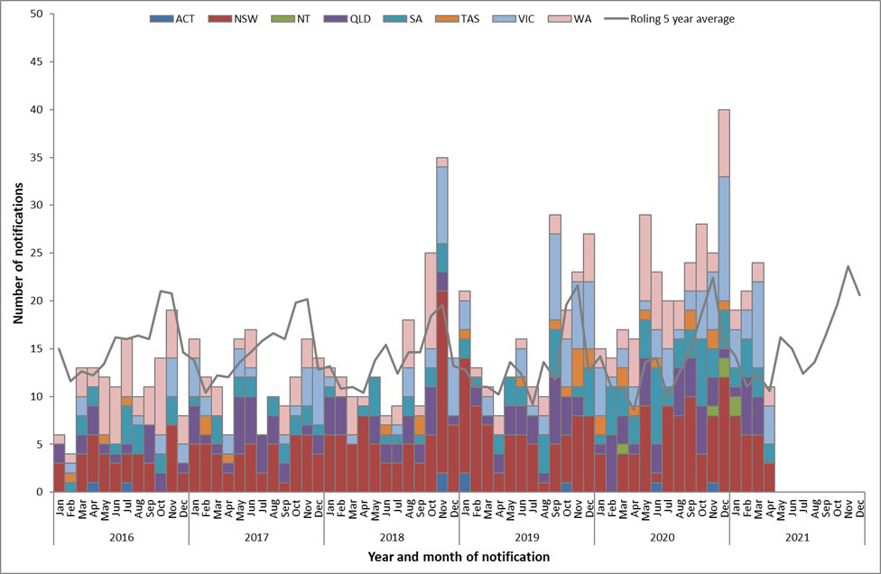

**Figure 2. Notifications of *Legionella pneumophila*, Australia, 1 January 2016 to 25 April 2021, by state or territory and month and year of notification**

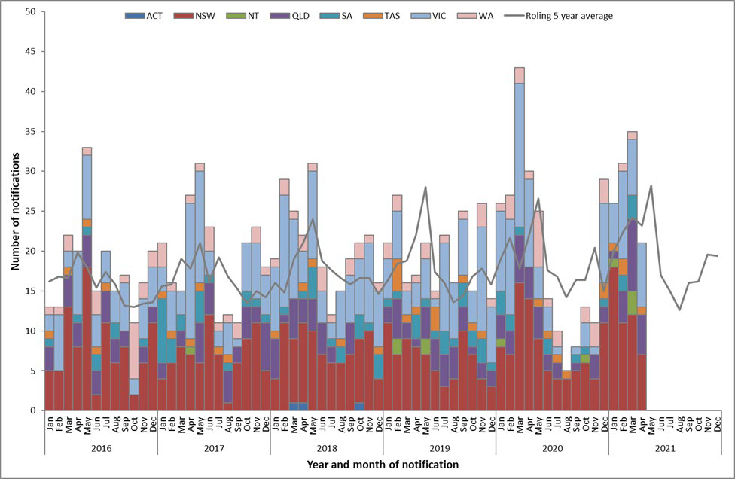

# Leptospirosis

In the past 12 months (26 April 2020 to 25 April 2021), there have been 162 cases of leptospirosis reported to the National Notifiable Diseases Surveillance System (NNDSS). This is higher than the mean number of cases reported for the historical five-year mean (n=115.6). In the past fortnight (12 April 2021 to 25 April 2021), 17 cases of leptospirosis were notified compared to three cases in the same reporting period in the previous year. In the past quarter (26 January 2021 to 25 April 2021), 86 cases of leptospirosis were notified compared to the quarterly rolling five year mean of

38.4 notifications. Of the 86 cases notified in the past quarter, the highest number of notifications occurred in Queensland (49/86, 57%), followed by New South Wales (22/86, 26%) and the Northern Territory (12/86, 14%). Increased mouse and rat populations following recent wet weather in eastern Australian may be a contributing factor leading to increased case notifications in some areas.

***Interpretative Notes***

*Selected diseases are chosen each fortnight based on either exceeding two standard deviations from the 90 day and/or 365 day five year rolling mean or other disease issues of significance identified during the reporting period. All diseases reported are analysed by notification receive date. Data are extracted each Monday of a CDNA week.*

*Totals comprise data from all States and Territories. Cumulative figures are subject to retrospective revision so there may be discrepancies between the number of new notifications and the increment in the cumulative figure from the previous period.*

*1The past quarter (90 day) surveillance period includes the date range (26/01/2021 to 25/04/2021).*

*2The quarterly (90 day) five year rolling mean is the average of 5 intervals of 90 days up to 25/04/2021. The ratio is the notification activity in the past quarter (90 days) compared with the five year rolling mean for the same period.*

*3The past year (365 day) surveillance period includes the date range (26/04/2020 to 25/04/2021).*

*4The yearly (365 day) five year rolling mean is the average of 5 intervals of 365 days up to 25/04/2021. The ratio is the notification activity in the past year (365 days) compared with the five year rolling mean for the same period.*

*The five year rolling mean and the ratio of notifications compared with the five year rolling mean should be interpreted with caution. Changes in surveillance practice, diagnostic techniques and reporting may contribute to increases or decreases in the total notifications received over a five year period. Ratios are to be taken as a crude measure of current disease activity and may reflect changes in reporting rather than changes in disease activity.*

**Notification received date**

|  |  |  |  |  |  |  |  |  |  |  |  |  |  |  |  |  |  |  |  |  |  |  |
| --- | --- | --- | --- | --- | --- | --- | --- | --- | --- | --- | --- | --- | --- | --- | --- | --- | --- | --- | --- | --- | --- | --- |
|  | | | | | | | | | | | | | | | | | | | | | | |
| **ADT FN08/2021** | | | **State or Territory** | | | | | | | | **Totals for Australia** | | | | **Historical 90 Day Period** | | | | **Historical Yearly Period** | | | |
| **Disease group** | **Disease name** | **Disease code** | **ACT** | **NSW** | **NT** | **Qld** | **SA** | **Tas** | **Vic** | **WA** | **This reporting period**  **12/04/2021**  **25/04/2021** | **Previous reporting Period**  29/03/2021  11/04/2021 | **Same reporting period last year**  12/04/2020  25/04/2020 | **Current year YTD**  01/01/2021  25/04/2021 | **Past Quarter**  26/01/2021  25/04/2021 | **Quarterly rolling 5 year mean** | **Ratio past quarter/5 year mean\*** | **Exceeds quarterly rolling mean +2 SD by** | **Past Year**  26/04/2020  25/04/2021 | **Yearly rolling 5 year mean**  26/04/2015  25/04/2020 | **Ratio past year/5 year mean\*** | **Exceeds yearly rolling mean +2 SD by** |
| **Bloodborne diseases** | Hepatitis B (newly acquired) | 039 | ‐ | ‐ | ‐ | 3 | ‐ | ‐ | ‐ | ‐ | 3 | 1 | 6 | 26 | 17 | 38.2 | 0.4 | ‐ | 107 | 152.6 | 0.7 | ‐ |
| Hepatitis B (unspecified) | 052 | 3 | 75 | ‐ | 34 | ‐ | 5 | 37 | 17 | 171 | 140 | 137 | 1,453 | 1,180 | 1,465.2 | 0.8 | ‐ | 4,847 | 5,923.4 | 0.8 | ‐ |
| Hepatitis C (newly acquired) | 040 | ‐ | ‐ | ‐ | 15 | ‐ | ‐ | ‐ | 1 | 16 | 21 | 22 | 209 | 174 | 167.0 | 1.0 | ‐ | 664 | 714.6 | 0.9 | ‐ |
| Hepatitis C (unspecified) | 053 | 1 | 101 | 4 | 95 | 1 | 4 | 38 | 46 | 290 | 251 | 216 | 2,316 | 1,828 | 2,492.6 | 0.7 | ‐ | 7,327 | 9,698.6 | 0.8 | ‐ |
| Hepatitis D | 050 | ‐ | 2 | ‐ | 1 | ‐ | ‐ | ‐ | ‐ | 3 | 1 | 2 | 25 | 22 | 14.4 | 1.5 | ‐ | 80 | 66.6 | 1.2 | ‐ |
| **Gastrointestinal diseases** | Botulism | 045 | ‐ | ‐ | ‐ | ‐ | ‐ | ‐ | ‐ | ‐ | ‐ | ‐ | ‐ | 1 | 1 | 0.2 | 5.0 | ‐ | 2 | 1.2 | 1.7 | ‐ |
| Campylobacteriosis | 005 | 30 | 444 | 8 | 414 | 105 | 36 | 4 | 97 | 1,138 | 1,068 | 650 | 11,756 | 8,892 | 7,101.4 | 1.3 | ‐ | 32,647 | 29,531.0 | 1.1 | ‐ |
| Cryptosporidiosis | 061 | ‐ | 21 | 9 | 22 | 7 | 2 | 14 | 4 | 79 | 41 | 74 | 634 | 481 | 1,663.8 | 0.3 | ‐ | 1,450 | 3,944.6 | 0.4 | ‐ |
| Haemolytic uraemic syndrome (HUS) | 055 | ‐ | ‐ | ‐ | ‐ | ‐ | ‐ | 1 | ‐ | 1 | ‐ | ‐ | 4 | 3 | 3.8 | 0.8 | ‐ | 14 | 16.0 | 0.9 | ‐ |
| Hepatitis A | 038 | ‐ | ‐ | ‐ | ‐ | ‐ | ‐ | ‐ | 1 | 1 | ‐ | 10 | 5 | 3 | 82.2 | 0.0 | ‐ | 16 | 242.0 | 0.1 | ‐ |
| Hepatitis E | 051 | ‐ | ‐ | ‐ | ‐ | ‐ | ‐ | ‐ | ‐ | ‐ | ‐ | ‐ | ‐ | ‐ | 18.4 | ‐ | ‐ | 4 | 49.0 | 0.1 | ‐ |
| Listeriosis | 018 | ‐ | ‐ | ‐ | ‐ | ‐ | ‐ | ‐ | 1 | 1 | 1 | 1 | 15 | 10 | 21.0 | 0.5 | ‐ | 44 | 68.8 | 0.6 | ‐ |
| Paratyphoid | 080 | ‐ | ‐ | ‐ | ‐ | ‐ | ‐ | ‐ | ‐ | ‐ | ‐ | 2 | ‐ | ‐ | 33.2 | ‐ | ‐ | 2 | 86.4 | 0.0 | ‐ |
| STEC | 054 | ‐ | 6 | ‐ | 1 | 5 | ‐ | 6 | 2 | 20 | 21 | 10 | 218 | 174 | 142.2 | 1.2 | ‐ | 526 | 481.6 | 1.1 | ‐ |
| Salmonellosis | 030 | 8 | 119 | 18 | 214 | 39 | 10 | 57 | 38 | 503 | 499 | 387 | 4,974 | 3,594 | 5,375.6 | 0.7 | ‐ | 10,580 | 15,817.4 | 0.7 | ‐ |
| Shigellosis | 031 | ‐ | 3 | 3 | 1 | 3 | ‐ | 2 | 2 | 14 | 17 | 37 | 166 | 129 | 575.6 | 0.2 | ‐ | 690 | 2,121.2 | 0.3 | ‐ |
| Typhoid Fever | 035 | ‐ | ‐ | ‐ | ‐ | ‐ | ‐ | 1 | ‐ | 1 | ‐ | 2 | 5 | 5 | 65.0 | 0.1 | ‐ | 21 | 153.0 | 0.1 | ‐ |
| **Quarantinable diseases** | Avian influenza in humans (AIH) | 076 | ‐ | ‐ | ‐ | ‐ | ‐ | ‐ | ‐ | ‐ | ‐ | ‐ | ‐ | ‐ | ‐ | ‐ |  | ‐ | ‐ | ‐ |  | ‐ |
| COVID‐19 | 081 | ‐ | 102 | 52 | 34 | 53 | ‐ | 13 | 38 | 291 | 157 | 532 | 1,373 | 996 | 1,377.0 | 0.7 | ‐ | 23,022 | 1,379.2 | 16.7 | 15,474.8 |
| Cholera | 008 | ‐ | ‐ | ‐ | ‐ | ‐ | ‐ | ‐ | ‐ | ‐ | ‐ | ‐ | ‐ | ‐ | 0.4 | ‐ | ‐ | ‐ | 1.4 | ‐ | ‐ |
| MERS‐CoV | 079 | ‐ | ‐ | ‐ | ‐ | ‐ | ‐ | ‐ | ‐ | ‐ | ‐ | ‐ | ‐ | ‐ | ‐ |  | ‐ | ‐ | ‐ |  | ‐ |
| Plague | 025 | ‐ | ‐ | ‐ | ‐ | ‐ | ‐ | ‐ | ‐ | ‐ | ‐ | ‐ | ‐ | ‐ | ‐ |  | ‐ | ‐ | ‐ |  | ‐ |
| Rabies | 028 | ‐ | ‐ | ‐ | ‐ | ‐ | ‐ | ‐ | ‐ | ‐ | ‐ | ‐ | ‐ | ‐ | ‐ |  | ‐ | ‐ | ‐ |  | ‐ |
| Severe acute respiratory syndrome (SARS) | 071 | ‐ | ‐ | ‐ | ‐ | ‐ | ‐ | ‐ | ‐ | ‐ | ‐ | ‐ | ‐ | ‐ | ‐ |  | ‐ | ‐ | ‐ |  | ‐ |
| Smallpox | 069 | ‐ | ‐ | ‐ | ‐ | ‐ | ‐ | ‐ | ‐ | ‐ | ‐ | ‐ | ‐ | ‐ | ‐ |  | ‐ | ‐ | ‐ |  | ‐ |
| Viral haemorrhagic fever (NEC) | 036 | ‐ | ‐ | ‐ | ‐ | ‐ | ‐ | ‐ | ‐ | ‐ | ‐ | ‐ | ‐ | ‐ | ‐ |  | ‐ | ‐ | ‐ |  | ‐ |
| Yellow fever | 041 | ‐ | ‐ | ‐ | ‐ | ‐ | ‐ | ‐ | ‐ | ‐ | ‐ | ‐ | ‐ | ‐ | ‐ |  | ‐ | ‐ | ‐ |  | ‐ |
| **Sexually transmissible infections** | Chlamydial infection | 007 | 60 | 1,104 | 31 | 875 | 191 | 52 | 31 | 375 | 2,719 | 2,572 | 2,848 | 26,382 | 20,455 | 26,394.2 | 0.8 | ‐ | 85,235 | 99,983.6 | 0.9 | ‐ |
| Donovanosis | 010 | ‐ | ‐ | ‐ | ‐ | ‐ | ‐ | ‐ | ‐ | ‐ | ‐ | ‐ | ‐ | ‐ | ‐ |  | ‐ | ‐ | ‐ |  | ‐ |
| Gonococcal infection | 011 | 14 | 396 | 29 | 205 | 62 | 11 | 70 | 107 | 894 | 841 | 951 | 8,451 | 6,504 | 7,581.6 | 0.9 | ‐ | 26,982 | 28,224.8 | 1.0 | ‐ |
| Syphilis < 2 years | 066 | 3 | 46 | 16 | 23 | 8 | ‐ | 59 | 37 | 192 | 176 | 204 | 1,614 | 1,261 | 1,151.8 | 1.1 | ‐ | 5,136 | 4,500.4 | 1.1 | ‐ |
| Syphilis > 2 years or unspecified duration | 067 | ‐ | 2 | 1 | 7 | 1 | ‐ | 44 | 4 | 59 | 47 | 47 | 513 | 399 | 546.6 | 0.7 | ‐ | 1,834 | 2,185.8 | 0.8 | ‐ |
| Syphilis congenital | 047 | ‐ | ‐ | ‐ | ‐ | ‐ | ‐ | ‐ | ‐ | ‐ | 1 | ‐ | 5 | 4 | 1.0 | 4.0 | 1.6 | 18 | 7.0 | 2.6 | 6.8 |
| **Vaccine preventable diseases** | Diphtheria | 009 | ‐ | ‐ | ‐ | ‐ | ‐ | ‐ | ‐ | ‐ | ‐ | ‐ | 1 | 1 | 1 | 2.0 | 0.5 | ‐ | 6 | 8.0 | 0.8 | ‐ |
| Haemophilus influenzae type b | 012 | ‐ | ‐ | ‐ | ‐ | ‐ | ‐ | ‐ | ‐ | ‐ | 1 | ‐ | 7 | 6 | 4.0 | 1.5 | ‐ | 22 | 19.0 | 1.2 | ‐ |
| Influenza (laboratory confirmed) | 062 | ‐ | 6 | 4 | 18 | ‐ | 1 | 9 | 1 | 39 | 29 | 162 | 253 | 194 | 14,564.4 | 0.0 | ‐ | 1,429 | 166,058.2 | 0.0 | ‐ |
| Measles | 021 | ‐ | ‐ | ‐ | ‐ | ‐ | ‐ | ‐ | ‐ | ‐ | ‐ | ‐ | ‐ | ‐ | 44.6 | ‐ | ‐ | ‐ | 126.8 | ‐ | ‐ |
| Mumps | 043 | ‐ | ‐ | ‐ | ‐ | ‐ | ‐ | ‐ | ‐ | ‐ | 1 | 7 | 10 | 7 | 172.6 | 0.0 | ‐ | 53 | 622.2 | 0.1 | ‐ |
| Pertussis | 024 | 1 | 3 | ‐ | 6 | 1 | ‐ | 9 | 1 | 21 | 12 | 213 | 175 | 147 | 3,075.2 | 0.0 | ‐ | 1,060 | 15,509.6 | 0.1 | ‐ |
| Pneumococcal disease (invasive) | 065 | 1 | 16 | 1 | 8 | 7 | 2 | 12 | 3 | 50 | 46 | 25 | 327 | 263 | 261.2 | 1.0 | ‐ | 1,072 | 1,900.4 | 0.6 | ‐ |
| Poliovirus infection | 026 | ‐ | ‐ | ‐ | ‐ | ‐ | ‐ | ‐ | ‐ | ‐ | ‐ | ‐ | ‐ | ‐ | ‐ |  | ‐ | ‐ | ‐ |  | ‐ |
| Rotavirus | 077 | ‐ | 10 | 1 | 11 | 15 | 1 | NN | 4 | 44 | 52 | 21 | 355 | 269 | 633.4 | 0.4 | ‐ | 1,112 | 4,732.2 | 0.2 | ‐ |
| Rubella | 029 | ‐ | ‐ | ‐ | ‐ | ‐ | ‐ | ‐ | ‐ | ‐ | ‐ | ‐ | 1 | 1 | 5.6 | 0.2 | ‐ | 3 | 13.8 | 0.2 | ‐ |
| Rubella congenital | 046 | ‐ | ‐ | ‐ | ‐ | ‐ | ‐ | ‐ | ‐ | ‐ | ‐ | ‐ | ‐ | ‐ | ‐ |  | ‐ | ‐ | 0.2 | ‐ | ‐ |
| Tetanus | 033 | ‐ | ‐ | ‐ | ‐ | ‐ | ‐ | ‐ | ‐ | ‐ | 1 | ‐ | 3 | 2 | 1.4 | 1.4 | ‐ | 8 | 3.8 | 2.1 | 1.6 |
| Varicella zoster (chickenpox) | 073 | 8 | NN | 1 | 1 | 12 | ‐ | 17 | 14 | 53 | 65 | 59 | 478 | 381 | 720.8 | 0.5 | ‐ | 2,254 | 3,612.0 | 0.6 | ‐ |
| Varicella zoster (shingles) | 074 | 13 | NN | 11 | 2 | 89 | 17 | 51 | 71 | 254 | 269 | 534 | 2,612 | 1,992 | 2,946.4 | 0.7 | ‐ | 12,434 | 11,130.4 | 1.1 | ‐ |
| Varicella zoster (unspecified) | 075 | 3 | NN | 11 | 343 | 61 | 21 | 7 | 74 | 520 | 483 | 592 | 5,406 | 3,943 | 3,457.8 | 1.1 | ‐ | 15,382 | 14,228.0 | 1.1 | ‐ |
| **Vectorborne diseases** | Barmah Forest virus infection | 048 | ‐ | 5 | ‐ | 9 | ‐ | ‐ | ‐ | 2 | 16 | 17 | 37 | 151 | 126 | 123.0 | 1.0 | ‐ | 695 | 374.2 | 1.9 | 155.0 |
| Chikungunya virus infection | 078 | ‐ | ‐ | ‐ | ‐ | ‐ | ‐ | ‐ | ‐ | ‐ | ‐ | ‐ | 2 | 2 | 17.6 | 0.1 | ‐ | 4 | 86.4 | 0.0 | ‐ |
| Dengue virus infection | 003 | ‐ | ‐ | ‐ | ‐ | ‐ | ‐ | ‐ | ‐ | ‐ | ‐ | 7 | 1 | ‐ | 382.6 | ‐ | ‐ | 8 | 1,378.8 | 0.0 | ‐ |
| Flavivirus infection (unspecified) | 001 | ‐ | ‐ | ‐ | ‐ | ‐ | ‐ | ‐ | ‐ | ‐ | ‐ | ‐ | 2 | 1 | 12.4 | 0.1 | ‐ | 12 | 32.2 | 0.4 | ‐ |
| Japanese encephalitis virus infection | 059 | ‐ | ‐ | ‐ | ‐ | ‐ | ‐ | ‐ | ‐ | ‐ | ‐ | ‐ | ‐ | ‐ | ‐ |  | ‐ | ‐ | 1.2 | ‐ | ‐ |
| Malaria | 020 | ‐ | ‐ | ‐ | ‐ | ‐ | ‐ | ‐ | ‐ | ‐ | 3 | 4 | 12 | 11 | 93.6 | 0.1 | ‐ | 58 | 346.0 | 0.2 | ‐ |
| Murray Valley encephalitis virus infection | 049 | ‐ | ‐ | ‐ | ‐ | ‐ | ‐ | ‐ | ‐ | ‐ | ‐ | ‐ | ‐ | ‐ | 0.2 | ‐ | ‐ | ‐ | 0.4 | ‐ | ‐ |
| Ross River virus infection | 002 | ‐ | 35 | 6 | 43 | 4 | 2 | 44 | 13 | 147 | 122 | 888 | 1,757 | 1,315 | 1,768.2 | 0.7 | ‐ | 6,042 | 4,383.6 | 1.4 | ‐ |
| West Nile/Kunjin virus infection | 060 | ‐ | ‐ | ‐ | ‐ | ‐ | ‐ | ‐ | ‐ | ‐ | ‐ | ‐ | ‐ | ‐ | 0.2 | ‐ | ‐ | ‐ | 1.6 | ‐ | ‐ |
| **Zoonoses** | Anthrax | 058 | ‐ | ‐ | ‐ | ‐ | ‐ | ‐ | ‐ | ‐ | ‐ | ‐ | ‐ | ‐ | ‐ | ‐ |  | ‐ | ‐ | ‐ |  | ‐ |
| Australian bat lyssavirus infection | 063 | ‐ | ‐ | ‐ | ‐ | ‐ | ‐ | ‐ | ‐ | ‐ | ‐ | ‐ | ‐ | ‐ | ‐ |  | ‐ | ‐ | ‐ |  | ‐ |
| Brucellosis | 004 | ‐ | ‐ | ‐ | 1 | ‐ | ‐ | ‐ | ‐ | 1 | ‐ | ‐ | 4 | 4 | 4.8 | 0.8 | ‐ | 16 | 19.2 | 0.8 | ‐ |
| Leptospirosis | 017 | ‐ | 8 | ‐ | 9 | ‐ | ‐ | ‐ | ‐ | 17 | 10 | 3 | 99 | 86 | 38.4 | 2.2 | 24.6 | 162 | 115.6 | 1.4 | ‐ |
| Lyssavirus infection (NEC) | 064 | ‐ | ‐ | ‐ | ‐ | ‐ | ‐ | ‐ | ‐ | ‐ | ‐ | ‐ | ‐ | ‐ | ‐ |  | ‐ | ‐ | ‐ |  | ‐ |
| Ornithosis | 023 | ‐ | ‐ | ‐ | ‐ | ‐ | ‐ | ‐ | ‐ | ‐ | ‐ | 2 | 6 | 1 | 3.6 | 0.3 | ‐ | 61 | 19.2 | 3.2 | 27.6 |
| Q fever | 027 | ‐ | 5 | ‐ | 15 | ‐ | ‐ | ‐ | ‐ | 20 | 16 | 24 | 168 | 144 | 136.6 | 1.1 | ‐ | 470 | 542.2 | 0.9 | ‐ |
| Tularaemia | 070 | ‐ | ‐ | ‐ | ‐ | ‐ | ‐ | ‐ | ‐ | ‐ | ‐ | ‐ | ‐ | ‐ | ‐ |  | ‐ | 2 | ‐ |  | 2.0 |
| **Other bacterial infections** | Legionellosis | 015 | ‐ | 7 | ‐ | 3 | ‐ | ‐ | 6 | 4 | 20 | 21 | 26 | 198 | 165 | 109.2 | 1.5 | ‐ | 544 | 415.2 | 1.3 | 17.3 |
| Leprosy | 016 | ‐ | ‐ | ‐ | ‐ | ‐ | ‐ | ‐ | ‐ | ‐ | ‐ | ‐ | 1 | 1 | 1.8 | 0.6 | ‐ | 7 | 11.4 | 0.6 | ‐ |
| Meningococcal disease (invasive) | 022 | ‐ | ‐ | ‐ | 2 | 1 | ‐ | ‐ | 2 | 5 | 2 | 4 | 24 | 19 | 43.0 | 0.4 | ‐ | 77 | 260.0 | 0.3 | ‐ |
| Tuberculosis | 034 | ‐ | 25 | ‐ | 8 | ‐ | 1 | 9 | 10 | 53 | 54 | 63 | 417 | 313 | 341.4 | 0.9 | ‐ | 1,564 | 1,421.4 | 1.1 | ‐ |
|  | | | 145 | 2,541 | 206 | 2,423 | 665 | 165 | 541 | 969 | 7,656 | 7,059 | 8,810 | 72,615 | 55,526 |  | | | 245,805 |  | | |

Footnotes:

* Ratio of the 90 day prior surveillance period to the past 90 day 5 year rolling mean, or ratio of the year period prior surveillance period to the year period 5 year rolling mean. NN = Not Notifiable, NEC = Not Elsewhere Classified

The data in this report are reliant on the provision of data from states and territories to the Australian Government Department of Health. Backlogs in notifications at the state or territory level may contribute to delays in reporting to the NNDSS. Notifications for some high volume conditions are only uploaded quarterly by some jurisdictions, which can result in apparent large variability over time. The NNDSS is a dynamic dataset, with data in this report representing data available on **(27/04/2021).** Data in this report are subject to retrospective revision and may vary from data reported in published NNDSS reports and reports of notification data by states and territories.