National Aged Care Mandatory Quality

Indicator Program

(QI Program)

Manual 2.0 – Part B

**National Aged Care Mandatory Quality Indicator Program Manual 2.0 – Part B**

This publication is published by the Australian Government Department of Health as a manual to support the National Aged Care Mandatory Quality Indicator Program (QI Program).

**Copyright Notice**

© 2021 Commonwealth of Australia as represented by the Department of Health.

This work is copyright. You may copy, print, download, display and reproduce the whole or part of this work in unaltered form for your own personal use or, if you are part of an organisation, for internal use within your organisation, but only if you or your organisation:

1. do not use the copy or reproduction for any commercial purpose; and
2. retain this copyright notice and disclaimer as part of that copy or reproduction.

Apart from rights as permitted by the Copyright Act 1968 (Cth), or allowed by this copyright notice, all other rights are reserved, including (but not limited to) all commercial rights. Unauthorised use of a copy or reproduction is strictly prohibited.

This licence does not cover, and there is no permission given for, use of the Commonwealth Coat of Arms or any logos and trademarks (including the logo of the Department of Health).

**Disclaimer**

The information in this manual does not constitute, and must not be relied upon as, medical or clinical advice. Any medical questions must be referred to, and obtained from, an independent medical or clinical adviser.

**Assistance**

For further assistance, please contact the My Aged Care provider and assessor helpline on 1800 836 799. The helpline will be available between 8am and 8pm Monday to Friday, and between 10am and 2pm on Saturday local time across Australia, except for public holidays.

**Acknowledgements**

The Commonwealth would like to acknowledge the work undertaken by the Victorian Department of Health from 2006 to 2021 which assisted the Commonwealth to establish the National Aged Care Mandatory Quality Indicator Program. 

Table of Contents

1.0 Introduction to the National Aged Care Mandatory Quality Indicator Program 1

2.0 Introduction to quality improvement 3

3.0 Pressure injuries 8

4.0 Physical restraint 15

5.0 Unplanned weight loss 22

6.0 Falls and major injury 29

7.0 Medication management - polypharmacy 36

8.0 Medication management - antipsychotics 43

Endnotes 51

# Introduction to the National Aged Care Mandatory Quality Indicator Program



Participation in the National Aged Care Mandatory Quality Indicator Program (QI Program) has been a requirement for all approved providers of residential care services since 1 July 2019. The QI Program requires quarterly reporting against five quality indicators across crucial care areas – pressure injuries, physical restraint, unplanned weight loss, falls and major injury, and medication management.

## QI Program objectives

The objectives of the QI Program are:

* For providers to have robust, valid data to measure and monitor their performance and support continuous quality improvement in the care they provide to aged care recipients.
* Over time, to give consumers transparent information about quality in aged care to assist decision making.

Figure 1: SUMMARY OF QI Program objectives

For government and policy makers:
Provide nationally consistent quality measures across residential care services in Australia. 
Support sector-wide improvement and provide information about quality aged care.

For residential care services:
Provide robust, valid data to measure and monitor performance.
Enable the use of quality data to identify and implement activities to improve quality of care delivered.

For consumers, care recipients and the community:
Provide transparent information about quality in aged care.
Enhance understanding of quality and assist decision making.

## Quality indicators in the QI Program

The QI Program requires the collection and reporting of quality indicators that relate to important aspects of quality of care across five crucial care areas. Data for each quality indicator is collected through measurements and assessments within each of the categories set out in Figure 2 below. Information is then compiled or derived and is provided to the Secretary of the Australian Government Department of Health (Secretary), or the Secretary’s delegate, in accordance with legislative requirements.

The Aged Care Quality and Safety Commission (Commission) is responsible for the operational administration of the QI Program, including QI Program compliance. QI Program data reported by approved providers of residential care is used to guide the Commission’s regulatory activities. The Commission’s Compliance and Enforcement Policy details the approach to non-reporting of information.

All approved providers of residential care services must collect data across the five quality indicators, comprised of eight categories, in accordance with the figure below.

Figure 2: SUMMARY OF QI PROGRAM QUALITY INDICATORS

QI Program quality indicators are:
1. Pressure injuries - percentage of care recipients with pressure injuries, reported against six pressure injury stages.
2. Physical restraint - percentage of care recipients who were physically restrained.
3. Unplanned weight loss - percentage of are recipients who experienced significant unplanned weight loss (5% or more. Percentage of care recipients who experienced consecutive unplanned weight loss.
4. Falls and major injury - percentage of care recipients who experienced one or more falls. Percentage of care recipients who experienced one or more falls resulting in major injury.
5. Medication management - Percentage of care recipients who were prescribed nine or more medications. Percentage of care recipients who received antipsychotic medications.

## The QI Program Manual 2.0

The QI Program Manual 2.0 consists of three parts, all available on the Department’s website. QI Program Manual 2.0 – Part A (Part A) provides legislated guidance for collecting, recording and submitting data. QI Program Manual 2.0 – Parts B (this document) and C are not legislated. QI Program Manual 2.0 – Part B aims to support providers to improve quality of care through continuous quality improvement. QI Program Manual 2.0 – Part C (Part C) is a guide for approved providers to access and use the QI Application in the My Aged Care provider portal as well as submit quality indicator data and access QI Program reports.

# Introduction to quality improvement



Quality improvement leads to improvements in the quality and experience of care, as well as improving outcomes for care recipients. Quality improvement is an important part of everyone’s job and should be understood and accepted by all levels of management and staff.[1] The QI Program aims to support approved providers of aged care to understand and use quality indicator data to be able to continuously improve quality of care and services.

## What is quality improvement?



Quality improvement **is a systematic, coordinated and ongoing effort to improve the quality of care and services.**



Quality **is described as care that is effective and safe, and provides a positive experience by being caring, responsive and person-centred.**

Quality improvement works to identify how well systems are working and to understand the quality of care and services being delivered in order to improve outcomes for aged care recipients.[2]

Providers should aim to answer three key questions throughout the quality improvement process:

1. What are we trying to accomplish?
2. How will we know that a change is an improvement?
3. What changes can we make that will result in improvement?

An understanding of quality improvement is important for anyone who delivers or manages care, as it can lead to improvements in the quality, experience, productivity and outcomes of care and services.

### Supporting a culture of quality improvement

Building a culture of improvement is key in supporting quality improvement in your organisation. Leadership and management play a crucial role in establishing an improvement culture, helping staff understand the importance of quality improvement, and ensuring that they feel safe and able to raise issues relating to the quality of services or care. It is also important that clear governance arrangements are established so there is a consistent approach to identifying quality issues and engaging in quality improvement activities.

Figure 3: Quality improvement benefits

The benefits of quality improvement include:
- Improving the delivery of care and services
- Identifying quality issues early
- Being more responsive to the changing needs of care recipients
- Improving outcomes for care recipients
- Improving systems to monitor and track change
- Creating long-term and sustainable improvement across organisations
- Increasing collaboration amongst staff at all levels
- Enhancing professional development across the workforce

## When should quality improvement be undertaken?

Quality improvement is ongoing and aims to make a difference to care recipients by improving the safety, effectiveness and experience of care and services.

QI Program data and reports assist approved providers in understanding the quality of services and help to identify opportunities to continuously improve the care they deliver.

Figure 4: Steps to enable quality improvement

Step 1 - collect and submit data in line with QI Program requirements.
Step 2 - review quality indicator data reports through the provider portal.
Step 3 - compare your performance to national, state and territory level data available on the AIHW GEN Aged Care Data Website.
Step 4 - Identify how your performance compares to the national benchmark, previous performance and/or other like services.
Step 5 - Record performance and note that a quality issue exists.
Step 6 - Take action to improve quality of care through initiating a quality improvement activity.

It is important to note that quality improvement should be an ongoing focus for all approved providers of aged care services, regardless of performance.

## How to undertake quality improvement in aged care

Quality improvement approaches can help aged care services to improve the quality of care for care recipients.

### Quality improvement approaches

There are a range of different approaches to quality improvement. One option is the Plan-Do-Check-Act tool which uses evidence to help organisations deliver quality improvement activities through four steps. The Plan-Do-Check-Act tool allows organisations to identify quality issues and trial a quality improvement activity at a small scale. This helps organisations to understand if the activity works before implementing the activity across the entire system.

The Plan-Do-Check-Act tool can be used across all five quality indicators in order to make improvements in the delivery of care. Examples of how the Plan-Do-Check-Act tool can be used across each quality indicator are outlined in this Manual.

Figure 5: Plan-Do-Check-Act tool

Plan - Understand the problem. State the objectives. Develop a plan.
Do - Carry out the activity. Document observations, problems and unexpected outcomes. Collect data.
Check - Collect data. Analyse results. Identify what worked and what needs to be changed.
Act - Make a decision as to whether or not the activity has been successful.

|  |
| --- |
| PLANNING is an important first step in quality improvement.   * **Gather information** to understand the current situation and identify what is causing the quality issue. This includes reviewing quality indicator data and may also include collecting additional data. * **Establish goals** for your quality improvement activity. Goals should be measurable and have a set timeframe to be achieved. * **Make a plan** for how the quality improvement activity will be carried out. This process should be collaborative and include different levels of staff, as well as care recipients where possible. The plan should be detailed, define who is affected by the activity, outline the tasks required and who is required to deliver them. |
| DOING focuses on implementing and delivering the quality improvement activities you have planned.   * **Allocate** resources to deliver the quality improvement activity. * **Test** the activity at a small scale and adjust as needed. * **Inform** stakeholders. * **Document** observations, including any decisions made while delivering the activity and if any changes are made to the plan. * **Collect** data based on the measures agreed in the planning phase. |
| CHECKING involves evaluating what you are doing to check if it is working using qualitative and quantitative information.   * **Qualitative** information involves asking questions to understand what did and did not work well, and how further improvement can occur. * **Quantitative** information involves collecting data to measure outcomes from a quality improvement activity. A validated quality improvement tool is a helpful way to collect this data.   Once information and data has been collected, the results should be analysed to understand if any changes should be made to your plan. |
| ACTING involves making a decision to decide if a quality improvement activity has been successful.   * **If the activity is successful**, organisations should work to embed the new activity at a larger scale. This includes training and educating staff, updating policies and procedures, and informing stakeholders. * **If the activity is not successful**, it is important to identify why this might be and what can be done differently. The Plan‑Do‑Check‑Act tool should be used again, but this time with a different quality improvement activity. |

# Pressure injuries



Pressure injuries are a major and prevalent health concern for older Australians, with evidence demonstrating that pressure injuries are an important and recognised issue in residential aged care.

## Overview of pressure injuries

Figure 6 below provides an overview of the prevalence of pressure injuries in residential aged care services.

Figure 6: Pressure injuries in residential aged care services [3] [4] [5] [6] [7] [8]

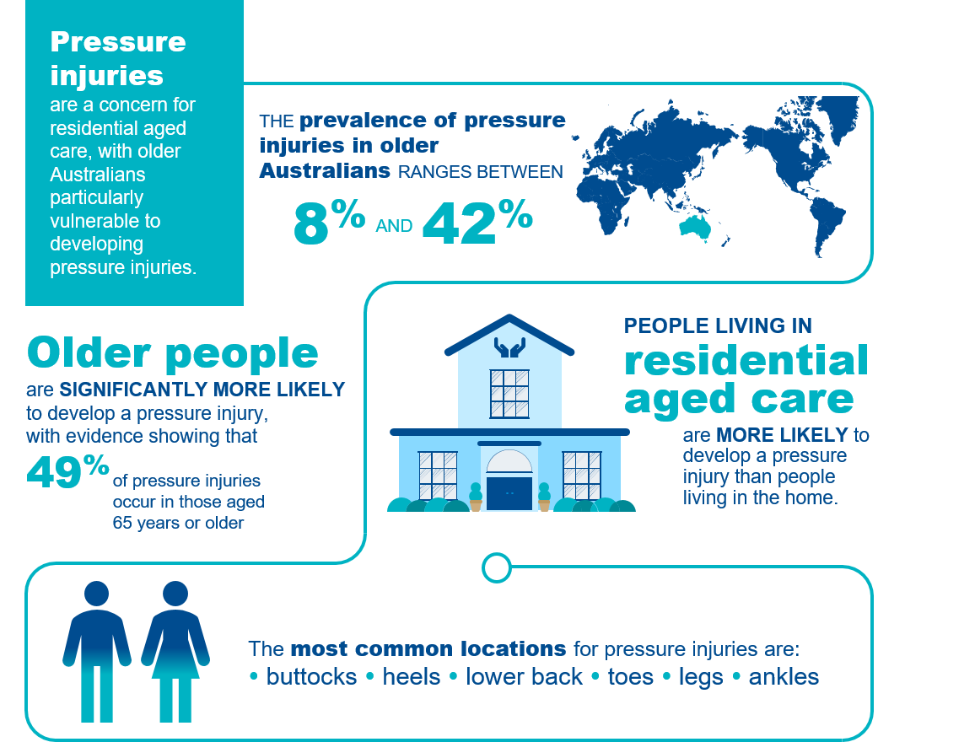

## Pressure injuries in residential aged care

A pressure injury is a localised injury to the skin and/or tissues underneath as a result of pressure, shear, or a combination of these factors.[9] Pressure injuries usually occur over a bony prominence but may also be caused by an object, such as a medical device.[10]

The ICD 10 Australian Modified (AM) pressure injury classification system outlined in the Prevention and Treatment of Pressure Ulcers/Injuries: Clinical Practice Guideline 2019[11] includes the following six pressure injury stages:

1. Stage 1 Pressure Injury
2. Stage 2 Pressure Injury
3. Stage 3 Pressure Injury
4. Stage 4 Pressure Injury
5. Unstageable Pressure Injury
6. Suspected Deep Tissue Injury

Details of the collection and reporting requirements for the pressure injuries quality indicator can be found in Part A.

## Causes of pressure injuries

Pressure injuries may occur when an **area of skin and the tissues underneath it is damaged** by being under enough pressure that the blood supply is reduced.[12] **Pressure injuries have three core causes:**[13][14][15]

1. **Pressure**: the force of a person’s body weight or an external object compressing on the skin for a period of time, causing a wound to form. This commonly occurs in people with poor mobility who are unable to easily shift their weight to relieve pressure.
2. **Friction**: when two surfaces rub against each other, causing a wound to develop. This may occur when a person is pulled across bed linen. Moisture also increases friction.
3. **Shearing**: downward pressure or sliding that creates friction and causes a wound to develop. This may occur when a person is positioned upright in bed and they slide downward.

## Adverse clinical events and pressure injuries

Pressure injuries can have long and short-term impacts on care recipients’ health and wellbeing, including **reduced quality of life**, **increased disability** and even **death**.[16] [17] [18] They can take many months to heal and, in some cases, may never heal completely. Common complications associated with pressure injuries include: [19] [20] [21] [22] [23]

* pain and discomfort
* infection and sepsis
* stress, anxiety and depression
* reduced physical and social functioning
* limb-threatening injuries, including amputation.

Pressure injuries are also expensive to manage and cause a financial burden to residential aged care services.[24]

## Risk factors for pressure injuries

Older Australians are significantly more vulnerable to developing a pressure injury due to age-related issues. Figure 7 describes the key risk factors for developing pressure injuries in residential aged care. Having a strong understanding of the risk factors is crucial to identify care recipients who are at risk of developing pressure injuries.

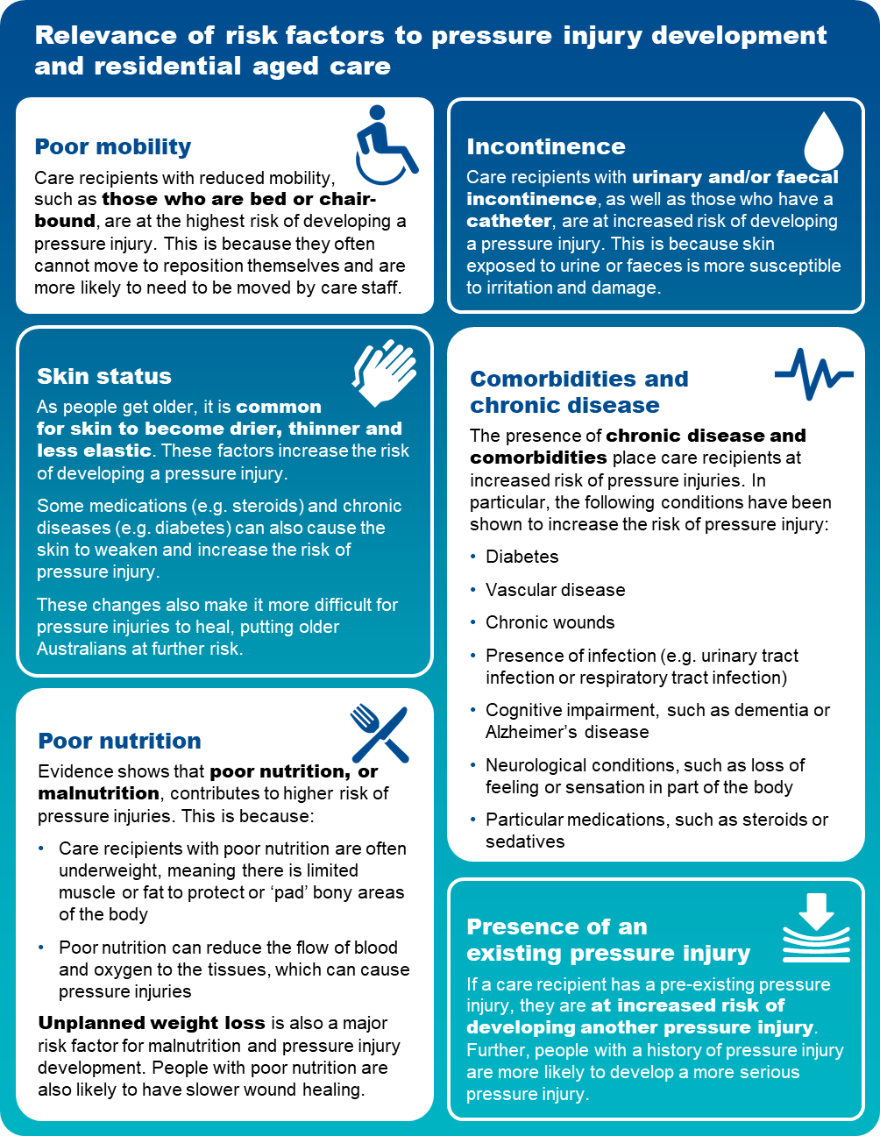Figure 7: risk factorS and Relevance to pressure injury development and residential aged care

[25] [26] [27] [28] [29] [30] [31] [32] [33] [34] [35] [36] [37] [38] [39] [40] [41] [42] [43]

## Prevention and management of pressure injuries

Awareness of risk factors and some simple steps can reduce the chance of pressure injuries occurring. Figure 8 below outlines some important aspects of care that can be considered to prevent and manage pressure injuries.

Figure 8: pressure injury risk factors

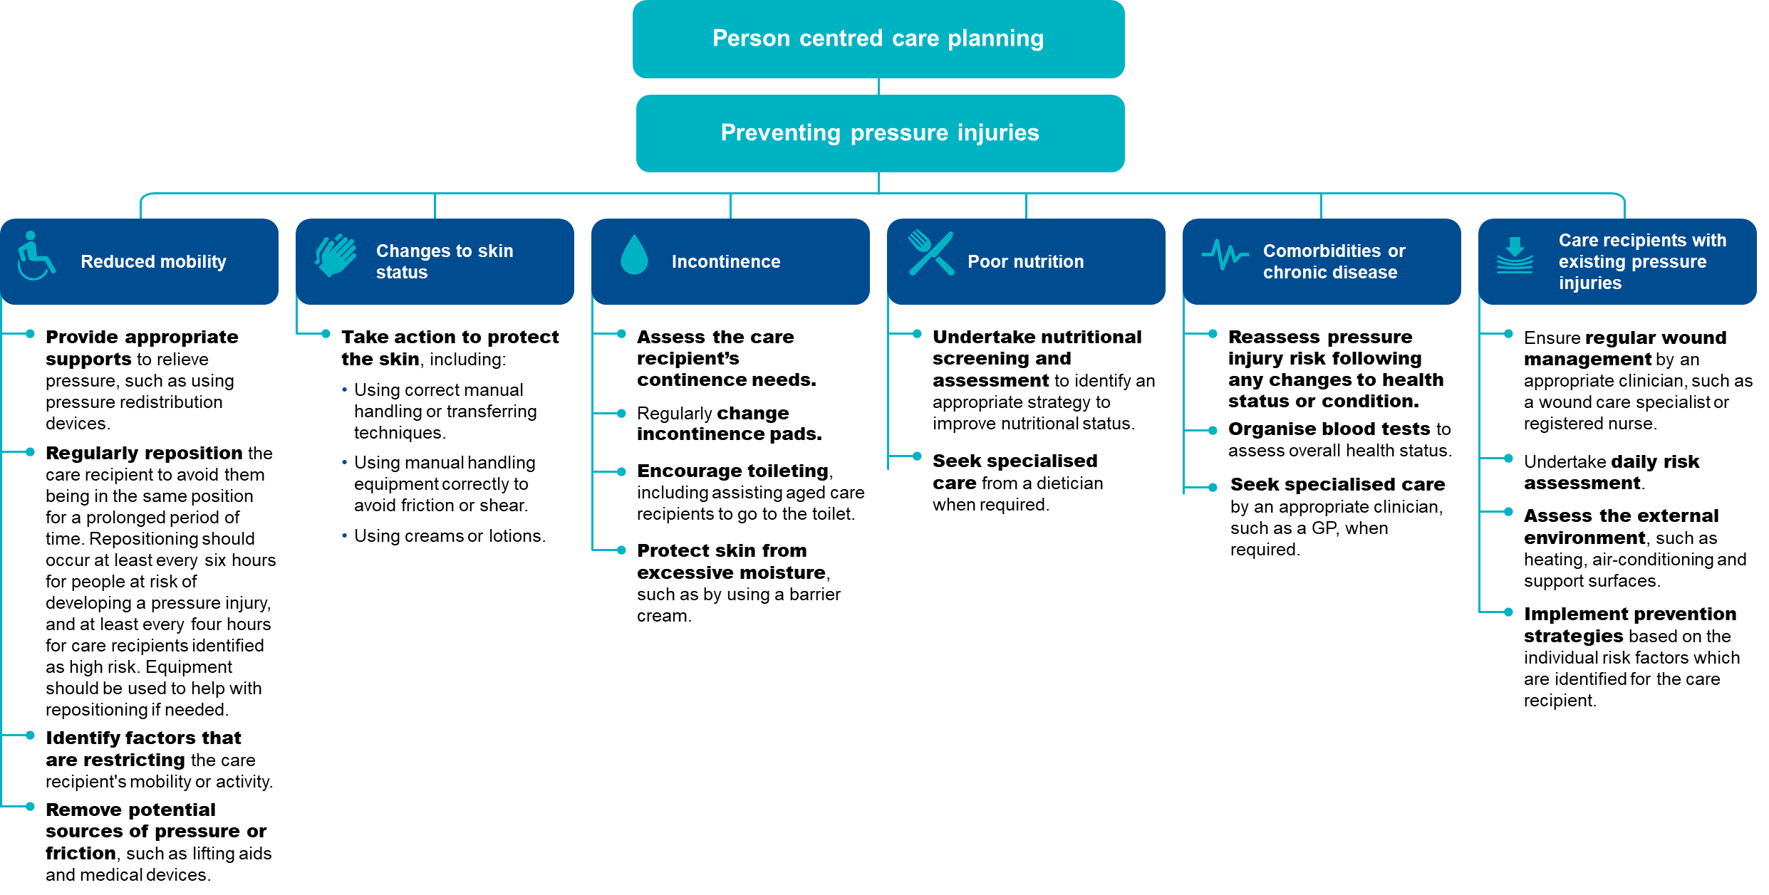

The checklist below will help assess care recipients who are at risk of pressure injuries and identify prevention strategies to reduce the risk of pressure injuries occurring.

Figure 9: Checklist of the prevention of pressure injuries

**Checklist to assist in the prevention of pressure injuries**

|  |  |
| --- | --- |
| Step 1 | Conduct a skin assessment   * + - A head-to-toe assessment with a focus on skin at bony prominences.     - Examine for any changes in skin colour, including redness, blanching and inflammation.     - Assess for:       * dryness, changes and thinning of the skin       * moist skin such as from sweating or incontinence       * areas of localised pain. |
| Step 2 | **Undertake pressure injury risk assessments regularly**   * + - When a care recipient is first admitted to a residential aged care service.     - When a care recipient returns from a different care setting, such as a hospital or rehabilitation service.     - If a care recipient’s health or condition changes, such as change in mobility, nutrition status, medication or increased frailty.     - Following surgery, other medical procedures or investigation.     - On a daily basis for care recipients considered to be high risk and those who have an existing pressure injury. |
| Step 3 | **Document findings in a care plan**   * + - Activities to be undertaken to prevent a pressure injury developing.     - Frequency and timing of prevention activities.     - Preferences, including ability of care recipient to reposition themselves.     - Risk factors, including comorbidities and mobility status. |
| Step 4 | **Implement appropriate  prevention strategy**  *Focus on key risk factors, such as:*   * + - Reduced mobility     - Changes to skin status     - Incontinence     - Poor nutrition     - Comorbidities or chronic disease     - Care recipients with existing pressure injuries. |
| Step 5 | **Undertake frequent reassessment**   * + - Perform regular reassessment to monitor risk and check for early signs of pressure damage.     - Reassess prevention strategies to adjust care plans. |

## Quality improvement for pressure injuries

Quality improvement can help providers increase the quality of care for care recipients at risk of developing pressure injuries.[44] Quality improvement activities should be ongoing and part of business-as-usual for approved providers.

The QI Program will help prompt when a specific quality improvement activity should be undertaken. It is important to review QI Program data reports through the provider portal and compare against national benchmarks and other services to understand where quality improvement activities should be focussed.

The **Plan-Do-Check-Act tool** is a useful tool to plan, deliver and monitor quality improvement activities focused on preventing and reducing pressure injuries.[45] [46]

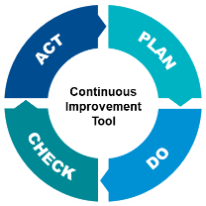**PRESSURE INJURIES**

Plan, Do, Check, Act Continuous Improvement Tool

|  | | | | ↑ CONTINUOUS IMPROVEMENT |  | |
| --- | --- | --- | --- | --- | --- | --- |
|  |  |  |  |  |  |
|  | |  |  | | |  |
| PLAN | |  | * + - **Develop a pressure injury champion team to focus on delivering quality improvement activities for pressure injuries.** A multidisciplinary team is recommended, including personal care staff, healthcare professionals, and management staff to provide leadership and governance.     - **Ensure staff are adequately trained to assess, recognise, prevent and manage pressure injuries.** This might include online training, on-the-job learning, core induction materials, hard copy resources (*refer to “Example tools, guidance and resources to support continuous quality improvement”*).     - **Develop an understanding of the prevalence of pressure injuries at your service using QI Program data** to understand if a targeted quality improvement activity is needed.     - **Collaborate with the multidisciplinary team to identify opportunities and plan quality improvement interventions that will prevent and reduce pressure injuries**. Depending on the individual circumstances of your service, quality improvement activities for pressure injuries may include additional training, updating equipment and/or updating policies to include assessment guidance.     - **Measure performance and impact of planned activities**. Pressure injury process indicators should be adapted to the circumstances of your service.51 This includes developing process indicators, key performance indicators and targets so you can measure and monitor improvement or change. | | |  |
| DO | |  | * + - **Carry out your planned activities and pressure injury prevention strategies.** Initially, the activity may be trialled at one floor of the service or at one service of an approved provider, which will allow adjustments to be made.     - **Document key findings, information and data**. This includes documenting any changes to the planned activities. | | |
| CHECK | |  | * + - **Collect** information, evidence, and QI Program datato understand if prevention activities are making a difference.     - **Analyse** information, evidence and QI Program datato determine if the quality improvement activity is achieving the desired outcomes. | | |
| ACT | |  | * + - If the activity is successful, embed the pressure injury prevention activities into business‑as‑usual processes.     - If the activity is unsuccessful, identify why the activity was not successful and what can be done differently next time. Consider the need to seek expert advice or collaborate with other health professionals to identify ways to improve implementation.     - **Restart the Plan-Do-Check-Act tool** to develop and trial an improved quality improvement activity to reduce the prevalence of pressure injuries at your service, to improve outcomes for care recipients and ensure you are providing the best possible care. | | |
|  |  |  |  | CONTINUOUS IMPROVEMENT ↓ |  |  |
|  |  |  |  |  |  |

## Example tools, guidance and resources to support continuous quality improvement

* **Waterlow Pressure Ulcer Scale**. Can be found online at the New South Wales Agency for Clinical Innovation website here: [Microsoft Word - Clinician Summary v.5.0_Waterlow.docx (nsw.gov.au)](https://www.aci.health.nsw.gov.au/__data/assets/pdf_file/0011/387929/07.-_Waterlow-Clinician-Summary-v.5.0.pdf)
* **Braden Scale** for predicting pressure injury risk. Can be found on the Western Australian Department of Health website here: [Microsoft Word - Braden Scale for Predicting Pressure Sores.doc (health.wa.gov.au)](https://ww2.health.wa.gov.au/~/media/Files/Corporate/general%20documents/safety/PDF/Bradenscale.pdf) or via the AN‑ACC tool via the Australian Department of Health website here: [AN‑ACC Reference Manual and AN‑ACC Assessment Tool](https://www.health.gov.au/resources/publications/an-acc-reference-manual-and-an-acc-assessment-tool)
* **Prevention and Treatment of Pressure Ulcers/Injuries: Clinical Practice Guideline**. The International Guideline 2019. Can be found on the Wounds Australia website here: [Prevention and Treatment of Pressure Ulcers Injuries Clinical Practice Guideline 2019](https://www.woundsaustralia.com.au/Web/Resources/Publications/Other_Publications/Prevention_and_Treatment_of_Pressure_Ulcers_Injuries_Clinical_Practice_Guideline_2019.aspx#:~:text=Prevention%20and%20Treatment%20of%20Pressure%20Ulcers%2FInjuries%20%3A%20Clinical,be%20used%20by%20health%20professionals%20throughout%20the%20world.)
* **Standardised care process (SCP) – Pressure injuries**. Can be found on the Victorian Department of Health website here: [Standardised care processes](https://www2.health.vic.gov.au/ageing-and-aged-care/residential-aged-care/safety-and-quality/improving-resident-care/standardised-care-processes#:~:text=A%20series%20of%20evidence-based%20standardised%20care%20processes%20%28SCPs%29,Evidence-based%20practice%20requires%20organisational%20readiness%20and%20change%20leadership.)
* **Assessment and Management of Pressure Injuries: Learning module.** Can be accessed through Wound Innovations’ [Online Wound Education Program](https://elearning.woundinnovations.com.au/).

*Some tools, guidance and resources may be updated over time; it is important to ensure you are looking at the most recent version.*

# Physical restraint



There are significant concerns about the overuse of physical restraint for older Australians. While physical restraint is often used with the intention of supporting the safety of care recipients and others, it can also be associated with negative impacts and outcomes for care recipients.

## Overview of physical restraint

Figure 10 below provides an overview of physical restraint in residential aged care.

Figure 10: Physical restraint in residential aged care services [47]

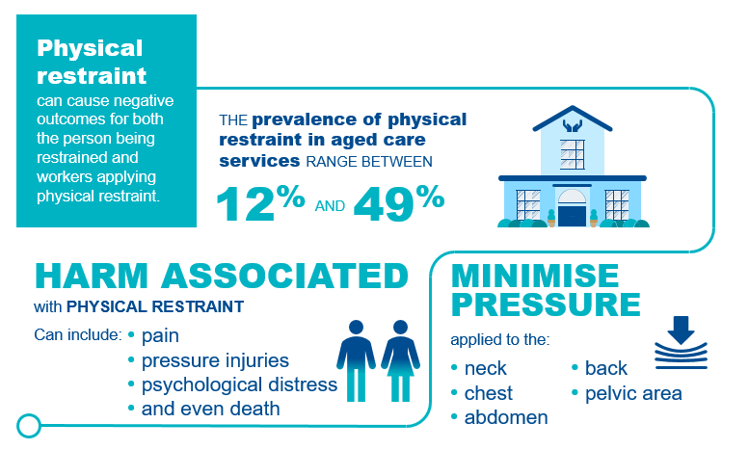

## Restrictive practices and physical restraint in residential aged care

The [Quality of Care Principles 2014](https://www.legislation.gov.au/Series/F2014L00830) (Quality of Care Principles) define **restrictive practices** as any practice or intervention that has the effect of restricting the rights or freedom of movement of a care recipient.

For the purposes of the QI Program, **physical restraint** includes all forms of restrictive practice, excluding chemical restraint, as follows:

* *Mechanical restraint* is a practice or intervention that is, or that involves, the use of a device to prevent, restrict or subdue a care recipient’s movement for the primary purpose of influencing the care recipient’s behaviour, but does not include the use of a device for therapeutic or non-behavioural purposes in relation to the care recipient.
* *Physical restraint* is a practice or intervention that:
  1. Is or involves the use of physical force to prevent, restrict or subdue movement of a care recipient’s body, or part of a care recipient’s body, for the primary purpose of influencing the care recipient’s behaviour.
  2. Does not include the use of a hands-on technique in a reflexive way to guide or redirect the care recipient away from potential harm or injury if it is consistent with what could reasonably be considered to be the exercise of care towards the care recipient.
* *Environmental restraint* is a practice or intervention that restricts, or that involves restricting, a care recipient’s free access to all parts of the care recipient’s environment (including items and activities) for the primary purpose of influencing the care recipient’s behaviour.
* *Seclusion* is a practice or intervention that is, or that involves, the solitary confinement of a care recipient in a room or a physical space at any hour of the day or night where:

1. Voluntary exit is prevented or not facilitated
2. It is implied that voluntary exit is not permitted

for the primary purpose of influencing the care recipient’s behaviour.

For the purposes of the QI Program, restraint through the use of a **secure area** includes only environmental restraint, as defined above.

All listed forms of restrictive practice, including instances where the care recipient or their representative instigate or request the restrictive practice, are considered physical restraint for the purposes of the QI Program (chemical restraint is excluded).

Details of the collection and reporting requirements for the physical restraint quality indicator can be found in Part A.

## Adverse clinical events and physical restraint

Physical restraint can cause physical and psychological harm and can have a significant impact on the quality of life of care recipients. These include:

* **Psychological consequences**, such as fear, shame, anxiety, anger, loneliness, boredom, loss of dignity, agitation, depression, and lower cognitive performance.
* **Physical consequences**, such as bruising, direct skin injuries, pressure injuries, contractures, respiratory complications, urinary and faecal incontinence and constipation, under‑nutrition, reduced mobility and increased dependence in activities of daily living, impaired muscle strength and balance, reduced cardiovascular endurance, serious injury and death.

Physical restraint can also result in death, for example physical restraint applied for falls prevention may lead to neck compression and entrapment causing asphyxia.[48]

The Commission has developed a [Minimising Restraint in the Home](https://www.agedcarequality.gov.au/resources/minimising-restraint-home-services-storyboard-and-user-guide) storyboard and user guide intended to be used to start conversations within services about what constitutes restraint, the impact of restraint, and ways the use of restraint can be minimised.[49]

## Prevention and management of physical restraint

The Quality of Care Principles 2014 outline that physical restraint in aged care services should only be used as a last resort and only when necessary to protect the care recipient or another person. Physical restraint can be used only if:

* an approved health practitioner with day-to-day knowledge of the care recipient has assessed the care recipient as posing a risk of harm to themselves or another person
* the requirement to have a behaviour support plan in place for every care recipient who has restrictive practices considered, applied or used as part of their care has been fulfilled
* alternatives have been used to the extent possible
* the restraint used is the least restrictive possible
* informed consent has been obtained from the care recipient or their representative.

Figure 11: PREVENTING physical restraint [50]

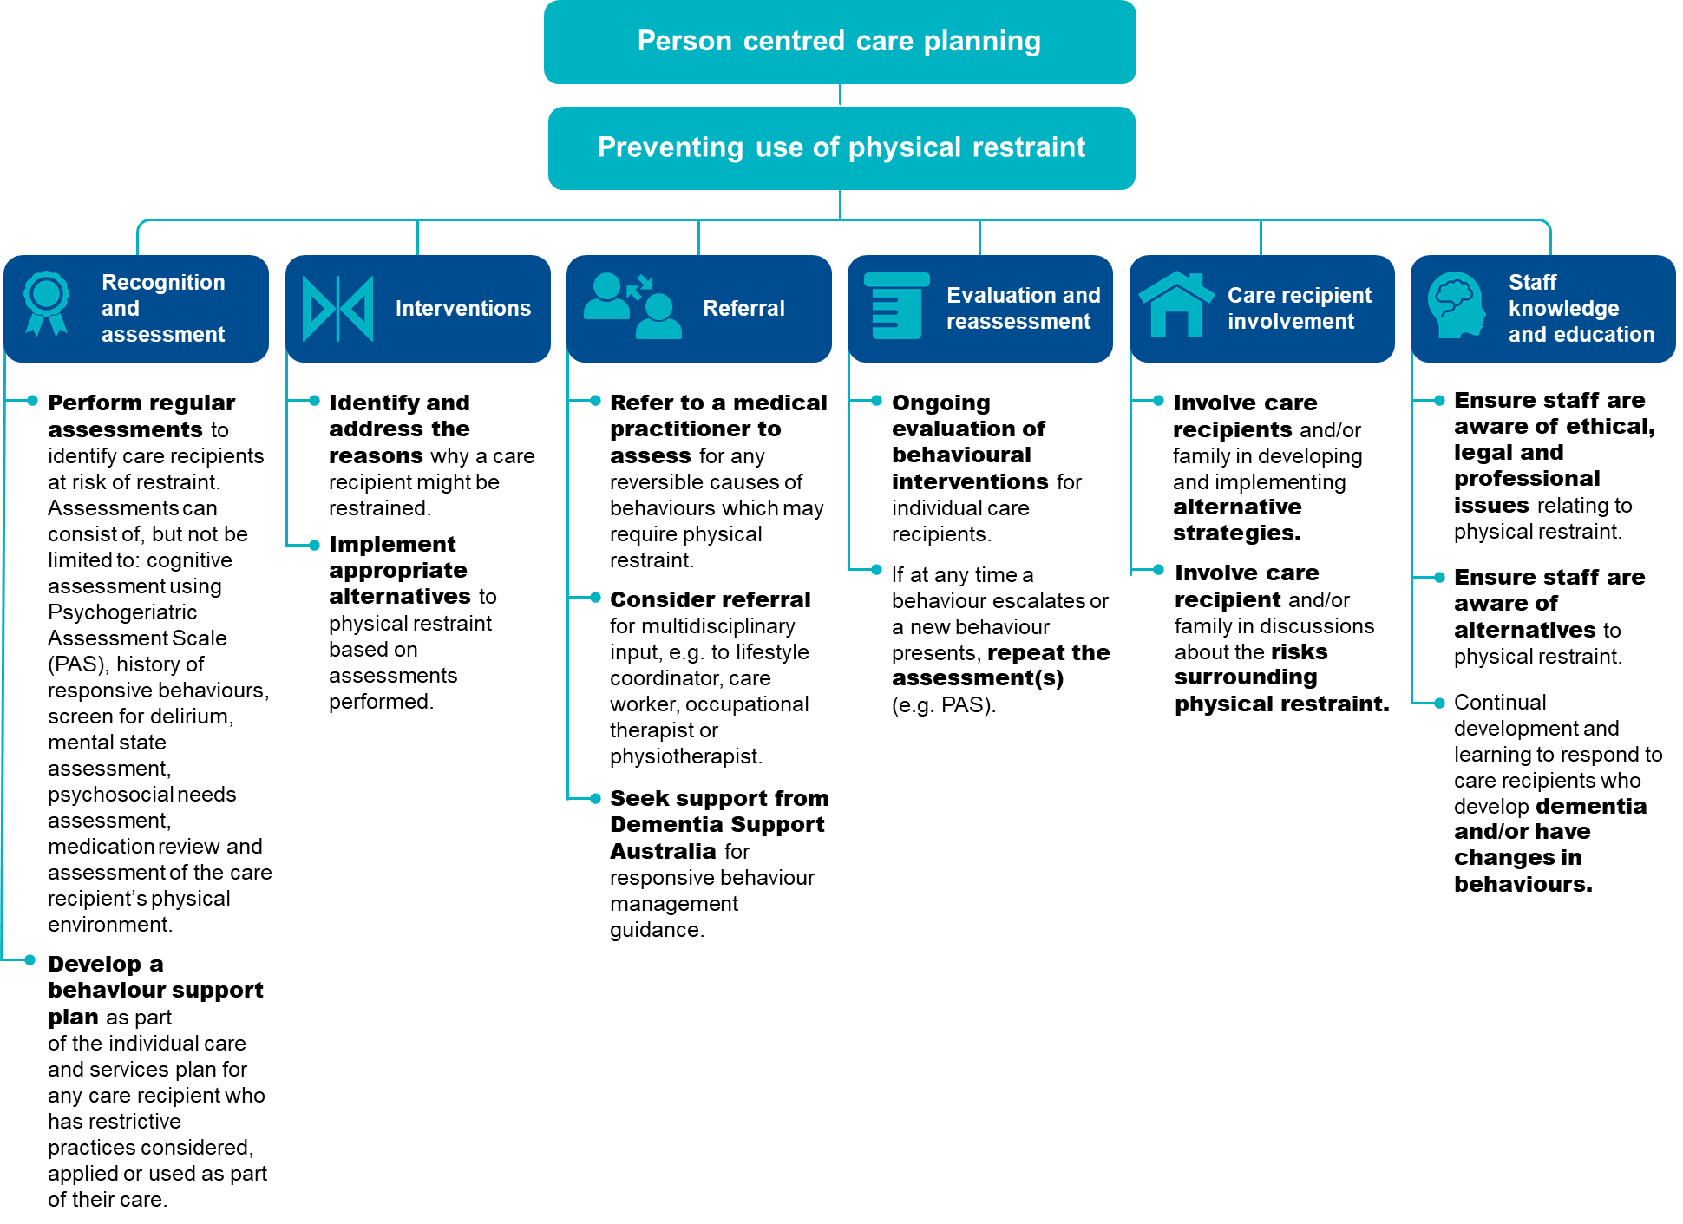

Providers can reduce the need for physical restraint in an aged care setting. The checklist below outlines steps that providers can undertake to help identify alternatives to physical restraint.[51] [52]

Figure 12: Checklist for the prevention of physical restraint. [53] [54]

Checklist for the prevention of physical restraint

|  |  |
| --- | --- |
| Step 1 | **Assess environmental factors**   * + - Reduce the risk of physical trauma to the care recipient, such as using non-slip flooring, non-slip footwear, improved lighting, appropriate bed and seating for comfort, mobility aids     - Reduce environmental noise, for example where a care recipient becomes agitated due to the TV volume in a common area, guide the care recipient away from the area or turn the TV volume down.     - Alter the layout of the residential aged care service to support ease of navigation for care recipients, such as having a straight hallway from the bedroom to a recreational area. |
| Step 2 | **Assess psychosocial factors**   * + - Ensure familiar staff engage with care recipients.     - Minimise the frequency, complexity and duration of expectations of the care recipient.     - Foster companionship for care recipients with staff and other care recipients.     - Encourage participation in activities with care recipients that they enjoy or are meaningful to them. * Identify opportunities for engagement with familiar loved ones and friends through visits and phone calls. |
| Step 3 | **Assess care approach factors**   * + - Ensure individualised routines to meet specific needs of care recipients.     - Increase supervision and staff interaction.     - Evaluate and monitor conditions affecting behaviour.     - Ensure staff liaise with family and seek professional assistance to guide responses as needed. |
| Step 4 | **Assess physiological factors**   * + - Review medications, in particular for medications that may contribute to worsening cognitive function, restlessness and agitation.     - Manage nutrition and hydration.     - Manage pain and / or infection, for example urinary tract infections or viral infections can often cause agitation.     - If physical restraint is used in a residential aged care service, it is important that staff review this checklist and reflect on factors that were not appropriately managed and may have contributed to the use of physical restraint. |

## Quality improvement for physical restraint

Quality improvement can help providers increase the quality of care for care recipients at risk of physical restraint.[55] Quality improvement activities should be ongoing and part of business-as-usual for approved providers.

The QI Program will help prompt when a specific quality improvement activity should be undertaken. It is important to review QI Program data reports through the provider portal and compare against national benchmarks and other services to understand where quality improvement activities should be focussed.

The **Plan-Do-Check-Act tool** is a useful tool to plan, deliver and monitor quality improvement activities focused on preventing and reducing physical restraint.[56] [57]

**PHYSICAL RESTRAINT**

Plan, Do, Check, Act Continuous Improvement Tool

|  | | | | ↑ CONTINUOUS IMPROVEMENT |  | |
| --- | --- | --- | --- | --- | --- | --- |
|  |  |  |  |  |  |
|  | |  |  | | |  |
| PLAN | |  | * + - **Develop a physical restraint champion team to focus on delivering quality improvement activities for physical restraint.** A multidisciplinary team is recommended, including personal care staff, healthcare professionals, and management staff to provide leadership and governance.     - **Ensure staff are adequately trained to assess, recognise, prevent and manage physical restraint.** This might include online training, on-the-job learning, core induction materials, hard copy resources *(refer to “Example tools, guidance and resources to support continuous quality improvement”*).     - **Use QI Program data to develop an understanding of the prevalence of physical restraint at your service.** This will help you understand if a targeted quality improvement activity is needed.     - **Collaborate with the multidisciplinary team to identify opportunities and plan quality improvement interventions that will prevent and reduce physical restraint**. Depending on the individual circumstances of your service, quality improvement activities for reducing physical restraint may include additional training, updating equipment and/or updating policies to include assessment guidance.     - **Develop ways to measure the performance and impact of planned activities**.This includes developing process indicators, key performance indicators and targets so you can measure and monitor improvement or change. | | |  |
| DO | |  | * + - **Carry out your planned activities and physical restraint prevention strategies.** Initially, the activity may be trialled at one floor of the service or at one service of an approved provider, which will allow adjustments to be made.     - **Document key findings, information and data**. This includes documenting any changes to the planned activities. | | |
| CHECK | |  | * + - **Collect** information and evidence and use QI Program data to understand if prevention activities are making a difference.     - **Analyse** information, evidence and QI Program data to determine if the quality improvement activity is achieving the desired outcomes. | | |
| ACT | |  | * + - If the activity is successful, embed the physical restraint prevention activities into business‑as‑usual processes.     - If the activity is unsuccessful, identify why the activity was not successful and what can be done differently next time. Consider the need to seek expert advice or collaborate with other health professionals to identify ways to improve implementation.     - **Restart the Plan-Do-Check-Act tool** to develop and trial an improved quality improvement activity to reduce the prevalence of physical restraint at your service, to improve outcomes for care recipients and ensure you are providing the best possible care. | | |
|  |  |  |  | CONTINUOUS IMPROVEMENT ↓ |  |  |
|  |  |  |  |  |  |

## Example tools, guidance and resources to support continuous quality improvement

* [**Psychogeriatric Assessment Scales (PAS)**](https://www.health.gov.au/resources/publications/cognitive-decline-scale-pas#:~:text=Cognitive%20Decline%20Scale%20%28PAS%29%20%20%20%20,have%20reduced%20fine%20motor%20skills%20or%20visually%20impaired.) – Aged care providers can use this to test cognitive impairment of care recipients. It includes the questions and the scoring method. It is suitable for people who are non-verbal, have reduced fine motor skills or are visually impaired.
* [**Minimising Restraint in Residential Care storyboard and user guide**](https://www.agedcarequality.gov.au/resources/minimising-restraint-residential-care-storyboard-and-user-guide) – Minimising Restraint in Residential Care storyboard and user guide | Aged Care Quality and Safety Commission
* [**Severe Behaviour Response Teams (SBRT)**](https://dementia.com.au/services/severe-behaviour-response-teams-sbrt) – 24/7 contact with a Dementia Consultant on 1800 699 799 to access SBRT service. - Severe Behaviour Response Teams (SBRT) -– Dementia Support Australia
* [**Dementia Behaviour Management Advisory Service (DBMAS)**](https://dementia.com.au/services/dementia-behaviour-management-advisory-service-dbas) – 24/7 contact with a Dementia Consultant on 1800 699 799 for advice or to make a referral – Dementia Behaviour Management Advisory Service (DBMAS) - Dementia Support Australia

* **[Dementia Support Australia behaviour support plan resources](https://dementia.com.au/bsp)** - Dementia Support Australia has released a toolkit of resources to support aged care homes meet new behaviour support plan requirements aimed at minimising the use of restraints in residential aged care.

*Some tools, guidance and resources may be updated over time; it is important to ensure you are looking at the most recent version.*

# Unplanned weight loss



Unplanned weight loss is common among care recipients, with approximately half either being malnourished or at risk of malnutrition. It is important to understand and recognise where care recipients are experiencing unplanned weight loss, and to respond with actions to minimise or eliminate the cause.

## Overview of unplanned weight loss

Figure 13 below provides an overview of unplanned weight loss in residential aged care.

Figure 13: Unplanned weight loss in residential aged care services5859

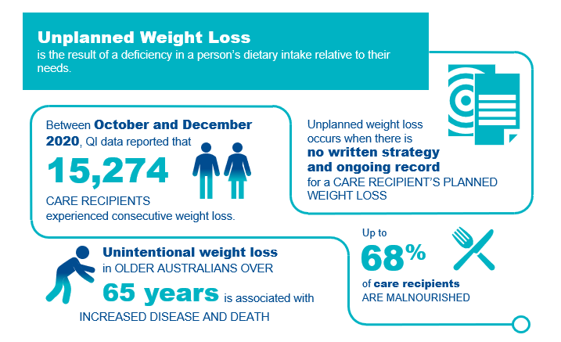

## Unplanned weight loss in residential aged care

For the purposes of the QI Program, unplanned weight loss is where there is weight loss and no written strategy or ongoing record relating to planned weight loss for the care recipient. There are two categories of unplanned weight loss:[58]

* **Significant unplanned weight loss** is weight loss equal to or greater than 5% of body weight over a three-month period.
* **Consecutive unplanned weight loss** is weight loss of any amount of weight every month over three consecutive months.

Details of the collection and reporting requirements for the unplanned weight loss quality indicator can be found in Part A.

## Causes and risk factors of unplanned weight loss

There are many causes of unplanned weight loss in adults over the age of 65, including food choice and quality, negative dining experiences, limited staff training and support, difficulty eating, poor appetite and mood. Care recipients may experience multiple causes, which may be curable or treatable.

Risk factors for unplanned weight loss may be due to a range of causes, including social, physical, physiological, emotional or the care setting, as described in Figure 14.[59] [60] [61] [62]

Figure 14: Risk factors FOR UNPLANNED WEIGHT LOSS AND MALNUTRITION

**PSYCHOLOGICAL AND EMOTIONAL CAUSES**

**PHYSICAL   
CAUSES**

**SOCIAL   
CAUSES**

**CARE SETTING   
CAUSES**

**Mood disorders**

Anxiety, depression

**Cognitive impairment**

Alzheimer’s disease, Lewy body dementia, stroke

**Bereavement**

Grief, loss

**Other**

Loss of enjoyment

**Disease related**

Acute illness, cancer, pain, pressure injury, constipation, and increased nutritional requirements

**Medication related**

Cardiac, neurologic, polypharmacy, nausea

**Functional issues**

Dexterity, mobility impairment, vision, chewing and swallowing, eating support needs

**Reduced intake**

Food quality, oral health, dentition/dentures, appetite, changes in taste or smell, restricted diets (e.g. texture modified), early satiety

**Reduced social engagement**

Loss of choice, social withdrawal, eating alone, limited communication

**Cultural factors**

Different life experiences of food and the mealtime environment, dining in institutional settings

**Dining experience**

Lighting, sound and smell, social interaction, staff activity, task-focussed service

**Staff**

Limited staff to assist with eating, limited skills to identify and respond to weight loss, task focussed, workload

**Food service mode**

Limited food choices, meal time requirements, plating and service approach

**Food preparation**

Inadequate nutritional content, insufficiently enriched foods



## Adverse clinical events and unplanned weight loss

Unplanned weight loss is a sign of malnutrition, which affects every system in the body and results in increased vulnerability to illness, loss of independence, frailty, increased complications, higher risk of hospital admissions and, in extreme cases, even death.[63] [64] [65] [66] It contributes to a reduced quality of life.

Figure 15: Impact of unplanned weight loss

Unplanned weight loss impacts include:
- the brain
- impaired temperature regulation
- muscles and function
- impaired wound healing
- higher risk of hospital admissions
- elimination
- reduced quality of life
- the immune system

## Prevention and management of unplanned weight loss

Preventing unplanned weight loss in care recipients requires a tiered approach, recognising and responding to the needs, preferences, and cultural requirements of each care recipient:[67] [68] [69]

There are three core methods to address unplanned weight loss through primary prevention, secondary prevention and tertiary prevention.

### 5.5.1 Primary prevention of unplanned weight loss

Primary prevention seeks to reduce health risks before they occur. This means ensuring each aged care recipient has the opportunity and support to maintain adequate nutritional intake using a food-first approach. The food-first approach helps to support nutritional intake through using every-day nourishing foods and drinks that each consumer likes, and ensuring they are actually consumed.[70] [71] [72]

To support a food-first approach, and deliver a positive mealtime environment, it is important that different professionals come together to create a multidisciplinary nutrition policy in the context of the individual’s preferences, choices and cultural factors. This should include assessment of why appetite is poor or food is not being eaten, and considering food, nutrition, and a mealtime experience all together to help care recipients maintain a healthy weight.[73]

### 5.5.2 Secondary prevention of unplanned weight loss

Secondary prevention seeks to reduce the impact of risk or threats to health. For unplanned weight loss, this means ensuring staff have the right training, care recipients are screened for early identification of causes of poor intake, weight loss and implementing strategies that improve health and day-to-day life.

### 5.5.3 Tertiary prevention of unplanned weight loss

Tertiary prevention seeks to minimise the impact of ongoing threats to health. This may involve strategies that reduce the risk of the negative effects of unplanned weight loss, such as minimising the risk of acquiring pressure injuries and discomfort.

Care recipients experiencing adverse consequences of unplanned weight loss should be under the care of an appropriately skilled team of health professionals, including a Dietitian. Care should include a robust, monitored individualised nutrition care plan, completion of appropriate risk assessments, and the development and implementation of plans to manage the adverse consequences of unplanned weight loss.

**5.5.4 Prevention strategies for unplanned weight loss**

The checklists below provide strategies that may be used to prevent unplanned weight loss.

Figure 16: Checklist to support the prevention of unplanned weight loss

Checklist for the prevention of unplanned weight loss

|  |
| --- |
| **Primary prevention of unplanned weight loss and malnutrition**   * + - Taking a food-first approach     - Developing and implementing an integrated food and nutrition policy that covers hospitality, allied health, clinical care and quality professionals     - Consider the mealtime environment, including understanding if:     - the dining area is clean, tidy, and well-lit     - the dining area is arranged in a communal or family-like way     - care recipients who require meal-time support are provided this support     - care recipients have enough time to eat at a time and pace of their choosing     - snacks are provided when care recipients need to eat more frequent smaller meals     - Care recipients are provided with tailored advice and information on maintaining a healthy weight     - The provider uses and acts on a holistic food, nutrition, and meal-time experience tool     - A mechanism to monitor and detect when sufficient food is not consumed, and to respond early     - Ongoing consultation and feedback from each care recipient about their food and eating experience and responding to issues identified |

|  |
| --- |
| **Secondary prevention of unplanned weight loss and malnutrition**   * + - Care recipients are screened for risk of malnutrition using a validated screening tool at assessment prior to entry, at the beginning of care, and on a regular basis     - Care recipients who are malnourished, or at risk of malnutrition, have a multidisciplinary management care plan that aims to meet their needs using a food-first approach     - Each care recipient who is screened for malnutrition (or their representative) have their results and nutrition support goals documented in writing     - Care recipients have their nutrition support goals and needs reviewed at planned intervals     - Care recipients who manage their own artificial feeding support or those caring for them have training to manage their nutrition needs     - Staff receive annual training on identifying and managing risk of malnutrition and malnutrition using a validated tool     - Policies and guidelines support compliance with aged care standards, and governance processes monitor this compliance |
| **Tertiary prevention of unplanned weight loss and malnutrition**   * + - Care recipients experiencing negative effects of unplanned weight loss are under the care of an appropriately skilled, multidisciplinary team of health professionals including a Dietitian.     - Care recipients are receiving treatment for the adverse consequences of unplanned weight loss |

Figure 17: Prevention strategies for unplanned weight loss[74]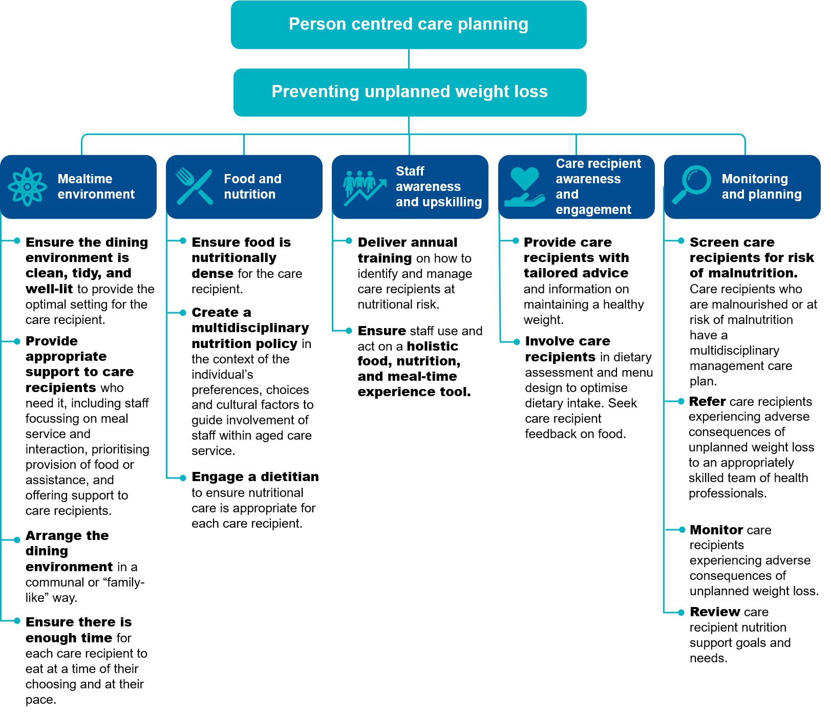

## Quality improvement mechanisms

Quality improvement can help providers reduce the risk of care recipients experiencing unplanned weight loss and malnutrition.

Quality improvement activities should be ongoing and part of business-as-usual for approved providers. QI Program data can help prompt when a specific quality improvement activity should be undertaken. It is important to review QI Program data reports through the provider portal and compare against national benchmarks and other services to understand if unplanned weight loss and malnutrition is an issue within your organisation.

The **Plan-Do-Check-Act tool** is a useful tool to plan, deliver and monitor quality improvement activities focused on unplanned weight loss.

**UNPLANNED WEIGHT LOSS**

Plan, Do, Check, Act Continuous Improvement Tool

|  | | | | ↑ CONTINUOUS IMPROVEMENT |  | |
| --- | --- | --- | --- | --- | --- | --- |
|  |  |  |  |  |  |
|  | |  |  | | |  |
| PLAN | |  | * + - **Develop an unplanned weight loss champion team to focus on delivering quality improvement activities for unplanned weight loss.** This should include care recipients, their representatives and staff involved in their nutritional care.     - **Ensure staff are adequately trained to prevent, recognise, assess, and manage unplanned weight loss.** This might include online training, on-the-job learning, hard copy resources, and incorporating nutrition, assessment and mealtime experience into the staff induction process.     - **Develop an understanding of the prevalence of unplanned weight loss at your service using QI Program data** to understand if a targeted quality improvement activity is needed. Using QI Program data, in combination with malnutrition risk screening, will provide greater opportunities to identify those people requiring intervention.     - **Collaborate with the multidisciplinary team to identify opportunities and plan quality improvement interventions that address risks of unplanned weight loss**. This could include organising extra training, developing new ways to seek feedback on food experiences, reviewing food service models, developing and implementing a nutrition care policy and referral pathway.     - **Measure performance and impact of planned activities**. This may include developing process indicators, key performance indicators and targets so you can measure and monitor improvement and progress in implementing new processes, tools, policies and care plans. | | |  |
| DO | |  | * + - **Carry out your planned activities and unplanned weight loss prevention strategies.** Initially, the activity may be trialled at one floor of the service or at one service of an approved provider, which will allow adjustments to be made.     - **Document key findings, information and data**. This includes documenting any changes to the planned activities. | | |
| CHECK | |  | * + - **Collect** information and evidence and use QI Program data to understand if prevention activities are making a difference.     - **Analyse** information, evidence and QI Program data to determine if the quality improvement activity is achieving the desired outcomes. | | |
| ACT | |  | * + - If the activity is successful, embed the pressure injury prevention activities into business‑as‑usual processes.     - If the activity is unsuccessful, identify why the activity was not successful and what can be done differently next time. Consider the need to seek expert advice or collaborate with other health professionals to identify ways to improve implementation.     - **Restart the Plan-Do-Check-Act tool** to develop and trial an improved quality improvement activity to reduce the prevalence of unplanned weight loss at your service, to improve outcomes for care recipients and ensure you are providing the best possible care. | | |
|  |  |  |  | CONTINUOUS IMPROVEMENT ↓ |  |  |
|  |  |  |  |  |  |

## Example tools, guidance and resources to support continuous quality improvement

* [The Malnutrition Universal Screening Tool (MUST) (bapen.org.uk)](https://www.bapen.org.uk/screening-and-must/must/must-toolkit)
* [‘MUST’ Calculator (bapen.org.uk)](https://www.bapen.org.uk/screening-and-must/must-calculator) – can be used to establish nutritional risk using objective measurements to obtain a score and a risk category
* Dieticians Australia (2020) [Malnutrition in Aged Care](https://dietitiansaustralia.org.au/wp-content/uploads/2021/04/DietitiansAustralia_Malnutrition_in_Aged_Care_Dec-2020.pdf) position statement. The Lantern Project [www.thelanternproject.com.au](http://www.thelanternproject.com.au) Online community seeking to improve food and the meal-time experience for care recipients in residential aged care settings
* Queensland Health (2017) Validated Malnutrition Screening and Assessment Tools: [Comparison Guide](https://www.health.qld.gov.au/__data/assets/pdf_file/0021/152454/hphe_scrn_tools.pdf)
* BAPEN (2019) *Food First Project Leaflets* BAPEN offer five leaflets online supporting providers to maximise intake using a food-first approach: [Food First Project Leaflets (bapen.org.uk)](https://www.bapen.org.uk/nutrition-support/nutrition-by-mouth/food-first-project-leaflets)

*Some tools, guidance and resources may be updated over time; it is important to ensure you are looking at the most recent version.*

# Falls and major injury



**Falls are currently the leading cause of unintentional injury in older Australians.** While not all falls can be prevented, there is strong evidence to suggest that falls can be reduced through screening, monitoring and prevention activities.

## Overview of falls and major injury

Figure 18 below provides an overview of falls and major injury in residential aged care.

Figure 18: falls and major injury in residential aged care services[75] [76] [77] [78] [79] [80] [81]

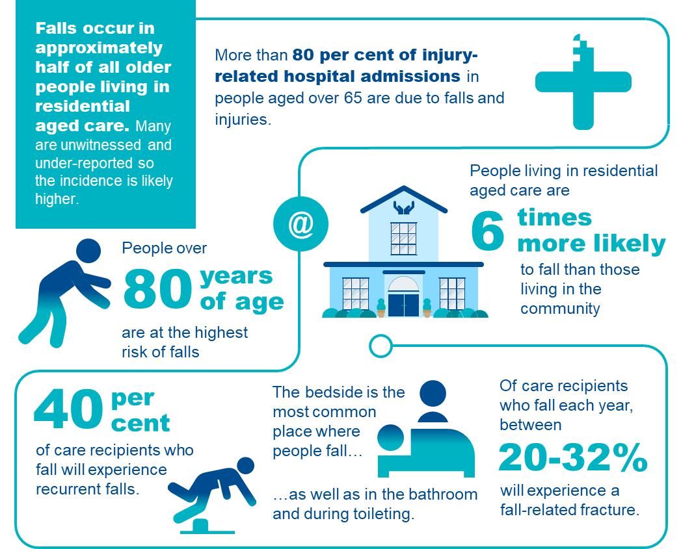

## Understanding falls and major injury in residential aged care

For the purposes of the QI Program, a fall is defined as an event that results in a person inadvertently coming to rest on the ground, floor or other lower level.[82] Under the QI Program, a fall resulting in major injury is a fall that meets the definition above and results in one or more of the following:

* bone fractures
* joint dislocation
* closed head injuries with altered consciousness
* subdural haematoma.[83]

Falls commonly occur as a result of a person **tripping**, **slipping** or **stumbling**.[84]

Details of the collection and reporting requirements for the falls and major injury quality indicator can be found in Part A.

## Adverse clinical events associated with falls and major injury

**Falls and major injury are a significant safety and quality risk across residential aged care**.

There are many negative consequences of falls, including **minor and major injury, pain, reduced physical functioning, decreased independence, psychological impacts, and occasionally death**.94 Figure 19 below outlines the common complications associated with falls in residential aged care.

Figure 19: COMMON COMPLICATIONS OF FALLS86 87 88

Common complications of falls include:
- Fractures
- Bruising and lacerations
- Joint dislocations
- Head injuries
- Psychological impacts
- Increased frailty[85] [86] [87]

## Risk factors of falls and major injury

Older Australians are at increased risk of falls and are also more likely to suffer an injury as a result of a fall. This is due to increased frailty, reduced mobility and muscle tone, as well as conditions commonly associated with older age, such as osteoporosis and osteopenia, which weaken bones and increase the risk of injuries occurring from a fall.[88] Poor nutrition also increases the risk of falls and major injury.[89] 94

There is a range of risk factors that place care recipients at increased risk of falling (see Figure 20 below). [90] [91] [92] [93] [94] Having a strong understanding of the risk factors is crucial to identify care recipients who are at risk of falling.

Figure 20: Risk factorS that increase a care recipient’s RISK of falling

Risk factors which place individuals at increased risk of falling include:
- History of previous falls
- Postural instability, unsteady gait or muscle weakness
- Cognitive impairment, delirium or altered behaviour
- increased urinary frequency and incontinence
- Low blood pressure, particularly postural hypotension
- Dizziness or fainting
- Use of sedatives and/or antipsychotic medicines
- Visual impairment
- Medical conditions which cause balance problems, such as vertigo or previous stroke.

## Prevention and management of falls and major injury, including prevention checklist

While not all falls (with and without injury) can be prevented, **awareness of risk factors and some simple steps** canreduce the risk of falling and an injury occurring.

There are three key focuses of falls prevention:

1. **To assess** an individual’s risk of falling through identifying specific risk factors.
2. **To implement** specific prevention programs or interventions to target these specific risk factors.
3. **To prevent injuries** in those people who do fall.

There are important aspects of care that can be considered to prevent and manage falls and injuries. Figure 21 below provides simple steps to identifying a care recipient’s falls risk and preventing falls and injuries from occurring.

Figure 21: RISK FACTORS AND PREVENTION AND MANAGEMENT STRATEGIES FOR FALLS

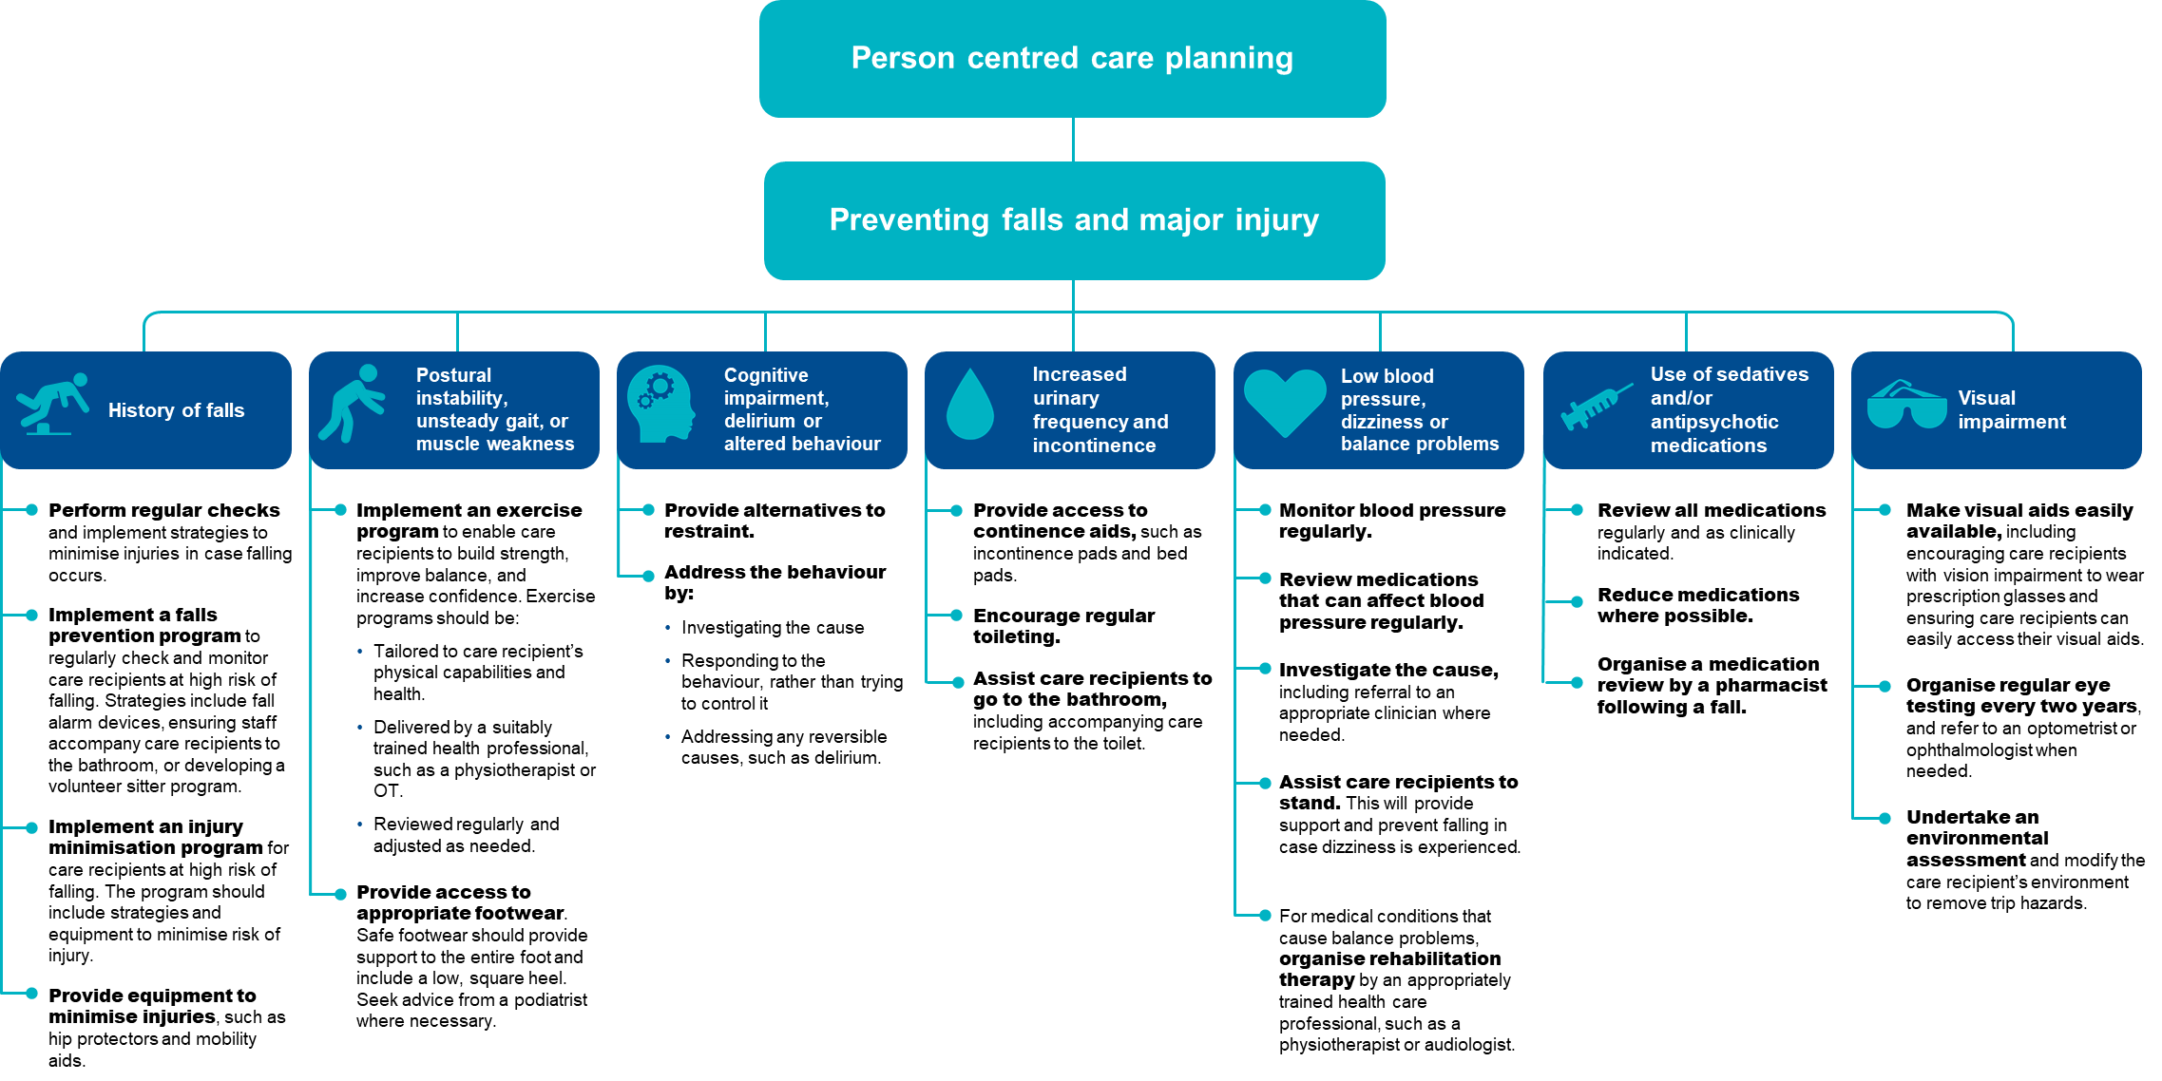

The checklist below will help to assess care recipients who are at risk of falls and major injury and identify prevention strategies to reduce the risk of falls and major injury occurring.

Figure 22: CHECKLIST FOR THE PREVENTION OF FALLS AND MAJOR INJURY

Checklist for the prevention of falls and major injury

|  |  |
| --- | --- |
| Step 1 | **Undertake an environmental review and modify as needed**   * + - Conduct a quarterly environmental review at the service level (e.g. in common areas or hallways).     - Conduct a quarterly review at the individual level (e.g. in bedrooms and bathrooms).     - Make modifications where hazards are identified. |
| Step 2 | **Undertake a falls risk assessment using a validated tool**   * + - When a care recipient is first admitted to a residential aged care service.     - After a care recipient has a fall.     - After a change in health status.     - On an annual basis for all care recipients. |
| Step 3 | **Document findings in a care plan**   * + - Outline the activities that will be undertaken to reduce the care recipient’s risk of falling.     - Document risk factors, including comorbidities and mobility status.     - Consider the care recipient’s personal preferences. |
| Step 4 | **Implement an appropriate prevention strategy based on the care recipient’s risk factors**   * + - Previous or history of falls: Implementing a falls surveillance program and/or injury minimisation program.     - Postural instability, unsteady gait or muscle weakness: Implement exercise programs and provide access to appropriate footwear.     - Cognitive impairment, delirium or altered behaviour: Provide alternatives to restraint and address the behaviour.     - Increased urinary frequency and incontinence: Provide continence management aids.     - Low blood pressure and postural hypotension: Regularly monitor and manage blood pressure.     - Dizziness or fainting: Assist with standing and seek advice from GP.     - Use of sedative and/or antipsychotic medications: Regularly review and reduce medications, including seeking advice from a pharmacist or GP. Reducing psychotropic use and polypharmacy     - Visual impairment: Provide access to visual aids and undertake regular environmental assessment.     - Medical conditions and medications which impair balance: Provide access to rehabilitation therapy. |
| Step 5 | **Undertake frequent reassessment to monitor risk**   * + - When new or changing risk factors are evident.     - Following any change to health status or wellbeing.     - After a care recipient has a fall.     - At least annually for all care recipients.     - Reassess prevention strategies and adjust care plans as needed. |

## Quality improvement mechanisms

Quality improvement can help providers increase the quality of care for care recipients at risk of falling.[95] Quality improvement activities should be ongoing and part of business-as-usual for approved providers.

The QI Program will help prompt when a specific quality improvement activity should be undertaken. It is important to review QI Program data reports through the provider portal and compare against national benchmarks and other services to understand where quality improvement activities should be focused.

The **Plan-Do-Check-Act tool** is a useful tool to plan, deliver and monitor quality improvement activities focused on preventing falls and minimising injuries.

**FALLS AND MAJOR INJURY**

Plan, Do, Check, Act Continuous Improvement Tool

|  | | | | ↑ CONTINUOUS IMPROVEMENT |  | |
| --- | --- | --- | --- | --- | --- | --- |
|  |  |  |  |  |  |
|  | |  |  | | |  |
| PLAN | |  | * + - **Develop a falls champion team to focus on delivering quality improvement activities for falls and major injury.** A multidisciplinary team is recommended, including personal care staff, healthcare professionals, and management staff to provide leadership and governance.     - **Ensure staff are adequately trained to assess, recognise, prevent and manage falls and major injury** including online training, on-the-job learning, core induction materials, hard copy resources *(refer to “Example tools, guidance and resources to support continuous quality improvement”*), and continuing professional development.     - **Develop an understanding of the prevalence of falls and major injury at your service using QI Program data** to understand if a targeted quality improvement activity is needed.     - **Collaborate with the multidisciplinary team to identify opportunities and plan quality improvement interventions that will prevent and reduce falls and injuries**. Depending on the individual circumstances of your service, quality improvement activities for falls and major injury may include additional training, updating equipment and/or updating policies to include assessment guidance.     - **Measure performance and impact of planned activities**. This includes developing process indicators, key performance indicators and targets so you can measure and monitor improvement or change. | | |  |
| DO | |  | * + - **Carry out your planned activities and falls/injury prevention strategies.** Initially, the activity may be trialled on one floor of the service or at one service of an approved provider, which will allow adjustments to be made.     - **Document key findings, information and data.** This includes documenting any changes to the planned activities. | | |
| CHECK | |  | * + - **Collect** information and evidence and use QI Program data to understand if prevention activities are making a difference.     - **Analyse** information, evidence and QI Program data to determine if the quality improvement activity is achieving the desired outcomes. | | |
| ACT | |  | * + - If the activity is successful, embed the falls/injury prevention activities into business‑as‑usual processes.     - If the activity is unsuccessful, identify why the activity was not successful and what can be done differently next time. Consider the need to seek expert advice or collaborate with other health professionals to identify ways to improve implementation.     - **Restart the Plan-Do-Check-Act tool** to develop and trial an improved quality improvement activity to reduce the prevalence of falls and injuries at your service, to improve outcomes for care recipients and ensure you are providing the best possible care. | | |
|  |  |  |  | CONTINUOUS IMPROVEMENT ↓ |  |  |

## Example tools, guidance and resources to support continuous quality improvement

* Preventing Falls and Harm from Falls in Older People. Best practice guidelines for Australian hospitals. Can be found on the Australian Safety and Quality Commission website here: [Guidelines-HOSP.pdf (safetyandquality.gov.au)](https://www.safetyandquality.gov.au/sites/default/files/migrated/Guidelines-HOSP.pdf)
* Standardised care process (SCP) – Falls. Can be found on the Victorian Department of Health website here: [Standardised care processes](https://www2.health.vic.gov.au/ageing-and-aged-care/residential-aged-care/safety-and-quality/improving-resident-care/standardised-care-processes#:~:text=A%20series%20of%20evidence-based%20standardised%20care%20processes%20%28SCPs%29,Evidence-based%20practice%20requires%20organisational%20readiness%20and%20change%20leadership.)
* Falls Risk Assessment Tool (FRAT), found online here: [Falls Risk Assessment Tool (FRAT) - health.vic](https://www2.health.vic.gov.au/about/publications/policiesandguidelines/falls-risk-assessment-tool)

*Some tools, guidance and resources may be updated over time; it is important to ensure you are looking at the most recent version.*

# Medication management - polypharmacy



Medication management plays a critical role in achieving quality of care for older Australians in aged care and hospital settings. The two categories within this quality indicator are:

1. Medication management – polypharmacy (this section), and
2. Medication management – antipsychotics (see Section 8 of this manual).

## Overview of polypharmacy

In residential aged care, polypharmacy describes when care recipients are taking more medications than can be practically and safely consumed. Polypharmacy in older Australians can increase negative health outcomes.[96] [97]

Figure 23: Polypharmacy in residential aged care services

Research demonstrates that instances of older Australians regularly using 5 or more unique medications has increased from 2006 to 2017 by 52% with 36% of older Australians being affected in 2017.

## Polypharmacy in residential aged care

Medication is defined as a chemical substance given with the intention of preventing, diagnosing, curing, controlling or alleviating disease or otherwise enhancing the physical and/or mental welfare of people. For the purpose of the QI Program, it includes prescription and non-prescription medicines, including complementary health care products, irrespective of the administered route.

For the purposes of the QI Program, polypharmacy is defined as the prescription of nine or more medications to a care recipient.

For the purposes of the QI Program, any medication with an active ingredient is counted in the polypharmacy quality indicator, except for those listed below which must not be included in the count of medications:

* Lotions, creams or ointments used in skin and wound care
* Dietary supplements, including those containing vitamins
* Short-term medications, such as antibiotics or temporary eye drops
* PRN medications.

Different dosages of the same medicine must not be counted as different medications.

Details of the collection and reporting requirements for the polypharmacy category of the medication management quality indicator can be found in Part A.

## Causes of polypharmacy

Polypharmacy is an increasing concern amongst care recipients in residential aged care services, and elderly people in general. Older Australians are often prescribed several medications to manage comorbidities and extend life, but there is evidence that the prevalence of polypharmacy is increasing amongst older Australians.

Figure 24: Risk factors associated to polypharmacy[98]

**Older Australians are at risk of polypharmacy for a variety of reasons:**

**As people age, they experience an increase in disease and chronic pain. This promotes the prescription of multiple medicines to address these age-related health issues.
Older Australians often have several prescribers involved in their care as they interact with a variety of GPs and specialists. An older person's number of medications is known to increase with the number of prescribers involved in their care.
There is limited data surrounding medications for older people. To inform the prescription of medication, evidence from clinical trials that don't include older people are extrapolated and applied to address health challenges in older Australians, often with multimorbidity.
Older Australians are vulnerable to a prescribing cascade. This is when medications are prescribed to treat adverse effects from other medications, which are wrongly interpreted as symptoms of a new condition.
In older people, there is a tendency for medications to be prescribed even when they are no longer needed. Clinicians can be reluctant to deprescribe these medications due to:
- clinical complexity
- incomplete information on the rationale for medications
- ambiguous or frequently changing are goals
uncertainty about the harms of continuing or stopping medications
- perception that it is the responsibility of another clinician
- lack of defined processes for deprescribing.
**

## Adverse clinical events of polypharmacy

As people age, they are more sensitive to the effects of medication. This is exacerbated when they are prescribed multiple medications. Older Australians have an increased risk of experiencing adverse drug reactions (ADRs) due to physiological changes impacting how medicine is adsorbed, distributed, metabolised and eliminated. An older person’s risk of an ADR increases with the number of medications they are prescribed.

Figure 25: Common complications associated with polypharmacy

Common complications associated with polypharmacy include;
- falls and associated harms, such as fractures
- dehydration
- functional decline
- cognitive impairment
- delirium
- declining nutritional status
- adverse drug reactions
- toxicity
- hospitalisation
- death
- drug interactions
- medical errors due to complex medication

## Prevention and management of polypharmacy, including prevention checklist

The prescription, supply and administration of medicines is strictly regulated for safety and quality of care. Various health professionals are involved in this process to promote safe and quality use of medicines in residential aged care services. Care recipients should understand and be involved in their own medication management and consent.

Figure 26 below discusses strategies to manage and prevent polypharmacy.

Figure 26: Prevention strategies for polypharmacy

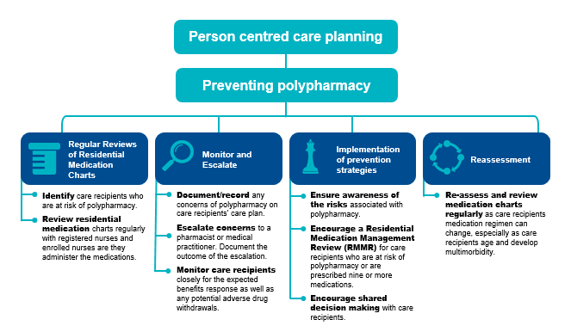

The checklist below will help to assess and involve care recipients who are at risk of polypharmacy and identify prevention strategies to reduce the risk of polypharmacy from occurring.

Figure 27: Checklist for prevention of polypharmacy

Checklist for prevention of polypharmacy

|  |  |
| --- | --- |
| Step 1 | **Complete Regular Reviews of Residential Medication Charts**   * + - Aged care service staff are key to identifying care recipients who are at risk of polypharmacy or are already prescribed nine or more medications.     - Regular review of residential medication charts by registered nurses and enrolled nurses as they administer medications. Escalate to pharmacist or medical practitioner where appropriate.     - Review care recipient’s medication charts for medication changes upon return from hospital admissions. |
| Step 2 | **Document, Monitor and Escalate Instances of Polypharmacy**   * + - Document/record concerns of polypharmacy on a care recipient’s care plan and escalate to a pharmacist or medical practitioner. The outcome of this escalation should also be documented and planned for in the care recipient’s care plan.     - Monitor the care recipient closely for the expected benefits response as well as potential adverse drug withdrawals. A carer or enrolled nurse should discuss concerns of polypharmacy with the registered nurse so the escalation process to the pharmacist or medical practitioner is initiated for review. |
| Step 3 | **Implement prevention strategies**  **Educate staff and promote awareness about polypharmacy**   * + - Remain aware of the risks associated with polypharmacy. Programs supporting awareness and understanding of deprescribing and polypharmacy are effective in promoting safer medication regimens as staff play an active role in monitoring care recipients’ residential medication charts.   **Encourage Residential Medication Management Reviews** *(refer to “Example tools, guidance and resources to support continuous quality improvement”)*   * + - Encourage a Residential Medication Management Review (RMMR) for care recipients who are at risk of polypharmacy or are prescribed nine or more medications.     - Collaborate with medical practitioners and pharmacists to perform a RMMR for a residential care recipient. These medication management services are subsidised by Medicare.   **Encourage shared decision making with care recipients**   * + - Discuss medication needs with the care recipient to understand their perspective and support their participation in making decisions (where possible).   **Escalate concerns of polypharmacy for consideration of deprescribing (where appropriate)**   * + - Escalate concerns of polypharmacy to a pharmacist or medical practitioner. The purpose of this is to target medications no longer beneficial to the care recipient, reduce complexity in their medication regime and prevent consequences of a high-risk medication.     - Deprescribing can only be actioned by a medical practitioner and must be reflected in the care recipient’s medication chart. |
| Step 4 | **Undertake Frequent Reassessment of Residential Medication Charts**   * + - Re-assess and review regularly as a care recipient’s medication regimen can change regularly, especially as care recipients age and develop multimorbidity. |

## Quality improvement for polypharmacy

Quality improvement can help providers increase the quality of care for care recipients at risk of polypharmacy. Quality improvement activities should be ongoing and part of business-as-usual for approved providers.

The QI Program will help prompt when a specific quality improvement activity should be undertaken.

It is important to review QI Program data reports through the provider portal and compare against national benchmarks and other services to understand where quality improvement activities should be focussed.

The **Plan-Do-Check-Act tool** is a useful tool to plan, deliver and monitor quality improvement activities focused on preventing and reducing polypharmacy.

**POLYPHARMACY**

Plan, Do, Check, Act Continuous Improvement Tool

|  | | | | ↑ CONTINUOUS IMPROVEMENT |  | |
| --- | --- | --- | --- | --- | --- | --- |
|  |  |  |  |  |  |
|  | |  |  | | |  |
| PLAN | |  | * + - **Develop a polypharmacy champion team to focus on delivering quality improvement activities for polypharmacy.** A multidisciplinary team is recommended, including personal care staff, healthcare professionals, and management staff to provide leadership and governance.     - **Ensure staff are adequately trained to assess, recognise, prevent and manage polypharmacy** including online training, on-the-job learning, core induction materials, hard copy resources *(refer to “Example tools, guidance and resources to support continuous quality improvement”*).     - **Develop an understanding of the prevalence on polypharmacy at your service using QI Program data** to understand if a targeted quality improvement activity is needed.     - **Collaborate with the multidisciplinary team to identify opportunities and plan quality improvement interventions that will prevent and reduce polypharmacy**. Depending on the individual circumstances of each service, quality improvement activities for reducing polypharmacy may include additional training, updating equipment and/or updating policies to include assessment guidance, including: * non-medicinal preventative and intervention strategies * regular reviews of care recipient medication charts * documenting instances of polypharmacy on a care recipient’s care plan * formal processes for escalation of polypharmacy to medical practitioners * documenting outcomes of escalation.   + - **Measure performance and impact of planned activities** including developing process indicators, key performance indicators and targets so you can measure and monitor improvement or change. | | |  |
| DO | |  | * + - **Carry out your planned activities and polypharmacy prevention strategies.** Initially, the activity may be trialled at one floor of the service or at one service of an approved provider, which will allow adjustments to be made.     - **Document key findings, information and data**. This includes documenting any changes to the planned activities. | | |
| CHECK | |  | * + - **Collect** information and evidence and use QI Program data to understand if prevention activities are making a difference.     - **Analyse** information, evidence and QI Program data to determine if the quality improvement activity is achieving the desired outcomes. | | |
| ACT | |  | * + - If the activity is successful, embed the polypharmacy prevention activities into business‑as‑usual processes.     - If the activity is unsuccessful, identify why the activity was not successful and what can be done differently next time. Consider the need to seek expert advice or collaborate with other health professionals to identify ways to improve implementation.     - **Restart the Plan-Do-Check-Act tool** to develop and trial an improved quality improvement activity to reduce the prevalence of polypharmacy at your service, to improve outcomes for care recipients and ensure you are providing the best possible care. | | |
|  |  |  |  | CONTINUOUS IMPROVEMENT ↓ |  |  |

## Example tools, guidance and resources to support continuous quality improvement

* Further information on current medications used in Australia can be found on [**Australian Medicines Handbook**](https://amhonline.amh.net.au/auth)
* Another source of medications available can be found in [**Monthly Index of Medical Specialties (MIMS) Australia**](https://www.mims.com.au/index.php/products/mims-online)
* [**The Fourth Australian Atlas of Healthcare Variation: Polypharmacy, 75 years and over**](https://www.safetyandquality.gov.au/sites/default/files/2021-04/fourth_atlas_2021_-_6.1_polypharmacy_75_years_and_over.pdf)explores the effects of polypharmacy in older Australians.
* [**Older Persons Advocacy Network**](https://opan.org.au/yourchoice/)organisations provide information about aged care service provision and the rights and responsibilities of consumers of Commonwealth funded aged care services.

*Some tools, guidance and resources may be updated over time; it is important to ensure you are looking at the most recent version.*

# Medication management - antipsychotics



Medication management plays a critical role in achieving quality of care for older Australians in aged care and hospital settings. The two categories within this quality indicator are:

1. Medication management – polypharmacy (see Section 7 of this manual); and
2. Medication management – antipsychotics (this section).

## Overview of antipsychotics

Medication management is critical for residential aged care as older Australians are often prescribed several medications to manage comorbidities and extend life, being particularly vulnerable to the significant risks of antipsychotics.

Figure 28: antipsychotics in residential aged care services [99][100]

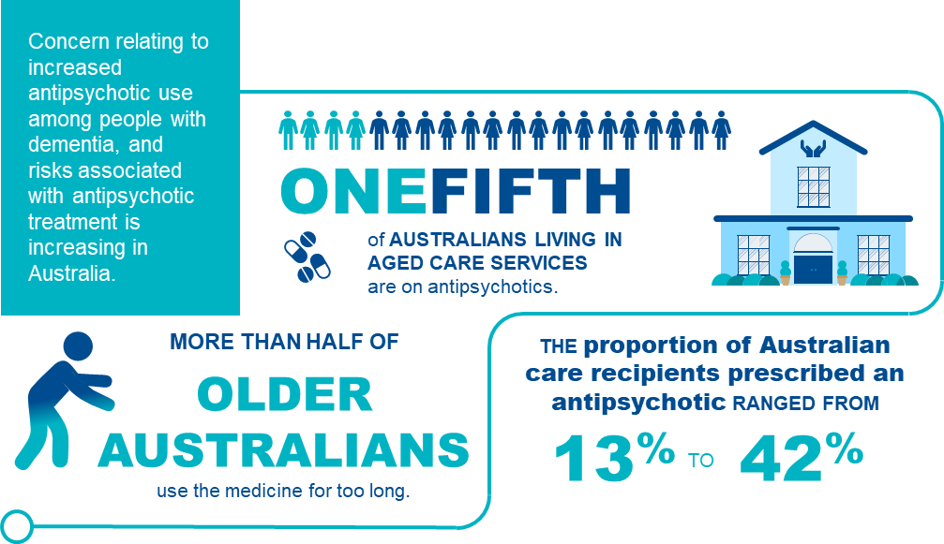

## Antipsychotic use in residential aged care

Antipsychotics are medications prescribed for the treatment of a diagnosed condition of psychosis. Antipsychotic medication is often prescribed to older Australians to manage the behavioural and psychological symptoms of dementia.

The following is a non-exhaustive list of antipsychotics:

* Amisulpride
* Aripiprazole
* Asenapine
* Brexpiprazole
* Chlorpromazine
* Clozapine
* Droperidol
* Flupentixol
* Haloperidol
* Lurasidone
* Olanzapine
* Paliperidone
* Periciazine
* Quetiapine
* Risperidone
* Trifluoperazine
* Ziprasidone
* Zuclopenthixol.

*\* List of antipsychotics approved for use in Australia can be updated at any time so reviewing the list alongside updated evidence-based sources is advised.*

Regular monitoring of the use of antipsychotics is important because the inappropriate use of certain medication classes, such as antipsychotics, has been shown to be associated with poor health outcomes.

Details of the collection and reporting requirements for the antipsychotics category of the medication management quality indicator can be found in Part A.

## Adverse clinical events of antipsychotics

The adverse effects of antipsychotic medications range from those that are relatively minor to others that are very unpleasant, painful, disfiguring or life-threatening. Figure 29 below explores the adverse clinical effects of antipsychotic use.

Figure 29: Significant adverse effects of antipsychotics

Significant adverse effects of antipsychotics include;
- falls and associated harms
- sedation
- extrapyramidal symptoms
- tardive syndrome
- death

Research suggests that antipsychotic medications are frequently prescribed off-label for the behavioural and psychological symptoms of dementia.[101] [102] However, antipsychotics that are not beneficial or are not required should be discontinued.

## Risk factors of antipsychotic use

Older Australians are significantly more vulnerable to the significant risks associated with antipsychotic use due to age-related issues. Having a strong understanding of the risk factors is crucial to identify care recipients who are particularly at risk with antipsychotic use. The risk factors associated with the use of antipsychotics in residential aged care services are explored in Figure 30 below.

Figure 30: Risk factors associated with antipsychotic use in residential aged care services [103][104][105][106][107][108]

Risk factors associated with antipsychotic use in residential aged care services include:
- constipation
 dry mouth
- blurred vision
- urinary retention
- involuntary movement
- falls.

## Prevention and management of antipsychotic use, including prevention checklist

Antipsychotic prescribing increases markedly once an older person is admitted into residential aged care, and there is evidence that up to 42% of older Australians in residential aged care services are regularly prescribed an antipsychotic.[109] [110]

Figure 31 below explores strategies for managing antipsychotics use.

Figure 31: prevention strategies FOR antipsychoticS usePrevention strategies for antipsychotic use include:
- non-pharmacologic intervention
- alternate options/ medications
- lower the dose
- switch antipsychotic

Complications from antipsychotics are treatment dependent. Complications can arise from the choice of antipsychotic, the dose used, the duration of exposure, the other medications the person is taking and the particular sensitivity of the individual to complications.

If the intended use of antipsychotics is for chemical restraint, providers are required to have a behaviour support plan in place. Section 4 of this Manual provides further information about physical restraint.

The checklist overleaf will help to assess care recipients who are at risk of antipsychotic use and identify prevention strategies to reduce the risk of antipsychotic use from occurring:

Figure 32: Checklist for prevention of antipsychotic use

Checklist for prevention of antipsychotic use

|  |  |
| --- | --- |
| Step 1 | **Complete Regular Reviews of Residential Medication Charts**   * + - Identify care recipients who are taking antipsychotic medications.     - Regular review of care recipient medication charts by registered nurses and enrolled nurses as they administer medications. Escalate to pharmacist or medical practitioner where appropriate.     - Ensure care recipients’ medication charts are reviewed upon returning from the hospital as there could be significant medication changes. |
| Step 2 | **Document, Monitor and Escalate Instances of Antipsychotic**   * + - Document/record concerns of antipsychotic use on a care recipient’s care plan and escalate to a pharmacist or medical practitioner. The outcome of this escalation should also be documented and planned for in the care recipient’s care plan.     - Monitor the care recipient closely for changes in behaviour. A carer or enrolled nurse should discuss concerns of antipsychotic use with the registered nurse so the escalation process to the pharmacist or medical practitioner is initiated for review. |
| Step3 | **Implement prevention strategies**  **Educate staff and promote awareness about antipsychotic use**   * + - Remain aware of the risks associated with antipsychotic use. Programs supporting awareness and understanding of antipsychotic use are effective in promoting safer medication regimens as staff play an active role in monitoring care recipients’ residential medication charts.   **Encourage Residential Medication Management Reviews** *(refer to “Example tools, guidance and resources to support continuous quality improvement”)*   * + - Encourage a Residential Medication Management Review (RMMR) for care recipients who are at risk with antipsychotic use.     - Collaborate with medical practitioners and pharmacists to perform a RMMR for a care recipient of residential aged care. These medication management services are subsidised by Medicare.   **Encourage shared decision making with care recipients**   * + - Discuss antipsychotic needs with the care recipient to understand their perspective and support their participation in making decisions (where possible).   **Escalate concerns of antipsychotic use for consideration of deprescribing or change in medication (where appropriate)**   * + - Escalate concerns of antipsychotic use to a pharmacist or medical practitioner. The purpose of this is to assess if the antipsychotic medication is no longer beneficial to the care recipient, reduce complexity in their medication regime and prevent consequences of a high‑risk medication.     - Deprescribing and change in medications can only be actioned by a medical practitioner and must be reflected in the care recipient’s medication chart. |
| Step 4 | **Undertake Frequent Reassessment of Residential Medication Charts**   * + - Re-assess and review regularly care recipient’s medication charts as regimen can change regularly, especially as care recipients age and develop multimorbidity. |

## Quality improvement for antipsychotic use

Quality improvement can help providers increase the quality of care for care recipients at risk of antipsychotic use. Quality improvement activities should be ongoing and part of business-as-usual for approved providers.

The QI Program will help prompt when a specific quality improvement activity should be undertaken. It is important to review QI Program data reports through the provider portal and compare against national benchmarks and other services to understand where quality improvement activities should be focussed.

The **Plan-Do-Check-Act tool** is a useful tool to plan, deliver and monitor quality improvement activities focused on preventing and reducing antipsychotic use.

**ANTIPSYCHOTICS**

Plan, Do, Check, Act Continuous Improvement Tool

|  | | | | ↑ CONTINUOUS IMPROVEMENT |  | |
| --- | --- | --- | --- | --- | --- | --- |
|  |  |  |  |  |  |
|  | |  |  | | |  |
| PLAN | |  | * + - **Develop an antipsychotics champion team to focus on delivering quality improvement activities for antipsychotics use.** A multidisciplinary team is recommended, including personal care staff, healthcare professionals, and management staff to provide leadership and governance.     - **Ensure staff are adequately trained to assess, recognise, prevent and manage antipsychotics** including online training, on-the-job learning, core induction materials, hard copy resources (refer to *Example tools, guidance and resources to support continuous quality improvement*).     - **Develop an understanding of the prevalence of antipsychotics at your service using QI Program data** to understand if a targeted quality improvement activity is needed.     - **Collaborate with the multidisciplinary team to identify opportunities and plan quality improvement interventions that will prevent and reduce antipsychotics use**. Depending on the individual circumstances of your service, quality improvement activities for reducing antipsychotics use may include additional training, updating equipment and/or updating policies to include assessment guidance. This could include updating your service’s policies to include: * non-medicinal preventative and intervention strategies * regular reviews of residential medication charts * documenting instances of antipsychotic use on a care recipient’s care plan * formal processes for escalation of antipsychotic use to medical practitioners * documenting outcomes of escalation.   + - **Measure performance and impact of planned activities**.This includes developing process indicators, key performance indicators and targets so you can measure and monitor improvement or change. | | |  |
| DO | |  | * + - **Carry out your planned activities and antipsychotic use prevention strategies.** Initially, the activity may be trialled at one floor of the service or at one service of an approved provider, which will allow adjustments to be made.     - **Document key findings, information and data**. This includes documenting any changes to the planned activities.     - **Use Antipsychotic Tracking Tool (APTT)** which has been developed to monitor antipsychotics usage in aged care services. | | |
| CHECK | |  | * + - **Collect** information and evidence and use QI Program data to understand if prevention activities are making a difference.     - **Analyse** information, evidence and QI Program data to determine if the quality improvement activity is achieving the desired outcomes. | | |
| ACT | |  | * + - If the activity is successful, embed the antipsychotics prevention activities into business‑as‑usual processes.     - If the activity is unsuccessful, identify why the activity was not successful and what can be done differently next time. Consider the need to seek expert advice or collaborate with other health professionals to identify ways to improve implementation.     - **Restart the Plan-Do-Check-Act tool** to develop and trial an improved quality improvement activity to reduce the prevalence of antipsychotics use at your service, to improve outcomes for care recipients and ensure you are providing the best possible care. | | |
|  |  |  |  | CONTINUOUS IMPROVEMENT ↓ |  |  |
|  |  |  |  |  |  |

## Example tools, guidance and resources to support continuous quality improvement

* [**Guide to deprescribing antipsychotics for treatment of behavioural and psychological symptoms of dementia**](https://www.nswtag.org.au/wp-content/uploads/2018/06/1.2-Deprescribing-Guide-for-Antipsychotics-for-Treatment-of-Behavioural-and-Psychological-Symptoms-of-Dementia.pdf) – This guide provides deprescribing information that can be applied to written and/or verbal communication (in the form of “preferred language”) between clinicians, patients and/or carers. Adapt appropriately for individual care recipients.
* [**Antipsychotic Tracking Tool**](https://dta.com.au/medication-tool-to-monitor-antipsychotic-use-in-residential-aged-care/) – Dementia Training Australia has developed a tool to help aged care providers monitor their use of antipsychotic medications.
* Further information on current medications used in Australia can be found on [**Australian Medicines Handbook**](https://amhonline.amh.net.au/auth)
* Another source of medications available can be found in [**Monthly Index of Medical Specialties (MIMS) Australia**](https://www.mims.com.au/index.php/products/mims-online)
* [**Severe Behaviour Response Teams (SBRT)**](https://dementia.com.au/services/severe-behaviour-response-teams-sbrt) – 24/7 contact with a Dementia Consultant on 1800 699 799 to access SBRT service.
* [**Dementia Behaviour Management Advisory Service (DBMAS)**](https://dementia.com.au/services/dementia-behaviour-management-advisory-service-dbas)- 24/7 contact with a Dementia Consultant on 1800 699 799 for advice or to make a referral.

*Some tools, guidance and resources may be updated over time; it is important to ensure you are looking at the most recent version.*

# Endnotes

1. Batalden PB and Davidoff F. What is “quality improvement” and how can it transform healthcare? BMJ Quality & Safety 2007; 16(2-3).
2. Aged Care Quality and Safety Commission. 2021. Continuous improvement. Sourced. https://www.agedcarequality.gov.au/providers/assessment-processes/continuous-improvement>
3. Bogaisky M, Dezieck L. Early hospital readmission of nursing home care recipients and community-dwelling elderly adults discharged from the geriatrics service of an Urban teaching hospital: Patterns and risk factors. J Am Geriatr Soc, 2015; 63(3): 548-552.
4. Jeon Y-H, Casey A-N, Fethney J, Poole B, Vo K, Rogers K. Associations between clinical indicators of quality and aged-care care recipients' needs and consumer and staff satisfaction: the first Australian study. Aust Health Rev. 2019;43(2):133-41.
5. Ferguson C, Prentice J, Crouchley K, Ling A, Mason L. Pressure injury point prevalence: state-wide survey to identify variability in Western Australia hospitals. Australian Journal of Advanced Nursing, 2019; 36(4): 31.
6. Stevenson R, Collinson M, Henderson V, Wilson L, Dealey C, McGinnis E, Briggs M, Nelson EA, Stubbs N, Coleman S, Nixon J. The prevalence of pressure ulcers in community settings: An observational study. Int J Nurs Stud, 2013.
7. Clinical Excellence Commission. 2018 NSW Pressure Injury Point Prevalence Survey Report, 2019; Sydney: 9.
8. Jorgensen M, Siette J, Georgiou A, Westbrook J. Longitudinal variation in pressure injury incidence among long-term aged care facilities. International Journal for Quality in Health Care, 2018; 30(9): 684-691.
9. Australian Wound Management Association (2014).
10. European Pressure Ulcer Advisory Panel, National Pressure Injury Advisory Panel and Pan Pacific Pressure Injury Alliance. Prevention and Treatment of Pressure Ulcers/Injuries: Clinical Practice Guideline. The International Guideline. Emily Haesler (Ed.). EPUAP/NPIAP/PPPIA: 2019.
11. Prevention and Treatment of Pressure Ulcers/Injuries: Clinical Practice Guideline 2019
12. National Institute for Healthcare Excellence, 2018. Quick guide: Helping to prevent pressure ulcers. Sourced: https://www.nice.org.uk/about/nice-communities/social-care/quick-guides/helping-to-prevent-pressure-ulcers
13. Baharestani MM, Ratcliff CR. Pressure ulcers in neonates and children: an NPUAP white paper. Adv Skin Wound Care, 2007; 20(4): 208.
14. Shaked E, Gefen A. Modeling the effects of moisture-related skin-support friction on the risk for superficial pressure ulcers during patient repositioning in bed. Front Bioeng Biotechnol, 2013; 14(1): 9.
15. Royal Children’s Hospital. Clinical Guidelines (Nursing). Nursing Clinical Effectiveness Committee. 2019; Melbourne.
16. Jackson DE, Durrant LA, Hutchinson M, Ballard CA, Neville S, Usher K. Living with multiple losses: Insights from patients living with pressure injury. Collegian, 2017.
17. Gorecki C, Brown JM, Nelson EA et al (2009) Impact of pressure ulcers on quality of life in older patients: a systematic review. J Am Geriatr Soc 57:1175–1183.
18. Black JM, Berke CT. Deep Tissue Pressure Injuries: Identification, Treatment, and Outcomes Among Critical Care Patients. Crit Care Nurs Clin North Am. 2020; 32(4): 563-572.
19. Labeau SO, Afonso E, Benbenishty J, et al. Prevalence, associated factors and outcomes of pressure injuries in adult intensive care unit patients: the DecubICUs study. Intensive Care Med. 2021;47(2):160-169. doi:10.1007/s00134-020-06234-9.
20. Haesler E, Cuddigan J, Kottner J, Carville K. Guideline Governance Group, International consumer engagement in pressure injury/ulcer guideline development: Global survey of patient care goals and information needs, in National Pressure Ulcer Advisory Panel 2019 Annual Conference. 2019: St Louis.
21. A pressure injury can provide an inlet for bacteria to enter the body and cause osteomyelitis. Osteomyelitis is an infection of the bone and may be acute or chronic.
22. Galhardo VAC, Magalhaes MG, Blanes L, Juliano Y, Ferreira LM. Health-related quality of life and depression in older patients with pressure ulcers. Wounds: A Compendium of Clinical Research & Practice, 2010; 22(1): 20-26.
23. Essex HN, Clark M, Sims J, Warriner A, Cullum N. Health-related quality of life in hospital inpatients with pressure ulceration: assessment using generic health-related quality of life measures. Wound Repair and Regeneration, 2009; 17(6): 797-805.
24. Nguyen BEcon, MEcon, PhD K-H, Chaboyer RN, PhD W, Whitty BPharm, GradDipClinPharm, PhD JA. Pressure injury in Australian public hospitals: a cost-of-illness study. Aust Heal Rev. 2015;39(3):329-336.
25. Perneger T, Gaspoz J, Borst F, Vitek O. Screening for pressure ulcer risk in an acute care hospital: development of a brief bedside scale. J Clin Epidemiol, 2002; 55(5): 498-504.
26. Tescher AN, Branda ME, Byrne TJ, Naessens JM. All at-risk patients are not created equal: Analysis of Baden pressure ulcer risk scores to identify specific risks. J Wound Ostomy Continence Nurs, 2012; 39(3): 282-291.
27. Braden B, Bergstrom N. A conceptual schema for the study of the etiology of pressure sores. Rehabil Nurs, 1987; 12(1): 8-12.
28. Lin S, Hey HWD, Lau ETC, Tan KA, Thambiah JS, Lau LL, Kumar N, Liu KPG, Wong HK. Prevalence and predictors of pressure injuries from spine surgery in the prone position. Spine (Phila Pa 1976), 2017; 42(22): 1730-1736.
29. Smith IL, Brown S, McGinnis E, Briggs M, Coleman S, Dealey C, Muir D, Nelson EA, Stevenson R, Stubbs N, Wilson L, Brown JM, Nixon J. Exploring the role of pain as an early predictor of category 2 pressure ulcers: A prospective cohort study. BMJ Open, 2017; 7(1): e013623.
30. Dobos F, Gefen A, Blume-Peytavi U, Kottner J. Weight-bearing-induced changes in the microtopography and structural stiffness of human skin in vivo following immobility periods. Wound Repair Regen, 2015; 23(1): 37-43.
31. Verbrugghe M, Beeckman D, Van Hecke A, Vanderwee K, Van Herck K, Clays E, Bocquaert I, Derycke H, Geurden B, Verharghe S. Malnutrition and associated factors in nursing home care recipients: A cross sectional, multi-centre study. Clin Nutr, 201; 32(3): 438-443.
32. White J. Consensus Statement: AND and ASPEN: Characteristics recommended for the identification and documentation of adult malnutrition (undernutrition). J Acad Nutr Diet, 2012; 112(5): 730-738.
33. Saghaleini SH, Dehghan K, Shadvar K, Sanaie S, Mahmoodpoo A, Ostadi Z. Pressure ulcer and nutrition. Indian J Crit Care Med, 2018; 22(4): 283-289.
34. Unplanned weight loss is defined as weight loss equal to or greater than 5 per cent over a three-month period, or weight loss of any amount every month over three consecutive months.
35. Dorner B, Posthauer ME, Thomas D; National Pressure Ulcer Advisory Panel. The role of nutrition in pressure ulcer prevention and treatment: National Pressure Ulcer Advisory Panel white paper. Adv Skin Wound Care 2009;22:212‑21.
36. Vilhena L, Ramalho A. Friction of human skin against different fabrics for medical use. Lubricants, 2016; 4(1): doi.org/10.3390/lubricants4010006.
37. Klaassen M, Schipper D, Masen M. Influence of the relative humidity and the temperature on the in-vivo friction behaviour of human skin. Biotribology, 2016; 6: 21-28.
38. Nassaji M, Askari Z, Ghorbani R. Cigarette smoking and risk of pressure ulcer in adult intensive care unit patients. Int J Nurs Pract, 2014; 20(4): 418-23.
39. Nixon J, Nelson EA, Cranny G, Iglesias CP, Hawkins K, Cullum NA, Phillips A, Spilsbury K, Torgerson DJ, Mason S, PRESSURE Trial Group. Pressure relieving support surfaces: a randomised evaluation. Health Technol Assess, 2006; 10(22): iii-x, 1.
40. Ranzani OT, Simpson ES, Japiassu AM, Noritomi DT, Amil Critical Care G. The challenge of predicting pressure ulcers in critically ill patients. A multicentre cohort study. Annals of the American Thoracic Society, 2016; 13(10): 1775‑1783.
41. de Souza D, de Gouveia SV. Incidence of pressure ulcers in the institutionalized elderly. Journal of Wound, Ostomoy and Continence Nursing: Official Publication of the Wound, Ostomy and Continence Nurses Society / WOCN, 2010; 37(3): 272-276.
42. Smith IL, Brown S, McGinnis E, Briggs M, Coleman S, Dealey C, Muir D, Nelson EA, Stevenson R, Stubbs N, Wilson L, Brown JM, Nixon J. Exploring the role of pain as an early predictor of category 2 pressure ulcers: A prospective cohort study. BMJ Open, 2017; 7(1): e013623.
43. Nixon J, Nelson EA, Cranny G, Iglesias CP, Hawkins K, Cullum NA, Phillips A, Spilsbury K, Torgerson DJ, Mason S, PRESSURE Trial Group. Pressure relieving support surfaces: a randomised evaluation. Health Technol Assess, 2006; 10(22): iii-x, 1.
44. Abrampah NM, Syed SB, Hirschhorn LR, Nambiar B, Iqbal U, Garcia-Elorrio E, Chattu VK, Devnani M, Kelley E. Quality improvement and emerging global health priorities. International Journal for Quality in Health Care, 2018; 30(1): 5-9.
45. Nelson EC, Batalden PB, Godfrey MM. Quality by design. San Francisco, CA: Jossey-Bass; 2007.
46. Institute for Healthcare Improvement. How to improve, 2021. Sourced at http://www.ihi.org/resources/Pages/HowtoImprove/default.aspx
47. Family and Community Services. Restrictive Practices Guidance Physical Restraint. Sourced at Restrictive Practices Resources physical restraint guidance (nsw.gov.au)
48. Bellenger E, Ibrahim JE, Bugeja L, Kennedy B. [Physical restraint deaths in a 13-year national cohort of nursing home care recipients. Oxford Academic,](https://academic.oup.com/ageing/article/46/4/688/2801280) 2017, 46(4): 688-693
49. Australian Government Aged Care Quality and Safety Commission. Minimising Restraint in Residential Care storyboard and user guide, 2020. Sourced at Minimising Restraint in Residential Care storyboard and user guide | Aged Care Quality and Safety Commission
50. Victoria State Government Health and Human Services. Physical restraint standardised care process, 2018. Sourced at https://www2.health.vic.gov.au/~/media/Health/Files/Collections/Factsheets/S/SCP%20Physical%20restraint%20pdf
51. Burns K, Jayasinha R, Tsang R, Brodaty H. Behaviour Management: A Guide to Good Practice Managing Behavioural and Psychological Symptoms of Dementia (BPSD). 2012, Dementia Collaborative Research Centre: Kensington, NSW.
52. Department of Veterans’ Affairs, 2019, Veterans’ Mates—Helping your patients with cognitive impairment to live well at home. Sourced https://www.veteransmates.net.au/topic-54-therapeutic-brief.
53. Burns K, Jayasinha R, Tsang R, Brodaty H. Behaviour Management: A Guide to Good Practice Managing Behavioural and Psychological Symptoms of Dementia (BPSD). 2012, Dementia Collaborative Research Centre: Kensington, NSW.
54. Department of Veterans’ Affairs, 2019, Veterans’ Mates—Helping your patients with cognitive impairment to live well at home. Sourced https://www.veteransmates.net.au/topic-54-therapeutic-brief.
55. Abrampah NM, Syed SB, Hirschhorn LR, Nambiar B, Iqbal U, Garcia-Elorrio E, Chattu VK, Devnani M, Kelley E. Quality improvement and emerging global health priorities. International Journal for Quality in Health Care, 2018; 30(1): 5-9.
56. Nelson EC, Batalden PB, Godfrey MM. Quality by design. San Francisco, CA: Jossey-Bass; 2007.
57. Institute for Healthcare Improvement. How to improve, 2021. Sourced at http://www.ihi.org/resources/Pages/HowtoImprove/default.aspx
58. Flanagan D, Fisher T, Murray M, Visvanathan R, Charlton K, Thesing C, Quigley G, Walther K. Managing undernutrition in the elderly Australian Family Physician. Australian Family Physician, 2012, 41(9): 695-699.
59. Huffman GB. Evaluating and treating unintentional weight loss in the elderly. American Family Physician, 2002, 65(4): 640-50.
60. Mayo Clinic. Senior health: How to prevent and detect malnutrition, 2019. Sourced at https://www.mayoclinic.org/healthy-lifestyle/caregivers/in-depth/senior-health/art-20044699
61. Hugo C, Isenring E, Sinclair D, Agarwal E. What does it cost to feed aged care care recipients?. Nutrition and Dietetics, 2018, 75: 6-10
62. Agarwal E, Marshall S, Miller M, Isenring E. Optimising nutrition in residential aged care: A narrative review. Maturitas, 2016, 92: 70-78
63. Huffman GB. Evaluating and treating unintentional weight loss in the elderly. American Family Physician, 2002, 65(4): 640-50.
64. Mayo Clinic. Senior health: How to prevent and detect malnutrition, 2019. Sourced at https://www.mayoclinic.org/healthy-lifestyle/caregivers/in-depth/senior-health/art-20044699
65. Hugo C, Isenring E, Sinclair D, Agarwal E. What does it cost to feed aged care care recipients?. Nutrition and Dietetics, 2018, 75: 6-10.
66. Agarwal E, Marshall S, Miller M, Isenring E. Optimising nutrition in residential aged care: A narrative review. Maturitas, 2016, 92: 70-78.
67. Wang D, Everett B, Brunero S, Northall T. Perspectives of care recipients and staff regarding food choices in residential aged care. Journal of Clinical Nursing, 2019, 29(3-4): 626-37.
68. Health and Human Services (Victoria). Unplanned weight loss, 2016. Sourced at https://www2.health.vic.gov.au/ageing-and-aged-care/residential-aged-care/safety-and-quality/participating-with-consumers
69. Agarwal E, Marshall S, Miller M, Isenring E. Optimising nutrition in residential aged care: A narrative review. Maturitas, 2016, 92: 70-78.
70. Wang D, Everett B, Brunero S, Northall T. Perspectives of care recipients and staff regarding food choices in residential aged care. Journal of Clinical Nursing, 2019, 29(3-4): 626-37.
71. Health and Human Services (Victoria). Unplanned weight loss, 2016. Sourced at https://www2.health.vic.gov.au/ageing-and-aged-care/residential-aged-care/safety-and-quality/participating-with-consumers
72. Agarwal E, Marshall S, Miller M, Isenring E. Optimising nutrition in residential aged care: A narrative review. Maturitas, 2016, 92: 70-78.
73. Bauer J, Biolo G, Cederholm T, Cesari M, Cruz-Jentoft AJ, Morley JE, Phillips S, Sieber C, Stehle P, Teta D, Visvanathan R, Volpi E, Boirie Y. Evidence-based recommendations for optimal dietary protein intake in older people: a position paper from the PROT-AGE Study Group. J Am Med Dir Assoc. 2013,14(8):542-59.
74. Agarwal E, Marshall S, Miller M, Isenring E. Optimising nutrition in residential aged care: A narrative review. Maturitas, 2016, 92: 70-78.
75. Victorian Department of Health and Human Services. Quality indicators in public sector residential aged care services: Resource materials. Victoria: State Government; 2015.
76. Kannus P, Khan K and Lord S (2006). Preventing falls among elderly people in the hospital environment. Medical Journal of Australia 184(8):372–373.
77. Butler M, Kerse N and Todd M (2004). Circumstances and consequences of falls in residential care: the New Zealand story. The New Zealand Medical Journal 117(1202):1076–1088.
78. Johannson E, Jonsson H, Dahlberg R. The efficacy of multifactorial falls-prevention programme, implemented in primary health care. British Journal of Occupational Therapy; 2018.
79. Synergia. Reducing Harm from Falls Programme Evaluation: A report for the Health Quality & Safety Commission. New Zealand. 2016.
80. Hitcho E, Krauss M, Birge S, Dunagan W, Fischer I, Johnson S, Nast P, Costantinou E and Fraser V (2004). Characteristics and circumstances of falls in a hospital setting: a prospective analysis. Journal of Geriatric Internal Medicine 19(7):732–739.
81. National Institute for Health and Care Excellence. NICE impacts falls and fragility fractures. United Kingdom; 2018.
82. World Health Organisation (2007), WHO global report on falls prevention in older age.
83. RTI International. MDS 3.0 Quality Measures USER’S MANUAL. RTI International; 2019; Xu D, Kane R, Arling G. Relationship between nursing home quality indicators and potentially preventable hospitalisation. BMJ Qual Saf. 2019;28(7):524-33.
84. Australian Commission on Safety and Quality in Health Care (ACSQHC) 2009, Preventing falls and harm from falls in older people. Best practice guidelines for Australian residential aged care facilities, ACSQHC, Sydney.
85. Synergia. Reducing Harm from Falls Programme Evaluation: A report for the Health Quality & Safety Commission. New Zealand. 2016.
86. World Health Organization (WHO) 2007, *WHO global report on falls prevention in older age*, WHO, Geneva.
87. AIHW (Australian Institute of Health and Welfare) (2008). Hospitalisations due to falls by older people, Australia 2005‑06, Australian Institute of Health and Welfare, Australian Government, Canberra.
88. National Institute for Health and Care Excellence. NICE impacts falls and fragility fractures. United Kingdom; 2018.
89. Commonwealth of Australia. Royal Commission into Aged Care Quality and Safety, 2021.
90. [Falls prevention | Australian Commission on Safety and Quality in Health Care](https://www.safetyandquality.gov.au/our-work/comprehensive-care/related-topics/falls-prevention).
91. Hshieh TT, Yue J, Oh E, Puelle M, Dowal S, Travison T, et al. Effectiveness of multi-component non-pharmacologic delirium interventions: a meta-analysis. JAMA Intern Med 2015;175(4):512–20.
92. Huang SCC, Forster AJ. Adverse events and falls. Medication-Related Falls in Older People. 2016, 75-89.
93. AIHW (Australian Institute of Health and Welfare) (2008). A Picture of Osteoporosis in Australia, Australian Institute of Health and Welfare, Australian Government, Canberra.
94. NARI (National Ageing and Research Institute) (2004). An Analysis of Research on Preventing Falls and Falls Injury in Older People: Community, Residential Care and Hospital Settings (2004 update), Australian Government Department of Health and Ageing, Department of Health and Ageing, Injury Prevention Section, Canberra.
95. Abrampah NM, Syed SB, Hirschhorn LR, Nambiar B, Iqbal U, Garcia-Elorrio E, Chattu VK, Devnani M, Kelley E. Quality improvement and emerging global health priorities. International Journal for Quality in Health Care, 2018; 30(1): 5-9.
96. Hoel RW, Giddings Connolly RM and Takahashi PY. Polypharmacy in Management in Older Patients. Thematic Review on Aging. 2021; 96(1): 242-256.
97. Hoel RW, Giddings Connolly RM and Takahashi PY. Polypharmacy in Management in Older Patients. Thematic Review on Aging. 2021; 96(1): 242-256.
98. Halli-Tierney AD, Scarbrough C and Carroll D. Polypharmacy: Evaluating Risks and Deprescribing. American Family Phycian. 2019, 100: 32-38
99. Westaway K, Sluggett J, Alderman C, Moffat A, Procter N and Roughhead E. The extent of antipsychotic use in Australian residential aged care facilities and interventions shown to be effective in reducing antipsychotic use: a literature review. Dementia. 2018, 1-14.
100. Philpott L. AJP. The Aged Care Dementia, 2020. Sourced at https://ajp.com.au/features/the-aged-care-dilemma-2/
101. Macfarlane S, Cunningham C. Limiting antipsychotic drugs in dementia. Aust Prescriber. 2021, 44: 8-11.
102. Westaway K, Sluggett J, Alderman C, Moffat A. The extent of antipsychotic use in Australian residential aged care facilities and interventions shown to be effective in reducing antipsychotic use: A literature review. Dementia. 2018, 0(0): 1-14.
103. Cochrane. Drug treatment for constipation caused by antipsychotic medications, 2017. Sourced at https://www.cochrane.org/CD011128/SCHIZ_drug-treatments-constipation-caused-antipsychotic-medications
104. Walker NF, Brinchmann K and Batura D. Linking the evidence between urinary retention and antipsychotic or antidepressant drugs: a systematic review. Neurourol Urodyn. 2016, 35: 866-874
105. Tan ECK, Lexomboon D, Sandborgh-Englund G, Haasum Y and Johnell K. Medictions that cause dry mouth as an adverse effect in older people: a systematic review and metaanalysis. Journal of the American Geriatrics Society. 2017, 66: 76-84
106. Sydney and South Western Sydney LHD Mental Health Services. Antipsychotic Medications. 2008. Sourced at https://www.dhi.health.nsw.gov.au/ArticleDocuments/304/Antipsychotic_Medications2013.pdf.aspx
107. Ward KM and Citrome L. Antipsychotic-related movement disorders: drug-induced parkinsonism vs. tardive dyskinesia – key differences in pathophysiology and clinical management. Neurology and therapy. 2018, 7: 233-248.
108. Fraser LA, Liu K, Naylor KL et Al. Falls and fractures with atypical antipsychotic medication use. JAMA Internal Medicine. 2015, 175: 450-452.
109. Macfarlane S, Cunningham C. Limiting antipsychotic drugs in dementia. Aust Prescriber. 2021, 44: 8-11.
110. Westaway K, Sluggett J, Alderman C, Moffat A. The extent of antipsychotic use in Australian residential aged care facilities and interventions shown to be effective in reducing antipsychotic use: A literature review. Dementia. 2018, 0(0): 1-14.