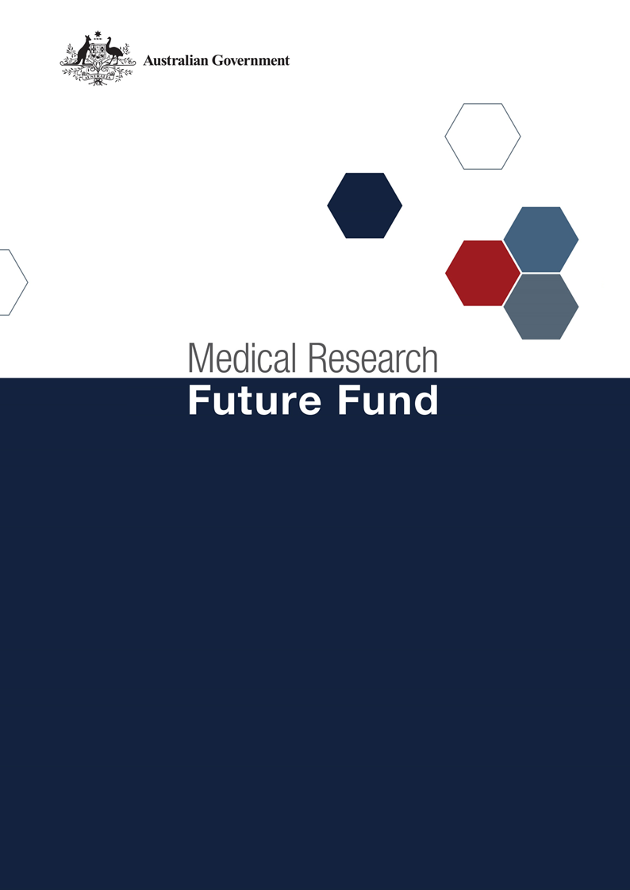

**Traumatic Brain Injury Mission Roadmap and Implementation Plan National Consultation Report**

**September 2021**

Table of Contents

Introduction 2

Community participation and submissions 3

Responses to national consultation submissions 4

# Introduction

The Medical Research Future Fund’s (MRFF) Traumatic Brain Injury Mission (the Mission) was announced as part of the 2019-20 budget to provide $50 million for research to improve patient recovery after Brain injury. It will support projects that predict recovery outcomes, or identify the most effective care and treatments.

An Expert Working Group was established to provide advice to the Minister for Health on the strategic priorities for research investment through the Mission. As per the MRFF Mission Governance document, the Expert Working Group provides advice on priorities for research investment through the Mission by developing a Roadmap and Implementation Plan.

The Mission’s Roadmap is a high-level strategic document that includes the aim, vision, goal and priorities for investment for the Mission. To support the Roadmap, the Implementation Plan outlines the priorities for investment (short, medium and long term), evaluation approaches and measures, supporting activities, and collaborative opportunities. The Roadmap and Implementation Plan will be used by the Department of Health to design and implement Mission’s investments via Grant Opportunities promoted through GrantConnect ([grants.gov.au](https://www.grants.gov.au/)).

A draft Roadmap and Implementation Plan developed by the Expert Working Group underwent international review on 30 October 2020. The International review report was made available to the public as part of the consultation process.

A national consultation to seek feedback from the community on the Mission’s draft Roadmap and Implementation Plan was conducted over the period 14 December 2020 to 23 April 2021, during which time submissions were accepted through the Department’s [consultation hub](https://consultations.health.gov.au/health-economics-and-research-division/mrff-tbi-mission/).

During the consultation, the Chair and Deputy Co-Chairs of the Expert Working Group hosted two webinars, on 23 February and 5 March 2021. This gave an opportunity for the community to gain a greater understanding of the purpose of the Roadmap and Implementation Plan and ask questions, prior to providing written submissions to the consultation.

The following questions were provided on the consultation hub to guide submissions:

1. Are the priority areas for investment identified in the Implementation Plan the most effective way for delivering on the Traumatic Brain Injury Mission’s goal and aims?
2. Are there existing research activities which could be utilised to contribute to the Traumatic Brain Injury Mission Roadmap and/or Implementation Plan aims and priority areas for investment? How can these be leveraged?
3. Are the ‘Evaluation approach and measures’ appropriate for assessing and monitoring progress towards the Traumatic Brain Injury Mission’s goal and aims?

This report summarises the national consultation through webinar participation and written submissions.

## Community participation and submissions

27 stakeholders (from 58 registrations) attended the two webinars from across all states and territories of Australia. A diverse range of stakeholders participated including those from; research organisations (including universities and Medical Research Institutes), consultancy organisations, consumer advocacy groups, State Government (Health) departments, and individual community members.

At the close of the consultation period, five (5) written submissions were received via the consultation hub, representing Medical Research Institutes, and national and state-based consumer organisations.

The Expert Working group considered all responses from the national consultation and, where relevant, revised the Roadmap and Implementation Plan. Summarised feedback from the submissions and the Expert Working Group’s responses are outlined below.

# Responses to national consultation submissions

|  |  |  |
| --- | --- | --- |
| **Consultation Question** | **Submission Feedback / Themes** | **Action by Expert Working Group** |
| **Are the priority areas for investment identified in the implementation plan the most effective way for delivering on the Mission’s goal and aims?** | * Inclusion of the long-term impact of brain injury at a young age and their different challenges is required. | * Wording added to the Implementation Plan to encompass the ‘lifespan of the individual’. |
| * Greater focus on developing rehabilitation interventions to provide clinicians with new treatment options is needed. | * As Priority area 2.2 focuses on rehabilitation, the Group recommended no further additions were required. |
| * Greater focus on collaboration across the health system is required. | * As collaboration is built in throughout the Implementation Plan with explicit language included in both the Roadmap and Implementation Plan, the Group recommended no further additions were required. |
| * Greater emphasis on discovery research required. | * Whilst important, the Mission’s priority is to support translational research to improve patient outcomes, the Group recommended no changes were required |
| * Capacity building for evaluation and impact assessment is needed in health services. Existing private and academic sector services are not meeting these needs. | * Numerous priority areas in the Implementation Plan support evaluation and impact assessment. Priority area 3.2 may identify variations in workforce building capacity in rural areas as a barrier to reducing inequalities in treatment and care. The Group recommended no changes were required. |
| * Research that focuses on outcomes that are both cost-effective and affordable to the needs of rural, regional, and Indigenous populations should be incorporated. | * As the Roadmap and Implementation Plan includes these populations as ‘all demographics’ in numerous sections, the Group recommended no further additions were required. |
| * Involvement of rural, remote and Indigenous researchers in the research design and its implementation and within consortium is required for effective impact. | * The Group noted this recommendation and included these researcher demographics under the ‘Funding Principles’ section of the Roadmap. |
| * Discouragement of supporting research using animal models due to ethical treatment of animals - human-relevant methods of TBI research must be prioritised. | * The Group agreed that this was not a requirement that should be articulated in the documents and recommended no changes were required. |
| * Embed a data-centric perspective for the purpose of conducting data-intensive research throughout the Mission | * This Mission incorporates a data-centric approach throughout the Roadmap and Implementation Plan. The Group recommended no further additions were required. |
| **Are there existing research activities which could be utilised to contribute to the Mission’s Roadmap and/or Implementation Plan aims and priority areas for investment? How can these be leveraged?** | * Reference how Vision TBI (now named Connectivity); its initiatives and governance programs are managed to align rather than duplicate the Mission objectives. | * Reference to Vision TBI has been amended to reflect its new name, with additional text to provide a context of the organisation and its alignment to support the Mission, rather than duplicate initiatives. |
| * Highlight specific research initiatives in the sector that align with the Mission Aims and research priorities. | * The Group noted that specific research initiatives funded outside of the Mission can contribute to supporting and providing partner funding to the research priorities of the Mission. While language in the Implementation Plan has been changed to reflect these inclusions, it was agreed that it is not feasible to list every research initiative in scope. Of note, this recommendation was applied across all Mission Implementation Plans. |
| * Collaborate with consumer organisations to achieve Mission objectives | * As above. Specific stakeholder organisations are not directly listed, but collaboration is encouraged. |
| **Are the ‘Evaluation approach and measures’ appropriate for assessing and monitoring progress towards the Mission’s goal and aims?** | * The Mission funding scheme should be underpinned by a strong evaluation framework to ensure cost effective, affordable and sustainable provision of high-value person-centred care is achieved through the collaboration, consultation and integration of services. | * The Group strongly agrees with this suggestion. As a result, reference to the MRFF Monitoring, evaluation and learning strategy has been included in the revised Implementation Plan for all Missions. |