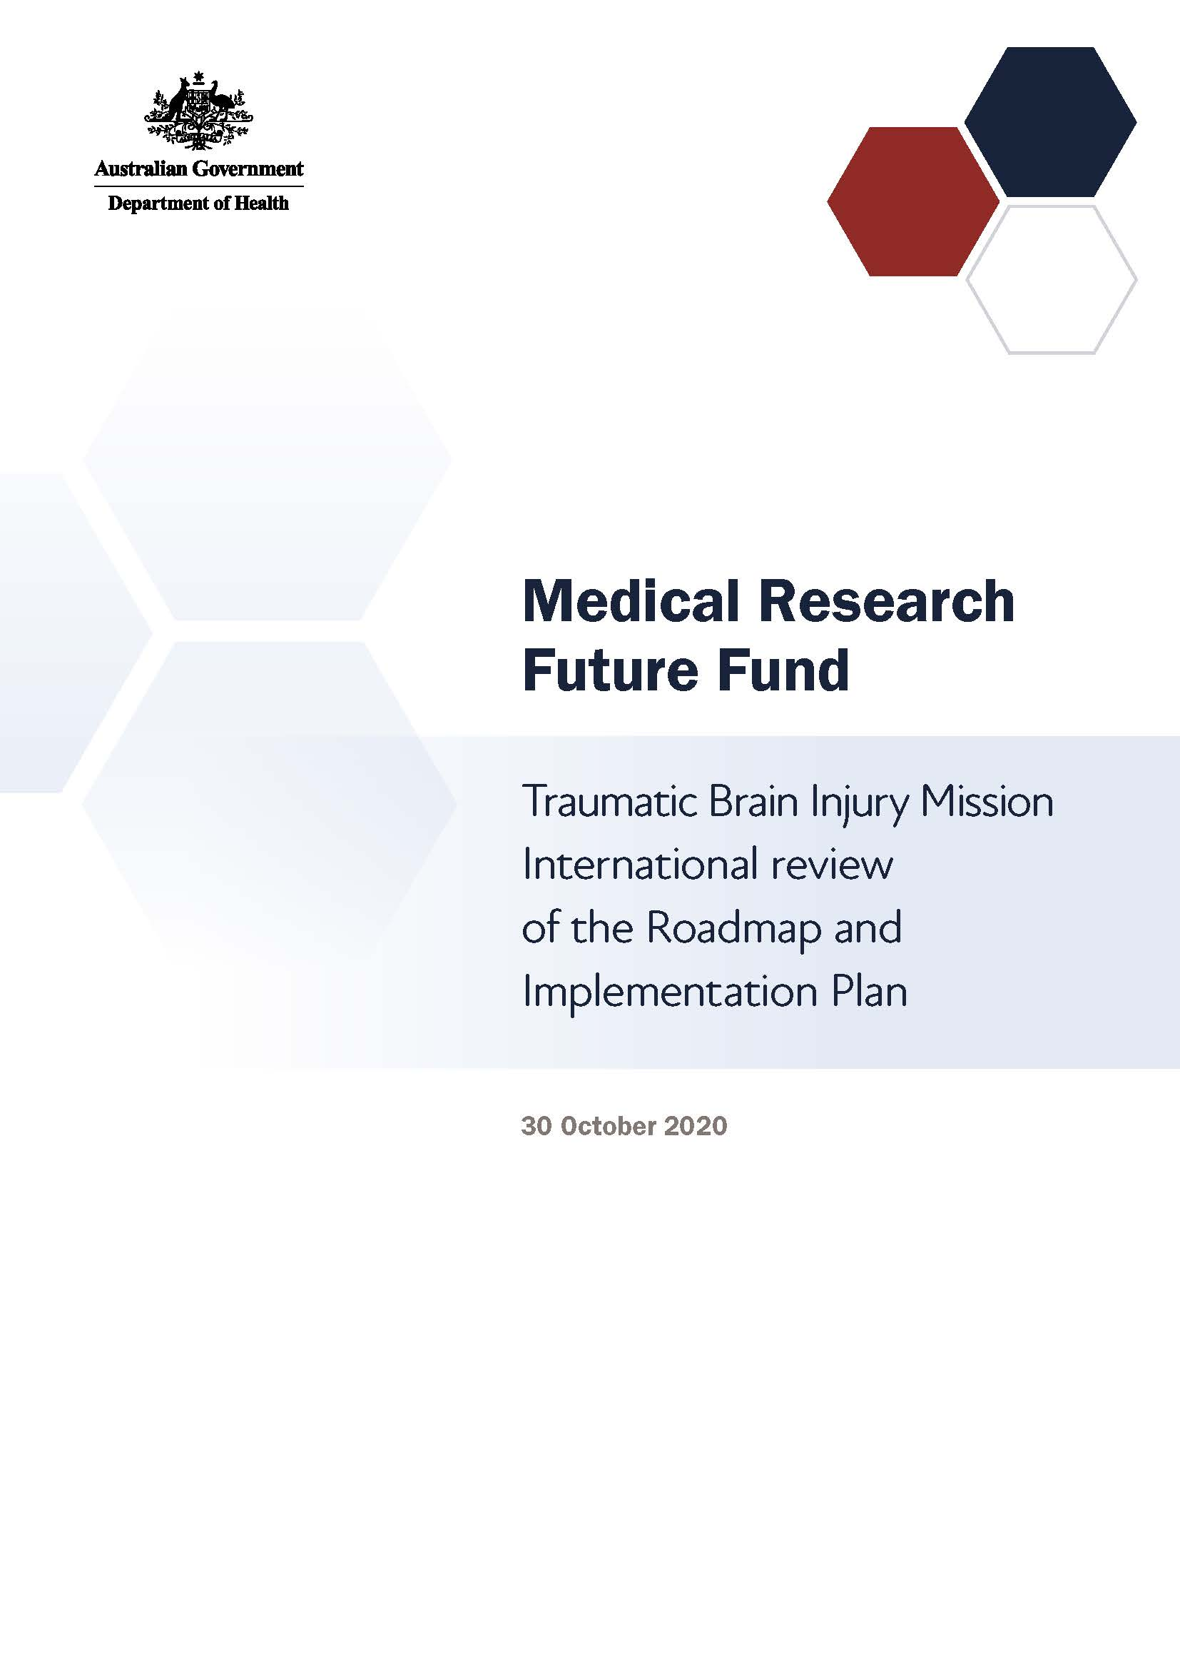

# Introduction

The Medical Research Future Fund (MRFF) is a $20 billion long-term investment supporting Australian health and medical research. The MRFF aims to transform health and medical research and innovation to improve lives, build the economy and contribute to health system sustainability.

The Traumatic Brain Injury Mission will provide A$50 million over 9 years under the MRFF to support research designed to improve the lives of all Australians who experience traumatic brain injury.

## Traumatic Brain Injury Mission Expert Working Group

A Traumatic Brain Injury Expert Working Group was established to advise the Australian Minister for Health on the strategic priorities for research investment through the Traumatic Brain Injury Mission.

The Traumatic Brain Injury Expert Working Group’s role is to define evidence and knowledge gaps that should be addressed through mission research funding to help transform health care and health outcomes for individuals and communities. This role includes defining key research questions that — if answered — will deliver meaningful change to patients through the translation of research.

**Our mission**

To accelerate Australian traumatic brain injury research that develops and delivers innovative and effective treatments that substantially and equitably optimise and improve outcomes for people who experience traumatic brain injury, in partnership with people with traumatic brain injury and carers.

**Our goal**

To better predict recovery outcomes after a traumatic brain injury and identify the most effective care and treatments.

The Traumatic Brain Injury Expert Working Group developed a Roadmap and Implementation Plan to advise about priorities for research investment through the Traumatic Brain Injury Mission.

The Roadmap includes:

* the mission statement and goal
* possible themes and priorities for investment

The Implementation Plan includes:

* 3 aims that outline how the Traumatic Brain Injury Mission will benefit Australians
* priorities for investment in the short, medium and long term
* opportunities for leveraging additional investment
* activities needed to support the Traumatic Brain Injury Mission’s outcomes and facilitate their implementation

Traumatic Brain Injury Expert Working Group members will consult and engage with other researchers, industry, and consumer and patient groups, and participate in media and public activities to build awareness of, and facilitate interaction with, the mission and with other MRFF-funded research.

# Traumatic Brain Injury Mission International Review Panel

The Traumatic Brain Injury Mission International Review Panel’s role was to provide expert feedback and experiential advice in the context of relevant activities occurring internationally, which can inform the strategic direction of the Traumatic Brain Injury Mission’s Roadmap and Implementation Plan.

The Traumatic Brain Injury Panel members were asked to:

1. Advise on the applicability of the Traumatic Brain Injury Mission’s goal to the international context; specifically, whether the goal duplicates or contributes to international research activities
2. Advise on the likely effectiveness of the research priorities (including their sequencing) to achieve the goal
3. Provide learnings from international research activities in the field
4. Identify opportunities for leveraging and complementing international research activities to achieve the goal
5. Advise on the appropriateness of the proposed measures for evaluating progress towards meeting the goal

The Traumatic Brain Injury Panel comprised 7 members representing expertise in a variety of clinical and scientific research areas:

* Prof David Menon — Head of Division of Anaesthesia, University of Cambridge, England
* Prof Alice Theadom — Director, Traumatic Brain Injury Network, Auckland University of Technology, New Zealand
* Dr Ramon Diaz-Arrastia — Presidential Professor of Neurology, University of Pennsylvania, USA
* Prof David B Arciniegas — Professor of Psychiatry, Neurology and Physical Medicine and Rehabilitation, Baylor College of Medicine, Texas, USA
* Prof Grant Iverson — Director, Sports Concussion Program, Massachusetts General Hospital for Children; and Director, Neuropsychology Outcome Assessment Laboratory, Harvard Medical School, USA
* Dr Michael Bell — Division Chief, Critical Care Medicine Critical Care Specialist, Children’s National Hospital, Washington DC, USA
* Dr Virginia Newcombe — Clinician Scientist Fellow, Cambridge Neuroscience, University of Cambridge, England
* Professor Angela Colantonio — Director, Rehabilitation Science Institute (on administrative leave September 2020 to August 2021), University of Toronto, Canada

# Consultation discussion

The Traumatic Brain Injury Panel met on Friday 30 October 2020 to discuss the Traumatic Brain Injury Mission’s Roadmap and Implementation Plan.

All participants at the meeting were required to declare any conflicts of interest and relevant collaborations. None of the declared interests were considered material to the meeting.

**Key points**

* The mission is an ambitious, exciting opportunity to advance traumatic brain injury research and translation in Australia
* The mission aligns with international research programs and plans
* The Traumatic Brain Injury Panel fully supported the mission, including the approaches outlined in the Roadmap and Implementation Plan for achieving the goals and vision of the mission
* The long-term success of the mission will need development of an overarching national consortium to oversee the research efforts and maximise data collection
* Such a consortium can help support the infrastructure needed for sustainability of the effort over time, and for training and mentoring junior investigators and early-stage faculty
* It would be ideal to include clinical outcomes data in any data collection, and to define a set of core data elements that could be collected in all projects
* Integrating outcomes with those from other missions could maximise research efforts and minimise duplication
* The Traumatic Brain Injury Panel supported the planned involvement of consumers from the start, so that research is patient driven
* Australia would benefit from actively recruiting the best young research talent into research on traumatic brain injury, and supporting and developing their careers over the long term
* It is important to ensure that healthcare guidelines are developed and that they reflect research findings. Guidelines need to then be implemented into everyday care to improve patient outcomes

## General comments

The Traumatic Brain Injury Panel saw the Traumatic Brain Injury Mission as an ambitious, exciting opportunity to advance traumatic brain injury research and translation in Australia. Overall the Traumatic Brain Injury Panel supported the approaches outlined in the Traumatic Brain Injury Mission’s Roadmap and Implementation Plan.

The Traumatic Brain Injury Panel also viewed the Australian medical research funding system as unique with a high-value proposition. The panel felt that much can be achieved with the funding amounts allocated for the MRFF program.

## Align with international work

The Traumatic Brain Injury Panel agreed that the mission aligns with and complements international research efforts in traumatic brain injury, and fully supported the mission. Continued interactions and fostering collaborations with international investigators will leverage investments made in Australia and elsewhere to improve health outcomes after traumatic brain injury.

## Collaborate through consortiums

The Traumatic Brain Injury Panel flagged that it may be beneficial to set up a national traumatic brain injury consortium to oversee the mission’s research, optimise informatics approaches, and call for research proposals based on the priorities identified within the implementation plan. Collaborative leadership is imperative to prevent researcher silos, which can happen when individual grants are awarded to independent researchers. A consortium could help ensure that the research of the mission is well integrated and that best practices are embedded in all projects within the mission and with other missions.

Consortium-led data collection could result in much larger and continuous datasets than could otherwise be achieved, incorporating integrated data linkage. Smaller research programs should ensure they contribute to such datasets (also see ‘Use clinical data and collect core data elements’).

A consortium could also help guide outcomes in the longer term, as some research takes years to result in patient improvements at the clinical level. The Traumatic Brain Injury Panel queried whether there were opportunities for funding beyond 5 years, to help create the infrastructure needed for long-term dataset maintenance. The Traumatic Brain Injury Panel noted that the mission included leveraging existing infrastructure and other

funding to support the outcomes, which was considered to be useful, although did not preclude the need for support for infrastructure from within the mission.

## Link with other missions

The Traumatic Brain Injury Panel flagged the importance of linking and integrating with other missions to ensure research efforts are maximised and not duplicated, and ensure that learnings are embedded in other projects. In particular, there is alignment with the Dementia, Ageing and Aged Care Mission with regards to the links between injury, ageing and cognitive decline, and the Genomics Health Futures Mission with which data and biological samples could be shared.

Linking with other missions would assist researchers to ‘switch’ missions during their research career (also see ‘Involve the right people and recruit the best’).

The Traumatic Brain Injury Panel also recognised the importance of links between the clinical aims of the mission and preclinical research programs funded through other streams. The opportunities for forward and back translation are substantial, and should not be missed.

## Use clinical data and collect core data elements

It would be extremely beneficial if the Traumatic Brain Injury Mission could ensure that core data elements are collected in every project, including data collected as part of routine clinical care and clinical outcomes data. The Australia New Zealand Trauma Registry collects core data on severe trauma in general, which could be leveraged and expanded on for the Traumatic Brain Injury Mission. The Traumatic Brain Injury Panel proposed that use of existing clinical data including data in electronic health records would be beneficial and complement the use of research-quality data held in registries.

The Traumatic Brain Injury Panel advised that long-term data collection is particularly important for mild to moderate traumatic brain injury. Information on these patients is generally lacking, but data for this patient group is crucial for predicting the ongoing care they are likely to need and for improving their health outcomes in the long term.

## Involve the right people and recruit the best

The Traumatic Brain Injury Panel highlighted the importance of having the right people involved, and suggested recruiting aggressively, including from overseas, for both clinician scientists and translational basic researchers. For the mission’s long-term success, it is crucial to attract young talent — including at the doctoral student, postdoctoral researcher, and young primary investigator levels — and support their careers through training opportunities over time. It is also important to at least partially integrate missions, to ensure researchers can ‘move’ from one mission to another if their work takes them that way, such as from the Dementia, Ageing and Aged Care Mission to the Traumatic Brain Injury Mission, and vice versa. This is also crucial for networking, which drives further collaboration and integration among projects.

The Traumatic Brain Injury Panel highlighted the importance of involving all care pathways, as this has been a barrier to progress in the past. For example, researchers from acute care, post-acute care, rehabilitation and sports medicine all need to collaborate to ensure the best outcomes.

In addition, the Traumatic Brain Injury Panel noted that the planned consumer participation is essential to achieve the best outcomes, and that this should be done at the start of projects, not at the end. This helps to ensure that research projects are patient driven.

## Translate research into policies and guidelines

The Traumatic Brain Injury Panel emphasised the importance of the plans for guideline development and implementation to ensure improved patient outcomes are achieved. Guidelines need to:

* consider all phases of the injury cycle, from admission to the intensive care unit (assessment) through to treatment, rehabilitation and long- term care. Also, consider that rehabilitation can start in the very acute phases, and be planned for at this time
* consider all states and territories, and all systems of care
* consider all types of traumatic brain injury (mild, moderate, severe)
* be inclusive of vulnerable/underserved populations (eg homeless, gender diverse, multicultural) and consider intersectional approaches that extend to the analyses and knowledge transfer phases of the research
* be invested in, so that they are implemented and ensure best practice

Guidelines should be based on international guidelines but be adapted to the Australian context. Implementing guidelines needs partnership between the health care system and the private system.

# Recommendations

* Support a national consortium to oversee the research and data collection. Clinical trials and other research proposals based on the priorities identified within the implementation plan can be investigator driven
* Integrate with other missions to ensure the best outcomes for patients
* Collect routinely collected clinical and clinical outcomes data to complement research data, and follow up patients in the long term
* Recruit the best and brightest from around the world
* Ensure research priorities are patient driven
* Develop guidelines that are based on international best practice and optimised for the Australian setting