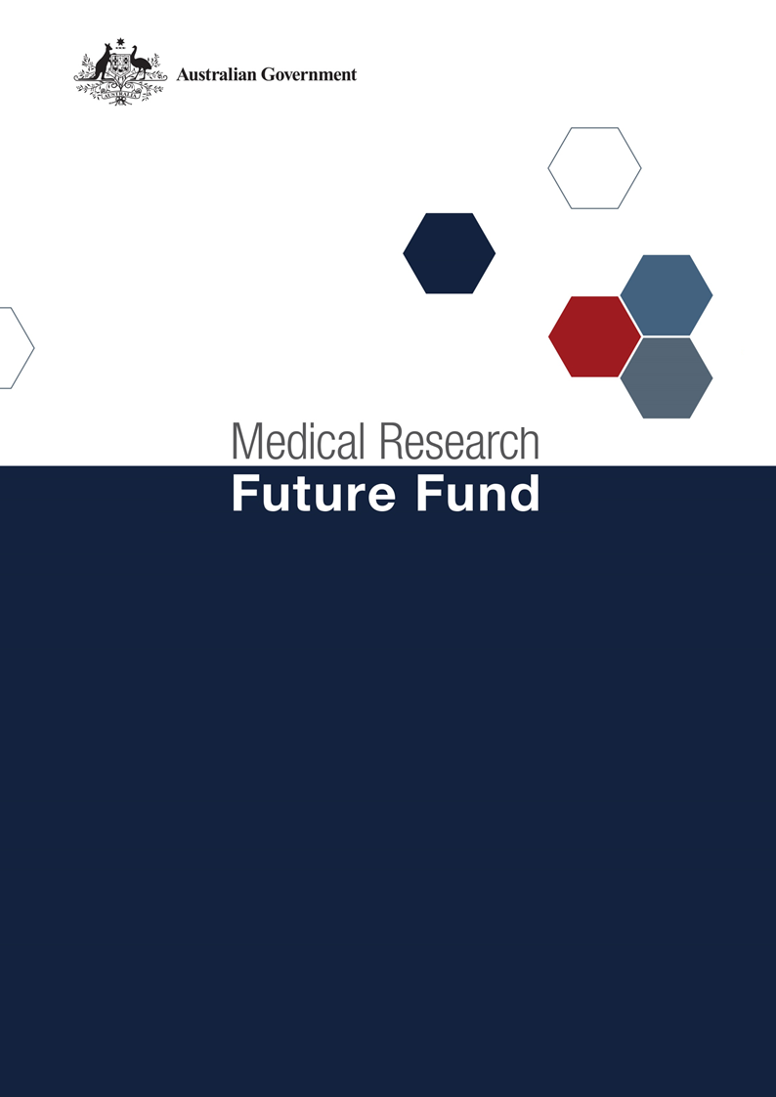

**Dementia, Ageing and Aged Care Mission Roadmap and Implementation Plan National Consultation Report**

**September 2021**

Table of Contents

Introduction 2

Community participation and submissions 3

Responses to national consultation submissions 4

# Introduction

The Medical Research Future Fund’s (MRFF) Dementia, Ageing and Aged Care Mission (the Mission) was announced as part of the 2019-20 budget. The Mission will provide $185 million over 10 years to support research designed to improve outcomes for people living with dementia and older Australians.

An Expert Advisory Panel was established to provide advice to the Minister for Health and Aged Care on the strategic priorities for research investment through the Mission. As per the Minister for Health and Aged Care’s agreed [Governance arrangements for MRFF Missions](https://www.health.gov.au/resources/publications/mrff-mission-governance), the Expert Advisory Panel has provided advice on priorities for research investment through the Mission by developing a Roadmap and Implementation Plan.

The Mission’s Roadmap is a high-level strategic document that includes the aim, vision, goal and priorities for investment for the Mission. To support the Roadmap, the Implementation Plan outlines the priorities for investment (short, medium and long term), evaluation approaches and measures, supporting activities, and collaborative opportunities. The Roadmap and Implementation Plan will be used by the Department of Health to design and implement Mission’s investments via Grant Opportunities promoted through GrantConnect ([grants.gov.au](https://www.grants.gov.au/)).

A draft Roadmap and Implementation Plan developed by the Expert Advisory Panel underwent international review on 5 November 2020; the outcome of the review is outlined in a report endorsed by the [International Review Panel](https://consultations.health.gov.au/health-economics-and-research-division/mrff-daac-mission/).

A national consultation to seek feedback from the community on the Mission’s draft Roadmap and Implementation Plan was conducted over the period 14 December 2020 to 23 April 2021, during which time submissions were accepted through the Department’s [consultation hub](https://consultations.health.gov.au/health-economics-and-research-division/mrff-daac-mission/).

During the consultation, the Co-Chairs of the Expert Advisory Panel hosted two webinars, on 16 February 2021 and 19 March 2021. This gave an opportunity for the community to gain a greater understanding of the purpose of the Roadmap and Implementation Plan and to ask any questions, prior to providing written submissions to the consultation.

The following questions were provided on the consultation hub to guide submissions:

1. Are the priority areas for investment identified in the Implementation Plan the most effective way for delivering on the Dementia, Ageing and Aged Care Mission’s goal and aims?
2. Are there existing research activities which could be utilised to contribute to the Dementia, Ageing and Aged Care Mission Roadmap and/or Implementation Plan aims and priority areas for investment? How can these be leveraged?
3. Are the ‘Evaluation approach and measures’ appropriate for assessing and monitoring progress towards the Dementia, Ageing and Aged Care Mission’s goal and aims?

This report summarises the national consultation through webinar participation and written submissions.

## Community participation and submissions

27 stakeholders (from 47 registrations) attended the two webinars from across all states and territories of Australia. A diverse range of stakeholders participated including those from: research organisations (including universities and medical research institutes); consultancy organisations; consumer advocacy groups; state government (health) departments; and individual community members.

At the close of the consultation period, seventeen (17) written submissions were received via the consultation hub, representing medical research institutes, and national and state-based consumer organisations.

The Expert Advisory Panel considered all responses from the national consultation and, where relevant, revised the Roadmap and Implementation Plan. A summary of the feedback from the submissions and the Expert Advisory Panel’s responses are outlined below.

# Responses to national consultation submissions

| **Consultation Question** | **Submission Feedback / Themes** | **Action by Expert Advisory Panel (the Panel)** |
| --- | --- | --- |
| **Are the priority areas for investment identified in the implementation plan the most effective way for delivering on the Mission’s goal and aims?** | The Royal Commission’s findings should be reflected in the priorities and turned into priorities aimed at the most pressing needs | The Panel was cognisant of the work of the Royal Commission and feel that the priority areas listed in the Implementation Plan are compatible with the findings |
| The Mission needs to have a greater focus on discovery as well as translational research | The Roadmap and Implementation Plan include discovery and translational research priorities. As the goal of the Mission is to see material change and outcomes in the life of the Mission (10 years) there is a significant focus on translation and implementation research |
| Ageing well and care of older people are influenced by multiple environmental, socio-economic, as well as health/clinical care and psycho/social factors. Priority areas need to address these areas as well as chronic illness, lifestyle and models of care | The Mission Roadmap includes these factors in the funding principles and priority areas for investment, which specifically reference considering “all older people, inclusive of socioeconomic status, culture, gender, geography and life experience” and models of care |
| There needs to be greater emphasis on the importance of data and using and developing the right data collections to identifying inequalities and measuring progress | The Panel noted this and included the following as a Funding principle in the Roadmap – “build appropriate data and information infrastructure(s) to facilitate critical measurement” |
| Greater emphasis is required on the need for large national programs of work of strategic importance in key priority areas including multi-disciplinary collaborations | This recommendation will be reflected in the guidelines for relevant grant opportunities and an additional point has been included on p2 of the Roadmap: “be, or contribute to, large national programs of work of strategic importance in key priority areas as outlined in the Implementation Plan. The research activities are expected to foster collaboration and harness resources across the system to deliver on improved health outcomes for Australians.”  Further, an additional point has been included on p4 of the Implementation Plan under “Implementation Strategy”: “Research activities will be or contribute to large programs of work of national strategic importance that are informed by the key priority areas outlined in this Implementation Plan. The research activities are expected to foster collaboration and harness resources across the system to deliver on improved health outcomes for Australians.” |
| There is support for using the current wording of “people” and “older people” instead of “end user” or “patient” | This will continue to be reflected in documentation for the Mission |
| The Mission should give consideration to childhood dementia | The Panel agreed that while a very important area, the Mission’s goal is to focus on dementia in mid to later life |
| Particular issues were raised including:   * inclusion of support for rural clinical workforce development - to address rural inequalities * determining optimal workforce models * improvement of the ageing experience without a specific disease/condition | The panel agreed that while these are important areas, due to limited Mission funds these are considered to not be priorities for the Mission |
| A number of specific areas were suggested for funding including:   * efficacy and barriers of adoption of massage therapy and myotherapy for the care of older people and people with dementia * detection and treatment of poor mental health and wellbeing in older adults living in the community as well as in aged care settings * enhancing the health of older carers of older people so that they can sustain their caring role for longer * sensory (vision, hearing etc.) contributions to healthy ageing, their relationship to dementia and associated health systems research to enhance prevention and management * high prevalence health conditions such as incontinence * the role of non-human connections (aka pets) for people with dementia and their carers in health * further research into physical activity inventions for those who look generally well but have mild mobility dysfunction * research to determine interventions to prevent or delay the onset of dementia – including into biomarkers, and genetic and environmental risk factors | The Panel agreed that there will be no barrier to funding these specific areas (or others) as long as they are relevant to a grant opportunity |
| Consider the role of Advance Care Planning (ACP) for people living with dementia and those in residential aged care. | Reference has been included in Priority areas 1.2 and 3.1 of the Implementation Plan |
| Further improvement in ageing and aged care needs to be framed through a human rights lens | The Panel agreed with this statement and included “promote and protect the human rights of older people” in Priority area 3.1 of the Implementation Plan |
| Explicitly state that Aims 2-3 exclude dementia-related research to avoid disproportionately funding dementia research | The Panel agreed no change is required as dementia is intertwined with aged care and research should not exclude people living with dementia |
|  | | |
| **Are there existing research activities which could be utilised to contribute to the Mission’s Roadmap and/or Implementation Plan aims and priority areas for investment? How can these be leveraged?** | A number of general and more specific activities were recommended including:   * engaging with activities arising from the Royal Commission into Aged Care Quality and Safety * utilising tested interventions developed by state government health promotion foundations * utilising the national *Advance Care Planning documentation dataset* to inform strategy, policy development and improving care * utilising frameworks and plans developed through the *NHMRC National Institute for Dementia Research,* data from the second *National Eye Health Survey (NEHS)* and the World Health Organisation’s research and publications on a human rights approach to dementia | Language in the Implementation Plan has been changed to enable the inclusion of additional activities. The Panel agreed that it is not feasible to list every research activity that is in scope |
| A number of additional organisations or initiatives were also recommended as potential leverage or collaboration opportunities | Language in the Implementation Plan has been changed to enable the inclusion of additional organisations or initiatives. The Panel agreed that it is not feasible to list every organisation or initiative that is in scope |
|  | | |
| **Are the ‘Evaluation approach and measures’ appropriate for assessing and monitoring progress towards the Mission’s goal and aims?** | A number of submissions identified the need to:   * have explicit benchmarks and key milestones for each priority which are assessed regularly * reference to the MRFF’s Monitoring, evaluation and learning strategy | The Panel strongly agrees with these recommendations and   * explicit benchmarks and key milestones will be required within applications and assessed appropriately (requirements will be emphasised within the grant guidelines) * reference to the MRFF Monitoring, evaluation and learning strategy has been included in the revised Implementation Plan for this and all other Missions |
| A number of general evaluation metrics were recommended including:   * the involvement of people with a lived experience in the monitoring and evaluation process to ensure the research findings are translatable * extending beyond aged care settings to ageing well and increasing the duration of a healthy active life * vost-effectiveness and affordability of research | As above, explicit benchmarks and key milestones will be required within applications and assessed appropriately (requirements will be emphasised within the grant guidelines) |
| The following specific evaluation metrics for Aim 1 were recommended including:   * monitoring changes in incidence rates of dementia in relation to prevention-related research * the discovery of novel intervention under the final evaluation measure | The Panel noted the recommendations and agreed the evaluation measures are in line with the Aim |