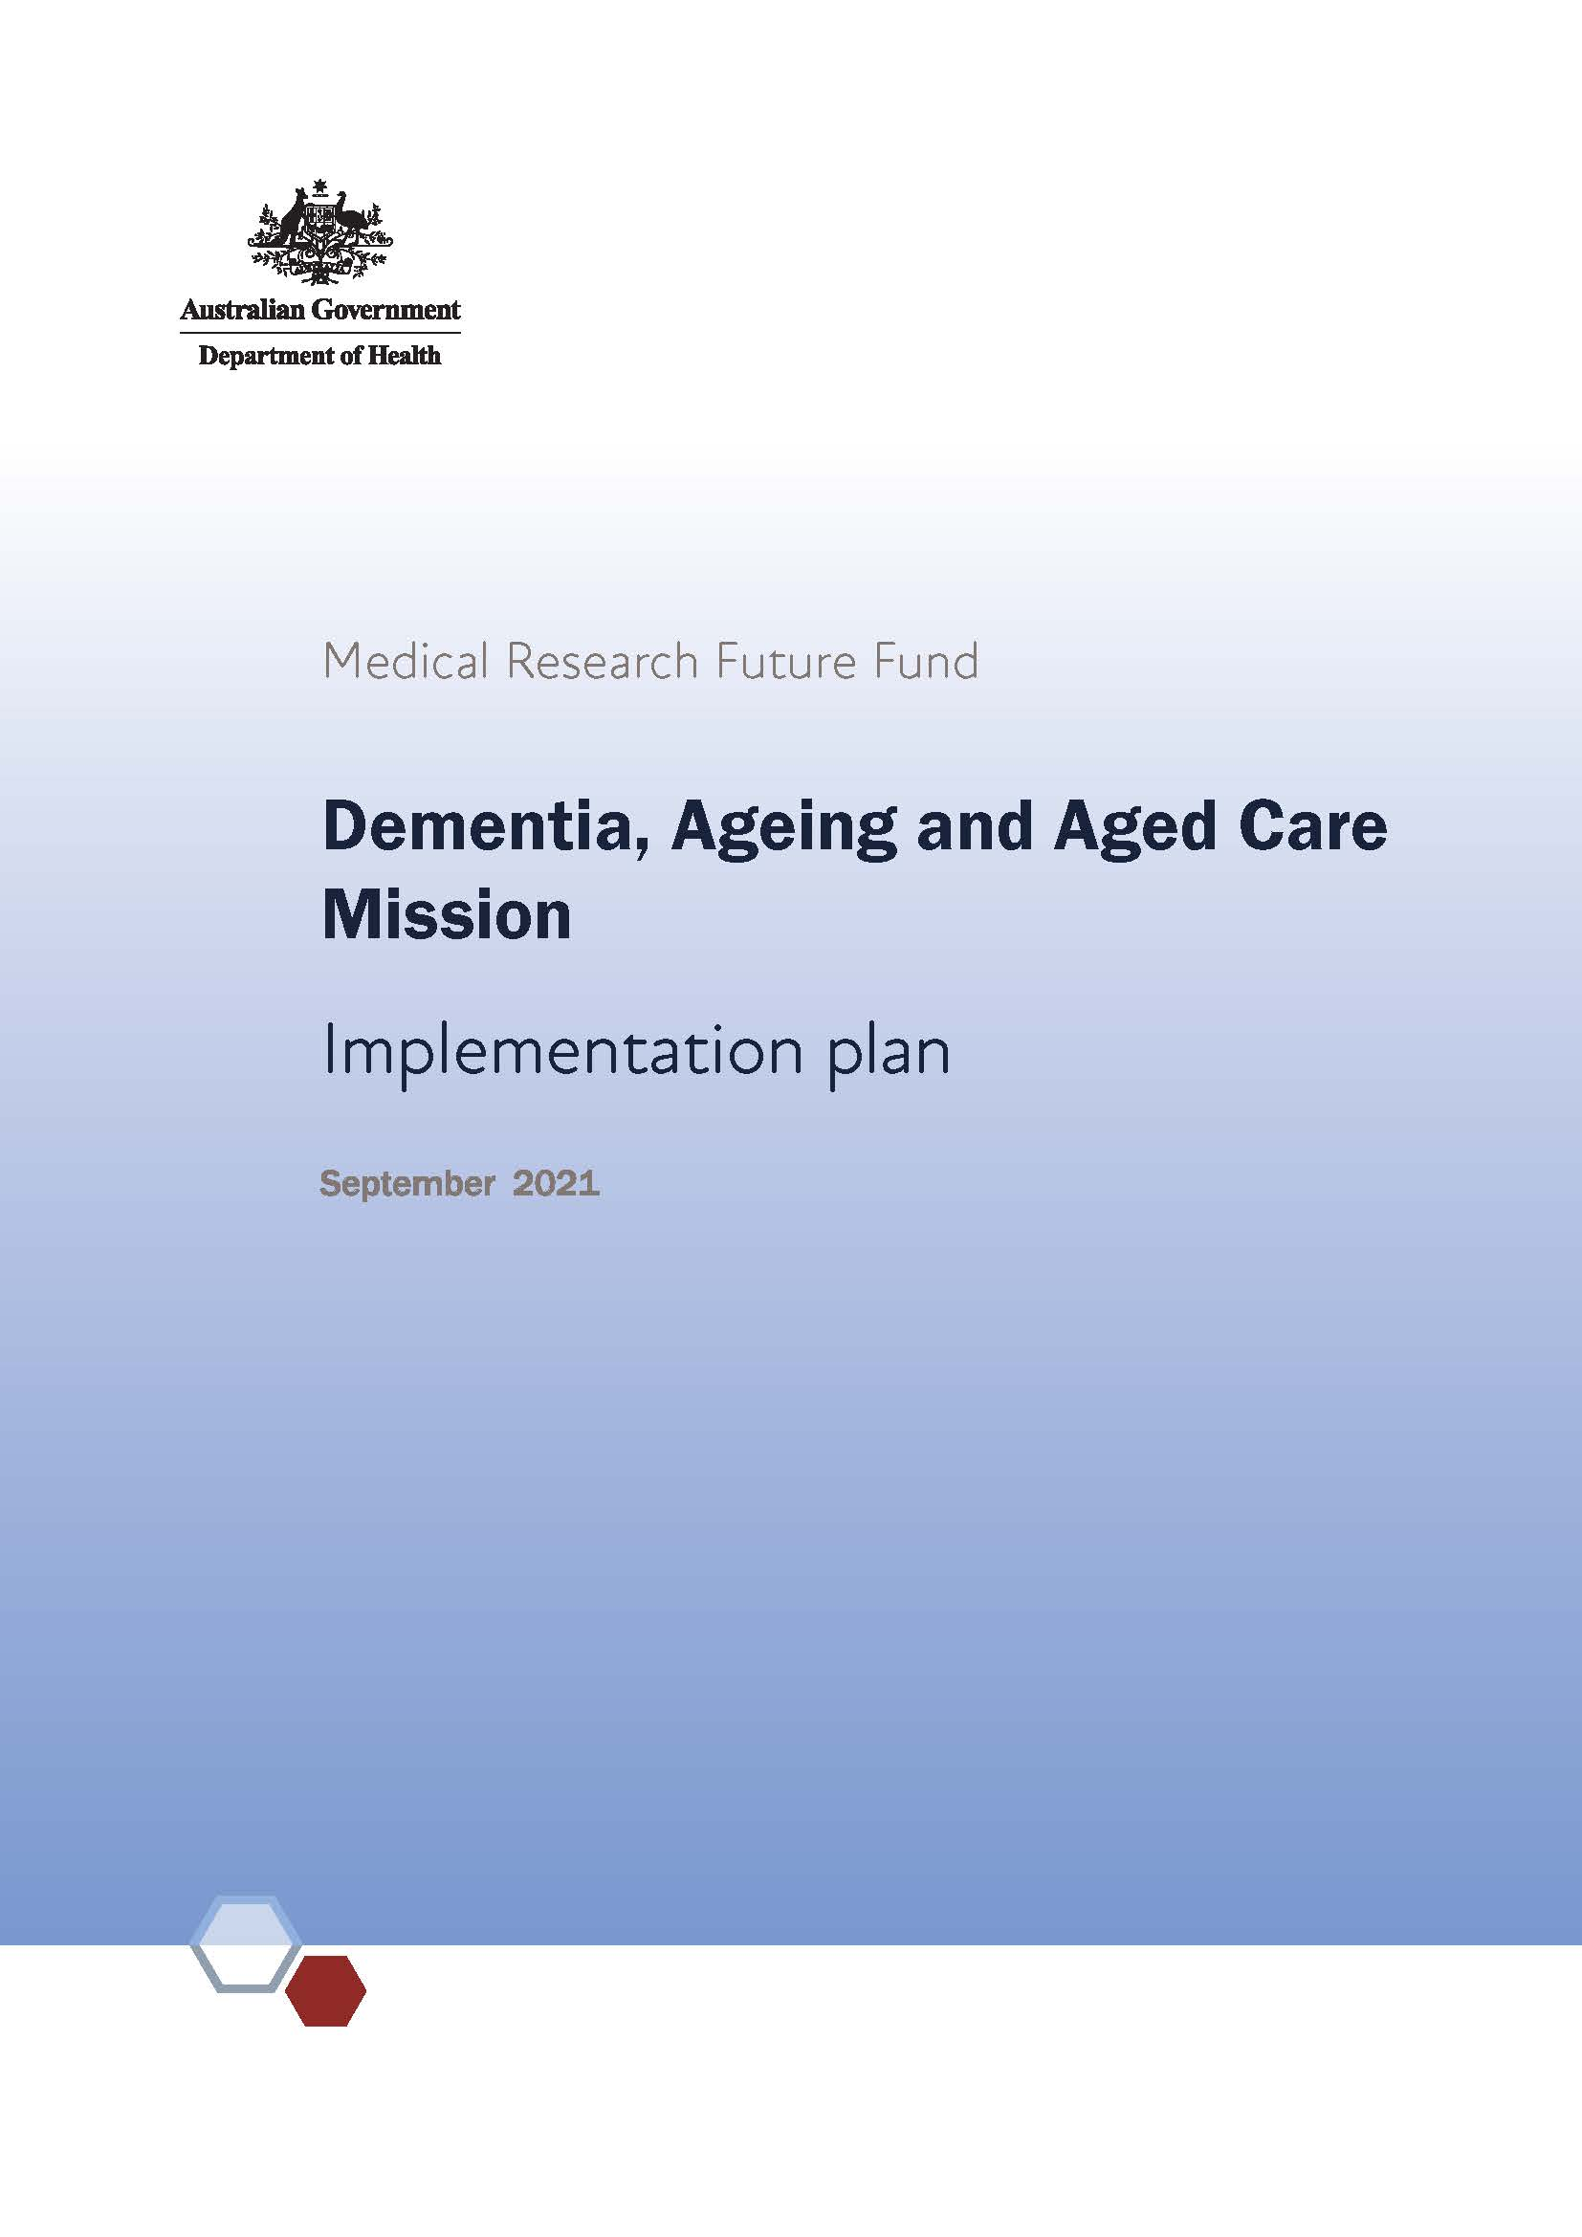

# Background

The Dementia, Ageing and Aged Care Mission aims to improve outcomes for people living with dementia, and support older Australians to maintain their health and quality of life as they age, live independently for longer and access quality care when they need it. The mission will generate measurable improvements for those living with dementia, increasing the healthy lifespan experienced by older Australians and improving care for older Australians across all care settings.

This plan supports the implementation of the Dementia, Ageing and Aged Care Mission roadmap and establishes a strategic plan to address the mission’s goals within the context of the Medical Research Future Fund 10-year plan. This implementation plan should be read in the context of the mission roadmap, which describes the mission’s scope, goals and principles.

# Overview

To target activities to achieve the objectives of the mission within the 10-year plan, the following aims and priority areas for research investment have been identified.

| Aim | Priority areas for investment |
| --- | --- |
| 1. Achieve measurable improvements in detection, prevention, assessment, care and support for people living with dementia | 1.1 Determine and implement interventions that prevent or delay the onset of dementia symptoms — pre- and post-diagnosis |
| 1.2 Implement care approaches for people with dementia and their carers that provide reliable and robust strategies to manage the impact of dementia on wellbeing, quality of life and end of life |
| 1.3 Implement care and diagnostic pathways that improve timeliness of diagnosing dementia |
| 2. Achieve measurable improvements in healthy life expectancy among older Australians | 2.1 Discover and implement health and medical interventions in mid-life and beyond that will extend healthy, active years of life and compress the period of morbidity |
| 2.2 Conceive and encourage implementation of new ways to embed more proactive health management, including health literacy, for older people |
| 2.3 Develop interventions that address social, economic and cultural barriers to healthy ageing to reduce inequality in healthy life expectancy in Australia |
| 3. Achieve measurable improvements in consistency and quality of care for older Australians across all care settings | 3.1 Investigate and support implementation or adoption of models of care that are most effective in:   * delivering high-quality, culturally appropriate care, informed by life experience, in home and residential aged care settings, that support individuals and their informal/family carers * ensure equitable and appropriate access to quality clinical care and minimise avoidable transitions between all care settings * identify and implement ways to maximise medical, nursing and allied health impact * identify and implement ways to maximise social inclusion and multigenerational engagement in long‑term care settings |

# Implementation strategy

The implementation strategy has been developed to guide research investment over the life of the mission. Investment aims to build capability and knowledge, as well as facilitate translation of advancements to clinical practice, to achieve the mission’s objectives. The implementation strategy is intended to make the research purpose and direction transparent, and provide certainty to stakeholders. It also establishes how the outcomes of each focus area will be evaluated in terms of benefit to older Australians, which will help to clarify the intended outcome and facilitate tracking of the mission’s progress towards its objectives.

Research activities will be, or contribute to, large programs of work of national strategic importance that are informed by the key priority areas outlined in this implementation plan. The research activities are expected to foster collaboration and harness resources across the system to deliver improved health outcomes for Australians.

To support the Dementia, Ageing and Aged Care Mission, the [MRFF Monitoring, evaluation and learning strategy](https://www.health.gov.au/resources/publications/mrff-monitoring-evaluation-and-learning-strategy-2020-21-to-2023-24) provides an overarching framework for assessing the performance of the MRFF, focused on individual grants, grant opportunities, initiatives (eg the Dementia, Ageing and Aged Care Mission) and the entire program. The strategy sets out the principles and approach used to monitor and evaluate the MRFF. It outlines the need for evaluations to be independent and impartial. The strategy aims to be transparent in process and outcomes, and agile to the needs of the MRFF, its consumers and stakeholders (such as the health and medical research industry). The Dementia, Ageing and Aged Care Mission and grants funded under this initiative will be evaluated against the strategy.

# Aim 1: Achieve measurable improvements in detection, prevention, assessment, care and support for people living with dementia

## Priority area 1.1

Determine and implement interventions that prevent or delay the onset of dementia symptoms – pre- and post-diagnosis

## Priority area 1.2

Implement care approaches for people with dementia and their carers that provide reliable and robust strategies to manage the impact of dementia on wellbeing, quality of life and end of life

| Research to begin in the … | Priorities for investment (research questions and objectives) |
| --- | --- |
| short term (1–2 years) | Identify an appropriate suite of measures that enable appraisal of local organisation and system performance to assess the impact of new care delivery models and quality improvement.  Develop interventions that deliver holistic and multidisciplinary care after diagnosis to improve quality of life for people living with dementia and their carers, including:   * using digital technologies to support care * managing transitions between care types and settings * managing disease progression |
| medium term (2–5 years) to long term (6–10 years) | Conduct implementation research to test interventions that are designed to improve uptake of holistic primary and secondary prevention activities to delay the onset and severity of dementia.  Conduct implementation research focused on addressing inequalities in uptake of prevention activities and in quality of life, including for:   * Aboriginal and Torres Strait Islander people * rural, regional and remote populations * culturally and linguistically diverse populations |

## Priority area 1.3

Implement care and diagnostic pathways that improve timeliness of diagnosing dementia

| Research to begin in the … | Priorities for investment (research questions and objectives) |
| --- | --- |
| short term (1–2 years) to medium term (2–5 years) | Develop new and improved diagnostic and prognostic tools for dementia, including biological markers of disease onset and progression.  Enhance utility of neuropsychological tests for dementia. |
| long term (6–10 years) | Conduct implementation research to support effective adoption and best-practice use of diagnostic and prognostic tools (biological, neuropsychological, etc), including facilitating transitions to the most appropriate care pathways. |

## Evaluation approach and measures

New diagnostic or prognostic tools for dementia developed

Utility of neuropsychological testing improved, resulting in increased use by clinicians

New tools and strategies for improving quality of life for people living with dementia and their carers developed and implemented through guidelines, practice or private partnerships

New tools and strategies for improving uptake of preventive activities developed and implemented through guidelines, practice or private partnerships

Evidence of improved diagnostic approaches, deferred onset and improved quality of life of people living with dementia and their carers

# Aim 2: Achieve measurable improvements in healthy life expectancy among older Australians

## Priority area 2.1

Discover and implement health and medical interventions in mid-life and beyond that will extend healthy, active years of life and compress the period of morbidity

## Priority area 2.2

Conceive and encourage implementation of new ways to embed more proactive health management, including health literacy, for older people

## Priority area 2.3

Develop interventions that address social, economic and cultural barriers to healthy ageing to reduce inequality in healthy life expectancy in Australia

| Research to begin in the … | Priorities for investment (research questions and objectives) |
| --- | --- |
| short term (1–2 years) | Conduct implementation research on preventive health care to:   * better understand enablers and barriers * develop tools and strategies for improving access to and utilisation of care   Strategies will focus on mid-life and beyond.  Conduct research to support early diagnosis and treatment of conditions that are prevalent among older Australians. The research will address stigma and include vulnerable populations. |
| medium term (2–5 years) to long term (6–10 years) | Conduct implementation research focused on addressing inequalities in uptake of prevention activities, including for:   * Aboriginal and Torres Strait Islander people * rural, regional and remote populations * culturally and linguistically diverse populations |

## Evaluation approach and measures

New tools and strategies for improving uptake of preventive activities developed and implemented through guidelines, practice or private partnerships

Increase in average healthy life expectancy and reduction of variability in healthy life expectancy

# Aim 3: Achieve measurable improvements in consistency and quality of care for older Australians across all care settings

## Priority area 3.1

Investigate and support implementation or adoption of new or existing models of care that are most effective in:

delivering high-quality, culturally appropriate care, informed by life experience, in home and residential aged care settings, that support individuals and their informal/family carers, and promote and protect the human rights of older people

ensure equitable and appropriate access to quality clinical care and minimise avoidable transitions between all care settings

identify and implement ways to maximise medical, nursing and allied health impact, including palliative care and end of life care

identify and implement ways to maximise social inclusion and multigenerational engagement in long-term care settings

| Research to begin in the … | Priorities for investment (research questions and objectives) |
| --- | --- |
| short term (1–2 years) | Identify the key components of high-quality care for older Australians and how these can be combined to ensure optimal care. Determine how to measure the key components for all specific care settings and population groups. Ensure the components can be readily adopted and implemented nationally.  Improve care for older Australians by optimising informatics approaches that gather nationally representative data. Conduct a small-scale development project to establish feasible, evidence-based approaches that cover:   * an individual’s journey across the care continuum * variations in care across jurisdictions and between care settings, allowing for comparisons * the care provided to individuals so that differences between individuals in the same setting can be compared * individuals’ reported wellbeing in different care settings   Conduct research to understand and address barriers to effective infection control practices in aged care settings and during transitions. |
| medium term (2–5 years) to long term (6–10 years) | Conduct implementation research to understand the barriers and enablers to, and impact of, the adoption of the key components of high‑quality care for older Australians across:   * care settings * population groups (either by disease type, age group or other characteristic)   Develop new tools, technologies and strategies to support adoption of the key components of high-quality care for older Australians.  Conduct implementation research focused on addressing inequalities in access to high-quality care for older Australians from diverse and disadvantaged backgrounds, including, but not limited to:   * people from Aboriginal and/or Torres Strait Islander communities * people from culturally and linguistically diverse backgrounds * people who live in rural or remote areas * people who are financially or socially disadvantaged * people who are veterans of the Australian Defence Force or an allied defence force, including the spouse, widow or widower of a veteran * people who are homeless or at risk of becoming homeless * people who are care leavers (including Forgotten Australians, Former Child Migrants and Stolen Generations) * parents separated from their children by forced adoption or removal * people from lesbian, gay, bisexual, trans/transgender and intersex (LGBTI) communities * prisoners and ex-prisoners   Conduct small-scale development projects to develop innovative new approaches for providing optimal care for vulnerable people. |

## Evaluation approach and measures

Key components of high-quality care identified and accepted for implementation by the aged care sector

New tools and strategies for implementing the key components of high-quality care in short- and long-term residential aged care settings developed and implemented through guidelines, practice or private partnerships

### Opportunities to use additional investment and other research to support the priority areas include, but are not limited to, the following

Dementia Australia

ADNeT (dementia registry)

National Health and Medical Research Council

Australian Research Council

Dementia Centre for Research Collaboration

Department of Health

Philanthropy

Other MRFF missions: Cardiovascular Health Mission, Indigenous Health Research Fund

Aged & Community Services Australia

Leading Age Services Australia

The Aged Care Guild

COTA (Council on the Ageing)

National Seniors

Spinifex Network

### Activities required to support the research and facilitate long-term implementation include, but are not limited to, the following

Large-scale population and data linkage studies to better understand the impact of dementia over time

Clinical trials that include people with dementia and people in residential aged care facilities

Development and testing of systems or measurement tools that enable an understanding of programs that provide care for older people and support continuous improvement

* Collaborative, interdisciplinary network of all stakeholders, including established consumer representative groups, to:
* identify research priorities
* develop research capability in a coordinated way

co-design research with people with lived experience of dementia and aged care, including carers

* Establishment of a National Ageing Study — a longitudinal cohort study with data linkage — to:
* improve understanding of ageing and care-seeking patterns over time

allow modelling to support policy and program responses to population dynamics over time