COVID-19 Vaccination Program – Disability Service Providers Communication Guide
Date: 1 September 2021
Disability service providers have an important role in ensuring a safe rollout of COVID-19 vaccines to people with disability and disability workers.
Vaccines save lives. We know that vaccination is the most effective way to protect against infectious diseases. The COVID-19 vaccines protect against severe illness from COVID-19.

COVID-19 has changed our lives and changed the world. The only path we have out this pandemic – and the devastation is has caused – is by arming ourselves against COVID-19.

You can help
We need your support to help encourage disability workers to receive their COVID-19 vaccine, because we’re not safe until we’re all safe.
As a provider, you play a vital role in the success of this campaign as an influential and trusted voice to your workforce.
This kit includes campaign key messages and links to materials including videos, radio files, posters, social media content and images, and sample website and newsletter content.
We encourage you to use the resources provided in this kit to help spread the message of the importance of vaccination, encourage workers to look for accurate information from trusted sources and lead by example in promoting the vaccination program – for the benefit of workers and people with disability.

How can you help raise awareness?
The Therapeutic Goods Administration (TGA) has implemented arrangements to facilitate the communication of information about approved COVID-19 vaccines. These arrangements permit you to develop your own communication materials about TGA-approved COVID-19 vaccines.
Under these new arrangements, you can create materials as long as the content is consistent with Government messaging and does not contain:
- references to specific brands of vaccines, or compare different COVID-19 vaccines
- statements that COVID-19 vaccines cannot cause harm or have no side effects
- any statement that is false or misleading
- promotion of any vaccine that has not been approved by the TGA.
References to specific brands of vaccines can only be used when taken directly from Government content.

We encourage you to use your communication networks to help spread awareness about the importance and benefits of being vaccinated.

Key messages for you to share with disability workers
- All disability workers are eligible to receive the COVID-19 vaccine.
- A COVID-19 vaccine will help to protect yourself, your family and people you care for.
- Don’t delay. Book in for your vaccination today.
- Disability workers play a critical role in supporting the vaccination of people with disability.
- We rely on you to continue to encourage the disability community to get vaccinated.
- It’s important that everyone arm themselves against COVID-19 as soon as they can.
- Australia’s approved vaccines are very effective at preventing severe illness from COVID-19.
- Vaccines are the best chance we have to help end the pandemic.
- It is one thing we can all do to help beat COVID-19.
- Visit Australia.gov.au or call 1800 020 080 to find out when you can arm yourself and book your vaccination.

Campaign assets
- Videos
- Audio/radio ads
- Posters
- Images
- Fact sheets

If you wish to use our COVID-19 vaccination branding here is a link to the style guide.

Social media
In addition to the campaign social media assets, here is some sample content you can use across your social media channels.
Channel | Post | Tile
Facebook | Disability workers are eligible to receive a COVID-19 vaccine now. If you work in the disability sector, especially in outbreak areas, don’t delay. Protect yourself and the people with disability that you support today at health.gov.au/eligibility-checker  #health #COVID19 #COVID19vaccines | 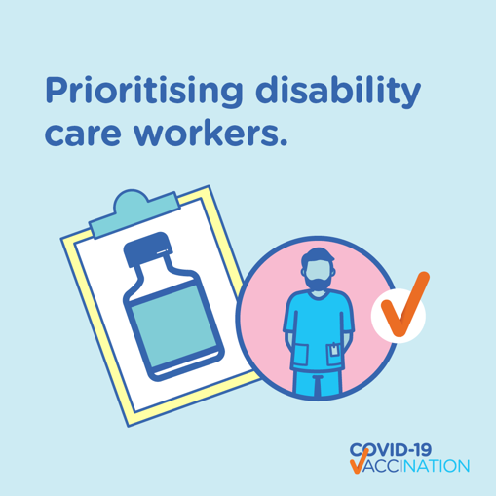
Twitter | Disability workers are eligible to receive a COVID-19 vaccine now. If you work in the disability sector, especially in an outbreak area, don’t delay. Protect yourself and the people with disability that you support today at health.gov.au/eligibility-checker  #health #COVID19 #COVID19vaccines | 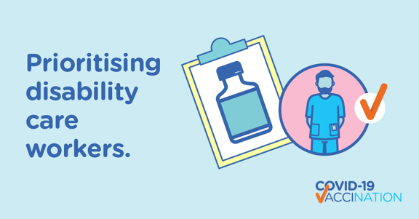
Instagram | Disability workers are eligible to receive a COVID-19 vaccine now. If you work in the disability sector, especially in an outbreak area, don’t delay. Protect yourself and the people with disability that you support today at health.gov.au/eligibility-checker  #health #COVID19 #COVID19vaccines | 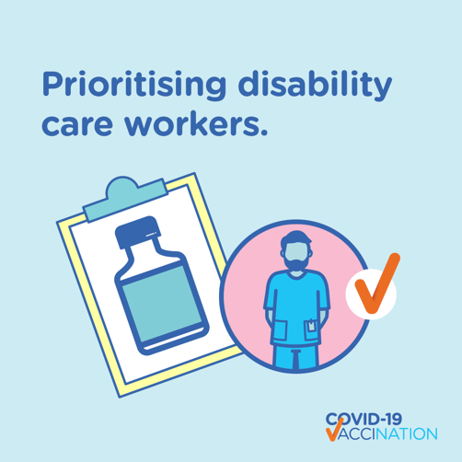

Signature blocks
If you wish to add arm yourself messaging to your business signature blocks here is a link to a selection to choose from.

Common questions about vaccines and addressing misinformation
You can help encourage people to rely on reputable sources of information to help make informed choices and stay up-to-date on the latest news about COVID-19 vaccines.
With new COVID-19 vaccine developments happening every day, it’s normal to have questions or concerns, and possibly feel hesitant about getting a vaccine. Our ‘Is it True’ web page provides accurate, evidence-based answers to questions about COVID-19 vaccines.

Tailored Resources
We have a range of tailored resources for you to share within your network, including:
- COVID-19 vaccination – Easy Read resources
- COVID-19 vaccination videos in Auslan
- Information for service providers, workers and people with disability about COVID-19 vaccines.
- COVID-19 vaccine information in your language.

Information to support your internal communication program
Lead by example and encourage your internal employees to be vaccinated as soon as they are able. We have a range of sample content to help you communicate about the vaccination program with the people you work with.
Other useful resources
You can also access a range of other useful resources to help promote COVID-19 vaccination, including:
- EDM and newsletter sample content
- Explainer videos
- Patient resources
- The latest ATAGI advice
- Case studies and people sharing reasons for vaccination
- Information on getting vaccinated for COVID-19.
- Eligibility explained brochure.
- Infographics and promotional items.
Contact us
Should you need any more information, we would be more than happy to support you.
Please get in touch with us at:
covidvaccinecomms@health.gov.au

