# Commonwealth Home Support Programme (CHSP) – Extension Readiness Survey Results

## Overview

The CHSP 2022-23 Extension Readiness Survey closed on 2 August 2021. A total of 800 responses (or 57% response rate) was received, with coverage from all Service Types and Aged Care Planning Regions.

## Payment in Arrears Survey

Transitioning to payment in arrears will be a significant change for many CHSP providers. The Survey provided Health with a better understanding of providers’ current situation, business practices and readiness for change.

The Survey has given the department insights into the issues associated with moving to payment in arrears. Specifically, the need to consider the fixed costs of delivering services, an organisation’s IT and their ability to track funding at the individual client level, and service provider cashflow/reserves.

Thank you to all the CHSP providers who completed the survey.

## High level survey results

* 57% of all CHSP service providers responded to the survey (800[1]/1410).
* 86% of respondents enforce a CHSP client contribution policy.
* 64% of respondents currently receive payment in arrears for services provided outside of CHSP.
* 80% of respondents have a long-term plan to deliver aged care services.
* 83% of respondents use accounting software or Client Relationship Management Software to manage invoicing and record services delivered.
* 54% of respondents have a service delivery model to track individual consumer services and the amount spent on each individual client (government funding and client contribution).
* 89% of respondents have the ability to track and report against CHSP staff (including subcontractors and volunteers) who have received their COVID-19 Vaccination, with 64% already voluntarily reporting.

**Graph 1** Percentage of providers who responded by service type (n=800)

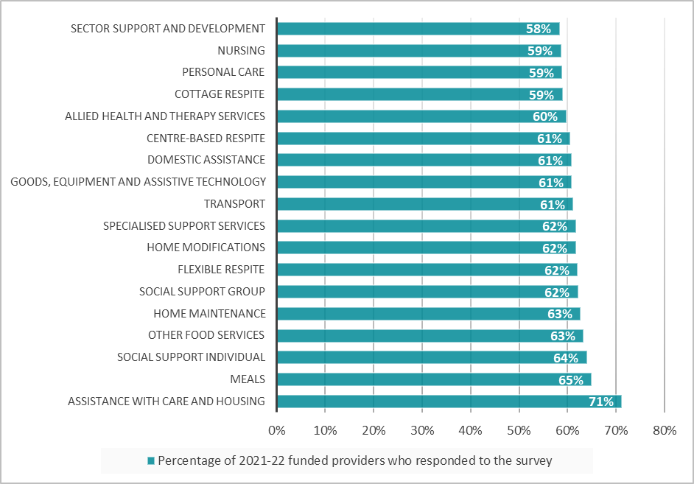

**Graph 2** Percentage of providers who responded by State and Territory (n=800)

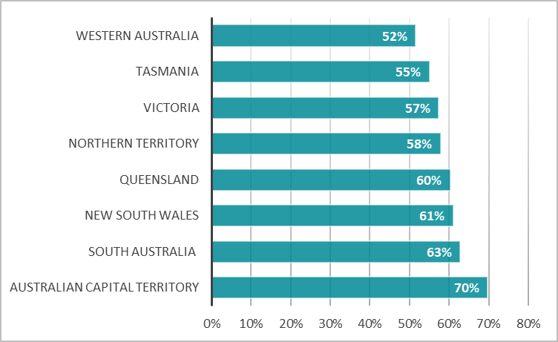

**Graph 3** Percentage of respondents who identified the contributing factors to how the organisation sets their unit price (providers could select multiple options, n=800).

**Graph 4** Percentage of providers who identified their concerns related to transitioning to PIA (providers could select multiple options, n=800).

## Upcoming work and meetings

* Working Group met again on 13 September and another update will be provided at the end of September 2021.
* The payment mechanism will be agreed upon in September 2021.
* The next Working Group meeting is on 11 October.
* The National Unit Pricing Policy will be finalised in October 2021.
* The implementation timeframes for PIA are outlined in the [CHSP – Payment in arrears and unit pricing fact sheet](https://www.health.gov.au/resources/publications/commonwealth-home-support-programme-chsp-payment-in-arrears-and-unit-pricing-fact-sheet).

## Further Information

Health aims to regularly update providers on the changes to CHSP. All CHSP providers will be able to access these updates under [CHSP news](https://www.health.gov.au/initiatives-and-programs/commonwealth-home-support-programme-chsp/commonwealth-home-support-programme-chsp-news). Alternatively, please direct any enquiries to [homesupportpolicy@health.gov.au](mailto:homesupportpolicy@health.gov.au).

1. There was a total of 849 responses to the survey, of which 49 records have been excluded from the results due to data discrepancies and/or duplicated submissions.