Better Access Initiative - Social Worker’s Checklist

Social workers can provide focussed psychological strategies (FPS) under the Better Access Initiative (BAI), where their clients can access up to 10 individual sessions per calendar year.

**Note**: BAI has been temporarily increased to an additional 10 sessions per calendar year in response to COVID-19 until 30 June 2022, there are [different item numbers](https://www.servicesaustralia.gov.au/organisations/health-professionals/topics/education-guide-better-access-mental-health-care-eligible-health-professionals/35591) for these additional sessions.

Patients can also access up to 10 group sessions (involving 6-10 patients) per client per calendar year. Group services are separate from individual services and do not count towards the 10 individual services per calendar year maximum.

# Allied health practitioner eligibility

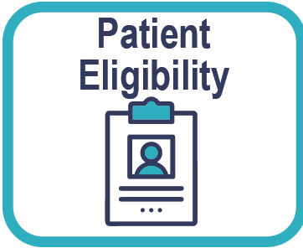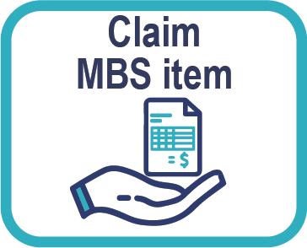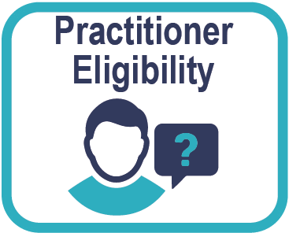

Member of the Australian Association of Social Workers.

Certified by AASW as meeting the standards for mental health set out in the document published

by AASW titled ‘Practice Standards for Mental Health Social Workers 2014’.

# Checking patient eligibility

## Initial referral - Does the patient meet all of the following criteria?

Has a referral from:

a medical practitioners (as part of a mental health treatment plan, shared care plan or psychiatrist assessment and management plan, or

a psychiatrist, or a paediatrician.

**Make sure you provide a written report to the referring medical pratitioner after each course of treatment.**

## Subsequent referral - As above, and:

patient has had a review with their referring practitioner and who has issued a new referral.

**Note**: A new treatment plan is not needed.

**Make sure you provide a written report to the referring medical pratitioner after each course of treatment.**

## Additional referral (COVID-19 10 sessions - 30/6/22)

As above and:

patient has had a review with their referring practitioner and who has issued a new referral.

**Note**: A new treatment plan is not needed.

**Make sure you provide a written report to the referring medical pratitioner after each course of treatment.**

## Referral requirements

A referral for Better Access services should specify the number of sessions a patient is being referred for, if a social worker receives a referral that does not specify they can use their clinical judgment to provide sessions up to the maximum amount allowed for that particular course of treatment.

The maximum number of sessions allowed in a calendar year for each course of treatment is as follows:

* Initial course of treatment – a maximum of 6 sessions.
* Subsequent course of treatment – a maximum of 6 sessions up to the patient’s cap of 10 sessions (e.g. if the patient received 6 sessions in their initial course of treatment, they can only receive 4 sessions in a subsequent course of treatment).
* Additional 10 COVID-19 sessions (only available until 30 June 2022) – a maximum of 10 sessions.

# Completing documentation requirements

Have you provided a written report to the referring medical practitioner **after each course of treatment**, and does the report include information on:

* + assessments carried out
  + treatment provided
  + recommendations on how to manage the patient’s condition in the future.

**Note**: You are obliged under Medicare requirements to keep contemporaneous notes. The [‘record keeping](https://www.health.gov.au/resources/publications/record-keeping-quality-improvement-guide)

[- quality improvement guide’](https://www.health.gov.au/resources/publications/record-keeping-quality-improvement-guide) is designed to provide you with the information and tools to assist in ensuring you meet these guidelines.

# Claiming MBS item

Have you met all elements of the service? Check [MBS online](http://www.mbsonline.gov.au/internet/mbsonline/publishing.nsf/Content/Home) if you are unsure.

Source: Services Australia, [Education guide - Better Access to mental health care for eligible health professional](https://www.servicesaustralia.gov.au/organisations/health-professionals/topics/education-guide-better-access-mental-health-care-eligible-health-professionals/35591)[s](https://www.servicesaustralia.gov.au/organisations/health-professionals/topics/education-guide-chronic-disease-individual-allied-health-services-medicare-items-10950-10970/33196) (last accessed August 2021)