­­­National Action Plan for Endometriosis

July 2018

© Commonwealth of Australia as represented by the Department of Health 2018

**Creative Commons Licence**

cid:image001.png@01D10CD1.33FE7F70

This publication is licensed under the Creative Commons Attribution 4.0 International Public License available from <https://creativecommons.org/licenses/by/4.0/legalcode> (“Licence”). You must read and understand the Licence before using any material from this publication.

Restrictions

The Licence may not give you all the permissions necessary for your intended use. For example, other rights (such as publicity, privacy and moral rights) may limit how you use the material found in this publication.

The Licence does not cover, and there is no permission given for, use of any of the following material found in this publication:

* the Commonwealth Coat of Arms (by way of information, the terms under which the Coat of Arms may be used can be found on the Department of Prime Minister and Cabinet website http://www.dpmc.gov.au/government/commonwealth-coat-arms);
* any logos and trademarks;
* any photographs and images;
* any signatures; and
* any material belonging to third parties.

Attribution

Without limiting your obligations under the Licence, the Department of Health requests that you attribute this publication in your work. Any reasonable form of words may be used provided that you:

* include a reference to this publication and, where practicable, the relevant page numbers;
* make it clear that you have permission to use the material under the Creative Commons Attribution 4.0 International Public License;
* make it clear whether or not you have changed the material used from this publication;
* include a copyright notice in relation to the material used. In the case of no change to the material, the words “© Commonwealth of Australia (Department of Health) 2018” may be used. In the case where the material has been changed or adapted, the words: “Based on Commonwealth of Australia (Department of Health) material” may be used; and
* do not suggest that the Department of Health endorses you or your use of the material.

Enquiries

Enquiries regarding any other use of this publication should be addressed to the Branch Manager, Communication Branch, Department of Health, GPO Box 9848, Canberra ACT 2601, or via e-mail to [copyright@health.gov.au](mailto:copyright@health.gov.au)

# Ministerial Foreword

I consider it a great privilege to write the foreword for this momentous document.

Just over six months ago, a group of passionate patients and parliamentarians banded together to shine a light on an issue that had been hidden for too long. They brought endometriosis to my attention as a condition that afflicts hundreds of thousands of Australian women, with often devastating consequences.

I listened to the stories of women who had suffered in silence for so long, and resolved that on my watch, Australian women would no longer have to battle this in private. I issued an apology on behalf of the Australian Parliament and medical system for the historic failures that sufferers of endometriosis endured. I also announced that work would begin immediately on a National Action Plan for Endometriosis, as a first ever national approach to combat this insidious condition.

On the following pages, you will find Australia's blueprint to tackle endometriosis on all fronts ­– through awareness and education, clinical management and care and medical research. For the first time, Australia now has a coordinated and structured strategy to improve awareness and understanding of endometriosis, to speed up diagnosis, develop better treatment options and to ultimately find a cure.

Already, the Turnbull Government has announced an initial investment of $2.5 million through the landmark Medical Research Future Fund, to improve diagnosis and treatment options for better patient outcomes. A further $1 million is being directed to increase awareness of endometriosis among GPs and other frontline health professionals. I now look forward to all state and territory governments also taking on the overarching goals, objectives and actions of the plan, with their own funding and service commitments.

This comprehensive plan was developed by a dedicated team. I offer my thanks to the patients, clinicians, researchers and policymakers for their expertise and enthusiasm for this project. In particular, I wish to thank the women and girls who shared their own personal experiences of endometriosis, as well as the advocacy groups that promote their voices and their wellbeing.

It is my hope that the National Action Plan for Endometriosis will serve to improve the quality of life for Australian women with endometriosis now and into the future; and that gradually, patients will no longer be defined by the condition they live with, but will be able to live full lives, with the uncompromised support of those responsible for their care.

Sincerely



**The Hon Greg Hunt MP**

Minister for Health

# About the Plan

There is growing recognition within Australia of the need for improved awareness, education, diagnosis, treatment and research into endometriosis and associated chronic pelvic pain. This National Action Plan for Endometriosis (National Action Plan) emerges from the combined efforts of patients, advocacy groups, clinicians, researchers and parliamentarians to have endometriosis acknowledged as a chronic condition and a substantial health burden in Australia.

The Turnbull Government announced the development of the National Action Plan in December 2017. This is the first National Action Plan for Endometriosis. It provides a platform for improving the awareness, understanding, treatment of, and research into, endometriosis and associated chronic pelvic pain in Australia.

Investment into endometriosis awareness, education, diagnosis, treatment, and research will benefit women, girls and other individuals affected by endometriosis and chronic pelvic pain associated with endometriosis, as well as their families, partners and carers, with earlier diagnosis and intervention, broader multi-disciplinary treatment options and clear care management pathways made possible. Investment will ultimately benefit the Australian community, with a reduction in the overall burden of disease, through lower healthcare costs and absenteeism rates, and an increase in social and economic participation made possible.

With increased funding directed towards research, both prevention and a cure for endometriosis may be achievable – the aspirational goal of this National Action Plan.

The National Action Plan is aligned to the goals of the National Strategic Framework for Chronic Conditions, which was published by the Australian Health Ministers’ Advisory Council (AHMAC) in 2017[1]. It shares the aim that all Australians live healthier lives through effective prevention (where possible), early intervention and management of chronic conditions.The National Action Plan also shares many of the underlying principles of the Framework and, like the Framework, builds on existing work and is designed as a tool to enhance activities already underway and to guide the development of new and innovative policies and approaches.

The National Action Plan for Endometriosis can inform consideration of a number of related conditions, such as polycystic ovary syndrome, adenomyosis, pelvic inflammatory disease and chronic pelvic and period pain, but does not specifically address these conditions. There is potential for the identified priorities of education and awareness, clinical management and care and research, as outlined in the National Action Plan, to consider the spectrum of related conditions where appropriate. The National Action Plan uses the terms endometriosis and chronic pelvic pain with the intention that, where appropriate, this reflects connections between endometriosis and other related conditions.

This National Action Plan is one of the first steps for Australia’s renewed action on endometriosis.

## Acknowledgements

Many organisations and individuals have contributed to the development of this first National Action Plan for Endometriosis. In particular, we would like to thank the following:

ACE – Australian Coalition for Endometriosis (comprising the following organisations)

Canberra Endometriosis Network

EndoActive

Endometriosis Australia

Pelvic Pain Foundation of Australia

Qendo – Queensland Endometriosis Association

Australian Gynaecological Endoscopy and Surgery Society Limited

Australian Longitudinal Study on Women’s Health

Canberra Endometriosis Centre

Hudson Institute of Medical Research

Jean Hailes for Women’s Health

Mercy Health

Monash University

Parliamentary Friends for Endometriosis Awareness Group

Gai Brodtmann MP

Nicolle Flint MP

The Hon Catherine King MP

Nola Marino MP

Maria Vamvakinou MP

Pelvic Pain SA

Robinson Research Institute

The Royal Children’s Hospital Melbourne

The Royal Hospital for Women, Sydney

The Royal Women’s Hospital Victoria Australia

The University of Adelaide

The University of Melbourne

The University of Queensland

University of New South Wales

WHoA! – Women’s Health of Australia

World Endometriosis Society

Contents

Ministerial Foreword ii

About the Plan iii

Acknowledgements iv

What is endometriosis 1

Why endometriosis matters 3

Call for action 5

Foundation for action 8

What we want to achieve 11

Partnerships 13

Priorities 15

Priority 1 – Awareness and education 16

Priority 2 – Clinical management and care 23

Priority 3 – Research 30

Achieving progress 34

Next steps 35

Appendix A Implementation partners 36

Appendix B Plain Text Alternatives 40

Appendix C References 44

# What is endometriosis

Endometriosis is a common yet frequently under-recognised chronic disease. Endometriosis occurs when cells similar to those that line a woman’s uterus grow in other parts of her body, usually around the pelvis, and less commonly in tissues and organs outside the pelvic cavity. Endometriosis is a highly individualised disease, with the symptoms and impact of the disease ranging significantly from person to person. Some people have very little pain or other common symptoms, and others have reoccurring symptoms that impact on a daily basis. Once diagnosed, many people will have endometriosis effectively managed, although in many cases it can lead to debilitating long-term chronic pain, symptom recurrence, compromised fertility and sexual function. It can also significantly impact the families, partners and carers of those with endometriosis, as well as the social and economic participation, physiological, mental and psychosocial health of those affected.[2],[3],[4]

It is estimated that more than 700,000 Australian women, girls and other individuals are living with endometriosis; however, delays in diagnosis and a lack of definitive research on the domestic burden of disease suggest the number could be far higher.[5] Some research indicates the condition is more common than breast cancer, prostate cancer, and diabetes.[6] It can affect all women and girls, transgender, non-binary, and gender-diverse people assigned female at birth, regardless of age, background or lifestyle, from pre-pubescence to beyond menopause.

As stated earlier, it is acknowledged that there are a number of conditions related to endometriosis. Whilst this National Action Plan does not specifically address these conditions, there is potential for the identified priorities of education and awareness, clinical management and care and research, to consider the spectrum of related conditions where appropriate. The National Action Plan uses the terms endometriosis and chronic pelvic pain with the intention that, where appropriate, this reflects connections between endometriosis and other related conditions.

## Myth busting endometriosis

There are many myths around what endometriosis is, what are effective treatments and the options for people who have the disease. Through scientific research, many of these myths have been debunked, however misinformation continues to be delivered to people by both healthcare professionals and the general public. Some of these myths and the accompanying facts are in the diagram below:

| **Myth:** Period pain is normal – you must have a low pain threshold.  **Fact:** Severe pain (dysmenorrhea) with menstruation is not normal and can be caused by endometriosis or other related conditions.  **Myth:** Everyone who has endometriosis has severe period pain.  **Fact:** Many individuals have no symptoms at all.  **Myth:** Having a baby will ‘fix’ endometriosis.  **Fact:** Endometriosis symptoms can appear to improve during pregnancy due to changes in hormone levels. These effects may only be temporary and symptom recurrence can occur.  **Myth:** If you have endometriosis, you can't have children.  **Fact:** Although it can be more difficult to conceive, most women with endometriosis are still able to have children.  **Myth:** A hysterectomy will cure the disease.  **Fact:**There is no cure. For some women it is a suitable option to alleviate some symptoms, but symptoms can return. |
| --- |

# Why endometriosis matters

The majority of Australians will know at least one person with endometriosis. Endometriosis has been historically under-recognised amongst both the medical community and the public, and subsequently underdiagnosed. The delay between onset and diagnosis is, on average, between seven and twelve years.[7],[8] This is influenced by the fact that symptoms can vary significantly from person to person, making clear assessment difficult, and that an invasive operation is required for formal diagnosis. The delay in diagnosis is also influenced by stigma and cultural taboo, with periods considered ‘women’s business’ and not something that women, girls or other individuals want to discuss with male doctors or educators, as well as low education or miseducation about menstrual health.[9] This means that many individuals living with endometriosis and associated chronic pelvic pain are not receiving adequate treatment and management until they have had the condition for many years.

The causes of endometriosis remain unclear. It is likely that there is no single cause, and that genetic, biological and environmental factors may influence the condition.[10] Although treatments are available, they are not always effective. There is currently no cure for endometriosis, with symptom recurrence following medical or surgical treatments common. However, it is recognised that early assessment and intervention can lead to better long-term management, including lessening the impact of symptoms and improving quality of life, helping individuals affected by endometriosis to live normal healthy lives.[11]

Figure 1: Indication of the impact of endometriosis in Australia[12],[13],[14],[15],[16]

Note: this information is taken from a range of references. Statistics for transgender and non-binary individuals are unknown.

Plain text alternative

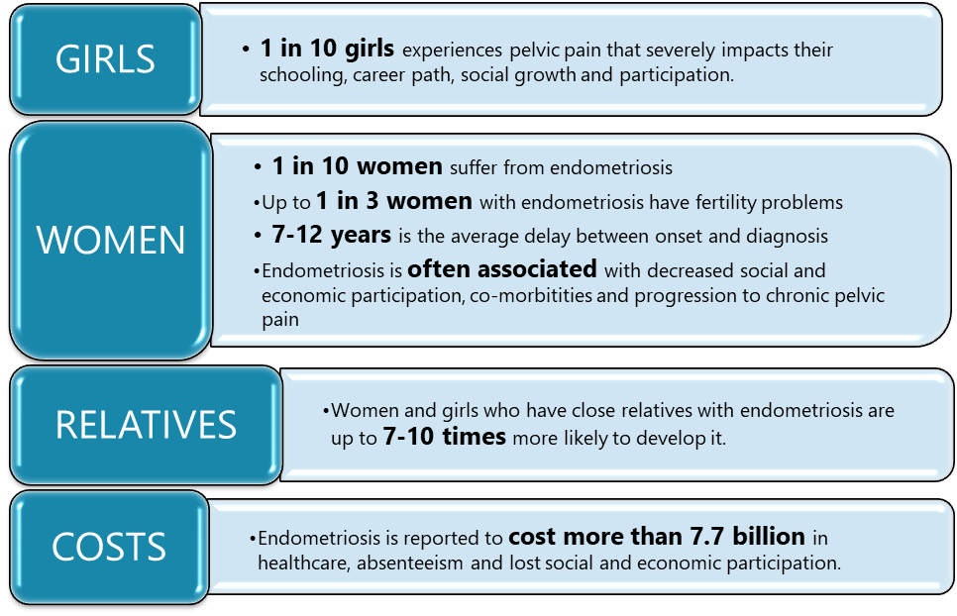

# Call for action

It is evident that endometriosis can have a profound impact on women, girls, and other individuals, their families, partners and carers, and society as a whole – it is a significant issue throughout the world, with approximately 176 million women and girls living with endometriosis.[17] There is significant frustration with the under-recognition and misdiagnosis of endometriosis, and the subsequent delays from onset to diagnosis and treatment. Individuals living with endometriosis and chronic pelvic pain want to be recognised and have their condition taken seriously. At home and internationally, there is a pressing need to strengthen the response to the condition and to improve the quality of life for those affected.[18]

Given there has been little attention directed towards endometriosis to date, there is a need for significant improvements in outcomes for individuals with this condition, with earlier diagnosis and intervention, broader multi-disciplinary treatment options and clear care management pathways possible.

Specifically, there is a need for:

| **Greater awareness and education** |
| --- |
| Timely education and increased awareness for multiple groups, spanning patients, health professionals and the Australian public.  Stronger appreciation and understanding of endometriosis as a complex chronic condition, and the psychological and social effects of endometriosis, as well as communication regarding its potentially detrimental effects on women’s fertility and social and economic participation.  Engagement with schools and employers to increase awareness and understanding of endometriosis and its impact, enabling schools and workplaces to provide supportive environments for individuals with endometriosis and chronic pelvic pain.  Greater clarity about the patient care pathway and where women, girls, other individuals with endometriosis and their support networks can seek help. |

| **Improved access to services that are appropriate, available and accessible** |
| --- |
| Evidence-based clinical guidelines and an effective accreditation process for clinicians, to promote diagnostic and treatment excellence.  Better-informed, earlier access to detection, diagnosis, intervention, management and care.  Improved case management and integration between services at each stage of the care pathway, to support the individual patient care pathway.  Improved accessibility for people in rural and regional areas, as well as Aboriginal and Torres Strait Islander people, culturally and linguistically diverse communities, transgender and non-binary people, women with disabilities, and disadvantaged groups.  Improved, comprehensive management for complex pain, to minimise the daily impact on patients and their social, academic and professional capability. |

| **Support for further research relevant to need** |
| --- |
| Enhanced support for clinical trials and research organisations.  Improved data capture and use in Australia, and to capitalise on Australia’s strong research capability to pursue international research goals.  Investment into agreed research priorities |

There is a long way to go to improve outcomes for women, girls and other individuals living with endometriosis and associated chronic pelvic pain in Australia. Indeed, Australians have spoken powerfully about the need for action.

A small selection of the patient experiences that have been raised by Members of Parliament, voiced during the launch of the Parliamentary Friends of Endometriosis Awareness, quoted in the Australian media and those received through the online consultation process for the development of this National Action Plan, are illustrated in Figure 2.

### Figure 2: Living with endometriosis – in their own words

|  |  |  |
| --- | --- | --- |
| *“I feel misunderstood, isolated and defeated as a result of this disease. I have 'lost almost everything' to this disease and struggle to manage life on a daily basis because of pain, grief and PTS. It would be life altering to have the support and understanding and some way of bridging the gap between myself and those who do not live with the disease.”* | | *"So many doctors say it's in our heads and is just period pain so it will be very good to have a plan in place to make sure we get the proper care we deserve”* |
| *“I've been turned away from Emergency Departments, ignored by GPs, been told pregnancy is a solution. I’ve been told there is nothing that can be done, been told it’s all in my head, been told excruciating period pain is normal. Education for medical professionals is the most important part of the plan. Education for young girls on what is and isn't normal is an important step in early diagnosis and intervention.”* | | *“It’s a disease that slowly destroys your body, your social life, relationships, dreams of becoming a mother, careers, work, financial stability, self-esteem, sex life, ability to function normally, ability to parent fully and your mental state.”* |
| *“Young women and girls and doctors need to know that pain with periods should be taken seriously. that pain is a sign of something going on. I went to so many doctors about my pain and they thought it was kidney stones, or a slipped disc, to being red headed and therefore being more sensitive.”* | | *“I don't like to make comparisons, but! People are understanding and empathetic for my asthma or nut allergy but not so much the symptoms of my endo, which impact me far more greatly.”* |
| *“It affects the entirety of a woman and her wellbeing. Mental health support, physio, fertility assistance, financial assistance, nutrition, gentle exercise and other more intensive therapies such as hormones and surgery should be considered.”* | *“Endometriosis is a misunderstood and under researched disease that can be debilitating... Not only is the pain and other issues debilitating, the mental suffering that goes along with it is unfathomable and unreasonable.”* | |
| *“One night Mum and Dad took me to the hospital and told them I had endometriosis. The doctor said ‘How do you spell that?’ and I remember lying there thinking, ‘What am I doing here? He doesn’t even know how to spell it.’”* | *“I’d been told everything from it being a digestive issue to [being caused by] gluten to it’s all in my head and I’m neurotic… if it happened to me, it happened to millions of other women.”* | |
| *“1 in 10 women may suffer from endometriosis, but for some women, treatment can be as simple as using a different contraceptive pill or IUD. For others, it can mean chronic daily pain, inability to work/study, impact on bowel/bladder/sexual function, infertility, recurrent miscarriage and loss of dignity.”* | *“I really think that this is a disease that is not talked about because it is about women’s bodies and blood, I found when I talked to male doctors about my periods they would tell me about pain killers. So I stopped asking.”* | |

# Foundation for action

## The Australian context

Despite the need for improvement, there are also multiple positives to build upon in this National Action Plan. Australia’s existing health, community and research landscape provides a strong foundation for action on endometriosis and associated chronic pelvic pain.

Centrally, this is due to an existing, comprehensive health system with widespread, safe, and generally subsidised access to a range of care options. Strong health system infrastructure is supported by highly specialised expertise in endometriosis research and laparoscopic surgery, a significant range of existing online support tools and information resources and published materials, as well as goodwill and willingness for collaboration among diverse members of the endometriosis community.

This enabling environment is illustrated in Figure 3.

### Figure 3: Enablers to support action in the Australian health system

Plain text alternative

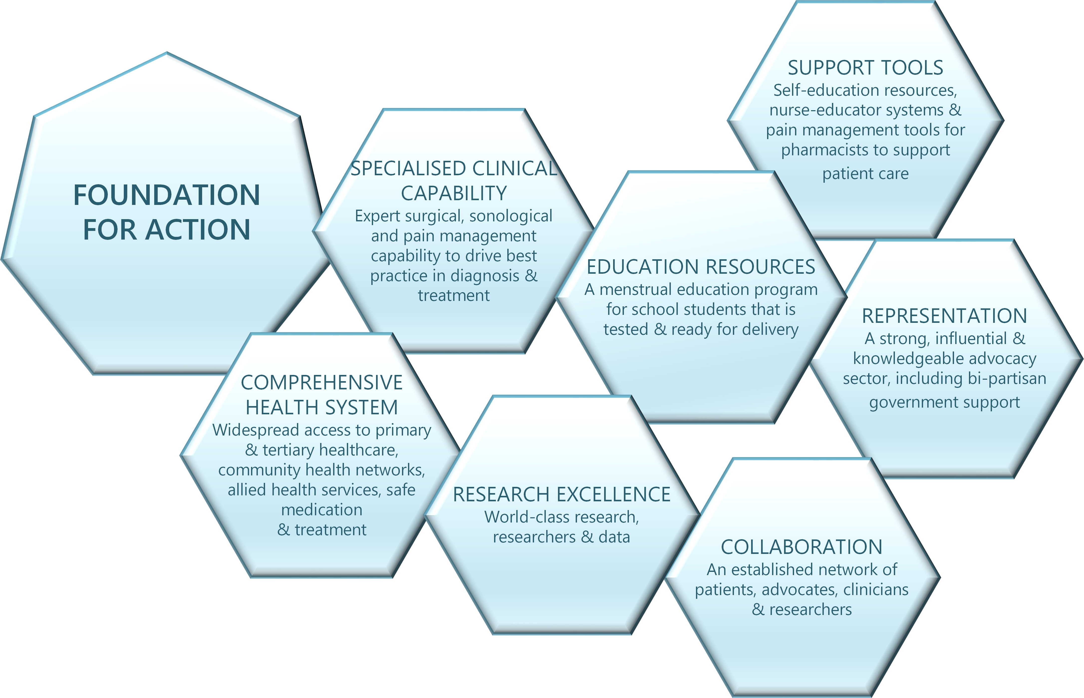

#### International approach

Internationally, work is being undertaken to improve awareness, understanding and treatment of endometriosis. A global consortium of investigators in endometriosis has recently published its recommendations for research priorities for endometriosis.[19] Similarly, the Endometriosis Priority Setting Partnership (PSP) was formed with the objective of identifying the key questions about endometriosis that were most important to both women and girls who have endometriosis and healthcare practitioners involved in their care. [20] Following extensive consultation, the PSP agreed the top ten endometriosis research priorities in the UK and Ireland. These ten priorities are intended to ensure that future research funding and activities focus on questions that are important to individuals with endometriosis and to healthcare practitioners. These priorities, outlined in Figure 4 below, are also relevant in the Australian setting.

Figure 4: Top ten research priorities for endometriosis in the UK and Ireland[21]

| 1. Can a cure be developed for endometriosis? 2. What causes endometriosis? 3. What are the most effective ways of educating healthcare professionals throughout the healthcare system resulting in reduced time to diagnosis and improved treatment and care of women with endometriosis? 4. Is it possible to develop a non-invasive screening tool to aid the diagnosis of endometriosis? 5. What are the most effective ways of maximising and/or maintaining fertility in women with confirmed or suspected endometriosis? 6. How can the diagnosis of endometriosis be improved? 7. What is the most effective way of managing the emotional and/or psychological and/or fatigue impact of living with endometriosis (including medical, non-medical, and self-management methods)? 8. What are the outcomes and/or success rates for surgical or medical treatments that aim to cure or treat endometriosis, rather than manage it? 9. What is the most effective way of stopping endometriosis progressing and/or spreading to other organs (e.g. after surgery)? 10. What are the most effective non-surgical ways of managing endometriosis-related pain and/or symptoms (medical/nonmedical)? |
| --- |

The National Institute for Health and Care Excellence (NICE) in the United Kingdom issued a new guideline on endometriosis in September 2017. The guideline, *Endometriosis: diagnosis and management*, aims to raise awareness of the symptoms of endometriosis, and to provide clear advice on what action to take when women with signs and symptoms first present in healthcare settings.[22] It also provides advice on the range of treatments and care pathways that can be used by both clinicians to guide treatment options and patients to understand what to expect with the treatment and management of endometriosis.

In Canada, the Society of Obstetricians and Gynaecologists of Canada (SOGC) has also developed and published a clinical practice guideline for endometriosis diagnosis and management.[23] The aim of the SOGC guidelines are to improve the understanding of endometriosis and to provide evidence-based guidelines for diagnosis and management, including the impact of the medical and surgical management of endometriosis on women’s experience of morbidity and infertility.

# What we want to achieve

The overall goal of the first National Action Plan for Endometriosis is:

|  |
| --- |
| A tangible improvement in the quality of life for individuals living with endometriosis, including a reduction in the impact and burden of disease at individual and population levels. |

## Supporting objectives

Figure 5 outlines the supporting objectives that will enable the achievement of the goal. Each supporting objective relates directly to one of the priorities of the National Action Plan, outlined over the following pages.

### Figure 5: Objectives of the first National Action Plan for Endometriosis

#### Awareness and education

| 1 | Improved public understanding and health literacy through targeted education initiatives and visible, widespread, public awareness campaigns with particular regard to vulnerable and at-risk population groups. |
| --- | --- |
| 2 | Patients, families, partners and their carers are empowered, well-informed, active decision makers and participants in their own healthcare with streamlined access to a broad range of resources, including self-education and self-management tools. |
| 3 | Healthcare professionals, educators and employers are well-informed about endometriosis and its significant impacts, take women’s pain seriously and provide appropriate care and support for all people with endometriosis. |

#### Clinical management and care

| 4 | Healthcare professionals are supported to deliver best-practice, nationally consistent clinical management and care of endometriosis and chronic pelvic pain. |
| --- | --- |
| 5 | Early access to endometriosis-specific education, diagnosis, intervention, fertility treatment, pain management options and providers of choice reduces delays at all stages of the care pathway. |
| 6 | Affordable and accessible pain management, mental health and psychosocial care options for all patients, including vulnerable population groups, with nationally consistent clinical guidelines, standards and pathways, to aid strong clinical delivery. |

#### Research

| 7 | The gap in quality of life, including social and economic participation, between patients with endometriosis and their peers continues to narrow. |
| --- | --- |
| 8 | Patients benefit from greater understanding of the nature and cause of endometriosis and have access to simpler and less invasive diagnostic tests and treatment options. |
| 9 | High-quality research findings are translated and implemented to achieve real-world outcomes, and there is continuing progress towards prevention and the development of a possible cure. |

## Partnerships

To improve the experiences of and outcomes for individuals living with endometriosis and chronic pelvic pain, their families, partners and carers, collaborative and continued effort is required across multiple domains. Collaboration on the development and implementation of the priorities and actions identified in this National Action Plan has the potential to markedly improve outcomes for patients with endometriosis.

Collaboration must go beyond a simple network to be an inter-professional collaborative practice. Partnerships must centre around the people affected by endometriosis and associated chronic pelvic pain, their families, personal partners and carers. Government organisations, the health and education sectors and other industry organisations and agencies are direct or potential partners. These partners are critical to the provision of responses that maximise the use of resources to drive change, together with advocacy and support groups.

By using this National Action Plan, all partners will be able to better focus their attention on key areas where they are best placed to provide additional support and ensure their investment is appropriately directed. These partnerships are represented in Figure 6.

### Figure 6: Key partners for successful implementation

Plain text alternative

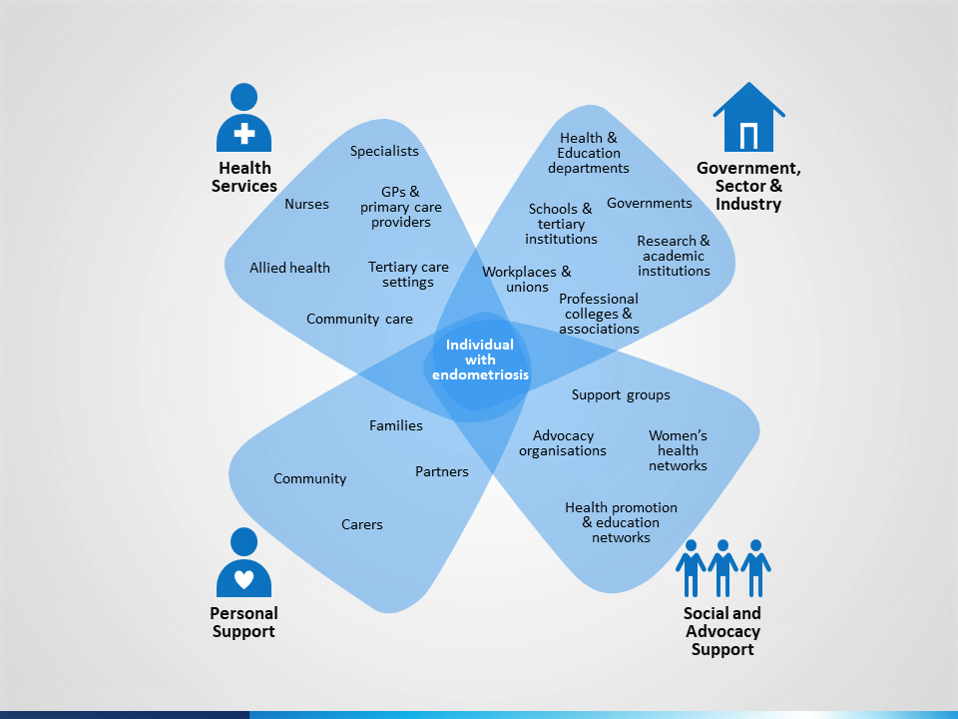

All partners are encouraged to identify areas of mutual benefit which improve health outcomes and take action according to their role and capacity. Greater cooperation between partners can lead to more successful individual and system outcomes.

A detailed list of key partners and priority-specific partners is provided at Appendix A.

# Priorities

There are three priorities that identify the actions that will deliver a multipronged approach to endometriosis in Australia. Each of these priorities contribute towards the overall goal and objectives of the National Action Plan.

The three priorities are:

1. Awareness and education
2. Clinical management and care
3. Research

Each priority is of equal importance and will require the cooperation of multiple parties. Attention must be paid to all three in order to achieve real progress and achieve holistic reductions in the impact and burden of disease.

Importantly however, the implementation of actions must be prioritised and coordinated to ensure that any increase in demand for services is able to be met. For example, when increasing awareness in the community, there first needs to be nationally endorsed clinical guidelines, an appropriate pathway to care, availability of educational resources and access to appropriately skilled and trained clinicians available to provide care.

The integration of the priorities is modelled in Figure 7.

### Figure 7: Priorities for the National Action Plan

Plain text alternative

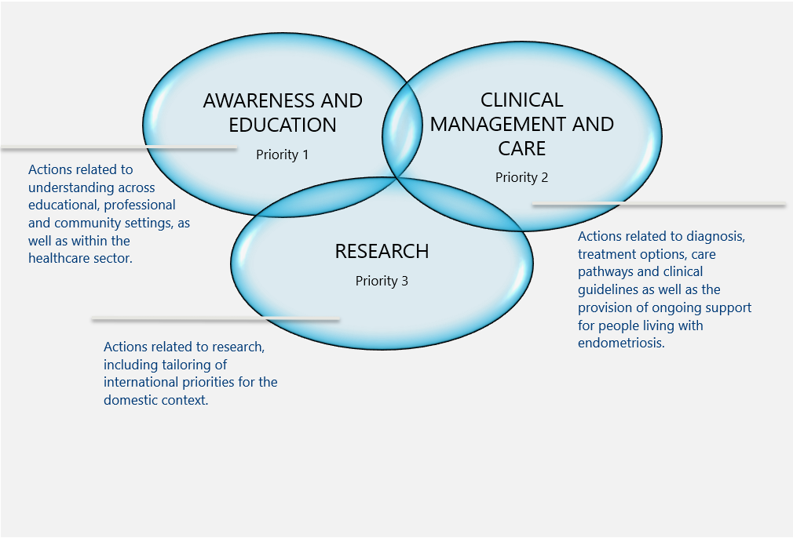

## Priority 1 – Awareness and education

Stronger awareness, recognition, acknowledgment and education about endometriosis are the bedrock of an improved response. Raising awareness is the first step to reducing diagnostic delay. Education, particularly in younger age groups and among health professionals, is fundamental for breaking the cycle of under-recognition and diagnostic delay.

This is the first priority of the National Action Plan, which acknowledges the need to improve understanding and impact of the condition among patients, health and education professionals, the broader health sector, and the Australian community generally.

### What will be different?

The profile of endometriosis as a chronic condition will be raised, leading to an informed and accurate understanding of endometriosis by individuals, education and health professionals and the community more broadly. This will enable early recognition of symptoms, greater awareness of treatment options and understanding of the impact of the condition.

Women, girls and other individuals who are at-risk or affected by endometriosis, and their families, partners and carers, will be more empowered and active decision-makers and participants in their healthcare, supported by well-informed and respectful interactions with education and health professionals and the community.

### Priorities and actions

There are four key areas for awareness and education.

#### Develop widespread, visible and context-specific community awareness campaigns delivered through multiple channels.

|  | Action | Detail |
| --- | --- | --- |
| 1.1 | Develop, promote and deliver community awareness campaigns, delivered across multiple platforms, to improve the visibility of endometriosis in public life, and to ensure that endometriosis is a widely recognised chronic condition. | Awareness campaigns should be developed through a co-design process involving people with endometriosis to facilitate comprehensibility, usability, acceptability and feasibility of the information and messaging.  Improve endometriosis’ visibility in public life to ensure that endometriosis (‘endo’) enters the public vernacular. Increased visibility should enable increased public awareness of the condition, as well as its prevalence, long-term health implications, and the appropriate routes to further information.  Information collation and dissemination could be achieved through:   * Targeted social media * electronic resources (e.g. websites) * webinars (low cost, far reaching and repeatable) * face-to-face contact sessions (high impact, but resource intense)   Utilise public figures to raise awareness of endometriosis, particularly for young girls.  Partner with industry to promote awareness across multiple platforms, including but not limited to packaging of menstrual, contraceptive and analgesic products, partnerships with health funds and sports organisations, and advertising campaigns designed for public bathrooms and other appropriate settings. Include a layered approach to messaging – opinion pieces and spokesperson partnerships as well as traditional advertising routes.  Utilise the existing health prevention and promotion infrastructure at the local level to support implementation. |
| 1.2 | Support the development of endometriosis-specific media and awareness materials that are tailored for adolescents, Aboriginal and Torres Strait Islander communities, culturally and linguistically diverse groups, people with disability, transgender men and non-binary individuals, and for rural and regional contexts. | Education and awareness materials and campaigns need to be tailored for each cohort across the community, with time taken to work with these groups to investigate and co-design the specific messages required for each group at a local level.  Materials and campaigns need to be developed in a culturally appropriate way for Indigenous people, with recognition of cultural sensitivities and literacy levels.  Utilise the existing health prevention and promotion infrastructure at the local level to support implementation. |
| 1.3 | Develop workplace-specific materials to educate employers on the prevalence and impact of endometriosis, to enable employers and workplace human resources departments to support employees with endometriosis in a professional setting. | Encourage schools, higher education institutions, universities, employers and workplace human resources (HR) departments to increase education about endometriosis.  Utilise models for best practice HR policies and procedures that are targeted to small and medium businesses and work through local industry groups, in partnership with health promotion networks, to deliver community education in the workplace. |

#### Promote early education on women’s health, delivered in school settings, and provided for all genders.

|  | Action | Detail |
| --- | --- | --- |
| 2.1 | Update school puberty and sexual health curriculums to include a menstrual education program resource, delivered by specially qualified personnel, to educate students about menstrual health, the symptoms of endometriosis and related conditions. Promote access to resources for students and parents to learn more about menstrual health. | Support the expansion of the Menstrual Education (ME) Schools Program to deliver this.  Support both face-to-face and online sources as tools for learning.  Education needs to be in partnership with teachers, parents and the local community. Consideration needs to be given to adolescents in out-of-home care or living with a disability to include education of foster families, carers and professionals in the family, community and social services sectors.  Utilise the existing health prevention and promotion infrastructure at the local level to support implementation. |
| 2.2 | Equip primary and secondary school educators, as well as physical and mental healthcare staff in these environments, to recognise the symptoms of endometriosis and provide resources, guidance and support to students, including information regarding relevant referral pathways. | This could involve the mobilisation of the PIPPA (Period ImPact and Pain Assessment) test in the school curriculum to monitor for early signs of menstrual disturbance, endometriosis or pelvic pain. |
| 2.3 | Acknowledge cultural barriers and community diversity and develop education programs sensitive to the expectations of different demographic groups. Deliver endometriosis education and develop resources in multiple languages, accessible to people with varying levels of literacy and from different cultural backgrounds. | Education materials need to be tailored for each cohort across the community, with time taken to investigate the specific messages required for each group at a local level.  Materials and campaigns need to be developed in a culturally appropriate way for Indigenous people, with recognition of cultural sensitivities and literacy levels.  Provide education and awareness training in endometriosis for Aboriginal education assistants in schools with a high indigenous population, school counsellors and other diversity counsellors with an inclusion background. |

#### Improve access to information, self-education and self-management tools for individuals living with endometriosis at all stages of their journey.

|  | Action | Detail |
| --- | --- | --- |
| 3.1 | Develop and publish a clear flow diagram to map the pathways for individuals with endometriosis or chronic pelvic pain through the healthcare system, from first consultation through to medical intervention, to inform and enable patients to be active decision-makers and participants at each stage of care. | The map should prepare patients to be active decision-makers at each stage of disease progression. It will educate patients on the available pathway(s) and provide basic detail on what patients should ask for at each stage of their care. The map should span the care pathway through various healthcare services and should indicate alternatives for services that may not be available to all patients.  This should include information targeted at women with subfertility concerns who are not experiencing pelvic pain but may have underlying endometriosis. |
| 3.2 | Develop and promote a resource kit for individuals newly diagnosed with endometriosis to provide general information about the condition and inform patients about where to find further resources and access support, treatment and post-operative services. The kit should be provided freely and be available in both physical and discrete digital formats. | Develop a *My Endometriosis Journey* resource kit which draws on the success of the Breast Cancer Network Australia’s *My Journey Kit*.  The resource kits and other self-help tools should be developed through a co-design process involving people with endometriosis to facilitate comprehensibility, usability, acceptability and feasibility of the information and messaging.  Develop resources in multiple languages, and in a variety of modes, accessible to people with disability, varying levels of literacy and from different cultural or socioeconomic backgrounds. |
| 3.3 | Support the development of interactive tools (phone-based applications, web-based diagnostic tools and symptom checkers) to increase patient health literacy and promote proactive health-seeking behaviour. | Promote these tools to health professionals and health networks to facilitate information sharing and to raise awareness of their application. |
| 3.4 | Support educational, advocacy and support networks, providing information on available clinical services and helping patients, their families, partners and carers, navigate the health system. | Networks to highlight existing clinical and education tools to clarify the care pathway for an individual at any stage of disease progression, from new symptoms to established care. |
| 3.5 | Promote existing and emerging information sources that acknowledge cultural differences around discussion of women’s health and menstruation and ensure these can be accessed discreetly online through multiple sources. | Promote the availability of these online resources through multiple, public sources including social media, school and university settings, community centres, etc. |

#### Improve awareness and understanding of endometriosis among health professionals working at every stage in the clinical pathway.

|  | Action | Detail |
| --- | --- | --- |
| 4.1 | Provide general practitioners (GPs), practice nurses, nurse practitioners, ED staff and other clinicians involved in front-line healthcare, with concise educational materials on the prevalence, symptoms and treatment options for endometriosis, both for their own professional development and for distribution to patients. Ensure that GPs are encouraged to refer patients with chronic pelvic pain symptoms or subfertility concerns through the appropriate care pathways and are better supported to provide psychosocial care. | Implement ‘train the trainer’ educational programs for GPs who work in educational or regional and rural contexts, and for voluntary members of all other general practices to attend and distribute information back to their practices.  Emphasise the role of gynaecologists in the development of health plans.  Supplement interactive digital tools with desktop resources for use in individual consultations, which can be provided to GPs for distribution to patients who have chronic pelvic pain symptoms or subfertility concerns.  Education should aim to also increase the communication skills necessary to engage in challenging conversations regarding a person’s menstrual history. |
| 4.2 | Provide specialised training for sonographers, sonologists and radiologists on the imaging features of endometriosis as part of routine services for pelvic pain or related conditions and ensure an understanding of appropriate referral pathways. | Update guidelines for routine ultrasounds for women to include assessment for endometriosis, including reporting of symptoms in follow-up with GP. |
| 4.3 | Educate clinicians, nurses, emergency departments, physiotherapists, allied health professionals, fertility specialists and others involved in endometriosis care on the prevalence, symptoms and available pathways for treatment and embed pain management guidance into educational programs. | Include GPs pharmacists, nurse practitioners, surgeons, emergency department triage staff physicians in the process.  Pain management guidance needs to assist with shorter term management as well as longer term referral.  Include guidance on pathways for women presenting with subfertility concerns without common endometriosis symptoms such as chronic pelvic pain. |
| 4.4 | Update teaching and training standards to include endometriosis and pelvic pain training in the curriculum for all relevant medical and health practitioner colleges, both at student and postgraduate levels. | Promote partnerships between relevant specialist colleges and medical schools to deliver specialised training on endometriosis and pelvic pain. Engage medical student associations to support the rollout of education programs and awareness campaigns.  Inclusion of pain training across relevant medical and allied health specialties. |
| 4.5 | Facilitate advanced training for interested health professionals to provide an advanced level of expertise in endometriosis and chronic pelvic pain diagnosis, treatment and management. | Upskill a sub-group of GPs, nurses, nurse practitioners, physiotherapists, gynaecologists, sonographers, sonologists, dietitians, etc, to be endometriosis and pelvic pain specialists.  This could include specialised training for sonographers and sonologists to look for deep infiltrating endometriosis as part of a routine assessment. |

## Priority 2 – Clinical management and care

Clinical management and care is the second priority of the National Action Plan. This section emphasises the pivotal role of the health sector in the combined effort to improve outcomes for patients with endometriosis.

Health professionals have roles connecting and providing services to patients at all stages of their care pathway and at any point of disease progression. They are a key audience for this National Action Plan, as are the professional, educational and industry bodies that represent them.

### What will be different?

Affordable and consistent healthcare options, and better treatment options, available nationally to support timely and effective access to endometriosis diagnosis, management and care, improving day-to-day and long-term health outcomes for all patients with care for vulnerable population groups and chronic care needs meeting standards and guidelines for all.

### Priorities and actions

There are five key areas for clinical management and care.

Develop clinical guidelines and clinical care standards to promote integrative care for all stages of the care pathway.

|  | Action | Detail |
| --- | --- | --- |
| 1.1 | Develop authoritative national clinical guidelines and clinical care standards on endometriosis for health services and health practitioners throughout Australia. | Developing National Health and Medical Research Council (NHMRC)-endorsed guidelines for endometriosis should be undertaken as a priority, as it is a key step towards improving the care of people with endometriosis in Australia.  The development of clinical practice guidelines should include a review of existing international clinical guidelines such as the UK’s National Institute for Health and Care Excellence guidelines or other international guidelines on endometriosis and chronic pelvic pain for consideration in the Australian context. The guidelines and standards should uphold both the safety and quality of care and promote collaboration between multidisciplinary centres of excellence and centralised networks of expertise in the development process. |
| 1.2 | Define and document best-practice evidence-based patient pathways from self-information, GP and primary care consultation, through specialised nurses to senior specialist care, providing a national clinical resource to guide referral and progressive movement of patients through the care system. | Patient pathways and clinician pathways need to be developed collaboratively to ensure consistency.  Embed a standardised procedure involving listening to the patient’s story, experience, and family history, followed by pelvic pain examination and ultrasound. Acknowledge the need for minor adjustment or individualisation of the care pathway through instituting a patient-centred approach. |
| 1.3 | Establish clear models of care (MOC) for self-management, medical management and/or surgical management of endometriosis. Develop clear clinical and plain language resources to outline best practice and distribute to healthcare professionals, patients, their families, partners and carers. | MOC must be multidisciplinary and adaptable for various contexts and settings in the Australian healthcare landscape, including regional and rural service providers, must be implementation-focused, and should aid quality assurance and the nationalisation of standards across all services.  MOC should provide clinically appropriate care that is culturally safe.  MOC should cover endometriosis lesions, pain management, fertility management, including subfertility presentations without pelvic pain, and management of psychosocial, functional and participation aspects of living with endometriosis and associated chronic pelvic pain. |
| 1.4 | Promote and utilise accreditation guidelines for advanced laparoscopic surgery, to set the standard for advanced laparoscopic surgery to deliver optimal surgical outcomes for the patient at their first surgery. | Utilise accreditation guidelines already developed by the Australasian Gynaecological Endoscopy and Surgery Society (AGES) and the Royal Australian and New Zealand College of Obstetricians and Gynaecologists (RANZCOG).  These accreditation guidelines for advanced laparoscopic surgery outline the surgical skillset required to deal with moderate to severe endometriosis and adherence to the guidance by credentialing bodies is recommended. |

#### Target diagnostic delay and promote early access to intervention, care, and treatment options.

|  | Action | Detail |
| --- | --- | --- |
| 2.1 | Define and establish Centres of Expertise in specialised endometriosis and chronic pelvic pain diagnosis, treatment and management across Australia. | Define what constitutes centres of expertise and the specific clinical, administrative and research requirements for these sites. The establishment of multidisciplinary teams may be located in hospitals or other healthcare facilities, and work in partnership with individuals presenting with endometriosis, chronic pelvic pain or period pain. Centres should be available in the public sector as well as the private sector.  Established specialised centres with multidisciplinary teams could become part of the care pathway, particularly for referral from GPs and Eds for further screening, triaging and assessment, and to help patients navigate where to go to receive specialised care. |
| 2.2 | Devise and promote a simple, standardised and easily accessible tool to aid or precede diagnosis, that can be completed by women with potential symptoms of endometriosis prior to a GP appointment, to encourage early action and intervention. | A questionnaire or screening assessment.  Publish online and distribute through patient networks, schools and via healthcare providers. Develop a more robust and accessible version of the PIPPA (Period ImPact and Pain Assessment) test or the PPFA questionnaire to accompany or contribute to this screening process.  These tools should allow data collection to enable follow up research to validate long-term use. |
| 2.3 | Clearly identify criteria to determine when follow-up interventions are needed for formal diagnosis or treatment, in order to improve triage processes for multidisciplinary endometriosis care. | This needs to be an integrated approach as part of the patient care pathway.  For where a GP consultation, transvaginal ultrasound, laparoscopy or other intervention is needed.  Delineate the roles of different forms of informal diagnosis and best practice ‘next steps’ for various markers of disease, including indicators of psychosocial impact. |

#### Improve the affordability, accessibility and national consistency of management and care options throughout Australia.

|  | Action | Detail |
| --- | --- | --- |
| 3.1 | Support dissemination of best practice information and approaches throughout services in Australia. | Supported by the patient care pathways.  Including guides to the nurse-led care and support mechanisms such as those developed at the Canberra Endometriosis Centre and examples of best practice in ultrasound and radiology |
| 3.2 | Develop a phone-based application for clinicians to support the observation of symptoms of endometriosis and clarify ‘next steps’ for referral at any stage of the care pathway. | Supported by patient care pathways and existing digital and phone-based services such as My Health Record and HealthDirect. |
| 3.3 | Ensure no populations or demographics ‘fall through the gaps’ by integrating clinical guidance on endometriosis into guidelines for services targeted towards vulnerable and at-risk groups, specifically, Aboriginal and Torres Strait Islander people, culturally and linguistically diverse populations, people with disability, people in rural and remote settings, adolescents, transgender men and non-binary people. | Guidelines need to be tailored for each cohort across the community, with time taken to work with these groups to investigate and co-design the specific messages required for each group at a local level.  Clinical guidance needs to be developed in a culturally appropriate way for Indigenous people, with recognition of cultural sensitivities and literacy levels. |
| 3.4 | Educate patients with endometriosis, their families and advocacy groups, regarding the confidential nature of sexual or reproductive health information and conversations held with health professionals. | Ensure that information and resources on endometriosis, pelvic pain and menstrual and reproductive health can be accessed discretely, through web or phone-based information sources, to reduce the impact of stigma as a barrier to education. |
| 3.5 | Reduce barriers to assessment and treatment by pursuing options to reduce waiting times, the cost of consultations, diagnostics, medications, treatments, surgeries and sanitary products for women, girls and other individuals with endometriosis and associated chronic pelvic pain. | Through the Medical Benefits Schedule (MBS) Review, seek a review of relevant consultation and treatment items, including non-interventional management of pain symptoms.  Consider partnering with pharmaceutical companies to pursue Pharmaceutical Benefits Scheme listing for endometriosis medications, including the contraceptive pill, menopausal hormone therapy (MHT) – also known as hormone replacement therapy (HRT) – and pain medications.  Make provisions for Aboriginal and Torres Strait Islander people with endometriosis and associated chronic pelvic pain through the Closing the Gap PBS Co-payment Measure.  Improve access to medical diagnostic ultrasound and other imaging modalities to improve assessment of deep infiltrating endometriosis to assist with diagnosis preparation for laparoscopic surgery and timely access to follow up care.  Establish ‘Endometriosis Nurses’, similar to Breast Care nurses, specially trained to provide physical and emotional support for individuals with endometriosis. |

#### Ensure endometriosis is recognised as a chronic condition by all health practitioners, acknowledging its physical, psychological and social impacts.

|  | Action | Detail |
| --- | --- | --- |
| 4.1 | Inform and educate health professionals about the psychological and social impacts that chronic pelvic pain, subfertility and under-recognition of endometriosis has on women, girls and other individuals living with the condition, and ensure access to appropriate resources, social and psychological support mechanisms, and holistic care. | Strengthen pathways between GPs, specialists, emergency departments, pharmacists, mental health services and other health professionals, to promote horizontal and vertical integration between the numerous primary care services used by patients with endometriosis.  Consider use of existing chronic disease management mechanisms such as GP Management Plans and Team Care Arrangements to ensure access to appropriate support and holistic care.  Consider adapting the Faculty of Pain Medicine Pelvic Pain curriculum to use as the basis for training. |
| 4.2 | Inform and educate health professionals about the potential long-term impacts on fertility, including recognition that subfertility in the absence of pain can be an indicator of endometriosis, and provide support to health professionals to discuss with patients the possible impacts of endometriosis on fertility. | Provide resources and access to information and support through online forums, advocacy and women’s health website and social media presences, and fertility-specific information sources and healthcare providers.  Include information on when subfertile women with little or no pelvic pain should be referred for a laparoscopy to check for possible endometriosis.  The ‘who, how, when,’ and costs associated with fertility preservation and IVF, should also be considered and discussed with patients.  Encourage patients with endometriosis to consider fertility and future options.  Information dissemination should be tailored to cover the spectrum of fertility, recognising that not everyone with endometriosis will experience fertility issues and not everyone wants to have children. |

#### Narrow the gap in quality of life between patients and their peers.

|  | Action | Detail |
| --- | --- | --- |
| 5.1 | Improve access to clinicians with specific pain management skills (including pain specialists, gynaecologists and primary care specialists) to reduce day-to-day impact on personal life, contribution and social and economic participation, leading to improved outcomes. | Ensure patients with endometriosis have adequate access to appropriate and effective evidence-based treatment, including medications and pain management technique and complementary and alternative medicine, regardless of their ability to pay for specialist treatment or consultation.  Expand pelvic pain training, recently introduced into the Faculty of Pain Medicine curriculum, to other Colleges to widen expertise in specific pelvic pain management. |
| 5.2 | Use clinical care standards to optimise outcomes for patients with endometriosis, ensuring the right care at the right time in the right place. | Supported by the patient care pathways and national clinical guidelines.  Seek to minimise repeat surgical interventions where possible and encourage patients to seek a second opinion when referred for repeat laparoscopy.  Include reference to the physical, emotional and mental health effects, and chronic post-operative pain effects of repeated surgeries in professional educational materials and disseminate information on alternatives to surgical intervention when deemed clinically appropriate.  Consider development of a public register of endometriosis specialists, including gynaecologists who have met the accreditation guidelines for advanced laparoscopic surgery, and health practitioners who have undertaken advanced training in endometriosis and chronic pelvic pain. |
| 5.3 | Promote strong multidisciplinary teams by strengthening clinical pathways between health professionals involved in the daily and long-term management of endometriosis and chronic pelvic pain symptoms. | Including GPs, nurses, nurse practitioners, pain specialists, pelvic floor specialists, clinical psychologists, social workers, counsellors, physiotherapists, osteopaths, dietitians, sex therapists, case managers for highly complex cases, and other specialists.  Consider alternative and complementary providers where therapies have been shown to have an effect on the management of endometriosis symptoms and chronic pelvic pain in an individual.  Communities of practice around endometriosis and chronic pelvic pain conditions could be established for health professionals to share information and support each other in their practice. |

## Priority 3 – Research

Due to the strength, collaborative will and specialised knowledge of its research community, Australia is well placed to lead and develop endometriosis research on an international scale. Accordingly, research is the third priority of the National Action Plan.

An initial Commonwealth investment of $2.5 million through the Medical Research Future Fund will support research into endometriosis, including development of a national clinical trials network, and an Australian Collaborative Research Framework.[24] The funding will develop research capacity in areas identified by the National Action Plan.

### What will be different?

The research opportunities offered by the National Health and Medical Research Council and, in particular, the funds made available through the Medical Research Future Fund will offer significant opportunities to make immediate and longer-term improvements in health outcomes for people living with endometriosis, both in Australia and internationally. Specifically, research will enable a more accurate quantification of the burden of disease, research into the pathogenesis and different types of endometriosis, investigation of its epidemiological nature, its causes and the potential for a cure. Research techniques will be innovative and include the development of novel diagnostics and therapies and research translation, and will be supported by discerning, effective use of clinical trials.

### Priorities and actions

There are three key areas for research.

#### Build a collaborative environment that enables world-leading research on endometriosis.

|  | Action | Detail |
| --- | --- | --- |
| 1.1 | Establish a national Clinical Trials Network that coordinates support for research organisations to conduct clinical trials for endometriosis treatments and services. | Use the network to compile resources from hospitals, universities and research institutions and to oversee the discerning use of clinical trials to substantiate research and draw out actionable clinical outcomes. Improve evidence base through recruiting and coordinating cohorts where possible.  Consider establishment of an online register to provide opportunities for individuals with endometriosis to participate in clinical trials.  Invest in international collaborations. |
| 1.2 | Develop an Australian Research Collaboration Framework to support coordinated patient recruitment, consistent data collection and a national database and biorepository developed from clinical trials and research projects. | Partner with public and private providers to share the financial load of research projects.  Consider establishment of an online register to provide opportunities for individuals with endometriosis to participate in patient recruitment, data collection and development of a biorepository. |
| 1.3 | Release a targeted call for endometriosis research through the Medical Research Future Fund. Seek grant applications for Australian research that responds to identified national and international priorities. | Utilise the $2.5 million as the first building block for enabling research into national and international priorities for endometriosis research.  Through the establishment of collaborative research environment, pursue further investment through the Medical Research Future Fund. |

#### Mine existing data and improve data linkage between sources to improve understanding of the current state of endometriosis in Australia.

|  | Action | Detail |
| --- | --- | --- |
| 2.1 | Develop innovative, easy to use tools for patients and clinicians to capture valuable data. | Apps, image capture and processing, computer-based questionnaires, record linkages, central databases, etc.  Data capture and subsequent Australian Institute of Health and Welfare (AIHW) reporting could be enhanced by providing all endometriosis-related admissions and service utilisations with unique codes (e.g. ED admissions, GP appointments, sonography for endometriosis, specialist consultations) and through linking with My Health Record data. |
| 2.2 | Promote current and future international collaboration and data translation for the Australian context, to ensure that ongoing research into endometriosis benefits from the most up-to-date Australian and international information. | Prioritising funding for translational and implementation research in the Australian context through NHMRC and the MRFF to ensure that high-quality international and local research is translated into clinical practice. |
| 2.3 | Identify existing resources and databases in Australia and pursue linkages between these data sources to enrich available data on endometriosis. | Support further data mining and linkage between existing resources and databases in Australia. Use available and emerging longitudinal data from resources such as (but not limited to) the Longitudinal Study on Women's Health and the Endometriosis Management in Australia study, to determine the average age of onset of endometriosis (from available regions) as well as long-term health implications for women with endometriosis, including changes in health outcomes following surgery or menopause.  Establish regular collections of a comprehensive range of anthropometric and biomedical measures (as collected in the Australian Health Survey 2011-2013) in conjunction with routine national health surveys. |

#### Conduct further research to understand the causes and impacts of endometriosis and progress towards the development of a cure.

|  | Action | Detail |
| --- | --- | --- |
| 3.1 | Fund and commission research to develop a non-invasive diagnostic test for endometriosis. | Collaborate with gynaecological specialists, specialist sonologists, radiologists and the scientific community to determine effective alternatives to laparoscopy to determine the presence of endometriosis. This may include the use of ultrasound to detect superficial as well as deep infiltrating endometriosis and other non-invasive tools such as biomarkers in the blood, or genetic markers. |
| 3.2 | Conduct further research on the aetiology, pathogenesis and genomics of endometriosis in order to understand the causes and underlying factors that lead to the development and progression of the disease, and to pave the way for prevention and the development of a possible cure. | Consistent with internationally agreed research directions and patient identified priorities and building on international research.  Support innovative research aimed at developing future treatments and diagnostics. |
| 3.3 | Promote further research into the implications of endometriosis for pain and fertility and ideal approaches to symptom management and prevention. | Link with current research on chronic pain and support further research into the development of evidence-based medicines and pharmaceuticals for the treatment of pain, subfertility and infertility associated with endometriosis and other chronic pelvic conditions.  Support research and trials into the effectiveness of new and existing approaches, including but not limited to, physiotherapy, psychological, behavioural and nutritional interventions, and various complementary and alternative medicines for relieving the symptoms of endometriosis, in order to establish what therapies work and under what circumstances.  Coordinate research with the establishment of the National Clinical Trials network. |
| 3.4 | Research the direct and indirect health system cost of endometriosis in Australia, including financial impact on the individual, the healthcare system and estimated social and economic participation loss. | Seek to understand the direct and indirect health system cost of endometriosis in Australia.  Capitalise on existing and new Australian datasets to understand the historic burden and change over time, as well as international datasets for comparison and baseline assessment. |
| 3.5 | Continue to research the epidemiology of endometriosis and chronic pelvic pain through support for longitudinal research to track the burden of disease in Australia, for long-term assessment of the success of interventions and increased action on endometriosis. | Use available and emerging longitudinal data from relevant national and international sources and databases.  Include social impact research with a focus on the ‘lived experience’ through specific patient cases and ethnographies.  Create an access point, such as an online register, for individuals with endometriosis and chronic pelvic pain to be a part of the research. |

# Achieving progress

To ensure the effectiveness of the National Action Plan in fulfilling its objectives, the following is proposed:

1. Establish an Implementation Steering Group to facilitate and drive implementation of the National Action Plan; and
2. Conduct a five-year review, with twelve-month and three-year development checks, to assess progress made in each of the priorities.

## Expectations for the future

In five years’ time, we would expect to see a marked improvement against the objectives of the National Action Plan, with indication of progress against the overarching goal of an improvement in quality of life for women, girls and other individuals living with endometriosis and chronic pelvic pain. Progress against these goals may be difficult to quantify – for example, an increase in community awareness of endometriosis may result in a heightened number of diagnoses or an increase in estimated prevalence. Accordingly, direct quantitative targets – particularly at the population level – are unlikely to be useful measures. It is proposed that evaluation tools such as Patient Reported Outcomes Measures (PROMs) and program logic models will be used to measure the effectiveness of the National Action Plan in meeting its objectives.

Table 1 lists the proposed criteria.

#### Table 1: Proposed criteria for Five-Year Review of progress against the National Action Plan

|  |  |
| --- | --- |
| 1 | Have nationally endorsed Australian Clinical Care Guidelines been developed, and disseminated throughout the country? |
| 2 | Has access to appropriate healthcare improved for people with endometriosis, including assessment, diagnosis, pain management, psychosocial support and specialist services (PROM)? |
| 3 | Have school menstrual education programs been implemented and embedded, and has students’ knowledge and awareness increased? |
| 4 | Do GPs, other healthcare professionals, employers and the community throughout Australia demonstrate a base-level increase in understanding of endometriosis? |
| 5 | Are optimal care pathways available for patients with endometriosis, from first consultation through to surgical intervention and post-operative care? |
| 6 | Has the domestic research program expanded significantly, with a view to meeting international research priorities? |

# Next steps

Further work is required to operationalise each of the priorities in the National Action Plan. It is proposed that an Implementation Steering Group coordinates the effort to develop an interventional timeline to prioritise the actions within the National Action Plan, identify the sector area responsible for driving implementation of each action, who the key implementation partners will be and how to progress implementation to achieve the overall objectives of the National Action Plan.

1. Implementation partners

Implementation partners will include organisations from across various sectors, operating at local, state, territory and national levels. Dependent on the priority and action, partners may be required to work in direct collaboration or in parallel. Partners need to include education providers and peak bodies; primary, secondary and tertiary healthcare providers; general practice, allied health and specialist colleges and representative bodies; researchers; advocates; industry groups; industry partners; the media; and policymakers and governments.

Below is a summary of identified partners who will be critical to collaboration across all three priorities to enable the delivery of numerous actions. Subsequently, identified partners for each of the three priorities are listed. These lists are indicative and not exhaustive as potential partners will continue to be identified. Lead partners for each action will need to be determined through the implementation planning process.

## Identified Partners

* Patients
* Their families
* Partners and carers
* Primary, secondary and tertiary healthcare providers
* Commonwealth and State and Territory Governments

## Health organisations, advocacy & support groups

* ACE - Australian Coalition for Endometriosis (comprising the following organisations)
  + Canberra Endometriosis Network
  + EndoActive
  + Endometriosis Australia
  + Pelvic Pain Foundation of Australia
  + Qendo – Queensland Endometriosis Association
* Alternative medicines associations
* Australian Sexual Health Alliance (ASHA)
* Canberra Endometriosis Centre, ACT Health
* Jean Hailes for Women’s Health
* Local Hospital Networks (LHNs)
* Local/regional health prevention & promotion networks
* NPS MedicineWise
* Pain Australia
* Patient/consumer peak body associations
* Pelvic Pain Foundation of Australia
* Pelvic Pain SA
* Primary Health Networks (PHNs)
* Public Health Association of Australia (PHAA)
* Support groups for vulnerable populations
* WHoA! – Women’s Health of Australia
* Women’s Health Services
* World Endometriosis Society

### Professional colleges and peak bodies

* Australian and New Zealand College of Anaesthetists, including Faculty of Pain Medicine
* Australian and New Zealand Society of Paediatric and Adolescent Gynaecology
* Australian College of Applied Psychology
* Australasian College of Emergency Medicine
* Australian College of Nursing
* Australian College of Nurse Practitioners
* Australian College of Rural and Remote Medicine
* Australasian Gynaecological Endoscopy & Surgery Society
* Australian Medical Association
* Australian Medical Council
* Australian Medical Students’ Association
* Australian Nursing & Midwifery Federation
* Australian Pain Society
* Australian Physiotherapy Association
* Australian Primary Health Care Nurses Association
* Australasian Society for Ultrasound in Medicine Australasian Sonographers Association
* Australian Women’s Health Nurses Association
* Dietitian’s Association of Australia
* Fertility Society of Australia
* National Aboriginal Community Controlled Health Organisation
* Pharmacy Guild of Australia
* Pharmaceutical Society of Australia
* Royal Australian and New Zealand College of Obstetricians and Gynaecologists
* Royal Australian and New Zealand College of Psychiatrists
* Royal Australian College of General Practitioners
* Royal Australian College of Physicians
* Royal Australasian College of Radiologists
* Royal Australasian College of Surgeons
* Urological Society of Australia and New Zealand

### Additional identified partners relevant to Priority 1

* All Departments of Education
* Educational institutions, particularly health providers located in these environments
* Employers and workplace human resources (HR) departments
* Fair Work Australia
* Industry partners, spanning multiple consumer products and services
* HealthDirect
* Media, including social media and marketing agencies
* Mothers, fathers and parental figures
* Primary and secondary schools, tertiary institutions and university, including public, private, independent and faith-based systems
* Professionals involved in the care of people with endometriosis such as social workers, youth workers, prison workers, disability workers, out-of-home care providers
* School nurses and health educators
* Sporting organisations, particularly women’s sports leagues
* Teaching peak bodies – private, religious and public
* Tertiary medical schools and vocational medical training institutions
* Unions and employee peak bodies

### Additional identified partners relevant to Priority 2

* Australian Commission on Safety and Quality in Healthcare
* Aboriginal Community Controlled Health Organisations (ACCHOs)
* Health Insurance Providers
* Pharmaceutical industry, particularly, but not limited to, manufacturers of analgesics, hormonal therapies and endometriosis-specific medications
* Private hospital sector

### Additional identified partners relevant to Priority 3

* Australian researchers and research groups with relevant expertise
* Association of Australian Medical Research Institutes
* Australian Bureau of Statistics
* Australian Institute of Health and Welfare
* Australian Society for Medical Research
* International research partners
* National Health and Medical Research Council
* Philanthropic organisations, relevant commercial/industry partners and other research foundations associated with medical colleges

1. Plain Text Alternatives

## Figure 1: Indication of the impact of endometriosis in Australia

### Girls

* One in ten girls experience pelvic pain that severely impacts their schooling, career path, social growth and participation.

### Women

* One in ten women suffer from endometriosis
* Up to one in three women with endometriosis have fertility problems
* 7-12 years is the average delay between onset and diagnosis
* Endometriosis is often associated with decreased social and economic participation, co-morbitities and progression to chronic pelvic pain

### Relatives

* Women and girls who have close relatives with endometriosis are up to 7-10 times more likely to develop it

### Costs

* Endometriosis is reported to cost more than 7.7 billion in healthcare, absenteeism and lost social and economic participation.

Back to document

## Figure 3: Enablers to support action in the Australian health system

### Foundation for Action

#### Specialised clinical capability

Expert surgical, sonological and pain management capability to drive best practice in diagnosis & treatment.

#### Comprehensive health system

Widespread access to primary & tertiary healthcare, community health networks, allied health services, safe medication & treatment.

#### Support tools

Self-education resources, nurse-educator systems & pain management tools for pharmacists to support patient care.

#### Education resources

A menstrual education program for school students that is tested & ready for delivery.

#### Research excellence

World-class research, researchers & data.

#### Representation

A strong, influential & knowledgeable advocacy sector, including bi-partisan government support.

#### Collaboration

An established network of patients, advocates, clinicians & researchers.

Back to document

## Figure 6: Key partners for successful implementation

Figure showing the relationship between Health Services, Government, Sector & Industry, Social and Advocacy Support, and Personal Support for an Individual with endometriosis. For health services: specialists, nurses, GPs & primary care providers, allied health, tertiary care settings, and community care are listed. For government, sector & industry: health & education departments, schools & tertiary institutions, governments, workplaces & unions, research & academic institutions, and professional colleges & associations are listed. For social and advocacy support: support groups, advocacy organisations, women’s health networks, and health promotion & education networks are listed. For personal support: families, community, partners, and carers are listed.

Back to document

## Figure 7: Priorities for the National Action Plan

### Priority 1: Awareness and education

Actions related to understanding across educational, professional and community settings, as well as within the healthcare sector.

### Priority 2: Clinical management and care

Actions related to diagnosis, treatment options, care pathways and clinical guidelines as well as the provision of ongoing support for people living with endometriosis.

### Priority 3: Research

Actions related to research, including tailoring of international priorities for the domestic context.

Back to document

1. References

1. Australian Health Ministers’ Advisory Council, “National Strategic Framework for Chronic Conditions,” (2017), Australian Government, Canberra.
2. Moradi et al, “Impact of endometriosis on women’s lives: a qualitative study,” BMC Women’s Health 14.123 (2014), <biomedcentral.com/1472-6874/14/123>.
3. Montgomery et al, “The search for genes contributing to endometriosis risk,” Human Reproduction Update 14.5: 447-57.
4. Nnoaham et al, “Impact of endometriosis on quality of life and work productivity: a multicenter study across ten countries,” Fertil Steril 96.2 (2011): 366-73.
5. Simoens et al, “The burden of endometriosis: costs and quality of life of women with endometriosis and treated in referral centres,” Human Reproduction 27.5 (2012): 1292-9.
6. Treloar et al, “Predictors of hysterectomy: an Australian study,” American Journal of Obstetrics & Gynecology 180 (1999): 945–54.
7. Moradi et al, “Impact of endometriosis on women’s lives: a qualitative study,” BMC Women’s Health 14.123 (2014), <biomedcentral.com/1472-6874/14/123>.
8. Horne et al, “Top ten endometriosis research priorities in the UK and Ireland,” Lancet 389 (2017): 2191-2.
9. Bush D, S Evans & T Vancaillie, “The $6 Billion Woman and the $600 Million Girl: The Pelvic Pain Report,” (2011), <fpm.anzca.edu.au/documents/pelvic_pain_report_rfs>.
10. Montgomery et al, “The search for genes contributing to endometriosis risk,” Human Reproduction Update 14.5 (2008): 447-57.
11. Semedo, D, “Early detection and intervention in adolescent ovarian endometriosis,” Endometriosis News (2015) [<endometriosisnews.com/2015/06/24/](https://endometriosisnews.com/2015/06/24/)>.
12. Bush D, S Evans & T Vancaillie, The $6 Billion Woman and the $600 Million Girl: The Pelvic Pain Report, (2011), <fpm.anzca.edu.au/documents/pelvic_pain_report_rfs>.
13. Peters KM, P Wrigley & IS Fraser, “The Cost of Endometriosis in Australia, 12th World Congress on Endometriosis,” São Paulo, (2014).
14. Endometriosis Australia, Fertility and Endometriosis – Should I worry?” (2016), <endometriosisaustralia .org/single-post/2016/12/05/Fertility-and-Endometriosis-%E2%80%93-Should-I-worry>.
15. Jean Hailes, Understanding endometriosis, (2016), <jeanhailes.org.au/contents/documents/Resources/Booklets/Understanding_endometriosis.pdf>.
16. Peters KM, P Wrigley & IS Fraser, “The Cost of Endometriosis in Australia, 12th World Congress on Endometriosis,” São Paulo, (2014).
17. Endometriosis Australia, Endometriosis Research <endometriosisaustralia.org/research>.
18. Adamson, GD, S Kennedy & L Hummelshoj, “Creating solutions in endometriosis: global collaboration through the World Endometriosis Research Foundation,” Journal of Endometriosis 2.1 (2010): 3-6.
19. Rogers PA, Adamson GD, Al-Jefout M, Becker CM, D'Hooghe TM, Dunselman GA, Fazleabas A, Giudice LC, Horne AW, Hull ML, Hummelshoj L, Missmer SA, Montgomery GW, Stratton P, Taylor RN, Rombauts L, Saunders PT, Vincent K, Zondervan KT; WES/WERF Consortium for Research Priorities in Endometriosis, “Research priorities for endometriosis: recommendations from a global consortium of investigators in endometriosis,” Reprod Sci. 24.2 (2017): 202-226.
20. Horne et al, “Top ten endometriosis research priorities in the UK and Ireland,” Lancet 389 (2017): 2191-2.
21. Ibid.
22. National Institute for Health and Care Excellence, “Endometriosis: diagnosis and management,” (2017) [<nice.org.uk/guidance/ng73/resources](http://www.nice.org.uk/guidance/ng73/resources)>.
23. The Society of Obstetricians and Gynaecologists of Canada, “Endometriosis: diagnosis and management,” Journal of Obstetrics and Gynaecology Canada 32.7 (2010): <sogc.org/wp-content/uploads/2013/01/gui244CPG1007E.pdf>.
24. Commonwealth of Australia, “Medical research funding to accelerate action on endometriosis,” 2 March 2018, <health.gov.au/internet/ministers/publishing.nsf/Content/health-mediarel-yr2018-hunt021.htm>.