# Disability provider alert

Special Announcement – 26 August 2021

1 September 2021 – register now!

## Webinar for people with intellectual disability

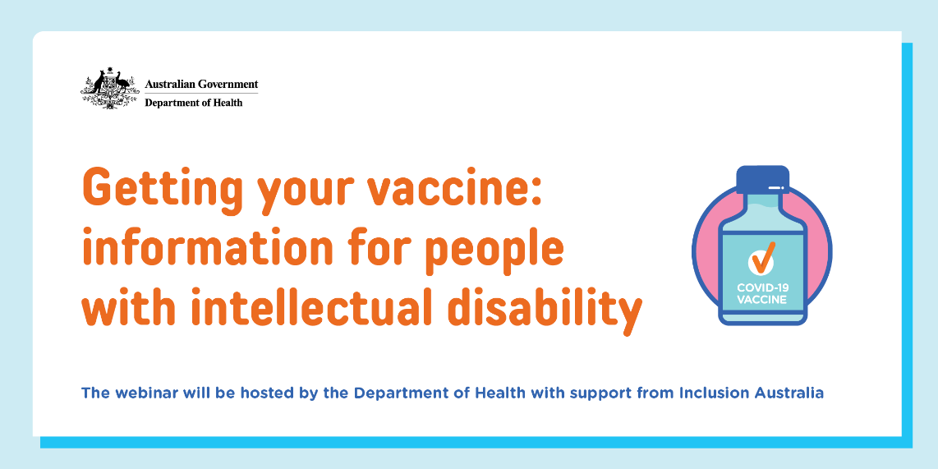

Discussing COVID-19 vaccination will be **Professor Nick Lennox**, Senior Medical Advisor for Disability & Health at the Department of Health and **Tara Elliffe**, a self-advocate from NSW who has had a Covid jab. Tara will talk about her experience and why getting the jab was important to her. A staff member from **Inclusion Australia** will also help with questions and other things.

**The purpose of the meeting is to discuss the importance of getting a COVID-19 vaccine and answer questions from people with intellectual disability and supporters.**

An Auslan interpreter and live captioning will be available during the meeting.

[Click on this link to register](https://www.eventbrite.com.au/e/168185935661) and to find more information about the webinar.

**Please circulate this information widely amongst your network.**