# *Keep your disability workforce up to date by circulating this alert widely in your organisation* Disability provider alert

**Mass vaccination hubs in Sydney and region**

Sonic Healthcare now have more mass vaccination hub locations. These centres specially cater to aged and disability care workers eligible under Phase 1a or 1b.

Sonic vaccination hubs are now open:

* Blacktown International Sportspark
* Macquarie Fields in Sydney’s south
* Sydney CBD (Pitt Street)
* East Campbelltown Community Hall (till 29 August 2021)

To check your eligibility and book an appointment use the  [vaccine eligibility checker](https://covid-vaccine.healthdirect.gov.au/eligibility).

**2,000 new vaccination appointments now available in the ACT**

2000 appointments are now available for Canberra’s health, aged care and disability care workers to receive a Pfizer COVID-19 vaccination.

It is very important to get vaccinated as soon as possible. Don’t wait.

Book your appointment by calling the ACT COVID-19 Vaccination Line on 02 5124 7700 (7am to 7pm, daily). Identify yourself as a disability care worker and you’ll be prioritised and get an appointment as soon as possible.

You can also use the ACT Government online booking system [MyDHR](https://www.covid19.act.gov.au/stay-safe-and-healthy/vaccine/book-a-vaccination-appointment#MyDHR).

If you already have a booking, we encourage you to call or go online to see if you can get an earlier appointment.

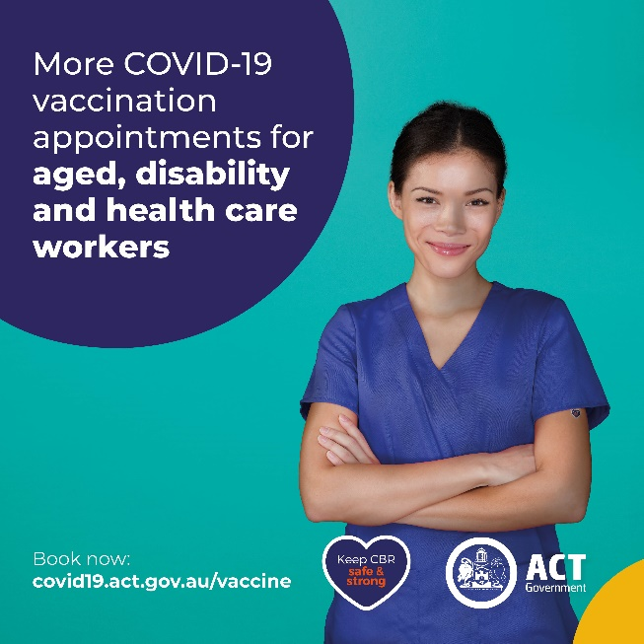

**Priority for disability worker vaccinations**

Vaccinations for disability workers are being prioritised across jurisdictions.

We congratulate all those who have been vaccinated so far and encourage those not yet vaccinated to take advantage of these opportunities.

The Sonic hubs in NSW are particularly timely. They are also centrally located to make it as easy as possible for workers to access them.

Canberra has vaccination appointments specially for disability workers as set out above.

WA also has a scheme addressing the need to prioritise vaccinations for disability workers that was described in the previous addition of the alert.

So take advantage of these offers and encourage your disability workforce to get the jab.

**What to expect before your vaccination: New visual resource**

Scope Australia has developed a new resource to help explain the vaccination process. Below is a series of images that can be used to talk about what to expect before you go for a coronavirus vaccine.

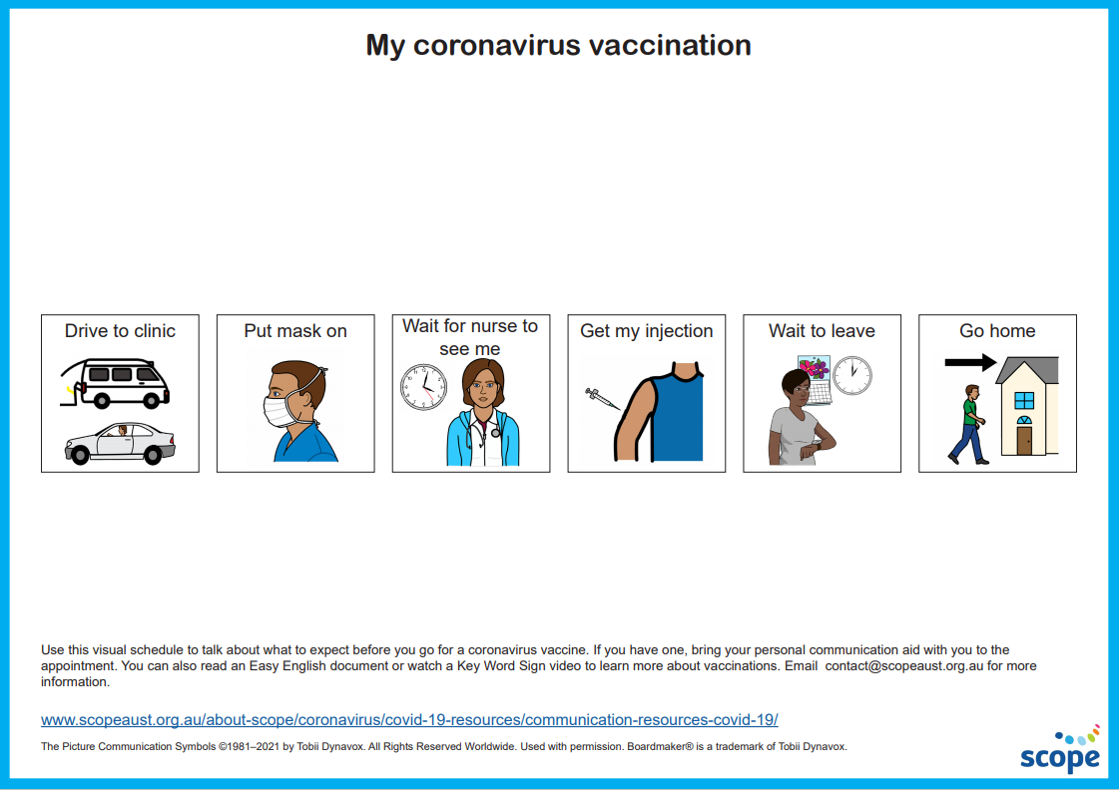  
With thanks to Scope (Aust) Ltd for making this resource available for use as part of the vaccination program. It is available for download along with other resources at the following website - [**https://www.scopeaust.org.au/visual-schedule_coronavirus-vaccination/**](https://www.scopeaust.org.au/visual-schedule_coronavirus-vaccination/)  
**Save the date: webinar for people with disability, their families and carers**

A webinar forpeople with disability, their families and carers is scheduled for 5 August 2021.

The purpose of the webinar is to answer questions from people with disability, their families and carers to support them through the vaccination program.

The panel answering questions will be:

* Professor (Practice) Alison McMillan (Chair), Chief Nursing and Midwifery Officer
* Dr Steph Davis, Deputy Chief Medical Officer
* Ms Chris Faulkner, Assistant Secretary, COVID-19 Vaccine Task Force - Disability

Further details such as how to access the webinar and start time will be included in the next edition of the disability provider alert.

## Social post

The below social media post is for you to distribute through your channels. Accompanying images are attached to the email that was sent to you, or can be accessed on the provider alert edition page [at this link](https://www.health.gov.au/resources/collections/covid-19-vaccination-disability-provider-alert).

### Post

#### Facebook

Caption: Are you a disability care worker? You’re eligible for a COVID-19 vaccine now. Help keep yourself, your family and the community safe. Book your appointment online via

Link: <https://www.health.gov.au/eligibility-checker>

#### Twitter

Caption: Are you a disability care worker? You’re eligible or a COVID-19 vaccine now. Help keep yourself, your family and the community safe. Book your appointment online via

Link: <https://www.health.gov.au/eligibility-checker>

#### Instagram

Caption: Are you a disability care worker? You’re eligible for a COVID-19 vaccine now. Help keep yourself, your family and the community safe. Book your appointment online via

Link: <https://www.health.gov.au/eligibility-checker>

## Resources to support people getting vaccinated

The Department of Health encourages disability providers to have vaccination resources available in [Easy Read](https://www.health.gov.au/resources/collections/covid-19-vaccination-easy-read-resources) format and in [other languages](https://www.health.gov.au/initiatives-and-programs/covid-19-vaccines/covid-19-vaccine-information-in-your-language) for people getting vaccinated. These resources cover all aspects of the vaccination process including preparing for COVID-19 vaccination and the period after the COVID-19 vaccination. You can download and print these from the Department of Health website.

For more information call the National coronavirus and   
COVID-19 vaccination helpline on 1800 020 080.