# *Keep your disability workforce up to date by circulating this alert widely in your organisation* Disability provider alert

**Vaccine In-Reach Program**

The phase 1a rollout to disability residential accommodation sites continues to be a priority. Eligibility criteria includes a person with disability living in residential accommodation (in settings with two or more people with disability only). Under this program, Vaccine Administration Service (VAS) providers, administer and deliver in-reach vaccination services. These visits continue to be arranged and scheduled directly with providers.

The VAS provider contacts the site directly to arrange the date and time for a vaccination team to visit. The Department of Health COVID-19 Vaccine Taskforce is not involved in this arrangement.

The VAS provider asks the site coordinator the number of residents and staff needing to be vaccinated on the day. During the visit, all residents and staff present will get the Pfizer vaccine. It may be that other staff can also be vaccinated if there are remaining doses in addition to those needed for the 1a group.

**Access to vaccines for disability workers not eligible in phase 1a**

While many disability workers can receive vaccinations as part of the phase 1a in-reach program, we encourage all support workers to take advantage of the other vaccination channels and options available to them.

Workers can access local GP and medical centres, state and territory clinics, primary care clinics and ‘pop up’ clinics. For more information on these vaccination options please visit [COVID-19 vaccine information for disability workers | Australian Government Department of Health](https://www.health.gov.au/initiatives-and-programs/covid-19-vaccines/information-for-service-providers-workers-and-people-with-disability-about-covid-19-vaccines/covid-19-vaccine-information-for-disability-workers#where-you-will-get-your-covid19-vaccine).

Additionally, several community pharmacies are beginning to come online in most states and territories. Available community pharmacies can be found in your area by using the [eligibility checker](https://www.health.gov.au/resources/apps-and-tools/covid-19-vaccine-eligibility-checker). **Easy Reads**

Easy reads are a great resource explaining complex subjects in an easy to understand way. We have just added this Easy Read about the AstraZeneca vaccine to the [resources page](https://www.health.gov.au/resources/collections/covid-19-vaccination-easy-read-resources) – see the sampler below. An Easy Read about the Delta strain has also been added to the resources page.

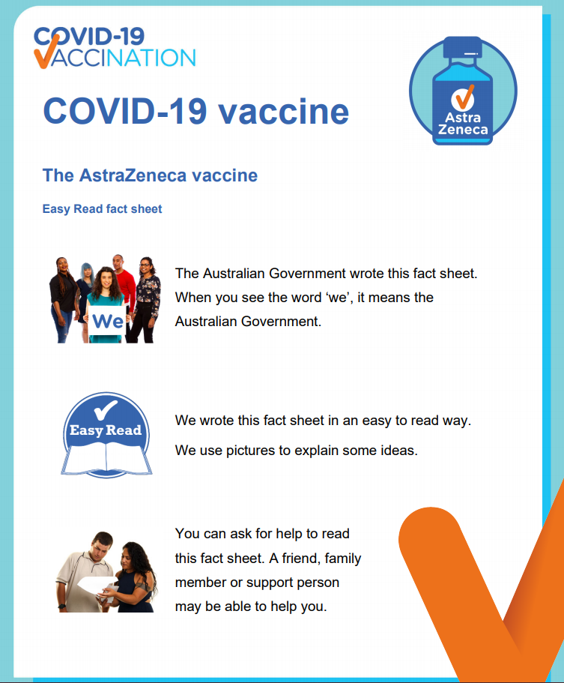

**Webinar for people with disability, their families and carers – Thursday 5 August 2021 at 11.30am**

The webinar will answer questions from people with disability, their families and carers to support them through the vaccination program.

The panel answering questions will be a mix of health professionals, COVID-19 Vaccine Disability Taskforce staff and a person from the disability community who has navigated their way through the vaccination process.

For program details and to register for the webinar [click here](https://www.eventbrite.com.au/e/dept-of-health-meeting-for-people-with-disability-their-families-carers-tickets-165210120919).

# COVID-19 Disaster Payment

The COVID-19 Disaster Payment is a lump sum support payment available for workers adversely affected by state public health orders.

Disability support workers who are losing work entitlements because of the current COVID-19 outbreak in the below states may be eligible for this payment.

Services Australia have recently restructured their COVID-19 Disaster Payment content to group the information by state as per the links below:

* [New South Wales](https://www.servicesaustralia.gov.au/individuals/services/centrelink/covid-19-disaster-payment-new-south-wales)
* [Queensland](https://www.servicesaustralia.gov.au/individuals/services/centrelink/covid-19-disaster-payment-queensland)
* [South Australia](https://www.servicesaustralia.gov.au/individuals/services/centrelink/covid-19-disaster-payment-south-australia)
* [Victoria](https://www.servicesaustralia.gov.au/individuals/services/centrelink/covid-19-disaster-payment-victoria).

For further, information about these payments, refer to [COVID-19 Disaster Payment - Services Australia](https://www.servicesaustralia.gov.au/individuals/services/centrelink/covid-19-disaster-payment).

## CALD COVID-19 Health Small Grants Fund

The Australian Government has engaged the Federation of Ethnic Communities’ Councils of Australia (FECCA) to administer a [CALD COVID-19 Small Grants Fund](https://fecca.org.au/grants/), to support multicultural community groups to design and lead grass roots communication activities, tailored to meet the needs of their communities.

Visit the CALD COVID-19 Small Grants Fund webpage at <http://fecca.org.au/grants/> or contact [smallgrants@fecca.org.au](mailto:smallgrants@fecca.org.au) for information about how to apply.

## Social media post

The below social media post is provided for you to distribute through your channels. The accompanying images are attached to the email that was sent to you, or can be accessed on the provider alert edition page [at this link](https://www.health.gov.au/resources/collections/covid-19-vaccination-disability-provider-alert).

### Post

#### Facebook

Caption:

Are you a disability worker? There are several ways that a you can get a COVID-19 vaccine.

For disability support workers aged over 60 years:

* If you work in a disability residential support setting, check with your workplace if they are arranging vaccinations for staff
* Attend an AstraZeneca COVID-19 vaccination clinic, such as a local GP
* Attend an Aboriginal Community Controlled Health Service

For disability support workers aged under 60 years:

* If you work in a disability residential support setting, check with your workplace if they are arranging vaccinations for staff
* Attend a Pfizer COVID-19 vaccination clinic run by your state or territory
* Talk to your GP to see if the AstraZeneca is right for you.

Don’t delay, find a vaccination clinic and book your appointment today: <https://www.health.gov.au/eligibility-checker>

#health #COVID19 #COVID19vaccines

Link: <https://www.health.gov.au/eligibility-checker>

#### Twitter

Caption:

Are you a disability worker? There are several ways that a you can get a COVID-19 vaccine.

Visit our website to find out how: <https://www.health.gov.au/resources/publications/covid-19-vaccination-how-disability-workers-can-get-a-covid-19-vaccine>

#health #COVID19 #COVID19vaccines

Link: <https://www.health.gov.au/resources/publications/covid-19-vaccination-how-disability-workers-can-get-a-covid-19-vaccine>

#### Instagram

Caption:

Are you a disability worker? There are several ways that a you can get a COVID-19 vaccine.

For disability support workers aged over 60 years:

* If you work in a disability residential support setting, check with your workplace if they are arranging vaccinations for staff
* Attend an AstraZeneca COVID-19 vaccination clinic, such as a local GP
* Attend an Aboriginal Community Controlled Health Service

For disability support workers aged under 60 years:

* If you work in a disability residential support setting, check with your workplace if they are arranging vaccinations for staff
* Attend a Pfizer COVID-19 vaccination clinic run by your state or territory
* Talk to your GP to see if the AstraZeneca is right for you.

Don’t delay, book your appointment today by clicking the ‘Vaccine Eligibility’ link in our bio.

#health #COVID19 #COVID19vaccines

#### LinkedIn

Caption:

Are you a disability worker? There are several ways that a you can get a COVID-19 vaccine.

For disability support workers aged over 60 years:

* If you work in a disability residential support setting, check with your workplace if they are arranging vaccinations for staff
* Attend an AstraZeneca COVID-19 vaccination clinic, such as a local GP
* Attend an Aboriginal Community Controlled Health Service

For disability support workers aged under 60 years:

* If you work in a disability residential support setting, check with your workplace if they are arranging vaccinations for staff
* Attend a Pfizer COVID-19 vaccination clinic run by your state or territory
* Talk to your GP to see if the AstraZeneca is right for you.

Don’t delay, book your appointment today: <https://www.health.gov.au/eligibility-checker>

#health #COVID19 #COVID19vaccines

Link: <https://www.health.gov.au/eligibility-checker>

## Resources to support people getting vaccinated

The Department of Health encourages disability providers to have vaccination resources available in [Easy Read](https://www.health.gov.au/resources/collections/covid-19-vaccination-easy-read-resources) format and in [other languages](https://www.health.gov.au/initiatives-and-programs/covid-19-vaccines/covid-19-vaccine-information-in-your-language) for people getting vaccinated.

These resources cover all aspects of the vaccination process including preparing for a   
COVID-19 vaccination and the period after the COVID-19 vaccination. You can download and print these from the links above or from the Department of Health website.

For more information call the National coronavirus and   
COVID-19 vaccination helpline on 1800 020 080.