Keep your disability workforce up to date by circulating this alert widely in your organisation
Disability provider alert
COVID-19 vaccine push to peaks, providers, workers, carers and participants
Peaks and Providers
Disability and carer providers play a critical role in supporting the vaccination of people with disability, workers and carers. Let’s continue to encourage the disability community to get vaccinated.

Information about the COVID-19 vaccine is available in various accessible formats on the Department of Health website at Information for people with disability about COVID-19 vaccines | Australian Government Department of Health.

NDIS Participants
All NDIS participants aged 16 years and over are eligible for the COVID-19 vaccine. More than 15 million vaccine doses have already been given to Australians.
If you haven’t had your vaccination yet, book in today.
Talk to your GP or visit the Department of Health website to find out how to get a COVID-19 vaccine. Information for people with disability about COVID-19 vaccines | Australian Government Department of Health

Carers of NDIS participants and disability workers
All disability workers and carers over 16 years of NDIS participants are eligible for the COVID-19 vaccine.
If you haven’t had yours yet, don’t delay. Book in for your vaccination today. A COVID-19 vaccine will help to protect yourself, your family and the people you care for.
To book a COVID-19 vaccine appointment, use the COVID-19 Vaccine Eligibility Checker on the Department of Health website or contact the National Coronavirus and COVID-19 Vaccination Helpline on 1800 020 080.

Disability workers and carers – general
Are you a disability worker or carer? A COVID-19 vaccine will help to protect yourself, your family and the people you care for.
Don’t delay. Book in for your vaccination today. To find out if you are eligible and how to book in for your vaccination, go to the Department of Health’s COVID-19 Vaccine Eligibility Checker or contact the National Coronavirus and COVID-19 Vaccination Helpline on 1800 020 080.

Lifestyle Solutions vaccination hub extended in Sydney
Lifestyle Solutions has extended the operation of its hub at Burwood, Sydney. The hub is specifically for NDIS participants, people with disability, their support staff or carers as well as people working in aged care.

State | Hub Location | Dose 1 dates | Dose 2 dates
NSW | Lifestyle Solutions  Level 2, 11 – 15 Deane Street, BURWOOD, NSW, 2134 | 23 - 27 August 2021  6 – 10 September 2021 | 13 – 17 September 2021  20 – 24 September 2021  27 September – 1 October 2021

You can check your vaccination eligibility with the COVID-19 vaccine eligibility checker.

The QR code below will take you to the Healthcare Australia (HCA) Aged Care and Disability Sector COVID-19 booking system.

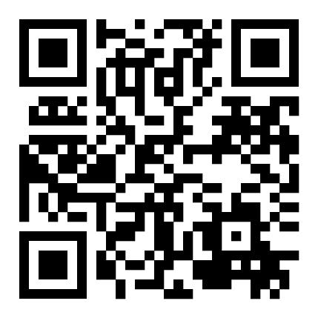 | Please share this information and the booking link to your networks in the disability and aged care sectors.

Please do not share this link with family & friends who are not considered an unpaid or informal carer of an NDIS participant.

Tasmania to run a six-week COVID vaccination blitz

Tasmania has begun a six-week COVID-19 vaccination blitz to drive up the state's vaccination targets.
This blitz will assist disability workers in the Phase 1b group to book with state vaccination clinics. The clinics will have expanded operating hours, allowing extra bookings during the six-week period.
To make a booking use this link - Book a vaccination appointment | Coronavirus disease (COVID-19)
Pharmacies will also be brought online to offer AstraZeneca to eligible people.
The Phase 1a rollout to sites with two or more disabled residents will continue as planned. This Commonwealth-run scheme has providers visiting sites as part of its in-reach program.

New Vaccine Administration Service Providers have joined the Phase 1a in-reach program
The phase 1a rollout to disability residential accommodation sites continues to be a priority.
Vaccine Administration Service providers (VAS) deliver and administer in-reach vaccination services.
Two new VAS providers have joined the program. They are International SOS and Oceana. These providers join Aspen and Health Care Australia, two organisations that are already providing vaccination in-reach services.
Site coordinators can expect to receive calls from these providers to arrange in-reach visits. During the visit, all residents and staff present will be able to get the Pfizer vaccine. It may be that other staff can also be vaccinated if there are doses in addition to those needed for the 1a group.

COVID-19 resources in other languages
The Department of Health has a range of resources on www.health.gov.au with information about COVID-19 vaccines in other languages.
COVID-19 vaccination – ATAGI recommends all adults get vaccinated (other languages)
This language set contains translations of a poster that explains all adults should get vaccinated with the available vaccines. Click here to access these resources.
The image below is a sample of the webpage where you can access information in other languages.
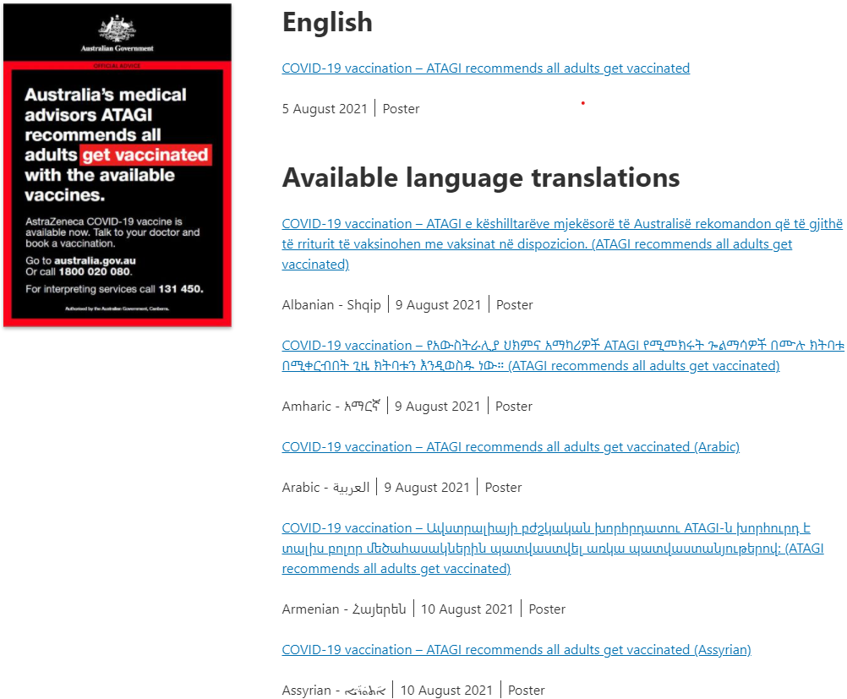

Council for Intellectual Disability Easy Read Guides
The Council for Intellectual Disability has released two new Easy Read Guides to support people in group homes during an outbreak. They are:
- Supporting people in group homes – plain English guide
- What is happening in my home – Easy Read

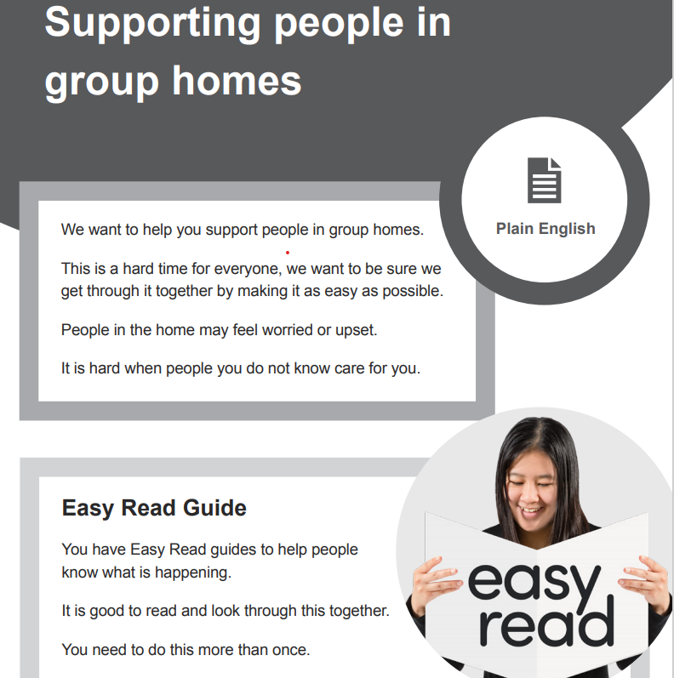

The image above is a sample of the Easy Read guide mentioned above. You can view the Easy read by clicking on the links above the image.

Social post
The below social media post is for you to distribute through your channels. Accompanying images are attached to the email that was sent to you, or can be accessed on the provider alert edition page at this link.

Post

Facebook
Caption:
Disability Care workers are eligible to receive a COVID-19 vaccination. If you work in disability care, especially in an outbreak area, don’t delay. Protect yourself and the people you care for today at: https://www.health.gov.au/eligibility-checker
#health #COVID19 #COVID19vaccines
Link: https://www.health.gov.au/eligibility-checker

Twitter
Caption:
Disability Care workers are eligible to receive a COVID-19 vaccination. If you work in disability care, especially in an outbreak area, don’t delay. Protect yourself and the people you care for today at: https://www.health.gov.au/eligibility-checker
#health #COVID19 #COVID19vaccines
Link: https://www.health.gov.au/eligibility-checker

Instagram
Caption:
Disability Care workers are eligible to receive a COVID-19 vaccination. If you work in disability care, especially in an outbreak area, don’t delay. Protect yourself and the people you care for today at: https://www.health.gov.au/eligibility-checker
#health #COVID19 #COVID19vaccines
Link: https://www.health.gov.au/eligibility-checker

Resources to support people getting vaccinated
The Department of Health encourages disability providers to have vaccination resources available in Easy Read format and in other languages for people getting vaccinated. These resources cover all aspects of the vaccination process including preparing for COVID-19 vaccination and the period after the COVID-19 vaccination. You can download and print these from the Department of Health website.
For more information call the National coronavirus and
COVID-19 vaccination helpline on 1800 020 080.

