# *Keep your disability workforce up to date by circulating this alert widely in your organisation* Disability provider alert

## Disability sector receives COVID-19 vaccine on the Downs

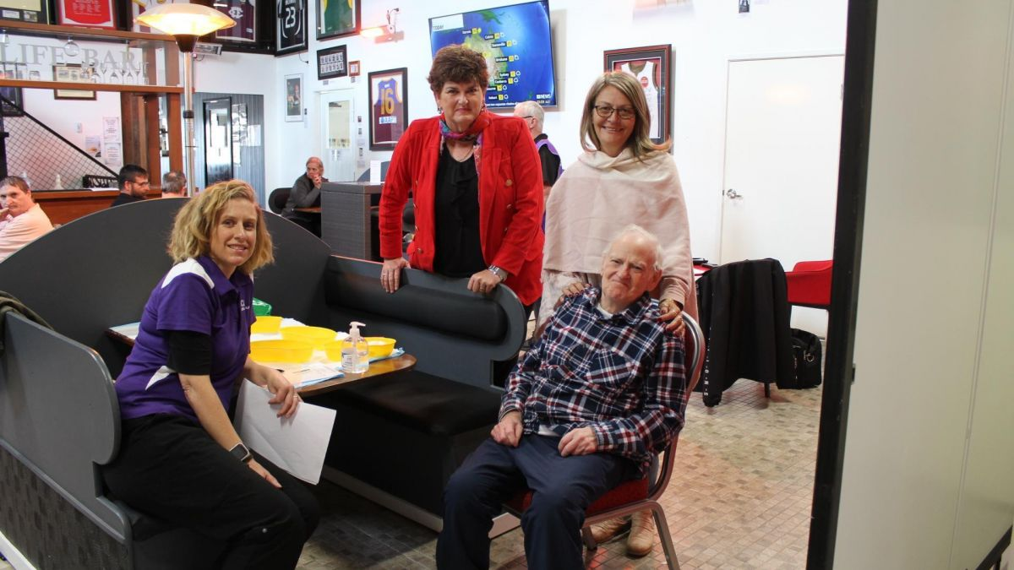

Pictured are clients and disability staff located in the Darling Downs region. They received their first dose of the COVID-19 vaccine at a vaccination hub held in Toowoomba in mid-July. The hub was hosted by Quality Lifestyle Support (QLS) at their social enterprise café Another Life Coffee and Wares.

QLS Director Robyn Cavanagh said the hub provided easy access to the COVID-19 vaccine in a safe and welcoming environment.

“It’s pleasing to know that our clients and staff are on their way to being fully vaccinated, providing a layer of comfort not only to them but also to their loved ones,” Ms Cavanagh said.

This initiative is supported by the Darling Downs and West Moreton PHN. PHN CEO Merrilyn Strohfeldt said it was pleasing to see the COVID-19 vaccine roll-out in disability services underway.

## Lifestyle Solutions vaccination hubs

Lifestyle Solutions have vaccine hubs open for bookings in Sydney, Newcastle (NSW) and Beenleigh (QLD). They are specifically for NDIS participants, people with disability, their support staff or carers, as well as people working in aged care.

The hubs are open 5 days a week over the weeks of 9 to 13 August 2021 (Dose 1) and 30 August to 3 September 2021 (Dose 2). This will allow for a minimum of 21 days between doses.

**Please share this information and the booking link to your networks in the disability and aged care sector.**

The QR code below will take you to the Healthcare Australia (HCA) Aged Care and Disability Sector COVID-19 booking system.

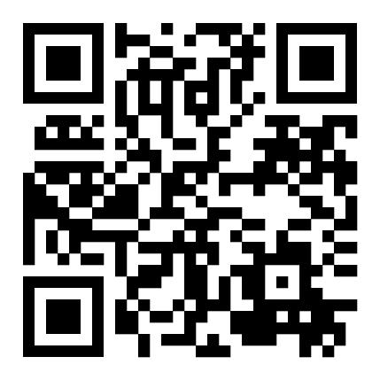

|  |  |  |  |
| --- | --- | --- | --- |
| **State** | **Hub Location** | **Dose 1 dates** | **Dose 2 dates** |
| **NSW** | **Lifestyle Solutions**  Level 2, 11 – 15 Deane Street, **BURWOOD**, NSW, 2134 | 9 – 13 August 2021 | 30 August – 3 September 2021 |
| **NSW** | **Lifestyle Solutions**  37 Fern Street **NEWCASTLE**, NSW, 2296 | 9 – 13 August 2021 | 30 August – 3 September 2021 |
| **QLD** | **Lifestyle Solutions**  Suite 203/58-60 Manila Street **BEENLEIGH**, QLD, 4207 | 9 – 13 August 2021 | 30 August – 3 September 2021 |

Please do not share this link with family & friends who **are not** considered an unpaid or informal carer to the NDIS participant.

You can check your vaccination eligibility with the [COVID-19 vaccine eligibility checker](https://www.health.gov.au/resources/apps-and-tools/covid-19-vaccine-eligibility-checker).

## Infection prevention and control signage

The Australian Commission on Safety and Quality in Health Care (the Commission) have revised their poster on infection prevention and control. This was based on guidance issued by the Australian Government Infection Control Expert Group. The poster deals with situations where the assessed risk of transmission of COVID-19 is low. The poster is now more generic and as such more appropriate for disability settings.

The Commission’s [COVID-19 Break the Chain poster](https://www.safetyandquality.gov.au/publications-and-resources/resource-library/break-chain-infection-poster-a3) will also be of interest to the disability services sector. This poster illustrates the chain of transmission of infection of COVID-19. The poster highlights measures that can be implemented to interrupt the spread of infection.

## COVID-19 coronavirus in pictures

[Healthdirect](https://www.healthdirect.gov.au/coronavirus-covid-19-in-pictures#covid-symptoms) have a range of infographics to explain COVID issues along with Stay Informed videos

## Webinar for people with disability, their families and carers

The Department of Health hosted a webinar for people with disability, their families and carers on Thursday 5 August 2021. The Department will publish a recording of the meeting soon, which can be accessed on [the video and webinar](https://www.health.gov.au/resources/videos) section of [www.health.gov.au](http://www.health.gov.au). A link to the transcript and video will be in a subsequent Alert.

The webinar was well attended with more than 280 participants. Attendees asked the panel a wide range of questions. These questions covered vaccines, roll-out of vaccines to people with disability and disability workers as well as the 12 to 15 year old age group eligibility. It was a highly interactive session.

Special thanks to Grace Edward from Refugee Health Network Queensland for participating on the panel and sharing her personal COVID-19 vaccination experience.

## Social post

The below social media post is for you to distribute through your channels. Accompanying images are attached to the email that was sent to you, or can be accessed on the provider alert edition page [at this link](https://www.health.gov.au/resources/collections/covid-19-vaccination-disability-provider-alert).

### Post

#### Facebook

Caption:

Disability Care workers are eligible to receive a COVID-19 vaccination. If you work in disability care, especially in outbreak area, don’t delay. Protect yourself and the people you care for today at: <https://www.health.gov.au/eligibility-checker>

#health #COVID19 #COVID19vaccines

Link: <https://www.health.gov.au/eligibility-checker>

#### Twitter

Caption:  
Disability Care workers are eligible to receive a COVID-19 vaccination. If you work in disability care, especially in outbreak area, don’t delay. Protect yourself and the people you care for today at: <https://www.health.gov.au/eligibility-checker>  
  
#health #COVID19 #COVID19vaccines

Link: <https://www.health.gov.au/eligibility-checker>

#### Instagram

Caption:  
Disability Care workers are eligible to receive a COVID-19 vaccination. If you work in disability care, especially in outbreak area, don’t delay. Protect yourself and the people you care for today at: <https://www.health.gov.au/eligibility-checker>  
  
#health #COVID19 #COVID19vaccines

Link: <https://www.health.gov.au/eligibility-checker>

## Resources to support people getting vaccinated

The Department of Health encourages disability providers to have vaccination resources available in [Easy Read](https://www.health.gov.au/resources/collections/covid-19-vaccination-easy-read-resources) format and in [other languages](https://www.health.gov.au/initiatives-and-programs/covid-19-vaccines/covid-19-vaccine-information-in-your-language) for people getting vaccinated. These resources cover all aspects of the vaccination process including preparing for COVID-19 vaccination and the period after the COVID-19 vaccination. You can download and print these from the Department of Health website.

For more information call the National coronavirus and   
COVID-19 vaccination helpline on 1800 020 080.