

# ACFI Monitoring Report – May 2021

## Summary

* Average ACFI claims increased in May.
* The solid line in Figure 1 shows the average daily claim rate.
* The impact of the temporary increase in subsidies in the March 2019 quarter is highlighted in the dotted line, while the dashed line shows the impact of temporary funding increase from 1 March 2020 to 31 August 2020 in response to the COVID-19 pandemic.
* The remainder of this report provides analysis based on the changes in claim rates without the temporary increases incorporated.

Figure . Average daily ACFI claim per month [1]

Chart shows the impact of ACFI measures in 2016/17, with average rates declining and holding steady, then returning to growth in late 2019. Also shows temporary measures in March to June 2019 and March to September 2020.


Table : Cumulative Daily Average ACFI Subsidies and Growth Rates by ACFI Category

| **Average ACFI Category Subsidy** | **Jul 2019 To May 2020** | **Jul 2020 To May 2021** | **Nominal Growth Over Same Period in Previous Year** | **Real Growth Over Same Period in Previous Year** |
| --- | --- | --- | --- | --- |
| ADL | $96.79 | $100.49 | 3.8% | 2.2% |
| BEH | $28.53 | $29.63 | 3.9% | 2.2% |
| CHC | $53.41 | $55.81 | 4.5% | 2.8% |

Figure . Daily Average $/Day Trend by Month – 2020/21 Dollars

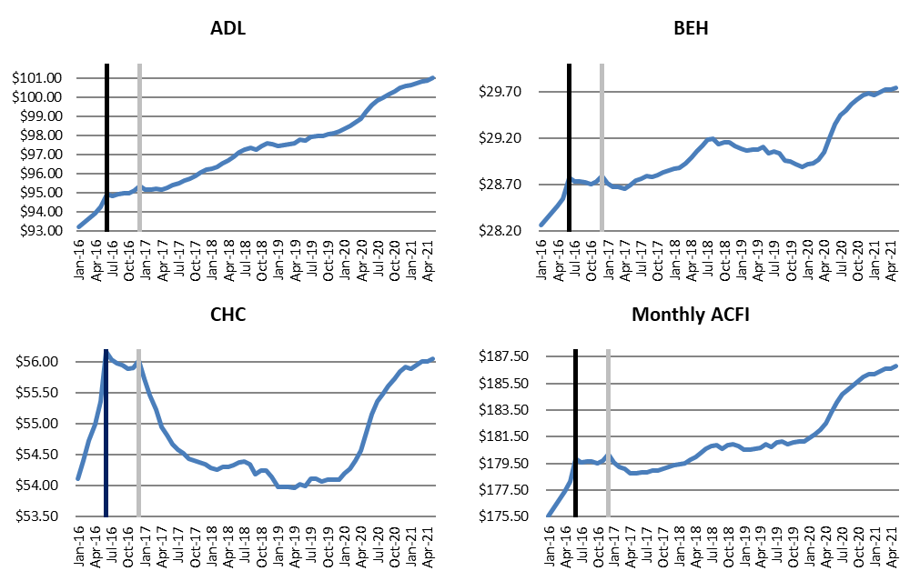

Table : Cumulative Daily Average ACFI Subsidies and Growth Rates by State

| **State** | **Jul 2019 To May 2020** | **Jul 2020 To May 2021** | **Nominal Growth Over Same Period in Previous Year** | **Real Growth Over Same Period in Previous Year** |
| --- | --- | --- | --- | --- |
| **Projected National** | $178.74 | $184.66 | 3.3% | 1.7% |
| **Actual National** | $178.74 | $185.94 | 4.0% | 2.4% |
| NSW | $174.65 | $182.67 | 4.6% | 2.9% |
| VIC | $185.00 | $191.20 | 3.3% | 1.7% |
| QLD | $176.78 | $183.86 | 4.0% | 2.4% |
| WA | $185.01 | $190.66 | 3.1% | 1.4% |
| SA | $176.46 | $184.63 | 4.6% | 3.0% |
| TAS | $171.59 | $179.91 | 4.8% | 3.2% |
| ACT | $172.19 | $182.09 | 5.8% | 4.1% |
| NT | $172.20 | $189.33 | 10.0% | 8.2% |

Table : Cumulative Daily Average ACFI Subsidies and Growth Rates by Remoteness

| **Remoteness** | **Jul 2019 To May 2020** | **Jul 2020 To May 2021** | **Nominal Growth Over Same Period in Previous Year** | **Real Growth Over Same Period in Previous Year** |
| --- | --- | --- | --- | --- |
| Major Cities of Australia | $182.34 | $189.35 | 3.8% | 2.2% |
| Inner Regional Australia | $172.23 | $179.57 | 4.3% | 2.6% |
| Outer Regional Australia | $166.25 | $174.78 | 5.1% | 3.5% |
| Remote Australia | $143.45 | $151.26 | 5.4% | 3.8% |
| Very Remote Australia | $149.79 | $158.75 | 6.0% | 4.3% |

Table : Cumulative Daily Average ACFI Subsidies and Growth Rates by Organisation Type

| **Organisation Type** | **Jul 2019 To May 2020** | **Jul 2020 To May 2021** | **Nominal Growth Over Same Period in Previous Year** | **Real Growth Over Same Period in Previous Year** |
| --- | --- | --- | --- | --- |
| Not-For-Profit | $174.64 | $182.24 | 4.4% | 2.7% |
| For-Profit | $187.09 | $193.83 | 3.6% | 2.0% |
| Government | $153.98 | $158.36 | 2.8% | 1.2% |

Table : Cumulative Daily Average ACFI Subsidies and Growth Rates by Provider Size

| **Provider Size\*** | **Jul 2019 To May 2020** | **Jul 2020 To May 2021** | **Nominal Growth Over Same Period in Previous Year** | **Real Growth Over Same Period in Previous Year** |
| --- | --- | --- | --- | --- |
| 0-39 | $149.80 | $161.43 | 7.8% | 6.1% |
| 40-74 | $164.15 | $172.23 | 4.9% | 3.3% |
| 75-129 | $171.00 | $177.53 | 3.8% | 2.2% |
| 130-499 | $176.79 | $184.32 | 4.3% | 2.6% |
| 500-999 | $183.22 | $190.58 | 4.0% | 2.4% |
| 1000+ | $184.29 | $190.74 | 3.5% | 1.9% |

*Based on full time equivalent residents per year for 2019-20. Only includes providers active during July 2020.

Table : Cumulative proportion of total days by ACFI Level and ACFI Category

|  | ADL | | | BEH | | | CHC | | | |
| --- | --- | --- | --- | --- | --- | --- | --- | --- | --- | --- |
| **ACFI Level** | **Jul 2019 To May 2020** | **Jul 2020 To May 2021** | **Change ADL** | **Jul 2019 To May 2020** | **Jul 2020 To May 2021** | **Change BEH** | **Jul 2019 To May 2020** | **Jul 2020 To May 2021** | **Change CHC** | |
| H | 61.1% | 64.8% | 3.7% | 63.6% | 65.8% | 2.1% | 51.9% | 55.2% | | 3.3% |
| M | 29.0% | 27.3% | -1.7% | 22.3% | 21.9% | -0.3% | 31.8% | 30.9% | | -0.8% |
| L | 9.4% | 7.5% | -1.9% | 10.2% | 9.1% | -1.1% | 15.8% | 13.4% | | -2.4% |
| N | 0.5% | 0.3% | -0.1% | 3.9% | 3.2% | -0.7% | 0.6% | 0.5% | | -0.1% |

Table : Cumulative proportion of total days by ADL Scores and ADL Question

|  | **Jul 2019 To May 2020** | | | | **Jul 2020 To May 2021** | | | |
| --- | --- | --- | --- | --- | --- | --- | --- | --- |
| **ADL Question** | **A** | **B** | **C** | **D** | **A** | **B** | **C** | **D** |
| Nutrition | 2.70% | 12.7% | 70.2% | 14.4% | 2.00% | 10.70% | 72.9% | 14.4% |
| Mobility | 1.50% | 2.0% | 33.3% | 63.2% | 1.10% | 1.50% | 30.9% | 66.4% |
| Personal Hygiene | 0.40% | 5.0% | 8.6% | 86.1% | 0.30% | 4.10% | 7.8% | 87.8% |
| Toileting | 2.10% | 9.2% | 15.4% | 73.3% | 1.60% | 7.70% | 15.1% | 75.6% |
| Continence | 10.80% | 2.0% | 3.7% | 83.5% | 9.00% | 1.60% | 3.2% | 86.1% |

Table : Cumulative proportion of total days by BEH Scores and BEH Question

|  | **Jul 2019 To May 2020** | | | | **Jul 2020 To May 2021** | | | |
| --- | --- | --- | --- | --- | --- | --- | --- | --- |
| **BEH Question** | **A** | **B** | **C** | **D** | **A** | **B** | **C** | **D** |
| Cognitive Skills | 7.2% | 27.9% | 38.20% | 26.8% | 6.3% | 27.0% | 39.50% | 27.2% |
| Wandering | 85.3% | 4.6% | 3.30% | 6.8% | 86.8% | 4.1% | 3.10% | 6.0% |
| Verbal | 11.8% | 11.3% | 19.80% | 57.2% | 10.6% | 11.2% | 20.40% | 57.8% |
| Physical | 27.3% | 15.6% | 19.60% | 37.5% | 26.1% | 16.0% | 20.60% | 37.3% |
| Depression | 34.1% | 29.8% | 18.30% | 17.8% | 32.7% | 29.5% | 19.40% | 18.5% |

## Jul 2019 to May 2020

Appraised before 1 July 2016

Table : Distribution of claim days for the CHC

|  |  |  |  |  |
| --- | --- | --- | --- | --- |
| **Q12 Q11** | **A** | **B** | **C** | **D** |
| **A** | 0.0% | 0.0% | 0.2% | 0.0% |
| **B** | 0.1% | 0.3% | 0.8% | 1.8% |
| **C** | 0.3% | 0.2% | 0.8% | 2.2% |
| **D** | 0.1% | 0.7% | 4.8% | 1.5% |

| Rating | Proportion |
| --- | --- |
| Nil | 1.2% |
| Low | 6.9% |
| Med | 17.8% |
| High | 74.0% |

### Appraised between 1 July 2016 and 31 December 2016

| **Q12 Q11** | **A** | **B** | **C** | **D** |
| --- | --- | --- | --- | --- |
| **A** | 0.0% | 0.0% | 0.0% | 0.0% |
| **B** | 0.0% | 0.1% | 0.4% | 1.0% |
| **C** | 0.1% | 0.1% | 0.3% | 1.1% |
| **D** | 0.0% | 0.3% | 0.3% | 1.0% |

| Rating | Proportion |
| --- | --- |
| Nil | 0.9% |
| Low | 7.3% |
| Med | 27.4% |
| High | 64.4% |

### Appraised on or after 1 January 2017

| **Q12 Q11** | **A** | **B** | **C** | **D** |
| --- | --- | --- | --- | --- |
| A - No Assistance | 0.3% | 0.1% | 0.4% | 0.2% |
| B - Assistance | 8.3% | 5.8% | 26.5% | 34.9% |
| C - Injections | 0.0% | 0.6% | 0.7% | 3.7% |

| Rating | Proportion |
| --- | --- |
| Nil | 0.5% |
| Low | 17.8% |
| Med | 34.3% |
| High | 47.4% |

## Jul 2020 to May 2021

### Appraised before 1 July 2016

| **Q12 Q11** | **A** | **B** | **C** | **D** |
| --- | --- | --- | --- | --- |
| **A** | 0.0% | 0.0% | 0.1% | 0.0% |
| **B** | 0.1% | 0.2% | 0.4% | 1.1% |
| **C** | 0.2% | 0.1% | 0.4% | 1.4% |
| **D** | 0.1% | 0.4% | 3.1% | 1.0% |

| Rating | Proportion |
| --- | --- |
| Nil | 1.1% |
| Low | 6.2% |
| Med | 16.2% |
| High | 76.5% |

### Appraised between 1 July 2016 and 31 December 2016

| **Q12 Q11** | **A** | **B** | **C** | **D** |
| --- | --- | --- | --- | --- |
| A | 0.0% | 0.0% | 0.0% | 0.0% |
| B | 0.0% | 0.1% | 0.2% | 0.6% |
| C | 0.0% | 0.0% | 0.2% | 0.7% |
| D | 0.0% | 0.1% | 0.1% | 0.6% |

| Rating | Proportion |
| --- | --- |
| Nil | 0.6% |
| Low | 5.9% |
| Med | 24.4% |
| High | 69.1% |

### Appraised on or after 1 January 2017

| **Q12 Q11** | **A** | **B** | **C** | **D** |
| --- | --- | --- | --- | --- |
| A - No Assistance | 0.3% | 0.1% | 0.4% | 0.2% |
| B - Assistance | 7.6% | 4.7% | 27.5% | 42.4% |
| C - Injections | 0.0% | 0.5% | 0.6% | 4.3% |

| Rating | Proportion |
| --- | --- |
| Nil | 0.4% |
| Low | 14.3% |
| Med | 32.5% |
| High | 52.7% |

Table : Actual Average ACFI per day – Monthly and Cumulative

| **ACFI** | **Jul 20** | **Aug 20** | **Sep 20** | **Oct 20** | **Nov 20** | **Dec 20** |
| --- | --- | --- | --- | --- | --- | --- |
| Monthly ACFI | $184.66 | $184.95 | $185.32 | $185.65 | $186.01 | $186.19 |
| Cumulative ACFI | $184.66 | $184.80 | $184.97 | $185.14 | $185.31 | $185.46 |
| **ACFI** | **Jan 21** | **Feb 21** | **Mar 21** | **Apr 21** | **May 21** | **Jun 21** |
| Monthly ACFI | $186.19 | $186.39 | $186.57 | $186.62 | $186.79 |  |
| Cumulative ACFI | $185.57 | $185.66 | $185.76 | $185.85 | $185.94 |  |

Figure . ACFI Category - Change in Proportion of Total Care Days Year to Date – Year on Year*

ACFI Category – Change in Proportion of Total Care Days Year to Date – Year on Year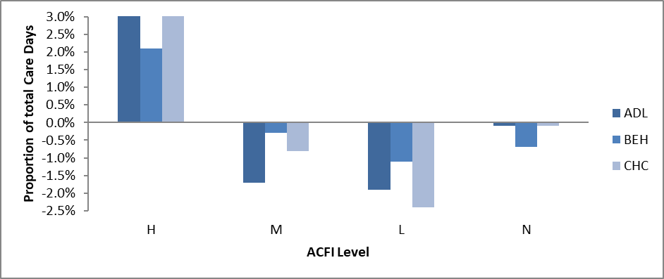

*Compares change in proportion of care days for 1 July to 31 May between 2019/20 and 2020/21

1. 1. All $ values are based on ACFI Question Responses and calculated at 2020/21 ACFI rates