Supporting the Aboriginal and Torres Strait Islander

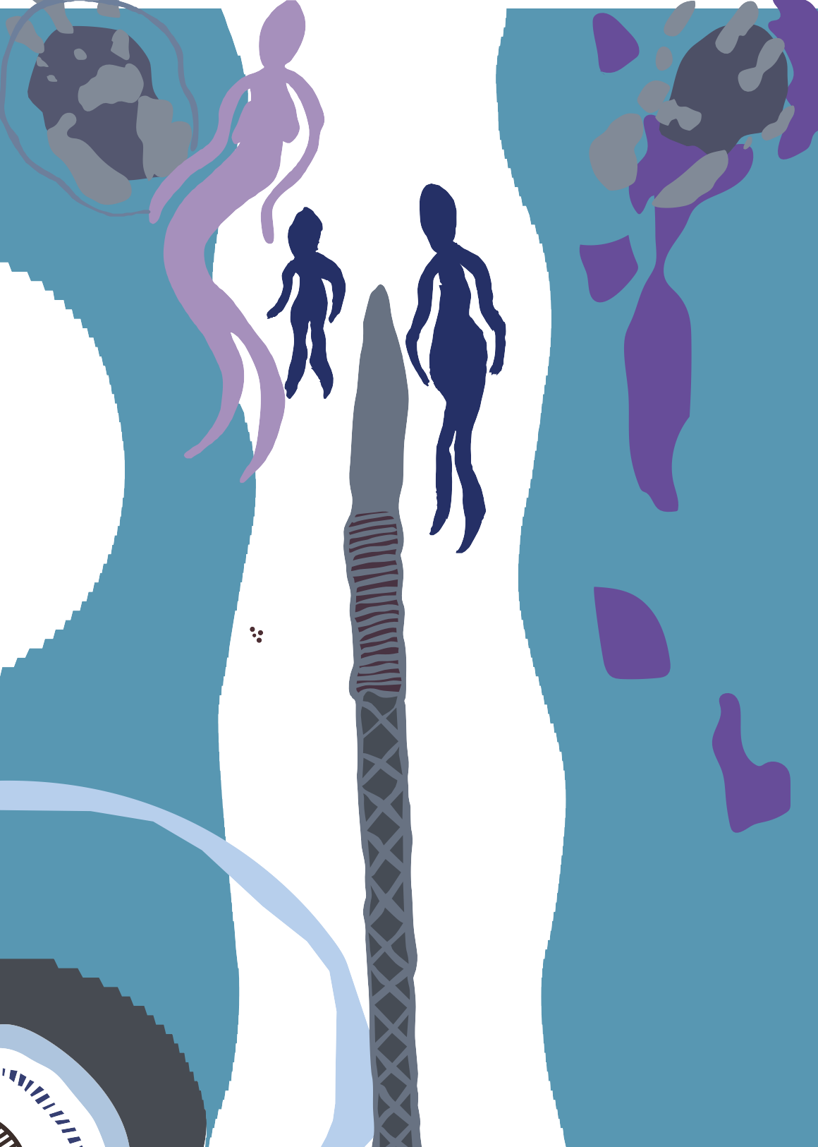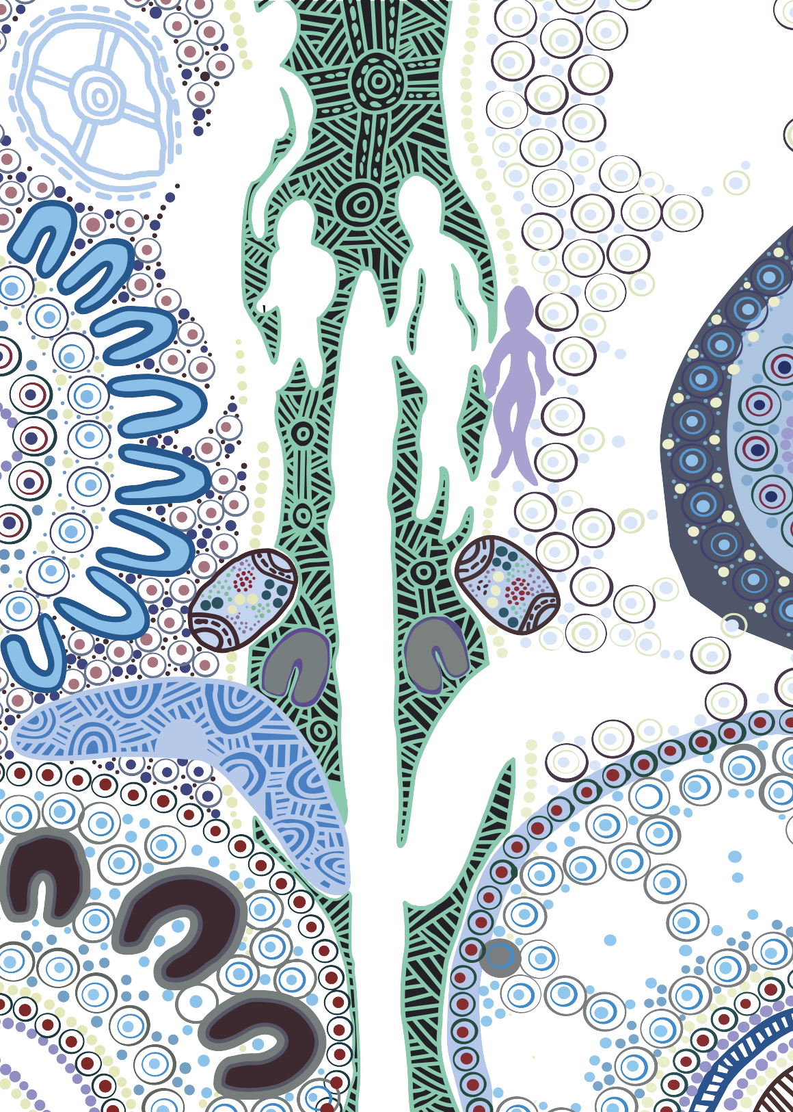

**Step 4: Repeat every 12 months**

patient journey to good health

715 health checks are available for Aboriginal and Torres

**Step 1: Reception and practice managers will interact with new**

**or existing patients at booking. For new patients this process can be daunting, extra reassurance would be beneficial to build trust.**

Strait Islander people of all ages. Health checks have been specifically designed to support the physical, social and emotional wellbeing of Aboriginal and Torres Strait Islander patients and provide preventative and early intervention strategies.

**Existing patients**

* Check if existing Aboriginal and/or Torres Strait Islander patients have received annual 715 health check
* Set up annual reminder – letter and/or SMS
* Promote any services or programs that are available
* Ensure information is available in waiting room and posters displayed
* Rebook 715 health checks on regular basis
* Encourage patients to tell family and friends about the 715 health check

**New patients**

* Ask if the patient identifies as Aboriginal and/or Torres Strait Islander
* Provide information to the patient about Indigenous health

programs and services you can provide

* Ask if the patient has received their annual 715 health check
* Offer to book the patient a 715 health check

**Key facts**

* Only **3 out of 10** Aboriginal and Torres Strait Islander people currently receive a 715 health check
* Aboriginal and Torres Strait Islander people are

**2.3 times** more likely to experience burden of disease than non-Indigenous Australians

715 health checks can be undertaken by any general practice or Aboriginal Medical Service.

**A whole of practice approach**

Patients may interact with various staff within a health service. It is important all staff are aware of the needs of Aboriginal and Torres Strait Islander patients.

**Is your service culturally safe?**

0 Do you acknowledge the local Traditional Owners of the land?

0 Have staff undertaken cultural awareness or cultural safety training?

0 Do you employ an Aboriginal Health Worker or Aboriginal Health Practitioner?

0 Do you have a male and a female practitioner on staff for patients to choose who they are comfortable with? This is culturally important for women’s and men’s business.

0 Is community transport assistance available?

0 Are there any out of pocket costs to be incurred by the patient? Make sure these are mentioned at the time

of booking.

0 Does the patient have family members that should also consider a 715 Health Check?

0 Do you support patients to bring someone with them to the health check? Some patients may be visiting a health service for the first time and feel more comfortable bringing someone with them.

0 Do you explain confidentiality? Some patients may be concerned or worried about what happens to the information they provide.

**Prescription medications**

Aboriginal and Torres Strait Islander people with a chronic disease (or at risk of a chronic disease) may be eligible for the Closing the Gap PBS Co-payments. It provides prescription medication at a lower price, or free of charge with a **Health Care Card**.

**Step 2: Health professionals deliver the 715 health assessment**

Practice Nurses and/or Aboriginal Health Workers or Aboriginal Health Practitioners can conduct elements of the health check under the direction of a Doctor.

0 Check blood pressure, blood sugar levels, height and weight

0 Collect blood and urine tests

0 Talk about family history

0 Physical examination

0 Consider mental health and wellbeing

0 Provide the patient a health action plan and any referrals

0 Encourage patient to refer family and friends for their 715

**Visit** [**www.health.gov.au**](http://www.health.gov.au/)**/715-health-check for more information, including a full list of MBS items for Aboriginal and Torres Strait Islander patients.**

**Step 3: Follow up and referrals**

Doctors are responsible for managing the health check and recommending any follow up care. Up to 10 follow up items are claimable per patient, per year under MBS item 10987.

0 further examinations identified by the health check

0 access to counseling and lifestyle activities

0 prevention services for chronic conditions

0 clinical progress checks

IMPORTANT NOTE: 10987 follow up items are not claimable without a 715 health check completed for the patient.