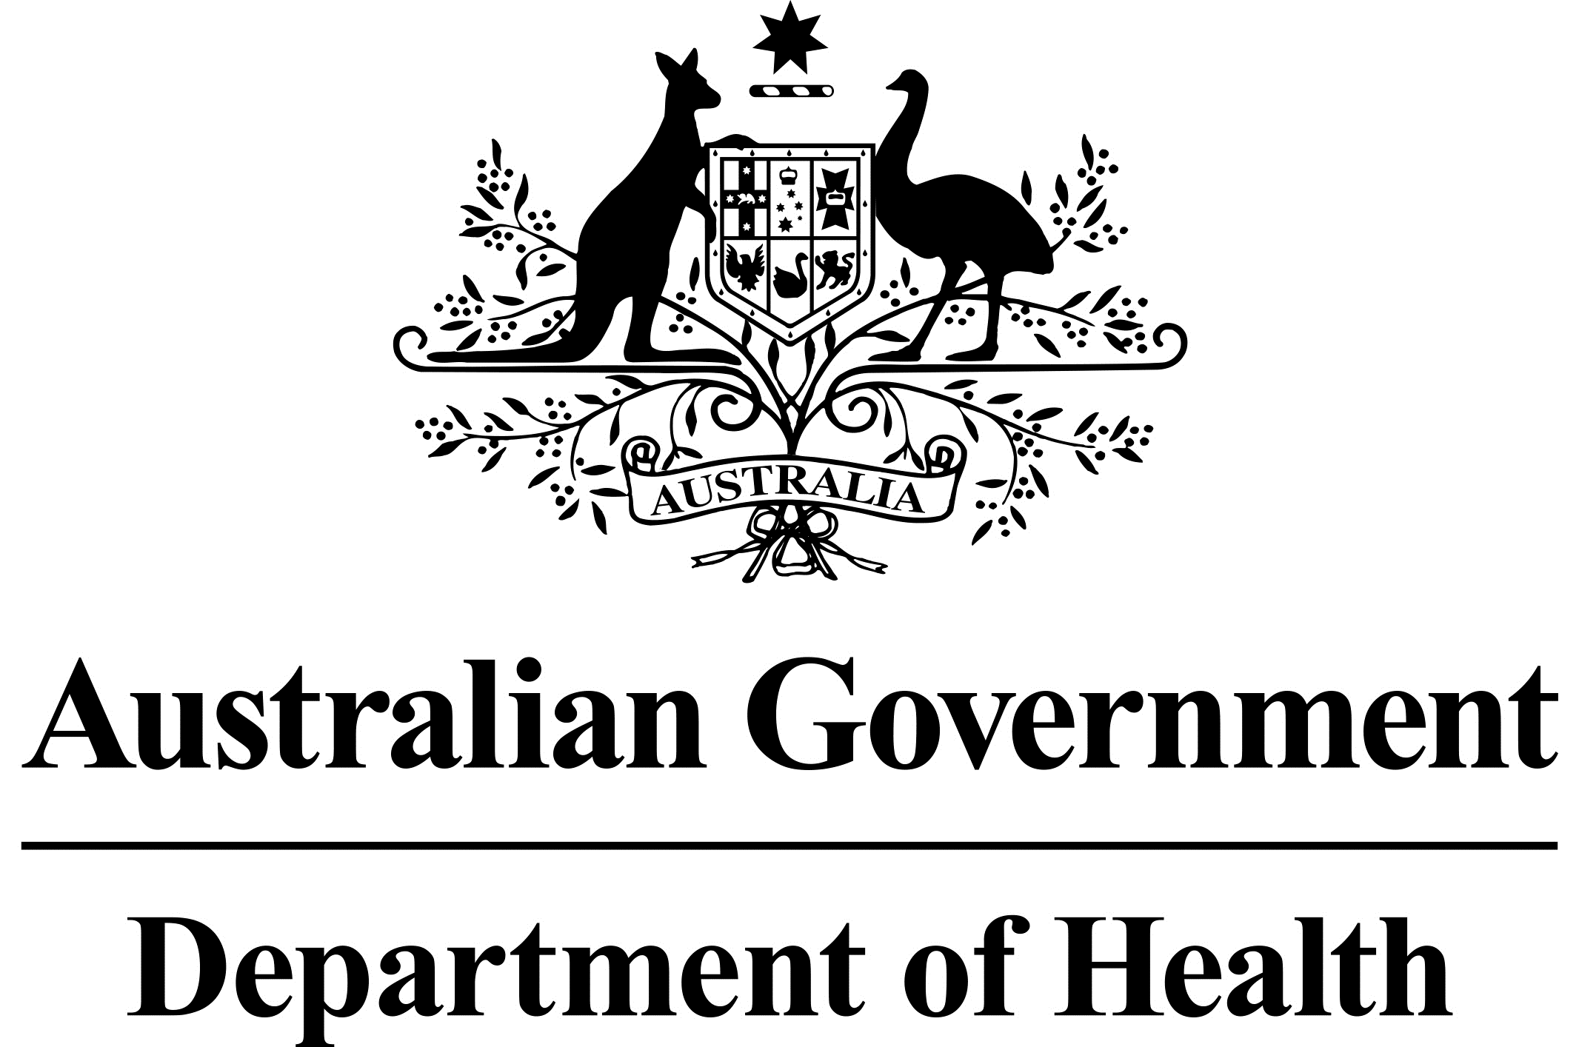

Primary care Rural Innovative Multidisciplinary Models (PRIMM) Grant GO4600

# FEEDBACK FOR APPLICANTS

## OVERVIEW

The Primary care Rural Innovative Multidisciplinary Models (PRIMM) grant opportunity is provided by the Health Workforce Program of the Australian Government Department of Health. The Office of the National Rural Health Commissioner is overseeing this grant opportunity.

The purpose of the PRIMM grant opportunity is to enable the design of community‑supported, locally designed rural multidisciplinary models of primary care.

This feedback is provided to all applicants in relation to PRIMM grant Round 1 held in March 2021.

The objectives of the PRIMM grant opportunity are for grant recipients to:

* Develop local, integrated, multidisciplinary models of primary care through a co‑design process, which includes engagement with local rural and remote communities, health services and training providers in order to address local health, service and/or workforce needs;
* Formalise processes/pathways that integrate and enhance service delivery across sub‑regions and improve access, appropriateness and availability of local health services; and
* Create innovative models of care that include structured and supported processes for professional development, and service and learning opportunities for students, early career and senior health professionals and staff. These processes should be designed with local regional training providers and link with health needs and service gaps.
* The intended outcomes of the PRIMM grant opportunity are for grant recipients to:
* Develop a ‘trial-ready’ multidisciplinary primary care model that will address specific population health needs and/or health workforce issues of communities or a sub-region;
* Develop a flexible methodology for the engagement of communities in co-designing solutions to address population health, service and/or workforce needs; and
* Document and share findings and lessons learned from the design and co-design process with other rural and remote communities across Australia, to empower them to design their own primary healthcare solutions.

## OUTCOME OF APPLICATIONS

There was significant interest in the PRIMM grant Round 1, with 45 applications received of which two were successful for funding through an open competitive grant process.

## ASSESSMENT OF APPLICATIONS

Applications were assessed on their merits and comparatively against other applications based on:

* the overall objective/s to be achieved in providing the grant;
* the extent to which the evidence in the application, including attachments demonstrates that it will contribute to meeting the outcomes/objectives of the program;
* the extent to which the geographic location of the application matches identified priorities, noting was given to proposals for Modified Monash (MM) MM4-7 locations; and
* the relative value of the grant sought.

## ASSESSMENT FEEDBACK

The common elements of high quality applications are tabled in the assessment feedback below, including examples of how these applications met the selection criteria.

Strong applications provided a clear and concise project description which identified the target community groups to benefit from the project, the activities to be conducted and the location or coverage area of the project (e.g. by naming the towns and their Modified Monash Model (MMM) classifications).

### Criterion 1: How will your grant activity align with program objectives and outcomes?

Describe your project and demonstrate how your proposal aligns with the program and grant opportunity objectives and outcomes at Section 2.1.

Strong responses:

* Clearly described the proposed project to be delivered;
* Demonstrated how the proposed project would meet the objectives of PRIMM and deliver on the outcomes of PRIMM;
* Clearly outlined plans for a multidisciplinary approach to care for the community. While noting differing population health needs according to some regions, strong applications generally included multi-disciplinary teams comprised of a range of medical practitioners, nurses, allied health professionals, pharmacists, dentists, and aged care workers, rather than one specific discipline (e.g. medical practitioners only);
* Considered how a new model of care would be sustainable in the long term once implemented; and

| Presented opportunities for training and career development of local healthcare workers. Sub-criteria | Common elements and examples |
| --- | --- |
| A clear problem definition describing the specific local population health needs and primary healthcare access barriers faced by the communities or sub-region, supported by data and evidence. You should name the communities covered by your proposal. | Strong responses:   * Named the communities or sub-regions covered by the proposal, including their MMM classification. * Clearly articulated the rationale for co-designing a multidisciplinary health workforce employment model in the area. * Provided data specific information to the communities or sub-regions covered by the proposal and compared it to relevant state or national data. * Discussed local difficulties in recruiting and retaining an appropriately qualified workforce. * Described barriers faced by the community to accessing primary healthcare services, e.g. the only services available to community X is in town Y two hours’ drive away. |
| A case for why the project is needed, including service gaps and a description of how this project links to other relevant activities, services and reforms underway (where available or applicable). You should use evidence or data in your response to support your claims. | Strong responses:   * Demonstrated the need for the project in the community including discussion of: * The current services available to the community; * Known service gaps and needs of the community; and * Relevant changes in demographics in the community (e.g. increasingly aging population requiring different model of care). * Described past work that could be built upon in the community. * Described how the project would link into existing broader initiatives and reforms at local, state or national level. |
| The expected outcomes and benefits arising from the implementation of the model developed as part of this activity. | Strong responses:   * Described what the project aims to achieve for the communities involved, e.g. a multi-disciplinary model of care that supports GPs and allied health professionals to work together to manage chronic disease and prevent hospitalisation, resulting in better health outcomes for patients. |

### Criterion 2: Community and stakeholder engagement

Describe how you will co-design a solution to the identified issues in Criterion 1 with the community and stakeholders, including local health service providers.

Strong responses:

* Clearly described genuine co-design with the communities involved and service providers in the area;
* Described recent engagement with the community on the project to demonstrate community buy-in to the project; and
* Described how key patient or population groups would be included in the co-design process.

| Sub-criteria | Common elements and examples: |
| --- | --- |
| * Details on the arrangements your organisation or consortia will use to work with the community, Aboriginal and Torres Strait Islander peoples/leaders/elders, health professionals and other service providers in the region to develop a model that has community support. | Strong responses:   * Provided specific information on how co-design would work in the community and with stakeholders. This may have included:   + How co-design participants would be recruited and trained; and   + How specific vulnerable population groups would be included in co-design (e.g. through an advisory committee or workshops held specifically for the group). * Described an iterative process to develop a model of care to ensure the community and stakeholders come along on the journey.   High quality applications also described existing arrangements working with other health service providers in the region and highlighted formalising and strengthening these arrangements with grant funding using the experience of the consortium. For example, shared recruitment strategies with the Local Health District, Primary Health Networks (PHNs), allied health providers and NDIS providers. Methods also highlighted employment strategies to reduce hospital admissions where possible. |
| * Details of your organisation or consortia’s existing service footprint within the region | * Strong responses: * Described the services and activities the lead organisation was currently providing or undertaking in the communities involved. * Where a consortium was proposed, services and activities for each member organisation was described clearly. * Demonstrated the lead organisation and any partner organisations together had a breadth of service experience within the communities.   High quality applications may have also described clearly how each consortia member/partner had contributed to servicing multiple communities in rural and remote locations and could build on this experience. For example Local PHN stakeholder engagement, population health analysis and workforce recruitment strategies; universities located in the state or region had assisted with research and evaluation of other projects or models; and what level of available local GPs, rural generalists, specialists, nurses and allied health practitioners for their clinical expertise could be innovatively mobilised to service a number of communities within a defined region. |
| Details of how you will overcome potential or known issues or barriers to obtain support for a model. | Strong responses:   * Named known issues or barriers to support within the communities and proposed specific measures to address these, e.g. in communities where English is a second, third or fourth language, an organisation might hire project workers who speak the local language. |

### Criterion 3: Outline your organisation’s capacity and performance

Demonstrate your organisation or consortium’s capacity to deliver the proposed project.

Strong responses:

* Clearly described the consortia’s previous experience in engaging with health service provision and communities;
* Provided clearly defined governance structures, with previous experience of project oversight; and
* Balanced membership within governance structures, particularly membership from vulnerable population groups or other health consumers.

| Sub-criteria | Common elements and examples: |
| --- | --- |
| Details on your organisation or consortium’s capability and capacity to undertake this activity, including:   * Links and engagement you have within the communities or sub-region; * Organisational and staff capacity to manage this project including information on past experience; and * The governance and management structure. Where applicable, applicants should detail the governance arrangements for consortium arrangements. | Strong responses:   * Provided examples of current or previous projects the consortium or a group of members of the consortium had delivered together to show they had successfully worked together previously. * Provided examples of current or previous engagement with the communities named for the project. * Outlined the staff members who would be working on the project, their role and their relevant expertise and experience. * Specified that key roles would be based in the communities that were the subject of the application. * Provided an existing or proposed governance structure including staff and stakeholder membership on committees, and a plan for how often they would meet. * Included representation of key patient or population groups in the governance structure, e.g. young adults with lived experience of mental health issues/disorders on a steering committee for a model of care to treat them. |
| Organisational and staff capacity to manage this project including information on past experience | Strong responses:   * Listed past successful grants and the outcomes of the past grants. Gave names of staff and their qualifications. * Examples of functional and current collaboration across local rural networks, as well as strong links with stakeholders delivering across allied health, nursing and specialist services. |
| The governance and management structure. Where applicable, applicants should detail the governance arrangements for consortium arrangements. | Strong responses:   * Provided a governance structure and associated plan, which may have included committee leadership and staff make-up of the committee, and when and how often they would meet to ensure oversight of project outcomes. Some applications provided diagrams and flow charts of proposed governance structures. Strong applications also sought to have governance arrangements established at the onset of funding which provided confidence that project planning and milestones would be managed appropriately. |
| Your application should indicate you have support from the local service and training providers including but not limited to, Primary Health Networks, Rural Workforce Agencies, the Local Health Networks (or equivalent), local Aboriginal Medical Services, Aboriginal Community Controlled Health Services and University Departments of Rural Health and other training providers. | Strong responses:   * Provided letters of support from local stakeholders (in addition to organisations as part of a consortia) for the project, e.g. GP clinics, local council. |

### Criterion 4: Project plan (timelines, performance and use of grant funds

Demonstrate how you will undertake the proposed activity, and how it is an efficient and economical use of grant funds.

Strong responses:

* Provided clearly defined activity work plans, that included governance frameworks, timeframes, deliverables and projected outcomes;
* Provided detailed budgets within available funding of $400,000; and
* Well defined risk profiles with appropriate mitigation strategies.

| Sub-criteria | Common elements and examples: |
| --- | --- |
| A description of how the project will be implemented and managed (including the budget) within the grant period. | Strong responses:   * Described each stage of the projects implementation in addition to providing detail in the attached activity work plan. * Aligned with the project and activities described in other criteria. |
| The deliverables to be achieved, and how they link to grant outcomes. | Strong responses:   * Provided well defined deliverables (outputs) with a strong description of what is to be achieved (outcomes). |
| How you will measure outcomes and progress towards achieving the grant objectives. | Strong responses:   * Described how outcomes and project progress would be measured and tracked, e.g. monthly steering committee meetings, tracking of deliverables in activity work plan. |
| In addition to responding to the above criteria, the applicant must complete and attach the following documents to support their claims:   * Indicative Budget; * Risk Management Plan; and * Activity Work-plan. | A good budget:   * Provided a well-defined budget including administration costs, staffing requirements, and consultation costs. * Provided a brief rationale for the costs. * Was $400,000 (GST exclusive) or below as detailed in the Guidelines. * Had regard to eligible expenditure items and items that the grant cannot be used for, as detailed in the Guidelines.   A good risk management plan:   * Demonstrated a sound knowledge of risk management principles. * Clearly articulated specific risks to their specific proposed project, e.g. community engagement. * Provided practical measures and controls to mitigate risks associated with their proposed project.   A good work plan:   * Presented activities in a logical sequence with reasonable timeframes. * Aligned with the project and activities described in other criteria. * Aligned with the outcomes and deliverables described in Criterion 4. * Had sufficient level of detail on deliverables, expectations and how planned activities will meet the goals of the described project. |