MBS REVIEW ONLINE CONSULTATION

### FINAL REPORT

**INTENSIVE CARE & EMERGENCY MEDICINE**

9 JANUARY 2018

FINAL PREPARED FOR DEPARTMENT OF HEALTH





**URBIS STAFF RESPONSIBLE FOR THIS REPORT WERE:**

|  |  |
| --- | --- |
| Director | Dr Linda Kurti |
| Associate Director | Dr Caroline Tomiczek |
| Senior Consultant | Evylyn Brophy |
| Research Assistant | Simon To, Adele Martin |
| Project Code | SPP28416 |
| Report Number | Final Report |

Urbis’ Public Policy team has received ISO 20252 Certification for the provision of Social Policy Research and Evaluation

Template version 2016.1.0

All information supplied to Urbis in order to conduct this research has been treated in the strictest confidence. It shall only be used in this context and shall not be made available to third parties without client authorisation. Confidential information has been stored securely and data provided by respondents, as well as their identity, has been treated in the strictest confidence and all assurance given to respondents have been and shall be fulfilled.

You must read the important disclaimer appearing within the body of this report.

**URBIS**

**Australia Asia Middle East**

urbis.com.au

TABLE OF CONTENTS

Introduction 1

Medicare Benefits Review overview 1

Methodology 1

Intensive Care and Emergency Medicine 4

Profile of respondents 4

Recommendations 5

Feedback on report 8

**Appendix A** Questionnaire

URBIS

ROUND 5 - FINAL INTENSIVE CARE AND EMERGENCY MEDICINE REPORT - 9 JAN 18 2018

# INTRODUCTION

## MEDICARE BENEFITS REVIEW OVERVIEW

In April 2015, the Hon. Susan Ley MP, former Minister for Health and Sport, announced that a Medicare Benefits Schedule (MBS) Review Taskforce would be established. The Taskforce is considering how over 5,700 items on the MBS can be aligned with current evidence and practice to improve health outcomes for patients. The Taskforce has established 60 clinical committees and working groups to review MBS items. The diagram below provides an overview of the review process.

Review Process image shows the following steps: 
Clinical Committee established, Clinical Committee drafts report including recommended changes, Public consultation on Clinical Committee report, Clinical Committee considers feedback, Clinical Committee provides final report to Taskforce, Taskforce considers final report and public feedback, Taskforce delivers final recommendations to government, Government will consider Taskforce recommendations.

## METHODOLOGY

The Taskforce is releasing reports for public consultation in rounds. This report presents the final findings from the fifth round of public consultation.

##### Online consultations

Four reports (Round 5) were publicly released on Tuesday 22 August 2017. Public consultation for this round closed at 7pm (EST) on Friday 6 October 2017.

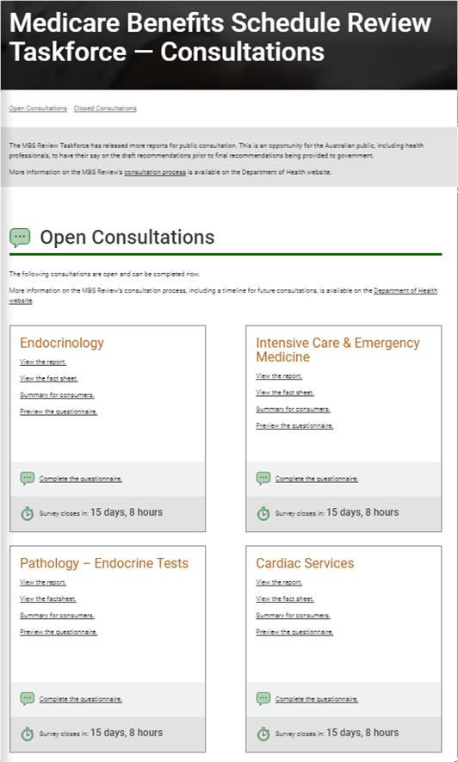

The MBS Review website (mbsreview.com.au) provided information about the reports open for consultation and links to the online consultation questionnaires. The website also provided links to the full reports and fact sheets outlining the main recommendations.

The four reports included in round five were:

* Endocrinology
* Pathology – Endocrine Tests
* Intensive Care and Emergency Medicine (ICEM)
* Cardiac Services.

URBIS

ROUND 5 - FINAL INTENSIVE CARE AND EMERGENCY MEDICINE REPORT - 9 JAN 18

INTRODUCTION 1

The online questionnaires were hosted on the SurveyGizmo platform. Each questionnaire commenced with ‘how to complete the questionnaire’ instructions, and links to the full draft report and summary for consumers (in HTML format). A downloadable overview of the questions was provided, should respondents wish to review this prior to completing the questionnaire.

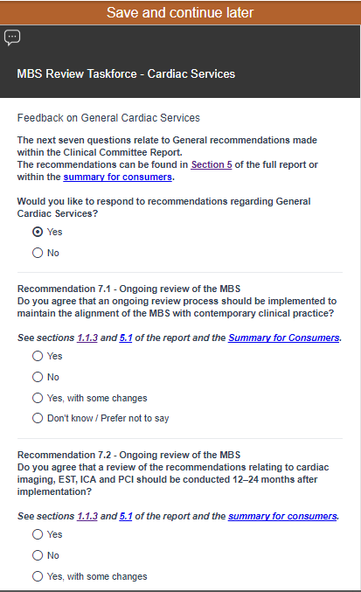

Respondents were then asked to provide feedback on each report recommendation. Links to the full text of the recommendation in the report and the summary for consumers were also provided.

The Taskforce supplied all questionnaire wording. For each recommendation, respondents were asked to answer a closed question with four response options:

1. Yes
2. Yes, with some changes
3. No
4. Don’t know / prefer not to say.

Respondents who select ‘Yes, with some changes’ or ‘No’ were asked to provide suggested changes (via free text responses), including reasoning or evidence.

All respondents were then asked to rate their level of agreement with four statements about the understandability and comprehensiveness of the information in the reports.

The questionnaires concluded with a set of demographic questions to identify the type of respondent (organisation, health professional or consumer), the location of the respondent, and whether the respondent had offered or received the service(s) covered in the report.

Respondents were asked to provide consent for their responses to be provided to the Taskforce and for their comments to be published.

The full questionnaires for each report are provided in Appendix A.

##### Data analysis

Quantitative and qualitative analysis was undertaken for this report.

Qualitative data analysis was conducted for all open-ended, free responses received. This process involved development of a thematic coding frame for each question. Free text responses were then allocated to one or more codes.

The coding frame was developed through an iterative process that created high- level topics reflective of responses provided to a specific question. Coding was completed by several members of the Urbis research team, with regular peer reviews to ensure consistency.

Quantitative data analysis was undertaken using a specialist software package, SPSS. Descriptive statistical analysis (including cross-tabulations) was conducted to assess level of agreement with recommendations and to profile respondents.

Results are reported as whole counts rather than percentages.

Whole counts presented in the report are based on the total number of valid responses to the question being reported. In most cases, results reflect those respondents who had a view and for whom the questions were applicable. ‘Don’t know’ and ‘Unsure’ responses have been presented to aid in the interpretation of the results.

URBIS

ROUND 5 - FINAL INTENSIVE CARE AND EMERGENCY MEDICINE REPORT - 9 JAN 18

INTRODUCTION 2

##### This report

This final report provides an overview of responses received for Intensive Care and Emergency Medicine (ICEM), including:

* the number of submissions received and general agreement across all recommendations
* a profile of respondents
* a summary of responses to each recommendation, including most frequently mentioned comments
* a selection of verbatim quotes from respondents.

URBIS

ROUND 5 - FINAL INTENSIVE CARE AND EMERGENCY MEDICINE REPORT - 9 JAN 18

INTRODUCTION 3

# INTENSIVE CARE AND EMERGENCY MEDICINE

Table 1 provides an overview of responses received for the ICEM Clinical Committee report.

Table 1 – Overview of responses

|  |  |  |  |
| --- | --- | --- | --- |
| **Questionnaire accessed** | **Number of respondents** | **Completed responses** | **Response rate** |
| 80 | 52 | 47 | 65% |

## PROFILE OF RESPONDENTS

The base numbers for each question reflect the number of valid responses for that question. As some respondents may not have answered every question, the base may differ.

The one respondent who identified themselves as being an ‘other’ individual (figure 1) specified being both a family member of a consumer and a health law academic with a specific interest in the provision of health care services under the MBS.

The breakdown of the five organisations who responded is as follows:

* three peak body or advocacy organisations
* one private hospital
* one identified as other and specified ‘medical college’.

Figure 1 – Respondent type

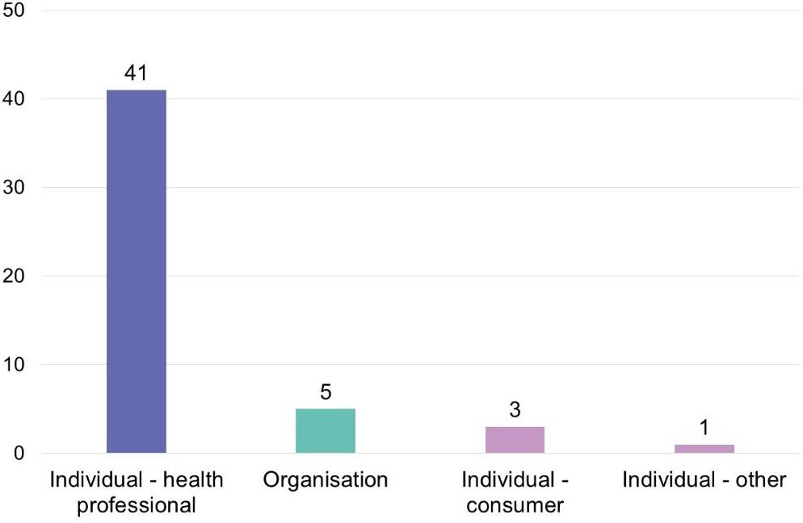

Base: n= 50

Most (35 of 41) respondents who identified as being a ‘health professional’ (figure 2, over page) specified working as a ‘medical specialist’, three indicated being a ‘nurse’ and one indicated they are a ‘general practitioner’. Two respondents selected the ‘other’ category; one of whom specified being an ‘emergency physician (non-FACEM; non-VR)’, and the other an ‘intensive care trainee’. All health professionals had provided services related to intensive care and emergency medicine.

URBIS

ROUND 5 - FINAL INTENSIVE CARE AND EMERGENCY MEDICINE REPORT - 9 JAN 18

INTENSIVE CARE AND EMERGENCY MEDICINE 4

Figure 2 – Respondent type – health professional

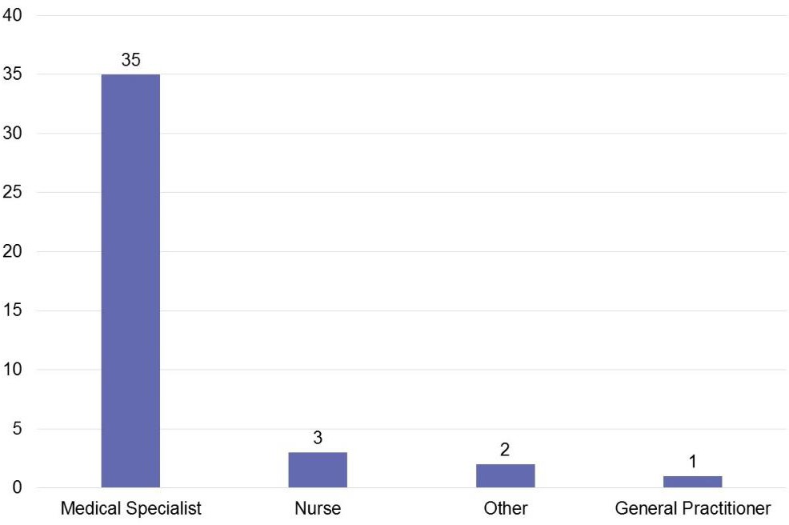

Base: n=41

Table 2 – Respondents by jurisdiction

|  |  |  |  |  |  |  |  |  |  |
| --- | --- | --- | --- | --- | --- | --- | --- | --- | --- |
|  | **Nat** | **ACT** | **NSW** | **Qld** | **NT** | **SA** | **Tas** | **Vic** | **WA** |
| Organisation | 4 | - | - | 1 | - | - | - | - | - |
| Individual | - | 1 | 9 | 11 | - | 2 | 7 | 13 | 2 |

Base: Organisation n=5; Individual n=45

Note: Organisations could provide multiple responses. Only organisations could select ‘National’.

Of the 44 individuals who provided a valid postcode, 32 were in a major city, 11 were in an inner regional area, and one was in an outer regional area. One individual did not provide a valid postcode.

## RECOMMENDATIONS

The ICEM Clinical Committee made ten recommendations. Recommendations 8 (remove item 14200) and 9 (expedited MSAC assessment for listing an MBS item for a rapid response system/code blue attendance services) received the highest level of agreement (table 3). Recommendations 1 (restructure Emergency Department attendance items [501-536] into three tiered base items with add-on items) and 2 (use of a consistent framework for all emergency attendances, regardless of the provider type) generated a high proportion of ‘don’t know/prefer not to say’ ratings (30 and 27 respectively).

Most respondents were supportive of the six remaining recommendations:

* Recommendation 3 (leave items 13870, 13873 and 13876 unchanged)
* Recommendation 4 (remove the differential fees for managing counterpulsation by intraaortic balloon for the first day [item 13847] and subsequent days [item 13848])
* Recommendation 5 (expedited MSAC [Medical Services Advisory Committee] assessment for listing MBS items for extracorporeal life support)
* Recommendation 6 (revise descriptors for item 13815 [central vein catheterisation] and item 13842 [intra-arterial cannulation] to encourage providers to use ultrasound guidance)
* Recommendation 7 (introduce an MBS item for discussion and documentation of goals of care by an Intensive Care Specialist)
* Recommendation 10 (leave items 13818, 13830, 13857 and 13881-13888 unchanged).

The number of comments received across all recommendations was relatively low, with most comments made by health professionals with experience providing ICEM services.

URBIS

ROUND 5 - FINAL INTENSIVE CARE AND EMERGENCY MEDICINE REPORT - 9 JAN 18

INTENSIVE CARE AND EMERGENCY MEDICINE 5

Table 3 – Agreement with recommendations

|  |  |  |  |  |  |
| --- | --- | --- | --- | --- | --- |
| **Recommendation** | **Yes** | **No** | **Yes, with some changes** | **Don't know / prefer not to say** | **Total responses (n)** |
| Recommendation 1 | 18 | 2 | 1 | 30 | 51 |
| Recommendation 2 | 19 | 3 | 2 | 27 | 51 |
| Recommendation 3 | 35 | 2 | 5 | 8 | 50 |
| Recommendation 4 | 35 | 5 | - | 9 | 49 |
| Recommunication 5 | 39 | 1 | - | 9 | 49 |
| Recommendation 6 | 23 | 9 | 9 | 7 | 48 |
| Recommendation 7 | 36 | 3 | 5 | 5 | 49 |
| Recommendation 8 | 40 | 5 | - | 4 | 49 |
| Recommendation 9 | 40 | 2 | 5 | 3 | 50 |
| Recommendation 10 | 39 | 1 | 1 | 8 | 49 |

##### Comments on recommendations

**Recommendation 1 (restructure Emergency Department attendance items [501-536] into three tiered base items with add-on items) received 2 comments:** one respondent who commented on this recommendation disagreed with the proposed restructure to Emergency Department attendance items, suggesting that members of the Clinical Committee could have a conflict of interest. This respondent provided the same critique of the ICEM Clinical Committee representation across all recommendations (referred to as a ‘reoccurring comment’ from this point forward). The other respondent who commented on this recommendation supported the proposed restructure, although they suggested access to the items could be extended beyond private hospital settings.

**Recommendation 2 (use of a consistent framework for all emergency attendances, regardless of the provider type) received 5 comments:** two respondents disagreed with the recommendation: one argued that clinicians with extensive emergency department skills (though lacking formal emergency fellowship qualifications) should be able to command a higher fee based on their emergency-related experience and skill; the other respondent suggested rebates should be paid per procedure rather than by medical provider. One respondent was critical of the three tiered structure based on professional involvement, and one other respondent argued that any changes should include a ‘scale and mechanism for individual review’. The remaining response was the reoccurring comment submitted by the same respondent as outlined in recommendation 1 above.

**Recommendation 3 (leave items 13870, 13873 and 13876 unchanged) received 5 comments:** four respondents suggested changes to the intensive care management items covered by recommendation 3: one proposed the use of pulmonary artery catheters be restricted to use relating to peri-cardiac surgery, and the other three stressed that the descriptor for item 13876 requires updating to reflect current best practice for central venous pressure and monitoring. The remaining response was the reoccurring comment submitted by the same respondent outlined in recommendation 1 above.

**Recommendation 4 (remove the differential fees for managing counterpulsation by intraaortic balloon for the first day [item 13847] and subsequent days [item 13848]) received 5 comments:** four respondents suggested differential fees are required, as the first day of care managing counterpulsation by intraaortic balloon pump (IABP) is more complex and time consuming than the ongoing day-to-day management of care. The remaining response was the reoccurring comment submitted by the same respondent as outlined in recommendation 1 above.

**Recommendation 5 (expedited MSAC [Medical Services Advisory Committee] assessment for listing MBS items for extracorporeal life support) received 1 comment:** the only comment provided for this recommendation was the reoccurring comment described under recommendation 1 above.

Recommendation 6 (revise descriptors for item 13815 [central vein catheterisation] and item 13842 [intra-arterial cannulation] to encourage

URBIS

ROUND 5 - FINAL INTENSIVE CARE AND EMERGENCY MEDICINE REPORT - 9 JAN 18

INTENSIVE CARE AND EMERGENCY MEDICINE 6

**providers to use ultrasound guidance) received 15 comments:** almost half (7 of 15) of the respondents proposed ultrasound services should be billed separately to incentivise their appropriate use. A third (5 of 15) of respondents agreed with the recommendation, while proposing that the use of ultrasound be guided, not mandated. Two of these five respondents also argued that clinicians should be able to exercise clinical judgement when deciding whether to use ultrasounds. One respondent disagreed with the proposed changes citing that clinicians should be free to choose the most appropriate technique for the situation, and one other respondent was concerned the proposed changes would increase the risk of litigation if an ultrasound was not used. The remaining response was the reoccurring comment submitted by the same respondent as outlined in recommendation 1.

**Recommendation 7 (introduce an MBS item for discussion and documentation of goals of care by an Intensive Care Specialist) received 7 comments:** one respondent strongly agreed with the proposed introduction, proposing that the change will ultimately improve patient outcomes. Another three respondents were supportive, while proposing amendments such as greater flexibility with the minimum 60-minute time commitment, expanding access to the item for outpatients, and allowing clinicians to access the item in addition to the daily consult item. Two respondents disagreed with the proposed introduction, arguing that a rebate for clinicians to discuss patient goals was unjustified. The remaining response was the reoccurring comment submitted by the same respondent as outlined in recommendation 1.

**Recommendation 8 (remove item 14200) received 3 comments:** two of the three respondents who commented on this recommendation disagreed with the proposed change: one argued that there are circumstances where a gastric lavage is appropriately used, and that further assessment of the appropriate use of this technique is required before removing the item, while the other did not specify a reason. The remaining response was the reoccurring comment submitted by the same respondent outlined in recommendation 1 above.

**Recommendation 9 (expedited MSAC assessment for listing an MBS item for a rapid response system/code blue attendance services) received 6 comments:** four respondents were supportive of the recommendation: one stated rapid response is an increasing part of the workload within a hospital; one proposed the fee for the new item should reflect that of item 110 (or similar); one proposed the rebate should be payable regardless of setting

URBIS

ROUND 5 - FINAL INTENSIVE CARE AND EMERGENCY MEDICINE REPORT - 9 JAN 18

(public or private hospital); and one argued the item should be claimable in addition to emergency department (ED)/intensive care unit (ICU) attendance items if attendance is outside these settings. One unsupportive respondent suggested there is insufficient evidence to support the use of rapid response/medical emergency team call out services. The remaining response was the reoccurring comment submitted by the same respondent outlined in recommendation 1 above.

**Recommendation 10 (leave items 13818, 13830, 13857 and 13881-13888 unchanged) received 1 comment:** the single comment received against recommendation ten was the reoccurring comment submitted by the same respondent as outlined in recommendation 1.

INTENSIVE CARE AND EMERGENCY MEDICINE 7

## FEEDBACK ON REPORT

Respondents were asked to provide their level of agreement on several statements regarding the ICEM Clinical Committee report (figure 3).

Figure 3 – Summary of feedback on ICEM Clinical Committee report

The Summary for consumers included in the Clinical Committee report was easy to understand. 5 disagreed, 4 neither agreed or disagreed, 35 agreed and 7 dont' know or prefered not to say.

There was enough information provided in the Clinical Committee report for me to understand the recommendations. 2 disagreed, 3 neither agreed or disagreed, 43 agreed and 3 prefered not to say.

There was enough information provided in the Clinical Committee report to support the recommendations. 5 disagreed, 5 neither agreed or disagreed, 38 agreed and 3 prefered not to say.

The Clinical Committee report was easy to understand. 2 disagreed, 4 neither agreed or disagreed, 42 agreed and 3 prefered not to say.

Base: n=51

Twelve respondents provided additional feedback on the report. Of the relevant comments:

* six proposed that the ICEM Clinical Committee consider creating or reviewing additional items
* one expressed their support for the intensive care recommendations
* one reiterated their critique of the ICEM Clinical Committee membership
* one requested further information about the economic impacts of the proposed changes
* one requested further clarification of the implications of recommendation 2.1
* one suggested that private emergency departments are currently underfunded
* one requested a list of intensive care item numbers be distributed at the end of the review process.

URBIS

ROUND 5 - FINAL INTENSIVE CARE AND EMERGENCY MEDICINE REPORT - 9 JAN 18

INTENSIVE CARE AND EMERGENCY MEDICINE 8

*[Regarding Recommendations 1-10 – all recommendations*] Every single person on the committee except the consumer rep has a conflict of interest as they will benefit financially from the decisions made by the committee. – *Health professional*

*[Regarding recommendation 4 - remove the differential fees for managing counterpulsation by intraaortic balloon for the first day (item 13847) and subsequent days (item 13848)]* The first day of IABP care is often more complex and time consuming due to high patient acuity and the first day fee reflects this. –

#### Health professional

*[Regarding Recommendation 6 - revise descriptors for item 13815 (central vein catheterisation) and item 13842 (intra-arterial cannulation) to encourage providers to use ultrasound guidance*] Providers are already encouraged to use ultrasound when appropriate by numerous clinical guidelines. Having the recommendation appear in the MBS will simply expose them to the possibility of either litigation or failure of payment should they choose not to use ultrasound for whatever reason. – *Health professional*

URBIS

ROUND 5 - FINAL INTENSIVE CARE AND EMERGENCY MEDICINE REPORT - 9 JAN 18

DISCLAIMER 9

*[Regarding Recommendation 7 - introduce an MBS item for discussion and documentation of goals of care by an Intensive Care Specialist]* Yes, very strongly agree. This is an increasing part of our workload, increasingly NOT performed by the patient's primary doctors. Introducing a payment for having this difficult conversation will likely SAVE the government money in the long term... – *Health professional*

*[Regarding Recommendation 8 - remove item 14200]* Whilst this may be rarely indicated, it is still occasionally indicated … I think before removing the item number entirely, you should review the fifteen cases where it was used, and see how many were appropriate. – *Health professional*

URBIS

ROUND 5 - FINAL INTENSIVE CARE AND EMERGENCY MEDICINE REPORT - 9 JAN 18

DISCLAIMER 10

**DISCLAIMER**

This report is dated 9 January 2018 and incorporates information and events up to that date only and excludes any information arising, or event occurring, after that date which may affect the validity of Urbis Pty Ltd’s (**Urbis**) opinion in this report. Urbis prepared this report on the instructions, and for the benefit only, of Department of Health (**Instructing Party**) for the purpose of MBS Review consultation report (**Purpose**) and not for any other purpose or use. To the extent permitted by applicable law, Urbis expressly disclaims all liability, whether direct or indirect, to the Instructing Party which relies or purports to rely on this report for any purpose other than the Purpose, and to any other person which relies or purports to rely on this report for any purpose whatsoever (including the Purpose).

In preparing this report, Urbis was required to make judgements which may be affected by unforeseen future events, the likelihood and effects of which are not capable of precise assessment.

All surveys, forecasts, projections and recommendations contained in or associated with this report are made in good faith and on the basis of information supplied to Urbis at the date of this report, and upon which Urbis relied. Achievement of the projections and budgets set out in this report will depend, among other things, on the actions of others over which Urbis has no control.

In preparing this report, Urbis may rely on or refer to documents in a language other than English, which Urbis may arrange to be translated. Urbis is not responsible for the accuracy or completeness of such translations and disclaims any liability for any statement or opinion made in this report being inaccurate or incomplete arising from such translations.

Whilst Urbis has made all reasonable inquiries it believes necessary in preparing this report, it is not responsible for determining the completeness or accuracy of information provided to it. Urbis (including its officers and personnel) is not liable for any errors or omissions, including in information provided by the Instructing Party or another person or upon which Urbis relies, provided that such errors or omissions are not made by Urbis recklessly or in bad faith.

This report has been prepared with due care and diligence by Urbis and the statements and opinions given by Urbis in this report are given in good faith and

in the reasonable belief that they are correct and not misleading, subject to the limitations above.

URBIS

ROUND 5 - FINAL INTENSIVE CARE AND EMERGENCY MEDICINE REPORT - 9 JAN 18

DISCLAIMER 11

**APPENDIX A QUESTIONNAIRE**

URBIS

ROUND 5 - FINAL INTENSIVE CARE AND EMERGENCY MEDICINE REPORT - 9 JAN 18 APPENDICES

**MBS Review Taskforce - Intensive Care and Emergency Medicine**

Thank you for your interest in participating in the MBS Review public consultation for the Intensive Care and Emergency Medicine Clinical Committee report.

This public consultation allows the Australian public, including health professionals, an opportunity to provide feedback on the Intensive Care and Emergency Medicine Clinical Committee draft report, prior to the final recommendations being provided to government. You can review the [full draft report](http://mbsreview.com.au/reports/intensive-care_1.html) or the [Summary for consumers](http://mbsreview.com.au/reports/intensive-care_11.html#_Toc484008512).

The online consultation survey includes the following sections:

* + Responses to the 11 recommendations in the Intensive Care and Emergency Medicine Clinical Committee draft report (including links to each report recommendation and a summary for consumers to allow for easy reflection on the recommendations)
  + 3 questions to provide feedback on the draft report
  + 3-4 demographic questions
  + 2 questions on privacy and consent of responses.

You can also review a [PDF of the survey questions.](http://mbsreview.com.au/previews/)

Please note: only submissions submitted through this online survey process will be considered.

As part of the first section, you will be given an opportunity to upload additional documents relevant to your feedback or supporting evidence to your response.

You are able to save your responses and return to the survey using the ‘Save and Continue Later’ button. You can also review and print your responses prior to submitting your completed survey.

This survey will close at 7pm (EST) Friday 8 September 2017.

By clicking the ‘Next’ button, you are consenting to participate in the MBS Review Public Consultation for the Intensive Care and Emergency Medicine Clinical Committee report.

**Feedback on Recommendations 1 - 10**

Recommendation 1 – Emergency medicine

Do you agree with Recommendation 1 which proposes to restructure Emergency Department attendance items (501-536) into three tiered base items with add-on items?

*Refer to* [*Section 4.2*](http://mbsreview.com.au/reports/intensive-care_5.html#_INTCARE_R-1) *and the* [*Summary for consumers*](http://mbsreview.com.au/reports/intensive-care_11.html#_INTCARE_S4-R1-2-2.1)

( ) Yes

( ) No

( ) Yes, with some changes

( ) Don't know / Prefer not to say

*[If ‘No’ or ‘Yes, with some changes’ Max word count = 500]*

Please provide suggested changes, including your reasoning or evidence

Recommendation 2 – Emergency medicine

Do you agree with Recommendation 2 which proposes to use a consistent item framework for all emergency attendances, regardless of what type of medical provider attends to the patient?

*Refer to* [*Section 4.3*](http://mbsreview.com.au/reports/intensive-care_5.html#_INTCARE_R-2) *and the* [*Summary for consumers.*](http://mbsreview.com.au/reports/intensive-care_11.html#_INTCARE_S4-R1-2-2.1)

( ) Yes

( ) No

( ) Yes, with some changes

( ) Don't know / Prefer not to say

*[If ‘No’ or ‘Yes, with some changes’ Max word count = 500]*

Please provide suggested changes, including your reasoning or evidence

Recommendation 2.1 – Emergency medicine

The Intensive Care and Emergency Medicine Clinical Committee has referred its recommendation to allow referred in-hospital attendance services provided by Emergency Physicians to attract a patient rebate equivalent to that received for attendances by Consultant Physicians to the Consultation Services Clinical Committee to review.

*Refer to* [*Section 4.4*](http://mbsreview.com.au/reports/intensive-care_5.html#_INTCARE_R-2.1) *and the* [*Summary for consumers.*](http://mbsreview.com.au/reports/intensive-care_11.html#_INTCARE_S4-R1-2-2.1)

Recommendation 3 – Intensive care

Do you agree with Recommendation 3 for intensive care management items 13870, 13873 and 13876 to remain unchanged?

*Refer to* [*Section 5.2*](http://mbsreview.com.au/reports/intensive-care_6.html#_INTCARE_R-3) *and the* [*Summary for consumers.*](http://mbsreview.com.au/reports/intensive-care_11.html#_INTCARE_S5-R3-7)

( ) Yes

( ) No

( ) Yes, with some changes

( ) Don't know / Prefer not to say

*[If ‘No’ or ‘Yes, with some changes’ Max word count = 500]*

Please provide suggested changes, including your reasoning or evidence

Recommendation 4 – Intensive care

Do you agree with Recommendation 4 which proposes to remove the differential fees for managing counterpulsation by intraaortic balloon for the first day (item 13847) and subsequent days (item 13848)?

*Refer to* [*Section 5.3*](http://mbsreview.com.au/reports/intensive-care_6.html#_INTCARE_R-4) *and the* [*Summary for consumers.*](http://mbsreview.com.au/reports/intensive-care_11.html#_INTCARE_S5-R3-7)

( ) Yes

( ) No

( ) Yes, with some changes

( ) Don't know / Prefer not to say

*[If ‘No’ or ‘Yes, with some changes’ Max word count = 500]*

Please provide suggested changes, including your reasoning or evidence

Recommendation 5 – Intensive care

Do you agree with Recommendation 5 which proposes consideration of an expedited MSAC assessment for listing MBS items for extracorporeal life support, and revise items 13851 and 13854 to clarify that they are intended to cover ventricular assist devices (VADs)?

*Refer to* [*Section 5.4*](http://mbsreview.com.au/reports/intensive-care_6.html#_INTCARE_R-5) *and the* [*Summary for consumers.*](http://mbsreview.com.au/reports/intensive-care_11.html#_INTCARE_S5-R3-7)

( ) Yes

( ) No

( ) Yes, with some changes

( ) Don't know / Prefer not to say

*[If ‘No’ or ‘Yes, with some changes’ Max word count = 500]*

Please provide suggested changes, including your reasoning or evidence

Recommendation 6 – Intensive care

Do you agree with Recommendation 6 which proposes a revision of the item descriptors for intra- arterial cannulation (item 13842) and central vein catheterisation (item 13815) to encourage providers to use ultrasound guidance?

*Refer to* [*Section 5.5*](http://mbsreview.com.au/reports/intensive-care_6.html#_INTCARE_R-6) *and the* [*Summary for consumers.*](http://mbsreview.com.au/reports/intensive-care_11.html#_INTCARE_S5-R3-7)

( ) Yes

( ) No

( ) Yes, with some changes

( ) Don't know / Prefer not to say

*[If ‘No’ or ‘Yes, with some changes’ Max word count = 500]*

Please provide suggested changes, including your reasoning or evidence

Recommendation 7 – Intensive care

Do you agree with Recommendation 7 which proposes to introduce an MBS item that covers discussion and documentation of goals of care by an Emergency Physician or Intensive Care Specialist for patients where relevant goals of care have not yet been decided?

*Refer to* [*Section 5.6*](http://mbsreview.com.au/reports/intensive-care_6.html#_INTCARE_R-7) *and the* [*Summary for consumers.*](http://mbsreview.com.au/reports/intensive-care_11.html#_INTCARE_S5-R3-7)

( ) Yes

( ) No

( ) Yes, with some changes

( ) Don't know / Prefer not to say

*[If ‘No’ or ‘Yes, with some changes’ Max word count = 500]*

Please provide suggested changes, including your reasoning or evidence

Recommendation 8 – Gastric lavage

Do you agree with Recommendation 8 which proposes to remove Gastric lavage (item 14200) from the MBS?

*Refer to* [*Section 6.1*](http://mbsreview.com.au/reports/intensive-care_7.html#_INTCARE_R-8) *and the* [*Summary for consumers.*](http://mbsreview.com.au/reports/intensive-care_11.html#_INTCARE_S6-R8-10)

( ) Yes

( ) No

( ) Yes, with some changes

( ) Don't know / Prefer not to say

*[If ‘No’ or ‘Yes, with some changes’ Max word count = 500]*

Please provide suggested changes, including your reasoning or evidence

Recommendation 9 – Rapid response system / code blue attendance services

Do you agree with Recommendation 9 which proposes consideration of an expedited MSAC assessment for listing an MBS item for a rapid response system/code blue attendance service?

*Refer to* [*Section 6.2*](http://mbsreview.com.au/reports/intensive-care_7.html#_INTCARE_R-9) *and the* [*Summary for consumers.*](http://mbsreview.com.au/reports/intensive-care_11.html#_INTCARE_S6-R8-10)

( ) Yes

( ) No

( ) Yes, with some changes

( ) Don't know / Prefer not to say

*[If ‘No’ or ‘Yes, with some changes’ Max word count = 500]*

Please provide suggested changes, including your reasoning or evidence

Recommendation 10 – Intensive care

Do you agree with Recommendation 10 for intensive care procedure items 13818, 13830, 13857 and 13881–13888 to remain unchanged?

*Refer to* [*Section 6.3*](http://mbsreview.com.au/reports/intensive-care_7.html#_INTCARE_R-10) *and the* [*Summary for consumers.*](http://mbsreview.com.au/reports/intensive-care_11.html#_INTCARE_S6-R8-10)

( ) Yes

( ) No

( ) Yes, with some changes

( ) Don't know / Prefer not to say

*[If ‘No’ or ‘Yes, with some changes’ Max word count = 500]*

Please provide suggested changes, including your reasoning or evidence

If you wish to upload a submission or further evidence to support your responses please upload your file(s) below.

Maximum file size is 2MB and files need to be .doc, .docx, .pdf, .xls, .xlsx or .txt. A maximum of 10 files can be uploaded

**Feedback questions**

Below are some statements about the Intensive Care and Emergency Medicine Clinical Committee draft report. For each statement, please indicate whether you agree or disagree.*

|  |  |  |  |  |  |  |
| --- | --- | --- | --- | --- | --- | --- |
|  | **Strongly disagree** | **Disagree** | **Neither agree nor disagree** | **Agree** | **Strongly Agree** | **Don't know**  **/ Prefer not to say** |
| The Clinical Committee report was easy to understand | ( ) | ( ) | ( ) | ( ) | ( ) | ( ) |
| There was enough information provided in the Clinical Committee report to support the recommendations | ( ) | ( ) | ( ) | ( ) | ( ) | ( ) |
| There was enough information provided in the Clinical Committee report for me to understand the recommendations | ( ) | ( ) | ( ) | ( ) | ( ) | ( ) |
| The Summary for consumers included in the Clinical Committee report was easy to understand | ( ) | ( ) | ( ) | ( ) | ( ) | ( ) |

*[Max word count = 200]*

Please provide any further comments or suggestions about the recommendations included in the Intensive Care and Emergency Medicine Clinical Committee draft report in the space below.

*[Max word count = 200]*

Please provide any further comments or suggestions in relation to consumer content within the draft report.

**About you**

Any personal information provided will be held in compliance with the Australian Privacy Principles (APP) contained in the Privacy Act 1998 and the Privacy (Market and Social Research) Code 2014.

Are you responding to this consultation as an individual or as a member of an organisation?

If you work within a peak body or health care organisation, please indicate whether you will be primarily answering from an individual or organisational perspective.*

( ) I am responding to this consultation as an INDIVIDUAL ( ) I am responding on behalf of an ORGANISATION

*[If ‘responding as a member of an organisation’]*

Please provide the name of the organisation you are responding on behalf of.*

*[If ‘responding as a member of an organisation’]*

What type of organisation are you responding on behalf of?

Please just give your best guess if you are unsure.*

( ) Allied health

( ) Peak Body or advocacy organisation ( ) Consumer organisation

( ) General Practice

( ) Medical Specialist Practice ( ) Medical corporation

( ) Other Industry ( ) Public hospital ( ) Private hospital

( ) Indigenous health service ( ) State government

( ) Nursing college

( ) Primary Health Network ( ) Private health insurer

( ) Don’t know/ not sure

( ) Other professional - please specify: ( ) Other government - please specify: ( ) Other non-government - please specify:

*[If ‘responding as a member of an organisation’]*

In which jurisdictions does your organisation operate?

Please select all those that apply*

[ ] ACT

[ ] New South Wales [ ] Northern Territory [ ] Queensland

[ ] South Australia [ ] Tasmania

[ ] Victoria

[ ] Western Australia

[ ] All Australian States and Territories [ ] I'd prefer not to say

*[If ‘responding as an individual’]*

Are you responding to this consultation primarily as a consumer or health professional?*

( ) I am responding to this consultation primarily as a CONSUMER

( ) I am responding to this consultation primarily as a HEALTH PROFESSIONAL ( ) Don't know / not sure

( ) Other - please specify:

*[If ‘responding as a health professional’]*

Have you ever provided services related to Intensive Care and Emergency Medicine?*

( ) Yes

( ) No

( ) Prefer not to say

*[If ‘responding as a health professional’]*

Are you a...?*

( ) Allied Health Professional ( ) Medical Specialist

( ) General Practitioner ( ) Nurse

( ) Surgeon

( ) Health worker

( ) I'd prefer not to say

( ) Other - please specify:

*[If ‘responding as a consumer’]*

Have you ever received or accessed services related to Intensive Care and Emergency Medicine?*

( ) Yes

( ) No

( ) Prefer not to say

*[If ‘responding as an individual’]*

What is your postcode?*

*[If ‘responding as an individual’]*

Do you identify as Aboriginal and/or Torres Strait Islander?*

( ) Yes, Aboriginal

( ) Yes, Torres Strait Islander

( ) Yes, Aboriginal and Torres Strait Islander ( ) No

( ) I'd prefer not to say

**Privacy consent**

**The questions below apply to the responses you have provided to the online survey only. Any documentation uploaded, including written feedback will be provided in full to the MBS Review Taskforce and Clinical Committees via the Department of Health.**

**The MBS Review Taskforce would like to access each full response made to this consultation to inform the recommendations for the final version of the report.**

**Do you consent to your, or your organisation's response to this survey being provided to the MBS Review Taskforce and Clinical Committee via the Department of Health? \***

*[If ‘responding as an individual’]* ( ) Yes, I consent to my response (including the demographic details provided in the previous section) being provided to the MBS Review Taskforce and Clinical Committee

*[If ‘responding as an organisation’]* ( ) Yes, I consent to my organisation’s response (including demographic details) being provided to the MBS Review Taskforce and Clinical Committee

*[If ‘responding as an individual’]* ( ) Yes, I consent to my response being provided to the MBS Review Taskforce and Clinical Committee (excluding demographic details)

*[If ‘responding as an organisation’]* ( ) Yes, I consent to my organisation's response being provided to the MBS Review Taskforce and Clinical Committee (excluding demographic details)

*[If ‘responding as an individual’]* ( ) No, I only consent to my response being used for Urbis research purposes and reported to the MBS Review Taskforce and Clinical Committee in aggregate form. (Your response will be only be used by Urbis for research purposes. Aggregated responses will be reported to the Taskforce, along with some non-identifiable example comments.)

*[If ‘responding as an organisation’]* ( ) No, I only consent to my organisation's response being used for Urbis research purposes and reported to the MBS Review Taskforce and Clinical Committee in aggregate form. (Your organisation's response will be only be used by Urbis for research purposes. Aggregated responses will be reported to the Taskforce, along with some non-identifiable example comments.)

*[If ‘responding as a member of an organisation’ and ‘providing consent to response being provided to Taskforce’]*

Please provide your name, organisation details and email address.*

Organisation: Role:

Email address:

*[If ‘responding as an individual’ and ‘providing consent to response being provided to Taskforce’]*

Please provide your name and email address*

Name:

Email address:

**Privacy consent cont**

The MBS Review Taskforce would like to publish a sample of comments made to this consultation.

Do you consent to the comments you made as part of this survey being published by the MBS Review Taskforce? *

( ) Yes, I consent to my comments being published and attributed to my organisation

( ) Yes, I consent to my comments being published but not attributed to me or my organisation ( ) No, I do not consent to my comments being published

**Review your response**

Do you want to review your response?

( ) Yes

( ) No, I would like to submit my response now

**Submit your response**

Thank you for providing feedback on the Intensive Care and Emergency Medicine Clinical Committee report.

Once you click submit your responses will be submitted and you will not be able to view or amend them.

For further information on the Medicare Benefits Schedule Review and the Taskforce please visit the [Health.gov.au website](http://www.health.gov.au/internet/main/publishing.nsf/Content/MBSR-consult)

For further information or to report any technical issues with this survey please contact Urbis on [mbsreview@urbis.com.au](mailto:mbsreview@urbis.com.au)



###### BRISBANE

Level 7, 123 Albert Street

Brisbane QLD 4000 Australia

T+61 7 3007 3800

###### MELBOURNE

Level 12, 120 Collins Street

Melbourne VIC 3000 Australia

T +61 3 8663 4888

###### PERTH

Level14, The Quadrant 1 William Street

Perth WA 6000 Australia

T +61 8 9346 0500

###### SYDNEY

Level 23, Darling Park Tower 2

201 Sussex Street

Sydney NSW 2000 Australia

T +61 2 8233 9900

###### URBIS.COM.AU