On your vaccination day

What will happen at your vaccination?
You can bring someone you trust with you to your COVID-19 vaccination, such as a:
- family member
- friend
- support worker or carer.
 | The person doing your vaccination will ask you some questions before they start.
After they talk to you, they will give you your vaccination.
The person giving you your vaccination has been trained. They know how to give you your COVID-19 vaccination the right way.
They will:
- choose where to put the vaccine – usually into your upper arm
- inject the COVID-19 vaccine with a needle
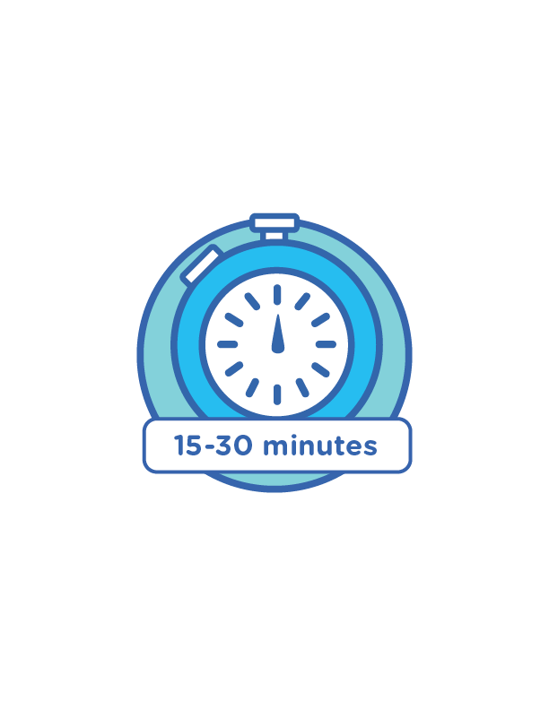 | - ask you to wait between 15 to 30 minutes before you leave to make sure you are okay.

What questions will they ask you?
The person giving you the vaccination must ask you some questions before they start.
They may ask you the following questions:
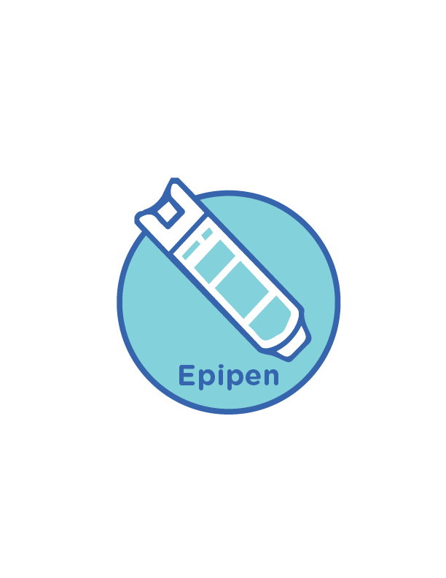 | Do you have any allergies?  An allergy is when your body reacts to something, such as food or medicine. This is called an allergic reaction.  Do you have anaphylaxis?  Anaphylaxis is a very serious allergic reaction.  Do you have an EpiPen?
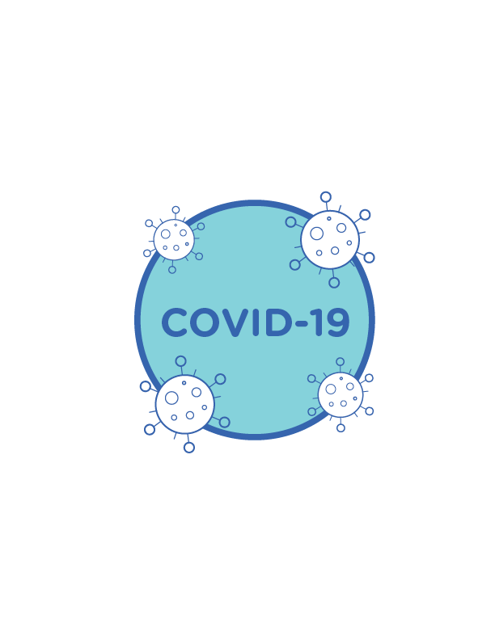 | Has your body reacted to a vaccine before?  Have you had COVID-19 before?
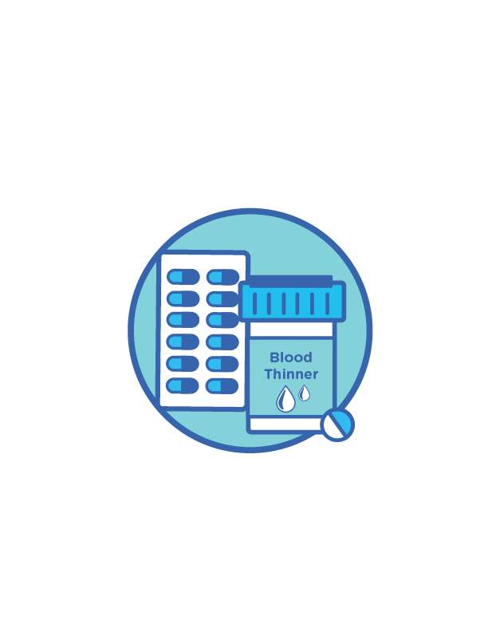 | Do you have a bleeding disorder?  A bleeding disorder is a health problem that affects your blood.  Do you take any medicine to thin your blood?
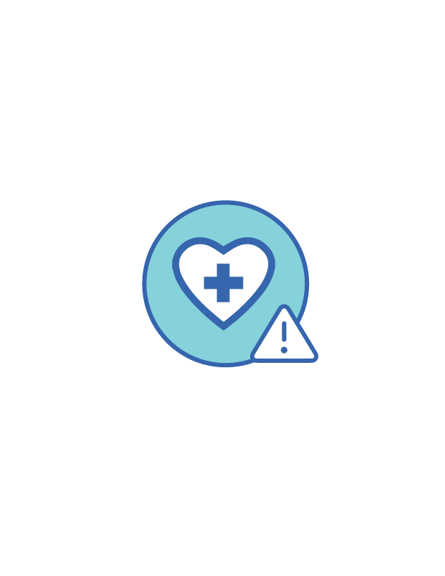 | Are you immunocompromised?  If you are immunocompromised, it is harder for your body to fight:  - infections  - other diseases.
You might be immunocompromised if you:
- have a health problem
- are taking a certain medication.
You must tell the person doing your vaccination if you are taking any medications.
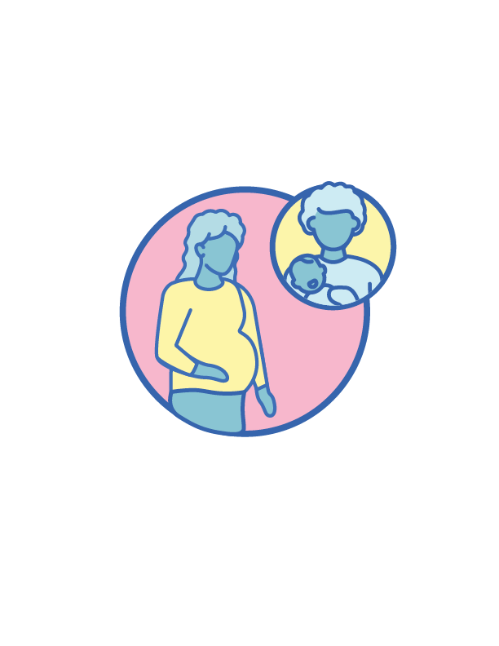 | Are you pregnant?  Do you think you might be pregnant?  Are you trying to get pregnant?  Are you breastfeeding?
Have you had any symptoms of COVID-19 recently? Such as:
- a cough?
- a sore throat?
- a fever?
Have you been feeling tired?
Have you been finding it hard to breathe?
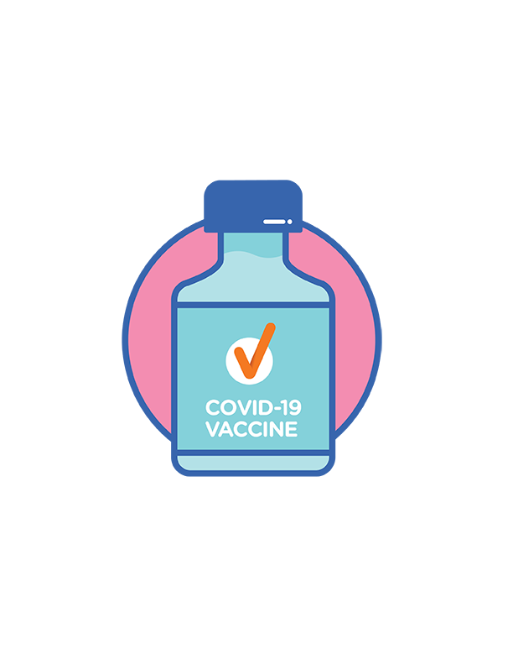 | Have you had a COVID-19 vaccination before?  If you have had a COVID-19 vaccination before, they will ask you which vaccine you had.  Have you had any other vaccinations in the last 7 days?
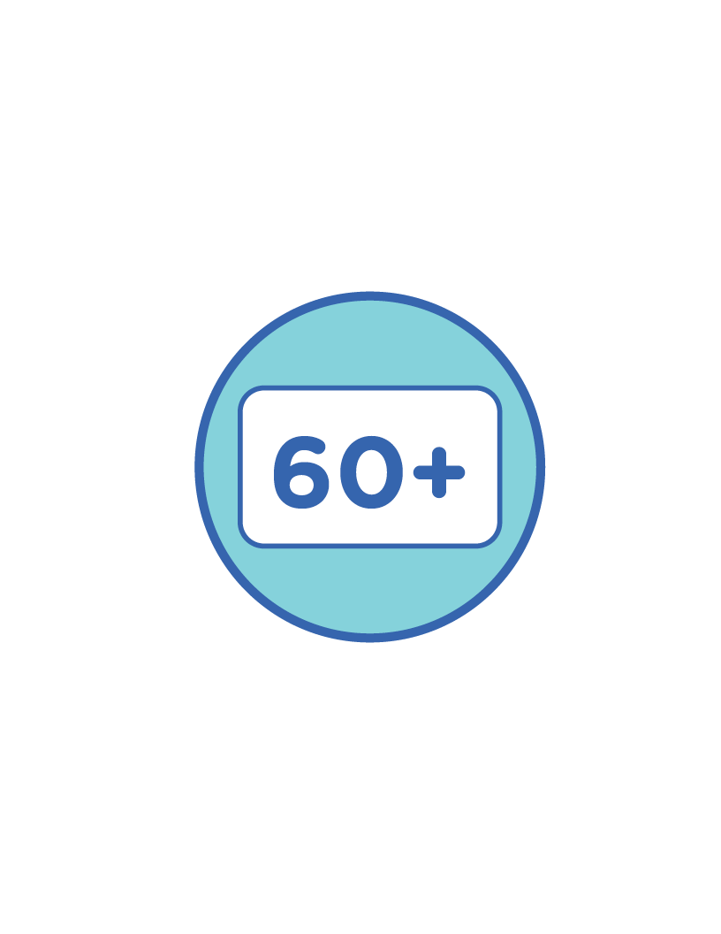 | Are you aged 60 years or over?
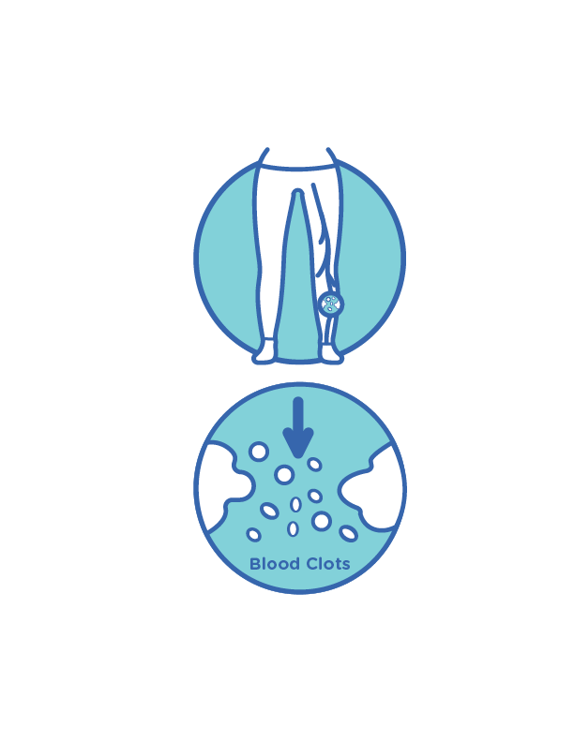 | Do you have a serious condition that causes blood clots?  When blood gets thick and sticks together, we call it a blood clot.  There are safe blood clots, like when you get a small cut and it stops bleeding.  But there are also blood clots that are not safe.  Some conditions can cause blood clots that are not safe.

What else will they talk to you about?
They will also ask you if you give your consent to have:
- the COVID-19 vaccination today
- a second dose of the vaccine later.
When you give your consent, you say it is ok for someone to do something.
You can choose to have the vaccination.
 | But you don’t have to have it if you don’t want to.

Information you need to bring
The person doing your vaccination will collect some information about you.
They need to keep a record of:
- who has had the vaccine
- how many doses you have had.
They need to know your:
- name
- date of birth
- home address
- phone number
- email address
- gender

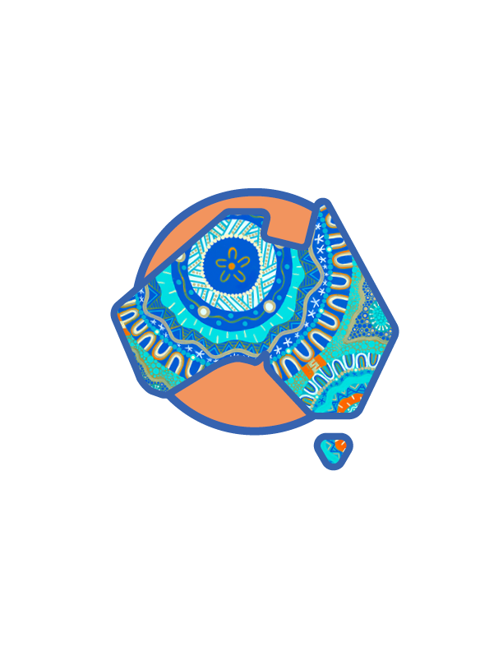 | They will also ask if you are an Aboriginal or Torres Strait Islander person.

Your second appointment
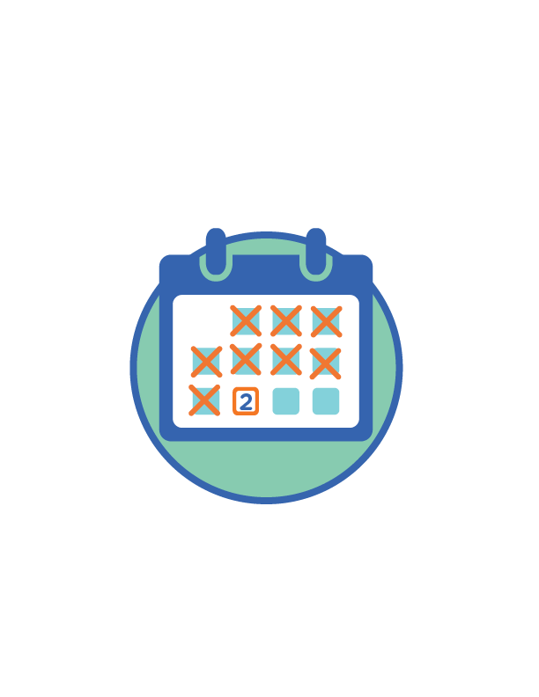 | The person doing your vaccination will tell you when you need to have your second dose of the vaccine.
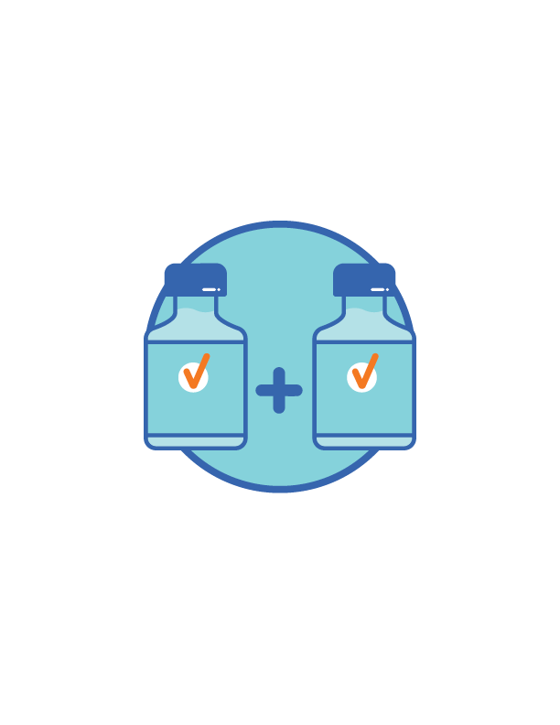 | Australia’s COVD-19 vaccines need 2 doses to work in the right way.  You need to have the same vaccine both times.
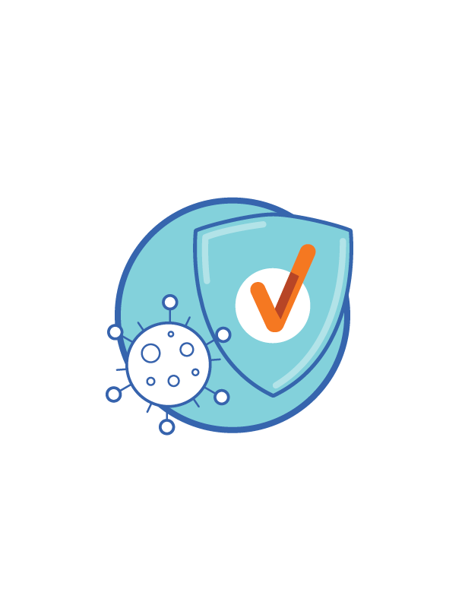 | The vaccines take 1-2 weeks after your second dose to work properly against COVID-19.

More information
 | You can visit the Department of Health website at www.health.gov.au/covid19-vaccines-languages for more information about the vaccine in your language.
 | You can call the National Coronavirus Helpline  on 1800 020 080.  If you need information in a language other than English, call the Translating and Interpreting Service on 131 450.

