# COVID-19 vaccine side effects

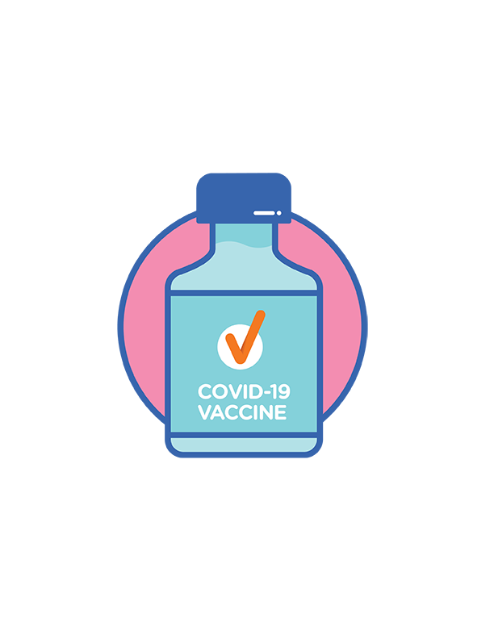A vaccine is medicine that:

* helps people fight a virus if they come in contact with it
* can stop people from getting very sick from the virus.

The COVID-19 vaccines don’t have any COVID-19 in them. You can’t get the virus from the vaccine.

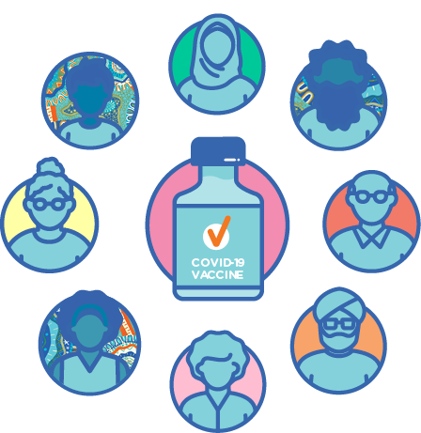

COVID-19 vaccines are the best way to protect:

* you
* your family
* the community.

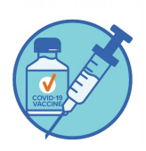

A **vaccination** is when you receive an injection of the vaccine. This is done with a needle.

## What is a side effect?

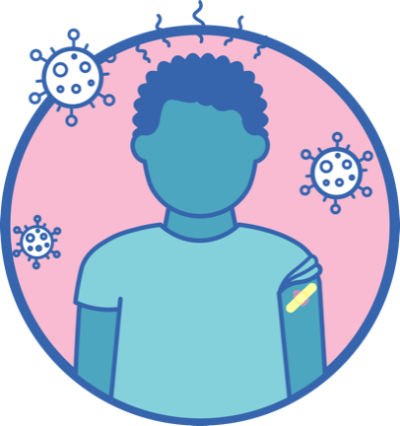

After you have your vaccination, you might feel some side effects.

A side effect is something that sometimes happens to people after they take medicine.

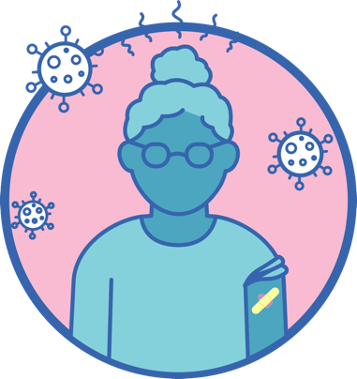

Side effects are a sign that the vaccine is teaching your body how to fight the virus.

Side effects don’t happen to everyone, and generally don’t last for long.

## Common side effects

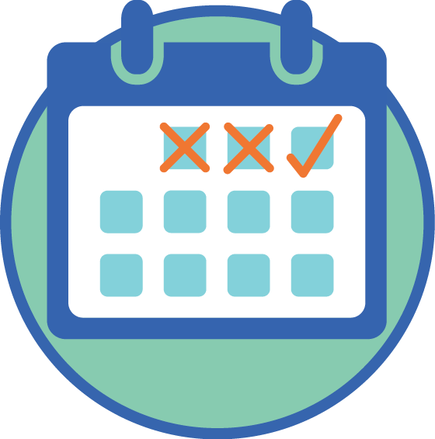

Most side effects:

* are not serious
* go away on their own in a couple of days.

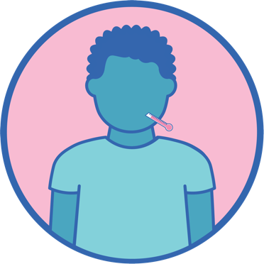Some common side effects include:

* Pain or swelling in your arm where the needle went in
* a fever
* sore muscles or joints
* tiredness
* headaches.

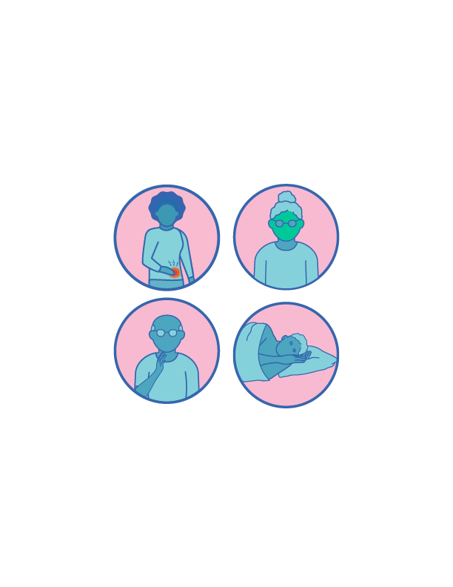

Other less common side effects include:

* feeling like you might vomit
* feeling sick in your stomach
* lumps in your neck
* pain in your leg
* not sleeping well.

Where the needle went in your arm it   
might be:

* red
* itchy.

## Serious side effects

Someone should call Triple Zero (000) straight away if, after the needle, you:



* have trouble breathing
* wheeze – this means you hear sounds you don’t usually hear when you breathe
* feel a very fast heartbeat
* fall down or faint

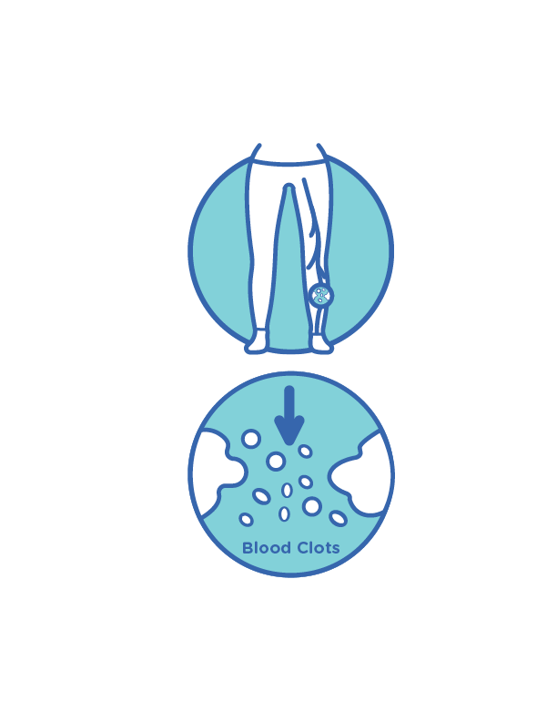

A serious side effect after receiving the AstraZeneca vaccine is a very rare blood clotting condition, called **thrombosis with thrombocytopenia (TTS)**.

A blood clot prevents blood from flowing normally through the body.

This rare condition can cause serious long term disability or death.

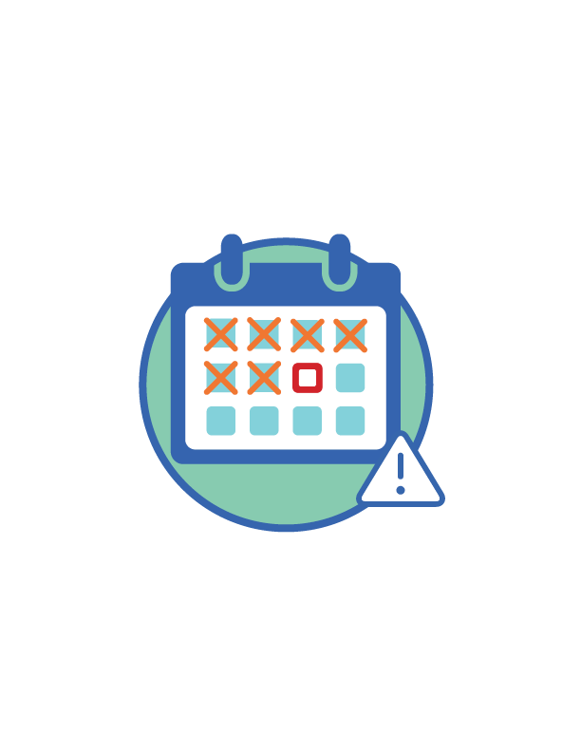If you have any of these side effects   
4-28 days after getting a COVID-19   
vaccine, you should speak to your doctor straight away:

* a bad headache or bellyache that doesn’t go away for a long time, even with pain medication
* 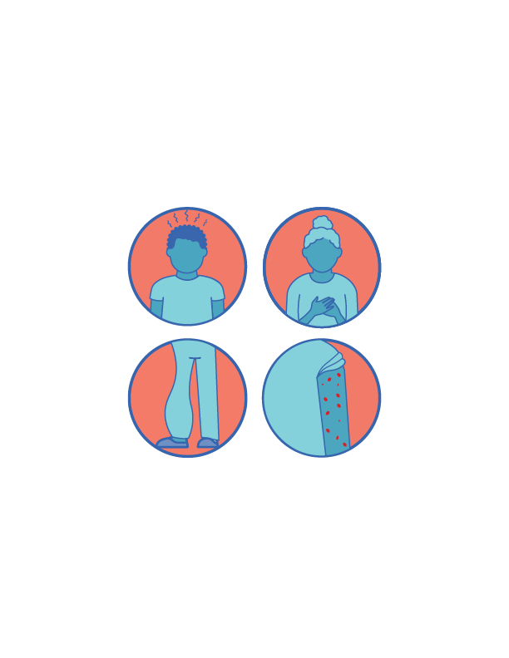blurred vision
* difficulty with speech
* drowsiness
* seizures
* shortness of breath
* chest pain
* swelling in your leg
* tiny blood spots under the skin, not near where the needle went in.

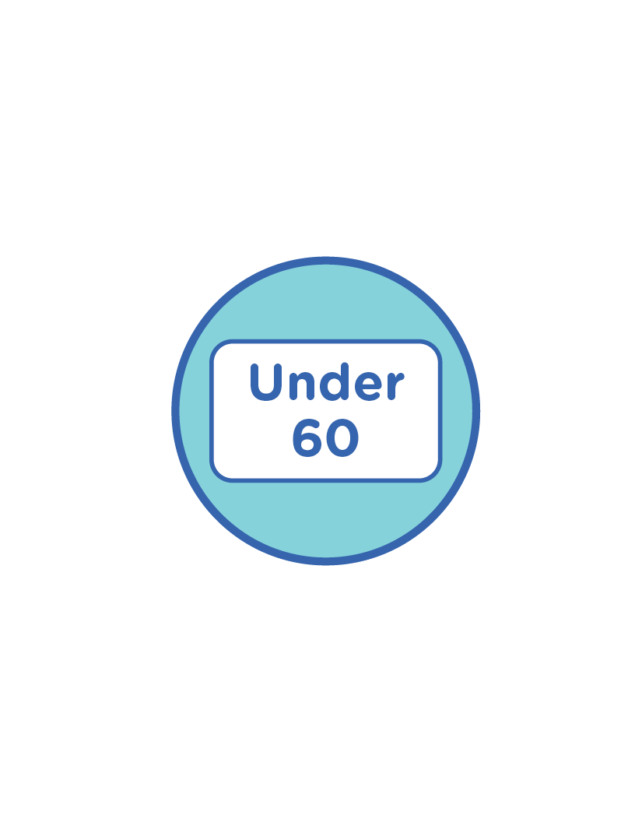

The Pfizer vaccine is preferred for people under 60 years old who have not already had their first AstraZeneca dose.

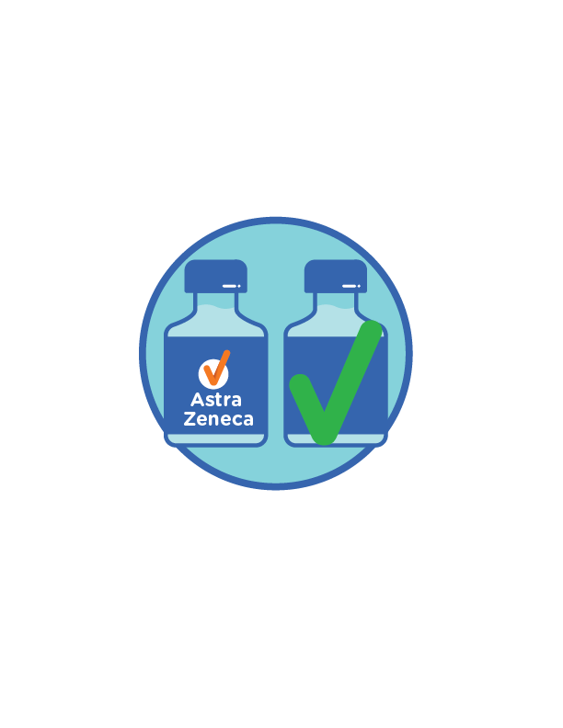  
  
If you have already had your first AstraZeneca vaccine dose with no serious side effects, you can get your second dose.

## What should you do if you feel side effects?

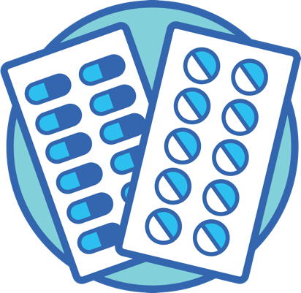

If you have any side effects that are   
bothering you, you can take pain medication.

A simple painkiller like paracetamol or ibuprofen might be right for you.



Check with your doctor or support person before you take any other types of pain medication.

You can also use a cold pack on your arm where the needle went in.



You should talk to your doctor if you think you are having an **allergic reaction**.

An allergic reaction is when your body reacts to something, such as food or medicine.

For example, you might get an itchy rash or your tongue might get bigger.

You should also talk to your doctor if you:

* are worried about a side effect
* have a side effect that lasts more than a couple of days
* you have a side effect that starts more than 3 days after your vaccination
* have a side effect that isn’t in this   
  fact sheet.

If you get any side effects, you can also tell the **Therapeutic Goods Administration (TGA)**.  
The TGA:



* approves vaccines
* keeps track of how well they work.



You can tell the TGA about any side effects on   
their website: <http://www.tga.gov.au/reporting-suspected-side-effects-associated-covid-19-vaccine>

## Do you need to get a COVID-19 test after the vaccination?

Some of the side effects of the vaccination   
are the same as the symptoms of COVID-19.

A symptom is a sign that you might be sick.  
You might:

* see symptoms
* feel symptoms.

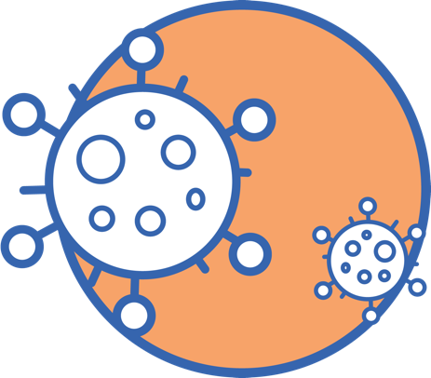

Some people might still get COVID-19 after their vaccination.

You might need a COVID-19 test if you have any COVID-19 symptoms, including:

* 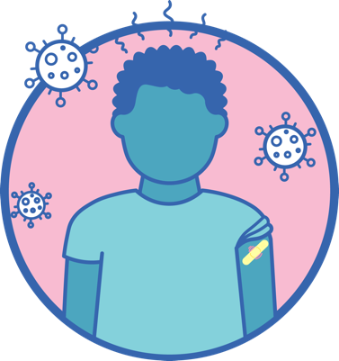fever
* sore throat
* cough
* tiredness
* shortness of breath
* losing your sense of taste
* losing your sense of smell.

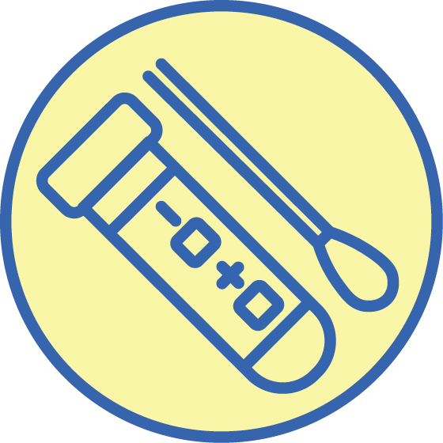You also might need a COVID-19 test if:

* someone you have seen lately has COVID-19
* you live in a state or territory with a lot of COVID-19 cases.

If you’re not sure, you should talk to your doctor.

## More information

Have a yarn with your healthcare worker.



You can visit the Department of Health website at[www.health.gov.au](http://www.health.gov.au)for more information about the vaccine.



You can call the National Coronavirus Helpline on **1800 020 080.**