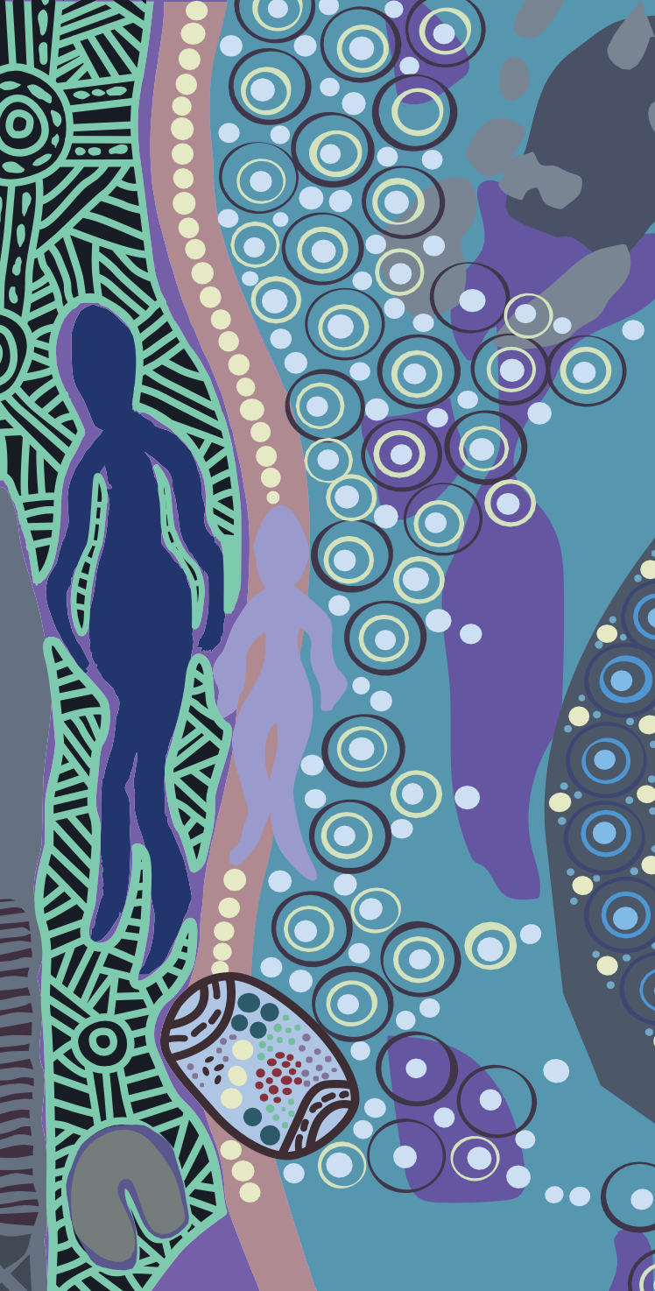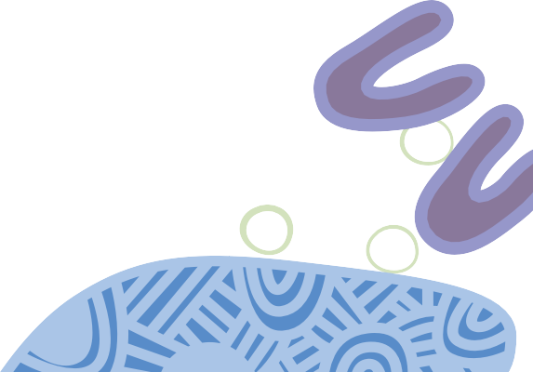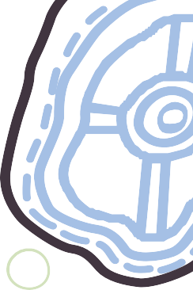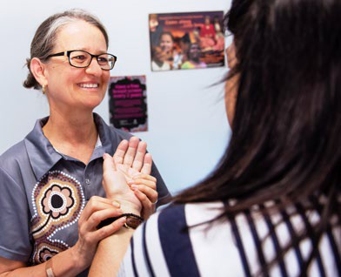

health professionals

715 health checks to improve Indigenous health

[**www.health.gov.au**](http://www.health.gov.au/)**/715-health-check**

Torres Strait Island flag

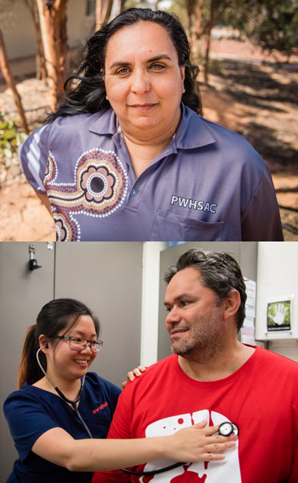

**We acknowledge that many individuals refer to themselves by their clan, mob, and/or country. For the purposes of this document, we respectfully refer**

**to Aboriginal and Torres Strait Islander people as Aboriginal and Torres Strait Islander throughout.**

**A specific health check is available for Aboriginal and Torres Strait Islander people. The 715 health check helps**

**to identify risk factors for chronic disease to manage the good health of the patient.**

# KEY POINTS

0 Available to every Aboriginal and Torres Strait Islander person annually, with a minimum claim period of 9 months.

0 Patients who self-identify as Aboriginal and/or Torres Strait Islander are eligible

0 Patients are eligible for up to 10 follow up services under MBS item 10987

0 Both MBS items 715 and 10987 can be bulk billed

0 Can be conducted by any general practice or Aboriginal Medical Service.



# CONDUCTING THE HEALTH CHECK

A 715 health check should include an assessment of the patient’s physical, psychological and social wellbeing.

Key elements include:

0 information collection

0 overall assessment of the patient

0 recommending appropriate follow up care

0 advice and information to the patient

0 a record of the assessment

0 providing the patient, or their carer, with a copy of the assessment and follow up plan.

A Practice Nurse, Aboriginal Health Worker or Aboriginal Health Practitioner may assist with initial tests and medical history. A General Practitioner delivers the final assessment and recommends appropriate follow up care.

# BENEFITS FOR PRACTITIONERS

0 Practice Nurses, Aboriginal Health Workers, Aboriginal Health Practitioners and Doctors all have a role to play in undertaking a 715 health check.

0 The 715 MBS item fee is paid at 100% benefit. The latest fees are available at mbsonline.gov.au

0 Following a 715 health check a patient has access to follow up MBS items, making it easier to support your patient to manage their health.

# FOLLOW UP CARE

A 715 health check should identify a strategy for the patient’s good health. This could include

follow up services or referrals. It may also include the individual actions the patient, or parent/carer, should take. 10 follow up items are claimable, per patient, per year.

This can include:

0 further examinations

0 access to counselling and lifestyle activities

0 prevention services for chronic conditions

0 clinical progress checks.

Patients must have completed a 715 to be eligible to claim 10987 follow up items.

Patients may also be eligible for lower price or free prescription medicines. Closing the Gap PBS Co-payment information is available on the PBS website or through the enquiry line on **1800 222 032**.

# RESOURCES

Information, resources and links to the Practice Incentives Program Indigenous Health Incentive program is available at:

## [www.health.gov.au](http://www.health.gov.au/)

The NACCHO/RACGP *National guide to a preventive health assessment for Aboriginal and Torres Strait Islander people* provides the evidence to support a 715 health check:

[**www.racgp.org.au/national-guide**](http://www.racgp.org.au/national-guide)



# FREQUENTLY ASKED QUESTIONS

## How can we identify Aboriginal and/or Torres Strait Islander patients?

You can ask patients if they wish to identify as Aboriginal and/or Torres Strait Islander. You can include this information for new patients on your patient registration form.

Providing cultural awareness training for your staff can help build confidence in dealing with patients in a culturally safe way.

## How can we promote our service to Aboriginal and Torres Strait Islander patients?

Patients are more likely to access health care if culturally appropriate services are available.

You may consider displaying information in your practice and online.

This could include:

0 identifying partnerships with Aboriginal organisations

0 providing information about health issues affecting Aboriginal and Torres Strait Islander people

0 acknowledging if staff have undertaken cultural appreciation or cultural safety training

0 providing an Acknowledgment of Country.

For patients that do identify as Aboriginal and/or Torres Strait Islander, ask if they have undertaken a 715 health check recently. You could also set up a reminder for patients that they are due for their 715 health check. This could be a text message, email or letter.

## What happens if a patient has already claimed a 715 health check within the period?

The 715 item is claimable once per patient, every 9 months. Providers with access to Health Professional Online Services (HPOS) can check their patients eligibility prior to conducting the check.

## Why should we undertake a 715 for Aboriginal and/or Torres Strait Islander patients?

Undertaking a 715 health check helps your Aboriginal and Torres Strait Islander patients to better manage their health. It is specifically designed to address the health needs of Aboriginal and Torres Strait Islander people.

## What clinical benefit is there to undertaking a 715 health check?

Cultural, social or economic reasons may prevent patients from accessing health care. The health check is an important preventative step to identifying early risk factors for chronic disease.

## How can we ensure culturally appropriate care?

Aboriginal and Torres Strait Islander patients may not access health care if they feel culturally unsafe. Ensuring that health service providers understand cultural issues is important to patient care. Cultural awareness or competency training for practice or clinic staff is a great first step.

**OUR HEALTH CHECK ARTWORK**

‘LET’S WALK AND TALK OUT BUSH’

**LUKE PENRITH**

PROUD ABORIGINAL MAN FROM BRUNGLE, HIS GREAT GRANDMOTHER’S COUNTRY.

CONNECTED CULTURALLY TO THE WIRADJURI, WOTJOBOLUK, YUIN

AND GUMBAYNGGIRR ABORIGINAL NATIONS.

**Walking and talking to family while doing physical exercise is deadly for the emotional wellbeing of First Nation peoples.**

**Going out bush walking with mob can benefit communities socially, culturally and does wonders for your mental health.**

**The two coolamons show abundance of bushtucker picked while out bush, the two boomerangs represents our past and our future, the six U symbols at the bottom**

**represents male and female leadership in our past, in**

**our present, and our emerging health leaders.**

**Women’s business and Men’s business is vital to our health**

**– engaging in these, ground in communities, have health and cultural benefits.**

**Being active shows our children that it’s good to be outdoors learning culture and showing Yindyamarra (Respect) to Elders and ancestors while out bush.**

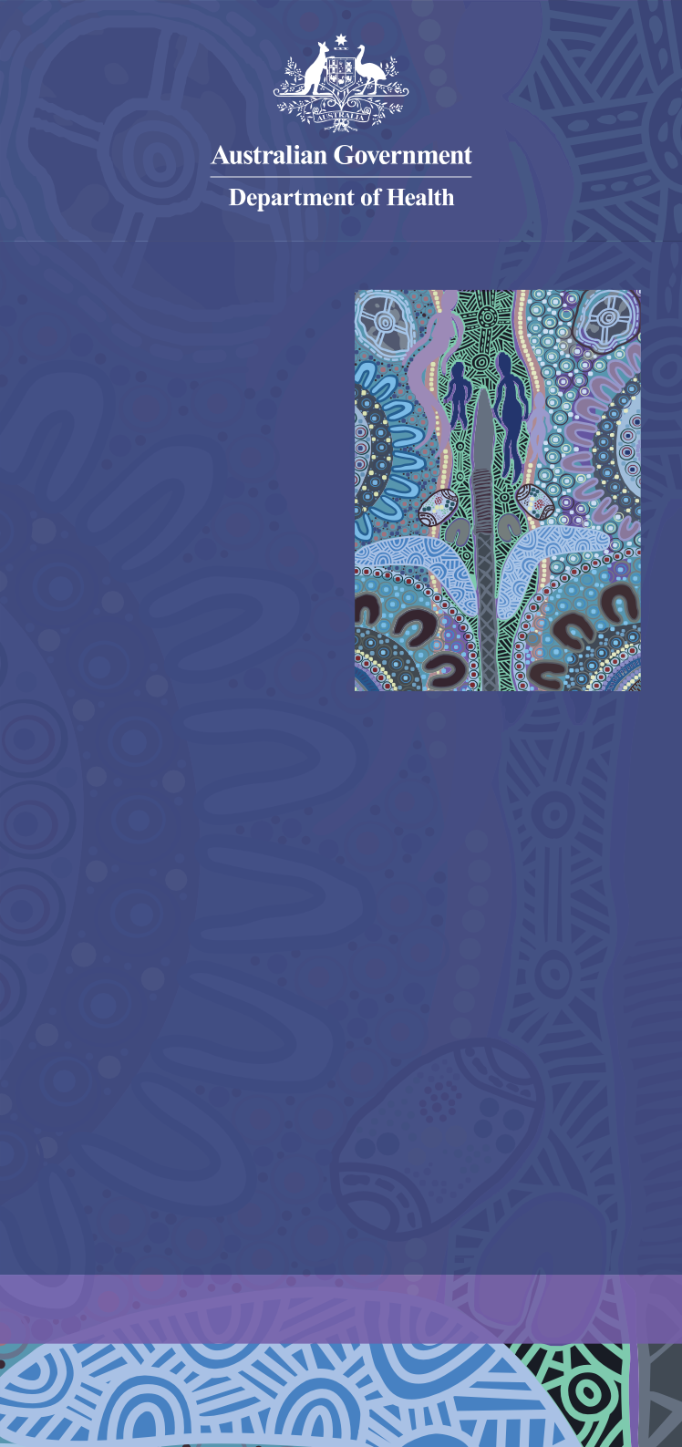

[**www.health.gov.au**](http://www.health.gov.au/)**/715-health-check**