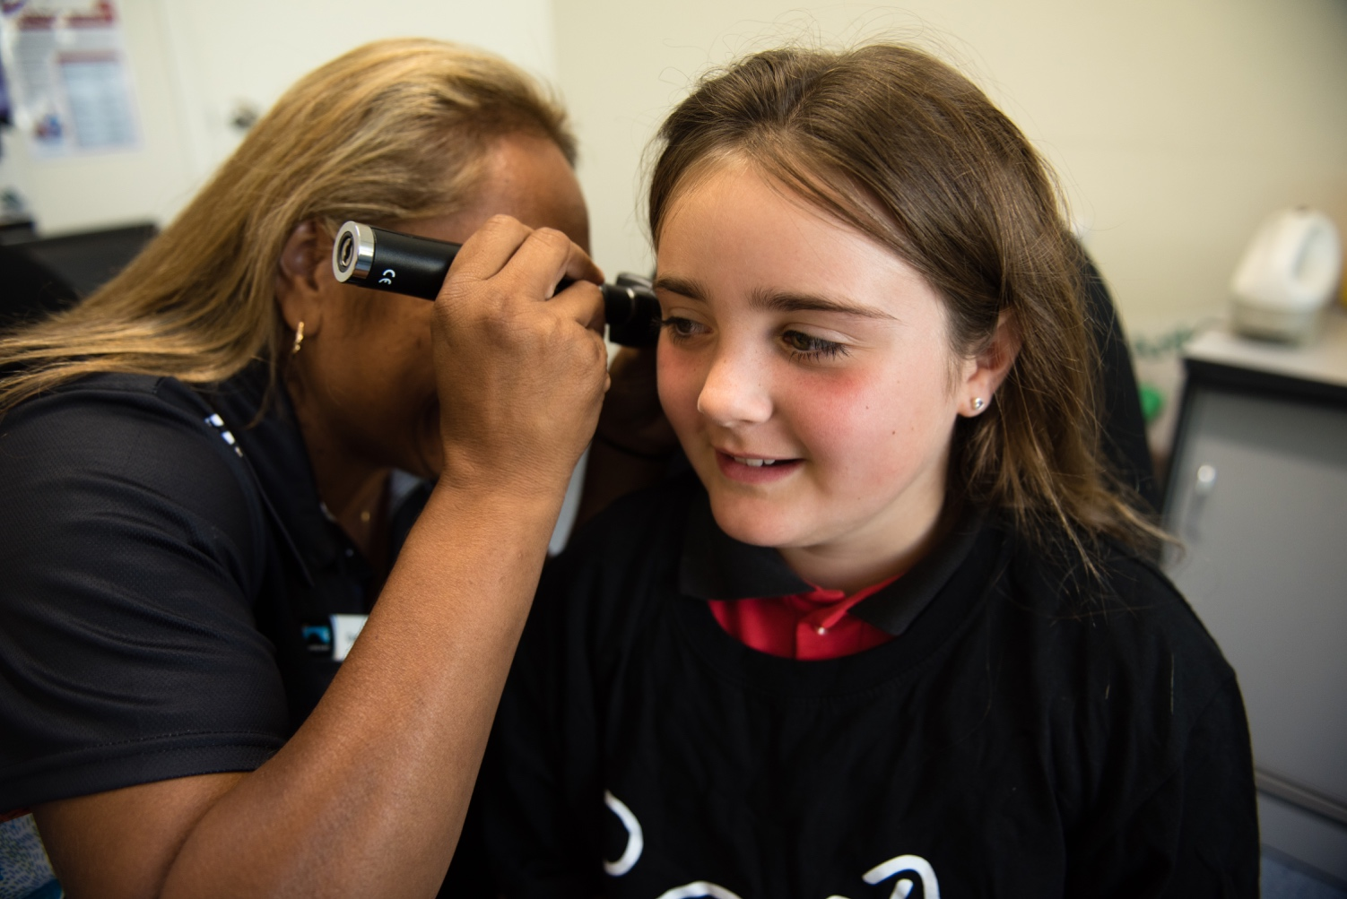A person standing next to a tree


**YOUR HEALTH IS IN YOUR HANDS**

KEEP YOUR MIND AND BODY HEALTHY AND STRONG WITH A free annual 715 HEALTH CHECK!

All Aboriginal and Torres Strait Islander people are eligible for an annual health check. It’s a good way to look after your health and wellbeing to keep your mind and body healthy and strong.

715 health checks are free at Aboriginal Medical Services and bulk billing practices. Call your local clinic or Doctor book your 715 health check, today.

Find out more:  
Visit www.health.gov.au/715-health-check or search #715healthcheck on social media

**POSTER TEMPLATE**

(delete this box before finalising):

To change the **image**, select an image, right click on the image and select **Change Image**. Choose new image from your files. You can use two images in this template.

To **change the crop of the image**. Click on the image select **Format Picture** from the top menu, and then select **Crop**. Use the handles to change the crop of the picture.

To **update the text**, select the words in the text box below as you would edit normally.

**All text is Arial.**

**Headline** to be CAPS and approx. 60-70pt.

**Subhead** to be CAPS and approx. 18pt.

**Body** approx. 16pt

**Find out more information** approx. 12pt.