

**Planning in a commissioning environment - Resources**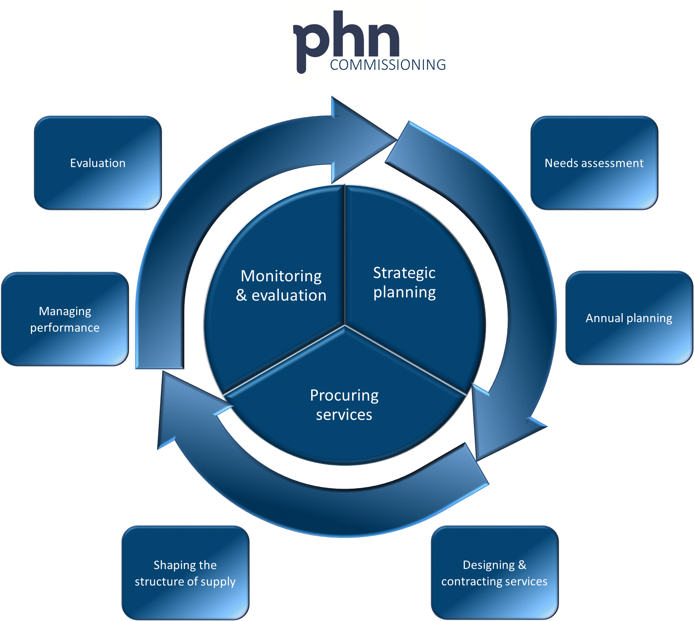

**Version 1.0 June 2016**

**Acknowledgement**

This resources document has been developed by the Australian Government Department of Health and PricewaterhouseCoopers (PwC) as part of a project funded by the Department to develop guidance and resources for Primary Health Networks on commissioning.

The input of the Primary Health Networks Commissioning Working Group in the development of this document is appreciated.

**Note**

This document does not override the requirements set out in the PHN Funding Agreement.

Contents

INTRODUCTION 1

Stage 1: Developing a set of potential activities 2

1.1 Define the level at which each proposed activity is described 3

1.2 Describe the activity in a manner sufficient for consideration by decision makers 6

1.3 Develop a high level ‘business case’ for each proposal 7

1.4 Ensure proposals demonstrate an understanding of market capability and constraints 9

1.5 Identify any co-dependencies with other potential activities 12

Stage 2: Priority setting and choosing activities 13

2.1 Development of criteria for priority setting and decision making 14

2.2 Employ methods for rating activities against the criteria to inform prioritisation 15

2.3 Assess implications of current services against future plans 19

2.4 Review decisions in light of any broader implications 19

2.5 Ensure that the commissioning strategy for each activity is understood by decision makers 21

Stage 3: Reviewing and ratifying the whole plan 23

3.1 Review the plan for balance and focus 24

3.2 Formally ratify the plan 26

3.3 Complete activity plan and template 27

3.4 Initiate approach to market 27

3.5 Communicate with stakeholders and communities 28

# INTRODUCTION

The accompanying document, ‘Planning in a commissioning environment – a Guide’ provides a general overview of issues that Primary Health Networks (PHNs) are likely to need to address as they move into their commissioning role. This document is an initial attempt to identify some resources that may be useful to PHNs in doing so. It is therefore by nature a more ‘open-ended’ document that can be expanded over time. PHNs are of course also encouraged to use a variety of other mechanisms to share useful tools, resources and approaches with others.

This document should be considered as part of a broader set on the PHN commissioning cycle, which includes previous guidance on **needs assessment**, subsequent guidance and resources on **designing and contracting services** and the **PHN Performance Framework**.

These resources are structured around the three steps or stages outlined in the ‘Planning in a commissioning environment - a Guide’.

Figure 1.1: Key steps in developing the Activity Work Plan

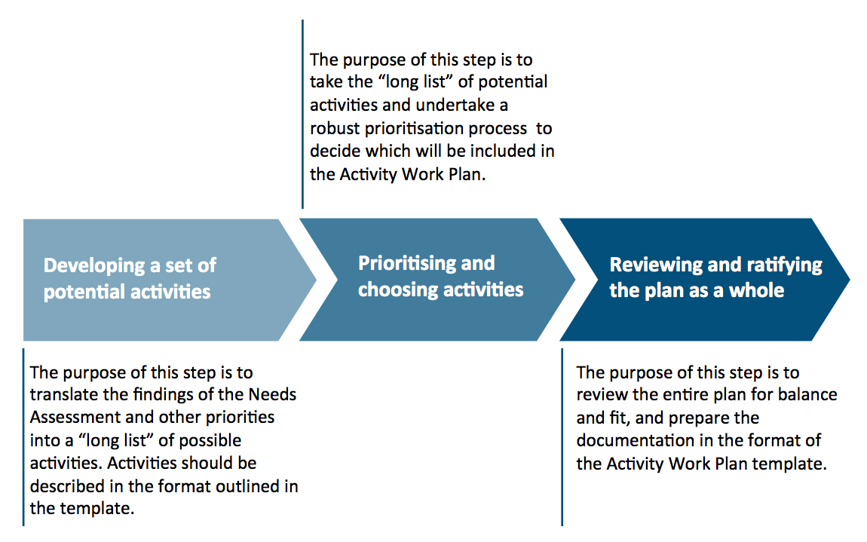

The intention is that these resources will grow over time as a result of input from PHNs – tools they have used, resources that they have found helpful, and their experiences in plan development. These are *resources.* None are intended to be prescriptive.

# Stage 1: Developing a set of potential activities

Figure 1.2: Key steps in developing a set of potential activities

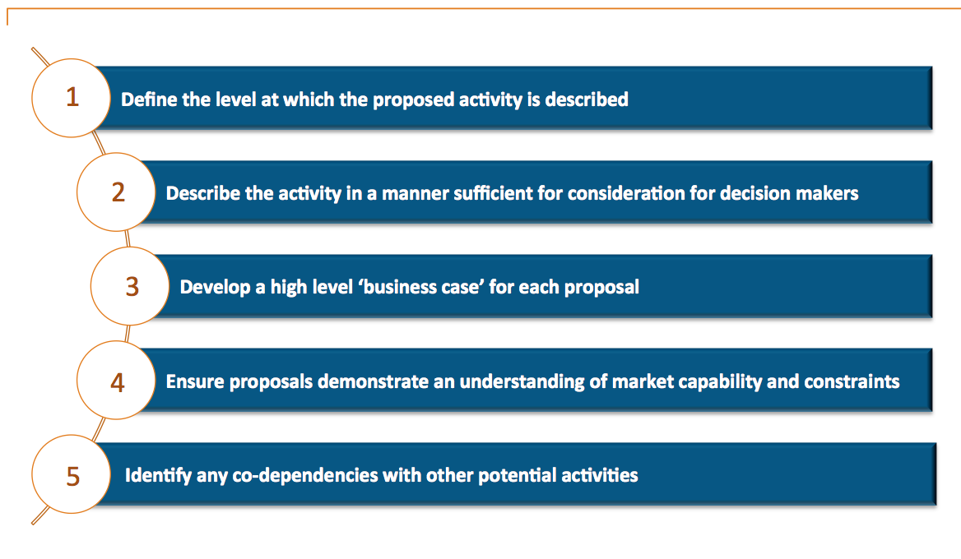

Key considerations in progressing these steps include:

* Potential activities should relate to the PHN objectives.
* Potential activities must reflect the outcome of the needs assessment.
* All potential activities are described in a consistent and comparable manner.   
  (See Appendix 2 to ‘Planning in a commissioning environment - a Guide’ for examples of activity descriptions used by the former Medicare Locals.)
* In most cases the activity is to be wholly or partly commissioned. If not, the activity should clearly describe instances where that is not the case and provide a supporting rationale.
* Performance information is in line with the guidance provided in the PHN Performance Framework. It is acknowledged that some performance indicators proposed in the plan may need to be modified on the basis of the PHN’s experience when implementing the activity.
* Careful consideration of health services provided by States and Territories, and active discussion with Local Hospital Networks (LHNs) or their equivalents. PHNs are commissioning into an existing environment, and collaboration will be important in ensuring that collective funding is leveraged and utilised to achieve optimal outcomes.

This section describes a set of potential resources relating to each element of Stage 1.

## 1.1 Define the level at which each proposed activity is described

### Overview

The objective of this first step is to agree on a broadly consistent level of detail (descriptors) for each activity so that they can be considered and compared. To agree on descriptors, PHNs need to understand their purpose. They could be used to:

* Simply describe the activity
* Allow comparisons
* Enable prioritisation
* Inform evaluation criteria to be used in contracting
* Inform overall evaluation of activity efficacy

PHNs might find it useful to develop templates or pro-formas that afford a consistent approach to documenting activities, covering headings such as:

* Brief description of the activity
* Strategic fit or alignment with national and PHN aims/objectives
* Whether it is a current or planned activity
* Cohorts to whom it might apply
* Key stakeholders
* Any understanding of the market’s ability to deliver the activity
* Potential impacts in terms of cost, patient and provider experience and health outcomes (see the Triple and Quadruple Aim resources below)
* Whether it would need to be delivered in partnership and with whom
* Capacity and capability implications
* Other local considerations

### Supporting resources

#### Triple Aim and Quadruple Aim

The ‘Triple Aim’ was developed by the US Institute for Healthcare Improvement (IHI) in 2007 and outlined in an article by Donald Berwick.[1]

The Triple Aim consists of:

* improving the individual experience of care;
* improving the health of populations; and
* reducing per capita costs of care for populations.

There is a momentum behind adding a fourth dimension ‘Improved clinician experience’ to the Triple Aim, making it a ‘Quadruple Aim’. This is in recognition of the idea that the health and well-being of the healthcare workforce (including clinicians and staff) is a critical factor in improving the health of a population.

The argument to expand the Triple to the Quadruple Aim was advanced by Thomas Bodenheimer and Christine Sinsky in a 2014 article in the [Annals of Family Medicine](http://www.annfammed.org/content/12/6/573.full.pdf+html).[2]

The Triple or Quadruple Aim can be used as an overall framework underpinning both activities for the PHN and the activities identified in contracts with commissioned organisations.

Critically, the Triple Aim and Quadruple Aim can also be used as a common way to describe activities and as a benchmark or set of evaluation criteria against which potentially competing health systems can be assessed. This could be at the development stage, the planning and prioritisation stage, in business case development, the contracting stage (to help inform the evaluation of bids received) or post-delivery evaluation, by considering what impact the new approach has had on each of the Triple (or Quadruple) Aim components.

A number of global integrated care systems use the IHI Triple Aim as the framework for performance management and evaluation, for example [Gesundes Kinzigtil Integrated Care](https://www.ekiv.org/en/).

The following illustrations depict the Triple Aim and the Quadruple Aim (the addition of improved clinician (or some would say ‘care provider’) experience):

Figure 1.3: The Triple Aim and Quadruple Aim

This figure refers to the Triple Aim and the Quadruple Aim.  The Triple Aim refers to Population Health; Experience of Care; and Per Capita Cost.  The Quadruple Aim refers to: Better Outcomes; Improved Clinician Experience; Improved Patient Experience; and Lower Costs.

The Triple Aim The Quadruple Aim

Berwick argued that the preconditions for pursuing the Triple Aim are:

* recognition of a population as the unit of concern;
* externally supplied policy constraints (such as a total budget limit or the requirement that all subgroups be treated equitably); and
* existence of an ’integrator’ that is able to focus and coordinate services to help the population in all three dimensions at once.

The ultimate objective of pursuing the three dimensions of the Triple Aim is to optimise health system performance. Because the Triple Aim pushes for the pursuit of improvement at all levels of the system, it requires greater coordination and cooperation (between healthcare organisations, public health departments, social service organisations etc.), accountability, and transparency.

In a 2015 review of the first seven years of the Triple Aim, Whittington et al found that:

pursuing the Triple Aim requires the execution of three core components. These components, which enhance the program theory for achieving the Triple Aim and form a basis for future testing, are:

1. Creating the right foundation for population management.

2. Managing services at scale for the population.

3. Establishing a learning system to drive and sustain the work over time.

This review also identifies a number of practical implications of the Triple Aim that are consistent with commissioning, such as conducting a ‘needs and assets’ assessment, developing a ‘portfolio’ of projects and designing or redesigning services.

Some useful references are:

The [Institute for Healthcare Improvement website](http://www.ihi.org/) which includes a [Primer on Defining the Triple Aim](http://www.ihi.org/resources/Pages/Publications/PrimerDefiningTripleAim.aspx), a [guide to measuring the Triple Aim](http://www.ihi.org/resources/pages/ihiwhitepapers/aguidetomeasuringtripleaim.aspx), and an [assessment tool](http://www.ihi.org/resources/pages/ihiwhitepapers/aguidetomeasuringtripleaim.aspx).

Berwick DM et al, Bodenheimer T & Sinsky S. [The triple aim: care, health and cost](http://content.healthaffairs.org/content/27/3/759.full), Health Affairs 2008: 27: 3: 759-769. [From Triple to Quadruple Aim: Care of the Patient Requires Care of the Provider](http://www.annfammed.org/content/12/6/573.full.pdf+html), Annals of Family Medicine, November/December 2014: 12:573-576.

Commonwealth Fund. [The Triple Aim journey: improving population health and patients’ experience of care, while reducing costs](http://www.commonwealthfund.org/publications/case-studies/2010/jul/triple-aim-improving-population-health), Pub No. 1421 Vol 48 2010.

Whittington J et al. [Pursuing the Triple Aim: the first 7 years](http://www.mydocvault.us/uploads/7/5/8/6/7586208/pursuing_the_triple_aim-the_first_7_years.pdf), The Milbank Quarterly 2015: 93: 2: 263-300.

#### World Health Organization (WHO) health system strengthening framework

Another framework that is widely used in health system change and improvement is the World Health Organization (WHO) health system strengthening framework. The conceptual framework describes any health system by disaggregating it to six fundamental components: service delivery, health workforce, health information systems, medical products, vaccines and technologies, health system financing, and leadership and governance. The six components are used to assess the performance of a health system.

A detailed description of the WHO health systems strengthening framework is available in the publication [Everybody’s business](http://www.who.int/healthsystems/strategy/everybodys_business.pdf).

Guidelines on indicators and measurement strategies to monitor the components of the WHO framework are described in the publication [Monitoring the Building Blocks of Health Systems](http://www.who.int/healthinfo/systems/WHO_MBHSS_2010_full_web.pdf?ua=1).

The commissioning environment gives PHNs more explicit responsibility for leading change and system improvement, so they should start thinking about the whole system at a macro level. The WHO framework is a tool that could be used in this respect. As commissioners, PHNs should be cognisant of the capacity and capability of the health system as a whole before developing the long list and prioritising activities.

This broader thinking is consistent with PHNs’ responses to a survey undertaken as part of this project, to inform the development of the commissioning guidance and resources. In their responses to the survey, PHNs identified an intention to progress towards joint and outcomes based commissioning, with longer term plans to move to place-based commissioning.

The way in which activities are described and compared are expected to evolve with this commissioning thinking.

It is also worth looking at a recent ‘evidence check’ on commissioning primary health care, undertaken by the University of NSW and the Sax Institute for NSW Health, available in the article [Commissioning primary healthcare](http://www.saxinstitute.org.au/wp-content/uploads/Commissioning-primary-health-care.pdf).

Resources cited under stages 2.1 and 2.2 of this document may also be useful in defining the measures or descriptors of activities. These are the approaches for conducting prioritisation against ‘decision criteria’. In order to fully assess what needs to be captured at this stage, PHNs need to be cognisant of how it will be used. Stages 2.1 and 2.2 cover this use.

## 1.2 Describe the activity in a manner sufficient for consideration by decision makers

### Overview

This relates closely to stage 1.1 and effectively builds on it to describe (i.e. complete the template or pro-forma for) each of the potential activities.

This will inevitably require research and evidence that supports potential activities or interventions, including their costs, impact, efficacy etc. PHNs may find it helpful to share information with their peer PHNs in relation to these factors. It is likely that colleagues will have researched similar activities and will have data that is useful in populating these descriptions/tables.

This process is also likely to be iterative, with refinements being made as new data or insights are acquired.

### Supporting resources

Resources will be similar to stage 1.1.

## 1.3 Develop a high level ‘business case’ for each proposal

### Overview

The purpose of this stage is effectively to prepare the ‘case for change’ or ‘defining factors’ for each of the activities. These high level business cases will inform the decision making process. PHNs may consider that they have gone far enough in stage 1.2 and may choose to skip this stage or use its content to augment what is done at stage 1.2.

There are many business case templates available on the internet but many of these relate to starting a new business or investing for business purposes. In these cases the motives will relate to things like top line revenue growth (more sales), market share increase, increased margin or profitability or other strategic objectives. This description reinforces a key point – that a business case must be a case for progressing the objectives of the business – in this case of the PHN. The acid test question therefore is how would this activity or initiative add to or detract from the overall objectives of the PHN, all having regard for the other implications thereof – costs, staffing implications, timing etc.

PHNs should have considered these factors in addressing what needs to be captured, or how things need to be described at stages 1.1 and 1.2.

### Supporting resources

As outlined above, there are numerous business case templates available on the internet. However, rather than cite one of those, the following text describes what PHNs may wish to consider in business cases (as a PHN rather than a business). These would be appropriate if PHNs determine that they need to go beyond the actions described in stages 1.1 and 1.2.

Typical PHN business case content could include:

1. **Overview** – Description of the activity. What is proposed? How would it work etc?
2. **Strategic case** – How does this activity fit with the overall aims and objectives of the PHN: how does it add value to these?
3. **Needs assessment** –How does this activity address the priorities and options identified in the needs assessment?
4. **Evidence base** – Where has this been done before, if at all? With what impact?
5. **Design** – Is there an established way of doing this? Is co-design required, and if so, how? With whom?
6. **Market assessment** – What capacity exists in the market? What would need to be developed? How feasible is that?
7. **Financial case** – What are the capital and funding implications? When would the costs be incurred and how would they be financed?
8. **Impact** – What would be the impact and how would that be valued/assessed? What are the outputs and outcomes?
9. **Stakeholder and partner issues** – Would the PHN need to partner with another organisation (state government, Local Hospital Network, another PHN) to achieve the desired outcome?
10. **Implementation** – Subject to commissioning approaches and strategies, what are the planned stages and timelines?
11. **Human resource implications** – Are there any staffing or human resource implications for the PHN?
12. **Technology implications** – Are there any information technology implications for the PHN?
13. **Risk assessment** – What are the key risks and how could they be mitigated?
14. **Evaluation** – How would success be measured? What would be the key performance indicators (KPIs)?

Given the potential content of business cases and the fact that these are likely to go beyond the stage 1.1 and 1.2 descriptors, PHNs may well consider this to be a valuable stage. Boards may also consider that the numbered points above (1-14) provide a useful checklist for whether executives have considered all the salient issues.

## 1.4 Ensure proposals demonstrate an understanding of market capability and constraints

### Overview

PHNs are commissioners, not service deliverers, and as such they must consider the market implications of planned activities.

Market implications might be included in business cases – see point 6 under stage 1.3 above. But PHNs may wish to conduct a more formal market assessment – generally, or in relation to potential activities.

### Supporting resources

Market assessments should consider:

1. **Extent** – The collection or number of actual or potential operators – important from a contestability, joint-working and innovation perspective. How many providers are there?
2. **Capacity** – How big are the providers? At what scale can they operate? How big do the providers need to be in order to effectively deliver activities? Could they grow? How and over what timescales?
3. **Capability** – What can they do, and what have they done? Can this be expanded? Are the providers culturally appropriate for the population needs?
4. **Willingness** – Are they willing to engage and deliver the required service? Are the barriers to entry insignificant or difficult to overcome? Where are potential providers in relation to delivery?
5. **Availability** – Where do they operate? What is their span of operation? Could they be attracted into the local region?
6. **Commercially sustainable** – Is the planned activity likely to generate sufficient business for providers?
7. **Delivery** – What is their operating model? Do they have a proven track record in delivering similar, high quality services? Do they have constitutional issues? Could they be a commissioned provider? Does the PHN need to build capacity in providers? What provider investment is needed to create sustainable delivery?
8. **Affordability** – Can the providers deliver cost-efficient services? Is this assessable?
9. **’Right way’** – Working with others; co-delivery; with commissioners? See the [UK Government’s Strategic Partnering Partnership Assessment Tool (PAT)](http://www.iape.org.il/upload/AssessingStrategicPartnership.pdf).
10. **Overall** - How can providers work together to deliver the model of care?

There are several approaches and considerations for how markets can be assessed:

1. Seeking expressions of interest (EOI) or conducting soft market soundings exercises. This approach can be quite effective, provided that its limitations are effectively managed. PHNs should be aware that this strategy can be limited by the willingness (or otherwise) of potential providers to give detailed responses outside of a formal procurement process.   
     
   Hunter New England and Central Coast PHN (HNECC PHN) has been an early adopter of this approach, and is developing learning and good practice application. Examples of this include:

* ensuring the EOI process clearly seeks an *expression of interest* rather than detailed responses;
* using the EOI step as a necessary precursor for eligibility to apply for subsequent tenders released during a nominated period;
* ensuring that there is an ongoing open opportunity for organisations and service providers to register as a supplier to be notified of all future EOIs, requests for quotations, tenders etc;
* using the EOI process to identify parties who are interested in proposing innovative ideas or are willing to connect with other organisations to develop new or improved primary health care models;
* ensuring that the EOI process is part of broader market engagement and communication strategies; and
* using the results of the EOI process to inform market mapping and analysis. [3]

1. There are options for timing. This could be done initially as part of the annual planning process, say through soft market soundings, or as part of a formal procurement process. However, PHNs need to invest in ongoing market engagement and awareness. This should be part of ‘business as usual’ rather than a discrete annual or bi-annual event. PHNs therefore need to invest in the capacity, capability and approaches to make this effective.
2. PHNs can place advertisements advising the market that they plan to commission activities either immediately or over the next 12 months. This informs the market of what it might expect and can be used to solicit responses (say in the form of soft market soundings). The European Union (EU) procurement rules require what is referred to as a Prior Information Notice (PIN) and guidance here may be useful. (PHNs should be aware, however, that the EU process is highly regulated and that any guidance should only be considered as that).
3. PHNs can hold what are sometimes referred to as ‘industry days’, where providers or potential providers can be brought together to be briefed and consulted upon the PHN’s plans. PHNs should note that these kinds of events are more likely to be effective as ‘information giving forums’ rather than for information gathering, as providers may be reluctant to share their thoughts in front of what may be future competitors. However, industry days can be a useful way of signalling changes to the market, for example, that consortia rather than single organisation bids will be welcomed, thereby providing an opportunity for the market to meet and create connections.
4. Selling the opportunity – it is the PHN’s role to do this. Many in public procurement consider themselves to be operating in a buyer’s market. The reality is that this equilibrium may not be as skewed. As part of the PHN’s overall market making responsibilities they need to have regard for the fact that potential providers are as interested in qualifying opportunities to ‘bid’ or ‘provide’ as are the commissioners in qualifying bidders. PHNs need to invest in ensuring that the market sees them as a viable and attractive customer.
5. Engaging markets on an ongoing basis. As indicated at point 2 above, PHNs need to establish appropriate arrangements to keep markets engaged and to be alive to developments in the market. PHNs may want to establish ‘market intelligence’ functions to help keep track of developments across Australia and beyond.
6. Co-design. PHNs can assess markets and providers through this process. (See the separate guidance and resources for PHNs on designing and contracting services).
7. Policy and legislative developments. PHNs need to consider the market implications of such changes, including whether they will have positive or negative impacts on the market; whether they are likely to introduce ‘change requests’ from the market, and increase or decrease market participation and willingness; and who takes the risk for such changes. This needs to be built into contracts.

As an example, ACT PHN has developed a set of tools to understand market capability and capacity, including:

1. A standardised comprehensive market tool to map data and identify market capability and capacity. In using this tool, ACT PHN is able to identify areas of significant variance and develop solutions accordingly.
2. A market ‘heat map’ that is used to understand the geographical distribution of services.
3. A balanced score card to summarise the results of market mapping from different perspectives.
4. A market investment matrix, which is used to identify how the PHN might maximise the impact of any investments.

ACT PHN has agreed to share these tools with interested PHNs.

## 1.5 Identify any co-dependencies with other potential activities

### Overview

Activities cannot be considered in isolation. There will inevitably be interdependencies and these need to be considered and documented, particularly in prioritisation – see Stage 2.

### Supporting resources

These interdependencies could be:

1. **With other activities.** Many activities and interventions can be reliant on the inputs, processes or outputs of others. PHNs need to establish/test whether activities are dependent upon other activities for their operation and success and/or whether other activities are dependent upon them.
2. **Common enablers.** These might include systems, technology, processes or people. Where there are common enablers this will need to be factored into prioritisation, scheduling (what needs to be done before something else can be effective?) and costing of activities.
3. **With other stakeholders or commissioners.** As PHN activities become more outcome- and person-centric it is likely that certain activities may be interrelated or part of a broad ‘bundle’ of activities aimed at a high level outcome. PHNs will need to identify such interrelationships and consider their impact from a prioritisation perspective. For example, there is no benefit in prioritising an activity that is dependent upon an LHN doing something, if the LHN has not agreed to do it.
4. **Constructive or destructive in nature.** For some activities delivered together, ‘the whole may be greater than the sum of the parts’ because of constructive synergies. The opposite can also be true.
5. **Upstream or downstream.** The former relates to things that need to have been done before this activity can have full impact and the latter relates to things that are dependent on this activity.

Overall, each of these activities cannot be considered, or be effective, in isolation. This is particularly important in the prioritisation of activities.

There are some online resources that may be useful but many are project rather than activity related. Some of the approaches in a slide presentation by Nicolay Worren on managing interdependencies in complex organisations may be useful.[4]

# Stage 2: Priority setting and choosing activities

Figure 2.1: Key steps in priority setting and choosing activities

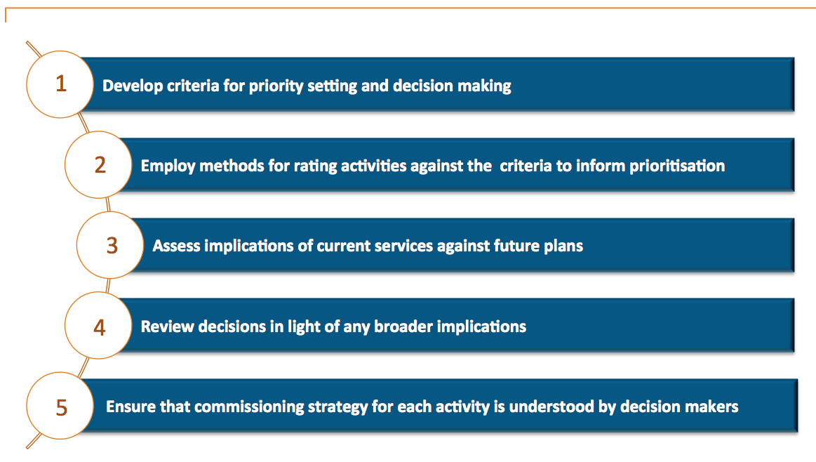

Key considerations in progressing these steps include:

* Priority setting and decision making is transparent and, where appropriate, supported by tools and evidence.
* The prioritised list of activities reflects the outcomes of the needs assessment.
* The prioritised list shows an understanding of the need to commission. Where the activity involves decommissioning, this is understood and documented, and consideration is given to the needs of those involved.
* In cases where priorities, options and opportunities that emerged from the needs assessment are not being considered, the PHN should be confident as to the reasons why, and be able to explain this to a range of stakeholders. (For example, other agencies may be the most appropriate bodies to commission/deliver these services, or there is a lack of alignment with the PHN objectives.)

This section describes a set of potential resources relating to each element of Stage 2.

## 2.1 Development of criteria for priority setting and decision making

### Overview

PHNs must have a rationale and evidence base for prioritising what will and will not be carried forward to the plan.

This requires what is classically referred to as an options appraisal, considering which options are preferable over others, typically based on weighted decision criteria. This stage is therefore about defining these decision criteria.

Evaluation criteria can be defined in many ways but a working definition is included below:

*“A benchmark, standard, or yardstick against which the accomplishment, conformance, performance, and suitability of an individual, alternative, activity, product, or plan, as well as of risk-reward ratio can be measured.”* [5]

It is imperative that there is a flow and consistency in terms of how evaluation criteria are used, as shown in Figure 2.2, below.  
  
Figure 2.2: Use of evaluation criteria

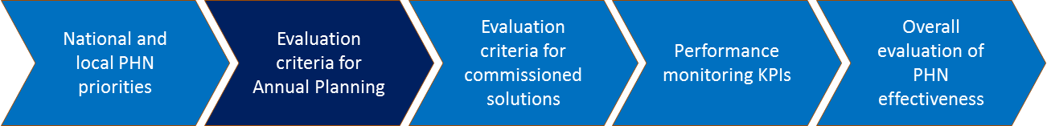

### Supporting resources

Decision criteria should be agreed, reflecting a number of factors:

1. Overall PHN objectives and requirements as defined by the Australian Government and encapsulated in the PHN Funding Agreement.
2. Local PHN priorities, aims and objectives.
3. Other statutory or legal issues.
4. Ability to address the outcomes of the Needs Assessment.
5. Costs and benefits.
6. Other issues that are important to the PHN – legality, capacity implications etc.

The key question here is what are the things that activities need to have a positive impact upon?

Evaluation criteria should be considered in two ways:

1. **Pass/fail or ‘hurdles’** – are there criteria that are binary – either they are delivered/passed or not; and
2. **Weighted criteria** – weighted to reflect their relative importance.

There are several approaches to weighting but the overall consideration should be about *relative* priority. One approach to this is to consider high, medium and low as the relative importance of priorities. Another is to use numerical scoring systems – with say ‘1’ representing lower priority, ‘2’ as medium and ‘3’ as high.

PHNs need to consider how these weightings might be used in later ‘scoring’ and prioritisation. If PHNs plan to use mathematical approaches (effectively deriving weighted scores per potential activity) and then compare these scores to support prioritisation, they need to be aware of this weighting in those outcomes. For example, a weighting of ‘3’ suggests that that criterion is three times more important than a criterion that is weighted ‘1’. Consideration needs to be given to whether that is accurate and appropriate.

PHNs also need to consider the views of different stakeholders in both agreeing the criteria and in weighting them. Diverse stakeholders will inevitably have diverse views about what should be taken into account, and the relative importance.

PHNs therefore need effective governance arrangements to reconcile these different views. Use of workshops to agree on criteria and weighting may be appropriate.

## 2.2 Employ methods for rating activities against the criteria to inform prioritisation

### Overview

This stage is about *informing* not *replacing* prioritisation. It should be used as an input to the prioritisation process, and provide supporting evidence that the PHN has duly considered the options available to it.

There are many approaches by which public bodies have assessed the relative merits of competing priorities and some of these are included below in the section on ‘Supporting resources’.

The Department does not plan to stipulate what approaches should be deployed, and PHNs need to use what works best for them. The Department will need to ensure that PHNs have followed due diligence processes to demonstrate that plans are well-founded, but the means of doing this is at PHNs’ discretion.

It is anticipated that good practice will emerge and be shared as the process develops.

### Supporting resources

***PHN example***

Brisbane South PHN uses two levels of decision criteria with a ‘gateway’ between each:

*Level 1*

1. Alignment with national and strategic priorities and whole of region needs.
2. Partnership and market readiness.
3. Best practice, evidence based review and service effectiveness/incentives for identified needs.

*Level 2*

1. Accessibility, equality and reach.
2. Safety and quality.
3. Acceptability/consumer satisfaction.
4. Governance and management.
5. Efficiency and affordability (value for money). [6]

Set out below is a range of approaches found in international settings that in whole or in part address the question of prioritisation and the comparison of costs and benefits.

#### Cost benefit analysis, cost effectiveness analysis and cost utility analysis

The three main economic approaches used by other parts of the public sector are:

* cost benefit analysis (CBA);
* cost effectiveness analysis (CEA); and
* cost utility analysis (CUA).

***Cost benefit analysis (CBA)***

CBA is an analytical tool that aims to identify whether the benefits of an intervention exceed its costs. Both benefits and costs are measured in monetary terms. CBA is a generic tool that allows decision makers to rank alternative health interventions based on their net benefit; the intervention with the highest net benefit would be the preferred choice.

CBA is attractive as a tool for guiding priority setting because:

1. it considers the benefits and losses to the entire population on whose behalf the CBA is being undertaken; and
2. benefits are measured monetarily - a single and familiar measurement scale - therefore, it is easy to justify implementing a proposed activity compared to doing nothing.

Measuring benefits monetarily does of course mean that the CBA has pitfalls – it assumes that all implications of a proposed activity can and should be expressed in monetary terms alone. It is, therefore, challenging to use CBA when qualitative outcomes such as health gains are under consideration. It is hardly ever practical to value all costs and benefits of health interventions in monetary terms. There may be benefits or health impacts of an intervention which cannot be measured in dollar terms (e.g. life years gained).

***Cost effectiveness analysis (CEA) and cost utility analysis (CUA)***

In using tools like these, the challenge for decision makers is to find a common unit for comparing the benefits of different health interventions. Both CEA and CUA are economic approaches that can be used when major benefits cannot be measured in monetary terms. They assess the costs of alternative options which all achieve the same objectives.

CEA measures health effects in two ways:

1. in natural units (e.g. life years gained); and
2. with a summary measure encompassing mortality or morbidity effects (e.g. quality adjusted life years, disability adjusted life years).

CUA is a development of CEA that affords more comparability between competing potential interventions. CUA estimates the ratio between the cost of a health-related intervention and the benefit it produces in terms of the number of years lived in full health by the beneficiaries. Hence it can be considered a special case of cost-effectiveness analysis, and the two terms are often used interchangeably. CUA effectively calculates the ‘bang for the buck’.

Cost is measured in monetary units. Benefit needs to be expressed in a way that allows health states which are less preferable to full health to be given a quantitative value. However, unlike cost-benefit analysis, the benefits do not have to be expressed in monetary terms – the approach used is usually to express benefits in quality-adjusted life years (QALYs).

This approach allows the comparison of different interventions based on their relative impact in terms of QALYs – the intervention with the greatest QALYs impact *per dollar* will be given preferential consideration.

CUA and QALYs have been used by the National Institute for Health and Care Excellence (NICE) (see the [Improving health and social care through evidence-based guidance](https://www.nice.org.uk/)) as a means of prioritising new and competing procedures/drugs.

#### Program budgeting and marginal analysis

One of the main objectives of priority setting is to maximise the benefits and minimise the opportunity costs for a given set of resources. Program budgeting and marginal analysis (PBMA) is a process that helps to maximise benefits using existing resources by bringing together the two economic concepts of ‘opportunity cost’ and ‘marginal analysis’.

When applied in practice, PBMA provides the framework (program budget) to determine which activities require a decrease in spending and which activities require additional spending (achieved by moving resources between programs) to increase total benefits (marginal analysis). Priority setting decisions should include not only the allocation of new money and developments but also core spending and disinvestments.

PBMA has been used at the regional level in Australia, New Zealand, Canada and the United Kingdom.

* An example of how the PBMA framework has been applied successfully at a micro level to reallocate resources in respiratory care in North Wales can be found in the article [Use of programme budgeting and marginal analysis as a framework for resource reallocation in respiratory care in North Wales, UK](http://jpubhealth.oxfordjournals.org/content/early/2015/09/15/pubmed.fdv128.full#ref-5).
* The Australian Government’s Department of Prime Minister and Cabinet provides [further guidance on CBA and related approaches](http://www.dpmc.gov.au/resource-centre/regulation/cost-benefit-analysis-guidance-note), along with references to further reading.
* The Business Council of Australia has a useful [cost benefit analysis tool](http://www.bca.com.au/docs/FFAC5778-2D15-4933-9C29-65FD83338ECC/policy_essentials_cost_benefit_analysis_final_7-9-2012.pdf).
* A [2012 ‘Evidence Check’review](https://www.saxinstitute.org.au/wp-content/uploads/01_Priority-setting-methods-to-inform-prioritisation.pdf) by Gavin Mooney, Blake Angell and Jennie Paras was brokered by the Sax Institute for the NSW Treasury and the NSW Agency for Clinical Innovation. This discusses PBMA and a number of other priority setting tools.

***A few words of caution…***

It should be noted that tools like CBA, CEA and CUA only form part of the picture and could easily lead PHNs to abdicate the process of prioritisation to a ‘mechanical and economics-driven’ exercise. As shown in the Brisbane South PHN example, the assessment of priorities needs to go beyond the simple net benefit position and reflect other factors that PHNs should have encompassed in decision or evaluation criteria.

## 2.3 Assess implications of current services against future plans

### Overview

PHNs should have prepared an assessment of the current service delivery landscape as part of their Needs Assessment.

In prioritising future delivery, PHNs will therefore need to have regard for:

1. How the planned activities compare with those currently delivered, including overlaps, both in terms of what is currently delivered that would not be prioritised in the future (candidates for decommissioning), and in terms of priorities that are not currently delivered.
2. Any quality differences.
3. Where services are currently delivered that may not be required in the future, the options for decommissioning. This will be picked up in the designing and contracting services stage but PHNs need to be cognisant of the flexibility they may or may not have.
4. The various stakeholder implications for these overlapping positions.
5. The service continuity or service start-up implications.
6. Any dependencies between the services that may or may not be delivered in the future and any of the planned new activities.
7. Any implications for ‘enablers’ such as systems and technology.
8. Governance and communication implications.

### Supporting resources

Guidance on decommissioning can be found on the English National Health Service (NHS) website at the [Commissioning Handbook for Librarians (references for disinvestment](http://commissioning.libraryservices.nhs.uk/commissioning-cycle/disinvestment)) and the article [Engaging public essential guide clinical commissioning groups](http://www.nhscc.org/latest-news/engaging-public-essential-guide-clinical-commissioning-groups/).

## 2.4 Review decisions in light of any broader implications

### Overview

As outlined above, this process involves some complex decision making within the PHN but may also need to be considered by the PHN in its broader environment.

### Supporting resources

One framework that might prove useful in this analysis is the PESTLE approach, shown in Figure 2.3, below.

Figure 2.3: PESTLE approach

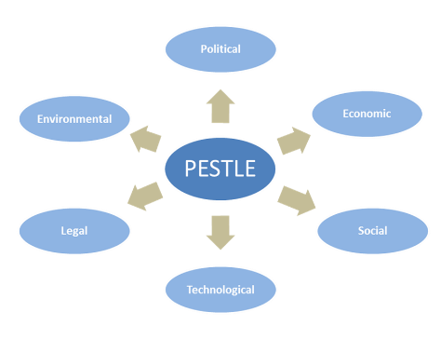

In this case, this framework could be applied as follows:

Political

* Has the PHN considered and had regard for all the policy direction from the Australian Government?
* Has it had regard for local direction and strategy from the PHN Board?
* Are there any State Government policies that should be taken into account – say in relation to the interaction between PHNs and LHNs?

Economic

* What are the forecast economic changes in the PHN’s area?
* Will the broader economic position of the PHN’s area have any impacts for local needs or service delivery?
* What could be the effect on markets?
* Are there economic determinants of health and should the PHN have regard for these? How?

Social

* What are the area’s consumer or patient trends (behaviour and attitudes)? Are these changing?
* Are there any relevant lifestyle trends?
* Have planned or forecast demographic changes (age, sex, gender, ethnicity, employment, home ownership), whether picked up in the Needs Assessment or not, been reflected?
* Are there any major events planned for the area – say a change in employment opportunities or other activity?
* Are there any broader ethical issues that need to be considered (note that Brisbane South PHN had regard for this in its assessment criteria).
* Are there social determinants of health that need to be considered? Does the PHN need to work with other sectors in addressing these?

Technological

* The digital economy, innovation and research and development implications of what is planned – for example, is the PHN planning a migration to more tele-health, implications of the roll-out of the National Broadband Network
* Partner systems – are these planned to change – for example, Electronic Medical Records (EMR) and My Health Record changes
* Telecommunications – are any relevant changes planned?

Legal

* Are there any changes to the legal frameworks within which either the PHN or its partners operate?
* What are their implications?
* Legal obligations/risks that Board Members carry?
* Governance?

Environmental

* Are there weather, geographical location or climate change implications to consider?

Further details on PESTLE can be found at the [Pestle Analysis website](http://pestleanalysis.com/what-is-pestle-analysis/).

## 2.5 Ensure that the commissioning strategy for each activity is understood by decision makers

### Overview

There are two implications of this stage:

* understanding commissioning strategy implications; and
* communicating these to stakeholders.

Overall approaches to commissioning are covered by the Designing and Contracting Services Guidance.

PHNs should establish overarching commissioning strategies that include ‘guiding design principles’ that should steer how commissioning is adopted in the PHN’s own environment and circumstances.

In terms of communications, PHNs need to consider:

1. Preparing a communications strategy and materials, including consideration of what needs to be communicated, to whom, and with what desired effect.
2. The key stakeholders (which should have been pre-defined).
3. The governance approaches that are being adopted.
4. Whether there is a feedback loop to the PHN Board and/or sub-committees around the decisions Boards have made; how the Board will understand the feedback and implications of their thinking and decisions; – and whether there may be an opportunity to deploy Community Advisory Committees or other mechanisms.
5. Ensuring transparency in decision making.

### Supporting resources

Communications strategies may include[7]:

1. **Introduction** – a brief overview to define the scope of the strategy.
2. **Purpose** (in the context of the Australian Government’s and PHNs’ overall objectives).
3. **Key messages** – tailored to audiences.
4. **Guiding principles** that should be adopted.
5. **Project management and governance** – including the person responsible for the communications.
6. **Objectives of the Communications Plan** – the specific objectives of the ‘campaign’.
7. **Target Audience** – demographics, psychographics, geographic locations, specific interests, etc.
8. **Outline any current activities** that contribute to your communications objectives.
9. **Market Research** – detail any research that may have been undertaken or is available that may assist your communications plan.
10. **Communication Strategies** – outline the communications strategy or strategies that will be used to achieve your objectives (briefly touching on tactics for each).
11. **Communications Tools/Tactics** – provide the specific details of each selected communications strategy.
12. **Budget** – an itemised breakdown of the total budget including all activity, if not included elsewhere.
13. **Timing** – a table with a timeline of the actions that are required to implement the outlined activities.
14. **Evaluation** – how and when the plan will be evaluated.

# Stage 3: Reviewing and ratifying the whole plan

Figure 3.1: Key steps in reviewing and ratifying the plan

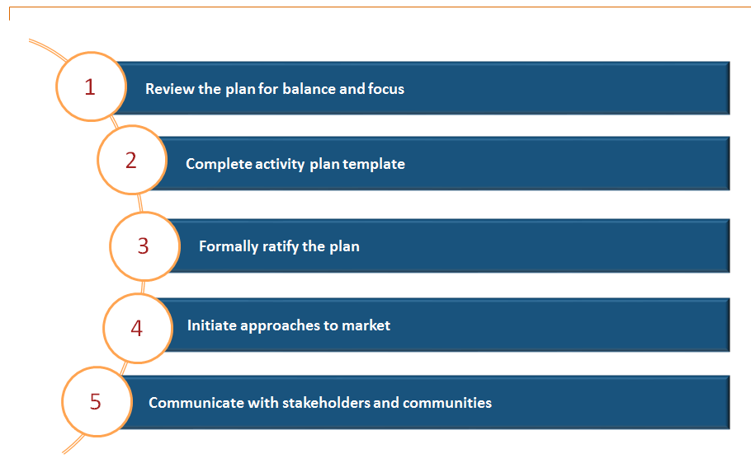

PHNs should ensure that the final plan:

* clearly relates to the PHN objectives and reflects the outcomes of the needs assessment;
* is balanced in order to achieve activity across a broad range of primary health care;
* shows a level of coordination and (where possible) integration between different activities, and that dependencies between activities are recognised and capable of being coordinated;
* demonstrates an awareness of the market, now and in the future;
* encourages the involvement of others in service design and, where appropriate, in procurement processes; and
* identifies new areas of focus and those planned for decommissioning.

This section describes a set of potential resources relating to each element of Stage 3.

## 3.1 Review the plan for balance and focus

### Overview

Reviewing and finalising the plan requires two key questions to be addressed:

1. Is the plan balanced? Is there an appropriate balance of activities that addresses the needs assessment and other lenses that might be applied, for example the needs of particular community groups like Aboriginal and Torres Strait Islander people? There will never be sufficient resources to address all needs but the PHN must ensure that it has balanced different needs and perspectives appropriately.
2. Is the plan focused? This is a key question (that in some ways could be seen as contradicting the first). Public services have for many years operated on the basis of universality and viewing the ‘delivery of similar services to all’ as a measure of equity. The reality is that PHNs must target their efforts and resources and do the things that have the potential for greatest impact, in the context of meeting the PHN program objectives. Only then will plans be focused.

PHNs will want to consider potential unintended consequences and the ‘political’ and stakeholder ramifications of their plans. It is useful to consider the plan through a different lens to identify unintended consequences. For example, how would the community, the supply market or the media react to the plan?

Contrary to where this might take PHNs, they also need to consider whether the changes being proposed are sufficient (e.g. are they too conservative because of concerns about consequences, or are they too radical?)

PHNs also need to consider how they would operationalise the plans through commissioning, including whether the plan represents an appropriate mix of activities to be commissioned, and how the PHN might package the activities (the act of bringing together individual services, activities or outcomes into a coherent grouping).

### Supporting resources

One approach to considering the plan in overall terms might be the deployment of something similar to Dr Edward de Bono's Six Thinking Hats. This approach is primarily aimed at fostering collaborative thinking and cohesion with teams but it could be used here by executives or Boards to check on the balance and cohesiveness of the overall plan.

Traditionally, the idea behind the Six Thinking Caps (depicted in Figure 3.2, below) is that each ‘team member’ takes a different perspective and challenges the overall proposals from that perspective:

Figure 3.2: Dr Edward de Bono’s Six Thinking Caps

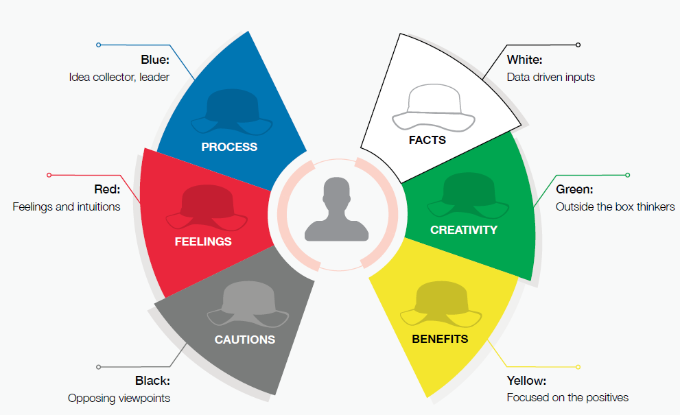

This approach could be applied to the final plan proposals:

Blue

* Board Chair and Chief Executive testing underlying ideas based on their broader knowledge of what others are doing.

White

* Is the plan driven by evidence and the needs assessment?

Green

* Is the plan sufficiently challenging? Is it ‘too safe’?
* Are any of the proposed activities innovative?

Yellow

* What are the planned benefits?
* How would they be measured?

Black

* What might go wrong?
* What are the biggest risks? How are these mitigated?
* Where would the biggest challenges come from?
* How could the plan be perceived badly?

Red

* Does the plan ‘feel’ right?
* How would others ‘feel’ about it?
* Has the community been consulted sufficiently, and their views taken into account?

## 3.2 Formally ratify the plan

### Overview

Ratification will be part of the overall agreed governance processes for the PHN but it is likely to include a number of sign off steps and processes. This will include consideration by Clinical Councils and Community Advisory Committees, and potentially other stakeholder groups too, such as the relevant Aboriginal and Torres Strait Islander health peak bodies in the region. PHNs need to strike the right balance between consultation and participation (with stakeholders) and getting the plan signed off.

### Supporting resources

#### Road map

A ‘road map’ provides PHNs with a format to summarise the activities that they are choosing to invest in so that the Board and sub-committees can see at a glance the range of activities, outcomes and timelines that the commissioning activities are designed to accomplish. It places the commissioning plans in one place which provides PHNs with the ability to build a narrative around what they are going to commission and why. The road map approach encourages PHNs to adopt a program management mindset. Figure 3.3 provides an example of a roadmap template.

Figure 3.3: Road map template

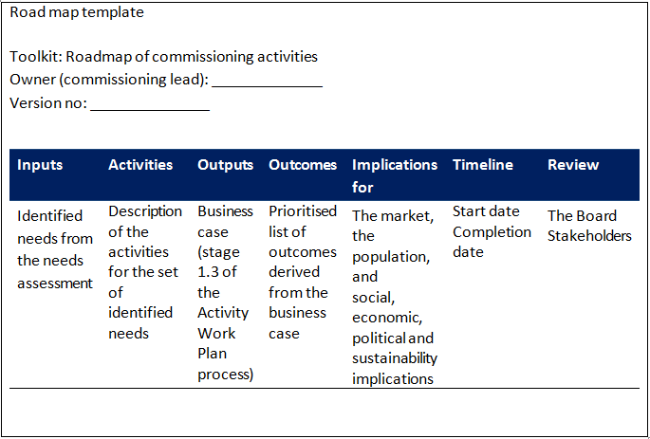  
  
PHNs may also prepare more graphical summaries.

## 3.3 Complete activity plan and template

### Overview

PHNs need to complete the Activity Work Plan in accordance with Australian Government guidance.

### Supporting resources

The tool for this section is the Activity Work Plan 2016-2018 template produced by the Australian Government Department of Health.

## 3.4 Initiate approach to market

### Overview

As discussed earlier in this guidance, it is likely that PHNs will have engaged with the market prior to the ratification of the plan. However, ratification provides a good opportunity to communicate the final plan to the market and build on work done to date.

Some questions for PHNs to consider will include:

1. The objectives of such an approach.
2. Whether the whole plan should be communicated, or just part of it.
3. Whether it should be summarised into a more ‘user friendly’ communique, or more than one, reflecting different audiences.
4. Whether the PHN wants to solicit any responses from the market; and if so, what, how and when.

### Supporting resources

The Designing and Contracting Services Guidance provides further advice on market engagement and provides resources that support dialogue with the market.

## 3.5 Communicate with stakeholders and communities

### Overview

As discussed in stage 2.5 above, communication is critically important in the planning and commissioning processes.

### Supporting resources

Communications resources are referred to in stage 2.5 above.

Whilst developed some years ago, the International Association for Public Participation (IAP2) public participation framework is a practical tool that assists decision makers with selecting the right level of public participation. It also helps guide communication and consultation activities. It shows that differing levels of participation are appropriate depending on the goals, resources, time frame and level of concern in the decision to be made. The five levels of stakeholder participation are: inform, consult, involve, collaborate and empower.

The framework provides an ‘at a glance’ tool to help guide the level of engagement and identify appropriate activities for any project. A description of the IAP2 public participation framework and examples of communication tools that can be used when planning and implementing the community approach can be found at the [International Association for Public Participation Australia's IAP2 Public Participation spectrum](https://www.saxinstitute.org.au/wp-content/uploads/01_Priority-setting-methods-to-inform-prioritisation.pdf).

1. Berwick D. *The triple aim: care, health and cost.* Health Affairs, 2008: 27: 3: 759-769.
2. Bodenheimer T. & Sinsky S*. From Triple to Quadruple Aim: Care of the Patient Requires Care of the Provider*.   
   [Annals of Family Medicine](http://www.annfammed.org/content/12/6/573.full.pdf+html). November/December 2014: 12:573-576
3. For an example of this approach crefer to the Hunter New England Central Coast Public Healthcare Network [tenderlink page](https://www.tenderlink.com/hneccphn/)
4. Nicolay Worren. *Managing Interdependencies in Complex Organizations*. Presented at the Organization Design Forum Conference, 2006. Available [online](http://www.slideshare.net/NicolayWorren/managing-interdependencies-in-complex-organizations-2406305).
5. Adapted from the [businessdictionary.com](http://www.businessdictionary.com/definition/evaluation-criteria.html#ixzz44iiruAYZ).
6. Presentation at PHN National Forum, March 2016. *PHN Commissioning - Strategic planning and prioritising local need***.** Presented by Tracey De Angelis, General Manager – Commissioning, Brisbane SouthPHN*.* 
7. Adapted from SA Government guidance at the [Government of South Australia website](http://www.govcommunications.sa.gov.au/content/developing-your-communications-plan).