 

**Planning in a commissioning environment - a Guide**

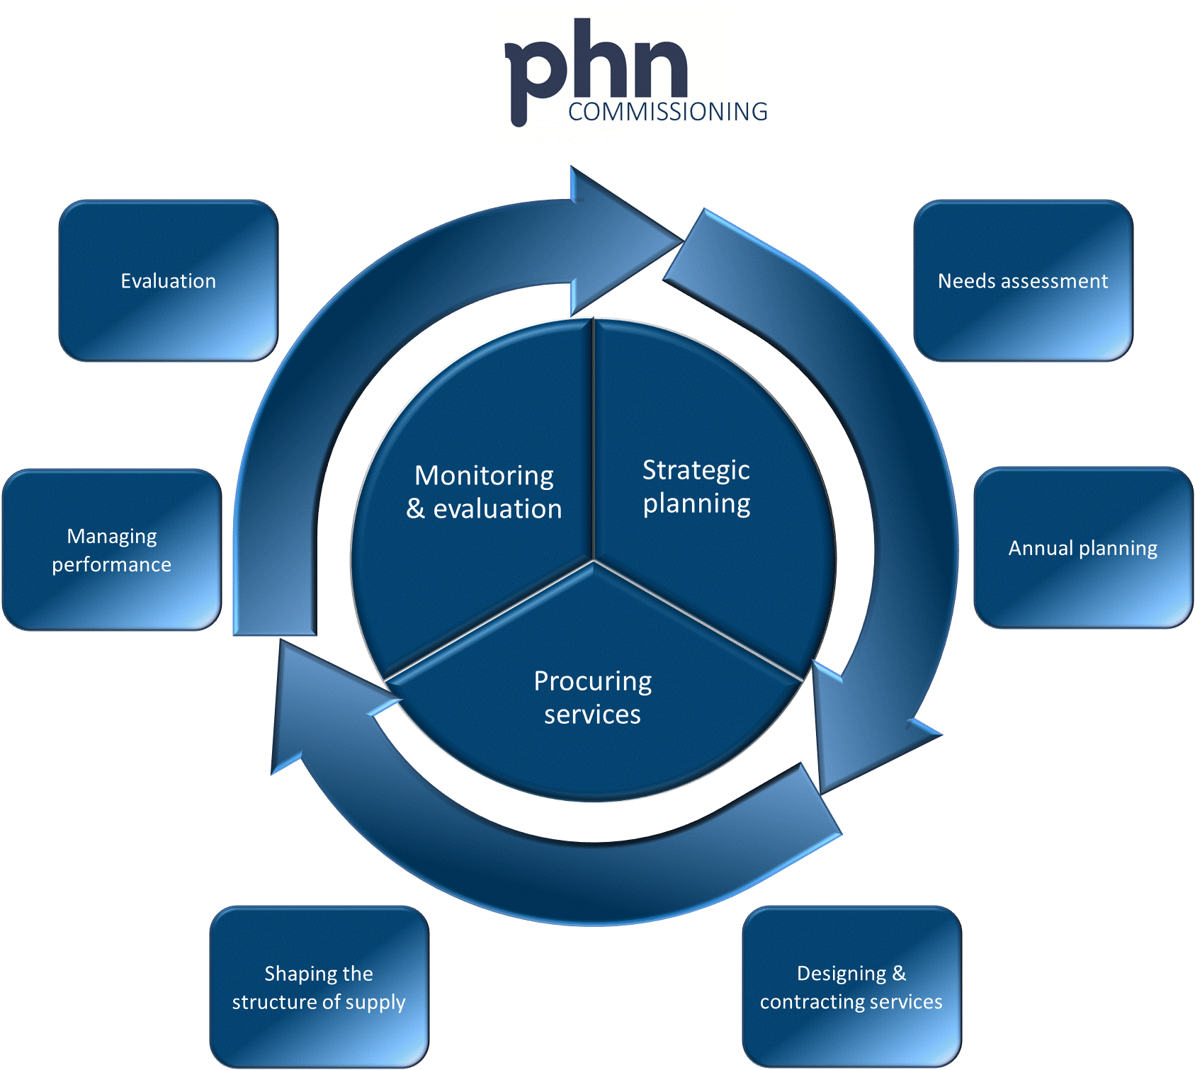

**Version 1.0 June 2016**

**Acknowledgement**

This document has been developed by the Australian Government Department of Health and PricewaterhouseCoopers (PwC) as part of a project funded by the Department to develop guidance and resources for Primary Health Networks on commissioning. It has been informed by a literature and evidence review on commissioning by The King’s Fund and the University of Melbourne, and by the results of an online survey of all PHNs by PwC, both undertaken in 2016 as part of this project.

The input of the Primary Health Networks Commissioning Working Group in the development of this guide is appreciated.

**Note**

This guide does not override the requirements set out in the PHN Funding Agreement.

Contents

1. Overview 1

1.1 Introduction 2

1.2 Key messages 3

2. Planning in a commissioning environment 6

2.1 The PHN commissioning framework 6

Commissioning 7

Planning 7

Planning for commissioning 8

2.2 Considerations for PHNs 9

PHN objectives, needs assessment and national priorities 9

Leadership, governance and organisational capacity 10

Engagement and consultation, autonomy and responsibility 11

Priority setting and decision making 12

Decommissioning and direct service delivery 14

Performance measurement 16

3. PHN Planning for commissioning 2016-18 19

3.1 Overview 19

3.2 Stage 1: Developing a set of potential activities 20

3.3 Stage 2: Priority setting and choosing activities 21

3.4 Stage 3: Reviewing and ratifying the plan as a whole 22

APPENDIX I. Activity Workplan CHECKLIST 23

APPENDIX II. Examples of activity headings 24

Endnotes 26

# 1. Overview

This document attempts to outline some of the characteristics that may be particular to planning by Primary Health Networks (PHNs) in a commissioning environment.

Through its availability to PHNs as a consultation draft, it provided PHNs with guidance, ahead of completion of the first 2016‑18 Activity Work Plans. These are the first plans that PHNs have produced which articulate the commissioning role, and the timeframes involved were short. It has therefore only been possible in this guide to canvass issues in a generic sense. Updated and or/additional guidance may be developed at a later date which takes account of the evidence in the 2016-18 Activity Work Plans and of PHNs' experience in undertaking the planning.

This guide is accompanied by a compendium of resources that may be of use to PHNs in planning. The intention is to progressively build this resource base, drawing on PHN practice, in order to provide a solid foundation for future PHN planning.

The guide should be read in conjunction with the *PHN Commissioning – Needs Assessment Guide* published by the Department of Health in December 2015, and the *Designing and Contracting Services Guidance*.

## 1.1 Introduction

PHNs were established in July 2015 and are moving to a commissioning environment in the second year of operation (2016-17).This document follows on from earlier advice on needs assessment published by the Department of Health (the Department).[1] It is intended to:

* discuss how planning by PHNs may be different in a commissioning environment in 2016-17 and beyond;
* provide information on the Department's expectations in regard to the preparation of the 2016-18 Activity Work Plans; and
* provide an accompanying compendium of resources that can be progressively developed during 2016‑17.

There are three important points to make at the outset:

* This document is intended to give initial guidance and is a work in progress. It will need to be revisited during 2016-17 in light of the experience gained by PHNs in preparing their first plans in a commissioning environment. The information contained in these plans is very important in understanding the direction of travel for PHNs both individually and collectively, and for the PHN program as a whole.
* As in any other part of the commissioning cycle, planning is not linear but iterative. While planning is a discrete area of activity and focus in the annual commissioning cycle, its boundaries are porous. A number of issues that are central to PHN planning will inevitably have had to be considered to some extent during the needs assessment phase, such as value for money, fit with the PHN role or indeed achievability.
* Similarly, a number of issues around service design and procurement processes will influence decision making during the development of PHNs’ plans. There are no easy answers to this, other than to note that these issues are probably more pronounced during the initial year of a commissioning cycle.

## 1.2 Key messages

Commissioning provides a range of opportunities for improving the primary health care system. PHN commissioning can help to drive more systematic and proactive management of chronic disease, a population-based approach and more integrated models of care. Commissioning is one of the key means for achieving these ends.

*Effective planning in a commissioning environment*

* A number of characteristics of effective planning are the same in both a commissioning environment and when an organisation is planning for service delivery. This includes clarity about purpose, being based on an understanding of need, and being developed with clear and transparent processes and under strong governance.
* A number of aspects of planning are different in a commissioning environment. Fundamentally, planning in a commissioning environment is about identifying what will be commissioned to be delivered (by third parties) rather than, operationally, what will be delivered by the PHN. This requires a greater focus on ‘what’ will be delivered rather than ‘how’ it will be delivered. This also includes different supports or inputs into decision making processes – information and data, tools, governance, resources, methods, approaches – and different competencies in market assessment, service design and contracting.
* Activities proposed in a PHN plan must obviously be aligned with the PHN’s role and in particular the two PHN program objectives (see page 6, below). PHNs should also be mindful of the six key priority areas for targeted work (see page 10, below).
* The plans need to be based on the needs, opportunities, priorities and options identified in the needs assessment.
* Boards need to be aware of and fully understand the commissioning role.
* The plans should seek to leverage available resources, and demonstrate the PHN’s role as a leader in health system improvement.
* In parallel, PHNs will need to plan for building the skills and competencies required for successful commissioning, and build provider capacity.

*Stakeholder engagement*

* The nature of engagement with communities, clinicians, service providers and other stakeholders will be different in a commissioning environment. There are enhanced opportunities to explore more collaborative ways of working, but also a heightened need for transparency in decision making.
* The commissioning environment provides greater opportunity to design and co-design new forms of service delivery. This is accompanied by a responsibility to ensure that these are appropriate and acceptable to providers, communities and individuals, are based on evidence and are consistent with agreed standards of quality and clinical safety.

*Priority setting and decision making*

* Priority setting and decision making is core to the commissioning role. Success in priority setting requires the PHN to establish legitimacy, particularly when making difficult and unpopular decisions. Having a clear rationale and criteria for decision making is central to this; as is a clear ‘audit trail’ that demonstrates why decisions were made.
* Priority setting in a commissioning environment involves an understanding of the capacity of the market; this will often require a degree of market testing or soundings. Some PHNs have made good progress in this area.

*Planning for specific populations*

* It is of course expected that PHN planning will recognise the social and cultural needs of specific populations within their region. In particular, this has been recognised in respect to planning and commissioning services for Aboriginal and Torres Strait Islander people, and the role of Aboriginal Community Controlled Health Organisations (ACCHOs).
* A set of Guiding Principles for relationships between PHNs and ACCHOs has been developed in consultation with ACCHO Peak Bodies and PHNs and covers actions to be taken by each party across six key domains: Closing the Gap; cultural competency; commissioning; engagement and representation; accountability, data and reporting; service delivery; and research. This document is available at the [PHN website](http://www.health.gov.au/internet/main/publishing.nsf/Content/PHN-Accho).

*Working with State and Territory Governments*

* PHNs will be working closely with States and Territories and their health agencies and Local Hospital Networks (LHNs) or equivalents, which have extensive resources, data and skills. A collaborative approach to planning and commissioning is required, and an understanding of State/Territory roles across the whole system, including inpatient, community and outpatient care.
* In PHN planning it is important for PHNs to work closely with the States and Territories to ensure that gaps, overlaps or any disconnect in the provision of Commonwealth and state funded services is identified: not only to reduce duplication, but to ensure that consumers can transition as seamlessly as possible between different parts of the health system.

*Performance measurement*

* Guidance on performance measurement is covered in detail in the PHN Performance Framework.

*Decommissioning*

* Proposals for decommissioning need to consider a number of factors other than the termination of a service, including having an evidence-based rationale, good communication, providing as much notice as possible and supporting parties through the process.

*Direct service provision*

* Where a plan proposes a continuation of a direct service delivery arrangement, PHNs need to adhere to the requirements in the Core Funding schedule and outline activity designed to test and stimulate the market, and include proposals for moving to commissioning in the longer term.

*Completing and submitting the Activity Work Plan*

* PHNs need to submit the Activity Work Plan as described in the template and in Word format. This allows information to be in a form suitable for aggregation, analysis, comparison and use in program and policy development.
* Activities need to be described at a consistent level. Previous experience with Medicare Locals suggests that 15-20 activities would be an indicative benchmark.
* There are three broad stages to developing the Activity Work Plan:
* developing a list of activities for consideration;
* priority setting and decision making on the basis of these activities; and
* reviewing the final set of activities to ensure balance and focus.

These issues are covered in more detail in the guidance.

***Guidance for planning in specific program areas***

Specific guidance is available separately for PHNs on needs assessment and planning in relation to mental health and suicide prevention, and drug and alcohol treatment services. The specific guidance needs to be read in conjunction with the generic guidance provided here.

# 2. Planning in a commissioning environment

## 2.1 The PHN commissioning framework

Figure 2.1 PHN Commissioning framework



PHNs were established in July 2015, with the objectives of:

* increasing the efficiency and effectiveness of medical services for patients, particularly those at risk of poor health outcomes; and
* improving coordination of care to ensure patients receive the right care in the right place at the right time.

As commissioners, PHNs will be regional purchasers of health services with the flexibility to stimulate innovative public and private health care solutions to improve frontline services and better integrate health service sectors. PHNs will only directly provide services in exceptional circumstances, such as where local services do not exist. [2]

The commissioning framework has been developed so that PHNs can ensure that their commissioning approach is consistent with the approach adopted for the PHN program as a whole and that the process results in consistent, comparable and measurable outputs and outcomes. There are three main phases in the commissioning cycle – strategic planning, procuring services, and monitoring and evaluation.[3]

It is important to keep in mind that commissioning is a holistic approach to enable PHNs to work as strategic organisations at the system level. It is not merely a process. It is expected that PHNs may well be engaged in different parts of the cycle throughout the year (such as monitoring contracts). While PHNs are required to review and update their needs assessments and plans annually, in practice these are under continual review as new information, data and experience become available.

### Commissioning

Commissioning is a continual and iterative cycle involving the development and implementation of services based on planning, procurement, monitoring and evaluation. Commissioning describes a broad set of linked activities, including needs assessment, priority setting, service design and procurement through contracts, monitoring of service delivery, and review and evaluation.

A key characteristic of commissioning is that procuring or purchasing decisions occur within a broader conceptual framework. The difference between purchasing and commissioning in the health care context has been described as follows:

Commissioning is a term used most in the UK context and tends to denote a proactive strategic role in planning, designing and implementing the range of services required, rather than a more passive purchasing role. A *commissioner* decides which services or healthcare interventions should be provided, who should provide them and how they should be paid for, and may work closely with the provider in implementing changes. A *purchaser* buys what is on offer or reimburses the provider on the basis of usage.[4]

As health systems differ between countries, PHN commissioning will of course differ from other nations’ experiences. However, the fundamental elements remain valid in the Australian context.[5]

### Planning

The transition to a commissioning environment has proved a complex and multifaceted process in other health systems, and this will also be the case in Australia. The 2016-18 PHN plans, including the Activity Work Plan for core funding, represent the first full articulation of not only what PHNs are proposing to do, but also – to some degree at least – how PHNs are proposing to do it.

Effective planning is a characteristic of any successful organisation, and takes place at a number of levels – strategic, business, operational – and across a number of different areas.

Effective plans:

* provide clarity about the organisation’s intended activity;
* are based on an assessment of need, an understanding of the organisation’s objectives, capability, and resourcing;
* are developed through appropriate governance structures;
* effectively and appropriately manage potential conflicts of interest and risk; and
* show an awareness of the activity of other related parties such as providers, stakeholders and partners. [6] [7]

### Planning for commissioning

At this stage, this document primarily relates to aspects of planning for PHNs to consider when preparing their Activity Work Plans for Core Funding (hereafter ‘the plan’). However, in a commissioning environment, a number of considerations are common across other areas of planning; including planning for other Department of Health funding streams, or for operational plans developed on the basis of the plan.

More broadly, there are a number of ways in which planning in a commissioning environment will be different for PHNs than was the case for Divisions of General Practice or Medicare Locals in the past, or for other organisations with a service delivery focus. This could be because:

* PHNs are planning to do similar things as in the non-commissioning past, to achieve similar outcomes, but in a different way; and/or
* PHNs are planning to do different things, and become involved in new areas of activity.

This will inevitably change the nature of many decisions made in the development of a plan and PHNs will often need different supports or inputs into decision making processes – information and data, tools, governance, resources, methods, approaches and competencies. It has been noted that:

Successful commissioning is one of the best ways a PHN can achieve the programme’s overall aim of improving health outcomes. However, commissioning is not an easy task. Successful execution of the commissioning of services requires careful planning and identification of priorities on behalf of the board...[8]

There are some specific factors PHNs need to be cognisant of that influence the approach to planning. This is depicted in Figure 2.2 below. As outlined above in section 1.2 (Key Messages), this also includes working closely with States and Territories.

Figure 2.2 Factors relevant to PHN planning

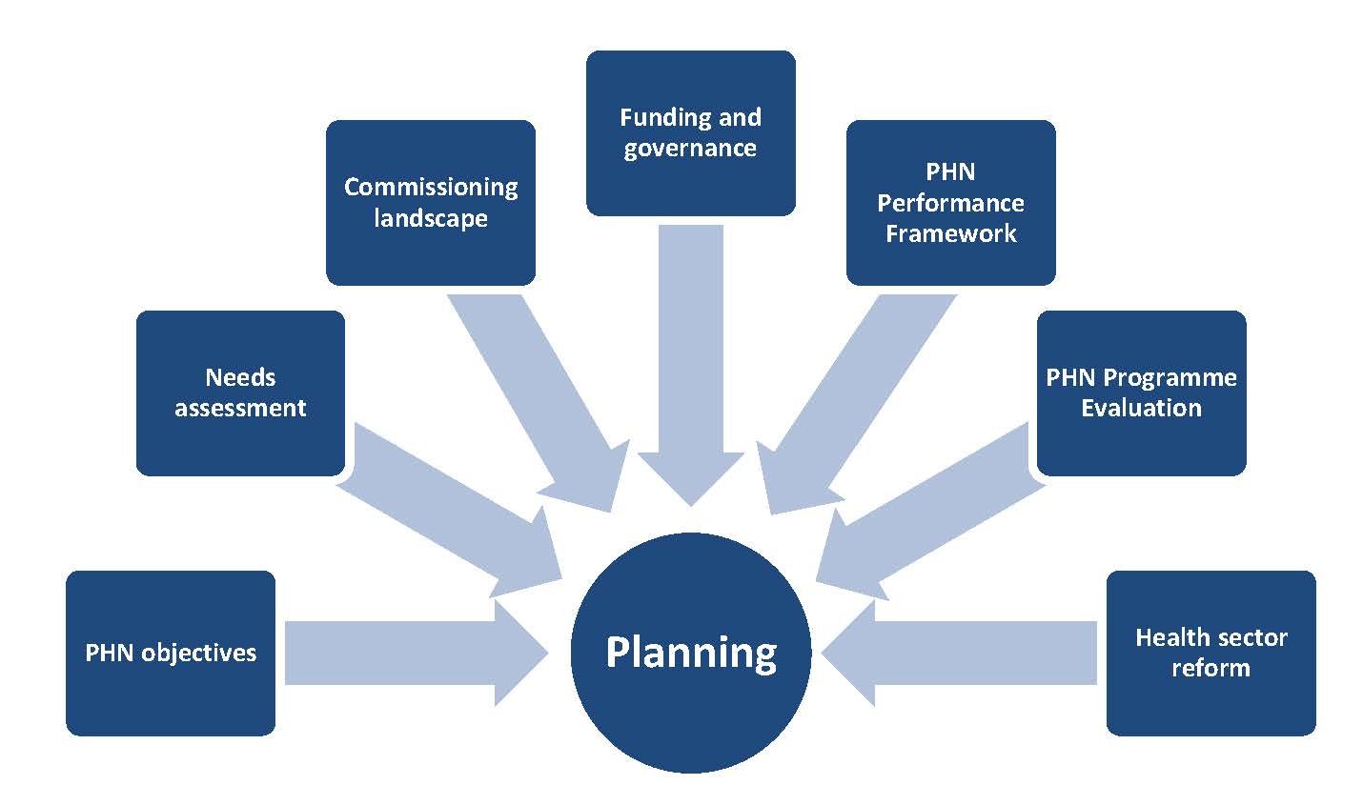

The following section proposes a number of considerations related to the commissioning role that are relevant to the development of PHN plans. Issues are grouped under the following broad headings:

* the PHN objectives, needs assessment and national priorities;
* leadership, governance and organisational capacity;
* engagement and consultation, and autonomy and responsibility;
* priority setting and decision making;
* decommissioning and direct service delivery; and
* performance measurement.

## 2.2 Considerations for PHNs

### PHN objectives, needs assessment and national priorities

As indicated earlier, PHNs have been established to increase the efficiency and effectiveness of medical services for patients, particularly those at risk of poor health outcomes, and to improve coordination of care.[9]

The first point to make about planning in a commissioning environment is that commissioning is a means to an end rather than an end in itself. While commissioning is the agreed approach, the key intention of PHN planning is to achieve the objectives of the PHN program.

The plan is not, therefore, a ‘commissioning plan’, and the primary focus is to describe the proposed areas of PHN activity and funding streams. The PHN objectives focus on particular aspects of the health system – efficiency, effectiveness, improved targeting and improved coordination. There needs to be a strong link between all activities proposed in the plan and the objectives outlined above.

Similarly, the plan needs to be based on the opportunities, priorities and options identified in the needs assessment. The Needs Assessment Guide noted that:

In their Annual Plans, PHNs may pursue a number of priorities through flexible funding. In addition, some priorities may more appropriately be addressed through the use of separate programme-specific funding. While an annual plan has a particular focus on the upcoming financial year it will also include medium and longer term perspectives.

A number of areas may be identified where further investigation is required. There may also be identified priorities where it will take longer to develop responses, or where it is more appropriate that another agency such as Local Hospital Networks (LHNs) or equivalents would take the lead role.[10]

PHNs should also be mindful of the six key priorities for targeted work: mental health, Aboriginal and Torres Strait Islander health, population health, health workforce, eHealth and aged care.[11]

### Leadership, governance and organisational capacity

Commissioning organisations are often described as leaders of the local health care system… Critical to this leadership role is the ability to develop and articulate a clear vision for the local health and care system, and to win the support of key stakeholders in delivering that vision and driving change.[12]

The leadership and governance of health systems, also called stewardship, is arguably the most complex but critical building block of any health system… It requires both political and technical action, because it involves reconciling competing demands for limited resources, in changing circumstances, for example, with rising expectations, more pluralistic societies, decentralisation or a growing private sector.[13]

PHNs have a more explicit remit about leading change and system improvement than their predecessors. This is a key part of what is different and unique for PHNs in a commissioning environment. As commissioners, PHNs have an important leadership, integration and coordination role in the local health system. The decisions that PHNs make and articulate in their plans – particularly their decisions in respect of service design and procurement – will inevitably involve changes to previous arrangements and, as such, be open to an increased level of scrutiny.

Traditionally, organisational leaders who hold 'authority' and 'weight' are often those with the largest budgets, biggest resource pool, and greatest asset base. While PHNs do not have the level of resourcing held by LHNs or their equivalents, the plans they develop in a commissioning environment provide the opportunity for PHNs to lead beyond their immediate and organisational authority. The term 'leading beyond authority' is used for people who can help set strategy or direction and produce change beyond their direct circle of control, where they rely on their capacity to persuade and their ability to form networks and coalitions.

Identifying and developing the competencies and skills sets for effective PHN commissioning will take time. PHNs will need to develop a workforce with the ability to analyse performance data, co-design new forms of services, conduct cost-benefit analysis and options appraisals, and draw up and manage appropriate contracts.[14] As a result:

* PHN Boards need to be aware of and fully understand the commissioning role, and how to involve both Clinical Councils and Community Advisory Committees in the development of the plan. The role of PHN Boards in leading change in primary care is discussed at length in the recent publication by Duckett et al;[15]
* planned activities should seek to leverage available resources, and demonstrate the PHN’s role as a leader in health system improvement and part of a regional health leadership team that includes individuals and both government and non-government agencies; and
* PHNs need to carefully consider the skills and competencies required for successful commissioning, and to ensure that the organisation has plans for building, buying or sharing the capability to undertake the proposed activities.

### Engagement and consultation, autonomy and responsibility

Relational aspects are important to successful commissioning, especially when implementing difficult decisions around service redesign. The evidence suggests that leaders need to work collectively across stakeholder groups and organisations, operating with political ‘astuteness’.[16]

Engaging clinicians in developing outcomes is important to ensure their longer-term buy-in to the transformation programme and to its ultimate success. Similarly, agreeing outcomes in consultation with patients, carers and the wider community is vital for developing and communicating the focus and ambition of the programme, rather than being driven by contract and procurement technicalities. Commissioners and others involved in the programme must have a clear understanding of the desired outcomes and be able to articulate them to a range of audiences.[17]

In a PHN commissioning environment, the nature of engagement with communities, clinicians, service providers and other stakeholders will be different where the PHN commissions rather than provides services. Commissioning allows both the PHN and potential service providers to work together in the development of different approaches and new, flexible and innovative service delivery methods.[18]

As a result, plan development needs to be built on collaboration with providers and other local partners, as effective commissioning involves nurturing relationships as well as formal structures. Clinical Councils and Community Advisory Committees are a crucial element in engagement, but not the only one.

Engagement and consultation will be critical in both the development and implementation of plans. A number of PHN activities will involve service transformation, transfiguration, modification or decommissioning. This is likely to have substantial impact on both providers and consumers, many of whom will not, as yet, have a fully developed understanding of the PHN’s commissioning role. Effective commissioning needs to focus on relational aspects, and the plan is a means of articulating a shared purpose and a process towards achieving it.[19]

Engagement and consultation are critical. Beyond this, however, commissioning a flexible funding program provides PHNs with autonomy and requires responsibility: autonomy to develop and commission new approaches to health care, and the responsibility for addressing issues which may previously have been considered at the national level as part of the design of more traditional programs. This includes the need to ensure that activities proposed in the plan reflect all the dimensions of quality and clinical safety, are appropriate and acceptable to their communities, based on evidence, support patient choice, and promote equity and so on.[20]

### Priority setting and decision making

Priority setting is a fundamental part of the commissioning function. However, it is not a single activity but rather involves a series of distributed tasks. Although commissioners are expected to undertake priority setting activities, they are rarely in a position to take control over all of its dimensions. Priority setting describes decisions about the allocation of resources between the competing claims of different services, different patient groups or different elements of care…

Prioritisation is not a purely mechanistic process. In practice, prioritisation decisions are heavily influenced by a range of factors. As well as the national or more ‘objective’ policies or protocols, commissioning decisions are driven by providers (particularly clinical decision-making and referral patterns), historical commissioning patterns, political arguments and public opinion. Policy-makers and commissioners should seek to understand the range of features that impact on commissioning decisions, in order to be transparent and minimise their influence where possible.[21]

Priority setting is a key feature of the planning process. Examples of tools that can support commissioners in setting priorities are included in the accompanying toolkit. Priority setting is covered in some detail in the literature and evidence review on commissioning prepared for the Department by The King’s Fund and University of Melbourne, in alliance with PwC.[22]

The authors note that:

* Elements of priority setting will be undertaken at a national and local level. (In the case of the PHN program, these are set out in the PHN Grant Programme Guidelines and any schedules for funding national priorities.)
* Cost-effectiveness analysis using robust information and data plays an important role in making comprehensive and defensible commissioning decisions. However, in practice other considerations such as historic service provision and provider sustainability also have an influence.
* Commissioners should actively and regularly engage with their local community in priority setting and communicate the outcome and impact of commissioning decisions.
* Priority setting and decision making is core to the commissioner role and therefore having adequate skills and capacity to provide the supporting information and analysis on an on-going basis is vital.[23]

Decisions that PHNs make on prioritisation of activities, resources and funding will be carried out in the public eye. The interest from communities, organisations (public and private) and providers in the outcome of the plan requires a sophisticated level of operating particularly in managing risk, conflicts, relationships and transparency. Having a clear rationale and criteria for decision making is a key to this. [24]

Priority setting in a commissioning environment involves an understanding of the capacity of the market. In the first year in particular, an element of planned PHN activities may involve ways in which to test that capacity through, for example, a general expression of interest or a request to tender for a specific service. A study of priority setting in English Primary Care Trusts that is relevant to PHNs suggests that commissioners will need to consider the following factors when making resource allocation decisions:

* skills in needs assessment, decision analysis, economic evaluation and stakeholder engagement;
* dedicated resources to establish evidence, engage a range of stakeholders and manage the forums and organisations responsible for decision-making;
* the need to consider processes of implementation in a context of complex delivery systems; and
* the ability to establish the necessary local legitimacy, particularly when making difficult and unpopular decisions. Clinical leadership is important for establishing this legitimacy.[25]

In terms of the use of particular tools, an ‘evidence check’ by the Sax Institute in 2012 identified Program Budgeting and Marginal Analysis (PBMA) as possibly the most appropriate for use in Australian health care settings out of a number reviewed. This argued that the criteria used in priority setting could be described as follows:

*Background Criteria*

Acceptance of the need to prioritise

Incentives for change

Leadership/championing

*Essential Criteria*

Opportunity cost within health care

The concept of the margin

Some set of acceptable principles or objectives: organisations can be differently structured

Having the capacity to be understood and acted upon by clinicians in health services and networks

*Highly Desirable Criteria*

Explicitness and transparency

An evidence-based approach

Local evidence

Local values

Efficiency

Equity

Inclusion of non-health service costs

Able to resolve:

whose values to adopt with respect to, for example, setting principles, defining benefit, trading off between different benefits. How equity is to be defined and by whom; and

how important equity is compared to efficiency and who decides: there is often a ‘trade off’ or conflict between these; the relative importance of each needs to be addressed.[26]

### Decommissioning and direct service delivery

#### Decommissioning

This concept is concerned with ceasing activities that are no longer deemed essential or effective. This encompasses the replacement and removal of a product or service as part of evidence-based practice at the organisational level, and also policies to remove interventions from across wider geographical areas and/or patient populations, and strategic reconfiguration of services leading to organisational downgrading or closure.[27]

A decision to decommission may not be straightforward. Decommissioning is one end of a decision-making spectrum, and there will be situations where a PHN plans to do similar things, to achieve similar outcomes, but in such a different way that it equates to decommissioning from the current provider’s perspective. International experience indicates that health service re-design decisions are difficult, and can result in community and political resistance and even in decisions being overturned if there is not enough evidence and community support. In relation to decommissioning decisions:

Experience suggests that in the case of service transformation or closure, stakeholder engagement can make decision making more difficult… Although de-commissioning is an inevitable output of the prioritisation process, particularly where budgets are under pressure, in practice commissioners have often struggled to implement decisions to stop providing a particular service or treatment due to protests from the local population, or resistance from politicians.[28]

Achieving transparency and accountability is crucial in decommissioning. This requires a strong evidence base, clinical leadership and community support.

The UK National Audit Office has developed a toolkit to support commissioners in this area which has a range of advice that may be useful to PHNs. Among other guidance – including the need to give as much early warning as possible and supporting all parties through the process – this identifies the following principles for successful decommissioning:

1. Good communication.
2. Understanding needs and the provider market when considering options, risks, impacts and effects on users and providers and value for money.
3. A strong focus on users and the community.
4. Having a clear rationale and seeking consensus on the reasons why change is needed.
5. Understanding impact, including longer term ‘whole-life’ impacts of services on users, providers and the wider community.
6. Focus on value for money which protects outcomes whilst improving productivity.
7. Robust risk management.
8. Understanding current and potential future costs, benefits and savings.
9. Good governance and clear decision making processes. [29]

Decisions on decommissioning also require consultation with appropriate stakeholders, including LHNs and non-government organisations (NGOs) in order to prevent negative impacts on communities. PHNs should also ensure that they communicate early with the Department in relation to any decommissioning decisions that are made, and must seek the Department’s approval to directly provide services.[30]

#### Direct service delivery

Direct service delivery must not be considered as an option that is equally valid as commissioning. The possibility of a PHN planning to directly provide services is covered in the PHN Grant Programme Guidelines which state:

As a general rule, the PHN’s role in primary health care service provision in the second year of operation (2016-17) as far as possible will be as a commissioner, rather than a provider of services. If the PHN’s needs assessment identifies a specific population or cohort or area with a lack of, or inequitable access to medical and health care services, PHNs must take reasonable steps to utilise existing service providers within their PHN. Where local services do not exist, PHNs will work to stimulate the market through investment in health and medical services to attract new providers, including from outside of the PHN.

In the event that no appropriate service provider is available and the PHN cannot reasonably facilitate new providers, a PHN must seek the department’s approval to directly provide services either as an interim or longer term arrangement. In these instances, the PHN must demonstrate to the department that the region is lacking appropriate services and the PHN has investigated alternative avenues for service delivery.[31]

In terms of planning for 2016-17, it is acknowledged that in many instances changing from direct service delivery to a commissioning approach from 1 July 2016 may not be immediately feasible. However, in any circumstances where a PHN proposes to continue direct service provision the plan will need to demonstrate that:

* there are approaches designed to test and stimulate the market;
* there is an intention to move to commissioning services within the 2016-17 financial year; and
* where direct service provision appears likely to continue beyond 2016-17, there are proposals for moving to commissioning in the longer term.

### Performance measurement

Performance measurement is covered in detail in the PHN Performance Framework (v.1.0). The diagram below from the Performance Framework shows an overview of the process to identify local indicators.

Figure 2.3: Overview of process to identify local indicators

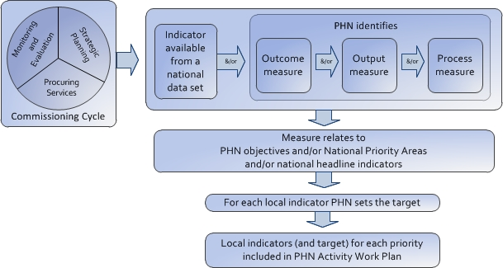

The Performance Framework gives the following guidance for determining local indicators:

* Local indicators need to cover all local activities. An indicator might cover multiple activities, and one activity might have multiple indicators.
* Where outcome indicators are either not available, or not a meaningful measure, then process or output measures can be a better option, provided there is evidence to indicate that the processes and/or outputs being measured will, in time, contribute to the achievement of the outcome that is sought.
* Interventions that (according to robust evidence) are likely to take several years to realise a health outcome (e.g. preventive health) might be better assessed through processes or outputs.
* Administrative data sets such as the Medicare Benefits Schedule (MBS) or Pharmaceutical Benefits Scheme (PBS) could contribute to an appropriate measure. A number of the indicators available from national data sets use the MBS as a data source, however PHNs may identify MBS and/or PBS based indicators, not included on this list, which may be better suited to assess the relevant local activity.
* As well as relating to specific local priorities, local indicators will also relate to:
* PHN objectives; and/or
* national priority areas; and/or
* a national headline indicator.
* Performance targets will be negotiated so as to demonstrate continuous improvement across multiple years.
* Local indicators and targets will be reviewed and revised annually in subsequent plans.
* Where a priority targets a sub-region e.g. to meet a need in a certain town or region, regional-specific indicators will be required, ideally at the Statistical Area Level 3 (SA3).
* PHNs are likely to require more specific and detailed performance information of the agencies from which they commission activity. PHNs will need to maintain a ‘line of sight’ between indicators in their contracts with commissioned agencies, and their own local indicators selected as part of the Framework.

Joint planning on performance information with LHNs may also help to establish a consistent approach, particularly in relation to common priorities such as chronic disease.

# 3. PHN Planning for commissioning 2016-18

## 3.1 Overview

The template for the plan has at its core a set of tables, in Word format. Each table asks for information on the nature of the 'activity' – including the degree of collaboration with other parties, duration and coverage, commissioning approach, performance measurement and planned expenditure. Figure 3.1 below sets out the three steps or stages in developing the plan: firstly, the descriptions of individual activities that might be included in the plan; secondly, a process for prioritisation and selection; and thirdly, reviewing and finalising the plan in its entirety.

Figure 3.1: Key steps in developing the Activity Work Plan

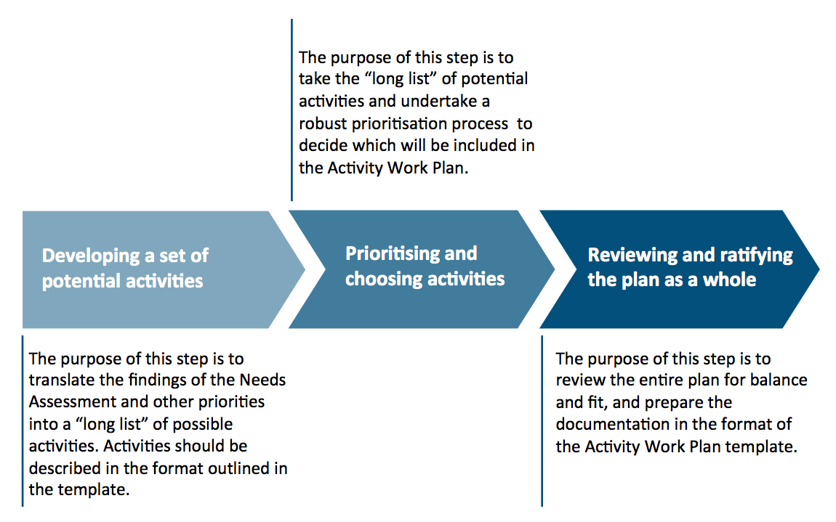

The key steps for each of these three stages is further detailed below, and the accompanying compendium of planning resources (*PHN planning in a commissioning environment – Resources*) is structured around these stages.

## 3.2 Stage 1: Developing a set of potential activities

Figure 3.2: Key steps in developing a set of potential activities

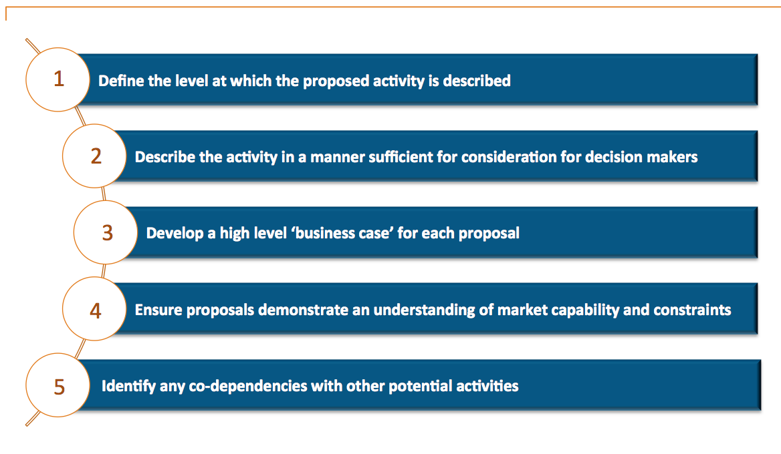

Key considerations in progressing these steps include:

* Potential activities should relate to the PHN objectives.
* Potential activities must reflect the outcome of the needs assessment.
* All potential activities are described in a consistent and comparable manner. (See Appendix 2 for examples of activity descriptions used by the former Medicare Locals.)
* In most cases the activity is to be wholly or partly commissioned. If not, the activity should clearly describe instances where that is not the caseand provide a supporting rationale.
* Performance information is in line with the guidance provided in the PHN Performance Framework. It is acknowledged that some performance indicators proposed in the plan may need to be modified on the basis of the PHN’s experience when implementing the activity.
* Careful consideration of health services funded or provided by States and Territories, and active discussion with LHNs or their equivalents. PHNs are commissioning into an existing environment, and collaboration will be important in ensuring that funding is leveraged and utilised to achieve optimal outcomes.

## 3.3 Stage 2: Priority setting and choosing activities

Figure 3.3: Key steps in priority setting and choosing activities

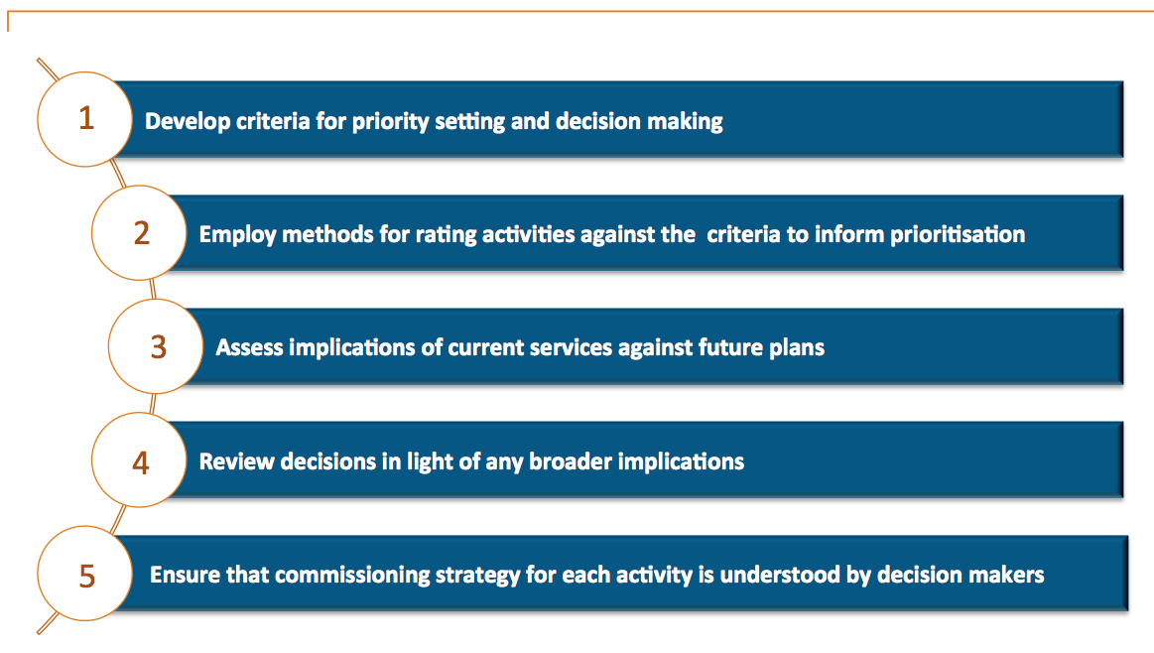

Key considerations in progressing these steps include:

* Priority setting and decision making is transparent and, where appropriate, supported by tools and evidence.
* The prioritised list of activities reflects the outcomes of the needs assessment.
* The prioritised list shows an understanding of the need to commission. Where the activity involves decommissioning, this is understood and documented, and consideration is given to the needs of those involved.
* In cases where priorities, options and opportunities that emerged from the needs assessment are not being considered, the PHN should be confident as to the reasons why, and be able to explain this to a range of stakeholders. (For example, other agencies may be the most appropriate bodies to commission/deliver these services, or there is a lack of alignment with the PHN objectives.)

## 3.4 Stage 3: Reviewing and ratifying the plan as a whole

Figure 3.4: Key steps in reviewing and ratifying the plan

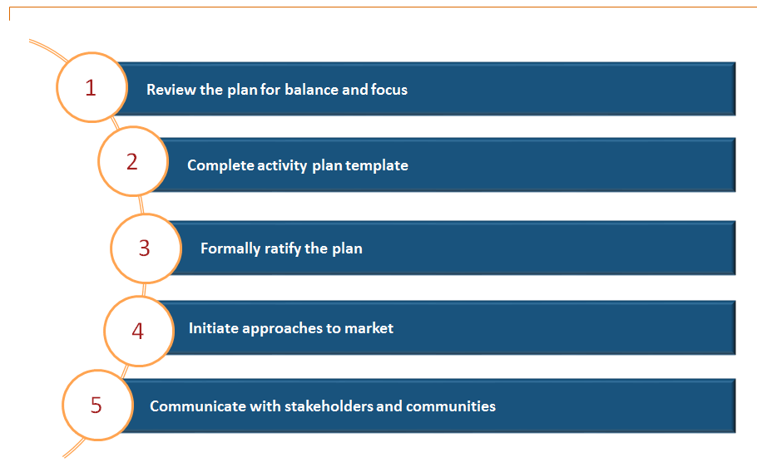

PHNs should ensure that the final plan:

* Clearly relates to the PHN objectives and reflects the outcomes of the needs assessment.
* Is balanced in order to achieve activity across a broad range of primary health care.
* Shows a level of coordination and (where possible) integration between different activities, and that dependencies between activities are recognised and capable of being coordinated.
* Demonstrates an awareness of the market, now and in the future.
* Encourages the involvement of others in service design and, where appropriate, in procurement processes.
* Identifies new areas of focus and those planned for decommissioning.

# APPENDIX I. Activity Workplan CHECKLIST

| **Requirement** | **✓** |
| --- | --- |
| Governance structures have been put in place to oversee and lead the planning process. |  |
| The plan is based on the outcomes of the needs assessment and is consistent with the PHN objectives. |  |
| Opportunities for collaboration and partnership in the development of the plan have been identified. |  |
| The validity and appropriateness of proposed performance information has been verified. |  |
| All possible potential providers have been defined and identified. This includes service providers and stakeholders that may fall outside the PHN region. |  |
| The PHN has the human and physical resources and skills required to undertake the activities identified in the plan. Where there are deficits, steps have been proposed to address these. |  |
| Formal processes and timeframes (such as a Project Plan) are in place for implementing the plan. |  |
| The PHN is able to provide further evidence to the department about any of the proposed activities if requested. |  |
| The plan clearly identifies where an activity is targeted to specific geographical regions or locations within the PHN. |  |
| There are mechanisms in place to publish and disseminate the plan and to communicate to participants and key stakeholders who were involved in the preceding needs assessment process. |  |
| There are mechanisms for ongoing monitoring and evaluation of individual activities and the plan as a whole. |  |

# APPENDIX II. Examples of activity headings

These are examples of activity headings used in previous Medicare Local plans: the intention is to provide examples of the level and manner at which the activity is described, not the content. Some activity descriptions have been edited but all retain their original intent.

| **Examples of the level of activity headings** |
| --- |
| Aged care and palliative care |
| Cancer service integration |
| Child, youth and family |
| Chronic disease management |
| Chronic disease pathways |
| Chronic disease risk factors |
| Collaborations to improve the health journey for older people with complex health needs |
| Collaborative approaches to address low levels of health literacy |
| Community Health promotion and consumer and provider literacy gap improvement |
| Community Mental Health |
| Coordinated and integrated care in chronic disease management |
| Developing patient-centred and integrated models of service |
| Early intervention and prevention services |
| Ensure local primary health care services are inclusive and accessible |
| Health pathways |
| Health promotion, prevention and early intervention |
| Healthy lifestyle programs and targeted health promotion activities for high risk populations |
| Immunisation |
| Improve access to health services in rural areas for young people |
| Improve access to appropriate health services for people with a mental illness |
| Improve alcohol and prescription medication management |
| Improve awareness of and capacity to address behavioural risk factors in community settings |
| Improve consumer and provider knowledge and awareness of available primary health care services |
| Improve coordination of care through access to a range of specialist health services for rural patients |
| Improve health connections and performance |
| Improve primary health clinicians response to low levels of health literacy |
| Improve screening and management of behavioural risk factors in the primary care setting |
| Improve the health status of older people |
| Improve the management of chronic disease through the primary care setting |
| Improved access for aged populations |
| Improved access for Culturally and Linguistically Diverse populations |
| Improving Aboriginal and Torres Strait Islander Health |
| Increase access to Mental Health services |
| Increase access to primary health care services for Aboriginal and Torres Strait Islander People |
| Increase accessibility and availability of primary health services in rural areas |
| Integrated care – model of integrated care |
| Integrated care – holistic care |
| Integrated care – referral pathways |
| Integrated health care and shared governance arrangements |
| Integrated planning and stakeholder engagement |
| Integration – Aboriginal and Torres Strait Islander health |
| Integration – chronic disease |
| Investigate and implement innovative models of care to improve the patient journey |
| Lifestyle and risk factors programs |
| Maternal and Child Health |
| Mental health coordination |
| Mental health support and integration – capability, capacity and quality improvement |
| Population health and prevention – child wellness |
| Population health and prevention – diabetes prevention and screening |
| Pregnancy and the early years |
| Residential Aged Care Facilities – capability, capacity and quality improvement |
| Sexual health – coordinated approach to primary care, education and prevention for STIs and BBVs |
| Youth service support |

# Endnotes

1. The [PHN Needs Assessment Guide](http://www.health.gov.au/internet/main/publishing.nsf/Content/PHN-Needs_Assessment_Guide) is available on the Department’s PHN website, under the Tools and Resources tab.
2. Australian Government Department of Health. [*Primary Health Networks Grant Programme Guidelines February 2016 – Version 1.2*](http://www.health.gov.au/internet/main/publishing.nsf/Content/PHN-Program_Guidelines). Section 1.7. Available on the PHN website.
3. The commissioning cycle is most commonly presented in a diagram. This diagram is based largely on that developed by the NHS Information Centre and used to support World Class Commissioning between 2000 and 2010. See the [NHS Information Centre archive](http://webarchive.nationalarchives.gov.uk/20090122034729/ic.nhs.uk/commissioning) and [Commissioning Handbook for Librarians](http://commissioning.libraryservices.nhs.uk/commissioning-cycle). Another model that is used extensively, with variations, was developed by the Institute for Public Care (IPC). First developed in 2003 and since adapted by a number of different agencies, the IPC cycle shows the relationship between strategic commissioning (the outer circle) and procurement, contracting and purchasing (the inner circle). This model follows the 4 step Plan-Do-Study-Act cycle first developed by Deming and used as the basis for many quality control and continuous improvement programs. See: Institute of Public Care. *Commissioning for Health and Social Care*. Oxford Brookes University 2014, pp.11-13. Bovaird T et al. *Commissioning across government: review of evidence*. Third Sector Research Centre Research Report 86: for the UK National Audit Office. August 2012, pp.48-49.
4. Smith J, Curry N, Mays N, Dixon J. *Where next for commissioning in the England NHS?* The Nuffield Trust and the King’s Fund 2010, p.12. Also see Øvretveit J. *Purchasing for health: a multidisciplinary introduction to the theory and practice of health purchasing*. Open University Press 1995.
5. Australian Government Department of Health. *Primary Health Networks Grant Programme Guidelines* *February 2016 – Version 1.2*.p.10.

   Unlike purchasing models, in the context of the PHN Programme, commissioning is characterised by a strategic approach to procurement that is informed by the baseline needs assessment and associated market analysis undertaken in 2015-16. Commissioning will enable a more holistic approach in which PHNs can plan and contract medical and health care services that are appropriate and relevant to the needs of their communities. Commissioning is further characterised by ongoing assessment to monitor the quality of services and ensure that relevant contractual standards are fulfilled. It is expected that PHN commissioning capabilities will continue to develop over time.
6. Some examples and possible resources on health planning include:

   * World Health Organization. [National Health Planning Tools](http://www.who.int/nationalpolicies/resources/resources_tools/en/).
   * Australian Indigenous HealthInfonet portal. [Health planning and evaluation tools](http://www.healthinfonet.ecu.edu.au/health-infrastructure/health-workers/resources/health-planning-evaluation-tools).
   * Australian College of Health Services Management [Reading Lists](https://www.achsm.org.au/Public/Education/Fellowship/Reading_lists/Public/Education_/Fellowship/Reading_Lists.aspx?hkey=c73eeb41-051a-4bc7-92d5-a32c768b5a9b)
   * The Victorian Department of Health and Human Services – Hume Region. [Health Planning Toolkit](https://www2.health.vic.gov.au/about/reporting-planning-data/health-planning-toolkit).
   * Queensland Health – [Guide to Health Service Planning 2015](https://publications.qld.gov.au/dataset/health-services-planning-guidelines-and-strategies/resource/c38be5bc-a62a-4cca-9831-23a8c3eff46d). A common guideline for integrated health service planning in Queensland.
   * South West Sydney LHD. [Health Service Planning: a guide for professionals and managers](http://www.swslhd.nsw.gov.au/planning/content/pdf/GuideHealthProfessionals.pdf).

   Recent thinking about planning and commissioning in NHS England can be found in [*Delivering the Forward View: NHS planning guidance 2016/17 – 2020/21*](https://www.england.nhs.uk/ourwork/futurenhs/deliver-forward-view/). Gateway Ref. 04437. This document looks at place-based planning and the development of ‘Local Health System Sustainability and Transformation Plans’ which are:

   a holistic pursuit of the triple aim – better health, transformed quality of care delivery, and sustainable finances… We are asking local systems first to focus on creating an overall local vision, and the three overarching questions:

   How will you close the health and wellbeing gap?

   How will you drive transformation to close the care and quality gap? and

   How will you close the finance and efficiency gap?
7. AICD. *Good governance principles and guidance for Not-for-Profit Organisations.* Australian Institute of Company Directors 2013. p.29.

   Once an organisation has decided on its purpose and related strategies, it is common practice as part of a strategic planning process to choose measures or indicators that enable the board to track progress i.e. the key performance indicators (KPIs) to measure the organisation’s performance on execution of its strategy and achievement of its purpose. In this regard, boards need to consider, with regard to the purpose of the NFP, which performance indicators are most appropriate in the organisation’s circumstances (e.g. activities undertaken, grantor requirements, etc), and which indicators should be chosen for measurement purposes. Obviously, it is very important for boards to ensure the metrics adopted are capable of being measured and understood.
8. Duckett S, Beaumont M, Bell G, Gunn J, Murphy A, Wilson R, Crowley T. [*Leading change in primary care: Boards of primary health networks can help improve the Australian health care system*](https://ahha.asn.au/sites/default/files/docs/policy-issue/leading_change_in_primary_care.pdf)*.* Copyright by authors. 2015. Chapter 4 in particular. This extract continues to say:

   Contracts should, ideally, specify key attributes of the product including volume, quality and price. Whilst the PHN executive will be primarily responsible for the writing and signing of individual commissioning contracts, the board must play a role in determining the general ‘flavour’ of the PHN’s portfolio of projects… the commissioning process provides PHNs with an opportunity to pursue their broader interests, as PHNs have the power to use their funding to alter the commissioning specifications with particular objectives in mind. It will be important, then, for the board to be clear about what these overall objectives are, and how the PHN’s overall commissioning strategy might be best tailored towards achieving them.
9. Australian Government Department of Health. [*Primary Health Networks Grant Programme Guidelines* *February 2016 – Version 1.2*](http://www.health.gov.au/internet/main/publishing.nsf/Content/PHN-Program_Guidelines). Available at the PHN website.
10. [PHN Needs Assessment Guide](http://www.health.gov.au/internet/main/publishing.nsf/Content/PHN-Needs_Assessment_Guide). p.22. The Needs Assessment Guide is available on the Department’s PHN website, under the Tools and Resources tab.
11. The Hon Sussan Ley MP. Media Release dated 11 April 2015. [*New Primary Health Networks to deliver better local care*](http://www.health.gov.au/internet/ministers/publishing.nsf/Content/health-mediarel-yr2015-ley036.htm)*.* Available at the PHN website.
12. The King’s Fund and University of Melbourne, in alliance with PricewaterhouseCoopers. *Challenges and lessons for good practice: Review of the history and development of health service commissioning*. Prepared for the Australian Government Department of Health. 2016. Section 2.5. Leadership.
13. WHO. *Everybody’s business: strengthening health systems to improve health outcomes: WHO’s framework for action*. World Health Organization 2007. pp.23-24. The WHO identifies the following as important elements of leadership and governance:

    * Policy guidance
    * Intelligence and oversight
    * Collaboration and coalition building
    * Regulation (for PHNs, as in contract management)
    * System design
    * Accountability and transparency

   
14. See the following:

    * Williams I, Bovaird T et al. *Designing whole-systems commissioning: lessons from the English experience*. Paper partially based on a report commissioned by the London Borough of Newham 2013.
    * Allcock C. *Outcomes-based commissioning – much promise, but is it something CCGs can deliver on?* The Health Foundation blog 24 Sept 2015: discussion of the recently released publication: Taunt R, Allcock C, Lockwood A. *Need to nurture: outcomes based commissioning in the NHS.* The Health Foundation 2015.
    * NHS. World Class Commissioning Competencies. Available from: http://webarchive.nationalarchives.gov.uk/+/www.dh.gov.uk/en/Managingyourorganisation/Commissioning/Worldclasscommissioning/DH_083204
    * Woodin J, Wade E. *Towards world class commissioning competency*. Health Services Management Centre School of Public Policy. University of Birmingham 2007. pp.10-14. Woodin and Wade noted that:

    a meaningful definition of competency must take into account organisational, contextual and behavioural factors, and not focus entirely on the knowledge, skills and capabilities of individuals, or particular groups of managers and clinicians.

    * Dickinson H. Commissioning public services evidence review: lessons for Australian public services. Melbourne School of Government 2015. p.17. Standards developed by the University of Birmingham. Commissioning for better outcomes: a route map. University of Birmingham, Local Governments Association and Department of Health. ‘Competency’ can be understood at both the individual and organisational level, where it might be more appropriate to talk in terms of standards.

   
15. Duckett S, Beaumont M, Bell G, Gunn J, Murphy A, Wilson R, Crowley T. *Leading change in primary care: Boards of primary health networks can help improve the Australian health care system.* Copyright by authors. Available at the [AHHA website](https://ahha.asn.au/sites/default/files/docs/policy-issue/leading_change_in_primary_care.pdf)
16. Robinson S, Dickinson H, Durrington C. *Something old, something new, something borrowed, something blue? Reviewing the evidence on commissioning and health services*. Australian Journal of Primary Health 2016: 22: 1. p.12.
17. The King’s Fund and University of Melbourne, in alliance with PricewaterhouseCoopers. *Challenges and lessons for good practice: Review of the history and development of health service commissioning*. Prepared for the Australian Government Department of Health. 2016. Section 2.2.3. Contracting for quality.
18. See: Harper I, Anderson P, McCluskey S, O’Brien M. *Competition Policy Review Final Report*. Commonwealth of Australia 2015; and Sturgess G, Cummings L. *Payment by Outcome: A Commissioner’s Toolkit*. 2020 Public Services Trust 2011.
19. This is an adaption of a point made by Dawda P, True A, Wells L*. Commissioning: perspectives from the ground.* Australian Journal of Primary Health 2016: 22: 1. p.6. The original wording is:

    It is our view that effective commissioning needs to focus even more on relational aspects, to first agree a shared purpose and then work towards achieving it.
20. Donabedian A. *Evaluating the quality of medical care.* Milbank Quarterly 1966: 44: 3 Pt 2. Reprinted 2005: 83: 4: 691-729, and Donabedian A. *The seven pillars of quality.* Archives of Pathology and Laboratory Medicine 1990: 114: 11:1115-1118. Donabedian argued that there are seven attributes of health care that define its quality and his list of non-mutually exclusive attributes was:

    *efficacy:* the ability of care, at its best, to improve health.

    *effectiveness:* the degree to which attainable health improvements are realized.

    *efficiency:* the ability to obtain the greatest health improvement at the lowest cost.

    *optimality:* the most advantageous balancing of costs and benefits.

    *acceptability:* conformity to patient preferences regarding accessibility, the patient-practitioner relation, the amenities, the effects of care, and the cost of care.

    *legitimacy:* conformity to social preferences concerning all of the above.

    *equity:* fairness in the distribution of care and its effects on health.
21. The King’s Fund and University of Melbourne, in alliance with PricewaterhouseCoopers. *Challenges and lessons for good practice: Review of the history and development of health service commissioning*. Prepared for the Australian Government Department of Health. 2016. Section 2.7. Priority setting and decision making.
22. The King’s Fund and University of Melbourne, in alliance with PricewaterhouseCoopers. *Challenges and lessons for good practice: Review of the history and development of health service commissioning*. Prepared for the Australian Government Department of Health. 2016.
23. The King’s Fund and University of Melbourne, in alliance with PricewaterhouseCoopers. *Challenges and lessons for good practice: Review of the history and development of health service commissioning*. Prepared for the Australian Government Department of Health. 2016. Section 2.7. Priority setting and decision making.
24. The King’s Fund and University of Melbourne, in alliance with PricewaterhouseCoopers. *Challenges and lessons for good practice: Review of the history and development of health service commissioning*. Prepared for the Australian Government Department of Health. 2016. Section 2.2.1 Figure 4. The following are the key questions commissioners should ask themselves drawn up by Monitor, the regulator of NHS services in England. See Monitor. *Substantive guidance on the procurement, patient choice and competition regulations.* 2013.

    What are the needs of the health care service users we are responsible for? Are those needs currently being met? Have they changed since services were last reviewed? What level of engagement with the local community, patients and patient groups, clinicians and others should we undertake?

    How good are current services? How can we improve them?

    How can we make sure that the services are provided in a more joined-up way with other services so that they are seamless from the perspective of the patient? How can we get the professionals that are responsible for different elements of a patient’s care to work together more effectively for patients?

    Could services be improved by giving patients a choice of provider to go to and/or by enabling providers to compete to provide services?

    How can we identify the most capable provider or providers of the services? Is the current provider the only provider capable of providing the services?

    Are our actions transparent? Do people know what decisions we are taking and the reasons why we are taking them? Do we have appropriate records of our decisions?

    How can we make sure that providers have a fair opportunity to express their interest in providing services? What do we need to do to make sure that we do not discriminate against any providers?

    Are there any conflicts between the interests in commissioning the services and providing them? If so, how can we manage them to make sure that they do not affect or appear to affect the integrity of the award of any contract at a later point in time?

    Are our actions proportionate? Are they commensurate with the value, complexity and clinical risk associated with the provision of the services in question and consistent with our commissioning priorities?
25. Robinson S et al. *Priority-setting and rationing in healthcare: evidence from the English experience*. Social Science and Medicine 2012: 75: 2386-2393. Also see:

    Robinson S et al. *Setting priorities in health: the challenge of clinical commissioning*. A study of English primary care trusts. Nuffield Trust 2011.

    Dickinson H, Freeman T, Robinson S, Williams I. *Resource scarcity and priority setting: from management to leadership in the rationing of health care?* Public money and Management September 2011: 363-370.

    McDonald J, Ollerenshaw A. *Priority setting in primary health care: a framework for local catchments*. Rural and Remote Health 2011: 11: 1714.
26. Mooney G et al. *Priority-setting methods to inform prioritisation: a rapid review*. An evidence check review brokered by the Sax Institute for the NSW Treasury and the Agency for Clinical Innovation 2012. This reviewed the following:

    * PBMA (including the associated use of option appraisal, multi-criteria decision analysis and multiple attribute analysis)
    * QALY league tables
    * Needs assessment, cost of illness and burden of disease
    * Target setting
    * Core and ‘non-core’ services
    * Generalised cost effectiveness
    * Other approaches (Accounting for reasonableness and Swedish priority setting)

   
27. Dickinson H. *Commissioning public services evidence review: lessons for Australian public services.* Melbourne School of Government 2015. p.15.
28. The King’s Fund and University of Melbourne, in alliance with PricewaterhouseCoopers. *Challenges and lessons for good practice: Review of the history and development of health service commissioning*. Prepared for the Australian Government Department of Health. 2016 Section 2.7.5. Stakeholder engagement.
29. UK National Audit Office. [Decommissioning Toolkit](http://www.nao.org.uk/decommissioning/)
30. Australian Government Department of Health. *Primary Health Networks Grant Programme Guidelines February 2016 – Version 1.2*. Section 1.7.
31. Australian Government Department of Health. [*Primary Health Networks Grant Programme Guidelines February 2016 – Version 1.2*](http://www.health.gov.au/internet/main/publishing.nsf/Content/PHN-Program_Guidelines). Section 1.7.