# A commissioning overview in the PHN context

## What is commissioning and how does it work?

Commissioning is a continual and iterative cycle involving the development and implementation of services based on needs assessment, planning, co-design, procurement, monitoring and evaluation. Commissioning encompasses this full range of activities, not simply the procurement of services.

An overarching PHN commissioning framework (Figure 1, below) has been developed to help PHNs ensure that their commissioning approaches are consistent with the approach adopted for the PHN Program. PHN commissioning approaches should result in consistent, comparable and measurable outputs and outcomes, and should support PHNs to realise their own local vision. This framework and supporting PHN commissioning resources are available on the [Department’s PHN website](http://www.health.gov.au/phn) at www.health.gov.au/phn.

Figure 1: PHN Commissioning Framework

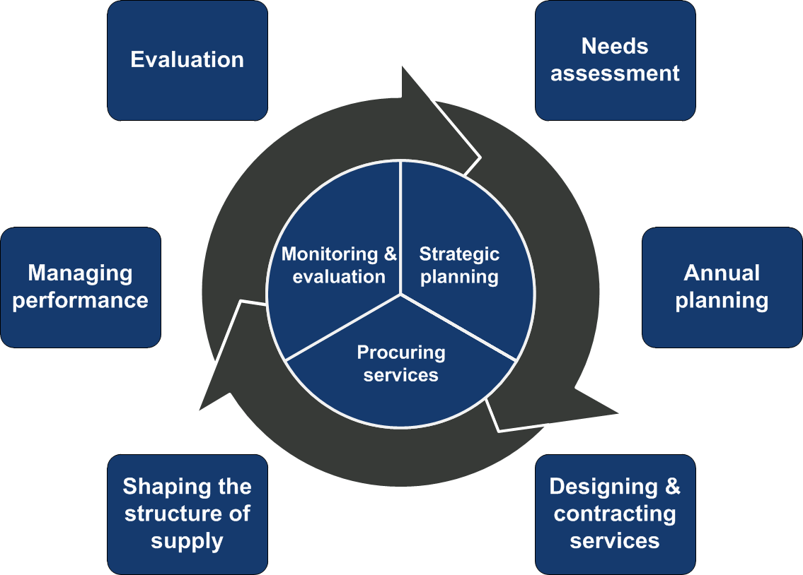

On the basis of needs assessment and prioritisation, PHNs as commissioners decide which services or health care interventions should be provided or which outcomes need to be secured, who should provide them and how they should be paid for, and often work closely with providers to do this.

As commissioners, PHNs also have a role in supporting the development of markets so that they are sustainable, and provide scalable solutions that leverage local workforces. PHNs need to ensure that in partnership with stakeholders and providers, they can appropriately support local primary health care needs.

## Key features and benefits of a PHN commissioning approach include:

* Better understanding the needs of local populations.
* Encouraging the bringing together of different data sources (including through stakeholder consultation) to provide a richer view of present and future health needs, which supports better integration across care sectors and settings.
* Encouraging a greater focus on outcomes that matter to patients and communities.
* Putting patients and communities at the centre so that care is organised and delivered around them. This supports better integration and coordination of care, and better outcomes.
* Working in partnership with stakeholders, providers and service users (as practicable) in the design, funding and delivery of services. This includes PHNs engaging with potential providers well in advance of procuring services, where feasible.
* Procuring and contracting for services to achieve value for money using open and transparent processes that reflect the scale and scope of the procurement.
* Identifying what works and changing what does not, so that resources can be invested to maximise impact.
* Working with contracted providers to monitor and evaluate provider progress and impact.

## What does commissioning mean for providers?

The relationship between PHNs and providers is moving towards being more partnership focused, with PHNs and providers working together to:

* identify how the primary health care needs of local populations can be best addressed through the existing health care market, and the various activities and services supported by the PHN;
* collaborate with a broader range of stakeholders in the design of new and innovative services that are culturally safe, competent and appropriate;
* identify opportunities to introduce new and innovative approaches;
* identify opportunities to commission for outcomes; and
* collect and analyse data, monitor progress and evaluate the impact or outcomes of the commissioned service or activity.

One of the changes that providers will notice is an increase in opportunities to connect with PHNs in a range of areas relating to better understanding local health needs. This sharing of ideas is a key element of commissioning. More broadly, this means that PHNs will be encouraging providers to:

* continue to work collaboratively and openly with them;
* be increasingly open in discussing their views, insights and ideas;
* participate in discussions that go beyond those that occur during a formal procurement process, for example, participate in design and planning of services;
* be prepared to work collaboratively with other stakeholders to benefit consumers and to build towards the achievement of desired outcomes;
* share data to support continuous improvement; and
* be open to new and innovative ways of funding, delivering and monitoring services, within the parameters of the PHN Funding Agreements and the PHN Grant Programme Guidelines.

Successfully embedding a commissioning approach will take time as PHNs and providers continue to develop their relationships and how they work together. Similarly, new ways of working will require new skills and capabilities from those involved.

Acknowledgement

This document has been developed by the Australian Government Department of Health and PwC as part of a project funded by the Department to develop guidance, tools and training for Primary Health Networks (PHNs) on commissioning. It has been co-designed with PHNs through the PHN Commissioning Working Group and the relevant sub-group and informed by interviews with, and case studies from, some PHNs.

The active contribution of the PHNs in the development of this guidance is appreciated.

Contributions from Helen Dickinson, Associate Professor Public Service Research and Director Public Services Research Centre, University of New South Wales, Canberra have provided insight on the commissioning evidence base.

© Commonwealth of Australia 2018. Updated March 2019.

This work is copyright. You may download, display, print and reproduce the whole or part of this work in unaltered form for your own personal use or, if you are part of an organisation, for internal use within your organisation, but only if you or your organisation do not use the reproduction for any commercial purpose and retain this copyright notice and all disclaimer notices as part of that reproduction. Apart from rights to use as permitted by the Copyright Act 1968 or allowed by this copyright notice, all other rights are reserved and you are not allowed to reproduce the whole or any part of this work in any way (electronic or otherwise) without first being given the specific written permission from the Commonwealth to do so. Requests and inquiries concerning reproduction and rights are to be sent to the Communication Branch, Department of Health, GPO Box 9848, Canberra ACT 2601, or via e-mail to [copyright@health.gov.au](mailto:copyright@health.gov.au).

In regards to copyright, PHNs have authorisation to download, display, print and reproduce the whole or part of this work in unaltered form for use within their organisations, but only if they do not use the reproduction for any commercial purpose and retain this copyright notice and all disclaimer notices as part of that reproduction.

Preferred citation: Australian Government Department of Health. (2018). *A commissioning overview in the PHN context.* Available at: http://www.health.gov.au/internet/main/publishing.nsf/Content/PHNCommissioningResources

Disclaimer

Opinions expressed in this document are those of the authors and not necessarily those of the Australian Government Department of Health. Data may be subject to revision.

Note

## This document does not override the requirements set out in the PHN Funding Agreement.