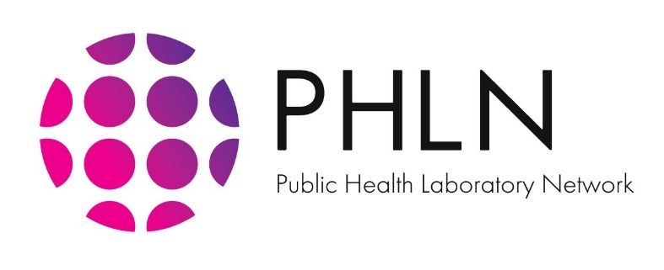

Monday, 7 June 2021

**PHLN STATEMENT ON USING SALIVA AS A RESPIRATORY SPECIMEN FOR SARS-CoV-2 TESTING**

Diagnostic testing for SARS-CoV-2 is central to detecting new and emerging outbreaks. It is also a key pillar in controlling the COVID-19 pandemic. In Australia, the gold standard test for diagnosing acute SARS-CoV-2 infection is nucleic acid amplification (NAA) testing using real time reverse transcription polymerase chain reaction (RTPCR). This test method is very sensitive and detects nucleic acid sequences specific to the virus. Diagnostic testing for SARS-CoV-2 requires the collection of a respiratory specimen via:

* nasopharyngeal swab; or
* combined throat and bilateral deep nasal swab; or
* in severe cases, sputum.

PHLN continues to monitor and evaluate emerging testing technology, to improve Australia’s COVID-19 response. This includes exploring saliva specimens for RTPCR testing.

PHLN notes that some countries with a high prevalence of COVID-19 have used saliva for routine diagnostic testing. However, Australia’s COVID-19 disease prevalence remains low and its epidemiological situation is unique. This difference in prevalence may adversely impact test performance. PHLN does not advise routine use of saliva for diagnostic testing in adults or children, except in specific situations, due to the lower performance of the test. Saliva may be useful for screening purposes (when testing is repeated daily or every few days), where regular nasopharyngeal sampling is unacceptable. Workers in quarantine settings are an example where saliva is used as part of a regular repeat testing surveillance mode.

PHLN note that some early validation studies on the use of saliva specimens internationally and in Australia[1][2][3][4] show promising results. However, different collection and testing methods used in these studies makes it difficult to generalise about performance and effectiveness. Assessment of each different method is required.

Noting the current evidence, PHLN considers the potential advantages of saliva for SARS-CoV-2 RTPCR testing are:

* it is minimally invasive and can be reliably self-collected under an approved health professional’s supervision;
* it reduces the infection risk to health care workers and minimises the demand for personal protective equipment;
* it is likely, and in some settings proven, to be more acceptable to people, particularly those undergoing repeated testing.[5]

However, a recent systematic review and meta-analysis found a lower rate of identifiying positive results when testing saliva.[6] Test performance was further reduced when using saliva specimens collected 7 days or more after symptom onset.6 Much remains unknown about RTPCR test sensitivity for:

* different specimen collection methods;
* differences in processing protocols; and
* testing different populations (children vs. adult and late vs. early in disease course).

In Australia, in vitro diagnostic medical devices (IVDs) must be approved for use by the Therapeutic Goods Administration (TGA). Currently, few registered SARS-CoV-2 IVDs list saliva as a specimen type in the manufacturers’ instructions for use (IFU).

**Current Status**

On 17 November 2020, the Australian Health Protection Principal Committee (AHPPC) published a statement recommending the regular testing of workers in COVID-19 quarantine and isolation settings. As a result, jurisdictions implemented frequent testing of quarantine facility workers and health care workers who are at an increased risk of exposure to SARS-CoV-2. Most states and territories introduced screening programs using saliva as the preferred specimen. These specimen are subsequently sent for laboratory-based RTPCR testing.

In these cases, workers must give a saliva sample once per shift. This testing program is considered appropriate for screening purposes in asymptomatic individuals. If the test results are positive or unclear, an a combined throat and bilateral deep nasal (or nasopharyngeal) specimen is required for RTPCR diagnostic testing. Since starting screening programs using saliva, PHLN laboratories have encountered some constraints. These are outlined below. Referring healthcare personnel must consider these.

Resource limitations

1) Clinical performance of saliva as a specimen is difficult to assess, due to low SARS-CoV-2 prevalence.Assay validation will remain an issue while SARS-CoV-2 prevalence remains low. Pathologist advice should be sought on specimen collection methods which are not included in an IVD’s IFU. For example, advice should be sought when using a specimen type that has not been validated by the manufacturer for use with the device.

2) Global demand has caused a shortage of swabs used for saliva, and for other testing. As a result, some laboratories are experiencing difficulty in maintaining a supply of swabs validated for saliva collection.

Lower specimen sensitivity

1) Much remains unknown about the sensitivity of RTPCR test when using saliva specimen. In Australia’s saliva screening program, a lower sensitivity has been observed when testing saliva. 6 However, both published and emerging modelling studies 6,7 provide evidence that regular repeated screening of an individual using a less-sensitive test may offset limits to test sensitivity, such as reducing the risk of delayed or missed recognition of a true-positive infection.

Additionly, higher cycle threshold values when conducting RTPCR tests on saliva specimens have been observed. This may impact on the time to reach diagnosis.

To give further confidence that a case is not missed, saliva screening may be supplemented with a combined throat and bilateral deep nasal (or nasopharyngeal) at regular intervals, for example, weekly. In addition, individuals must be tested using combined throat and bilateral deep nasal (or nasopharyngeal) as soon as symptoms emerge consistent with COVID-19.

2) In self-collected samples, the collection protocol must be followed.

6 Lee RA et al. Performance of Saliva, Oropharyngeal Swabs, and Nasal Swabs for SARS-CoV-2 Molecular Detection: A Systematic Review and Meta-analysis. J Clin Microbiol. 2021 Jan 27

7 Larremore DB, Wilder B, Lester E, Shehata S, Burke JM, Hay JA, Tambe M, Mina MJ, Parker R. 2020.Test sensitivity is secondary to frequency and turnaround time for COVID-19 surveillance. medRxiv. DOI: https://doi.org/10.1101/2020.06.22.20136309

8 Mina MJ, Parker R, Larremore DB. Rethinking Covid-19 Test Sensitivity–A Strategy for Containment. 2020. N Engl J Med. 383(22):e120. DOI: 10.1056/NEJMp2025631.

1. Khurshid, Z., Zohaib, S., Joshi, C., Moin, S., Zafar, M. and Speicher, D. (2020). *Saliva as a non-invasive sample for the detection of SARS-CoV-2: a systemic review.* medRxiv. Doi: 10.1101/2020.05.09.20096354.
2. Azzi, L. Carcano, G., Gianfangna, F. et al., *Saliva as a reliable tool to detect SARS-CoV-2*, Journal of Infection. Doi: 10.1015/jinf.2020.04.005
3. To, K., Tsang, O., Leung,. W., Tam, W., Wu, T., Lung, D. et al. *Temporal profiles of viral load in posterior oropharyngeal saliva samples and serum antibody responses during infection by SARS-CoV-2: an observational cohort study*. The Lancet Infectious Diseases. Doi: 10.1016/S1473-3099(20)30196-1.
4. Williams, E., Bond, K., Zhang, B., Putland, M. and Williamson, D. A. (2020). *Letter to the Editor: Saliva as a non-invasive specimen for detection of SARS-CoV-2*. Journal of Clinical Microbiology. Doi: 10.1128/JCM.00776-20.
5. Valentine-Graves M, Hall E, Guest J, et al. At-home self-collection of saliva, oropharyngeal swabs and dried blood spots for SARS-CoV-2 diagnosis and serology: post-collection acceptability of specimen collection process and patient confidence in specimens. Preprint. medRxiv. 2020;2020.06.10.20127845. Published 2020 Jun 12. doi:10.1101/2020.06.10.20127845
6. Compared to nasopharyngeal or combined throat and bilateral deep nasal specimens