National framework for advance care planning documents

May 2021

Acknowledgements

The *National framework for advance care planning documents* was prepared by Nous Group Pty Ltd. The extensive consultation process involved considerable input from key stakeholders and representatives from all jurisdictions. The work undertaken by Nous and all contributors to the development of the Framework is recognised and appreciated.

Contents

Acknowledgements 1

Contents 2

Foreword 1

1 Overview of the Framework 2

2 Intent of key terms 3

3 Introduction 6

3.1 Advance care planning is one way of recognising that illness, death and dying are normal parts of life 6

3.2 The purpose of the Framework is to provide principles-based information about considering, developing and enacting advance care planning documents in a nationally consistent way 7

3.3 Framework implementation considerations 8

4 The Framework considers advance care planning in three iterative stages 9

4.1 Having the advance care planning conversation 9

Advance care planning can occur early and often 10

4.2 Making an advance care planning document 11

Decision-makers can assist an individual through supported decision-making and make substitute decisions if an individual loses capacity 13

4.3 Accessing and enacting an advance care planning document 13

5 Ethical considerations 14

5.1 Having the advance care planning conversation 14

5.2 Making an advance care planning document 15

5.3 Accessing and enacting an advance care planning document 16

6 Best-practice principles 18

6.1 Having the advance care planning conversation 18

6.2 Making an advance care planning document 20

6.3 Accessing and enacting an advance care planning document 22

Appendix A Stakeholders consulted 26

Appendix B Relevant state and territory legislation 27

Appendix C Checklist for Advance Care Directives 29

Appendix D Useful resources 30

Education and information about advance care planning 30

National implementation guides for advance care planning 31

National implementation guides for My Health Record in different settings 31

Guidelines on supported decision-making 31

Appendix E This Framework builds on the 2011 National Framework for Advance Care Directives 32

Foreword

Australians are – on average – living longer than at any other point in history. Every day, medical advances are presenting new options to prevent, manage, or cure illness and more people are living through conditions that would have been fatal in the past. These medical advances continue to provide Australians with an increasing number of options for future care, making advance care planning more important than ever.

Advance care planning is based on the fundamental principles of self-determination, dignity and the avoidance of suffering and is integral for delivering person-centred care. Health and illness are not a linear process and individuals at all stages of life may want to think about their future health and personal care decisions and begin the advance care planning process (or revise their documented preferences) at any time.

The National framework for advance care planning documents represents the commitment of the Australian and state and territory governments to support all people to consider and provide direction on their future care, if they choose to do so. The Framework outlines ethical considerations and best practice principles which will support uptake of a shared language and common approach to advance care planning and provide a pathway toward mutual recognition of Advance Care Directives across state and territory borders.

The Framework builds on the National Framework for Advance Care Directives released in 2011 and reflects the many changes that have taken place in our landscape over the past 10 years. It has been developed through extensive consultation with the Australian, state and territory health departments, health practitioners, universities, peak bodies and community organisations as well as public submissions. We thank the many people who contributed to its development.

*Endorsed by Health Chief Executives Forum*

# Overview of the Framework

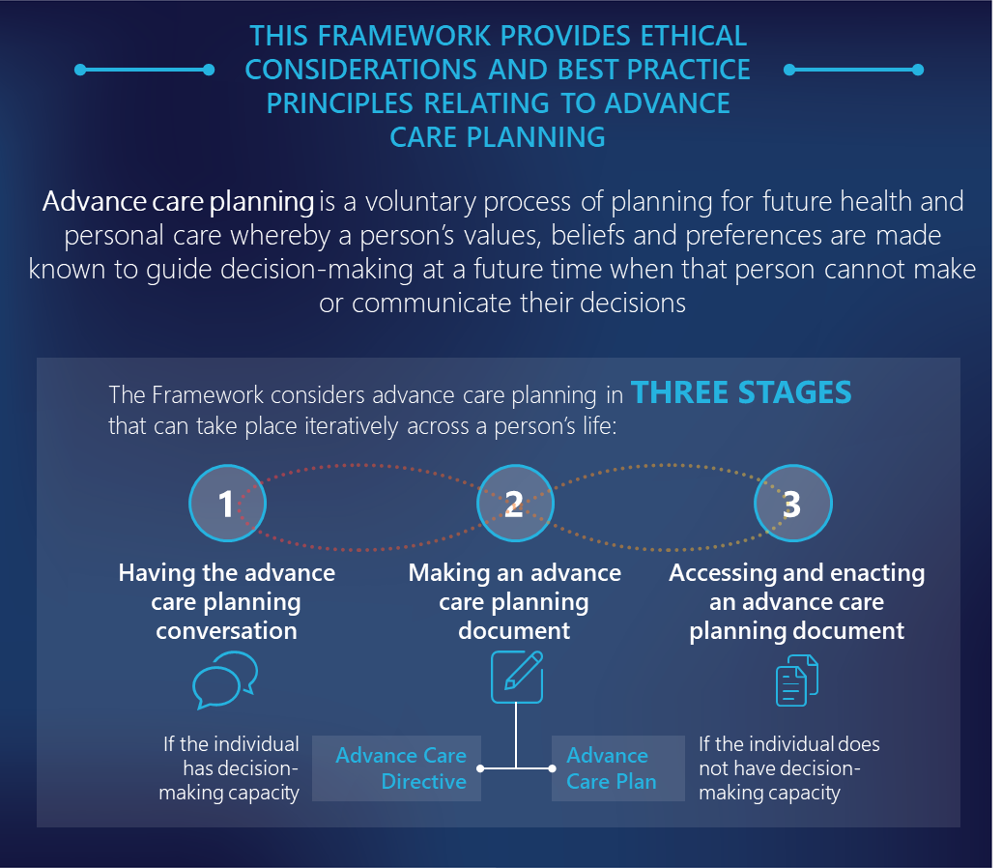

# Intent of key terms

Terminology regarding advance care planning varies across jurisdictions.

Table 1 provides an overview of key terms used in this document.

Table 1 | Key terms used in this Framework

| Key term | Description |
| --- | --- |
| Advance Care Directives  Including, but is not limited to: Advance Care Directives, Advance Health Directive, Statement of Choices – Competent Person, Advance Personal Plan, Health Direction, Enduring Powers of Attorney, Enduring Guardian, Medical Treatment Decision-Maker or any other similar Advance Care Directives in legislation. | Advance Care Directives is used in this Framework as a catch-all term to refer to the instruments which are recognised in each jurisdiction under advance care directive legislation or common law.  They are voluntary, person-led documents completed and signed by a competent person that focus on an individual’s values and preferences for future care decisions, including their preferred outcomes and care. Advance Care Directives are recognised by specific legislation (statutory) or under common law (non-statutory). They come into effect when an individual loses decision-making capacity.  Advance Care Directives can also appoint substitute decision-makers who can make decisions about health or personal care on the individual’s behalf. Advance Care Directives are focused on the future care of a person, not on the management of his or her assets. |
| Common law (non-statutory) Advance Care Directive: a structured document that is completed and signed by a competent adult and that is not a legislated statutory document.  This includes:   * a document completed and signed by a competent person in a jurisdiction which does not have legislation authorising an Advance Care Directive regarding preferences for care (that is, New South Wales and Tasmania) * an instruction or directive completed and signed by a competent person, in a jurisdiction with advance care planning legislation, but where the document does not comply with the requirements set out in this legislation and is recognised instead by common law. |
| Statutory Advance Care Directive: a signed document that complies with the requirements set out by a jurisdiction’s legislation. |
| Advance Care Plan[1]  Including but not limited to: Advance Care Plans, Statements of Choice; Statement of Choices – No Legal Capacity | Documents that capture an individual’s beliefs, values and preferences in relation to future care decisions, but which do not meet the requirements for statutory or common law recognition due to the person’s lack of competency, insufficient decision-making capacity or lack of formalities (such as inadequate person identification, signature and date).  An Advance Care Plan for a non-competent person is often very helpful in providing information for substitute decision-makers and health practitioners and may guide care decisions but are not legally binding.  An Advance Care Plan may be oral or written, with written being preferred. A substitute decision-maker named in an Advance Care Plan is not a statutory appointment. |
| Advance care planning | A process of planning for future health and personal care whereby the person’s values, beliefs and preferences are made known to guide decision-making at a future time when that person cannot make or communicate their decisions.  Registered and non-registered health practitioners have a role in advance care planning and require capability to facilitate these conversations effectively. The National Quality Standards for aged care, general practice and health services all promote advance care planning. Individuals can also choose to engage in advance care planning with other non-health practitioners, such as friends or family. |
| Advance care planning documents | A catch all term to include documents that result from advance care planning. This includes Advance Care Directives and Advance Care Plans. |
| Advance care planning legislation | A catch all term to refer to jurisdictional legislation that promotes advance care planning. Legislation, including, but not limited to Advance Care Directives, medical treatment decisions, guardianship and administration, advance personal planning and medical treatment. |
| Capacity | The ability to make a decision for oneself.  Decision-making capacity can be assessed by trained professionals, and its assessment depends on the type and complexity of the decision to be made.  Capacity assessment does not assess whether the decision is considered “good” or “bad” by others such as health practitioners or family, but rather considers the person’s ability to make a decision and comprehend its implications.  Generally, when a person has capacity to make a particular decision they can do all of the following:   * understand and believe the facts involved in making the decision * understand the main choices * weigh up the consequences of the choices * understand how the consequences affect them * make their decision freely and voluntarily * communicate their decision.   By default, people are assumed to have capacity, unless there is evidence to the contrary. |
| Comprehensive care plan  Including but not limited to: clinical care plans, clinical pathway, or medical order | A document or electronic view which describes agreed goals of care, and outlines planned medical, nursing and allied health activities for a patient. Comprehensive care plans reflect shared decisions made with patients, carers and families about the tests, interventions, treatments and other activities needed to achieve the goals of care. The content of comprehensive care plans will depend on the setting and the service that is being provided and may be called different things in different health organisations. For example, a care or clinical pathway for a specific intervention may be considered a comprehensive care plan.  A comprehensive care plan is different to an Advance Care Directive. While an Advance Care Directive is completed by an individual and recognised within legislation, a comprehensive care plan is written by health practitioners together with the individual through shared decision-making (wherever possible). It is appropriate that comprehensive care plans be put in place whether or not the person has made an Advance Care Directive or Advance Care Plan, but when there is an existing document that records directions about care, the comprehensive care plan complements, and therefore should be informed by, the person’s documented preferences. |
| Competency | Competency is a legal term used to describe the mental ability required for an adult to perform a specific task. Competency is recognised in legislation and in common law as a requirement for completing a legal document that prescribes future actions and decisions, such as a will or an Advance Care Directive.  A person is deemed to be either competent or not competent – there are no shades of grey. Competency must be assumed unless there is evidence to suggest otherwise. |
| Decision-making | Contemporaneous decision-making: a decision made in the present time. Individuals with competency and capacity may make contemporaneous decisions about their care and these may differ from those decisions recorded in an Advance Care Directive. Contemporaneous decisions should be respected foremost. |
| Substitute decision-maker: (also known as surrogate decision-makers): A collective term for a person appointed or identified by law to make substitute decision(s) on behalf of a person whose decision-making is impaired. A substitute decision-maker may be appointed by the person, appointed for (on behalf of) the person, or identified as the default decision-maker within legislation. Substitute decision-makers listed in Advance Care Directives are statutory appointments. Substitute decision-makers listed in Advance Care Plans are not. |
| Substitute decision-making: Decisions made by an appointed decision-maker on behalf of the individual, whose decision-making capacity is impaired. |
| Supported decision-making: the process of enabling a person who requires decision-making support to make, and/or communicate, decisions about their own life. The decision-making is supported, but the decision is theirs. |
| Goals of care | Clinical and other goals or a patient’s episode of care that are determined in the context of a shared decision-making process.  Goals of care may change over time, particularly as the patient enters the terminal phase and during end-of-life care.  Medical goals of care may include attempted cure of a reversible condition, a trial of treatment to assess reversibility of a condition, treatment of deteriorating symptoms, or the primary aim of ensuring comfort for a dying patient.  Non-medical goals of care articulated by the person may include returning home or reaching a particular milestone, such as participating in a family event.  Goals of care documents are different to Advance Care Directives. Goals of care are completed by medical practitioners but should align with the preferred health outcomes and treatment decisions made by the individual (to the capacity they have to participate in shared decision-making). The person may or may not have previously completed an Advance Care Directive. Where an Advance Care Directive has been completed, and the individual no longer has decision-making capacity, the goals of care should reflect the Advance Care Directive, and should include a discussion with the person’s substitute decision-maker. |
| Health practitioners | In this Framework, health practitioners include registered professionals such as medical, nursing and paramedicine and non-registered professionals who provide care including social workers and care workers. |

# Introduction

A note about the intended audience of this Framework

The intended audience of the Framework includes:

* policymakers and regulators, including legislators and policymakers in governments and parliaments
* administrators of advance care planning programs in the health and aged care sectors.

While the Framework can be used by anyone, health practitioners and consumers are not intended as the primary audience.

## Advance care planning is one way of recognising that illness, death and dying are normal parts of life

More than ever before, Australians are taking steps to consider their future care and what is important to them in terms of their health and wellbeing.

In reality, many individuals will also go through periods where they are unable to make informed decisions for themselves in the moment, such as during chronic illness, a sudden injury, cognitive decline, periods of acute mental illnesses or other times when their competency levels are fluctuating.

Advance care planning is a voluntary and beneficial process, in which individuals can think and plan for their future care; that is, care that is required during periods where they cannot make contemporaneous decisions for themselves. It can bring to light an individual’s values, beliefs and preferences, including:

* what characterises acceptable or non-acceptable health outcomes for each person
* who should be involved in making decisions about an individual’s care
* what are the types of medical responses they would like for different stages of wellness or illness
* what are the individual’s preferred care, or carer arrangements.

Advance care planning is the context in which future care is discussed. Advance care planning can occur at any time, including when an individual is in full health. It may be an iterative conversation, where an individual’s values, beliefs and preferences change and evolve over time. It might also coincide with a conversation about setting goals of care. Conversations are valuable in their own right however the completion of an advance care planning document may provide important information to inform future care decisions.

Advance care planning is therefore the embodiment of person-centred care and is based on fundamental principles of self-determination, dignity and the avoidance of suffering. In addition to better outcomes for the individual, advance care planning supports health practitioners and the wider health system to provide person-centred care.

This Framework is designed to support increased awareness and uptake of advance care planning which would see more people in Australia preparing, using and maintaining advance care planning documents.

## The purpose of the Framework is to provide principles-based information about considering, developing and enacting advance care planning documents in a nationally consistent way

This Framework recognises the value of advance care planning conversations and the importance of an individual’s values, beliefs and preferences being made known and honoured.

The Framework preferences the use of Advance Care Directives for individuals with decision-making capacity and promotes consistency and mutual recognition of Advance Care Directives across state and territory borders.

The Framework recognises that Advance Care Directives may not be appropriate or desirable to everyone (for example, where individuals may have diminished decision-making capacity). In such cases, Advance Care Plans are a valuable source of information to inform future care decisions. The Framework calls out where ethical considerations and best practice principles apply equally across both types of advance care planning documents.

Policy makers and administrators are encouraged to use this Framework to support the development and storage of quality records of individuals’ values and preferences – in whatever form is most appropriate – so that these can be accessed and enacted when they matter most.

Future care decisions for those with a loss of decision-making capacity is governed by different legislative instruments or policies in each Australian jurisdiction. At the time of writing, the Australian Capital Territory, Northern Territory, South Australia, Queensland, Victoria and Western Australia all have advance care planning legislation for documenting preferences of care, while New South Wales and Tasmania operationalise Advance Care Directives for preferences of care according to policy and common law. Common law (non-statutory) Advance Care Directives are also recognised in all jurisdictions, with the exception of Queensland. All jurisdictions have legislation and statutory forms to recognise and appoint one or more substitute decision-maker(s).

The differences in advance care planning legislation creates inconsistencies in terminology, forms, content, formalities and witnessing requirements of Advance Care Directives which may be affecting the awareness and uptake of advance care planning and enactment of Advance Care Directives throughout Australia. For example:

* There are challenges relating to the low uptake of Advance Care Directives, particularly for members of vulnerable populations, including the aged or frail, and those from Aboriginal and Torres Strait Islander or culturally and linguistically diverse backgrounds.
* There is some ambiguity around the legal requirements to enact an Advance Care Directive made in another state or territory. The lack of mutual recognition is problematic for an increasingly mobile population who may not be in the jurisdiction in which an Advance Care Directive was created, when needed.
* There are barriers for organisations that operate in multiple jurisdictions (such as private health services and aged care facilities) who use standard Advance Care Directives or Advance Care Plan templates that may not satisfy local legislative requirements or best practice.

This Framework supersedes the “National Framework for Advance Care Directives” published in 2011 (see Appendix E for key background on this revision). It proposes ethical considerations and best-practice principles that relate to considering, developing and enacting Advance Care Directives. Should these elements be reflected into states’ and territories’ legislative framework and policy, it would promote consistency and mutual recognition of quality Advance Care Directives. In turn, this upholds the recognition of an individual’s documented values, beliefs and preferences, ensuring they can be acted upon anywhere in Australia.

The Framework may be used to:

* inform legal and policy reform to develop shared language and a consistent approach to advance care planning documents used by all jurisdictions
* inform the development of guidance, procedures and protocols at a service level
* inform the design of Advance Care Directive forms to facilitate the enactment of quality documentation.

The Framework is not intended to be used as an operational or practice document.

## Framework implementation considerations

To meaningfully implement this Framework, jurisdictional policymakers and health and aged care administrators should consider the following strategies and activities:

* how community understanding and uptake of advance care planning can be increased
* what policy and legislative changes are required to adhere with best-practice advance care planning, as outlined in this Framework
* what system enablers and workforce capability uplift (for both registered and non-registered health workers) is required to improve the quality of advance care planning documents and their implementation
* what systems, processes and education are required to improve storage and access of all advance care planning documents
* how can the uptake and use of quality advance care planning documents be accurately measured and monitored
* how to increase health practitioner and administrator confidence in legal protections for enactment of Advance Care Directives.

# The Framework considers advance care planning in three iterative stages

To ensure that ethical considerations and best practice principles that inform advance care planning legislation, policy and implementation are comprehensively applied, it is helpful to consider the typical stages an individual may go through during their advance care planning journey (noting that these may be iterated across an individual’s lifetime). Subsequent sections on ethical considerations and best-practice principles are divided according to these stages. Figure 1 summarises the three stages of advance care planning used in the Framework.

Figure 1 | The 3 iterative stages of advance care planning

Figure 1 shows 3 iterative stages of  advance care planning. These are:
1. Having an advance care planning conversation
2. Making an advance care plan (in a document)
3. Accessing and enacting an advance care plan document


## Having the advance care planning conversation

Stage 1 refers to the period in time in which individuals are considering their future care and how they want to communicate their values, beliefs and preferences.

Advance care planning is about understanding what is important to the individual. Over the last decade, the concepts of self-determination, autonomy and dignity have become increasingly embedded in the Australian health care system. Concurrently, the profile of advance care planning has also increased as professionals and consumers alike have begun to recognise that advance care planning is not limited to palliative and/or end-of-life care.

Advance care planning is therefore an opportunity for individuals to think about their future care and consider what is important to them. Advance care planning should be considered as a process rather than an event, and the culmination of conversations can lead to several possible outputs, including a:

* conscious decision not to make decisions about future care, or a decision to allow other people to make choices about future care in the absence of any type of recorded instructions
* decision to complete or update an Advance Care Directive for preferences of care and/or appointment of a substitute decision-maker, or
* decision to complete or update an Advance Care Plan outlining what is important to the individual to inform their future care decisions, or directions on treatment or other care options the individual would like honoured.

### Advance care planning can occur early and often

Figure 2 shows an individual’s life course. Health and illness are not a linear process and advance care planning should not be reserved only for the end-of-life period. Rather, individuals can think about their future health and personal care decisions and begin the advance care planning process at any time. Common triggers include:

* proactive future planning, such as advance care planning that is concurrent to financial or estate planning during periods of good health
* diagnosis of a life-limiting illness
* diagnosis of a chronic condition
* involvement in someone else’s advance care planning process
* routine health checks for older individuals, part of a chronic disease assessment and prior to admission for aged care services
* beginning palliative care
* beginning end-of-life care
* the advent of new medical technologies or treatments
* a change in family dynamic such as birth, death, marriage or separation
* the illness or death of a loved one
* experience of health care during a period of diminished capacity.

Figure 2 | Individuals may consider advance care planning at any point in time, including in response to certain triggers

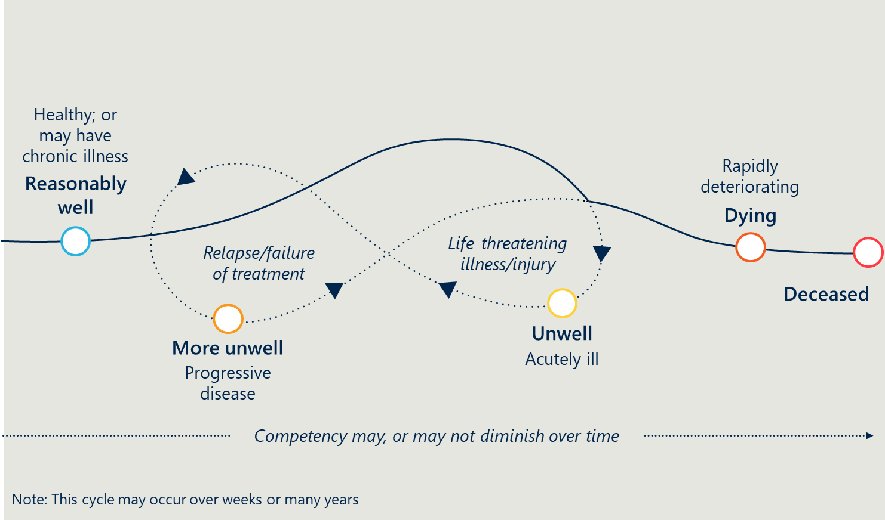

## Making an advance care planning document

As Figure 3 shows, an individual’s values and preferences might be captured in a number of different documents, including Advance Care Directives, Advance Care Plans, Comprehensive Care Plans and Goals of Care documents.

Figure 3 | Documents that might contain information about an individual’s future care preferences

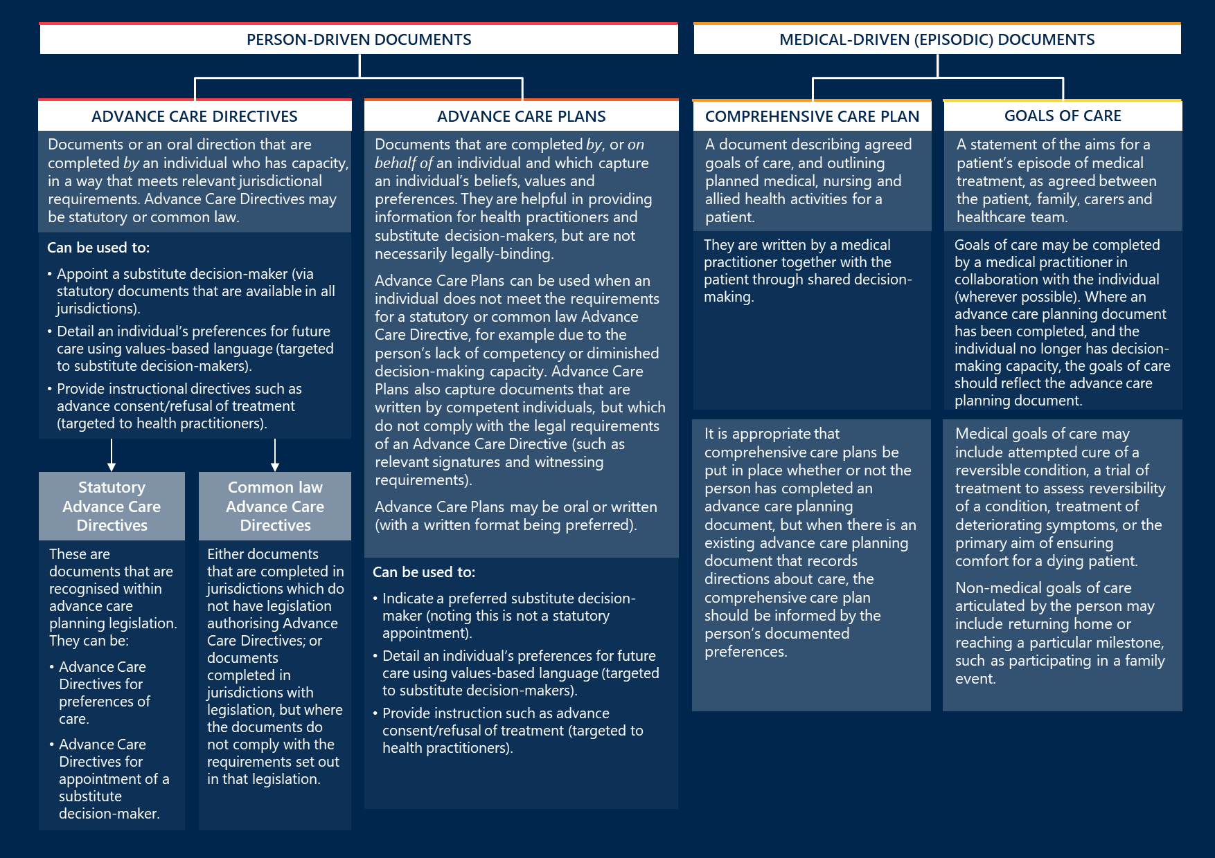

Stage 2 of this Framework encourages recording an individual’s values, beliefs and preferences in an Advance Care Directive wherever possible, as these documents hold more weight in a court of law. When a person is deemed to lack sufficient decision-making capacity, developing and recording the individual’s preferences in an Advance Care Plan continues to be a valuable exercise.

### Decision-makers can assist an individual through supported decision-making and make substitute decisions if an individual loses capacity

Supported decision-making is about helping individuals to make their own decisions so they can have control over the things that are important to them. This might include discussing the risks and benefits of different treatment options, and exploring individuals’ preferences in different scenarios. Health practitioners, family members, friends or other people might be involved in supported decision-making, and individuals should be engaged in supported decision-making to the greatest extent possible.

Once an individual’s decision-making capacity is fully compromised however, substitute decision-makers are responsible for making medical treatment decisions on their behalf. There are three types of substitute decision-makers available to an individual. The legal requirements associated with each of these types varies by jurisdiction. The types include:

* A substitute decision-maker chosen by the individual (where decision-making power about an individual’s health and personal care issues is legally conferred through either the statutory Advance Care Directive or other legal instrument).
* A substitute decision-maker assigned to the individual by law in the absence of a chosen decision-maker.
* A substitute decision-maker appointed for the individual by a legal or regulatory body (for example, a guardian appointed by a guardianship tribunal).

## Accessing and enacting an advance care planning document

Individuals should be supported to meaningfully participate in decisions about their own care to the extent to which they are able. Stage 3 refers to the period in which an individual can no longer make contemporaneous decisions about their care and an advance care planning document is used to direct others to make decisions on their behalf.

To be useful, the existence of an advance care planning document must be known and easily located. Substitute decision-makers must be able to confidently interpret the individual’s values, beliefs and preferences and reflect them in decisions about that individual’s care.

Central electronic storage of advance care planning documents is a means of ensuring that documents are easily accessible across different health and aged care settings.

My Health Record is an example of an effective storage solution. It:

* provides a mechanism for individuals to upload documents that are important to them (including Advance Care Directives and Advance Care Plans), or for general practitioners or other health practitioners to do so on their behalf with the person’s consent
* also allows for health practitioners to upload Goals of Care documentation providing there is patient consent
* enables health practitioners across Australia to upload or access advance care planning documents in a consistent way
* allows advance care planning documents to be uploaded under specific titles so they can be easily identified and accessed at short notice.

At the time of writing, more than 90 per cent of Australians have an active My Health Record[2], which means that more health practitioners, health services and aged care services will routinely access information on My Health Record to inform individuals’ care.

# Ethical considerations

This section is intended to provide a set of ethical considerations to guide practice where advance care planning documents are used for future health and personal care decisions. These considerations underpin the best practice principles. It is acknowledged that specific legal requirements in each jurisdiction may override these considerations where they differ; however, it is intended that this Framework will guide legal reform in the future so that all states and territories approach advance care planning documents in a nationally consistent way.

## Having the advance care planning conversation

|  |  |
| --- | --- |
| Considerations | |
| 1. Individuals are entitled to make their own decisions about personal and health matters. | Advance care planning is embedded in concepts of self-determination, respect for autonomy and person-centred care. Advance care planning should focus on facilitating individuals to make decisions based on what is important to them. Advance Care Directives are the preferred method of recording an individual’s direction about future treatment and their values, beliefs and preferences towards quality of life, interventions and death. Advance Care Plans are another method. |
| 1. Individuals can engage in advance care planning and make advance care planning documents at any point in time. | Individuals should be supported to consider their future care at any stage of life. The types of documents they might produce to record their values and preferences may be influenced by the individual’s level of competency and capacity. |
| 1. An individual’s personal and cultural attitudes towards what constitutes an acceptable health or lifestyle outcome and the interventions they want should be respected in advance care planning. | The advance care planning process should be undertaken in a way that is sensitive to individuals’ experiences, needs, values, beliefs and preferences. Individuals should be supported to think about their future care within the context of their own culture or belief system. This may include making decisions alone, delegating decisions to others, making collaborative decisions with family or community, or a combination of these approaches. |
| 1. Individuals should be assisted to understand all their options when it comes to planning for their future care. | When an individual considers options for their future care and begins the advance care planning process, they should be assisted to understand their options. Some common outputs of the advance care planning process include:   * an Advance Care Directive * an Advance Care Plan, or * a decision not to document their values, beliefs and preferences. |
| 1. An individual’s appointed substitute decision-maker should be involved in the advance care planning process as early as possible. | When an individual begins the advance care planning process and selects a substitute decision-maker, the decision-maker should be involved in the process as soon as is feasible (and desirable to the individual). This will help substitute decision-makers to deeply understand the individual’s experiences, needs, values, beliefs and preferences. This will enable the decision-maker to make informed decisions, as required. |

## Making an advance care planning document

|  |  |
| --- | --- |
| Considerations | |
| 1. An individual should be presumed to have capacity at the time of making an Advance Care Directive unless there is evidence demonstrating a lack of capacity at this time. | By default, an individual over the age of 18 can be presumed competent and capable when completing an Advance Care Directive.  Young people (under the age of 18) should also be actively involved in decisions about their future care and these decisions can be recorded in some format[3]. |
| 1. Individuals can express their future care preferences through a variety of modalities. | Although it is preferable for individuals to complete a standardised and structured form, Advance Care Directives completed through other methods of communication should be considered valid, when appropriately signed and witnessed[4]. Other methods of communication might include:   * a handwritten document * a document written by an individual in their first language with an official translation into English * a typed document * a document filled out by another person on the individual’s behalf with their recorded consent * a video recording * an oral direction * other recorded communication types. |
| 1. Advance care planning documents should focus on values-based language. | Advance care planning documents should be written with the aim of communicating values, beliefs and preferences, with a view that substitute decision-makers and health practitioners can translate what is important to the individual to any circumstance in which the advance care planning document may need to be enacted.  This may include describing characteristics of health or mental acuity that define wellbeing to that person and the types of actions they would like to be taken under these circumstances.  While the use of values-based language should be prioritised, individuals should have the option to include instructional directives if they wish. An instructional directive within an Advance Care Directive that is relevant to a medical treatment and indicated, may be relied upon as though the person was making the decision. Individuals should be supported to understand the potential applications and unintended consequences of instructional directives, and to document the specific circumstances in which they intend for them to apply. |
| 1. Advance care planning documents are not a means of requesting interventions that are illegal or would otherwise be unavailable. Advance care planning documents are not to document a request for voluntary assisted dying, or anything that would promote elder abuse. | Advance care planning documents should articulate a person’s values, beliefs and preferences. They should not request specific interventions that may only apply to a narrow set of circumstances or be used as a means to compel futile or illegal treatments. Health practitioners are under no obligation to provide care that is not clinically appropriate. |
| 1. While recommended, an individual should not be required to access a medical opinion for their Advance Care Directive to be valid. | While individuals should be encouraged to access medical advice during advance care planning and the development of Advance Care Directives, the validity of an Advance Care Directive should not be contingent on them having received such medical advice[5]. |
| 1. Advance care planning documents can include direction on whatever is important to that individual. | Directions are not limited to medical treatment and health care decisions; advance care planning documents may also be used to record related directions about personal care concepts such as preferred accommodation or carer arrangements. The feasibility of these preferences and the impact they may have on others should be considered[6]. |
| 1. Advance care planning documents can explicitly describe when they are intended to apply. | Individuals can record when they intend for their advance care planning document to be applied[7]. |
| 1. Advance care planning documents can – and should – be revised. | A competent individual may update, revise and/or change their advance care planning document at any time. Revising an advance care planning document may be particularly relevant in response to certain triggers, such as an onset or change of a certain illness; a change in family dynamics or relationships; or the advent of new medical technologies and treatment options. |
| 1. Individuals who do not meet the competency threshold should be encouraged and supported to make Advance Care Plans. | Individuals, their families or carers should be supported to document an individual’s values, beliefs and preferences in an Advance Care Plan if an Advance Care Directive is not appropriate, so that this information can still guide decisions about the individual’s future care. The Advance Care Plan should indicate that it was documented on behalf of a non-competent individual. |

## Accessing and enacting an advance care planning document

|  |  |
| --- | --- |
| Considerations | |
| 1. Advance care planning documents should be enacted only when an individual cannot make decisions for themselves. | Individuals should be engaged in contemporaneous decisions about their care to the greatest extent possible. The existence of an advance care planning document should not preclude or replace the individual’s right to make decisions whilst they are able to do so. Individuals who are able to make decisions with support, should be provided with access to the support necessary for them to make, communicate and participate in decisions that affect their lives. | |
| 1. Advance care planning documents should be accessible. | Advance care planning documents should be stored in a way that makes them easily accessible when they are needed. Individuals should communicate with their substitute decision-maker, family, carers and/or health practitioners that they have completed an advance care planning document and provide copies. Individuals should be encouraged to upload their advance care planning document to their My Health Record.  Health and aged care services should (with the individual’s consent) routinely upload advance care planning documents onto shared platforms, such as My Health Record, or a health service electronic medical record[8]. | |
| 1. Advance Care Directives can be presumed valid. | By default, the values and preferences expressed in Advance Care Directives should be considered as accurate directions for their treatment or care. | |
| 1. The values and preferences set out in an Advance Care Directive should be reflected into medical treatment decisions. | Substitute decision-makers and health practitioners should act in good faith to reflect an individual’s values and preferences into medical treatment decisions. Instructional directives such as advance consent/refusal for treatment must be followed as written (when clinically indicated). Where possible, decision-makers and health practitioners should also act in good faith to honour the beliefs, values and preferences set out in an Advance Care Plan. | |

# Best-practice principles

## Having the advance care planning conversation

|  |  |
| --- | --- |
| PRINCIPLE 1: Individuals should be supported to think about their future health and personal care and decide whether an advance care planning document is right for them | |
| 1. Advance care planning documents are not mandatory and may not be appropriate or desirable to everyone. | Advance care planning is voluntary and individuals should be supported to understand all the components of the advance care planning process. After engaging in the advance care planning process, an individual may make the conscious decision to complete – or not complete – an Advance Care Directive or Advance Care Plan. Advance care planning conversations, without documentation, are valuable in their own right. |
| 1. The advance care planning process should be undertaken in a way that is sensitive to an individual’s needs. | Individuals’ views on acceptable and unacceptable health outcomes, interventions and death are influenced by a range of personal and cultural factors. These factors may include people who are:   * Aboriginal or Torres Strait Islander people * ageing and/or frail * children and adolescents * culturally and linguistically diverse * experiencing homelessness * lesbian, gay, bisexual, transgender, intersex, queer and/or gender-diverse * living with chronic conditions and/or disability including cognitive impairment such as dementia * living in long-term institutional care (including being incarcerated) * living with mental health condition(s) (both temporary and long term) * living in rural and remote areas.   Individuals should be supported to think about their future care in a person-centred way. This may include:   * actively encouraging other people that are important to the individual to be involved in the advance care planning process * providing guidance materials on advance care planning and Advance Care Directives in a variety of common languages and using interpreters * delivering advance care planning within culturally safe and secure contexts * linking with other services who provide health and/or personal care to under-served population groups * involving carers and advocates. | |
| 1. Information about future care and advance care planning should be available to all individuals. | Information about an individual’s options for future care should be easily available and accessible such as at health care provider settings or at other community settings. | |
| 1. Individuals can consider developing and updating advance care planning documents at any point in their life. | Individuals can be supported to engage in advance care planning through many avenues, including with family or friends, general practitioners, and other health practitioners. These discussions should not be reserved solely for when the individual is approaching their end of life; individuals can express preferences and revise previous preferences for their future care at any point in time.  It is particularly important to begin advance care planning discussions as early as feasible once a diagnosis is made that will likely compromise future decision-making capacity, to optimise choice and decision-making while this is possible. | |
| 1. It is up to individuals to choose who they would like to involve in their advance care planning process and should be supported, as required. | Individuals should be prompted to consider who they would like to be involved in making decisions about their future care. These people (whether they are the individual’s substitute decision-maker, health practitioner or other) should ideally be involved in the advance care planning process. | |
| 1. Individuals should be informed that advance care planning documents do not substitute or replace wills or legal documents that confer authority onto another to manage financial and legal affairs. | Individuals should be supported to understand how Advance Care Directives interact with other legal documents. For example, that:   * Advance Care Directives are instruments to set out directions for future treatment decisions, values and preferences for health and personal care that legally must be followed. * Advance Care Directives provide more legal certainty than Advance Care Plans. Advance Care Plans may guide future care decisions but are not necessarily legally binding. * Wills and/or other legal documents are still required to provide direction about legal processes such as distribution of assets. | |

|  |  |
| --- | --- |
| PRINCIPLE 2: Substitute decision-makers should be involved in the advance care planning process as early as possible | |
| 1. Individuals should appoint substitute decision-makers on the basis that they can make decisions that align with their own values and preferences. | Individuals may choose to appoint decision-makers that can make substitute decisions about their care on their behalf. An Advance Care Directive may also stipulate the types of decisions they do not want made by a decision-maker. It is important that the substitute decision-maker knows the individual well and deeply understands what is important to them.  Appropriate substitute decision-makers may include a spouse or partner, adult child, other family member or a close friend or neighbour[9]. Ideally, they should not include legal professionals, health practitioners, paid care providers or someone without a personal connection to the individual. | |
| 1. To the extent desired by the individual, substitute decision-makers should be involved in the advance care planning process to deeply understand the individual’s values and preferences. | Individuals should be encouraged to involve potential substitute decision-makers early in the advance care planning process. This may assist the decision-maker to understand what is important to the individual and the types of decisions they would make for themselves if they were able to do so.  This should also assist all parties involved to understand what the role of substitute decision-maker entails. Substitute decision-makers should be provided with information and support as required[10].  Engagement with substitute decision-makers is particularly important immediately following diagnosis of dementia or other illness that may involve cognitive decline. | |
| 1. Health service organisations should have systems in place to support decision-making around future care. | Health service organisations should have policies, processes and systems for health practitioners to partner with individuals and/or their supported decision-makers to plan, communicate, set goals and make decisions about their current and future care.  The provision of decision support tools may be particularly useful. Decision support tools bring together high-quality evidence to provide a basis for a discussion around risks and benefits of different interventions, and may surface individual’s preferences in different scenarios. | |

## Making an advance care planning document

|  |  |
| --- | --- |
| PRINCIPLE 3: Advance Care Directives must comply with the local legal requirements to be valid | |
| 1. An individual requires decision-making capacity to make a valid Advance Care Directive. | An Advance Care Directive is a document with legal status and its validity can be challenged in a court of law under certain circumstances.  While all individuals should be supported to think about their future care and their values and preferences, there are certain legal tests that must be met for an individual to validly make an Advance Care Directive, including the requirement to have sufficient decision-making capacity.  An individual has decision-making capacity if they:   * understand the specific situation, relevant facts or basic information about choices * evaluate reasonable implications or consequences of making choices * use reasoned processes to weigh the risks and benefits of the choices * communicate relatively consistent or stable choices.   A person is assumed to have decision-making capacity unless there is evidence otherwise. Health, legal and other professionals that are assisting individuals to undertake advance care planning should consider the legal requirements in their own jurisdictions to ensure an Advance Care Directive can be made. | |
| 1. Individuals who lack decision-making capacity may still complete an Advance Care Plan which sets out their values and preferences. | Decision-making capacity (or lack thereof) can fluctuate over time, particularly during periods of illness. An individual must have capacity at the time to make a valid Advance Care Directive.  If an Advance Care Directive cannot be made due to an individual’s lack of decision-making capacity (that is, they are not competent to do so), they should still be supported to consider their future care and communicate their beliefs, values and preferences through another medium such as an Advance Care Plan. The Advance Care Plan should indicate that it was documented on behalf of a non-competent person. | |
| 1. Advance Care Directives must meet jurisdictional legal requirements to be valid. | Advance Care Directives must be completed in a way that meets the legislative requirements specific to each state and territory.  Common requirements may include specifying:   * the name of the individual * address of the individual * the date of birth of the individual * the date the Advance Care Directive is finalised * a signature by the individual * a signature of a witness[11]. | |

|  |  |
| --- | --- |
| PRINCIPLE 4: Advance Care Directives should incorporate a core set of information fields | |
| 1. All Advance Care Directives should be completed in a nationally consistent way with each jurisdiction adopting common language, structure and witnessing requirements. | Advance Care Directives, however structured and expressed, should include a core set of information fields to support mutual recognition across state and territory borders. All Advance Care Directives should include fields to capture an individual’s:   * personal details (such as name, date of birth, address) * substitute decision-maker’s details (if appointed) * preferred health outcomes * values and preferences relating to future care * date the Advance Care Directive was made or reviewed * preferences relating to organ donation.   *See Appendix C for a checklist of suggested requirements for all Advance Care Directive forms.* | |

|  |  |
| --- | --- |
| PRINCIPLE 5: Advance care planning documents should focus on communicating an individual’s preferences in a way that can be understood and enacted by others | |
| 1. Advance care planning documents should prioritise the use of value-based language to articulate an individual’s preferences. | Individuals should be encouraged to articulate their values and preferences, including what acceptable outcomes look like for them. They may also choose to direct what type of medical response they would like in these circumstances.  For example, an individual may use an advance care planning document to articulate that they highly value their ability to communicate independently with others. They may direct that if they are unable to communicate independently (e.g. due to advanced dementia) or an intervention is unlikely to return them to a point where they can communicate independently (e.g. following a head trauma sustained in a car accident), they would not like to receive life sustaining treatment. Alternatively, an individual may direct that they value life above all else, and they would want all medically-indicated care to be administered in all circumstances. Documenting preferences in value-based language ensures that the individual’s intent is understood and can be translated in predictable and unforeseen circumstances.  Individuals should also have the option to document instructional directives within an Advance Care Directive to provide future consent, withdrawal and/or refusal of specific medical treatment [12]. While a focus on outcomes and values tends to be more constructive, instructional directives are unambiguous and targeted to health practitioners[13].  When an individual would like to include instructional directives, the intent of their preferences should be clearly articulated and documented including the specific circumstances in which they intend for them to apply. The individual should also be encouraged to understand the full implication of this preference and potential scenarios where this might be applied.  Where an advance care planning document articulates preferences which affect an individual’s family, friends and/or community (for example, nominating a preferred carer, or preferred care location), the individual should be encouraged to share these preferences with those affected. | |
| 1. Advance care planning documents should be expressed in plain language. | Individuals should be encouraged to articulate their values and preferences in a way that is easily understood and applied by others. To this end, use of legalistic or other jargon should be avoided. | |

## Accessing and enacting an advance care planning document

|  |  |
| --- | --- |
| PRINCIPLE 6: Advance care planning documents should be stored in a way that makes their existence known | |
| 1. Advance care planning documents should be available at short notice. | Individuals should be encouraged to inform their substitute decision-makers, families, carers and/or health practitioners (as relevant) that they have completed an Advance Care Directive or Advance Care Plan. Individuals should be encouraged to provide a copy of their advance care planning document to their substitute decision-makers, along with other people who might be involved in their future care.  Individuals should also be encouraged to upload their advance care planning document to My Health Record or request a health practitioner to do so on their behalf.  If an individual chooses not to store their document on My Health Record, the physical location of the document should be noted under the custodian on the My Health Record platform.  Health and aged care providers such as hospitals, ambulance services, residential aged care facilities and palliative care services as well as general practitioners should have clear internal processes and policies in place which ensure advance care planning documents are identifiable and accessible by relevant health practitioners and substitute decision-makers. This could be achieved by health and aged care services configuring their patient records software to interface with My Health Record.[14] | |
| 1. Advance care planning documents should be afforded the same privacy protections as other health records. | Advance care planning documents should be created, stored, accessed and transferred consistent with privacy legislation that applies to all health records. | |

|  |  |
| --- | --- |
| PRINCIPLE 7: Reasonable steps should be taken to identify if an advance care planning document has been made | |
| 1. Reasonable steps should be taken to locate an Advance Care Directive or Advance Care Plan as well as an individual’s appointed substitute decision-maker. | When it is considered likely that a person would have an advance care planning document, reasonable steps should be taken to locate it. In non-emergency situations, reasonable steps may include: searching internal patient records, jurisdictional and/or national databases (such as My Health Record), talking to an individual’s family or emergency contact, contacting the individual’s general practitioner, or other similar measures.  In emergency situations where an advance care planning document is not immediately apparent or available, health practitioners should take immediate reasonable steps to source an advance care planning document and/or discuss the individual’s preferences with their substitute decision-maker. Reasonable steps in an emergency includes asking present family members if the individual has documented their preferences and searching established databases such as My Health Record[15]. During this period when an advance care planning document is being located, regular process for emergency management (as set out in each jurisdiction’s legislation) should be followed.  Health and aged care providers should also have policies, procedures and systems in place to identify an individual’s advance care planning document and substitute decision-maker on admission. | |

|  |  |
| --- | --- |
| PRINCIPLE 8: Substitute decision-makers should follow a specific pathway when making decisions about an individual’s care | |
| 1. There is an established hierarchy of decision-makers and documents when it comes to enacting an advance care planning document. | When a decision about an individual’s health or personal care needs to be made, the following hierarchy of decision-makers apply[16]:   1. The individual, to the extent that they are competent and capable to make decisions either on their own or with support. 2. A legally appointed substitute decision-maker or, if required, another substitute decision-maker set out in state and territory law.   Decisions made by others should align with records according to the following hierarchy:   1. A statutory Advance Care Directive 2. A common law (non-statutory) Advance Care Directive 3. Other verbal or written expressions by a competent individual 4. An Advance Care Plan. | |
| 1. Decision-makers should consider certain factors when interpreting an individuals’ values and preferences. | If an Advance Care Directive contains a valid instructional directive refusing treatment then this must be followed and not overruled by a substitute decision-maker or health care practitioner. An instructional directive must be expressly identified as such. Instructional directives can be relied upon as though the person had capacity and was making the decision. This means that:   * if the instructional directive consents to the relevant treatment, the health practitioner may provide clinically indicated treatment. * if the instructional directive refuses the relevant treatment, the health practitioner must not provide that treatment.   In the absence of relevant instructional directives, health practitioners must turn to the person’s substitute decision-maker to give consent to treatment decisions.  Substitute decision-makers should deliberate the values and preferences expressed in advance care planning documents when making care decisions.  Medical treatment decisions should be made with additional consideration given to:   * advice from health practitioners or others regarding treatment options and likely outcomes of those options * specific consent or refusal of medical treatments or interventions expressed by the individual.   Personal care decisions, such as accommodation arrangements, should consider the:   * adequacy of existing arrangements and the desirability of not disturbing those arrangements * feasibility of arrangements considering the individual’s needs and impact on other people who may be affected (such as family or carers). | |

|  |  |
| --- | --- |
| PRINCIPLE 9: Legal protections should exist for those who are acting in good faith | |
| 1. Substitute decision-makers and health practitioners (registered and non-registered) who are acting in good faith on an Advance Care Directive should be legally protected. | Jurisdictional legislation, common law precedent and policies should offer protection from criminal and civil liability to substitute decision-makers and health practitioners (registered and non-registered) who act on the directions of an Advance Care Directive in good faith[17]. | |
| 1. Individuals with reduced or lacking decision-making capacity should be protected. | Where a family member or health practitioner (registered and non-registered) suspects a substitute decision-maker has misused or abused their power, they can undertake dispute resolution (*see Principle 10*).[18] | |

|  |  |
| --- | --- |
| PRINCIPLE 10: There should be a clear, consistent and timely process in place to resolve disputes related to Advance Care Directives’ enactment | |
| 1. Jurisdictions should provide a clear, consistent and timely process of dispute resolution. | Substitute decision-makers, family members and health practitioners (registered and non-registered) may seek dispute resolution if they are concerned that a decision made by a substitute decision-maker is not in line with the directions of an Advance Care Directive.  The dispute resolution process should focus on timely resolution, involvement of all relevant parties and be carried out in line with jurisdictions’ legislative and common law requirements. | |

1. Stakeholders consulted

A wide variety of stakeholders were consulted to inform the writing of this Framework. In alphabetical order, this includes representatives from:

* Health practitioners and representatives from health services across metropolitan, regional and remote Australia
* Peak bodies and community organisations such as:
  + ACON
  + Advance Care Planning Australia
  + Aged and Community Services Australia
  + Australian College of Nursing
  + Council on the Ageing (COTA) Australia
  + Consumers Health Forum of Australia
  + End of Life Directions for Aged Care (ELDAC)
  + Federation of Ethnic Communities’ Councils of Australia (FECCA)
  + National Aboriginal Community Controlled Health Organisations
  + National Lesbian, Gay, Bisexual, Transgender and Intersex Health Alliance
  + Palliative Care Australia
  + Palliative Care Nurses Australia
* State and Territory Departments of Health
* Primary Health Networks
* The Australian Commission on Safety and Quality in Health Care
* Universities.

1. Relevant state and territory legislation

The following information is accurate at the time of writing. Individuals should check their jurisdiction’s legislation for any changes before using this information to inform decisions.[19]

|  |  |  |  |
| --- | --- | --- | --- |
| Jurisdiction | Title of legislation | Create statutory Advance Care Directive? | Appoint decision-maker? |
| Australian Capital Territory | Medical Treatment (Health Directions) Act 2006 (ACT) | ✔ | ✖ |
| Guardian and Management of Property Act 1991 (ACT) | ✖ | ✔ |
| Powers of Attorney Act 2006 (ACT) | ✖ | ✔ |
| Northern Territory | Advance Personal Planning Act 2013 (NT) | ✔ | ✔ |
| Guardianship of Adults Act 2016 | ✖ | ✔ |
| Queensland | Powers of Attorney Act 1998 (Qld) | ✔ | ✔ |
| Guardianship and Administration Act 2000 (Qld) | ✖ | ✔ |
| Western Australia | Guardianship and Administration Act 1990 (WA) | ✔ | ✔ |
| South Australia | Advance Care Directives Act 2013 (SA) | ✔ | ✔ |
| Guardianship and Administration Act 1993 (SA) | ✖ | ✔ |
| Powers of Attorney and Agency Act 1984 (SA) | ✖ | ✔ |
| Consent to Medical Treatment and Palliative Care Act 1995 (SA) | ✖ | ✔ |
| Health Care Act 2008 (SA) | ✖ | ✖ |
| Victoria | Medical Treatment Planning and Decisions Act 2016 (Vic) | ✔ | ✔ |
| Guardianship and Administration Act 2019 (Vic) | ✖ | ✔ |
| Powers of Attorney Act 2014 (Vic), Powers of Attorney Amendment Act 2016 (Vic) | ✖ | ✔ |
| New South Wales | Guardianship Act 1987 (NSW) | ✖ | ✔ |
| Guardianship Regulations 2016 (NSW) | ✖ | ✔ |
| Tasmania | Guardianship and Administration Act 1995 (Tas) | ✖ | ✔ |
| Powers of Attorney Act 2000 (Tas) | ✖ | ✔ |

In addition to jurisdictional legislation and common law precedent, national standards apply. The Australian Commission on Safety and Quality in Health Care’s [*National Safety and Quality Health Service Standards*](https://www.safetyandquality.gov.au/sites/default/files/migrated/National-Safety-and-Quality-Health-Service-Standards-second-edition.pdf)(2nd ed.) set out standards expected of providers of residential and home care.

1. Checklist for Advance Care Directives

Forms which guide the creation of Advance Care Directives should prompt individuals to provide open statements in their own words about their values, beliefs, preferences and acceptable and unacceptable health outcomes. Quality forms should accommodate the following requirements:

* be labelled in a way that is immediately recognisable including to an individual’s family or carer, ambulance personnel or to other health practitioners
* use plain English and avoid legal language where possible
* record the name and date of birth of the person for clear identification
* record both the individual’s gender and sex assigned at birth
* record the date of completion
* be accompanied by guidelines that explain how Advance Care Directives work, guide completion of the form and also advise what to do when substitute decisions are needed
* be easy to complete in a variety of settings without the need for professional advice
* apply to any period of impaired decision-making capacity, not just at the end of life
* record values, preferred outcomes and goals of care
* record acceptable and unacceptable health outcomes against which treatment decisions can be assessed
* record preferences about personal matters, such as indicating preferred carer arrangements, relationships the person wants to continue and who they do not want to see, as well as health matters
* allow for separate directions or preferences to be recorded for temporary and permanent periods of diminished decision-making capacity and for end-of-life situations
* require the signatures of the person, the witness and any decision-makers appointed (with date of signature)
* include a date for review if necessary, including space to record that the form has been reviewed but no changes made

Where the form is the instrument also used to appoint a decision-maker, it should allow for:

* appointing one or more substitute decision-makers and directing how they act and make decisions (e.g. making decisions together, individually, in a particular order or as available, and how matters will be resolved if multiple decision-makers cannot agree on a care decision)

1. Useful resources[20]

## Education and information about advance care planning

* Advance Care Planning Australia (advancecareplanning.org.au)
  + Educational resources
  + Help someone start an Advance Care Directive
  + Advance Care Planning in Different Settings and Groups
  + Information and legal forms hub
  + National advisory service
  + ACD prevalence research findings
* CareSearch (caresearch.com.au)
  + Palliative Care eLearning
  + Talking end of life with people with intellectual disability
* Clayton, J. M., Hancock, K. M., Butow, P. N., Tattersall, M. H., & Currow, D. C. (2007). Clinical practice guidelines for communicating prognosis and end-of-life issues with adults in the advanced stages of a life-limiting illness, and their caregivers. The Medical Journal of Australia, 186(12), S77.
* End of Life Directions for Aged Care (ELDAC) (eldac.com.au)
  + Carer information
  + How to guides
  + Forms and templates
* MIGA (miga.com.au)
  + Education resources
* palliAGED (palliaged.com.au)
  + Practice centre
  + Evidence centre
  + Emergency planning and management
* Program of Experience in the Palliative Approach (PEPA) (pepaeducation.com)
  + Palliative Care Education and Training Collaborative
* The Advance Project for primary healthcare teams (theadvanceproject.com.au)
* The Royal Australian College of General Practitioners (racgp.com.au)
  + Online modules available through GP learning
* ThinkGP modules on advance care planning (thinkgp.com.au)
* University of Sydney Cognitive Decline Partnership Centre (cdpc.sydney.edu.au)
  + Information and tools to support advance care planning for people with dementia

## National implementation guides for advance care planning

* Advance Care Planning Australia
* Batchelor F, Haralambous B, Nolte L, Mackell P, Fearn M, Hwang K, Detering K. Advance care planning in aged care: A guide to support implementation in community and residential settings. Austin Health, Melbourne: Advance Care Planning Australia, 2017

## National implementation guides for My Health Record in different settings

* Australian Commission on Safety and Quality in Health Care (safetyandquality.gov.au)
* Emergency Department Clinicians' Guide to My Health Record in ED
* My Health Record (myhealthrecord.gov.au)
* Mental Health Toolkit: e-book for healthcare providers
* National guidelines for using My Health Record to support advance care planning and goals of care (‘Enabling Access to Advance Care Planning Documents’)[21]

## Guidelines on supported decision-making

* Sinclair, C., Field, S., & Blake, M. (2018). Supported decision-making in aged care: A policy development guideline for aged care providers in Australia. (2nd Edition) Sydney: Cognitive Decline Partnership Centre.

1. This Framework builds on the 2011 National Framework for Advance Care Directives

A *National Framework for Advance Care Directives* was published in 2011 following endorsement by the Australian Health Ministers’ Advisory Council. At the time, the Framework was instrumental in raising the profile of advance care planning and Advance Care Directives among both the health and legal sectors and provided a reference source for jurisdictions developing new legislation.

As shown in Figure 4there have been significant changes in the advance care planning landscape since the Framework’s release, meaning that some of the information provided in the 2011 version has become outdated. Furthermore, stakeholders have reported experiencing particular barriers to developing and using Advance Care Directives. This Framework has been designed to build on the strengths of the original Framework, while providing more targeted information to assist with known barriers.

Figure 4 | Key changes to the advance care planning landscape and known barriers to developing and enacting advance care planning documents

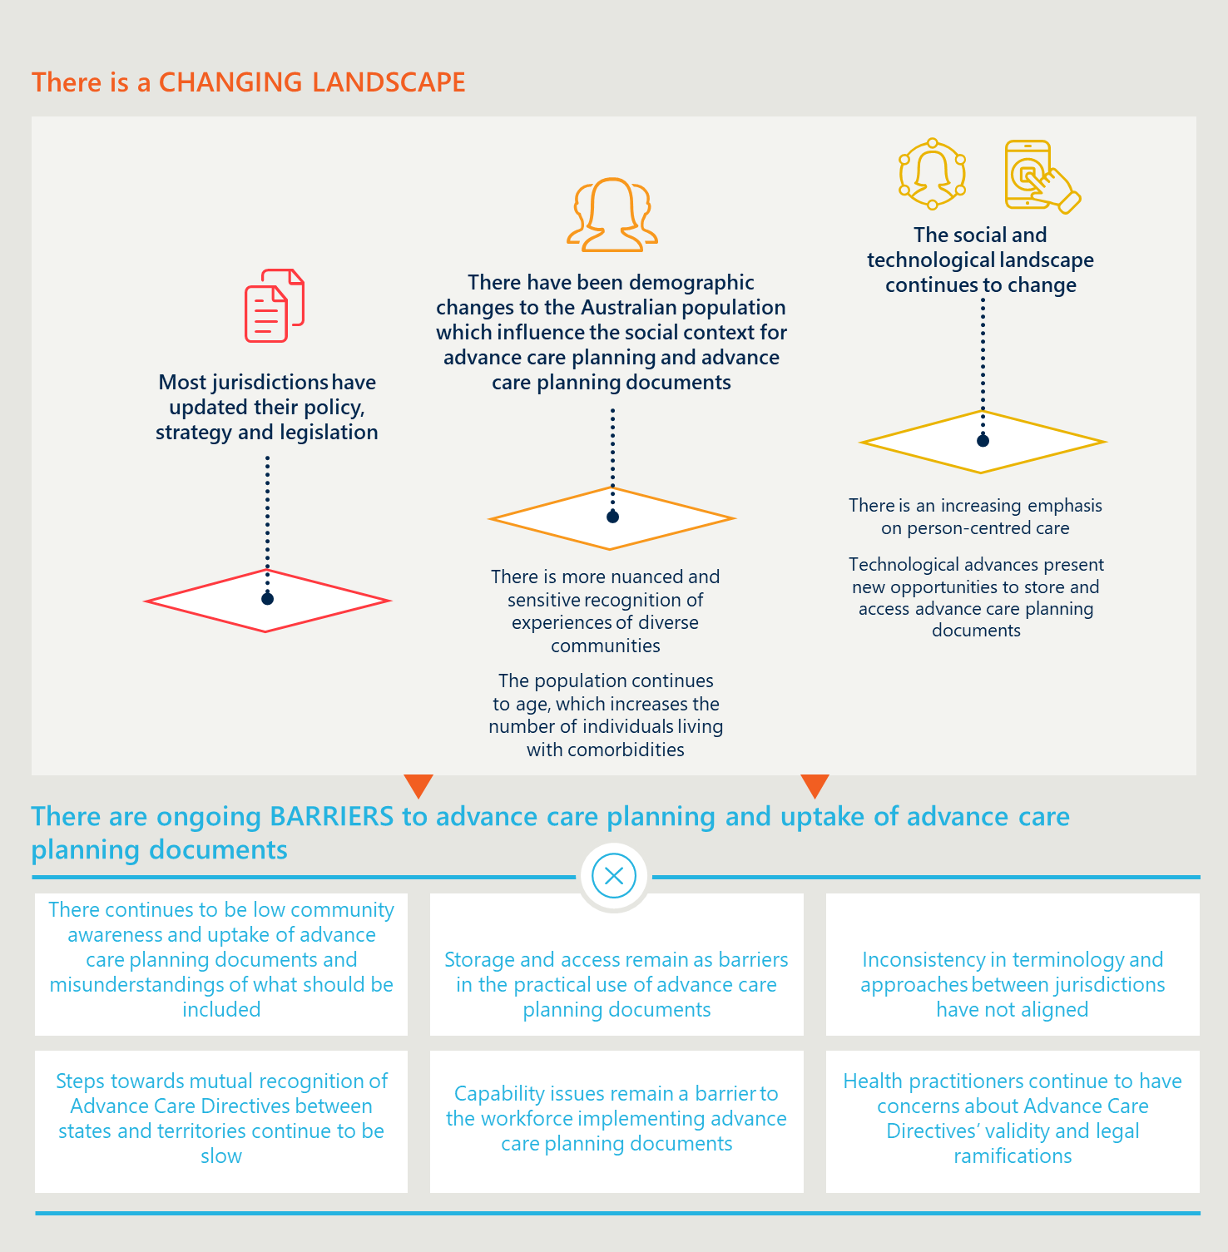

1. Some jurisdictions use the term ‘advance care plan’ for documents which are completed and signed by a competent adult and that are legally binding by common law. Within this Framework, these documents are considered ‘Common law (non-statutory) Advance Care Directives’. In these jurisdictions the definition of ‘advance care plan’ should be read in conjunction with ‘Common law (non-statutory) Advance Care Directives’.
2. Source: Australian Digital Health Agency
3. At the time of writing, minors who meet specific criteria can make an Advance Care Directive.
4. At the time of writing, many jurisdictions require form Advance Care Directives to be handwritten in English.
5. At the time of writing, some jurisdictions require a medical practitioner to witness the Advance Care Directive. In Victoria, for example, the medical practitioner witnessing an Advance Care Directive is expected to discuss the document with their patient and ensure they understand the implications of the statements made in the document and the potential outcomes if the Advance Care Directive is enacted.
6. Preferences for accommodation arrangements and site of care should not be legally binding as they may not always be feasible.
7. Within Advance Care Directives, the trigger for “activating” the instrument is loss of decision-making capacity in an individual. Within instruments such as Enduring Powers of Guardianship, individuals generally have the ability to stipulate when this instrument should be applied. This may include stipulating that the Advance Care Directive should be applied only when the individual is experiencing permanent and irreversible loss of competency and capacity (such as due to deteriorating dementia) or may also include temporary loss of competency and capacity (such as during an acute period of mental illness).
8. In 2020 My Health Record implemented changes that enabled health practitioners to upload Advance Care Directives on behalf of their patients.
9. In all jurisdictions but the Northern Territory, there is an established default hierarchy relating to who can make substitute-decisions about an individual’s medical care.
10. In many jurisdictions, substitute decision-makers are required to sign advance care directives indicating their acceptance to act in this role.
11. The requirement for a witness to be physically present is a barrier to some individuals formalising Advance Care Directives. At the time of writing, the validity of remote witnessing arrangements, such as using fax or email to obtain witnesses signatures during telehealth consultations had not yet been tested in a court of law but could be a useful way to address this barrier.
12. Some jurisdictions have Advance Care Directives that allow individuals to include instructional directives about the administration of treatment as well as the refusal or withdrawal of treatment; whereas others only have legislation in relation to refusal or withdrawal of treatment. Instructional directives should not be binding for site of care decisions (such as being taken to hospital or other preferred place of care) and non-medical decisions such as accommodation or carer arrangements as these will not always be feasible.
13. At the time of writing, the extent to which instructional directives are binding varies between jurisdictions.
14. At the time of writing, the Australian Digital Health Agency is making improvements to My Health Record functionality to improve its utility as a central storage and access point for advance care planning documentation. For additional guidance on optimally using My Health Record as a storage and access point for advance care planning documents in all health contexts, see the national guidelines for using My Health Record to support advance care planning and goals of care (‘Enabling Access to Advance Care Planning Documents’) which at the time of writing is in draft, or contact the Australian Digital Health Agency for further support.
15. It is anticipated that once My Health Record has implemented planned changes and increased its usage as a single point of storage and access for advance care planning documentation, looking on My Health Record will be the quickest and most effective means for determining if an individual has documented their preferences in both emergency and non-emergency situations.
16. Jurisdictions have different arrangements in place about recognising the hierarchy of decision-makers.
17. In nearly all circumstances, an individual’s Advance Care Directive must be followed to be considered as acting in ‘good faith’ and for protections to apply.
18. Any individuals who have an interest in the case can make an application to their state administrative tribunal body to express their concerns.
19. Readers should check reputable sources hosting Australian legislation, such as [AustLII](http://www.austlii.edu.au/) [http://www.austlii.edu.au/].
20. These resources were available at the time of printing.
21. At the time of writing this guideline was being drafted.