Disability provider alert
18 June 2021

Updated ATAGI advice on the AstraZeneca vaccine
On 17 June 2021, the Australian Technical Advisory Group on Immunisation (ATAGI) reviewed their advice on the AstraZeneca COVID-19 vaccine. They recommended Pfizer as the preferred for vaccine for people aged under 60 years. This updates the previous recommendation for Pfizer over the AstraZeneca COVID-19 vaccine in those aged 16 to under 50 years.
This doesn’t change who is eligible for a COVID-19 vaccine, but it means the Pfizer vaccine is now the preferred vaccine for people under 60 years.
If you have already had one dose of AstraZeneca and you did not experience severe side effects, there is no reason you cannot receive a second dose of AstraZeneca.
A frequently asked questions (FAQ) document is available on the Department of Health website. This document contains FAQs about the revised ATAGI advice for people regarding COVID-19 vaccines.

State and territory information
The Department of Health has resources for people with disability, disability service providers, and disability workers. More information from states and territories, including for people with disability and disability support workers is available at:
- Australian Capital Territory
- New South Wales
- Northern Territory
- Queensland
- South Australia
- Tasmania
- Victoria
- Western Australia

Consent for a COVID-19 vaccine
Before a vaccination provider can administer a vaccine, the patient needs to provide informed consent to receiving a COVID-19 vaccine. It is preferable that the patient provides consent before the site visit. This is particularly important where supported decision making arrangements in place as it can take time to receive the consent needed.
The Department of Health website contains information on consent for disability service providers as well as a printable copy of the consent form.

Disability worker meeting
The Department of Health hosted a virtual meeting on Thursday, 17 June 2021. The purpose of the meeting was to answer questions from disability support workers about the COVID-19 vaccination program. Professor (Practice) Alison McMillan, Chief Nursing and Midwifery Officer chaired the discussion.
The panel also included:
- Professor Nick Lennox, Senior Medical Advisor, Health and Disability Interface
- Chris Faulkner PSM, the Assistant Secretary, COVID-19 Vaccine Task Force – Disability
- Barbara Dow, Executive Lead COVID Response Unit and National Incident Controller, Life without Barriers
- Samantha Ferguson, Team Leader, Life without Barriers
A recording of the meeting will be available on the Department of Health website next week.

Social posts and tiles
The below social media post has been developed for your to distribute through your channels.
Post | Tile
Pfizer is now available for people 50-59 years

Facebook  Pfizer is now the preferred vaccine for people under 60 years old.  If you’re 50-59 years old and you’ve had your first dose of AstraZeneca without any serious adverse effects, you should still get your second dose.  Two doses will provide you with excellent protection against severe illness from COVID-19.  Use the eligibility checker to find your nearest clinic or vaccination hub and make a booking. Learn more at www.health.gov.au/COVID-19-vaccines  #COVID19vaccines #COVID19  Twitter/LinkedIn  Pfizer is now the preferred vaccine for people under 60 years old.  If you’re 50-59 years old and you’ve had your first dose of AstraZeneca without any serious adverse effects, you should still get your second dose. Learn more at www.health.gov.au/COVID-19-vaccines  #COVID19vaccines #COVID19 #eligibilitychecker  Instagram  Pfizer is now the preferred vaccine for people under 60 years old.  But what if I have already had one dose of AstraZeneca? Should I have a different vaccine for my second dose?  If you’re 50-59 years old and you’ve had your first dose of AstraZeneca without any serious adverse effects, you should still get your second dose.  Two doses will provide you with excellent protection against severe illness from COVID-19.  Use the eligibility checker to find your nearest clinic or vaccination hub and make a booking. Learn more at www.health.gov.au/COVID-19-vaccines  #COVID19vaccines #COVID19 | 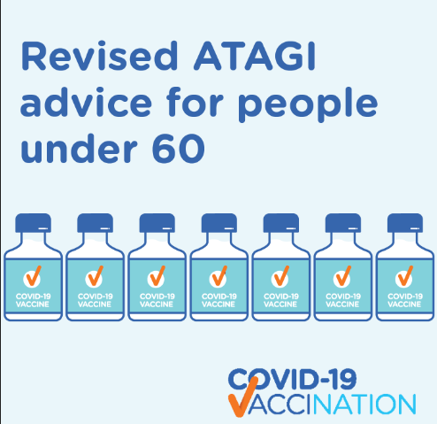

Resources to support people getting vaccinated
The Department of Health encourages disability providers to have vaccination resources available in Easy Read format and in other languages for people getting vaccinated. These resources cover all aspects of the vaccination process including preparing for COVID-19 vaccination and after the COVID-19 vaccination. You can download and print these from the Department of Health website.

For more information call the National Coronavirus and
COVID-19 Vaccination Helpline on 1800 020 080.

