Phoenix Australia – Generic
Tile | Channel | Accompanying text
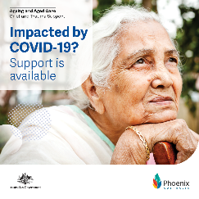 | Facebook | COVID-19 has impacted many people in aged care, from residents and their families, friends and loved ones, to home recipients, aged care workers and community visitors.  Phoenix Australia provides resources for people impacted by emotional trauma and those who support them. They offer:  - Information for aged care recipients, their families and loved ones  - Resources for aged care providers and staff to support people  - Wellbeing information and tools for aged care staff  Start using trauma recovery resources today, or share the information with someone you know may need it: www.phoenixaustralia.org/aged-care  Phoenix Australia is respectful of people’s culture, religion, identity and lifestyles.
 | Twitter | Resources for #agedcare residents, recipients, families, loved ones, friends & workers on emotional trauma, its impacts and how to support people affected by #COVID19, start exploring today, @Phoenix_Trauma: www.phoenixaustralia.org/aged-care  #traumainformed #traumaresources #agedcareworkers
 | LinkedIn | Aged care recipients, their families, friends, loved ones, families of choice, community visitors and representatives, and aged care workers impacted by COVID-19 can now access free emotional trauma recovery resources.  Phoenix Australia provides:  - Information for aged care recipients, their families and loved ones  - Resources for aged care providers and staff to support people  - Wellbeing information and tools for aged care staff  Start using emotional trauma recovery resources today, or share the information with someone you know may need it: www.phoenixaustralia.org/aged-care  Phoenix Australia is respectful of people’s culture, religion, identity and lifestyles.  #traumainformedcare #COVID19 #agedcare

Phoenix Australia – Aged care resident
Tile | Channel | Accompanying text
 | Facebook | Aged care residents may have been exposed to emotional trauma because of COVID-19. While some people will recover, others may develop mental health problems and need help.  Phoenix Australia has videos, guidance and self-care strategies to help those who have experienced trauma, as well as to help those caring for someone affected by trauma.  Need help? Seek it: www.phoenixaustralia.org/aged-care  Phoenix Australia is respectful of people’s culture, religion, identity and lifestyles.
 | Twitter | #AgedCareResidents experiencing emotional trauma due to #COVID19 & those providing support, can access free videos, guidance and self-care strategies. Need help? Seek it from @Phoenix_Trauma: www.phoenixaustralia.org/aged-care  #senioraustralians #traumaresources #traumasupport #COVID19trauma
 | LinkedIn | People living in residential aged care impacted by COVID-19 can access free resources to help understand emotional trauma and gain strategies for coping.  Phoenix Australia has videos, guidance and self-care strategies to help those impacted by trauma.  Need help? Seek it. See others needing help? Share it: www.phoenixaustralia.org/aged-care  Phoenix Australia is respectful of people’s culture, religion, identity and lifestyles.

Phoenix – Home care recipient
Tile | Channel | Accompanying text
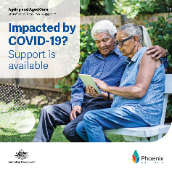 | Facebook | Emotional and mental trauma can be more difficult to cope with if an older person is also experiencing loss and grief, or is living with dementia, particularly during the COVID-19 pandemic.  Phoenix Australia has videos, guidance and self-care strategies to help senior Australians receiving home care, who have experienced trauma, as well as to help those caring for someone affected by trauma.  Reach out to Phoenix Australia for supportive resources: www.phoenixaustralia.org/aged-care  Phoenix Australia is respectful of people’s culture, religion, identity and lifestyles.
 | Twitter | #COVID19 experiences may have caused grief & emotional trauma for many older Australians. @Phoenix_Trauma has produced videos, guidance & self-care strategies for information & support, reach out: www.phoenixaustralia.org/aged-care  #senioraustralians #traumaresources #traumasupport #COVID19trauma
 | LinkedIn | COVID-19 experiences may have caused grief and emotional trauma for many older people.  Phoenix Australia has videos, guidance and self-care strategies to help senior Australians receiving home care, who have experienced trauma, as well as to help those caring for someone affected by trauma.  Reach out to Phoenix Australia for supportive resources: www.phoenixaustralia.org/aged-care  Phoenix Australia is respectful of people’s culture, religion, identity and lifestyles.  #senioraustralians #traumarecovery #COVID19trauma

Phoenix Australia – Family
Tile | Channel | Accompanying text
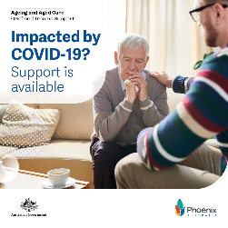 | Facebook | Support from family, family of choice, friends, loved ones, community visitors and representatives is very important when an older person is recovering from the impacts of emotional or mental trauma.  If you are caring for a senior person who has experienced trauma due to COVID-19, there are simple things you can do to help the person recover.  Phoenix Australia has produced awareness and self-care resources for families and carers. Do you need support?  Find help at: www.phoenixaustralia.org/aged-care  Phoenix Australia is respectful of people’s culture, religion, identity and lifestyles.
 | Twitter | Family, friends & loved ones caring for a #SeniorAustralian who has experienced #COVID19trauma can access freely available awareness & self-care resources & strategies. Connect w/ @Phoenix_Trauma: www.phoenixaustralia.org/aged-care  #traumaresources #traumasupport #traumarecovery
 | LinkedIn | If you are caring for a senior person who has experienced emotional or mental trauma due to COVID-19, there are simple things you can do to help the person recover.  Phoenix Australia has produced awareness resources and self-care strategies for families and carers. Do you need support? Seek it: www.phoenixaustralia.org/aged-care  Phoenix Australia is respectful of people’s culture, religion, identity and lifestyles.  #SeniorAustralian #traumaresources #traumasupport #traumarecovery

Phoenix Australia – Aged care staff
Tile | Channel | Accompanying text
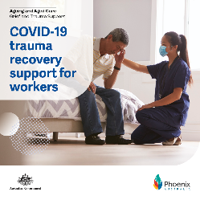 | Facebook | If you work in aged care, work may be difficult or stressful at times, particularly during events such as the COVID-19 pandemic. Learn about how you can look after yourself and those you care for.  Phoenix Australia provides practical advice and helpful tips so you can focus on your health and wellbeing. Share this information in your workplace and with your colleagues: www.phoenixaustralia.org/aged-care  Phoenix Australia is respectful of people’s culture, religion, identity and lifestyles.
 | Twitter | #AgedCareWorkers experienced difficult & stressful times during #COVID19. @Phoenix_Trauma provides advice & tips for you to learn how to look after your health & wellbeing, share insights with your colleagues: www.phoenixaustralia.org/aged-care  #COVIDtrauma #traumarecovery #agedcareworkforce
 | LinkedIn | If you work in aged care, work may be difficult or stressful at times, particularly during events such as the COVID-19 pandemic. Learn about how you can look after yourself and those you care for.  Phoenix Australia provides practical advice and helpful tips so you can focus on your health and wellbeing. Share this information in your workplace and with your colleagues: www.phoenixaustralia.org/aged-care  Phoenix Australia is respectful of people’s culture, religion, identity and lifestyles.  #AgedCareWorkers #COVIDtrauma #traumarecovery #agedcareworkforce

OPAN - Aged care resident
Tile | Channel | Accompanying text
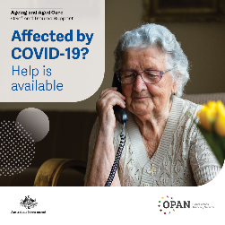 | Facebook | Aged care residents impacted by COVID-19 can access free and confidential aged care advocacy and advice.  The Older Persons Advocacy Network (OPAN) is an independent service, providing COVID-19 advisory support and aged care advocacy for senior Australians living in aged care.  OPAN operates nationally, and can be reached on 1800 700 600 or online at www.opan.com.au  OPAN is respectful of people’s culture, religion, identity and lifestyles.  If you or a loved one require a translator, phone the Translating and Interpreting Service (TIS) on 131 450. Ask for your language and the service will connect you. Sign language interpreting services are also available. Contact Auslan Connections on 1300 010 877, email interpreter.bookings@deafservices.org.au or SMS 0407 647 591.
 | Twitter | #SeniorAustralians living in #agedcare who have been impacted by #COVID19 can access free & confidential aged care advocacy & advice. Reach out to @ OPAN_AU 1800 700 600 or www.opan.com.au to talk to an advocate.  #agedcareadvocacy #confidentialadvice
 | LinkedIn | Aged care residents impacted by COVID-19 can access free and confidential aged care advocacy and advice.  The Older Persons Advocacy Network (OPAN) is an independent service, providing expanded COVID-19 support for senior Australians living in aged care.  OPAN operates nationally, and can be reached on 1800 700 600 or online at www.opan.com.au  OPAN is respectful of people’s culture, religion, identity and lifestyles.  If you or a loved one require a translator, phone the Translating and Interpreting Service (TIS) on 131 450. Ask for your language and the service will connect you. Sign language interpreting services are also available. Contact Auslan Connections on 1300 010 877, email interpreter.bookings@deafservices.org.au or SMS 0407 647 591.  #SeniorAustralians #AgedCare #agedcareadvocacy #confidentialadvice

OPAN – Families
Tile | Channel | Accompanying text
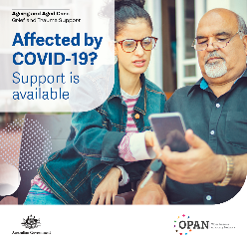 | Facebook | Families, friends, loved ones, families of choice and representatives of aged care residents can access free and confidential aged care advocacy and advice.  The Older Persons Advocacy Network (OPAN) is an independent service, providing COVID-19 support for families and providers for a referral to services.  OPAN operates nationally, and can be reached on 1800 700 600 or online at www.opan.com.au  OPAN is respectful of people’s culture, religion, identity and lifestyles.  If you or a loved one require a translator, phone the Translating and Interpreting Service (TIS) on 131 450. Ask for your language and the service will connect you. Sign language interpreting services
 | Twitter | Families, friends & loved ones of #SeniorAustralians living in #agedcare who have been impacted by #COVID19 can access free & confidential aged care advocacy & advice. Reach out to @OPAN_AU 1800 700 600 or www.opan.com.au talk to an advocate.  #agedcareadvocacy #confidentialadvice
 | LinkedIn | Families, friends, loved ones, families of choice and representatives of aged care residents can access free and confidential aged care advocacy and advice.  The Older Persons Advocacy Network (OPAN) is an independent service, providing expanded COVID-19 support for families and providers for a referral to services.  OPAN operates nationally, and can be reached on 1800 700 600 or online at www.opan.com.au  OPAN is respectful of people’s culture, religion, identity and lifestyles.  If you or a loved one require a translator, phone the Translating and Interpreting Service (TIS) on 131 450. Ask for your language and the service will connect you. Sign language interpreting services are also available. Contact Auslan Connections on 1300 010 877, email interpreter.bookings@ deafservices.org.au or SMS 0407 647 591.  #SeniorAustralians #AgedCare #agedcareadvocacy #confidentialadvice#SeniorAustralians #AgedCare #agedcareadvocacy #confidentialadvice

Dementia Support – Aged Care resident
Tile | Channel | Accompanying text
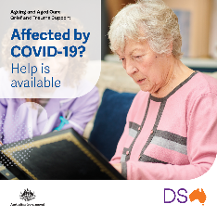 | Facebook | Aged care residents living with dementia may have changed behaviours as a result of COVID-19 restrictions.  Dementia Support Australia has developed engagement plans and strategies to help care for residents living with dementia who are experiencing changing behaviours and psychological symptoms.  Need help responding to changing behaviours? Call on 1800 699 799 or visit www.dementia.com.au  All services are confidential, Dementia Support Australia are respectful of people’s culture, religion, identity and lifestyles.  If you require a translator, phone the Translating and Interpreting Service (TIS) on 131 450. Ask for your language and the service will connect you. Sign language interpreting services are also available. Contact Auslan Connections on 1300 010 877, email interpreter.bookings@deafservices.org.au or SMS 0407 647 591.
 | Twitter | #AgedCare residents living w/ #dementia may be experiencing changed behaviours b/c of #COVID19 restrictions. Contact @DemSupportAu on 1800 699 799 or visit www.dementia.com.au for engagement plans & strategies to help care for residents.  #dementiasupport #dementiaengagement
 | LinkedIn | Aged care residents living with dementia may have changed behaviours as a result of COVID-19 restrictions.  Dementia Support Australia has developed engagement plans and strategies to help care for residents living with dementia who are experiencing changing behaviours and psychological symptoms.  Need help responding to changing behaviours? Call on 1800 699 799 or visit www.dementia.com.au  All services are confidential. Dementia Support Australia are respectful of people’s culture, religion, identity and lifestyles.  If you require a translator, phone the Translating and Interpreting Service (TIS) on 131 450. Ask for your language and the service will connect you. Sign language interpreting services are also available. Contact Auslan Connections on 1300 010 877, email interpreter.bookings@deafservices.org.au or SMS 0407 647 591.  #agedcare #dementia #dementiasupport #dementiaengagement

Dementia Support – Families
Tile | Channel | Accompanying text
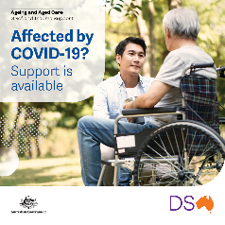 | Facebook | Advice and support is available for aged care residents living with dementia – and their families, family of choice, friends, loved ones, community visitors and representatives – who have been impacted by COVID-19.  Dementia Support Australia provides advice and recommendations to people who care for someone living with dementia where behaviours are impacting their care.  Engagement consultants, clinical support, advice and information services are available 24 hours a day across Australia.  Need help responding to changing behaviours? Call on 1800 699 799 or visit www.dementia.com.au  All services are confidential. Dementia Support Australia are respectful of people’s culture, religion, identity and lifestyles.  If you require a translator, phone the Translating and Interpreting Service (TIS) on 131 450. Ask for your language and the service will connect you. Sign language interpreting services are also available. Contact Auslan Connections on 1300 010 877, email interpreter.bookings@deafservices.org.au or SMS 0407 647 591.
 | Twitter | #AgedCare residents living w/ #dementia may be experiencing changed behaviours as a result of #COVID19 restrictions. Contact @DemSupportAu on 1800 699 799 or www.dementia.com.au for support, advice & information to help care for residents.  #dementiasupport #dementiaadvice
 | LinkedIn | Advice and support is available for aged care residents living with dementia – and their families, family of choice, friends, loved ones, community visitors and representatives – who have been impacted by COVID-19.  Dementia Support Australia provides advice and recommendations to people who care for someone living with dementia where behaviours are impacting their care.  Engagement consultants, clinical support, advice and information services are available 24 hours a day across Australia.

Australian Centre for Grief and Bereavement – Family and friends
Tile | Channel | Accompanying text
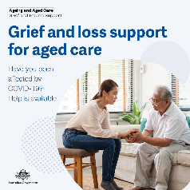 | Facebook | Aged care residents, home care recipients, their families, loved ones and staff affected by loss or trauma as a result of COVID-19 can now access free grief, loss and bereavement support services.  Easy to access and tailored to your own needs - including in-person help where possible - support is available via the Australian Centre for Grief and Bereavement.  Call 1800 222 220 or visit www.aged.grief.org.au for help, or to download the My Grief app. All services are inclusive, confidential, and can use TIS and Auslan.
 | Twitter | Grief & loss support is available to aged care recipients, their families and loved ones + #agedcareworkers affected by #COVID19.  Reach out, call 1800 222 200, download the My Grief app or visit www.aged.grief.org.au  #agedcare #support #counselling #translations #auslan
 | LinkedIn | It’s been a difficult year for many aged care residents, home care recipients, families and aged care workers.  Free, new grief, loss and bereavement services are available. The Australian Centre for Grief and Bereavement can provide support including:  - Phone counselling  - COVID-19 grief and trauma resources  - In-person and telehealth sessions with a bereavement practitioner  - MyGrief app with tools to support bereaved people, and advice on how loved ones can support someone experiencing grief and loss  It’s ok to seek help, so please call 1800 222 200, download the MyGrief app or visit aged.grief.org.au  The services are inclusive, confidential, and available for #interpreting and use #Auslan for people who are deaf or hard of hearing.  #agedcare #support #counselling #confidential

Australian Centre for Grief and Bereavement – Recipient
Tile | Channel | Accompanying text
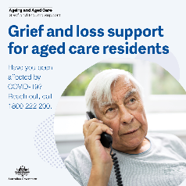 | Facebook | If you are an aged care resident and have experienced grief, loss, bereavement or trauma as a result of COVID-19, help is available.  New, easy to access services are tailored to your own needs - including in-person help where possible - and available via the Australian Centre for Grief and Bereavement.  Reach out by calling 1800 222 220 or visit www.aged.grief.org.au for help, or to download the My Grief app. All services are inclusive, confidential, and use TIS and and Auslan.  You can also ask your aged care provider for more information.
 | Twitter | Aged care residents affected by #COVID19 can access free grief & loss support services.  Call 1800 222 200, download the My Grief app or visit www.aged.grief.org.au  #agedcare #support #counselling #translations #auslan
 | LinkedIn | If you live in residential aged care and have been affected by the loss of a friend or loved one as a result of COVID-19, support is available to you.  We know it’s been a difficult year, the Australian Centre for Grief and Bereavement has developed specialised counselling, resources and tools:  - Phone counselling  - COVID-19 grief and trauma resources  - In-person and telehealth sessions with a bereavement practitioner  - MyGrief app with tools to support bereaved people, and advice on how loved ones can support someone experiencing grief and loss  It’s ok to seek help, so please reach out to 1800 222 200, download the MyGrief app or visit aged.grief.org.au  The services are inclusive, confidential, available for #interpreting and use #Auslan for people who are deaf or hard of hearing.  You can also ask your aged care provider for more information.  #agedcare #support #counselling #confidential

Australian Centre for Grief and Bereavement – Couple
Tile | Channel | Accompanying text
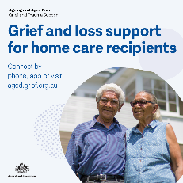 | Facebook | If you receive home aged care and have been affected by the loss of a loved one or are experiencing loss due to social isolation as a result of COVID-19, help is available.  Free support services are easy to access, tailored to your own needs - including in-person help where possible - and available via the Australian Centre for Grief and Bereavement.  Reach out and call 1800 222 220 or visit www.aged.grief.org.au for help, or to download the My Grief app. All services are inclusive, confidential, can be translated and use Auslan.  You can also ask your home care service provider for more information.
 | Twitter | Home care recipients affected by #COVID19 and needing grief & loss support can now access free, new services.  Connect on 1800 222 200, download the My Grief app or visit www.aged.grief.org.au  #agedcare #support #counselling #translations #auslan
 | LinkedIn | If you receive home aged care and have been affected by the loss of a loved one or friend, or are grieving the loss of something else as a result of COVID-19, support is available for you.  Free new grief and loss services are available to help home care recipients impacted by #COVID-19.  The Australian Centre for Grief and Bereavement provides free grief and loss services and resources:  - Phone counselling  - COVID-19 grief and trauma resources  - In-person and telehealth sessions with a bereavement practitioner  - MyGrief app with tools to support bereaved people, and advice on how loved ones can support someone experiencing grief and loss  Call 1800 222 200, download the MyGrief app or visit aged.grief.org.au  The services are inclusive confidential, available for #translation and use #Auslan for people who are deaf or hard of hearing.  You can also ask your home care service provider for more information.  #agedcare #support #counselling #confidential

Australian Centre for Grief and Bereavement – Family
Tile | Channel | Accompanying text
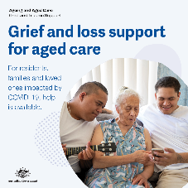 | Facebook | Do you have a family member, loved one, friend or family of choice who has been affected by COVID-19 in aged care?  Free grief, loss and bereavement support is available. Families, loved ones, families of choice, friends and community visitors experiencing loss, grief or bereavement can access new services and resources, tailored to your own needs - including in-person help where possible - available via the Australian Centre for Grief and Bereavement.  Connect and call 1800 222 220 or visit www.aged.grief.org.au for help, or to download the My Grief app. All services are inclusive, confidential, and use TIS and Auslan.
 | Twitter | Families w/ loved ones or friends in aged care impacted by #COVID19 can access free grief, loss & bereavement support.  Reach out, call 1800 222 200, download the My Grief app or visit www.aged.grief.org.au  #agedcare #support #counselling #translations #auslan
 | LinkedIn | It’s been a difficult year for families and friends of aged care residents. Help is available for those experiencing grief and loss as a result of COVID-19.  The Australian Centre for Grief and Bereavement is delivering new, free services, including:  Phone counselling  - COVID-19 grief and trauma resources  - In-person and telehealth sessions with a bereavement practitioner  - MyGrief app with tools to support bereaved people, and advice on how loved ones can support someone experiencing grief and loss  It’s ok for you, your family and loved ones to seek help, please reach out to 1800 222 200, download the MyGrief app or visit aged.grief.org.au  All services are inclusive, confidential, available for #interpreting and use #Auslan for people who are deaf or hard of hearing.  #agedcare #support #counselling #confidential

Australian Centre for Grief and Bereavement – Carer
Tile | Channel | Accompanying text
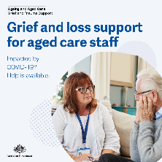 | Facebook | Have you been affected by the loss of a loved one, or feel grief as a result of COVID-19? Support and resources are available to aged care staff.  The new services are free and easy to access, tailored to your own needs - including in-person help where possible - and available via the Australian Centre for Grief and Bereavement.  Call 1800 222 220 or visit www.aged.grief.org.au for help, or to download the My Grief app. All services are inclusive, confidential, and use TIS and Auslan.
 | Twitter | #Agedcareworkers impacted by #COVID19 and needing grief, loss & bereavement support can now access free, new services. Call 1800 222 200, download the My Grief app or visit www.aged.grief.org.au #support #agedcare #counselling #translations #auslan
 | LinkedIn | If you are an aged care worker, it’s ok to seek help for you or the people you care for. Free and confidential grief, loss and bereavement services are available to help aged care staff affected by COVID-19.  We know it’s been a difficult year, the Australian Centre for Grief and Bereavement delivers support including:  - Phone counselling  - COVID-19 grief and trauma resources  - In-person and telehealth sessions with a bereavement practitioner  - MyGrief app with tools to support bereaved people, and advice on how loved ones can support someone experiencing grief and loss  Reach out to 1800 222 200, download the MyGrief app or visit aged.grief.org.au  All our services are inclusive, confidential, available for #translation and use #Auslan for people who are deaf or hard of hearing.  #agedcare #support #counselling #confidential

